Tropical Cyclone Report
Hurricane Omar
(AL152008)
13-18 October 2008

John L. Beven II and Chris Landsea
National Hurricane Center
3 February 2009

Omar, which directly impacted the Leeward Islands, underwent rapid intensification (up to a category 4 hurricane on the Saffir-Simpson Hurricane Scale) and an immediately subsequent rapid weakening.

- Synoptic History

Omar originated from an easterly wave that moved westward off the coast of west Africa on 30 September. The wave had a robust mid-level circulation and widespread deep convection as it reached the eastern Atlantic. However, by 2 October, convection associated with this wave diminished. The wave continued westward during the next several days with little change in structure. The wave reached the Lesser Antilles on 9 October, and deep convection redeveloped two days later in the eastern Caribbean Sea. The convective structure continued to increase over the next 36 h, and it is estimated that the system became a tropical depression around 0600 UTC 13 October in the central Caribbean Sea, about 165 n mi south of the southeastern tip of the Dominican Republic. The westward movement of the depression slowed that day as the deep layer steering currents weakened. The cyclone was slow to intensify after genesis, taking about 18 h to become a tropical storm about 125 n mi north-northeast of Aruba. The “best track” chart of the Omar’s path is given in Fig. 1, with the wind and pressure histories shown in Figs. 2 and 3, respectively. The best track positions and intensities are listed in Table 1.

Omar moved slowly in a counter-clockwise turn on 14 October, and this motion continued early the next day. Later on 15 October, the cyclone began moving toward the northeast under the influence of a broad, deep tropospheric trough to Omar’s northwest and a mid- to low-level ridge to its east. This trough accelerated Omar northeastward for the next few days, with the storm reaching a peak forward speed of about 30 kt on 17 October.

After becoming a tropical storm, a central dense overcast developed over Omar, and the cyclone underwent an extended period of rapid intensification. Omar’s intensity increased from 35 kt at 0000 UTC 14 October to 115 kt at 0600 UTC 16 October. The intensity increased 30 kt from 0000 14 October to 0000 UTC 15 October, and increased 35 kt in the 12 h period starting at 1800 UTC 15 October. Omar reached hurricane intensity around 0000 UTC 15 October about 115 n mi north of Bonaire. Figure 4 shows the evolution of the convective structure of Omar on 14-16 October. The first four microwave images depict how the deep convection quickly developed banding features and a ragged eye on 14 October, with the continued development of symmetric inner core convection and a very distinct eye on 15-16 October. This rapid intensification occurred while Omar was experiencing moderate to low vertical wind shear, a divergent flow aloft, very warm waters with high ocean heat content, and a moist low to mid troposphere. One can speculate that the impact of the vertical shear during the second rapid intensification period was mitigated by Omar's motion being in the same direction as the shear vector. However, the importance of the relative orientations of the shear and storm motion vectors has not been well quantified by the research community.

Rapid intensification abruptly ended near 0600 UTC 16 October, and rapid weakening promptly commenced (a 45-kt decrease in 12 h). The final two panels of Figure 4 show that the eye dissipated and the deep convection became well removed to the north and east of the center. Additionally, visible images on 16 October revealed an exposed low-level center. This weakening appeared to be due to a combination of strong vertical shear and low to mid-level dry air impacting the cyclone’s inner core. Omar lost most of its deep convection by early on 17 October, and AMSU imagery indicated that it had also lost its upper-level warm core.

Omar briefly re-intensified later that day as the west-southwesterly vertical shear decreased while the hurricane still remained over warm waters. During this secondary peak in intensity, deep convection re-developed around the center, and an eye was discernable for a few hours in both geostationary and microwave satellite imagery.

Also on 17 October, the strong trough that caused the rapid northeastward motion bypassed the hurricane. Omar began decelerating, but continued moving toward the northeast and then the east-northeast during the next three days under the influence of a mid- to low-level ridge to its south and the mid-latitude westerlies to its north.

Late on 17 October, westerly vertical shear again increased, and the hurricane moved over sea surface temperatures below 26ºC, causing a final erosion of Omar’s deep convection. The cyclone weakened to a tropical storm around 0000 UTC 18 October about 690 n mi east of Bermuda. Omar then degenerated into a remnant low 12 h later. The low persisted for two days before dissipating around 0600 UTC 21 October about 700 n mi west of the Azores.

- Meteorological Statistics

Observations in Omar (Figs. 2 and 3) include satellite-based Dvorak technique intensity estimates from the Tropical Analysis and Forecast Branch (TAFB) and the Satellite Analysis Branch (SAB), as well as flight-level, stepped frequency microwave radiometer (SFMR), and dropwindsonde observations from flights of the 53rd Weather Reconnaissance Squadron of the U. S. Air Force Reserve Command. Data and imagery from NOAA polar-orbiting satellites, the NASA Tropical Rainfall Measuring Mission (TRMM), the NASA QuikSCAT, Defense Meteorological Satellite Program (DMSP), and the EUMETSAT ASCAT satellites, among others, as well as the Curacao and San Juan radars were also useful in tracking Omar.

Dvorak classifications by TAFB and SAB began at 2345 UTC 12 October. The system was assessed to be a tropical depression the next day based upon a combination of Dvorak estimates, radar imagery from Curacao, low level cloud drift winds, and surface observations. Dvorak estimates, data from the Advanced Dvorak Technique (ADT), and a CIMSS AMSU analysis first indicated that the depression became a tropical storm on 14 October. An aircraft reconnaissance mission later that day showed that Omar was rapidly intensifying and was near hurricane force. Nearly continuous aircraft reconnaissance was subsequently available while Omar underwent rapid intensification.

Omar’s peak intensity is estimated to be 115 kt at 0600 UTC 16 October, based upon an SFMR estimate of 113 kt along with 700-mb flight-level winds of 132 kt flight-level winds. This intensity is higher than the Dvorak-based satellite estimates of about 105 kt at that time. It appears the aircraft sampled during the time of the peak intensity, as the eye was most apparent in satellite imagery around 0600 UTC and a subsequent penetration by the aircraft two hours later showed significant filling.

The minimum central pressure of 958 mb in Omar is analyzed to also have occurred around 0600 UTC based upon a GPS dropwindsonde sea-level pressure measurement of 959 mb with an observed 14-kt surface wind.

The intensity of Omar during rapid weakening is more uncertain than normal. No aircraft data was available, and the system decayed faster than the Dvorak technique can accommodate. Intensities at those times are based primarily upon the ADT and QuikSCAT data. Omar’s modest re-intensification on 17 October is based upon the depiction of a redeveloping eye in conventional and microwave imagery and a 75-kt QuikSCAT wind speed observation.

No ships reported winds of tropical storm force directly associated with Omar. Selected surface observations from land stations and data buoys are given in Table 2. The most extreme surface winds observed were from St. Barthelemy, which reported a 1-min wind of 53 kt, and from the National Ocean Service station at Christiansted Harbor, St. Croix, which measured a 6-min mean wind of 52 kt. The peak observed gust was 75 kt from an unofficial site at the Buccaneer Resort at Christiansted, St. Croix. National Data Buoy Center buoy 42059 in the eastern Caribbean measured a peak significant wave height of 17.7 ft.

Omar caused a storm surge in portions of the Virgin Islands and northern Leeward Islands. On Antigua, the surge was estimated at 2-3.5 ft accompanied by wave heights of 4.5-7 ft. Surge heights from other islands are not currently available.

Omar caused storm total rainfalls of 2-6 inches across the Virgin Islands and northern Leeward Islands, with a maximum of 9.13 inches at Antigua.

- Casualty and Damage Statistics

There are no known casualties from Omar.

Impacts from Omar were first felt in the Netherland Antilles of Aruba, Bonaire, and Curacao. Southwesterly winds on the south side of Omar generated large waves that caused beach erosion and significant damage to coastal facilities. On all three islands, a considerable number of houses experienced roof damage, while several trees were uprooted because of winds near tropical storm intensity. Sections of Aruba experienced significant flooding from heavy rains.

At the time of peak intensity, Omar was about 50 n mi west of Anguilla and St. Martin/St. Maarten in the Leeward Islands, and about 30 n mi southeast of Virgin Gorda in the British Virgin Islands. Fortunately, the eye of Omar moved through the Anegada Passage, and the core of major hurricane force winds did not impact any inhabited islands. Sombrero Island likely experienced the eye of Omar, but this island is uninhabited.

In the U.S. Virgin Islands, it is estimated that St. Thomas received tropical-storm conditions, while St. Croix – especially the eastern end of the island – was affected by low-end Category 1 hurricane conditions. In St. Croix, electrical power was lost due to downed trees, power lines and utility poles. The east end of St. Croix was hardest hit by the winds. There were 47 vessels sunk at St. Croix, with 33 in the Christiansted Harbor, 11 near the St. Croix Yacht Club, one in the vicinity of Cotton Valley, and two near Salt River. St. Croix experienced substantial road damage and landslides. Eighty people sought shelter from the hurricane. Total damage was reported to be about $5 million. There were no major impacts in the remaining U.S. Virgin Islands and Puerto Rico.

Omar also affected the Netherland Antilles of Saba, St. Eustatius, and St. Maarten, which experienced tropical storm conditions that produced damaging coastal flooding. Widespread damage was experienced to coastal facilities, buildings and infrastructure.

In Antigua, the storm surge caused damaging flooding with water reaching near the roofs of some houses in low lying areas.

- Forecast and Warning Critique

The genesis of Omar was well anticipated. The first mention of Omar’s originating disturbance in the Tropical Weather Outlook was at 1200 UTC 9 October. The disturbance was given only a “low” (less than 20% chance of tropical cyclone formation within 48 h) chance of formation through 1800 UTC 11 October, which was 36 h before genesis. A “medium” probability (20-50% chance of tropical cyclone formation within 48 h) of formation was predicted from 0000-1800 UTC 12 October, 12 h before genesis. A “high” probability greater than 50% chance of tropical cyclone formation within 48 h) was operationally assigned from 0000-1200 13 October, with genesis occurring (as determined in post-analysis) at 0600 UTC that day.

A verification of official and guidance model track forecasts is given in Table 3. Average official track errors for Omar were 42, 84, 114, 166, 280, and 472 n mi for the 12, 24, 36, 48, 72, and 96 h forecasts, respectively. The number of forecasts ranged from 18 at 12 h to 4 at 96 h. These errors are greater than the average 5-yr official track errors (Table 3). Examination of the along- and cross-track official forecast errors (not shown) indicates that the absolute errors were due primarily to a significant slow bias (along-track) in the predictions. A variety of the track guidance models were better than the official forecast across the various forecast periods. The consistently available consensus techniques (TVCN, TVCC) generally provided improvements over the individual models, and the official track errors were quite similar in magnitude to these guidance schemes, including the significant along-track slow bias. The Florida State University Superensemble (FSSE) also lower mean track forecast errors than the official forecasts. The best performer amongst the dynamical models was the BAMD.

A verification of official and guidance model intensity forecasts is given in Table 4. Average official intensity errors were 12, 15, 19, 26, 14, and 10 kt for the 12, 24, 36, 48, 72, and 96 h forecasts, respectively. For comparison, the average 5-yr official intensity errors are: 7, 10, 12, 14, 18, 20, and 22 kt, respectively. These larger-than-average errors were due to the combination of a large low bias in the forecasts issued on 13-14 October when Omar’s rapid intensification was not adequately anticipated, and a large high bias in the predictions on 15-16 October when Omar did not weaken as quickly as forecast. The GHMI and HWFI models had mean intensity forecast errors near or smaller than those of the official forecast from 24-48 h, as was the case for the consensus models ICON, IVCN, and FSSE.

Omar experienced two periods of rapid intensification, with the first starting at 1800 UTC 13 October and the second at 1800 UTC 14 October. For the first period, none of the statistical techniques suggested rapid intensification. However, the 0000 UTC GHMI and the 0000/0600 UTC HWFI model runs correctly anticipated this strengthening. For the second period, the dynamical intensity techniques were calling for intensification, but only the 1800 UTC DSHP and LGEM models explicitly predicted at least a 30-kt increase in winds. The SHIPS Rapid Intensification Index correctly suggested a 68% chance of RI at 1800 UTC 14 October (9.3 times the sample mean of 8%) and 58% chance at 0000 UTC 15 October.

Watches and warnings associated with Omar are given in Table 5. A hurricane watch was issued for Puerto Rico and the U.S. Virgin Islands about 30 h before Omar’s closest approach (to St. Croix). A Hurricane Warning was issued for the U.S. Virgin Islands about 24 h before Omar’s closest approach.

Acknowledgements

The San Juan Weather Forecast Office provided their Post Tropical Cyclone Report with details on key observations and impacts that occurred in Puerto Rico and the U.S. Virgin Islands. Data from Antigua, the French West Indies, and the Netherland Antilles were provided by the meteorological services of those countries.

Table 1. Best track for Hurricane Omar, 13-18 October 2008.

Date/Time  (UTC) | Latitude  (°N) | Longitude  (°W) | Pressure  (mb) | Wind Speed  (kt) | Stage
13 / 0600 | 15.4 | 69.0 | 1005 | 25 | tropical depression
13 / 1200 | 15.2 | 69.6 | 1005 | 30 | "
13 / 1800 | 14.8 | 69.8 | 1004 | 30 | "
14 / 0000 | 14.5 | 69.6 | 1001 | 35 | tropical storm
14 / 0600 | 14.3 | 69.3 | 997 | 40 | "
14 / 1200 | 14.2 | 69.1 | 991 | 50 | "
14 / 1800 | 13.9 | 68.8 | 983 | 60 | "
15 / 0000 | 14.1 | 68.3 | 983 | 65 | hurricane
15 / 0600 | 14.4 | 68.0 | 985 | 70 | "
15 / 1200 | 14.9 | 67.4 | 984 | 75 | "
15 / 1800 | 15.6 | 66.5 | 977 | 80 | "
16 / 0000 | 16.7 | 65.2 | 970 | 95 | "
16 / 0600 | 18.2 | 63.9 | 958 | 115 | "
16 / 1200 | 19.6 | 62.1 | 975 | 90 | "
16 / 1800 | 21.1 | 60.4 | 985 | 70 | "
17 / 0000 | 22.8 | 58.8 | 986 | 65 | "
17 / 0600 | 25.1 | 57.1 | 984 | 70 | "
17 / 1200 | 27.9 | 55.7 | 982 | 75 | "
17 / 1800 | 30.1 | 54.4 | 985 | 65 | "
18 / 0000 | 31.3 | 53.2 | 988 | 55 | tropical storm
18 / 0600 | 32.4 | 52.1 | 991 | 50 | "
18 / 1200 | 33.0 | 51.3 | 996 | 40 | remnant low
18 / 1800 | 33.5 | 50.5 | 1002 | 35 | "
19 / 0000 | 34.0 | 49.7 | 1006 | 30 | "
19 / 0600 | 34.5 | 49.0 | 1008 | 30 | "
19 / 1200 | 35.1 | 48.3 | 1012 | 25 | "
19 / 1800 | 35.7 | 47.5 | 1012 | 30 | "
20 / 0000 | 36.4 | 46.8 | 1013 | 30 | "
20 / 0600 | 37.0 | 46.2 | 1014 | 25 | "
20 / 1200 | 37.6 | 45.3 | 1015 | 25 | "
20 / 1800 | 37.9 | 44.3 | 1016 | 25 | "
21 / 0000 | 38.3 | 43.3 | 1016 | 25 | "
21 / 0600 |  |  |  |  | dissipated
16 / 0600 | 18.2 | 63.9 | 958 | 115 | minimum pressure & maximum wind

Table 2. Selected surface observations for Hurricane Omar, 13-18 October 2008.

Location | Minimum Sea Level Pressure |  | Maximum Surface  Wind Speed |  |  | Storm surge  (ft)^{c} | Storm  tide  (ft)^{d} | Total  rain  (in)
Location | Date/  time  (UTC) | Press.  (mb) | Date/  time  (UTC)ª | Sustained  (kt)^{b} | Gust  (kt) | Storm surge  (ft)^{c} | Storm  tide  (ft)^{d} | Total  rain  (in)
Antigua
TAPA – Antigua  (17.12ºN 61.78ºW) | 16/0700 | 1007.2 | 16/1000 | 35 | 42 | 1.8-3.6 |  | 9.13
French West Indies
St. Barthelemy Airport | 16/0300 | 1003.1 | 16/0400 | 31 | 64
St. Barthelemy Gustavia Meteo | 16/0400 | 1003.0 | 16/0400 | 53 | 68 |  |  | 1.97
St. Martin Grand Case Airport | 16/0300 | 1001.8 | 16/0500 | 42 | 70 |  |  | 4.53
Netherland Antilles
TNCA – Aruba  (12.50ºN 70.02ºW) |  |  | 14/1014 | 31 | 39 |  |  | 4.00
TNCB – Bonaire  (12.15ºN 68.28ºW) |  |  | 15/0723 | 34 | 50 |  |  | 1.60
TNCC – Curacao  (12.20ºN 68.97ºW) |  |  | 14/1626 | 31 | 39 |  |  | 1.70
TNCE - St. Eustatius  (17.48ºN 61.98ºW) |  |  | 16/0525 | 36 | 50 |  |  | 4.02
TNCM - St. Maarten  (18.05ºN 63.12ºW) |  |  | 16/0710 | 46 | 66 |  |  | 5.49
Puerto Rico and the US Virgin Islands
TIST - St. Thomas Airport, VI (18.33ºN 64.98ºW) | 16/0546 | 1003.1 | 16/0428 | 29 | 43 |  |  | 2.42
TISX - St. Croix Airport, VI (17.70ºN 64.80ºW) | 16/0326 | 993.9 | 16/0410 | 42 | 54 |  |  | 5.30
Carolina Airport, PR | 15/2337  16/0448 | 1006.4 | 16/0628 | 17 | 23
Cotton Valley, VI |  |  |  |  |  |  |  | 3.44
Buoys
42059 Eastern Caribbean  (15.01ºN 67.50ºW) | 15/1150 | 987.5 | 15/1300 | 50 | 68
National Ocean Service (NOS) Sites
CHSV3 - Christiansted Harbor  (17.75ºN 64.72ºW) | 16/0342 | 993.0 | 16/0342 | 52 | 68 |  | 2.2
LTBV3 - Lime Tree Bay  (17.68ºN 64.75ºW) | 16/0424 | 995.4 | 16/0418 | 44 | 65
Sites from other Government Agencies
SRBV3 - Integrated Coral Observing Network  Salt River Bay  (17.78ºN 64.76ºW) |  |  | 16/0130 | 35
Unofficial US Virgin Islands
Buccaneer Resort, Christiansted, St. Croix | 16/0350 | 992.8 | 16/0410 |  | 75 |  |  | 9.11

ª Date/time is for sustained wind when both sustained and gust are listed.
^{b} Except as noted, sustained wind averaging periods for C-MAN and land-based ASOS reports are 2 min; buoy averaging periods are 8 min.
^{c} Storm surge is water height above normal astronomical tide level.
^{d} Storm tide is water height above National Geodetic Vertical Datum (1929 mean sea level).
Table 3. Track forecast evaluation (heterogeneous sample) for Hurricane Omar, 13 – 18 October 2008. Forecast errors (n mi) are followed by the number of forecasts in parentheses. Errors smaller than the NHC official forecast are shown in boldface type.
Forecast Technique | Forecast Period (h)
Forecast Technique | 12 | 24 | 36 | 48 | 72 | 96 | 120
CLP5 | 83 (19) | 171 (17) | 321 (15) | 529 (13) | 971 ( 9) | 1322 ( 5)
GFNI | 37 ( 7) | 64 ( 7) | 111 ( 7) | 181 ( 7) | 348 ( 5) | 715 ( 1)
GFDI | 50 (19) | 103 (17) | 150 (15) | 195 (13) | 240 ( 9) | 437 ( 5)
HWFI | 46 (19) | 74 (17) | 109 (15) | 177 (13) | 289 ( 9) | 400 ( 5)
NAMI | 88 (18) | 157 (14) | 248 (12) | 358 (11) | 631 ( 8)
COAI | 30 ( 5) | 58 ( 5) | 101 ( 5) | 135 ( 5)
GFSI | 54 (19) | 91 (17) | 121 (15) | 151 (13) | 198 ( 8) | 447 ( 5)
AEMI | 55 (19) | 91 (17) | 116 (15) | 158 (11) | 386 ( 7)
NGPI | 55 (16) | 89 (14) | 134 (12) | 191 (10) | 280 ( 7) | 574 ( 3)
UKMI | 46 (17) | 80 (15) | 120 (13) | 178 (11) | 352 ( 7) | 671 ( 3)
EGRI | 46 (17) | 78 (15) | 120 (13) | 180 (11) | 358 ( 7) | 685 ( 3)
EMXI | 49 (12) | 108 (11) | 158 (10) | 215 ( 8) | 373 ( 6) | 666 ( 2)
JGSI | 61 (13) | 98 (11) | 128 ( 9) | 177 ( 7) | 236 ( 3)
BAMD | 51 (19) | 79 (17) | 108 (15) | 148 (13) | 135 ( 9) | 238 ( 5)
BAMM | 53 (19) | 96 (17) | 129 (15) | 178 (13) | 340 ( 9) | 804 ( 5)
BAMS | 86 (19) | 169 (17) | 238 (15) | 319 (13) | 555 ( 9) | 1116 ( 5)
LBAR | 60 (19) | 97 (17) | 139 (15) | 185 (13) | 249 ( 9) | 352 ( 5)
TCON | 44 (14) | 79 (12) | 117 (10) | 179 ( 8) | 270 ( 4) | 515 ( 1)
TCCN | 43 (14) | 77 (12) | 116 (10) | 180 ( 8) | 295 ( 4) | 591 ( 1)
TVCN | 45 (19) | 82 (17) | 115 (15) | 159 (13) | 250 ( 9) | 436 ( 5)
TVCC | 43 (19) | 78 (17) | 109 (15) | 152 (13) | 259 ( 9) | 516 ( 5)
GUNA | 46 (14) | 83 (12) | 122 (10) | 180 ( 8) | 270 ( 4) | 543 ( 1)
CGUN | 43 (14) | 83 (12) | 124 (10) | 184 ( 8) | 295 ( 4) | 622 ( 1)
FSSE | 42 (13) | 63 (11) | 98 ( 9) | 163 ( 7) | 242 ( 3)
OFCL | 42 (18) | 84 (16) | 114 (14) | 166 (12) | 280 ( 8) | 472 ( 4)
NHC Official  (2003-2007 mean) | 34.0 (1742) | 58.2 (1574) | 82.2 (1407) | 106.2 (1254) | 154.2 (996) | 207.5 (787) | 272.5 (627)
Table 4. Intensity forecast evaluation (heterogeneous sample) for Hurricane Omar, 13 – 18 October 2008. Forecast errors (kt) are followed by the number of forecasts in parentheses. Errors smaller than the NHC official forecast are shown in boldface type.

Forecast Technique | Forecast Period (h)
Forecast Technique | 12 | 24 | 36 | 48 | 72 | 96 | 120
OCD5 | 17.1 (19) | 19.4 (17) | 21.9 (15) | 28.1 (13) | 29.4 ( 9) | 17.6 ( 5)
GHMI | 13.1 (19) | 14.9 (17) | 14.5 (15) | 18.3 (13) | 20.9 ( 9) | 25.6 ( 5)
GFNI | 16.3 ( 7) | 16.0 ( 7) | 12.1 ( 7) | 20.0 ( 7) | 16.6 ( 5) | 20.0 ( 1)
HWFI | 13.4 (19) | 15.1 (17) | 13.9 (15) | 16.0 (13) | 17.7 ( 9) | 25.2 ( 5)
LGEM | 18.4 (19) | 20.8 (17) | 21.7 (15) | 30.5 (13) | 30.4 ( 9) | 21.8 ( 5)
DSHP | 16.1 (19) | 18.2 (17) | 20.4 (15) | 26.7 (13) | 23.8 ( 9) | 8.8 ( 5)
FSSE | 15.4 (13) | 15.7 (11) | 14.4 ( 9) | 13.9 ( 7) | 13.7 ( 3)
ICON | 14.7 (19) | 15.2 (17) | 15.7 (15) | 20.6 (13) | 17.4 ( 9) | 7.8 ( 5)
IVCN | 14.8 (19) | 14.9 (17) | 15.1 (15) | 20.5 (13) | 17.3 ( 9) | 8.2 ( 5)
OFCL | 12.2 (18) | 15.0 (16) | 19.3 (14) | 26.3 (12) | 14.4 ( 8) | 10.0 ( 4)
NHC Official  (2003-2007 mean) | 6.7 (1742) | 10.0 (1574) | 12.3 (1407) | 14.3 (1254) | 18.2 (996) | 19.7 (787) | 21.8 (627)

Table 5. Watch and warning summary for Hurricane Omar, 13-18 October 2008.

Date/Time (UTC) | Action | Location
13 / 2100 | Tropical Storm Watch issued | Puerto Rico, US Virgin Islands, Vieques, and Culebra, andBritish Virgin Islands
13 / 2100 | Tropical Storm Watch issued | Dominican Republic from Isla Saona to Cabo Engano
14 / 2100 | Tropical Storm Watch changed to Tropical Storm Warning/ Hurricane Watch | Puerto Rico, US Virgin Islands, Vieques, and Culebra, and British Virgin Islands
14 / 2100 | Tropical Storm Watch discontinued | Dominican Republic from Isla Saona to Cabo Engano
14 / 2100 | Tropical Storm Watch issued | Montserrat
14 / 2100 | Tropical Storm Warning/ Hurricane Watch issued | Anguilla, St. Kitts, Nevis, Saba, St. Eustatius, St. Maarten, St. Martin, and St. Barthelemy
15 / 0300 | Tropical Storm Warning/ Hurricane Watch changed to Hurricane Warning | US Virgin Islands, Vieques, and Culebra
15 / 0300 | Tropical Storm Warning/ Hurricane Watch changed to Hurricane Warning | British Virgin Islands, Anguilla, St. Kitts, Nevis, Saba, St. Eustatius, St. Maarten, St. Martin, and St. Barthelemy
15 / 0300 | Tropical Storm Warning issued | Antigua and Barbuda
15 / 0300 | Tropical Storm Watch changed to Tropical Storm Warning | Montserrat
15 / 1800 | Hurricane Warning changed to Tropical Storm Warning/ Hurricane Watch | St. Kitts and Nevis
16 / 0700 | All warnings discontinued | Puerto Rico
16 / 0900 | All warnings discontinued | US Virgin Islands, Vieques, and Culebra, British Virgin Islands
16 / 1200 | All warnings discontinued | St. Kitts, Nevis, Antigua, Barbuda, St. Martin, St. Maarten, St. Eustatius, St. Barthelemy, Saba, Anguilla, and Montserrat

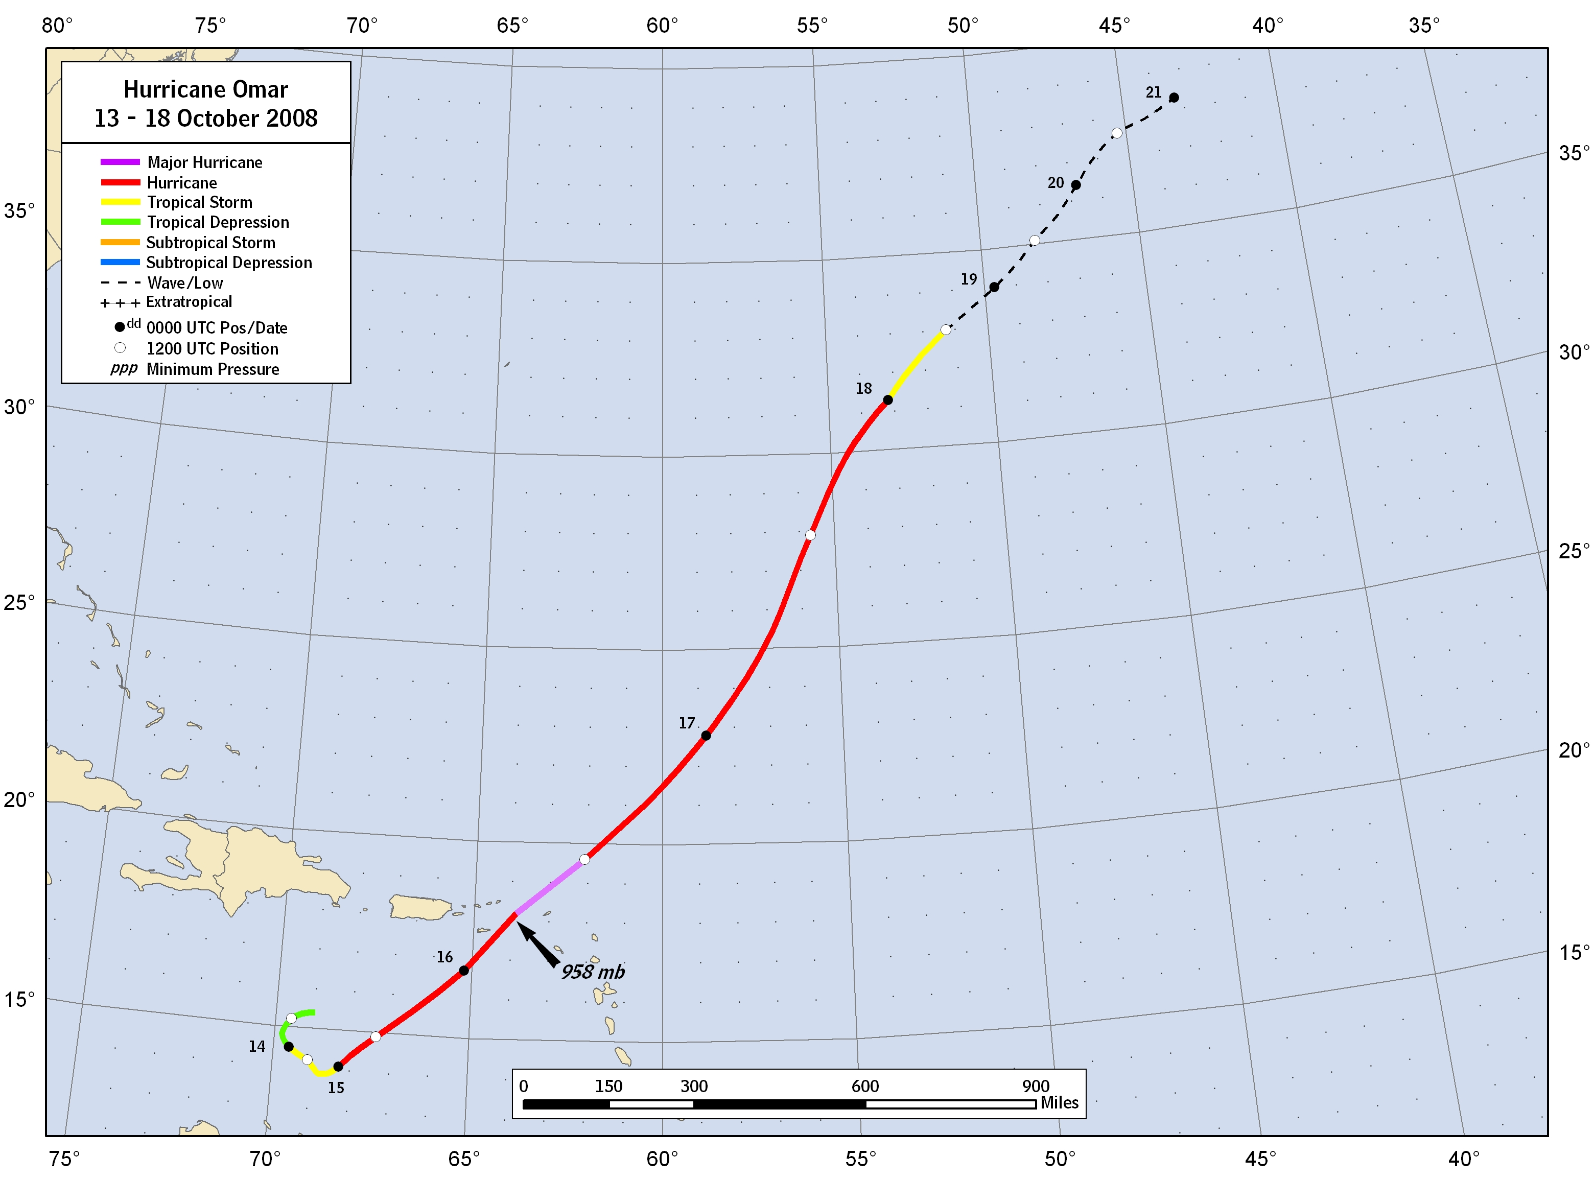
Figure 1. Best track positions for Hurricane Omar, 13-18 October 2008. Track during the remnant low stage is based on analyses from the NOAA Ocean Prediction Center.
AMSU - CIMSS
Figure 2. Selected wind observations and best track maximum sustained surface wind speed curve for Hurricane Omar, 13 – 18 October 2008. Aircraft observations have been adjusted for elevation using 90%, 80%, and 75% adjustment factors for observations from 700 mb, 850 mb, and 925 mb, respectively. Dropwindsonde observations are surface wind estimates derived from the mean wind over the lowest 150 m of the wind sounding (LLM). Objective Dvorak estimates represent linear averages over a three-hour period centered on the nominal observation time. CIMSS AMSU intensity estimates are included when the estimated radius of maximum winds was at least 25 n mi. Dashed vertical lines correspond to 0000 UTC.
AMSU - CIMSS
Figure 3. Selected pressure observations and best track minimum central pressure curve for 13 – 18 October 2008. Objective Dvorak estimates represent linear averages over a three-hour period centered on the nominal observation time. CIMSS AMSU intensity estimates are included when the estimated radius of maximum winds was at least 25 n mi. Dashed vertical lines correspond to 0000 UTC.
AMSU - CIMSS
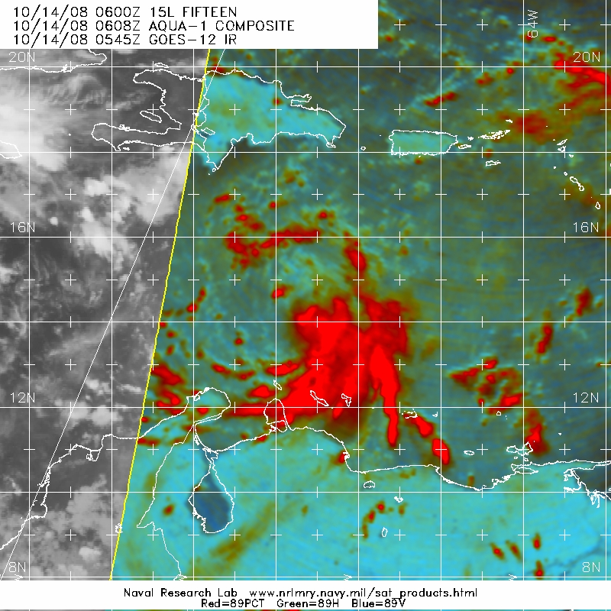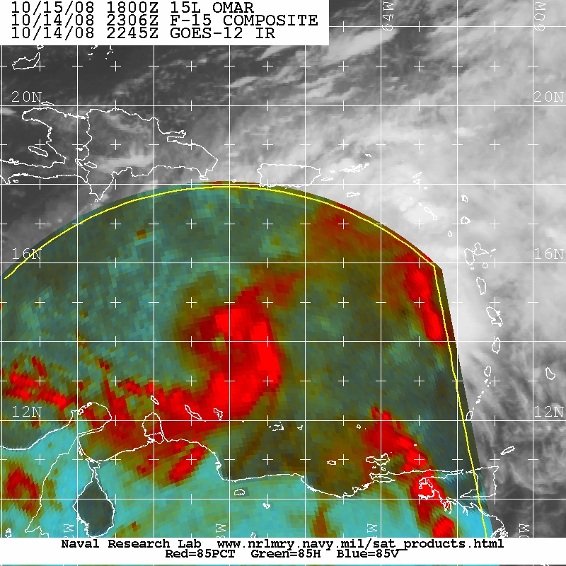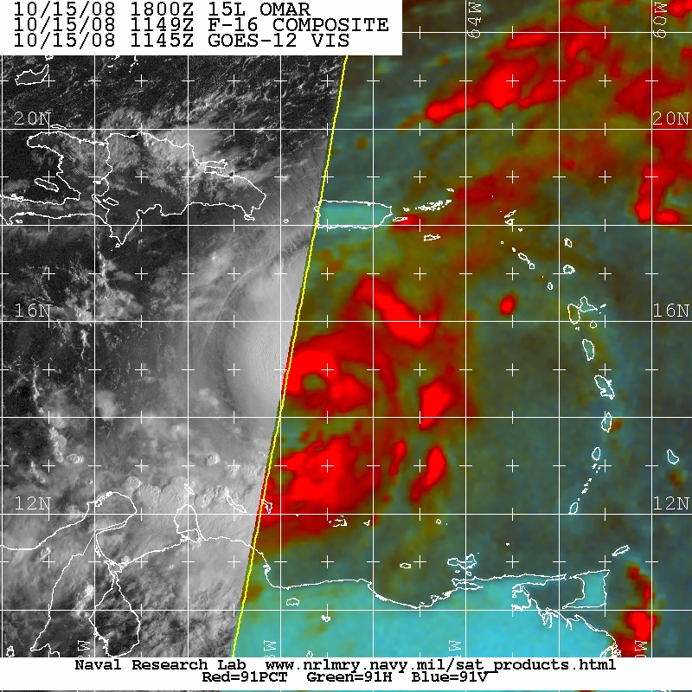
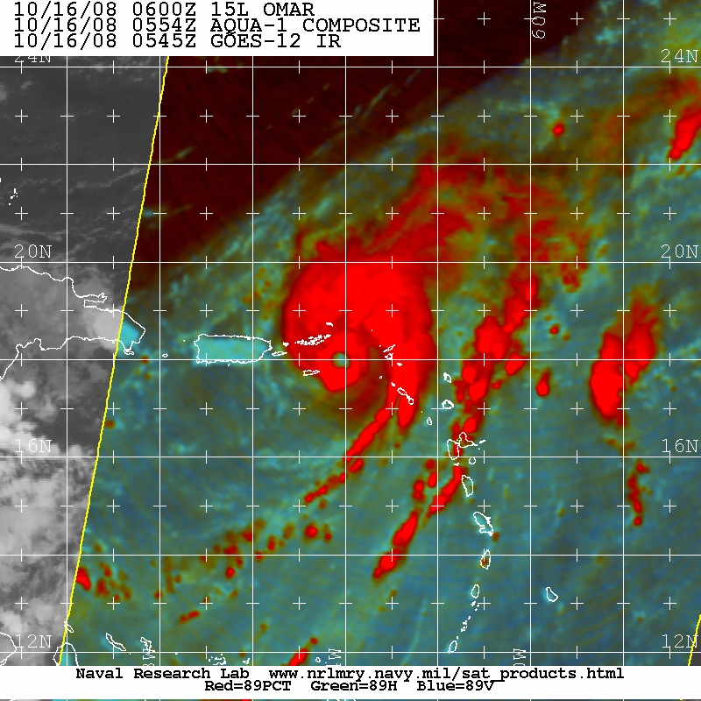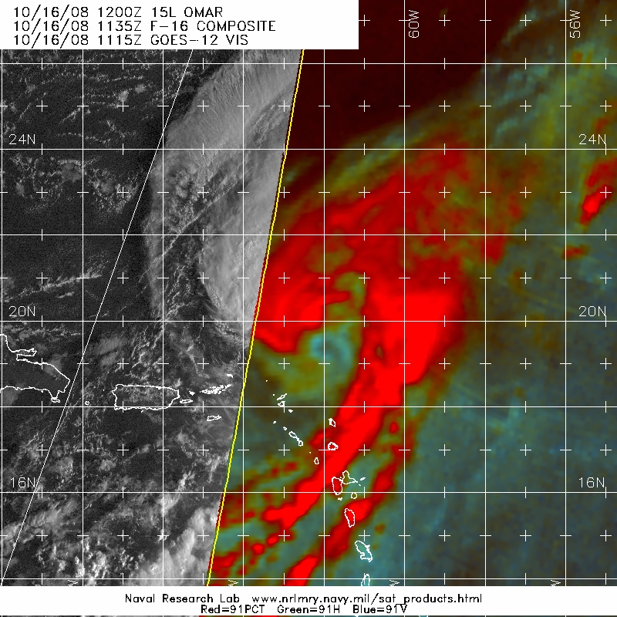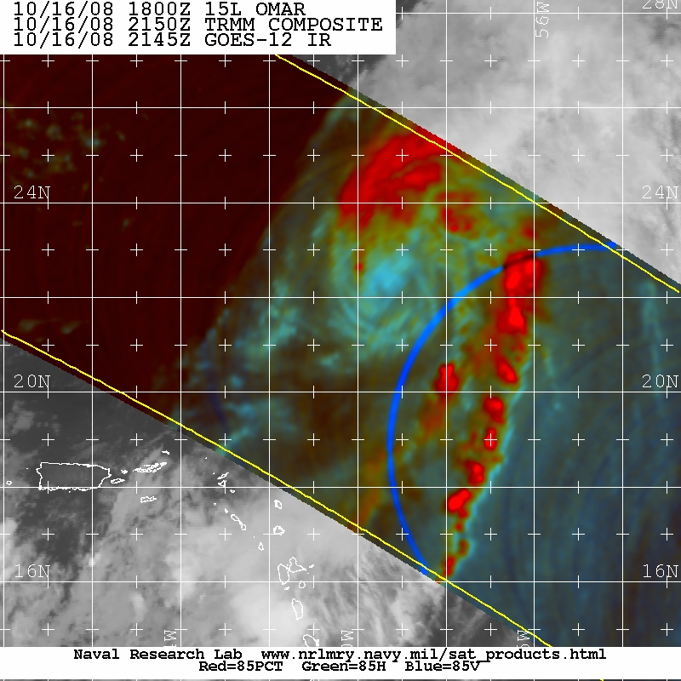
Figure 4. Microwave imagery depicting the rapid evolution of Omar’s convective structure during a 40 h period: (from top left to bottom right) 0608 UTC on 14 October (intensity 40 kt), 2306 UTC on 14 October (intensity 65 kt), 1149 UTC on 15 October (intensity 75 kt), 0554 UTC on 16 October (intensity 115 kt), 1135 UTC on 16 October (intensity 90 kt), and 2150 UTC on 16 October (intensity 70 kt). Images courtesy NRL Monterey, CA.

A digital record of the complete best track, including wind radii, can be found on line at ftp://ftp.nhc.noaa.gov/atcf. Data for the current year’s storms are located in the btk directory, while previous years’ data are located in the archive directory.

