Tropical Cyclone Report
Tropical Storm Cristina
(EP032008)
27-30 June 2008

Richard J. Pasch
National Hurricane Center
18 February 2009

Cristina was an uneventful tropical cyclone that remained well offshore.

- Synoptic History

The genesis of Cristina can be traced back to a tropical wave that crossed Central America on 21 June and moved over the eastern North Pacific Ocean by 22 June. An area of showers and thunderstorms associated with the wave moved westward within the ITCZ with little change in organization for several days. By 1200 UTC 26 June, several curved bands of deep convection became evident, and the system received its first Dvorak satellite classification at that time. Over the next day or so, the system’s cloud pattern continued to become a little better organized, but NASA QuikSCAT data showed that the surface circulation was not yet sufficiently well-defined to warrant its designation as a tropical cyclone. By 1800 UTC 27 June, however, visible satellite imagery indicated that the low-level circulation had become more distinct, and it is estimated that a tropical depression formed while centered nearly 900 n mi southwest of the southern tip of Baja California. The “best track” chart of the tropical cyclone’s path is given in Fig. 1, with the wind and pressure histories shown in Figs. 2 and 3, respectively. The best track positions and intensities are listed in Table 1.

The depression moved west-northwestward and strengthened into a tropical storm by 1200 UTC 28 June. Mid-level high pressure intensified to the north of Cristina, and the tropical cyclone turned toward the west. Vertical wind shear was not very strong over the area but, since it was situated in a relatively stable air mass and over marginal sea surface temperatures of about 26ºC, Cristina was not able to strengthen much. The storm reached its estimated peak intensity of 45 kt later on 28 June. This intensity was more or less maintained until around 0600 UTC 29 June, by which time the cyclone began to weaken, apparently due to an increasingly stable air mass and greater easterly vertical wind shear. Over the next day or so, Cristina produced some bursts of deep convection but became mostly devoid of banding features while its maximum winds gradually declined. By 1200 UTC 30 June, the system had lost most of its deep convection, and it is estimated that the cyclone weakened to a tropical depression. A little later that day, the depression degenerated into a remnant low pressure area that continued heading westward. On 2 July, the low turned southwestward and south-southwestward, and it dissipated on 3 July about 1700 n mi west-southwest of the southern tip of Baja California.

- Meteorological Statistics

Observations in Cristina (Figs. 2 and 3) include satellite-based Dvorak technique intensity estimates from the Tropical Analysis and Forecast Branch (TAFB) and the Satellite Analysis Branch (SAB). Data and imagery from NOAA polar-orbiting satellites, the NASA Tropical Rainfall Measuring Mission (TRMM), the NASA QuikSCAT, and Defense Meteorological Satellite Program (DMSP) satellites, among others, were also useful in tracking Cristina. The maximum intensity of Cristina is based on Dvorak estimates from TAFB and SAB as well as QuikSCAT data. Cristina’s minimum pressure is estimated to have occurred at 0000 UTC 29 June, at which time the storm appeared to be the best organized on satellite images.

No ship reports of tropical-storm-force winds associated with Cristina have been received.

- Casualty and Damage Statistics

There were no reports of damage or casualties associated with Cristina.

- Forecast and Warning Critique

Cristina’s genesis was not anticipated especially far in advance. The area of disturbed weather that developed into Cristina was not mentioned in the Tropical Weather Outlook (TWO) until 30 h prior to genesis, at which time the formation probability was assigned to the “low” category. Eighteen hours prior to genesis, it was acknowledged in the TWO that the system could develop into a tropical depression, and the formation probability was boosted into the “medium” range. Six hours later, 12 h before genesis, the probability was set to the “high” range.

A verification of official and guidance model track forecasts is given in Table 2. Average official track errors for Cristina were 19, 36, 51, and 63 n mi for the 12, 24, 36, and 48 h forecasts, respectively. The number of forecasts ranged from 10 at 12 h to 4 at 48 h; there were no forecasts verifying at 72, 96, or 120 h. It can be seen that the mean official track forecast errors for Cristina were lower than the average 5-yr official track errors (Table 2). Some of the numerical guidance had even lower track errors, however it should be noted that the number of verifying cases is quite small.

A verification of official and guidance model intensity forecasts is given in Table 3. Average official intensity errors were 8, 7, 7, and 5 kt for the 12, 24, 36, and 48 h forecasts, respectively. For comparison, the average 5-yr official intensity errors are 6, 10, 14, and 16 kt, respectively. None of the official intensity forecasts called for significant strengthening of this tropical cyclone, which proved to be a correct expectation.

Watches or warnings were neither required nor issued for Cristina.
Table 1. Best track for Tropical Storm Cristina, 27-30 June 2008.

Date/Time  (UTC) | Latitude  (°N) | Longitude  (°W) | Pressure  (mb) | Wind Speed  (kt) | Stage
27 / 1800 | 13.5 | 122.0 | 1007 | 30 | tropical depression
28 / 0000 | 13.9 | 122.7 | 1006 | 30 | "
28 / 0600 | 14.2 | 123.5 | 1006 | 30 | "
28 / 1200 | 14.4 | 124.3 | 1005 | 35 | tropical storm
28 / 1800 | 14.6 | 125.0 | 1000 | 45 | "
29 / 0000 | 14.6 | 125.7 | 999 | 45 | "
29 / 0600 | 14.6 | 126.4 | 1000 | 45 | "
29 / 1200 | 14.5 | 127.1 | 1002 | 40 | "
29 / 1800 | 14.4 | 127.9 | 1002 | 40 | "
30 / 0000 | 14.3 | 128.8 | 1002 | 40 | "
30 / 0600 | 14.3 | 129.7 | 1002 | 40 | "
30 / 1200 | 14.2 | 130.7 | 1005 | 30 | tropical depression
30 / 1800 | 14.1 | 131.7 | 1007 | 30 | low
01 / 0000 | 14.1 | 132.7 | 1008 | 25 | "
01 / 0600 | 14.1 | 133.7 | 1009 | 20 | "
01 / 1200 | 14.1 | 134.5 | 1009 | 20 | "
01 / 1800 | 14.0 | 135.3 | 1009 | 20 | "
02 / 0000 | 13.8 | 136.0 | 1009 | 20 | "
02 / 0600 | 13.5 | 136.5 | 1009 | 20 | "
02 / 1200 | 13.1 | 136.9 | 1009 | 20 | "
02 / 1800 | 12.8 | 137.1 | 1009 | 20 | "
03 / 0000 | 12.5 | 137.2 | 1009 | 20 | "
03 / 0600 |  |  |  |  | dissipated
29 / 0000 | 14.6 | 125.7 | 999 | 45 | minimum pressure

Table 2. Track forecast evaluation (heterogeneous sample) for Tropical Storm Cristina, 27-
30 June 2008. Forecast errors (n mi) are followed by the number of forecasts in parentheses. Errors smaller than the NHC official forecast are shown in boldface type.

Forecast Technique | Forecast Period (h)
Forecast Technique | 12 | 24 | 36 | 48 | 72 | 96 | 120
CLP5 | 32 (10) | 62 ( 8) | 109 ( 6) | 134 ( 4)
GFDI | 22 (10) | 37 ( 8) | 45 ( 6) | 67 ( 4)
HWFI | 38 (10) | 67 ( 8) | 91 ( 6) | 108 ( 4)
GFSI | 25 (10) | 34 ( 8) | 47 ( 6) | 66 ( 4)
AEMI | 29 (10) | 35 ( 8) | 35 ( 6) | 55 ( 4)
NGPI | 42 ( 2) | 72 ( 2) | 101 ( 2) | 139 ( 2)
UKMI | 23 ( 8) | 58 ( 6) | 192 ( 4) | 599 ( 2)
EGRI | 21 ( 8) | 47 ( 6) | 84 ( 4)
EMXI | 10 ( 5) | 24 ( 4) | 29 ( 3) | 11 ( 2)
BAMD | 43 (10) | 81 ( 8) | 122 ( 6) | 162 ( 4)
BAMM | 35 (10) | 68 ( 8) | 102 ( 6) | 149 ( 4)
BAMS | 46 (10) | 91 ( 8) | 147 ( 6) | 209 ( 4)
LBAR | 33 (10) | 85 ( 8) | 160 ( 6) | 218 ( 4)
TVCN | 22 (10) | 31 ( 8) | 35 ( 6) | 39 ( 4)
FSSE | 19 ( 7) | 36 ( 5) | 72 ( 3) | 221 ( 1)
OFCL | 19 (10) | 36 ( 8) | 51 ( 6) | 63 ( 4)
NHC Official  (2003-2007 mean) | 31.9 (1282) | 55.1 (1129) | 77.4 (979) | 97.9 (849) | 136.2 (620) | 180.1 (439) | 226.1 (293)

Table 3. Intensity forecast evaluation (heterogeneous sample) for Tropical Storm Cristina, 27-30 June 2008. Forecast errors (kt) are followed by the number of forecasts in parentheses. Errors smaller than the NHC official forecast are shown in boldface type.

Forecast Technique | Forecast Period (h)
Forecast Technique | 12 | 24 | 36 | 48 | 72 | 96 | 120
OCD5 | 6.9 (10) | 7.9 ( 8) | 8.8 ( 6) | 5.3 ( 4)
GHMI | 7.0 (10) | 7.3 ( 8) | 6.2 ( 6) | 4.5 ( 4)
HWFI | 4.7 (10) | 6.1 ( 8) | 4.5 ( 6) | 5.3 ( 4)
LGEM | 7.7 (10) | 9.3 ( 8) | 9.7 ( 6) | 8.8 ( 4)
DSHP | 6.1 (10) | 4.9 ( 8) | 4.5 ( 6) | 2.0 ( 4)
FSSE | 6.4 ( 7) | 3.2 ( 5) | 5.7 ( 3) | 2.0 ( 1)
ICON | 5.9 (10) | 5.5 ( 8) | 5.5 ( 6) | 5.0 ( 4)
OFCL | 7.5 (10) | 6.9 ( 8) | 6.7 ( 6) | 5.0 ( 4)
NHC Official  (2003-2007 mean) | 6.2 (1282) | 10.4 (1129) | 13.9 (979) | 16.3 (848) | 18.7 (620) | 19.2 (439) | 19.1 (293)

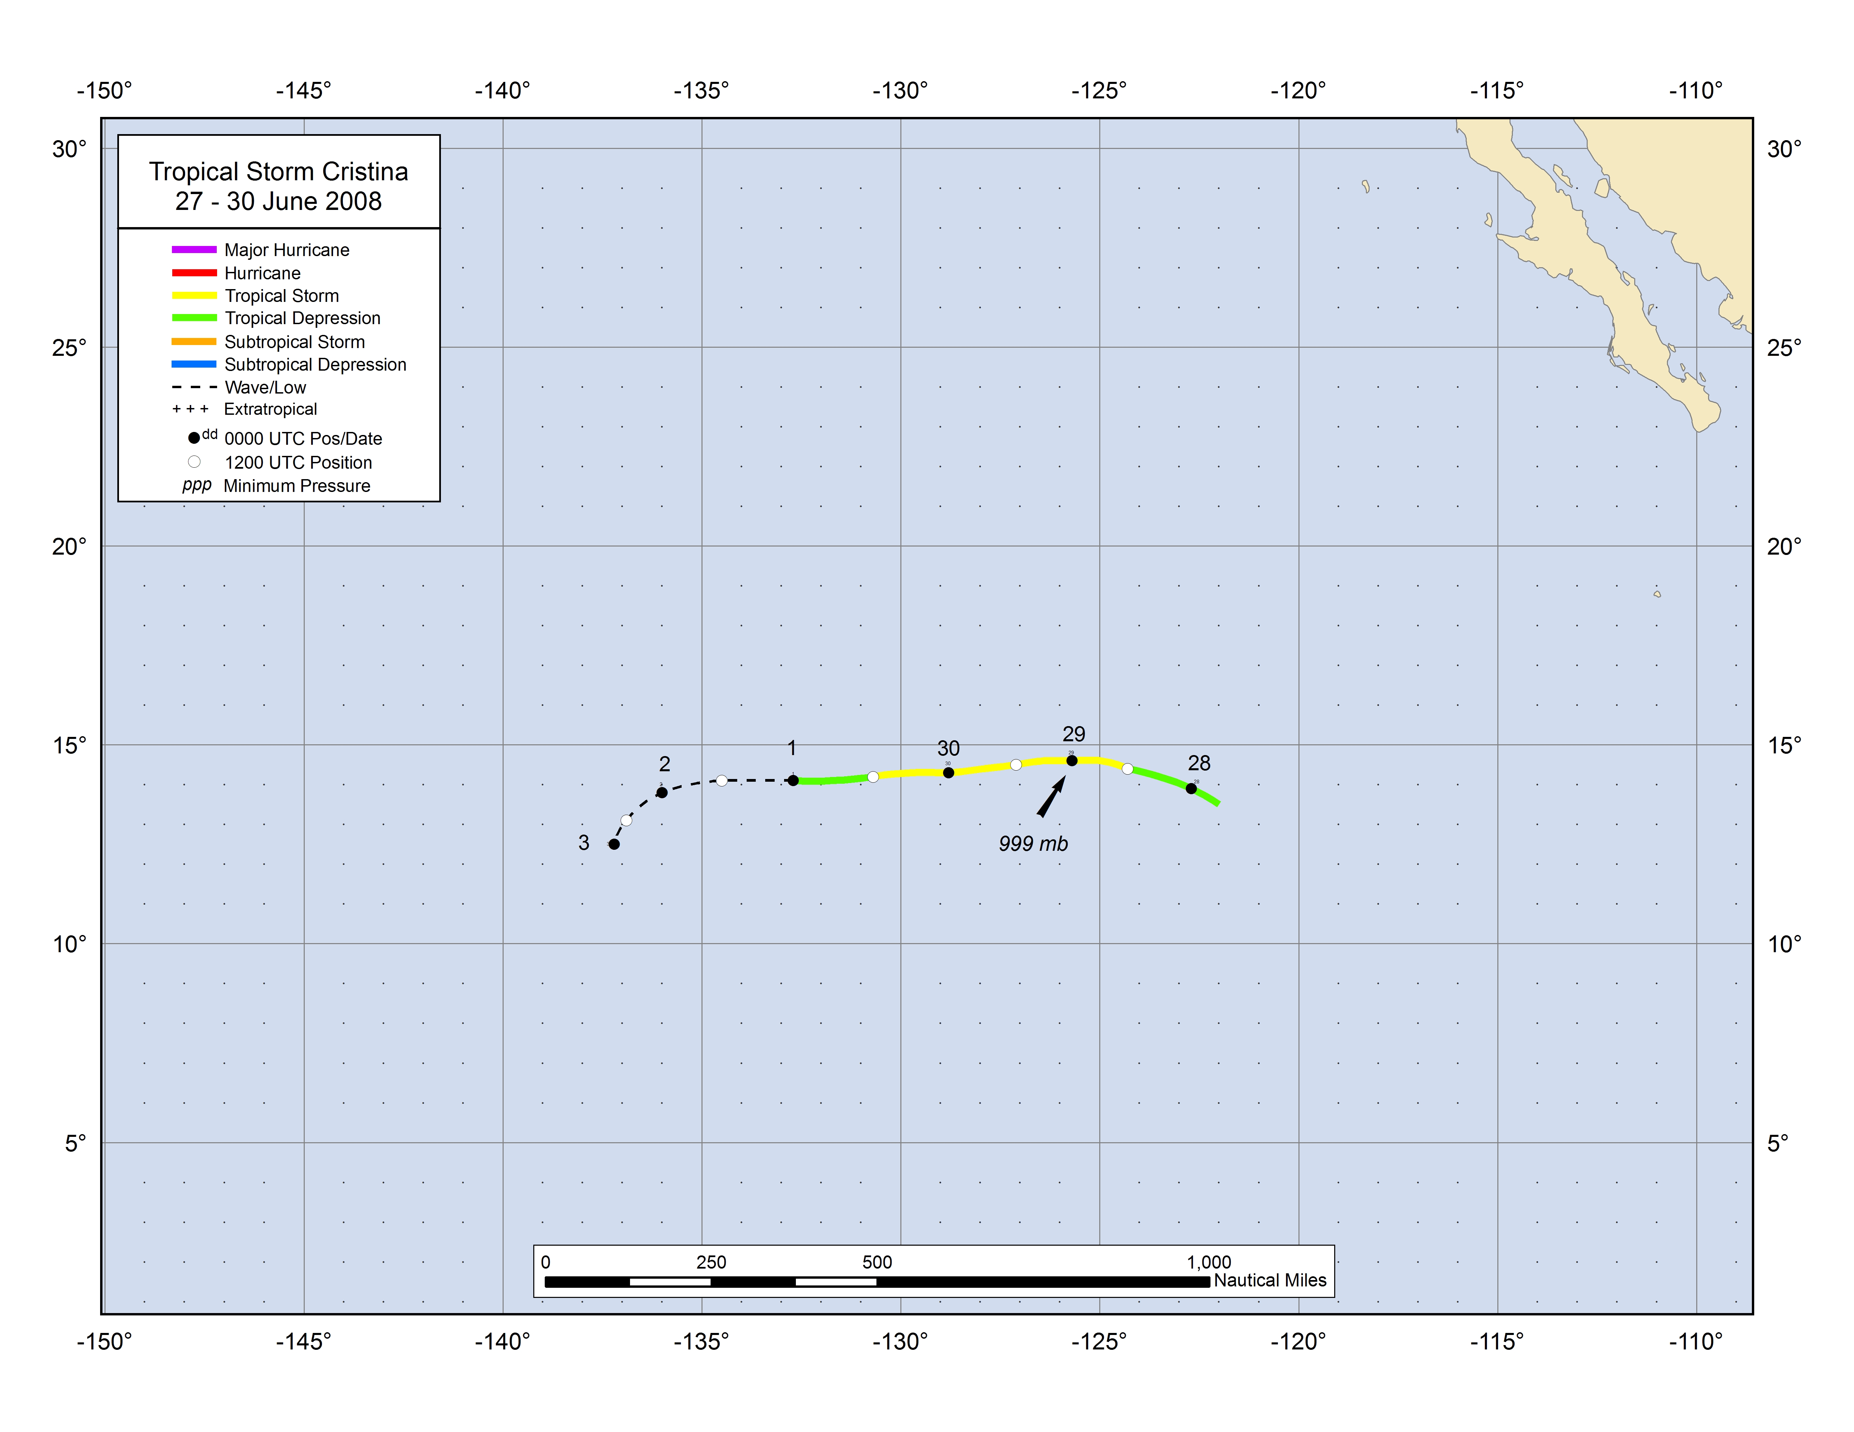
Figure 1. Best track positions for Tropical Storm Cristina, 27-30 June 2008.
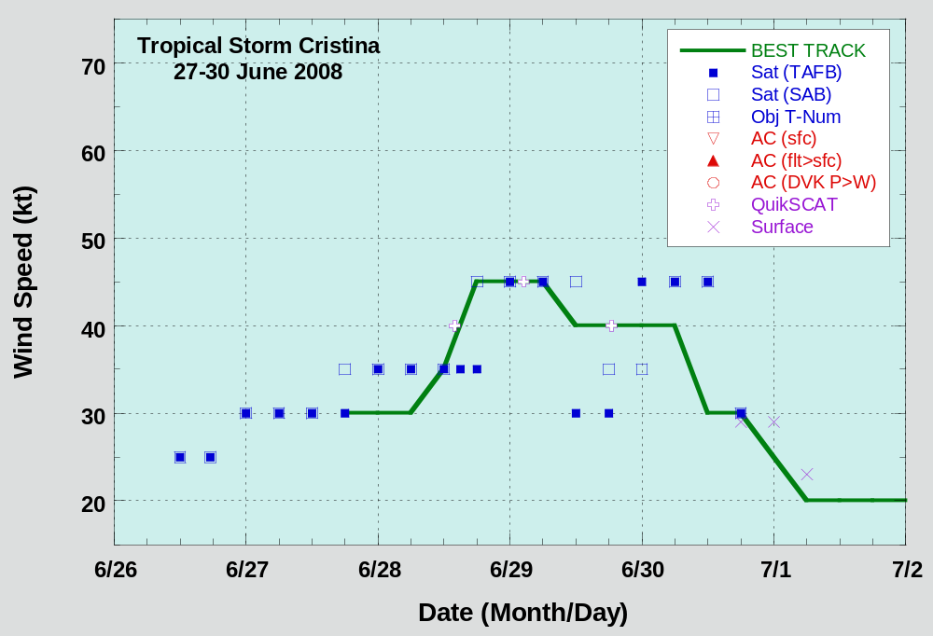
Figure 2. Selected wind observations and best track maximum sustained surface wind speed curve for Tropical Storm Cristina, 27-30 June 2008. Dashed vertical lines correspond to 0000 UTC.

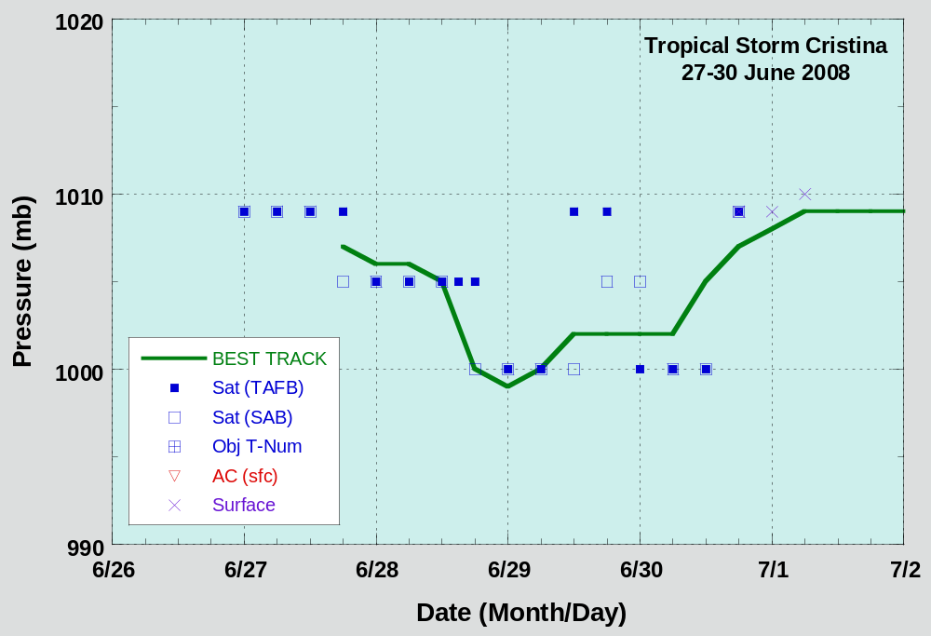
Figure 3. Selected pressure observations and best track minimum central pressure curve for Tropical Storm Cristina, 27-30 June 2008. Dashed vertical lines correspond to 0000 UTC.

A digital record of the complete best track, including wind radii, can be found on line at ftp://ftp.nhc.noaa.gov/atcf. Data for the current year’s storms are located in the btk directory, while previous years’ data are located in the archive directory.

