USDA Foreign Agricultural Service
GAIN Report

Template Version 2.09

Global Agriculture Information Network

Required Report - public distribution
Date: 9/23/2005
GAIN Report Number: AS5027
AS5027
Australia
Livestock and Products
Annual
2005

Approved by:
Kathleen Wainio, Agricultural Counselor
U.S. Embassy
Prepared by:
Mike Darby, Agricultural Specialist

Report Highlights:
Exports of Australian beef are forecast to reach an historically high level in 2005 on the strength of Japanese and Korean demand. Australian feedlot capacity has surpassed one million head. Current record beef and cattle prices are dependent on four major markets (domestic, Japan, Korea and the U.S.), which account for 95 percent of Australian production.

Includes PSD Changes: Yes
Includes Trade Matrix: Yes
Annual Report
Canberra [AS1]
[AS]
Table of Contents
SECTION ONE: SITUATION AND OUTLOOK 3
SECTION TWO: STATISTICAL TABLES 4
SECTION THREE: NARRATIVE ON SUPPLY AND DEMAND, POLICY & MARKETING 13
CATTLE 13
Inventory 13
Cattle on Feed 13
Live Exports 14
Slaughter 14
Production 15
Consumption 16
Trade 16
Exports 16
Impact of Resumption of U.S. Trade to Japan and Korea 16
Prices 17
Policy 17
SWINE 19
Inventory 19
Slaughter 19
Production 20
Trade 20
Imports 20
Exports 21
Consumption 21
Prices 21
Policy 22

SECTION ONE: SITUATION AND OUTLOOK

Australian livestock industries have experienced relatively extreme conditions over the past three years. Severe drought conditions have sharply reduced feed grain and fodder supplies and created downward pressure on inventories. The drought, which began in CY 2002 and ended midway through CY 2005, is regarded by many as the worst in 100 years.

More recently, heavy soaking rains in many of the livestock producing and feed grain growing areas, have seen pasture conditions and fodder reserves improve greatly. This circumstance is likely to see average cattle slaughter fall for CY 2005 and CY 2006 and inventories rise. Production of beef is expected to rise in CY 2005 however, as slaughter weights improve with seasonal conditions. Production is expected to fall slightly in CY 2006 as producers continue to withhold cattle from slaughter for breeding purposes.

Exports of Australian beef are forecast to remain at historically high level for CY 2005 and CY 2006 as export demand maintains its strength. The absence of US beef from the Japanese market has resulted in record exports and the Australian feedlot industry has reacted by increasing capacity, with record numbers on feed.

The strength of the Australian dollar continues to constrain performance for export dependant industries such as pig meat. A higher dollar has reduced export returns and increased consumer buying power in relation to imports. Pork imports are forecast at record levels for CY 2005 and CY 2006. Exports are forecast to increase modestly.

A Federal Court ruling in the first half of CY 2005 created uncertainty for future pork imports. This ruling was recently overturned under appeal, however the intermittent period saw high levels of pork imports, particularly from the United States, in anticipation of a trade impact. Following the favorable ruling, post expects monthly import levels to revert those experienced prior to the court ruling with imports poised to resume the long-term growth trend established over the past decade.

SECTION TWO: STATISTICAL TABLES

PSD Table
Animal Numbers, Cattle
 | 2004 | Revised | 2005 | Estimate | 2006 | Forecast | UOM
 | USDA Official [Old] | Post Estimate [New] | USDA Official [Old] | Post Estimate [New] | USDA Official [Old] | Post Estimate [New]
Market Year Begin |  | 01/2004 |  | 01/2005 |  | 01/2006 | MM/YYYY
Total Cattle Beg. Stks | 26640 | 26640 | 26747 | 27100 | 27100 | 27600 | (1000 HEAD)
Dairy Cows Beg. Stks | 2028 | 2028 | 2041 | 2041 | 0 | 2050 | (1000 HEAD)
Beef Cows Beg. Stocks | 12300 | 12300 | 12500 | 12500 | 0 | 12900 | (1000 HEAD)
Production (Calf Crop) | 9547 | 9988 | 9983 | 9880 | 0 | 10860 | (1000 HEAD)
Intra EC Imports | 0 | 0 | 0 | 0 | 0 | 0 | (1000 HEAD)
Total Imports | 0 | 0 | 0 | 0 | 0 | 0 | (1000 HEAD)
TOTAL Imports | 0 | 0 | 0 | 0 | 0 | 0 | (1000 HEAD)
TOTAL SUPPLY | 36187 | 36628 | 36730 | 36980 | 27100 | 38460 | (1000 HEAD)
Intra EC Exports | 0 | 0 | 0 | 0 | 0 | 0 | (1000 HEAD)
Total Exports | 637 | 638 | 580 | 580 | 0 | 560 | (1000 HEAD)
TOTAL Exports | 637 | 638 | 580 | 580 | 0 | 560 | (1000 HEAD)
Cow Slaughter | 3781 | 3781 | 3700 | 3700 | 0 | 3700 | (1000 HEAD)
Calf Slaughter | 960 | 929 | 985 | 790 | 0 | 750 | (1000 HEAD)
Other Slaughter | 4012 | 4130 | 4315 | 4260 | 0 | 4100 | (1000 HEAD)
Total Slaughter | 8753 | 8840 | 9000 | 8750 | 0 | 8550 | (1000 HEAD)
Loss | 50 | 50 | 50 | 50 | 0 | 50 | (1000 HEAD)
Ending Inventories | 26747 | 27100 | 27100 | 27600 | 0 | 29300 | (1000 HEAD)
TOTAL DISTRIBUTION | 36187 | 36628 | 36730 | 36980 | 0 | 38460 | (1000 HEAD)
Calendar Yr. Imp. from U.S. | 0 | 0 | 0 | 0 | 0 | 0 | (1000 HEAD)
Calendar Yr. Exp. to U.S. | 0 | 0 | 0 | 0 | 0 | 0 | (1000 HEAD)

Import Trade Matrix
Animal Numbers, Cattle
Time Period | Cal Yr | Units: | Number
Imports for: | 2003 |  | 2004
U.S. | 23 | U.S. | 0
Others |  | Others
Total for Others | 0 |  | 0
Others not Listed | 0 |  | 0
Grand Total | 23 |  | 0

Export Trade Matrix
Animal Numbers, Cattle
Time Period | Cal Yr | Units: | Number
Exports for: | 2003 |  | 2004
U.S. | 0 | U.S. | 0
Others |  | Others
Indonesia | 387160 | Indonesia | 359560
Philippines | 96016 | China | 73911
Malaysia | 87955 | Malaysia | 47541
China | 44138 | Philippines | 46918
Israel | 43213 | Jordan | 34154
Jordan | 23065 | Israel | 20947
Japan | 22034 | Japan | 18098
Brunei | 19796 | Brunei | 17927
Saudi Arabia | 15969 | Mexico | 5633
Egypt | 7583 | Kuwait | 4668
Total for Others | 746929 |  | 629357
Others not Listed | 27319 |  | 8391
Grand Total | 774248 |  | 637748

PSD Table
Meat, Beef and Veal
 | 2004 | Revised | 2005 | Estimate | 2006 | Forecast | UOM
 | USDA Official [Old] | Post Estimate [New] | USDA Official [Old] | Post Estimate [New] | USDA Official [Old] | Post Estimate [New]
Market Year Begin |  | 01/2004 |  | 01/2005 |  | 01/2006 | MM/YYYY
Slaughter (Reference) | 8753 | 8853 | 9000 | 8750 | 0 | 8550 | (1000 HEAD)
Beginning Stocks | 100 | 100 | 60 | 76 | 43 | 44 | (1000 MT CWE)
Production | 2100 | 2114 | 2170 | 2181 | 0 | 2131 | (1000 MT CWE)
Intra EC Imports | 0 | 0 | 0 | 0 | 0 | 0 | (1000 MT CWE)
Total Imports | 10 | 6 | 7 | 7 | 0 | 7 | (1000 MT CWE)
TOTAL Imports | 10 | 6 | 7 | 7 | 0 | 7 | (1000 MT CWE)
TOTAL SUPPLY | 2210 | 2220 | 2237 | 2264 | 43 | 2182 | (1000 MT CWE)
Intra EC Exports | 0 | 0 | 0 | 0 | 0 | 0 | (1000 MT CWE)
Total Exports | 1395 | 1389 | 1400 | 1470 | 0 | 1390 | (1000 MT CWE)
TOTAL Exports | 1395 | 1389 | 1400 | 1470 | 0 | 1390 | (1000 MT CWE)
Human Dom. Consumption | 755 | 755 | 794 | 750 | 0 | 760 | (1000 MT CWE)
Other Use, Losses | 0 | 0 | 0 | 0 | 0 | 0 | (1000 MT CWE)
TOTAL Dom. Consumption | 755 | 755 | 794 | 750 | 0 | 760 | (1000 MT CWE)
Ending Stocks | 60 | 76 | 43 | 44 | 0 | 32 | (1000 MT CWE)
TOTAL DISTRIBUTION | 2210 | 2220 | 2237 | 2264 | 0 | 2182 | (1000 MT CWE)
Calendar Yr. Imp. from U.S. | 0 | 0 | 0 | 0 | 0 | 0 | (1000 MT CWE)
Calendar Yr. Exp. to U.S. | 528 | 528 | 537 | 537 | 0 | 0 | (1000 MT CWE)

Import Trade Matrix
Meat, Beef and Veal
Time Period | Cal Yr | Units: | MT
Imports for: | 2003 |  | 2004
U.S. | 466 | U.S. | 375
Others |  | Others
New Zealand | 3599 | New Zealand | 5459
Lebanon | 112 | Brazil | 245
Brazil | 69 | Italy | 71
Croatia | 39 | Croatia | 41
Fiji | 38 | Fiji | 25
Italy | 19 | Lebanon | 19
Jordan | 18 | Vanuatu | 13
Philippines | 7 | Lithuania | 8
Taiwan | 6 | Jordan | 7
Thailand | 3 | Taiwan | 2
Total for Others | 3910 |  | 5890
Others not Listed | 0 |  | 34
Grand Total | 4376 |  | 6299

Export Trade Matrix
Meat, Beef and Veal
Time Period | Cal Yr | Units: | MT
Exports for: | 2003 |  | 2004
U.S. | 375187 | U.S. | 357058
Others |  | Others
Japan | 288860 | Japan | 416690
Korea South | 67640 | Korea South | 104707
Taiwan | 31659 | Taiwan | 27137
Canada | 30100 | Indonesia | 8506
Indonesia | 16960 | Canada | 7839
Philippines | 10285 | Malaysia | 7374
Malaysia | 9696 | New Zealand | 6070
New Zealand | 7167 | Philippines | 5938
Mexico | 5109 | United Kingdom | 4981
United Kingdom | 4409 | Papua New Guinea | 2980
Total for Others | 471885 |  | 592222
Others not Listed | 39450 |  | 28636
Grand Total | 886522 |  | 977916

PSD Table
Animal Numbers, Swine
 | 2004 | Revised | 2005 | Estimate | 2006 | Forecast | UOM
 | USDA Official [Old] | Post Estimate [New] | USDA Official [Old] | Post Estimate [New] | USDA Official [Old] | Post Estimate [New]
Market Year Begin |  | 01/2004 |  | 01/2005 |  | 01/2006 | MM/YYYY
TOTAL Beginning Stocks | 2658 | 2658 | 2533 | 2556 | 2600 | 2600 | (1000 HEAD)
Sow Beginning Stocks | 340 | 340 | 345 | 335 | 0 | 340 | (1000 HEAD)
Production (Pig Crop) | 5327 | 5327 | 5369 | 5310 | 0 | 5351 | (1000 HEAD)
Intra EC Imports | 0 | 0 | 0 | 0 | 0 | 0 | (1000 HEAD)
Total Imports | 0 | 0 | 0 | 0 | 0 | 0 | (1000 HEAD)
TOTAL Imports | 0 | 0 | 0 | 0 | 0 | 0 | (1000 HEAD)
TOTAL SUPPLY | 7985 | 7985 | 7902 | 7866 | 2600 | 7951 | (1000 HEAD)
Intra EC Exports | 0 | 0 | 0 | 0 | 0 | 0 | (1000 HEAD)
Total Exports | 1 | 1 | 2 | 1 | 0 | 1 | (1000 HEAD)
TOTAL Exports | 1 | 1 | 2 | 1 | 0 | 1 | (1000 HEAD)
Sow Slaughter | 0 | 0 | 0 | 0 | 0 | 0 | (1000 HEAD)
OTHER SLAUGHTER | 5451 | 5428 | 5300 | 5265 | 0 | 5350 | (1000 HEAD)
Total Slaughter | 5451 | 5428 | 5300 | 5265 | 0 | 5350 | (1000 HEAD)
Loss | 0 | 0 | 0 | 0 | 0 | 0 | (1000 HEAD)
Ending Inventories | 2533 | 2556 | 2600 | 2600 | 0 | 2600 | (1000 HEAD)
TOTAL DISTRIBUTION | 7985 | 7985 | 7902 | 7866 | 0 | 7951 | (1000 HEAD)
Calendar Yr. Imp. from U.S. | 0 | 0 | 0 | 0 | 0 | 0 | (1000 HEAD)
Calendar Yr. Exp. to U.S. | 0 | 0 | 0 | 0 | 0 | 0 | (1000 HEAD)

Export Trade Matrix
Animal Numbers, Swine
Time Period | Cal Yr | Units: | Number
Exports for: | 2003 |  | 2004
U.S. | 1350 | U.S. | 0
Others |  | Others
Malaysia | 220 | Philippines | 1132
Saudi Arabia | 124 | Japan | 23
Vietnam | 44 | Solomon Islands | 18
Indonesia | 33
Total for Others | 421 |  | 1173
Others not Listed | 0 |  | 0
Grand Total | 1771 |  | 1173

PSD Table
Meat, Swine
 | 2004 | Revised | 2005 | Estimate | 2006 | Forecast | UOM
 | USDA Official [Old] | Post Estimate [New] | USDA Official [Old] | Post Estimate [New] | USDA Official [Old] | Post Estimate [New]
Market Year Begin |  | 01/2004 |  | 01/2005 |  | 01/2006 | MM/YYYY
Slaughter (Reference) | 5451 | 5450 | 5300 | 5300 | 0 | 5350 | (1000 HEAD)
Beginning Stocks | 12 | 12 | 10 | 10 | 5 | 10 | (1000 MT CWE)
Production | 399 | 394 | 385 | 385 | 0 | 395 | (1000 MT CWE)
Intra EC Imports | 0 | 0 | 0 | 0 | 0 | 0 | (1000 MT CWE)
Total Imports | 77 | 76 | 80 | 90 | 0 | 95 | (1000 MT CWE)
TOTAL Imports | 77 | 76 | 80 | 90 | 0 | 95 | (1000 MT CWE)
TOTAL SUPPLY | 488 | 482 | 475 | 485 | 5 | 500 | (1000 MT CWE)
Intra EC Exports | 0 | 0 | 0 | 0 | 0 | 0 | (1000 MT CWE)
Total Exports | 59 | 58 | 65 | 55 | 0 | 58 | (1000 MT CWE)
TOTAL Exports | 59 | 58 | 65 | 55 | 0 | 58 | (1000 MT CWE)
Human Dom. Consumption | 419 | 414 | 405 | 420 | 0 | 430 | (1000 MT CWE)
Other Use, Losses | 0 | 0 | 0 | 0 | 0 | 0 | (1000 MT CWE)
TOTAL Dom. Consumption | 419 | 414 | 405 | 420 | 0 | 430 | (1000 MT CWE)
Ending Stocks | 10 | 10 | 5 | 10 | 0 | 12 | (1000 MT CWE)
TOTAL DISTRIBUTION | 488 | 482 | 475 | 485 | 0 | 500 | (1000 MT CWE)
Calendar Yr. Imp. from U.S. | 1 | 0 | 10 | 40 | 0 | 40 | (1000 MT CWE)
Calendar Yr. Exp. to U.S. | 0 | 0 | 0 | 0 | 0 | 0 | (1000 MT CWE)

Import Trade Matrix
Meat, Swine
Time Period | Cal Yr | Units: | MT
Imports for: | 2003 |  | 2004
U.S. | 0 | U.S. | 377
Others |  | Others
Canada | 32399 | Canada | 33918
Denmark | 20394 | Denmark | 26685
 |  | New Zealand | 36
Total for Others | 52793 |  | 60639
Others not Listed | 0 |  | 0
Grand Total | 52793 |  | 61016

Export Trade Matrix
Meat, Swine
Time Period | Cal Yr | Units: | MT
Exports for: | 2003 |  | 2004
U.S. | 33 | U.S. | 28
Others |  | Others
Singapore | 26874 | Singapore | 21448
Japan | 12537 | Japan | 8601
New Zealand | 9250 | New Zealand | 7694
Philippines | 2826 | Philippines | 2284
Taiwan | 1630 | Korea South | 1608
Korea South | 1402 | Hong Kong | 1341
Hong Kong | 917 | Taiwan | 850
South Africa | 543 | Papua New Guinea | 386
China | 315 | Malaysia | 350
Germany | 252 | South Africa | 316
Total for Others | 56546 |  | 44878
Others not Listed | 1454 |  | 1170
Grand Total | 58033 |  | 46076

SECTION THREE: NARRATIVE ON SUPPLY AND DEMAND, POLICY & MARKETING

CATTLE

Inventory

Australia’s cattle inventory is forecast to rise by nearly two percent to 29.3 million head by the end of CY 2006. This increase is largely in line with Meat and Livestock Australia (MLA) and Australian Bureau of Agriculture and Resource Economics (ABARE) forecasts, which have inventories increasing but slightly lower. High prices and improved seasonal conditions are the main reasons for the forecast increase in cattle inventories. A return to more normal weather conditions has seen pasture conditions and fodder reserves greatly improve following three years of drought.

Post has revised the closing inventory for CY 2005 upwards slightly to 27.6 million head. The mitigation of drought conditions in mid-2005 and record cattle prices have greatly increased confidence in this sector. Lower slaughter numbers and improved breeding conditions have facilitated higher cattle inventories.

Closing inventory for CY 2004 has been revised downwards slightly to 27.1 million head, largely in-line with MLA’s inventory figure.

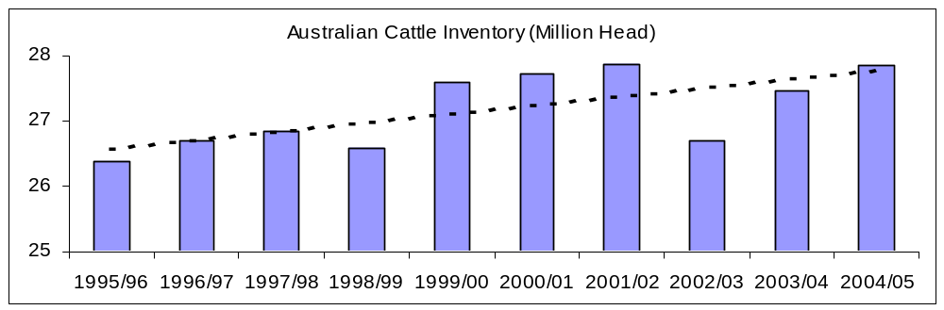
Source: ABARE Data (July-June)

Cattle on Feed

The number of Australian cattle on feed has risen significantly in recent times, driven by increased demand for Australian feeder cattle in Japan following the exclusion of U.S. beef from this market.

Industry sources recently reported that the number of cattle on feed in the March 2005 quarter reached a record 856,025 head, up nearly 14 percent on the previous quarter and over 11 percent on the previous record set in the September quarter of 2004. Australian feedlot capacity also reached record levels at 994,692 head. Finally, the number of cattle on feed destined for the Japanese export market reached a record 519,491 head.

According to media reports, Australian feedlot capacity has now surpassed one million head. Post anticipates numbers of cattle on feed to remain at record or near-record levels for the remainder of CY 2005 and into CY 2006.

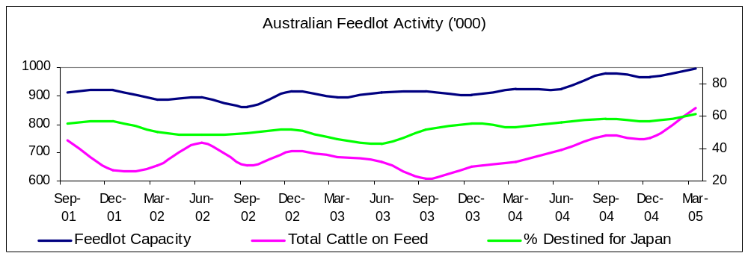Source: Australian Lot Feeders Association/ Meat and Livestock Australia survey (Quarterly)

Live Exports

Live exports for CY 2006 are forecast at 560,000 head, down from the previous year. This figure represents a historically low level according to ABARE data. A strong Australian dollar, strong competition from processors and a lack of cattle suitable for live export have seen live export levels decline in previous years.

Post estimates live exports for CY 2005 at 580,000 head in line with MLA figures, unchanged from previous report. Live exports for CY 2004 have been revised upwards only slightly 638,000 head in line with revised Australian Bureau of Statistics (ABS) figures.

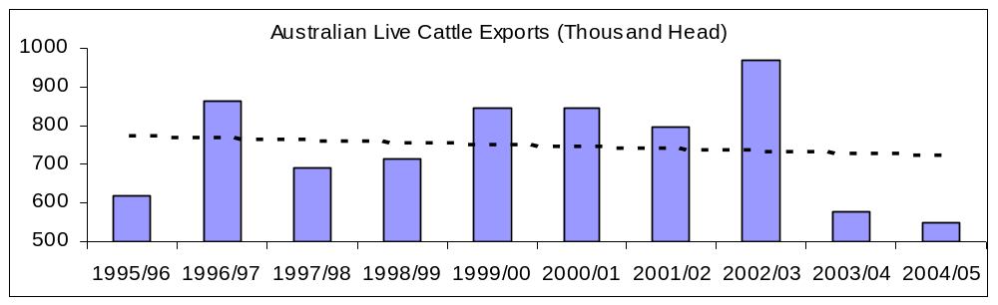
Source: ABARE Data (July-June year)

Slaughter

Total slaughter for CY 2006 is forecast at 8.55 million head, down over two percent from the revised estimate for the previous year. MLA have also forecast a decline. Post anticipates cattle to be held back from slaughter as producers rebuild herd numbers following three years of drought conditions.

Post estimates slaughter at 8.75 million head for CY 2005, down one percent on the revised figure for the previous year. Year-to-date ABS figures show a 0.5 percent decline for the first half of CY 2005 and industry data show slaughter declining over the past nine consecutive months. Post anticipates slaughter to continue to fall for the remainder of CY 2005 bringing the total slaughter number down by approximately one percent. This continual fall in slaughter numbers is due to greatly improved seasonal conditions.

Total slaughter for CY 2004 has been revised upwards to 8.84 million head in line with revised ABS figures. This upwards revision of this slaughter figure is representative of the severity of the drought experienced in key livestock producing regions of Australia.

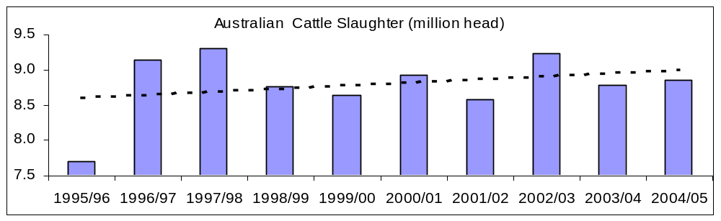
Source: ABARE Data (July-June year)

Production

Total production of beef and veal in CY 2006 is forecast at 2,131 thousand metric tones (TMT) in carcass weight equivalent (CWE), down over two percent on the revised estimate for the previous year. This fall is almost directly in line with the forecast fall in cattle slaughter for CY 2006, assuming a slightly lower average carcass weight. The forecast fall in production in CY 2006 is reliant upon the continued return to more normal weather conditions experienced from mid 2005 onwards. A return to drought conditions would likely see higher than forecast slaughter and production.

Production of beef and veal for CY 2005 is estimated at 2,181 TMT (CWE), slightly higher than the figure in Post’s previous report. If achieved, this figure would represent an increase of three percent on the revised figure for the previous year. This level of is largely in line with ABS year-to-date data. Post has taken into consideration a slight decrease in slaughter levels expected in the second half of CY 2005. Post has also taken into consideration significantly higher slaughter weights due to greatly improved pasture conditions.

Total beef production in CY 2004 has been revised downwards slightly to 2,114 TMT in line with revised ABS figures.

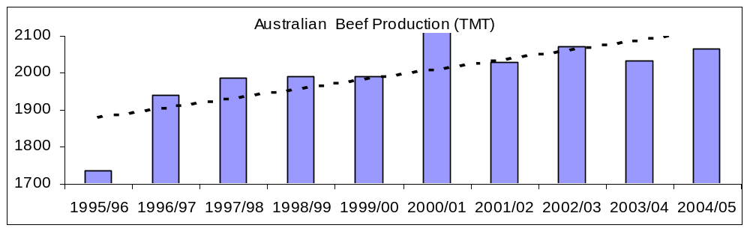
Source: ABARE Data (July-June year)

Consumption

Total beef and veal consumption for CY 2006 is forecast at 760 TMT, up slightly on the revised estimate of 750 TMT for the previous year. Slightly weaker export demand is expected to see domestic consumption move upwards slightly.

Trade

Exports

Total beef and veal exports in CY 2006 are forecast at 1,390 TMT (CWE), down five percent on the revised estimate for the previous year. The forecast fall in slaughter and production due to improved seasonal conditions is likely to reduce the available surplus of beef suitable for export. Furthermore, the anticipated re-entry of U.S. beef into Japan and Korea is also likely to reduce export demand in those markets. These factors combined with stronger domestic consumption are likely to see exports fall in CY 2006.

Exports of beef and veal for CY 2005 are estimated at 1,470 TMT (CWE), up significantly on the 1,380 TMT in Post’s previous report. Official ABS year-to-date figures show exports up by 12 percent (January – July) however Post sees this slowing in the second half of CY 2005 (as turnoff falls) to give an overall increase of five percent. Dry conditions in the first half of CY 2005 increased the availability of beef suitable for export to Japanese markets, however the second half of CY 2005 has produced excellent seasonal condition and turnoff and slaughter is expected to fall sharply.

Exports of beef and veal for CY 2004 stand at 1,389 TMT (CWE), in line with official ABS figures and up slightly on Post’s previous report.

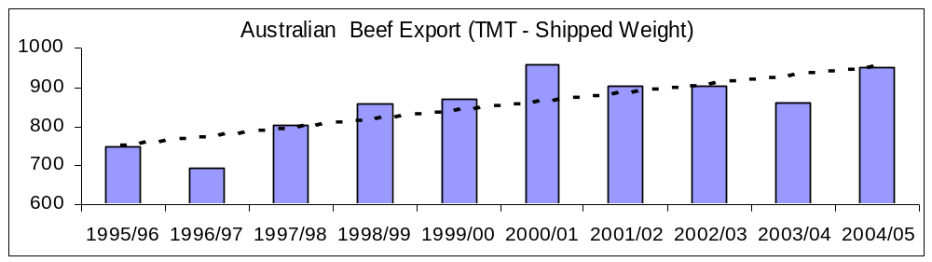
Source: ABARE Data (July-June year, Shipped Weight)

Impact of Resumption of U.S. Trade to Japan and Korea

Australian beef exporters are wary of the possibility of a significant reduction in demand and price for beef in 2006, with expectations of resumption in trade of U.S. and Canadian beef to North Asian markets. The industry now anticipates a larger price impact than previously forecast in part because the U.S.-Japanese beef import protocol will likely include U.S. beef from USDA A40 grade cattle. The industry is also watching the Korean market to see if cattle less than 30 months of age (per OIE guidelines) will be accepted, rather than beef from cattle less than 21 months. Trade sources report both Japan and Korea are reducing stocks in anticipation of the re-entry of North American beef.

According to MLA, the Australian beef and cattle industry is more vulnerable to a major price decline now than at any time in the past 3 decades. Australia’s current record beef and cattle prices are currently dependent on four major markets (domestic, Japan, Korea and the U.S.), which account for 95 percent of Australian production. Any decline in demand in these markets would have a resounding impact on Australian prices.

Australian exports to other markets has fallen over the past couple years, particularly to traditional markets such as South East Asia, Hong Kong and China. Australian trade sources report significant inroads have been made by South American, Chinese and New Zealand beef exporters in a number of markets including Taiwan, Hong Kong, the Philippines, Indonesia and the Middle East. Further, exports to more minor markets are expected to remain low over the next few years.

Australian industry sources report price volatility in the Japanese market resulting from concerns over triggering the safeguard, which caused major distortions in trade during Summer 2005. Industry sources are not ruling out the possibility of triggering the safeguard, especially following the resumption of Japanese imports of North American beef. Even if the safeguard were not triggered, speculation of the possibility affects trade. MLA reports triggering the safeguard is a further possibility in subsequent years following the resumption of trade with North America.

Prices

Live cattle prices are expected to weaken slightly in CY 2006 in line with expected falls in export prices received in both the U.S. and Japan. CY 2005 has seen record or near-record prices received for certain types of live cattle and beef. These high prices have created a high level of confidence in beef industry participants. Post believes that these high prices, combined with a return to normal seasonal conditions following years of drought are responsible for the end of partial herd liquidation in Australia and a return to herd rebuilding experienced prior to the drought.

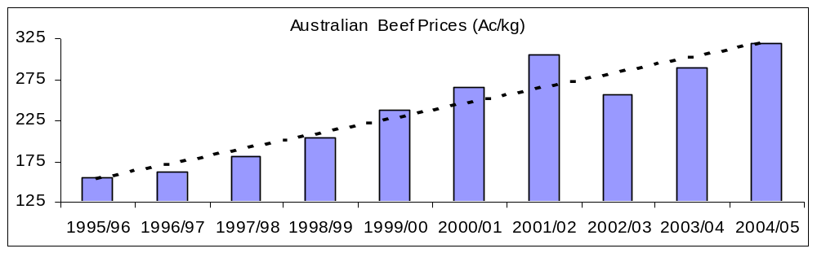
Source: ABARE Data (July-June year)

Policy

Levy increase

The Australian Beef Cattle industry and Federal Government recently agreed to increase the levy (check off) on beef cattle transactions from A$3.50 to A$5.00 per head. This increase, to be introduced on January 1, was supported by a popular majority of beef producers and more recently approved by the Federal Agricultural Minister.

The increase is expected to almost double the availability of funds for promotion from an estimated A$22.1 million to 44.2 million. The Federal government stated, in its reasons for approving the increase, the success of low cost producers such as Brazil and anticipated re-entry of the United States and Canada into global markets would require a boost in marketing efforts. However, according to industry sources, much of the increased funding will likely be spent on promoting beef on the domestic market, which currently accounts for around a third of Australian production.

National Livestock Identification Scheme

Australia has begun rolling out its National Livestock Identification Scheme (NLIS) for cattle, both beef and dairy. As of July 1, 2005, the system became mandatory, with the exception of Queensland and the Northern Territory, which will not achieve full compliance until 2007.

Under NLIS, it is mandatory for “whole of life” Radio Frequency Identification Devices (RFID’s) to be fitted to cattle prior to leaving the property of birth. All livestock movements over the lifetime of the animal are recorded electronically at central points such as livestock auctions, feedlots and slaughter plants. A central database records the movement of cattle using the existing Property Identification Code (PIC) used by the previous “tail tag” system. (Tail tags are due to be phased out over the next year).

NLIS only covers cattle and buffalo. At this point sheep, pigs and goats are not affected by NLIS. These industries are expected to follow suit in one form or another.

NLIS is expected to deliver much improved trace-back capacity to assist with issues such as disease and chemical residue control. Industry anticipates that market access may also be improved. NLIS is also expected to deliver benefits in the areas of carcass performance feedback and on farm health management. Industry proponents also suggest it will be valuable in curbing stock theft.

Australian livestock industries are heavily reliant on export markets, with around 60 percent of Australian beef and sheep meat production exported annually. Consumer expectations, quality assurance, disease and residue management have increased the need for greater accountability within Australian livestock industries.

NLIS was formed under a joint industry/government partnership (SAFEMEAT). However, industry through its producer service organization, Meat and Livestock Australia, now largely manages the database.

Australia-U.S. Free Trade Agreement and Beef

The Australia-U.S. Free Trade Agreement (FTA) went into effect on January 1, 2005. Concerns over the impact the FTA may have on Australian industries and on government policies has been hotly debated.

The United States is currently Australia’s second largest beef export market, with exports subject to a tariff rate quota (TRQ). Under the TRQ, Australia is granted duty-free access for the quota amount, with tariffs applied to any additional quantities. Under the FTA, Australia received an additional quota allocation for manufacturing beef, once U.S. beef exports return to their 2003 (pre-BSE) levels, or three years after implementation of the agreement, whichever occurs first. The U.S. “above-quota” tariff on Australian beef is to be phased out over an 18-year period. The previous U.S. tariff of $US4.4 cents per kilogram on the quota quantity was eliminated upon enactment of the FTA.

Under the FTA, the United States will have immediate duty-free access to Australia for beef and beef products, as well as all other agricultural products. U.S. beef exports to Australia, however, are temporarily banned due to the detection of BSE in the United States.

Australian Government changes rules for allocating US beef quota

The Australian Federal recently changed the rules for the allocation of US Beef quota among Australian beef exports. Under the new arrangements, if Australian calendar year beef exports to the US reach 85 percent of the total quota prior to October 1, the remaining 15 percent of the quota will be allocated to exporters based on their performance over the past two years.

SWINE

Inventory

Inventory for CY 2006 is forecast to close at 2.6 million head, unchanged from the estimate for the previous year. Increasing pressure from imports and the continued strength of the Australian dollar are expected to limit increased inventories, despite improved supplies of grain. Closing inventory for CY 2006 is forecast to remain unchanged at 2.6 million head.

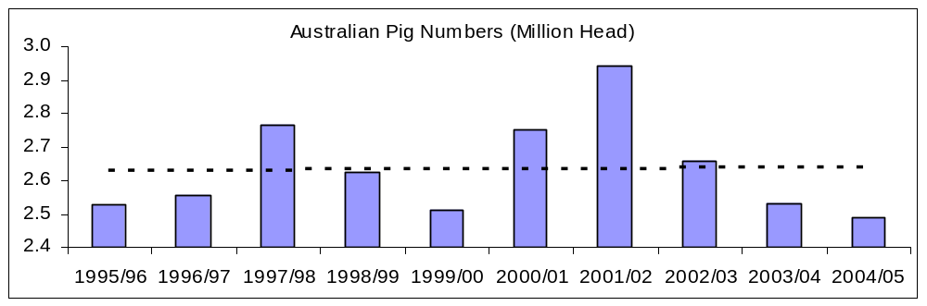

Slaughter

Total slaughter for CY 2006 is forecast at 5.35 million head, up significantly on the 5.27 million head estimated for the previous year. An increase in sow numbers is expected to increase turnoff and slaughter. Post anticipates the pig industry will grow beyond CY 2006 having reconsolidated in CY 2005 and CY 2006.

The slaughter estimate for CY 2005 has been revised downwards slightly to 5.27 million head. ABS year-to-date data shows declining slaughter levels towards the second half of CY 2005 compared with the same period for the previous year. Post anticipates that the slowing slaughter rate will slightly lower slaughter over CY 2005.

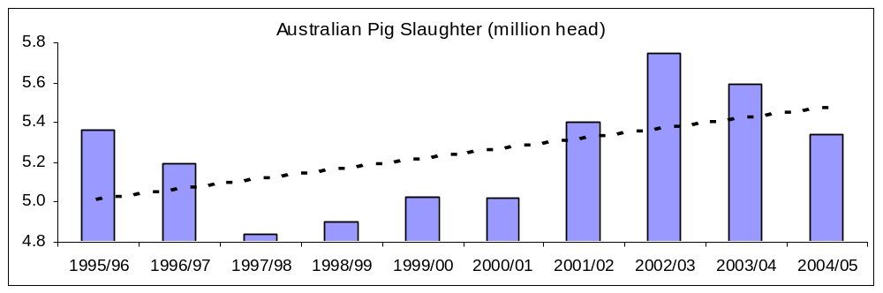
Source: ABARE Data (July-June)

Production

Total pork production is forecast at 395 TMT in CY 2006, up slightly on the 385 TMT estimated for the previous year. Improved availability of grain due to an ending of drought conditions is expected to see pork production increase slightly due to improved slaughter weights, despite falling slaughter levels. The Australian pig industry has established a long-term trend for gradually increasing slaughter weights as feed grain supplies allow.

Production for CY 2005 is estimated at 385 TMT, down slightly on the 394 TMT recorded for the previous year. The estimated decline is in line with ABS year-to-date data showing a two percent decline for the first half of CY 2005.

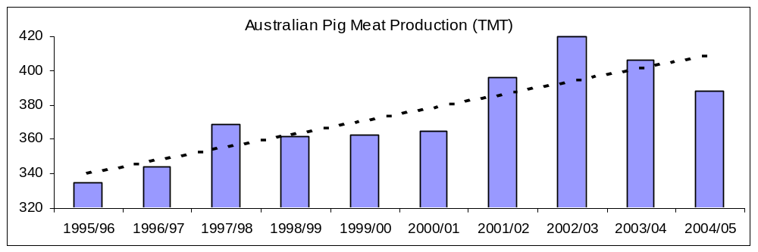

Trade

Imports

Total imports for CY 2006 are forecast at 95 TMT (CWE), up on the 90 TMT estimated for the previous year. If achieved, this would represent an all-time record in Australian pig meat imports. The United States has emerged as a significant supplier of imported pork. Pig meat imports for CY 2005 are estimated at 90 TMT (CWE), up sharply on levels recorded for the previous year.

Pork imports for CY 2004 have been revised downwards slightly to 76 TMT (CWE), in line with revised ABS statistics. This equates roughly to a shipped weight volume of 61 TMT. Post uses a conversion factor of 1.25 to convert shipped weight to Carcass Weight Equivalent (CWE).

Exports

Exports of pig meat for CY 2006 are forecast at 58 TMT (CWE), up on the revised estimate of 55 TMT for the previous year. Slightly higher production levels are likely to see exports increase slightly. Exports for CY 2005 are estimated at 55 TMT, down slightly on the previous year and down sharply on the figure quoted in Post’s previous report. Official ABS year-to-date figures have exports down significantly compared to the same period in the previous year. A stronger Australian dollar has lowered the prospects for pork exports in CY 2005.

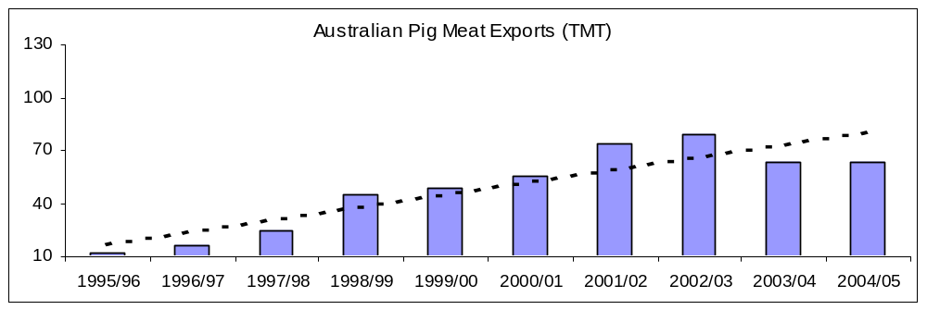

Consumption

Domestic consumption is forecast at 430 TMT for CY 2006, up on the 420 TMT estimated for the previous year. A general trend towards pork and poultry has seen consumption of pork increase steadily over the past decade. Furthermore, the ever-broadening cultural base within Australia has seen dietary intake change over the past decade with the inclusion of more Asian style meals. This trend has aided increased consumption of pig meat domestically.

Prices

The prices received by Australian pig meat producers have generally been considered low in recent times. This combined with high feed grain prices and low feed grain availability during the drought saw diminishing margins in the pig meat industry. ABARE have forecast pig meat prices to remain relatively low for the remainder of CY 2005 and into CY 2006. This is likely to constrain heard expansion to minimal levels.

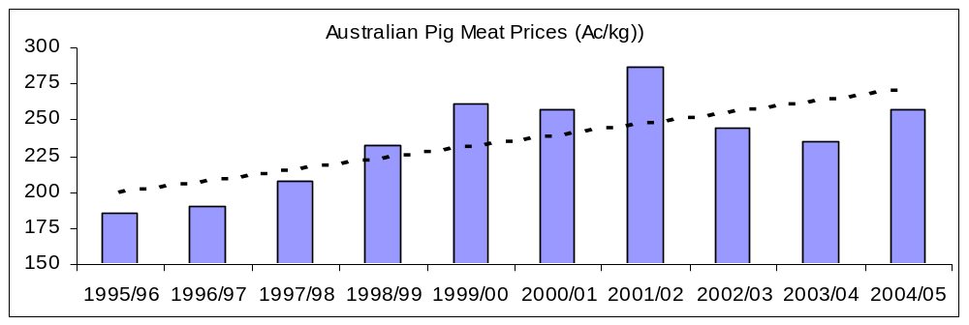

Policy

AUSTRALIAN FEDERAL COURT UPHOLDS PORK APPEAL

On September 16, the Full Bench of the Australian Federal Court upheld the appeal by Australia’s Director of Quarantine against a May 27, 2005 Court judgment affecting the importation of pig meat into Australia. Australian Pork Limited (APL) and Windridge Farms had challenged a policy determination by the Director of Quarantine that set conditions for the importation of pork. The APL action had also challenged the subsequent issuing of one specific import permit based on the policy conditions.

The Court Decision means that pork from third countries may enter Australia under the existing conditions. Further, the current 83 import permits remain valid and new import permits may be granted. The permit that had been suspended is re-validated. Consideration of the additional countries seeking access for pork to Australia (Italy, Sweden and Finland) will continue.

The Full Court Decision is available at the following website: http://www.austlii.edu.au/au/cases/cth/FCAFC/2005/206.html

Suspected Case of Post Weaning Multi-Systemic Wasting Syndrome (PMSW) in Australia: The results remain inconclusive on the suspect case of PMSW in South Australia. Restriction of movement continues from the state and the investigation is continuing.

