PAN and Trace Hydrohalocarbon ExpeRiment (PANTHER)
Elkins & Moore, NOAA/CMDL

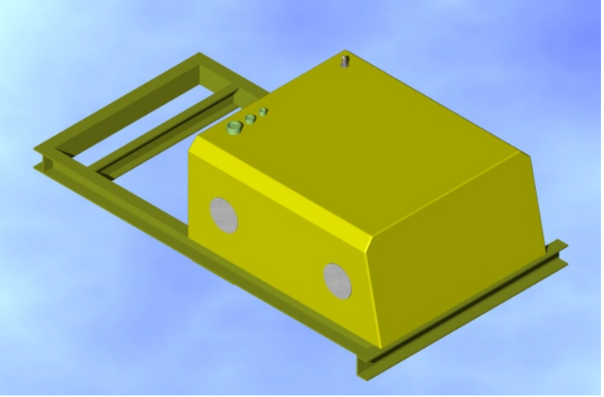

Structural Analysis:
ITEMIZED WEIGHT (< 200 lb)

Mass Spectrometer. lb (kg)
Vacuum Chamber with MSD + Turbo pump 35.8 (16.3)
Pump (diaphragm) 8.3 (3.7)
Electronics 4.2 (1.9)
Total = 48.3 (39.1)
G.C. Module (M.S.)
SSV (Stream Selection Valve) 2.3 (1.0)
Two GSVs (Gas Sample Valve) 4.6 (2.1)
Two Capillary Columns 1.5 (0.7)
Two Traps 2.3 (1.2)
Pressure and Flow Control Module 0.58 (0.26)
Sample Loop (SL) 0.65 (0.29)
SL Pump (diaphragm) 3.7 (1.6)
Total = 15.6 (7.1)
Pan Module (ECD)
GSV 2.3 (1.0)
Capillary Column 0.68 (0.31)
Pressure and Flow Control Module 0.58 (0.26)
ECD (Electron Capture Detector) Oven 1.6 (0.72)
PAN Production Cell plus Power Supply 0.71 (0.32)
Total = 5.9 (2.7)
Packed Column Module (SF₆, N₂O)
GSV 2.3 (1.0)
Packed Column Oven 1.6 (0.72)
Pressure and Flow Control Module 0.58 (0.26)
ECD (Electron Capture Detector) Oven 1.5 (0.68)
Total = 6.0 (2.7)
Packed Column Module (CH₄, CO, H₂) Total = 6.0 (2.7)
Packed Column Module (halon-1211, CFC-11, CFC-12)
(or CFC-11, CFC-113, chloroform, MC, CT) Total = 6.0 (2.7)
GC SSV Total = 2.3 (1.0)
Remaining Electronics.
CPU and Stack 3.3 (1.5)
4 Electrometers 0.15 (0.07)
16 Temp. Controllers 4.1 (1.9)
Set of VICOR Power Converters 1.2 (0.54)
Total = 8.7 (4.0)
Inlet Pump (diaphragm) Total = 16.7 (7.6)
Gas Cylinders etc.
Two Air Calibration (ALT 296 C) 4.8 (2.1)
One PAN Calibration (ALT 296 C) 2.4 (1.1)
One He Carrier (ALT 296 C) 2.4 (1.1)
One N2 Carrier (ALM 350) 5.0 (2.3)
or (ALT 639) at 7.0 (3.2)
3 Al bottles. 1.1 (0.5)
6 Tescom Al Regulators 3.8 (1.7)
2 Tescom SS Regulators 6.2 (2.8)
4 Traps 0.88 (0.4)
Total = 26.6 (12.1)
Estimate for structural and wire. Total ≈ 30 (13.6)

Structural aluminum is hogged out 2024--T3 1/2” plate, 2024-T3 0.025 sheet, 2024-T3 “L” brackets, and 6061-T6 hogged out 1/2” plates. Structural bolts are 1/4-28 (AN4-6A and / or MA20004-12), 10-32 and 8-32 (AN525-). Bolts thread into aircraft plate nuts (MS21069L4, MS21070L3, MS21048L08, MS21052L08, MS21087L08, MS21048L06, MS21069L06, MS21052L06, MS21069L04.) An occasional locking helical insert or locking nut (MS21083N-) is used. Rivets used are primarily MS20470AD and MS20426AD with an occasional Cherry Max blind aircraft rivet (CR3212-4-2, CR3213-4-1) used. Gas bottles are held by two “Voss Ind. Inc.” (T3237H-62-536-SL, T3237H-62-402-SL) stainless steal mounts.
Element. | Max load on Bolt | Safety Factor
Main PANTHER bolt down | Forward 3g on 1/4-28 AN | 28
Mass Spec +Turbo bolt down | Down 4.5g on 10-32 AN | 24
Gas Bottles bolt down | Down 4.5g on 8-32 AN | 140
Center Plate bolts down | Forward 3g on 8-32 AN | >> 4.8

Calculations for tension and sheer on structural bolts follow below logic.

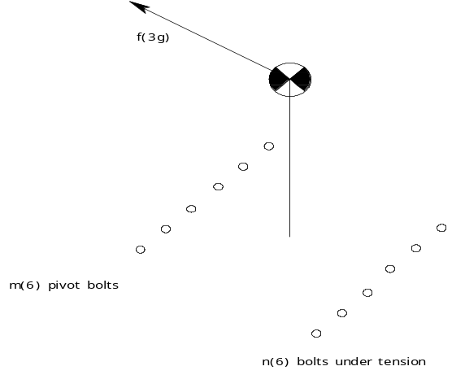

Shear is applied uniformly to all m+n bolts. Where the shear force on a single bolt is
f_{S}= f/(m+n).

Assume that m forward bolts (or edge of material) form a pivot point for a rigid rotor that puts tension on the n back bolts.

Tension, uniformly distributed on n back bolts, is calculated assuming a rigid rotor around pivot bolts (or forward edge) with mechanical advantage estimated using equivalent torque.
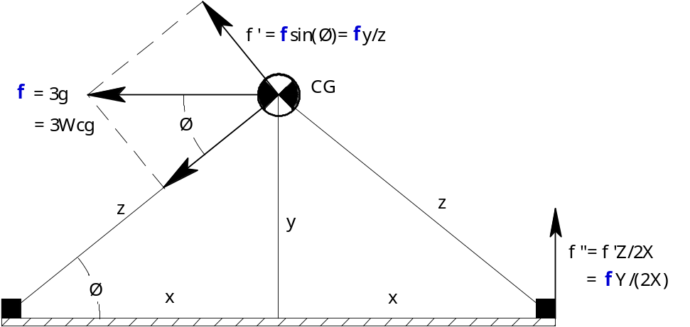

Tension on single bolt f_{T} = f ″/ n = (z/2x) (f ′/n) = (z/2x) (f/n)sin (φ) = f•y/(2•n•x) were f is the applied force of 3•g = 3•W_{cg} applied at the center of gravity.

Max load on bolt (assuming tension and shear simply add) is:

L_{B}= 3•W_{cg} [1/(n+m) + y/(n•2•x)].
Main support of PANTHER

Main support of PANTHER is supplied by 4 1/4-28 AN bolts at the corners. A 5th bolt is available but will not be used in the analysis. All elements of PANTHER are contained within a 2024-T3 aluminum shell secured to the main plate shown below.

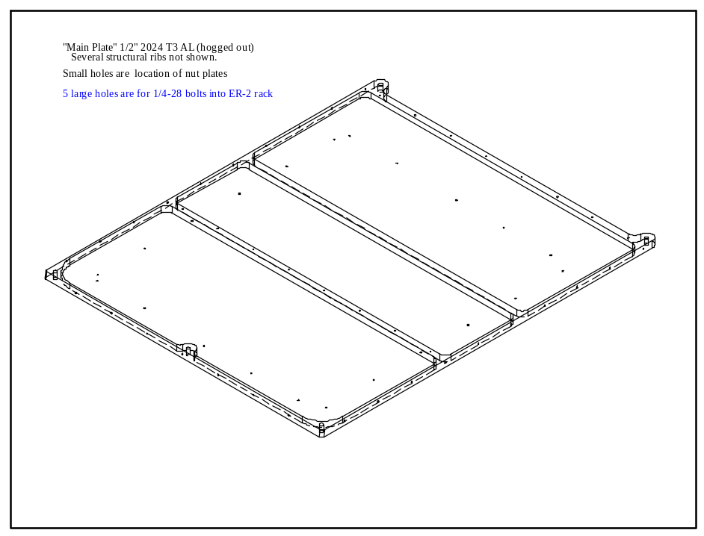

Max load will occur on the two bolts under both tension and shear with m=2, n =2, and Wcg = 200 lb located 6” above the geometric center of the plate. Therefore Y= 6” and 2X = 27.5 for forward and aft loads, and 2X = 22.5 for side loads.

Forward/Aft at 3 g : L_{B} = 3•200(lb)[1/4 + 6”/(2•27.5”)] = 215 lb per bolt.

Lateral at 1.5 g : L_{B} = 1.5•200(lb)[1/4 + 6”/(2•22.5”)] = 115 lb per bolt.

Up at 2 g : L_{B} = 2•200(lb)[1/4] = 100 lb per bolt.

Down at 4.5 g : No load on bolts.

AN rating on a 1/4-28 bolt is 125,000(psi.)•0.049(si) = 6135 lb per bolt.

Safety Factors on 1/4-28 bolts ≥ 6135 / 215 = 28

Three Major Internal Structure Issues.

Mass Spec./Turbo Pump: The combined weight of the Mass Spec. and Turbo Pump is less than 40 lb. It is bolted to the 1/2 hogged out Center Plate with 4 10/32 AN bolts. In addition it is retained by a clamp ring on the bottom of the Turbo pump for added support but this will not be used in the analysis. In the lower diagrams X = Y = 5” and 2X' = 17”.
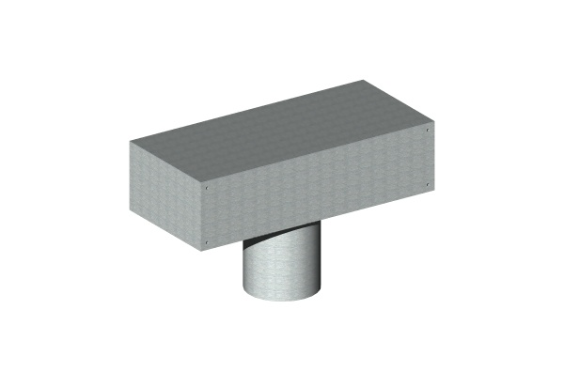
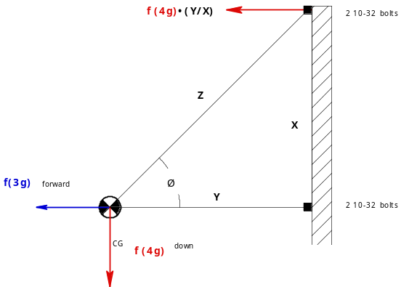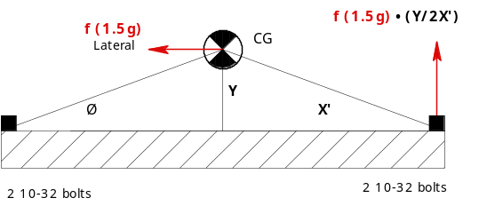
Forward at 3 g : Assuming all load comes to bare in tension on lower 2 10-32 bolts
(ignoring help from upper 2 bolts). L_{B} = 3•40(lb)/2 = 60 lb per bolt.
Aft at 1.5 g : No load on bolts.
Down at 4.5 g : With all 4 bolts sharing the shear force, the two upper bolts also under tension have the largest load per bolt. L_{B} = 4.5•40(lb)[1/4 + 5”/(2•5”)] = 135 lb per bolt.
Up at 2 g : With all 4 bolts sharing the shear force, the two lower bolts also under tension have the largest load per bolt. L_{B} = 2•40(lb)[1/4 + 5”/(2•5”)] = 60 lb per bolt.
Lateral at 1.5 g : With all 4 bolts sharing the shear force, the two side bolts also under tension have the largest load per bolt. L_{B} = 1.5•40(lb)[1/4 + 5”/(2•17”)] = 24 lb per bolt.
AN rating on 10/32 bolt is 125,000(psi.)•0.026(si) = 3267 lb per bolt.

Safety Factors on these 10-32 bolts ≥ 3267 / 135 = 24

Gas Bottles : Each large gas bottle is mount to the center plate or the main plate with two commercial clamp rings. Each clamp ring is mounted with two 8-32 AN bolts for a total of 4 8-32 AN bolts per gas bottle. The Largest gas bottle has a Wcg = 7 lb with a CG 3.5” off the plate.
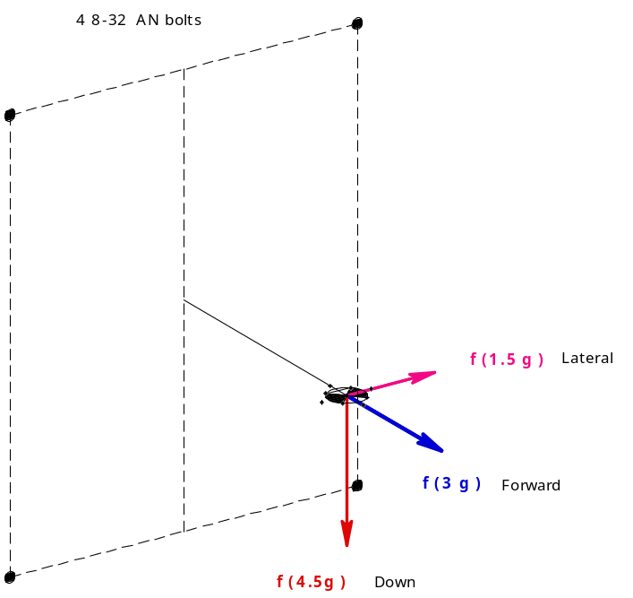

Forward at 3 g : With equal tension on 4 bolts: L_{B} = 3•7(lb)[1/4] = 5.25 lb per bolt.
Aft at 1.5 g : Induces no load on bolts.
Lateral 1.5 g : With all 4 bolts sharing the shear force, the two left bolts also under tension have the largest load per bolt. L_{B} = 1.5•7(lb)[1/4 + 3.5”/(2•5”)] = 6.3 lb per bolt.
Down at 4.5 g : With all 4 bolts sharing the shear force, the two upper bolts also under tension have the largest load per bolt. L_{B} = 4.5•7(lb)[1/4 + 3.5”/(2•6”)] = 17 lb per bolt.
Up at 2 g : With all 4 bolts sharing the shear force, the two upper bolts also under tension have the largest load per bolt. L_{B} = 2•7(lb)[1/4 + 3.5”/(2•6”)] = 8 lb per bolt.

AN rating on 8/32 bolt is 125,000(psi.)•0.020(si) = 2512 lb per bolt.

Safety Factors on these 8-32 bolts ≥ 2512 / 17 = 140

Center Plate mounted to Main Plate: The Center Plate has mounted to it the 40 lb Mass Spec., 8 gas regulators that add 9 lb, and 3 or 4 gas bottles which add as much as 10 lb. The plate it’s self will add 2 lb. Wcg = 67 lb for this plate and the CG is approximately centered at 6” off the main plate. It is bolted on edge to the main plate with eight 8-32 AN bolts. In addition is has its sides supported by 0.025” thick 2024 T3 sheet metal under tension for forward and aft loads. The mass spec is also supported at the bottom by a clamp ring attached to the main plate approximately 5” from the Center Plate effectively forming a cross member. We show below that ignoring these cross supports and using only the eight 8-32’s we still have a safety margin of 4. The true safety margin is much higher.

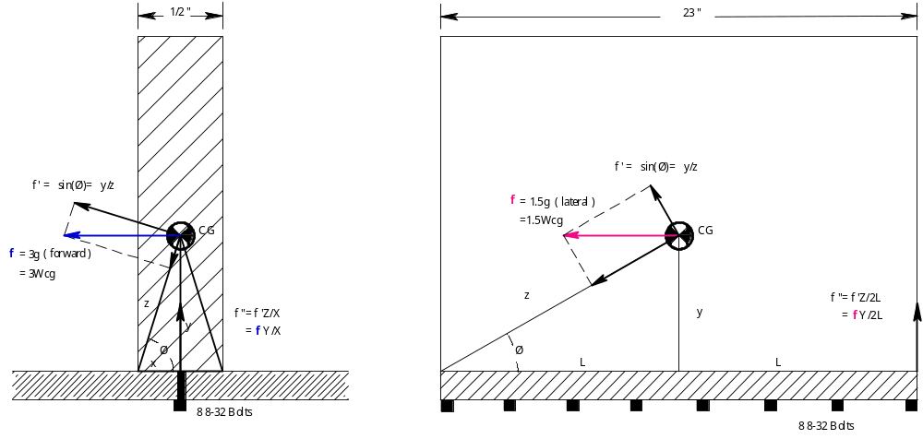

Forward at 3 g : With equal shear and tension on 8 bolts we have the load per bolt:
L_{B} = 3•67(lb)[1/8 +5”/(8•0.25”)] = 527 lb per bolt.
Aft at 1.5 g : With equal shear and tension on 8 bolts we have the load per bolt:
L_{B} = 1.5•67(lb)[1/8 +5”/(8•0.25”)] = 263 lb per bolt.
Lateral 1.5 g : With all 8 bolts sharing the shear force, if we assume the far right bolt picks up
all the tension (ignoring the other 6 bolts) we have the largest load per bolt:
L_{B} = 1.5•67(lb)[1/8 + 5”/(8•23”)] = 16 lb per bolt.
Down at 4.5 g : Induces no load on bolts.
Up at 2 g : With all 8 bolts sharing the tension force, L_{B} = 2•67(lb)[1/8] = 17 lb per bolt.

AN rating on 8/32 bolt is 125,000(psi.)•0.020(si) = 2512 lb per bolt.

Safety Factors on these 8-32 bolts ≥ 2512 / 527 = 4.8

