DOT/FAA/AR-96/121  Office of Aviation Research  Washington, D.C. 20591 | Design Procedures and Analysis  of Turbine Rotor Fragment  Hazard Containment  March 1997  Final Report  This document is available to the U.S. public  through the National Technical Information  Service, Springfield, Virginia 22161.    U.S. Department of Transportation  Federal Aviation Administration

NOTICE

This document is disseminated under the sponsorship of the U.S. Department of Transportation in the interest of information exchange. The United States Government assumes no liability for the contents or use thereof. The United States Government does not endorse products or manufacturers. Trade or manufacturer's names appear herein solely because they are considered essential to the objective of this report.

Technical Report Documentation Page
1. Report No.  DOT/FAA/AR-96/121 | 2. Government Accession No. |  |  | 3. Recipient's Catalog No.
4. Title and Subtitle  DESIGN PROCEDURES AND ANALYSIS OF TURBINE ROTOR FRAGMENT |  |  |  |  | 5. Report Date  March 1997
HAZARD CONTAINMENT |  |  |  |  | 6. Performing Organization Code
7. Author(s)  Dr. J.A. Mathis |  |  |  |  | 8. Performing Organization Report No.
9. Performing Organization Name and Address  Mechanical Engineering Department  Wichita State University |  |  |  |  | 10. Work Unit No. (TRAIS)
Wichita, KS 67260-0133 |  |  |  |  | 11. Contract or Grant No.  DTFA03-92-C-00044
12. Sponsoring Agency Name and Address  U.S. Department of Transportation  Federal Aviation Administration |  |  |  |  | 13. Type of Report and Period Covered  Final Report
Office of Aviation Research  Washington, DC 20591 |  |  |  |  | 14. Sponsoring Agency Code  AAR-431
15. Supplementary Notes

.
16. Abstract

Containment design procedures are reviewed through an extensive literature summary that spans 23 years of research from 1970 to 1993. Sixty-four reports are summarized and cross referenced to provide a useful bibliography on the subject. Comments from industry and government agencies are included along with a study of existing analytical methods. These analytical methods have substantiated that system level engine and nacelle evaluations are research areas that require future development and standardization.

17. Key Words  Turbine engine, Rotor, Containment |  |  | 18. Distribution Statement  This document is available to the public through the National Technical Information Service (NTIS), Springfield, Virginia 22161.
19. Security Classif. (of this report)  Unclassified | 20. Security Classif. (of this page)  Unclassified |  |  | 21. No. of Pages  35 | 22. Price

Form DOT F1700.7 (8-72) Reproduction of completed page authorized

TABLE OF CONTENTS

Page

EXECUTIVE SUMMARY v
1. INTRODUCTION
2. LITERATURE SURVEY
2.1 Comprehensive Literature Summary
2.2 Index of Key Topics
3. COMMENTS FROM INDUSTRY AND REGULATORY GROUPS
3.1 Large Engine Manufacturers
3.2 Small Engine and APU Manufacturers
3.3 Large Airframe Manufacturers
3.4 Small Airframe Manufacturers
3.5 Research Institutions and Government Agencies
4. ANALYSIS OF CONTAINMENT/SHIELDING STRUCTURES
5. CONCLUSIONS

LIST OF FIGURES

Figure Page

1 Flat Plate—Inconel 625 and A286 Steel Displacement Versus Impactor Energy
2 Flat Plate—Inconel 625 Maximum Total Reaction Force Versus Impactor Energy
3 Flat Plate—Inconel 625 and A286 Steel Time of Maximum Plate Deflection
4 Steel Rings Internal Energy Time Histories

LIST OF TABLES

Table Page

1 Material Properties
2 Containment Experiment Results

EXECUTIVE SUMMARY

The Wichita State University Department of Mechanical Engineering was tasked by the Federal Aviation Administration (FAA) William J. Hughes Technical Center to evaluate the existing literature and procedures used to design engine rotors and containment of engine rotors for hazard mitigation. This report presents an extensive literature summary of 64 reports covering 23 years of research from 1970 to 1993. The reports are cross referenced to an index of key topics for future researchers. The final sections of the report provide industry viewpoints and examples of work performed. To date there is no industry standard for assessing the containment capability of a combined engine and nacelle with proven numerical methods. Additional finite element code development is necessary to match the numerical results with the growing body of experimental data.

1. INTRODUCTION.
The general topic of containment of rotating parts in gas turbine engines and protection of the aircraft in the case of noncontainment remains an active area for industry research and development and regulatory interest. The work summarized in this report was to determine some sense of whether a state of the art exists for the problem of designing structural components for containment or shielding functions.

This report is divided into three sections. The first is a literature summary of reports and articles published on rotor fragment containment and deflection. The literature citations are organized chronologically and each is accompanied by a brief summary. A keyword index also accompanies the literature summary section, so that interested designers might find a convenient means to locate relevant technical reports.

In the second section, the results of many discussions with aircraft engine manufacturers, aircraft airframe manufacturers, and related governmental and research institutions are presented. Included are statements from technical personnel about general and specific design methods in use. Comments offered about the overall topic of rotor burst containment, minimization of damage from uncontained rotor bursts, and the relation of these topics in the overall concept of aircraft safety are also reported.

In the final section, some results of containment/shielding structure analysis are presented. This work was accomplished with commercially available general purpose finite element structural codes and the purpose of engaging in this task was to determine the suitability of such tools for the design problem. Some examples are provided, showing the types of design information which can be obtained from these codes.

2. LITERATURE SURVEY.

2.1 COMPREHENSIVE LITERATURE SUMMARY.
This section is a bibliography, including a short summary of each article, of reports and articles published on rotor burst containment and related issues. The time period covered is from 1970 to 1993. The citations are limited to those directly addressing the subject, hence more general articles on topics such as high velocity impact, for example, are not included. The ordering of references is chronological.

In section 2.2, an index of key words and topics contained in these references is provided. The index numbers refer to the RECORD NUMBERS in this section.

RECORD NO. N001
Title: Simplified Analysis of a Trifragment Rotor Disk Interaction with a Containment Ring
Author: R. Bruce McCallum
Date: May 1970
Report No.: Journal of Aircraft, Vol. 7, No. 3
SUMMARY: The report discusses the JET 1 program developed at MIT for predicting the large deflection transient response of a containment ring structure. Compares predicted shear stress values with material ultimate shear stress values and discusses applicability of a shear stress failure criteria.

RECORD NO. N002
Title: Designing Rotor Burst Protection
Author: A.A. Martino
Date: April 1971
Report No.: ASME 71-GT-70
Gas Turbine Conference and Products Show
Houston, Texas, March 28-April 1, 1971
SUMMARY: The report describes the NASA sponsored Rotor Burst Protection Program including a summary of MIT computer code development and the test program carried out at the Naval Air Propulsion Test Center. The test facility and test procedures are described and several factors important in the design of containment systems, shown from the test data, are presented.

RECORD NO. N003
Title: Status of Engine Rotor Burst Protection Program for Aircraft
Author: Patrick T. Chiarito
Date: May 1971
Report No.: NASA SP-270
SUMMARY: The report discusses the NASA program and describes the experimental facility at the Naval Air Propulsion Test Center for testing containment rings. Parameters noted to be especially relevant include early experimental results on the deformation characteristics of the ring, the effect of the number of fragments on the containment capability of the ring (i.e., is a four-way rotor burst worse than a three-way burst), and the relative performance of candidate containment ring materials including several steels and ballistic nylon cloth. The use of partial rings as deflector shields is discussed. Some nondimensional parameters affecting containment ring performance are identified.

RECORD NO. N004
Title: Dimensional Analysis Considerations in the Engine Rotor Fragment Containment/ Deflection Problem
Author: John W. Leech, Emmett A. Witmer, and Raffi P. Yeghiayan
Date: December 1971
Report No.: NASA CR-120841
SUMMARY: The use of dimensional analysis to design effective containment experiments is discussed. An example illustrates the technique used to determine parameters necessary to design simple circular containment rings impacted by bladed rotor fragments. Use of a parameter called the containment threshold is discussed for characterizing performance. Suggestions are made for the design of a testing program to investigate material effects.

RECORD NO. N005
Title: Examination of the Collision Force Method for Analyzing the Responses of Simple Containment/Deflection Structures to Impact by One Engine Rotor Blade Fragment
Author: Robert M. Zirin and Emmett A. Witmer
Date: May 1972
Report No.: NASA CR-120952
SUMMARY: Describes the theory and applicability of the (MIT developed) Collision Force Method (CFM). The method predicts collision forces and ring and fragment responses. The report includes a section addressing the use of this method in deducing blade structural behavior during impact, e.g., elastic-plastic curling.

RECORD NO. N006
Title: Development and Modifications of the RB211 Engine
Author: Anon
Date: May 1972
Report No.: Aircraft Engineering Vol. 44
SUMMARY: Narrative of blade containment considerations in engine design. Lists containment ring general features.

RECORD NO. N007
Title: Rotor Burst Protection Program: Statistics on Aircraft Gas Turbine Engine Failures That Occurred in Commercial Aviation During 1971
Author: R.A. DeLucia and G.J. Mangano
Date: February 1973
Report No.: NASA-CR-131525
SUMMARY: One of an annual series. (Refer to Record No. N061.)

RECORD NO. N008
Title: Application of the Collision-Imparted Velocity Method for Analyzing the Responses of Containment and Deflector Structures to Engine Rotor Fragment Impact
Author: Thomas P. Collins and Emmett A. Witmer
Date: August 1973
Report No.: NASA-CR-134494
SUMMARY: Presents theory, application, and example problems of fragment/containment ring response calculated with the collision-imparted velocity method (CIVM). Includes a detailed user’s guide to the MIT-developed CIVM-JET-4A program. The program calculates transient response for complete and partial rings which may have a number of boundary conditions subject to impacting fragments specified by initial dynamical properties. The report includes comparisons with experiments.

RECORD NO. N009
Title: Experimental and Data Analysis Techniques for Deducing Collision-Induced Forces From Photographic Histories of Engine Rotor Fragment Impact/Interaction With a Containment Ring
Author: Raffi P. Yeghiayan, John W. Leech, and Emmett A. Witmer
Date: October 1973
Report No.: NASA-CR-134548
SUMMARY: Describes experiments and data analysis for obtaining transient response data (force and deformation history) of containment rings. Data is intended to be used as input for a structural response computer code to estimate the forces which would have been required for the measured input to be produced.

RECORD NO. N010
Title: General Specification for Engines, Aircraft, Turbojet, and Turbofan
Author: U.S. Military Specification
Date: October 1973
Report No.: MIL-E-5007D
SUMMARY: This is a generic specification for all departments and agencies of the Department of Defense. Containment criteria are specified, consisting primarily in the ability of the engine to completely contain a single fan, compressor or turbine blade, and all parts damaged and released by the failure of the blade. The means of demonstrating that containment criteria have been met is also specified.

RECORD NO. N011
Title: Rotor Burst Protection Program: Statistics on Aircraft Gas Turbine Engine Rotor Failures That Occurred in U.S. Commercial Aviation During 1972
Author: R.A. DeLucia and G.J. Mangano
Date: March 1974
Report No.: NASA-CR-136900
SUMMARY: One of an annual series. (Refer to Record No. N061.)
RECORD NO. N012
Title: The Containment of Disk Burst Fragments by Cylindrical Shells
Author: A.C. Hagg and G.O. Sankey
Date: April 1974
Report No.: ASME 73-WA-Pwr-2
ASME Winter Annual Meeting, Detroit, Michigan, November 11-15, 1973
SUMMARY: The paper discusses containment of steel disk fragments by a steel cylindrical shell. Test results support an analytical development that describes containment in terms of a two-stage process—a localized inelastic impact and momentum transfer followed (if penetration does not occur) by development of large tensile strains in large areas of the shell. It also includes criteria for containment and test results for cylindrical shells.

RECORD NO. N013
Title: Analysis of Rotor Fragment Impact on Ballistic Fabric Engine Burst Containment Shields
Author: J.H. Gerstle
Date: September 1974
Report No.: ISSN: 0021-8669
Symposium on Propulsion System Structural Integration and Engine Integrity
Naval Postgraduate School, Monterey, California, September 3-6, 1974
SUMMARY: This report discusses the development of a material model for ballistic fabrics in which fabric is modeled as a single or multilayered membrane which can support loads along the fibers. It also includes a comparison with experimental test data.

RECORD NO. N014
Title: Rotor Burst Protection Program: Statistics on Aircraft Gas Turbine Engine Rotor Failures That Occurred in U.S. Commercial Aviation During 1973
Author: R.A. DeLucia and G.J. Mangano
Date: August 1975
Report No.: NASA-CR-134854
SUMMARY: One of an annual series. (Refer to Record No. N061.)

RECORD NO. N015
Title: Rotor Burst Protection Program: Statistics on Aircraft Gas Turbine Engine Rotor Failures That Occurred in U.S. Commercial Aviation During 1974
Author: R.A. DeLucia and G.J. Mangano
Date: September 1975
Report No.: NASA-CR-134855
SUMMARY: One of an annual series. (Refer to Record No. N061.)

RECORD NO. N016
Title: Structural Effects of Engine Burst Noncontainment
Author: T.W. Coombe
Date: October 1975
Report No.: ISSN: 0549-7191
Spec Meeting on Impact Damage Tolerance of Structures
Ankara, Turkey, September 28-October 3, 1975
SUMMARY: This report discusses the general problem of designing to minimize structural damage and contains an empirical correlation for energy absorbed by full penetration for several ductile metals.

RECORD NO. N017
Title: Design Considerations for Minimizing Damage Caused by Uncontained Aircraft Turbine Engine Rotor Failures
Author: Federal Aviation Administration
Date: November 1975
Report No.: Order 8110.11 (FAA)
SUMMARY: This order outlines design considerations in terms of engine location, location of critical systems and components, and protective armor and deflectors.

RECORD NO. N018
Title: User’s Guide to Computer Program CIVM-JET 4B to Calculate the Transient Structural Responses of Partial and/or Complete Structural Rings to Engine-Rotor-Fragment Impact
Author: Thomas R. Stagliano, Robert L. Spilker, and Emmett A. Witmer
Date: March 1976
Report No.: NASA-CR-134907
SUMMARY: This detailed user’s guide includes a FORTRAN IV listing of the program. The CIVM-JET 4B program, developed at MIT under contract to NASA, was developed to predict the large-deflection elastic-plastic structural responses of single layer partial or complete ring containment structures.

RECORD NO. N019
Title: Development of Fiber Shields for Engine Containment
Author: R.J. Bristow and C.D. Davidson
Date: March 1977
Report No.: NASA CP-2017
SUMMARY: Empirical work done at the Boeing Company is described. Two models were developed from the experimental work. The first relates the weight of the shield with projectile sizes and velocities. The second relates the shield mount load to the mount dynamic stiffness and attachment method.

RECORD NO. N020
Title: Federal Aviation Administration’s Approach to Engine Rotor Integrity
Author: A.K. Forney
Date: March 1977
Report No.: NASA CP-2017
SUMMARY: This report summarizes the FAA policy and philosophy at the time of the conference. It also discusses the three-fold approach of (1) designing engines not to fail, (2) designing engines for containment when they fail, and (3) designing aircraft for minimum damage when engines fail and containment fails. The FARs pertinent to this philosophy are cited and summarized.

RECORD NO. N021
Title: Ceramic Composite Protection for Turbine Disc Bursts
Author: P.B. Gardner
Date: March 1977
Report No.: NASA CP-2017
SUMMARY: This report discusses the design and testing of a shield developed to protect the tail section of the A300B from auxiliary power unit compressor rotor fragment attack. The design, consisting of boron carbide panels backed with woven fiberglass in a high-temperature resin, is stated to have been very successful in terms of economics and minimum weight penalty.

RECORD NO. N022
Title: Analysis Method for Kevlar Shield Response to Rotor Fragments
Author: J.H. Gerstle
Date: March 1977
Report No.: NASA CP-2017
SUMMARY: This report describes the theory of a Boeing Company developed finite difference large deflection plate/shell code. Comparisons of predicted and measured peak displacements are shown.

RECORD NO. N023
Title : Engine Noncontainment—The UK CAA View
Author: G.L. Gunstone
Date: March 1977
Report No.: NASA CP-2017
SUMMARY: This report presents the CAA philosophy on designing for engine noncontainment. Worldwide accident histories are discussed as rationale for the regulations. Some background is presented explaining the implementation of a probability figure (probability of catastrophic failure as a result of uncontained failure) as part of the design criteria.

RECORD NO. N024
Title : Metallic Armor for Ballistic Protection From Steel Fragments
Author: Donald F. Haskell
Date: March 1977
Report No.: NASA CP-2017
SUMMARY: This report describes experimental data collected for cylindrical steel fragments impacting on six different alloys. Experimental data is available in unclassified reports of the U.S. Army Ballistic Research Laboratory.

RECORD NO. N025
Title: Concepts for the Development of Lightweight Composite Structures for Rotor Burst Containment
Author: Arthur G. Holms
Date: March 1977
Report No.: NASA CP-2017
SUMMARY: This report summarizes lessons learned from previous rotor burst containment experiments and uses these observations to form guidelines for an effective testing program.

RECORD NO. N026
Title: Rotor Burst Protection Program—Experimentation to Provide Guidelines for the Design of Turbine Rotor Burst Fragment Containment Rings
Author: G.J. Mangano, J.T. Salvino, and R.A. DeLucia
Date: March 1977
Report No.: NASA CP-2017
SUMMARY: This report discusses results of experimentation done at the Naval Air Propulsion Test Center. Guidelines were developed for designing optimum weight containment rings for turbine disk fragments.

RECORD NO. N027
Title: Types of Rotor Failure and Characteristics of Fragments
Author: D. McCarthy
Date: March 1977
Report No.: NASA CP-2017
SUMMARY: This report presents statistics on engine noncontainment collected by Rolls Royce. Discusses in detail the possible failure modes of engine components. Describes characteristics of fragments in terms of size, velocity, energy, and angle of deflection.

RECORD NO. N028
Title: Rotor Burst Protection Criteria and Implications
Author: Ralph B. McCormick
Date: March 1977
Report No.: NASA CP-2017
SUMMARY: This report reviews, without specifics, aircraft design methods for minimizing damage from uncontained rotor burst and the effect of noncontainment and noncontainment protection on aircraft design. Presents brief results of a Boeing study of noncontainment accident statistics. A point made is that if additional containment (weight) measures will contain low-energy fragments but be ineffective against high-energy fragments, the improvement to aircraft safety will be minimal.

RECORD NO. N029
Title: Blade Fragment Energy Analysis
Author: M.A. O’Connor, Jr.
Date: March 1977
Report No.: NASA CP-2017
SUMMARY: This document generally discusses work done at Douglas Aircraft but with no details. It also describes the development of analytical methods to describe blade fragment dynamics and a testing program to determine the effectiveness of Kevlar cloth containment systems.

RECORD NO. N030
Title: Numerical Analysis of Impact in Woven Textile Structures
Author: D. Roylance
Date: March 1977
Report No.: NASA CP-2017
SUMMARY: This report describes the theory and application of a computer code designed to predict the impact response of woven fabrics. User input consists of material properties, weave geometry, and projectile velocity. Experiments are compared to the computed predictions for single layer Kevlar 29 fabric and small projectiles with velocities up to 700 meters per second. A comparison of Kevlar 29, Kevlar 49, nylon, and graphite based on the results of the computer model is also examined.

RECORD NO. N031
Title: Engine Noncontainment—UK Risk Assessment Methods
Author: J.C. Wallin
Date: March 1977
Report No.: NASA CP-2017
SUMMARY: A detailed technical discussion of the calculation of risk to the aircraft from uncontained rotor burst including the use of a detailed engine failure model as part of the calculation process. It also discusses some specific measures implemented in the Concorde.
RECORD NO. N032
Title: Lightweight Engine Containment
Author: A.T. Weaver
Date: March 1977
Report No.: NASA CP-2017
SUMMARY: This paper summarizes the Pratt & Whitney work done for development of Kevlar fabric containment systems for blade containment. The work included ballistic impact evaluations, laboratory tests, spin pit tests, and engine tests. Key results included the efficiency of Kevlar compared to hardened steel, the result that Kevlar efficiency decreases if the fabric deflection is constrained, and the fact that Kevlar fabric can absorb multiple hits. Wicking and flammability tests to define the fire resistance of Kevlar are also reported.

RECORD NO. N033
Title: Analysis of Simple 2-D and 3-D Metal Structures Subjected to Fragment Impact
Author: E.A. Witmer, T.R. Stagliano, R.L. Spilker, and J.J.A. Rodal
Date: March 1977
Report No.: NASA CP-2017
SUMMARY: This report describes analytical work done at the MIT Aeroelastic and Structures Research Laboratory. It also discusses the merits and limitations of the collision force method versus the collision imparted velocity method. Analytical predictions are compared with experimental data obtained at the Naval Air Propulsion Center (both single-blade fragment and trihub turbine rotor burst) and impact experiments done with solid spherical impactors against aluminum panel and beam targets.

RECORD NO. N034
Title: Rotor Burst Protection Program: Statistics on Aircraft Gas Turbine Engine Rotor Failures That Occurred in U.S. Commercial Aviation During 1975
Author: R.A. DeLucia and G.J. Mangano
Date: May 1977
Report No.: NASA-CR-135304
SUMMARY: One of an annual series. (Refer to Record No. N061.)

RECORD NO. N035
Title: Study to Improve Airframe Turbine Engine Rotor Blade Containment
Author: C.O. Gunderson
Date: July 1977
Report No.: FAA-RD-77-44
SUMMARY: This study, performed by McDonnell Douglas Corporation for the FAA, examines the range of energies and trajectories of various blade fragments and tests the energy absorption capability of various candidate materials to provide protection from the blade fragments. The necessary armor weights are determined, and the economics of installing such armor is discussed.

RECORD NO. N036
Title: Report on Aircraft Engine Containment
Author: Society of Automotive Engineers/Committee on Engine Containment
Date: October 1977
Report No.: AIR 1537
SUMMARY: This report contains detailed statistics on noncontained failures including classification by degree of damage, fragment type, flight mode, and cause of failure. It also contains a discussion on potential for improvement of aircraft safety in terms of engine design, aircraft design, and increased containment capability.

RECORD NO. N037
Title: Rotor Fragment Protection Program: Statistics on Aircraft Gas Turbine Engine Rotor Failures That Occurred in U.S. Commercial Aviation During 1976
Author: R.A. DeLucia and J.T. Salvino
Date: July 1978
Report No.: NASA-CR-159474
SUMMARY: One of an annual series. (Refer to Record No. N061.)

RECORD NO. N038
Title: Two-Dimensional Finite-Element Analyses of Simulated Rotor-Fragment Impacts Against Rings and Beams Compared with Experiments
Author: Witmer
Date: August 1978
Report No.: NASA-CR-159645
SUMMARY: The report presents a detailed theoretical description of the CIVM-JET 4B computer code. The response of containment ring response to a trihub burst is analyzed and discussed. It also includes dimensional analysis considerations and the use of deflectors for fragment control.

RECORD NO. N039
Title: Containment of Composite Fan Blades
Author: C.L. Stotler and A.P. Coppa
Date: July 1979
Report No.: NASA-CR-159544
SUMMARY: Prepared by General Electric under a NASA contract, this document describes (1) an analytical determination of blade impact behavior; (2) scaled blade impact tests conducted on containment rings formed of Kevlar/epoxy fins mated to an aluminum ring, Kevlar cloth faced with an aluminum ring, aluminum honeycomb, and stainless steel ring; and (3) design and fabrication of a containment system utilizing results of testing and final testing of the design concept. A graph showing Kevlar thickness required for containment versus blade kinetic energy is included.

RECORD NO. N040
Title: Composite Containment Systems for Jet Engine Fan Blades
Author: G.T. Smith
Date: February 1981
Report No.: NASA-TM-81675
Thirty-Sixth Annual Conference of the Reinforced Plastics/Composites Institute of the Society of the Plastics Industry, Inc., Washington, D.C., February 16-20, 1981
SUMMARY: The report describes the testing of composite containment structures that include Kevlar/epoxy fins mounted on an aluminum ring, an aluminum honeycomb, and a Kevlar cloth filled ring. It also includes the curve of Kevlar thickness required versus blade kinetic energy.

RECORD NO. N041
Title: Development of Advanced Lightweight Systems Containment
Author: C.L. Stotler
Date: May 1981
Report No.: NASA CR-165212
SUMMARY: This report describes testing done by General Electric (NASA contract) with dry weave Kevlar for blade containment for a CF6-size engine. Experimental data is used to construct a curve of amount of Kevlar cloth required versus blade impact energy.

RECORD NO. N042
Title: Rotor Fragment Protection Program: Statistics on Aircraft Gas Turbine Engine Rotor Failures That Occurred in U.S. Commercial Aviation During 1978
Author: R.A. DeLucia and J.T. Salvino
Date: September 1981
Report No.: NASA-CR-165388
SUMMARY: One of an annual series. (Refer to Record No. N061.)

RECORD NO. N043
Title: Rotor Fragment Protection Program: Statistics on Aircraft Gas Turbine Engine Rotor Failures That Occurred in U.S. Commercial Aviation During 1979
Author: R.A. DeLucia and J.T. Salvino
Date: October 1982
Report No.: NASA/CR-168163
SUMMARY: One of an annual series. (Refer to Record No. N061.)

RECORD NO. N044
Title: Statistics on Aircraft Gas Turbine Engine Failures That Occurred in U.S. Commercial Aviation During 1981
Author: R.A. DeLucia, J.T. Salvino, and T. Russo
Date: March 1987
Report No.: DOT/FAA/CT-86/42
SUMMARY: One of an annual series. (Refer to Record No. N061.)

RECORD NO. N045
Title: Report on Aircraft Engine Containment
Author: Society of Automotive Engineers/Committee on Engine Containment
Date: September 1987
Report No.: AIR 4003
SUMMARY: This report presents detailed statistical data on noncontained rotor failures including classification by degree of damage, engine type, flight mode, engine and rotating part component, and cause. It also includes rotorcraft and general aviation data not included in a similar report issued in 1977. This report also discusses potential improvements in the areas of engine design, aircraft design, bird threat, and maintenance. This report provides an overview of related FAA regulations and certification procedures.

RECORD NO. N046
Title: Design Considerations for Minimizing Hazards Caused by Uncontained Turbine Engine and Auxiliary Power Unit Rotor and Fan Blade Failures
Author: Federal Aviation Administration
Date: March 1988
Report No.: Advisory Circular AC 20-128
SUMMARY: This AC recommends design consideration be directed at location of rotating sections relative to critical components and suggests a maximum fragment size and energy level for design purposes. It also suggests that the airframe designer obtain fragment energies and trajectories from the engine manufacturer’s data.

RECORD NO. N047
Title: A Turbine Wheel Design Story
Author: Wilson R. Taylor, Keith Wheless, and Lee G. Gray
Date: June 1988
Report No.: ASME 88-GT-316
Gas Turbine and Aeroengine Congress
Amsterdam, The Netherlands, June 6-9, 1988
SUMMARY: Design considerations relating to containment issues for a Jet Fuel Starter used in the F-15 Fighter Aircraft are discussed. Consideration is given to limiting the power turbine containment ring by designing the power turbine wheel to break into small pieces.
RECORD NO. N048
Title: Statistics on Aircraft Gas Turbine Engine Rotor Failures That Occurred in U.S. Commercial Aviation During 1982
Author: R.A. DeLucia and J.T. Salvino
Date: July 1988
Report No.: DOT/FAA/CT-88/23
SUMMARY: One of an annual series. (Refer to Record No. N061.)

RECORD NO. N049
Title: Experimental Guidelines for the Design of Turbine Rotor Fragment Containment Rings
Author: James T. Salvino, Robert A. DeLucia, and Tracy Russo
Date: July 1988
Report No.: DOT/FAA/CT-88/21
SUMMARY: Experiments performed at the Naval Air Propulsion Center are described. In the first set of experiments, containment rings constructed of Kevlar fabric and ballistic nylon are tested for containment of trihub turbine rotor failures. In the second set, containment rings constructed of aluminum, 304 stainless steel, and A-286 steel are tested for their ability to contain single and triple blade release events. Test results include findings that a minimum casing thickness of 0.375 inch is required to contain the tested JT8D and JT3D blades.

RECORD NO. N050
Title: Statistics on Aircraft Gas Turbine Engine Rotor Failures That Occurred in U.S. Commercial Aviation During 1983
Author: R.A. DeLucia and J.T. Salvino
Date: March 1989
Report No.: DOT/FAA/CT-89/5
SUMMARY: One of an annual series. (Refer to Record No. N061.)

RECORD NO. N051
Title: Statistics on Aircraft Gas Turbine Engine Rotor Failures That Occurred in U.S. Commercial Aviation During 1984
Author: R.A. DeLucia, J.T. Salvino, and B.C. Fenton
Date: June 1989
Report No.: DOT/FAA/CT-89/6
SUMMARY: One of an annual series. (Refer to Record No. N061.)

RECORD NO. N052
Title: Statistics on Aircraft Gas Turbine Rotor Failures That Occurred in U.S. Commercial Aviation During 1985
Author: R.A. DeLucia, J.T. Salvino, and B.C. Fenton
Date: July 1989
Report No.: DOT/FAA/CT-89/7
SUMMARY: One of an annual series. (Refer to Record No. N061.)

RECORD NO. N053
Title: Development of an Advanced Fan Blade Containment System
Author: Alan D. Lane
Date: August 1989
Report No.: DOT/FAA/CT-89/20
SUMMARY: Ceramic-based blade containment systems are studied. Such a system is designed for minimum weight and compared with metal systems for weight and cost effectiveness. Kevlar and B₄C/Spectra systems are examined.

RECORD NO. N054
Title: Statistics on Aircraft Gas Turbine Engine Rotor Failures That Occurred in U.S. Commercial Aviation During 1986
Author: R.A. DeLucia, J.T. Salvino, and B.C. Fenton
Date: January 1990
Report No.: DOT/FAA/CT-89/30
SUMMARY: One of an annual series. (Refer to Record No. N061.)

RECORD NO. N055
Title: Development of Helicopter Modular Armor Systems and Installation Techniques
Author: U.S. Army Materials Technology Laboratory
Date : March 1990
Report No.: MTL TR 90-11
SUMMARY: Not summarized.

RECORD NO. N056
Title: An Overview of Propulsion System Risks 1959 Through 1989
Author: G.P. Sallee
Date: November 1990
Report No.: Boeing Commercial Airplane Company D6-55456
SUMMARY: A comprehensive study of all propulsion-type risks, which includes statistics on uncontained turbojet and turbofan engine failures.
RECORD NO. N057
Title: Titanium Rotating Components Review Team Report
Author: Federal Aviation Administration/Aircraft Certification Service/Engine and Propeller Directorate
Date: December 1990
Report No.: N/A
SUMMARY: This report describes the results of a project to collect data and provide a review of industry practices relevant to titanium rotating parts in aircraft turbine engines. Aspects of design, manufacturing, quality control, and inspection procedures were investigated. Detailed recommendations are made.

RECORD NO. N058
Title: Statistics on Aircraft Gas Turbine Engine Rotor Failures That Occurred in U.S. Commercial Aviation During 1987
Author: R.A. DeLucia, B.C. Fenton, and Janine Blake
Date: January 1991
Report No.: DOT/FAA/CT-90/19
SUMMARY: One of an annual series. (Refer to Record No. N061.)

RECORD NO. N059
Title: The Impact Load on Containment Rings During a Multiple Blade Shed in Aircraft Gas Turbine Engines
Author: T.B. Dewhurst
Date: June 1991
Report No.: ASME 91-GT-163
International Gas Turbine and Aeroengine Congress and Exposition, Orlando, Florida, June 3-6, 1991
SUMMARY: Using experimental data of ring displacement during a multiple blade shed event in a medium sized gas turbine engine, the finite element code ANSYS is used to develop an impact load record. Reaction force results are presented. Details and problems with the numerical analysis are discussed. Observations of field experience are presented regarding failure modes, with brittle tensile failure identified as the most common mode.

RECORD NO. N060
Title: Statistics on Aircraft Gas Turbine Engine Rotor Failures That Occurred in U.S. Commercial Aviation During 1988
Author: R.A. DeLucia, B.C. Fenton, and E.R. Chapdelaine
Date: March 1992
Report No.: DOT/FAA/CT-91/28
SUMMARY: One of an annual series. (Refer to Record No. N061.)
RECORD NO. N061
Title: Statistics on Aircraft Gas Turbine Engine Rotor Failures That Occurred in U.S. Commercial Aviation During 1989
Author: E.R. Chapdelaine, B.C. Fenton, R.A. DeLucia, and M. Muller
Date: June 1992
Report No.: DOT/FAA/CT-92/5
SUMMARY: The statistics contained in this report were taken from the FAA Flight Standards Service Difficulty Reports. The reports were analyzed to establish the number of contained and uncontained rotor bursts, the distribution of failures among engine components and fragment types, and the cause of failure. Also included is the distribution of incidents by engine type and the flight condition at the time of failure. An analysis of engine failure rate according to engine fleet hours is included. The incidence of uncontained rotor bursts in the years 1962 through 1984 is presented.

RECORD NO. N062
Title: The Use of Imposed Displacements to Determine Impact Forces in a Multiple Blade Shed Incident
Author: T.B. Dewhurst
Date: May 1993
Report No.: ASME 93-GT-127
International Gas Turbine and Aeroengine Congress, Cincinnati, Ohio
SUMMARY: The report presents an approach to finding forces exerted on containment rings by blades. Experimental data on containment ring deflection is used with the ANSYS finite element code. The report also focuses on the correct use of the numerical parameters required for accurate modeling.

RECORD NO. N063
Title: Fiber Reinforced Structures for Turbine Engine Fragment Containment
Author: J. Pepin
Date: June 1993
Report No.: AIAA 93-1816
29th Joint Propulsion Conference, Monterey, CA
SUMMARY: The report describes experimental program to test fiber reinforced systems for containment of turbine rotor disks. The effect of construction details is investigated. Hybrid sandwich panels were found to perform comparably to honeycomb panels. Polybenzbisoxazole (PBO) is tested as an option for hot-section containment.

RECORD NO. N064
Title: Analysis of Turbine Engine Rotor Containment and Shielding Structures
Author: J.A. Mathis, S.C. Parduhn, and P. Alvarez
Date: June 1993
Report No.: AIAA 93-1817
29th Joint Propulsion Conference, Monterey, CA
SUMMARY: Applies commercial finite element codes to geometries and fragment energies typical of containment problems. Describes results available from analysis such as displacement, reaction force, and energy absorption histories.

2.2 INDEX OF KEY TOPICS.
The following index accompanies the record number list in section 2.1. Key topics from the bibliographic record are arranged here in alphabetical order. The index numbers refer to the RECORD NUMBERS in section 2.1.

Analytical research—001, 005, 008, 009, 018, 022, 024, 033, 039, 059, 062
Fabric—013, 022, 030
Failure criteria—001
Finite element codes—059, 062, 064

Armor
Helicopter—055
Metallic—024

Auxiliary power unit—021

Blade fragments
Deformation—002
Dynamics—029, 035
Impact structural behavior—039

Ceramic
Ceramic composite—021, 053
Ceramic composite, environmental test—021
Ceramic composite resin, high temperature—021
Ceramic composite armor—021

Civil Aviation Authority (CAA)—016, 023, 031

Containment
Blades—002, 003, 006, 010, 032, 049, 059, 062
Containment criteria—004, 022, 026, 028, 040
Military engines—010
Disk fragments—001, 003, 026, 024, 049, 063
Engine casing thickness required—049
Fan blades—039, 040, 041, 053
Parameter study—004, 025
Threshold—004

Containment ring
Axial length—026
Clearance from rotor—002
Deformation of—013
Failure mode—001, 012, 059
Finned—022
Restraints—002, 003
Sandwich panel (hybrid structural)—063
Stiffening ribs—006
Weight of—013

Deflectors—017
Disk fragment—024

Design
Aircraft considerations—016, 017, 020, 028, 035, 036, 045
Containment rings—041, 049
Experimental guidelines—026, 049
Engine considerations—006, 036, 045, 047, 049, 057

Dimensional Analysis—003, 004, 039

Disk failure mode—012, 027

Empirical Models—016, 019, 035, 049

Environmental testing—021, 032

Experimental research—002, 012, 019, 035, 039, 040, 041, 049, 063
Ceramic composites—021
Comparison with analytical work—009
Engine containment test—032
Planning for experiments—004, 025, 053
Spin pit testing—002, 009, 019, 026, 040, 063

Federal Aviation Administration Policy—020, 036, 045

Fragments
Deflection of—003, 027
Energy—002, 012, 027, 029
Geometry—002, 027, 053
Number of—003, 026
Residual velocity—012
Retention—039, 040
Spread angle—016, 027
Trajectory—013

Honeycomb materials—029, 041
Containment structure, aluminum—035, 039
Containment structure, steel—035

Kevlar—019, 022, 032, 035, 039, 040, 041, 049, 053, 063
Environmental tests—032
Fire resistance—032
Restraint of fabric—040
Weave geometry—030, 032, 049, 063
Weight required—032, 035, 039, 040, 053

Material
Material comparisons—002, 022, 053, 063
Material models—004
Fabric—013, 022, 030
Strain rate—024

Materials
Alumina—021, 053
Aluminum—002
Ballistic nylon—002, 003, 049
Boron carbide—021, 026, 053
Ceramics—053
Ceramic/polymer fiber composite—053
E-glass—002, 003
Rubber/metal composite—021
PBO (polybenzbisoxazole)—063
S-glass—013, 022
Spectra
TRIP steel—002, 003

Military Containment Criteria—010

Risk, calculation of—016, 023, 031, 056

Shields—002, 017, 019
Mounting—019

Statistics
Uncontained failures—002, 007, 011, 014, 015, 023, 034, 036, 037, 042,
043, 044, 045, 048, 050, 051, 052, 054, 056, 058
060, 061
Cause—007, 011, 014, 023, 027, 034, 036, 037, 042, 043, 044, 045
048, 050, 051, 052, 054, 056, 058, 060, 061
Damage severity—028, 036, 045
Propulsion related—056
United Kingdom—027
Worldwide—023, 056

Testing
Verification of containment criteria—010, 020

Turbine Wheel
Frangible—047

Uncontained failure
Energy absorption by aircraft structure—035
Engine failure model—031
Structural damage—016, 028, 031

Weight of containment structures—013, 023, 026, 035

3. COMMENTS FROM INDUSTRY AND REGULATORY GROUPS.
A portion of this research task included visiting with and gathering the opinions and comments of a variety of airframe and engine manufacturers and agencies involved in the issue of containment. An initial list of companies involved was developed, however not everyone contacted wished to participate in discussions.

Generally, the companies and agencies visited could be placed in the following categories: large engine manufacturers, small engine and APU manufacturers, large airframe manufacturers, small airframe manufacturers, research institutions, and governmental agencies. Since issues involving rotor burst containment are considered by most to be highly sensitive, the comments presented in this report are left anonymous in the above categories. Most companies were unsure of our motives in talking with them, especially in light of the research project being funded by the FAA and the fact that the preparation of the AC on minimizing the hazards from engine rotor burst noncontainment was still ongoing.

3.1 LARGE ENGINE MANUFACTURERS.
A typical opinion expressed by large engine manufacturers was that their extensive research and development efforts into rotor containment advances had cost them a lot of money. Hence, they did not wish to reveal any technical details or discuss company philosophy. One company indicated that analytical modeling of fragments impacting containment structures was a research effort that has spanned at least 10 years and has been conducted in part with a version of DYNA-3D.

3.2 SMALL ENGINE AND APU MANUFACTURERS.
One company discussed their computational modeling efforts with us which consisted of using a version of DYNA-3D to simulate the interaction of a typical containment ring with fragments released from a trihub rotor burst. However, they stated that this research effort is still in a developmental stage and most of their design guidelines come from test data generated in-house. A problem mentioned with use of this type of modeling is that of finding a failure model. Continuing research effort is directed toward correlating and nondimensionalizing the data in useful ways.

3.3 LARGE AIRFRAME MANUFACTURERS.
Manufacturers interviewed in this category included civilian transport and military aircraft manufacturers. On the question of the appropriateness of the fragment size/spread angle data included in the proposed Advisory Circular, different opinions were offered. While one manufacturer felt that the historical data well supported this fragment definition, another manufacturer felt that the data was not realistic nor conservative. This company is supporting analytical research to address this question. When questioned on design methods used when dealing with uncontained rotor burst (URB) events, the approach of designing redundant systems and relocating critical components to areas outside of an expected fragment trajectory envelope was mentioned as a primary method. One company related some design work involving the possible use of structural shielding. They mentioned that a possible drawback to the use of shields is that in certain cases, more serious structural damage results as a consequence of using the shield, because the shield transfers the impact reaction to more structural members. Another manufacturer has devoted some number of years of research into the use of analytical codes (DYNA-3D) that can be used to model the interaction of released URB fragments with the aircraft structure.

Military manufacturers stressed their compliance with generic military specifications for dealing with URB threats and typically suggested the relocation of critical components as their primary design tool. In compliance with the military specifications, this is one item addressed on a required program plan where apparently the operating history of the engine is taken into consideration. Finally, one company felt that a probability number for design would be more desirable than the proposed Advisory Circular approach of minimizing the hazard.

3.4 SMALL AIRFRAME MANUFACTURERS.
An opinion expressed is that the smaller airplane, if required to have the same degree of protection as the large transport airplane, would be penalized because the structural components themselves are less massive. The companies surveyed basically rely presently on geometric analysis and the relocation of critical components out of the trajectory path as a means of minimizing the hazard from and URB event. The question of the role of maintenance was addressed by more than one company. If, for example, the engine of a general aviation business jet is inspected with a frequency of three times that to which a transport jet engine is inspected, or if the engine is monitored in a formalized trend monitoring program, why should both the small jet and transport category jet be subject to the same criteria for protection from URB events? Some reservations about the use of the words “minimize the hazard” in the draft Advisory Circular were expressed with a stated preference for a specific quantitative probability number in lieu of the more general term minimize. If this approach were adopted, what merit should be given to field histories?

Another small company interviewed retrofitted various fixed and rotary wing aircraft with small gas turbine engines. The status of policy for minimizing damage from uncontained rotor bursts was of great interest to this company. Such questions as how to demonstrate that a certain shielding material and configuration would be adequate were stated by this company to be of critical interest, as the necessity of extensive testing would make the conduct of business impossible.

3.5 RESEARCH INSTITUTIONS AND GOVERNMENT AGENCIES.
Opinions offered by various individuals employed at civilian and military airworthiness agencies are grouped under this category. Some individuals offered suggestions for the direction of future research efforts. These included investigating the effect of the engine case pressurization of the fragment trajectories, the design of disks to limit the mass of fragments by breaking into small pieces, and the design of directed failure paths. Some concern was voiced that if more stringent requirements for containment were required, less emphasis would be directed to engine part integrity and or monitoring. The repeatability of containment tests was questioned, with a suggestion that this be investigated. Finally, an opinion was received that follow-up on the recommendations of the Titanium Rotating Components Review Team would result in overall enhanced safety by providing improved materials and inspection techniques which will reduce the probability of manufacturing defects.

4. Analysis of Containment/Shielding Structures.
A review of the past work accomplished reveals many previous analytical studies. Some computer codes have been especially developed for modeling of containment rings and deflector shields, notably the codes developed by MIT as part of the NASA-sponsored Rotor Burst Protection Program (see Record Numbers N001 and N008 in section 1.1). However, these codes do not appear to have been adapted for widespread use in the aerospace industry. Part of the present research effort involved examining the use of currently available general commercial finite element codes for the design of containment structures and related structural components.

The availability, capability, and workability of commercially available finite element codes has increased dramatically in recent years. These codes offer the ability to accurately perform the dynamic, nonlinear, high-velocity impact analyses required to model containment and shielding problems. Such tools allow the impact and energy transfer mechanisms and the time dependent development of stress patterns to be studied in detail for various materials and geometries. Two such codes were evaluated for their capability to model various structural configurations representative of containment rings or shielding components. No attempt was made to model any specific engine components; rather, a generalized study was made with fragment kinetic energies representative of gas turbine engine sizes ranging from auxiliary power units (APU) through 50,000 pound thrust engines (lb.t). Only metallic structures were modeled in this research. The geometries studied were circular containment rings and flat plates subject to direct impact. One of the goals of this research was to determine if the use of such commercially available codes could be useful in modeling and providing design information for the high-velocity impact problems encountered in containment and shielding.

The flat plate was 12 x 24 x 1 in. thick. It was meshed with quadrilateral shell elements with minimum edge dimensions of 1 inch. The element dimensions were minimum in the center of the plate, where impact occurs, and a maximum of 3 inches near the edge of the plate, resulting in a total number of degrees of freedom (including variables associated with contact elements) of 1776. All edges of the plate were fixed against displacement in three directions. The plate was impacted with a rigid flat cylindrical disk 8 inches in diameter and 2.2 inches thick. The impactor mass was 6.36 slugs; its velocity was varied from 25 in/sec to as high as 700 in/sec resulting in a kinetic energy range of 170 to 130,000 in-lb. The ratio of impactor mass to plate mass was approximately 2.5.

The ring model was circular and unflanged with dimensions chosen to match experiments performed at the Naval Air Propulsion Laboratory (see Record Number N049 in section 1.1). The ring had an inside diameter of 28 inches, an axial length of 9 inches, and a thickness which varied in different runs from 0.187 to 0.390 inch. The total number of elements in the ring model was 810. Quadrilateral shell element dimensions were 1 inch, and the top and bottom edges of the ring were fixed against displacement in three directions. The ratio of impactor mass to ring mass ranged from 2.3 to 6.4. In both the flat plate and ring models, the mesh sizes were coarse compared with the rigid impactor contact area, hence its geometry was somewhat irrelevant.

Problems were run with two codes: ABAQUS (Hibbett, Karlsson, and Sorensen, Version 4.9) and DYTRAN (MacNeal-Schwendler, Version 2.0). ABAQUS is a finite element direct integration implicit code that solves the nonlinear equilibrium equations. The implicit time integration operator is a modification of the trapezoidal rule called the Hilbert-Hughes-Taylor operator. This formulation contains a parameter used to introduce artificial damping and can be used to eliminate the high frequency noise that is generated as a result of the time step being changed in the automatic time stepping procedure. A force tolerance and moment tolerance are entered by the user to define the accuracy with which equilibrium must be satisfied. Time stepping can be user defined or an automatic incrementation scheme is applied which adjusts the time step after comparing the equilibrium residuals half way through the time step with those at the end of the time step.

The second code, DYTRAN, is an analysis code for analyzing dynamic, nonlinear behavior of structures, using explicit time integration. It is an adaptation of the DYNA-3D code developed at Lawrence Livermore National Laboratory. Time steps are controlled automatically to assure stable solutions. The default automatic time step is calculated by the program to be smaller than the time taken for a stress wave to cross the smallest element; a user adjustable safety factor (typically of 2) is then applied to this calculation to determine the actual time step. Both codes were operated on a HP9000 Series 730 workstation.

Simple bilinear elastic-plastic material models were used for the materials studied, A286 Steel and Inconel 625. Required parameters include the yield point, elastic modulus, hardening modulus, and Poisson’s ratio. Values are summarized in table 1.

Table 1. Material Properties

ParameterInconel | Steel
Yield Stress (psi) | 4.40E4 | 9.00E4
Elastic Modulus (psi) | 29.8E6 | 22.5E6
Hardening Modulus (psi) | 25.3E5 | 20.3E5
Poisson’s Ratio | 0.29 | 0.25
Density (lbf sec₂ /in) | 7.82E-4 | 7.40E-4

Generally, both codes were found to be effective in modeling problems of this nature, and both compared well, providing some verification of one another. Time histories of maximum deflection and energy summaries from both programs proved to be nearly identical. For the models and dynamic time period ranges studied, the explicit code ran in approximately one-tenth the time required for the implicit code. Some convergence problems with the implicit code were encountered. These occurred at energy levels insufficient to produce plastic dissipation. Even maximum values of artificial damping parameters proved insufficient to eliminate the high frequency noise generated as a result of time step changes in the automatic time stepping procedure.

The analysis results for the flat plate models include maximum displacement that occurs at various impactor energy levels, time of maximum displacement, plastic dissipation, and maximum total reaction force. Maximum displacements occurred in the center of the plate in the impact area, and for the two materials, these are plotted in figure 1. The maximum displacement is seen to increase nonlinearly with impactor energy. The displacement of the Inconel is, in the plastic region, less than that of the steel; the ratio of Inconel deflection to steel deflection is the same as the ratio of the respective material hardening moduli—approximately 1.25.

For the Inconel plate, the maximum total reaction force and the sum of all reaction forces in the direction of impactor travel are plotted against impactor energy in figure 2. The value is seen to rise sharply with energy and level off at approximately 200,000 lb. The time at which maximum displacement occurs for both plates, is shown in figure 3. Times are higher for the Inconel plate, and the ratio of time for the Inconel to that for the steel is approximately 1.35. The increase scales with the product of relative hardening modulus and density for the two materials.

Containment ring models of A286 steel were also constructed with geometries chosen to match experimental work performed earlier. A summary of these experiments is shown in table 2.

TABLE 2. CONTAINMENT EXPERIMENT RESULTS

Thickness (in.) | Fragment Energy (in-lb) | Result
0.140 | 23,490 | Not Contained
0.187 | 29,900 | Contained
0.250 | 98,900 | Not Contained
0.390 | 116,000 | Contained

These experiments were modeled numerically with the DYTRAN program. Geometry models matched those of the experiment and impactor velocities were chosen to result in identical energy levels. However, several aspects of the experiments differed from the computer model. In the experiments the rings were hanging free, suspended by chains, while in the model the top and bottom edges were restrained. Also, in the experiments the impactors were actual turbine blades, not rigid disks. Curves showing the total amount of energy absorbed by the rings is shown in figure 4 with the maximum values in good agreement with the fragment initial energies.
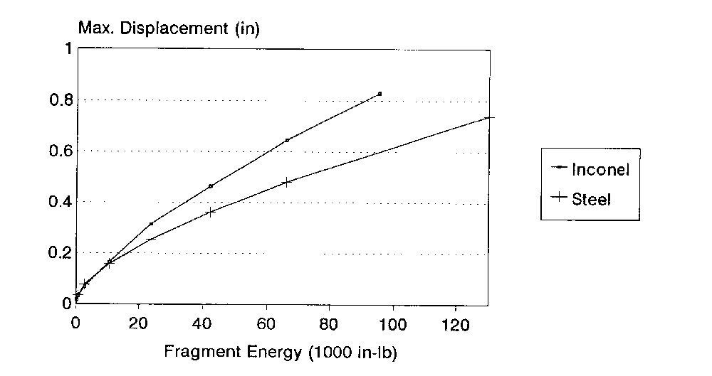
FIGURE 1. FLAT PLATE—INCONEL 625 AND A286 STEEL DISPLACEMENT VERSUS IMPACTOR ENERGY

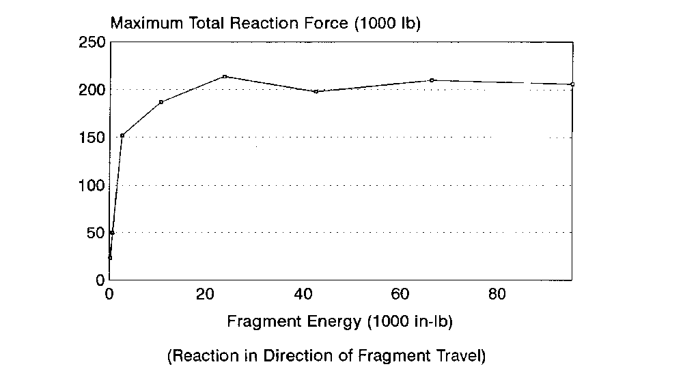
FIGURE 2. FLAT PLATE—INCONEL 625 MAXIMUM TOTAL REACTION FORCE VERSUS IMPACTOR ENERGY

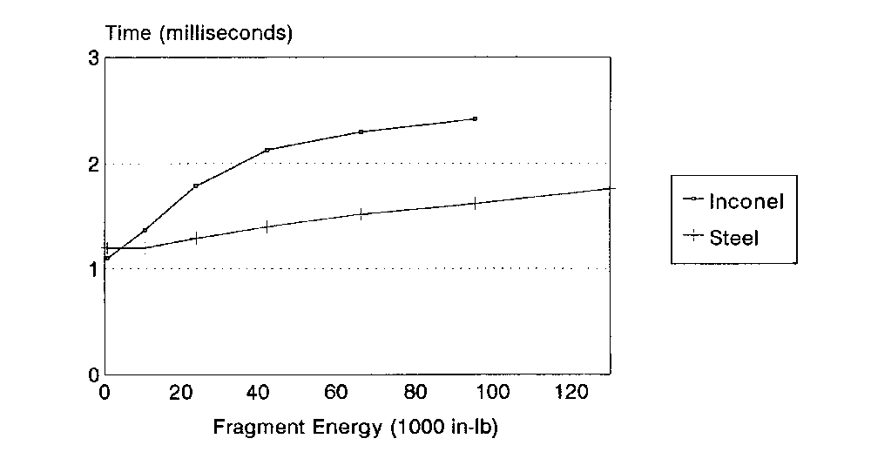
FIGURE 3. FLAT PLATE—INCONEL 625 AND A286 STEEL TIME OF MAXIMUM PLATE DEFLECTION

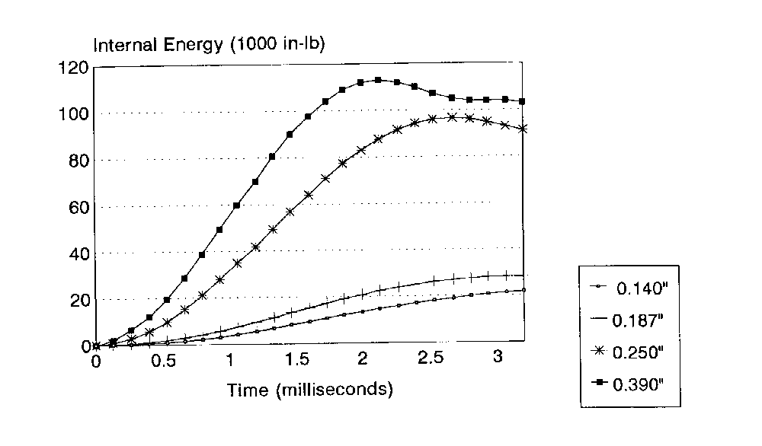
FIGURE 4. STEEL RINGS INTERNAL ENERGY TIME HISTORIES

5. CONCLUSIONS.
Few published research results on design methods for the containment of rotating parts within the gas turbine engine case have appeared in the last 15 years. The nature of such research, requiring a large amount of expensive test data, is such that most development has occurred at the engine manufacturers. The work is considered to be highly proprietary and details are not generally released by the companies involved.

Some research work has been carried out under various NASA, DOD, and DOT programs. Experimental work has been performed at the Naval Air Propulsion Center, which is publicly available and provides a wealth of experimental spin pit testing results on many candidate containment ring materials for rotor segment and blade containment. This work is presently continuing under sponsorship of the FAA William J. Hughes Technical Center and focusing on the application of fiber composite materials.

A number of companies report using finite element codes to model containment structures and shields; derivatives of the DYNA-3D program are often mentioned. However, in no cases were these tools described as a simple solution. Indeed, many companies described a substantial research effort, consisting of years of development, to obtain useful computational results. While time histories of deflection, stress levels, and reaction forces are fairly simple to obtain, as shown by some examples in this report. Selection of an appropriate failure model and hence the ability to predict containment capability, remains a problem.

