Case Management & Oversight’s
Monitoring of Postsecondary Institutions

FINAL AUDIT REPORT



ED-OIG/A04-D0014

September 2004


Our mission is to promote the efficiency, U.S. Department of Education effectiveness, and integrity of the Office of Inspector General
Department’s programs and operations. Atlanta, Georgia

Statements that managerial practices need improvements, as well as other conclusions and recommendations in this report, represent the opinions of the Office of Inspector General. Determinations of corrective action to be taken will be made by the appropriate Department of Education officials.

In accordance with the Freedom of Information Act (5 U.S.C. §552), reports issued by the Office of Inspector General are available to members of the press and general public to the extent information contained therein is not subject to exemptions in the Act.

TABLE OF CONTENTS

Page

EXECUTIVE SUMMARY……………………………………………………………………..1

AUDIT RESULTS………………………………………………………………………………3

Finding No. 1 – The Institutional Assessment Model Is An Ineffective Tool for
Identifying “At Risk” Institutions.………………………………………….3
Recommendations………………………………………………………………………………6

Finding No. 2 – The Program Review Process Needs Improvement..……………………...10
Recommendations……………………………………………………………………………..14

Finding No. 3 – Technical Assistance Was Not Adequately Documented or

Followed Up…...…………………………………………………………….16
Recommendations……………………………………………………………………………..18

Finding No. 4 – CMO-HQ Monitoring of Regional Office Operations Needs
Improvement.……………………………………………………….………18
Recommendation.……………………………………………………………………………...21

BACKGROUND………………………………………………………………………………24

OBJECTIVE, SCOPE, AND METHODOLOGY..……………………………………..……25

STATEMENT ON MANAGEMENT CONTROLS..……………………………….………27

APPENDIX A – CMO Regional Office Exceptions..……………………………………..…28

APPENDIX B – Written Response to the Draft Report…………………………............…29

EXECUTIVE SUMMARY

Our objectives were to evaluate (1) Case Management & Oversight’s (CMO) use of program reviews as a compliance tool (2) CMO’s use of technical assistance as a compliance tool, and (3) CMO Headquarters (CMO-HQ) management controls over regional offices’ monitoring of postsecondary institutions. Audit coverage included CMO monitoring of institutional compliance with the Title IV, Student Financial Assistance (Title IV) requirements during the period August 2001 through May 2003. To accomplish our objectives, we visited the CMO-HQ in Washington, DC, and four CMO regional offices (Atlanta, GA; Chicago, IL; Dallas, TX; and San Francisco, CA).

We identified weaknesses in the Institutional Assessment Model (IAM) used to identify and select institutions for review, the CMO regional office program review process, and the CMO regional office technical assistance process. We also found that CMO-HQ monitoring of regional office operations needed strengthening.

The IAM did not contain complete and accurate information, and the IAM risk scores did not always predict problematic institutions. There were no policies, procedures, and management controls over the information entered into the IAM and no evaluation of its effectiveness. The weaknesses identified with the IAM may prevent CMO from effectively prioritizing case management efforts. While it should be noted that the IAM was not the only methodology used by CMO to identify problematic institutions, it was a significant tool used to identify high-risk institutions for review.

The CMO regional office program review reporting process, retention of supporting documentation, and consistency in the review process needs improvement. Weaknesses in the program review process were caused by a lack of detailed policies and procedures and a lack of compliance with the limited existing policies and procedures. These weaknesses placed CMO at risk of failing to adequately identify and report significant instances of noncompliance and of being inconsistent and inequitable in its conduct and resolution of program reviews.

We also identified problems with the regional offices’ documentation of technical assistance and a lack of follow-up on the results of technical assistance. These problems were caused by a failure to comply with existing policies and procedures and a lack of detailed policies and procedures for some compliance areas. Failure to document and follow up on technical assistance prevented CMO management from having the ability to measure the effectiveness of technical assistance as a compliance tool.

The CMO-HQ monitoring of regional office operations needed strengthening. CMO-HQ did not (1) monitor regional offices’ use of the IAM, (2) provide guidance for the selection of institutions for case management in the absence of an updated IAM risk list, (3) monitor regional offices’ compliance with internal policies and procedures for program reviews and technical assistance, (4) evaluate the effectiveness of program reviews or technical assistance conducted or the consistency of regional offices’ selection of institutions for program review or technical assistance, and (5) evaluate the effectiveness of the enforcement actions taken as a result of regional office program reviews. These weaknesses were primarily a result of the level of autonomy given to regional office managers over monitoring decisions. This also created the potential for inconsistent treatment of institutions across the country.

CMO-HQ is currently developing a new electronic CMO (eCMO) initiative to improve the overall monitoring process. According to CMO-HQ officials, the eCMO structure is grounded in the case management process model and is focused primarily on updating tools and systems to help support decision-making that is informed, effective, efficient, consistent, documented, standardized, and distributed. During an end of fieldwork meeting, CMO-HQ officials provided information on how the new eCMO initiative may address some of the concerns noted in this audit report; however, the new initiative was still in the research and development phase and the officials were unable to provide an estimated implementation date. Even if eCMO is fully implemented, CMO will need to address the management deficiencies identified in this audit.

We recommend that the Chief Operating Officer for Federal Student Aid (FSA) require CMO-HQ to:

- Develop and implement management controls to ensure that the data used to identify the most at-risk institutions is complete, accurate, and applicable to the institutions being evaluated.
- Develop a methodology for evaluating the effectiveness of any risk assessment model used to identify the institutions presenting the highest risk of loss of Title IV funds.
- In the absence of an effective risk model, provide guidance to the regional case management teams for identifying institutions for program review and technical assistance.
- Establish detailed policies and procedures over supervisory review of program reviews, record retention, off-site program reviews, specific items for making a program review or technical assistance the appropriate monitoring action, and the appropriate action to be taken as a result of a specific compliance issue identified at an institution.
- Develop a quality control process to ensure regional compliance with the policies and procedures concerning the program review function and consistency across the regions in decisions pertaining to monitoring actions taken and enforcement actions in the event of noncompliance.
- Develop and implement policies and procedures for providing technical assistance in a consistent manner across all regions, documenting the technical assistance provided, identifying when technical assistance ends and enforcement begins, and following up on technical assistance visits and measuring the effectiveness of them as a compliance/monitoring tool.
- Implement management controls to ensure consistent treatment of institutions across regional offices.
- Develop internal policies and procedures to ensure management oversight of CMO operations.

FSA did not agree with all of the audit findings; however, FSA agreed to take action on the recommendations. We summarized FSA’s written response after each finding and included the response as Appendix B to this report. Due to the large volume of pages, we did not include the attachments to the written response. Our comments to FSA’s written response are included after each finding.

AUDIT RESULTS

Finding No. 1 – The Institutional Assessment Model Is An Ineffective Tool for Identifying “At Risk” Institutions

We found that the IAM may prevent CMO from effectively prioritizing case management efforts. The IAM did not contain complete and accurate information, and the IAM risk scores did not always accurately identify problematic institutions. This occurred due to a lack of policies, procedures, and management controls around the information used in the IAM and the lack of evaluation of the effectiveness of the IAM. By maintaining a risk system that does not accurately identify the most at-risk institutions, CMO may be making ineffective decisions about the best use of its resources and ineffectively prioritizing its case management efforts.

Section 498A of the Higher Education Act of 1965 (HEA) prescribes the requirements for the conduct of program reviews as follows:

(a) GENERAL AUTHORITY. - In order to strengthen the administrative capability and financial responsibility provisions of this title, the Secretary- (1) shall provide for the conduct of program reviews on a systematic basis designed to include all institutions of higher education participating in programs authorized by this title.

According to this section of the HEA, the Secretary is to give priority for program review to institutions of higher education that have a cohort default rate in excess of 25 percent, a loan default rate that places the institution in the highest 25 percent of such institutions, a significant fluctuation in Federal loan or Pell grant volume, reported deficiencies or financial aid problems, high annual dropout rates, and institutions that the Secretary determines may pose a significant risk of failure to comply with the administrative capability or financial responsibility provisions of the Act.

In fiscal year (FY) 2001, CMO adopted the IAM to rank institutions according to their potential risk of loss of Government funds. The IAM system, hosted by OakRidge National Laboratories (ORNL), is a tool to prioritize case management efforts in selecting schools for on- and off-site program reviews and technical assistance. The IAM software uses school data taken from various sources, organizes it, and then presents it in a manner that will track, assess, and anticipate risk among institutions participating in Title IV programs. The IAM is based on statistical data collected and utilized over a period of time. The information is used to assess the probability of a specific event befalling a school. For each specific financial problem that is identified through the assessment, several probability measurements can be constructed. “At risk” schools identified in the assessment are grouped into problem related categories pertaining to surety, fines, reimbursements, or penalties.

Institutional data from the following U.S. Department of Education systems is submitted to ORNL for use in arriving at the IAM risk score: National Student Loan Data System (NSLDS), Recipient Financial Management System (RFMS), Grants Administration Payments System (GAPS), Central Processing System (CPS), Postsecondary Education Participants System (PEPS), and the Default Management System.

The IAM Did Not Contain Complete Information
We compared the institutions participating in Title IV programs (i.e., schools for which disbursements were reported in NSLDS and GAPS) to institutions receiving an IAM score for two years. Our analysis showed that approximately 525 of the 6,371 institutions (8.2 percent) that participated in the Title IV programs were not assigned an IAM score in the July 2001 risk assessment. In addition, approximately 500 of the 6,371 institutions (7.8 percent) that participated in the Title IV programs were not assigned an IAM score in the November 2002 risk assessment. Of this 500, 424 were the same institutions that did not receive a score in the July 2001 risk assessment.

CMO-HQ officials explained that institutions did not receive an IAM risk assessment score if they were a new school or a “satellite” campus whose information was rolled into the main campus score, had insufficient information for a score, were not on the eligibility list, or had been inadvertently dropped because there was no case team assigned to them per the IAM database. CMO-HQ officials said they reviewed a sample of the schools that were not assigned an IAM risk score and found that although some of the schools should have received a score, other schools did not receive a score because they had closed, merged with another school, lost Title IV funding, or had not been in the program long enough to provide sufficient data to support the calculation.

Information Submitted By the Department to OakRidge National Laboratories (ORNL) Was Incomplete
ORNL used data provided from PEPS to assign an IAM risk score to institutions participating in the Title IV programs. Some of the PEPS data did not accurately reflect an individual institution’s financial responsibility, a factor used in calculating the IAM score. According to CMO officials, financial statements that fail certain conditions (e.g., audit opinion, compliance issues, contingent liabilities, debt agreement violation, change in auditor, late refunds) are “flagged” in the PEPS system. If there are 10 schools covered by a financial statement (e.g., OMB A-133 Statewide Single Audit of public institutions), all 10 schools receive the same flag. Thus, it is possible for schools with high risk not to be flagged and for schools with low risk to be flagged as high risk. As a result, the IAM scores assigned to public institutions may not necessarily reflect an accurate financial responsibility rating.

In addition, information in PEPS relating to the total amount of liabilities assessed as a result of noncompliance in a program review was not always correct. We obtained a PEPS extract dated June 26, 2003, that contained the total amount of liabilities assessed as a result of all program reviews conducted during our audit period. Our review of a random sample of program review report files in the four regional offices visited revealed that liability amounts reported in the CMO Final Program Review Determination (FPRD) letters did not always match the liability amounts reported in PEPS. Of the 40 report files reviewed for which a FPRD letter had been issued, we found 8 differences between liability amounts in PEPS and the FPRD letters. For these 8 files, the FPRD letters showed liabilities totaling $778,140 while PEPS showed liabilities totaling $180,864. As a result, some of the liabilities assessed as a result of reported noncompliance may be incorrectly or incompletely reported in PEPS. ORNL used the PEPS data to develop risk scores for institutions.

Information pertaining to program review findings in PEPS was also sometimes inaccurate. Our review of a sample of program review report files in the regional offices visited revealed that the CMO institutional review specialists did not always report all program review findings identified during the review. This resulted in incomplete information pertaining to program review findings being used to develop risk scores. Finding No. 2 provides additional information regarding this problem.

IAM Scores Did Not Always Predict Problematic Institutions
As part of our institutional file review, we compared the relationship between the IAM risk score and the findings of noncompliance at institutions identified in audit reports, program reviews, and other documentation in the files indicating possible noncompliance. In 74 of the 155 school files reviewed (48 percent), there was no apparent relationship between the IAM score and the findings of noncompliance identified at the institutions. For these 74 files, 58 institutions had a high IAM score with a low level of evidence supporting noncompliance issues, and 16 institutions had a low IAM score with a high level of evidence supporting noncompliance issues.

We found no policies, procedures, or management controls in place to evaluate the effectiveness of the IAM or to ensure that the data provided to ORNL to identify the most at-risk institutions was complete, accurate, and applicable to the institutions being evaluated. By maintaining a risk system that does not accurately identify the most at-risk institutions, CMO may be making ineffective decisions about the best use of its resources and incorrectly prioritizing its case management efforts.

During our end of fieldwork briefing with CMO-HQ officials, we were informed that CMO and ORNL were currently evaluating the overall effectiveness of the IAM. The officials said the results of this review would be used to develop an improved risk model that will be part of the future electronic CMO (eCMO). The officials said that since eCMO was in the design phase, they were unable to provide an estimated completion date for the eCMO project and/or rollout of the improved risk system. Until CMO and ORNL complete their analysis of the IAM, the CMO-HQ should strengthen current policies, procedures, and management controls over the determination of the most at-risk institutions.

RECOMMENDATIONS

We recommend that the Chief Operating Officer for Federal Student Aid require CMO-HQ to:

  - Develop and implement management controls to ensure that the data used to identify the most at-risk institutions are complete, accurate, and applicable to the institutions being evaluated.

  - Develop a methodology for evaluating the effectiveness of any risk assessment model used to identify institutions presenting the highest risk of loss of Title IV funds.

  - In the absence of an effective risk model, provide guidance to the regional case management teams for identifying institutions for program review and technical assistance.

FSA RESPONSE AND OIG COMMENTS

In general, FSA agreed that internal procedures and management controls can be strengthened in the areas identified. FSA stated that it will review and revise the procedures as necessary and provide training to the case teams on the new procedures. FSA agreed that the IAM system could be enhanced, and stated that the Schools Eligibility Channel (SEC) staff have identified the requirements for a new model as part of the development of the Integrated Partner Management System.

Regarding FSA’s disagreement with certain statements in the audit report, the information provided in the written response was not sufficient to convince us to amend the finding and recommendations. FSA’s specific response to the draft report and our comments are summarized below.

FSA Response. FSA stated that the audit findings were overstated and FSA took issue with some of the statements in the report. FSA stated that the IAM is only one tool used by the SEC to identify institutions with a probability of risk for case management. Case management is an extensive review of a school, given the school’s individual circumstances. This case management review determines appropriate oversight actions that may include an on-site or off-site program review.

FSA said the SEC conducts oversight activities required by legislation and regulation to identify at-risk institutions, including reviews of annual audits and financial statements, calculations of default rates, eligibility reviews, and program reviews. In addition, the SEC conducts technical assistance visits to help schools prevent problems. The SEC analyzes data to proactively identify schools that may need intervention. All these activities are in addition to the risk probability information being provided by the IAM system.

FSA disagreed with the statement that “by maintaining a risk system that does not accurately identify the most at-risk institutions, CMO may not be making effective decisions about the best use of its limited resources.” FSA said the current model was designed to identify schools with four conditions of risk: the presence of surety (letter of credit), the presence of a fine greater than $10,000, the condition of being on reimbursement, or the condition of having a liability from audits or program reviews greater than $10,000. The model is a good predictor of institutions likely to have these four conditions. These predictions are based on a type of regression analysis that starts with identifying those schools that have the condition or problem, and then looks for variables that contribute to the school having the condition.

OIG Comments. We disagree with FSA’s comment that the audit findings were overstated. The report states that the IAM is one of several tools used by FSA to identify high risk institutions for review. We placed emphasis on the IAM because it was a primary tool used to identify and select institutions for review. As stated by FSA, the IAM is a tool to identify schools with a probability of risk for case management (an extensive review of a school) and that the case management review determines appropriate oversight actions that may include an on-site or off-site program review. Therefore, it is important to correctly identify the most at risk institutions for proper allocation of resources and prioritization of workload. Since CMO had not evaluated the effectiveness of the IAM, we did so through this audit and found that the IAM was an ineffective tool for identifying “at risk” institutions because the IAM did not contain complete information, the information submitted by the Department to ORNL for use in calculating risk scores was incomplete, and the risk scores did not always predict problematic institutions.

FSA Response. Regarding the schools that were not assigned an IAM score in the July 2001 and November 2002 risk assessments, FSA stated that most of these schools should not have had a risk score for various reasons (e.g., closed schools, merged/consolidated schools, loss of Title IV eligibility, loss of State accreditation/authorization or voluntary withdrawal, not eligible and/or not certified, funding office only, and insufficient data to support calculation). FSA said 68 schools were inadvertently dropped from the July 2001 risk list due to an error (56 of which should have received a risk score). This error was detected and corrected for the November 2002 list. Five of the 56 schools that should have received a risk score in July 2001 were included on the November 2002 high-risk list. FSA said the fact that it had identified the 68 schools with missing scores for July 2001 showed that it did perform analysis and checks on the IAM data and system. FSA concluded that there were 67 schools with a valid missing risk score for the July 2001 and November 2002 risk assessments. FSA also provided a spreadsheet of its analysis on why schools that we identified as missing an IAM score should not have had a score.

OIG Comments. Our point of the missing scores was that the IAM did not contain complete information and, therefore, there could be schools that needed to be case managed for which FSA did not have complete information. The problem with the 68 schools with missing scores for July 2001 was not completely corrected for the November 2002 risk assessment. We found that 13 of these 68 schools also did not receive a risk score in the November 2002 risk assessment. The support for FSA’s comment that it had identified the 68 schools with missing scores showed that it did perform analysis and checks on the IAM data and system consisted of an e-mail from the contractor dated July 31, 2003. This was a month after the start of this audit and about eight months after the November 2002 IAM scores had been generated.

While there may be schools that validly did not have an IAM score, we identified discrepancies in the data provided by FSA in response to this issue. Because of these discrepancies, we could not determine the actual number of institutions that validly did not have an IAM score. These discrepancies further support our conclusion that CMO-HQ needs to evaluate the effectiveness of the IAM or any other methodology used to generate risk scores to ensure that all participating schools receive coverage. For example, (1) a school that closed after the IAM risk assessment did not receive a risk score; (2) a school that closed before the IAM risk assessment received a risk score; and (3) discrepancies existed in the dates necessary for analysis (e.g., the data showed a school began participating in the Title IV programs on January 1, 1965, and lost its State authorization the same day, and the action updated 37 years later). Follow-up discussions with FSA officials revealed that there were errors in the data and that additional schools should have received a risk score.

FSA Response. FSA disagreed that IAM scores assigned to public institutions did not reflect financial responsibility. FSA said the IAM indicator for all schools is the presence or absence of a flagged financial statement, or a missing financial statement. Whenever a financial statement fails a condition, the SEC sets a flag in the system for the school. If there are 10 schools covered by the financial statement, all 10 schools receive the same flag.

OIG Comments. FSA’s comments did not change our conclusion regarding the IAM indictor for public institutions. We did, however, amend the finding to better reflect how public schools receive a flag in PEPS. FSA’s comments confirmed that it is possible for schools with high risk not to be flagged and for schools with low risk to be flagged.

FSA Response. Regarding the differences between liability amounts in PEPS and the FPRD letters, FSA said the differences were caused by data entry timing delays, FPRDs being issued after OIG extracted the data from PEPS, data entry conducted on the same day that OIG extracted its data, and the case team not reporting deficiencies that had been corrected by the school. FSA also said current practice allows corrections of program review finding on-site, or shortly thereafter, and the finding is not included in the FPRD. FSA said a delay in entry of program review information is not sufficient to support the OIG’s claim that information submitted to IAM is incomplete. FSA said all of the data for the schools reviewed by OIG has since been entered or corrected in PEPS.

OIG Comments. We amended the finding to reflect differences for 8 of the 40 files we reviewed (instead of 11 of 40) based on the information provided by FSA in its written response. Our review of the “data entry timing delay” justification offered by FSA revealed that the applicable FPRD’s were issued about 5, 7, 9, and 12 months prior to the time the PEPS data was extracted for OIG (June 2003). We do not agree that such delays in entering FPRD data into PEPS is justified. The IAM model was designed to identify schools with four conditions of risk, one of which is a liability from audits or program reviews greater than $10,000. The failure to enter program review liabilities into PEPS in a timely manner prevents the IAM from identifying all institutions that meet this condition. We also disagree with FSA’s policy of not reporting all program review findings if the findings are corrected on-site, or shortly thereafter. This issue is discussed in more detail in Finding 2.

FSA Response. FSA said the statement that IAM scores did not always predict problematic institutions is inaccurate because OIG (1) used a different definition of noncompliance from the IAM definition (i.e., OIG used audit and program review findings to define noncompliance), (2) used the peer group probability score in many instances, instead of the national score for comparing noncompliance, and (3) scrutinized IAM as a distinct, independent application, not as an integrated tool that is inherently aligned with the case management approach.

OIG Comments. For purposes of our analysis, we compared the IAM score to program reviews, audit findings, and any other information found in the institutional file to indicate possible noncompliance. Other information found in the file to indicate possible noncompliance included the four conditions of risk upon which the IAM model is based (i.e., the presence of surety (letter of credit), the presence of a fine greater than $10,000, the condition of being on reimbursement, or the condition of having a liability from audits or program reviews greater than $10,000).

At the beginning of the audit, we were informed that CMO used the peer group score for selecting high-risk schools from the July 2001 risk assessment and used the national score for selecting high-risk schools from the November 2002 assessment. We evaluated the correlation of the risk scores (peer group scores for the July 2001 assessment and national scores for the November 2002 assessment) with the information in the institutional files.

We recognize, as the report states, that the IAM is one of several tools used by FSA to identify institutions for review. Although the IAM is one of several tools, it was a major tool used by the regional offices to identify high-risk schools for review.

FSA Response. In response to Recommendation 1.1, FSA agreed to develop and implement a process to validate critical data in PEPS. FSA said it believes that the data needs to be complete and accurate regardless of the system used to determine the probability of risk.

OIG Comments. While we agree with FSA’s statement on the need for correct and accurate data, FSA’s response did not fully address Recommendation 1.1. FSA should ensure that the validation of PEPS data includes the accuracy of information regarding financial responsibility, assessed liabilities, and program review findings. In addition, FSA needs to ensure that risk scores are determined for all schools that receive Title IV funds and that the scores identify high-risk institutions (regardless of whether the scores are determined by the IAM, the FY 2004 Compliance Initiative, or eCMO). FSA’s response did not address the implementation of management controls to ensure the data used to identify the most at-risk institutions are complete, accurate, and applicable to the institutions being evaluated.

FSA Response. In response to Recommendation 1.2, FSA agreed to evaluate the effectiveness of the FY 2004 Compliance Initiative. FSA is currently using the FY 2004 Compliance Initiative, not solely IAM, to identify schools with a potential for noncompliance in identified areas.

OIG Comments. FSA’s response to Recommendation 1.2 did not fully address the recommendation. FSA should also develop a methodology to evaluate the effectiveness of the IAM if it continues to be used as a risk assessment model, the eCMO when it is implemented, and any other model developed to assess risk.

FSA Response. In response to Recommendation 1.3, FSA stated that one of the basic requirements and a continuing function of the case management process after performing a comprehensive review of all functional area information is for the teams to recommend appropriate next steps. This includes making recommendations to perform program reviews, refer for administrative action, or provide technical assistance. FSA said as additional data analysis is performed that identifies additional data outliers, the SEC would provide these potential risk issues and guidance for resolution to the case teams. The SEC performed analysis and identified several schools to be worked by the case teams as their risk list in the FY 2004 Compliance Initiative. The training of trainers for the current Compliance Initiative took place on July 27-28, 2004. Management Improvement Services (technical assistance) procedures were issued in July with an effective date of August 1, 2004. Training was conducted July 29, 2004.

OIG Comments. In response to Recommendation 1.3, FSA provided a summary of the FY 2004 Compliance Initiative, which outlined seven anomalies identified through data mining consisting of 379 institutions for case management. Although institutions were identified for case management, the initiative documentation did not provide a methodology for case teams to select institutions for program review and technical assistance. We also requested the Compliance Initiative training materials and were informed that the materials were in draft.

Finding No. 2 – The Program Review Process Needs Strengthening

Management controls over CMO’s program review process need strengthening. Our review of program review report files and interviews of case team members in four regional offices identified weaknesses in the program review process, reporting process, record retention, and consistency in the program review process across regions. This occurred due to a failure to comply with existing policies and procedures and a lack of detailed policies and procedures for some compliance areas. These weaknesses put CMO at risk of failing to properly identify and report significant instances of noncompliance and of being inconsistent and inequitable in its conduct and resolution of program reviews.

As previously noted, the HEA requires guidelines for the conduct of program reviews. Section 498A states “the Secretary shall establish guidelines designed to ensure uniformity of practice in the conduct of program reviews of institutions of higher education. . . .”

Excess Cash Review
We were unable to determine whether or not Institutional Review Specialists adequately reviewed excess cash as part of the program review. Determining whether or not an institution is maintaining excess cash is part of the fiscal review to be performed during the program review. The Program Review Guide outlines the procedures for performing a fiscal review of institutional records to determine noncompliance with cash management regulations, and requires that documentation be maintained to support this review. We did not find sufficient documentation to support the conclusions reached in the excess cash reviews performed. In three of the four regions visited, the only documentation found within the files to indicate that a fiscal review was performed was Grants Administration and Payment System (GAPS) printouts and bank statements. No documentation was maintained to support tracing of Title IV funds to ensure that funds were spent within required timeframes.

Reporting Process
Institutional review specialists did not always report all findings in program review reports. In two regions visited, although a finding was identified, the reviewers did not cite the correct number of student file review exceptions for the finding. Instead, the reviewers cited a few examples of the student files containing the problem. In addition, the reviewers sometimes resolved findings while on-site and neither reported the problem nor the number of student file review exceptions in the program review report. We found these issues in 15 of the 47 files reviewed. As a result, liabilities were not consistently and fully assessed.

Adequacy of Full File Review Results
Institutional review specialists did not adequately review the results of institutional full file reviews performed in response to program review findings. The procedures followed by reviewers during their analyses of institutional full file reviews were inadequate in two of the regions visited. The review of the institutional full file reviews were inadequate because the reviewers did not identify the fact that the institution failed to include all student exceptions in the documentation submitted to CMO for the full file reviews. In addition, the reviews did not verify refund calculations submitted by the institutions. By failing to adequately analyze information submitted by an institution for a full file review, there was no assurance that the full file reviews could be relied upon, that the schools understands how to correctly administer the Title IV programs, or that all liabilities from non-compliance have been assessed. This can lead to repeated noncompliance.

CMO’s failure to report all findings in program review reports and adequately review the results of the full file review documentation submitted by institutions occurred, in part, due to a lack of supervisory review. Although case team members said that supervisory review of the working papers and reports was performed prior to issuing a program review report, there was no documentation in the files to support this statement. Also, the Program Review Guide did not address the topic of supervisory review.

Retention of Supporting Documentation
We identified weaknesses in the retention of documentation to support program review results. The time period for which documentation was retained to support program review findings varied across the four regions visited. We noted differences in the time period for which documentation to support program review findings was maintained. One region purged all supporting documentation after the final program review determination appeal period ended; another region maintained documentation up to 5 years after the appeal period ended, or longer if necessary; one region maintained documentation within the office until all issues were resolved after which time the records were archived for 5 years; and one region maintained documentation up to three years or as long as storage space was available.

The Program Review Guide did not provide specific guidance on how long supporting documentation was to be maintained. CMO-HQ officials said that the official document retention policy for documentation to support program review reports was the same as FSA’s record retention policy. FSA’s record retention policy is found within the Department of Education Records Disposition Schedules (ED/RDS), Part 10. ED/RDS, Part 10, Item 23a (N1-441-00-01, Item 4a) requires the maintenance of program review files indefinitely unless the institution is terminated from the Title IV programs. If an institution is terminated, the files must be retained for one year from termination.

FSA’s document retention policy was not readily available for reviewers on CMO’s website. The most recent record retention documentation information was a September 2002 e-mail sent to the case management teams. Furthermore, CMO officials were uncertain of the exact terms of their document retention policy prior to researching its exact terms in response to our questions. CMO’s weakness in the maintenance of documentation to support program review findings was primarily due to its failure to follow existing Departmental document retention policies and procedures or to make the policies and procedures for the time period for which supporting documentation is to be retained known to the case teams.

Inconsistencies in the Program Review Process Across Regions
We identified three inconsistencies in the program review process across the regional offices visited. First, the methodology for selecting and performing off-site program reviews was inconsistent. Second, there were differences in the weight placed on factors considered to determine whether or not a program review was warranted. Examples of these factors included the IAM risk score, findings in prior program review reports and audit reports, and any other information found within the institutional file suggesting potential noncompliance. Finally, the actions taken as a result of program reviews with similar findings and liability assessments varied across regions.

In one region, off-site reviews were similar to on-site program reviews. All documentation that would normally be examined during an on-site program review was obtained from the institution within 48 hours of the institution being notified of the review. Another region used off-site program reviews to establish liabilities at the institutions with the Department. The remaining two regions used off-site program reviews for a combination of purposes such as to establish a liability; to take a school off of reimbursement; or to perform focused reviews, which examine specific issues known by the case team prior to performing the review.

Inconsistencies in the selection and conduct of off-site reviews created the potential for inaccurate reporting of data into FSA’s systems such as PEPS. Most of the off-site program reviews reported by CMO were excess cash liability determinations made at the request of Direct Loan Staff. Direct Loan excess cash reviews were limited reviews of Title IV fund drawdowns and school expenditures for the purpose of establishing a liability to the Department for excess cash that had been drawn down. However, these reviews were coded as off-site program reviews. This inclusion of Direct Loan excess cash reviews as off-site reviews inflated the total number of program reviews reported in PEPS. The information in PEPS did not accurately reflect program reviews conducted by CMO. Table 2.1 below shows the number and amount of Direct Loan excess cash reviews that were reported as off-site reviews.

Table 2.1 – Direct Loan Excess Cash Reviews Included in Off-Site Program Reviews
 | 2001 |  | 2002
 | Direct Loan Excess Cash Reviews | Reported Reviews | Direct Loan Excess Cash Reviews | Reported Reviews
Reviews | 139 | 188 | 161 | 181
Off-Site Liabilities | $5,182,259 | $11,105,532 | $7,433,266 | $10,272,629

In early 2003, CMO stopped conducting Direct Loan excess cash reviews. At this point, the Direct Loan Operations Section of FSA began assessing liabilities for excess cash.

We also noted differences in the weighting of factors considered for determining whether or not a program review was warranted. We reviewed 234 files of institutions that were either case managed, provided technical assistance, or had an off-site direct loan excess cash review to determine whether there was any information indicating that an on-site program review was warranted. Factors that may have suggested that an on-site review was warranted included a large number or significant findings in prior audit reports and program review reports, large liabilities assessed as a result of the audit or program review, and a long time period since the last program review. We identified 10 institutions where an on-site program review was warranted, and two institutions where technical assistance was warranted. For example, one institution had a history of repeat findings in six of the previous audit reports, several of which were repeat audit findings including refunds. An ED-OIG audit found that the school failed to meet the 85/15 rule and recommended recovery of over $1 million. A program review had not been conducted in the past 5 years. The regional office case-managed the institution and determined that no further action was needed despite the problems reported. We found instances in other regions where a similar compliance history triggered a program review.

The monitoring actions taken as a result of program review findings varied across the regions. The actions taken as a result of program reviews with similar findings and liability assessments varied both within and across regions. We identified instances where institutions within the same region had a high number of program review findings and liability assessments; however one institution was placed on the reimbursement method of payment and another institution was not. We identified similar inconsistencies across the regions visited. For example, we noted instances where an institution within one region had few findings or liability assessments, but was placed on the reimbursement method of payment; while in another region an institution fitting this same scenario was not.

The inconsistencies identified were caused by a lack of policies and procedures and general oversight by the CMO-HQ. The Program Review Guide did not address all of the areas noted. Off-site program reviews, the weight to assign potential issues to trigger a program review, or the monitoring action to be taken in response to specific types of program review findings were not addressed in sufficient detail to ensure consistency of monitoring and enforcement within and across regions. CMO-HQ officials indicated that because of the level of experience, expertise, and familiarity with institutions by regional office staffs, they give autonomy to regional directors to do what they believe is needed to carry out the CMO mission. Although there may be merit in this management philosophy, the type of inconsistencies we identified will cause the Department to be at risk of failing to ensure compliance by institutions in a consistent and equitable manner. Greater oversight on the part of CMO-HQ would provide the opportunity to identify best practices and improve effectiveness.

Failure by CMO to identify noncompliance at an institution could result in additional problems in the future, unidentified liabilities due the Department, and potential harm to students attending the institution. Furthermore, the overall weaknesses in the program review process place the Department at risk of being inconsistent and inequitable in its monitoring of institutions and its assessment of liabilities. It also creates a potential inability for the Department to take action against institutions in the future. Finally, the weaknesses in the data limited CMO management’s ability to manage and prioritize monitoring efforts.

RECOMMENDATIONS

We recommend that the Chief Operating Officer for Federal Student Aid require CMO-HQ to:

  - Establish detailed policies and procedures over supervisory review of program reviews, record retention, off-site program reviews, specific items for making a program review or technical assistance the appropriate monitoring action, and the appropriate action to be taken as a result of a specific compliance issue identified at an institution.

2.2 Develop a quality control process to ensure regional compliance with the policies and procedures concerning the program review function and consistency across the regions in decisions pertaining to monitoring actions taken and enforcement actions in the event of noncompliance.

FSA RESPONSE AND OIG COMMENTS

FSA agreed that internal procedures should be strengthened and summarized the procedures that are currently being enhanced. FSA agreed with Recommendations 2.1 and 2.2 and stated that FSA will develop guidelines and procedures to address these issues. FSA will discuss its draft action plan during the September 2004 managers’ meeting, which will include all Division Directors, Area Case Directors, and Co-Team Leaders.

Regarding FSA’s disagreement with certain statements in the audit report, the information provided in the written response was not sufficient to convince us to amend the finding and recommendations. FSA’s specific response to the draft report and our comments are summarized below.

FSA Response. FSA stated that if reviewers did not identify any fiscal findings, including excess cash, there would be no documentation of the review. FSA agreed to clarify that the fiscal review should be documented, whether there are findings or not. Regarding the reporting process in general, FSA stated that institutional review specialists did not always report all program review findings identified during the review because the current practice states that if a finding is corrected while the reviewer is on-site at the school, or shortly thereafter, the finding would not need to be included in the FPRD. The finding would not need to be included in the FPRD if the reviewer concluded that the deficiency was inconsequential considering both the qualitative and quantitative factors. It is standard procedure for reviewers to use their professional judgment in determining whether the noncompliance issue identified has any material significance in the administration of the Title IV program. FSA agreed to develop procedures in this area to increase consistency of documentation.

OIG Comments. OIG disagrees with CMO’s policy of allowing reviewers the option of not reporting all program review findings identified during the review if the findings are corrected on-site, or shortly thereafter. This policy demonstrates a lack of management control that could place the institutional review specialist in a situation where they may be coerced by a school not to report findings. It is OIG’s position that all program review findings, regardless of when corrected, should be included in the program review report in order to document the findings identified during the review. Such documentation will serve to record the problems identified during the review. Although FSA stated that a deficiency is not included as a finding if a reviewer concludes it was inconsequential, we noted in our review significant issues such as unmade refunds that were not recorded as findings. It is important that compliance problems be documented so that independent public accountants, accrediting agencies, OIG, and other entities will have a clear picture of the weaknesses identified with the administration of the Title IV programs. In addition, it is impossible for FSA Headquarters to monitor consistency of regional office operations regarding program review findings if the findings are not recorded.

FSA Response. The information for one school (RETS Tech Center) is inaccurate because it was a program review to review dependency overrides. Since no guidance had been provided to schools on this issue, all schools with this type of program review received a Special Determination Letter rather than an FPRD. This school should not have been included as an example of reviewers that did not report all findings.

OIG Comments. All findings identified during a review should be reported, regardless of the type of report issued. All identified findings for the RETS Tech Center were not reported. Findings were documented within the program review working papers, but not reported.

FSA Response. FSA disagreed that the CMO full file reviews for two schools was inadequate. Since the CMO was successful in obtaining the return of $176,000 from one school (Trident Technical College), FSA is unsure of the basis on which OIG claimed the file review was inadequate. For another school (Victoria Beauty College), the program review report required the school to reconstruct the fiscal records for the 2000-2001 and 2001-2002 award years and the return of Title IV calculations for the period October 7, 2000, to the end date of the program review (April 11, 2003). After the school’s initial response, it was given an opportunity to provide additional explanation and/or documentation because the Title IV recalculations were not acceptable. The school was afforded an opportunity to redo its calculations and provide the reviewer with copies of the calculations as well as documentation. Based on the school’s October 2003 response, the FPRD closed the review with no assessment of liabilities due to the Department.

OIG Comments. CMO required Trident Technical College to conduct a full file review of refunds due to the Title IV programs. According to the institutional review specialist, the institution was required to submit a spreadsheet containing the results of the full file review. CMO reviewed the accuracy of the formula used to total the amount of Title IV refunds due to ED and lenders; however, there was no documentation to support CMO’s review of the accuracy of the full file review.

We found no documentation in the Victoria Beauty College file to support the adequacy of CMO’s review of the school’s full file review. The institutional review specialist explained that the process for CMO’s review of a school’s full file review included reviewing the submission from the school against the students identified in the full file review to determine if the school had performed the calculations correctly. An additional sample would be checked for accuracy. There was no documentation within the CMO institutional file to support that this procedure was followed. There was also no documentation in the institutional file giving the institution an opportunity to provide additional explanation and/or documentation since its first reconstruction was not acceptable because it failed to complete all steps to arrive at a correct recalculation. In addition, there was no documentation in the file to support the October 2003 FPRD.

FSA Response. FSA stated that its record retention policy is contained in the Department’s Records Disposition Schedules, and that it will inform the case teams and conduct training as appropriate to ensure that records retention procedures are understood. FSA also stated that it provided instructions on setting up and maintaining appropriate files. Regarding the OIG finding of inconsistencies in the program review process across regions, FSA stated that off-site program reviews are another method to ensure compliance in situations that do not require an on-site presence; the method is productive and provides flexibility. FSA stated that it will enhance procedures to ensure consistency, including guidance for more uniform decisions, and monitoring and quality control checks.

OIG Comments. FSA did not provide complete details on its planned corrective actions, so our recommendations are unchanged.

Finding No. 3 – Technical Assistance Was Not Adequately Documented Or Followed-Up On

We identified problems with the documentation of technical assistance and a lack of follow-up by regional offices on the results of technical assistance. We reviewed 40 instances where technical assistance was provided and interviewed various members of the case teams in the four regional offices visited. Two regions did not document technical assistance in the Case Management Information System (CMIS) or the institutional file, and one region did not document technical assistance in PEPS. Three regions performed informal follow-up and one region performed no follow-up at all. In three regions, follow-up was not documented. This occurred due to a failure to comply with existing policies and procedures and a lack of detailed policies and procedures for some compliance areas. Failure to document and follow up on technical assistance prevented CMO management from having the ability to measure the effectiveness of technical assistance as a compliance tool.

The Institutional Improvement Specialist Guide for conducting technical assistance states that technical assistance delivered by the institutional improvement specialist and the decision on how to proceed with technical assistance will be documented in CMIS and/or the school file. There was no CMO guidance requiring institutional review specialists (who usually conduct program reviews) to document their technical assistance visits.

Weaknesses in Documentation of Technical Assistance
Institutional review specialists and institutional improvement specialists did not always document technical assistance in CMIS, the institutional file, or PEPS. In two regions visited, there was no documentation within CMIS or the institutional file to document the technical assistance provided by either the improvement specialist or review specialist. Although there was no requirement for improvement specialists and review specialists to input technical assistance visits into PEPS, three regional offices visited documented technical assistance visits in PEPS and one region did not.

CMO did not comply with existing policies and procedures over technical assistance, and did not have formal policies and procedures for other aspects of the technical assistance process. Failure to consistently document technical assistance within the institutional files, CMIS, and PEPS prevented CMO management from having accurate data on the amount and frequency of technical assistance performed as a form of monitoring. A lack of accurate data prevented CMO management from having the ability to measure the effectiveness of technical assistance as a compliance tool.

No Formal Follow-Up Procedures for Technical Assistance
CMO could not demonstrate that it consistently followed-up on whether or not improvement had been made at institutions receiving technical assistance visits. One of the four regions visited did not have technical assistance follow-up procedures. The other three regions had informal procedures to follow-up on technical assistance; however, the follow-up results were only documented in one of the regions.

In April 2002, the General Accounting Office (GAO) issued a Report to Congressional Requesters entitled “FEDERAL STUDENT AID – Additional Management Improvements Would Clarify Strategic Direction and Enhance Accountability” (GAO-02-255). GAO reported that while FSA had developed strategies intended to improve schools’ regulatory compliance, it was not clear how FSA would know whether its strategies are effective. In response to GAO’s report, which recommended that FSA develop measures that better demonstrate whether its technical assistance activities result in improved compliance among schools, CMO developed the New School Initiative. This initiative called for technical assistance visits to new Title IV institutions and a follow-up technical assistance visit one year later to evaluate the institution’s understanding of the Title IV programs.

At the time of our review, regions had just begun to implement the new schools initiative. We identified differences among the regions regarding how the new schools initiative was being implemented. In some regions, the institutional improvement specialist performed the majority of the technical assistance being provided to new schools, while in some regions the case teams provided it and in other regions both the institutional improvement specialist and the case team performed it. CMO had not developed a formal follow-up initiative for schools already participating in the Title IV programs. Failure to follow-up on technical assistance places CMO at a disadvantage by not knowing whether or not technical assistance resulted in improved compliance by institutions.

RECOMMENDATION

We recommend that the Chief Operating Officer for Federal Student Aid require CMO-HQ to:

  - Develop and implement policies and procedures for
- providing technical assistance in a consistent manner across all regions,
- documenting the technical assistance provided,
- identifying when technical assistance ends and enforcement begins, and
- following up on technical assistance visits and measuring the effectiveness of them as a compliance/monitoring tool.

FSA RESPONSE

FSA did not agree with all aspects of the finding; however, FSA agreed with the recommendation and issued new Management Improvement Services (technical assistance) procedures in July 2004 to be effective August 1, 2004. Procedures include selecting schools for technical assistance, the use of corrective action plans, proper documentation, and follow-up. Training was conducted July 29, 2004, and a workgroup formed to improve the data collection on these services for effective analysis.

OIG COMMENTS

These procedures were not in effect during the course of our audit; therefore, we did not evaluate their effectiveness. However, the new Management Improvement Services procedures should aid FSA in improving its monitoring efforts, if they are fully implemented and the procedures are consistently followed.

Finding No. 4 – CMO-HQ Monitoring of Regional Office Operations Needs Improvement

Our review of CMO-HQ procedures and processes for monitoring operations of regional offices identified key management control areas that need improvement. The CMO-HQ did not (1) monitor regional offices’ use of the IAM, (2) provide guidance to regional offices as to which institutions to select for case management in the absence of an updated IAM risk list, (3) monitor regional offices’ compliance with internal policies and procedures over program review and technical assistance, (4) evaluate the effectiveness of program reviews conducted or the consistency of regional offices’ selection of institutions for review, and (5) evaluate the effectiveness or consistency of the enforcement actions taken as a result of regional office reviews. These weaknesses occurred as a result of the level of autonomy given to each regional office regarding monitoring decisions. This situation creates the risk of inconsistent treatment of institutions across the country.

The Standards for Internal Control in the Federal Government, issued by the U.S. General Accounting Office (GAO) in November 1999 (GAO/AIMD-00-21.3.1), defined internal control as “An integral component of an organization’s management that provides reasonable assurance that the following objectives are being achieved: effectiveness and efficiency of operations, reliability of financial reporting, and compliance with applicable laws and regulations.” The standards explain that internal control is a major part of managing an organization. It comprises the plans, methods, and procedures used to meet missions, goals, and objectives. Internal control, which is synonymous with management control, helps government program managers achieve desired results through effective stewardship of public resources.

According to the standards, internal control should provide reasonable assurance that the objectives of the agency are being achieved in the following categories: Effectiveness and efficiency of operations including the use of the entity’s resources; reliability of financial reporting, including reports on budget execution, financial statements, and other reports for internal and external use; and compliance with applicable laws and regulations.

The standards explain that internal control is management control that is built into the entity as a part of its infrastructure to help managers run the entity and achieve their aims on an ongoing basis. One internal control standard is control activities. Internal control activities help ensure that management’s directives are carried out. The control activities should be effective and efficient in accomplishing the agency’s control objectives. Control activities are the policies, procedures, techniques, and mechanisms that enforce management’s directives. An example of a control activity is top level reviews of actual performance.

Another internal control standard is monitoring. Internal control monitoring should assess the quality of performance over time and ensure that the findings of audits and other reviews are promptly resolved. Internal control should generally be designed to assure that ongoing monitoring occurs in the course of normal operations.

Institutional Assessment Model
The CMO-HQ did not monitor regional offices’ use of the IAM. Although regional offices were required to risk-manage the highest risk institutions identified by the IAM, CMO-HQ did not follow-up on actions taken by the regions regarding the institutions on the high-risk list. Regions were not required to provide feedback regarding risk-management activities to the CMO-HQ.

According to CMO policy for 2003, regions were required to case manage the most high-risk schools from the IAM list with a probability score of 80 percent or greater (approximately 600 schools). The CMO-HQ had not communicated to the regions how to meet their requirement of case management of the top 600 high-risk schools in the absence of a new IAM risk list being generated for 2004. The last IAM list was generated on November 11, 2002. At the time of our review, regional offices had completed their requirement of case managing the top 600 schools from the November 2002 list and were waiting for the new IAM list to be generated. According to regional officials, limited information was communicated to them about when the next IAM list would be generated or how they should proceed with their case management activities in the absence of a new IAM list. Each region we visited had adopted its own methodology for identifying schools for case management in the absence of a new IAM list. As a result, CMO was vulnerable to inconsistent treatment in selecting institutions for review.

Failure to Monitor Compliance with Internal Procedures
CMO policy required supporting documentation for excess cash reviews to be maintained. CMO, as required by Department policy, developed a policy for the retention of records to support program reviews. The policy requires program review files to be retained indefinitely unless the institution has been terminated from Title IV programs. It was also CMO policy to require institutional improvement specialists to document technical assistance visits in CMIS or the institutional file. However, CMO-HQ did not monitor regional office compliance with these policies.

Lack of Guidance Over Key Issues Pertaining to Monitoring
The CMO-HQ had not developed guidance on several key issues pertaining to the monitoring of postsecondary institutions. CMO-HQ had not developed guidance for weighting the factors used to select institutions for program review other than the IAM score, nor had it developed guidance to ensure consistency in the type of enforcement action to be taken in response to program review findings. CMO-HQ had also not developed a policy to monitor the effectiveness of program reviews or technical assistance.

GAO’s Report on Federal Student Aid (GAO-02-255) stated that FSA’s draft fiscal year 2002 performance plan reflects increasing reliance on providing technical assistance to schools as a way to ensure their compliance with financial aid rules and regulations. In the past, FSA relied extensively on conducting on-site program reviews to assess schools’ compliance with rules and regulations. GAO recommended that FSA develop measures that better demonstrate whether its technical assistance activities result in improved compliance among schools.

Our visits to four CMO regional offices revealed that each regional office had autonomy over its monitoring decisions. According to CMO-HQ officials, each regional office manager is trusted to make the correct monitoring decisions. Since the majority of the staff in each regional office has years of experience and institutional knowledge about FSA programs, CMO-HQ officials believe the regional managers will do the “right thing.” CMO-HQ officials said it was important that each region be given independence to monitor the institutions in its region in the manner that the regional manager believes to be most appropriate. However, this monitoring philosophy can create the potential for inconsistent treatment of institutions across the country. CMO-HQ had no policies and procedures to ensure that the regional managers were doing the “right thing.”

An end of fieldwork briefing was held with CMO-HQ officials in February 2004. During this meeting, CMO-HQ officials shared their current plan for the new electronic CMO (eCMO) initiative. According to CMO-HQ officials, the eCMO initiative is grounded in the case management process model and is focused primarily on updating tools and systems to help support decision-making that is informed, effective, efficient, consistent, documented, standardized and distributed. CMO-HQ officials provided information on how this new initiative may address some of the concerns noted in this report; however, the officials were unable to provide details such as an implementation date for the system. Failure to evaluate the effectiveness of program reviews and technical assistance places CMO at a disadvantage by not knowing whether or not their monitoring activities result in improved compliance by institutions.

RECOMMENDATIONS

We recommend that the Chief Operating Officer of Federal Student Aid require CMO-HQ to:

  - Implement management controls that provide for consistent treatment of institutions across regional offices.

  - Develop internal policies and procedures that provide for management oversight of CMO operations.

FSA RESPONSE AND OIG COMMENTS

FSA Response. FSA disagreed that each region had adopted its own methodology for identifying schools for case management in the absence of an IAM list. FSA said the case teams were managing schools as a result of recertification, audit resolution, financial analysis, program review, and other trigger events. The case teams are not waiting for a new risk list from IAM.

OIG Comments. CMO issued a Performance Improvement Procedure covering the “Use of IAM” on January 7, 2003, directing the regional offices to case manage those schools from the IAM list with a probability score of 80 percent or greater (approximately 600 schools). According to this procedure, case teams were also required to use the data from the IAM system when case managing schools based on other information such as complaints, deficient audits, flagged financial statements, recertification, and other trigger events. In the absence of an updated IAM list, case teams could not carry out the requirements of this policy. Although we found that the regional offices visited were case managing schools in FY 2004 as a result of these trigger events, the case teams were unable to use data from the IAM in the case management process. We found that the regional case teams had developed their own methodology for selecting institutions in the absence of an up-to-date IAM risk assessment.

During interviews with CMO regional personnel, we were informed that they were waiting for a new IAM risk list. We also learned that each region we visited received different information regarding whether or not a new IAM list would be provided, when it would be provided, and how to proceed with their directive of case managing schools with a probability score of 80 percent or greater.

FSA Response. FSA stated that during the audit period the case management teams had been operating on outdated guidance for document retention. Because the file in Washington, DC, was considered to be the “official” school file, regional offices were given the approval many years ago to purge their records. FSA stated that when Electronic Records Management was implemented, FSA received further guidance from the Office of the General Counsel that revised the document retention procedures. This revision was shared with the case teams in September 2002 and is being formalized in the Electronic Records Management plan.

OIG Comments. While FSA’s response indicates action to correct the specific problem identified, it does not address the underlying problem of the lack of management oversight and monitoring that led to the record retention problem across the regions.

FSA Response. As a process improvement, FSA agreed to develop more guidance related to selecting institutions for review, ensuring consistency in enforcement actions, and monitoring the effectiveness of program reviews and technical assistance. FSA stated that the FY 2004 Compliance Initiative provides case teams with training in the identification, documentation, and resolution of each of the reported areas of non-compliance; this also includes a specific process approach to improve consistency in enforcement actions. This initiative also provides for continuous feedback to closely monitor case team actions and gather results to inform future data analysis initiatives and program monitoring opportunities.

OIG Comments. The 2004 Compliance Initiative does not provide all of the policies and procedures we recommend. The 2004 Compliance Initiative is comprised of data mining and related follow up procedures for certain specified issues, most of which are very limited in scope. FSA did not provide information on how the compliance issues were identified and what made those issues important for identifying institutions for program review and technical assistance. The dollars identified at risk for the issues in the initiative ranged from $165,143 for 41 institutions to $47 million for 185 institutions. Of the 379 institutions identified in the 2004 Compliance Initiative, only 82 are identified as potentially having an on-site review as part of the data mining verification. The 2004 Compliance Initiative does not include guidance on how to address other compliance issues. CMO provided the Compliance Initiative Executive Summary, dated August 6, 2004, as part of its response to the draft report. When we requested a copy of the complete Compliance Initiative, we were informed that the document consisted only of the Executive Summary. We were referred to training materials for the implementation of the Compliance Initiative. When we requested the training materials we learned that they were still in draft.

FSA Response. FSA stated that while it generally agrees that management controls and procedures can be improved, FSA believes that it currently has an appropriate oversight and monitoring process in place. FSA recognizes that to achieve the best in the business in oversight strategies and desired outcomes, FSA must continually work to improve the processes. Therefore, FSA is developing an action plan to identify and enhance appropriate procedures. This plan will balance identification of appropriate corrective actions as allowed by regulation and legislation, while ensuring program integrity and access for students to educational opportunities. The planned eCMO initiative is expected to further assist the case teams and management to improve consistency in program oversight of schools. FSA will begin to gather requirements for eCMO in FY 2005.

OIG Comments. We disagree with FSA’s belief that it currently has appropriate oversight and monitoring processes in place. The exceptions cited in this report support our conclusion that a plan for improving institutional monitoring is needed. The FSA response does not deal with the management weaknesses noted in this finding. FSA needs to address CMO-HQ’s oversight responsibility in monitoring consistency among regional offices regarding the selection of institutions for program review and technical assistance, consistency in processes, and results among regional offices. Unless the management weaknesses identified in this report are fully addressed, we do not see how eCMO will improve consistency in program oversight of schools.

BACKGROUND

CMO is an organizational component of the Office of Federal Student Aid’s Schools Eligibility Channel. CMO-HQ is responsible for the oversight of operations in 10 regional offices throughout the Nation. CMO-HQ is responsible for providing guidance to the regional offices for, among other CMO actions, the conduct of program reviews and technical assistance. With approximately 186 staff members, CMO’s function is to monitor postsecondary institutions’ compliance with statutory and regulatory requirements for participation in Title IV programs. Monitoring activities include certifying FSA program eligibility for both new and established participating schools, conducting on- and off-site program reviews at participating institutions, financial statement analysis and providing technical assistance to institutions.

Case management is CMO's primary monitoring tool. It is a process where case team members meet to discuss the following events and issues: compliance audit findings, financial statements indicating a potential problem, program reviews, technical assistance, complaints, and congressional inquiries. The case management process is started by a "trigger" event. The trigger event may include the following: periodic recertification, financial statements indicating a potential problem, liabilities identified through compliance audit reports, accreditation issues, or a program review about to be conducted. Once an institution is identified through a trigger event, the institution is assigned to a case team to be case managed. A case team member examines the following areas: recertification, program review, program funding, IAM risk score, audits, financial analysis, and reimbursement if applicable. Each member of the case team researches his/her area of expertise and the team meets again to discuss the results of the research. The purpose for the case team discussion of the events/issues is to determine whether there is a need for the case team to take an action on an institution. The end result of the case team examination may be an on-site program review, a limited scope off-site review, technical assistance, or no action taken.

An on-site program review is an evaluation of an institution’s administration of Title IV programs and generally encompassed the two most recent closed award years and the current award year. On-site reviews generally take a week, but this timeframe may vary depending on the scope of the review. Normally, an overall assessment review is chosen when the case management team seeks a general evaluation of the school’s performance in meeting its administrative and financial obligations relative to the FSA programs. However, when a program review is needed to address specific issues known to the case management team, the scope of the review will be narrowed to focus on those issues. This type of review is known as a focused review. Although there was no formal definition of an off-site review and the regional offices’ definition of it varied, such reviews generally served the purpose of reviewing an institution where the case team already knew about a potential problem and needed to verify whether or not the problem existed. For off-site reviews, the case team requests the institution to forward specific documents to the case team for review. Technical assistance provided to institutions may include telephone contacts; providing written guidance; specialized training for targeted groups, and regional office assistance.

OBJECTIVE, SCOPE AND METHODOLOGY

Our audit objectives were to evaluate (1) CMO’s use of program reviews as a compliance tool, (2) CMO’s use of technical assistance as a compliance tool, and (3) CMO-HQ management controls over regional office monitoring of postsecondary institutions. Audit coverage included CMO activities during the period August 2001 through May 2003.

To accomplish our audit objectives we:

- Interviewed CMO officials, Case Team Directors, and other regional staff.

- Analyzed and reviewed applicable laws and regulations, the most recent copies of the Program Review Guide and Institutional Review Specialist Guide, IAM contracts, planning documents for eCMO, and GAO audit reports related to FSA.

- Reviewed a random sample of on-site and off-site program reviews conducted between August 1, 2001, through November 3, 2002, and November 4, 2002, through May 5, 2003. PEPS data was used to select a random sample of on-site and off-site program reviews. Our sample included 20 percent of all on-site program reviews and 20 percent of all off-site program reviews in each of the four regions visited (Atlanta, Chicago, Dallas, and San Francisco).

Sample Sizes for Two Years Reviewed
 | On-Site Program Reviews |  | Off-Site Program Reviews
 | No. Reviewed | Universe | No. Reviewed | Universe
Atlanta | 18 | 57 | 13 | 65
Chicago | 14 | 63 | 6 | 25
Dallas | 11 | 52 | 6 | 47
San Francisco | 12 | 35 | 3 | 63
Total | 55 | 207 | 28 | 200

- Reviewed a random sample of on-site and off-site technical assistance cases conducted between August 1, 2001, through November 3, 2002, and November 4, 2002, through May 4, 2003. PEPS data was used to select a random sample of on-site and off-site program reviews. Our sample included 20 percent of all on-site technical assistance cases and 20 percent of all off-site technical assistance cases in each of the four regions visited.
Sample Sizes for Two Years Reviewed
 | On-Site Technical Assistance |  | Off-Site Technical Assistance
 | No. Reviewed | Universe | No. Reviewed | Universe
Atlanta | 8 | 27 | 2 | 2
Chicago | 8 | 33 | 7 | 13
Dallas | 4 | 7 | 4 | 14
San Francisco | 8 | 19 | 0 | 0
Total | 28 | 86 | 13 | 29

- Reviewed a random sample of 20 school files from the IAM top 60/600 risk list (10 from the 2001 risk list and 10 from the 2002 risk list) that did not have a program review or technical assistance performed, but were case managed in each of the four regions visited.

- Reviewed a random sample of 10 schools that received direct loan excess cash reviews in each of the four regions visited.

To meet the objectives of our audit, we relied on computer-processed data in PEPS to identify the universe of program reviews and technical assistance conducted. During our review of PEPS data, we noted that the liabilities assessed as part of program reviews were not always the same in PEPS as in the program review FPRD letters and that technical assistance visits made by one region were not entered into PEPS. For the region that did not enter technical assistance visits into PEPS, we obtained a list of technical assistance visits at the regional office from which to select technical assistance for review. Overall, the PEPS data that we reviewed was determined to be accurate. Therefore, we determined that the PEPS data was sufficiently reliable for use in meeting the audit objectives with the exception of program review liabilities.

We examined program review (on-site and off-site) reports and supporting documentation, available case management documentation, and available technical assistance documentation for work conducted by CMO during the audit period. We visited the CMO-HQ in Washington, DC, and the CMO regional offices in Atlanta, GA; Chicago, IL; Dallas, TX; and San Francisco, CA. Audit work was performed during the period June through December 2003. We held an exit conference with CMO-HQ officials on June 28, 2004. Our audit was conducted in accordance with generally accepted government auditing standards appropriate to the scope of the review described above.

STATEMENT ON MANAGEMENT CONTROLS

As part of our audit, we assessed the system of management controls, policies, procedures, and practices applicable to CMO’s monitoring of postsecondary institutions. For the purposes of this report, we assessed and classified significant controls into the following categories: (1) completeness and accuracy of the IAM, (2) the program review process, (3) the technical assistance process, and (4) CMO-HQ monitoring of regional office operations. Due to inherent limitations, an evaluation made for the limited purposes described above would not necessarily disclose all material weaknesses in the management controls. Our overall assessment disclosed management control weaknesses in each of the control areas mentioned above. These weaknesses are discussed in the AUDIT RESULTS section of this report.

APPENDIX A – CMO Regional Office Exceptions

Findings | Regional Office A | Regional Office B | Regional Office C | Regional Office D | Total
#1 The IAM Is An Ineffective Tool for Identifying At-Risk Institutions

Liabilities reported in FPRD did not match those reported in PEPS | 2 of 8 | 3 of 14 | 6 of 11 | 0 of 5 | 11 of 38
IAM scores did not reflect problems at institutions | 19 of 40 | 18 of 36 | 18 of 41 | 19 of 38 | 74 of 155
#2 The Program Review Process Needs Improvement

Reviewers did not always report all findings in program review reports | 7 of 11 | 2 of 14 | 6 of 11 | 0 of 11 | 15 of 47
Inadequate review of institutions’ full file review | 1 of 7 | 0 of 7 | 4 of 7 | 0 of 6 | 5 of 27
Institution case managed, but should have received program review (or technical assistance) | 2 of 20 | 1 of 20 | 4 of 20 | 0 of 20 | 7 of 80
Institution received technical assistance, but should have received program review | 1 of 10 | 0 of 15 | 0 of 8 | 0 of 8 | 1 of 41
Institution received direct loan excess cash off-site review, but should have received on-site program review | 0 of 11 | 0 of 10 | 4 of 10 | 0 of 10 | 4 of 41
#3 Technical Assistance Not Adequately Documented or Followed Up On

Technical assistance not documented in CMIS or institutional file | 2 of 9 | 0 of 15 | 6 of 8 | 0 of 8 | 8 of 40
Technical assistance follow up procedures | Informal | Informal | Informal | None

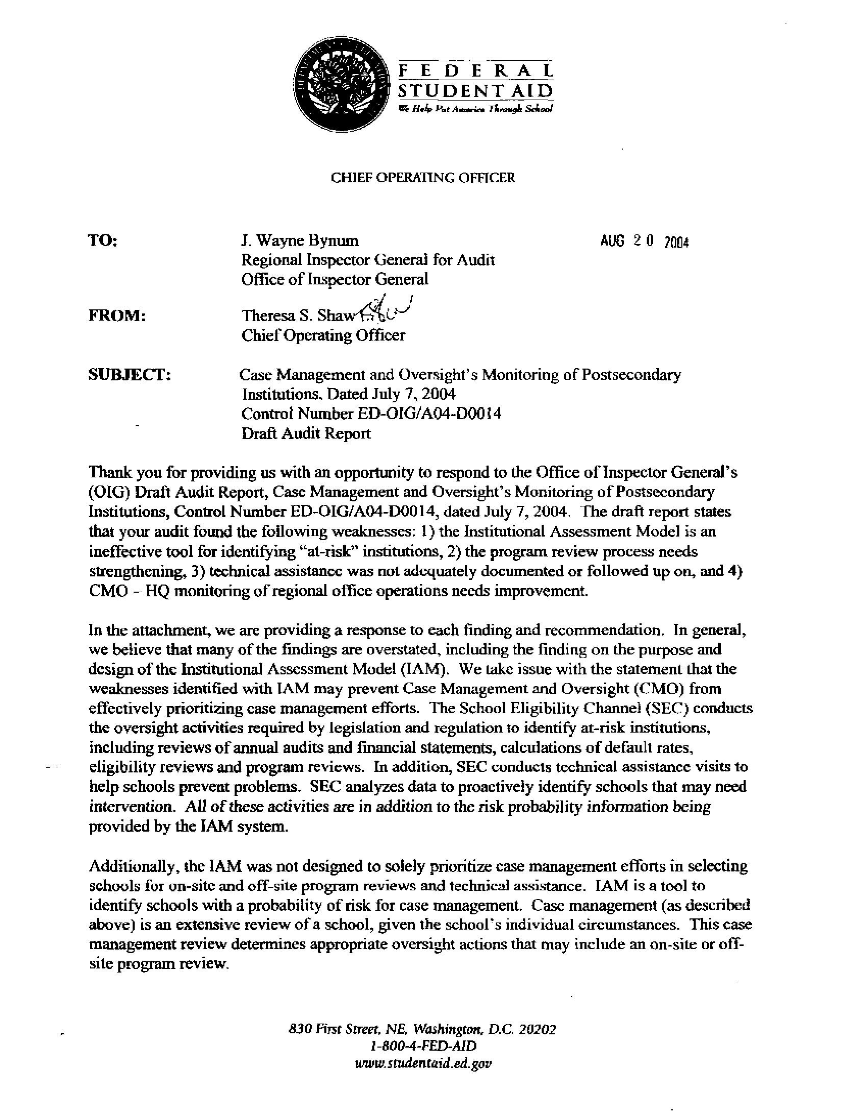

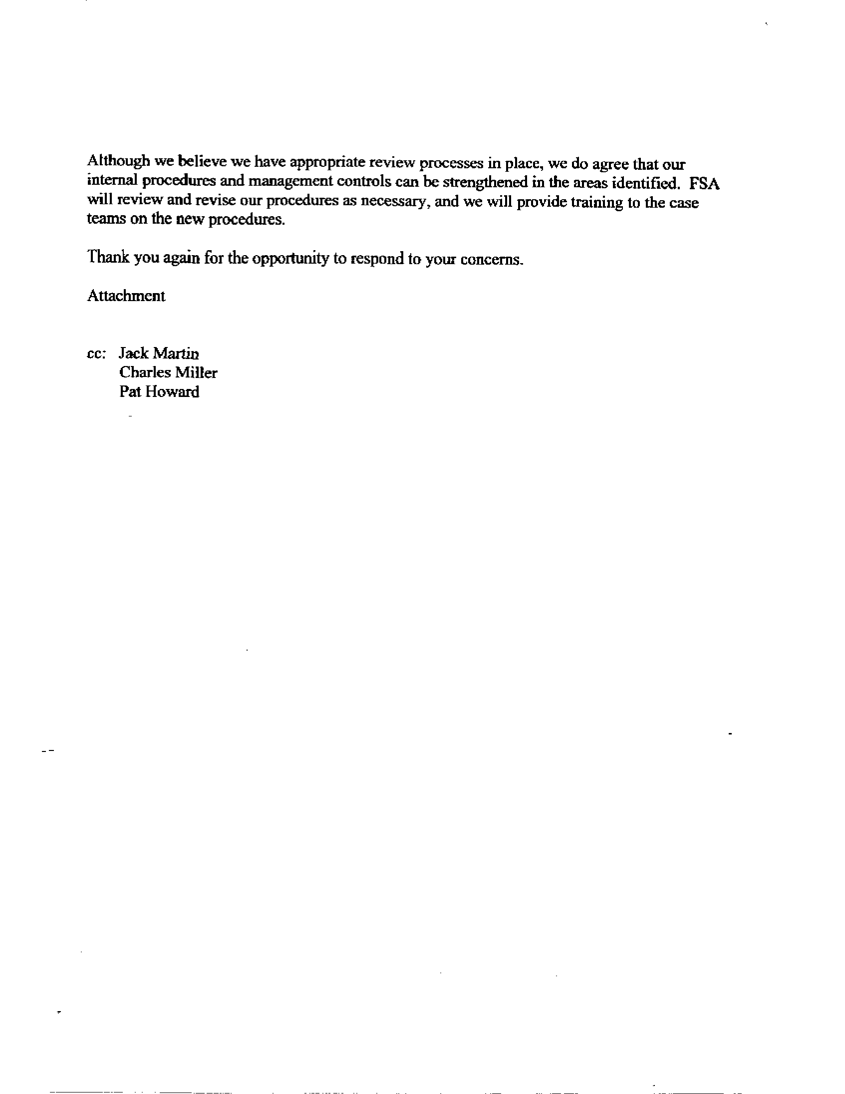

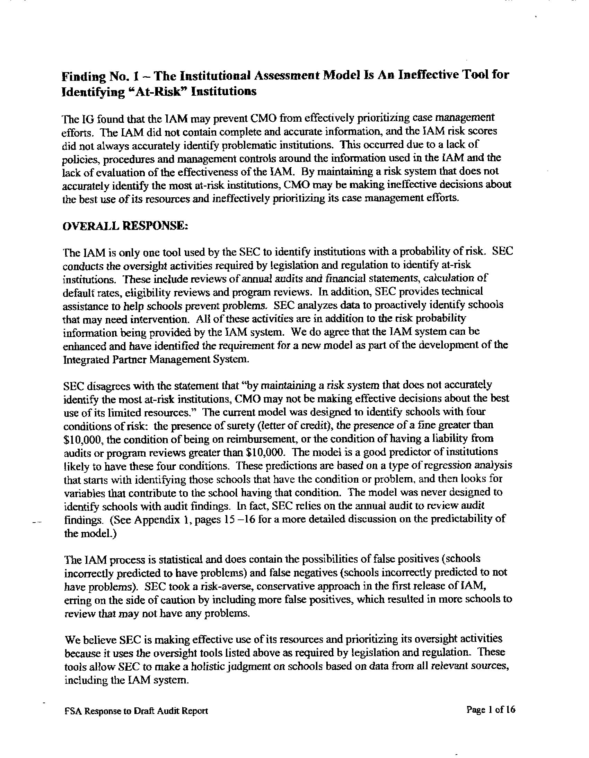

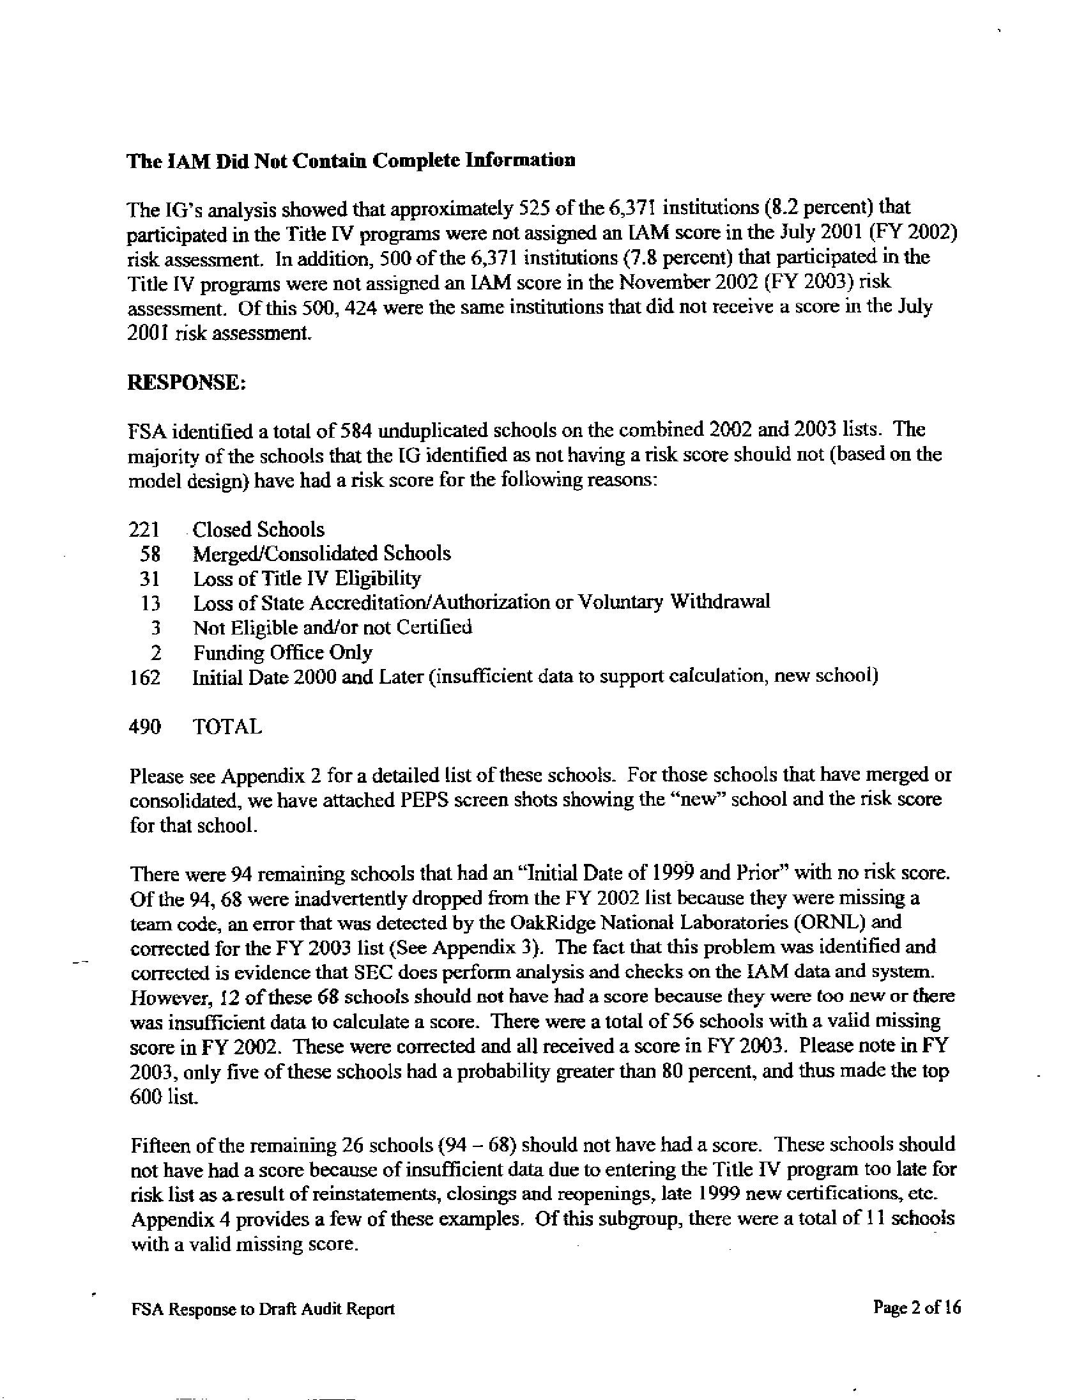

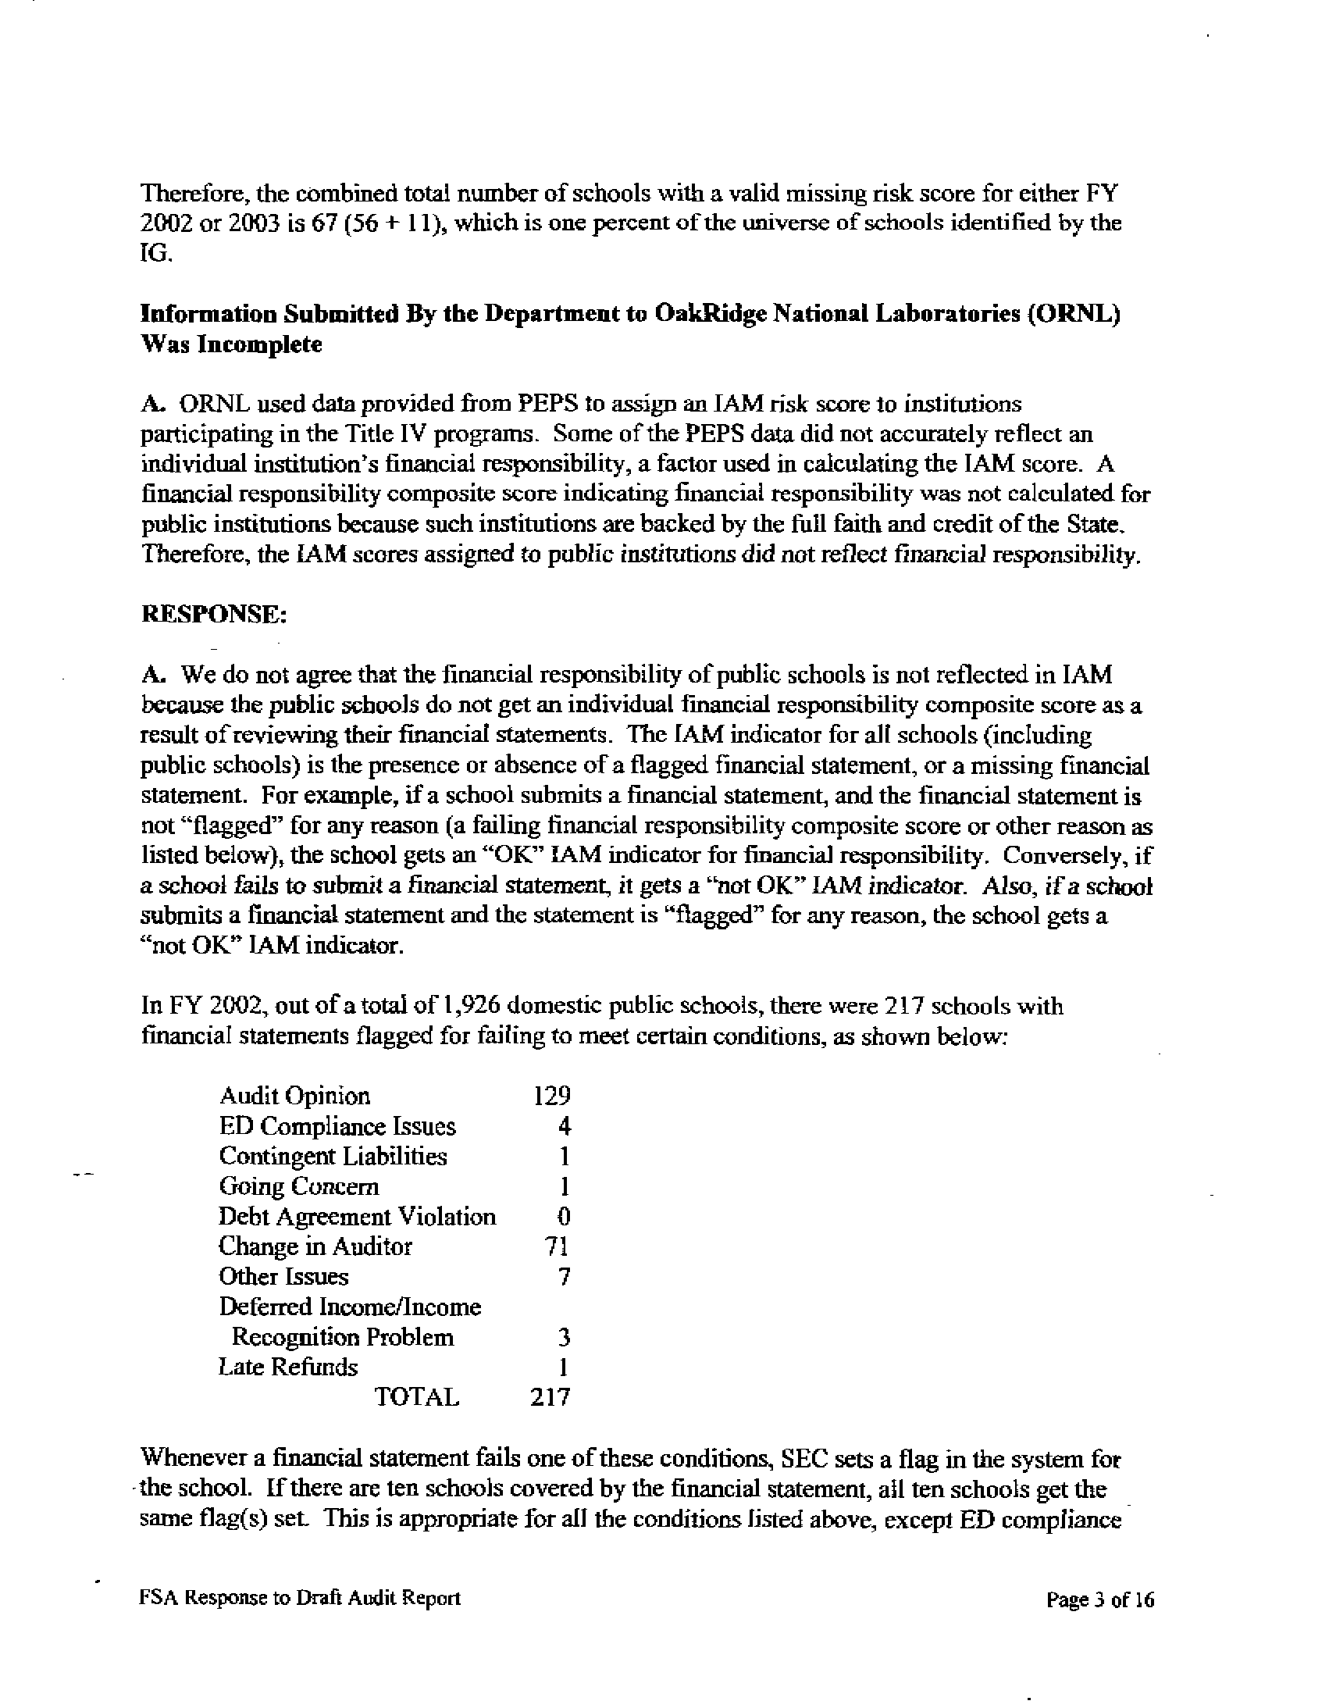

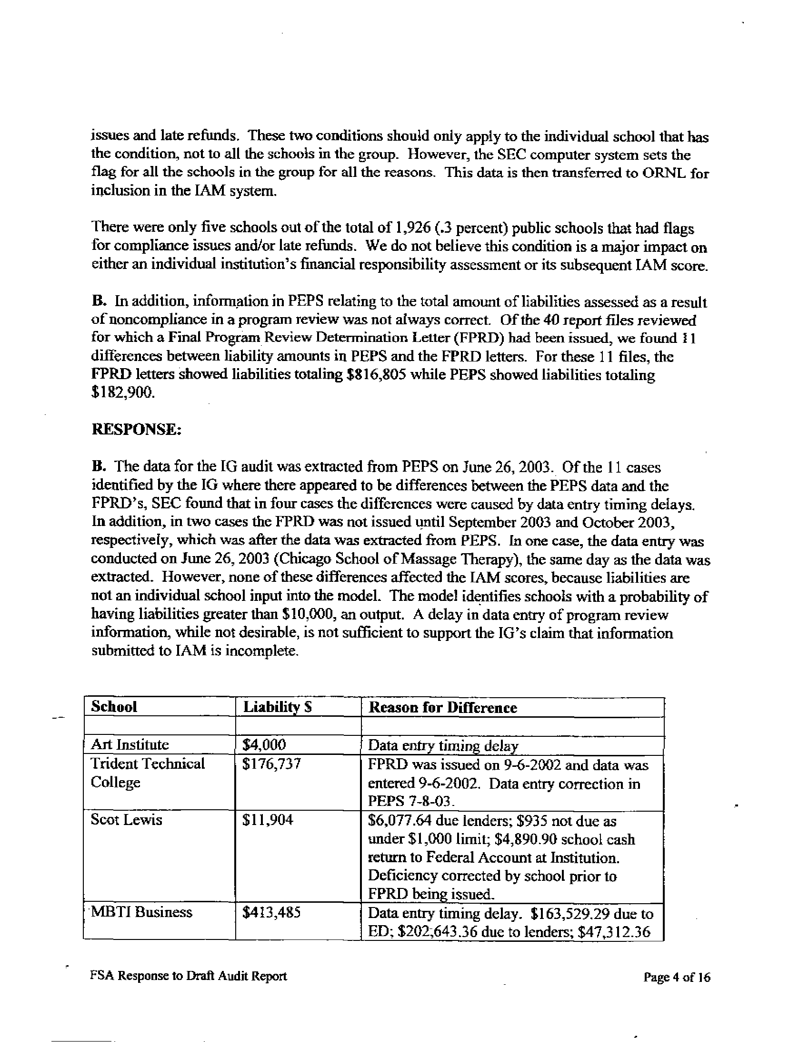

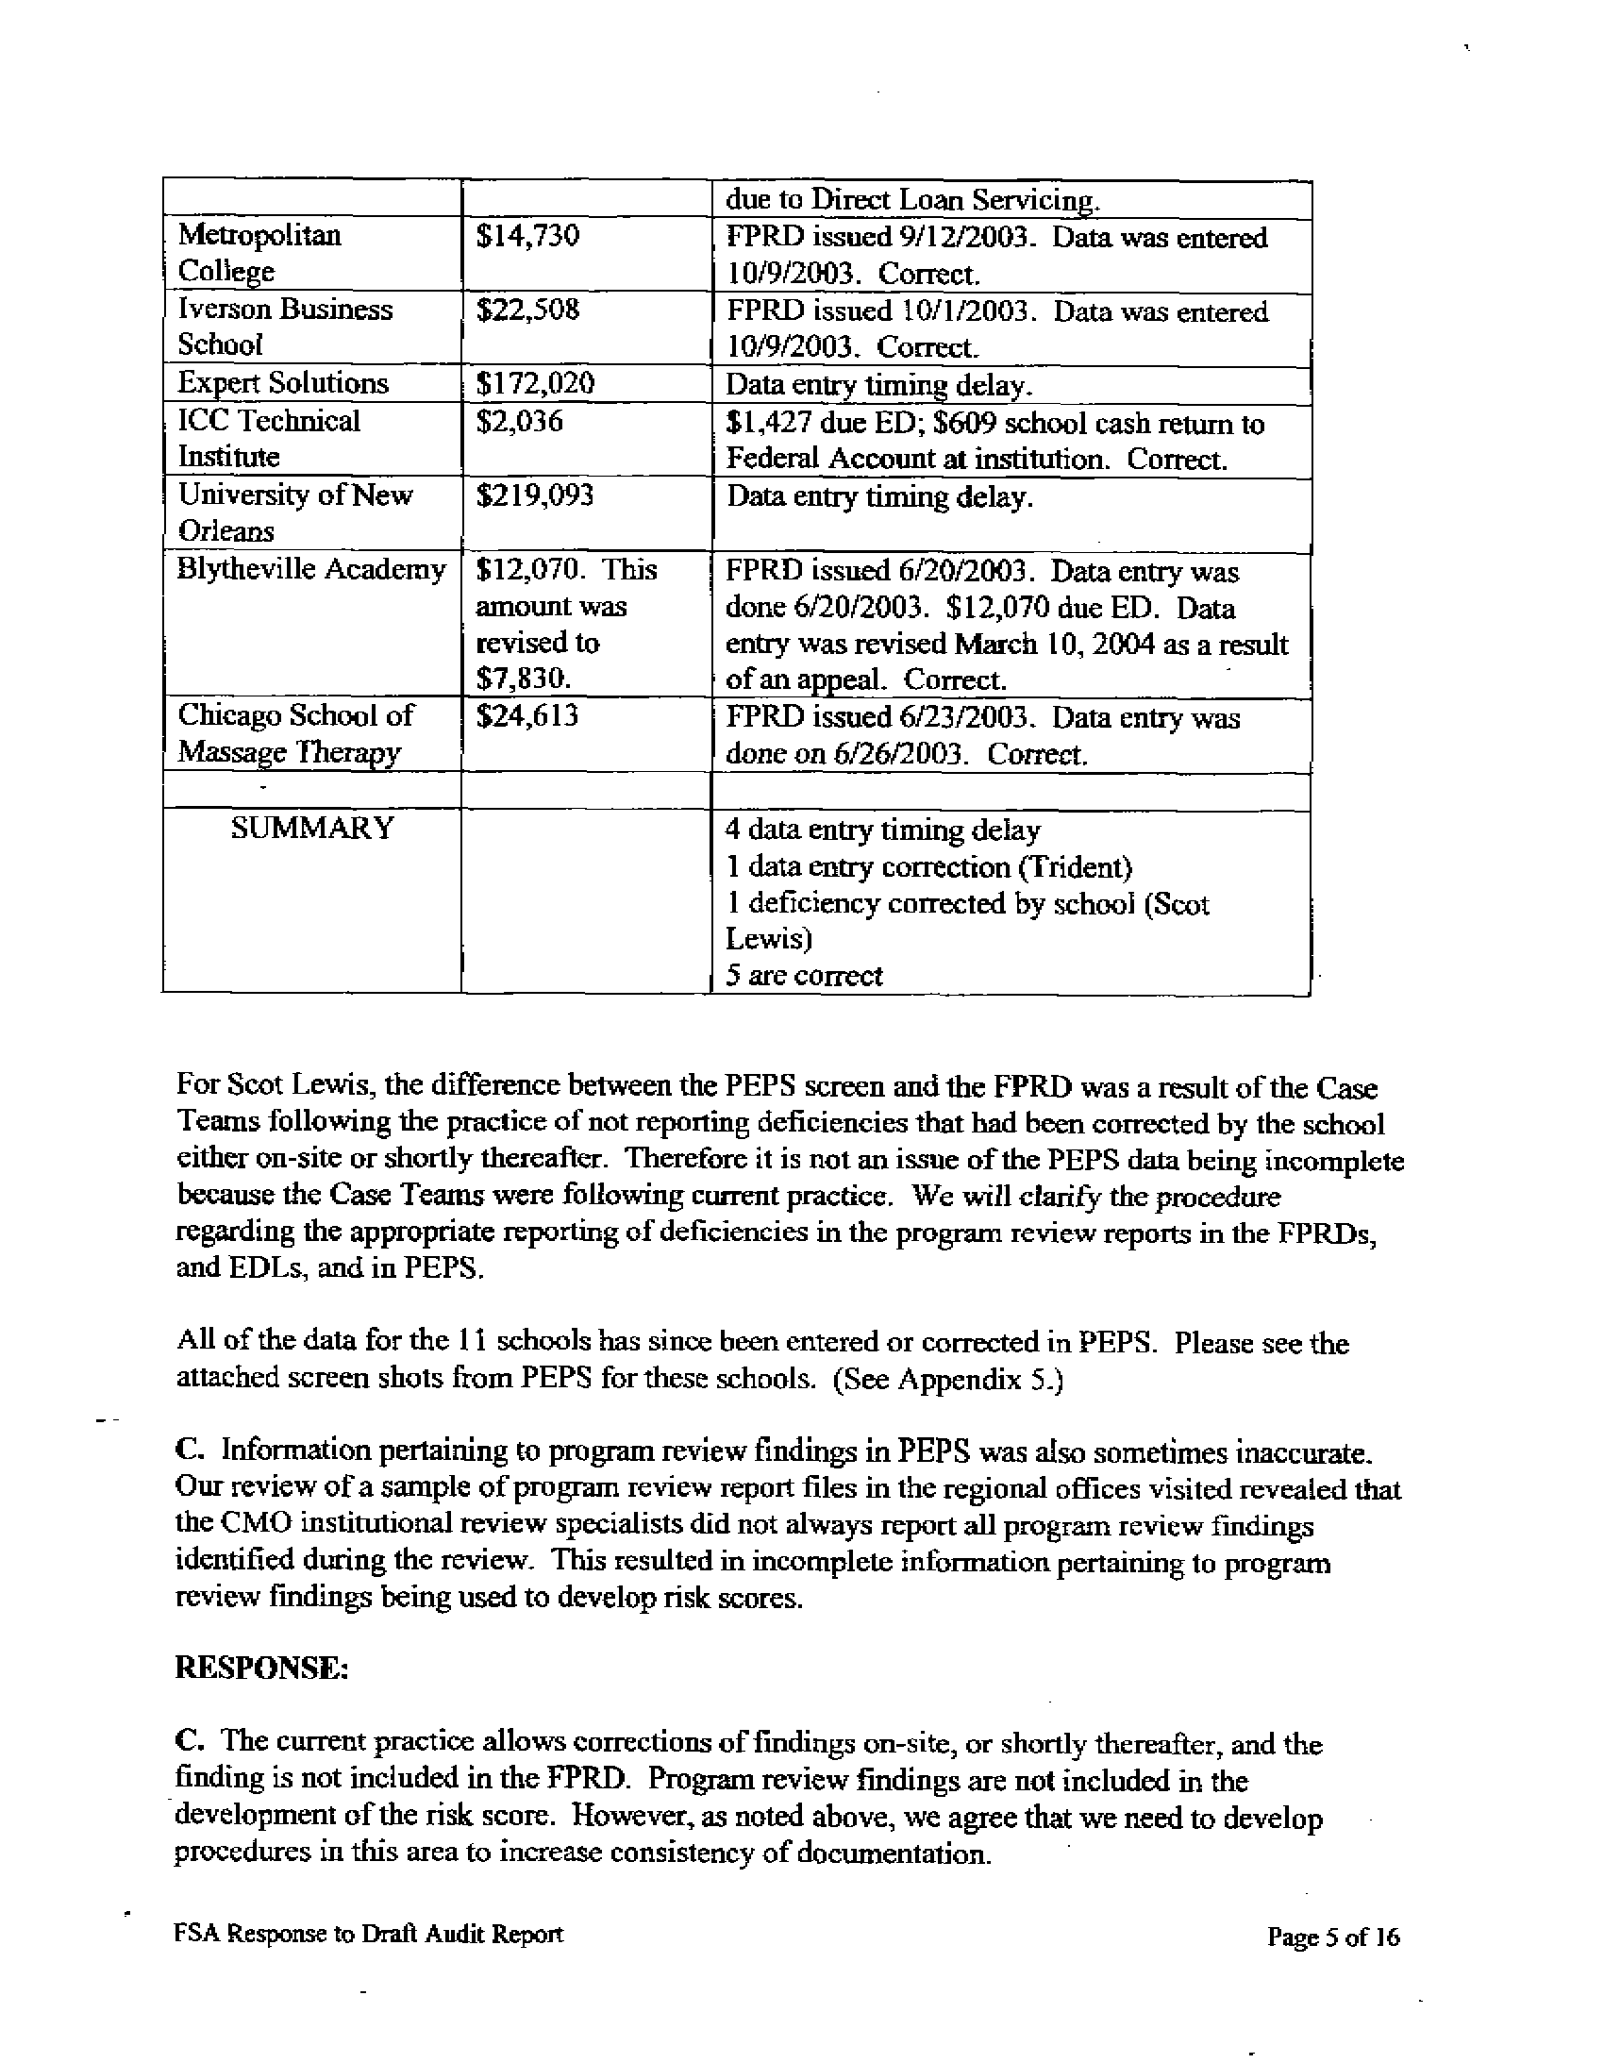

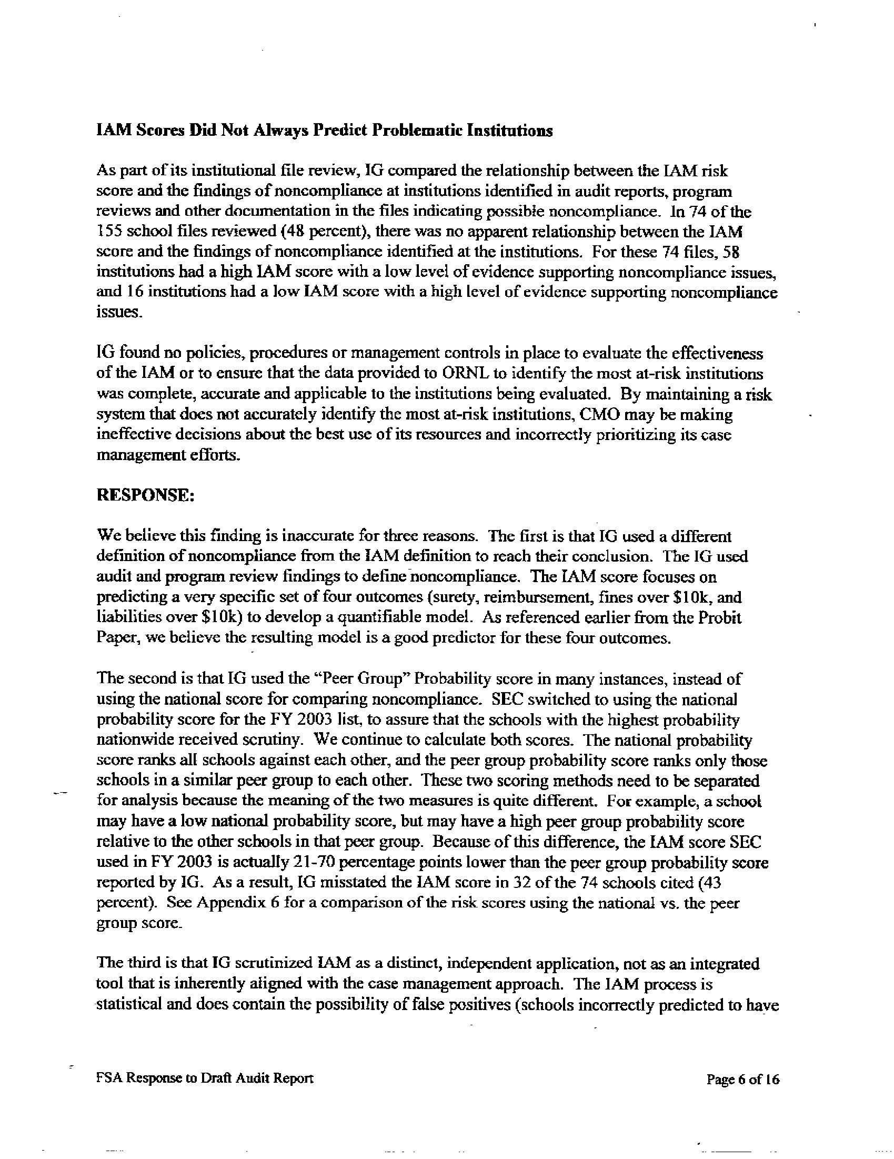

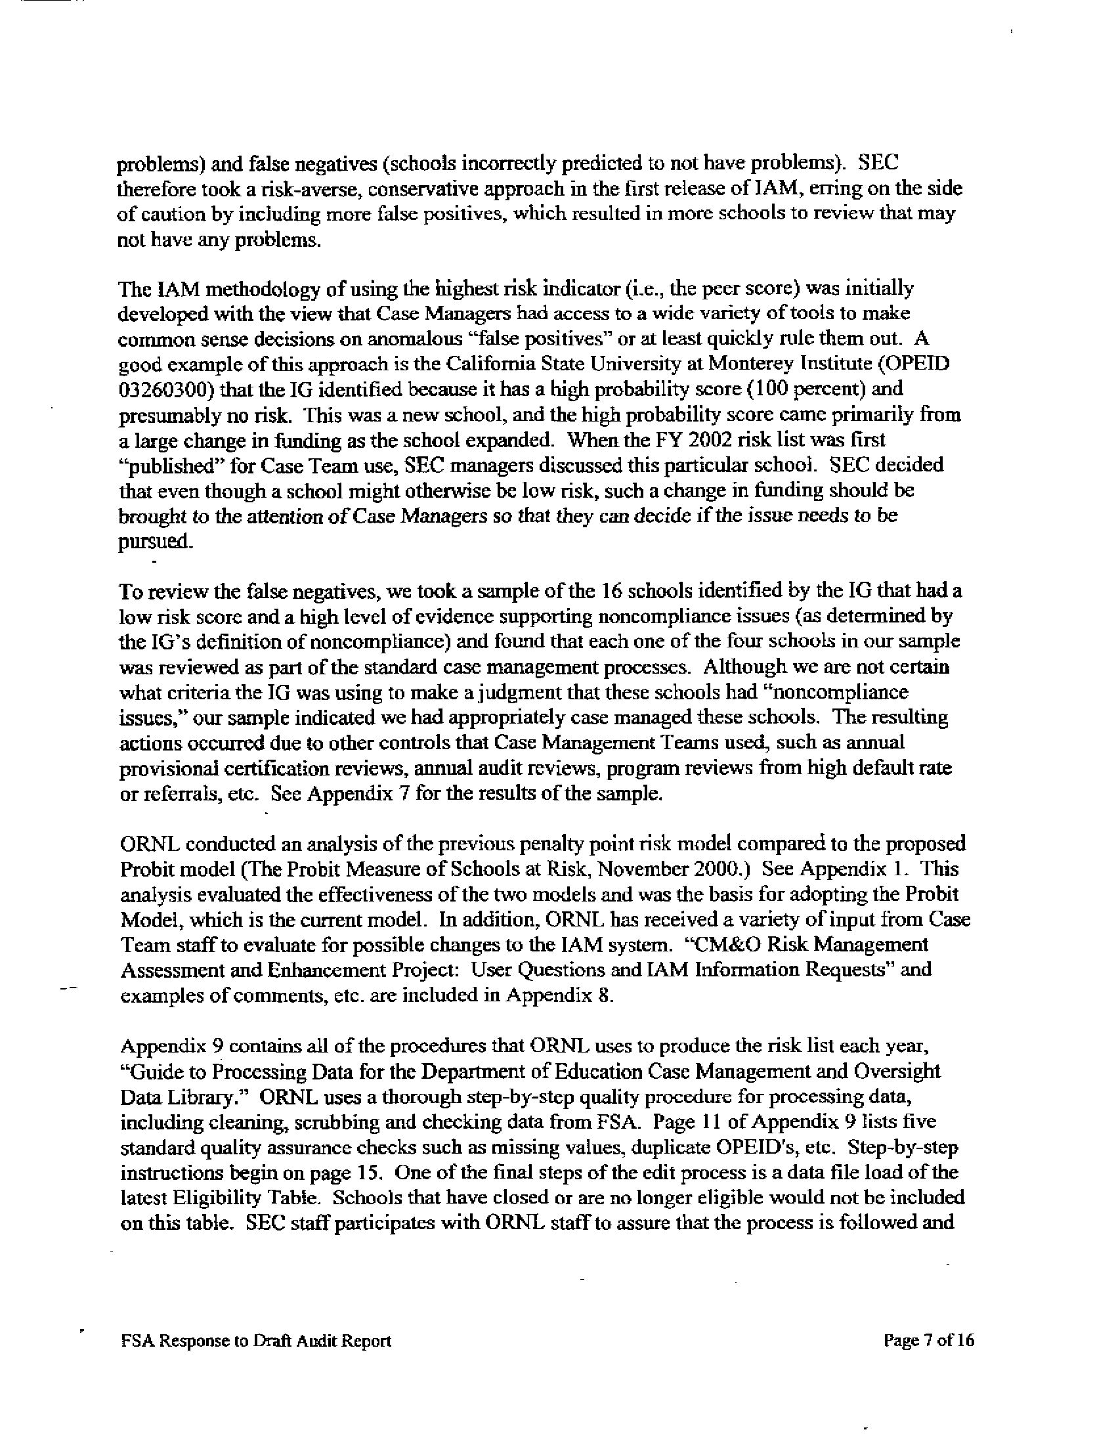

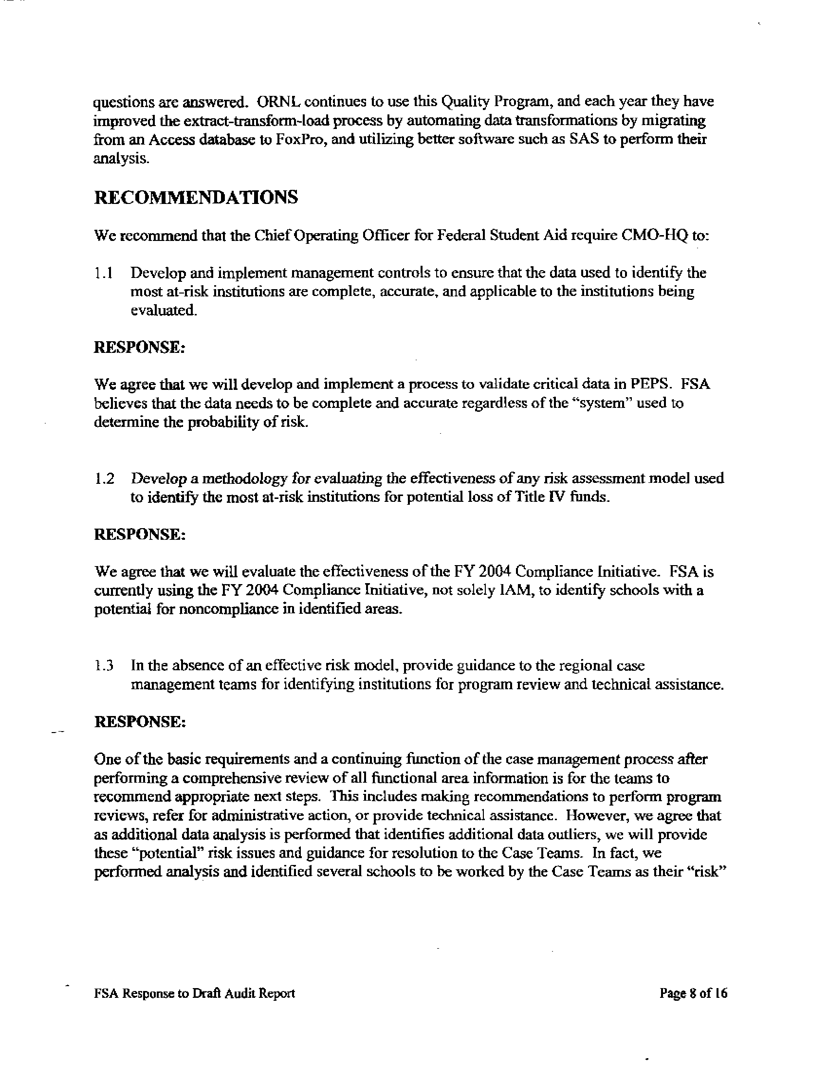

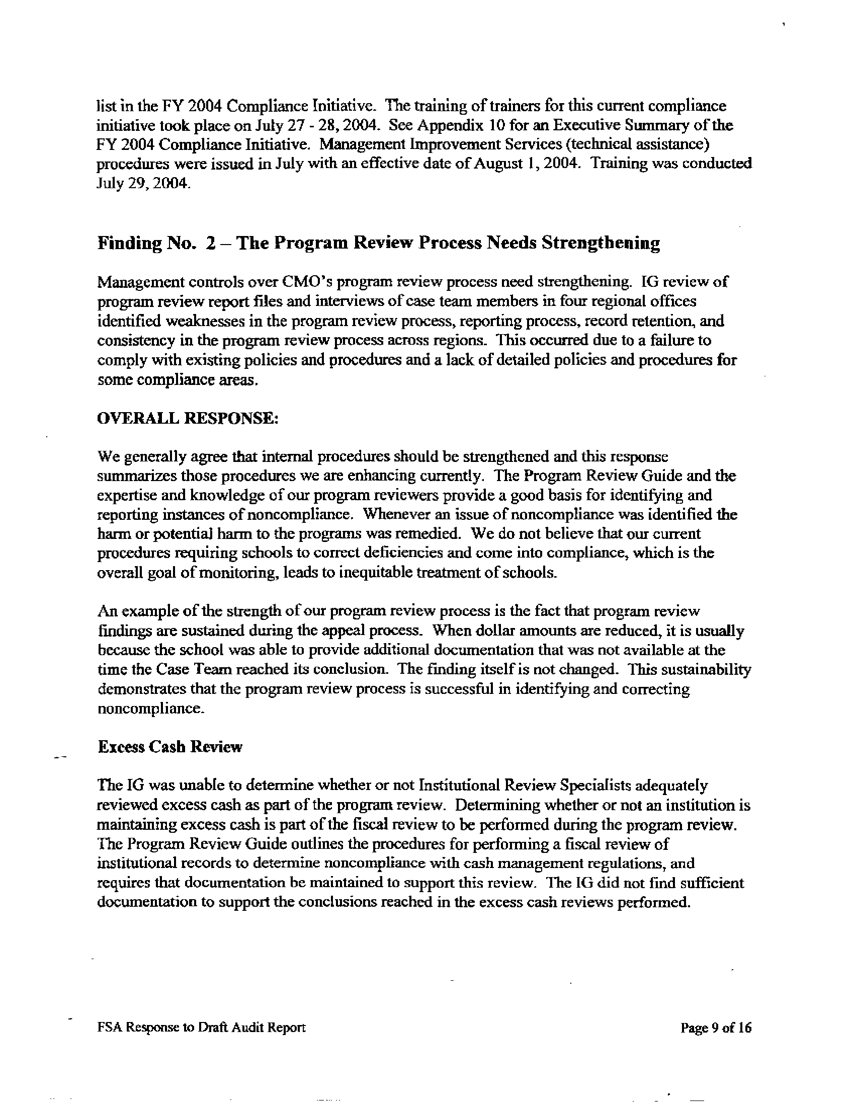

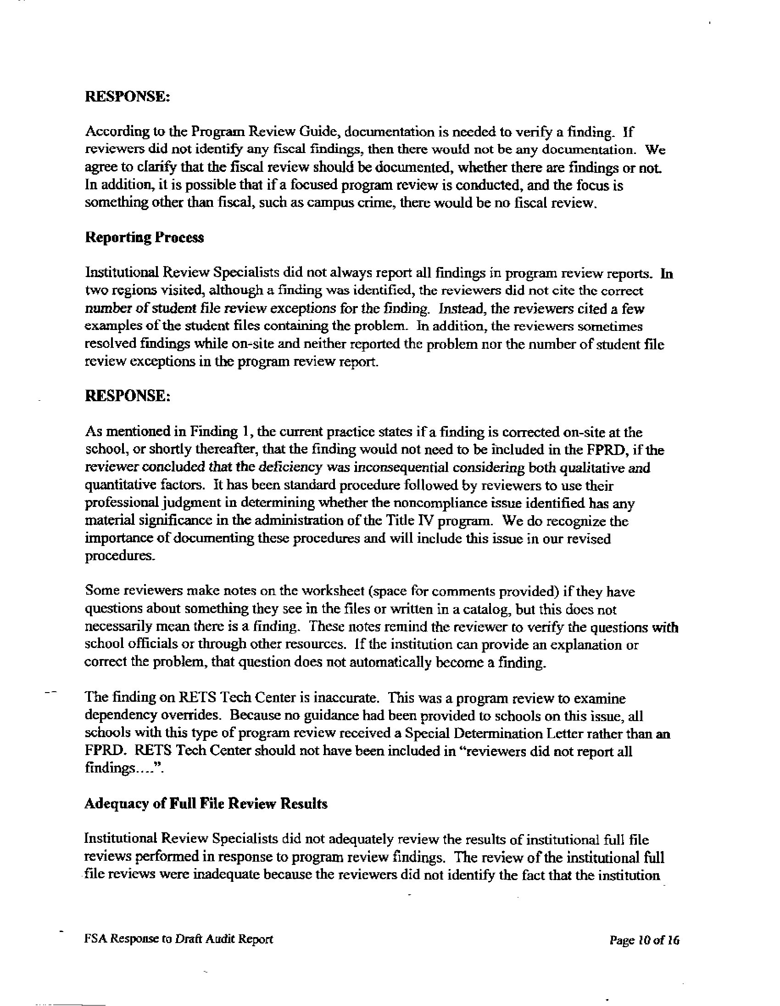

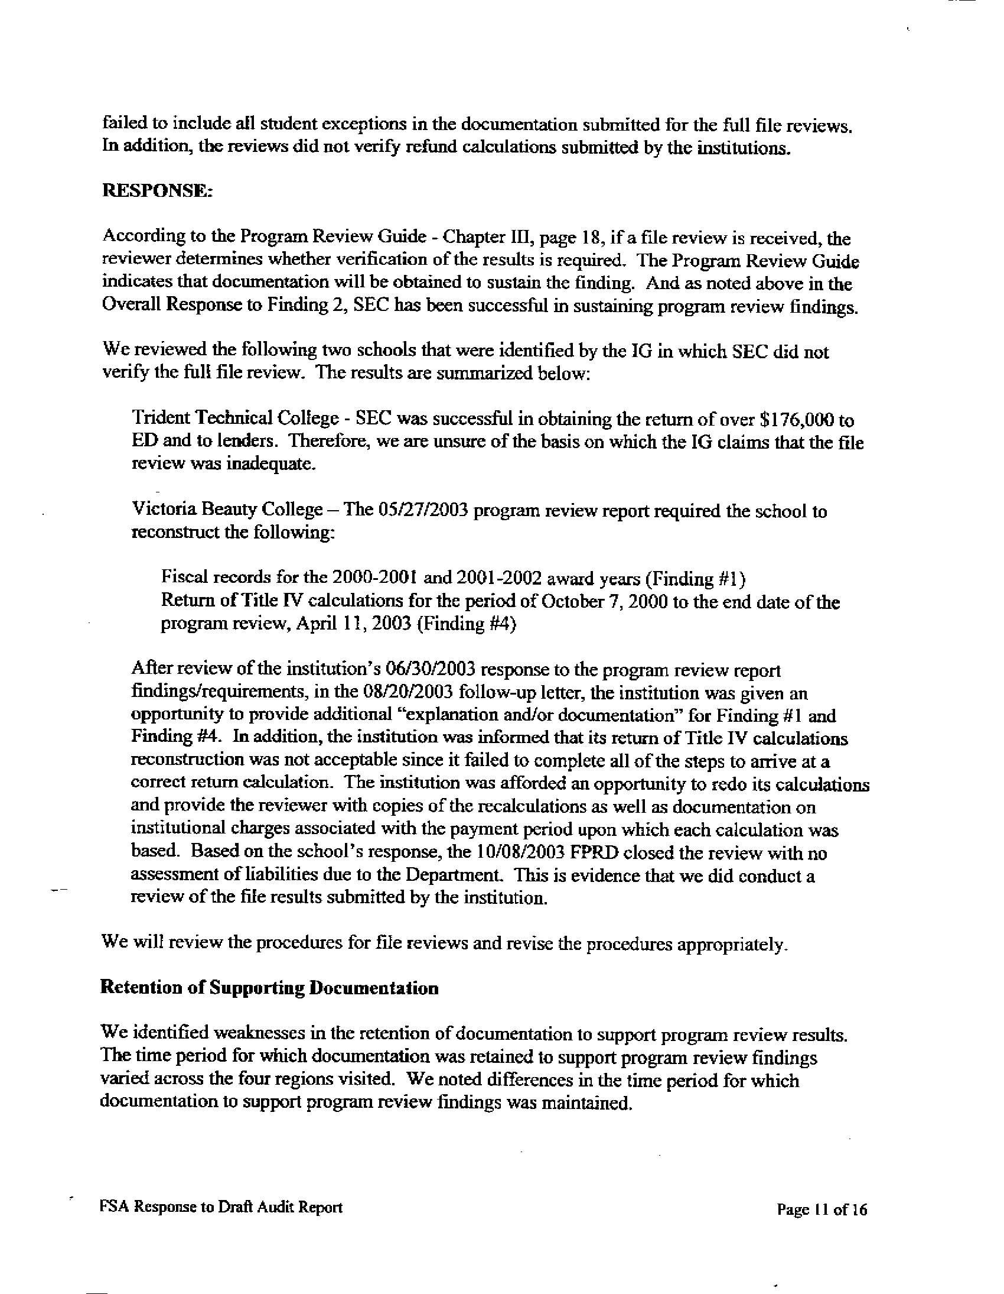

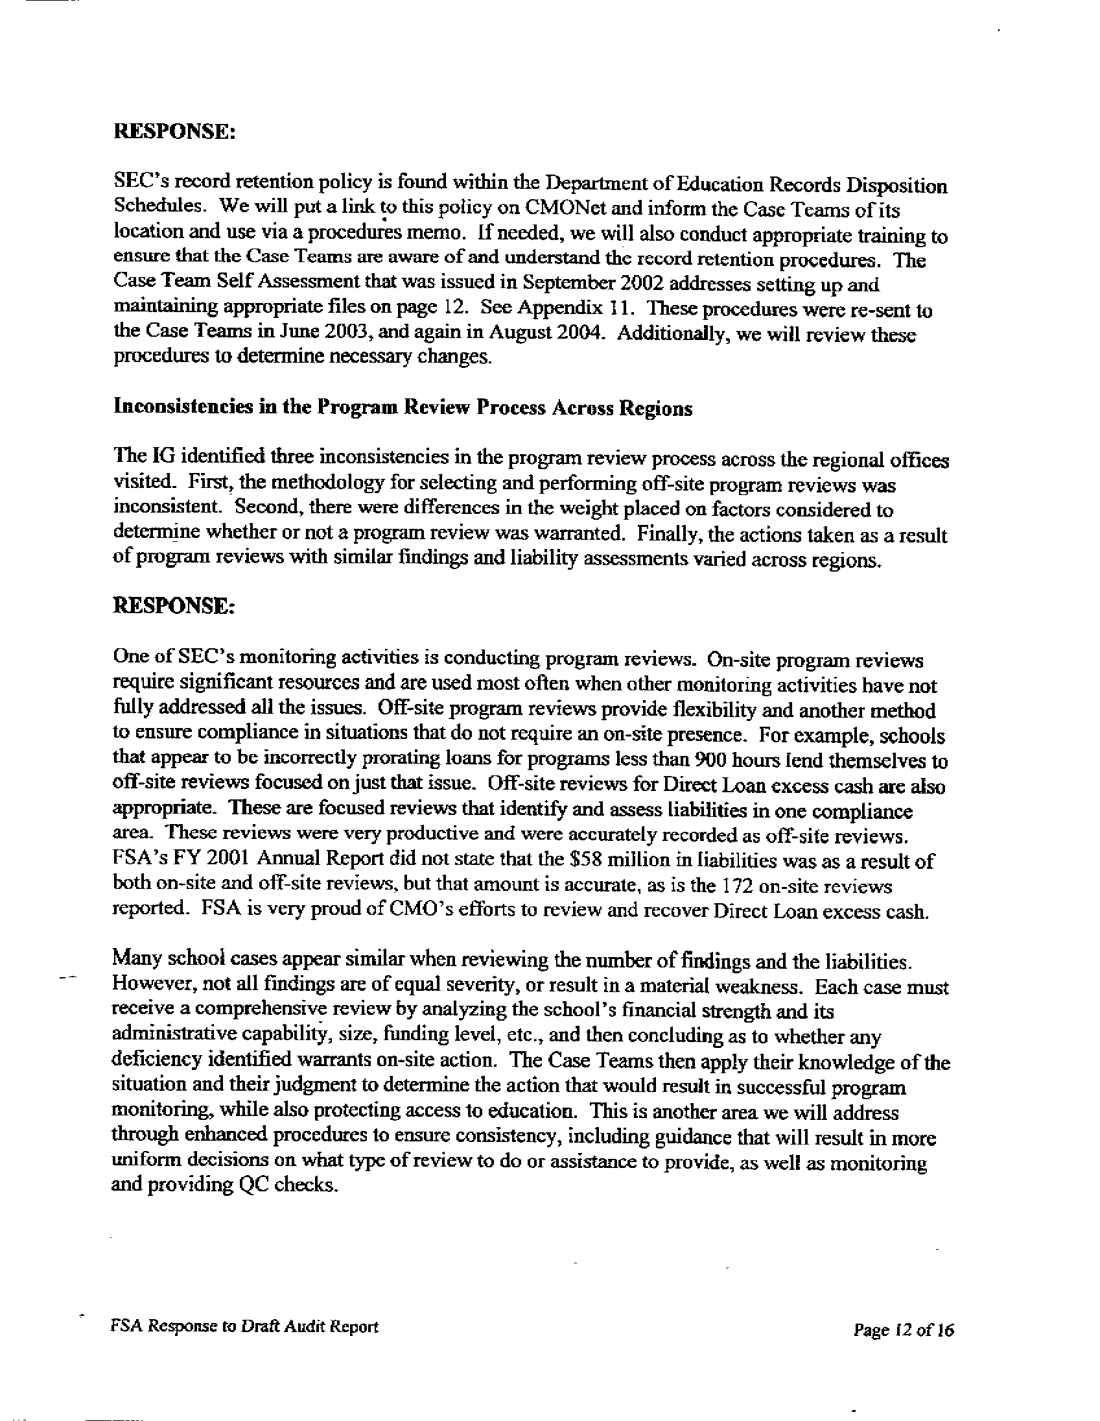

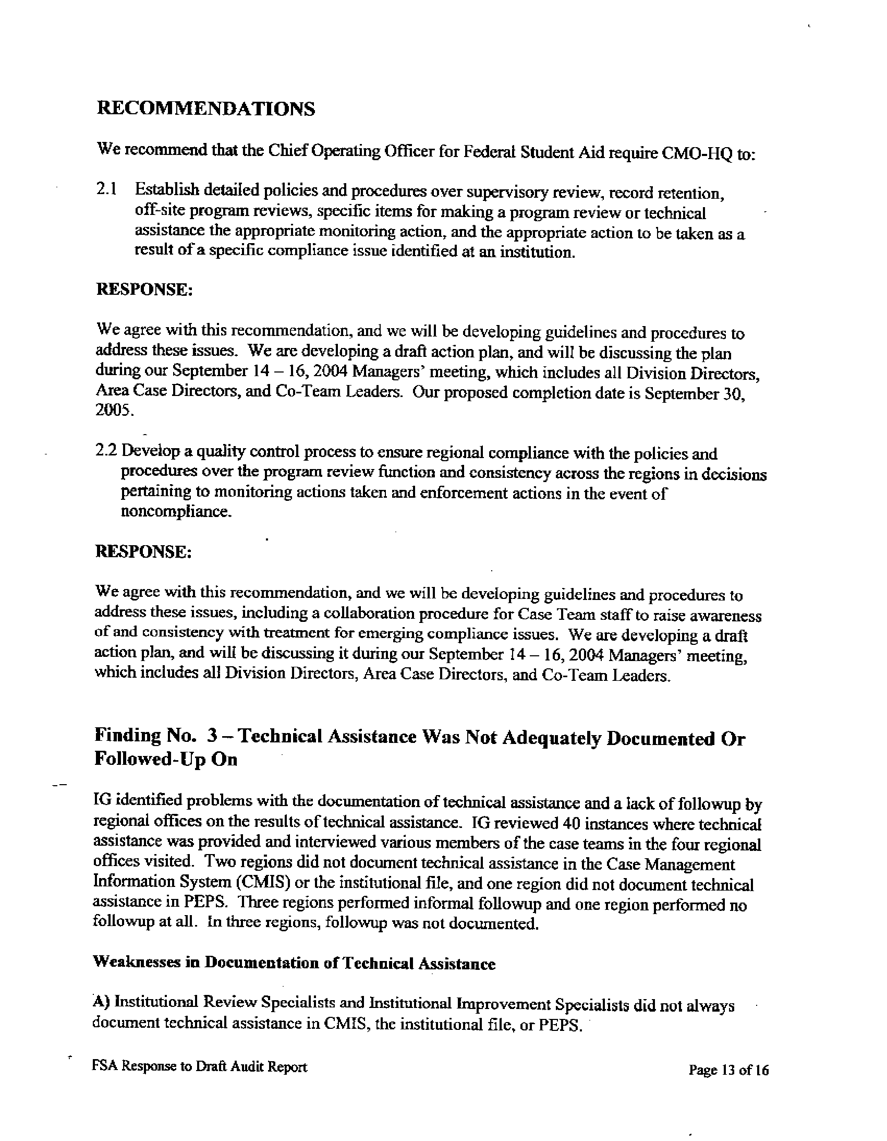

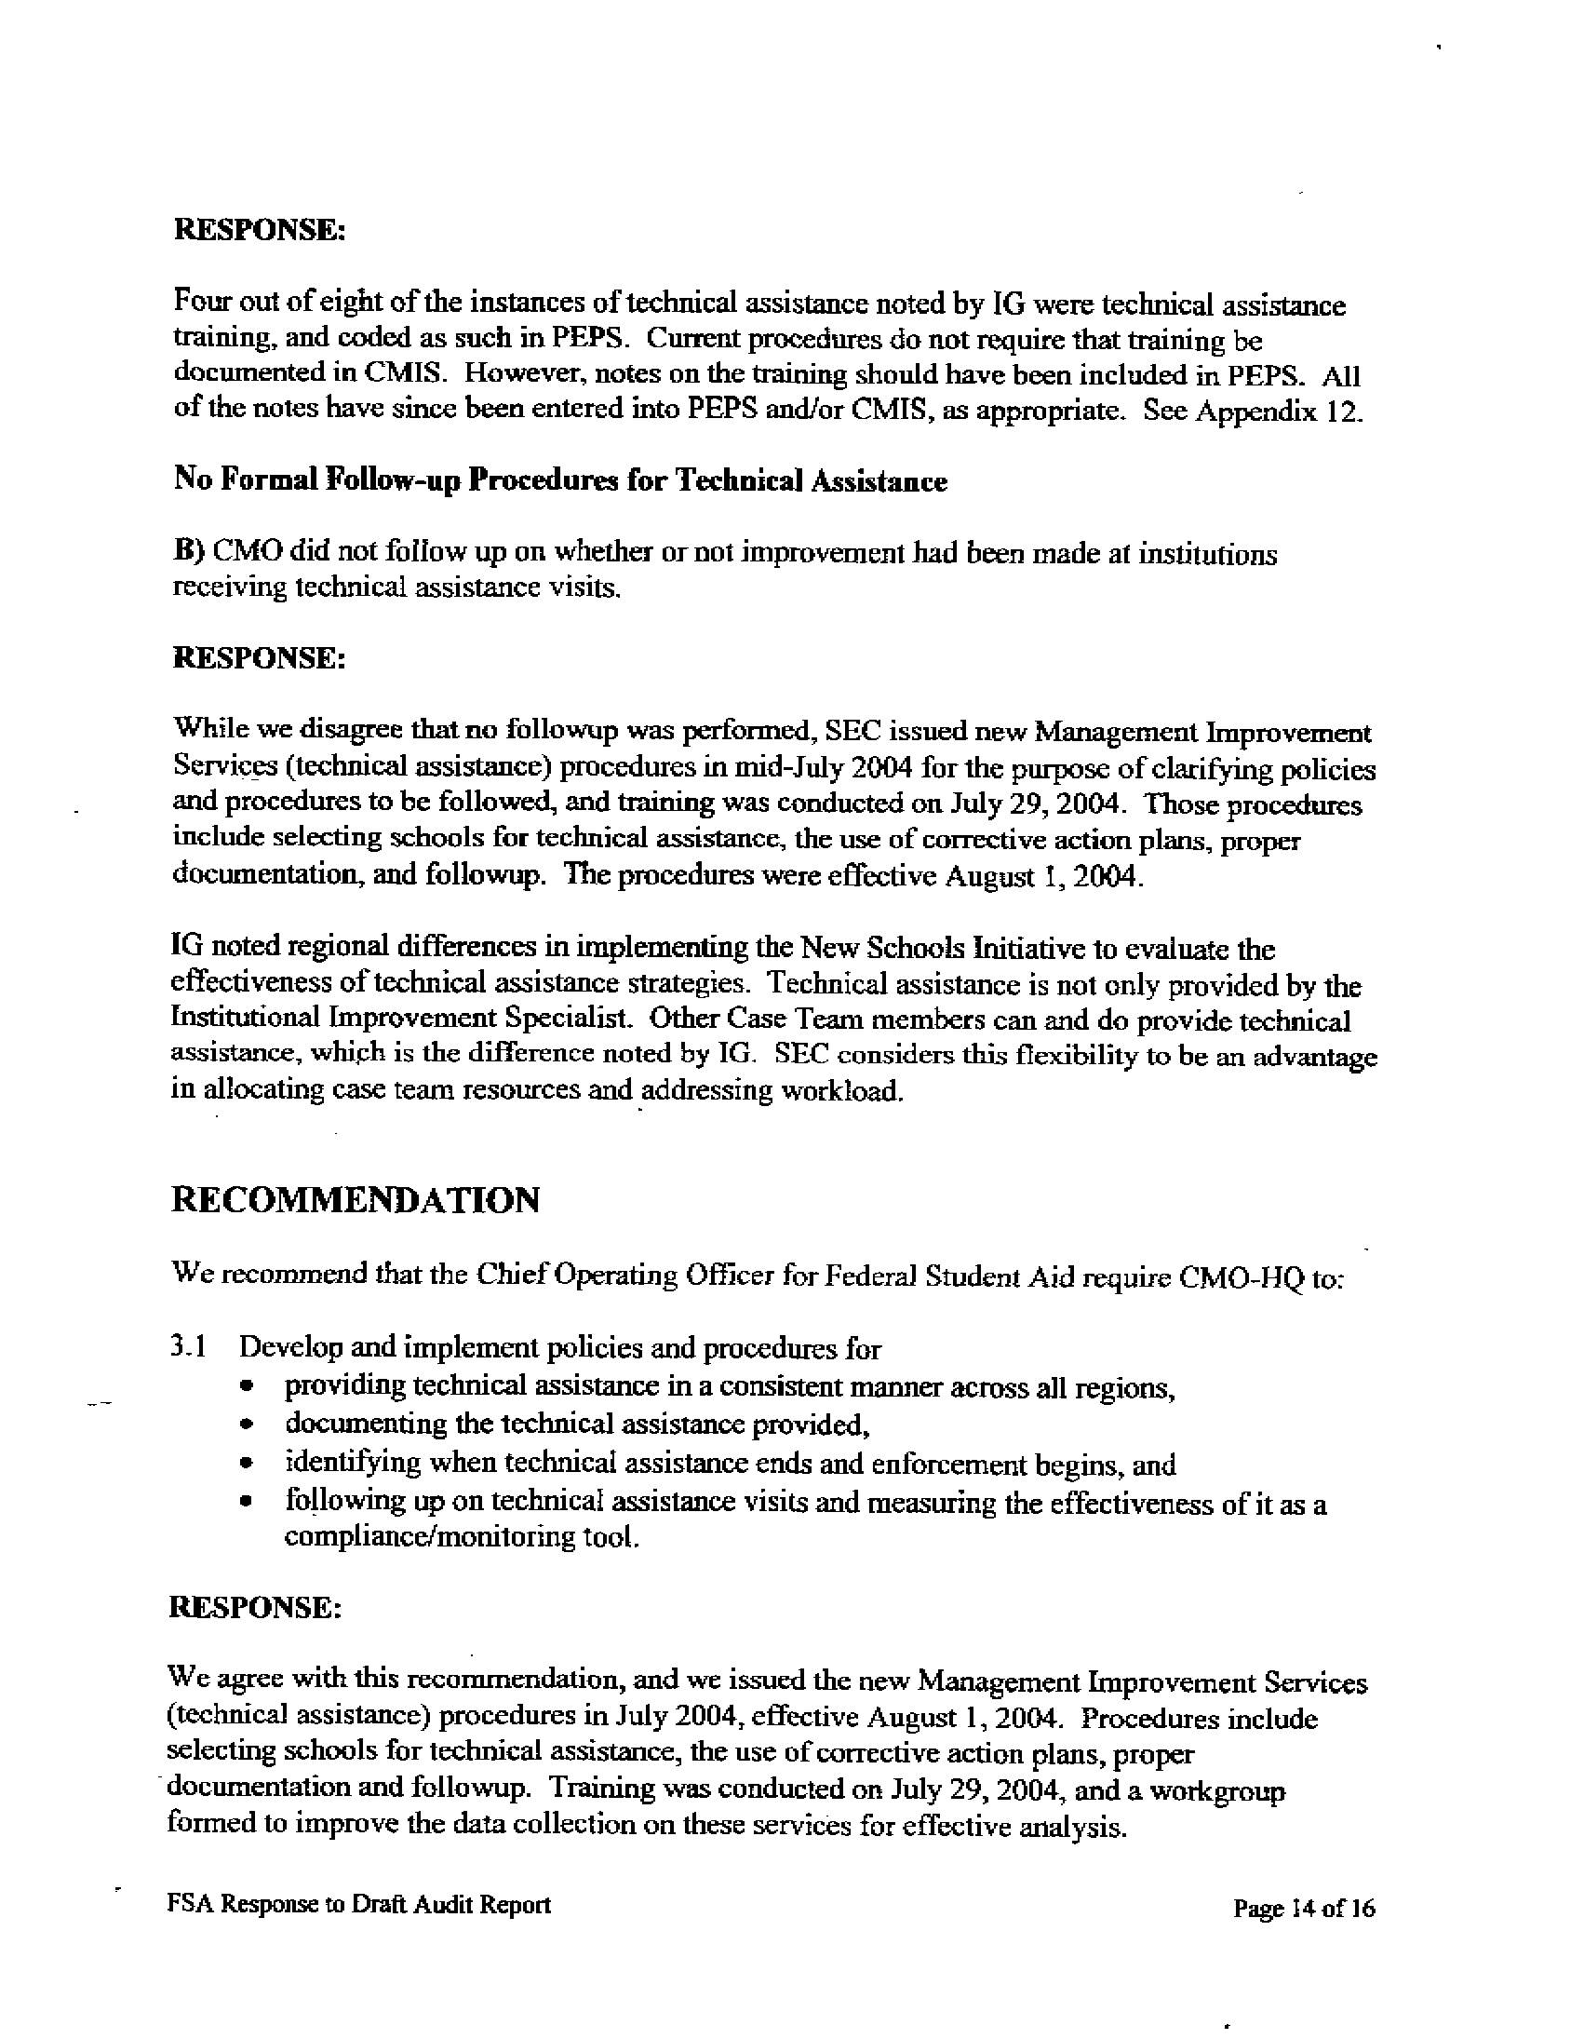

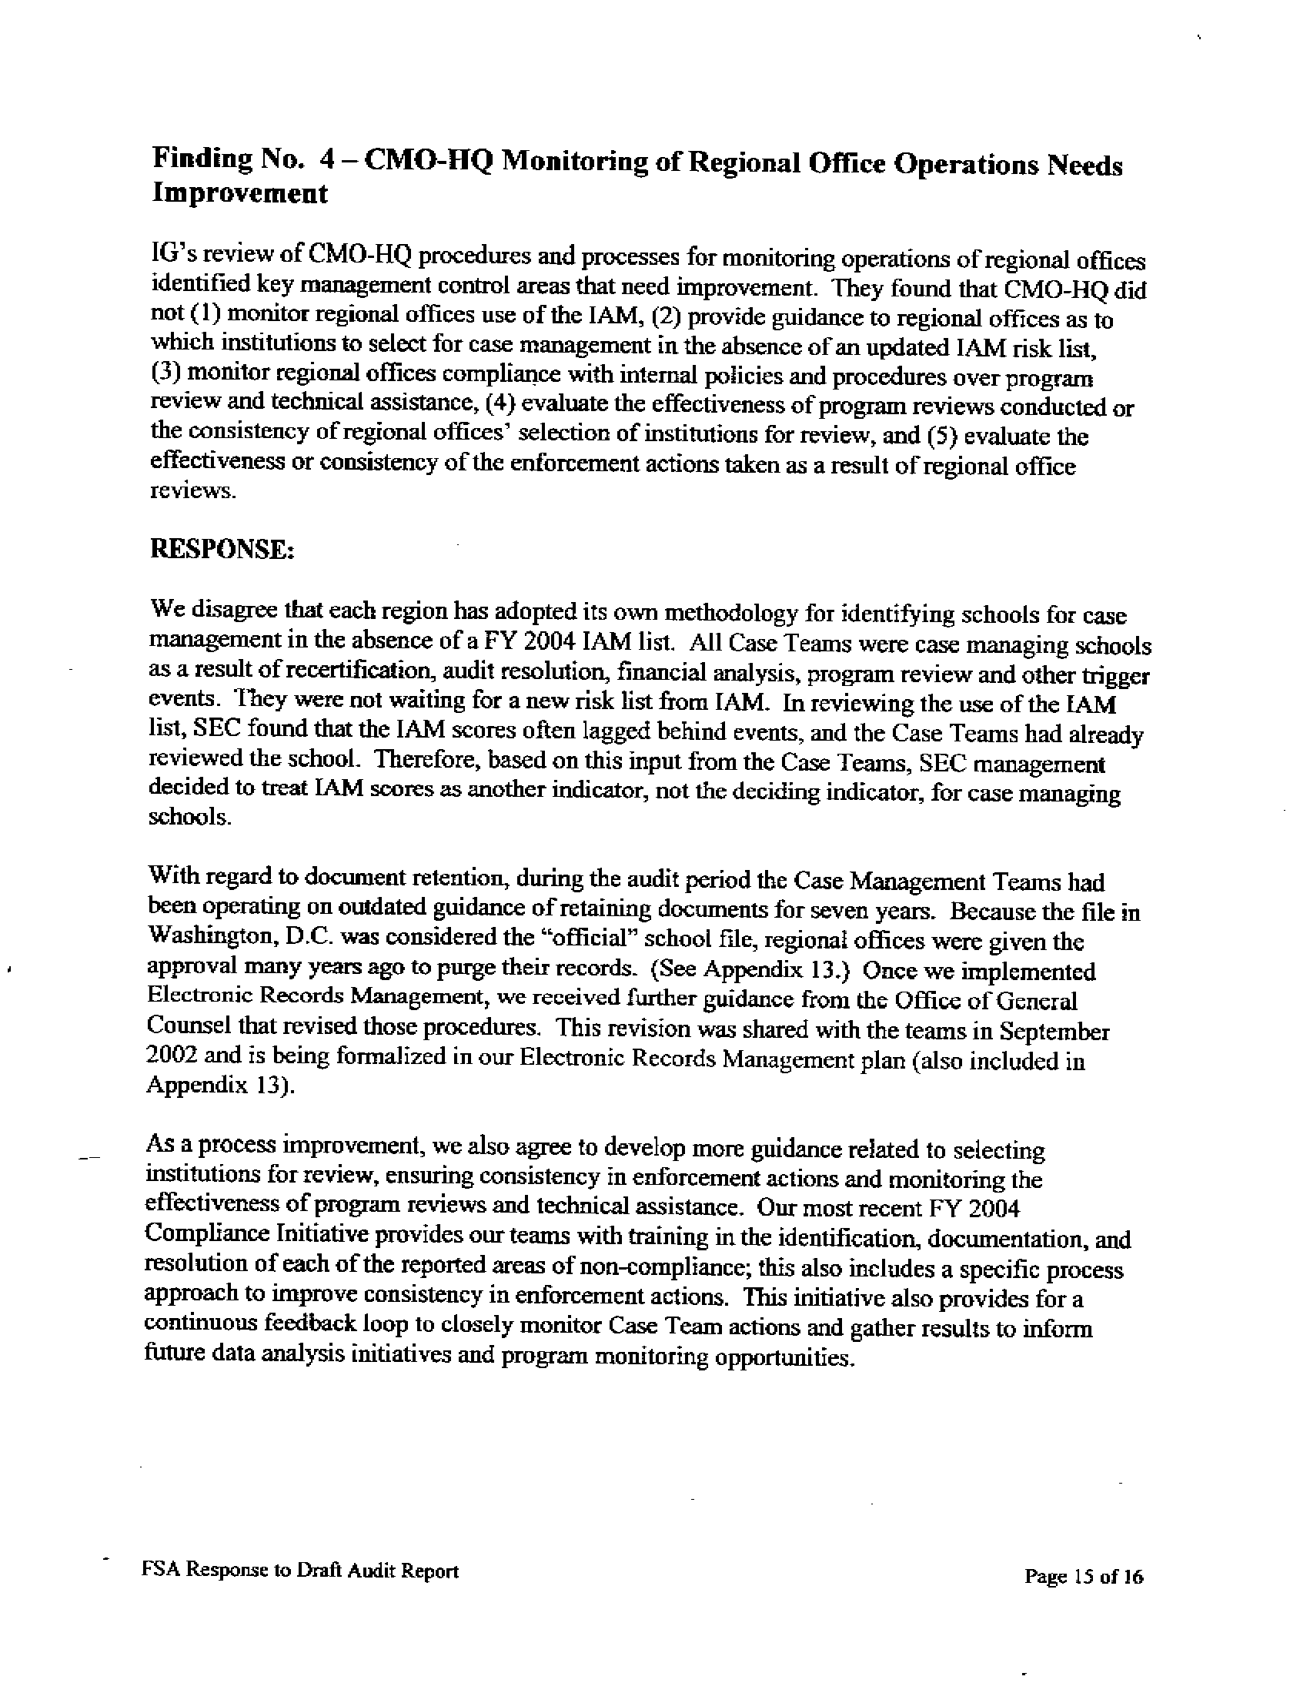

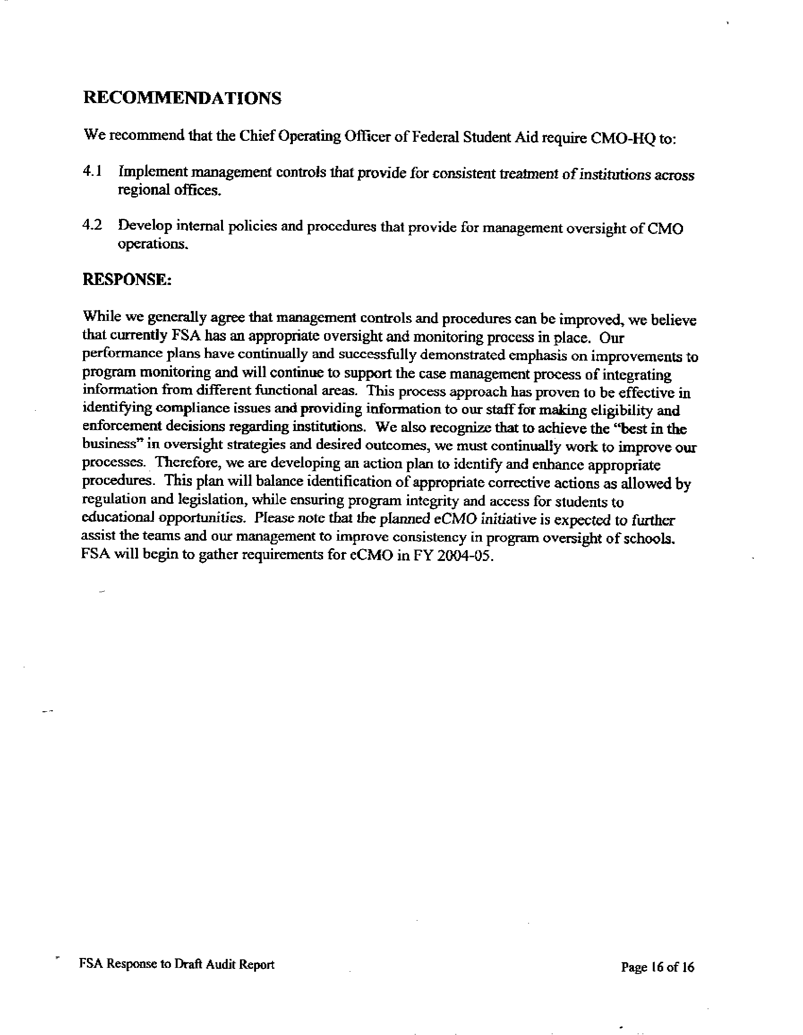
September 30, 2004

MEMORANDUM

TO: Theresa S. Shaw
Chief Operating Officer
Federal Student Aid

FROM: Helen Lew /s/ Helen Lew
Assistant Inspector General for Audit
Office of Inspector General

SUBJECT: FINAL AUDIT REPORT
Case Management and Oversight’s Monitoring of Postsecondary Institutions
Control No. ED-OIG/A04-D0014

Attached is the final audit report that covers the results of our review of Case Management and Oversight’s monitoring of postsecondary institutions during August 2001 through May 2003. An electronic copy has been provided to your Audit Liaison Officer. We received your comments nonconcurring with the findings and recommendations in our draft report. Our response to your comments is included in the Audit Results section of the report.

Corrective actions proposed (resolution phase) and implemented (closure phase) by your office will be monitored and tracked through the Department’s Audit Accountability and Resolution Tracking System (AARTS). ED policy requires that you develop a final corrective action plan (CAP) for our review in the automated system within 30 days of the issuance of this report. The CAP should set forth the specific action items, and targeted completion dates, necessary to implement final corrective actions on the findings and recommendations contained in this final audit report.

In accordance with the Inspector General Act of 1978, as amended, the Office of Inspector General is required to report to Congress twice a year on the audits that remain unresolved after six months from the date of issuance.

In accordance with the Freedom of Information Act (5 U.S.C. §552), reports issued by the Office of Inspector General are available to members of the press and general public to the extent information contained therein is not subject to exemptions in the Act.

We appreciate the cooperation given us during this review. If you have any questions, please call Regional Inspector General J. Wayne Bynum at 404-562-6477 or Assistant Regional Inspector General Mary Allen at 404-562-6465.

Enclosure

OIG reported a similar finding in a “Review of Case Management & Oversight’s Program Review Function,” Control No. ED-OIG A04-90003, issued in September 2000. This review found that CMO did not have a formal and consistent supervisory review process in place. Each region visited had unique supervisory review procedures for reports. This was documented differently in each region, and in one region it was not documented at all.
There were a few exceptions to these sample sizes. In order to have adequate audit coverage, if the universe of program reviews was small, we selected a larger percentage of files (from 25 percent to 50 percent) in order to have a sample size large enough to form conclusions on our review. In every case, we reviewed a minimum of three files.
There were a few exceptions to these sample sizes. In order to have adequate audit coverage, if the universe of program reviews was small, we selected a larger percentage of files (from 25 percent to 100 percent) in order to have sample size large enough to form conclusions on our review. In every case, we reviewed a minimum three files.

