Muon Collider
Advanced Accelerator R&D Proposal

Abstract
Muon Colliders offer a possible long term path to lepton-lepton collisions at center-of-mass energies √s ≥ 1 TeV. We propose a program of advanced accelerator R&D aimed at developing the Muon Collider concept. The proposed R&D program is motivated by recent progress on Muon Collider design in general, and in particular, by new ideas that have recently emerged on muon cooling channel design. We request support to complement and extend the ongoing Muon Collider R&D studies. This additional R&D will enable the development of a complete 6D cooling channel scheme for a Muon Collider with √s = 1.5 TeV, including design, component prototyping and testing, and demonstration in a muon beam. In addition, in the light of recent developments, we propose to take a fresh look at the overall design for a 1.5 TeV Muon Collider, identify the outstanding R&D issues not being addressed by the ongoing R&D program, and formulate a longer term R&D plan to address these issues. This proposal describes plans and deliverables for FY07, FY08 and beyond, and preliminary budget requests.

- INTRODUCTION

Muon Colliders offer a possible long term path to lepton-lepton collisions at center-of-mass energies √s ≥ 1 TeV. We propose a program of advanced accelerator R&D aimed at developing the Muon Collider concept. The proposed R&D is motivated by recent progress on Muon Collider design in general, and in particular, by recent new ideas on muon cooling channel design.

A Muon Collider complex is shown schematically in Fig. 1. It consists of the following major sub-systems:
i) Proton Driver to provide short bunches of several GeV protons and a beam power on target of one to a few megawatts.
ii) Proton target, pion collection, and decay channel to produce and capture a high-intensity beam of low energy muons (produced from pion decay).
iii) Buncher and phase rotation system to capture the muons into bunches and reduce the energy spread within the bunches using phase rotation.
iv) 6D muon cooling system to cool the muon beam by a factor of ~10⁶.
v) Acceleration system to accelerate the muons to their final energy.
vi) Collider ring.
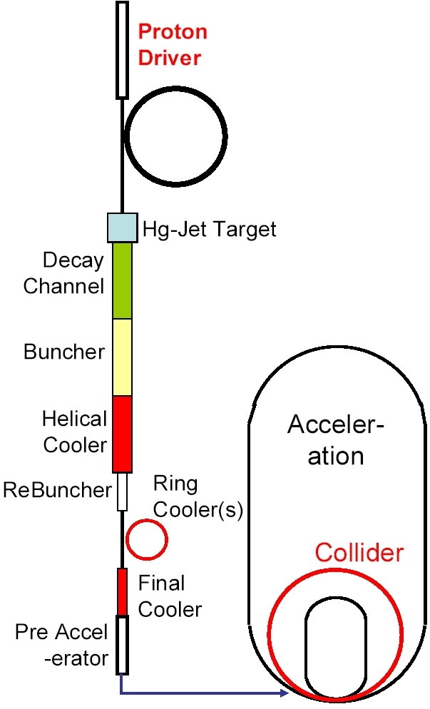
Fig.1: Muon Collider schematic for the design developed by the NFMCC.

The first detailed Muon Collider study [1] was conducted in 1995. This study assessed the physics program, specified the required collider parameters, and assessed the feasibility of achieving these parameters. The study concluded that (i) for a Muon Collider with √s = 1 TeV to a few TeV, the required luminosity is 10³⁴ – 10³⁵ cm⁻² s⁻¹, and (ii) Muon Colliders providing this luminosity seem plausible, but require an aggressive R&D program. In 1997, the Neutrino Factory and Muon Collider Collaboration (NFMCC [2]) was formed and began receiving support to pursue the required R&D program. Further studies by the NFMCC have identified, as the most challenging of the things needed before Muon Colliders can be considered viable, the design of a muon cooling channel to cool the initial muon beam in 6D phase space by about a factor of 10⁶. Other challenges included the design of a suitable proton driver, the development of the required target technology, the design of cost-effective bunching, phase rotation, and acceleration systems, and the design of the collider ring. In recent years there has been significant progress. In particular: (i) Suitable muliti-megawatt proton sources have been studied in the context of the future U.S., European, and Japanese particle physics programs (e.g., an 8 GeV SC H⁻ linac providing a 2 megawatt beam at Fermilab); (ii) A liquid Hg-jet target concept has been developed. The R&D is advanced, and a demonstration experiment (MERIT) is expected to run next year [3]; (iii) Cost-effective bunching and phase rotation channels have been successfully designed for Neutrino Factories. These designs are believed to also be suitable for Muon Colliders; (iv) Muon cooling R&D for the intital stages of a Muon Collider cooling channel has advanced, and a cooling channel demonstration experiment (MICE) is in preparation [4]; (iv) The NFMCC and Muons Inc. [5] have made a conceptual breakthrough in design concepts for a complete Muon Collider cooling channel. In the last two years the first complete self-consistent design for the required channel has emerged.
Muon Collider R&D activities are pursued by the NFMCC and by Muons Inc. The main focus of the NFMCC is to meet its commitments to MERIT and MICE, two crucial experiments for the R&D program [3,4]. The NFMCC also provides people for design and concept development. Muons Inc. complements the NFMCC effort, focusing mainly on design and concept development. Given the recent progress by the NFMCC and Muons Inc., two new activities, requiring additional resources, are required to:

- Take a fresh look at the overall Muon Collider design, identify the outstanding R&D issues not being addressed by the ongoing R&D program, and formulate a longer term R&D plan to address these issues.

- Develop and test the critical components needed to implement a complete Muon Collider cooling channel.

We propose to conduct this R&D in close collaboration with the NFMCC and Muons Inc. Our design studies will focus on a √s = 1.5 TeV Muon Collider, and will build on and complement earlier NFMCC studies for 100 GeV [2] and 3-4 TeV colliders [6]. This proposal describes plans and deliverables for FY07 and beyond, and the associated budget request.

2. BREAKTHROUGH IN COOLING CHANNEL IDEAS

In the last two years there has been a breakthrough in Muon Collider cooling channel ideas. Consolidating and building upon these new ideas will require additional resources, motivating this request for additional support.

To maximize the Muon Collider luminosity it is desirable that, in each cycle, all of the muons of a given sign are captured within a single bunch. Therefore, in the initial Muon Collider cooling channel designs all of the muons were captured into one, or at most two, bunches, and then cooled and accelerated. However, detailed simulations have shown that a cooling channel based on this concept is difficult to implement using realistic hardware. Despite several years of work, a complete Muon Collider cooling scheme for muons captured within one or two bunches has not emerged. On the other hand, cooling channel designs for a Neutrino Factory, in which the muons are captured within a long bunch train, have been successful. Note that, in contrast to the initial Muon Collider designs, in a Neutrino Factory the initial muon population is captured into many bunches, and hence each bunch within the train occupies a smaller longitudinal phase-space (energy spread and bunch length). This facilitates the use of higher frequency rf in the cooling channel, and hence higher accelerating gradients and smaller rf cavities.

In 2005-2006 a new Muon Collider cooling channel concept has been explored. In the new design the early part of the muon cooling channel resembles (and at present is identical to) a Neutrino Factory cooling channel. The muons passing through this channel are captured within a bunch train, enabling the use of “high frequency” (805 MHz) rf. Only after a large amount of longitudinal cooling are the muons captured into a single bunch. Cooling is then continued to achieve the desired final emittance. In this way, high frequency rf can be used throughout the cooling channel. The new concept has resulted in the first Muon Collider cooling scheme that uses plausible hardware and takes the muons from their initial emittance to the desired final emittance.

In addition to this conceptual breakthrough, in the last two years new cooling channel component concepts have emerged. The more promising of the new ideas include using (i) rf cavities filled with high pressure gas, (ii) very high field solenoids based on the developing HTS conductor technology, and (iii) more complex magnetic channels that provide helical motion of the bunches as they propagate down the channel.

Finally, exploiting these and other new cooling channel ideas from Muons Inc., it has been proposed that the muon beams might be cooled by factors greater than the 10⁶ required in the present Muon Collider designs, enabling the Muon Collider luminosity goal to be met using less muons. If true, this would reduce backgrounds in the detector, and reduce the “neutrino radiation” which is produced downstream of the straight sections in the collider ring by muon decay neutrinos interacting in the earth at some distant point. Note that the dose from this neutrino radiation increases with, depending on the details, the 3rd to 4th power of the collider energy. A factor of 10 decrease in the number of muons required to achieve the desired luminosity might ultimately result in a factor of two higher achievable collider energy. In addition, a very cold muon beam would fit within the acceptance of the ILC accelerating structures, and offer the possibility of an ILC energy upgrade to create, for example, a 1.5 TeV Muon Collider.

The cooling channel design breakthrough, together with the emergence of new cooling channel technologies and ideas, and the general progress on Neutrino Factory front-end R&D, have advanced the prospects for a Muon Collder.

3. A FRESH LOOK AT MUON COLLIDER DESIGN
We propose to study design alternatives for a √s=1.5 TeV Muon Collider. This work will take into account recent progress on proton drivers, target development, bunching and phase rotation design, cooling channel component R&D, and new cooling channel ideas from the NFMCC and Muons Inc. [7].

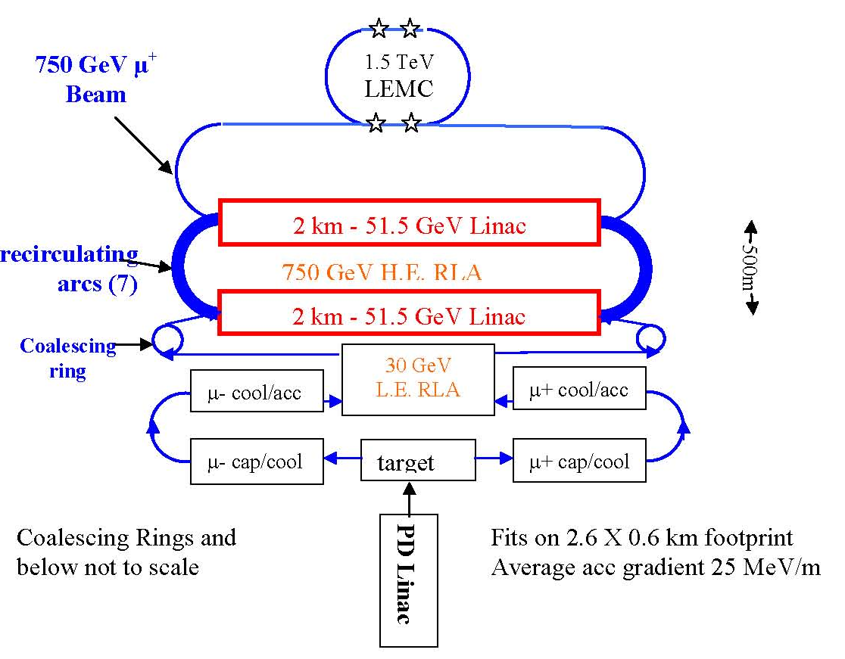
proton
accumulating
ring

Figure 2: Schematic for a 1.5 TeV Low Emittance Muon Collider complex.

A schematic for a 1.5 TeV Muon Collider complex is shown in Fig. 2. The detailed design of the accelerator complex depends on the emittance requirements of the collider ring, which determines the performance requirements for the cooling channel. Two representative collider parameter sets are shown in Table 1. Theoretical studies and tracking simulations are needed to establish the viability of any given design. The theoretical studies must be based upon achievable parameters for the collider ring components, and this will require some magnet design work. In addition, the muon cooling channel design and simulated performance must be consistent with the collider emittance requirements.

Table 1: Representative parameter sets for Low and high Emittance Muon Colliders.
Low Emitt. High Emitt.
Energy (TeV) .75+.75 (γ=7098.4)
Average Luminosity (1e34/cm^2/s) 2.7 1
Average bending field (T) 10 8.33
Mean radius (m) 361.4 363.8
Number of IPs 4 (350m/2 each) 2 (200m each)
P-driver rep.rate (Hz) 65 60
Beam-beam parameter/IP 0.052 0.1
β∗ (cm) 0.5 3
Bunch length (cm) 0.5 2
Number of bunches/beam 10 1
Number of muons/bunch (1e11) 1 12
Norm.transverse emittance (μm) 2.1 13
Energy spread (%) 1 0.1
Norm.longitudinal emittance (m) 0.35 0.14
Total RF voltage (GV) at 800MHz 406.6 ×103α_{c} 0.26×103α_{c}
RF bucket height (%) 23.9 0.6
Synchrotron tune 0.723 ×103α_{c} 0.02×103α_{c}
μ+ μ- in collision / proton 0.15 /2 0.15
8GeV proton beam power (MW) 1.1 0.6

  - Collder Ring Studies and Tracking Simulations

In studying collider ring design options and performance we will look at the following issues:

- correction of chromatic perturbations (chromatic beta-beating, nonlinear chromaticity and momentum compaction factor);
- radiation shielding necessary to protect the superconducting magnets and detectors at specific for the particular design beam intensity and sizes ;
- field quality of the magnets which have the required aperture and field strength (magnets being developed for the LHC luminosity upgrade is a good first approximation);
- dynamic aperture with realistic field and alignment errors;
- beam-beam effects;
- suppression of coherent instabilities at given bunch intensity, length, momentum compaction and lattice functions.

We estimate this activity will require an effort of 2.0 FTE in FY07, to be pursued as part of the AARD program at Fermilab.

  - Magnet Design Studies

The collider ring will consist of arc dipoles, quadrupoles, correctors as well as interaction region dipoles and quadrupoles. Preliminary collider design studies call for an arc dipole with a 10-12T bore field. These magnets must operate in a high radiation/high heat load environment from the muon decay electrons which in the vertical dipole bend-field are preferentially swept into the magnet midplane. Energy from these electrons must be intercepted or allowed to past beyond the magnet conductor or helium volumes. Two approaches have been taken in previous conceptual design studies: Magnets have (i) an absorber in the beam tube, cooled by water or liquid helium, or (ii) an “open midplane” i.e. an open evacuated space in the midplane with an absorber radially beyond the conductor volume. The former design requires a very large magnet aperture and potentially complicated absorber issues, while the later design requires an innovative mechanical structure to support the split coils, as well as field quality issues.

In our muon collider ring magnet studies we propose to:

- With the lattice design group, define the magnet parameters (aperture, length, B*dl, tolerances on field errors) and conductor choice, principally for the arc dipole magnets. We will take account of radiation deposition studies, and compare beam tube absorber vs. “open midplane” designs.
- Explore the feasibility of the open midplane design. The LBNL SD magnet configuration uses two Nb3Sn racetrack coils in a Helmholtz configuration to generate fields up to 12 T. This magnet concept provides a vehicle for a realistic test of the open-midplane configuration. For this test, we expect to use the existing Nb3Sn coils and procure a new structure to optimize for this task.

We estimate this activity will require an effort of 1.0 FTE and 100k$ of M&S funds in FY07, to be pursued as part of the AARD program at LBNL.

  - Cooling Channel Design Studies

The first complete scheme for a Muon Collider cooling channel has recently been simulated by the NFMCC, and yields promising results. More detailed simulation is required to confirm this performance. The scheme assumes components with parameters that are beyond current state of art, and will therefore require component R&D before it is viable. There are alternative candidate technologies that might be used to realize the cooling channel, or produce alternative cooling schemes. The present alternatives include ring coolers, linear cooling channels in a spiral geometry, reverse emittance exchange systems, rebunching systems, parametric resonance ionization cooling, channels with high-pressure gas RF cavities, HTS (high temperature superconductor) solenoids, and lithium lenses. Therefore, 6D cooling channel studies are needed to explore the alternatives and guide the component R&D.

In our 6D cooling channel studies we will look at the following:

- Physics analysis and computer simulations of the various candidate schemes for the 6D cooling channel, and a preliminary analysis of the technical feasibility and physical validity of the proposed design (momentum acceptance, medium-term dynamic aperture, coherent stability).
- Implications of the cooling channel performance on the collider ring parameters, and hence optimization of the chosen scheme.
- The requirements for the proton driver and other systems that determine the parameters of the beam at the input of the cooling channel.

We estimate this activity will require an effort of 2.0 FTE in FY07, to be pursued as part of the AARD program at Fermilab. The design studies will be complemented by work supported by the NFMCC and Muons Inc.

4. COOLING CHANNEL COMPONENT DEVELOPMENT

To guide design choices, and establish the viability and performance of a muon collider cooling channel, critical components must be prototyped and tested. The MUCOOL and MICE activities will develop and test some of these components (liquid hydrogen absorbers, and RF cavities with thin conducting windows operating in magnetic fields). Muons Inc. are developing, and with the collaboration of the NFMCC, testing high gradient cavities filled with high pressure hydrogen gas. The additional critical components that currently need to be studied are: (i) high field helical magnets, (ii) very high field solenoids (~50T), and (iii) lithium hydride absorbers. We propose, for each of the critical components, to do the initial component design work needed to establish plausible performance parameters, use the 6D cooling channel simulation studies to determine whether the performance parameters are consistent with a useful cooling channel device, and if this is so, prototype and test the component.

4.1 Helical Cooling Channel

The required magnet field profile is a solenoid with superimposed helical dipole and quadrupole fields. Tracking studies on 300 MeV/c muons show that a 4-m long helical solenoid filled with a low Z material can reduce the 6-D emittance by a factor of ~3. As shown in Figure 3, there are two helical concepts that can provide the required field.

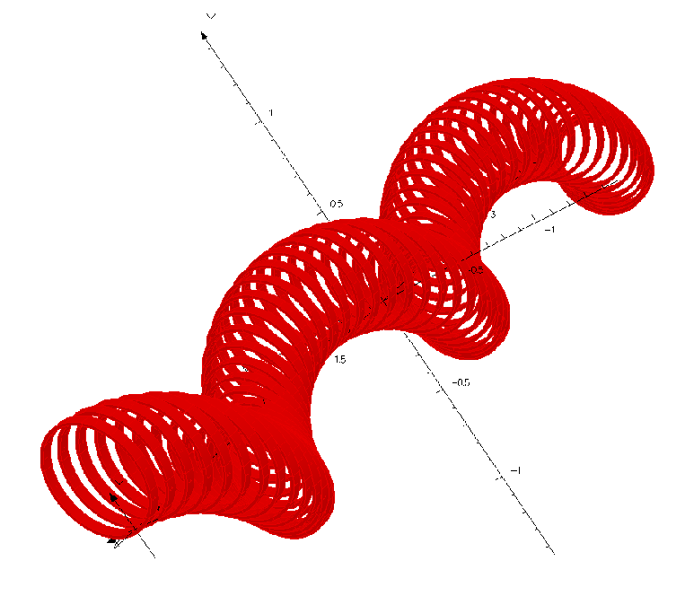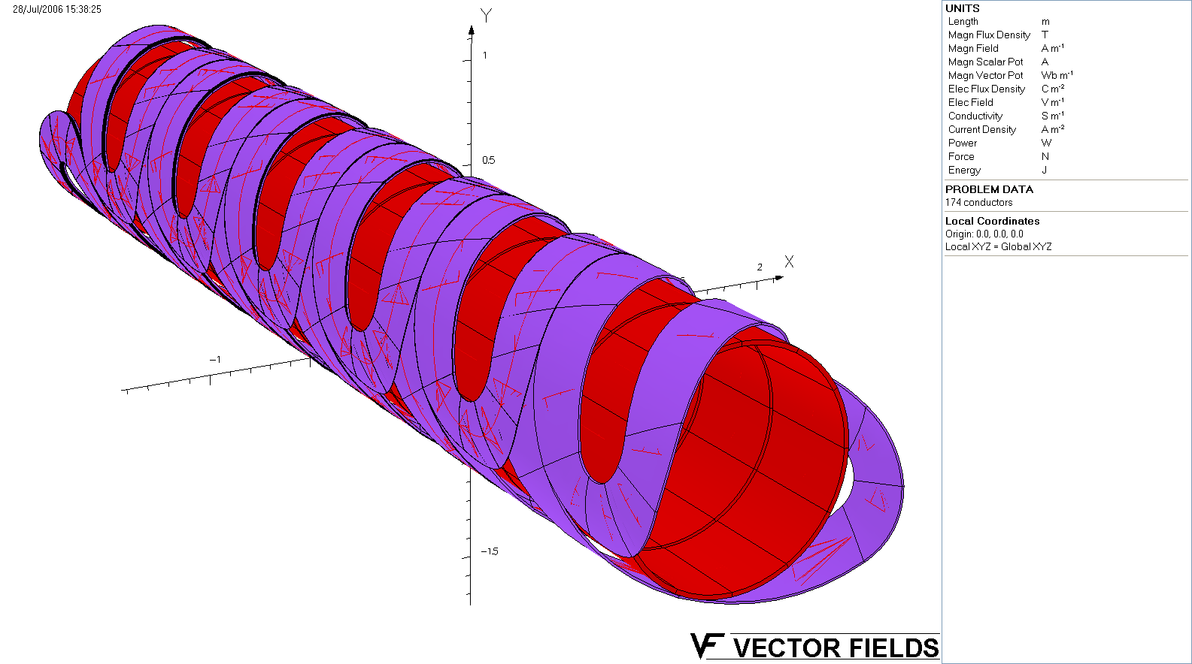

Fig.3: Two concepts of Helical Cooling Channel magnet.

Design choice “A” is a large diameter SC solenoid with dipole and quadrupole windings superimposed. The aperture of the inner solenoid is large enough to capture the muon helical path. Design choice “B” is a system of segmented solenoids. The required currents/fields for both designs can be accomplished with conventional NbTi Rutherford cable operating at 4.5 K.

In our Helical Cooling Channel magnet studies we will look at the following:

FY07
- Conceptual design/design domparison/design decision
- Build an “engineering model”
- Design and prototype plan

Results from these FY07 studies, together with the 6D cooling channel studies of the performance of a helical cooling channel with plausible parameters, will determine whether we will proceed to prototype and test a helical magnet. If yes, then:

FY08
- Complete engineering design
- Bids placed, prototype built in industry
- Test in IB1 (in sections)
- Preproduction review
FY09
- HCC and matching section magnets built
- Bench tests

We estimate this activity will require an effort of 1.5 FTE and 160k$ of M&S funds in FY07, to be pursued as part of the AARD program at Fermilab, and in collaboration with Muons Inc.

4.2 High Field HTS Solenoid

Very high focusing fields are required at the end of the cooling channel to obtain the final emittances. The presently favored technology is to use a very high field solenoid. In particular, solenoid fields on the order of 50T, apertures of 30 cm and lengths of 4 meters are proposed. To keep the power consumption reasonable, DC operation of a 50T solenoid of this size requires the use of HTS materials. HTS conductor could be used to provide the entire field or as an “insert” to a Nb3Sn /NbTi hybrid magnet. Although a 50 T DC solenoid is beyond the present technological capabilities, there are proposals at to build a 25-30 T HTS solenoid, and conceptual design studies for a 40-50T have been performed with Muons Inc in collaboration with BNL.
In our HTS solenoid studies we will look at the following:

- Conceptual designs: Key to challenges are the management of the Lorentz force induced stress on the superconducting material; quench protection schemes, segmentation of the coil to extract energy from the coil; and magnetic design, particularly in the end region to minimize stress on the HTS material. Work will be performed in conjunctions with Muons Inc. and in consultation with NHFML, building on the existing conceptual design and working towards a practical engineering design.
- HTS material studies: Properties of the HTS materials will drive the magnet design. Key study parameters are: Type of HTS, tape vs. round wire, wind-react vs. react-wind; critical current as a function of field, temperature, and stress. Samples of HTS materials will be studied, in cooperation with conductor vendors. HTS characterization will be performed at 1.8 K-77 K, including sensitivity to bending, transverse pressure and thermal cycling. In collaboration with OST, an Oxygen reaction site will be set up for BSCCO-2212 wire.
- Coil manufacturing/HTS solenoid inserts: Valuable experience with HTS coil manufacturing can be made through winding 3-5 T solenoid inserts, which are in turn placed in high field open aperture solenoids. Solenoids of 11/17 T are available at BNL/FNAL, and up to 45 T at NHMFL. Starting with inserts for 11-17T, studies can be performed on mechanical support, winding, reaction and potting techniques for coils.

We estimate this activity will require an effort of 2/3 FTE and 200k$ M&S in FY07, to be pursued as part of the AARD program at Fermilab. The HTS material studies will be performed in collaboration with BNL. That part of the AARD program at BNL will require an effort of 2/3 FTE and 150k$ M&S in FY07. BNL proposes to study pre-reacted BSCCO 2232 and YBCO tapes, with an emphasis on the effects of longitudinal and radial stress on conductor performance. Fermilab will start conductor tests on round strand BSCCO 2212.

  - Absorber Development

Liquid hydrogen absorbers, which are needed towards the end of the cooling channel, where multiple scattering must be minimized, are being developed by the NFMCC MUCOOL R&D program. The preferred absorber technology for the earlier stages of cooling uses LiH absorbers. We propose to design, prototype, and test a suitable LiH absorber. In particular, we will produce a number of fully instrumented encapsulated cast LiH absorbers modules that can eventually be tested in a high-power beam.

In our LiH absorber studies we will:

- Measure casting uniformity, heat-transfer characteristics and do decomposition studies
- Build an absorber and test it in a high power beam.

We estimate this activity will require an effort of 1 FTE and 65k$ M&S in FY07, to be pursued as part of the AARD program at Fermilab, in collaboration with the NFMCC.

5. BEAM TESTS
After the critical cooling channel components have been prototyped and tested on the bench, we propose to evaluate their performance in a beam. Two types of beam tests are required: (i) High power beam tests to ensure the technology works as expected in the presence of a high intensity beam, the deposited heat can be adequately removed, and that the components are radiation hard. A high intensity proton beam can be used for these tests. (ii) Muon beam tests to ensure that all the performance issues have been understood in evaluating the effect of the cooling test section on a real muon beam, and that the performance specifications have been fully met. A low intensity muon beam is being used for the “one muon at a time” ionization cooling demonstration experiment MICE. We propose to complement this technique by testing in a muon beam with an intensity of about 10⁸ muons per bunch. The NFMCC have constructed the MUCOOL TEST AREA (MTA) at the end of the Fermilab 400 MeV linac. The MTA is equipped to handle liquid hydrogen, and support the operation of high-power 805 MHz and 201 MHz RF cavities. In addition, there is a 5T solenoid in which an 805 MHz cavity can be inserted. In the coming year, it planned to bring a low intensity proton beam from the linac to the MTA to make the first tests of a high-pressure hydrogen filled cavity in an ionizing beam. Appendix C gives an implementation plan for this low intensity beam. We propose to further develop the MTA to (i) provide a high-intensity proton beam from the linac, and (ii) provide a muon beam with an intensity of about 10⁸ muons per bunch.

5.1 High Power Beam

The MuCool Test Area has been designed to accommodate full beam intensity from the Fermilab Linac (~2 X 10¹⁴ p/sec). This beam intensity corresponds to approximately 600W deposition into a 35 cm LH target. This beam intensity would allow us to test LH absorber components that would be in the final muon cooling sections of a muon collider, and investigate possible high-power beam effects on closed-cell vacuum and gas-filled RF structures. Currently the MTA can only accept low-intensity beam. We must install the beam absorber (a design exists and the absorbers Cu core components have already been fabricated) and add additional overburden to the facility.

To implement and use a high-power MTA beam we will:

- Install the beam absorber in the MTA and add the additional overburden shielding.
- Raise the existing equipment in the MTA (5T magnet and 201 MHz cavity) to the final beam height.
- Complete the cryogenic hookups (LHe and LN₂) between the MTA cryogenic plant and the 5T magnet

We estimate this activity will require 387k$ M&S and 128k$ SWF funds in FY07, to be pursued as part of the AARD program at Fermilab. Detailed MTA proton beam line cost breakdown is given in Appendix C.

5.2 Pressurized RF Cavity Studies
The high-intensity MTA beam will also support the Muons Inc development of high-gradient RF cavities filled with high pressure hydrogen gas. Pressurized RF cavities offer two advantages. The gas in the cavities doubles as absorber, making maximal use of limited space, but more importantly the gas lowers the electron mobility, thus suppressing break down effects. These cavities have been shown to be capable of high gradients, even in the presence of strong magnetic fields. Initial tests performed in the MTA give encouraging results. However, it remains to be shown if the higher gradient capability is maintained in the presence of an intense beam of ionizing particles. The next step is to build a high power pill-box cavity that will be the prototype for muon cooling applications. This new cavity is being designed by Muons, Inc. and will be ready for beam tests in the MTA in the summer of 2007. The first tests with a low intensity beam in the MTA are planned as soon as beam is available. Beyond this, tests with a high intensity beam are required.

In our high-intensity beam pressurized RF studies we will:

- Install the Muons Inc. setup in the MTA.
- Support beam tests and data analysis.

In FY07, the pressurized cavity effort will be mainly carried by Muons, Inc with small support of 0.25 FTE from the AARD program at Fermilab.

5.3 Muon Beam and Tests
Developing the MTA for tests with a muon beam is attractive because it will make maximum use of the existing investment in this unique facility, which supports operation and testing of the components needed for a muon cooling channel. A design for an MTA muon beamline does not yet exist. Therefore, initially we propose to study how a 250-300 MeV/c muon beam could be generated at the MTA using the linac H- beam. If the initial studies show that this is not practical, we will study alternative possibilities for implementing a suitable muon beam at Fermilab.

In Fig. 4 MARS simulation show the pion yield when 400GeV protons impinge on various nuclei. The total yield of positive pions within a 45 degree cone is 6e-3 for carbon, about 1% of which are in the desired momentum range (250-300MeV/c). Assuming ~10% collection efficiency the expected muon intensity is 1e8 per linac pulse (2e13 protons), or about 1e12 muons per day at 0.1 Hz average pulse repetition rate. Earlier studies [8] suggest that one may use a current-carrying, low Z target and a Lithum lens, similar to the ones used in pbar production for the collider program. Potentially, the lens and the target could be one and the same device. The expertise and equipment for designing and building such lenses is available in-house at Fermilab. The yield of such a setup will be determined by simulations using the MARS code.
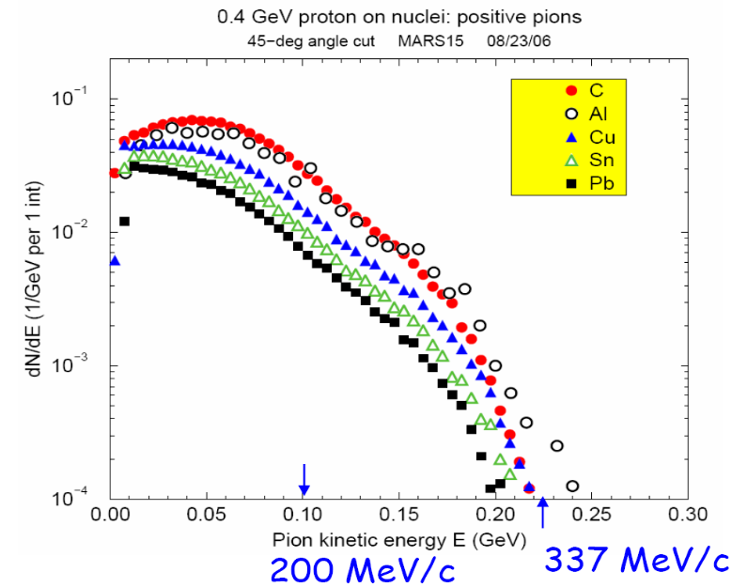
Fig.4: Pion production spectra from 400MeV/c protons hitting various targets (45 degree angle cut).
A suitable beam line optics will also be developed, to allow the accurate measurement of tranverse emittances and momentum spread, as well as to properly match the beam in and out of the HCC. The latter is a critical part of the experiment, since improper matching may easily mask any cooling effect. An important issue, in particular for the MTA location, is the amount of available space and coordination with the high-power proton beam testing program. MARS simulations will also be required to determine the level of additional shielding needed for safe operation with a muon beam.

In parallel with the muon beamline design, we will also design the first experimental setup using this beam. In particular, we will develop a design for an experiment to test the Helical Cooling Channel. This will include the experimental configuration, and the beam instrumentation. Here, there is a possibility to draw on the experience of the recent development in low intensity beam profile monitors for the MTEST beam line. These devices, based on scintillating fibers, are capable of both proportional and counting (single particle) mode and could hence be used for both a single particle and a beam type experiment.

In our muon beam design and experiment studies we will:
- Design and simulate the muon source (target, collection system, decay section).
- Design beam line optics, including matching into and out of the experiment.
- Design of and tests of instrumentation, and optimization of its location.
- Optmization of the HCC parameters for a cooling demonstration, including
simulations to determine the performance of the experiment.
- Develop components for, and build the muon beam line.
- Perform the cooling demonstration experiment
- Study how RF cavities could be incorporated into the HCC

We estimate the initial activity will require an effort of 2.0 FTE in FY07, to be pursued as part of the AARD program at Fermilab, in collaboration with the Muons Inc.

6. SUMMARY and R&D PLAN
We propose an AARD program at Fermilab to develop, in collaboration with the NFMCC, Muons Inc., BNL, and LBNL, the Muon Collider concept. The proposed R&D program is motivated by recent progress on Muon Collider design in general, and in particular, by new ideas that have recently emerged on muon cooling channel design. The focus of the R&D is, within a few years, to develop a practical design for a low emittance Muon Collider; design, prototype and bench test a complete set of components needed for 6D cooling channel, and, by FY2010, carry out 6D cooling demonstration experiment with beam of muons. This R&D builds upon the initial steps, taken by the MUCOOL and MICE programs, to develop a muon cooling channel for a Neutrino Factory. The proposed additional activities needed for a Muon Collider are:

  - Collider Design and Simulations to establish the muon cooling requirements: Given the recent progress on Muon Collider cooling channel design, proton driver designs, target R&D, and the MUCOOL and MICE programs, we will take a fresh look at the overall Muon Collider scheme. In addition to establishing the ionization cooling requirements, we will also identify the remaining muon source and collider design and performance issues.

  - Component Development: We will develop and bench test the components needed for the 6D cooling channel. In particular, we propose hardware R&D plan to prototype and test Helical Cooling Channel magnets, very high field HTS solenoids and pressurized RF cavities for the cooling channel. This hardware R&D is essential to guide further Muon Collider design studies.

  - Beam Tests and Experiments: We will perform beam tests of the components. For that we will build a proton beam line for high-intensity tests of LiH absorbers and pressurized RF cavities. Later, we will design and build a muon production, collection and transport system. 250-300 MeV/c muons will be used in the 6D ionization cooling demonstration experiment.

Major accomplishments and deliverables of the proposed AARD program will be:
FY07: a) initial design report for a 1.5 TeV low emittance muon collider;
b) MTA high power proton beam implementation plan;
c) HTS material studies report and development plan for a very high- field solenoid for muon cooling;
d) HCC design and utility report, decision to prototype;
FY08: a) pressurized RF cavity and absorber tests in the MTA with high- intensity proton beam;
b) development and installation of muon target, transport line and diagnostics in MTA;
c) 5T HTS insert built and tested at 15T and test report;
d) HCC and matching sections design finished, prototypes built;
FY09: a) muon beam commissioned, start of muon diagnostics tests;
b) HCC magnets construction starts;
c) 50T HTSC solenoid engineering design finished;
FY10: a) HCC magnets competed and 6D cooling experiment starts;
b) high-field HTSC solenoid prototype built.
c) Muon Collider cooling channel report

The final Muon Collider cooling channel report will describe the design of a complete 6D cooling channel for a Muon Collider and its simulated performance, the component performance parameters that are required, and the test results that demonstrate whether or not these component specifications can be met.

The estimated budget required for these activities is given in Appendix A. The budget breakdown by institution is given in Appendix B. An implementation plan for bringing proton beam to the MTA is given in Appendix C. A list of member of the “Muon Collider Study Group” contributing to formulating the R&D plan is given in Appendix D. Finally an estimated budget profile is given in Fig. 5.

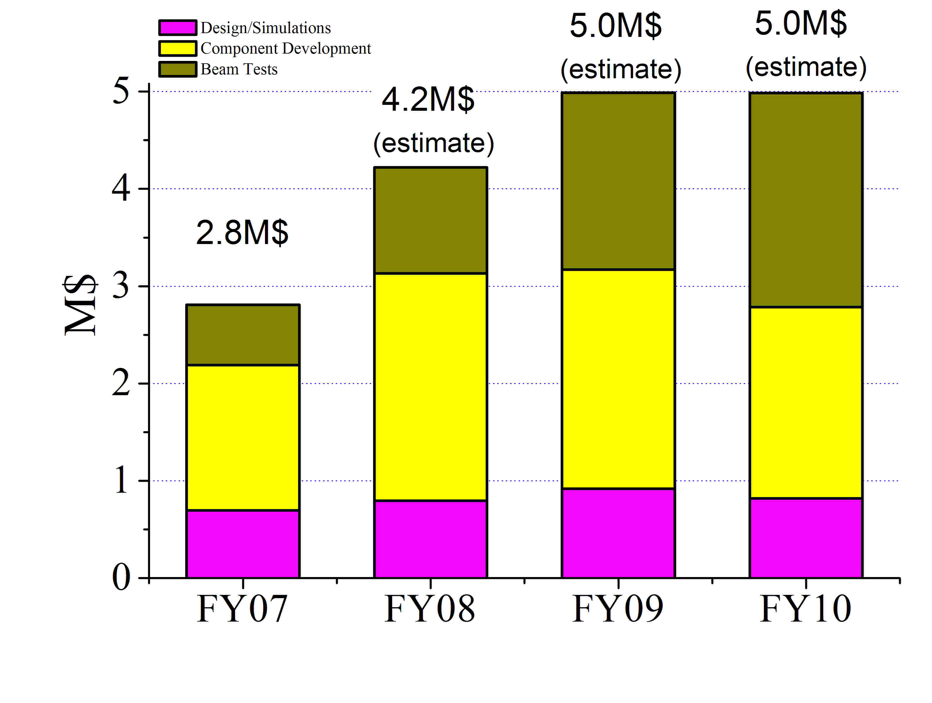
Figure 5: Estimated Muon Collider AARD budget profile.

References:
[1] μ+μ- Collider: A Feasibility Study (Muon Collaboration), FNAL-Conf-96/092 (1996)
[2] NFMCC Web site: http://www.cap.bnl/mumu/mu-home-page.html
[3] MERIT Inc. Web site: http://puhep1.princeton.edu/mumu/target/
[4] MICE web site: http://hep04-phys.iit.edu/cooldemo/
[5] Muons Inc. Web site: http://www.muonsinc.com
[6] C. M. Ankenbrandt et al. (Muon Collider Collaboration), Phys. Rev. ST Accel. Beams 2, 081001 (1999)
[7] Y. Derbenev and R. P. Johnson , Phys. Rev. ST Accel. Beams 8, 041002 (2005)
[8] V.Balbekov, N.Mokhov, Proc. 2001 IEEE PAC (Chicago, IL), p.1553 (2001)

APPENDIX A: BUDGET REQUEST SUMMARY
 |  |  |  |  | FY07 | FY08 | FY09 | FY10
 |  |  |  |  |  | (est) | (est) | (est)
TASK NO. |  | DESCRIPTION OF WORK: |  |  | k$ | k$ | k$ | k$
01 |  | COLLIDER DESIGN AND SIMULATIONS |  |  | 695 | 795 | 920 | 820
 | 1.1 |  | 1.5TeV Muon Collider studies
 |  |  |  | M&S | 10 | 10 | 10 | 10
 |  |  |  | SWF | 250 | 300 | 350 | 400
 | 1.2 |  | 6D Cooling Simulations
 |  |  |  | M&S | 10 | 10 | 10 | 10
 |  |  |  | SWF | 350 | 400 | 500 | 350
 | 1.3 |  | Collider Magnet Specs
 |  |  |  | M&S | 0 | 0 | 0 | 0
 |  |  |  | SWF | 75 | 75 | 50 | 50
02 |  | COLLIDER COMPONENT DEVELOPMENT |  |  | 1495 | 2355 | 2260 | 1965
 | 2.1 |  | HCC Magnet Design and Prototyping
 |  |  |  | M&S | 160 | 540 | 260 | 0
 |  |  |  | SWF | 250 | 270 | 270 | 75
 | 2.2 |  | HTS High Field Solenoid
 |  |  |  | M&S | 350 | 380 | 780 | 940
 |  |  |  | SWF | 245 | 525 | 525 | 525
 | 2.3 |  | Collider Magnet Design
 |  |  |  | M&S | 75 | 110 | 110 | 110
 |  |  |  | SWF | 200 | 315 | 315 | 315
 | 2.4 |  | Absorber Development
 |  |  |  | M&S | 65 | 65 | 0 | 0
 |  |  |  | SWF | 150 | 150 | 0 | 0
03 |  | EXPERIMENTAL BEAM TESTS |  |  | 620 | 1095 | 1820 | 2200
 | 3.1 |  | Muon 6D Cooling Test
 |  |  |  | M&S | 50 | 370 | 1300 | 1600
 |  |  |  | SWF | 400 | 520 | 520 | 600
 | 3.2 |  | High Power Absorber Test
 |  |  |  | M&S | 65 | 65 | 0 | 0
 |  |  |  | SWF | 65 | 65 | 0 | 0
 | 3.3 |  | Pressurized RF Beam Tests
 |  |  |  | M&S | 0 | 0 | 0 | 0
 |  |  |  | SWF | 40 | 75 | 0 | 0
 |  | TOTAL: |  |  | 2810 | 4245 | 5000 | 4985

APPENDIX B: FY07 BUDGET BREAKDOWN BY INSTITUTION

 |  |  |  |  | FNAL | BNL | LBNL
TASK NO. |  | DESCRIPTION OF WORK: |  |  | k$ | k$ | k$
01 |  | COLLIDER DESIGN AND SIMULATIONS |  |  | 695 | 0 | 0
 |  |  |  | M&S | 20 | 0 | 0
 |  |  |  | SWF | 675 | 0 | 0
02 |  | COLLIDER COMPONENT DEVELOPMENT |  |  | 940 | 280 | 275
 |  |  |  | M&S | 425 | 150 | 75
 |  |  |  | SWF | 515 | 130 | 200
03 |  | EXPERIMENTAL BEAM TESTS |  |  | 620 | 0 | 0
 |  |  |  | M&S | 115 | 0 | 0
 |  |  |  | SWF | 505 | 0 | 0
 |  | TOTAL: |  |  | 2255 | 280 | 275

APPENDIX C: MTA PROTON LINE IMPLEMENTATION PLAN

The purpose of the new beamline is to test the basic techniques and components proposed for muon ionization cooling and provide accurate measurements of Linac beam properties – important for future, stable high-intensity running of the downstream accelerators.
The new beamline and facility consists of a 15 Hz pulsed-magnetic extraction system which diverts an entire Linac macropulse into the new beamline and an ~50 m long beamline which feeds and ends in experiments housed in a 20’ x 40’ hall; the MuCool Test Area (MTA). Fig.1 below presents lattice functions of the beam line and area drawing.
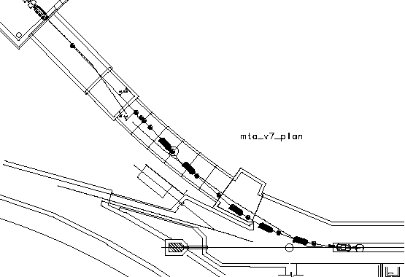
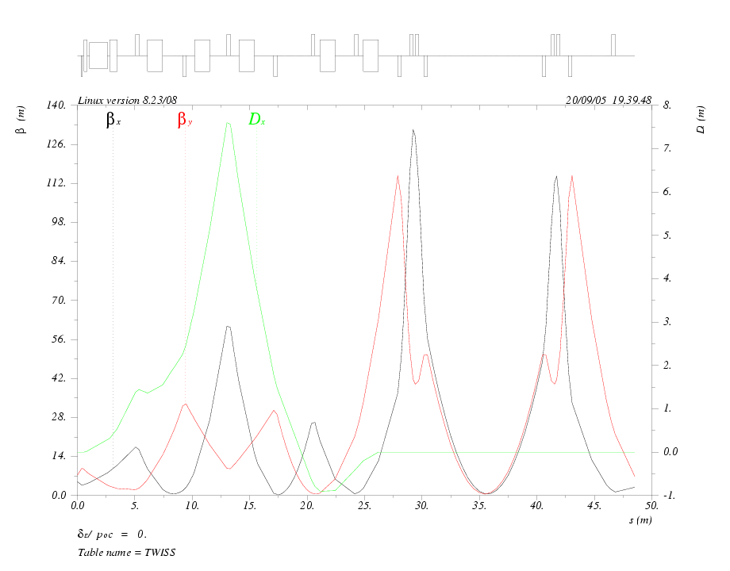
Fig.1: Optical functions (left) and overall plan for MTA proton beam line.

The beamline has been designed by the External Beamlines Department (Carol Johnstone) and will be installed by the Accelerator Division Support Departments under the aegis of the External Beamlines Department and the Proton Source Department. A mini review was lead by Mike Syphers.
At present (Sep. 2006) the longest lead time items, the pulsed magnets, have been ordered and all the stands are being fabricated. Four of the five cooling ring dipoles are in hand and the fifth is in storage. We are assuming that a fair amount of power supply installation and other electrical installation work will have been completed before the shutdown starts. The power supply for the pulsed magnets needs to be built and is a possible critical path item for the use of the beam, but not for the installation.
Cost estimates are attached below and one item to note is that the cost of the final beam absorber is included in Option 2 (see Table 1). This item is not necessary for the projected first use of the beamline however for general use it is necessary.
A draft installation schedule is attached (see Table 2) and shows that the installation can fit in the projected length of the next big shutdown, 2 months in Summer 2007. The first week will start with the core drilling through the concrete blocks and cleaning up after the drilling. Then the alignment group will set up their control network and mark stand locations. Work will start outside the tunnel on the water skid. Also work inside the Linac tunnel to allow the movement of elements down the tunnel. Week two will start the installation of the cable trays and the installation of the three most downstream quads on their stands. The assumption is made that a fair amount of power supply installation and other electrical installation work will have been completed before the shutdown starts.

Table 1: MTA proton line cost estimate

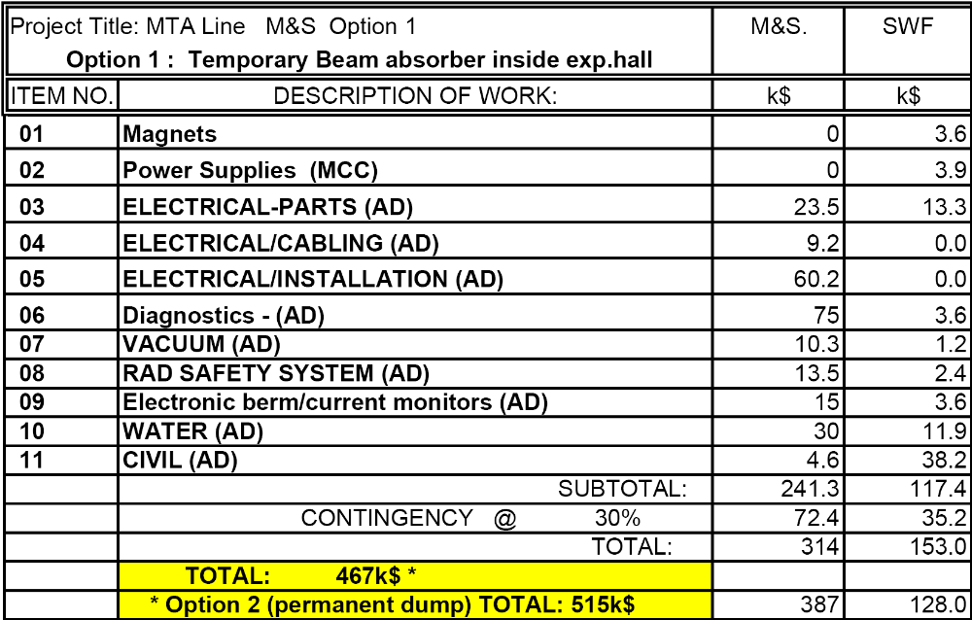

Table 2: Proton beam line installation schedule:
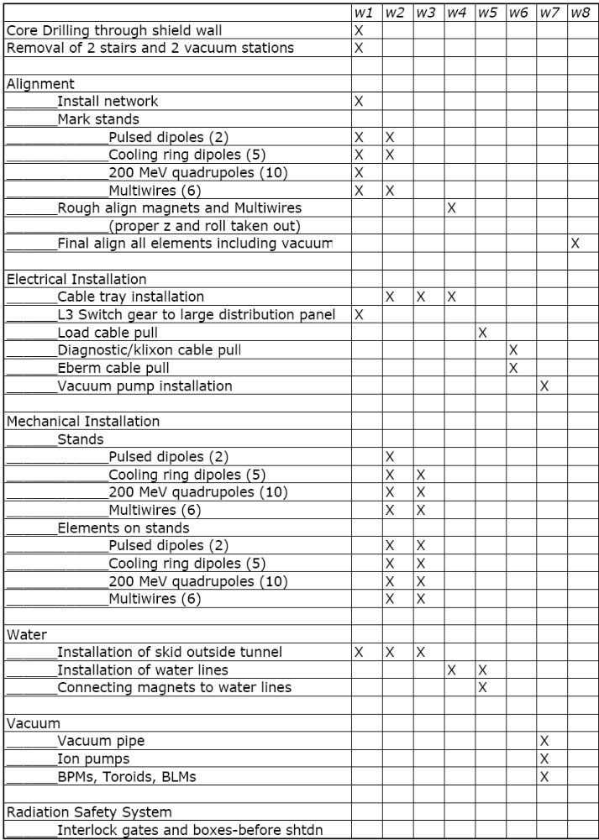

APPENDIX D: MUON COLLIDER STUDY GROUP

FNAL:
C.Ankenbrandt, Y.Alexahin, V.Balbekov, E.Barzi, C.Bhat, D.Brommelsiek, A.Bross, A.Burov, A.Drozhdin, D.Finley, S.Geer, N.Gelfand, E.Gianfelice-Wendt, M.Hu, A.Jansson, C.Johnstone, J.Johnstone, Vl.Kashikhin, V.Kashikhin, M.Lamm, V.Lebedev, N.Mokhov, C.Moore, A.Moretti, D.Neuffer, K.-Y.Ng, M.Popovich, I.Rakhno, V.Shiltsev¹, P.Spentsouris, A.Striganov, A.Tollestrup, A.Valishev, A.Van Ginneken, A. Zlobin.

MuonsInc:
R.Johnson, M.Cummings, S.Kahn, T.Roberts, K.Yonehara

BNL:
J.S.Berg, R.Gupta, H.Kirk, R.Palmer, R.Fernow, P.Wanderer

LBNL:
G. Sabbi, P.Ferracin, S.Caspi, M.Zisman

JLAB:
K.Beard, A.Bogacz, Y.-C.Chao, Y.Derbenev, B.Rimmer

ANL:
J.Norem

SWF rates used: 150k$/FTE of engineers and postdocs, 200k$/FTE of scientists
30% contingency is included in all M&S estimates
In FY07, most of MTA proton beam line cost of 515k$ to be covered from ongoing program funds
FNAL contacts
Muons Inc contact
BNL contact
Berkeley contact

