

E-GOVERNMENT STRATEGY
FY 2008 – FY 2013

September 2007

Building Upon Customer-Centric Initiatives for Results

Table of Contents

E-Gov Team, Chair’s Message 3
Executive Summary 4
Accomplishments 5
E-Gov Strategy Customer-Centric Objectives (CCO) 6
OBJECTIVE 1: Promote E-Gov Customer Awareness, Engagement, and Training 6
OBJECTIVE 2: Achieve a High Level of Customer Satisfaction … 7
OBJECTIVE 3: Improve the Management of E-Gov Investments 7
OBJECTIVE 4: Improve E-Gov Information Sharing and Reliability 8
Section 1. Introduction 9
Purpose 9
Scope 9
Assumptions 9
E-Gov Challenges 10
Section 2: Strategic Framework 11
DOI GPRA Strategic Plan 2007-2012 11
Management Excellence 11
PMA Expanded Electronic Government 12
E-Gov Initiatives 12
Lines of Business 12
DOI E-Government Strategy 2008-2013 13
E-Gov Strategy & Linkage from DOI GPRA Strategic Plan 14
Section 3: E-Gov Governance Overview 15
E-GOV Governance Framework 17
Section 5: Conclusion 18
Appendix A: E-Gov Strategy 2008-2013 Tactical Guide 19
How Will DOI Provide the Optimum E-Gov Experience? 19
OBJECTIVE 1 20
OBJECTIVE 2 22
OBJECTIVE 3 25
OBJECTIVE 4 28
Appendix B: Interior’s Investment Review Board 30
Appendix C: E-Government Team Charter 30


E-Gov Team, Chair’s Message:
Paul Hoffman, Deputy Assistant Secretary for Performance
Accountability and Human Resources

The DOI E-Government Strategy identifies four essential Customer-Centric Objectives (CCO) to strengthen the Department’s Mission Delivery while implementing E-Gov initiatives. Furthermore, we are building upon our significant accomplishments to better service our customers ––and achieve targeted results.

As the Chair of Interior’s E-Government (E-Gov) Team, I had the opportunity to help guide the development of the first DOI E-Government Strategy FY 2004-FY 2008 and its corresponding Governance Framework, as well as establish and co-chair the Investment Review Board (IRB). The E-Gov Strategy ensures that our business, E-Gov, and Information Technology (IT) leaders are working in concert to efficiently and effectively manage the DOI $1 billion E-Gov/IT investment portfolio.

The implementation of the DOI E-Gov Strategy has led to the significant maturation of the IRB portfolio decision-making processes to evaluate and manage investments, minimize risks, and maximize the return on investments. In 2006, our IRB established Management Objectives and Business Priorities criteria to strengthen our methodology of prioritizing initiatives, preventing duplicate investments, and leveraging shared solutions.

Since 2004, the Department has demonstrated consistent progress with its Management Excellence End Outcome Goal: Advance Modernization; however, it now requires the identification of new objectives to build upon our numerous E-Gov accomplishments. As a result, we have identified four E-Gov Strategy FY 2008 -FY 2013 Customer-Centric Objectives (CCO). The CCO are intended to improve efficiency in the following areas: Mission Delivery, DOI E-Gov initiatives, customer satisfaction, E-Gov investments, customer relationships; as well as information sharing and reliability. We are “raising the bar” with our new CCO outreach efforts that will enhance E-Gov services to the public and throughout the enterprise.

The new DOI E-Gov Strategy emphasizes our commitment to provide
SUPERIOR E-Gov services to our customers!

Executive Summary

In 2001, OMB released the President’s Management Agenda (PMA) E-Government Initiative to improve the Government’s use of IT investments, the accessibility of information and services, and the response time to citizens. In support of the PMA, DOI established an E-Gov Strategy 2004-2008 to guide our leaders in implementing collective approaches, reducing duplication, and enhancing efficiency and effectiveness of both the Departmental and Federal business processes.
The new DOI E-Gov Strategy 2008-2013 is a product of bureau cooperation in our enterprise efforts, and Government-wide efforts to improve data sharing across both business and Departmental lines to achieve results in Expanding Electronic Government. We are committed to our role as a Government-wide Managing Partner for Recreation One Stop (ROS) and Geospatial One Stop (GOS) to provide citizens with a user-friendly single access point to information; as well as the Geospatial Line of Business (LOB) that will result in a more coordinated approach to produce, maintain, and use geospatial data. Additionally, the Department is a Shared Service Provider for the Human Resources Management Line of Business (HRLOB) and the Financial Management Line of Business (FMLOB) that promote modern, cost effective, and standardized interoperable solutions.

As a Supporting Partner for 20 E-Gov initiatives and 8 lines of business (LOBs), Interior integrates operations and IT investments that significantly improve the Government's quality of service for citizens and businesses. This document incorporates tasks and performance measures along with tactics/procedures, targets, and responsible officials to assist leaders in their efforts to build upon past accomplishments and investments that can enhance the DOI E-Gov delivery.

It is important to note that the E-Gov Strategy goals are directly supported by several other programs, as follows: Enterprise Architecture, IT Security, Enterprise Infrastructure, E-Gov (Initiatives), IT Investment Management, Information and Records Management, and IT Workforce. A comprehensive strategic description of the above programs in support of legislation and Presidential Directives is provided in the Department’s IT Strategic Plan (FY 2007- FY 2012). The IT Strategic Plan will be updated in support of this E-Gov Strategy 2008-2013 and can be viewed at http://www.doi.gov/ocio/strategic_plan.html.

Accomplishments

Highlights that resulted in the improved PMA E-Gov Scorecard for Progress and Status include, but are not limited to, the following:

Managing Partner for Recreation One-Stop
Managing Partner for Geospatial One Stop
Winner of five coveted Excellence.gov awards, American Council for Technology, 2006
Managing Partner for Geospatial Line of Business (LOB)
Life-cycle cost savings realized through cost avoidance and reduced operational costs are projected to be $51.76 million (during 2008-2013).
Supporting Partner for 20 E-Gov Initiatives and 8 LOBs

Rated GREEN by OMB for the E-Gov Implementation PMA Milestones, 2006-2007
Government Lead for The Single Source Coal Reporting (SSCR)
Of 20 test companies, 80% reported the system saved time. The business case for the SSCR initiative shows a 10:1 payback on investment.
Participant of the PMA Enterprise Licensing Agreements Initiative
DOI has realized about $68.72 million (during 2005 - present) in cost-avoidance by committing to set quantities of select products up-front.
Best Practice Model in Enterprise Architecture

Received Excellence in Enterprise Architecture Award, 2004, 2006, E-Gov Institute
Rated # 1 EA Program across Government by OMB, 2005 -2007
Rated # 1 EA Program across Government on EA Maturity Framework by GAO, 2006
Maintaining High Standards to Protect Privacy
Achieved completion of Privacy Impact Statements for 90% of applicable systems
90% of systems with personally identifiable information have a system of records
Shared Service Provider/Center of Excellence
DOI’s National Business Center (NBC) leverages Government and commercial
best practices for HRLOB and FMLOB; thereby provides for our
customer base of more than 150 Government agencies.
E-Gov Strategy Customer-Centric Objectives (CCO)
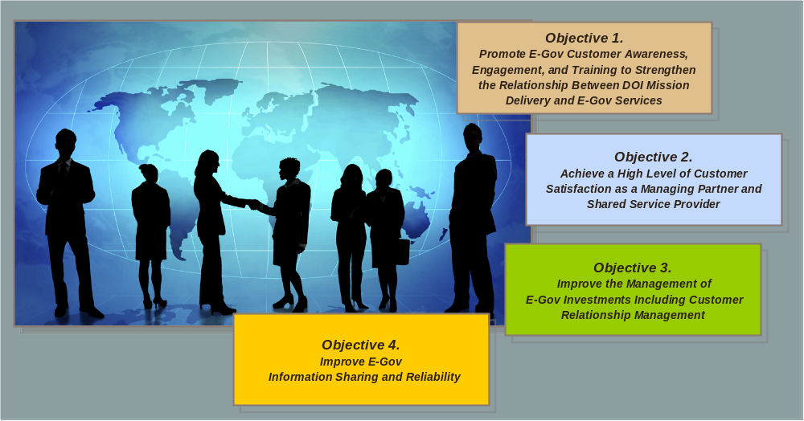
OBJECTIVE 1 Promote E-Gov Customer Awareness, Engagement, and Training to Strengthen the Relationship between the DOI Mission Delivery and E-Gov Services
- Focus: Customer “knowledge” of E-Gov services that support the overall Mission
- Internal customers: IT and non-IT workforce officials
- External customers: citizens, businesses, and Governments
- Coordinate communication and training with the DOI Initiative Owners and the IT Workforce Program Office to meet customer needs
- Training: End-user, administrator, and executive training; and map to the IT Workforce training
Performance Measure: % of Satisfied Customers (1.5% annual increase)
Tasks:
- Prepare communications plan
- Develop training programs for new systems
- Obtain customer feedback

OBJECTIVE 2 Achieve a High Level of Customer Satisfaction as a Managing Partner and Shared Service Provider
- Government leader in E-Gov implementation: Managing Partner and Shared Service Provider
- Enhance service delivery to citizens, businesses, and Governments
- Heighten customer-centric research and analyses
- Ensure that customer needs are met
Performance Measure: % of Satisfied Customers (TBD, as appropriate for annual targets below)
Tasks:
- Identify customers (both internal and external) and conduct market research on customer needs
- Prioritize customer needs
- Improve systems to meet identified customer needs
- Obtain customer feedback

OBJECTIVE 3 Improve the Management of E-Gov Investments Including Customer Relationship Management
- Develop comprehensive strategies for E-Gov Initiatives
- Incorporate best practices
- Implement a formal Customer Relationship Management function
- Execute E-Gov based on a knowledge base of customer needs and service-level requirements
- Standardize E-Gov/IT functions and organizations throughout the Department
- Create a more mature IT investment management organization
Performance Measures:

# of investments with business plans acceptable to OMB (Stage 4 ITIM by 2010 and maintain Stage 4 thereafter)

% of related investments in alignment with implemented modernization blueprints (100% )
% of redundant systems identified in approved modernization blueprints that have been "shut down” where the solution has been implemented (10% each year)
% of DOI information identified as records and preserved under an approved electronic records management system (10% annually)

Tasks:
- Incorporate organizational change management into system development processes
- Prioritize customer needs
- Develop DOI-wide Records Management Strategy
- Mature processes for managing investments
- Develop and implement segment architecture and modernization blueprints
- Conduct business process re-engineering

OBJECTIVE 4 Improve E-Gov Information Sharing and Reliability
- Information sharing can be achieved when the information is designed to be discoverable, accessible, and reliable.
- Information exchanges can be effectively managed when those exchanges use authoritative data sources.
- In order to achieve these goals, information must be categorized, standardized, and described following the guidance and framework standards documented in the DOI Data Reference Model (DRM).
- Additional guidance is offered in the Methodology for Business Transformation (MBT).

Performance Measures:

% of Satisfied customers (1.5% annually)
# of adopted data standards in alignment with business goals (25% by 2008 - TBD thereafter)
# of exchanges using adopted data standards (25% by 2008 – TBD thereafter)
# of designated authoritative data sources (ADS) (1 by 2008)

Tasks:
- Inventory, catalog, re-align, and/or consolidate public websites to improve customer satisfaction and citizen confidence
- Inventory, document, and steward information classes and exchanges available for sharing or re-use
- Adopt and implement data standards
- Assess and designate Authoritative Data Sources (ADS) associated with a modernization initiative

Section 1. Introduction
The DOI E-Gov Strategy’s supports the Departmental overall strategic Mission and Vision; builds upon the GPRA Strategic Plan Management Excellence Goal 2 Advance Modernization/Integration; and establishes Customer-Centric Objectives (CCO) for FY 2008 - FY 2013.

Purpose

- Strengthen the Department’s success in delivering Mission results and E-Gov services by establishing new customer-centric objectives (CCO)
- Emphasize improving upon E-Gov service delivery, customer satisfaction, and customer relationships
- Align the E-Gov Strategy with our PMA Progress and achievements
- Serve as the impetus for the migration of Interior’s E-Gov/IT portfolio toward integrated, Department-wide business processes and Expanded E-Gov when appropriate, as determined by the E-Gov Team

Scope

- Aligns with the DOI Strategic Plan FY 2007- 2012 Management Excellence GPRA End Outcome Goal 2 Advance Modernization, and its Intermediate Goal: E-Gov and IT Management

- Provides a heightened strategic and tactical focus that guides our leaders to build customer relationships while effectively implementing E-Gov initiatives (Government to Citizen, Government to Government, Government to Business, and Internal Efficiency and Effectiveness)

- Establishes the CCO along with tasks and performance measures

- Incorporates a Tactical Guide to achieve targeted 2008 – 2013 goals

Assumptions

- Citizens, businesses, and Governments will continue to be provided cost-effective services to solve citizen information and business information problems.

- The DOI E-Gov Strategy will improve the accessing and processing of information by employees. Subsequently, productivity and the DOI Mission delivery will be enhanced.

- The E-Authentication Program will secure our customers’ identity prevent confidential data from being compromised.

- The Department performs in compliance with the Freedom of Information Act (FOIA), Section 508, Rehabilitation Act of 1998, and privacy laws.

- Funding of initiatives in support of this E-Gov Strategy will require technological improvements/enhancements that will be addressed and decided upon by the established Governance Framework.

E-Gov Challenges
In spite of many challenges, the Department has continuously improved the PMA E-Government Scorecard results for Progress and Status. Our leaders continue to prepare for challenges, such as:

- Requirements to comply with new IT mandates
- Funding
- Communication
- Business management
- Rapid changes in technology
- Maintaining a highly skilled and diverse IT Workforce
- Increased expectations of customers for innovative and faster E-Gov and IT service applications
- Security and privacy threats that impact E-Gov
- Redundant and overlapping organizational structures within the Federal Government
- Coordination with (and/or reliability on) other Federal Agencies for our effective performance as a Managing Partner and Shared Service Provider

Section 2: Strategic Framework

This section presents the linkage of the DOI’s E-Gov Strategy 2008-2013 to the DOI GPRA
Strategic Plan FY 2007 – FY 2012, as well as the President’s Management’s Agenda.

DOI GPRA Strategic Plan 2007-2012

Mission: The U.S. Department of the Interior protects and manages the Nation’s natural resources and cultural heritage; provides scientific and other information about those resources; and honors its trust responsibilities or special commitments to American Indians, Alaska Natives, and affiliated Island Communities.

Vision: Communication, consultation, and cooperation, all in the service of conservation and community

Key Business Principles:
Increasing Accountability
Advancing Modernization / Integration

Management Excellence: Manage the Department to be highly skilled, accountable, modern, functionally integrated, citizen-centered and results-oriented

Management Excellence (Mission Supporting Goal): provides tools to evaluate the efficiency and effectiveness of programs throughout the enterprise. Resources are appropriately coordinated to evaluate required business processes and technology improvements. Management Excellence strategies have led to Interior’s continuous improvement in E-Gov performance.

PMA Expanded Electronic Government
Interior is actively involved in 20 E-Gov Initiatives and 8 Lines of Business (LOBs) as follows:
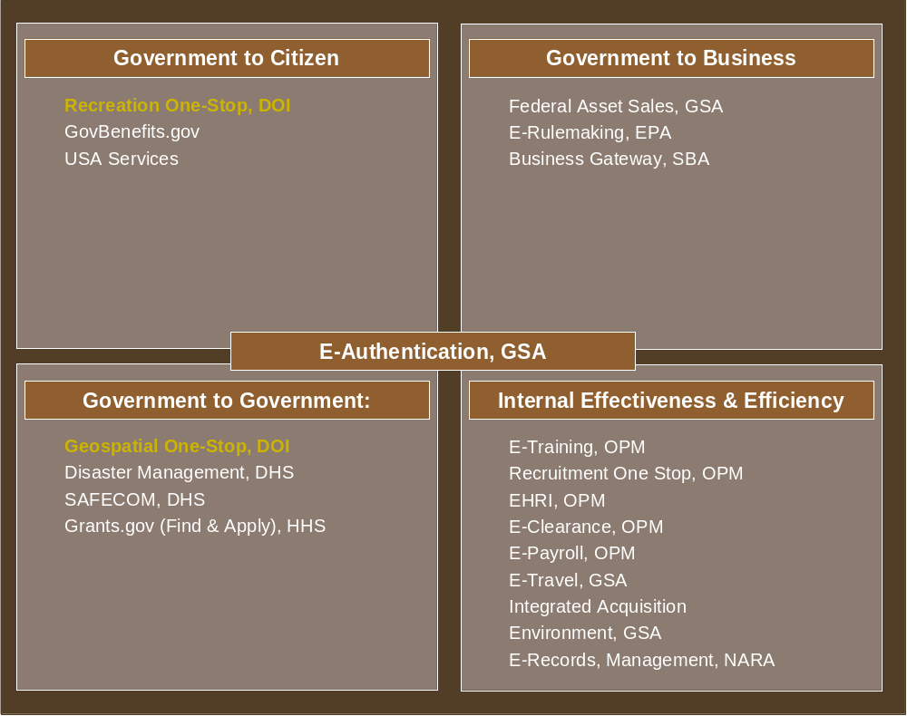
E-Gov Initiatives

Lines of Business
Geospatial, DOI, Managing Partner
Financial Management, DOI, Shared Service Provider
Human Resources, DOI, Shared Service Provider
Grants Management, HHS/NSF
Case Management, DOJ
Budget Formulation and Execution, ED
IT Security, DHS
IT Infrastructure Optimization. GSA

DOI E-GOVERNMENT STRATEGY 2008-2013

Mission: E-Government at the Department of the Interior enhances services for citizens and increases efficiency by using technology to improve business processes.

Vision: Technology for citizen-centered, integrated, secure services

Guiding Principles

- Citizen Focused: Continue to enable interactive processes that are simple, effective, and based on the citizen’s needs and capabilities

- Customer Focused: Address and enhance the overall service delivery, customer experience, and customer value

- Business-focused: Utilize technology to support customer-centric business needs

- Transformational: Simplify and focus service delivery by integrating common processes including processes with other Departments

- Partnership-based: Continue to leverage partnerships with Federal, state, and local agencies; as well as private sector by using the expertise to best serve citizens

- Efficient: Seek solutions to eliminate redundant and reduce long term operating costs

- Integrated: Ensure a consolidated and unified E-Gov approach while recognizing the unique missions and capabilities of DOI Bureaus and Offices

- Results-oriented: Ensure that DOI E-Gov initiatives are business-case driven and focused on tangible results

- Secure: Mitigate risk of unauthorized accesses to DOI technology infrastructure through a coordinated approach involving technology tools, policy guidance, and training

- Privacy: Address the business, legal, and procedural components of privacy issues, as well as the technology solution

- Transparent: Identify, evaluate, and select initiatives in a clear and open manner, based on the best value for the customer and the American public

E-Gov Strategy & Linkage from DOI GPRA Strategic Plan

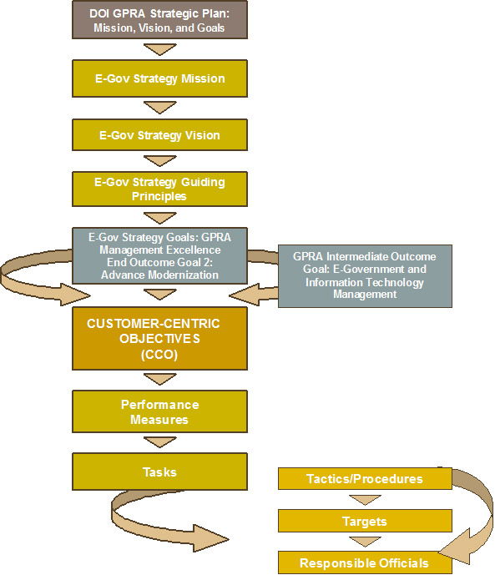

Section 3: E-Gov Governance Overview

This section presents an overview of the DOI E-Gov Strategy Framework and illustrates the collaborative interaction to make smart business decisions regarding E-Gov Investments.

DOI E-Government Strategy Governance Framework

The E-Gov Team established the DOI E-Government Strategy Governance Framework 2004-2008 and its required leadership and organizational structures to perform the tasks identified below.
■ Increase coordination and collaboration in identifying and managing E-Government, cross-cutting initiatives across the enterprise to increase efficiency and enhance Mission delivery
■ Improve two-way communication across program, Bureau, and Departmental lines regarding E-Government
■ Continue to strengthen the alignment of DOI technology investments with business needs
■ Use the portfolio management decision making-process to establish investment priorities
■ Identify new for opportunities for modernization, including the identification of business areas in need of transformation

At quarterly points during the ongoing CPIC portfolio management process, the Departmental IRB reviews the status of ongoing projects to make portfolio management decisions. The IRB will use its Management Objectives and Business Priorities criteria identified below to implement the initiatives in support of this E-Gov Strategy 2008-2013.

Management Objectives: Criteria to evaluate investments in the CPIC Process.
■ Implement legal and judicial mandates
■ Respond to internal and executive mandates
■ Obtain positive return on investments
■ Improve performance (showing links to the DOI Strategic Plan and bureau performance goals,
avoiding duplication, managing risk, improving efficiency, achieving specific objectives)
Business Priorities: The second tier of management guidance for portfolio decisions
■ Enterprise projects
■ Projects on schedule, within costs, meeting expectations (evaluated through control reviews)

■ Projects that are consistent with blueprints

Acronym and Name | Description
MEC: Management Excellence Council | ■ Chaired by the Deputy Secretary––and is the DOI most senior decision-making body comprised of Assistant Secretaries and Bureau Directors  ■ Provides leadership and oversight of DOI management reform activities including the approval of the DOI budget, major policy approval, and the approval of major initiatives within DOI
MIT: Management Initiatives Team | ■ Comprised of senior level business leaders who oversee the implementation of the PMA items and DOI management improvement initiatives  ■ Meets annually to prioritize investments and present final recommendations to the MEC
IRB: Investment Review Board | ■ Approves proposed IT investments and makes decisions on ongoing IT investments based on their performance  ■ Oversees the development, maintenance, and implementation of the Interior Enterprise Architecture - (See Appendix A)
E-Gov: E-Government Team | ■ Provide ongoing decision-making and coordination regarding the DOI E-Gov activities  ■ Serve on the IRB and represent the business perspective from each Bureau/Office within the Office of the Secretary
ITMC: Information Technology Management Council | ■ Provides guidance on standards and technology-related issues, and ensure that technology is supporting the needs of the Mission areas  ■ Serves on the IRB and represent the CIO/technology perspective from each Bureau/Office within the Office of the Secretary
IBAT: Interior Business Architecture Team | ■ Oversees the development of the DOI Modernization Blueprints and the continual evolution of the DOI business architecture
DAC: Data Advisory Council | ■ Works with the DOI data community to define the data architecture layer of the IEA
DOI Web Council | ■ Provides input and staff-work for E-Gov Team decision-making relating to information dissemination  ■ Ensures that DOI-wide web activities are aligned with the E-Gov Team’s business needs and priorities
IAWG: Interior Architecture Working Group | ■ Oversees the DOI Enterprise Architecture within the respective Bureaus/Offices consistent with Office of the Secretary and OCIO EA Guidance  ■ Perform as the main EA Governance Committee in the context of what is described in OMB’s EA Assessment Framework
CPWT: Capital Planning Working Team | ■ Conducts the rating and ranking of the investment requests that are evaluated by the IRB  ■ Leverages the DOI CPIC Guide that includes DOI enterprise architecture guidance
CTOC: Chief Technology Officer Council | ■ Serves the Interior CIO and ITMC on issues related to technical compliance with the IEA and operational use of technology within DOI
ITST: Information Technology Security Team | ■ Ensures the successful implementation of the OMB Circular A-130, Appendix III  ■Works on issues relating to IT security such as policy, procedures and reporting to oversight agencies
TAG: Telecommunications Advisory Council | ■ Provides advice to ITMC on telecommunications management and technology

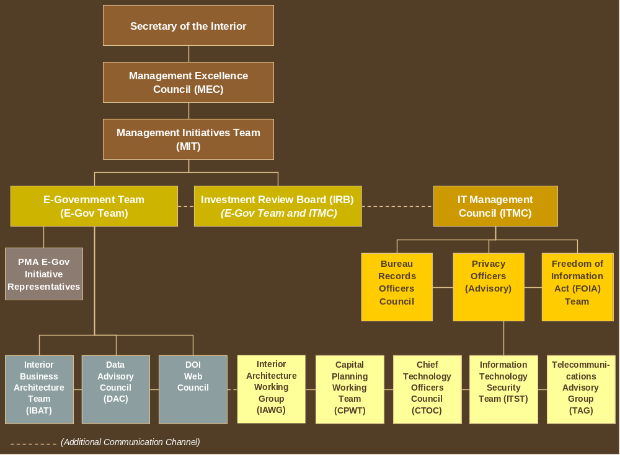
E-GOV GOVERNANCE FRAMEWORK

Section 5: Conclusion

The new DOI Customer-Centric Objectives directs E-Gov executives to explore opportunities to personalize applications, relationships, and services; as well as gain new customers and retain existing customers.
As a Managing Partner and Shared Service Provider, Interior will continue to eliminate information barriers, in compliance with Section 508, Rehabilitation Act of 1998 and create new opportunities for persons with disabilities. Our E-Gov leaders will strive to retain long-term relationships; provide optimum E-Gov accessibility to all customers; and protect security and privacy to further cultivate the confidence of our customers.
We are building on past accomplishments with a heighten focus on customer service quality and effectiveness! As a leader in implementing the PMA, Interior continues to enhance service delivery while streamlining business practices. The implementation of new DOI Customer-Centric Objectives is targeted for improved performance and results including the following:
- Increased marketing outreach efforts and number of customers
- Stronger relationships with existing customers to enhance customer retention
- Improved customer satisfaction including employee satisfaction
- Improved knowledge of our customers
- Enhanced customer feedback that can reveal new opportunities
- Increased efficiency of service delivery

The new E-Gov Strategy reflects Interior’s commitment to enhance
the achievement of GPRA and Management Excellence!

Appendix A

E-Gov Strategy 2008 – 2013 Tactical Guide
This section provides a comprehensive Tactical Guide to further indicate how DOI will provide the “optimum” E-Gov Experience to customer and achieve results.

How will DOI provide the “OPTIMUM” E-Gov Experience?

- Value our customers!
- Establish four Customer-Centric Objectives (CCO) to focus on maintaining long-term relationships with customers
- Identify, acknowledge, and meet customer needs to achieve results
- Conduct new outreach efforts to improve customer awareness
- Motivate employees to learn E-Gov skills
- Encourage customers (internal and external) to utilize services that are immediately available
- Further conduct market research to identify new E-Gov methodologies

MONITORING AND MEASURING PERFORMANCE

- Each strategic objective is presented with performance measures and tasks that collectively illustrate the DOI E-Gov Strategy.

- A corresponding Tactical Guide is presented that incorporates tactics/procedures and targets; as well as identifies responsible leaders who are committed to improving E-Gov service delivery to our customers.

- Quarterly status will be evaluated and reported to the E-Gov Team Chair.

These collective approaches are intended to improve results; reduce inefficiency and duplication; and ensure that customers are provided with the optimum E-Gov experience!

OBJECTIVE 1
Promote E-Gov Customer Awareness, Engagement, and Training to Strengthen the Relationship between the DOI Mission Delivery and E-Gov Services
 | This objective addresses the manner by which Interior will focus on customer “knowledge” of E-Gov services that support the overall Mission of the Department. Internal customers include IT workforce and non-IT workforce officials that utilize E-Gov to perform business processes. External customers are citizens, businesses, and Governments that will continue to benefit from information sharing services. However, both groups will be addressed with enhanced outreach efforts to strengthen the awareness and notification of E-Gov activities. Communication and training will be appropriately coordinated with the DOI Initiative Owners and the IT Workforce Program Office to meet customer needs. Additionally, this objective involves conducting analyses of the DOI end user training, administrator training, and executive training of initiatives; as well as the mapping to the IT Workforce training, as required.
 | Performance Measure: % of Satisfied Customers (1.5% annual increase)
 | STRATEGIC TASKS |  | TACTICAL GUIDE
 |  |  | Tactic/Procedure | Annual Targets (Qtr. or date) |  | Coordinator | Responsible Officials
 | Prepare Communications Plan |  | Review industry standards and identify 2 forms of media that will be used by each DOI E-Gov Initiative Owner | Q3 2008 |  | E-Gov Program Manager | E-Gov Program Manager and  DOI E-Gov Initiative Owners
 |  |  | Conduct meeting with the DOI E-Gov Initiative Owners to address Communication Plan | Q4 2008 |  | E-Gov Program Manager | E-Gov Program Manager, DOI E-Gov Initiative Owners, and IT Workforce Business Manager
 |  |  | Analyze Q4 2008 survey results (see Obtain Customer Feedback below) | Q1 2009 |  | E-Gov Program Manager | E-Gov Program Manager, DOI E-Gov Initiative Owners, and IT Workforce Business Manager
 |  |  | Finalize plan | Q3 2009 |  | E-Gov Program Manager | E-Gov Program Manager ,  DOI E-Gov Initiative Owners, E-Gov Team, and IT Workforce Business Manager
 | STRATEGIC TASKS |  | TACTICAL GUIDE
 |  |  | Tactic/Procedure | Annual Targets (Qtr. or date) |  | Coordinator | Responsible Officials
 |  |  | Implement plan | Q4 2009 |  | E-Gov Program Manager | E-Gov Program Manager,  DOI E-Gov Initiative Owners, CIOs, E-Gov Team, and IT Workforce Business Manager
 | Develop training programs for new systems |  | 1. Coordinate with the DOI E-Gov Initiative Owners to provide notification of training for their respective systems.  2. Coordinate with bureau IT workforce leads and HR management to identify training that will “maintain and sustain” the DOI IT workforce to manage new systems | 1. Q2 2008  2. Q4 2008 |  | OCIO IT Workforce Program Manager | DOI E-Gov Initiative Owners, NBC, CIOs, E-Gov Team, and IT Workforce Business Manager
 | Obtain Customer Feedback |  | 1. Conduct survey to assess % of DOI IT workforce satisfied with using new systems.  2. Report survey results | 1. Q4 2008  2. Q1 2009 |  | OCIO IT Workforce Program Manager | DOI E-Gov Initiative Owners, NBC, CIOs, E-Gov Team, and IT Workforce Business Manager
 |  |  | Conduct survey to assess % of E-Gov users (for selected population to establish baseline) | Q4 2008-2013 |  | E-Gov Program Manager | DOI E-Gov Initiative Owners, NBC, CIOs, E-Gov Team, and IT Workforce Business Manager
 |  |  | Analyze results and review Communication Plan for revisions and implementation | Q2 2010-2013 |  | E-Gov Program Manager | DOI E-Gov Initiative Owners, NBC, CIOs, E-Gov Team, and IT Workforce Business Manager
 |  |  | Conduct survey to determine if % of E-Gov Users has increased | Q4 2010-2013  1.5% annual increase |  | E-Gov Program Manager | DOI E-Gov Initiative Owners, NBC, CIOs, E-Gov Team, and IT Workforce Business Manager
OBJECTIVE 2
Achieve a High Level of Customer Satisfaction as a Managing Partner and Shared Service Provider
As one of the Government Leaders in E-Gov implementation, Interior will continue its Departmental and Governmental efforts to enhance service delivery to citizens, businesses, governments, as well as improve upon the overall internal efficiency and effectiveness of the Federal Government. As a Managing Partner and Shared Service Provider, Interior will heighten its customer-centric research and analyses to ensure that customer needs are met.
Performance Measure: % of Satisfied Customers (TBD, as appropriate for annual targets below)
STRATEGIC TASKS |  | TACTICAL GUIDE
 |  | Tactic/Procedure |  |  | Annual Targets (Qtr. or date) |  |  | Coordinator | Responsible Officials
Identify Customers (both internal and external) and Conduct Market Research on Customer Needs |  | Review industry standards for E-Gov technologies comparable to DOI E-Gov services |  |  | Provide findings Q2 2008 |  |  | DOI E-Gov Initiative Owners for Geospatial, ROS, and NBC (TBD) | CTOC and DOI E-Gov Initiative Owner
 |  | Geospatial One Stop  Survey Geospatial One Stop users  - Define customer categories (scientists, school children, general public, etc.)  - Identify common areas of need based on customer category  - Build, pilot/test, and finalize survey instrument.  - Conduct customer satisfaction survey  - Analyze survey data |  |  | - Customer category definitions, 7/30/2008  - Areas of Need Defined, 9/15/2008  - Build, pilot/test, and finalize survey instrument, 7/15/2009  - Survey conducted, 9/30/2009  - Survey data analyzed, 12/31/2009  - Adjust Survey 7/30/2010  - Survey conducted, 9/30/2010  - Survey data analyzed, 12/31/2010  - Survey conducted, 9/30/2011  - Survey data analyzed, 12/31/2011  - Survey conducted, 9/30/2012  - Survey data analyzed, 12/31/2012  - Survey conducted, 9/30/2013  - Survey data analyzed 12/31/2013 |  |  | Geospatial Initiative Owner | Geospatial Initiative Owner
STRATEGIC TASKS |  | TACTICAL GUIDE
 |  | Tactic/Procedure |  |  | Annual Targets (Qtr. or date) |  |  | Coordinator | Responsible Officials
 |  | NBC FMLOB  1. Conduct FMLOB annual customer survey.  2. Establish Business Development Office for customer outreach activities. |  |  | - Q4 2008 annually thereafter.  - Q4 2007 |  |  | NBC Finance and Procurement Systems Division (FPSD) Chief | NBC FPSD Business Development Office
 |  | NBC HRLOB. Conduct HRLOB annual customer survey. |  |  | Q4 2008 annually thereafter. |  |  | NBC HRLOB Program Manager | NBC Associate Director, Personnel and Payroll Systems and Services) (FPPSS) Federal Directorate
 |  | Recreation One Stop:  Survey Recreation One Stop users |  |  | 9/30/2008  Q4 2008 |  |  | ROS Initiative Owner | ROS Initiative Owner
Prioritize customer needs |  | Geospatial One Stop:  Categorize and prioritize customer needs, based on analysis of survey results |  |  | Process requests for change and control configuration based on Customer Needs Categories and Priorities,  6/15/2010  6/15/2011  6/15/2012  6/15/2013 |  |  | Geospatial Initiative Owner | CIO/USGS, E-Gov Rep/USGS, IRB, and Geospatial Initiative Owner
 |  | NBC FMLOB  Maintain effective communication among LOB program management, Business Development Office, and Customer Representatives and prioritize needs. |  |  | Q4 2008 annually thereafter. |  |  | NBC FPSD Chief | NBC FPSD Business Development Office
 |  | NBC HRLOB  HRLOB will host a customer user group and prioritize their needs annually |  |  | Q4 2008 annually thereafter |  |  | NBC HRLOB Program Manager | NBC Associate Director, FPPSS Directorate
 |  | Recreation One Stop |  |  | 11/30/2008  Q1 2009 |  |  | ROS Initiative Owner | ROS Initiative Owner
STRATEGIC TASKS |  | TACTICAL GUIDE
 |  | Tactic/Procedure |  |  | Annual Targets (Qtr. or date) |  |  | Coordinator | Responsible Officials
Improve systems to meet identified customer needs |  | Geospatial One Stop  1. Identify alternatives for system improvement, based on prioritized customer needs 2. Prepare project plan 3. Execute the project plan |  |  | Prepare design, conduct design review, develop software improvements, 12/15/2010 12/15/2011 12/15/2012 12/15/2013 |  |  | Geospatial Initiative Owner | CIO/USGS, E-Gov Rep/USGS, IRB, and Geospatial Initiative Owner
 |  | NBC FMLOB 1. Document “Lessons Learned” successful federal implementations with diverse customer profiles and modify process accordingly 2. Engage in federal best practices developed by NBC (in concert w/partners). |  |  | 4QFY08 and annually thereafter.  Ongoing basis. |  |  | NBC FPSD Chief | NBC FPSD Business Development Office
 |  | NBC HRLOB  HRLOB will improve systems and meet customer identified needs as required by OPM for Shared Service Centers. |  |  | E-Gov integration pilot, 2008. Entrance on Duty (EOD), 2009 Competency Management, 2010 Automated, 2011 |  |  | NBC HRLOB Program Manager | NBC Associate Director, FPPSS Directorate
 |  | Recreation One Stop |  |  | 2/28/2009  (Q2 09) |  |  | ROS Initiative Owner | ROS Initiative Owner
Obtain Customer Feedback |  | NBC FMLOB  1. Conduct FMLOB annual customer survey. 2. Conduct executive forums (1-2 per year). 3. Designate a customer representative to manage customer activities and expectations. 4. Conduct annual customer site visits. |  |  | 1. 4QFY08 annually thereafter.  2. Annually 3. 4QFY07 4. Annually |  |  | NBC FPSD Chief | NBC FPSD Business Development Office
 |  | Geospatial One Stop  Develop long term strategy and build /update methods/tools to obtain customer feedback.  Test the customer research plan with customers and stakeholders to assure that it is still relevant. |  |  | Customer methods/tools feedback tools identified and updated if necessary  10/1/2011 10/1/2012 10/1/2013 |  |  | Geospatial Initiative Owner | Geospatial Initiative Owner
 |  | Recreation One Stop |  |  | 9/30/2009  (Q4 2009) |  |  | ROS Initiative Owner | ROS Initiative Owner
OBJECTIVE 3
Improve the Management of E-Gov Investments Including Customer Relationship Management
This objective addresses the need to develop comprehensive strategies for E-Gov initiatives, as well as to incorporate best practices while utilizing effective architecture methodologies and project management techniques to ensure DOI success. Implementing a formal Customer Relationship Management function positions the Department to establish procedures that result in service-oriented processes and value-added customer-centric activities. As a result, E-Gov initiatives are executed effectively based on a knowledge base of customer needs and service-level requirements to guide the development of DOI products and services.
Intensive efforts are already underway to standardize E-Gov/IT functions and organizations throughout the Department. Further standardization along functional areas will enable Interior to create a more mature IT investment management organization.
Performance Measures:

# of investments with business plans acceptable to OMB (Stage 4 ITIM by 2010 and maintain Stage 4 thereafter)

% of investments in alignment with implemented modernization blueprints (TBD as identified in annual targets below)
% of redundant systems identified in approved modernization blueprints that have been "shut down” where the Solution has been implemented (10% each year)
% of DOI information identified as records and preserved under an approved electronic records management system (10% annually)
STRATEGIC TASKS | TACTICAL GUIDE
STRATEGIC TASKS | Tactic/ Procedure | Annual Targets (Qtr. or date) | Coordinator | Responsible Officials
Incorporate organizational change management into system development processes | 1. Define activities and procedures for implementing organizational change management  2. Integrate change management requirements into the SDLC | 1. Organizational Change Management Best Practices, 10/31/07  2. SDLC Updated, 3/31/08 | Program Manager, OCIO Project Management Office | Chief, PMD, and CIOs
Prioritize customer needs | 1. Work with necessary parties to:  a. Define DOI Customer Relationship Management  b. Determine how it will effectively be implemented at DOI c. Implement plans for CRM activities. | a. CRM Definition, 07/31/07 b. CRM Implementation Strategy, 9/28/07 c. CRM Implementation 06/31/08 | Departmental Business Architect | Chief, PMD CIOs, and Capital Planners
STRATEGIC TASKS | TACTICAL GUIDE
STRATEGIC TASKS | Tactic/ Procedure | Annual Targets (Qtr. or date) | Coordinator | Responsible Officials
 | Develop consistent records management policies & procedures | See below | OS and OCIO, Records Management Officers | OS, Bureau CIOs, and Bureau Records Officers
Annual Targets:
Conduct follow-up assessment of bureau progress on Capability Maturity Model process, and issue training to reach next step within the assessed Level on model for 20% of bureaus in 2008, and 40% of bureaus in 2009.
Conduct follow-up assessment of bureau progress on Capability Maturity Model process, and issue training to reach next step within the assessed Level on model for 60% of bureaus, 2010.

Conduct follow up assessment of bureau progress on Capability Maturity Model process, and issue training to reach next step within the assessed Level on model for 80% of bureaus, 2011.

Conduct follow-up assessment of bureau progress on Capability Maturity Model process, and issue training to reach next step within the assessed Level on model for 100% of bureaus, 2012.

Conduct follow-up assessment of bureau progress on Capability Maturity Model process, and issue training to reach a second step within the assessed Level on model for 20% of bureaus, 2013.

Develop DOI-wide Records Management Strategy | Update DOI Records Schedules to reflect electronic record keeping | 50% of schedules updated – 2008  50% by 2009 | OS and OCIO, Records Management Officers | OS, Bureau CIOs, and Bureau Records Officers
Develop DOI-wide Records Management Strategy | Establish requirements for Electronic Records Management Application | Document complete, 12/2007 | OS and OCIO, Records Management Officers | OS, Bureau CIOs, and Bureau Records Officers
Develop DOI-wide Records Management Strategy | Conduct cross Bureau business Process ERM Pilot | 3/2008 – 3/2009 – results report issued 9/2009 | OS and OCIO, Records Management Officers | OS, Bureau CIOs, and Bureau Records Officers
Develop DOI-wide Records Management Strategy | Begin Departmental Wide Implementation of application | 12/2009 – 12/2012 | OS and OCIO, Records Management Officers | OS, Bureau CIOs, and Bureau Records Officers
STRATEGIC TASKS | TACTICAL GUIDE
STRATEGIC TASKS | Tactic/Procedure | Annual Targets (Qtr. or date) | Coordinator | Responsible Officials
Mature processes for managing investments | 1. Document investment management roles and responsibilities in DOI’s federated model. 2. Develop a DOI-level investment maturity action plan.  3. Annually evaluate Bureau and Department’s progress in improving maturity of investment management processes. | DOI is at Stage 3 ITIM maturity at end of FY 2008.  Note: See- IT Strategic Plan p.24 http://www.doi.gov/ocio/strategic_plan.html  DOI is at Stage 4 ITIM Maturity at end of FY 2010.  Each Bureau is at Stage 3 Maturity at end of FY 2008. Each Bureau is at Stage 4 ITIM Maturity at end of FY 2010. | OCIO PMD | OCIO PMD, CIOs, and Bureau Capital Planners
Develop and implement segment architecture strategy and modernization blueprints | Develop the following blueprints: 1. Biological Resources  2. Infrastructure Optimization Implementation | 1. Biological Resources: 09/31/2008 2. Infrastructure Optimization 09/31/2009 | Departmental Business Architect | IRB, CIOs, Chief Architect, Bureau Architects, and CTOs
Conduct business process re-engineering | Define Enterprise Process Improvement  Provide E-Gov initiative managers with information to improve the performance of related business processes  Work collaboratively to define end-to-end processes that improve overall Mission performance | E-Gov Enterprise Improvement Strategy 09/15/2007  E-Gov Enterprise Improvement Guidance 12/31/2007 One process completed and implemented by 9/31/2008  Three processes completed and implemented by 9/31/2009 | Departmental Business Architect | CIOs, Chief Architect, Bureau Architects, and CTO

OBJECTIVE 4
Improve E-Gov Information Sharing and Reliability
Information sharing can be achieved when the information is designed to be discoverable, accessible, and reliable. Information exchanges can be effectively managed when those exchanges use authoritative data sources. In order to achieve these goals, information must be categorized, standardized, and described following the guidance and framework standards documented in the DOI Data Reference Model (DRM). Additional guidance is provided in the Methodology for Business Transformation (MBT). The DOI DRM artifacts and the MBT can be found at: http://www.doi.gov/ocio/architecture/index.html
Performance Measures:

% of Satisfied customers (1.5% annual increase)
# of adopted data standards in alignment with business goals (25% by 2008 - TBD thereafter)
# of exchanges using adopted data standards (25% by 2008 – TBD thereafter)
# of designated authoritative data sources (ADS) (1 by 2008)

STRATEGIC TASKS | TACTICAL GUIDE
STRATEGIC TASKS | Tactic/ Procedure | Annual Targets (Qtr. or date) | Coordinator | Responsible Officials
Inventory, catalog, re-align, and/or consolidate public websites to improve customer satisfaction and citizen confidence | 1. Develop Customer Satisfaction / Citizen Confidence Baseline  2. Inventory DOI Web sites  3. Develop a Catalog of DOI Web sites based on a common taxonomy  4. Re-align and/or consolidate DOI Web sites where appropriate  5.Update DOI Web Standards (386-DM-3)  6. Monitor compliance with DOI Web Standards (386-DM-3) | Improve Customer Satisfaction and Citizen Confidence by 1.5% annual increase Q4 2008-2013 | Web Administrator | DOI Web Administrator, and Bureau Web Administrators
STRATEGIC TASKS | TACTICAL GUIDE
STRATEGIC TASKS | Tactic/ Procedure | Annual Targets (Qtr. or date) | Coordinator | Responsible Officials
Inventory, document, and steward information classes and exchanges available for sharing or re-use. | Inventory data assets to include exchange standards and register in DOI Metadata Registry via Senior Information Architect. | 25% data assets inventoried and aligned to the DOI Information Classes. 9/31/2008 | Senior Information Architect | CIOs and Principal Data Stewards
 | Align data assets to DOI Information Classes |  | Senior Information Architect | CIOs and Principal Data Stewards
 | Extend DOI data standards model in accordance with the OCIO Directive 2006-011 for Data Standardization. This includes the assignment of stewards. |  | Senior Information Architect | CIOs and Principal Data Stewards
 | Define and publish exchange artifacts that re-use standards published in the DOI Data Standards Model. |  | Senior Information Architect | CIOs and Principal Data Stewards
Adopt and implement data standards. | Follow the OCIO Directive 2006-11 for Data Standardization and/or the MBT current version. http://www.doi.gov/ocio/architecture/mbt/guidance.htm. | 25 data standards adopted and implemented  9/31/2008 | Senior Information Architect | CIOs and Principal Data Stewards
Assess and designate Authoritative Data Sources (ADS) associated with a modernization initiative. | Conduct analysis of data stores. Designate ADS in accordance with the MBT current version. http://www.doi.gov/ocio/architecture/mbt/guidance.htm.  Plan transition. | 1 ADS designated  9/31/2008 | Senior Information Architect | CIO and Principal Data Stewards

.

Appendix B

DOI Investment Review Board (IRB)

The IRB is comprised of the E-Gov Team Member and Chief Information Officer from each of the Bureaus/Offices identified below and is co-chaired by the Deputy Assistant Secretary for
Performance Accountability and Human Resources, and Interior’s Chief Information Officer.

INDIAN AFFAIRS/OFFICE OF SPECIAL TRUSTEE

Bureau of Indian Affairs
Office of the Special Trustee

LANDS AND MINERALS MANAGEMENT
Bureau of Land Management
Office of Surface Mining
Minerals Management Service
FISH, WILDLIFE AND PARKS

U. S. Fish and Wildlife Service
National Park Service
WATER AND SCIENCE

Bureau of Reclamation
U. S. Geological Survey
POLICY, MANAGEMENT AND BUDGET/DEPARTMENTAL OFFICES/IMMEDIATE OFFICE OF
THE SECRETARY
National Business Center
Policy, Management and Budget
Budget
Solicitor
NON-VOTING MEMBERS (EX-OFICIO /ADVISORS)

Planning & Performance Management
Inspector General
Office of Hearings and Appeals

Appendix C:



E-GOVERNMENT TEAM
CHARTER

September 2007

Department of the Interior
E-Government Team
Charter

Purpose

The Department of the Interior (DOI) E-Government Team will lead efforts to accomplish its Departmental E-Government (E-Gov) Mission of enhancing services for citizens and increasing efficiency by using technology to improve business processes. The E-Gov Team will serve as the focal point for managing the business needs, priorities, and implications relating to Departmental E-Gov transformation initiatives.

The E-Gov Team’s activities and responsibilities have been developed to minimize additional administrative burdens, reporting requirements, and review processes. This charter describes the membership, roles and responsibilities, functioning processes and relationship to other committees.

Scope

The E-Gov Team’s oversight encompasses implementation efforts in coordination with all Bureaus and Offices within DOI.

Membership

The E-Gov-Team’s membership is designed to facilitate coordination among bureaus and Departmental offices, as well as business, technology, planning and financial management disciplines.

The E-Gov Team is chaired by two senior executives who are selected by DOI’s Secretary and/or Deputy Secretary. The Deputy Assistant Secretary for Performance Management and Accountability serves as the Chair; and the DOI Chief Information Officer (CIO) serves as the Deputy Chair. Team membership primarily consists of the following officials indicated below.

- Senior level managers representing the various program areas throughout the Department to provide primary business insight and bureau coordination

- Up to two Bureau CIOs to provide technical advice and coordination with the ITMC, as elected by the Information Technology Management Council (ITMC)

- One representative from the DOI Office of Planning and Performance Management to support long-term alignment with the DOI Strategic Plan

- One representative from the DOI, Office of Budget to align E-Government activities with budget activities.
Roles and Responsibilities

The E-Gov Team will primarily be responsible for providing the business context and coordination for Departmental E-Gov and information technology (IT) initiatives. The primary roles will include:

- Drive business requirements
  - Define shared business needs
  - Identify potential gaps in implementing strategic goals
  - Identify opportunities for further review and business case development
  - Guide relevant business process redesign efforts
  - Support E-Gov innovation in service delivery

- Define business priorities
  - Determine significance and urgency of shared needs
  - Review IT capital panning initiatives in collaboration with the ITMC
  - Make recommendations on proposed initiatives.

- Provide ongoing coordination
- Facilitate top-down and bottom-up communication with bureaus regarding E-Gov activities
- Communicate with E-Gov-related groups, both internal and external to DOI
- Highlight relevant best practices
- Prevent duplications
- Leverage shared solutions
- Identify and remove common barriers to E-Gov
- Provide oversight for ongoing E-Gov efforts

Meetings Communications and Decision-making

The E-Gov Team will meet on the 2nd Wednesday of each month at 9:00 am. Products for review will be circulated to all members prior to the meetings. Minutes documenting action items and responsibilities will be circulated to all members following the meeting.

Investment Review Board, (IRB). Once each quarter, the E-Gov Team will meet jointly with the ITMC as the IRB. The IRB, as part of the annual Capital Planning and Investment Control (CPIC) process will review the status of ongoing initiatives and review and recommend approval of capital investments. More frequent meetings may be needed to respond to specific action items, such as providing input for budget submissions.

A quorum is not required for meetings to take place. Decision-making will be by consensus of those attending, or by vote at the option of the Chair.

Members unable to attend may appoint an alternate to vote their proxy. However, the alternate should be at substantially the same level or higher in the organization as the member and must be able to make commitments for their organization. E-Gov Team members and ITMC representatives may appoint an alternate from their respective committees.
Relationship to Other Committees

- Management Initiative Team (MIT): The E-Gov Team reports to the MIT that is comprised of senior level business leaders who oversee the implementation of the PMA items and DOI’s management improvement initiatives. The MIT meets annually to prioritize investments and present final recommendations to the MEC.

- Subordinate Teams: Teams will report to the E-Gov Team as indicated below.

  - Interior Business Architecture Team (IBAT): The IBAT oversees the development of the DOI’s Modernization Blueprints and the continual evolution of the DOI business architecture.

  - Data Advisory Council (DAC): The DAC works with DOI's data community to define the data architecture layer of the IEA.

  - DOI Web Council: This council provides input and staff-work for E-Gov Team decision-making relating to information dissemination and ensures that DOI-wide web activities are aligned with the E-Gov Team’s business needs and priorities.

- Information Technology Management Council: The E-Gov Team will work jointly with the ITMC through the DOI-CIO and the ITMC representatives. The E-Gov Team will solicit and consider ITMC input into all work products and present any ITMC recommendations on E-Gov Team work products to the MIT. The ITMC will also provide guidance on standards and technology-related issues, and ensure that technology is supporting the needs of the Mission areas.

- Work Groups:

  - The E-Gov Team will provide E-Gov input and support to any President’s Management Agenda component and other MIT work groups.

  - The E-Gov Team has the authority to establish working groups or committees, as needed to complete action items

Staff Support

In order to enable the E-Gov Team to function smoothly and maximize productivity at meetings, one of two staff personnel from the Office of the CIO will be assigned to support the E-Gov Team. Their responsibilities are indicated below.

- Developing and vetting meeting agendas

- Working with the E-Gov Team members and reporting sub-Teams (Web Council, IBAT, and Federal E-Gov Representatives) and others throughout the Department to identify business needs and challenges for discussion
- Preparing the appropriate discussion documentation

_______________________________________________________________
Chair/Deputy Assistant Secretary for Date
Performance Management and Accountability

______________________________________________________________
Deputy Chair/Chief Information Officer Date

