August 15, 2003

Report of the SSG-WI
Transmission Planning and Expansion In the West

Abstract

The information developed for this report indicates that there may be economic benefits from expanding the transmission in specific locations in the Western Interconnection. This report does not address transmission needed to maintain system reliability or to mitigate for local market power problems. Economic transmission investment largely depends on the location of future generation. If new generation is located near load centers, or if there is limited growth in demand, then relatively little new transmission may be needed. If generation is located far from load centers, then significant new transmission will be needed.

This report presents selected results from modeling transmission system congestion in the Western Interconnection in 2008 and 2013. Because of the long lead times to construct major new transmission infrastructure, the results of the 2013 modeling are of greater interest. Three generation scenarios were run to examine congestion in 2013:
- A gas-fired scenario that assumes new generation is predominately fueled with natural gas and located near load centers;
- A coal scenario that assumes __ percent of the new generation added between 2008 and 2013 is coal-fired; and
- A renewable energy scenario that assumes that __ percent of new generation in 2013 is from renewable resources. Only the renewables scenario would meet existing state Renewable Portfolio Standards.

In modeling the scenarios, a concerted effort was made to maximize the use of non-proprietary information to allow other parties, including regulatory agencies to perform their own analyses. It is expected that the information developed for this report will be particularly useful for sub-regional transmission planning studies and by potential project sponsors.

The report also examines historical flows on the transmission system and outlines a pro-active, interconnection-wide transmission planning process for the West. The report identifies actions needed to improve the capability to model future transmission system congestion. SSG-WI will be working to make such improvements and expects to issue a second report on transmission planning and expansion in the Western Interconnection in 2004.

- Executive Summary

This report provides an assessment of electric transmission planning and expansion in the Western Interconnection for the snapshot timeframes of 2008 and 2013. Its purpose is to present the first version of what is expected to be an annual review of existing transmission, potential needs and expansion issues. The report represents the work of the Seams Steering Group of the Western Interconnection (SSG-WI), a voluntary alliance of the three proposed western regional transmission organizations (RTOs) that includes a broad-based group of public and private sector representatives. The work was developed through a process open to all parties in the Western Interconnection. This first report describes the SSG-WI Planning Work Group’s (PWG) initial effort to address transmission planning and analysis. It provides a summary of three work products: (1) an analysis of actual transmission path utilization data from 1998-2002; (2) an illustrative simulation of potential transmission congestion in 2008 and 2013; and, (3) a description of a proposed and evolving SSG-WI transmission planning function as it fits in the overall framework of western regional transmission planning. It is the intent of SSG-WI to refine these work products in future reports. Recommended next steps that can be taken to that end are also identified.

Western Interconnection Context

The Western Interconnection covers 1.8 million square miles in all or parts of 14 U.S. states, two Canadian provinces and Northwest Mexico with 115,743 circuit miles of transmission. There are 33 control areas, two functioning Independent System Operators and three proposed RTOs. More than 70 million people rely on the transmission system to meet their energy needs. Under projections of future population growth, this will increase by XX % by XX. At growth rates averaging XX% annually, electricity demand will increase from XX in XX to XX by 2013. This increasing demand will require increased investment in some combination of generation (central station and distributed), transmission, energy efficiency and demand response.

In the past, vertically-integrated utilities that owned both generation and the transmission system planned and built generation and transmission to meet their needs. Once a project was announced, coordinated planning was undertaken. Since the Federal Energy Regulatory Commission’s open transmission access order in 1996, the close linkage between generation and transmission planning has eroded. The Western electricity crisis of 2000-2001 prompted the region’s political leaders to ask whether adequate transmission was being planned and built to meet the region’s needs. The crisis led to an expedited effort to pro-actively estimate future transmission needs in the Western Interconnection. (See Western Governors’ Association Conceptual Transmission Plans Report, 2001.) In a February 2002 report to the Western Governors, the region’s stakeholders concluded that a pro-active transmission planning process is a necessary (but not sufficient) requisite for financing needed transmission. Subsequently, Western governors urged the development of an ongoing pro-active, interconnection-wide transmission planning effort. In its RTO orders, the Federal Energy Regulatory Commission (FERC) has also requested that the Western RTOs develop a pro-active, seamless interconnection-wide planning process.

The power plant construction boom of the past two years has provided additional generation that is expected to ensure adequate power supplies in the near-term, i.e. 2006 to 2010 depending on economic conditions and other parameters. But increasing electricity demand, coupled with limited commitments to build new generation beyond 2004, raises the possibility that sub-regions of the West might fall below Western Electricity Coordinating Council (WECC) 7% operating reserve requirements during this decade, even in the case of “1 in 2 year weather” assumptions and optimistic assumptions regarding surplus Northwest hydro capacity.

The Western Interconnection has a history of long-distance power transfers that take advantage of the load and resource diversity in the region. While some incremental transmission upgrades and additions have been or will be completed in coming years, limited new capacity is planned. Given the long lead-time necessary to build new transmission, it is incumbent upon the region to develop information necessary for market participants to undertake specific transmission projects. Assessments of the transmission required for different generation fuel scenarios provide valuable input for Federal, state and provincial energy policy makers setting policies affecting resource adequacy, generation additions, transmission additions, and demand response. The Western electricity crisis has awakened stakeholder interest in examining the adequacy of the transmission system to capitalize on the region’s load and resource diversity and allow for efficient competition in wholesale markets.

Historical Path Utilization 1998-2002

SSG-WI’s initial step in evaluating the western transmission system was to explore historical utilization of the major transmission paths in the Western Interconnection using data on actual flows from 1998 through 2002. The results are being used to test the reasonableness of future path congestion modeling results. The information can also be used to understand anomalies where transmission scheduling is constrained despite actual flows being less than path transfer capabilities. However, it cannot be concluded from this historical analysis that it is either necessary or economical to take any corrective actions for the loading levels reported.

Figure I-1 shows the percentage of time that flows were at least equal to 75 percent of the path’s operating transfer capacity (OTC). The 75 percent level was chosen for illustrative purposes only and should not be interpreted as a definition of a congested path. The bars are for the season (winter, spring, summer) of greatest path utilization during the 1998-2002 study period. The path numbers correspond to the paths shown by bars in the simplified transmission map in Figure I-2.
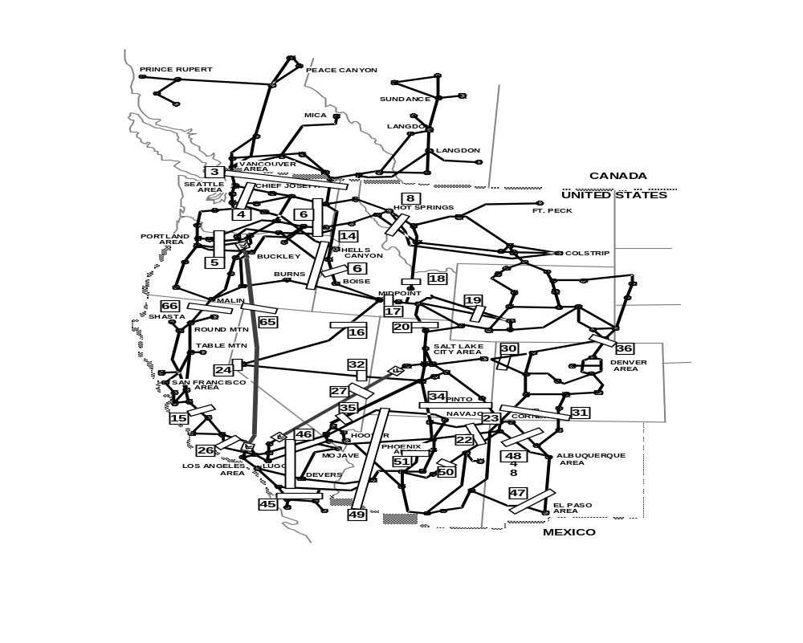
Figure I-1
Figure I-2
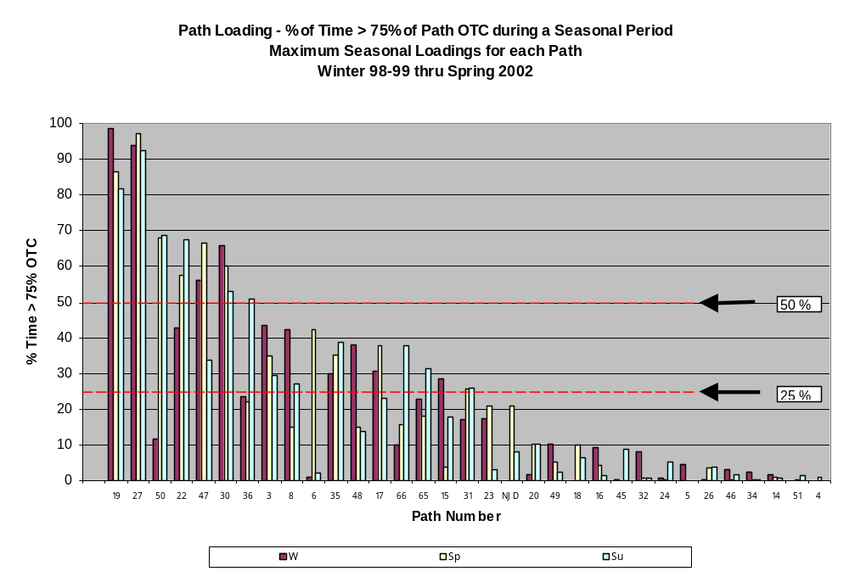

Numbers on bars show major transmission paths and correspond to numbers on graph
Major Transmission Paths in the Western Interconnection
Simulation of Transmission Congestion in 2008 and 2013

SSG-WI has conducted a simulation of transmission congestion in 2008 and 2013 to provide market participants and Western states and provinces with information on potential transmission congestion in the Western Interconnection.. The analysis refines the assessment conducted for the 2001 Western Governors’ Association’s Conceptual Transmission Plans Report.

Description and Purpose of 2008 Case: The purpose of modeling 2008 transmission congestion is to provide a benchmark for the generation scenario analysis for 2013 and to identify any immediate congestion problems. Little new transmission infrastructure beyond that which is already in the permitting process is expected to be added by 2008. Much of the new generation expected to be on-line by 2008 is already committed and thus can be readily identified. As a result, there is greater confidence in the 2008 transmission congestion estimates, however, there is limited ability to make significant changes in the transmission system by that date.

The configuration of the transmission system in the 2008 scenario was taken from the WECC 2007 power flow case. Adjustments were made to update the case for expected changes in the transmission system before 2008. Assumed non-coincident peak load was taken from the WECC 10-Year Coordinated Plan. Using a conservative approach to identify generation additions between 2003 and 2008, the simulation includes those new generating units expected to be on-line by the end of 2003 and projects presently under construction that have a high probability of coming on-line after December 31, 2003. This conservative approach was taken in response to recent changes in the industry that have led to the cancellation of a large number of announced power plants. These load and generation assumptions resulted in installed nameplate generation capacity of __ MW, or __ percent more than the non-coincident peak load in 2008.

Description and Purpose of 2013 Case: The 2013 simulations were developed recognizing that this timeframe was long enough to allow new transmission to be constructed. However, there are large uncertainties about the type, size, and location of new generation that might be constructed over the next ten years. (In order to evaluate the transmission system, it is necessary to know the location and type of generation that will exist.) To accommodate this uncertainty, SSG-WI developed three widely divergent generation scenarios.

One scenario reflects a continuation of the current trend in which most new generation is gas-fired. In this scenario it was assumed that new natural gas generation is located near load centers. The selected locations for new generation generally reflect the location of proposed power plants. The second scenario was developed through the efforts of representatives of the Western coal industry and defines hypothetical coal-fired generation additions by 2013. The third scenario was developed by the American Wind Energy Association and Western Resource Advocates and defines hypothetical renewable energy generation additions by 2013. The selection of these scenarios allowed consistency between this study and work previously done by WGA; the results highlight for decision-makers the transmission implications of different generation resource fuel-type choices. While it is unlikely that any of the scenarios will be implemented exactly as modeled, it is believed that the three cases taken in concert could highlight key transmission additions that would be effective in serving the more likely outcome of mixed renewable resource, gas and coal generation additions. The 2013 scenarios maintained approximately the same percentage of installed capacity over non-coincident peak loads as the 2008 scenario as a place-holder for resource adequacy until resource adequacy initiatives in the West provide definitive metrics.

The 2013 coal and natural gas scenarios are included to allow comparison of the potential impacts on the transmission infrastructure. However, the generation resources included in these scenarios do not meet the legislative targets mandated by the Renewable Portfolio Standards now in effect for Arizona, California, Nevada and New Mexico. In lieu of any legislative changes not currently anticipated, only the Renewables Scenario includes sufficient renewable generation to meet all of these targets for the year 2014.

Although specific separate cases were not developed to examine the impact of accelerated energy efficiency and demand response investments or expanded use of distributed generation, the modeling information provides insight on the impacts such developments would have on transmission needs. For example, an indication of the impact of reduced demand in 2013 can be garnered from examining the model results using 2008 load levels. If load growth between 2003 and 2013 occurred at the rate of 1 percent per year instead of the assumed 2 percent per year, demand in 2013 could be met with the transmission assumed to be in place in 2008. An indication of the impact of distributed generation on transmission needs can be garnered from the natural gas scenario where new generation is located close to load centers.

Some argue that delay in making large investments in transmission without jeopardizing the integrity of the grid is prudent since such a strategy allows more of an unknown future to unfold. For example, if new technologies, such as economical fuel cells, develop, congestion on the transmission system could decrease significantly. As potential transmission additions move from the conceptual level in this report to sub-regional planning and project specific analyses, the quality and specificity of the analyses of demand reduction and distributed generation options will increase.
Linkages Between Interconnection-wide Planning and a Sub-regional Planning Process the Southwest Transmission Expansion Plan (STEP)

[Jeff Miller to add text]
It is important to understand what this congestion analysis is and what it is not. The analysis:

- Simulates transmission congestion in 2008 using conservative assumptions about generation and transmission additions likely to be in service by that time;
- Simulates transmission congestion in 2013 under three different generation scenarios;
- Assumes the dispatch of generation with the lowest operating costs first as a simplified approach to simulating the market;
- Provides a source of information for –
    - Market participants, thereby encouraging collaboration in defining and planning specific transmission projects;
    - Sub-regional transmission planning (see sidebar)
    - State/Federal/provincial policy makers on transmission needs and costs associated with different future generation scenarios.
- Represents the next step down the path of proactive, interconnection-wide transmission planning that was begun with the release of the WGA Conceptual Transmission Plans Report in 2001.

The analysis does not:

- Constitute a transmission plan ready for implementation in the Western Interconnection;
- Represent a least-cost resource plan;
- Consider the capital cost of generation options, or demand-side management options,
- Evaluate the risks associated with future fuel prices or environmental regulation;
- Optimize interconnection-wide transmission expansion;
- Consider the value of transmission expansion to mitigate the exercise of market power; or
- Quantify the specific benefits of individual project additions.

This report presents selected illustrative analytic results. Efforts have been made to make as much input data and modeling results as possible publicly available so that other parties can perform additional analyses or verify the conclusions in this report. The analysis is limited by the quality of data available, the sophistication of modeling tools, the assumptions regarding economic dispatch, and the ability to predict loads and renewable resource output, particularly of the Northwest hydro system. These caveats would apply to any simulation of the system, and on balance, the SSG-WI Planning Work Group believes this to be a reasonable, useful assessment of possible future system parameters.

Observations and Results

The following are selected results from the analysis of historical path flows:

- There are wide variations in the degree to which transmission paths in the Western Interconnection are utilized.
- Many paths have large variations in utilization in different seasons.
- Actual flows may differ from those shown based on the experience of system operators when seeking to schedule power over paths.
- OTHER OBSERVATIONS TO BE PROVIDED BY DEAN PERRY

The following are selected results from the simulation of transmission congestion in 2008:

- Under average water and medium gas price assumptions, natural gas-fired generation will account for 28.7 percent of total megawatt hours of generation in the Western Interconnection in 2008, up from 18.1 percent in 1998.
- Natural gas prices have a larger impact on the need for new transmission to minimize generation costs than changes in hydro generation conditions.
- Paths and interfaces that show the greatest congestion in this simulation are: (identify paths and hours that congestion occurs, including selected congestion duration curves.)
- As an illustration of the application of the generic 2008 analysis in a specific location, expanding transmission capacity between Arizona and Southern California will provide the most significant benefit (identify $ results for relieving the congestion using average$/mw, simulated hours of loading above a certain % at high and low limit; and total system generation cost estimate based on congestion duration curve)
- … OTHER OBSERVATIONS TO BE PROVIDED BY JAMIE AUSTIN

The following are selected results from simulating transmission additions and congestion in 2013:

- The transmission additions associated with adding new generation or mitigating transmission congestion is highly dependent on fuel choices, with little transmission needed when future generation is gas-fired and significantly more generation needed when future generation is from coal or renewable resources.
- The coal and renewable energy scenarios illustrate transmission that may be needed to accommodate large amounts of such generation in 2013. The results do not represent lowest cost transmission expansion scenarios to accommodate non-gas-fired generation. Future work by SSG-WI and sub-regional planning efforts would be needed to develop lower cost transmission scenarios to accommodate coal and renewable energy development.
- In the coal scenario, (xx) miles of transmission additions were simulated to relieve congestion. The cost of such transmission additions was judged to be more than offset by lower generation production costs. (The capital costs of the new generation were not considered in the simulation.) The most congested paths identified under this simulation are (paths and location).
- In the renewables scenario, (xx) miles of transmission additions were simulated to relieve congestion. As with the coal scenario, the cost of such transmission additions was judged to be more than offset by lower generation production costs. (The capital costs of the new generation were not considered in the simulation.) The most congested paths identified under this simulation are (paths and location).

Next Steps: Improving the Assessment of Transmission System Expansion/Congestion

- [IDEAS ON NEXT STEPS IN THE ANALYSIS OF HISTORICAL PATH CONGESTION?]
- There is a need to improve the modeling tools available to estimate the value of mitigating transmission congestion. Current tools are inadequate to effectively model hydro generation. They also assume thermal generation is dispatched based on the marginal cost of each generating unit. In reality, the behavior of generators bidding into the market may be based on factors other than lowest marginal cost. A bidding behavior model being developed by the California ISO may be used by SSG-WI in the future to supplement the existing modeling tool.
- There is a need to more closely integrate into the SSG-WI modeling effort with (1) the results of resource planning by LSEs, (2) the results of sub-regional planning, and (3) WECC path rating procedures (I question (3) ???).
- Because of the growing reliance on natural gas-fired generation, there is a need to integrate the electricity transmission modeling effort with a gas supply model to determine the likelihood of adequate gas supplies being available to fuel proposed gas-fired generation.
- …[TO BE ADDED]

SSG-WI Transmission Planning

The third product of the SSG-WI Planning Work Group is the design of a transmission planning function that is a proactive, interconnection-wide, transmission planning effort addressing transmission needs and alternatives to meet conceptual resource development scenarios. The SSG-WI planning function is open to all market participants, Western states and provinces, and other stakeholders within the Western Interconnection. The planning function will identify transmission congestion issues that impact the marketing of energy between RTOs or sub-regions, including the study of congested paths within a region that may impact on the ability to market between sub-regions. The study of transmission congestion within an RTO that does not impact other sub-regions remains the responsibility of the individual RTOs or local/sub-regional entities. However, RTOs or other entities may request the SSG-WI’s Planning Work Group’s assistance in evaluating, or developing, specific projects.

Regional transmission planning performed by the RTOs/ISOs, sub-regions and others within the West each make up an important part of the overall transmission planning process for the West. SSG-WI provides for a seamless transmission planning function throughout the interconnection enabling the coordination of individual company plans, sub-regional transmission plans including those to be developed by RTOs, and interconnection-wide transmission plans. The SSG-WI planning function provides information for Load Serving Entities (LSEs), other market participants and state/provincial policy makers to make informed decisions about the transmission implications of possible resource scenarios. The study time horizon is five years and beyond.

Planning by SSG-WI comports with the regional planning guidelines contained in WECC’s bylaws. SSG-WI’s planning activities are linked to transmission planning done by LSEs, sub-regional planning, and future RTO planning. Figure I-3 illustrates how SSG-WI planning is integrated with other planning activities in the Western Interconnection.
Figure I-3

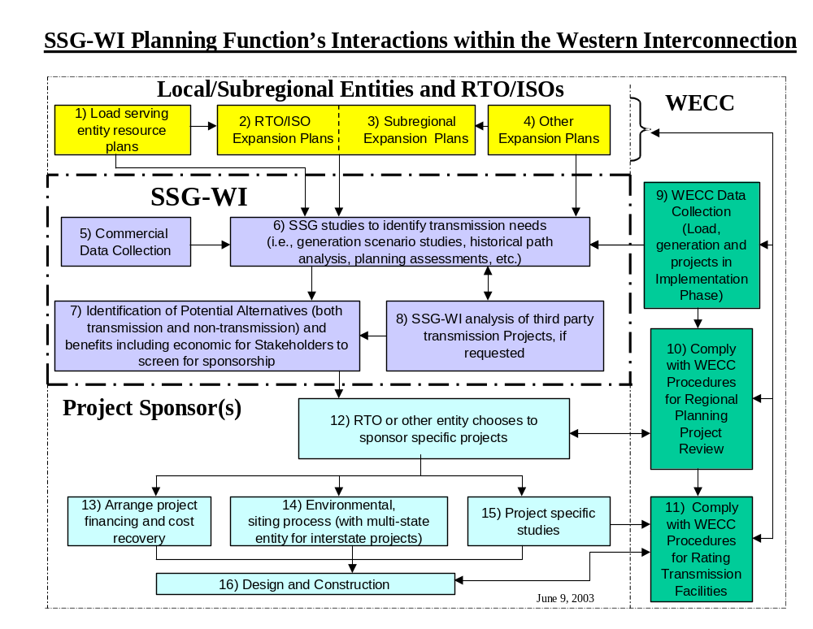

Introduction

Context and Purpose of SSG-WI Study

This report documents the work of the Seams Steering Group - Western Interconnection - Planning Work Group (SSG-WI-PWG). SSG-WI is a voluntary alliance of the three proposed western regional transmission organizations (RTOs) and includes a broad-based group of public and private sector representatives. The PWG was formed in 2002 to establish a collaborative west-wide expansion planning forum with the goal of facilitating seamless transmission planning across the Western Interconnection. A full description of the SSG-WI planning process, and how it coordinates with other planning activities in the western interconnection, is provided in the Section III of this report.

The work of the PWG is focused on developing transmission projects that are needed to enhance wholesale power markets through the mitigation of uneconomic congestion. It is clear that the development of a robust competitive wholesale generation market is dependant on the availability of a robust transmission system. While the need for developing the transmission system to enhance wholesale power markets has existed long before industry restructuring, industry restructuring has led to an increase in participants in the power markets with an increasing focus on the development of a robust transmission system.

To determine what transmission facilities need to be added under various generation scenarios, the PWG first had to estimate the amount and location of future load growth and evaluate potential generation additions. After developing these load and generation assumptions, detailed mathematical models were used to simulate the hourly operation of the Western Interconnection over a year’s time. The output of these models identified congested transmission interfaces and allowed the estimation of economic savings to both producers and consumers achievable by reducing or eliminating this congestion. A comparison of these savings to the cost of transmission additions needed to mitigate congestion will facilitate decisions of whether to pursue a transmission project(s), or not.

Two years were selected for study--2008 and 2013. These timeframes provide a near-term and mid-term perspective on the use of the transmission grid. For the mid-term case (2013), a wide variation in potential resource plans was studied to aid policy makers in developing energy policy for the west. The three alternate resource plans presented in this report focused on gas, coal, and/or renewable generation additions.

The completion of these studies is intended to meet the following three needs:

- To identify opportunities to further facilitate competitive and efficient markets through the development of additional power transmission facilities. The results of this study will be used in various planning processes to help facilitate reinforcements to the transmission system where that is determined to be economically beneficial.
- To provide policy-makers with information concerning transmission impacts of various energy policies being considered by State and Federal entities. For example, this study helps to identify the major bulk transmission facilities that would likely be necessary to integrate large quantities of wind generation into the western interconnection.
- To identify to generation developers the major transmission additions that could be necessary to deliver specific generation resources to load. Generation developers have stated to SSG-WI that this information is critical to their ability to successfully develop these new resources.

In addition to the production cost studies, the PWG has completed an analysis of actual transmission path utilization data from 1998-2002. This information was used to provide insights into congestion concerns that exist today and to help benchmark the production cost studies. A detailed description of this work is provided in Section IV of this report.

Comparison of SSG-WI and WGA Studies

This type of study is not new to the Western Interconnection. In the past, WECC has completed this type of analysis. The most recent study of this type was completed in August of 2001 for the Western Governors Association (WGA). The WGA study was entitled: Conceptual Plans for Electricity Transmission in the West. In the WGA study, two book-end generation expansion scenarios were studied for 2010, and conceptual transmission expansion plans were developed for both scenarios. These included a gas generation expansion scenario and an “other than gas” scenario with large amounts of new coal-fired generation and renewables. The WGA study reached the conclusion that if generation expansion is mostly of the gas-fired type located close to loads, the transmission expansions that are already underway are likely to be adequate. However, if new generation expansion includes significant new coal, wind, hydro, and geothermal resources that are typically located in the more electrically remote regions of the system, then substantial new transmission investments will likely be required. The report also noted that the cost-savings of the remote generation would probably be sufficient to justify the additional transmission cost. Of course, the study conclusions were heavily dependent on the input assumptions such as fuel prices.

This SSG-WI study is essentially an update of WGA study. In addition, it addresses many of the recommended “Next Steps” that were identified in the WGA report. These next steps included items such as evaluating the impact of natural gas prices on electricity prices and refining the plans for transmission additions necessary to integrate remotely located resources like coal and renewable generation into the grid.

The results of the SSG-WI-PWG studies are described in Sections VII and VIII of this report. Following the study results section is a discussion of possible improvements that could be made in future studies and a section that summarizes the overall findings, conclusions and recommendations of the study.

- Description of SSG-WI Planning Function and its Interactions Within the Western Interconnection:

SSG-WI Planning Goals and Objectives

The goal of the SSG-WI planning function is to facilitate a competitive and reliable regional power market by providing information on transmission infrastructure additions that would result in a robust transmission system. A robust transmission system is one that can accommodate an efficient and competitive exchange of electric power among industry participants to enable them to serve load.

The SSG-WI planning function deals with congestion issues that impact the marketing of energy between regional transmission organization (RTOs), which are in various stages of formation, and the sub-regions of the West. The study of transmission congestion within an RTO that does not impact other regions will remain the responsibility of the individual RTOs. Load service/reliability planning will be the responsibility of the RTOs, PTOs and LSEs. The SSG-WI planning process will be coordinated and be compatible with the RTO Planning processes, the local planning processes and the reliability planning processes of WECC.

The SSG-WI planning effort will focus on project needs and assume voluntary participant funding for projects. If it is determined in the future that a backstop role is necessary (beyond that of the individual RTO’s), other funding mechanisms and cost allocations can then be developed.

Focus of expansion options for marketing analysis is beyond the time frame for currently committed projects, reaching out 5-15 years in future . The expansion options will cover possible load, transmission and resource scenarios that could occur in this timeframe. A committed project might be one in a state siting process or under construction.

The SSG-WI will annually develop and recommend to the Western RTOs a Transmission Long Range Plan that is robust, embraces numerous planning variables, and provides insight and direction for interconnection expansion. The Plan will be forward looking beyond existing capabilities to portray the “next step” in system development.

The SSG-WI Planning Work Group – Its Goal and Scope of Work

SSG-WI organized a Transmission Planning Work Group (PWG) in the Spring of 2002 to develop a western interconnection regional transmission planning process. (See Figure III-1) This process was to be implemented prior to the western RTO’s becoming operational.

On May 15, 2002, The SSG-WI Steering Group adopted the following Goal and Scope of Work for the SSG-WI Planning WG, as guidance for the SSG-WI Planning Work Group (PWG) in establishing a collaborative west wide transmission expansion planning function for the West.

Goal :To provide a forum to further the development of a robust, West-wide interstate transmission system that is capable of supporting a competitive and seamless West-wide wholesale electricity market.

In furtherance of that goal, the PWG should, in its efforts, distinguish between transmission projects that are needed primarily to achieve certain economic benefits (economically-driven expansion projects) and those that are necessary to satisfy established reliability criteria (reliability-driven expansion projects). The efforts of the PWG will primarily focus on the evaluation and, if appropriate, support of economically driven expansion projects that support creation of a seamless West-wide market.

The SSG-WI Planning Work Group is tasked to implement a collaborative west wide expansion planning effort for the Western Interconnection. The planning effort should be proactive and fulfill the following functions:

- identify transmission congestion that is an impediment to the efficient operation of the western market

- develop through a collaborative process, strategic transmission development options and specific alternative plans for eliminating congestion and provide information on these alternatives to the marketplace.

- review and evaluate sponsor’s analysis of proposed projects (transmission and non-transmission) having interconnection wide commercial impacts

- perform planning studies as necessary at a high level, including cost and benefit assessment

- encourage development of economic projects developed through this planning effort or by sponsors, by working jointly and closely with the states and potential project sponsors

- develop guidelines for reviewing viable non-transmission alternatives.

- provide technical support to appropriate regulatory agencies by identifying congested paths and the costs and benefits of eliminating the congestion

- assist the appropriate regulatory agencies by providing technical transmission planning support to such agencies in their development of western energy policy.

- issue a biennial report, assessing current trends, future transmission needs and other identified alternatives, to facilitate development of an efficient seamless western market

The effort will not have project approval authority. The effort will not address planning issues whose impact is limited to within an RTO boundary. The west wide expansion planning function should be consistent with the proposed planning functions and responsibilities of the individual RTOs. Participation is open to all stakeholders.

This SSG-WI expansion planning effort and the WECC reliability effort should be complementary and closely coordinated to avoid duplication. Recommendations from the planning group will be brought to the SSG-WI.

The PWG will collect the following inputs to the planning process:

    - Historical path use.
    - Future resource/demand scenarios.
    - Production/Cost or other market analysis of these scenarios.
    - Transmission expansion plans from 3 RTO’s (or individual TO’s prior to RTO formation).
    - Local transmission expansion plans from TO’s and LSE’s.
    - Inter-RTO expansion plans to facilitate a competitive WI energy market (reduce market power) developed by SSG-WI.
    - Higher-level transmission development concepts, guidelines and/or principles for long-range development; long-range visions for development of the western grid developed by SSG-WI and others.
    - Resource planning processes of major load-serving entities
    - State, Provincial and Federal energy policies
    - Demand-side management options
    - Other inputs as necessary.

From these inputs, the PWG will produce and recommend to the Steering Group, West-wide long-range expansion scenarios that have broad benefits. Drivers of each project and sponsors, if any, will be included.

The PWG will evaluate transmission system implications and costs for various generation and load scenarios impacting the interconnected transmission system, for LSE’s and other market participants to use in their resource planning and Least Cost Planning Process.

SSG-WI Steering Group
FIGURE III-1:

Planning Work Group

Chair – Dean Perry
Planning Process

Chair – Marv Landauer
Long Range Planning

Chair – Harlow Peterson

Study Lead Team

Study Technical Support

Chair – Jeff Miller
Modeling Improvements

Chair – Dennis Phillips

January 2003 Report to FERC

The three proposed western RTOs (RTO West, California ISO and WestConnect) jointly filed a report with FERC on January 8, 2003. Included in this report was a description of the elements of a draft SSG-WI planning process with a diagram depicting the flow of information within this process and with other interfacing processes. The filing indicated that the planning process was still being worked on and it was expected to evolve over time as experience is gained with interconnection wide transmission planning. The January filing also identified four major issues with this planning process that needed to be addressed to make the planning process functional. How these issues were resolved is described in Appendix III.

This document reflects the result of review and update of the SSG-WI planning process described in the January 8, 2003 FERC report. This description of the SSG-WI Planning Function and its interactions within the Western Interconnection, was developed by the SSG-WI Planning Work Group(PWG) in coordination with WECC and participating stakeholders. The PWG participants consist of representatives of the proposed RTOs, WECC, state regulators, public entities, and generation developers.

The primary driver for SSG-WI involvement in interconnection wide planning is to address seams issues that arise between the three proposed western interconnection RTOs and to address major transmission constraints that affect a wide area of the Interconnection. The PWG recommends that whenever a planning seams issue is identified, SSG-WI should be prepared to address the issue. These seams issues can range from investigating long term inter-RTO transmission requirements to providing processes to address planning issues that affect one or more areas (for example, beyond the boundaries of a single RTO). This mainly includes working with other organizations and agencies that have interconnection wide scope. The PWG may work with individual entities or projects, upon their request, to facilitate the development of transmission projects.

The process described in this document is applicable to both the pre- and post- RTO time frames. However it is likely the process will evolve over time and will be reviewed and modified for post-RTO operation. The WECC portion of the process is an existing process, described in the WECC document “Procedures for Regional Planning Project Review and Rating Transmission facilities”. The SSG-WI portion of the process is new and is now being implemented. The first SSG-WI Transmission Planning Report resulting from the SSG-WI portion of the process will be issued in September 2003.

The SSG-WI Planning Function

NOTE: Details of the role of the SSG-WI Planning Function in the Western Interconnection are described in Appendix I. A summary description of the WECC Regional Planning Project Review Process is described in Appendix II. The proposed resolution of the four planning issues identified in the January 8, 2003 SSG-WI report to FERC is presented in Appendix III.

The SSG-WI Planning Function is a proactive, region-wide, transmission planning effort addressing transmission needs and alternatives to meet conceptual resource development scenarios. It is a stakeholder-involved process. It addresses congestion issues that impact the marketing of energy between RTOs or subregions, including the study of congested paths within a subregion that have an impact on the ability to market between subregions. The study of transmission congestion within an RTO that does not impact other subregions remains the responsibility of the individual RTO’s or local/subregional entities. However, RTOs or other entities may request the PWG to assist them in evaluating or developing specific projects.

Transmission planning performed by the RTO/ISOs, subregions and others within the West is an important part of the overall transmission planning process for the West and SSG-WI provides for a seamless transmission planning function throughout the interconnection.

The SSG-WI Planning Function provides information for Load Serving Entities (LSEs), other market participants and state/provincial policy makers to make informed decisions about the transmission implications of possible resource scenarios for meeting their load obligations. The time horizon is five years and beyond. In this timeframe, SSG-WI planning incorporates transmission expansions that are being implemented and investigates the subsequent needs of the West.

The SSG-WI Planning Function is open to industry segments and stakeholders within the Western Interconnection. It includes state and regulatory input. SSG-WI will coordinate its process and planning cycle with the three RTO’s and others within WECC.

The PWG addressed the relationship between the SSG-WI Planning Function and the WECC processes. The WECC Regional Planning Project Review Process describes how transmission planning should take place within the West. The SSG-WI and WECC processes are very complementary and reinforce each other. They will build on each other to foster successful completion of both processes. The SSG-WI Planning Function will provide proactive region-wide planning at the front end of the WECC process, while the WECC process will provide follow through and closure for sponsored projects moving through to implementation and facility rating.

WECC’s coordinated planning policies and procedures for the Western Interconnection, documented in “Procedures for Regional Planning Project Review and Rating Transmission Facilities” can be found at www.wecc.biz. (For a summary description, see Appendix II). The Rating Transmission Facilities portion of the WECC procedures is clearly the responsibility of a project sponsor and beyond the scope of the SSG-WI Planning Function.

The SSG-WI Planning Function is expected to incorporate several inputs, including input from RTO, subregional and LSE expansion and resource plans. SSG-WI will perform an analysis of historical path use and future system needs. At this time, this analysis includes generation scenario modeling and transmission long range planning. Other analyses may be added or modified in the future as the planning function evolves. The SSG-WI Planning Function takes the information gathered from outside sources (e.g. Subregional Planning Groups, RTOs/ISOs, PTOs, LSEs, non-RTO/ISO members) and the results of its own internal studies, and identifies future system needs and possible solutions to these needs, both transmission and non-transmission. This information is developed in an open process and disseminated to all interested parties and posted for input from the market participants and other parties interested in regional planning. As SSG-WI analyzes the transmission needs of the system (from its various inputs), it will also propose high-level alternative solutions to these problems.

These solutions include possible non-transmission solutions or an aggregate set of non-transmission alternatives. The level of detail of these non-transmission alternatives includes favorable location and sizes of generation and demand-side measures that would be necessary to impact the transmission alternatives. All of these possible solutions are posted for market input and comment before SSG-WI completes its expansion plan.

The SSG-WI Planning Function is envisioned to provide information to market participants to facilitate market participant decisions. The SSG-WI Steering Group decides which issues should be recommended to the RTOs for further analysis. The Planning Function incorporates any input received into its analysis and develops an annual SSG-WI Transmission Planning Report. SSG-WI is limited in its ability to go beyond the identification of possible future transmission and non-transmission additions for others to implement. It is not intended to be a decision-making body but rather take on a supporting and facilitating role. It does not fund or compel any projects nor allocate costs.

The goal is to get Project sponsors to come forward to review the SSG-WI planning work and to determine whether there is an economic interest in pursuing project development. Sponsors are responsible for determining if there are other interested projects participants and for taking projects through the WECC Regional Planning Project Review Process and subsequent project development actions such as environmental analysis and siting, permitting and approval requirements.

SSG-WI does not perform environmental analysis of sponsored projects. SSG-WI does not participate in siting processes or other governmental activities with analysis or recommendations unless requested by project sponsors or state agencies. SSG-WI limits its participation to making models available and explaining the extent of its analysis. Project sponsors are responsible for developing economic justification, arranging financing, designing and constructing the project.

Sub-regional Planning Groups

Prior to the formation of RTOs in the West, Subregional Planning Groups, working in cooperation with the SSG-WI Planning Work Group, will play a significant role in Planning of the Western Interconnection transmission system. Through SPGs, stakeholders are able to become involved in finding solutions to local transmission needs.

SSG-WI and the SPGs will develop a cooperative, supportive and complementary working relationship. Both SSG-WI and the SPGs will work together to develop models and databases for production costing planning studies. SSG-WI will focus on interconnection wide needs. Results of SSG-WI studies will feed into SPGs for further economic analysis and detailed planning studies involving local transmission providers and stakeholders. Results of SPG studies will feed into SSG-WI for evaluation of potential interconnection wide benefits to entities beyond the local level.

Several SPGs have already formed or are in the formative stages. The following is a brief summary of those SPGs.

Central Arizona Transmission System (CATS)

The CATS SPG is focusing on development of the transmission system between the Phoenix and Tucson areas in Arizona. It is addressing transmission concerns related to load growth in this area and proposed generation additions in this area of approximately 10,000 MW. Participants include Arizona Public Service, Salt River Project, Tucson Electric Company, Southwest Transmission Cooperative, Citizens Communications Company, WAPA, and the Arizona Corporation Commission staff. The project was opened up to all stakeholders, thus many more participants became involved.

Today, the study area encompasses an area bounded by the Phoenix Metropolitan area to the north, the Tucson Metropolitan area to the south, the Palo Verde Generating Station to the west and the Arizona/New Mexico border to the east. An initial meeting was held in March 2000. The CATS Phase I Study was completed and report published in July 2001. The first CATS Phase II meeting was held in August 2001.Phase II analyzed the combining of several Phase I alternatives, and integrating other proposed transmission projects in Arizona that were not included in CATS Phase I.

Web Site for the CATS Subregional Planning Group is http://www.azpower.org/.

Southwest Transmission Expansion Plan (STEP)

The goal of STEP is “To provide a forum where all interested parties are encouraged to participate in the planning, coordination, and implementation of a robust transmission system between the Arizona, Nevada, Mexico, and southern California areas that is capable of supporting a competitive efficient and seamless west-side wholesale electricity market while meeting established reliability standards. The wide participation envisioned in this process is intended to result in a plan that meets a variety of needs and has a broad basis of support.

STEP is an ad-hoc voluntary organization whose membership is open to all interested stakeholders. STEP’s focus is on economically driven expansion projects that support the development of seamless west-wide markets. STEP will work with project sponsors to help assess the benefits of their independent transmission proposals.

STEP will develop a biennial planning process that produces a long-term bulk transmission expansion plan (10 years or more). It will identify current and future transmission congestion that is an impediment to the efficient operation of the western market. STEP will develop, through a collaborative process, strategic transmission options and specific alternative plans for reinforcing the transmission system and for reducing or eliminating g congestion. This information will e provided to the market place. It will rely as much as possible on the technical studies conducted by project sponsors and studies conducted in other forums. STEP will perform technical study work that is not duplicative of work done by others.

Additional information on STEP is available at the web site http://www1.caiso.com/docs/2002/11/04/2002110417450022131.html.

Rocky Mountain Subregional Planning Group

The Rocky Mountain SPG is an effort initiated by the Governors or the states of Wyoming and Utah. The Goal is: “To identify in an open and public process, the most critical electric transmission and generation project needs in the Rocky Mountain subregion, and with broad stakeholder involvement provide a framework for regional collaboration to improve the Western interconnection with technical, financial and environmentally viable projects identified for developmental consideration.

Electric transmission in the rocky Mountain region is constrained and as a result, the region’s vast wind, natural gas and coal resources are underutilized. RTOs are years from effective operation and there is no current collaborative Rocky Mountain planning g effort to consider transmission expansion from a holistic perspective.

Those to be involved include Western Interconnection electric utilities, IPPs, rural electric generation and transmission cooperatives, municipalities, federal power, transmission and marketing agencies, project developers, entrepreneurs, power brokers, state and federal regulators, state energy office representatives and anyone interested in regional electric generation and transmission planning.

Additional information on the Rocky Mountain Subregional Planning Group may be found at their web site http://psc.state.wy.us/htdocs/subregional/home.htm.

Northwest Subregional Planning Group

The Northwest utilities and stakeholders are currently organizing an SPG in the Northwest under the Northwest Power Pool. An initial organizing meeting was held August 6, 2003 in Portland, Oregon. The Scope of the group’s activities is currently under development. It is planned to focus the group on expansion of the Northwest transmission system, identifying congestion and potential solutions inorder to meet the projected future needs of the wholesale electricity market in the Northwest.

Additional information on the Northwest Subregional Planning Group will be posted under the Northwest Power Pool’s web site at http://www.nwpp.org.

- Historical Path Flow Study

The analysis of actual historical power flow data for the transmission system in the Western Interconnection provides an indication of how marketers and load serving entities have utilized the transmission system to market energy and serve load. This information is also useful in the analysis and identification of potential future areas of congestion and for verifying model representation for power flow and production costing analysis.

This work is the latest in a continuing effort to analyze utilization of the western Interconnection transmission system. Similar analysis was performed by the three western Regional Transmission Associations (RTA) as documented in the latest Biennial Transmission Plan, dated July 2000. Historical data analyzed and included in the August 2001 Western Governor’s transmission report was also incorporated. The time period covered by the analysis in this report is from Winter 1998-1999 through Spring 2002.

The analysis was performed for 33 transmission paths, representing all the major transmission paths in the western interconnection.

The analysis utilized real time hourly power flow and operating transfer capability data submitted by path operators and archived in the Western Electricity Coordinating Council’s EHV Data Pool database. Most data in the EHV Data Pool database is complete. In some cases, the real time path operating transfer capability was not reported and assumptions were made based upon published path transfer capabilities. These assumptions are noted in this report.

To facilitate comparison among the paths, a utilization indicator was calculated. The same indicator was used in the RTA’s Biennial Transmission Plan report. This indicator is calculated as the percentage of time the path exceeds 75% of its operating transfer capability over the season reported. The 75% level was chosen as an indication of a path that may be considered heavily utilized. This figure was developed for purposes of this report and has no basis in terms of an accepted industry standard or practice. The magnitude of the indicator is not necessarily an indication that there is congestion, or an inability to meet the needs of transmission users, on the path. In the western interconnection, paths are designed to be loaded to 100% of their operating transfer capability and withstand a credible outage without violating reliability standards.

A second loading indicator presented in this report, is the peak loading during the season. This indicator does not include a time factor as does the 75% indicator.

The work in this report was sponsored by the Seams Steering Group – Western Interconnection (SSG-WI), which is supported by RTO West, the California ISO and WestConnect. Data used in the analysis was provided by the Western Electricity Coordinating Council. This effort is a product of the SSG-WI’s Planning Work Group. Participants in the Work Group include RTO members, marketers, generators, renewable resource interests, non-RTO participating entities, representatives of various western state agencies and representatives of the Western Interstate Energy Board.

The following observations may be drawn from the analysis:

- The following paths had at least one season over the study period, in which the seasonal loading exceeded 75% of OTC 50% of the time or greater: (These may be considered the more heavily utilized paths relative to their operating transfer capability. This by itself is not an indication that these are the most commercially congested paths. These are also not the most heavily loaded paths in terms of the magnitude of MW loading)

Path 19 – Bridger West
Path 27 - IPP DC Line
Path 50 – Cholla – Pinnacle Peak
Path 22 – Southwest of 4 Corners
Path 47 – Southern New Mexico
Path 30 – TOT 1A (Colorado to Utah)
Path 36 – TOT 3 (Wyoming to Colorado)

- Paths with the highest loadings relative to their transfer capabilities are primarily located in the Rocky Mountain and Desert Southwest regions (Wyoming, Colorado, Arizona and New Mexico).

- The two most heavily loaded paths, West of Bridger and the IPP DC Line, are transmission paths with high load factors dedicated to the integration of generating plants in Wyoming (Jim Bridger) and Utah (Intermountain Power Project).

4. For use in future analysis, improvements should be made in the data reporting procedures for data to be included in the WECC EHV Data Pool database. One area that should be reviewed is the calculation and reporting of OTC limits.

From this analysis, it cannot be concluded whether there was significant congestion (defined as the inability to obtain transmission capacity when needed) on a path nor whether there are economic benefits to increasing the transfer capability of any of the paths analyzed.

Figures IV-1 and IV-2 summarize the path “peak loading” and “percentage of time exceeding 75% or OTC” . Path numbers are the WECC Rated Path numbers. The complete report, “Western Interconnection Path Flow Study – February 2003” is available on the SSG-WI web site at http://www.ssg-wi.com.

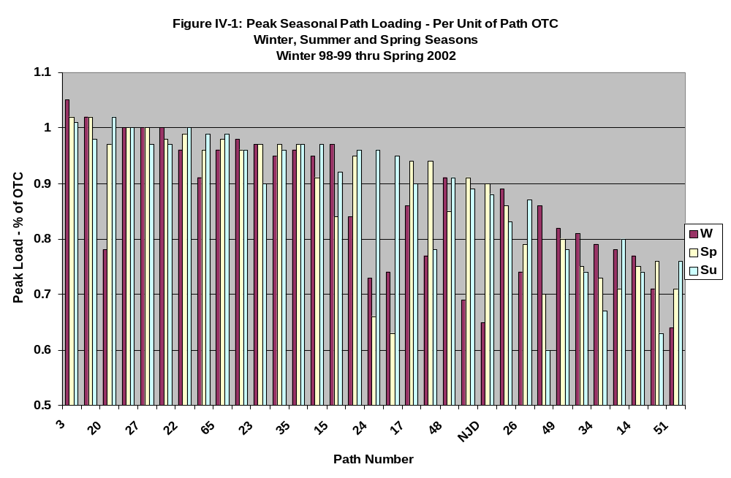
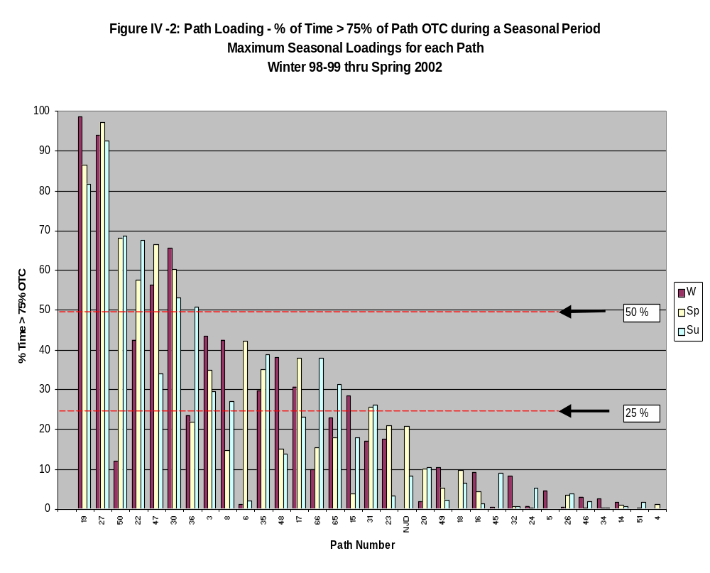

- Transmission Study Methodology

Description of ABB Market Simulator Model:

Market Simulator is ABB’s program for midterm simulation of large electricity power markets. By combining a physical network model, economic generation data and historical demand data, the model simulates the financial and physical performance of a power market with hourly resolution for studies up to one year in duration.

The primary use of Market Simulator, also known as the COUGER Model, is to assist planners in identifying the costs and benefits of proposed transmission and generation expansion projects. For each simulation, the model catalogs hourly production costs and nodal prices, to indicate the benefits and costs of expansion projects. Projects that are shown to be economically viable can be identified for further examination and to identify the point of diminishing financial returns for incrementally increasing transmission or generation capacity.

Economic preference for each thermal generating unit is specified by a piecewise linear incremental heat rate model, time varying fuel costs and variable O&M costs. Capacity and outage information for each unit are also specified as input data. The previous material describes the economic dispatch capabilities and algorithm of Market Simulator. Dispatch determines the loading of resources; predicting the on/off schedule of the thermal units is known as unit commitment. At run time, the user has two options regarding unit commitment:

- Disabled: In this mode, all units not on outage are assumed available for dispatch. Units on must run status have dispatch lower bounded by the normal unit minimum level. Units on fixed dispatch are locked to their assigned schedule. All other thermal units are made available for dispatch from 0 MW to normal unit maximum capacity.
- Enforced: The current version of Market Simulator features a multi-area priority list unit commitment method that reflects known transmission constraints when the transportation model is invoked to model the WECC. Both minimum up- and down-times are considered.

Nodal demand data and hydro dispatch are the two sets of input data that produce most of the temporal variations in the output results. The nodal demand is determined at each hour by imposing/fitting a set of load distribution factors obtained from a power flow case (Market Simulator required input data) on to load shapes chosen to describe control area demand patterns. Typically historical control area load data is used to describe the base case for simulation, with adjustments made to reflect current expectations of monthly peak and energy load. The load data can be further modified to stress test high- and low- demand scenarios if desired. The hydro dispatch is a simple peak-shaving algorithm, which takes monthly estimates of each projects average MW output and tries to shape the output towards peak periods while respecting the maximum MW, minimum MW, and ramping limits.

Transmission constraints take the form of thermal limits on AC lines and bi-directional flow limits on interfaces. Interfaces are sums of flows on sets of lines, known elsewhere as branch groups or nomograms. The (optionally seasonal) limits for lines and interfaces are input data.

At the heart of Market Simulator is a transmission-constrained economic dispatch algorithm that identifies for each hour of the study the generation dispatch that minimizes total system production cost while matching generation to load and losses and observing transmission congestion constraints. High algorithm performance in the algorithm is obtained by solving each hour’s dispatch through a technique known as delayed constraint generation, iterating between invocations? to a linear programming (LP) solver and a power flow calculator, as shown in Figure V-1. The LP solver produces a candidate dispatch, which is then evaluated for feasibility by the power flow calculator. If the associated power flow violates any transmission constraints, those constraints are added to the LP formulation, and the process continues until convergence is obtained. Because each hour’s dispatch begins its solution with the previous hour’s solved problem in memory, very few constraints are ever required to be added to the LP after a few hours’ solutions are obtained.

Because the dispatch of pumped storage units cannot be decoupled hourly, a price-leveling algorithm is used to schedule these units before the economic dispatch algorithm commences. While respecting pond capacity limits, each pumped storage plant is scheduled in alternating ‘blocks’ of generation and pumping energy until the expected local marginal price ratio does not compare favorably with the cycle efficiency of the unit.

Upon completion of the program, the following data are available for retrieval and plotting with hourly resolution:

- Loading for each generating unit;
- Flow on any AC or DC line
- Flow on any interface
- Locational marginal price for any bus
- Net import, load and generation for each area.

An auxiliary program provides a means of rapid extraction to present a subset of the hourly data in spreadsheet format.

In addition, summary information for the study including but not limited to total production cost, energy dispatch, etc. is provided in tabular format.

Hydro Modeling
COUGER is limited when it comes to hydro modeling and optimization. However, the model accepts hourly hydro shapes and treats them as fixed values. For the SSG Studies, an external algorithm was used to shape hydro.
The external algorithm used for hydro shaping can be described as a mix of peak shaving and “pseudo” run-of-the-river. It uses hydro resources to level the load shape without regards to the existence of other resources. The run-of-river hydro energy is modeled as base load energy; whereas the dispatchable “monthly” hydro energy dispatches to shave system peak load. Hydro power plants are scheduled one at a time over the horizon of the week, subject to hourly constraints for minimum and maximum generation, weekly constraints for ramp rates, and total energy.
In COUGER, the LMP differences get muted when looking across cases because the program just looks at variable costs and does not factor in costs associated with bid behavior (e.g., when the snow pack is low, market prices would likely be more than variable costs). In addition, the peak shaving algorithm will schedule a considerable percentage of the hydro hours at the minimum output level from the hydro power plants, which does not typically reflect actual hydro operations. Thus, peak shaving may underestimate the use of thermal peakers, lowering peak hour LMP estimates.

Wind Modeling

Distributed Generation/Demand Response

Non-wires alternatives will be considered in both the modeling of future congestion and in the SSG-WI/WECC Regional Transmission Planning Process that reacts to identified transmission needs and proposed projects. This process, which is graphically depicted in Figure C-1 of Appendix C, non-wires alternatives will be examined in Box 7 and included in the planning results in Box 9. For an illustration of how non-wires alternatives will be treated as part of SSG-WI modeling of congestion, see page __ on modeling results.
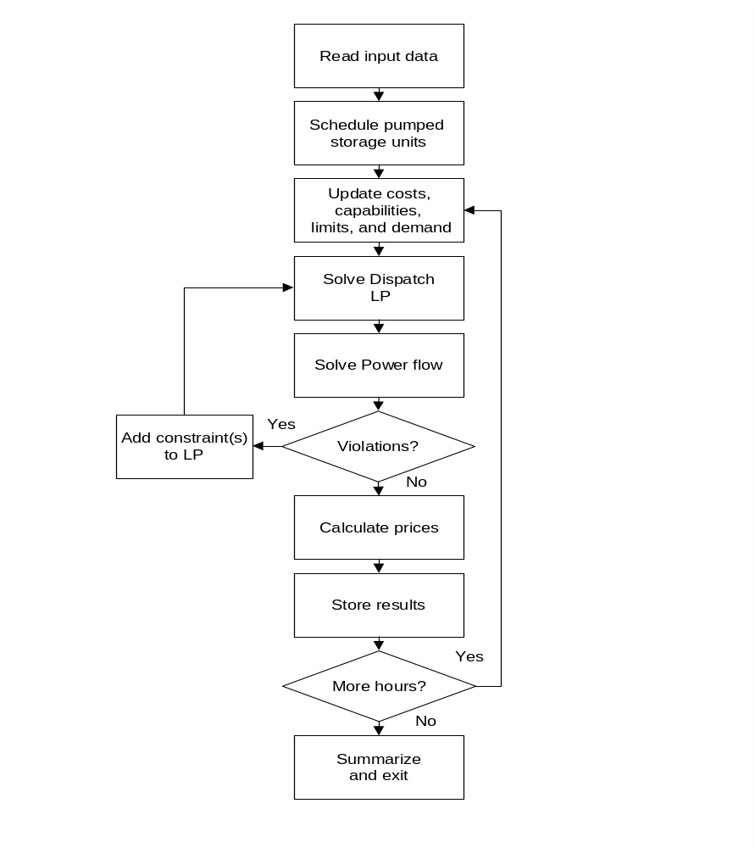

Figure V-1: Market Simulator Algorithm

Description of Model Assumptions:

Simulation of Hydroelectric Generation for Median, High and Low Water Conditions

Evaluation of median, high and low gas prices

In modeling transmission congestion in 2008 and 2013, SSG-WI used three alternative gas price assumptions: a low U.S. natural gas well-head price of $2.15/mcf in 2008 and $2.69/mcf in 2013; a medium well-head price forecast of $3.23 in 2008 and $3.77 in 2013; and a high well-head price forecast $4.84 in 2008 and $5.30 in 2013. All numbers are in 2003 dollars.

These gas price assumptions were selected to cover a wide range of future prices. Because the most recent price forecast done in 2003 is significantly higher than the forecasts done in 2002, SSG-WI has focused its analysis on its medium and high gas price scenarios.

Figure V-2 shows how the SSG-WI gas price assumptions compare with recent wellhead gas price forecasts by the California Energy Commission, the Northwest Power Planning Council, the Energy Information Administration’s Annual Energy Outlook 2003, GII (formerly DRIWEFA), and EEA.
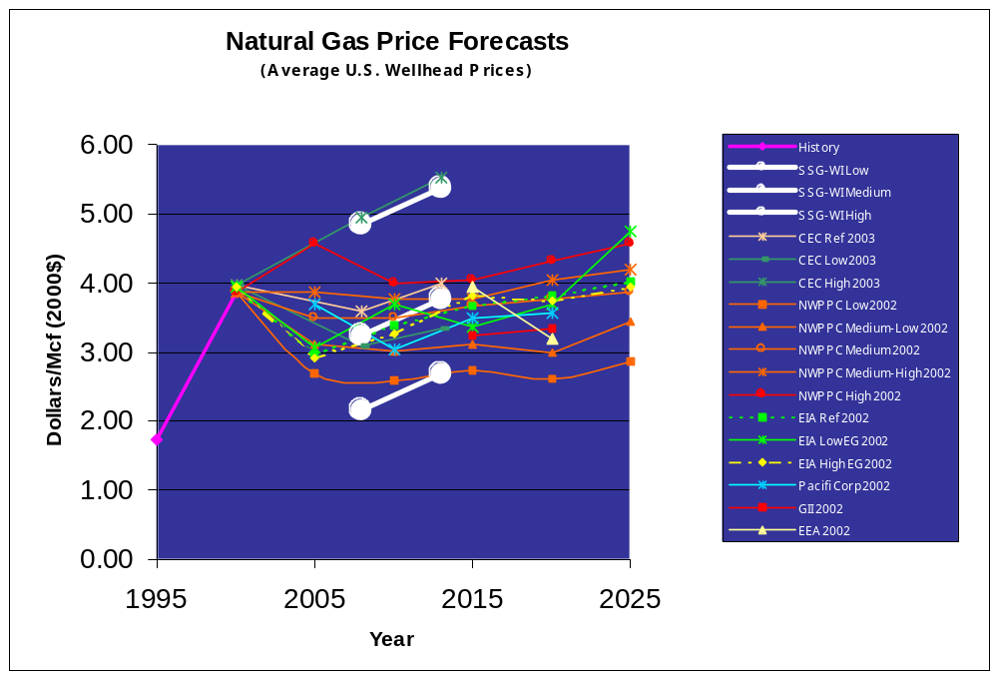

Figure V-2
Basis differentials and gas transportation costs are added to the assumed U.S. wellhead prices. The basis differentials and transportation adders are from the Northwest Power Planning Council's "Fuel Price Forecasts for the Fifth Power Plan," September 2002. Appendix __ [TBD] shows the assumed delivered cost of gas for each of the modeling regions.

Overview of Generation Scenarios

The goal of the generation scenarios is to demonstrate the implications of new power plants choices on the transmission system. The 2008 scenario includes only new power plants that are likely to be online by mid-2004. These plants are primarily natural gas fired.

For 2008 to 2013, three very different scenarios were modeled: one with mostly new natural gas plants, one with a mix of renewables and natural gas and a one with mostly coal-fired plants. For all four scenarios only announced retirements are modeled.

Each 2013 scenario adds enough new power plants to comfortably meet utility forecasts of load growth. The SSG-WI has not tried to develop one scenario that minimizes the combined cost of new plants, transmission additions and the operating costs for all plants. Uncertainties about future load growth, fuel costs and environmental regulations make it impossible to create a single least-cost plan. The locations of the generation additions for the 2013 scenarios are shown in Appendix X.

2008 GENERATION SCENARIOS

The power plants likely to be on line by mid-2004 produce enough power to meet expected loads in 2008. Plants added between 2000 and mid-2004 are primarily gas-fired. The level of congestion in the 2008 scenario provides a benchmark for the three 2013 scenarios and helps identify imminent congestion problems

Table G1 shows the net generation in place for the western interconnection for 2000, the 2008 scenario and the three 2013 scenarios [Additions between 2008 and 2013 for the three scenarios are shown in Graph X(?)]. Values in the table are the maximum capability of the plants. Planned maintenance, forced outages and renewable resource variability for hydro, wind and solar are included in the model.

Table V-1 Nameplate GW in Place by Scenario

Year | Coal | Natural  Gas | Nu-clear. | Hydro | Wind | Biomass &  Geothem. | Solar | Other | Total
2000  Actual | Kurt  has |  |  |  |  |  |  |  | 158.9?
2008 | 36.9 | 74.3 | 9.3 | 64.6 | 2.8 | 2.1 | 0 | 0.9 | 190.8
2013  Gas | 36.9 | 92.4 | 9.3 | 64.6 | 9.4 | 2.1 | 0 | 0.9 | 215.5
2013  Coal | 53.2 | 76.2 | 9.3 | 64.6 | 9.4 | 2.1 | 0 | 0.9 | 215.5
2013 Gas &  Renew. | 36.9 | 83.8 | 9.3 | 64.6 | 21.4 | 5.8 | 2.5 | 0.9 | 225.1

2013 NATURAL GAS GENERATION SCENARIO

The 2013 natural gas scenario adds 18,200 MW of combined-cycle combustion turbines to the level assumed in 2008. These are located based on load growth and proximity to gas and electric transmission lines.

All three 2013 scenarios add 6,500 MW (nameplate) of wind generation. These wind plants are placed in areas with good resources. These wind resources are placed closer to loads than the additional 12,000 MW wind added in the renewable scenario.

2013 COAL GENERATION SCENARIO

This scenario adds 16,300 MW of coal plants to the level assumed in 2008. These plants are located at or near coal mines. Representatives of the Western coal industry helped develop this scenario. This scenario also adds 1,900 MW of combined-cycle gas-fired plants in the Southern California and Northern Baja Mexico areas.

2013 RENEWABLE GENERATION SCENARIO

This scenario adds a mix of renewable and gas-fired generation. To the 2008 levels it adds 18,500 MW wind (nameplate), a mix of 2,500 MW of solar thermal and roof top and central station photo-voltaic (nameplate), 3,800 MW of baseload biomass and geothermal and 9,500 MW of combined cycle gas plants. Renewable plants are located in resource areas and gas plants are near load centers. Representatives of the American Wind Energy Association and Western Resource Advocates helped developed this scenario. There are enough renewable resources in this scenario to meet the renewable portfolio standards of California, Arizona, Nevada and New Mexico.

The variable generation of wind and solar plants are determined outside the model based on the resource characteristics. Biomass and geothermal plants run at full output when they are not down for routine or unplanned maintenance. Gas and coal fired plants are dispatched within the model to follow the remaining loads.

Non-Wires Alternatives

At the high level of planning done by SSG-WI, there at are at least a couple of ways to model the effectiveness of non-wires alternatives at relieving congestion and delaying construction of wires. The simplest way is to analyze the results of the 2008 and 2013 scenarios. Another way would be to run sensitivities on each generation scenario to measure the effectiveness of, say a 5% to 20% decrease in loads.

The results from modeling the 2008 and 2013 scenarios can be used to approximate the effectiveness of non-wires alternatives in reducing transmission congestion. The impact of successful demand-side measures in reducing transmission congestion can be estimated by extrapolating the lower load in 2008 to the 2013 scenarios. For example, if demand-side measures were able to hold peak load in 2013 to levels forecast for 2008 then….[TO BE FILLED IN WITH MODELING RESULTS].

The impact of generation on the load side of a constraint can be estimated using the results from the gas-fired scenario in 2013, which assumes gas-fired generation beyond that already planned, will be located near load centers. For example, if only load-based generation were added to meet load growth between 2008 and 2013 congestion on the transmission system would be….[TO BE FILLED IN WITH MODELING RESULTS]. Frequently the generation that can be located on the load side of a transmission constraint will be gas-fired. Changes in production costs under the natural gas generation scenario were evaluated using a high gas price scenario.

The impact of non-wires transmission alternatives, such as RAS and FACTS, could be estimated by the increase in the carrying capacity of the existing system when these devices are utilized.

Reserve Capacity Margin vs. Resource Adequacy

In order to be consistent with the WGA study, a 25% reserve margin was assumed to be a proxy for resource adequacy. However, it should be noted that there is no relationship between this assumption and the ongoing efforts in certain sub-regions of the Western Interconnection to establish a resource adequacy metric and possibly a standard. Especially in the Northwest where hydro is a predominant resource, a reserve capacity margin has little meaning in terms of ensuring resource adequacy given the energy limited nature of the resource.

The capacity associated with both thermal and hydro resources was assumed to be nameplate capacity. Following is a discussion of the capacity credit assumed for wind.

There is sometimes confusion on the use of the terms capacity factor and capacity credit as it is applied to intermittent sources of energy, such as wind power. This section describes the assumptions and methodologies used to determine these values for the report, and highlights the differences between the two. Much of the work in this field has been conducted by Michael Milligan, of the National Renewable Energy Laboratories. (see Milligan, M. R. (2002). Modeling Utility-Scale Wind Power Plants, Part 2: Capacity Credit. 67 pp.; NREL Report No. TP-500-29701)

WIND CAPACITY FACTOR

Capacity factor is calculated as the amount of energy actually produced during a year, divided by the theoretical maximum output that could be generated over that same period, based on the unit’s nameplate rating. For conventional power plants, this is an historical measure of how often the plant is shut down for maintenance, either routine or unplanned, as well as how often the plant’s output is reduced because other lower variable cost generation is available to meet load at any point in time.

Commercial wind plants typically have annualized capacity factors of 30-40%. From a mechanical standpoint, the availability of individual wind turbines is generally over 95%, and because wind farms consist of many individual turbines the “wind farm availability” is even higher. This availability is superior to that of conventional power plants. Wind plants are extremely reliable generators. However, wind plants rely on the use of intermittent resources – during windy periods there is adequate “fuel” to produce very low cost energy, but during lulls the output may drop to zero. Net wind availability has sometimes been represented as an “effective forced outage rate,” just as mechanical outages are treated with conventional units. Expressed this way “effective forced outage rate” is the inverse of capacity factor, or 60-70%. However, this calculation is misleading since the system reliability impacts of “forced outage rate” are not the same for wind plants as conventional plants. Modern wind farms are producing at least some energy over 80% of the time and very, very rarely experience instantaneous changes in output that rival “routine” startup and shut down of conventional plants.

Each wind plant modeled for this study was assigned a series of values for its capacity factor, depending on the diurnal and seasonal variations in the wind resource at that location. These were defined in a 4 x 4 matrix of values of each plant, detailing specific values for midnight to 6 am, 6 am to noon, noon to 6 pm, and 6 pm to midnight for each of the four seasons. Then, based on a statistical analysis of the historical wind resource distribution pattern, each of these “average” capacity factors was randomized to generate a unique hourly time series with 8,760 values per year as required for input to the model. While this process sounds very precise, it is important to understand that it is extremely difficult to generalize the behavior of individual wind farms across any geographic region, and that the raw wind resource data used to generate these time series over this broad geographic scope is not robust. Given the relative lack of sensitivity of the overall modeling results to these specific assumptions, this treatment is directionally correct and suitable for this screening exercise. However, uncritical use of this data set for more targeted evaluations of specific projects or follow on detailed planning is not recommended.

WIND CAPACITY CREDIT

The capacity credit of a plant is a measure of the increase in load carrying capability that a given generator can provide to an electrical system for a specific system reliability target. This target can be specified using alternative measures of reliability, such as loss of load probability (LOLP) or expected unserved energy (EUE). A standard criteria in general use is an LOLP of one day in ten years. The capacity credit represents the generator’s contribution to system reliability, by quantifying the likelihood that the entire portfolio of all generation resources will be able to meet load requirements at the instant they are requested. Therefore, unlike capacity factor, which simply quantifies the overall average energy delivery of a plant, capacity credit indicates both the plant’s availability and the correlation of this availability with time differentiated system requirements for capacity to deliver energy. The value depends heavily (but not exclusively) on events during high load hours for the utility system.

Capacity credit is defined as the change in effective load carrying capability (ELCC) of the system with the addition of the subject generator at a given level of system reliability. The ELCC cannot be calculated simply by specifying the generator average capacity factor or by measuring the plant output during last year’s system peak load hour – it must be determined by considering hourly loads and generating patterns, plus a statistical treatment of other generator forced outage rates, and the probability of unusual events such as an unseasonal weather event during e.g. a planned nuclear plant refueling outage, using an appropriate production-cost or reliability model. Many detailed studies of “capacity credit” have found a higher system “capacity value” during shoulder months of the year when most routine system maintenance is performed rather than during peak seasons when everyone is predicting maximum load levels and “all hands are on deck.” Because ELCC calculations can be very time consuming and data intensive, it is often estimated by averaging the capacity factor during the top 1,000 load hours during a typical year.

In lieu of performing a detailed ELCC analysis, for which robust data simply does not exist on this geographic scale, this report assumes a standard capacity credit of 20% for each wind plant. This assumption that capacity credit is, on average, roughly 60% of the wind capacity factor is judged to be conservative. However, it needs to be understood that this study is not sensitive to a precise measurement of wind capacity credit -- only requiring a quick screen to ensure overall “resource adequacy” of the generation portfolios and some assurance that overall system reliability is comparable between the various generation scenarios.

Model Assumptions vs. Expectations for the Market

HYDRO:

MARKET:

Competitive Market Assumption

The model assumes a fully competitive market in which all generators bid their marginal cost into a market clearing price IFM (Integrated Forward Market), do not engage in strategic bidding, withholding of any generator capacity or otherwise exercise market power or influence prices in the market. Likewise, it is assumed that all demand is price inelastic, and buyers do not engage in strategic or price influencing behaviors. Modeling such behavior is beyond the capabilities of available software, and in any event would be subjective and an invitation for unnecessary debate.

Never-the-less, it is only reasonable to assume there is or will be some strategic behavior in the market which will reduce overall market efficiency and increase overall market costs. Transmission capacity is the great equalizer. To the extent there is congestion on the grid, almost by definition there are opportunities for strategic behaviors and some inefficiencies that are not modeled. Therefore, since the thrust of the STEP/SSGwi effort is the evaluation of new transmission which without exception will eliminate or mitigate congestion to some degree, which in turn will mitigate strategic behaviors to some degree, there are benefits of the transmission upgrades which are not captured and quantified by the analysis.

RMR is not modeled.

The RMR generators are not modeled as must run generators which might underestimate the production of more expensive, less efficient generators in an import zone. Put the other way round, this might cause the simulation to over-estimate the amount of more expensive, less efficient generation that could be displaced by cheaper imports if a new transmission line is built. The efficient OPF (optimal power flow) dispatch simulation would dispatch the RMR generation to serve load whenever their cost is low enough to make them part of an efficient dispatch. However, to the extent they are RMR because they are in an import load pocket or a load pocket that would exist after an N-1 or because of voltage constraints which would require them to operate, but they are not efficient enough to be dispatched in merit order, they are not dispatched in the simulation. The OPF will instead dispatch more efficient resources, some of which will be imports made possible by the proposed new line, when this would not actually be acceptable if all operating constraints are taken into account.

Lower voltage line limits were not active in the model. Activating them might address part of the problem, but omission of RMR N-1 security and voltage constraints may still raise questions. However, it is possible that excess economical power dispatched from import resources would be present in the base case before addition of the proposed new transmission line such that the incremental benefits of the new line are not distorted or over-estimated. It is also possible that the proposed new lines themselves, or that network upgrades that will be needed to deliver additional imports associated with the new lines will reduce the need for RMR contracts and produce an economic benefit that has not been captured.

The OPF dispatch is not security constrained.

The ISO’s MD02 market is going to use a security constrained dispatch and unit commitment. That is, the dispatch will not only be constrained to prevent loading transmission lines beyond their normal (continuous) rating, but the dispatch will be constrained to prevent, for example, N-1 contingency loading beyond the overload (emergency) rating of lines. For example: suppose there are 2 parallel lines with supply at one end and demand at the other. Both lines are rated 100 MW normal, 120 mw emergency rating. A dispatch that is not security constrained will dispatch the system to send 200 MW over the parallel lines if this is the economic solution. A security constrained dispatch would only dispatch 120 MW over the parallel lines since following an N-1 contingency of one of the lines this is the maximum that could be reliably carried by the remaining line.

Although the simulation software does not determine security constraints, and some could have been omitted in the simulation, constraints were modeled where the WECC Path Ratings (e.g. Path 15, 26, EOR, WOR, etc), were included in the simulation. That is, the limits of “rated paths” include dynamic and thermal limits to prevent post contingency conditions from exceeding safe and reliable operating conditions. Non-rated internal paths such as those that have caused or foreseeably will cause intra-zonal congestion in the market, such as the west of Devers and North of Miguel systems are modeled. Likewise, Operating Nomograms such as SCIT were included in the simulation. All critical constraints known to exist at this time were modeled.

Failure to consider all operating security constraints could cause the analysis to over estimate the benefits of import lines since the model may overestimate the amount of internal, less efficient generation that would be displaced by imports. However, no omissions are known to exist at this time and it is assumed the results will be valid in this regard.

Unit Commitment module is not available or was not used.

Absent unit commitment constraints the OPF program would assume all generators were immediate available, and if the output of a unit was less expensive it might be dispatched for as few as a couple of MW and or as few as a couple of minutes. In actuality, a generator is not started to run under these kinds of conditions. Generators take a finite length of time to start, have a minimum output level, a minimum length of time it should be operated before it can be shut down and a minimum length of time it must be shutdown before it can be restarted.

While this would cause the program to tend to underestimate the total cost of production, it is impossible to say with certainty that this would have any impact on the calculated benefits of proposed transmission projects. It could cause an underestimate or overestimate of the incremental benefits of new transmission. Hopefully, any error introduced in this way would be present in both the base case and the case with the proposed new transmission project so that the calculated incremental benefits are valid. It probably will not be possible to do anything about this using the current software.

Certain internal proposed new generators were not modeled

Addition of new, efficient generators inside of an import control area will tend to reduce the benefits of proposed new import transmission lines. MountainView, Otay Mesa, and the Pastoria Expansion were discussed as examples of proposed new generators that did not meet the criteria for inclusion in the simulation but might have a significant impact on the analysis results if constructed. Mountain View, for example, could have an adverse impact on the economic benefits of the D-PV#2 line. Therefore, sensitivities will be performed to evaluate the impact of these projects on the economic analysis results.

Locational gas price differences were modeled, but transmission losses and wheeling charges were not.

The price of gas to generators inside of import areas like CA was assumed to be higher than the price to generators at the border or outside of CA and closer to gas fields. This would raise the cost of power from internal generators relative to external generators and cause the OPF to dispatch more power from resources external to CA and less from internal generators. This would in turn increase the economic benefits of the proposed new lines. In addition, loss factors that are around 5% at import locations like PV, and which would effectively raise the cost of the external generators by up to 5% relative to internal generators were not modeled, and wheeling charges that could raise the cost of external generators by $1 or $2 per MWH were not modeled. This would also cause the OPF to dispatch more power from external resources to CA load and less from internal generators, tending to increase the calculated economic benefits of proposed new transmission lines.

The net effect of these modeling assumptions would be to increase the incremental benefits of proposed new transmission projects such as those extending from California to Arizona and Nevada. It might be possible to add a constraint to the OPF formulation that would add a hurtle for use of designated lines for imports to simulate the effect of these charges. The simulation vendor should be contacted to see if this is possible. NOTE: new generation delivered at Imperial Valley does not have a wheeling charge to sell into CA as does the Arizona and Nevada generation, so the model would tend to overestimate the power imported from Arizona generation and underestimate the power dispatched from the IV generators and thus would tend to overestimate the benefits of a D-PV2 line and underestimate the benefits of an IV-San Diego line. Since the OPF (presumably) uses the same cost curve both for new CCGTs ikn Arizona and Nevada and those connecting at IV, it will tend to dispatch more then it should from PV generators and less then it should from the IV generators. In this particular case it might be possible to correct for the absence of this difference by adjusting the relative cost curves of these sets of generators.

Similar vintage and technology generators are assumed to have identical, flat incremental cost curves.

Obviously this is not the case in the real world. And just as obviously, the market bid price of generators can not really be known, irrespective of actual cost. Therefore, this is a reasonable assumption that is probably the best that can be accomplished in a competitive market in which actual cost information and biding strategy is not publicly disclosed. A flat cost curve will tend to result in a step function dispatch of generators which wouldn’t occur with a sloped cost curve which is perhaps more realistic. It’s hard to say with certainty whether or this would have any impact on calculated benefits, but since even a large new 500 kV line is a marginal change on a system as large as the WECC, it might be safe to assume there would be no significant impact.

An Average $3 gas price was used in the analysis.

This will be increased to $4 in the next revision with sensitivities considered at $3 and $5.

A higher gas price could tend to increase the economics benefits of displacing less efficient generation with more efficient import generation. The sensitivities will be helpful in this respect. If the increase in benefits at a gas price of $5 compared to the case with gas at $4 is much more then the decrease at a gas price of $3 compared to the case with gas at $4, we will know that the analysis is very sensitive to gas price assumptions and can factor this into judgments and decisions regarding use of the analysis results.

The model uses a DC - OPF

In a real AC power world, losses vary with the square of the power transmitted over a transmission line. Losses are not calculated by the DC OPF program as they would be in an AC OPF as is proposed for use by the CAISO in its MD02 proposal. MWH losses were estimated by the ISO under different loading conditions and included with the demand. Losses are included by grossing up the load at all busses by a fixed percentage adder. This seems satisfactory approach from the standpoint of production cost.

Generator forced outages are not modeled.

Given that the analysis is calculating the difference in costs with and without a possible new transmission line, the impact of omission of forced outages would probably be very close to the same in both the with and without proposed new project case. Thus, this should not have much if any impact on the calculation of incremental benefits associated with a possible new line.

The phase shifter model did not function properly.

Phase shifter model functional problems experienced in initial runs have been corrected. It is not certain yet what impact this will have on initial results.

Consumer and Producer Surplus allocations are critical.

The cost of power to consumers is calculated for each of 8760 hours in the year by summing the LMP at each bus times the load at each bus in an area (e.g. Arizona, SCE, San Diego, etc). To find the economic benefits of a new line the consumer cost of power after an upgrade project is subtracted from the cost before the upgrade. A reduction in the cost of power is assumed to be an increase in consumer surplus. The producer surplus was calculated in a similar fashion by summing the LMP at the generator minus the assumed production cost of the generator times the MWH production in each hour, with and without the upgrade project to find the incremental producer surplus. Consumer surplus increases calculated as above are offset by reduction in producer surplus when the generator experiencing the reduced surplus belongs to the consumer in an economic sense (e.g. is in the rate base of the utility serving the consumer). Thus the net benefits of a new line have been determined by summing the producer and consumer surplus of all buyers and sellers where those buyers and sellers are in the same economic region or control area.

The surplus of most interest is net consumer surplus in an import region or control area. If the net consumer surplus in an import region that results from a new transmission line is greater then the cost of the new line, there is an economic case to be made for proceeding with the line.

With respect to congestion revenues, the construction of a new transmission lime may reduce or eliminate the flow of congestion revenues to consumers that exists before the new line is built. Just as a reduction in supplier surplus is netted against an increase of consumer surplus in the same region, a reduction in congestion revenue must also be netted against an increase in consumer surplus.
- 2008 Simulation Results

- 2013 Simulation Results
- Long-term Model Improvements
Modeling Hydro
Opportunity for improvement: Hydro generation is a fixed input to the optimized power flow program (OPF), which is simply netted against the hourly bus bar load at each dam site.
Hydro dispatch is pre-determined using the following two-step process:
Step 1. BPA, BCH, WAPA, CEC and PacifiCorp provided monthly average hydro generation at all major hydro sites assuming high, medium and low water conditions. BPA’s data was derived from “Hydsim”, a hydro regulation model that simulates the monthly average generation at all federal and Mid-Columbia hydro facilities for various water and load conditions and subject to system operating constraints.
Step 2. The monthly hydro generation at each dam site was shaped into hourly data using a peak shaving algorithm that operated within minimum and maximum constraint limits to serve the WECC’s system-wide hourly load shape.
This approach tends to flex hydro operations beyond realistic hourly operating limits, and is for all practical purposes, blind to transmission constraints. It also creates a “rigid” dispatch scenario that does not react “dynamically” to hourly changes in OPF thermal dispatch.
In addition, the entire process is both time-consuming and prone to error because the analyst must use care to ensure that loads, inflow data and modeling assumptions are consistent between all three models. .
Potential Solutions:
1) Incorporate a fully integrated multi-dam hydro formulation within the optimized dispatch model.
2) With respect to the PNW hydro data - resolve proprietary issues and replace the peak shaving algorithm with outputs from BPA’s Hourly Operation System Simulator (HOSS) which models hydro dispatch with much greater precision.
3) "Tune" the existing process. I.e., adjust the monthly maximum and minimum limits until the peak shaving algorithm produces hourly generation shapes that more accurately reflect actual operations, (e.g., redefine limits based on a probability of exceedence concept).
4) Streamline overall input-output-report writing process to ensure consistency and reduce errors.

Modeling Uncertainty
Opportunity for improvement: Existing OPF programs tend to under-estimate price volatility because they “over-optimize” system operations. Simply put: our models “know” the future with perfect certainty and never make mistakes. As a result, our models do not “see” the price excursions that result from boom–bust cycles or the misallocation of hydro storage.
Potential Solutions:
In reality, the factors that affect the volatility in LMP prices, i.e., the long-term resource and transmission acquisition decisions, the hydro storage decisions, unit commitment decisions and annual maintenance decisions are made with imperfect knowledge. Hence we may want to investigate other modeling techniques that incorporate uncertainty into the decision making process.
And, at a minimum, we can always improve upon our existing processes. For example, our current approach incorporates uncertainty by simulating and weighting a range of alternative “scenarios” and in order to model these scenarios accurately and efficiently we need to have the ability to:
1) Create a sufficient number of scenarios that adequately represent the range of future possibilities.
2) Create scenarios that are based on consistent sets of input data, e.g., heating and cooling loads that are correlated to snow-pack and runoff.
3) Attach the appropriate probability weight to each scenario.
4) Automate as many of these functions as possible, minimizing turn-around time and data input errors.
Modeling New Resource Acquisitions
Opportunity for improvement: Transmission and generation are substitutes so the economic factors and reliability issues that drive transmission acquisition decisions will also affect resource acquisition decisions, and vice versa, so it is imperative that both strategies be developed in a consistent manner so as not to introduce a bias in study results.
For example, it is extremely difficult to “manually” create a consistent set of resource and transmission acquisition scenarios for a multiple scenario study in which fuel prices, capital costs, hydro inflows and load growth trajectories are continually varying over time.
Potential solutions:
Hardwiring new resource capacity is a viable option when analyzing a few scenarios and when the simulation is limited to a single year. However, this approach becomes unwieldy and may be infeasible when the study horizon spans more than a single year or if we adopt a Monte Carlo approach towards simulating uncertainty. A more practical solution may be to allow the model to acquire new resource capacity based on system economics, maintaining a minimum reliability standard and resource supply curve data.
Modeling Bus Bar Loads
Opportunity for improvement: The existing process does not allow us to simulate the temporal and spatial variability we would actually expect to see in bus bar loads. As a result, we may be underestimating congestion costs and dampening the price volatility. In addition, the load shapes we are using are usually not correlated to the hydro scenario being analyzed.
Potential solutions:
Explore the possibility of:
1) Using common historical water year and weather year data to derive regional hydro generation and temperature dependent bus bar load data.
2) Stochastically synthesize regional hydro inflows and correlated bus bar loads.
Modeling Game Theory and Market Behavior
Opportunity for improvement: Most existing models simulate perfect competition, which maximizes total social benefits. However, in reality, prices sometimes exhibit greater price volatility when firms maximize profits by withholding generation.
Potential solutions: We need to have a better understanding of how economic equilibrium concepts like Cournot-Nash work and how we might incorporate these features into future model formulations.
Modeling Marginal Losses
Opportunity for improvement: Marginal loss rates can create large LMP differentials that, when ignored, lead to inefficient dispatch and resource siting decisions.
Potential solution: Incorporate marginal loss methodologies in the LMP formulation.
- Findings, Conclusions and Recommendations

APPENDIX A

Glossary of Terms
APPENDIX B

Attachment 1 – Conclusions from the WGA Technical Study

Two bookend generation 2010 expansion scenarios were reviewed and transmission
expansion plans proposed for both.

- If generation expansion results in mostly gas-fired generation located in or close to loads, transmission expansion that is already under construction or committed to be on line in by 2004 is probably adequate. This conclusion is highly dependent on the assumptions made for gas prices.

- If generation expansion includes significant new coal, wind, hydro, and geothermal resources that are typically located in the more electrically remote regions of the system, $8 to $12 billion (in 2010 dollars) of new main grid transmission infrastructure and generation integration transmission may be needed. However, fuel savings and reductions in market clearing prices as compared with the gas case may justify the additional transmission, depending on assumptions of delivered gas prices, the capital cost of generation, and coal price assumptions. The difference in annual average variable cost savings between the Gas scenario and the Other-Than-Gas scenario is approximately $3 billion to $4 billion. In the high gas price sensitivity study, these annual savings jumped to over $5 billion.

- The initial cost of the Other-Than-Gas case transmission expansion could be reduced by $1 billion to $4 billion (all 2010 dollars) with further study or if main grid transmission plans influence optimum location of generation expansion.

- Capital costs of new generation were analyzed briefly in the spreadsheet study, but were not factored into the production cost model results. Depending on the treatment of capital costs and other fixed costs, including the capital costs of pipelines and fuel delivery systems, either “bookend” generation and transmission expansion scenario appears to be economical.

- Mitigation of market power and policy choices such as decreasing reliance on gas or developing indigenous renewable or coal resources will be important in deciding how much transmission expansion is needed.

Attachment 2 – WGA Study Recommendation for Additional Work

The WGA study recommended that additional work should be completed to refine the modeling analysis by:

- Evaluating alternative load growth scenarios that reflect implementation of end-use load management, energy efficiency and distributed generation resulting from consumers receiving closer-to-real-time signals on electricity price;

- Expanding the sensitivity analysis to examine the impacts of natural gas prices on electricity prices and load growth;

- Conducting an incremental transmission addition study to better quantify transmission levels and costs;

- Expanding the analysis by including DC transmission options;

- Evaluating the market power mitigation and operational flexibility benefits of either (a) additional generation in transmission-constrained areas or (b) the addition of more transmission; and

- Evaluating additional generation scenarios including combinations of wind and peaking resources.

- Evaluate the use of additional emerging technology-based solutions in increasing transfer capacity in the existing transmission system where applicable.

Attachment 3 – Comparison of WGA and SSG Technical Studies

 | WGA Study | Proposed SSG Study
Scenarios Studied | - All-Gas (25,000 MW)  - Other than Gas (18,000 MW of coal, 4,000 MW of wind, and 1,500 MW of geothermal) | - Gas Scenario  - Coal Scenario  - Renewables Scenario
Years Studied | 2004 and 2010 | 2008 and 2013
Analysis Tool | GE MAPS | ABB Market Simulator
Hydro Sensitivities | Yes – high, average, and low | Yes – high, average, and low
Gas Price Sensitivities | Yes – high, average, and low | Yes – high, average, and low

Benefits of SSG Study over WGA:

- Additional scenario that studies large amounts of wind generation
- Updated load, generation, and gas price assumptions
- Updated estimate of future congested interfaces.
- More refined and better optimized transmission expansion plans (consideration of DC)

APPENDIX C

Attachment 1 - - SSG-WI Planning Function and its Interactions

Within the Western Interconnection

The following describes the major elements of the SSG-WI planning function and its interactions within the Western Interconnection planning process as described below and depicted in Figure C-1. The SSG-WI Planning Function is consistent with and complements the WECC Regional Planning Project Review Process described in Appendix II and in the WECC document “Procedures for Regional Planning Project Review and Rating Transmission Facilities.” The process described in this appendix is applicable to both the pre- and post- RTO time frames. However it is likely the process will evolve over time and will be reviewed and modified for post-RTO operation.

The planning process chart depicts a general flow of the Western Interconnection planning process from the top to the bottom of the chart. It consists of four major areas as follows:

  - Local/Subregional Entities and RTO/ISOs: This area of the chart includes activities undertaken by these entities in the early stages of developing their plans, prior to entering in a regional planning activity. In addition to RTO/ISOs, these entities could include transmission owners, load serving entities, and groups such as the Northwest Power Pool. It should be noted that these RTO/ISO planning processes are not fully developed at this time, may develop under different timelines, and may not be similar in nature.

  - SSG-WI: This area of the chart describes the additional process detail that SSG-WI has developed and will use in its initial steps of identifying alternatives.

  - Project Sponsors: This area of the chart describes the high-level steps that project sponsors follow in implementing specific projects. Project sponsors could include any entity that proposes a transmission project, such as existing transmission owners, load serving entities, independent power producers, power marketers, or merchant transmission providers.

  - WECC: This area of the chart outlines the WECC procedures and other activities that support regional planning from the outset of entities making their internal needs and plans public through to project approval and implementation.

SSG-WI’s basic role is to identify areas of potential future transmission congestion in the Western Interconnection, develop and analyze alternative solutions and provide this information to all entities, including RTOs, Participating Transmission Owners, non-RTO members, LSEs, state agencies, generation owners and marketers. Since SSG-WI has no implementation authority, it is the role of these entities to review the SSG-WI analysis and to pursue project implementation for those projects that they determine have sufficient economic benefit.

BOX 1 – Load Serving Entity Resource Planning

Each load serving Entity (LSE) will be responsible for assuring its resource adequacy. It will keep the RTO’s and SSG-WI informed of its plans and needs and these resource plans will be included in the RTO and SSG-WI studies.

BOX 2 – RTO/ISO Expansion Plans

Each RTO Planning Process will be designed to address the transmission expansion needs of its service territory. The specifics of these processes will not be described in detail here (not all of them are fully developed at this time). Information may be found on the respective RTO/ISO Web sites (California ISO – www.caiso.com, RTO West – www.rtowest.com, WestConnect – www.westconnectrto.com).

BOX 3 – Subregional Expansion Plans

Subregional transmission planning processes are strongly encouraged to evaluate needs, alternatives and benefits of future transmission facilities within specific areas. This activity would be very useful to integrate with other transmission projects that may be contemplated. Identifying the associated costs and benefits derived from adding subregional transmission and generation projects would be important in deciding what facilities should be built. These subregional planning efforts can determine the best incremental additions to the system from their area’s perspective. These planning processes should be public and consider transmission as well as non-transmission alternatives. The expansion plans that are developed in these subregional-planning processes will be fed into the SSG-WI planning process for evaluation of how they fit into an optimal all-inclusive west-wide plan.

When the planning processes of the three proposed RTOs in the Western Interconnection are fully implemented, the subregional planning processes will be folded into the RTO planning processes.

BOX 4 – Other Expansion Plans

Projects that are proposed outside of RTO and subregional planning processes can be brought into the SSG-WI Planning Function. Opportunities for improved regional transmission efficiencies, unsponsored projects, ideas and potential needs can be brought into this process. These could come from non-RTO members or RTO members that are interested in exploring potential projects, or who have developed expansion plans for their own systems that have not been included in subregional plans under Boxes 2 and 3 respectively. These projects can be introduced into the RTO Planning Process and/or the SSG-WI Planning Function. Generally projects should start and coordinate at the lowest level possible in order to garner support.

BOX 5 – Collection of Commercial Data

The database developed by SSG-WI will be a public database. To perform the studies identified in Box 6, SSG-WI requires certain market sensitive generator data such as heat rates, fuel and maintenance costs, plant outage forecasts, etc. Because of the sensitivity of this data, plant owners may choose not to supply it to SSG-WI. In such cases, SSG-WI will develop its best approximation for use in the SSG-WI study program.

BOX 6 – SSG-WI Studies

Congestion in the Western Interconnection will impact the efficiency of electricity markets. To evaluate the amount of congestion on the system and its impacts, SSG-WI will collect data on historical transmission congestion and will conduct studies to estimate future system congestion. The studies will also evaluate alternative methods for mitigating congestion and will provide information to market participants concerning the transmission implications of alternative resource scenarios. The studies will examine various future years, alternative resource addition scenarios, and will include various sensitivities to key variables such as hydro generation levels and natural gas prices. The primary tool used to complete the analysis will be production cost studies. Key assumptions for the study and the study results will be discussed and approved in open stakeholder meetings. The database used for the studies and the study results will be available to all interested parties. It is anticipated that SSG-WI studies will take into consideration and build upon studies performed by the local/subregional entities and the RTOs/ISOs.

BOX 7 – Identification and Posting of System Needs and Alternative Solutions

Once SSG-WI completes its analysis of the system and determines the subsequent transmission limitations, it will develop a list of possible solutions. These solutions will include transmission system expansions and non-transmission alternatives. This information will be posted for comment. Potential high level benefits (both economic and non-economic) will be identified.

The needs of the regional transmission system will also be posted for comment and feedback. It will include transmission needs in specific locations (e.g., between eastern Wyoming and eastern Colorado) and potential transmission and non-transmission alternatives that would reduce the transmission limitations. Non-transmission alternatives would include generation on the load side of a constraint and demand-side actions.

This information will be available for all stakeholders. Potential project sponsors can analyze the SSG-WI results and determine if there are other alternatives that they feel should be considered in this process. This information will be provided to SSG-WI for its consideration. SSG-WI will evaluate these new proposals as to how they perform in reducing congestion.

BOX 8 – Requested Analysis

Box 8 indicates the analysis in the SSG-WI Planning Function of third party projects, if requested.

BOX 9 – WECC Data Collection

Projects going through the WECC Regional Planning Implementation phase will be represented in the SSG-WI studies. The transmission infrastructure represented in WECC base case studies will also be represented in the SSG-WI studies for the time frame of interest, thereby including an accurate model of the transmission system.

In addition the SSG-WI effort will complement the early process steps of the WECC process in Boxes 9 and 10 applied to interconnection wide planning efforts.

BOX 10 – WECC Regional Planning Project Review

Box 10 represents the need for all sponsored projects with regional significance to go through the WECC Regional Planning Project Review Process. It is intended that many of the steps in the WECC Regional Planning Project Review Process will be addressed as part of the SSG-WI study process. To complete the WECC Process, project sponsors must demonstrate that they have met the WECC Regional Planning Guidelines in addition to complying with the reliability and transmission rating review process. The WECC Regional Planning Project Review Process is described in Appendix II of this document.

WECC’s procedures provide for peer review to ensure that stakeholders are satisfied that project sponsors meet the requirements of the process. The peer review process consists of recommendation by the Planning Coordination Committee for WECC Board approval that the requirements of the process have been met. This peer review process is intended to provide opportunities for entities to participate in the development of transmission projects, but it does not certify that all stakeholders are satisfied with the outcome. It addresses only that the process requirements have been met.

BOX 11 – WECC Facility Rating Process

The WECC Facility Rating Process is the transmission rating process that project participants should follow to demonstrate that their project meets the WECC Reliability Criteria for Transmission System Planning. This rating process takes place after planning of the facility and is the responsibility of the project sponsor. It provides protection to the existing capability of the system as well as establishes a verifiable rating for the new facilities. Not all projects need to go through the rating process.

Additional details of the WECC Facility Rating Process are described in the document “Procedures for Regional Planning Project Review and Rating Transmission Facilities” which is available on the WECC Web Site at www.wecc.biz.

BOX 12 – RTO or Other Sponsorship

After the SSG-WI planning study results have been posted, with input from individual RTO Annual Study Reports, enough information should be available for interested project sponsors to step forward and begin the Project Implementation Phase in accordance with RTO/ISO policies and procedures for transmission expansion within the RTO’s/ISO’s control area. This first step in the Implementation Phase includes making the proper interconnection and transmission service requests and following the associated environmental protocols, going through the required WECC processes, and setting up adequate financing. When the three proposed RTOs become operational, they will have FERC approved authorities to participate, in cooperation with state agencies, in review and implementation of those economic projects identified through the SSG-WI Planning Function.

BOX 13 – Arrange Project Financing and Rate Recovery

The project sponsor is responsible for arranging financing for projects it intends to implement. It is also responsible for arranging for cost recovery for its project. Cost recovery could be including the project in an RTO’s tariff, obtaining FTRs that can be sold, or working proactively with states to obtain cost recovery acknowledgement or approvals earlier in the transmission expansion development process. If the project is included in a tariff, it will have to undergo regulatory review to ensure that ratepayers benefit from the project and the costs are just and reasonable. This step is obviously necessary prior to the project sponsor arranging financing for the project.

BOX 14 – Environmental and Siting Process

Project sponsors secure regulatory approvals from federal, state provincial, local and tribal governments necessary to proceed. In some states, utilities under state PUC jurisdiction need to secure a Certificate of Public Convenience and Necessity (CPCN) from the state PUC. Depending on the state, a CPCN confers the power of eminent domain and a degree of certainty that the cost of the project will be included in retail rates. For proposed transmission projects that cross international boundaries, the project sponsor must acquire the appropriate permits from the affected countries. In the case of U.S. utilities, a Presidential Permit is required to cross the border from the United States.

In all cases, project sponsors must acquire the necessary environmental/land use/siting permits from the appropriate federal, state, provincial, local and/or tribal agencies. For proposed transmission projects that cross state boundaries, the application to a state or federal government agency for a permit would trigger the Western Governors’ Association’s interstate transmission permitting protocol. Under the protocol, a project team consisting of the affected permitting agencies would be formed to establish a collaborative permit review process for the project. The protocol does not alter the legal responsibilities of the permitting agencies, but does require coordination among the agencies in the review of the project. The protocol has been signed by the governors of the eleven western states and the Departments of the Interior, Agriculture and Energy and the Counsel on Environmental Quality.

BOX 15 – Project Specific Studies

Project development requires completion of a number of detailed system engineering studies. These studies are much more detailed and thorough than are required in the WECC Regional Planning Project Review phase. Project studies are also required to complete the specific project Plan of Service design requirements for a project to proceed to the engineering and design phase, including the determination of equipment requirements and ratings, substation control requirements, protection equipment requirements, etc. This analysis may include power flow, transient stability and voltage stability studies. These studies are required to verify that the project meets WECC reliability standards and, if an approved rating is desired, that the WECC Facility Rating Process has been met.

BOX 16 – Design and Construction

Once all applicable processes are complete, the sponsoring entity is free to construct or arrange for construction of its project.

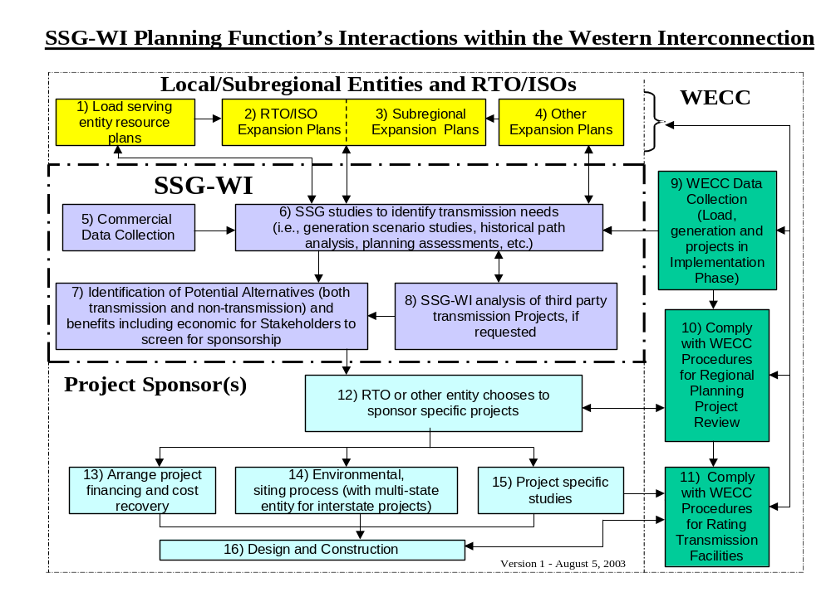
Figure C-1

Attachment 2 - - WECC Regional Planning Project Review Process

In fulfilling its responsibilities for developing and implementing a regional planning review process for the Western Interconnection, WECC has developed coordinated planning policies and procedures. These are documented in “Procedures for Regional Planning Project Review and Rating Transmission Facilities” which can be found at www.wecc.biz. The Rating Transmission Facilities portion of this procedure is the responsibility of a project sponsor, and beyond the scope of SSG-WI’s planning activities.

The WECC Regional Planning Project Review Process is designed to encourage coordination within the region while projects are being planned. Although it is the responsibility of the project sponsor to comply with the WECC Regional Planning Project Review Process, some of these requirements are expected to be completed within the SSG-WI Planning Function.

The following are the key aspects of the WECC Regional Planning Project Review Process:

- Regional planning should address projects in the conceptual planning stages and begin before a project is already well defined.
- The regional planning guidelines encourage consideration of various alternatives (including non-wire alternatives), to invite interested parties to participate in the planning process, and to promote planning efficiency and avoid duplicative projects.
- Those interested in the project form a regional planning review group. The regional planning review group prepares a regional planning report to describe how the project conforms to the regional planning guidelines.

- The WECC Planning Coordination Committee reviews the regional planning reports to evaluate projects’ conformance with the WECC Regional Planning Guidelines. If a project has addressed all the Regional Planning Guidelines, PCC recommends to the Regional Planning Policy Committee (RPPC) that the project has met all the Regional Planning Guidelines and has completed the regional planning review process.
- Upon acceptance of the project regional planning report by the RPPC, and upon approval by the WECC Board of Directors, notification is made that the project has completed the regional planning review process.
Completion of the regional planning review process is needed before a project can proceed to achieve a WECC Accepted Rating.

The other aspect of the process establishes a peer and outside stakeholder review of proposed projects that sponsors are implementing. This part of the process includes the following nine Regional Planning Guidelines that project sponsors must address to demonstrate conformance to following the Regional Planning Project Review Process:

a. Take multiple project needs and plans into account, including identified utilities' and non-utilities' future needs, environmental and other stakeholder interests.

b. Cooperate with others to look beyond specific end points of the entities' project to identify broader regional needs or opportunities.

c. Address the efficient use of transmission corridors (e.g., rights-of-ways, new projects, optimal line voltage, upgrades, etc.).

d. Identify and show how the project improves efficient use of, or impacts existing and planned resources of the region (e.g., regional benefits and impacts, transmission constraint mitigation) and cooperate with non-participant members in determining the benefits and impacts due to the project.

e. Identify transmission physical and operational constraints resulting from the project or that are removed by the project.

f. Coordinate project plans with and seeks input from all affected systems, sub-regional planning groups, power pools, and region-wide planning group(s).

g. Coordinate project plans with and seek input from other stakeholders (advisors) including utilities, independent power producers, environmental and land use groups, regulators (as represented by the advisors), and other stakeholders that may have an interest.

h. Review the possibility of using the existing system or upgrades and address the feasibility of alternatives.

i. Coordinate with potentially parallel or competing projects and consolidate projects where practicable.

WECC’s process provides for peer review to ensure that stakeholders are satisfied that the requirements of the process are met. As indicated above, the project sponsor is responsible for demonstrating that it has met these guidelines. This peer review process does not engage in any commercial discussions, nor does it certify that all stakeholders are satisfied with the outcome. It addresses only that the process requirements have been met.

Attachment 3--Response to Planning Seams Issues
Identified in the January 8, 2003 SSG-WI Report to FERC

FERC ISSUE #1

Develop a process to identify transmission projects that are needed for economic reasons to facilitate a comprehensive and seamless west wide wholesale electricity market.

The SSG-WI Planning Function is described in the body of this report, with details added in Appendix C—Attachment 1.

The SSG-WI Planning Work Group has formed a technical study group to perform interconnection wide transmission planning studies, based on an optimal dispatch or optimal production costing model, which determines the lowest cost congestion constrained generation dispatch. The SSG-WI Planning Function will be comprised of this annual study program as well as identification of system needs and economic projects, preparation of a SSG-WI Transmission Report, and dissemination of information to stakeholders.

The SSG-WI Planning Function involves the following steps (further details are described in Section II):

- Identify potential long term generation addition scenarios;
- Identify future transmission congestion and resulting price basis differentials, utilizing existing and forecast system representation and generation data and load forecasts;
- Define alternative transmission and non-transmission solutions;
- Provide results of studies to the market;
- Perform economic evaluation of specific projects, as requested by project sponsors.

The PWG will have planning and technical expertise representing the RTOs and stakeholders. In addition to overseeing the Technical Study Group, the PWG will have the following functions that serve to identify projects:

      - Oversee the technical studies;
      - Decide if SSG-WI will undertake economic evaluations of specific projects;
      - Incorporate other planning factors to develop an annual SSG-WI Long Term Expansion Plan;
      - Determine what information in addition to annual plans will be posted for public use;
      - Make recommendations to the RTOs on planning matters.

One process the RTOs will have to assist in identifying transmission projects that are needed for economic reasons is price signals from the RTOs congestion management processes. Within the RTOs, these price signals will initiate the planning processes internal to the RTOs. The congestion management processes will also be coordinated at the seams, and consequently will also serve to provide price signals for economic inter-RTO transmission projects or where intra-RTO projects have interconnection- wide significance.

FERC ISSUE #2

For Projects that: (1) would have a direct effect on more than one RTO, (2) are developed by sponsors outside of the Planning Work Group planning process, and (3) seek cost recovery from Western RTO ratepayers, SSG-WI will develop a process to evaluate whether the projects are justified (necessary and cost-effective)

A key element initiating the following process elements is that the proposed project may affect more than one RTO (condition 1 above) and consequently the RTOs need a process to work jointly on what would otherwise be within a single RTO’s planning responsibility. The SSG-WI Planning Function will address these situations as described below. This activity would be within Box 8 of the process described in Appendix I. The PWG believes that most projects should and will be initiated through one of the three RTOs. Furthermore, the PWG believes that SSG-WI should undertake additional evaluation described below only if requested to do so by a project sponsor or RTO. While few projects will meet conditions 2 and 3 above, this process may also be generally useful for projects meeting only condition 1.

The SSG-WI Planning Function provides for unsponsored projects and potential needs, initiated outside the RTO planning process by others through WECC processes, to be considered in the SSG-WI Planning Function. This could include transmission projects from transmission owners that are not RTO participants, generation projects, and non-transmission alternatives. FERC Issue #2 speaks to these projects.

The PWG believes that since the requested assistance may vary from situation to situation, the process response to these projects should be customized to the particular need and the detailed requirements determined at that time. The PWG expects that few projects will meet the criteria described in this issue. Most projects will be more appropriately addressed though one or more of the RTOs.

Since PWG is an RTO process, the normal PWG assessment of any non-RTO project would be limited to a high level assessment based on information submitted by the project sponsors and existing studies. The RTOs potentially affected by the project would sponsor any additional analysis by SSG-WI, with funding according to the participating RTO funding requirements. These details would be worked out on a project-by-project basis.

Depending on the depth of the analysis, SSG-WI may need metrics, standards, and criteria, based upon information provided by the project sponsor or RTOs, to support analysis and comparison of alternatives. Metrics would include discount rates, assumed facility lifetimes, and other parameters for comparing alternatives on a standard basis, and may be expressed as a range of values encompassing the ranges in values used by the RTOs or other planning entities. In addition to WECC planning standards, SSG-WI PWG may need to develop standards and criteria for comparing differing alternatives, such as transmission vs. generation or demand side alternatives.

The PWG, if requested by the RTOs, may also undertake reliability and financial assessments of alternatives. The PWG will post the results of any such assessments, including the benefits and costs of the project. It will be up to the RTOs and non-RTO project sponsors to negotiate regarding the allocation of benefits and costs to establish a project sponsorship, ratepayer cost recovery, and rights allocation. The outcome of these negotiations would feed back into the SSG-WI Planning Function.

Whether SSG-WI undertakes additional detailed studies and assessments, as well as the nature of these studies and assessments, will be determined by the entity requesting help. Factors used in these studies, such as metrics, standards, and criteria will be determined at that time on a case-by-case basis.

SSG-WI will post the results of its assessments according to SSG-WI and RTO procedures. However, the proposal does not include SSG-WI making recommendations on alternatives. Decisions to proceed with projects are the responsibility of project sponsors and may be subject to negotiations between sponsors and the RTOs. Resolution of different decision perspectives is outside the scope of SSG-WI PWG, more appropriately addressed by negotiations between directly affected parties.

FERC ISSUE #3

Determine if and how SSG-WI will support implementation of projects recommended by the PWG.

Implementation in this context is assumed to start when a project sponsor steps forward. If a project looks favorable according to a SSG-WI analysis, SSG-WI’s posting of this analysis of the project should encourage entities to investigate these projects further and hopefully step forward and sponsor the project if they also find it favorable. Once an entity sponsors a project, SSG-WI could provide support for the project by:

- Indicating that the proposed project would serve a need identified by SSG-WI PWG studies.
- Indicating that the sponsor was active within the planning process
- Indicating that the project might prove useful to the region such as increasing Transfer Capability and relieving congestion
- Making SSG-WI models available for others’ use
- Providing technical analysis and support if requested by the sponsor
- Upon request of a project sponsor or state siting agency, supporting the siting process

SSG-WI will not perform environmental analysis of sponsored projects, as this is the responsibility of the project sponsor.

Initially SSG-WI will build on existing processes to support implementation. Over time, as RTO West and WestConnect develop, SSG-WI expects the existing processes to evolve to reflect an increasing planning role of the RTOs. Following is a description of the initial process to support project implementation.

SSG-WI analysis will indicate broad regional requirements for transmission reinforcement or other non-transmission solutions. It will address how projects already identified in the WECC Regional Planning Project Review Process, RTO process, and otherwise brought forward to SSG-WI, will address these requirements. In addition, where regional requirements are not being addressed by project proposals, the SSG-WI analysis may prompt sponsors to step forward with new solutions.

The SSG-WI Planning Function will be integrated with the WECC Regional Planning Project Review Process. The SSG-WI Planning Function would be the front-end process that identifies broad regional requirements. It would also overlap and support the WECC Regional Planning Project Review Process, which would be initiated by the project sponsor to implement specific transmission projects and other system reinforcements. Projects already in the WECC Regional Planning Project Review Process will be incorporated in the SSG-WI Planning Function. These two processes, the SSG-WI Planning Function and the WECC Regional Planning Project Review Process, will provide a process to take a project from identification of initial conceptual need through to stakeholder agreement on a specific plan of service, leading into facility rating. These processes will support, but not incorporate, any commercial negotiations necessary to bring the project to implementation.

FERC ISSUE #4

Develop a process to resolve differences in transmission interconnections that enables parties to avoid going to the commission under the process set forth in Sections 210 and 211 of the Federal Power Act.

As RTOs form, the RTOs will represent the interests of FERC jurisdictional entities and non-jurisdictional entities that voluntarily choose to be RTO members. As discussed above in the description of this issue, the RTOs will apply their own procedures to resolve RTO to RTO differences, including differences in interconnection requirements. SSG-WI will serve as the forum to facilitate resolution of these differences.

However, it is expected that some transmission owners will not choose RTO membership. RTO nonmembers can participate in SSG-WI and its processes to address other planning issues. SSG-WI will gather information, participate in planning activities and studies, undertake its own studies, and identify possible alternative transmission additions. SSG-WI will not make any decisions regarding implementation of transmission plans or construction of facilities. For interconnections between RTO members, these decisions and any related cost allocations are decisions to be made in accordance with the procedures of each RTO. Where a decision involves an entity not a member of an RTO, interconnection decisions relating to that entity will be made by that entity in conjunction with the related RTO.

The WECC Procedures for Regional Planning Project Review and Rating Transmission Facilities identify “how transmission project sponsors should work and interact with their peers when developing a project that has a significant regional impact.” The procedure describes steps to follow to address differences between parties, but does not prescribe how these differences should be resolved. Most transmission owners not members of RTOs will at least be members of WECC, and thereby agree to follow these procedures. The PWG proposes that the WECC procedures will provide appropriate processes to resolve interconnection differences between RTOs and entities that are not members of RTOs. In addition, SSG-WI and the RTOs will be meeting the process requirements of all WECC members, regardless of RTO membership.

It is anticipated that these processes will facilitate parties’ voluntary resolution of planning, reinforcement and interconnection issues. Regarding entities’ rights to have issues addressed by FERC, these rights cannot be set aside through any SSG-WI process without the entities voluntarily agreeing to do so. Such agreements, if appropriate, will be addressed in the RTO agreements.

Appendix D

Historical Path Flow Study

Actual archived MW power flow data for the major transmission paths in the Western Interconnection were analyzed from winter 2000-01 through spring 2002, using data from the Western Electricity Coordinating Council (WECC) EHV Data Pool database. Results are presented in this report season and by individual path.

The purpose of the analysis was to determine the historical utilization of the major transmission paths in the Western Interconnection. It should not be concluded from this analysis that it is either necessary or economical to take any corrective actions for the loading levels reported. The results may, however, provide information for identifying paths for further study regarding the potential benefits and costs of increasing their path capacity.

Actual flows were calculated on a per unit basis, referenced to the paths Operating Transfer Capability (OTC). Table I identifies the OTC used for each path. Posted OTC was used unless it was not available.

This report presents the analysis results for the 3 seasons studied.

Paths Analyzed

Data for the following paths were analyzed. Path names and path numbers are from the WECC Project Rating Catalog. A map showing the geographic location of the individual paths is included in Figure 2. A list of the lines making up each path may be found in the WECC Path Rating Catalog.

WECC Path # WECC Path Name

- Northwest – Canada
4 West of Cascades – North
5 West of Cascades – South
6 West of Hatwai
8 Montana to Northwest
14 Idaho to Northwest
15 Midway – Los Banos
16 Idaho – Sierra
17 Borah West
18 Idaho – Montana
19 Bridger West
20 Path C
22 Southwest of Four Corners
23 Four Corners 345/500 Kv Qualified Path
24 PG&E – SPP
26 Northern – Southern California
27 Intermountain Power Project DC Line
30 TOT 1A
31 TOT 2A
32 Pavant – Gonder 230 Kv
34 TOT 2B
35 TOT 2C
36 TOT 3
45 SDG&E - CFE
46 West of Colorado River (WOR)
- Southern New Mexico
- Northern New Mexico
49 East of Colorado River (EOR)
50 Cholla – Pinnacle Peak
51 Southern Navajo
65 Pacific DC Intertie (PDCI)
- COI
73 North of John Day

Analysis Methodology

The WSCC EHV Data Pool database was used for the frequency distribution analysis. The analysis period for the frequency distribution analysis was from November 2000 through May 2002. Data from the 2000 Biennial Transmission Plan was incorporated to compare “peak” and “75% of OTC” values for the period from winter 98-99 through spring 2002. Data is grouped by month into the following seasons:

Winter - November 1 through March 31
Spring - April 1 through May 31
Summer - June 1through October 31

Table I summarizes for each transmission path, the years that were analyzed for the three seasons over the period winter 98-99 through spring 02. Table I also identifies the OTC assumption for each path.

Frequency Distribution

The percentage of time a path exceeded a given percentage of its OTC was calculated and presented as a frequency distribution plot for each transmission path, using the hourly MW flow data in the EHV Data Pool database. Plots for the individual paths are presented in Appendices D through G.

Percentage of time Exceeding 75% of OTC

Beginning with the 2000 Biennial Transmission Plan, a utilization indicator was developed. It is defined as the percentage of time over the season that the path loading exceeds 75% of the path OTC. In this report, the utilization indicator was calculated for winter, spring and summer seasons. Based upon WECC reliability criteria, a path may be loaded up to its OTC level and be able to withstand various outage contingencies without violating reliability criteria. Experience has shown, however, that loadings above approximately 75% of OTC may be associated with paths considered to be “congested” from a marketing or commercial use viewpoint. The 75% value is not based upon any industry standard or guide, and was chosen primarily to establish a figure of merit for ease of loading comparison between paths.

Peak Seasonal Loading

Peak path loading is calculated as the 99 percent probability loading. This means that at this value of path flow, 99% of the hourly loading samples are below this value and 1% of the loading samples exceed this value. This definition for peak loading was utilized in the 2000 Biennial Transmission Plan. It was felt that the absolute maximum hourly value should not be used as this could be associated with potentially erroneous data and a 99% value would be more representative of a peak value.

The derivation of the “Percentage of time exceeding 75% of OTC” and the “Peak Loading” values are graphically illustrated in Figure 1.

OTC Assumptions

Flow analysis is presented as a percentage or per unit of path Operating Transfer Capability (OTC). Hourly OTC values are reported in the EHV Data Pool database. Those reporting path OTC are supposed to calculate the OTC each hour adjusting reported values for changing operating conditions. This is not always the case, however. In some cases, no OTC values are reported by the path operator and a zero value is included in the database. In some cases, an OTC value is reported each hour, however the value is the same for each hour and is not varied as operating conditions change. In some cases, the OTC data is reported correctly in which case the reported OTC value does vary in magnitude, indicating that the path operator is adjusting the path capability for changing operating conditions.

Table I summarizes the OTC value used in this analysis. If a value is reported by the path operator, whether it is adjusted for changing operating conditions or not, this value is used. If no value is reported each hour and a zero appears in the database, the WECC path rating or the value set by the WECC OTC policy group is used.

Figure D-1

% of Time
exceeding
x axis
% of OTC
75%
1%
Equivalent to the 99 percentile point
Max. flow
Calculated 99% probability peak value
% of time exceeding 75% of OTC value

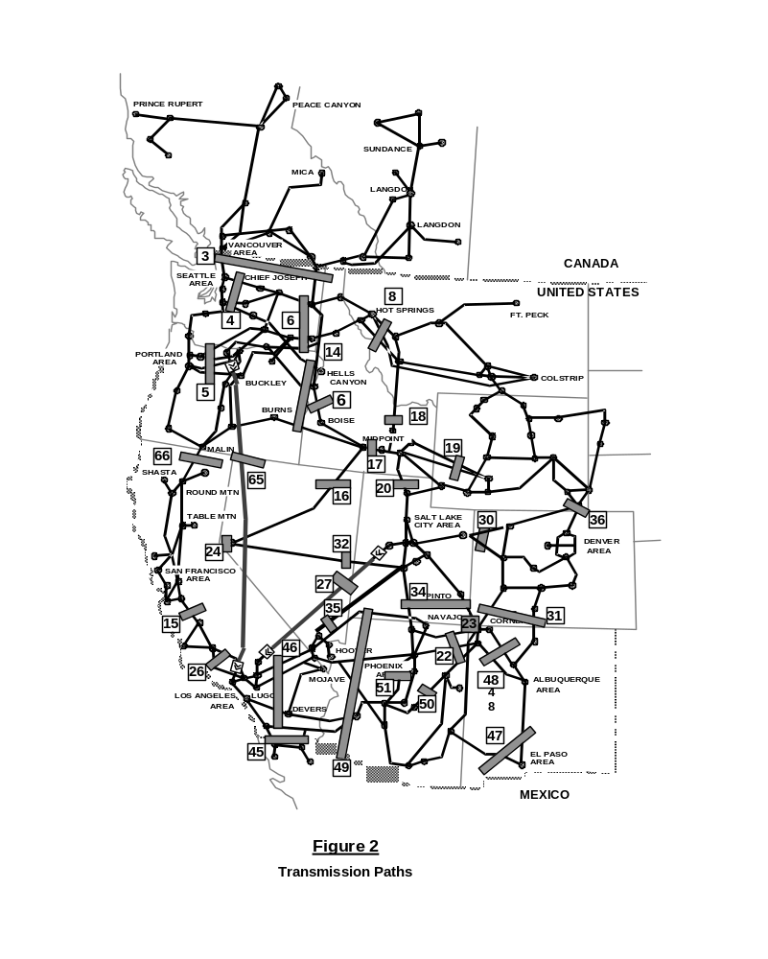

Analysis Results

Path Loading Summary Charts – Table II and Table III

The percentage of time each path exceeds 75% of the path OTC is tabulated in Table II for the following seasons:

Winter – 1998-99, 2000-01 and 2001-02
Spring – 1999, 2001, and 2002
Summer – 1999, 2000, and 2001

This represents the percentage of time during the season that the loading on the path exceeded 75% of the path transfer capability. For example, a path with a transfer capability of 1000 MW and a 30% calculated value for spring 2002 means that the path exceeded 750 MW (75% of OTC) for 439 hours (30% of a total of 1464 hours) during the months of April and May 2002. In some cases, a zero is reported for a path. This means that the path did not exceed 75% of the path OTC during the season. A path could have been operated at 74% of the path OTC for the entire season and the calculated value (for the % of time it exceeded 75% of OTC) would be zero.

Seasonal peak loadings are tabulated in Table III. The Peak value reported is the 99% probability value. The 99% value is used to avoid or decrease the likelihood of including erroneously high peak values. Peak values are reported for the following seasons:

Winter – 1998-99, 2000-01 and 2001-02
Spring – 1999, 2001, 2002
Summer – 1999, 2000, 2001

In some cases, no data was available for analysis during the period considered. This is indicated in the table as Not Available (N/A)

Path Loading Summary Bar Chart – 75% of OTC

Appendix A shows graphically the paths with the highest average loadings over a season. Results are presented in order of magnitude, from highest to least.

For each path, only the highest seasonal loading for the three seasons analyzed is presented. For example, path 19 has the highest winter loading in 2000-01, the highest spring loading in 2001 and the highest summer loading in 2000. These are the values that are plotted for path 19.

A line is drawn on the graph at the 50% and 25% levels. This was done to group the paths into loading ranges as an approximate measure of use. The geographic maps in Appendix B also group the paths into these same loading groupings.

Path Loading Summary Bar Chart – Peak

Appendix A also shows graphically the paths with the highest peak loadings. Results are presented in order of magnitude, from highest to least.

For each path, only the highest seasonal loading over the three seasons analyzed is plotted. For example, path 19 has the highest winter loading in 2000-01, the highest spring loading in 2001 and the highest summer loading in 2001. These are the values that were plotted for Path 19.

The data showed a few paths exceeding their OTC limit for their peak flows. In actual operation, path operators make every effort to keep the flows below the OTC limit in real time. It is possible that the data for the OTC limit could have been calculated for a slightly different hour that the posted flow data, depending upon how frequently the OTC value is updated. In some cases, the OTC limit may be calculated for use during the day ahead preschedule period and the actual OTC limit during real time may have been different. If the real time OTC value were higher, this could result in a flow level exceeding the reported OTC value. In the future, the calculation and posting of OTC limits in the EHV Data Pool Database should be reviewed and a standard methodology adopted.

Geographic Path Maps - Path Loading Groupings

Geographic path maps with path loading grouped into the following categories are shown in Appendix B. Loadings are grouped into the following three categories:

- Paths with loadings greater than 75% of OTC occurring more than 50% of the time during a season

- Paths with loadings greater than 75% of OTC occurring between 25% and 50% of the time during a season

- Paths with loadings greater than 75% of OTC occurring less than 25% of the time during a season.

Two maps are presented for each season showing the loading for the most current season and for the highest loading over the past 3 years.

The first figure in Appendix B illustrates which paths have unidirectional flows and which have bi-directional flows. This is described further in the section below, “Frequency Distribution”.

Seasonal Summary – by Region and Path

Appendix C shows the summer and winter frequency distribution plots by Region (Pacific Northwest, Rocky Mountain, Southwest and California). Winter plots represent the combined winter loadings for the 2000-01 and 2001-02 winter seasons. Summer plots represent the combined summer loadings for the Summer 2000 and 2001 seasons. These plots were calculated by totaling the hours for the two summer and winter seasons and calculating a frequency distribution plot for these total hours.

These plots show graphically which paths in each region are the most heavily utilized during summer and winter, relative to the path OTC over the two year period.

Frequency Distribution

Appendices D through G show the frequency distribution plots for each path by Region. Frequency distribution plots are presented for the total years analyzed and for the most recent season. On each plot, the peak and % of time exceeding 75% of OTC values are tabulated for each season analyzed.

Transfer Limits on the frequency distribution plots are the non-simultaneous limit as published in the 2000 WECC Path Rating Catalog.

For some paths, power flows occurred in both directions during the season. The flows were considered bi-directional if the flows in either direction occurred greater than approximately 10% of the time. For example if a path had flows N to S 95% of the time and flows in the S to N direction 5% of the time, the path was considered to be unidirectional for purposes of this analysis. If the flows in one direction were 85% of the time and 15% of the time in the other direction, the path was considered to be bi-directional and a bi-directional plot was made. For the bi-directional plots, the tabulated 75% values on the plot represent the total time the path exceeded 75% of OTC in both flow directions.

The first figure in Appendix B indicates which paths have unidirectional and which have bi-directional flows. For the bi-directional paths, the predominate direction of flow by season is noted.

Seams Steering Group of the Western Interconnection
In this document, the term “subregion” refers to a geographic sub-area of the Western Interconnection. The term “region” refers to the entire Western Interconnection.
The WECC Regional Planning Project Review Process is described in WECC, Procedures for Regional Planning Project Review and Rating Transmission Facilities. Currently, the WECC Procedures state that “the subject of this report . . . . is limited to identifying how transmission project sponsors should work and interact with their peers when developing a project that has a significant regional impact.” Id. at 1 (emphasis added).
or bid costs, if bid data is submitted in lieu of production cost data.
Point of diminishing returns could be the elasticity of the project costs associated with lowering the total cost of production.
Simulating the dispatch of hydro units on cascaded river systems is significantly more difficult than predicting thermal system operation for several reasons. First, the pondage storage capability and low incremental cost result in a scarcity of energy and not capacity. Market Simulator solves each hour’s dispatch sequentially and independently. To properly account for the load leveling capabilities of the river units, require linking the dispatch problems from multiple periods. Further, run-of-river simulation requires that water time delay effects be predicted. Finally, exogenous factors such as fish, recreation and irrigation place demands on hydro dispatch that are not directly associated with power market economics. For all these reasons, and because good historical/forecasted dispatch data for large WECC river systems is available, Market Simulator requires that hourly dispatch for hydro units be specified as input.
Phase shifters and DC line orders are also included with generation in the optimal dispatch.
A potential downside of this approach is that the difference between 2008 and 2013 is only one possible result. The difference in peak loads between 2008 and 2013 may prove to be under the threshold needed for demand side measures to be effective, but below what is actually attainable. On the other hand it could be way over what is needed to cost-effectively reduce congestion. We would be certain to gain insight by doing this analysis, but we may have to do addition al work, depending on what the analysis shows.
Subject to any future Federal rulemaking regarding the security of critical infrastructure information.
As of the date of this SSG-WI Planning Function document, Section 2.1 of the WECC Bylaws, Activities to Carry Out WECC’s Reliability Mission, includes the following pertinent subsections 2.1.6 and 2.1.11: Coordinated Regional Planning. With respect to the coordination of regional planning activities, the WECC: 2.1.6.1. will develop coordinated planning policies and procedures for the Western Interconnection, including facilitation of market-based solutions, consistent with WECC/NERC standards, FERC policy, and Section 2.5 of these Bylaws. 2.1.6.2. will review and assess Regional Entity (as that term is defined in Section 3 of these Bylaws) planning processes to determine whether WECC planning procedures have been satisfied; 2.1.6.3 will refer planning matters back to the originating Regional Entity for revision or other corrective actions when the WECC Board determines that WECC planning procedures have not been satisfied; and 2.1.6.4. may perform other interconnection-wide studies as needed, but shall not perform expansion planning studies. Avoiding Duplication with Regional Transmission Organizations 2.1.11 The WECC will endeavor to carry out the provisions of these Bylaws in a manner that does not conflict with or duplicate any FERC-approved functions of a Regional Transmission Organization including functions that may be delegated by the Regional Transmission Organization to any Regional Entity.

