LIHEAP Home Energy Notebook
For Fiscal Year 2003



U.S. DEPARTMENT OF HEALTH AND HUMAN SERVICES
Administration for Children and Families
Office of Community Services
Division of Energy Assistance
March 2005

LIHEAP Home Energy Notebook
For Fiscal Year 2003

This document has been prepared for the Office of Community Services' Division of Energy Assistance by APPRISE Incorporated under PSC Order No. 043Y00471301D. The statements, findings, conclusions, and recommendations are solely those of analysts from APPRISE and do not necessarily reflect the views of EIA or HHS.

Copies of this document can be obtained by contacting Leon Litow of the Division of Energy Assistance at the following address:

Administration for Children and Families
Office of Community Services
Division of Energy Assistance
370 L’Enfant Promenade SW
Washington, DC 20046

E-mail: llitow@acf.hhs.gov
Web site: www.acf.hhs.gov/programs/liheap

March 2005

Table of Contents
Table of Contents 1
Executive summary i
Home energy data i
Low income home energy trends iii
Trends in LIHEAP viii
Federal approach to measuring LIHEAP targeting performance viii
I. Introduction 1
Purpose of Notebook 1
Organization of Notebook 2
II. Home energy data 3
Residential energy data 3
Home heating data 5
Home cooling data 8
III. Low income home energy trends 10
Trends in consumption, expenditures, and burden 12
Analysis of energy trends 23
Trends in LIHEAP 28
Analysis of LIHEAP benefits 31
IV. Federal LIHEAP targeting performance 33
National LIHEAP program goal 33
National LIHEAP performance goals 34
Performance measures 34
Performance measurement research 37
Performance measurement statistics 39
Targeting performance measurement issues 43
Appendix A: Home energy estimates 45
Description of RECS 45
Strengths and limitations of RECS data 46
Average home energy consumption and expenditures 47
Energy burden 47
Projecting energy consumption and expenditures 50
Appendix B: Estimates of eligible households 61

Figures and Tables
Figure 1. Percent of U.S. residential energy expenditures by low income households, by end use, FY 2003 ii
Figure 2. Mean home heating and home cooling expenditures by all households, non low income households, low income households, and LIHEAP recipient households, FY 2003 iii
Figure 3. Mean individual burden of heating and cooling expenditures for all households, non low income households, low income households, and LIHEAP recipient households, FY 2003 iii
Figure 4. Percent of low income households using electricity and fuel oil as main heating fuels, 1979 to 2001 iv
Figure 5. Percent of low income households using central air-conditioning, 1979 to 2001 iv
Figure 6. Mean residential energy consumption (in mmBTUs) per low income household, 1979 to FY 2003 v
Figure 7. Mean residential energy expenditures for low income households, 1979 to FY 2003 v
Figure 8. Mean group residential energy burden by end use for households with incomes at or below 150 percent of the poverty income guidelines, 1979 to FY 2003 vi
Figure 9. Shifts in composite energy price index and Consumer Price Index (CPI), 1979 to FY 2003 vii
Figure 10. Index of heating degree days (HDD), heating consumption for low income households per HDD, cooling degree days (CDD), and cooling consumption for low income households per CDD, 1979 to FY 2003 vii
Figure 11. Number of LIEAP/LIHEAP eligible and recipient households, 1981 to FY 2002 viii
Table 2-1. Residential energy: Average annual household consumption, expenditures, and burden by all, non low income, low income, and LIHEAP recipient households, by main heating fuel type, United States, FY 2003 4
Table 2-2. Residential energy: Percent of residential energy expenditures for each of the major end uses by all, non low income, low income, and LIHEAP recipient households, United States, FY 2003 5
Table 2-3. Home heating: Percent of households using major types of heating fuels by all, non low income, low income, and LIHEAP recipient households, United States, April 2001 5
Table 2-4. Home heating: Average annual household consumption, expenditures, and burden by all, non low income, low income, and LIHEAP recipient households, by fuel type, United States, FY 2003 7
Table 2-5. Home cooling: Percent of households with home cooling by all, non low income, low income, and LIHEAP recipient households, United States, April 2001 8
Table 2-6. Home cooling: Average annual household consumption, expenditures, and percent of income by all, non low income, low income and LIHEAP recipient households that cooled, by fuel type, United States, FY 2003 9
Table 3-1. Definition of special terms 11
Table 3-2. Data used for the study of low income home energy trends 12
Figure 3-1. Main heating fuel for households with incomes at or below 150 percent of the poverty income guidelines, 1979 to 2001 13
Figure 3-2. Air-conditioning type for households with incomes at or below 150 percent of the poverty income guidelines, 1979 to 2001 13
Figure 3-3. Mean residential energy consumption per household in mmBTUs by end use for households with incomes at or below 150 percent of the poverty income guidelines, 1979 to FY 2003 14
Figure 3-4. Mean residential energy expenditures by end use for households with incomes at or below 150 percent of the poverty income guidelines, 1979 to FY 2003 15
Figure 3-5. Mean group residential energy burden by end use for households with incomes at or below 150 percent of the poverty income guidelines, 1979 to FY 2003 16
Figure 3-6. Comparison of mean group, mean individual, and median individual residential energy burden for households with incomes at or below 150 percent of the poverty income guidelines, 1979 to FY 2003 17
Figure 3-7. Comparison of mean group, mean individual, and median individual home energy burden for households with incomes at or below 150 percent of the poverty income guidelines, 1979 to FY 2003 17
Figure 3-8. Number of low income households spending over 5 percent and 10 percent of income on home energy, 1979 to FY 2003 19
Figure 3-9. Percent of low income households spending over 5 percent and 10 percent of income on home energy, 1979 to FY 2003 19
Figure 3-10. Total dollar need for LIHEAP funding for low income households spending over 5 percent and 10 percent of income on home energy, 1979 to FY 2003 20
Figure 3-11. Number of low income households spending over 15 percent and 25 percent of income on residential energy, 1979 to FY 2003 21
Figure 3-12. Total dollar need for LIHEAP funding for low income households spending over 15 percent and 25 percent of income on residential energy, 1979 to FY 2003 21
Figure 3-13. Aggregated residential energy expenditures by end use for households with incomes at or below 150 percent of the poverty income guidelines, 1979 to FY 2003 22
Figure 3-14. Percentage of LIHEAP eligible households with heat interruptions of two hours or more caused by an inability to pay for energy to run the household's main heating system, 1981-82 heating season to 2000-01 heating season 23
Figure 3-15. Index of dollar prices for fuel oil, natural gas, electricity, and a composite compared to the Consumer Price Index (CPI), 1979 to FY 2003 24
Figure 3-16. Index of heating consumption, heating degree days, and heating consumption per heating degree day for households with incomes at or below 150 percent of the poverty income guidelines, 1979 to FY 2003 25
Figure 3-17. Index of cooling consumption, cooling degree days, and cooling consumption per cooling degree day for households with incomes at or below 150 percent of the poverty income guidelines, 1979 to FY 2003 26
Figure 3-18. Mean group home energy burden for all households and for households with incomes at or below 150 percent of the poverty income guidelines, 1979 to FY 2003 27
Figure 3-19. Mean group residential energy burden for all households and for households with incomes at or below 150 percent of the poverty income guidelines, 1979 to FY 2003 27
Figure 3-20. Percentage of LIEAP/LIHEAP federally eligible households receiving LIEAP/LIHEAP heating and/or winter crisis assistance, FY 1981 to FY 2002 28
Figure 3-21. Number of households receiving LIEAP/LIHEAP heating and/or winter crisis assistance or cooling and/or summer crisis assistance, FY 1981 to FY 2002 29
Figure 3-22. Funds used for LIEAP/LIHEAP fuel assistance, FY 1981 to FY 2002 29
Figure 3-23. Mean combined LIEAP/LIHEAP heating and/or winter crisis benefits and mean cooling and/or summer crisis benefits, in dollars, FY 1981 to FY 2002 30
Figure 3-24. Mean combined LIEAP/LIHEAP heating and/or winter crisis benefits and mean cooling benefits, in constant 1981 dollars, FY 1981 to FY 2002 30
Figure 3-25. Amount and percentage of total home heating bill for LIEAP/LIHEAP eligible households covered by LIHEAP heating and winter crisis benefits, FY 1981 to FY 2002 31
Figure 3-26. Mean group home heating burden for all households and LIEAP/LIHEAP heating and winter crisis recipient households, FY 1981 to FY 2002 32
Table 4-1. LIHEAP recipiency targeting performance measures reported in the Final FY 2005 Annual Performance Plan, Final Revised FY 2004 Performance Plan, and FY 2003 Annual Performance Report 40
Table 4-2. LIHEAP recipiency targeting by priority groups by region for FY 2003 using weighted household counts from the 2003 CPS ASEC and using LIHEAP Household Reports from State LIHEAP administrators 41
Table 4-3. LIHEAP recipiency targeting of high burden households by region for FY 2001 from the 2001 RECS Survey and the 2001 RECS LIHEAP Supplement 42
Table 4-4. LIHEAP benefit targeting of high burden households by region for FY 2001 from the 2001 RECS Survey and the 2001 RECS LIHEAP Supplement 42
Table 4-5. LIHEAP burden reduction targeting of high burden households by region for FY 2001 from the 2001 RECS Survey and the 2001 RECS LIHEAP Supplement 43
Figure A-1. Distribution of LIHEAP eligible households by home energy burden, 2001 49
Table A-1. National price factors for FY 2003 51
Table A-2a. Residential energy: Average annual expenditures, by amount (dollars) and mean group burden (percent of income), for all, non low income, low income, and LIHEAP recipient households, by Census region and main heating fuel, FY 2003 52
Table A-2b. Residential energy: Average annual expenditures, by amount (dollars) and mean individual burden (percent of income), for all, non low income, low income, and LIHEAP recipient households, by Census region and main heating fuel, FY 2003 53
Table A-2c. Residential energy: Average annual expenditures, by amount (dollars) and median individual burden (percent of income), for all, non low income, low income, and LIHEAP recipient households, by Census region and main heating fuel, FY 2003 54
Table A-3. Home heating: Percent of households using major types of heating fuels, by all, non low income, low income, and LIHEAP recipient households, by Census region and main heating fuel type, April 2001 55
Table A-4. Home heating: Average consumption per household, by all fuels and specified fuels, by all, non low income, low income and LIHEAP recipient households, by Census region, FY 2003^{1/} 56
Table A-5a. Home heating: Average annual expenditures by amount and mean group burden, by all, non low income, low income, and LIHEAP recipient households, by Census region and main heating fuel type, FY 2003 57
Table A-5b. Home heating: Average annual expenditures by amount and mean individual burden, by all, non low income, low income, and LIHEAP recipient households, by Census region and main heating fuel type, FY 2003 58
Table A-5c. Home heating: Average annual expenditures by amount and median individual burden, by all, non low income, low income, and LIHEAP recipient households, by Census region and main heating fuel type, FY 2003 59
Table A-6. Home cooling: Percent of households that cool, average annual consumption per household, average annual expenditures per household, mean group burden, mean individual burden, and median individual burden for households that cooled, by all, non low income, low income, and LIHEAP recipient households, by Census region, FY 2003 60
Table B-1. Average of 2001, 2002, and 2003 state-level estimates of the number of LIHEAP income-eligible households using the Federal maximum LIHEAP income standard by vulnerability category 62
Table B-2. Average of 2001, 2002, and 2003 state-level estimates of the number of LIHEAP income-eligible households using State LIHEAP income standards by vulnerability category 63
Table B-3. Average of 2001, 2002, and 2003 state-level estimates of the number of LIHEAP income-eligible households using the Federal maximum LIHEAP income standard classified by HHS poverty guidelines 64
Table B-4. Average of 2001, 2002, and 2003 state-level estimates of the number of LIHEAP income-eligible households using the State maximum LIHEAP income standards 65

List of Acronyms and Abbreviations
ACF Administration for Children and Families
ASEC CPS Annual Social and Economic Supplement
CDD Cooling Degree Days
CPI Consumer Price Index
CPS Current Population Survey
DEA Office of Community Services’ Division of Energy Assistance
EIA Energy Information Agency
FY Fiscal Year
GPRA Government Performances and Results Act
HDD Heating Degree Days
HHS U.S. Department of Health and Human Services
LIHEAP Low Income Home Energy Assistance Program
LIEAP Low Income Energy Assistance Program
mmBTUs Million British Thermal Units
NC No cases in sample
OCS Administration for Children and Families’ Office of Community Services
RECS Residential Energy Consumption Survey

Executive summary
The Low Income Home Energy Assistance Program (LIHEAP) is authorized by Title XXVI of the Omnibus Budget Reconciliation Act of 1981 (OBRA), Public Law 97-35, as amended. The Administration for Children and Families (ACF) within the U.S. Department of Health and Human Services administers the Low Income Home Energy Assistance Program at the Federal level.
In 1994, Congress amended the purpose of LIHEAP to clarify that LIHEAP is "to assist low income households, particularly those with the lowest income, that pay a high proportion of household income for home energy, primarily in meeting their immediate home energy needs." (The Human Services Amendments of 1994, Public Law 103-252, Sec. 2602(a) as amended). The Coats Human Services Act of 1998 (Public Law 105-285) reauthorized LIHEAP through FY 2004 without substantive changes.
The LIHEAP Home Energy Notebook focuses on the home energy mission of LIHEAP by providing LIHEAP grantees with the latest national and regional data on home energy consumption, expenditures, and burden; low income home energy trends; and the LIHEAP program performance measurement system. This summary highlights information presented in the Notebook.

Home energy data
The primary information source for the data on residential energy is the Department of Energy's 2001 Residential Energy Consumption Survey (RECS). RECS covers all residential housing units that are primary residences in the United States and contains data for consumption and expenditures for calendar year 2001. RECS space heating and cooling consumption and expenditures have been adjusted to reflect FY 2003 weather and fuel prices.

Residential energy data
In FY 2003, average energy expenditures for all households were $1,527 and the mean individual energy burden was 6.3 percent of income. Low income households had energy expenditures of $1,304, about 15 percent lower than for all households. The energy burden for low income households was 13.6 percent, more than twice the energy burden of all households. LIHEAP recipient households had energy expenditures of $1,515, about 16 percent higher than for all low income households. The energy burden for LIHEAP recipients was 18.9 percent, more than 12 percentage points higher than for all households and more than 5 percentage points higher than for low income households.
Energy prices rose from FY 2002 to FY 2003. The weather in FY 2003 was 16 percent colder than in FY 2002. As a result, energy expenditures rose substantially (around 11 percent), from $1,377 in FY 2002 to $1,527 in FY 2003.
LIHEAP assists households with only that portion of residential energy costs that goes for home energy, i.e., home heating and home cooling. As shown in Figure 1, home heating and home cooling represents about 43 percent of residential energy expenditures for low income households. Refrigerators and freezers represent about 10 percent of residential energy expenditures, water heating represents about 14 percent of residential energy expenditures, and other appliances about 33 percent of residential energy expenditures.

Figure 1. Percent of U.S. residential energy expenditures by low income households, by end use, FY 2003
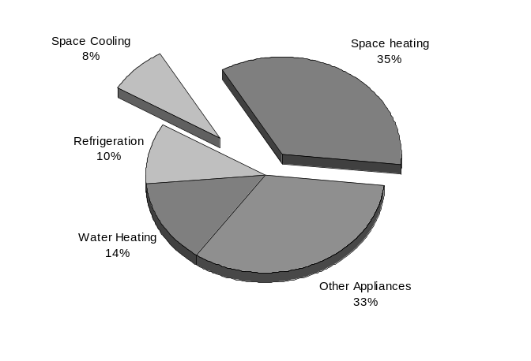

Home heating data
The three most common heating fuels in 2001 were natural gas (55 percent), electricity (29 percent), and fuel oil (8 percent). Over the last decade, the share of households using electricity as a main heating fuel has increased significantly, while the share using fuel oil has declined. There are only small differences in main heating fuel choice by income group.
For all households, average home heating expenditures were $511 and the mean individual home heating burden was 2.3 percent. Low income households had home heating expenditures of $463, about 9 percent lower than for all households. The mean individual home heating burden for low income households was 5.1 percent, twice as much as the home heating burden for all households. Home heating expenditures for LIHEAP households were $646, about 40 percent higher than the average for low income households and 26 percent higher than the average for all households. Mean individual home heating burden for LIHEAP households was 8.6 percent, more than 6 percentage points higher than the average for all households and more than 3 percentage points higher than the average for low income households. LIHEAP heating assistance recipients live in colder climates than does the average low income household, accounting for the higher home heating expenditures for LIHEAP households.

Home cooling data
About 88 percent of households cool their homes. Low income and LIHEAP recipient households are less likely to cool their homes than are non low income households; 82 percent of low income households and 83 percent of LIHEAP cooling recipient households cool their homes.
For all households, average home cooling expenditures were $170 and the mean individual home cooling burden was 0.6 percent. Low income households had home cooling expenditures of $123, about 28 percent lower than for all households. The mean individual home cooling burden for low income households was 1.3 percent, twice as much as the home cooling burden for all households. Home cooling expenditures for LIHEAP households were $92, which was 25 percent lower than the average for low income households and 46 percent lower than the average for all households. The mean individual home cooling burden for LIHEAP households was 1.1 percent, almost twice as high as the average for all households. LIHEAP cooling recipient households experienced approximately 24 percent fewer cooling degree days in FY 2003 than did low income households, accounting for their lower home cooling expenditures.

Figure 2. Mean home heating and home cooling expenditures by all households, non low income households, low income households, and LIHEAP recipient households, FY 2003
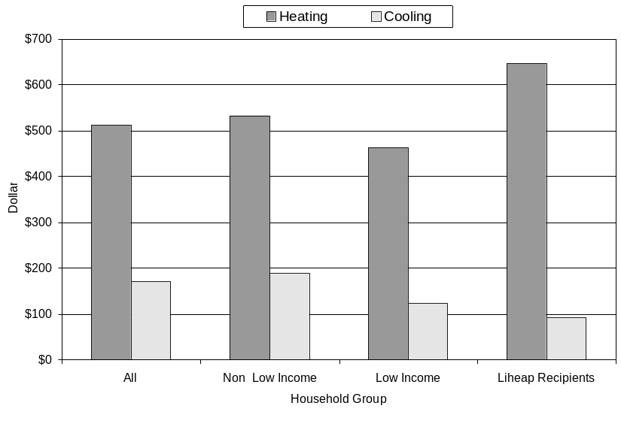

Figure 3. Mean individual burden of heating and cooling expenditures for all households, non low income households, low income households, and LIHEAP recipient households, FY 2003
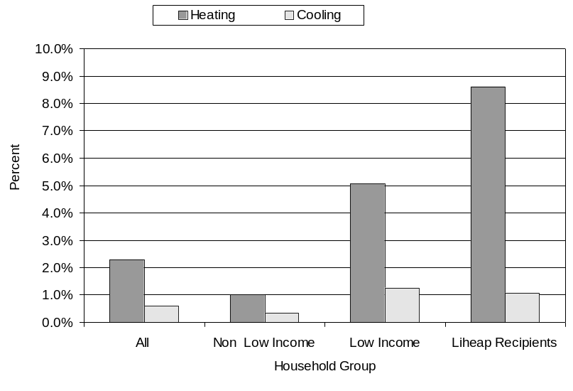

Low income home energy trends
The section presents data on home energy trends for low income households from 1979 through FY 2003. Statistics are derived from the series of national residential energy consumption surveys and from HHS' administrative statistics. The analyses show significant shifts since 1979 in the types of energy and the amount of energy used by low income households.

Home heating and cooling trends
Figure 4 demonstrates that low income households increased their use of electricity as their main heating fuel from 10 percent in 1979 to 34 percent in 2001. In contrast, households using fuel oil as their main heating fuel declined from 20 percent in 1979 to 8 percent in 2001. Natural gas remained the dominant type of space heating fuel used over the 15-year period.

Figure 4. Percent of low income households using electricity and fuel oil as main heating fuels, 1979 to 2001
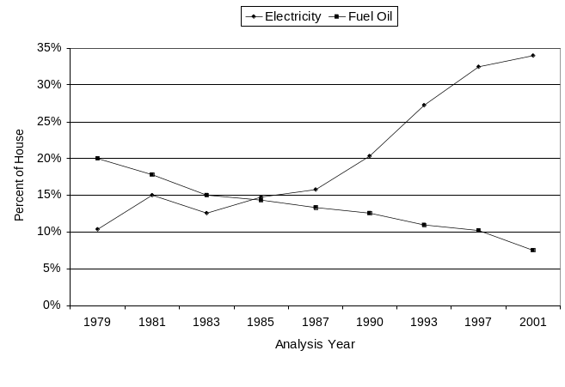
As shown in Figure 5, the most important change in home cooling has been in the percent of households with central air-conditioning. Low income households increased their use of central air-conditioning from 8.5 percent in 1979 to over 35 percent in 2001.

Figure 5. Percent of low income households using central air-conditioning, 1979 to 2001
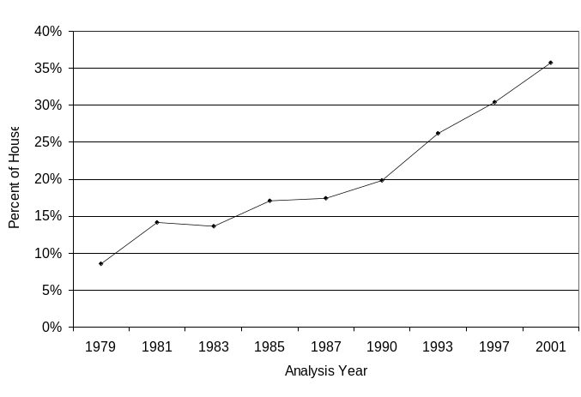

Trends in mean residential consumption, expenditures, and energy burden
Low income households substantially decreased their mean residential energy consumption between 1979 and 1983 as shown in Figure 6. This suggests a significant increase in efficiency that resulted from conservation measures or actions. From 1983 to 1990, mean residential energy consumption fluctuated from year to year, corresponding to expected changes in heating and cooling consumption because of changes in heating and cooling degree days. For 1993 through 2001, there appears to have been an increase in the use of energy for purposes other than home heating and home cooling. Between 2001 and FY 2003, the use of energy for home heating and home cooling, and for other purposes, appears to have remained stable.

Figure 6. Mean residential energy consumption (in mmBTUs) per low income household, 1979 to FY 2003
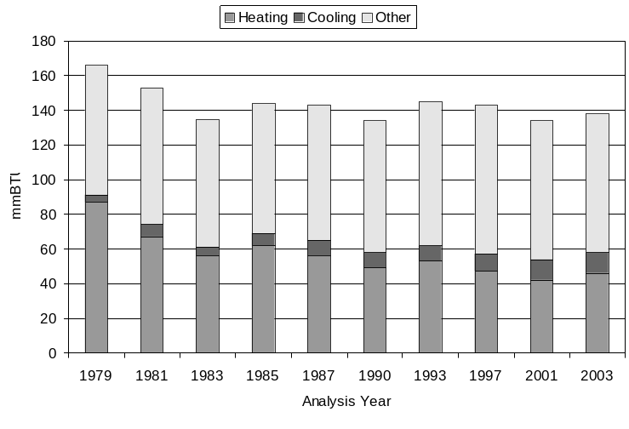
Residential energy expenditures increased rapidly between 1979 and 1985 because of fuel price increases, as shown in Figure 7. From 1987 through 1997, expenditures rose moderately; however in 2001, expenditures on heating increased dramatically as the result of fuel price increases and colder winter weather. In FY 2003, expenditures for home heating rose by 9 percent, again due to higher fuel prices and colder winter weather. Expenditures on uses other than home heating or home cooling rose continuously from 1979 to FY 2003. Expenditures on cooling rose from 1979 to 2001, and fell slightly from 2001 to FY 2003.

Figure 7. Mean residential energy expenditures for low income households, 1979 to FY 2003
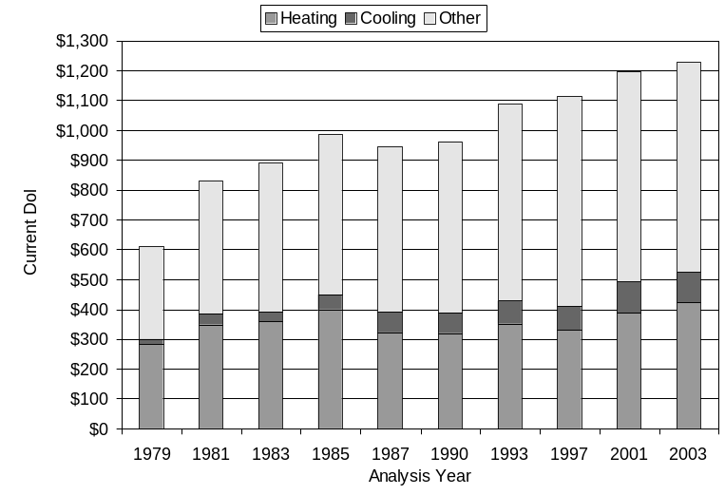

As Figure 8 shows, mean group home energy burden declined from about 8 percent in 1979 to about 5 percent in FY 2003, a total of 3 percentage points. The decline in residential energy burden from 1979 to FY 2003 was 5 percentage points (from 16 percent to about 11 percent). Most of the decline in residential energy burden is associated with a decline in home energy burden (i.e., burden associated with home heating and home cooling) rather than a decline in the burden associated with energy use for other purposes (i.e., water heating, appliances, and refrigeration).
Data on aggregate residential expenditures show that the proportion of expenditures for home energy fell from 50 percent in 1979 to 42 percent in FY 2003. However, the total expenditures for home energy increased 167 percent over the same period, from $4.5 billion in 1979 to $12.0 billion in FY 2003.
Figure 8. Mean group residential energy burden by end use for households with incomes at or below 150 percent of the poverty income guidelines, 1979 to FY 2003
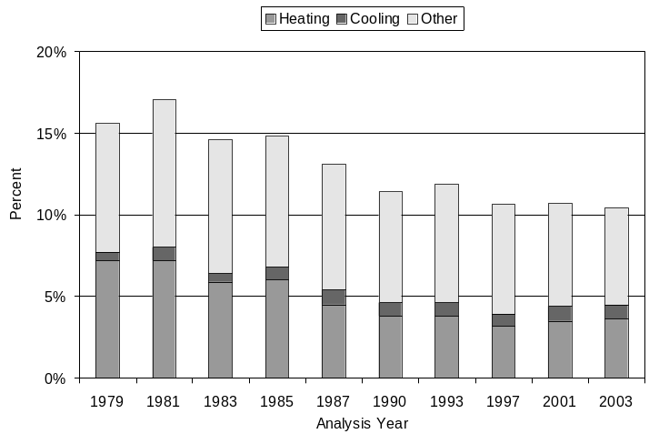

Analysis of energy trends
Trends in energy consumption and expenditure are dependent on factors such as energy prices, weather, and energy efficiency. Energy prices outpaced the Consumer Price Index (CPI) from 1979 through 1983, as shown in Figure 9 on the next page. While the CPI increased about 37 percent, the composite average of energy prices (a weighted average of electric, natural gas, and fuel oil prices) increased by about 78 percent between 1979 and 1983. From 1985 through 1993, energy prices rose at a slower rate than did the CPI (i.e., at a slower rate than the cost of other goods). In 2001 however, energy prices rose at a higher rate than did the prices of other goods. In 2001, the composite energy price index was 253 while the CPI was 243. The impact of energy prices on energy expenditures resulted in low income household energy expenditures surging upward until 1985 even though energy consumption for these households declined over the same period. The moderate growth in composite fuel prices from 1985 to 1997 (24 percent) explains why residential energy expenditures per low income household rose slightly during that period. In 2001, fuel prices increased 14 percent over 1997 prices. In FY 2003, fuel prices increased again slightly. FY 2003 prices were 1 percent higher than 2001 fuel prices. The increases in fuel prices from 2001 through FY 2003 contributed to the rise in expenditures during that period.

Figure 9. Shifts in composite energy price index and Consumer Price Index (CPI), 1979 to FY 2003
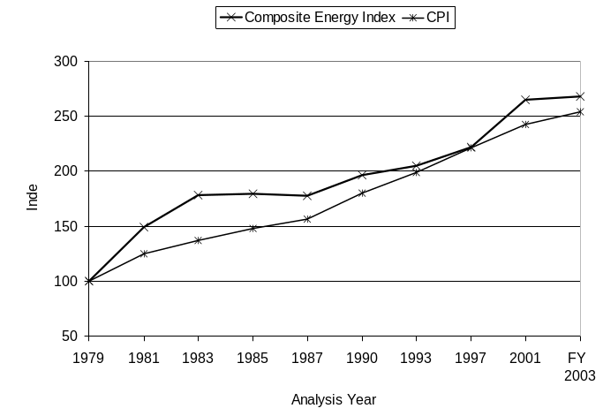
For low income households, Figure 10 shows energy consumption for heating and cooling compared to heating and cooling degree days from 1979 to FY 2003. As shown, heating consumption per heating degree day declined continuously as a result of energy conservation efforts. In contrast, cooling consumption per cooling degree day rose sharply over the same period because of a large increase in the availability of air-conditioning to low income households. Only 37 percent of low income households had air-conditioning equipment in 1979, but by 2001, the number had risen to 67 percent.
Figure 10. Index of heating degree days (HDD), heating consumption for low income households per HDD, cooling degree days (CDD), and cooling consumption for low income households per CDD, 1979 to FY 2003
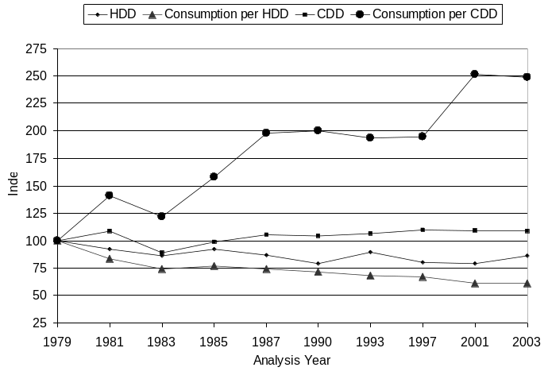
Mean group home energy burden for low income households has remained considerably higher than the burden for all households. In 1979, the mean group home energy burden of 8 percent for low income households was four times higher than the 2 percent burden for all households. In FY 2003, the mean group home energy burden for all income households was 1 percent, while for low income households it was almost 5 percent. Thus, in FY 2003, the mean group burden for low income households was still more than four times higher than that for all households.

Trends in LIHEAP
Between 1981 and FY 2002, as shown in Figure 11, the number of federally eligible households has risen 66 percent; however, Federal fuel assistance funds have risen by only 44 percent. As a consequence, the percentage of federally eligible households assisted has declined sharply from 36 percent in 1981 to 13 percent in FY 2002. Before adjusting for inflation, average winter crisis and heating benefits per household increased until 1985, fell through 1997, increased significantly in 2001, and then fell significantly in FY 2002. Cooling benefits per household actually fell until 1985, increased sharply in 1993 and 2001, but fell again in FY 2002. After adjusting for inflation, the mean value of combined Federal heating and winter crisis fell from $213 in 1981 to $141 in FY 2002. Cooling benefits fell from $129 in 1981 to $70 in FY 2002.
The percentage of the total home heating bill for LIEAP/LIHEAP eligible households covered by LIHEAP heating and winter crisis benefits decreased from 23 percent in 1981 to 12 percent in FY 2002. The decrease resulted from the combination of a larger total home heating bill and a smaller amount of assistance benefits.

Figure 11. Number of LIEAP/LIHEAP eligible and recipient households, 1981 to FY 2002
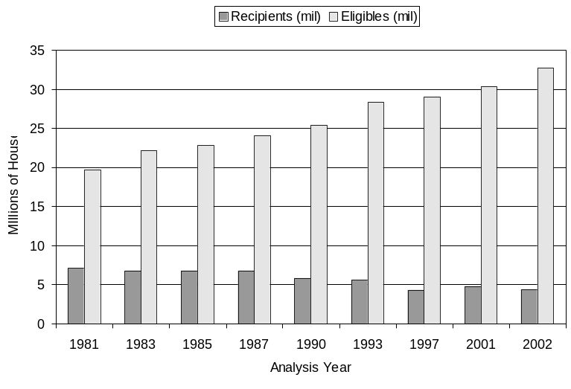
The mean group home heating burden for LIEAP/LIHEAP assisted households is substantially reduced because of the LIHEAP benefits, but even with the assistance, it has always remained about twice the burden of all households.

Federal approach to measuring LIHEAP targeting performance
The Government Performance and Results Act (GPRA) focuses on program results to provide Congress with objective information on the achievement of statutory objectives or program goals. The resulting performance data are to be used in making decisions on budget and appropriation levels. The GPRA performance plan for LIHEAP must take into account that the Federal government does not provide LIHEAP assistance to the public. Instead, the Federal government provides funds to States, Federal or State-recognized Indian Tribes and Tribal Organizations, and Insular Areas to administer LIHEAP at the local level. The LIHEAP performance plan also must take into account that LIHEAP is a block grant whereby LIHEAP grantees have broad flexibility to design their programs, within very broad Federal guidelines, to meet the needs of their citizens. Section IV of the Notebook describes the Federal LIHEAP performance plan.

LIHEAP program goals and performance goals
In FY 2002, 13 percent of federally income eligible households received assistance with their heating costs. Given that limitation, the LIHEAP statute requires LIHEAP grantees to provide, in a timely manner, that the highest level of assistance will be furnished to those households that have the lowest incomes and the highest energy costs or needs in relation to income, taking into account family size. The LIHEAP statute identifies two groups of low-income households as having the highest home energy needs:
- Vulnerable Households: Vulnerable households are those with at least one member that is a young child, an individual with disabilities, or a frail older individual.
- High Burden Households: High burden households are those households with the lowest incomes and highest home energy costs.
Based on the national LIHEAP program goals, ACF has focused its initial performance goals and measurement on targeting income eligible vulnerable households and income eligible high burden households. OCS’s performance plan focuses the LIHEAP program on “increasing the availability of LIHEAP fuel assistance to vulnerable and high-energy burden households whose health and/or safety are endangered by living in a home without sufficient heating or cooling." The explicit performance goals for FY 2003 are:
- Increase the percent of LIHEAP recipient households having at least one member age 60 years or older.
- Increase the percent of LIHEAP recipient households having at least one member age 5 years or younger.
- Increase the percent of LIHEAP recipient households having the lowest incomes and the highest energy costs.
Baseline data for these targeting performance goals have been measured to provide a picture of the current status of targeting performance across the country. The baseline data serve as a starting point against which the degree of change in LIHEAP targeting can be measured and analyzed.

Performance measures
Performance goals must be measurable in order to determine if the goals are being achieved. ACF has developed for its LIHEAP targeting goals a set of performance indicators that provide for the collection of quantitative measures regarding the following aspects of LIHEAP targeting performance:
- The recipiency targeting index quantifies targeting with respect to receipt of LIHEAP benefits.
- The benefit targeting index quantifies targeting with respect to the level of LIHEAP benefits.
- The burden reduction targeting index quantifies targeting with respect to the burden reduction resulting from LIHEAP benefits.
Individual LIHEAP grantees can use targeting indexes to examine the effectiveness of targeting in their program. The recipiency targeting index can help them to assess the effectiveness of their outreach to households with vulnerable members. The benefit and burden reduction targeting indexes can assist in examining the results of their benefit determination procedures.
ACF is using national targeting indexes to examine the current targeting performance of the LIHEAP program, to identify specific groups and regions of the country to target outreach materials, and to measure changes in performance over time.

Performance measurement data
The computation of targeting indexes requires the collection of data elements on eligible and recipient households. The sources of data vary for each of the targeting indicators.
For the recipiency targeting indexes for vulnerable households, the data required are demographic characteristics of eligible and recipient households. Data on income eligible households are available from the Current Population Survey (CPS) Annual Social and Economic Supplement (ASEC) Data on recipient households are available from the LIHEAP Household Reports. The CPS ASEC and LIHEAP Household Reports are used to develop national and regional recipiency targeting indexes on an annual basis for vulnerable households. The data show current targeting rates and changes in targeting rates over time. Those targeting rates are used in the GPRA performance plan for the LIHEAP program. Section IV furnishes national and regional targeting indexes for vulnerable households for FY 2003.
For the recipiency targeting index for high burden households, the data required are the energy burden characteristics of eligible and heating recipient households. The most recent data on income eligible households are available from the 2001 Residential Energy Consumption Survey (RECS). The most recent data on LIHEAP recipient households are available from the 2001 RECS LIHEAP Supplement. These data are used to develop national and regional recipiency targeting indexes for high burden households. Since the RECS is conducted every four years, data are not available on an annual basis to show current targeting rates and changes in targeting rates over time. Data will be available in 2006 to show the change in targeting rates for high burden households between 2001 and 2005. Section IV furnishes national and regional targeting indexes for high burden households for FY 2001.

Performance measurement statistics
The Final FY 2005 Annual Performance Plan, Final Revised FY 2004 Performance Plan, and FY 2003 Annual Performance Report furnished measurements of targeting performance using the CPS-based procedures for computing targeting indexes for vulnerable households. The report found that for the baseline period (FY 2001 through FY 2003), the LIHEAP program targeted LIHEAP benefits to elderly and young child households. The report also set a goal for increasing LIHEAP targeting performance. The FY 2004 Annual Performance Report should furnish data on whether LIHEAP performance is moving toward that goal.
The performance plan for the LIHEAP program set a goal of increasing targeting to high burden households. However, since the data were not available at the time of the plan development, no baseline statistics for targeting high burden households were included in the plan. Subsequently data for FY 2001 have been made available through the publication of data from the 2001 Residential Energy Consumption Survey (RECS). The RECS data show that the LIHEAP program targets high burden households. However, data for updating LIHEAP targeting performance to high burden households will not be available until FY 2006.

I. Introduction
The Administration for Children and Families (ACF) within the U.S. Department of Health and Human Services administers at the Federal level the Low Income Home Energy Assistance Program (LIHEAP). ACF awards annual LIHEAP block grants to the 50 States and the District of Columbia, Indian tribes and the tribal organizations, and the insular areas to assist eligible low income households in meeting their home energy costs.
In 1994, Congress amended the purpose of LIHEAP to clarify that LIHEAP is "to assist low income households, particularly those with the lowest income, that pay a high proportion of household income for home energy, primarily in meeting their immediate home energy needs." (The Human Services Amendments of 1994, Public Law 103-252, Sec. 2602(a) as amended.) Congress further indicated that LIHEAP grantees need to reassess their LIHEAP benefit structures to ensure that they are actually targeting those low income households that have the highest energy costs or needs. The Coats Human Services Act of 1998 (Public Law 105-285) reauthorized LIHEAP through FY 2004 without substantive changes.
For LIHEAP grantees to reassess their LIHEAP benefit structures, they need performance statistics on LIHEAP applicant and eligible households. In addition, they need technical assistance in how to make use of the performance statistics in planning and implementing changes to their programs.

Purpose of Notebook
ACF furnishes information and technical assistance to LIHEAP grantees. As part of that mission, ACF funded the development of this Notebook to assist LIHEAP grantees in meeting the requirements established by the 1994 amendments.
The LIHEAP Home Energy Notebook focuses on the home energy mission of LIHEAP by providing LIHEAP grantees with the latest national and regional data on home energy consumption, expenditures, and burden; low income home energy trends; and the LIHEAP program performance measurement system.
The FY 2003 home energy data presented in this Notebook were derived from existing data sources and analytic procedures, including:
- Household-level data on home energy available from the national Residential Energy Consumption Surveys (RECS) and household-level data on income available from the national CPS ASEC data files.
- National and state-level data on residential energy prices from the Energy Information Agency (EIA) Monthly Energy Review.
- Other publicly available sources of data such as weather data from National Oceanographic and Atmospheric Administration (NOAA).
- End use disaggregation procedures developed by the Office of Energy Markets and End Use (EMEU) of the Energy Information Administration (EIA).

Organization of Notebook
The remaining sections in this Notebook are organized as follows.
- Section II – Home energy data. This section presents national energy statistics and analyses for FY 2003. Tabulations are presented for all, low income, non low income, and LIHEAP recipient households. Statistics are developed for residential energy consumption, home heating, and home cooling. Statistics include estimates of home energy consumption, expenditures, and energy burden.
- Section III – Low income home energy trends. This section furnishes data and analyses on low income home energy trends for the period from 1979 to FY 2003. Subsections include trends in consumption, expenditures, and burden; analysis of energy trends; trends in LIHEAP; and analysis of LIHEAP benefits.
- Section IV – A Federal approach to measuring LIHEAP targeting performance. This section describes the LIHEAP program’s approach to performance measurement. It describes the performance measurement procedures and furnishes baseline data on targeting performance for the LIHEAP program.
- Appendix A documents the procedures used to prepare the FY 2003 energy statistics. Procedures reviewed include: projecting changes in energy consumption and expenditures, disaggregating energy consumption and expenditures into end use components, and computing energy burden statistics. Appendix A also includes detailed tabulations on residential energy use, expenditures, and burden at the national and regional level by main heating fuel for all, low income, non low income, and LIHEAP recipient households
- Appendix B furnishes averages of 2001, 2002, and 2003 state-level estimates of the number of LIHEAP eligible households by vulnerability group and by income group.

II. Home energy data
Section II presents home energy consumption and expenditure data. The primary information source for this section is the Department of Energy's 2001 Residential Energy Consumption Survey (RECS), which has energy consumption and expenditures data for calendar year 2001. For this Notebook, the 2001 space heating and cooling consumption and expenditures have been adjusted to reflect FY 2003 weather and fuel prices, as described in Appendix A.
National data on total residential energy, home heating, and home cooling are presented below. Regional variations in the national data are included in Appendix A. Home energy trend data are presented in Section III.

Residential energy data
Table 2-1, on the next page, presents data on average annual household energy consumption, expenditures, and burden by fuel type for all, non low income, low income, and LIHEAP recipient households. In FY 2003, average residential energy consumption for all households was 96.9 mmBTUs and average expenditures were $1,527. The mean individual energy burden for all households was 6.3 percent of income.
Low income households had average energy consumption of 84.4 mmBTUs (13 percent less than all households) and average energy expenditures of $1,304 (15 percent less than all households). Mean individual energy burden for low income households was 13.6 percent, more than twice the average for all households and more than four times the average for non low income households.
Average energy expenditures for LIHEAP recipient households were $1,515, about 16 percent higher than the average for all low income households. Mean individual energy burden was 18.9 percent, over 5 percentage points higher than the average for low income households.
Nationally, all households increased their average residential energy expenditures by 14 percent, from $1,337 in FY 2002 to $1,527 in FY 2003. Low income households increased their average residential energy expenditures by 12 percent, from $1,165 in FY 2002 to $1,304 in FY 2003. LIHEAP recipient households increased their average residential energy expenditures by 16 percent, from $1,309 in FY 2002 to $1,515 in FY 2003. The increases in expenditures resulted from the combination of increased fuel prices and colder winter weather in FY 2003 as compared to FY 2002.
Households consume residential energy for a variety of uses that include space heating, water heating, space cooling (air-conditioning or circulation), refrigeration, and other appliances. Table 2-2, on the second following page, furnishes data on the percentage of the residential energy bill that is attributable to each of these five end uses. By statute, LIHEAP targets assistance to home energy expenditures, i.e., to home heating and home cooling expenditures. In FY 2003, home heating was 35 percent of the residential energy bill for low income households and home cooling was 8 percent.
Table 2-1. Residential energy: Average annual household consumption, expenditures, and burden by all, non low income, low income, and LIHEAP recipient households, by main heating fuel type, United States, FY 2003^{1/}(See also tables A-2a – A-2c, Appendix A)
Main heating fuel | Fuel consumpton (mmBTUs)^{2/} | Fuel expenditures | Mean individual burden^{3/} | Median individual burden^{4/} | Mean group burden^{5/}
All households
All fuels | 96.9 | $1,527 | 6.3% | 3.4% | 2.6%
Natural gas | 114.2 | $1,585 | 6.4% | 3.4% | 2.7%
Electricity | 58.7 | $1,300 | 5.8% | 3.1% | 2.2%
Fuel oil | 130.2 | $1,924 | 7.1% | 3.9% | 3.3%
Kerosene | 79.1 | $1,341 | 13.9% | 8.2% | 2.3%
LPG^{6/} | 103.0 | $1,856 | 8.1% | 5.2% | 3.2%
Non low income households
All fuels | 102.7 | $1,631 | 3.0% | 2.6% | 2.1%
Natural gas | 119.3 | $1,674 | 2.9% | 2.6% | 2.2%
Electricity | 64.7 | $1,439 | 2.7% | 2.5% | 1.9%
Fuel oil | 134.7 | $1,982 | 3.5% | 3.1% | 2.6%
Kerosene | 92.6 | $1,498 | 3.4% | 3.0% | 1.9%
LPG^{6/} | 108.2 | $1,947 | 4.2% | 4.0% | 2.5%
Low income households
All fuels | 84.4 | $1,304 | 13.6% | 8.0% | 8.2%
Natural gas | 102.5 | $1,381 | 14.2% | 8.4% | 8.7%
Electricity | 46.5 | $1,020 | 11.8% | 6.6% | 6.4%
Fuel oil | 118.6 | $1,777 | 16.3% | 9.8% | 11.2%
Kerosene | 73.2 | $1,274 | 18.4% | 12.4% | 8.0%
LPG^{6/} | 93.7 | $1,692 | 15.1% | 10.2% | 10.7%
LIHEAP recipient households
All fuels | 105.3 | $1,515 | 18.9% | 12.4% | 11.5%
Natural gas | 125.0 | $1,539 | 19.4% | 12.6% | 11.7%
Electricity | 55.6 | $1,240 | 15.8% | 10.5% | 9.4%
Fuel oil | 143.5 | $1,992 | 20.9% | 15.5% | 15.1%
Kerosene | 91.9 | $1,549 | 25.4% | 13.5% | 11.7%
LPG^{6/} | 90.0 | $1,653 | 21.8% | 12.8% | 12.5%
^{1/}Data are derived from the 2001 RECS, adjusted to reflect FY 2003 heating degree days, cooling degree days, and fuel prices. Data represent residential energy used from October 2002 through September 2003.
^{2/}A British Thermal Unit (BTU) is the amount of energy necessary to raise the temperature of one pound of water one degree Fahrenheit. MmBTUs or mmBTUs refer to values in millions of BTUs.
^{3/}Mean individual burden is calculated by taking the mean, or average, of individual energy burdens, as calculated from FY 2003 adjusted RECS data. See Appendix A for information on calculation of energy burden.
^{4/}Median individual burden is calculated by taking the median of individual energy burdens, as calculated from FY 2003 adjusted RECS data.
^{5/}Mean group energy burden has been calculated by first calculating average residential energy expenditures from the 2001 RECS for each group of households and dividing the adjusted figures for FY 2003 by the average income for each group of households from the 2003 CPS ASEC.
^{6/}Liquefied petroleum gas (LPG) refers to any fuel gas supplied to a residence in liquid compressed form, such as propane or butane.
Residential energy expenditures of low income households are distributed in roughly the same way as those of all households. However, LIHEAP recipients spent a higher proportion of annual residential expenditures for space heating and a lower proportion for space cooling than other groups. LIHEAP recipient households spent 43 percent of their annual residential expenditures for space heating, 8 percentage points more than did the average low income household. LIHEAP recipient households spent 5 percent for space cooling, about 63 percent of the proportion spent by low income households. LIHEAP recipients are more likely than are other households to live in colder climates.
Table 2-2. Residential energy: Percent of residential energy expenditures for each of the major end uses by all, non low income, low income, and LIHEAP recipient households, United States, FY 2003
End Use | All households | Non low income households | Low income households | LIHEAP recipient households
Space heating | 33% | 33% | 35% | 43%
Space cooling | 10% | 10% | 8% | 5%
Water heating | 13% | 13% | 14% | 13%
Refrigeration | 9% | 9% | 10% | 8%
Appliances | 35% | 35% | 33% | 31%
All uses | 100% | 100% | 100% | 100%

Home heating data
This section presents data on main heating fuel type, home heating consumption, home heating expenditures, and home heating burden.

Main heating fuel type
Table 2-3 shows that more than half of the households in each income group use natural gas as their main heating fuel. Non low income households use natural gas at the highest rate, 56.3 percent. Almost 30 percent of households in each group, except LIHEAP recipient households, use electricity as their main heating fuel. Low income households use electricity at the highest rate, 30.7 percent, and LIHEAP recipient households use electricity at the lowest rate, 21.3 percent. LIHEAP recipient households tend to use bulk fuels more frequently than do households in other groups.
Table 2-3. Home heating: Percent of households using major types of heating fuels by all, non low income, low income, and LIHEAP recipient households, United States, April 2001^{1/} (See also table A-2, Appendix A)
Heating fuel | All households | Non low income households | Low income households | LIHEAP recipient households
Natural gas | 55.4% | 56.3% | 53.4% | 52.4%
Electricity | 29.1% | 28.3% | 30.7% | 21.3%
Fuel oil | 7.5% | 7.9% | 6.7% | 10.0%
Kerosene | 0.8% | 0.3% | 1.7% | 2.2%
LPG | 4.7% | 4.4% | 5.3% | 11.0%
Other^{2/} | 2.1% | 2.2% | 1.8% | 2.8%
^{1/}Data are derived from the 2001 RECS. Percentages may not add to 100 percent due to rounding.
^{2/}Households using wood, coal, and other minor fuels are categorized together under “Other.”

Non low income households increased their use of electricity for home heating from 24.1 percent of households in September 1990 to 28.3 percent in April 2001. Low income households increased their use of electricity as the main heat source from 20.0 percent in September 1990 to 30.7 percent in April 2001. LIHEAP recipient households' use of electricity as the main heat source rose from 14.4 percent in September 1990 to 21.3 percent in April 2001.

Home heating consumption, expenditures, and burden
Average annual home heating consumption, expenditures, and burden by fuel type for all, non low income, low income, and LIHEAP recipient households are presented in Table 2-4. In FY 2003, average home heating consumption for all households was 48.1 mmBTUs, average expenditures were $511, and mean individual home heating burden was 2.3 percent.
Low income households had average home heating consumption of 43.2 mmBTUs (10 percent less than the average for all households) and average home heating expenditures of $463 (9 percent less than the average for all households). The mean individual home heating burden for low income households was 5.1 percent, more than twice as much as the average home heating burden for all households and more than five times the average home heating burden for non low income households.
Average home heating consumption for LIHEAP households was 62.4 mmBTUs (30 percent higher than the average for all households), and average home heating expenditures were $646 (26 percent higher than the average for all households). Mean individual home heating burden for LIHEAP households was 8.6 percent, 3.5 percentage points higher than the average for low income households and more than three and one half times the average for all households. Average home heating consumption for LIHEAP recipient households was 44 percent greater than average home heating consumption for all low income households because LIHEAP heating assistance recipient households are more likely to live in colder climate regions. RECS data adjusted for FY 2003 weather show that LIHEAP heating assistance recipient households experienced 21 percent more heating degree days than did low income households.
For FY 2003, the heating season was 1 percent colder than the 30-year norm and 16 percent colder than FY 2002. Between FY 2002 and FY 2003, home heating consumption increased 18 percent for all households, 18 percent for low income households, and 20 percent for LIHEAP recipient households.
Compared to FY 2002, the FY 2003 prices for natural gas increased by 20 percent, fuel oil prices increased by 17 percent, and electricity prices increased by 2 percent. As a result of the increase in consumption (because of colder weather) and the increase in prices, average home heating expenditures increased in FY 2003. Average home heating expenditures increased by 37 percent for all households, by 37 percent for low income households, and by 41 percent for LIHEAP recipient households.
Home heating expenditures increased for all of the three major home heating fuels. Expenditures for households heating with natural gas increased by 38 percent. Expenditures for households heating with electricity increased by 19 percent. Expenditures for households heating with fuel oil increased by 54 percent.
Table 2-4. Home heating: Average annual household consumption, expenditures, and burden by all, non low income, low income, and LIHEAP recipient households, by fuel type, United States, FY 2003^{1/} (See also tables A-4, A-5a, A-5b, and A-5c, Appendix A)
Main heating fuel | Fuel consumpton (mmBTUs)^{2/} |  | Fuel expenditures | Mean individual burden^{3/} | Median individual burden^{4/} | Mean group burden^{5/}
All households
All fuels |  | 48.1 | $511 | 2.3% | 1.0% | 0.9%
Natural gas |  | 62.0 | $571 | 2.6% | 1.1% | 1.0%
Electricity |  | 14.5 | $306 | 1.5% | 0.6% | 0.5%
Fuel oil |  | 82.5 | $806 | 2.9% | 1.6% | 1.4%
Kerosene |  | 46.1 | $555 | 6.2% | 3.5% | 1.0%
LPG^{6/} |  | 56.8 | $807 | 3.3% | 2.2% | 1.4%
Non low income households
All fuels |  | 50.3 | $533 | 1.0% | 0.7% | 0.7%
Natural gas |  | 63.7 | $584 | 1.1% | 0.9% | 0.8%
Electricity |  | 16.0 | $333 | 0.6% | 0.5% | 0.4%
Fuel oil |  | 85.1 | $835 | 1.5% | 1.3% | 1.1%
Kerosene |  | 56.3 | $651 | 1.5% | 1.2% | 0.8%
LPG^{6/} |  | 60.7 | $872 | 1.9% | 1.7% | 1.1%
Low income households
All fuels |  | 43.2 | $463 | 5.1% | 2.5% | 2.9%
Natural gas |  | 58.1 | $540 | 6.0% | 2.8% | 3.4%
Electricity |  | 11.5 | $252 | 3.1% | 1.6% | 1.6%
Fuel oil |  | 75.9 | $733 | 6.5% | 4.3% | 4.6%
Kerosene |  | 41.8 | $514 | 8.2% | 4.5% | 3.2%
LPG^{6/} |  | 49.9 | $690 | 5.9% | 4.5% | 4.4%
LIHEAP recipient households
All fuels |  | 62.4 | $646 | 8.6% | 5.1% | 4.9%
Natural gas |  | 79.2 | $696 | 9.2% | 5.6% | 5.3%
Electricity |  | 19.4 | $427 | 5.8% | 3.2% | 3.2%
Fuel oil |  | 102.5 | $992 | 11.0% | 7.3% | 7.5%
Kerosene |  | 62.4 | $726 | 11.2% | 8.6% | 5.5%
LPG^{6/} |  | 45.9 | $674 | 10.7% | 5.2% | 5.1%
^{1/}Data are derived from the 2001 RECS, adjusted to reflect FY 2003 heating degree days and fuel prices. Data represent residential energy used from October 2002 through September 2003.
^{2/}A British Thermal Unit (BTU) is the amount of energy necessary to raise the temperature of one pound of water one degree Fahrenheit. MmBTUs or mmBTUs refer to values in millions of BTUs.
^{3/}Mean individual burden is calculated by taking the mean, or average, of individual heating energy burdens, as calculated from FY 2003 adjusted RECS data. See Appendix A for information on energy burden calculation.
^{4/}Median individual burden is calculated by taking the median of individual heating energy burdens, as calculated from FY 2003 adjusted RECS data.
^{5/}Mean group heating energy burden has been calculated by first calculating average home heating energy expenditures from the 2001 RECS for each group of households and dividing the adjusted figures for FY 2003 by the average income for each group of households from the 2003 CPS ASEC.
^{6/}Liquefied petroleum gas (LPG) refers to any fuel gas supplied to a residence in liquid compressed form, such as propane or butane.

Home cooling data
This section presents data on home cooling type, home cooling consumption, home cooling expenditures, and home cooling burden. In general, the home cooling data are less reliable than the home heating data for LIHEAP recipient households because there are fewer LIHEAP cooling recipient households in the RECS sample.

Cooling type
As shown in Table 2-5, about 88 percent of households cool their homes. Low income households are less likely to cool their homes than non low income households.
Table 2-5. Home cooling: Percent of households with home cooling by all, non low income, low income, and LIHEAP recipient households, United States, April 2001^{1/} (See also table A-6, Appendix A)
Presence of Cooling | All  Households | Non low income households | Low income households | LIHEAP recipient households
Cooling^{2/} | 88% | 91% | 82% | 83%
None^{3/} | 12% | 9% | 18% | 17%
^{1/}Data are derived from the 2001 RECS.
^{2/}Represents households that cool with central or room air-conditioning, as well as non air-conditioning cooling devices (e.g., ceiling fans and evaporative coolers).
^{3/}Represents households that do not cool or cool in ways other than those defined by the 2001 RECS (e.g., table and window fans).

Home cooling consumption, expenditures, and burden
Average annual home cooling consumption, expenditures, and burden for all, non low income, low income, and LIHEAP recipient households that cooled are presented in Table 2-6. In FY 2003, average home cooling consumption for households that cooled was 6.6 mmBTUs, average expenditures were $170, and mean individual home cooling burden was 0.6 percent.
Low income households had average home cooling energy consumption of 4.9 mmBTUs (26 percent less than the average for all households) and home cooling expenditures of $123 (28 percent less than the average for all households). The mean individual home cooling burden for low income households was 1.3 percent, more than twice the average home cooling burden for all households and more than four times the average home cooling burden for non low income households.
Average home cooling consumption for LIHEAP recipient households was 3.6 mmBTUs (45 percent less than all households), and home cooling expenditures were $92 (46 percent less than all households). Mean individual home cooling burden for LIHEAP recipient households was 1.1 percent, almost two times the average for all households. On average, LIHEAP recipient households consumed 27 percent fewer BTUs for cooling than the average for all low income households. RECS data adjusted for FY 2003 weather show that LIHEAP cooling recipient households experienced approximately 24 percent fewer cooling degree days than did low income households because they are more heavily represented in the cooler climate regions.
While the FY 2003 cooling season was 3 percent warmer than the 30-year norm, it was 12 percent cooler than FY 2002. From FY 2002 to FY 2003, home cooling consumption decreased by 13 percent for both all households and low income households, and decreased by 16 percent for LIHEAP recipient households.
Nationally, all households decreased their average home cooling expenditures by 11 percent, low income households decreased their average home cooling expenditures by 12 percent, and LIHEAP recipient households decreased their average home cooling expenditures by 17 percent. The changes in expenditures resulted from the combination of cooler weather and slightly higher electricity prices in FY 2003 than in FY 2002.
Table 2-6. Home cooling: Average annual household consumption, expenditures, and percent of income by all, non low income, low income and LIHEAP recipient households that cooled, by fuel type, United States, FY 2003^{1/} (See also table A-6, Appendix A)
Household group | Fuel consumpton (mmBTUs)^{2/} | Fuel expenditures | Mean individual burden^{3/} | Median individual burden^{4/} | Mean group burden^{5/}
All households | 6.6 | $170 | 0.6% | 0.3% | 0.3%
Non low income households | 7.3 | $189 | 0.3% | 0.2% | 0.2%
Low income households | 4.9 | $123 | 1.3% | 0.5% | 0.8%
LIHEAP recipient households | 3.6 | $92 | 1.1% | 0.5% | 0.7%

^{1/}Data are derived from the 2001 RECS, adjusted to reflect FY 2003 cooling degree days, and fuel prices. Data represent residential energy used from October 2002 through September 2003.
^{2/}A British Thermal Unit (BTU) is the amount of energy necessary to raise the temperature of one pound of water one degree Fahrenheit. MmBTUs or mmBTUs refer to values in millions of BTUs.
^{3/}Mean individual burden is calculated by taking the mean, or average, of individual cooling energy burdens, as calculated from FY 2003 adjusted RECS data. See Appendix A for information on energy burden calculation.
^{4/}Median individual burden is calculated by taking the median of individual cooling energy burdens, as calculated from FY 2003 adjusted RECS data.
^{5/}Mean group heating energy burden has been calculated by first calculating average home cooling energy expenditures from the 2001 RECS for each group of households and dividing the adjusted figures for FY 2003 by the average income for each group of households from the 2003 CPS ASEC.

III. Low income home energy trends
Important shifts in energy prices and consumption have occurred since the 1973 oil embargo. As a result, both energy expenditures by low income households and the energy burden on low income households have changed significantly.
In the FY 1989 annual LIHEAP report to Congress, Appendix K presented the results of a national study of residential energy consumption, expenditures, and burden for low income households from 1973 to 1989. Selected tables from that study were updated and published as a regular appendix in annual LIHEAP reports to Congress for FY 1991 through FY 1996. Beginning with the FY 1997-FY 1999 report, the tables are only published in the annual LIHEAP Notebook. The tables present data for low income households and, for comparison purposes, include statistics on all households. Beginning with 1979, the year before HHS' first energy assistance program was enacted, trend data are furnished on the following.
- Home energy consumption, expenditures, and burden.
- Factors affecting consumption, expenditures, and burden.
- The impact of LIHEAP assistance on net home energy expenditures.
A number of special terms are used throughout this section. Table 3-1 on the next page furnishes the reader with definitions of these special terms. One such term is "low income," which is defined as those households with incomes at or below 150 percent of the poverty level. Because of limitations on the availability of data, this definition is more restrictive than in other parts of the Notebook in which low income refers to LIHEAP eligible households, that is, those households with incomes below the greater of 150 percent of poverty or 60 percent of state median income. Based on estimates from the 2003 CPS ASEC, the more restrictive definition excludes 11.6 million households of the 34.7 million households that meet the definition of LIHEAP eligible households. Therefore, differences in FY 2003 home energy data reported in this section and in other parts of this Notebook are the result of the difference in definition of "low income."
Unless indicated otherwise, the energy data in this section are based on eight national residential energy surveys of occupied residential housing units and their fuel suppliers. Table 3-2 on page 12 identifies the surveys used, the date on which household interviews began, the time period in which residential energy bills were collected from fuel suppliers, the time frame for household income, and the number of households included in the survey.
For each survey, a national sample of residential housing units was selected, and interviewers attempted personal contacts with the householder. For those housing units where an authorization form was completed, the household's fuel supplier was contacted and asked to supply fuel costs and consumption data.
The collection of income data is not a primary focus of the residential energy surveys. Income statistics from the CPS ASEC are used to improve income data.

Table 3-1. Definition of special terms
Term | Definition
Billing data | Energy costs and consumption data furnished by the household’s fuel supplier.
Composite price | The weighted average price of electricity, natural gas, and fuel oil used for residential purposes.
Constant dollar expenditures | Costs adjusted for changes in the price of a market basket of consumer goods between two years (adjusted for inflation or deflation).
Cooling degree days | Daily cooling degree days are computed by comparing the mean temperature for a day to a base temperature (65 degrees). If the mean temperature on a day is 70, the number of cooling degree days experienced on that day is 5 (70 minus 65). In this Notebook, we refer to annual cooling degree days, or the sum of all cooling degree days experienced during a year.
Dollar expenditures | Actual costs as reported in the year of the energy survey (unadjusted for inflation or deflation). Unless noted otherwise all dollar expenditures are unadjusted.
Energy burden | The share or percentage of annual household income that is used to pay annual energy bills.^{1/}
Energy end uses | The specific use of energy in the home for home heating, home cooling or ventilation, water heating, and appliances.
Fuel assistance | LIHEAP heating, cooling, and crisis assistance.
Heating degree days | Daily heating degree days are computed by computing the mean temperature for a day to a base temperature. For example, if the mean temperature on a day is 60 and the base temperature is 65, the number of heating degree days experienced on that data is 5 (65 minus 60). In this Notebook, we refer to annual heating degree days, or the sum of all heating degree days experienced during a year.
Home energy expenditures | Expenditures for home space heating and home space cooling and ventilation.
LIHEAP coverage rate | The percentage of the aggregate home energy bills for low income households that is covered by LIHEAP fuel assistance.
LIHEAP eligible households | Households with incomes below the Federal maximum LIHEAP income standard – below the greater of 150 percent of the Federal poverty income guidelines or 60 percent of state median income.
LIHEAP participation rate | The percentage of LIHEAP eligible households that receive heating assistance.
LIHEAP recipient households | Households that indicated receiving home heating, cooling, or energy crisis benefits during the 12 months prior to a particular household survey.
Low income households | Households with incomes at or below 150 percent of the Federal poverty income guidelines.
MmBTUs | A British Thermal Unit (BTU) is the amount of energy necessary to raise the temperature of one pound of water one degree Fahrenheit. MmBTUs refers to millions of BTUs. An average household uses about 100 mmBTUs per year.
Residential energy expenditures | Fuel expenditures for all residential uses, including home heating, home cooling or ventilation, water heating, refrigeration, clothes drying, etc.
^{1/}Three different energy burden statistics are used in this Section: mean group burden, mean individual burden, and median individual burden. The definitions of these statistics are presented on page 15.
Table 3-2 presents information on the series of surveys that were used to prepare this Notebook. The reader should note that the in-home interview dates lag behind the analysis year for the years 1979 through 1985. In those years, the energy supplier survey included data from the year following the in-home interview. In all cases, the analysis year coincides with the end of the energy consumption history.

Table 3-2. Data used for the study of low income home energy trends
 | Analysis Year^{1/}
 | 1979 | 1981 | 1983 | 1985 | 1987 | 1990 | 1993 | 1997 | 2001 | FY 2003
Survey^{2/} | NIECS | RECS | RECS | RECS | RECS | RECS | RECS | RECS | RECS | RECS
Interview date^{3/} | 9/78 | 9/80 | 9/82 | 9/84 | 9/87 | 9/90 | 10/93 | 5/97 | 5/01 | ^{4/}
Billing data^{5/} | 4/78 to 3/79 | 4/80 to 3/81 | 4/82 to 3/83 | 4/84 to 3/85 | 1/87 to 12/87 | 1/90 to 12/90 | 1/93 to 12/93 | 1/97 to 12/97 | 1/01 to 12/01 | 10/02 to 9/03
Income data^{6/} | 1979 | 1981 | 1983 | 1985 | 1987 | 1990 | 1993 | 1997 | 2001 | 2003
Sample size | 4,081 | 6,051 | 4,724 | 5,682 | 6,229 | 5,095 | 7,111 | 5,900 | 5,318 | 5,318
^{1/}Represents the year that includes the last month for which billing data were collected from fuel suppliers.

^{2/}Surveys include the National Interim Energy Consumption Survey (NIECS) and the RECS.
^{3/}Month and year in which household interviews began.
^{4/}Data projected from the 2001 RECS using changes in weather and prices. See Appendix A for the procedure used to calculate the projections.
^{5/}Time period in which residential energy bills were collected from fuel suppliers.
^{6/}Mean income computed using calendar year data from the CPS ASEC.

Trends in consumption, expenditures, and burden
Since 1979, there have been important changes in the fuels used by households, the amount of energy consumed for specific residential end uses (i.e., home heating, water heating, home cooling, and other appliances), total residential energy expenditures, and the burden that residential energy expenditures represent for low income households. In this section, data that illustrate these changes are presented.
Figures 3-1 and 3-2, on the next page, furnish information on the fuel choices by low income households. Figure 3-1 shows that low income households have increased their use of electricity as a main heating fuel, from 10.4 percent in 1979 to 34.0 percent in 2001, while they have reduced their use of fuel oil as a main heating fuel, from 20.0 percent in 1979 to 7.5 percent in 2001. In addition, the use of wood or coal as a main heating fuel (included under "other") peaked in 1985 but has declined substantially since.
Figure 3-2 shows that low income households increased their use of central air-conditioning systems from 8.5 percent in 1979 to 35.8 percent in 2001. The proportion of low income households with no air-conditioning fell from 62.8 percent in 1979 to 33.2 percent in 2001. Other things being equal, increased use of air-conditioning equipment among low income households can be expected to increase home cooling expenditures.
Figure 3-1. Main heating fuel for households with incomes at or below 150 percent of the poverty income guidelines, 1979 to 2001
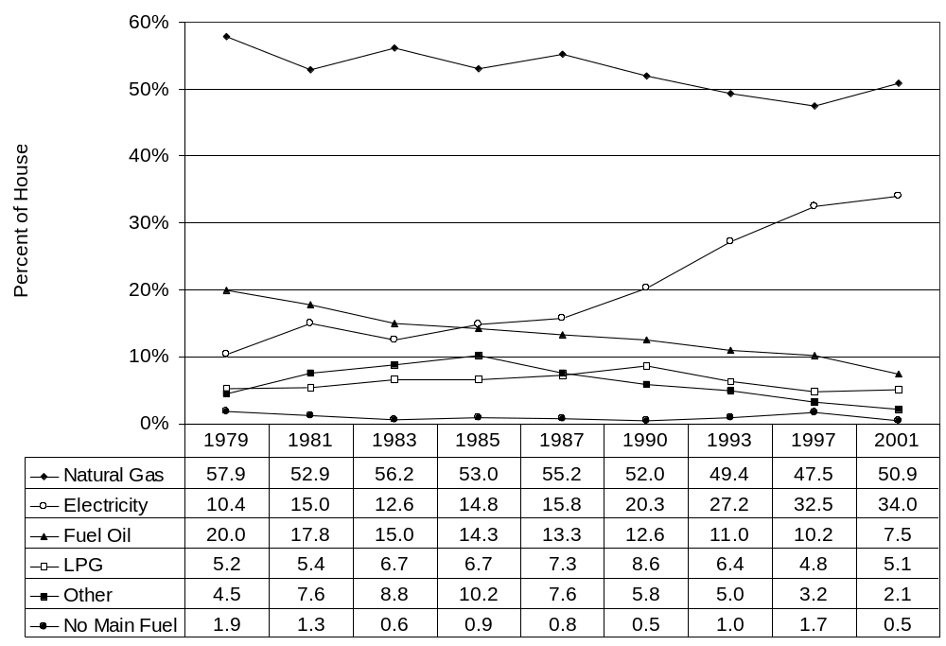
Figure 3-2. Air-conditioning type for households with incomes at or below 150 percent of the poverty income guidelines, 1979 to 2001
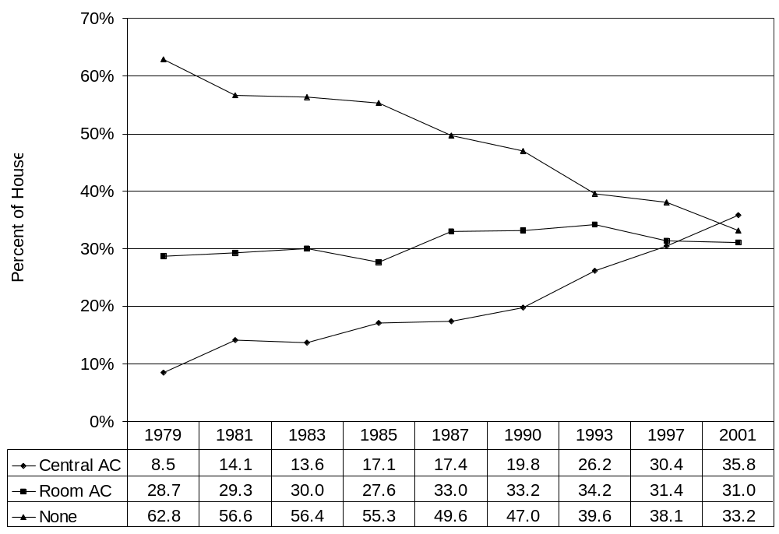

Figures 3-3 and 3-4 furnish information on the trends in mean residential energy consumption and expenditures for low income households from 1979 to FY 2003. Figure 3-3 shows that low income households substantially reduced their residential energy consumption between 1979 and 1983. Examination of the components of residential energy consumption indicates that the reduction was the result of reductions in home heating consumption. From 1983 to 1990, mean residential energy consumption fluctuated from year to year, corresponding to expected changes in heating and cooling consumption that resulted from changes in heating and cooling degree days. For 1993 through 1997, there appears to have been a significant increase in the use of energy for purposes other than home heating and home cooling. In 2001 through FY 2003, the use of energy for purposes other than heating and cooling was lower than it was in 1997.
Figure 3-3. Mean residential energy consumption per household in mmBTUs by end use for households with incomes at or below 150 percent of the poverty income guidelines, 1979 to FY 2003
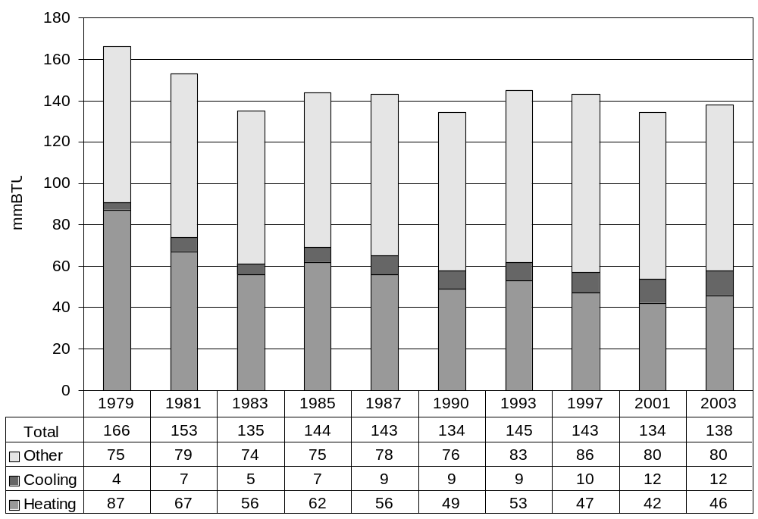
Figure 3-4, on the next page, shows that residential energy expenditures for low income households increased rapidly from 1979 to 1985, the result of fuel price increases. Examination of the components of energy expenditures indicates that the greatest increases were in home cooling and other residential expenditures, while increases in home heating expenditures were more moderate until 2001. Mean residential energy expenditures increased at a moderate rate from $943 in 1987 to $1,113 in 1997. From 1997 to 2001 residential energy expenditures increased by 7 percent to $1,196. In FY 2003, mean residential energy expenditures rose by 3 percent to $1,229. Mean home heating expenditures fell from $399 in 1985 to $318 in 1990, then rose and fell moderately until 1997. In 2001 home heating expenditures saw an 18 percent increase over 1997. Mean home heating expenditures rose by 9 percent in FY 2003. The increase in expenditures in 2001 was the result of higher fuel prices. The increase in expenditures in FY 2003 was the result of higher fuel prices and colder winter weather. Mean home cooling expenditures rose continuously from $51 in 1985 to $103 in 2001. In FY 2003 mean home cooling expenditures were $101.
Figure 3-4. Mean residential energy expenditures by end use for households with incomes at or below 150 percent of the poverty income guidelines, 1979 to FY 2003
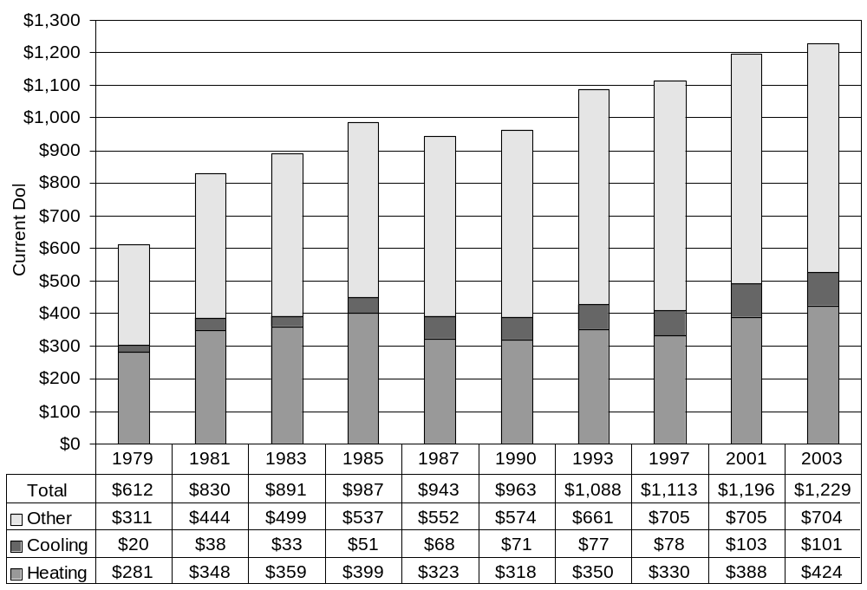
The next series of Figures, 3-5 through 3-7, furnishes information on energy burden for low income households. Three different energy burden summary statistics are presented in the three figures; mean group energy burden, mean individual energy burden, and median individual energy burden. Each of the statistics offers somewhat different information and gives somewhat different results. All three are valid from a statistical perspective. The statistics are defined as follows.
- Mean Group Burden: Computed as the ratio between mean energy expenditures and mean income for low income households. Energy expenditures are computed from RECS and income is derived from the CPS ASEC.
- Mean Individual Burden: Computed by first computing the energy burden for each individual low income household from the RECS and then taking the mean of the energy burden statistic for all low income households.
- Median Individual Burden: Computed by computing the energy burden for each individual low income household from RECS and finding the median, or middle point, of the distribution of household-level energy burdens.
Mean group burden is the burden statistic that has been used in the series of LIHEAP Annual Reports to Congress. Recent technical research has furnished additional insights on the range of alternative burden summary statistics. (See Appendix A for additional information on the interpretation of alternative burden statistics.)
Figure 3-5 shows the time series for mean group energy burdens by end use for low income households. Mean group home energy burden, the sum of mean heating and cooling burden from Figure 3-5, grew from 7.7 percent of income in 1979 to 8.0 percent in 1981, and then fell considerably after 1981 to 3.9 percent in 1997. From 1981 through 1997 mean group home energy burdens declined because mean home energy expenditures for low income households fell, while mean incomes for low income households rose. In 2001, mean group home energy burden rose to 4.4 percent. This increase in home energy burden was the result of the dramatic increase in expenditures for home energy due to higher prices. In FY 2003, burden rose slightly to 4.5 percent because expenditures rose. Home energy burden for FY 2003 was 15 percent higher than in 1997, 2 percent higher than in 2001, but it was 44 percent below the level in 1981.
Figure 3-5. Mean group residential energy burden by end use for households with incomes at or below 150 percent of the poverty income guidelines, 1979 to FY 2003
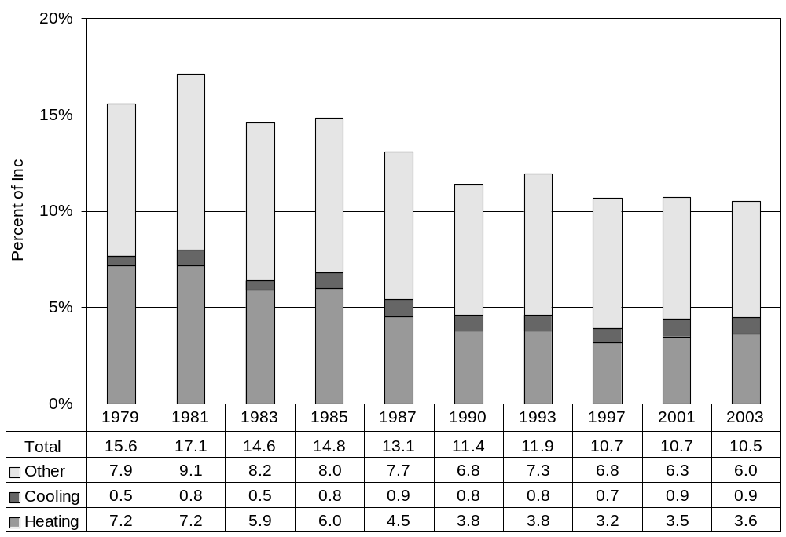
Tables 3-6 and 3-7 show how the mean individual and median individual energy burden statistics compare to the group energy burden statistics. Table 3-6 shows the trends in residential energy burden for low income households, and Table 3-7 shows the trends in home energy burden for low income households. In 2001, the mean individual residential energy burden was 16.8 percent, significantly higher than the median individual burden of 9.6 percent and the group burden of 10.7 percent. In 2001, the mean individual home energy burden was 7.2 percent, the median individual burden was 3.8 percent, and the mean group burden was 4.4 percent. For all three summary statistics, the highest home energy burden occurred in 1981 and the lowest home energy burden occurred in 1997. For FY 2003, median individual burden and group mean burden were almost 45 percent lower than the 1981 peak, while the mean individual burden was nearly 30 percent lower than the 1981 peak.
Figure 3-6. Comparison of mean group, mean individual, and median individual residential energy burden for households with incomes at or below 150 percent of the poverty income guidelines, 1979 to FY 2003
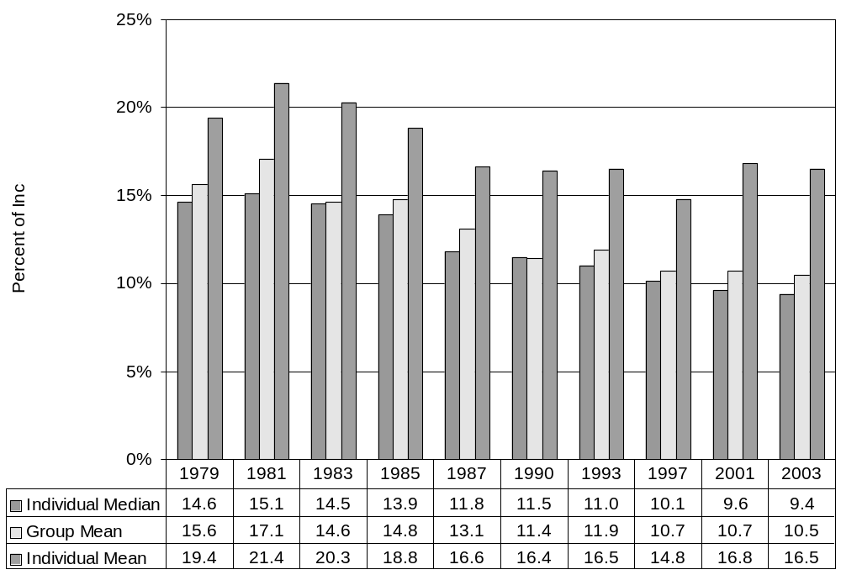
Figure 3-7. Comparison of mean group, mean individual, and median individual home energy burden for households with incomes at or below 150 percent of the poverty income guidelines, 1979 to FY 2003
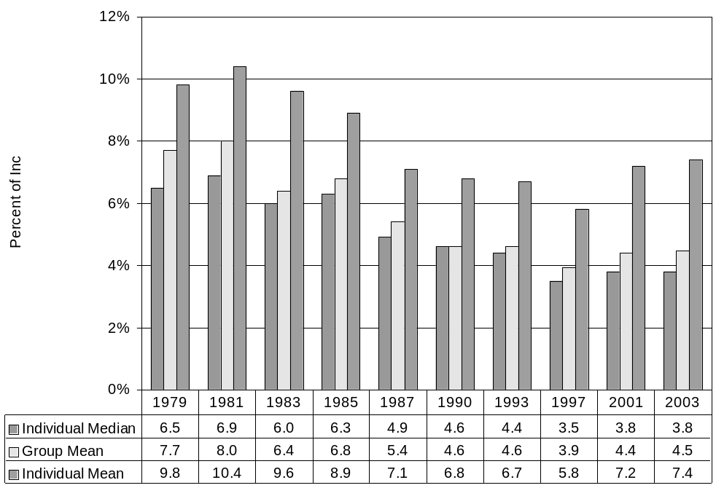
Figures 3-8, 3-9, and 3-10 present information on the number and percent of low income households that had energy burdens that exceeded specified levels. The levels are reference points and do not represent any judgment regarding an "affordable" level of energy burden.
As shown in Figure 3-8, the number of low income households with home energy burdens exceeding 10 percent of income grew from 5.0 million in 1979 to 7.1 million in 1985, an increase of 42 percent. The number of low income households with home energy burdens exceeding 5 percent of income grew by 62 percent from 1979 to 1985. These increases were primarily the result of growth in the total number of low income households. As Figure 3-9 shows, the percentage of low income households with home energy burdens exceeding specified levels remained quite stable from 1979 through 1985. For the period 1985 through 1997, however, both the number and percentage of low income households exceeding specified levels fell significantly from previous levels. For these years, both a reduction in home energy expenditures and increased incomes caused burden to decrease for low income households. In 2001, both the number and percent of households exceeding the specified levels rose and then remained stable in FY 2003. The number of low income households with home energy burdens exceeding 10 percent of income in FY 2003 was 38 percent less than the 1985 level and 49 percent less than the 1979 level.
Figure 3-10, on the next page, shows the total assistance funding that would be required to reduce the home energy burden for all low income households to 10 percent of income and 5 percent of income. The amount required for 5 percent of income was $2.2 billion in 1979, $4.6 billion by 1985, $3.3 billion in 2001, and $3.7 billion in FY 2003. The number of households with home energy burdens exceeding 5 percent of income fell between 1985 and 1997. The total dollars of assistance funding required to reduce home energy burden to 5 percent also fell through 1997. In 2001, increased expenditures caused the number of low income households exceeding the percent of income reference points to rise. Accordingly, the total dollars of assistance funding required to reduce home energy burden to 5 percent also rose substantially. In FY 2003, increased expenditures caused the number of low income households exceeding the percent of income reference points to rise further. Therefore, total dollars of assistance funding required to reduce home energy burden also rose.
Figure 3-8. Number of low income households spending over 5 percent and 10 percent of income on home energy, 1979 to FY 2003
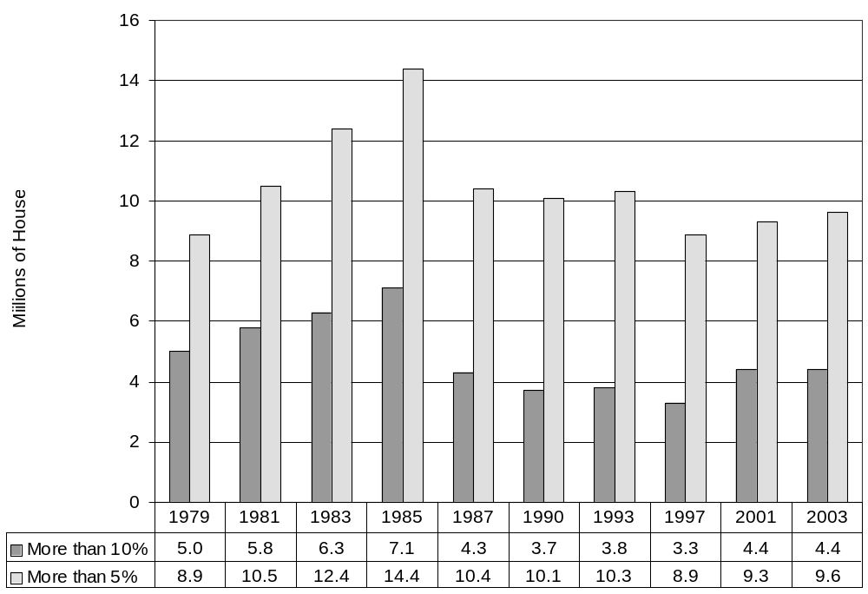
Figure 3-9. Percent of low income households spending over 5 percent and 10 percent of income on home energy, 1979 to FY 2003
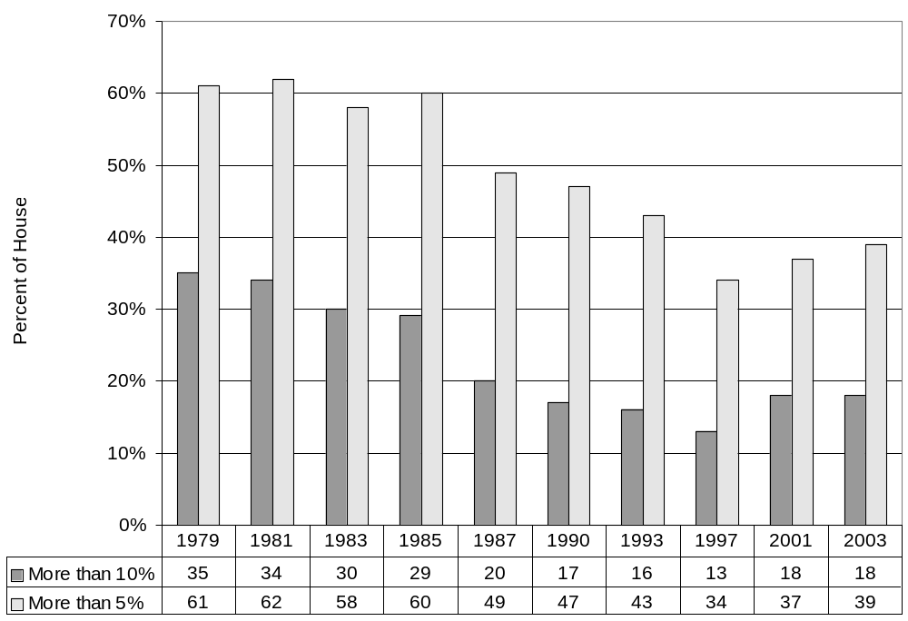
Figure 3-10. Total dollar need for LIHEAP funding for low income households spending over 5 percent and 10 percent of income on home energy, 1979 to FY 2003
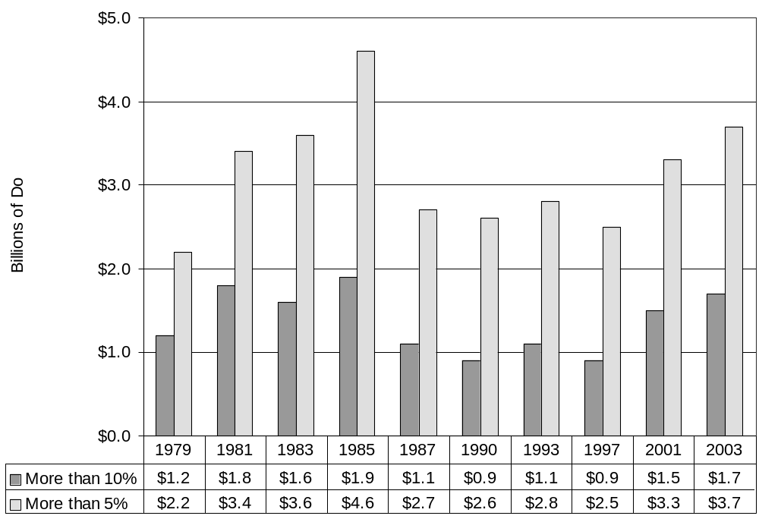
Figures 3-11 and 3-12 furnish statistics for residential energy expenditures. Figure 3-11 shows that the number of households spending over the specified percentages for residential energy (15 percent and 25 percent), followed a pattern similar to that observed in Figure 3-8. The largest number of households exceeded the specified percentages in 1983 and 1985. While the numbers exceeding 15 and 25 percent of income were lower in FY 2003 than during the peak years, they remained high. Figure 3-12 demonstrates that the funds required to reduce all low income households to the specified percentages remained quite high.
Figure 3-11. Number of low income households spending over 15 percent and 25 percent of income on residential energy, 1979 to FY 2003
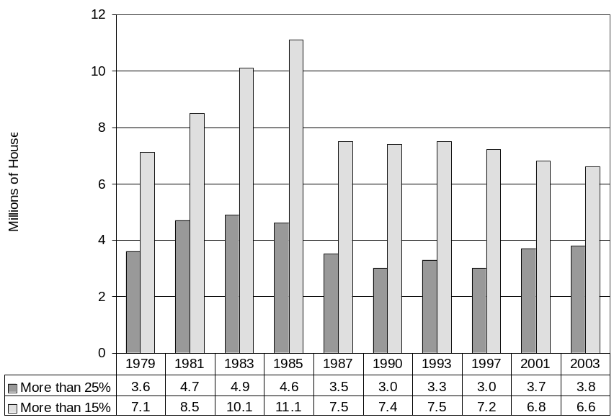
Figure 3-12. Total dollar need for LIHEAP funding for low income households spending over 15 percent and 25 percent of income on residential energy, 1979 to FY 2003
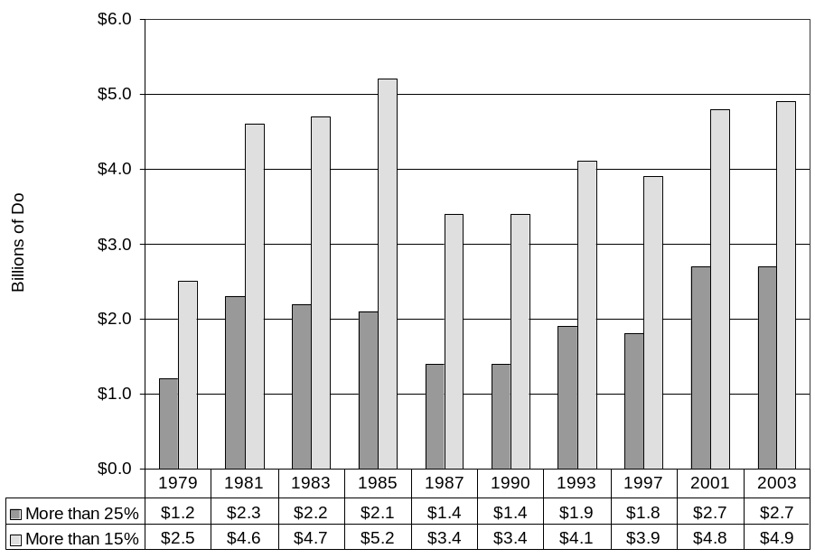
Figure 3-13 shows how the aggregated residential energy bill for all low income households has changed from 1979 to FY 2003. In 1979, the aggregated home energy bill for low income households was $4.5 billion. By FY 2003, the aggregated home energy bill had grown to $12.0 billion. This growth results from both the increase in average home energy bills and growth in the size of the low income population.
Figure 3-13 also shows that in 1979 home energy accounted for about half of the total low income residential energy bill. In FY 2003, home energy accounted for 42 percent of the total low income residential energy bill.
Figure 3-13. Aggregated residential energy expenditures by end use for households with incomes at or below 150 percent of the poverty income guidelines, 1979 to FY 2003
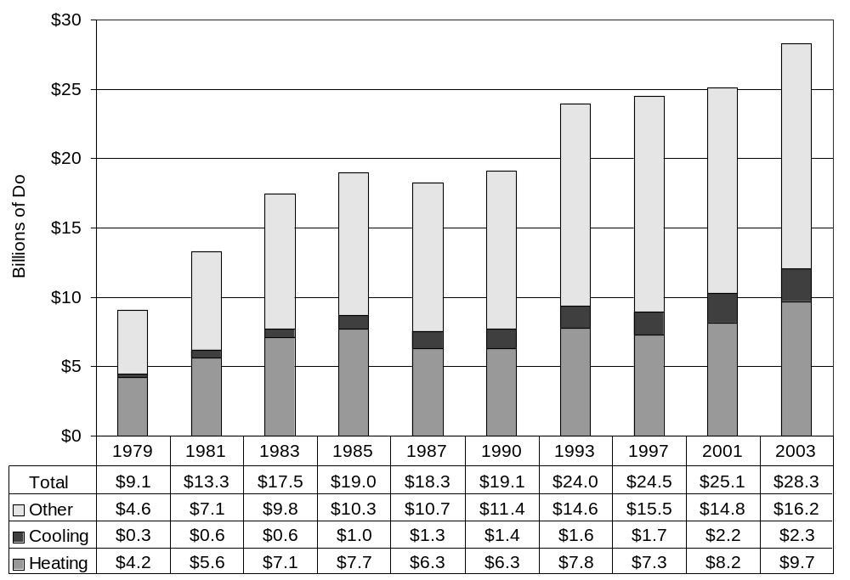
Figure 3-14, on the next page, presents an indicator of the impact of energy burden on LIHEAP eligible households. It shows the number of LIHEAP eligible households that reported that they were unable to use their main source of heat for a period of two hours or more during the heating season because they were unable to pay for their main heating fuel. During 1981-82, 984,000 LIHEAP eligible households (4.1 percent of LIHEAP eligible households) had heat interruptions during the heating season. The number and percentage grew to 1.34 million (5.1 percent) in 1983-84 and then fell consistently to 547,000 (2.1 percent) in 1987-1988. In 1989-90 there was a sharp increase to 1.0 million (3.7 percent). This higher level of heat interruptions was sustained in 1990-91 when 1.1 million (4.1 percent) LIHEAP eligible households had heat interruptions and in 1992-93 when 1.0 million (3.3 percent) LIHEAP eligible households had heat interruptions. The number and percentage increased to 1.2 million (3.6 percent) in 1996-97. In 2000-01, the number and percentage of LIHEAP eligible households with heat interruptions decreased to .9 million (2.7 percent).
Figure 3-14. Percentage of LIHEAP eligible households with heat interruptions of two hours or more caused by an inability to pay for energy to run the household's main heating system, 1981-82 heating season to 2000-01 heating season
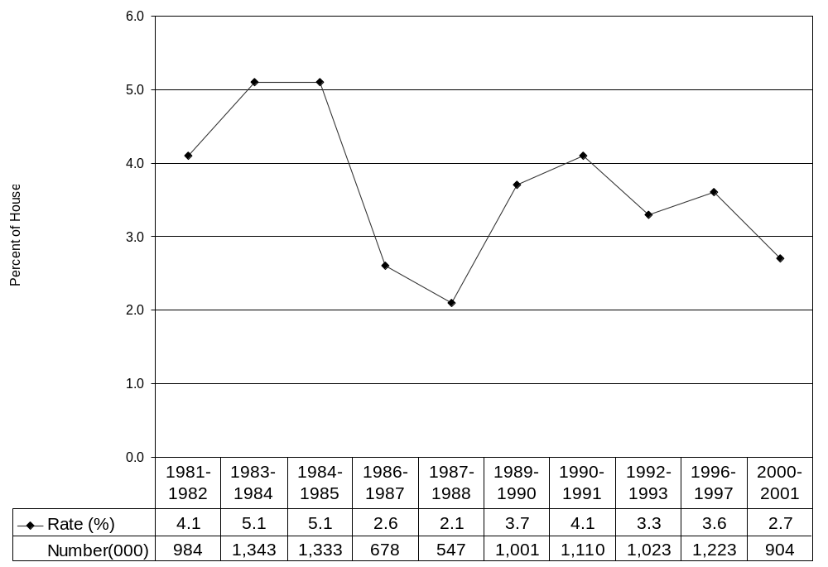

Analysis of energy trends
A number of factors underlie the energy consumption and expenditures trends. Three of the most important factors are fuel prices, weather, and energy efficiency. Figures 3-15, 3-16, and 3-17 furnish information on trends in these factors.
Figure 3-15, on the next page, furnishes an index of average fuel prices compared to the consumer price index. The index shows the percentage change from 1979 to 2003. For example, the index for the Consumer Price Index (CPI) grew from 100 in 1979 to 125 in 1981, indicating a 25 percent increase in consumer prices. Figure 3-15 shows that fuel prices outpaced the overall level of inflation from 1979 through 1983. The CPI increased by about 37 percent during that period, while the composite average of fuel prices increased by 78 percent. Since 1983, the increase in the composite average of fuel prices has moderated somewhat and has generally grown more slowly than the CPI. However, in 2001, the pattern was reversed; the composite average fuel price index was 265 while the CPI index was 243. The rapid growth of prices from 1979 through 1983 explains why residential energy expenditures per low income household rose so rapidly (Figure 3-4) while consumption was declining (Figure 3-3). The moderate growth in fuel prices from 1985 to 1997 (24 percent) explains why residential energy expenditures per low income household rose slightly during that period. In 2001, fuel prices increased 19 percent over 1997 prices. The increase in fuel prices explains why expenditures also rose. In FY 2003 prices increased again slightly and again contributed to an increase in expenditures.
Figure 3-15. Index of dollar prices for fuel oil, natural gas, electricity, and a composite compared to the Consumer Price Index (CPI), 1979 to FY 2003
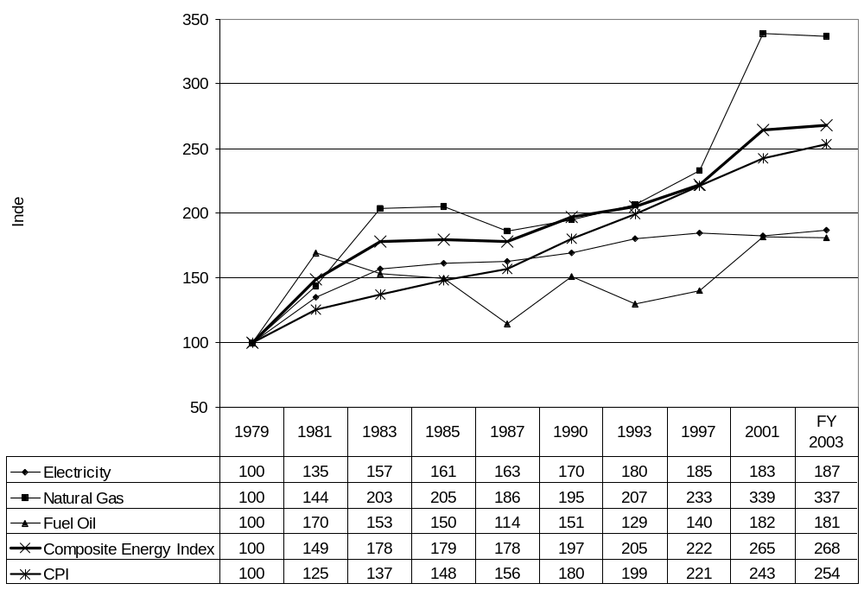
Figure 3-16 demonstrates how changes in heating energy consumption from 1979 to FY 2003 compared to changes in heating degree days for the same period. From 1979 to 1983, home heating consumption fell more rapidly than did heating degree days, suggesting a significant increase in efficiency as a result of conservation measures and/or actions. Consumption per heating degree day dropped rapidly for that period. From 1983 to 1997, there was only a moderate reduction in consumption per heating degree day. Thus, heating consumption fluctuations appear to be primarily a result of the changes in the weather for those years. In 2001, home heating consumption again fell more rapidly than did heating degree days, suggesting a moderate increase in efficiency as a result of conservation measures and/or actions. This was perhaps driven by the high fuel prices experienced in 2001. In FY 2003, consumption and heating degree days rose at the same rate and consumption per degree day remained steady.
Figure 3-16. Index of heating consumption, heating degree days, and heating consumption per heating degree day for households with incomes at or below 150 percent of the poverty income guidelines, 1979 to FY 2003
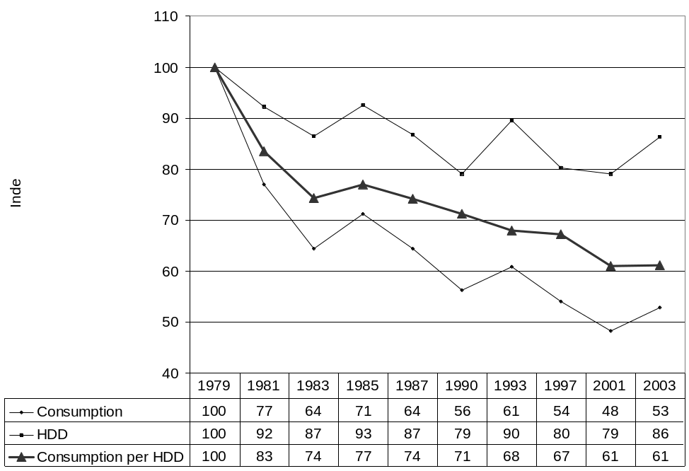
Figure 3-17 shows that home cooling consumption trends are somewhat more complex than are home heating consumption trends. In FY 2003, mean home cooling consumption was much higher than it was in 1979, even though households experienced only slightly more cooling degree days. Thus, mean consumption per cooling degree day increased substantially from 1979 to FY 2003, making it appear that there was a reduction in efficiency. However, the primary cause of the increase in mean home cooling consumption was the large increase in the availability of air-conditioning among low income households. As shown in Figure 3-2, only 37 percent of low income households had air-conditioning in 1979, while in 2001, 67 percent of low income households had air-conditioning. Because of this fundamental change in the way households use air-conditioning, it is very difficult to assess either changes in efficiency from 1979 to FY 2003 or year-to-year changes in consumption in response to changes in cooling degree days.
Figure 3-17. Index of cooling consumption, cooling degree days, and cooling consumption per cooling degree day for households with incomes at or below 150 percent of the poverty income guidelines, 1979 to FY 2003
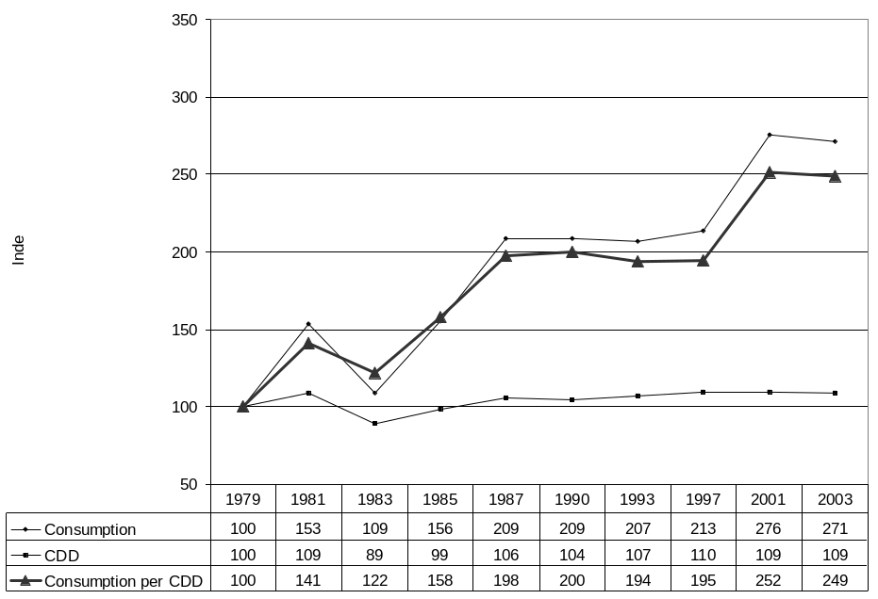
Figures 3-18 and 3-19, on the next page, show that mean group energy burdens for low income households are substantially higher than the mean for all households. In FY 2003, the mean group home energy burden for all households was 1.1 percent and it was 4.5 percent for low income households. In FY 2003, the mean group residential burden was 2.6 percent for all households and it was 10.5 percent for low income households. Over time, the gap between the burden for low income and all households has diminished somewhat. Figure 3-18 shows that in 1979, the mean group home energy burden for low income households was about 4 times that of all households, while in 1993, the mean group burden for low income households was just over 3 times that of all households. However in FY 2003, the mean group burden for low income households was again over 4 times that of all households.
Figure 3-18. Mean group home energy burden for all households and for households with incomes at or below 150 percent of the poverty income guidelines, 1979 to FY 2003
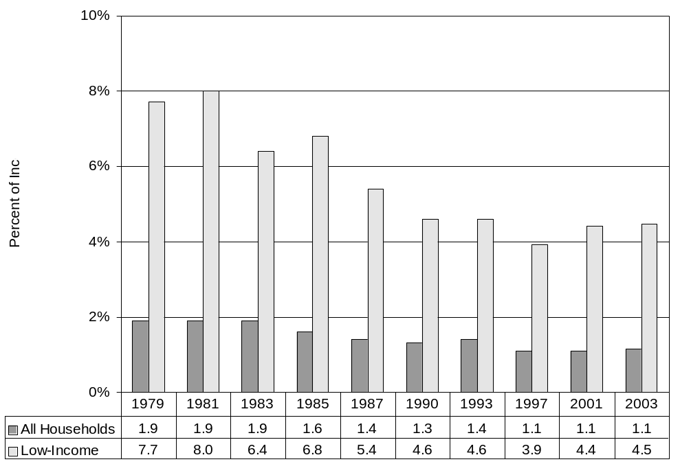
Figure 3-19. Mean group residential energy burden for all households and for households with incomes at or below 150 percent of the poverty income guidelines, 1979 to FY 2003
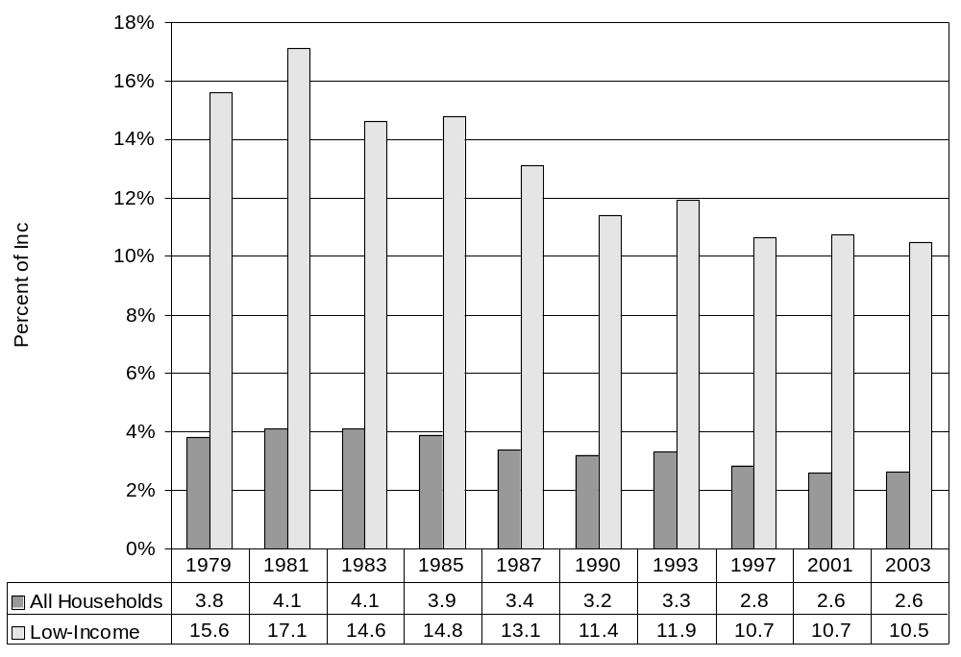

Trends in LIHEAP
Figures 3-20 through 3-24 furnish information on trends for HHS' energy assistance programs from FY 1981 through FY 2002. Figure 3-20 shows that the percentage of federally eligible households assisted has fallen significantly over time. In FY 1981, 36 percent of eligible households received heating and/or winter crisis assistance benefits. By FY 2002, 13 percent of eligible households received those benefits. Figure 3-21, on the next page, furnishes statistics on the count of recipients by benefit type.
Figure 3-22, on page 28, shows that the total funds used for fuel assistance benefits have fluctuated over time. For the years shown, funding was highest in FY 2001, when $2.47 billion dollars were used for assistance benefits, and lowest in FY 1997 when $0.94 billion dollars were used for assistance benefits. The large funding increase for FY 2001 is due in part to the substantial increase in funds for cooling assistance benefits. In FY 2002, funding for cooling assistance reached its highest level to date. Funding for heating assistance benefits reached $2.25 billion dollars. Only in FY 2001 was heating assistance funding higher than in FY 2002.
Figure 3-23, on page 29, shows that the mean heating/winter crisis benefits received by LIHEAP recipients were highest in FY 2001. For the years shown, mean heating/winter crisis benefits were $213 in FY 1981, grew to $242 in FY 1985, fell slightly to $213 in 1997, rose to $364 in FY 2001, and then fell significantly in FY 2002. Figure 3-24, on page 29, shows that, after adjusting for inflation, the mean value of benefits has fallen substantially. The inflation-adjusted mean value of benefits fell from $213 in FY 1981 to $141 in FY 2002. With the exception of FY 1981, mean cooling benefits ranged from $57 to $90 through FY 1997, and then rose to $107 in FY 2001. In FY 2002, mean cooling benefits fell dramatically to $70. In FY 1993, one State made program changes that significantly increased the mean benefit and decreased the total number of recipients.
Figure 3-20. Percentage of LIEAP/LIHEAP federally eligible households receiving LIEAP/LIHEAP heating and/or winter crisis assistance, FY 1981 to FY 2002
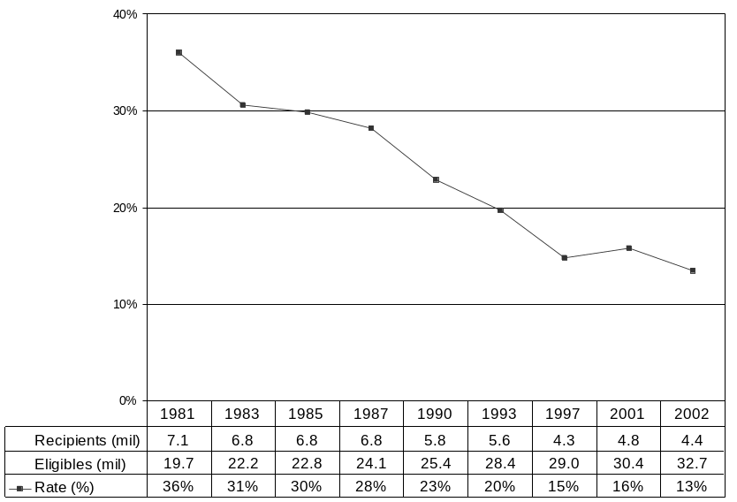

NOTE: 1981 Estimate of eligible households not directly comparable
SOURCE: HHS Administrative Data
Figure 3-21. Number of households receiving LIEAP/LIHEAP heating and/or winter crisis assistance or cooling and/or summer crisis assistance, FY 1981 to FY 2002
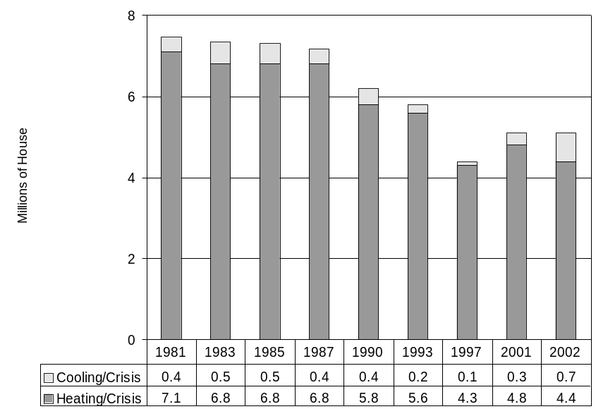

SOURCE: HHS Administrative Data

Figure 3-22. Funds used for LIEAP/LIHEAP fuel assistance, FY 1981 to FY 2002
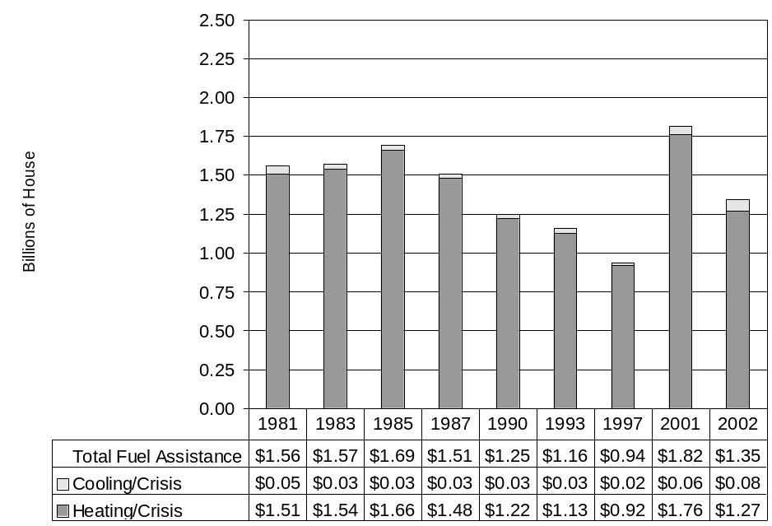

SOURCE: HHS Administrative Data

Figure 3-23. Mean combined LIEAP/LIHEAP heating and/or winter crisis benefits and mean cooling and/or summer crisis benefits, in dollars, FY 1981 to FY 2002
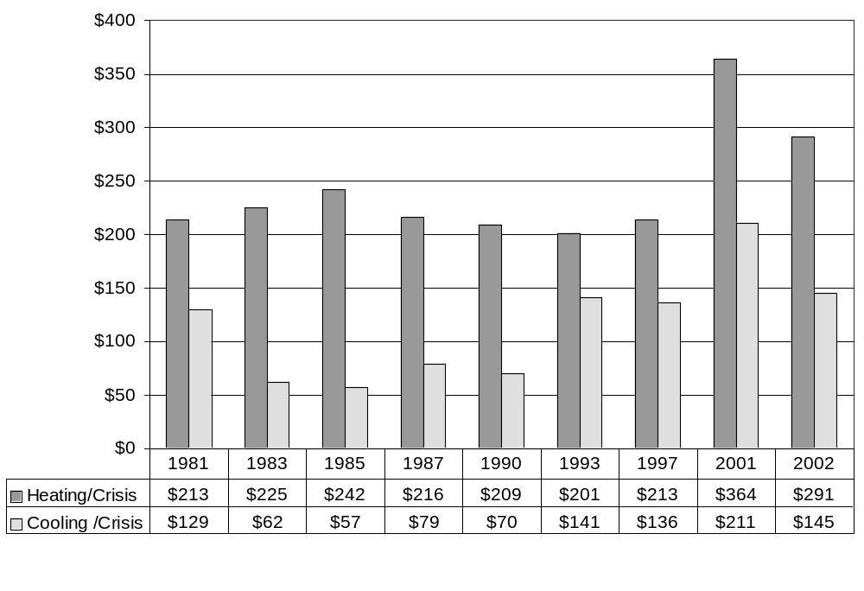

SOURCE: HHS Administrative Data

Figure 3-24. Mean combined LIEAP/LIHEAP heating and/or winter crisis benefits and mean cooling benefits, in constant 1981 dollars, FY 1981 to FY 2002
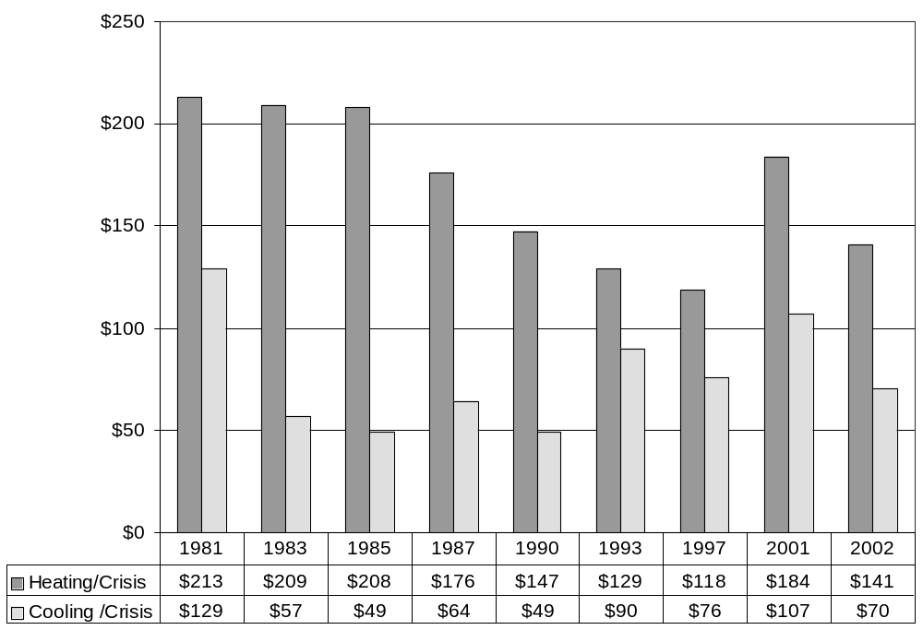

SOURCE: HHS Administrative Data

Analysis of LIHEAP benefits
The impact of LIHEAP heating benefits can be examined in at least two ways. Figure 3-25 shows the share of the aggregated total low income home heating costs covered by LIHEAP heating and winter crisis benefits (LIHEAP heating coverage). Figure 3-26, on the next page, shows the reduction in mean home heating burden as a result of LIHEAP benefits (LIHEAP burden offset).
Figure 3-25 shows that the LIHEAP heating coverage rate fell from 23 percent in FY 1981 to 12 percent in FY 2002. An increase in the size of the total bill and an increase in the number of households eligible for assistance benefits caused this reduction.
Figure 3-26 shows that the net effect of LIHEAP has been to lower recipient group home heating burdens to levels that are much closer to the levels of the average household. In FY 1981, gross mean group home heating burdens for LIEAP recipients were 8.5 percent, while net mean group home heating burdens (home heating expenditures minus LIEAP benefits) were 2.9 percent. In FY 2002, gross mean group home heating burdens for LIHEAP recipients were 3.6 percent, while net mean group home heating burdens were 1.3 percent. It is interesting to note that, while mean gross home heating burdens for LIHEAP recipients fell from 8.5 percent in FY 1981 to 4.0 percent in FY 1997, decreases in mean LIHEAP benefits caused mean net home heating burdens to remain twice as high as the burdens for all households. In FY 2001, significant increases in the mean heating benefit caused net mean group home heating burden for LIHEAP recipients to fall to 1.7 percent, however it remained twice as high as the mean group burden for all households. In FY 2002, the mean heating benefit decreased by about 20 percent, yet mean net group home heating burden also declined. The effect of the reduced heating benefit in FY 2002 was offset by lowered mean home heating expenditures due to milder winter weather in FY 2002.
Figure 3-25. Amount and percentage of total home heating bill for LIEAP/LIHEAP eligible households covered by LIHEAP heating and winter crisis benefits, FY 1981 to FY 2002
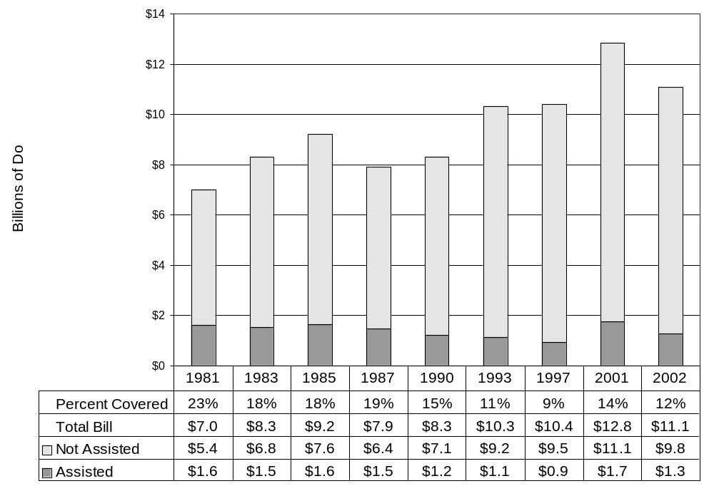

SOURCE: Assistance number from HHS data and heating bill estimates from RECS
Figure 3-26. Mean group home heating burden for all households and LIEAP/LIHEAP heating and winter crisis recipient households, FY 1981 to FY 2002
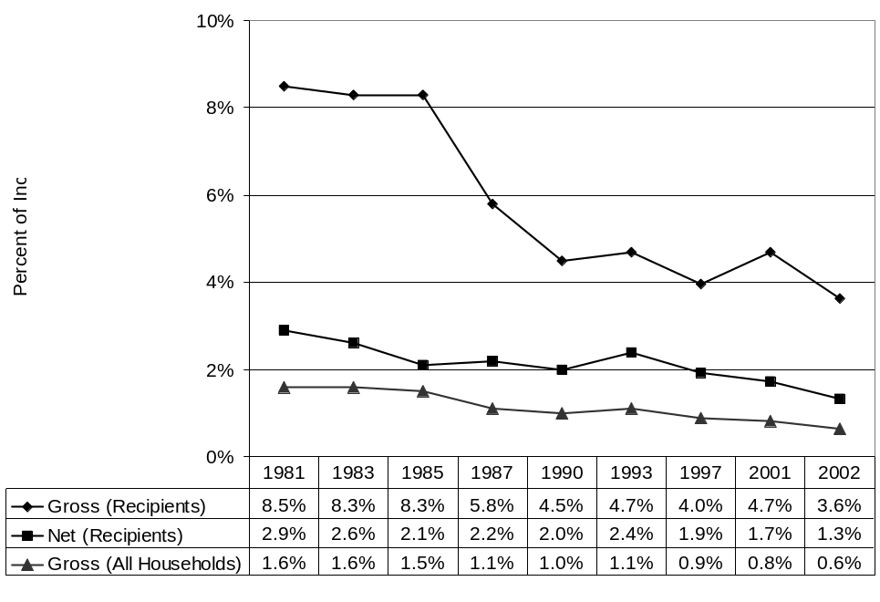

SOURCE: Mean burden uses expenditures from RECS and income from CPS ASEC
Net Burden = (Mean Expenditures - Mean Benefit) / Mean Income

IV. Federal LIHEAP targeting performance
The Government Performance and Results Act (GPRA) focuses on program results to provide Congress with objective information on the achievement of statutory objectives or program goals. The resulting performance data are to be used in making decisions on budget and appropriation levels. The GPRA performance plan for LIHEAP must take into account that the Federal government does not provide LIHEAP assistance to the public. Instead, the Federal government provides funds to States, Federal or State-recognized Indian Tribes and Tribal Organizations, and Insular Areas to administer LIHEAP at the local level. The LIHEAP performance plan also must take into account that LIHEAP is a block grant whereby LIHEAP grantees have broad flexibility to design their programs, within very broad Federal guidelines, to meet the needs of their citizens.
This Section of the Notebook describes ACF’s approach to LIHEAP performance measurement and discusses the findings from research that ACF has commissioned on performance measurement for the LIHEAP program, including:
- LIHEAP Performance Plan – Review of national LIHEAP program goals, national LIHEAP performance goals, and LIHEAP performance indicators.
- Performance Measurement Research – Discussion of the findings from studies commissioned by ACF to assess the validity of performance measurement estimation procedures.
- Energy Burden Evaluation Study – Summary of an evaluation of the performance of the LIHEAP program with respect to serving the lowest income households with the highest energy burdens.
- LIHEAP Performance Statistics – Statistics that document the performance of the LIHEAP program in serving vulnerable and high burden households.

National LIHEAP program goal
LIHEAP is not an entitlement program. The amount of LIHEAP funding varies by State. Therefore, the LIHEAP program is unable to serve all of the households that are income eligible under the Federal maximum income eligibility standard. In FY 2002, 13 percent of federally income eligible households received assistance with their heating costs. Given that limitation, the LIHEAP statute requires LIHEAP grantees to provide, in a timely manner, that the highest level of assistance will be furnished to those households that have the lowest incomes and the highest energy costs or needs in relation to income, taking into account family size. The LIHEAP statute identifies two groups of low-income households as having the highest home energy needs:
- Vulnerable Households: Vulnerable households are those with at least one member that is a young child, an individual with disabilities, or a frail older individual. The statute does not define the terms "young children," "individuals with disabilities," and "frail older individuals." The primary concern is that such households face serious health risks if they do not have adequate heating or cooling in their homes. Health risks can include death from hypothermia or hyperthermia and increased susceptibility to other health conditions such as stroke and heart attacks.
- High Burden Households: High burden households are those households with the lowest incomes and highest home energy costs. The primary concern is that such households will face safety risks in trying to heat or cool their home if they cannot pay their heating or cooling bills. Safety risks can include use of makeshift heating sources or inoperative/faulty heating or cooling equipment that can lead to indoor fires, sickness, or asphyxiation.
The authorizing legislation requires States to design outreach procedures that target LIHEAP recipiency to income eligible vulnerable and high burden households, and to design benefit computation procedures that target higher LIHEAP benefits to higher burden households.

National LIHEAP performance goals
Based on the national LIHEAP program goals, ACF has focused its initial performance goals and measurement on targeting income eligible vulnerable households and income eligible high burden households. OCS’s performance plan focuses the LIHEAP program on “increasing the availability of LIHEAP fuel assistance to vulnerable and high-energy burden households whose health and/or safety are endangered by living in a home without sufficient heating or cooling." The explicit performance goals for FY 2003 are:
- Increase the percent of LIHEAP recipient households having at least one member age 60 years or older.
- Increase the percent of LIHEAP recipient households having at least one member age 5 years or younger.
- Increase the percent of LIHEAP recipient households having the lowest incomes and the highest energy costs.
Baseline data for these targeting performance goals have been measured to provide a picture of the current status of targeting performance across the country. The baseline data serve as a starting point against which the degree of change in LIHEAP targeting can be measured, analyzed, and attributed to Federal performance enhancement initiatives. The baseline data also provide a roadmap from which ACF can set realistic recipiency performance standards (a quantitative statement of the degree of desired change) for those parts of the country in which targeting performance can be improved.

Performance measures
Performance goals must be measurable in order to determine if the goals are being achieved. ACF has developed a set of performance indicators (i.e., targeting indexes) that provide for the collection of quantitative measures regarding the following aspects of LIHEAP targeting performance:
- The recipiency targeting index quantifies recipiency targeting performance. The index is computed for a specific group of households by dividing the percent of LIHEAP households that are members of the target group by the percent of all income eligible households that are members of the target group. For example, if 25 percent of LIHEAP recipients are high burden households and 20 percent of all income eligible households are high burden, the recipiency targeting index for high burden households is 125 (100 times 25 divided by 20).
- The benefit targeting index quantifies benefit targeting performance. The index is computed by dividing the mean LIHEAP benefit for a target group of recipients by the mean LIHEAP benefit for all recipient households. For example, if high burden household recipients have a mean benefit of $250 and the mean benefit for all households is $200, the benefit targeting index is 125 (100 times $250 divided by $200).
- The burden reduction targeting index quantifies burden reduction targeting performance. The index is computed by dividing the percent reduction in the median individual energy burden for a target group of recipients by the percent reduction in the median individual energy burden for all recipients. For example, if high burden recipients have their energy burden reduced by 25 percent (e.g., from 8 percent of income to 6 percent of income) and all recipient households have their energy burden reduced by 20 percent (e.g., from 5 percent of income to 4 percent of income), the burden reduction targeting index is 125 (100 times 25 divided by 20).
The development of these indexes facilitates tracking of recipiency, benefit, and burden reduction performance for vulnerable and high burden households.
- The recipiency performance data allow for outreach initiatives to improve recipiency targeting performance.
- The benefit and burden reduction performance data facilitate analysis of how different kinds of benefit determination procedures lead to different levels of benefit targeting performance.
The benefit targeting index and the burden reduction targeting index are both useful indicators, but they measure the different aspects of benefit targeting.
- The benefit targeting index requires fewer data elements; it is a simple measure of how benefits for a particular group of recipient households compare to benefits for all recipient households.
- The burden reduction index is more comprehensive; it accounts for differences in both energy costs and benefit levels for the group of recipient households compared to energy costs and benefit levels for all recipient households.
The LIHEAP performance measurement plan has established performance goals only for recipiency targeting performance. Further, baseline performance statistics have been developed only for targeting to vulnerable households.

LIHEAP grantee use of targeting indexes
Individual LIHEAP grantees can use the recipiency targeting indexes to examine the effectiveness of their outreach to households with vulnerable members.
- In absolute terms, if a group has a recipiency targeting index over 100, it means that the group receives benefits at a rate higher than the group’s incidence in the eligible household population.
- In relative terms, if a group of vulnerable households is served at a higher rate than are households with no vulnerable members, that group has been targeted. For example, if the targeting index for elderly households is 90 and the index for households with no vulnerable members is 75, elderly households are served at a higher rate than are households with no vulnerable members.
Individual LIHEAP grantees can use the benefit and burden reduction targeting indexes to examine the effectiveness of their benefit determination procedures in serving households with vulnerable members and households with high energy burdens.
- In absolute terms, if a group has a benefit or burden reduction targeting index greater than 100, the group receives higher benefits (benefit targeting index) or experiences a greater burden reduction (burden reduction index) than the average for the recipient population. If a group has a benefit or burden reduction targeting index less than 100, the group receives lower benefits (benefit targeting index) or experiences a smaller burden reduction (burden reduction index) than the average for the recipient population. For example, if the benefit targeting index for elderly households is 125, this indicates that elderly households receive an average benefit that is 25 percent higher than the average for all recipients.
- In relative terms, if a group of vulnerable households has a higher targeting index than households with no vulnerable members, that group has been targeted. For example, if the benefit targeting index for elderly households is 90 and the targeting index for households with no vulnerable members is 75, this indicates that elderly households have higher benefits. If the burden reduction targeting index for elderly households is 90 and the targeting index for households with no vulnerable members is 75, this indicates that elderly households have a greater percentage reduction in energy burden.
Grantees can use the targeting indicators to gauge their current targeting performance and to track changes in targeting performance over time.

ACF’s use of targeting indexes
ACF is using national targeting indexes to examine the targeting performance of the LIHEAP program, to identify specific groups for whom Federal outreach materials should be provided, to identify regions of the country to target outreach materials, and to measure changes in performance over time. Specifically, ACF is examining the feasibility, reliability, and validity of targeting indexes in making the following comparisons:
- ACF can compare recipiency targeting indicators among groups of households and identify which groups are not effectively targeted by LIHEAP. For example, if the national LIHEAP recipiency targeting index for elderly households is 85 and the national LIHEAP recipiency targeting index for households with young children is 110, households with young children are targeted at a higher rate than are elderly households. ACF might conclude from these statistics that a greater share of the technical assistance efforts should be allocated to increasing targeting to elderly households.
- ACF can compare recipiency targeting indicators among areas of the country to assess which areas are in greatest need of technical assistance and to determine the type of technical assistance that is required. For example, if the recipiency targeting index for elderly households in the New England Census Division is 75, while the recipiency indexes for elderly households in all other regions are over 100, elderly households are served at a lower rate in New England than in other parts of the country. ACF might conclude from these statistics that a greater share of the technical assistance efforts should be allocated to increasing targeting to elderly households among grantees in New England.
- ACF can compare national targeting indicators over time to measure changes in targeting performance. For example, if the targeting indicator for elderly households was 75 in one fiscal year and was 85 in a later fiscal year, it would demonstrate that the LIHEAP program served elderly households at a higher rate over time.

Performance measurement research
ACF has commissioned a number of studies to develop a better understanding of LIHEAP targeting performance measurement. Two of these studies recommended that ACF consider making changes in the performance measurement plan for LIHEAP.
- Validation Study – The performance measurement validation study examined the available data sources for estimating the targeting indexes required by the performance measurement plan for LIHEAP and identified the data sources that furnished the most reliable data.
- Energy Burden Study – The energy burden evaluation study used the 2001 RECS LIHEAP Supplement to measure the baseline performance of the LIHEAP program in serving high burden households and to examine the competing demands associated with targeting vulnerable and high burden households.
Copies of these studies are available on OCS’ LIHEAP web site.

Performance measurement data sources
The ACF performance measurement plan for LIHEAP requires the development of targeting indexes for elderly households (i.e., households having at least one member age 60 years or older), young child households (i.e., households having at least one member age 5 years or younger), and high burden households (i.e., households having an energy burden that exceeds an energy burden threshold). Data elements needed to compute the recipiency targeting indexes are:
- Target group income eligible population – The number of elderly, young child, and high burden households that are income eligible for LIHEAP.
- Target group recipients – The number of elderly, young child, and high burden households that are LIHEAP heating recipients.
- Income eligible population – The number of all LIHEAP income eligible households.
- LIHEAP recipients – The number of all LIHEAP heating recipients.
The performance measurement validation study and the energy burden study identified the most reliable data sources for the required data elements. The studies found that a number of different data sources were needed to furnish the most reliable data for the computation of targeting indexes, including:
- Income eligible population - The CPS ASEC furnishes the most reliable estimates of the number of income eligible households.
- Income eligible vulnerable households – The ASEC furnishes the most reliable estimates of the number of income eligible vulnerable households (i.e., elderly households and young child households).
- LIHEAP heating recipients - The annual State LIHEAP Household Reports furnished by State LIHEAP administrators to the ACF furnish the most reliable estimates of the number of recipient households.
- Vulnerable household heating recipients – The annual State LIHEAP Household Reports furnish the most reliable estimates of the number of vulnerable recipient households.
- Income eligible high burden households - The Residential Energy Consumption Survey (RECS) furnishes the most reliable estimates of the number of income eligible high burden households.
- High burden heating recipients – The RECS LIHEAP Supplement furnishes the most reliable estimates of the number of high burden recipient households.
While these are the most reliable data sources, not all of the data are produced in a way that is timely with respect to the development of an annual performance measurement plan for LIHEAP. For example, in February 2004, ACF prepared the Final FY 2005 Annual Performance Plan, Final Revised FY 2004 Performance Plan, and FY 2003 Annual Performance Report. In order for a data source to be used for development of the plan, it needed to be available no later than the end of November 2003. The following discussion reviews each of the data sources and the timeliness of the data source in being able to meet the requirements for the development of annual performance measurement plan.
- CPS - The CPS is a national household sample survey that is conducted monthly by the Bureau of the Census. The ASEC includes a series of energy assistance questions, as well as other data that allow one to characterize household demographic characteristics. The CPS ASEC is the best national source of annual data for estimating the number of income eligible households and the number of income eligible vulnerable households. The CPS ASEC data needed to prepare performance statistics for the plan noted above were available in October 2003. That schedule meets the plan development requirements.
- LIHEAP Household Reports – The preliminary LIHEAP Household Reports for FY 2003 were due on September 1, 2003. ACF set a goal for the States to complete the final LIHEAP Household Reports for FY 2003 by December 2003. The 2003 LIHEAP household reports needed to be received, reviewed, and processed by November 2003 to prepare the FY 2003 Annual Performance Report by February 2004. The current schedule does not allow the final Household Reports to be used to meet the plan development requirements. Rather, the preliminary LIHEAP Household Reports would be used to meet the current plan development schedule.
- RECS – The RECS is a national household sample survey that is conducted once every four years by the U.S. Department of Energy. The most recent survey was conducted in 2001. The next survey is scheduled for 2005. The 2005 survey data will be available in late 2006. The RECS data were used for baseline measurement (2001) of targeting performance for high burden households and can track longer-term changes in performance over time (2001 to 2005). However, the RECS currently cannot furnish annual updates on LIHEAP targeting performance for high burden households.

Performance measurement indicators
With the available data, the annual performance plan for LIHEAP includes updates on targeting to vulnerable households, but not on targeting to high burden households. To develop a better understanding of the value of performance data on high burden households, ACF commissioned the LIHEAP Energy Burden Evaluation Study. The purposes of that study included:
- Targeting - Measure the extent to which the LIHEAP program is serving the lowest income households that have the highest energy burdens.
- Performance goals - Assessment of the importance of the performance goal of increasing the percent of LIHEAP recipient households having the lowest incomes and the highest energy costs.
- Measurement – Identification of procedures that can be used to measure performance of the LIHEAP program with respect to the goal of increasing the percent of LIHEAP recipient households having the lowest incomes and the highest energy costs.
The study furnished the following information to ACF with respect to targeting of high burden households.
- Targeting – The study found that, for FY 2001, the targeting index for high home energy burden households was 170, indicating that households with a high home energy burden are served as significantly higher rate than other households. The study furnishes a baseline statistic from which changes in targeting to high burden households can be compared.
- Performance goals – The study demonstrated that it is important to include a goal of targeting high burden households in the performance plan for the LIHEAP program. The LIHEAP statute gives equal status to the goals of targeting vulnerable households and high burden households. Performance goals that are limited to targeting of elderly and young child households encourage LIHEAP grantees to give preference to low burden vulnerable households over high burden households that do not have a vulnerable household member.
- Measurement – The study identified options for collecting annual data on high burden recipient households.
In addition, the LIHEAP Energy Burden Evaluation Study examined two other performance indicators – the benefit targeting index and the burden reduction targeting index. The study furnished baseline measures for those indicators, discussed the value of including those benefit and burden reduction targeting indicators in the performance plan for LIHEAP, and identified the challenges of including those indicators in the performance plan for LIHEAP.

Performance measurement statistics
The Final FY 2005 Annual Performance Plan, Final Revised FY 2004 Performance Plan, and FY 2003 Annual Performance Report furnished measurements of targeting performance using the CPS-based procedures for computing targeting indexes for vulnerable households. That report did not include any measure of targeting performance for high burden households.
Table 4-1 shows the performance measures that were included in that report. The first column in the table restates the performance goal. The second column in the reports shows the measured performance for FY 01, FY 02, and FY 03. For each fiscal year, the first number presented is the targeting index for the targeted group and the second number presented is the targeting index for households with no vulnerable members. For example, under performance measure 7.3a, the FY 01 targeting index for elderly households was 89, while it was 58 for nonvulnerable households. This demonstrates that for FY 01, elderly households were targeted at a higher rate than nonvulnerable households, since the targeting index for elderly households is higher than the targeting index for nonvulnerable households.
The CPS-based measurements included in the report measured very little change in targeting to elderly households during the period from FY01 to FY 03. The CPS-based measurements for young child households did measure an increase in targeting between FY 02 and FY 03.

Table 4-1. LIHEAP recipiency targeting performance measures reported in the Final FY 2005 Annual Performance Plan, Final Revised FY 2004 Performance Plan, and FY 2003 Annual Performance Report
Performance Measures | Fiscal Year | Target Group Index | Nonvulnerable Index
7.3a. Increase the targeting index of LIHEAP recipient households having at least one member 60 years or older compared to non-vulnerable LIHEAP recipient households | FY 03  FY 02  FY 01 | 90  91  89 | 63  64  58
7.3b. Increase the targeting index of LIHEAP recipient households having at least one member 5 years or younger compared to non-vulnerable LIHEAP recipient households | FY 03  FY 02  FY 01 | 120  109  111 | 63  64  58

However, the GPRA validation study found that CPS-based estimates are not consistent with State LIHEAP Household Reports. Table 4-2 furnishes detailed national and regional recipiency targeting indexes for FY 2003. The table includes the original index estimates developed using the CPS ASEC data and the revised estimates based on the State LIHEAP Household Reports.
For FY 2001, there are statistically significant differences at the national and regional level between the CPS-based estimates and the estimates based on State LIHEAP Household Reports. The GPRA validation study found that estimates were consistent for the period 1998 through 2000 (i.e., the differences in the indexes were not statistically significant). However, for 2001 and later years, the differences are statistically significant. Moreover, for 1998 to 2000, the count of LIHEAP recipients based on the CPS ASEC was about 68 percent of the number of recipients reported by States. In 2001, the CPS-based estimate was only 57 percent of recipients reported by States. This raises serious questions about the validity of CPS-based estimates for LIHEAP recipient households and CPS-based estimates for LIHEAP targeting indexes.
There are challenges associated with using State LIHEAP Household Reports to measure LIHEAP targeting, including:
- Nonvulnerable households – States report the number of elderly, disabled, and young child households (i.e., vulnerable households). However, they do not report the number of households that do not have any of those characteristics (i.e., nonvulnerable households). In their present format, the State reports cannot be used to develop the performance measures shown in Table 4.1. They can be used to furnish estimates of the targeting index for elderly and young child households, but they cannot compare those estimates to nonvulnerable households.
- Crisis and cooling assistance households – Some States furnish crisis benefits and/or cooling benefits to households that have not received heating assistance. For those States, the LIHEAP Household Reports do not furnish a way to obtain an unduplicated count of the characteristics of vulnerable energy assistance recipients, which introduces a potential bias in the estimated targeting indexes.
- Data quality issues – The LIHEAP Household Reports are reviewed by ACF for consistency and completeness. When errors are found, States are asked to revise their reports. However, it is possible that States have made other errors that cannot be identified from data inconsistencies. States are not required to have an independent audit of their household data reports.
The GPRA validation study recommended that ACF change performance measurement estimation procedures to rely on LIHEAP Household Reports for heating recipiency data. While some questions remain about the precision of those data, it appears that they furnish higher quality estimates than the CPS-based data.
Table 4-2. LIHEAP recipiency targeting by priority groups by region for FY 2003 using weighted household counts from the 2003 CPS ASEC and using LIHEAP Household Reports from State LIHEAP administrators
Region and priority group | CPS-based recipiency targeting index | Administrative recipiency targeting index
All Regions
Elderly | 90 | 78^{1/}
Young child | 120 | 119
No vulnerable^{2/} | 67 | N/A
Northeast
Elderly | 85 | 76^{1/}
Young child | 134 | 143^{1/}
No vulnerable | 68 | N/A
Midwest
Elderly | 77 | 70^{1/}
Young child | 139 | 139
No vulnerable | 72 | N/A
South
Elderly | 87 | 83
Young child | 135 | 108^{1/}
No vulnerable | 58 | N/A
West
Elderly | 115 | 115
Young child | 88 | 83
No vulnerable | 67 | N/A

^{1/}Differences are statistically significant at the 90 percent level.
^{2/}Nonvulnerable households include those households that do not have at least one member who is elderly, disabled, or a young child. An elderly person is anyone who is 60 years of age or older. A young child is defined as a child 5 years of age or younger.

The Final FY 2005 Annual Performance Plan, Final Revised FY 2004 Performance Plan, and FY 2003 Annual Performance Report did not furnish information on targeting high burden households. However, baseline statistics on high burden household targeting were developed by the energy burden evaluation study. That study recommended that measurement of targeting to high burden households is important since the LIHEAP program’s statutory mandate is to serve the households with the “lowest incomes and highest energy needs.”
Table 4-3 shows the national and regional targeting indexes for high burden households for FY 2001. The 2001 RECS and the 2001 RECS LIHEAP Supplement were used to develop these statistics. These statistics demonstrate that the LIHEAP program is targeting high burden households.
Table 4-3. LIHEAP recipiency targeting of high burden households by region for FY 2001 from the 2001 RECS Survey and the 2001 RECS LIHEAP Supplement
Region | Recipiency yargeting index for high burden households – residential energy | Recipiency targeting index for high burden households – home energy
Northeast | 185 | 163
Midwest | 155 | 132
South | 165 | 155
West | 264 | 293
United States | 184 | 170

The energy burden evaluation study also furnished estimates of the benefit and burden reduction targeting indexes for FY 2001. Benefit and burden reduction targeting are not part of the performance plan for LIHEAP. However, the study concluded that those indexes are consistent with the statutory mandate to “furnish the highest benefits to lowest income households with the highest home energy needs.”
Table 4-4 shows that national and regional benefit targeting indexes and Table 4-5 shows that national and regional burden reduction targeting indexes. Table 4-4 shows that at the national level and in all regions, high burden households receive slightly higher average benefits than households that do not have high burden. However, Table 4-5 shows that at the national level and for most regions, high burden households experience slightly lower burden reduction than households that do not have a high burden.
Table 4-4. LIHEAP benefit targeting of high burden households by region for FY 2001 from the 2001 RECS Survey and the 2001 RECS LIHEAP Supplement
Region | Benefit targeting index for high burden households – residential energy | Benfit targeting index for high burden households – home energy
Northeast | 103 | 103
Midwest | 109 | 108
South | 111 | 110
West | 115 | 124
United States | 108 | 109

Table 4-5. LIHEAP burden reduction targeting of high burden households by region for FY 2001 from the 2001 RECS Survey and the 2001 RECS LIHEAP Supplement
Region | Burden reducton targeting index for high burden households - residential energy | Burden redcution targeting index for high burden households – home energy
Northeast | 99 | 96
Midwest | 95 | 93
South | 108 | 98
West | 86 | 86
United States | 97 | 94

Targeting performance measurement issues
As presented above, targeting indexes are statistical tools that allow ACF to examine targeting across groups of households, across regions of the country, and over time. It is reasonable to expect that the greatest increases in targeting performance can be realized by supporting the targeting efforts for those areas of the country that are currently serving targeted households at the lowest rate. ACF is using targeting performance statistics to assist in determining the best allocation of Federal LIHEAP outreach materials to improve LIHEAP targeting to vulnerable and high burden households.
The major challenge is in finding an effective way to measure targeting indexes for vulnerable and high burden households in a timely way. In order to meet the information requirements for the ACF performance plan for the LIHEAP program data needs to be collected more frequently and needs to be delivered in a more timely way. The final LIHEAP Household Reports need to be made available to ACF earlier in the year. The RECS and the RECS LIHEAP Supplement need to be conducted more regularly and processed more quickly. In addition, the LIHEAP Household Reports need to be revised in a way that furnishes an unduplicated count of households receiving all types of LIHEAP assistance benefits.

Appendix A: Home energy estimates
Appendix A provides information on how estimates of home energy data were derived from the 2001 Residential Energy Consumption Survey (RECS) and updated for FY 2003. The following topics are covered in this Appendix.
- Description of RECS.
- Strengths and Limitations of RECS data.
- National and regional average home energy consumption and expenditures.
- Energy burden.

Description of RECS
RECS is a national household sample survey that provides information on residential energy use. It has been conducted by the Energy Information Administration (EIA) of the U.S. Department of Energy since 1978. It is designed to provide reliable data at the national and Census regional level. RECS includes information on energy consumption and expenditures, household demographics, housing characteristics, weatherization/conservation practices, home appliances, and type of heating and cooling equipment. Currently, this survey is conducted every four years.
The survey consists of three parts:
- EIA interviews households for information about fuels used, how fuels are used, energy-using appliances, structural features, energy-efficiency measures taken, demographic characteristics of the household, heating interruptions, and receipt of energy assistance.
- EIA interviews rental agents for those households whose rent includes some portion of their energy bill. This information augments information from those households that may not be knowledgeable about the fuels used for space heating or water heating.
- After obtaining permission from respondents, EIA mails questionnaires to their energy suppliers to collect the actual billing data on energy consumption and expenditures. This fuel supplier survey eliminates the inaccuracy of self-reported data. When a household does not consent or when fuel consumption records are unusable or nonexistent, regression analysis is used to impute missing data.
The 2001 RECS is the eleventh survey in the series of surveys. For the 2001 RECS, approximately 4,822 households were interviewed in the core sample. In addition, a supplemental sample of 496 LIHEAP recipient households were interviewed for the first time as part of the RECS. For the tabulations in this Notebook, 2001 RECS consumption and expenditure data were updated for FY 2003.

Strengths and limitations of RECS data
RECS provides the most recent, comprehensive data on home energy consumption and expenditures. The strengths of using RECS to derive home energy estimates are as follows.
- RECS uses a representative national household sample, providing statistically reliable estimates for all, non low income, and low income households.
- The 2001 RECS included a supplemental sample of LIHEAP recipient households that is representative of the population of LIHEAP heating and cooling assistance recipients.
- RECS includes use of all residential fuels.
- Energy suppliers provide information on actual residential energy consumption and expenditures of RECS sample households.
- Regression analyses of RECS data provide estimates of the amounts of fuels going to various end uses, including home heating and cooling.
While the updated 2001 RECS data provide the most current and comprehensive data on residential energy use by low income households, several significant limitations must be addressed:
- The 2001 RECS data for calendar year 2001 were updated to FY 2003 using procedures that adjust the 2001 data to reflect the weather and fuel prices for FY 2003 (October 1, 2002 to September 30, 2003). The methodology for the tabulations in this Notebook is comparable to that used for the FY 1986 - FY 2002 Annual LIHEAP Reports to Congress. The reader should exercise caution in comparing the data in this Notebook with data in Annual LIHEAP Reports to Congress prior to FY 1986 in which consumption and expenditure data were predicted on the RECS year (April 1 to March 31).
- For some variables, disaggregation of data into subgroups at the regional level results in estimates made from a small number of sample cases. This is particularly true of the LIHEAP recipient households and the liquefied petroleum gas and kerosene heating subgroups. This affects the reliability of the estimates.
- The household is a basic reporting unit for RECS and LIHEAP. RECS employs the Bureau of the Census' definition of household, i.e., a household includes all individuals living in a housing unit, whether related or not, who (1) share a common direct access entry to the unit from outside the building or from a hallway, and (2) do not normally eat their meals with members of other units in the building. A household does not include temporary visitors or household members away at college or in the military. LIHEAP defines a household as one or more individuals living together as an economic unit who purchase energy in common or make undesignated payments for energy in their rent. Some variation in the count of households, particularly those containing renters or boarders, may result from the difference in definitions.
- The CPS ASEC, conducted by the Bureau of the Census, provides total household income as a specific dollar amount at the national and regional levels. CPS' larger sample size and method of collecting income data result in more accurate income data compared to RECS income data. Therefore, the 2003 CPS ASEC is used to develop estimates of the number of low income households. In addition, mean income statistics from the CPS ASEC are used in the calculation of group energy burden for this Notebook.
- Households were classified in the 2001 RECS as eligible or ineligible for LIHEAP based on whether their income was above or below the maximum statutory income eligibility criteria (the greater of 150 percent of the poverty level or 60 percent of state median income). These estimates do not include households that were categorically eligible for LIHEAP under section 2605((b)(2) (A)) of the LIHEAP statute, whose incomes may have exceeded the statutory income standards. However, the tabulations of LIHEAP households include survey respondents who were reported as LIHEAP recipients by State LIHEAP administrative data but who reported incomes higher than the maximum statutory income in the RECS survey.

Average home energy consumption and expenditures
Average heating and cooling consumption and expenditure estimates for FY 2003 were calculated at national and regional levels for all, non low income, low income, and LIHEAP recipient households, for various fuels. The heating and cooling estimates were updated for each 2001 RECS sample case using FY 2003 heating degree days, cooling degree days, and price inflators applied to the original expenditure data, and the regression formula developed from the 2001 RECS. Home energy consumption and expenditure data were developed by aggregating and averaging home heating and cooling estimates for the sample cases that represented all, non low income, low income, and LIHEAP recipient households.
Tables A-2a through A-2c display national and regional expenditure data for residential energy (including energy used for space heating, water heating, space cooling, and appliances). Tables A-3 through A-5c display national and regional usage, consumption, and expenditure data for home heating. Table A-6 displays national and regional usage, consumption, and expenditure data for home cooling. Analysis and discussion of home energy consumption and expenditures appear in Section II of this Notebook.

Energy burden
Energy burden is an important statistic for policymakers who are considering the need for energy assistance. Energy burden can be defined broadly as the burden placed on household incomes by the cost of energy. However, there are different ways to compute energy burden and different interpretations of the energy burden statistics. The purpose of this section is to examine alternative energy burden statistics and discuss the interpretation of each.

Computational procedures
There are two ways to compute mean energy burden for households. The first is the "mean individual" approach, and the second is the "mean group" approach. While these approaches appear to be similar, they give quite different values.
Using the "mean individual burden" approach, energy burden is computed as follows: First, the ratio of energy expenditures to annual income for each household in a specified population is computed. Then, the mean of these energy burden ratios is computed for the population. For example, consider the situation where there are four households with energy burdens of 4, 5, 7, and 8 percent. The mean of these energy burdens is calculated by adding the percentages (24 percentage points) and dividing by the number of households (four households), resulting in a mean individual burden of 6 percent.
Using the "mean group burden" approach, energy burden is computed as follows. First, total energy expenditures for households and total annual income for households in a specified population are computed. Then, the ratio of total energy expenditures to total income is computed for the specified population. For example, consider the situation where a group consists of four households that have a total income of $100,000 and a total energy bill of $4,000. Dividing the $4,000 in total energy bills by $100,000 in total income results in a mean group burden of 4 percent.
Using the 2001 RECS, the mean residential energy burden for LIHEAP eligible households using the first approach is 19.1 percent and using the second approach is 11.8 percent. The disparity between the two statistics is because the lowest income households spend a greater share of their income on residential energy than do higher income households. If the relationship between income and residential energy expenditures is linear (i.e., a 10 percent increase in income is associated with a 10 percent increase in residential energy expenditures), the two statistics would be equal. However, since a number of low income households spend a large share of their income on energy, the relationship between income and residential energy expenditures is not linear (i.e., a 10 percent increase in income is associated with a considerably smaller increase in energy expenditures). Therefore, there is a substantial difference between the two statistics.

Statistical measures
Different "measures of central tendency" can be used to describe energy burden. The most commonly used measures are the mean and the median. As previously noted, the mean is computed as the sum of all values divided by the number of values. The median is computed as the value that is at the center of the distribution of values (i.e., 50 percent of the values are greater than the median and 50 percent are less).
In the discussion of computational procedures, the "mean individual burden" was examined. It is also possible to look at the "median individual burden." As noted above for LIHEAP eligible households, the mean residential energy burden computed as the "mean individual burden" was 19.1 percent. The median of the distribution of residential energy burdens from the 2001 RECS survey was 12.6 percent. The disparity between these two statistics is the result of the skewed distribution of energy burden ratios. Figure A-1 demonstrates a skewed distribution of LIHEAP eligible households by home energy burden.

Data files
The data files used to make estimates of energy burden also have some impact on the statistic. The RECS data file is the only reliable source of national information on energy expenditures. However, the income reported on the RECS is known to be deficient in several ways. First, it is generally true that income is underreported on household surveys. Second, RECS collects income data less precisely through the use of income intervals. Finally, the CPS ASEC collects income more precisely than RECS does and also has a larger sample size than RECS.
As a result, the RECS categorizes too many households as income eligible for LIHEAP. Based on the 2001 RECS, in calendar year 2001, 33.8 million households are estimated to be LIHEAP eligible households. Based on the 2001 CPS ASEC, the estimate of LIHEAP eligible households for calendar year 2001, is 30.4 million households. Since some households, which are not LIHEAP eligible, are categorized as LIHEAP eligible, the RECS overestimates the average energy expenditures for LIHEAP eligible households.

Figure A-1. Distribution of LIHEAP eligible households by home energy burden, 2001
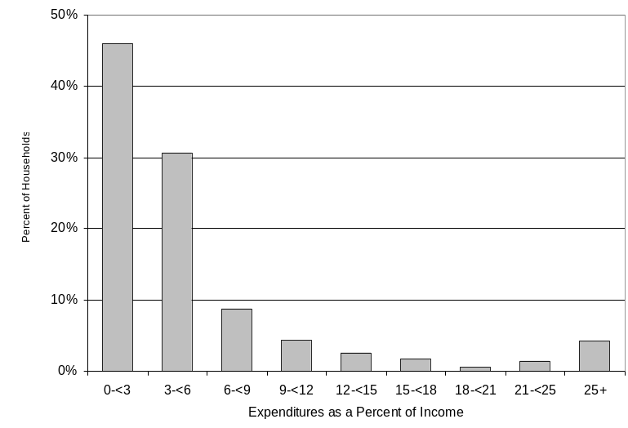

Data interpretations
The statistic used to describe energy burden depends on the question being asked. Each statistic offers some data on energy burden while not telling the whole story by itself.
The key difference between "mean individual burden" and "mean group burden" is that the first statistic focuses on the experience of households and the second on the experience of a group of households. The "mean individual burden" furnishes more information on how individual households are affected by energy burden (i.e., it computes a mean by using each household's burden). The "mean group burden" furnishes more information on group burden (i.e., it computes the share of all income earned by LIHEAP eligible households that goes to pay for energy). Both statistics are useful, though the individual burden statistic puts more emphasis on the experience of individual households, and the group burden puts more emphasis on the share of group income that is used for energy.
The key difference between the "mean individual burden" and the "median individual burden" is that the first statistic furnishes information on all LIHEAP eligible households at the expense of "overstating" what is happening to the "average" LIHEAP eligible household. The second statistic furnishes information on the "average" LIHEAP eligible household at the expense of disregarding what is happening to households at either end of the distribution.
The best way to furnish information on energy burden is to use all available statistics. For example, it would be informative to show the "mean individual burden," the "median individual burden," and the "distribution of individual energy burdens," for all LIHEAP eligible households, to indicate how individual households are affected by energy costs. In addition, it would be useful to show the "mean group burden" to indicate what share of income is going to pay energy bills for the group as a whole.
However, when doing an analysis of energy burden among several groups of households, it is very difficult to present the entire spectrum of available statistics. Thus, we usually limit the analysis to a comparison of one statistic between groups. In general, if only one statistic is used, either the "mean individual burden" or the "mean group burden" is preferred, since a mean is a more complete statistic than is a median. The choice between the two means is dictated by which of the following types of analysis is being conducted.
- If funding levels are being examined, the group burden is probably more useful. This statistic furnishes information on the size of the energy bill of LIHEAP eligible households and the portion of income for this group that is spent on energy. Using this statistic allows direct examination of the relationship between the total energy bill and total LIHEAP funding.
- If targeting decisions are being examined, the mean or median individual burden is probably more useful. This statistic furnishes information on the distribution of burdens among households in a group. Using this statistic helps to target those groups where a significant number of households have high energy burdens.
All three energy burden statistics are presented in this Notebook's tables to fully inform the reader. Beginning with the FY 1992 LIHEAP Report to Congress, both mean individual energy burden and mean group burden statistics are now furnished in the reports. Previous reports to Congress presented only the mean group burden. The text of this Notebook references mean group burden to maintain consistency with the previous reports to Congress.

Projecting energy consumption and expenditures
Projections were developed using microsimulation techniques that adjusted consumption and energy expenditures for changes in weather and prices. Consumption amounts for each household were adjusted for changes in heating and cooling degree days. Projected expenditures for each household were estimated as a function of projected consumption changes and actual changes in fuel prices. It was assumed that households had not changed their behavior as a result of weather and price changes.
Consumption projections utilized end use consumption estimates that were developed with the 2001 RECS data. These estimates were based on models for each fuel, using households that had actual (not imputed) consumption records for the fuel. The models used nonlinear estimation techniques to estimate parameters that described the relationship of consumption to end uses, housing characteristics, weather, and demographics.
To develop consumption projections, heating and cooling degree estimates of end use for the Calendar Year 2001 were adjusted for weather differences between 2001 and 2003. The following equation was applied to each household in the microsimulation data file.
2003 Projected BTUs = (2001 estimated heat use * HDD change) +
(2001 estimated cooling use * CDD change) +
(2001 estimated water use + 2001 estimated appliance use)
Expenditure projections were a function of projected changes in consumption and actual changes in prices. The following equations were used.
Preliminary Expenditures = 2001 Expenditures * (2003 Projected Usage/2001 Actual Usage)
Final Expenditures = Preliminary Expenditures * Price Change
The following chart shows the national price factors that were used. The price factors show the actual change in the average price of a fuel from calendar year 2001 to FY 2003. (For example, electricity prices increased by 1 percent from 2001 to FY 2003.)

Table A-1. National price factors for FY 2003

Fuel | Price Factors for FY 2003 Projections
Electricity | 1.0067
Natural gas | 0.9509
Fuel oil / kerosene | 1.0701
Liquefied petroleum gas (LPG) | 1.0111

Expenditure data were adjusted using national price factors for FY 2003. Earlier Notebooks used state-level price factor data. For FY 1993/1994, state-level data did not vary much from the national average for electricity and natural gas. For electricity, price changes varied between 0.3 percent and 1.2 percent; the national average was 0.8 percent. For natural gas, price changes varied between 1.7 percent and 2.8 percent; the national average was 2 percent. Expenditure projections using national price data do not appear to be significantly different from those obtained using state price data.

Table A-2a. Residential energy: Average annual expenditures, by amount (dollars) and mean group burden (percent of income), for all, non low income, low income, and LIHEAP recipient households, by Census region and main heating fuel, FY 2003
Census Region | All fuels |  | Main heating fuel
Census Region |  |  | Natural gas |  | Electricity |  | Fuel oil |  | Kerosene |  | LPG
Census Region | Dollars^{1/} | Percent^{2/} | Dollars | Percent | Dollars | Percent | Dollars | Percent | Dollars | Percent | Dollars | Percent
United States
All households | $1,527 | 2.6% | $1,585 | 2.7% | $1,300 | 2.2% | $1,924 | 3.3% | $1,341 | 2.3% | $1,856 | 3.2%
Non low income households | $1,631 | 2.1% | $1,674 | 2.2% | $1,439 | 1.9% | $1,982 | 2.6% | $1,498 | 1.9% | $1,947 | 2.5%
Low income households^{3/} | $1,304 | 8.2% | $1,381 | 8.7% | $1,020 | 6.4% | $1,777 | 11.2% | $1,274 | 8.0% | $1,692 | 10.7%
LIHEAP recipient households^{4/} | $1,515 | 11.5% | $1,539 | 11.7% | $1,240 | 9.4% | $1,992 | 15.1% | $1,549 | 11.7% | $1,653 | 12.5%
Northeast
All households | $1,846 | 3.0% | $1,880 | 3.0% | $1,500 | 2.4% | $1,956 | 3.1% | $1,571 | 2.5% | $2,170 | 3.5%
Non low income households | $1,999 | 2.3% | $2,070 | 2.4% | $1,718 | 2.0% | $2,032 | 2.4% | $1,912 | 2.2% | $2,370 | 2.8%
Low income households | $1,543 | 9.0% | $1,560 | 9.1% | $1,135 | 6.6% | $1,753 | 10.3% | $1,338 | 7.8% | $1,376* | 8.0%
LIHEAP recipient households | $1,816 | 12.8% | $1,805 | 12.7% | $1,687 | 11.9% | $2,042 | 14.4% | $1,572* | 11.1% | $1,666* | 11.7%
Midwest
All households | $1,584 | 2.8% | $1,597 | 2.8% | $1,172 | 2.1% | $1,748 | 3.1% | NC | NC | $1,985 | 3.5%
Non low income households | $1,642 | 2.2% | $1,637 | 2.2% | $1,396 | 1.9% | $1,871 | 2.5% | NC | NC | $1,995 | 2.7%
Low income households | $1,450 | 8.8% | $1,494 | 9.1% | $822 | 5.0% | $1,630 | 9.9% | NC | NC | $1,966 | 12.0%
LIHEAP recipient households | $1,492 | 11.1% | $1,501 | 11.2% | $1,189 | 8.8% | $1,445* | 10.7% | NC | NC | $1,926 | 14.3%
South
All households | $1,563 | 2.9% | $1,708 | 3.1% | $1,426 | 2.6% | $1,933 | 3.6% | $1,208 | 2.2% | $1,748 | 3.2%
Non low income households | $1,672 | 2.3% | $1,837 | 2.6% | $1,530 | 2.1% | $1,819 | 2.5% | $763* | 1.1% | $1,896 | 2.6%
Low income households | $1,320 | 9.2% | $1,417 | 9.9% | $1,185 | 8.3% | $2,382* | 16.7% | $1,307 | 9.1% | $1,515 | 10.6%
LIHEAP recipient households | $1,400 | 13.6% | $1,404 | 13.6% | $1,344 | 13.0% | $2,135* | 20.7% | $1,027* | 10.0% | $1,437 | 14.0%
West
All households | $1,133 | 1.9% | $1,211 | 2.0% | $925 | 1.5% | $1,513* | 2.5% | $1,170* | 1.9% | $1,682 | 2.8%
Non low income households | $1,235 | 1.6% | $1,290 | 1.6% | $1,070 | 1.3% | $1,513* | 1.9% | $1,468* | 1.9% | $1,702 | 2.1%
Low income households | $915 | 5.5% | $1,012 | 6.1% | $700 | 4.2% | NC | NC | $983 | 5.9% | $1,647 | 9.9%
LIHEAP recipient households | $975 | 6.7% | $1,011 | 6.9% | $667 | 4.6% | $1,233* | 8.5% | NC | NC | $1,703* | 11.7%
^{1/}Estimates are derived from the 2001 Residential Energy Consumption Survey (RECS), Energy Information Administration, U.S. Department of Energy. The 2001 RECS data have been adjusted for heating degree days, cooling degree days, and fuel price estimates for FY 2003. Expenditures represent the cost for fuel oil, kerosene, and LPG delivered and billed costs for natural gas and electricity. Expenditure data are not collected for other fuels.
^{2/}Represents the percent of household’s income used for residential energy expenditures. National and regional mean incomes are calculated from the 2003 CPS ASEC, which reports income for calendar year 2002. Mean group residential burden is computed as mean group energy expenditures (from RECS) by mean group income (from CPS ASEC). See text in Appendix A for a discussion of energy burden.
^{3/}Households with annual incomes under the maximum in section 2506(b)(2)(B) of Public Law 97-35.
^{4/}Includes households from the 2001 RECS LIHEAP supplemental sample.
* = This figure should be viewed with caution because of the small number of sample cases.
NC = No cases in the 2001 RECS household sample.

Table A-2b. Residential energy: Average annual expenditures, by amount (dollars) and mean individual burden (percent of income), for all, non low income, low income, and LIHEAP recipient households, by Census region and main heating fuel, FY 2003
Census Region | All fuels |  | Main heating fuel
Census Region |  |  | Natural gas |  | Electricity |  | Fuel oil |  | Kerosene |  | LPG
Census Region | Dollars^{1/} | Percent^{2/} | Dollars | Percent | Dollars | Percent | Dollars | Percent | Dollars | Percent | Dollars | Percent
United States
All households | $1,527 | 6.3% | $1,585 | 6.4% | $1,300 | 5.8% | $1,924 | 7.1% | $1,341 | 13.9% | $1,856 | 8.1%
Non low income households | $1,631 | 3.0% | $1,674 | 2.9% | $1,439 | 2.7% | $1,982 | 3.5% | $1,498 | 3.4% | $1,947 | 4.2%
Low income households^{3/} | $1,304 | 13.6% | $1,381 | 14.2% | $1,020 | 11.8% | $1,777 | 16.3% | $1,274 | 18.4% | $1,692 | 15.1%
LIHEAP recipient households^{4/} | $1,515 | 18.9% | $1,539 | 19.4% | $1,240 | 15.8% | $1,992 | 20.9% | $1,549 | 25.4% | $1,653 | 21.8%
Northeast
All households | $1,846 | 8.1% | $1,880 | 9.3% | $1,500 | 6.0% | $1,956 | 6.9% | $1,571 | 14.3% | $2,170 | 6.0%
Non low income households | $1,999 | 3.4% | $2,070 | 3.4% | $1,718 | 2.9% | $2,032 | 3.6% | $1,912 | 4.2% | $2,370 | 3.7%
Low income households | $1,543 | 17.2% | $1,560 | 19.1% | $1,135 | 11.1% | $1,753 | 15.9% | $1,338 | 21.3% | $1,376* | 15.2%
LIHEAP recipient households | $1,816 | 22.9% | $1,805 | 24.3% | $1,687 | 24.2% | $2,042 | 20.9% | $1,572* | 26.0% | $1,666* | 12.6%
Midwest
All households | $1,584 | 6.2% | $1,597 | 5.8% | $1,172 | 6.8% | $1,748 | 10.8% | NC | NC | $1,985 | 8.0%
Non low income households | $1,642 | 3.0% | $1,637 | 3.0% | $1,396 | 2.6% | $1,871 | 3.5% | NC | NC | $1,995 | 4.5%
Low income households | $1,450 | 13.3% | $1,494 | 13.0% | $822 | 13.3% | $1,630 | 17.8% | NC | NC | $1,966 | 14.6%
LIHEAP recipient households | $1,492 | 16.2% | $1,501 | 15.5% | $1,189 | 11.5% | $1,445* | 12.4% | NC | NC | $1,926 | 27.4%
South
All households | $1,563 | 6.8% | $1,708 | 7.1% | $1,426 | 6.2% | $1,933 | 5.5% | $1,208 | 14.3% | $1,748 | 8.9%
Non low income households | $1,672 | 3.1% | $1,837 | 3.2% | $1,530 | 2.9% | $1,819 | 2.7% | $763* | 2.2% | $1,896 | 4.4%
Low income households | $1,320 | 14.9% | $1,417 | 15.7% | $1,185 | 13.8% | $2,382* | 16.4% | $1,307 | 17.0% | $1,515 | 16.0%
LIHEAP recipient households | $1,400 | 19.4% | $1,404 | 22.5% | $1,344 | 17.4% | $2,135* | 26.8% | $1,027* | 9.9% | $1,437 | 18.2%
West
All households | $1,133 | 4.3% | $1,211 | 4.3% | $925 | 4.1% | $1,513* | 3.2% | $1,170* | 11.9% | $1,682 | 7.2%
Non low income households | $1,235 | 2.3% | $1,290 | 2.3% | $1,070 | 2.1% | $1,513* | 3.2% | $1,468* | 3.1% | $1,702 | 3.5%
Low income households | $915 | 8.6% | $1,012 | 9.3% | $700 | 7.2% | NC | NC | $983 | 17.5% | $1,647 | 13.5%
LIHEAP recipient households | $975 | 13.2% | $1,011 | 14.2% | $667 | 9.4% | $1,233* | 15.5% | NC | NC | $1,703* | 21.1%
^{1/}Estimates are derived from the 2001 Residential Energy Consumption Survey (RECS), Energy Information Administration, U.S. Department of Energy. The 2001 RECS data have been adjusted for heating degree days, cooling degree days, and fuel price estimates for FY 2003. Expenditures represent the cost for fuel oil, kerosene, and LPG delivered and billed costs for natural gas and electricity. Expenditure data are not collected for other fuels.
^{2/}Represents the percent of household income used for residential energy expenditures. For individual households, FY 2003 income is estimated by inflating income reported in the 2001 RECS by the consumer price index (CPI) and FY 2003 energy expenditures are estimated by adjusting energy expenditures reported in the 2001 RECS for changes in weather and energy prices. FY 2003 residential energy burden for each household is computed as estimated FY 2003 residential energy expenditures divided by estimated FY 2003 annual income. Mean burden is computed by computing the mean of the individual values. See text in Appendix A for a discussion of energy burden.
^{3/}Households with annual incomes under the maximum in section 2506(b)(2)(B) of Public Law 97-35.
^{4/} Includes households from the 2001 RECS LIHEAP supplemental sample.
* = This figure should be viewed with caution because of the small number of sample cases.
NC = No cases in 2001 RECS household sample.
Table A-2c. Residential energy: Average annual expenditures, by amount (dollars) and median individual burden (percent of income), for all, non low income, low income, and LIHEAP recipient households, by Census region and main heating fuel, FY 2003
Census Region | All fuels |  | Main heating fuel
Census Region |  |  | Natural gas |  | Electricity |  | Fuel oil |  | Kerosene |  | LPG
Census Region | Dollars^{1/} | Percent^{2/} | Dollars | Percent | Dollars | Percent | Dollars | Percent | Dollars | Percent | Dollars | Percent
United States
All households | $1,527 | 3.4% | $1,585 | 3.4% | $1,300 | 3.1% | $1,924 | 3.9% | $1,341 | 8.2% | $1,856 | 5.2%
Non low income households | $1,631 | 2.6% | $1,674 | 2.6% | $1,439 | 2.5% | $1,982 | 3.1% | $1,498 | 3.0% | $1,947 | 4.0%
Low income households^{3/} | $1,304 | 8.0% | $1,381 | 8.4% | $1,020 | 6.6% | $1,777 | 9.8% | $1,274 | 12.4% | $1,692 | 10.2%
LIHEAP recipient households^{4/} | $1,515 | 12.4% | $1,539 | 12.6% | $1,240 | 10.5% | $1,992 | 15.5% | $1,549 | 13.5% | $1,653 | 12.8%
Northeast
All households | $1,846 | 4.0% | $1,880 | 4.4% | $1,500 | 3.5% | $1,956 | 4.1% | $1,571 | 8.2% | $2,170 | 3.1%
Non low income households | $1,999 | 3.0% | $2,070 | 3.0% | $1,718 | 2.5% | $2,032 | 3.2% | $1,912 | 4.0% | $2,370 | 2.9%
Low income households | $1,543 | 9.2% | $1,560 | 9.8% | $1,135 | 6.1% | $1,753 | 9.2% | $1,338 | 8.8% | $1,376* | 9.7%
LIHEAP recipient households | $1,816 | 14.2% | $1,805 | 15.4% | $1,687 | 12.2% | $2,042 | 15.2% | $1,572* | 13.5% | $1,666* | 11.4%
Midwest
All households | $1,584 | 3.5% | $1,597 | 3.3% | $1,172 | 3.1% | $1,748 | 5.9% | NC | NC | $1,985 | 5.5%
Non low income households | $1,642 | 2.7% | $1,637 | 2.7% | $1,396 | 2.4% | $1,871 | 3.2% | NC | NC | $1,995 | 4.1%
Low income households | $1,450 | 8.2% | $1,494 | 7.5% | $822 | 5.8% | $1,630 | 11.6% | NC | NC | $1,966 | 11.7%
LIHEAP recipient households | $1,492 | 11.2% | $1,501 | 11.2% | $1,189 | 9.7% | $1,445* | 11.8% | NC | NC | $1,926 | 16.2%
South
All households | $1,563 | 3.6% | $1,708 | 3.7% | $1,426 | 3.4% | $1,933 | 3.1% | $1,208 | 9.6% | $1,748 | 5.6%
Non low income households | $1,672 | 2.7% | $1,837 | 2.8% | $1,530 | 2.7% | $1,819 | 2.7% | $763* | 2.0% | $1,896 | 4.5%
Low income households | $1,320 | 9.0% | $1,417 | 9.8% | $1,185 | 8.0% | $2,382* | 11.9% | $1,307 | 12.4% | $1,515 | 10.2%
LIHEAP recipient households | $1,400 | 12.7% | $1,404 | 13.0% | $1,344 | 11.8% | $2,135* | 26.8% | $1,027* | 9.7% | $1,437 | 11.7%
West
All households | $1,133 | 2.5% | $1,211 | 2.5% | $925 | 2.5% | $1,513* | 3.1% | $1,170* | 4.4% | $1,682 | 4.6%
Non low income households | $1,235 | 2.0% | $1,290 | 2.0% | $1,070 | 1.9% | $1,513* | 3.1% | $1,468* | 3.0% | $1,702 | 3.2%
Low income households | $915 | 5.1% | $1,012 | 5.4% | $700 | 4.0% | NC | NC | $983 | 12.8% | $1,647 | 8.6%
LIHEAP recipient households | $975 | 8.4% | $1,011 | 11.1% | $667 | 5.9% | $1,233* | 15.5% | NC | NC | $1,703* | 30.2%
^{1/}Estimates are derived from the 2001 Residential Energy Consumption Survey (RECS), Energy Information Administration, U.S. Department of Energy. The 2001 RECS data have been adjusted for heating degree days, cooling degree days, and fuel price estimates for FY 2003. Expenditures represent the cost for fuel oil, kerosene, and LPG delivered and billed costs for natural gas and electricity. Expenditure data are not collected for other fuels.
^{2/}Represents the percent of household income used for residential energy expenditures. For individual households, FY 2003 income is estimated by inflating income reported in the 2001 RECS by the consumer price index (CPI) and FY 2003 energy expenditures are estimated by adjusting energy expenditures reported in the 2001 RECS for changes in weather and energy prices. FY 2003 residential energy burden for each household is computed as estimated FY 2003 residential energy expenditures divided by estimated FY 2003 annual income. Median burden is computed by computing the median of the individual values.
^{3/}Households with annual incomes under the maximum in section 2506(b)(2)(B) of Public Law 97-35.
^{4/} Includes households from the 2001 RECS LIHEAP supplemental sample.
* = This figure should be viewed with caution because of the small number of sample cases.
NC = No cases in the 2001 RECS household sample.
Table A-3. Home heating: Percent of households using major types of heating fuels, by all, non low income, low income, and LIHEAP recipient households, by Census region and main heating fuel type, April 2001^{1/}
 | Natural Gas^{2/} | Electricity | Fuel Oil | Kerosene | LPG | Other^{3/}
United States
All households | 55.4% | 29.1% | 7.5% | 0.8% | 4.7% | 2.1%
Non low income households | 56.3% | 28.3% | 7.9% | 0.3% | 4.4% | 2.2%
Low income households^{4/} | 53.4% | 30.7% | 6.7% | 1.7% | 5.3% | 1.8%
LIHEAP recipient households^{5/} | 52.4% | 21.3% | 10.0% | 2.2% | 11.0% | 2.8%
Northeast
All households | 52.2% | 11.4% | 30.9% | 1.6% | 1.7% | 2.2%
Non low income households | 49.4% | 10.7% | 34.0% | 1.0% | 2.1% | 2.8%
Low income households | 57.8% | 12.7% | 24.7% | 2.7% | 1.0% | 1.0%
LIHEAP recipient households | 54.5% | 9.8% | 25.4% | 6.4% | 1.1% | 2.7%
Midwest
All households | 77.4% | 10.3% | 3.2% | NC | 7.5% | 1.5%
Non low income households | 80.1% | 9.1% | 2.3% | NC | 7.1% | 1.4%
Low income households | 71.1% | 13.3% | 5.5% | NC | 8.6% | 1.5%
LIHEAP recipient households | 68.9% | 12.7% | 0.9% | NC | 13.7% | 3.8%
South
All households | 40.2% | 49.7% | 2.1% | 1.0% | 5.2% | 1.5%
Non low income households | 40.3% | 50.4% | 2.4% | 0.3% | 4.6% | 1.6%
Low income households | 40.0% | 48.2% | 1.4% | 2.6% | 6.6% | 1.3%
LIHEAP recipient households | 31.8% | 41.0% | 3.4% | 0.4% | 22.2% | 0.7%
West
All households | 60.4% | 29.6% | 0.7% | 0.5% | 3.1% | 3.6%
Non low income households | 63.7% | 26.6% | 1.1% | 0.3% | 2.9% | 3.7%
Low income households | 53.5% | 36.1% | NC | 1.0% | 3.6% | 3.5%
LIHEAP recipient households | 47.0% | 34.3% | 4.5% | NC | 7.8% | 5.1%
^{1/}Data derived from the 2001 Residential Energy Consumption Survey (RECS), Energy Information Administration, U.S. Department of Energy. Represents main heating fuel used in April 2001.
^{2/}The sum of percentages across fuel types may not equal 100%, due to rounding.
^{3/}This category includes households using wood, coal, and other minor fuels as a main heating source and households reporting no main fuel.
^{4/}Households with income under the maximum in section 2605(b)(2)(B) of Public Law 97-35.
^{5/} Includes households from the 2001 RECS LIHEAP supplemental sample.
NC = No cases in the 2001 RECS household sample.
Table A-4. Home heating: Average consumption per household, by all fuels and specified fuels, by all, non low income, low income and LIHEAP recipient households, by Census region, FY 20031/
 | All Fuels^{2/} | Natural Gas | Electricity | Fuel Oil | Kerosene | LPG

 | (In MmBTUs)^{3/}
United States
All households | 48.1 | 62.0 | 14.5 | 82.5 | 46.1 | 56.8
Non low income households | 50.3 | 63.7 | 16.0 | 85.1 | 56.3 | 60.7
Low income households^{4/} | 43.2 | 58.1 | 11.5 | 75.9 | 41.8 | 49.9
LIHEAP recipient households^{5/} | 62.4 | 79.2 | 19.4 | 102.5 | 62.4 | 45.9
Northeast
All households | 72.9 | 79.3 | 22.3 | 84.9 | 66.5 | 75.2
Non low income households | 78.8 | 87.0 | 27.3 | 88.4 | 78.3 | 79.7
Low income households | 61.1 | 66.4 | 14.0 | 75.3 | 58.5 | 56.9*
LIHEAP recipient households | 79.0 | 85.4 | 23.8 | 100.6 | 64.2* | 33.4*
Midwest
All households | 75.7 | 83.8 | 25.7 | 78.8 | NC | 70.0
Non low income households | 77.6 | 84.2 | 32.7 | 78.8 | NC | 70.4
Low income households | 71.3 | 82.8 | 14.7 | 78.8 | NC | 69.2
LIHEAP recipient households | 77.0 | 93.2 | 20.4 | 106.0* | NC | 66.7
South
All households | 30.7 | 48.7 | 13.5 | 75.0 | 31.1 | 45.1
Non low income households | 31.8 | 50.1 | 14.0 | 75.3 | 25.1* | 52.3
Low income households | 28.5 | 45.6 | 12.1 | 73.9* | 32.4 | 33.8
LIHEAP recipient households | 37.8 | 56.4 | 21.5 | 133.1* | 20.7* | 28.7
West
All households | 26.4 | 34.4 | 10.9 | 49.6* | 40.8* | 47.5
Non low income households | 28.0 | 35.2 | 12.5 | 49.6* | 43.5* | 46.4
Low income households | 22.8 | 32.4 | 8.2 | NC | 39.0 | 49.5
LIHEAP recipient households | 29.7 | 38.4 | 9.6 | 82.1* | NC | 60.2*
^{1/}Developed from the 2001 Residential Energy Consumption Survey (RECS), Energy Information Administration, U.S. Department of Energy, for FY 2003.
^{2/}Weighted average of natural gas, electricity, fuel oil, kerosene, and liquefied petroleum gas space heating consumption. Consumption data are not collected for other fuels .
^{3/}A British Thermal Unit (BTU) is the amount of energy necessary to raise the temperature of one pound of water one degree Fahrenheit. MmBTUs refer to values in millions of BTUs.
^{4/}Households with income under the maximum in section 2605(b)(2)(B) of Public Law 97-35.
^{5/} Includes households from the 2001 RECS LIHEAP supplemental sample.
* = This figure should be viewed with caution because of the small number of sample cases.
NC = No cases in the 2001 RECS household sample.
Table A-5a. Home heating: Average annual expenditures by amount and mean group burden, by all, non low income, low income, and LIHEAP recipient households, by Census region and main heating fuel type, FY 2003
Census Region | All fuels |  | Main heating fuel
Census Region |  |  | Natural gas |  | Electricity |  | Fuel oil |  | Kerosene |  | LPG
Census Region | Dollars^{1/} | Percent^{2/} | Dollars | Percent | Dollars | Percent | Dollars | Percent | Dollars | Percent | Dollars | Percent
United States
All households | $511 | 0.9% | $571 | 1.0% | $306 | 0.5% | $806 | 1.4% | $555 | 1.0% | $807 | 1.4%
Non low income households | $533 | 0.7% | $584 | 0.8% | $333 | 0.4% | $835 | 1.1% | $651 | 0.8% | $872 | 1.1%
Low income households^{3/} | $463 | 2.9% | $540 | 3.4% | $252 | 1.6% | $733 | 4.6% | $514 | 3.2% | $690 | 4.4%
LIHEAP recipient households^{4/} | $646 | 4.9% | $696 | 5.3% | $427 | 3.2% | $992 | 7.5% | $726 | 5.5% | $674 | 5.1%
Northeast
All households | $805 | 1.3% | $850 | 1.4% | $622 | 1.0% | $825 | 1.3% | $750 | 1.2% | $1,170 | 1.9%
Non low income households | $867 | 1.0% | $921 | 1.1% | $730 | 0.8% | $862 | 1.0% | $890 | 1.0% | $1,278 | 1.5%
Low income households | $685 | 4.0% | $731 | 4.3% | $442 | 2.6% | $724 | 4.2% | $654 | 3.8% | $742* | 4.3%
LIHEAP recipient households | $869 | 6.1% | $912 | 6.4% | $719 | 5.1% | $971 | 6.8% | $747* | 5.3% | $609* | 4.3%
Midwest
All households | $673 | 1.2% | $681 | 1.2% | $488 | 0.9% | $755 | 1.3% | NC | NC | $901 | 1.6%
Non low income households | $685 | 0.9% | $680 | 0.9% | $589 | 0.8% | $763 | 1.0% | NC | NC | $914 | 1.2%
Low income households | $647 | 3.9% | $681 | 4.2% | $330 | 2.0% | $748 | 4.6% | NC | NC | $875 | 5.3%
LIHEAP recipient households | $654 | 4.9% | $675 | 5.0% | $433 | 3.2% | $975* | 7.2% | NC | NC | $894 | 6.6%
South
All households | $397 | 0.7% | $492 | 0.9% | $279 | 0.5% | $786 | 1.4% | $411 | 0.8% | $700 | 1.3%
Non low income households | $410 | 0.6% | $507 | 0.7% | $290 | 0.4% | $785 | 1.1% | $312* | 0.4% | $803 | 1.1%
Low income households | $366 | 2.6% | $458 | 3.2% | $253 | 1.8% | $789* | 5.5% | $434 | 3.0% | $537 | 3.8%
LIHEAP recipient households | $494 | 4.8% | $516 | 5.0% | $425 | 4.1% | $1,325* | 12.9% | $256* | 2.5% | $492 | 4.8%
West
All households | $275 | 0.5% | $300 | 0.5% | $208 | 0.3% | $480* | 0.8% | $501* | 0.8% | $693 | 1.1%
Non low income households | $295 | 0.4% | $314 | 0.4% | $239 | 0.3% | $480* | 0.6% | $508* | 0.6% | $699 | 0.9%
Low income households | $232 | 1.4% | $264 | 1.6% | $158 | 0.9% | NC | NC | $496 | 3.0% | $683 | 4.1%
LIHEAP recipient households | $317 | 2.2% | $327 | 2.2% | $191 | 1.3% | $808* | NC | NC | NC | $793* | NC
^{1/}Expenditures shown in this table are derived from the 2001 Residential Energy Consumption Survey (RECS), Energy Information Administration, U.S. Department of Energy. The 2001 RECS data have been adjusted for heating degree days and fuel price estimates for FY 2003. Expenditures represent delivered cost for fuel oil, kerosene, and LPG, and billed costs for natural gas and electricity used. Expenditure data are not collected for other fuels.
^{2/}Represents the percent of household income used for home heating energy expenditures. National and regional mean incomes are calculated from the 2003 CPS ASEC, which reports income for calendar year 2002. Mean group home heating burden is computed as mean group energy expenditures (from RECS) divided by mean group income (from CPS ASEC). See Appendix A for a discussion of energy burden.
^{3/}Households with annual incomes under the maximum in section 2506(b)(2)(B) of Public Law 97-35.
^{4/} Includes households from the 2001 RECS LIHEAP supplemental sample.
* = This figure should be viewed with caution because of the small number of sample cases.
NC = No cases in the 2001 RECS household sample.
Table A-5b. Home heating: Average annual expenditures by amount and mean individual burden, by all, non low income, low income, and LIHEAP recipient households, by Census region and main heating fuel type, FY 2003
Census Region | All fuels |  | Main heating fuel
Census Region |  |  | Natural gas |  | Electricity |  | Fuel oil |  | Kerosene |  | LPG
Census Region | Dollars^{1/} | Percent^{2/} | Dollars | Percent | Dollars | Percent | Dollars | Percent | Dollars | Percent | Dollars | Percent
United States
All households | $511 | 2.3% | $571 | 2.6% | $306 | 1.5% | $806 | 2.9% | $555 | 6.2% | $807 | 3.3%
Non low income households | $533 | 1.0% | $584 | 1.1% | $333 | 0.6% | $835 | 1.5% | $651 | 1.5% | $872 | 1.9%
Low income households^{3/} | $463 | 5.1% | $540 | 6.0% | $252 | 3.1% | $733 | 6.5% | $514 | 8.2% | $690 | 5.9%
LIHEAP recipient households^{4/} | $646 | 8.6% | $696 | 9.2% | $427 | 5.8% | $992 | 11.0% | $726 | 11.2% | $674 | 10.7%
Northeast
All households | $805 | 3.8% | $850 | 4.6% | $622 | 2.5% | $825 | 2.8% | $750 | 8.0% | $1,170 | 3.1%
Non low income households | $867 | 1.5% | $921 | 1.5% | $730 | 1.3% | $862 | 1.6% | $890 | 2.0% | $1,278 | 2.0%
Low income households | $685 | 8.2% | $731 | 9.8% | $442 | 4.4% | $724 | 6.1% | $654 | 12.0% | $742* | 7.2%
LIHEAP recipient households | $869 | 11.6% | $912 | 12.5% | $719 | 13.4% | $971 | 10.6% | $747* | 11.6% | $609* | 3.0%
Midwest
All households | $673 | 2.7% | $681 | 2.6% | $488 | 2.5% | $755 | 4.9% | NC | NC | $901 | 3.5%
Non low income households | $685 | 1.3% | $680 | 1.3% | $589 | 1.1% | $763 | 1.5% | NC | NC | $914 | 2.2%
Low income households | $647 | 6.0% | $681 | 6.1% | $330 | 4.7% | $748 | 8.2% | NC | NC | $875 | 6.1%
LIHEAP recipient households | $654 | 7.5% | $675 | 7.2% | $433 | 4.1% | $975* | 8.4% | NC | NC | $894 | 14.6%
South
All households | $397 | 1.9% | $492 | 2.3% | $279 | 1.4% | $786 | 2.2% | $411 | 5.1% | $700 | 3.4%
Non low income households | $410 | 0.8% | $507 | 1.0% | $290 | 0.6% | $785 | 1.1% | $312* | 0.8% | $803 | 1.8%
Low income households | $366 | 4.4% | $458 | 5.4% | $253 | 3.3% | $789* | 6.5% | $434 | 6.1% | $537 | 5.8%
LIHEAP recipient households | $494 | 8.0% | $516 | 10.5% | $425 | 5.3% | $1,325* | 16.7% | $256* | 2.1% | $492 | 8.5%
West
All households | $275 | 1.1% | $300 | 1.2% | $208 | 0.9% | $480* | 1.1% | $501* | 5.0% | $693 | 2.9%
Non low income households | $295 | 0.6% | $314 | 0.6% | $239 | 0.5% | $480* | 1.1% | $508* | 1.1% | $699 | 1.5%
Low income households | $232 | 2.3% | $264 | 2.6% | $158 | 1.7% | NC | NC | $496 | 7.4% | $683 | 5.4%
LIHEAP recipient households | $317 | 4.3% | $327 | 4.5% | $191 | 2.6% | $808* | 10.2% | NC | NC | $793* | 9.7%
^{1/}Expenditures shown in this table are derived from the 2001 Residential Energy Consumption Survey (RECS), Energy Information Administration, U.S. Department of Energy. The 2001 RECS data have been adjusted for heating degree days, cooling degree days, and fuel price estimates for FY 2003. Expenditures represent delivered cost for fuel oil, kerosene, and LPG, and billed costs for natural gas and electricity used. Expenditure data are not collected for other fuels.
^{2/}Represents the percent of household income used for home heating energy expenditures. For individual households, FY 2003 income is estimated by inflating income reported in the 2001 RECS by the consumer price index (CPI) and FY 2003 energy expenditures are estimated by adjusting energy expenditures reported in the 2001 RECS for changes in weather and energy prices. FY 2003 home heating energy burden for each household is computed by computing the mean of the individual values. See text in Appendix A for a discussion of energy burden.
^{3/}Households with annual incomes under the maximum in section 2506(b)(2)(B) of Public Law 97-35.
^{4/} Includes households from the 2001 RECS LIHEAP supplemental sample.
* = This figure should be viewed with caution because of the small number of sample cases.
NC = No cases in the 2001 RECS household sample.
Table A-5c. Home heating: Average annual expenditures by amount and median individual burden, by all, non low income, low income, and LIHEAP recipient households, by Census region and main heating fuel type, FY 2003
Census Region | All fuels |  | Main heating fuel
Census Region |  |  | Natural gas |  | Electricity |  | Fuel oil |  | Kerosene |  | LPG
Census Region | Dollars^{1/} | Percent^{2/} | Dollars | Percent | Dollars | Percent | Dollars | Percent | Dollars | Percent | Dollars | Percent
United States
All households | $511 | 1.0% | $571 | 1.1% | $306 | 0.6% | $806 | 1.6% | $555 | 3.5% | $807 | 2.2%
Non low income households | $533 | 0.7% | $584 | 0.9% | $333 | 0.5% | $835 | 1.3% | $651 | 1.2% | $872 | 1.7%
Low income households^{3/} | $463 | 2.5% | $540 | 2.8% | $252 | 1.6% | $733 | 4.3% | $514 | 4.5% | $690 | 4.5%
LIHEAP recipient households^{4/} | $646 | 5.1% | $696 | 5.6% | $427 | 3.2% | $992 | 7.3% | $726 | 8.6% | $674 | 5.2%
Northeast
All households | $805 | 1.7% | $850 | 1.8% | $622 | 1.4% | $825 | 1.6% | $750 | 3.5% | $1,170 | 1.8%
Non low income households | $867 | 1.2% | $921 | 1.3% | $730 | 0.9% | $862 | 1.3% | $890 | 1.6% | $1,278 | 1.7%
Low income households | $685 | 4.1% | $731 | 4.6% | $442 | 2.2% | $724 | 4.3% | $654 | 5.1% | $742* | 6.1%
LIHEAP recipient households | $869 | 7.1% | $912 | 7.6% | $719 | 5.8% | $971 | 7.1% | $747* | 8.6% | $609* | 4.1%
Midwest
All households | $673 | 1.4% | $681 | 1.3% | $488 | 1.2% | $755 | 2.5% | NC | NC | $901 | 2.3%
Non low income households | $685 | 1.1% | $680 | 1.1% | $589 | 0.9% | $763 | 1.4% | NC | NC | $914 | 1.7%
Low income households | $647 | 3.3% | $681 | 3.2% | $330 | 2.5% | $748 | 4.6% | NC | NC | $875 | 4.8%
LIHEAP recipient households | $654 | 4.6% | $675 | 4.8% | $433 | 3.0% | $975* | 8.3% | NC | NC | $894 | 5.6%
South
All households | $397 | 0.8% | $492 | 1.0% | $279 | 0.6% | $786 | 1.3% | $411 | 3.7% | $700 | 2.3%
Non low income households | $410 | 0.6% | $507 | 0.7% | $290 | 0.4% | $785 | 1.1% | $312* | 0.3% | $803 | 1.7%
Low income households | $366 | 2.4% | $458 | 3.1% | $253 | 1.6% | $789* | 3.2% | $434 | 4.4% | $537 | 3.7%
LIHEAP recipient households | $494 | 4.3% | $516 | 5.5% | $425 | 3.4% | $1,325* | 16.7% | $256* | 0.7% | $492 | 4.5%
West
All households | $275 | 0.5% | $300 | 0.5% | $208 | 0.4% | $480* | 0.9% | $501* | 1.6% | $693 | 1.9%
Non low income households | $295 | 0.4% | $314 | 0.4% | $239 | 0.3% | $480* | 0.9% | $508* | 0.9% | $699 | 1.0%
Low income households | $232 | 1.0% | $264 | 1.3% | $158 | 0.8% | NC | NC | $496 | 9.2% | $683 | 3.4%
LIHEAP recipient households | $317 | 2.1% | $327 | 3.1% | $191 | 1.4% | $808* | 10.2% | NC | NC | $793* | 15.6%
^{1/} Expenditures shown in this table are derived from the 2001 Residential Energy Consumption Survey (RECS), Energy Information Administration, U.S. Department of Energy. The 2001 RECS data have been adjusted for heating degree days, cooling degree days, and fuel price estimates for FY 2003. Expenditures represent delivered cost for fuel oil, kerosene, and LPG, and billed costs for natural gas and electricity used. Expenditure data are not collected for other fuels.
^{2/}Represents the percent of household income used for home heating energy expenditures. For individual households, FY 2003 income is estimated by inflating income reported in the 2001 RECS by the consumer price index (CPI) and FY 2003 energy expenditures are estimated by adjusting energy expenditures reported in the 2001 RECS for changes in weather and energy prices. FY 2003 home heating energy burden for each household is computed by computing the median of the individual values. See text in Appendix A for a discussion of energy burden.
^{3/}Households with annual incomes under the maximum in section 2506(b)(2)(b) of Public Law 97-35.
^{4/} Includes households from the 2001 RECS LIHEAP supplemental sample.
* = This figure should be viewed with caution because of the small number of sample cases.
NC = No cases in the 2001 RECS household sample.
Table A-6. Home cooling: Percent of households that cool, average annual consumption per household, average annual expenditures per household, mean group burden, mean individual burden, and median individual burden for households that cooled, by all, non low income, low income, and LIHEAP recipient households, by Census region, FY 2003
 | Percent that cool^{1/} | Consumption^{2/}  (in mmBTUs) | Expenditures^{2/} | Mean group burden^{3/} | Mean individual burden^{3/} | Median individual burden^{3/}
United States
All households | 87.7% | 6.6 | $170 | 0.3% | 0.6% | 0.3%
Non low income households | 90.6% | 7.3 | $189 | 0.2% | 0.3% | 0.2%
Low income households^{4/} | 81.5% | 4.9 | $123 | 0.8% | 1.3% | 0.5%
LIHEAP recipient households^{5/} | 83.0% | 3.6 | $92 | 0.7% | 1.1% | 0.5%
Northeast
All households | 83.5% | 2.5 | $87 | 0.1% | 0.3% | 0.1%
Non low income households | 87.1% | 2.9 | $100 | 0.1% | 0.2% | 0.1%
Low income households | 76.3% | 1.6 | $57 | 0.3% | 0.6% | 0.3%
LIHEAP recipient households | 72.6% | 1.7 | $57 | 0.4% | 0.6% | 0.2%
Midwest
All households | 92.3% | 4.0 | $98 | 0.2% | 0.3% | 0.2%
Non low income households | 95.0% | 4.5 | $110 | 0.1% | 0.2% | 0.2%
Low income households | 86.2% | 2.8 | $68 | 0.4% | 0.6% | 0.3%
LIHEAP recipient households | 87.2% | 3.2 | $79 | 0.6% | 0.8% | 0.4%
South
All households | 97.8% | 11.1 | $275 | 0.5% | 1.0% | 0.6%
Non low income households | 99.3% | 12.3 | $306 | 0.4% | 0.5% | 0.4%
Low income households | 94.5% | 8.4 | $203 | 1.4% | 2.2% | 1.2%
LIHEAP recipient households | 97.3% | 6.5 | $159 | 1.5% | 2.0% | 1.5%
West
All households | 69.6% | 3.8 | $110 | 0.2% | 0.3% | 0.1%
Non low income households | 73.8% | 4.1 | $123 | 0.2% | 0.2% | 0.1%
Low income households | 60.6% | 2.8 | $76 | 0.5% | 0.6% | 0.3%
LIHEAP recipient households | 71.6% | 2.0 | $44 | 0.3% | 0.6% | 0.3%
^{1/}Cooling includes central and room air-conditioning, as well as non-air-conditioning cooling devices (e.g., ceiling fans, evaporative coolers). Excludes households that do not cool or cool in ways other than those defined by the 2001 RECS (e.g., table and window fans.)
^{2/}Consumption and expenditures are derived from the 2001 Residential Energy Consumption Survey (RECS), Energy Information Administration, U.S. Department of Energy. The 2001 RECS data have been adjusted for heating degree days, cooling degree days, and fuel price estimates for FY 2003. Expenditures represent delivered cost for fuel oil, kerosene, and LPG, and billed costs for natural gas and electricity used. Expenditure data are not collected for other fuels.
^{3/}Represents the percent of household income used for home cooling energy expenditures. See text in Appendix A for definitions of different energy burden statistics.
^{4/}Households with annual incomes under the maximum in section 2506(b)(2)(b) of Public Law 97-35.
^{5/} Includes households from the 2001 RECS LIHEAP supplemental sample.

Appendix B: Estimates of eligible households
The Division of Energy Assistance encourages LIHEAP grantees to use performance measurement systems to manage LIHEAP programs. With extensive input from LIHEAP grantees, local administering agencies, and other interested parties, DEA developed model LIHEAP performance goals and measures. DEA has further developed targeting performance indicators to support measurement of LIHEAP targeting at the grantee level. For the last three years, DEA has furnished State grantees with state level estimates of the number of LIHEAP eligible households, including the number of vulnerable households and the number of households by poverty level. State grantees can use these estimates with their own data on LIHEAP recipient characteristics to compute target performance measurement statistics.
State-level estimates of the number of income eligible households for FY 2002 were developed using the CPS ASEC. While the CPS ASEC file can be used to make state-level estimates, the statistical variances for many States are too large for the data to be useful for analysis. The U.S. Bureau of the Census uses averages derived from three consecutive years of CPS ASEC data to develop state-level estimates of poverty for the school lunch program. This method reduces the variances of the estimates and improves confidence in the data. To estimate the FY 2002 numbers of LIHEAP eligible households in the population and eligible households in various vulnerability and poverty groups, averages derived from the 2001, 2002, and 2003 CPS ASEC were used.
Table B-1, on the next page, shows the number of LIHEAP eligible households (Federal Maximum Income Standard) by vulnerability group for each state. For example, it shows that 566,360 households in Alabama were eligible for the LIHEAP program and that 223,837 of those households had an elderly member. Table B-2, on the second page following, shows the number of LIHEAP eligible households (State Income Standards) by vulnerability group for each state. Table B-3, on the third page following, shows the number of LIHEAP eligible households (Federal Maximum Standard) by poverty level for each state. Table B-4, on the fourth page following, shows the number of LIHEAP eligible households (State Income Standards) by poverty level for each state.
Table B-1. Average of 2001, 2002, and 2003 state-level estimates of the number of LIHEAP income-eligible households using the Federal maximum LIHEAP income standard by vulnerability category ^{1/ 2/}
(Three-year Average of the CPS ASEC 2001-2003.)

 | Total number of | LIHEAP eligible households by vulnerability category ^{3/} |  |  | LIHEAP eligible
State | LIHEAP eligible  households | At least one  person 60+ years | At least one child less than 6 yrs. old | At least one person  with a disability ^{4/} | Households with no vulnerable members
Alabama | 566,360 | 223,837 | 106,644 | 230,319 | 241,629
Alaska | 57,857 | 14,432 | 17,788 | 15,207 | 26,341
Arizona | 522,988 | 187,748 | 128,564 | 112,067 | 213,290
Arkansas | 331,541 | 144,518 | 74,461 | 132,841 | 115,084
California | 3,636,518 | 1,267,856 | 876,448 | 947,598 | 1,538,767
Colorado | 465,120 | 157,894 | 90,595 | 87,970 | 218,529
Connecticut | 425,218 | 188,801 | 70,653 | 89,879 | 170,474
Delaware | 81,335 | 35,729 | 15,770 | 19,564 | 30,507
District of Columbia | 82,809 | 32,051 | 13,224 | 22,255 | 37,973
Florida | 1,983,048 | 928,578 | 299,798 | 493,243 | 767,834
Georgia | 895,205 | 322,615 | 192,643 | 263,026 | 385,576
Hawaii | 120,337 | 44,750 | 24,897 | 26,097 | 53,090
Idaho | 122,546 | 43,577 | 31,657 | 22,817 | 48,094
Illinois | 1,492,120 | 608,743 | 281,579 | 347,127 | 614,033
Indiana | 732,774 | 344,854 | 119,824 | 175,348 | 271,451
Iowa | 304,587 | 129,522 | 52,315 | 62,628 | 123,551
Kansas | 296,898 | 132,087 | 50,879 | 71,360 | 115,306
Kentucky | 469,566 | 190,582 | 87,666 | 183,615 | 192,603
Louisiana | 566,642 | 221,160 | 131,452 | 200,399 | 219,352
Maine | 171,627 | 88,993 | 19,740 | 56,331 | 63,667
Maryland | 606,449 | 280,131 | 79,569 | 109,663 | 249,772
Massachusetts | 867,073 | 410,096 | 133,222 | 220,568 | 330,021
Michigan | 1,249,438 | 503,403 | 215,709 | 368,086 | 535,598
Minnesota | 493,043 | 195,140 | 82,685 | 101,427 | 216,235
Mississippi | 381,164 | 136,066 | 91,620 | 148,594 | 157,390
Missouri | 577,725 | 240,810 | 105,570 | 131,023 | 235,085
Montana | 105,044 | 38,352 | 20,203 | 25,488 | 46,488
Nebraska | 172,107 | 75,146 | 31,419 | 31,953 | 66,583
Nevada | 193,767 | 77,056 | 43,592 | 38,501 | 76,554
New Hampshire | 129,836 | 64,980 | 17,187 | 34,008 | 48,273
New Jersey | 1,056,018 | 520,584 | 156,753 | 256,548 | 391,342
New Mexico | 196,936 | 74,283 | 42,585 | 53,134 | 82,281
New York | 2,419,342 | 1,021,462 | 423,773 | 711,172 | 997,549
North Carolina | 1,008,179 | 400,301 | 205,954 | 331,707 | 409,313
North Dakota | 76,164 | 33,022 | 13,050 | 12,302 | 30,410
Ohio | 1,265,130 | 541,618 | 227,139 | 328,497 | 509,352
Oklahoma | 394,664 | 155,456 | 79,794 | 113,701 | 164,485
Oregon | 370,846 | 130,937 | 74,015 | 101,673 | 168,137
Pennsylvania | 1,471,754 | 701,638 | 211,116 | 407,171 | 566,545
Rhode Island | 143,659 | 73,579 | 20,378 | 43,964 | 50,437
South Carolina | 461,616 | 212,567 | 72,975 | 171,814 | 179,219
South Dakota | 83,024 | 40,436 | 11,842 | 17,494 | 30,929
Tennessee | 731,687 | 285,446 | 138,261 | 247,766 | 311,506
Texas | 2,277,084 | 805,453 | 592,549 | 557,715 | 917,575
Utah | 181,240 | 55,367 | 59,208 | 38,853 | 68,552
Vermont | 70,012 | 30,623 | 10,160 | 19,247 | 29,572
Virginia | 740,479 | 308,814 | 133,874 | 215,196 | 301,511
Washington | 703,431 | 250,415 | 136,683 | 168,325 | 319,619
West Virginia | 229,541 | 95,818 | 39,109 | 94,931 | 96,348
Wisconsin | 552,232 | 235,672 | 98,356 | 137,943 | 221,046
Wyoming | 54,439 | 22,620 | 10,559 | 11,755 | 21,403
All States | 32,588,222 | 13,325,619 | 6,265,506 | 8,809,914 | 13,276,281

^{1/}State estimates are subject to sampling error, and may not sum to U.S. total due to rounding.
^{2/}The greater of 60 percent of state median income estimates or 150 percent of the poverty guidelines.
^{3/} A household can be counted under more than one vulnerability category.
^{4/} A person with a disability is defined as anyone 15 years or older who had limited work opportunities during the past year due to a disability, as reported on the CPS ASEC. The definition also includes individuals who received Veteran’s Disability income, Supplemental Security Income, or Social Security Disability income for themselves or for a surviving, dependent, or disabled child, as well as individuals under age 65 who received Medicare benefits during the past year.

Table B-2. Average of 2001, 2002, and 2003 state-level estimates of the number of LIHEAP income-eligible households using State LIHEAP income standards by vulnerability category ^{1/ 2/}
(Three-year Average of CPS ASEC 2001-2003.)
 |  |  | LIHEAP eligible households by vulnerability category ^{3/} |  |  | LIHEAP eligible
State | State Income Guidelines for 4-Person Household as % of HHS Poverty Guidelines | Total number of LIHEAP eligible  Households | At least one  person 60+ | At least one child  less than 6 yrs. old | At least one person  with a disability ^{4/} | Households with  no vulnerable members

Alabama | 125 | 365,072 | 132,198 | 76,572 | 172,601 | 160,590
Alaska | 150 | 42,650 | 10,504 | 13,254 | 11,900 | 19,410
Arizona | 150 | 395,220 | 130,887 | 106,920 | 94,581 | 163,679
Arkansas | 125 | 238,652 | 98,561 | 58,859 | 98,989 | 83,754
California | ^{5/}215 | 3,635,817 | 1,267,856 | 875,747 | 947,598 | 1,538,767
Colorado | 185 | 350,916 | 117,415 | 74,720 | 74,206 | 160,436
Connecticut | ^{5/}257 | 425,218 | 188,801 | 70,653 | 89,879 | 170,474
Delaware | 200 | 66,821 | 30,435 | 13,468 | 16,826 | 23,517
District of Columbia | 150 | 58,703 | 23,892 | 8,786 | 17,982 | 26,222
Florida | 150 | 1,427,174 | 640,173 | 227,029 | 403,192 | 570,910
Georgia | 150 | 618,735 | 228,334 | 136,201 | 200,254 | 258,016
Hawaii | 150 | 86,852 | 31,548 | 18,504 | 20,651 | 38,492
Idaho | 150 | 97,614 | 33,377 | 26,656 | 18,755 | 38,363
Illinois | 150 | 855,564 | 324,753 | 182,772 | 246,427 | 356,125
Indiana | 125 | 326,508 | 140,915 | 57,693 | 105,006 | 129,432
Iowa | 150 | 198,116 | 78,284 | 36,652 | 46,078 | 83,793
Kansas | 130 | 156,593 | 66,145 | 30,228 | 45,631 | 60,782
Kentucky | 113 | 246,929 | 86,290 | 53,538 | 113,487 | 108,090
Louisiana | 154 | 505,616 | 193,076 | 121,358 | 182,629 | 195,335
Maine | 150 | 125,536 | 62,534 | 14,848 | 47,305 | 48,737
Maryland | 150 | 285,512 | 144,031 | 31,377 | 72,782 | 111,742
Massachusetts | 200 | 673,870 | 330,456 | 103,544 | 194,301 | 245,819
Michigan | 110 | 442,046 | 143,216 | 84,813 | 172,581 | 215,866
Minnesota | ^{5/}189 | 379,545 | 156,063 | 58,717 | 84,247 | 165,781
Mississippi | 154 | 367,069 | 129,416 | 90,810 | 143,664 | 150,756
Missouri | 115 | 233,521 | 77,485 | 54,059 | 67,171 | 102,394
Montana | 150 | 89,632 | 31,893 | 18,272 | 23,032 | 39,467
Nebraska | 112 | 68,367 | 26,090 | 15,096 | 16,009 | 27,888
Nevada | 150 | 119,557 | 49,109 | 28,440 | 26,339 | 44,057
New Hampshire | ^{5/}224 | 129,836 | 64,980 | 17,187 | 34,008 | 48,273
New Jersey | 175 | 644,130 | 313,509 | 101,061 | 186,187 | 237,928
New Mexico | 150 | 184,129 | 68,512 | 40,625 | 49,972 | 77,204
New York | ^{5/}203 | 2,419,342 | 1,021,462 | 423,773 | 711,172 | 997,549
North Carolina | 113 | 488,025 | 190,256 | 103,045 | 183,523 | 198,545
North Dakota | 173 | 76,164 | 33,022 | 13,050 | 12,302 | 30,410
Ohio | 150 | 824,717 | 329,526 | 168,977 | 250,215 | 335,896
Oklahoma | 110 | 205,270 | 69,128 | 44,007 | 72,651 | 95,275
Oregon | 183 | 370,846 | 130,937 | 74,015 | 101,673 | 168,137
Pennsylvania | 135 | 745,399 | 329,397 | 123,374 | 249,420 | 295,770
Rhode Island | 220 | 143,659 | 73,579 | 20,378 | 43,964 | 50,437
South Carolina | 150 | 349,675 | 160,577 | 62,151 | 140,246 | 130,093
South Dakota | 160 | 68,065 | 33,016 | 9,828 | 15,301 | 25,405
Tennessee | 128 | 476,110 | 180,362 | 91,694 | 194,399 | 206,976
Texas | 125 | 1,363,237 | 462,929 | 399,843 | 388,338 | 528,316
Utah | 128 | 101,146 | 29,657 | 31,874 | 26,043 | 40,744
Vermont | 125 | 35,684 | 15,291 | 5,608 | 12,183 | 14,838
Virginia | 133 | 357,894 | 145,174 | 67,394 | 126,567 | 146,950
Washington | 121 | 288,512 | 85,577 | 71,579 | 80,945 | 132,257
West Virginia | 130 | 173,271 | 68,917 | 29,425 | 80,233 | 75,980
Wisconsin | 150 | 302,067 | 116,172 | 55,927 | 91,031 | 131,740
Wyoming | 154 | 39,419 | 16,812 | 7,824 | 9,913 | 14,926
All States | not applicable | 22,670,022 | 8,912,530 | 4,652,227 | 6,814,386 | 9,322,344
^{1/} State estimates are subject to sampling error, and may not sum to U.S. total due to rounding.
^{2/} State income guidelines can vary from 110 percent of the HHS Poverty Guidelines up to the Federal maximum LIHEAP income standard. The State maximum LIHEAP income standards were obtained from DEA/OCS/ACF.
^{3/} A household can be counted under more than one vulnerability category.
^{4/} A person with a disability is defined as anyone 15 years or older who had limited work opportunities during the past year due to a disability, as reported on the CPS ASEC. The definition also includes individuals who received Veteran’s Disability income, Supplemental Security Income, or Social Security Disability income for themselves or for a surviving, dependent, or disabled child, as well as individuals under age 65 who received Medicare benefits during the past year.
^{5/} These States use a percent of state median income. The figures reported are the conversion to a percent of the HHS poverty guidelines.
Table B-3. Average of 2001, 2002, and 2003 state-level estimates of the number of LIHEAP income-eligible households using the Federal maximum LIHEAP income standard classified by HHS poverty guidelines ^{1/ 2/}
(Three-year Average of CPS ASEC 2001-2003.)

 |  | Number of LIHEAP eligible households by intervals of HHS Poverty Guidelines
State | Total number of LIHEAP eligible households | At or below poverty guidelines | >100% - 125%  poverty guidelines | >125% - 150%  poverty guidelines | Over 150%  poverty guidelines
Alabama | 566,360 | 267,733 | 97,339 | 91,969 | 109,319
Alaska | 57,857 | 22,344 | 10,077 | 10,229 | 15,207
Arizona | 522,988 | 194,573 | 86,708 | 113,939 | 127,769
Arkansas | 331,541 | 180,393 | 58,259 | 73,867 | 19,022
California | 3,636,518 | 1,200,136 | 610,545 | 630,343 | 1,195,495
Colorado | 465,120 | 137,854 | 57,061 | 63,575 | 206,630
Connecticut | 425,218 | 92,521 | 49,195 | 49,111 | 234,390
Delaware | 81,335 | 20,032 | 11,068 | 11,014 | 39,220
District of Columbia | 82,809 | 37,863 | 10,640 | 10,200 | 24,106
Florida | 1,983,048 | 731,663 | 344,662 | 350,848 | 555,875
Georgia | 895,205 | 337,494 | 139,845 | 141,396 | 276,471
Hawaii | 120,337 | 48,955 | 17,247 | 20,650 | 33,485
Idaho | 122,546 | 47,130 | 24,976 | 25,508 | 24,932
Illinois | 1,492,120 | 475,762 | 175,459 | 204,344 | 636,556
Indiana | 732,774 | 216,283 | 110,224 | 132,420 | 273,847
Iowa | 304,587 | 87,576 | 53,922 | 56,618 | 106,471
Kansas | 296,898 | 97,139 | 46,860 | 60,854 | 92,046
Kentucky | 469,566 | 204,948 | 78,038 | 92,067 | 94,512
Louisiana | 566,642 | 264,927 | 108,526 | 106,054 | 87,135
Maine | 171,627 | 65,761 | 31,030 | 28,745 | 46,091
Maryland | 606,449 | 153,935 | 71,558 | 60,018 | 320,937
Massachusetts | 867,073 | 254,104 | 102,965 | 115,361 | 394,643
Michigan | 1,249,438 | 385,931 | 154,907 | 172,807 | 535,793
Minnesota | 493,043 | 122,426 | 64,455 | 63,150 | 243,012
Mississippi | 381,164 | 200,508 | 72,007 | 81,545 | 27,104
Missouri | 577,725 | 193,487 | 74,096 | 98,028 | 212,113
Montana | 105,044 | 43,866 | 22,057 | 23,709 | 15,412
Nebraska | 172,107 | 57,835 | 23,185 | 28,911 | 62,176
Nevada | 193,767 | 52,535 | 33,387 | 33,636 | 74,210
New Hampshire | 129,836 | 28,209 | 14,666 | 18,828 | 68,132
New Jersey | 1,056,018 | 250,866 | 133,009 | 125,604 | 546,539
New Mexico | 196,936 | 104,838 | 35,537 | 43,753 | 12,807
New York | 2,419,342 | 960,580 | 320,862 | 357,487 | 780,413
North Carolina | 1,008,179 | 409,889 | 165,089 | 171,330 | 261,870
North Dakota | 76,164 | 30,373 | 13,176 | 12,970 | 19,645
Ohio | 1,265,130 | 439,611 | 165,171 | 219,934 | 440,413
Oklahoma | 394,664 | 181,635 | 75,301 | 79,179 | 58,550
Oregon | 370,846 | 128,625 | 63,268 | 61,295 | 117,658
Pennsylvania | 1,471,754 | 441,075 | 219,193 | 209,582 | 601,904
Rhode Island | 143,659 | 46,726 | 20,264 | 20,071 | 56,599
South Carolina | 461,616 | 209,625 | 68,091 | 71,960 | 111,941
South Dakota | 83,024 | 30,154 | 14,482 | 16,608 | 21,781
Tennessee | 731,687 | 329,934 | 127,253 | 119,244 | 155,256
Texas | 2,277,084 | 977,866 | 385,371 | 392,170 | 521,677
Utah | 181,240 | 67,868 | 29,279 | 32,278 | 51,816
Vermont | 70,012 | 24,471 | 11,214 | 11,153 | 23,175
Virginia | 740,479 | 238,044 | 90,556 | 99,313 | 312,566
Washington | 703,431 | 205,313 | 94,355 | 108,151 | 295,611
West Virginia | 229,541 | 115,838 | 46,579 | 51,386 | 15,738
Wisconsin | 552,232 | 158,536 | 63,688 | 79,842 | 250,166
Wyoming | 54,439 | 17,220 | 9,139 | 10,726 | 17,355
All States | 32,588,222 | 11,593,011 | 4,905,841 | 5,263,780 | 10,825,590

^{1/}State estimates are subject to sampling error, and may not sum to U.S. total due to rounding.
^{2/}The greater of 60 percent of state median income estimates or 150 percent of the poverty guidelines.
Table B-4. Average of 2001, 2002, and 2003 state-level estimates of the number of LIHEAP income-eligible households using the State maximum LIHEAP income standards ^{1/ 2/}

(Three-year Average of CPS ASEC 2001-2003.)
 |  |  | Number of LIHEAP eligible households by HHS poverty intervals
State | State Income Guidelines for  4-Person Household as % of HHS Poverty Guidelines | Total number of LIHEAP eligible  Households | At or below  poverty guidelines | >100%-125%  poverty guidelines | >125%-150% poverty guidelines | Over 150% poverty guidelines

Alabama | 125 | 365,072 | 267,733 | 97,339 | 0 | 0
Alaska | 150 | 42,650 | 22,344 | 10,077 | 10,229 | 0
Arizona | 150 | 395,220 | 194,573 | 86,708 | 113,939 | 0
Arkansas | 125 | 238,652 | 180,393 | 58,259 | 0 | 0
California | ^{3/}215 | 3,635,817 | 1,200,136 | 610,545 | 629,642 | 1,195,495
Colorado | 185 | 350,916 | 137,854 | 57,061 | 63,575 | 92,426
Connecticut | ^{3/}257 | 425,218 | 92,521 | 49,195 | 49,111 | 234,390
Delaware | 200 | 66,821 | 20,032 | 11,068 | 11,014 | 24,707
District of Columbia | 150 | 58,703 | 37,863 | 10,640 | 10,200 | 0
Florida | 150 | 1,427,174 | 731,663 | 344,662 | 350,848 | 0
Georgia | 150 | 618,735 | 337,494 | 139,845 | 141,396 | 0
Hawaii | 150 | 86,852 | 48,955 | 17,247 | 20,650 | 0
Idaho | 150 | 97,614 | 47,130 | 24,976 | 25,508 | 0
Illinois | 150 | 855,564 | 475,762 | 175,459 | 204,344 | 0
Indiana | 125 | 326,508 | 216,283 | 110,224 | 0 | 0
Iowa | 150 | 198,116 | 87,576 | 53,922 | 56,618 | 0
Kansas | 130 | 156,593 | 97,139 | 46,860 | 12,595 | 0
Kentucky | 113 | 246,929 | 204,948 | 41,980 | 0 | 0
Louisiana | 154 | 505,616 | 264,927 | 108,526 | 106,054 | 26,110
Maine | 150 | 125,536 | 65,761 | 31,030 | 28,745 | 0
Maryland | 150 | 285,512 | 153,935 | 71,558 | 60,018 | 0
Massachusetts | 200 | 673,870 | 254,104 | 102,965 | 115,361 | 201,440
Michigan | 110 | 442,046 | 385,931 | 56,115 | 0 | 0
Minnesota | ^{3/}189 | 379,545 | 122,426 | 64,455 | 63,150 | 129,513
Mississippi | 154 | 367,069 | 200,508 | 72,007 | 81,545 | 13,010
Missouri | 115 | 233,521 | 193,487 | 40,034 | 0 | 0
Montana | 150 | 89,632 | 43,866 | 22,057 | 23,709 | 0
Nebraska | 112 | 68,367 | 57,835 | 10,532 | 0 | 0
Nevada | 150 | 119,557 | 52,535 | 33,387 | 33,636 | 0
New Hampshire | ^{3/}224 | 129,836 | 28,209 | 14,666 | 18,828 | 68,132
New Jersey | 175 | 644,130 | 250,866 | 133,009 | 125,604 | 134,652
New Mexico | 150 | 184,129 | 104,838 | 35,537 | 43,753 | 0
New York | ^{3/}203 | 2,419,342 | 960,580 | 320,862 | 357,487 | 780,413
North Carolina | 113 | 488,025 | 409,889 | 78,136 | 0 | 0
North Dakota | 173 | 76,164 | 30,373 | 13,176 | 12,970 | 19,645
Ohio | 150 | 824,717 | 439,611 | 165,171 | 219,934 | 0
Oklahoma | 110 | 205,270 | 181,635 | 23,635 | 0 | 0
Oregon | 183 | 370,846 | 128,625 | 63,268 | 61,295 | 117,658
Pennsylvania | 135 | 745,399 | 441,075 | 219,193 | 85,131 | 0
Rhode Island | 220 | 143,659 | 46,726 | 20,264 | 20,071 | 56,599
South Carolina | 150 | 349,675 | 209,625 | 68,091 | 71,960 | 0
South Dakota | 160 | 68,065 | 30,154 | 14,482 | 16,608 | 6,822
Tennessee | 128 | 476,110 | 329,934 | 127,253 | 18,924 | 0
Texas | 125 | 1,363,237 | 977,866 | 385,371 | 0 | 0
Utah | 128 | 101,146 | 67,868 | 29,279 | 4,000 | 0
Vermont | 125 | 35,684 | 24,471 | 11,214 | 0 | 0
Virginia | 133 | 357,894 | 238,044 | 90,556 | 29,294 | 0
Washington | 121 | 288,512 | 205,313 | 83,198 | 0 | 0
West Virginia | 130 | 173,271 | 115,838 | 46,579 | 10,854 | 0
Wisconsin | 150 | 302,067 | 158,536 | 63,688 | 79,842 | 0
Wyoming | 154 | 39,419 | 17,220 | 9,139 | 10,726 | 2,334
Entire U.S. | not applicable | 22,670,022 | 11,593,011 | 4,574,501 | 3,399,166 | 3,103,344
^{1/} State estimates are subject to sampling error, and may not sum to U.S. total due to rounding.
^{2/} State income guidelines can vary from 110 percent of the HHS Poverty Guidelines up to the Federal maximum LIHEAP income standard. The State maximum LIHEAP income standards were obtained from DEA/OCS/ACF.
^{3/} These States use a percent of state median income. The figures reported are the conversion to a percent of the HHS poverty guidelines.

See Appendix A for a discussion of the computation of energy burden statistics.
Unless otherwise indicated, “low income” refers to households with income at or below the Federal maximum LIHEAP eligibility standard (i.e., the greater of 150 percent of the poverty level and 60 percent of State median income). The terms “low income” and LIHEAP eligible” are equivalent in this summary. “Non low income” refers to those households with incomes above the Federal maximum LIHEAP eligibility standard.
Here, low income households are defined as those households with incomes at or below 150 percent of poverty.
The mean is the sum of all values divided by the number of values. The mean is also referred to as the average.
Air-conditioning equipment includes central air conditioners and window or wall units, ceiling fans, and evaporative coolers.
Comparisons are made among the four income groups of all, non low income, low income, and LIHEAP recipient households. All households represent the total number of households in the U.S. Non low income households represent those households with annual incomes above the LIHEAP income maximum of the greater of 150 percent of the poverty level or 60 percent of State median income. Low income households represent those households with annual incomes under the LIHEAP income maximum of the greater of 150 percent of the poverty level or 60 percent of State median income. LIHEAP households represent those low income households that received Federal fuel assistance.
Findings from the 2001 RECS, Energy Information Administration, U.S. Department of Energy.
Derived from: Monthly Energy Review, Energy Information Administration, U.S. Department of Energy, February, 2004, Tables 9.8, 9.9, and 9.11 for fuel oil, electricity, and natural gas, respectively.
As noted in Table 3-2, the datafiles used in this study include surveys from 1979 and 1981. The variable that designates LIHEAP eligibility was not coded for those datafiles.
For all households, the incidence of electric main heat grew from 15.8 percent in 1979 to 29.1 percent in 2001, and the incidence of fuel oil main heat fell from 22.1 percent to 8.3 percent.
For all households, the incidence of electric central air-conditioning grew from 23.0 percent in 1979 to 54.8 percent in 2001.
The numbers presented in this table are not directly comparable to the statistics that appear in Appendix A. In this figure, electricity BTUs have been adjusted to be comparable to BTUs for other fuels. This adjustment procedure is used to account for BTUs lost in the generation and transmission of electricity to the housing unit and to thereby furnish a better picture of changes in energy efficiency over time.
These figures present gross burden statistics; they do not account for the reduction in burden attributable to the receipt of LIHEAP benefits. Figure 3-26 compares gross burden and net burden for LIHEAP recipient households.
The mean is the sum of all values divided by the number of values, or what is commonly called the average. The median is the value at the midpoint in the distribution of values.
Data for the 1981-82 heating season refer to heat interruptions of one day or more. Between 10 and 15 percent of heat interruptions for LIHEAP eligible households last at least 2 hours but less than 24 hours. The procedures for analyzing heat interruption data have changed since the issuance of the Annual Report for FY 1993. The heat interruption rates for 1983-84 through 1987-88 are slightly higher with this new analysis.
Note that the Federal income eligibility guidelines for the FY 1981 Low Income Energy Assistance Program (LIEAP) were different from those for subsequent LIHEAP programs included in the table.
In general, the mean (or average) is preferred to the median (or midpoint), as it is more informative. The mean is the sum of all values divided by the number of values, or what is commonly called the average. The median is the value at the midpoint in the distribution of values. LIHEAP benefits are not highly skewed (or distorted) variables; therefore, mean benefits are used to compute the benefit targeting index. Because energy burden is a highly skewed statistic, the median energy burden, which is less affected by extreme values, is used to calculate the burden reduction index.
LIHEAP Targeting Performance Measurement Statistics: GPRA Validation of Estimation Procedures, August 2004, Report prepared by APPRISE Incorporated under PSC Order No. 043Y00471301D.
LIHEAP Energy Burden Evaluation Study, March 2005, Report prepared by APPRISE Incorporated under PSC Order No. 043Y00471301D.
The RECS LIHEAP Supplement was first introduced into the RECS survey in 2001. Because the design was experimental, no variance models were developed for the data file. As a result, it is difficult to develop a precise estimate of variances for statistics developed from the RECS LIHEAP Supplement. Preliminary analysis indicates that the targeting indexes in Table 4-3 are statistically significant while the targeting indexes shown in Table 4-4 and 4-5 are not statistically significant. The null hypothesis that high burden households and households that are not high burden are served at the same rate can be rejected. However, the null hypothesis that LIHEAP benefits and burden reduction are the same for high burden households and households that are not high burden cannot be rejected. The design of the 2005 RECS LHEAP Supplement has been revised so that appropriate variance models can be developed.
Regression analysis is a statistical tool for evaluating the relationship of one or more independent variables to a single continuous dependent variable. Formulas developed from regression analysis are used to predict the value of the dependent variable under varying conditions of the independent variable(s).
For information about the RECS sample design, see Energy Information Administration, Sample Design for the Residential Energy Consumption Survey, DOE/EIA-0555 (94)/1, Washington, DC, August 1994.
The data collected from the 2001 RECS are available on the EIA website: RECS homepage, Energy Information Administration, March 9, 2004, http://www.eia.doe.gov/emeu/recs/contents.html.
Information about the quality of RECS data is available on the EIA website: Energy Information Administration, March 9, 2004, http://www.eia.doe.gov/emeu/recs/contents.html.
More detailed information is available in the Division of Energy Assistance's technical report, Characterizing the Impact of Energy Expenditures on Low Income Households: An Analysis of Alternative Energy Burden Statistics, (November, 1994).
The mean is the sum of all values divided by the number of values. The mean is also referred to as the average.
For some households, residential energy expenditures appear to exceed income. Elderly households living on their savings are an example of such households. For such households, the energy burden has been limited to 100 percent.
For example, 2001 RECS households with incomes of $10,000 or less had average residential energy expenditures of $1042, while those with incomes between $20,000 - $35,000 had average residential energy expenditures of $1,315. Thus, households which had more than twice as much income spent only 26 percent more on energy.
The estimates of average energy burden may be overstated since RECS, like other surveys, understates income. Comparisons between the estimates of the number of LIHEAP eligible households from the 1990 RECS and the March 1991 CPS suggest that the probable range of the overestimate in average group energy burden is from 5-10 percent.
Price factors were obtained from the Energy Information Administration's Monthly Energy Review, February 2004 for all fuels.

