Section 2 Summary of Natural Resource Damage Assessment, Litigation, and Montrose Settlements 2-1
2.1 Releases of DDTs and PCBs into the Southern California Bight 2-1
2.1.1 DDTs 2-1
2.1.2 PCBs 2-6
2.2 Distribution of DDTs and PCBs in the Sediments of the Study Area 2-6
2.3 The Damage Assessment and Determinations of Injuries to Natural Resources 2-10
2.3.1 Sediment 2-10
2.3.2 Fish Reproduction 2-11
2.3.3 Birds 2-12
2.3.4 Marine Mammals 2-14
2.3.5 Summary of Natural Resource Injury Findings 2-15
2.4 Litigation and Settlements 2-16
2.5 Limitations on Uses of Settlement Funds for Natural Resource Restoration 2-18

Figures
2-1 Location of Montrose plant, LACSD Joint Water Pollution Control Plant, and outfalls
2-2 Concentrations of effluent constituents discharged to the ocean off Palos Verdes, 1971–2001
2-3 Palos Verdes Shelf, Los Angeles Harbor, Long Beach Harbor, and Dump
Sites 1 & 2
2-4 Distribution of DDTs and PCBs in surface sediments in and beyond the Palos Verdes Shelf

Section 2 2 Summary of Natural Resource Damage Assessment, Litigation,
and Montrose Settlements
During the 1960s and 1970s, scientists began investigating observations of dramatic declines in marine-associated bird populations in Southern California and observations of tumors and fin rot in local marine fish. Although the causes were at first unknown, researchers began examining associations between elevated DDT concentrations in fish and California brown pelican eggs collected from the Southern California Bight (SCB) and observed adverse effects such as eggshell thinning and other abnormalities.
In the same period the federal and state governments instituted more stringent environmental requirements, including mandates to monitor for a broader range of toxic chemicals in wastewater discharges. Thus, a large body of new data on contaminants and their effects on marine life began to develop in the 1960s and 1970s.
By the mid-1980s, the National Oceanic and Atmospheric Administration (NOAA) began collecting and reviewing information on extremely high levels of DDTs and PCBs in the SCB. These contaminants occurred at several levels of the local ecosystem, including sediments, fish, marine mammals and birds. Information available at that time reported adverse effects on natural resources, including reproductive abnormalities in birds and concentrations of DDTs and PCBs in fish that exceeded the guidelines set by the Food and Drug Administration for interstate commerce. The State of California had already issued advisories that warned about the consumption of fish caught locally. On the basis of this information, NOAA issued an initial report in 1989, called the Pre-Assessment Screen. It concluded that the concentrations and quantities of DDTs and PCBs were sufficient to have the potential to cause injury to natural resources and announced that the agency would begin a natural resource damage assessment. Soon thereafter other federal and state agencies with natural resource trustee responsibilities joined in the damage assessment efforts.
The following sections provide a more detailed background on the natural resource damage assessment, the nature of the injuries to natural resources that the Natural Resource Trustees for the Montrose case (Trustees) asserted were caused by the DDTs and PCBs at issue in the case, the litigation, and the resulting settlements. An understanding of the Trustees’ damage assessment case and the legal settlements establishes the context of and the limitations on the uses of settlement funds for natural resource restoration.

Releases of DDTs and PCBs into the Southern California Bight
Historically, DDTs and PCBs have been released to the Southern California marine environment through four different routes: (1) direct discharge to the ocean via public wastewater outfalls: (2) ocean dumping of wastes; (3) surface runoff, including runoff collected by storm drains; and (4) atmospheric transport and deposition. As discussed below, the most significant of these routes for releases of both DDTs and PCBs was the wastewater discharged through the Los Angeles County Sanitation Districts (LACSD) ocean outfalls near White Point on the Palos Verdes Shelf.

DDTs
The Montrose Chemical Corporation (Montrose) manufactured the pesticide DDT (referred to in this report as DDTs since the pesticide is not just one chemical but a mixture of several) at its facility located at 20201 South Normandie Avenue in Los Angeles, about 10 kilometers (6 miles) north of Los Angeles Harbor in Los Angeles County (Figure 2-1). The Montrose facility
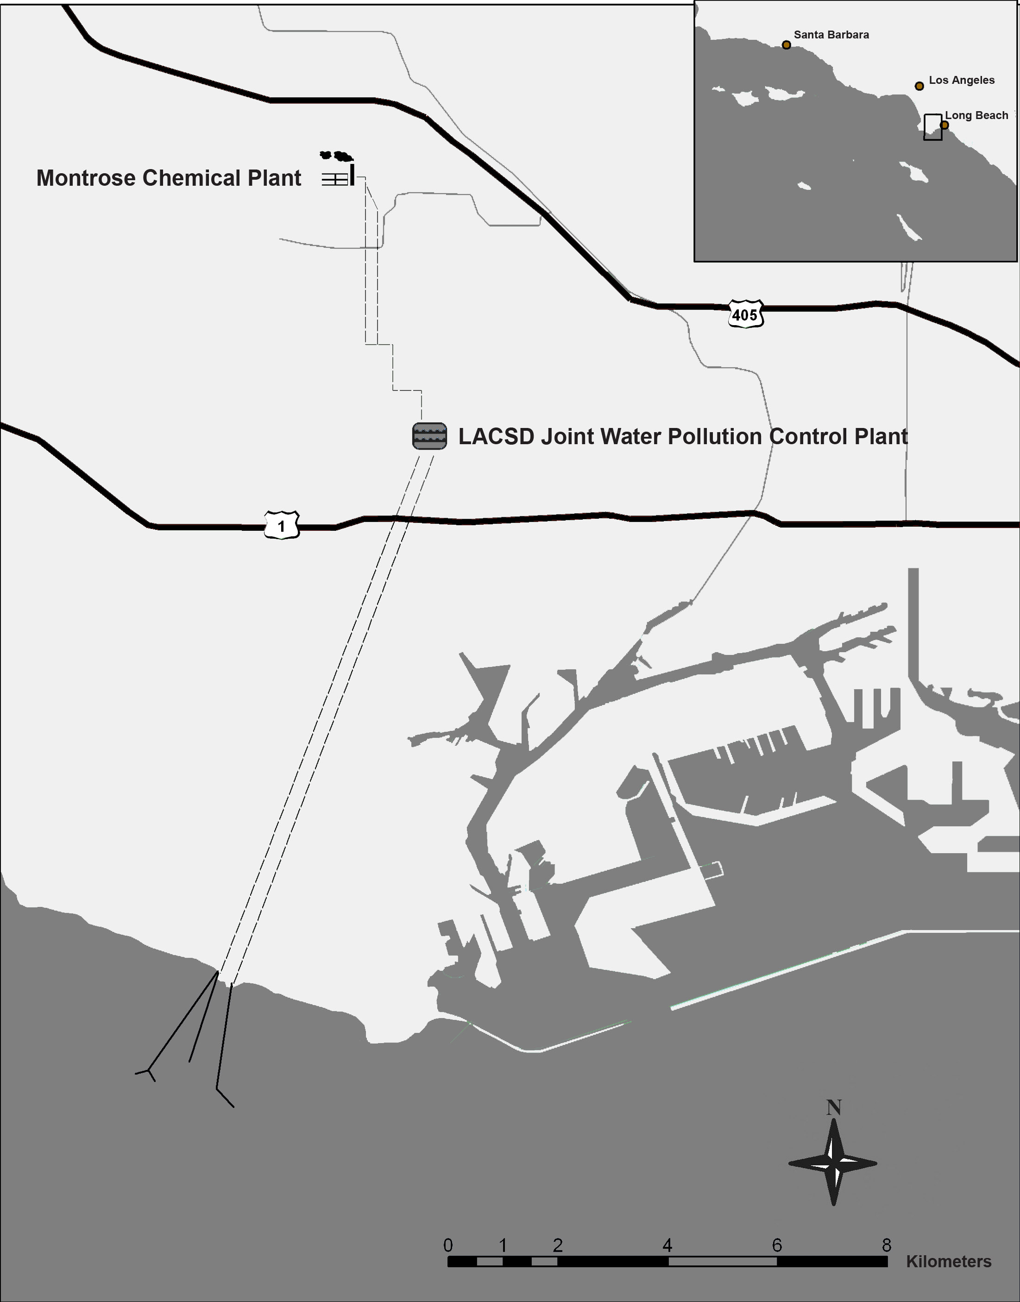
Figure 2-1. Location of Montrose plant, LACSD Joint Water Pollution Control Plant, and outfalls.
manufactured DDTs from 1947 to 1982. It was the only producer of DDTs in Southern California, and for much of that time it was the largest manufacturer of DDTs in the United States (NOAA et al. 1991). Although the sale of DDTs was banned in the United States in 1972, the Montrose facility continued to manufacture DDTs for export until 1982, when the plant was closed and its facilities dismantled (Metcalf and Eddy 1986, NOAA et al. 1991).
The Montrose plant’s discharge was permitted by the City of Los Angeles. The releases of industrial waste containing DDTs from the Montrose plant entered the LACSD sewer collection system, which discharged the contaminants through the LACSD Joint Water Pollution Control Plant (JWPCP) outfalls offshore of White Point beginning in 1953. In the late 1960s and early 1970s, LACSD conducted an investigation of sources of DDTs and PCBs that were entering the sewer system. LACSD identified the Montrose facility as the sole major source of DDTs to its sewer system, and estimated that the discharge from the Montrose plant was contributing 654 pounds (about 300 kilograms) of DDTs per day to the LACSD system (Summers et al. 1988). Chartrand et al. (1985) estimated that 1,800 metric tons (about 2,000 U.S. tons) of DDTs were discharged from these outfalls into the Southern California Bight from 1953 to 1970.
Although the Montrose facility stopped discharging to the LACSD sewer system in 1971, when its permit was revoked, residual DDTs remained in the sewer system and outfalls for some time thereafter. Annual mass emissions of residual DDTs from the outfall pipes decreased rapidly from 10 metric tons (11 U.S. tons) in 1971 to 1 metric ton (1.1 U.S. ton) in 1974 and then more gradually to 0.2 metric tons (0.22 U.S. tons) in 1984 (NOAA et al. 1991). Similarly, DDT concentrations dropped from 45 parts per billion (ppb) in 1971 to about 3 ppb in 1974, and were near zero after 1984 (LACSD 2002) (Figure 2-2).
To provide a perspective on the magnitude of the Montrose DDT discharges, MacGregor (1974) compared the Montrose DDT discharges to other estimates of organochlorine (pesticide) discharges into the marine environment and found that the amount discharged annually from the JWPCP outfall into the SCB in the late 1960s was about 10 times the amount of chlorinated pesticides estimated to be carried into the Gulf of Mexico each year by the Mississippi River at that time.
In addition to discharges from the JWPCP outfalls, DDTs were also released to the SCB through direct ocean dumping of acid sludge that originated from the Montrose facility. It is estimated that between 1947 and 1961, acid sludge containing 350 to 700 metric tons of DDTs were dumped into the San Pedro Basin off of Santa Catalina Island by the California Salvage Company (Chartrand et al. 1985, MBC 1988). The barrels were punctured at sea to make them sink; this procedure undoubtedly released large amounts of DDTs to surface waters (NOAA et al. 1991). The locations of the two dump sites are shown on Figure 2-3.
DDTs were also released from the contaminated soils and facilities at the Montrose plant through release of DDT dust generated by plant activities. An estimated 1.3 metric tons (1.4 U.S. tons) of DDTs were deposited by atmospheric transport into the coastal ocean waters off of Southern California during 1973–1974 (Young et al. 1976). DDTs were also released from the Montrose plant through surface water runoff. Contaminated surface waters collected from the site were transported via storm drains into the Dominguez Channel and from there into the Consolidated Slip in Los Angeles Harbor.
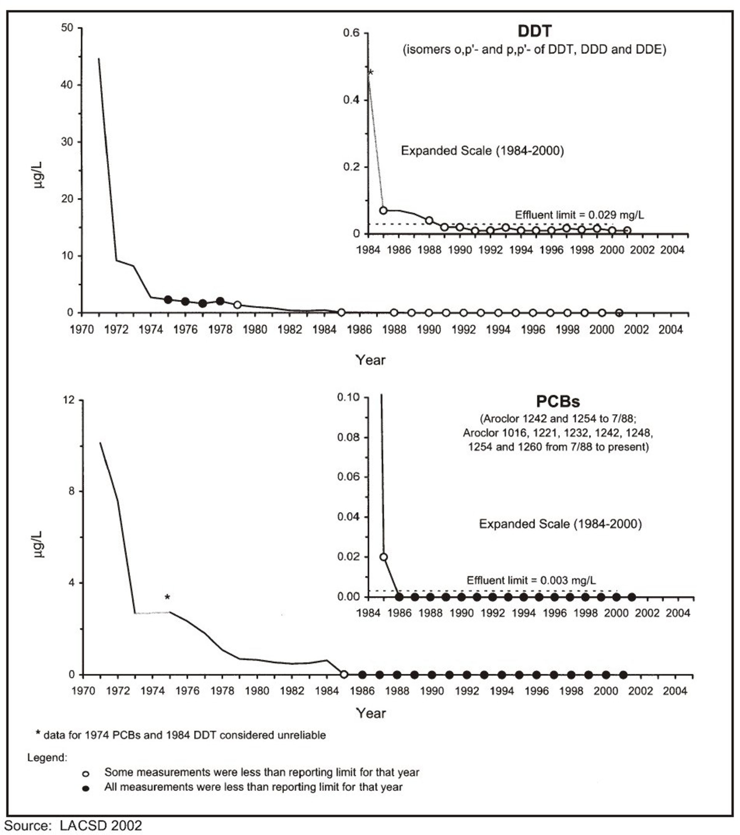
Figure 2-2. Concentrations of effluent constituents discharged to the ocean
off Palos Verdes, 1971–2001.
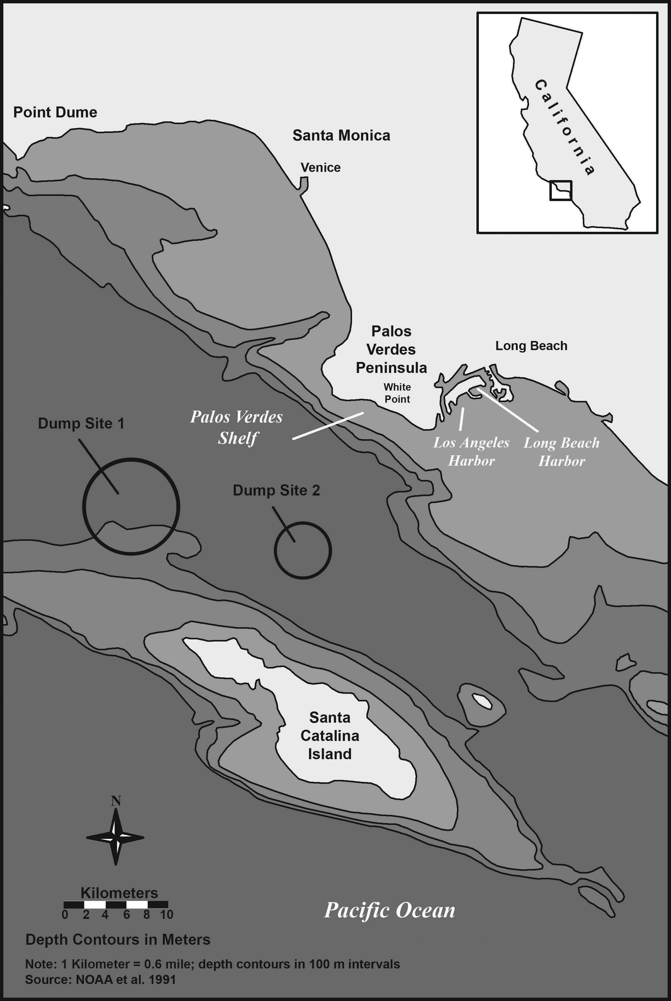
Figure 2-3. Palos Verdes Shelf, Los Angeles Harbor, Long Beach Harbor, and
Dump Sites 1 & 2

PCBs
PCBs have been found in the Southern California marine environment since the late 1930s, with peak inputs into the SCB from 1965 to 1970 (Horn et al. 1974, Mearns et al. 1988). Similar to DDTs, PCBs were released by discharge through municipal wastewater outfalls, surface runoff, and atmospheric transport. PCB contamination was also documented at Dump Sites 1 and 2, but the specific PCB sources for the dump sites have not been identified (Lyons 1989, NOAA et al. 1991) (Figure 2-3).
The LACSD wastewater outfalls on the Palos Verdes Shelf were the principal sources of releases of PCBs to the SCB (Young and Heeson 1980, NOAA et al. 1991). Concentrations of PCBs in the effluent from LACSD’s JWPCP reached 10 ppb by 1971 (LACSD 2001), with annual mass emissions in 1972 exceeding 116 metric tons (NOAA et al. 1991). There were numerous sources for the PCBs in the LACSD system during this period. In the late 1970s LACSD identified 16 industries as potential sources of PCBs. Significant sources included a Westinghouse Electric Company maintenance and repair facility in Dominguez Hills, and a Potlatch Corporation paper manufacturing plant in Pomona (NOAA et al. 1991).

Distribution of DDTs and PCBs in the Sediments of the Study Area
The sediments and sediment-associated biota of the Palos Verdes Shelf and surrounding region have been the subject of intense investigations by the Southern California Coastal Water Research Project, the LACSD, the U.S. Geological Survey (USGS), and others. Numerous past studies have shown that sediment and organism concentrations of DDTs and PCBs in the SCB have been among the highest ever reported for any coastal marine ecosystem (USEPA 2003).
As indicated in Figure 2-2, ongoing releases of DDTs and PCBs to the marine environment from the LACSD outfalls at White Point had declined dramatically in the 1980s and were virtually non-existent by the 1990s. Subsequent less-contaminated discharges from the White Point outfalls have placed cleaner effluent-affected sediment above the highly contaminated effluent-affected deposit; however, biological, chemical, and physical processes have modified and partly mixed the sediment, bringing contaminants from the deeper part of the effluent-affected deposit into the surface layers. These processes continue to occur even today (Lee and Wiberg 2002).
The spatial and depth distributions of DDTs and PCBs in shelf and slope sediments were extensively evaluated by the USGS, initially as part of the Trustees’ investigations for the natural resource damage assessment in the 1990s. Sediment data collected by USGS and LACSD provide the most complete coverage of the study area through 2001. The effluent-affected sediment deposit is most contaminated 20–30 centimeters (cm) (8–12 inches) below the sediment surface. This highly contaminated layer of the deposit, with concentrations of DDE (a metabolite, or breakdown, product of DDT) exceeding 10–100 parts per million (ppm), likely dates to the 1950s and 1960s, when the DDT manufacturer was discharging to the sewer system (Lee and Wiberg 2002). The overlying sediment, although less contaminated, still has widely distributed concentrations of DDE exceeding 1 ppm (Figure 2-4). Biological and physical mixing processes have likely combined older, more contaminated sediment with younger material to produce the surface layer. The results of USGS analysis of the temporal history of contamination levels at three locations on the Palos Verdes Shelf show that surface concentrations and total mass of DDE have remained
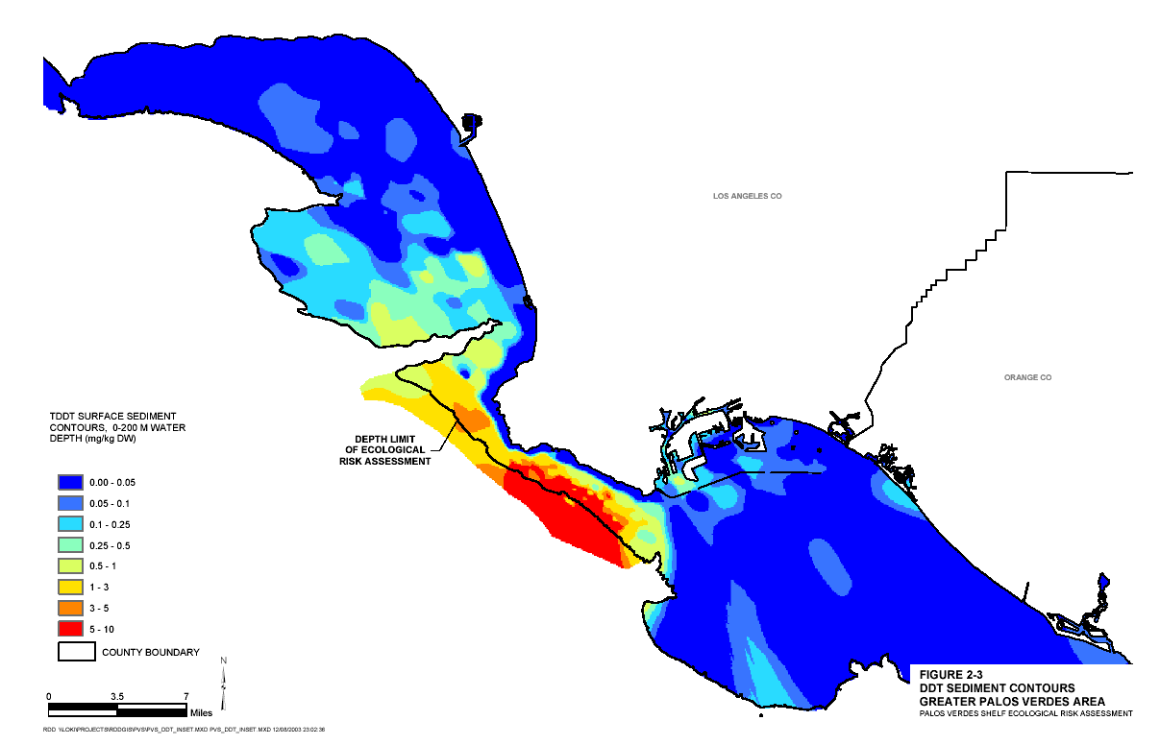
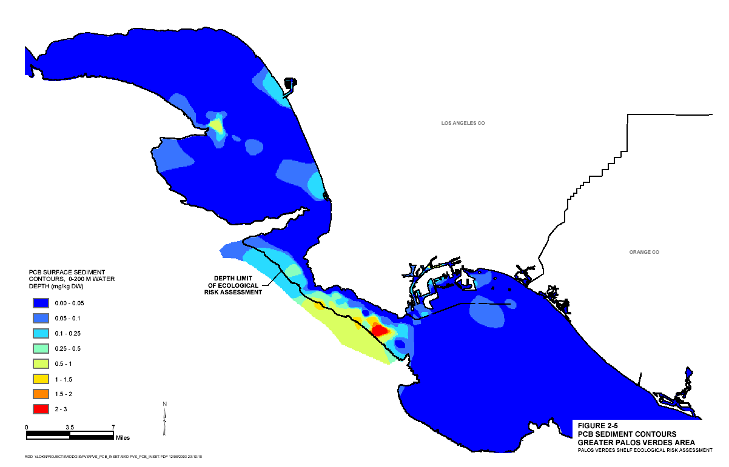
Figure 2-4. Distribution of DDTs and PCBs in surface sediments in and
beyond the Palos Verdes Shelf.
Note: Distribution of DDTs and PCBs in surface (0–15 cm [0–6 inches]) sediments in and beyond the Palos Verdes Shelf region (USEPA 2003); the line representing the depth limit of the ecological risk assessment corresponds to a depth of 200 meters (660 feet).
(Back of Figure 2-4)
almost unchanged over the last 20 years at stations nearest the outfall, although both quantities appear to be decreasing at the more distant location studied (Lee et al. 2002).
Additional U.S. Environmental Protection Agency (EPA) evaluation of contaminant concentration data in horizons across the uppermost 15 cm (6 inches) of sediment shows a strong relationship between concentrations in the surface and the deeper, more contaminated sediments, reflecting the fact that contaminants at depth are being remobilized to the surface (USEPA 2003). The mixed surface sediment layer represents the biologically active zone, that portion of the sediment where benthic (bottom) organisms are most abundant and where the greatest likelihood exists for exposure of benthic organisms and contaminant transfer up the food web. As part of its comprehensive evaluation of sediment and biological data trends for the ecological risk assessment, the EPA (2003) reported that within the Palos Verdes shelf study area, concentrations of DDTs and PCBs in surface sediments and tissues of marine organisms have decreased since the 1970s but have generally leveled off since the mid 1980s.
Transport of re-suspended sediments is considered an important process because contaminants such as DDTs and PCBs have strong affinities for particles. Thus, physical transport of sediments also results in dispersion of associated contaminants. In general, the most important processes governing the distribution and transport of sediment contaminants in the area appear to be a complex pattern of burial of older deposits by cleaner surface sediments, coupled with resuspension and desorption of contaminants, and redeposition of sediments and contaminants following the predominant currents northwestward along the continental shelf.
USGS researchers have also studied the processes that modify the seabed on the Palos Verdes shelf. Analysis of box-core samples of the seabed collected during field studies in the 1990s provided information about the physical and chemical properties of the sediment, biological mixing rates, and depositional history. Sherwood et al. (2002) developed a model to predict the evolution of DDE concentrations. Model predictions extending to 2050 indicate that most of the DDE present along the 60-meter depth northwest of the White Point outfall will remain buried and that surface concentrations will decrease slowly. The model also suggests that erosion near the southeast edge of the effluent-affected deposit is likely to reintroduce buried DDE into surface sediment and across the sediment-water interface.
As part of their ecological risk assessment, the EPA (2003) evaluated previous and more recent investigations of sediment contamination for trends in contaminant concentrations and distribution. Consistent with USGS findings, the EPA found that generally, concentrations of DDTs in surface layer sediment appear to be relatively constant as represented by the LACSD cores collected between 1991 and 2001.
Studies dealing with the Palos Verdes shelf region show a complex environment that is significantly impacted by anthropogenic processes. The studies also show that this area has partly recovered from the extremely high levels of contamination present in the early 1970s but that relatively high levels of contamination remain and continue to impact a number of animal species. Finally, models indicate that natural recovery will proceed slowly (Lee and Wiberg 2002).

The Damage Assessment and Determinations of Injuries to Natural Resources
In 1990, six federal and State of California agencies signed a Memorandum of Agreement (MOA) forming a Co-Trustee Advisory Panel to pursue the Montrose damage assessment case. The following year the Trustees modified the MOA, and the Advisory Panel formally became known as the Southern California Marine Environment Trustee Council. The council, now known as the Montrose Trustee Council (referred to throughout this document as the “Trustees”) had responsibility for coordinating all damage assessment activities. The state and federal agencies that compose the Trustees are:
- The California Department of Fish and Game
- The California Department of Parks and Recreation
- The California State Lands Commission
- The U.S. Fish and Wildlife Service
- The National Park Service
- The National Oceanic and Atmospheric Administration
In 1991, the Trustees issued a Draft Injury Determination Plan (NOAA et al. 1991), which was the culmination of months of work by technical working groups formed to closely examine potential injuries to natural resources. The plan was circulated for public comment, and based on the comments received (including comments from the defendants in the litigation) the Trustees approved an assessment plan for approximately 60 studies, including injury studies across several areas, such as bioaccumulation in fish tissues, benthic community alteration, and reproductive impairment in fish, birds, and marine mammals. The Trustees also conducted valuation and restoration planning studies.
Given the widespread contamination and long-term occurrence of DDTs and PCBs throughout the ecosystem, the Trustees selected resources and injuries that they felt were representative, rather than inclusive, of the potential injuries caused by the release of the contaminants. The Trustees’ studies of potential biological injuries are summarized below.

Sediment
Under the Comprehensive Environmental Response, Compensation, and Liability Act (CERCLA) damage assessment regulations, the sea floor sediments are defined as being injured if they are contaminated to a level that causes injury to a biological resource (Title 43 Code of Federal Regulations [CFR] Section 11.62(b)(v)). Large areas (20 square miles [52 square kilometers] or more) of the Palos Verdes Shelf and slope were known to possess surface sediment concentrations of DDTs and PCBs in excess of concentrations that could cause injury to benthic organisms. Much higher concentrations, hundreds of times higher, resided only 12 to 18 inches below the sediment-water interface due to deposition.
Based on the public comments, the Trustees decided to try to isolate any effects of DDTs and/or PCBs on benthic organisms from the potential effects of the numerous other contaminants that co-occurred with the DDTs and PCBs. To accomplish this goal, the Trustees commissioned a two-tiered study. The first tier involved toxicity testing of sediments collected from the Palos Verdes Shelf to determine the combined toxicity of all contaminants in the sediments. The second tier involved toxicity testing of clean sediments spiked only with DDTs and PCBs to isolate the effects of these contaminants. Some of the tests showed acute mortality in spiked sediment exposures but not from the field-collected sediments, and one test showed a reduction in reproductive output of the test organism; however, other tests did not meet quality control standards and were deemed unreliable because of high mortality among the control animals (i.e., too many animals died during the test that were not exposed to the test contaminants).
The Trustees also commissioned a “weight-of-evidence” analysis of sediment toxicity that used already-published results rather than gathering new field or laboratory data. This type of analysis is a standard approach for sediment toxicity evaluation. The weight-of-evidence analysis concluded that the concentrations of DDTs and PCBs in the sediments of the Palos Verdes Shelf are sufficient to cause toxicity to benthic organisms.

Fish Reproduction
Under the CERCLA regulations for natural resource damage assessment, injury to a biological resource occurs when a statistically significant difference in reproductive success between control organisms and test organisms can be measured (43 CFR 11.62(f)(4)(v)(E)). Reduced spawning rate, lowered number of eggs per spawn, diminished fertilization rate, and increased early loss of eggs were all reported by Hose et al. (1989) as being associated with exposure of white croaker and kelp bass to contaminants in San Pedro Bay. These investigators suggested that white croaker with ovarian DDT concentrations greater than 4 ppm wet weight could not spawn.
Concentrations of DDTs and PCBs in fish were lower in the early 1990s, when the Trustees commissioned the studies, than they had been in the early 1980s. However, the rate of decline in concentrations had leveled off, and there was no evidence that the downward trend was continuing. This leveling meant that past improvements in DDT and PCB concentrations in fish could not be expected to continue into the future, and that current conditions might continue indefinitely. The existing DDT and PCB concentrations in fish ovaries were near or exceeding the 4 ppm threshold that local researchers had suggested for reproductive impairment. In addition to evaluating the possibility of reproductive impairment in fish during the 1990s, the Trustees evaluated whether reproductive impairment had occurred at any time after the passage of CERCLA in 1980. This evaluation included a time when DDT and PCB concentrations in fish were elevated high above the levels that existed in 1992.
The Trustees commissioned a study that included the evaluation of both field-collected fish and laboratory-dosed fish. This approach allowed an assessment of effects in the field as well as under controlled laboratory dosing to provide a rigorous test for a causal relationship between exposure to DDTs and PCBs and reproductive effects, if any. Kelp bass was selected as the test species. The study also included work to evaluate the physiological response of the fish and hormone binding mechanisms to allow an understanding of the mechanisms of toxicity.
The fish collected from the field did not show the anticipated difference from the laboratory-dosed fish in body burdens of DDTs and PCBs. Thus, this part of the investigation provided no information on the effects of contaminant exposure. The laboratory exposures also failed to provide a valid test of contaminant effects because confounding factors made it difficult to isolate the effects of the contaminants. The results of the fish studies were inconclusive, neither proving nor disproving that reproductive impairment was caused by the DDTs and/or the PCBs.

Birds
The Trustees investigated potential injuries to several bird species that inhabit the Southern California marine environment. Two species in particular, the bald eagle and the peregrine falcon, received special focus because they, as top predators, are especially vulnerable to the effects of contaminants such as DDTs and PCBs (which are magnified at higher levels in the food web).
Bald eagles were a resident breeding species on all of the California Channel Islands from before the turn of the century (Kiff 1980). Kiff (2000) reports evidence that bald eagles nested on Santa Catalina, Anacapa, Santa Cruz, and Santa Rosa Islands, and probably San Nicolas Island, until at least the 1950s. From the late 1800s to 1960, active or remnant nests of bald eagles were reported at a minimum of 35 different locations on the islands, making the Channel Islands a stronghold for this species in Southern California (Kiff 2000). The last confirmed nesting of an eagle on the Channel Islands was in 1949 on Anacapa Island (Kiff 1980). By the early 1960s, bald eagles had disappeared from all of the Channel Islands. Efforts were initiated in 1980 to reintroduce bald eagles on Santa Catalina Island; however, the reintroduced bald eagles experienced reproductive failure. The bald eagles on Santa Catalina Island continue to this day to exhibit reproductive injury and are not self-sustaining (see Appendix B).
The peregrine falcon is one of five falcon species that occur in California. Peregrine falcons in California prey almost exclusively on smaller birds of aquatic and terrestrial ecosystems. Peregrine falcons were relatively common throughout California in the early 1900s and were part of Native American history and culture. Kiff (1980) and Hunt (1994) present evidence for 15 documented pairs of peregrines on the California Channel Islands during the first half of the century and estimate that between 20 and 30 pairs nested on the Channel Islands prior to 1945. The population of peregrine falcons on the Channel Islands was eliminated between the mid-1940s and the early 1960s due to shooting, harvest for falconry, egg collecting, and DDT contamination (Kiff 2000). In the mid 1980s, efforts were initiated to reintroduce peregrine falcons to the Northern Channel Islands. These efforts have increased the number of pairs of peregrine falcons on the Channel Islands, and even though peregrine falcons now appear to be self-sustaining on the Northern Channel Islands, they have not fully recovered to historical levels throughout the Channel Islands.
The Trustees were concerned about two types of bird injury specified in the CERCLA regulations for natural resource damage assessment. First, the regulations define eggshell thinning in birds as an injury if the current eggshells are more than 15 percent thinner than pre-DDT era eggshells (43 CFR 11.62(f)(4)(v)(A)). The regulations also make specific mention of eggshell thinning injury in cases where birds have been exposed to DDTs. Second, any type of avian reproductive impairment that causes a reduction in the mean number of fledglings per nest is defined as an injury according to 43 CFR 11.62(f)(4)(v)(B).
It is generally accepted that DDTs cause eggshell thinning in birds (Hickey and Anderson 1968, Risebrough et al. 1971, Lundholm 1997). Strong correlations have been reported between concentrations of DDTs and eggshell thinning in seven families of birds, including pelicans, cormorants, herons, ducks, eagles, falcons, and gulls. Eggshell thinning has also been experimentally induced in three families of birds. When the use of DDT was banned in the United States, severely affected species such as the pelicans, ospreys, and eagles recovered in most areas of the country. In addition, geographical patterns of eggshell thinning across the United States are consistent with the locations of high environmental concentrations of DDTs. The final piece of evidence supporting the connection between DDTs and eggshell thinning is that attempts to experimentally induce eggshell thinning with other compounds such as PCBs, dieldrin, mercury, and lead have failed at concentrations of these compounds typically found in the environment.
Prior to commissioning their own studies, the Trustees reviewed data showing that the eggshells of certain SCB seabirds (e.g., California brown pelicans, double-crested cormorants, Brandt’s cormorants, and western gulls) collected in the late 1960s were more than 15 percent thinner than eggshells collected during the pre-DDT era. In addition, eggshell abnormalities that had been shown to be consistent with the effects of DDTs were documented in two federally listed endangered species (the bald eagle and the light-footed clapper rail) for the SCB. PCBs were also known to cause other types of effects that could have reproductive consequences. These effects included toxicity to embryos in the egg and abnormalities in adult breeding behavior that could prevent effective reproduction.
High concentrations of DDTs and PCBs had been reported in the prey of Southern California bird species as well as in the birds and eggs themselves. Severe population reductions in several species of birds in the SCB began to be observed shortly after the start of DDT discharge into the SCB from the JWPCP outfalls and ocean dumping. The peregrine falcon disappeared from the Channel Islands by 1955, the bald eagle was extirpated from the Channel Islands by the early 1960s, the California brown pelican was driven to near extinction in the 1970s, and the double-crested cormorant population declined severely during the 1960s and 1970s. Releases of DDTs and PCBs from the LACSD outfall declined dramatically beginning in the early 1970s. By 1980, when Congress passed CERCLA, the California brown pelican and double-crested cormorant populations in Southern California were recovering. In contrast, neither the bald eagle nor the peregrine falcon had returned to the Channel Islands, even though both of these species were beginning to repopulate their historical ranges across the United States and worldwide.
Faced with the facts outlined above, the Trustees decided in the early 1990s that it was necessary to determine whether injuries to bird species in the SCB had been caused by and were continuing because of exposure to DDT and/or PCBs.
The Trustees commissioned a suite of studies consisting of investigations of (1) the organochlorine (i.e., DDTs and PCBs) contamination levels, reproductive success, and food habits of the bald eagles recently introduced onto Santa Catalina Island; (2) the organochlorine contamination levels, the reproductive success, and food habits of the peregrine falcons recently reintroduced to the Northern Channel Islands; (3) the long-term consequences of reduced reproduction on the populations of bald eagles and peregrine falcons; (4) eggshell thinning and organochlorine contamination levels in seabirds of the Channel Islands and comparatively in seabirds from along the west coast of North America; (5) the reproductive output of brown pelicans and double-crested cormorants in the SCB; and (6) a summary of effects of DDTs and PCBs on the birds of the SCB.
After considering the results of the commissioned bird studies and the interpretations of the Trustees’ experts, the Trustees drew the following conclusions:
- As a result of the elevated levels of DDTs in the marine environment of the SCB, the eggshells of bald eagles and peregrine falcons have become so thin and/or otherwise so abnormal that reproduction of these bird species has been severely disrupted or has not occurred, since as early as the late 1940s. To this day, bald eagles on Santa Catalina Island continue to demonstrate reproductive failure.
- Because bald eagles and peregrine falcons are the top predators in their respective food webs, and because metabolites of DDT are magnified in their prey species, bald eagles and peregrine falcons are more severely affected than other species by the presence of DDTs in the marine environment.
- Many seabird species, including the California brown pelican and the double-crested cormorant, were severely impacted in the past by the discharges of DDTs to the coastal waters of the SCB. However, the populations of these seabird species are generally recovering due to improved reproductive success since Montrose was stopped from discharging these contaminants into the LACSD system. For these other bird species, there was not conclusive evidence that reproductive problems meeting the definition of “injuries” within the CERCLA regulations were continuing.

Marine Mammals
Under the CERCLA regulations for natural resource damage assessment, both impaired reproductive capability and reduced immune response are considered injuries. A broad base of toxicological literature shows that compounds like DDTs and PCBs are capable of causing these types of effects (NOAA et al. 1991). Studies conducted in the 1970s in the SCB demonstrated an association between California sea lion females delivering non-viable premature pups and high concentrations of DDTs and PCBs (NOAA et al. 1991).
The vast majority of the marine mammal portion of the damage assessment was dedicated to investigating injury in California sea lions, a species that reproduces and resides at certain times on the Channel Islands. A comprehensive field study was undertaken to evaluate rates of premature pupping, rates of early life mortality, immune response, physiology, and contaminant body burdens in sea lions on San Miguel Island. In the final analysis, it was not possible to draw a cause and effect linkage between adverse effects on California sea lions and exposure to DDTs or PCBs. The Trustees decided not to put the work forward as part of the case because the causal linkage could not be established.
An important outcome of the work on marine mammals was the discovery that marine mammal carcasses, and probably placentas, are significant routes of DDT and PCB transfer through the food web. For example, marine mammal carcasses are eaten directly by bald eagles, and the carcasses and placenta of marine mammals are consumed by western gulls, which are subsequently preyed on by bald eagles and peregrine falcons. Contaminant concentrations in marine mammals may be so high that a small amount of consumption by a bird can represent a very large dose of contaminant.

Summary of Natural Resource Injury Findings
Based on the careful process undertaken by the Trustees, the information available, and the results of the studies commissioned as part of the damage assessment, the Trustees concluded that the following natural resource injuries had been occurring since before 1981 and were continuing to occur as a result of the historical releases of DDTs and PCBs at issue in the case:
- Water and Sediment Quality. The concentrations of DDTs found in the water column over the Palos Verdes Shelf exceeded the standards established by the State of California in the California Ocean Plan. The highest concentrations of DDTs occurred near the sediments; concentrations were lower near the water surface. This characteristic indicated that the source of the unacceptable concentrations of DDT in the water column was the contaminated sediments, representing a per se injury under the CERCLA regulations for damage assessment. The sediments of the Palos Verdes Shelf could not provide the full range of functions normally performed by ocean floor sediments. Palos Verdes Shelf sediments in the effluent-affected layer carried quantities and concentrations of DDTs sufficient to trigger the fishing closure and advisories mentioned above. Pathway studies showed that these sediments and the contamination passed on through fish into the Palos Verdes Shelf food web were also the ultimate route of exposure to injured species of birds.
- Fishing. Kelp bass, white croaker, and other species of fish collected from numerous locations in the study area were carrying concentrations of DDTs in edible tissues that exceeded the guidelines and standards set by both federal and state agencies for safe consumption. A commercial closure for white croaker and recreational advisories for kelp bass, white croaker, black croaker, California scorpion fish, California corbina, queenfish, and several species of rockfishes and surfperches had been issued by the State of California. This injury represented a loss of natural resource value to the public and a per se injury under the CERCLA regulations for damage assessment. The human use values of these fish resources, namely the public’s ability to catch and eat clean fish, continued to be harmed by the contamination.
- Bald Eagles. The Channel Islands (in particular, Santa Catalina Island) did not support a naturally reproducing population of bald eagles, as existed before the DDT releases. This injury was known because the bald eagles introduced onto Santa Catalina Island accumulated DDT at high concentrations and produced eggs that were structurally incapable of supporting the embryo without human intervention. Also, bald eagles had not yet returned to the other Channel Islands.
- Peregrine Falcons. The peregrine falcons reintroduced to the Northern Channel Islands had eggshells in 1992–1993 that were more than 15 percent thinner than peregrine eggshells from the pre-DDT era (Hunt 1994, Kiff 1994). The level of eggshell thinning found in peregrine falcons in the Northern Channel Islands was sufficient to affect the ability of the population to sustain itself. Also, peregrine falcons had not yet re-populated the Southern Channel Islands.
The Trustees therefore focused their efforts on obtaining damages for these ongoing injuries, with the goal of restoring these resources and their services to their baseline conditions (i.e., the conditions they would be in had the DDTs and PCBs never been released). In addition to seeking damages for ongoing injuries, the CERCLA regulatory framework provides for compensatory damages (i.e., damages to compensate the public for lost uses of resources during the period when they are below their baseline conditions). Targets for compensatory restoration actions may include certain resources that the evidence shows sustained past injuries from the DDTs and PCBs at issue in this case. The following resources in particular fall into this category:
- Fish. Concentrations of DDTs and PCBs in fish were lower in the 1990s, when the Trustees undertook fish injury studies, than they had been in the early 1980s, when a body of toxicological literature indicated that fish were being harmed by concentrations of these contaminants found in the Southern California coastal environment. Specifically, Hose et al. (1989) suggested an observed DDT concentration in ovaries associated with failures to spawn. Although the Trustee efforts to demonstrate that injuries were occurring and had occurred after the authorization of CERCLA were not conclusive, the Trustees consider fish and their habitats to be an appropriate target for compensatory restoration actions.
- Seabirds. As stated previously, many seabird species, including the California brown pelican and the double-crested cormorant, suffered dramatic declines in their populations as a result of the reproductive abnormalities caused by exposures to DDTs. Although the evidence is not conclusive regarding continuing injuries to these birds on the scale of the continuing injuries to bald eagles, the Trustees consider seabirds and their habitats to be an appropriate recipient for restoration actions. As a result of studies conducted by Fry (1994) and Kiff (1994), the Trustees have focused on those restoration projects that target seabirds that have demonstrated severe or significant eggshell thinning and/or seabirds whose DDT egg residues were significantly elevated in their colonies of the Southern California Bight. According to the data from these studies, the following seabirds are priority species for restoration: the double-crested cormorant, Brandt’s cormorant, the California brown pelican, the western gull, the ashy storm-petrel, Cassin’s auklet, the pelagic cormorant, and the pigeon guillemot. See Section 5.1.1 for a summary of the results of the seabird studies.
Through the natural resource damage assessment process as well as the litigation and settlements described in Section 2.4, the Trustees sought damages to fund restoration projects that are directly related to the injuries outlined above.

Litigation and Settlements
Following the preliminary investigations by NOAA mentioned at the beginning of this section, the United States and the State of California (the governments), on behalf of the Trustees and the EPA, filed a complaint in federal district court in Los Angeles in June 1990 against eight defendants. The complaint stated two claims under CERCLA. The first concerned the recovery of costs incurred by the United States in response to the release or threatened release of hazardous substances from the Montrose facility (upland site). The second sought declaratory relief and the recovery of response costs and damages for injury to natural resources in the areas offshore of Los Angeles and Long Beach, including the Palos Verdes Shelf, the Channel Islands, and the surrounding environment (offshore area) as the result of the release of hazardous substances. The complaint summarized the natural resource injuries to include fish, birds, and marine mammals. Almost immediately, the governments amended the complaint to add a ninth defendant: the LACSD, a publicly owned treatment works composed of fifteen local sanitation districts in Los Angeles County.
After the governments filed the complaint, the Trustees developed detailed injury study plans and implemented numerous studies over the next three and a half years. The studies covered nine categories. Complying with a court-ordered deadline, in October 1994 the governments produced 28 expert reports and designated 84 witnesses. The district court established a schedule for the defendants to question (depose) the governments’ witnesses and to provide their own expert reports and for the governments to question the defendants’ experts. This expert testimony occurred prior to trial.
Scarcely had the depositions of the governments’ experts commenced when the district court granted the defendants’ motion to dismiss the natural resource damage claim on the ground that the governments had filed the claim too late. The governments appealed this ruling successfully, and two years later, in mid-1997, the district court reinstated the natural resource damage claim. During the appeal process, an important event occurred: the EPA decided to expand its investigation to include the Palos Verdes Shelf.
Prior to this event, the Trustees had included restoration of the contaminated sediments on the Palos Verdes Shelf in their claim as primary restoration. This development changed the complexion of the case. Because the EPA now assumed responsibility for any response activity that might be conducted for the contaminated sediments on the Palos Verdes Shelf, the EPA’s response costs claim increased, and the Trustees’ claim for damages decreased, as the Trustees were no longer considering primary restoration for the contaminated sediments. With the EPA now addressing that aspect of the case, the Trustees narrowed their focus to the injured birds, fish, the lost use of the injured resources, and the restoration necessary to address those injuries.
The reinstatement of the case initiated two years of depositions of the governments’ experts by the defendants. In early 2000, the district court judge newly assigned to the litigation accelerated the pace of the case. That judge ordered the defendants to produce their expert reports within two months and allowed the governments only six weeks to depose the defendants’ experts. The judge set trial for early October 2000.
During the course of the litigation and prior to trial, the governments reached five settlements with three sets of defendants: two with Potlatch and Simpson, two with LACSD and other local governmental entities; and one with CBS Corp. (formerly Westinghouse). These settlements left four defendants. The settlements totaled $67.2 million for the EPA and the Trustees.
Trial began on October 17, 2000. While the trial was ongoing, the governments and the remaining four defendants reached settlement. The final settlement provided $73 million for the EPA and the Trustees. Appendix F contains a summary of the Montrose settlements and how the recoveries were divided between the EPA and the Trustees. The total principal amount paid to the federal government and the state government from all settlements combined was $140.2 million.

Limitations on Uses of Settlement Funds for Natural Resource Restoration
After considering the results of the damage assessment efforts, the Trustees determined that the following general categories of restoration actions meet the provisions of the settlement agreements and the relevant federal rules governing natural resource damage assessment and restoration (43 CFR Part 11):
- Actions that restore the public’s ability to fish for clean fish in the marine waters of the SCB.
- Actions that restore bald eagles and peregrine falcons to the Channel Islands.
- Actions that compensate the public for interim losses of these resources and services, and that restore interim losses of the seabirds and fish for which there is evidence of past injuries from exposures to the DDTs and PCBs at issue in this case.
Section 4 of this Restoration Plan describes the restoration goals and objectives as well as the strategies and planning process developed with public consultation.

The depth stratification for biological activity in the study area results in sediment layers with varying mixing rates. The surface layer (0-15 cm) is referred to by EPA as the complete mixing layer, in which sediment mixing largely occurs. The next layer (15-30 cm), experiences periodic mixing by deep burrowing organisms although rates are expected to be lower than in the top 15 cm (EPA 2003).
There is evidence that eggshell thinning occurred in California brown pelicans several years before it was first observed in 1969, because museum eggs collected from Anacapa Island in 1962 were found to be 26 percent thinner than eggs collected prior to 1946 (Anderson and Hickey 1970). Gress (1994) reported that the mean thickness of California brown pelican eggshells from the period 1986–1990 was 4.6 percent thinner than the pre-1947 mean (i.e., less than the regulatory definition of injury). Kiff (1994) further reports that 1992 California brown pelican eggs from Anacapa Island (18 eggs collected) was 3.6 percent thinner than the pre-1947 mean .
The Trustees deferred to response actions by the U.S. Environmental Protection Agency to address these injuries, and thus did not specifically seek natural resource damages to restore water and sediment quality.
See Appendix E for a timeline of the natural resource damage assessment and litigation.
The defendants were Montrose Chemical Corp. of California; Atkemix Thirty-Seven, Inc.; Stauffer Management Company; ICI American Holdings, Inc.; Chris-Craft Industries, Inc.; Westinghouse Electric Corp.; Potlatch Corp.; and Simpson Paper Company.
The governments alleged that LACSD had transported the hazardous substances through its sewer system to the Palos Verdes Shelf - a violation of CERCLA.
Those categories were (1) distribution and character of the contaminated sediments; (2) foodweb/pathway; (3) injury to sediments; (4) injury to fish; (5) injury to birds; (6) natural recovery of the contaminated sediments; (7) feasibility of sediment restoration alternatives; (8) biological restoration alternatives; and (9) prospective interim lost use value. In addition, the Trustees developed a quality assurance program, a data report and a natural resource damage assessment cost report.
Previously, EPA had focused its efforts on the upland site and its surrounding area.
Due to EPA’s decision to begin response actions related to the Palos Verdes Shelf, the parties amended the original consent decrees with Potlatch and Simpson and LACSD and the local governmental entities to address the changed role of EPA.
The defendants named the 140+ local governmental entities as third party defendants. These entities were the municipalities that owned and operated sewage collection or storm water conveyance systems that discharged into the ocean.
The governments had dropped one defendant from the case prior to the beginning of the trial. The remaining defendants were Montrose Chemical Corp. of California; Atkemix Thirty-Seven, Inc.; Aventis Cropscience USA, Inc. (formerly Rhone-Poulenc Inc., and corporate successor to Stauffer Chemical Company); and Chris-Craft Industries, Inc.

