CONCEPT: Understanding and Preventing Sexual and Racial Discrimination

APROXIMATE TIME: 1 Hour

OBJECTIVES:
1. Understand the definition of Sexual and Racial Discrimination
2. Understand the CAP’s policies concerning discrimination
3. Understand what Title VI and VII of the Civil Rights Act of 1964 mean and how they apply to the CAP’s policy.
4. Identify strategies and measures to take to prevent and report incidents of Sexual and Racial Discrimination

SUGGESTED MATERIALS:
Additional materials are: CAPR 39-1, Nondiscrimination in Federally Assisted Programs, CAPR 39-1 (E), Nondiscrimination in Federally Assisted Programs,
CAPR 39-2, Civil Air Patrol Membership, CAPR 123-2, Complaints
CAP OI HR-6, Human Resources, Grievances and Complaints, CAP Employee Policy, Benefits and Information Handbook, AFPAM 36-2705, Discrimination and Sexual Harassment, Copies of the Civil Rights Act of 1964, Titles VI and VII. Refer to the instructor information link in the user’s guide for the basic materials to teach the class.

INTRODUCTION:
Discrimination in any form can be a traumatic experience. It is also illegal and will not be tolerated in the Civil Air Patrol. But just what is discrimination? How do we prevent it from occurring? How do we report violations of CAP policies? This lesson will provide insights into discrimination and provide answers to these questions.

PURPOSE/RATIONALE:
In this lesson we gain an understanding of what sexual and racial discrimination is and how it can affect the way we accomplish our mission. We look at CAP’s policies toward discrimination and how we can prevent discrimination, in any form, from happening. We outline the CAP complaint system and give specific regulation guidance. We also discuss Tittles VI and VII of the Civil Rights Act of 1964 and how it applies to the CAP. Finally, we look at strategies to prevent incidences of sexual and racial discrimination.

SUGGESTED TEACHING STRATEGIES/EVALUATION:
- Define sexual discrimination and racial discrimination
- Describe CAP’s policies concerning sexual and racial discrimination
- Outline CAP’s complaint system as applied to sexual and racial discrimination
- Discuss Titles VI and VII of the Civil Rights Act of 1964 and how it applies to CAP
- Discuss strategies to prevent incidences of sexual and racial discrimination

Lesson Presentation:

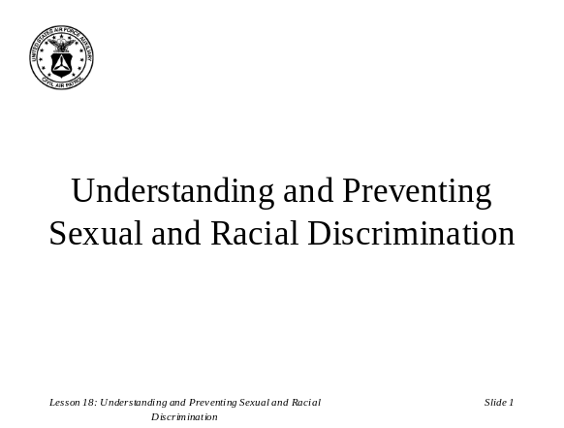Attention Step: (Slide 1) Welcome the students to class. Introduce the course and provide and example of discrimination as an attention getting step.

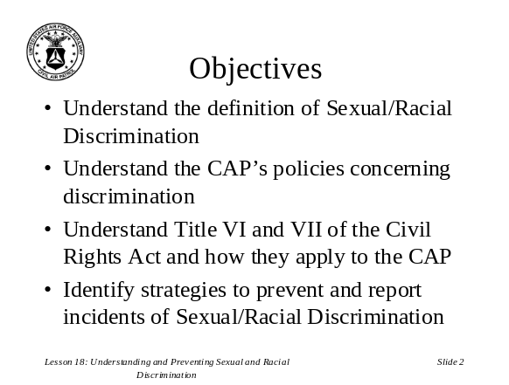Lesson Overview: (Slide 2) Give the students an overview of what you will be discussing. Point out each area and objectives. State what you hope the students need to take away from this course.

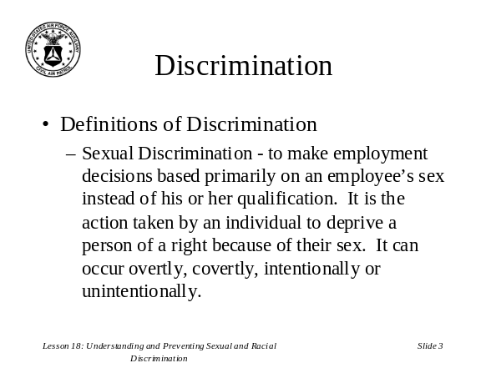Main Point 1: (Slide 3) Discuss the definition of sexual discrimination and be sure it is clearly understood.

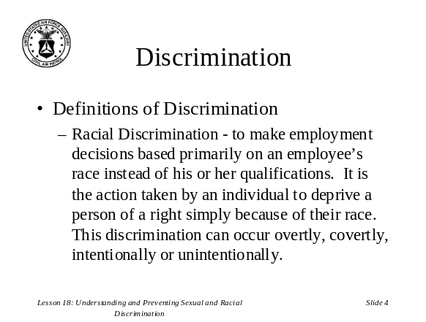Main Point 1: (Slide 4) Discuss the definition of racial discrimination and be sure it is clearly understood.

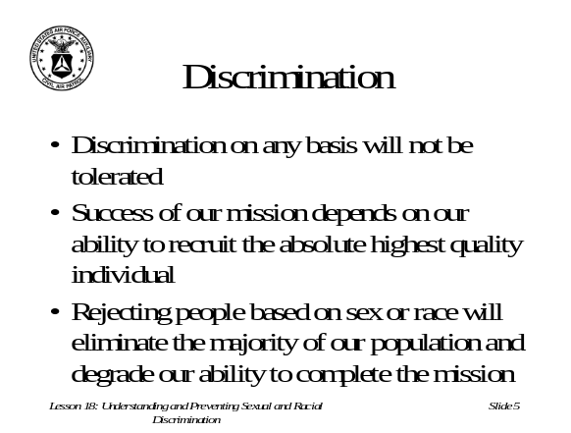Main Point 1: (Slide 5) Discuss CAP’s zero tolerance level and stress how diversity is what makes CAP a great organization. People who volunteer their time are rare. If they volunteer to help, and can contribute, the CAP will be better for it.

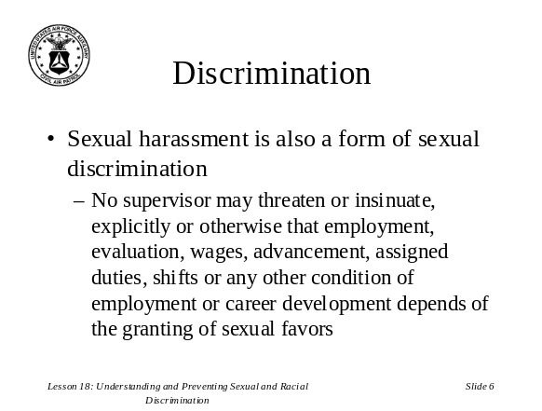Main Point 1: (Slide 6) Discuss the definition of sexual harassment and be sure it is clearly understood.

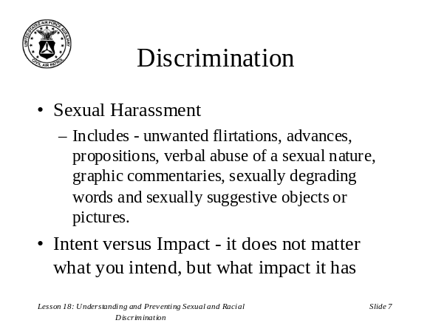Main Point 1: (Slide 7) Discuss examples of sexual harassment and how misperceptions can lead to charges of sexual misconduct. Be sure students understand the difference between “intent” versus “impact” and how it is what other people perceive, not what you intend.

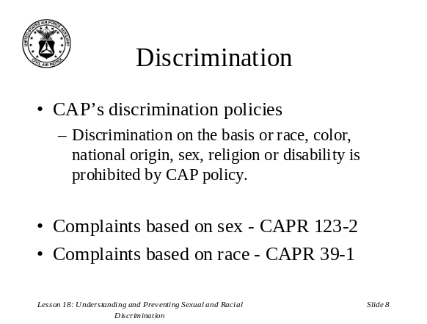Main Point 2: (Slide 8) Clearly state the CAP’s policies and stress the zero tolerance policy. Ideally you should pass the appropriate regulations around so the members can see them firsthand.

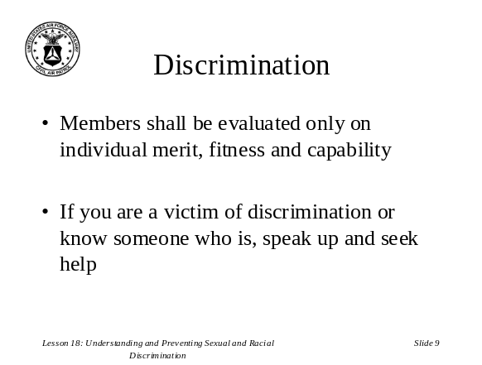Main point 2: (Slide 9) Discuss evaluation methods and how a member could forfeit their membership by not maintaining standards. Stress that every incident of discrimination should be reported and WILL be investigated.

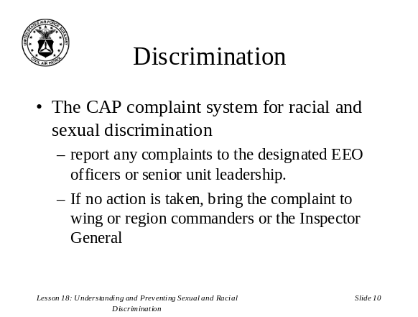Main Point 3: (Slide 10) Discuss how the complaint system works and exactly whom members should report complaints to.

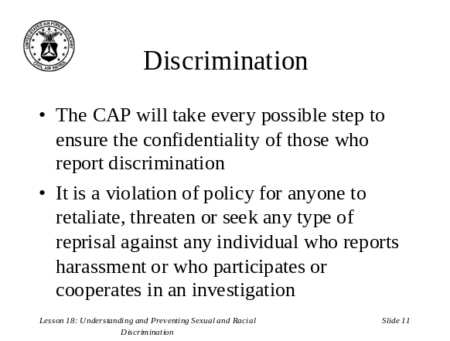Main Point 3: (Slide 11) Discuss how the investigation procedure protects those that report discriminatory acts. Reiterate that any retaliation against someone who reports an incident may be subject to loss of membership privileges.

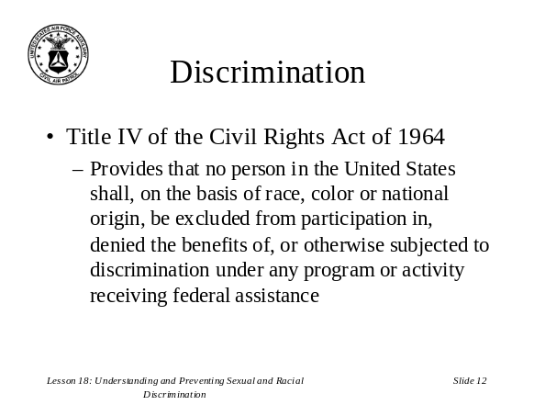Main Point 4: (Slide 12) Cover the basic premise of the Civil Rights Act Title IV and how it applies to the CAP.

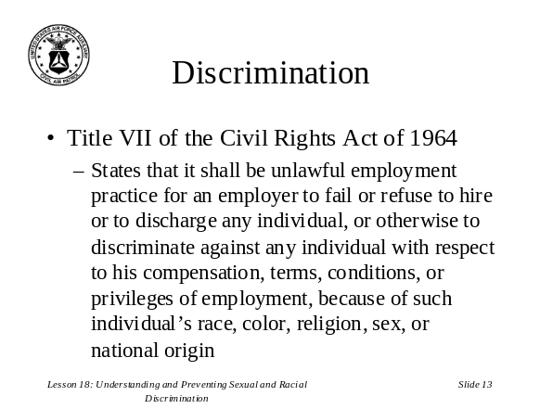Main Point 3: (Slide 13) Same as slide 12

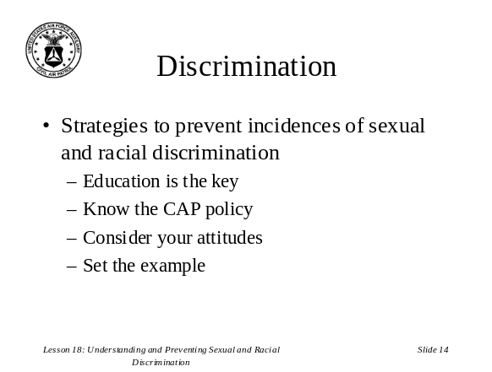Main Point 5: (Slide 14) Discuss strategies to prevent incidences of discrimination and how these strategies, if displayed by unit leadership, can influence other members and hopefully eliminate discrimination instances.

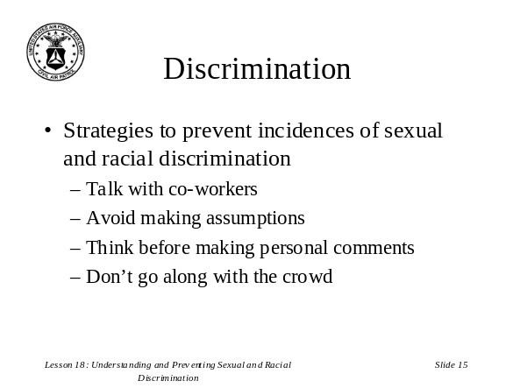Main Point 5: (Slide 15) Same as slide 14
.

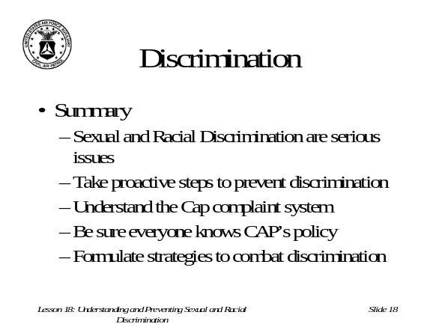Main Point 5: (Slide 16) Discuss how a good reputation can reduce the chance of being misperceived. Always base your decisions on documented criteria and maintain those documents in files.

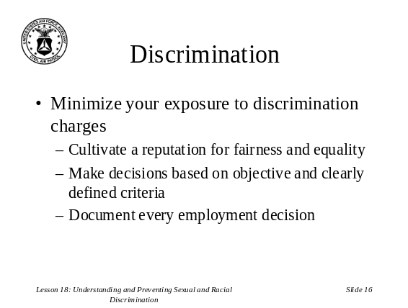Main Point 5: (Slide 17) Stress it is paramount that unit leadership set the example and act accordingly. Discuss how “open door” policies contribute to increased trust in the organization and the leadership.

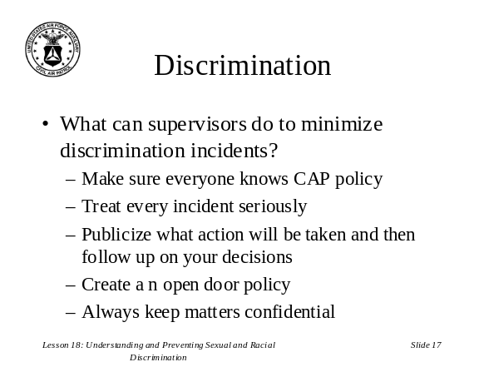Summary: (Slide 18) Reemphasize the importance of understanding what discrimination is and how to prevent it. Reiterate CAP policy against discrimination and remind members there are strategies to combat discrimination. Ask for questions and clarify and problem areas.

