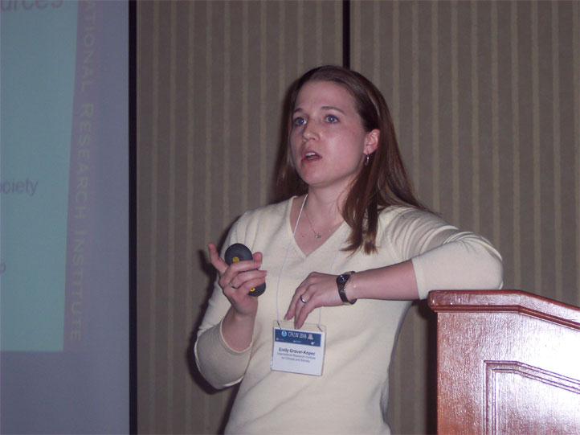
Tailored Climate Information Resources
for Malaria Control in Africa
Emily Grover-Kopec
International Research Institute for Climate and Society
The Earth Institute, Columbia University

Malaria in Africa
IMPACT
- 110 million people living in epidemic-prone areas
- More than 1 million deaths per year
- Decreases annual economic growth by 1.3%
TIME AND LOCATION OF OCCURRENCE
- Economic development has largely shaped distribution of malaria
BUT….
- Climate has a significant relationship with the distribution and seasonality of the disease where it has not been adequately controlled
- Rainfall recognized as major factor influencing malaria transmission in epidemic-prone regions
Climate and Malaria Resource Room
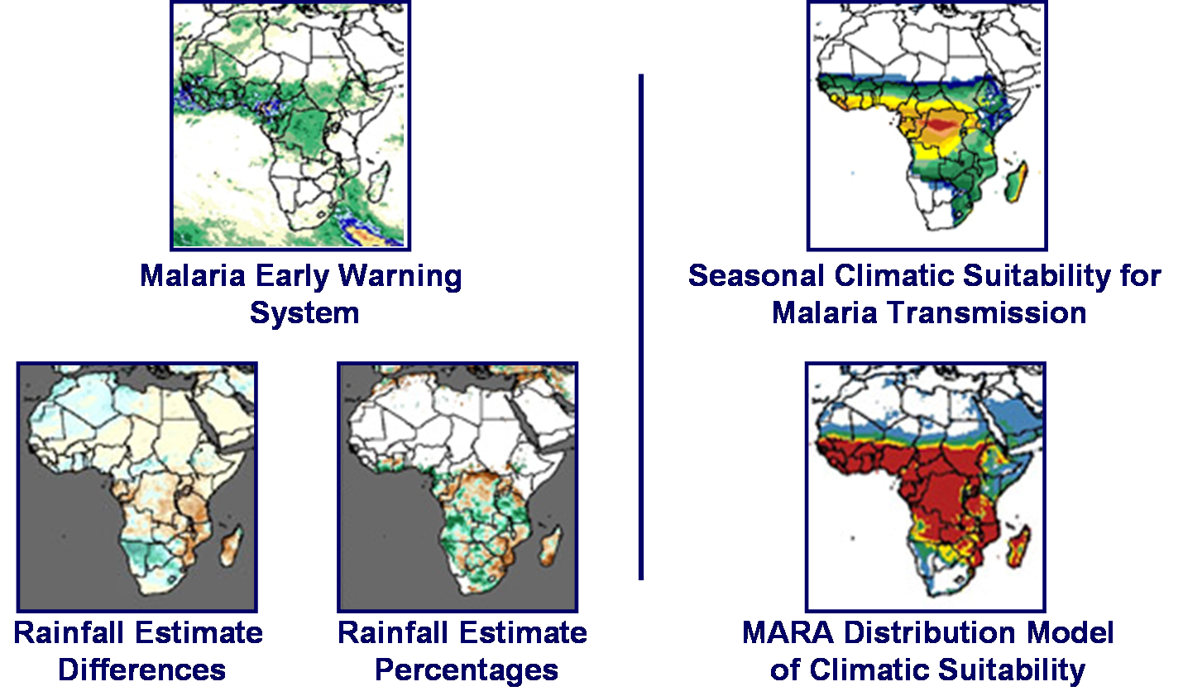
Rainfall Monitoring
Climatic Suitability Interface
Interactive product focused on climatic suitability for malaria transmission
What do we mean by “climatic suitability”?

The Role of Climate
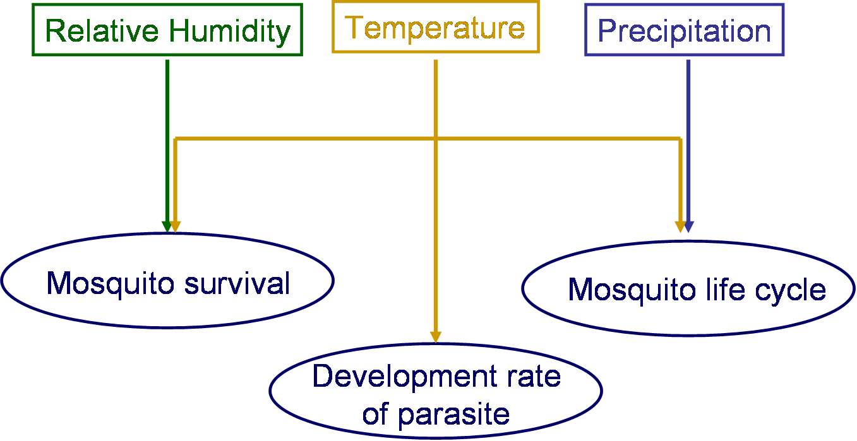
Suitable Conditions for Transmission
T < 18ºC | Development rate of parasite decreases significantly
T > 32ºC | Mosquito survival compromised
RH < 60% | Mosquito won’t live long enough for parasite to develop sufficiently
P < 80mm | Lacking sufficient surface water for egg laying, larval stage

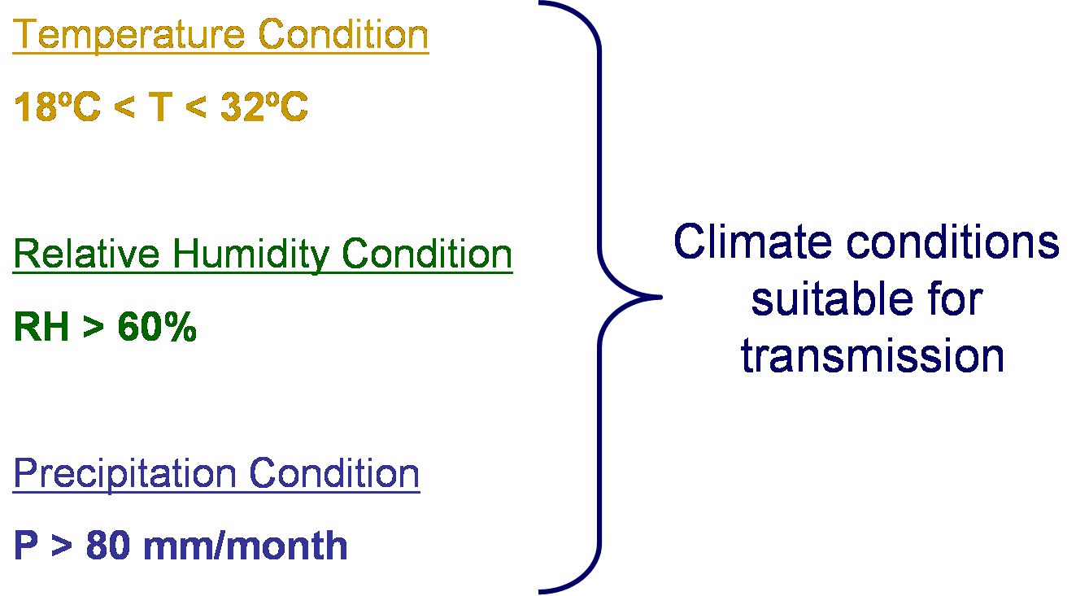
Climatic Suitability Interface
• Front page illustrates number of months during the year that are suitable based on “normal” conditions
• Visual options available to users:
- Map Overlays
- Zoom
Historical information about how often these conditions have actually occurred in the past can be obtained by clicking on the map at the point of interest
Climatic Suitability: A Historical View
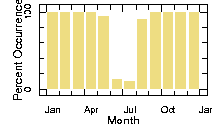
Percent occurrence of temperature condition (18ºC<T<32ºC) in 50-year historical record (1951-2000)
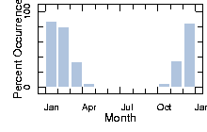
Percent occurrence of precipitation condition (P > 80mm) in 50-year historical record (1951-2000)
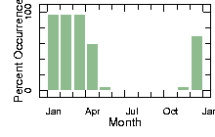
Percent occurrence of relative humidity condition (RH>60%) in 50-year historical record (1951-2000)
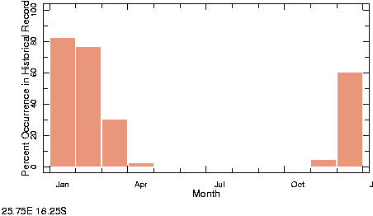
Percent occurrence of all three conditions in 50-year historical record (1951-2000)
Connection between Resources
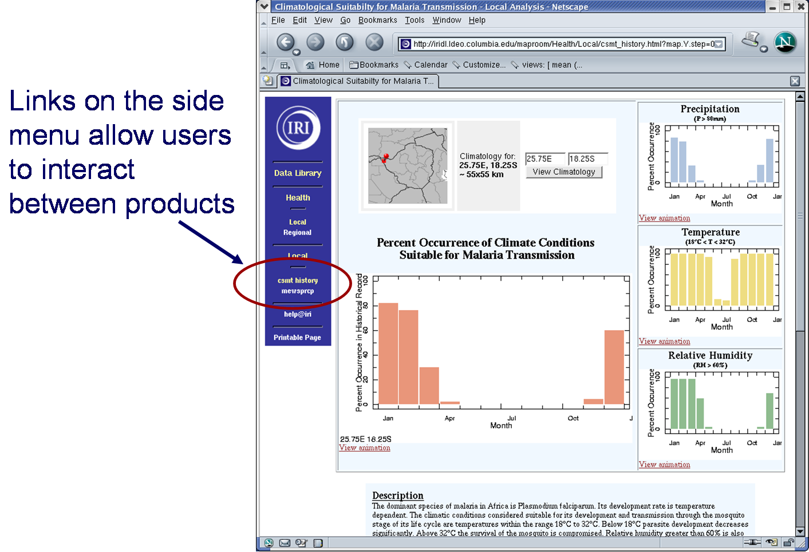
The Value of Seasonal Information
- Development of seasonal calendars to help malaria control programs focus activities
  - Drug procurement
  - Timing of spray activities
- Assist health services with day-to-day operations
  - Help avoid misdiagnosis and inappropriate drug treatment à Extremely important in reducing rate of parasite drug resistance
Climate and Malaria Resource Room
- Set of web-based climate information resources designed for/with malaria control community
- Freely available to public
  - Data and image downloads available
  - Disseminate information about resource via partners in field, sector-specific journals
- Future Work
  - Vegetation-based analyses
  - Instructional material about climatological jargon and concepts, probabilistic forecasts, etc.
Collaborators
WHO-Harare: Joaquim DaSilva, Samson Katikiti
WHO-Geneva: Mika Kawano
USGS: Robert Klaver
MARA: Marlies Craig
IRI: Steve Connor, Benno Blumenthal, Pietro Ceccato, Tufa Dinku, Judy Omumbo

http://iridl.ldeo.columbia.edu/maproom/.Health/.Regional/.Africa/.Malaria/

