FISC Proceedings, Federal Interagency Sedimentation Conferences, 1947 to 2006  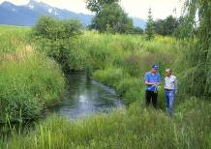  FISC Proceedings  Federal Interagency Sedimentation Conferences, 1947 to 2006  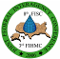  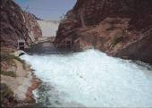  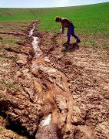  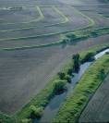  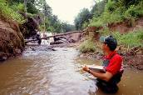  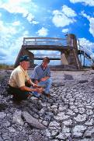  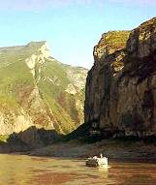 | 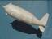 | FISC Proceedings, Federal Interagency Sedimentation Conferences, 1947 to 2006
  1st | 1947 | Denver, CO
  2nd | 1963 | Jackson, MS
  3rd | 1976 | Denver, CO
  4th | 1986 | Las Vegas, NV
  5th | 1991 | Las Vegas, NV
  6th | 1996 | Las Vegas, NV
  7th | 2001 | Reno, NV
  8th | 2006 | Reno, NV
FISC Proceedings, Federal Interagency Sedimentation Conferences, 1947 to 2006 | FISC Proceedings  Federal Interagency Sedimentation Conferences, 1947 to 2006 | FISC Proceedings, Federal Interagency Sedimentation Conferences, 1947 to 2006
  1st | 1947 | Denver, CO
  2nd | 1963 | Jackson, MS
  3rd | 1976 | Denver, CO
  4th | 1986 | Las Vegas, NV
  5th | 1991 | Las Vegas, NV
  6th | 1996 | Las Vegas, NV
  7th | 2001 | Reno, NV
  8th | 2006 | Reno, NV

