NWS FORM E-19 (COVER)

U.S. DEPARTMENT OF COMMERCE
NATIONAL OCEANIC AND ATMOSPHERIC ADMINISTRATION
NATIONAL WEATHER SERVICE

REPORT ON RIVER GAGE STATION

REVISED, PRINTED DATES: 11/20/2003, 12/20/2006

LOCATION: Florence
STREAM: Tennessee River
BASIN: Tennessee HSA: HUN

REFERENCES:
UPDATED 03/23/2000
USGS DESCRIPTION OF GAGING STATION DATED 2/14/1978

ABBREVIATIONS:

BM - bench mark EPA - Environmental Protection Agency
DS - downstream IBWC - International Boundary and Water Comm.
US - upstream MSRC - Mississippi River Commission
HW - high water MORC - Missouri River Commission
LW - low water NOAA - National Oceanic and Atmospheric Admin.
RB - right bank NOS - National Ocean Survey
LB - left bank NWS - National Weather Service
MGL - mean gulf level TVA - Tennessee Valley Authority
MLW - mean low water USACE - U.S. Army Corps of Engineers
MSL - mean sea level USBR - U.S. Bureau of Reclamation
MLT - mean low tide USGS - U.S. Geological Survey
MT - mean tide USWB - U.S. Weather Bureau
WQ - water quality NGVD - National Geodetic Vertical Datum
RM - reference mark NAD - North American Datum
RP - reference point

LOCATION IDENTIFICATION: FLOA1
NWS INDEX NUMBER: 03589500
USGS NUMBER: 03589500
MAP OF GAGE LOCATION

LATITUDE: 34 47 13 SOURCE: USGS
LONGITUDE: 87 40 12

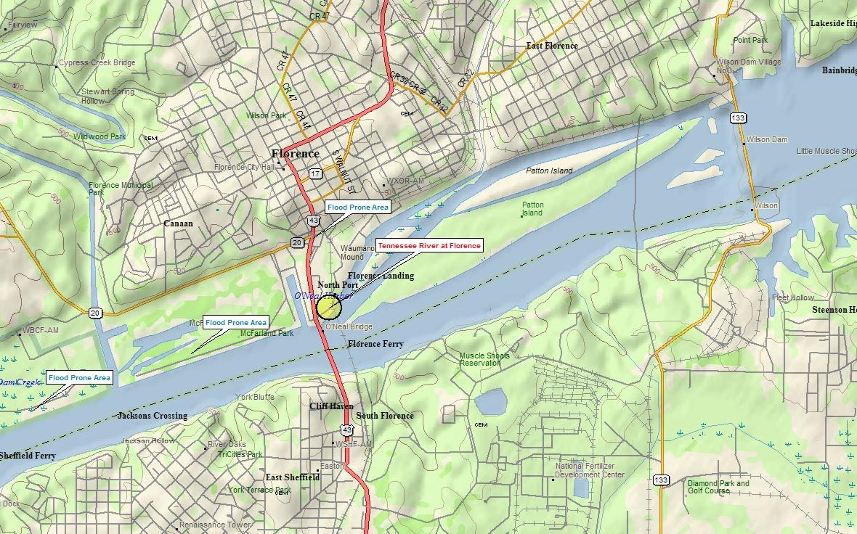

LOCATION: Tennessee River AT Florence, AL Revised, Printed Dates: 11/20/2003, 12/20/2006
ID: FLOA1 HSA: HUN NWS FORM E-19 PAGE 1: GAGE MAP

BENCHMARKS

ELEVATION OF GAGE ZERO: 401.120 VERTICAL DATUM: NGVD OF 1992
LEVELING AGENCY AND DATE: Level CHECKBAR: 0.000
RATING AGENCY:

BENCHMARK DESCRIPTION GAGE ZERO DATUM
---------------------------------------------------------------------------------------- --------- ------
RM10 (TVA) TOP OF 1 INCH TIEDOWN BOLT IN THE NORTHWEST CORNER OF FOOT PLATE ON 30.500 431.620
SECOND UPSTREAM FOOTING, NORTH OF SOUTH WATER STREET, OF THE SOUTHERN
RAILROAD BRIDGE.

RM11 A CHISELED SQUARE ON UPSTREAM STREAMWARD EDGE OF SECOND STEP LEADING TO 29.392 430.512
GAGE HOUSE.

RM12 TOP OF 1/2 INCH LAG BOLT IN TELEPHONE POLE 20 FT DOWNSTREAM OF STEPS TO 30.494 431.614
GAGE HOUSE.

RM13 TOP OF NUT ON 1/2 INCH ANCHOR 1/2 FOOT DOWNSTREAM OF GAGE DOOR SILL IN 32.600 433.720
WELL WALL.

RM7 (PBM 73 USE) IS A STANDARD USE BENCHMARK TABLET, STAMPED "73" SET IN THE 21.507 422.627
TOP OF THE LOWER END OF THE RIGHT CONCRETE LOCK WALL AT LOCK AND DAM
1,600 FT. UPSTREAM FROM THE GAGE.

RM8 (ABANDONED) A 2 INCH CHISELED SQUARE CUT INTO THE STEEL DOOR SILL AT THE 32.500 433.620
UPSTREAM STREAMWARD CORNER OF THE DOOR TO THE GAGE HOUSE.

RM9 A BRONZE TABLET SET IN TOP OF THE NORTH SIDE OF THE SECOND UPSTREAM 30.320 431.440
FOOTING, NORTH OF SOUTH WATER STREET, OF THE SOUTHERN RAILROAD BRIDGE.

RP10 (ABANDONED) A CHISELED ARROW CUT INTO THE CENTER OF THE STREAMWARD EDGE OF 16.880 418.000
THE STREAMWARD VALVE HANDLE BRACE INSIDE THE CLEANOUT DOOR.

RP11 (ABANDONED) AN ARROW CUT INTO SHOREWARD SIDE OF TRAP DOOR IN GAGE HOUSE. 32.508 433.628

RP12 (ABANDONED) AN ARROW CUT INTO FIRST ANGLE HANDRAIL BRACE FROM GAGE ON 31.522 432.642
BOTTOM OF WALKWAY.

RP13 (ABANDONED) AN ARROW CUT INTO TOP OF DOWNSTREAM SHOREWARD CORNER OF I-BEAM 14.906 416.026
SUPPORTING LOWER STAFF SECTION.

RP14 BETWEEN CUT MARKS ON ANGLE AT BOTTOM OF DOOR BELOW GAGE ITSELF. 32.692 433.812

RP15 CUT MARK ON UPSTREAM SIDE OF LOWER STAFF SECTION AND STREAMWARD CORNER OF 14.914 416.034
I BEAM.

LOCATION: Tennessee River AT Florence, AL Revised, Printed Dates: 11/20/2003, 12/20/2006
ID: FLOA1 HSA: HUN NWS FORM E-19 PAGE 2: BENCHMARKS

GAGES

DCP TELEM

NESS ID: 16F473F6 TYPE OF TELEMETRY: telemark
OWNER: USGS OWNER: USGS
REPORT TIME: 01:11 PHONE NUMBER: 256-767-7521
INTERVAL: 240 INTERVAL: UNK
CRITERIA: NONE
PAYOR/COST OF LINE: USGS / $

GAGE TYPE OWNER MAINTENANCE BEGAN ENDED GAGE LOCATION/REMARKS
----------- ----------- ----------- ---------- ---------- -------------------------------------------------------
float USGS USGS 04/03/1926 05/17/1934 WATER-STAGE RECORDER ON LEFT BANK AT LOWER END OF OLD LOCK
AND DAM, 1400FT.
float USGS USGS 05/17/1934 07/07/1939 AU CONTINUOUS RECORDER.
float TVA USGS 07/07/1939 01/31/1958 FRIEZ RECORDER.
Unk TVA Unk 02/01/1958 03/11/1958 TVA TEMPORARY GAGE USED.
float USGS USGS 03/11/1958 PRESENT GAGE AT MILE 256.7, 137 FEET UPSTREAM FROM RAILROAD BRIDGE AND 2.7 MILES DOWNSTREAM FROM WILSON DAM.
float USGS USGS 03/11/1965 08/26/1999 DIGITAL RECORDER.
crest USGS USGS 09/26/1996 CREST STAGE GAGE IS A 2" GALVANIZED PIPE ATTACHED TO THE
SHOREWARD SIDE OF THE GAGE HOUSE AT THE DOWNSTREAM CORNER.
pres trans USGS USGS 08/26/1999 CR10 DATA LOGGER WITH MODEM, SM192 MODULE AND PRESSURE
SENSOR IN A 5' BY 5' CONCRETE HOUSE. RECORDER IS REFERRED
TO A STAFF GAGE IN 3 SECTIONS. ORIFICE LINE FOR PRESSURE
SENSOR ATTACHED TO STAFF PLATE I-BEAM AND CONCRETE BLOCK IN STREAM.

LOCATION: Tennessee River AT Florence, AL Revised, Printed Dates: 11/20/2003, 12/20/2006
ID: FLOA1 HSA: HUN NWS FORM E-19 PAGE 3: GAGES
HISTORY

PUBLICATION/LOCATION OF RECORDS STARTING DATE ENDING DATE
------------------------------- ------------- -----------
USGS 11/06/1971

TYPE OF GAGE OWNER STARTING DATE ENDING DATE
------------ ----- ------------- -----------
float USGS 04/03/1926 05/17/1934
float USGS 05/17/1934 07/07/1939
float TVA 07/07/1939 01/31/1958
Unk TVA 02/01/1958 03/11/1958
float USGS 03/11/1958
float USGS 03/11/1965 08/26/1999
crest USGS 09/26/1996
pres trans USGS 08/26/1999

ZERO ELEVATION STARTING DATE
-------------- -------------
401.120 11/06/1971

LOCATION: Tennessee River AT Florence, AL Revised, Printed Dates: 11/20/2003, 12/20/2006
ID: FLOA1 HSA: HUN NWS FORM E-19 PAGE 4: HISTORY
CRESTS

FLOOD STAGE: 18.00 ACTION STAGE: 16.00 BANKFULL STAGE: 18.00
FLOOD FLOW: ACTION FLOW:

DATE OF TIME CREST FLOW FROM HIGH BASED ON CAUSED BY
CREST LST (ft) (CFS) WATERMARKS OLD DATUM ICE JAM REMARKS
---------- ------ ------ ------ ---------- --------- --------- ----------------------------------------------
03/19/1897 UNDEF 32.50 444000 FLOOD OF RECORD
04/20/1900 UNDEF 19.20
08/22/1901 UNDEF 18.90
03/08/1902 UNDEF 20.90
03/06/1903 UNDEF 18.90
03/15/1909 UNDEF 19.60
04/10/1911 UNDEF 22.00
04/13/1912 UNDEF 19.60
03/21/1913 UNDEF 18.50
12/31/1914 UNDEF 19.20
07/12/1916 UNDEF 20.50
03/12/1917 UNDEF 24.70
02/06/1918 UNDEF 22.00
05/09/1919 UNDEF 19.50
04/10/1920 UNDEF 23.50
02/13/1921 UNDEF 18.70
03/11/1922 UNDEF 21.50
02/11/1923 UNDEF 18.20
12/29/1926 UNDEF 26.50
04/24/1928 UNDEF 18.40
03/25/1929 UNDEF 22.90
02/04/1932 UNDEF 19.70
02/20/1933 UNDEF 21.20
03/05/1934 UNDEF 21.20
04/06/1936 UNDEF 24.40
01/04/1937 UNDEF 20.30
04/12/1938 UNDEF 21.10
02/17/1939 UNDEF 25.00
03/22/1942 UNDEF 18.10
01/02/1943 UNDEF 23.20
03/30/1944 UNDEF 25.60
02/22/1945 UNDEF 21.50
01/11/1946 UNDEF 25.10
01/20/1947 UNDEF 23.70
02/13/1948 UNDEF 28.00
01/08/1949 UNDEF 25.80
02/14/1950 UNDEF 22.50
03/29/1951 UNDEF 24.10
02/23/1953 UNDEF 18.20
01/23/1954 UNDEF 23.30
03/22/1955 UNDEF 25.70
02/05/1956 UNDEF 22.30
02/04/1957 UNDEF 26.20
03/08/1961 UNDEF 21.22 240000
02/28/1962 UNDEF 24.60 300000
03/14/1963 UNDEF 24.50 339000
03/15/1964 UNDEF 21.93 282000

LOCATION: Tennessee River AT Florence, AL Revised, Printed Dates: 11/20/2003, 12/20/2006
ID: FLOA1 HSA: HUN NWS FORM E-19 PAGE 5: CRESTS
DATE OF TIME CREST FLOW FROM HIGH BASED ON CAUSED BY
CREST LST (ft) (CFS) WATERMARKS OLD DATUM ICE JAM REMARKS
---------- ------ ------ ------ ---------- --------- --------- ----------------------------------------------
03/30/1965 UNDEF 24.60 341000
02/18/1966 UNDEF 16.30 171000
03/07/1967 UNDEF 15.49 164000
01/10/1968 UNDEF 20.82 260000
02/02/1969 UNDEF 21.00 267000
01/02/1970 UNDEF 21.01 250000
02/22/1971 UNDEF 18.80 196000
01/11/1972 UNDEF 18.31 171000
03/17/1973 UNDEF 30.03 530000
01/11/1974 UNDEF 25.03 327000
03/14/1975 UNDEF 25.00 341000
10/17/1975 UNDEF 18.54 185000
04/08/1977 UNDEF 21.81 252000
05/09/1978 UNDEF 21.74 226000
03/06/1979 UNDEF 20.21 237000
03/22/1980 UNDEF 24.83 336000
01/05/1982 UNDEF 20.06 234000
05/22/1983 UNDEF 23.06 273000
05/04/1984 UNDEF 23.81 339000
02/05/1985 UNDEF 15.42 159000
03/01/1987 UNDEF 20.92 243000
01/22/1988 UNDEF 14.46 142000
06/22/1989 UNDEF 21.71
11/02/1989 UNDEF 21.91 318000
12/23/1990 UNDEF 27.58 440000
12/03/1991 UNDEF 25.12 332000
03/27/1993 UNDEF 20.83 222000
03/28/1994 UNDEF 25.53 364000
03/03/1997 UNDEF 21.50
05/05/1997 UNDEF 19.50
06/18/1997 UNDEF 20.10
03/03/1998 UNDEF 21.50
04/22/1998 UNDEF 20.40
01/24/1999 UNDEF 20.10
02/19/2001 12:00 19.16
02/18/2003 23:15 21.94
05/07/2003 05:15 25.53
02/09/2004 13:30 20.44 gage was inoperative for several hours...crest was estimated
09/19/2004 06:15 20.01
09/19/2004 12:45 20.53 Inserted from the FloodTS table via Hydrobase
09/20/2004 13:45 20.75
09/22/2004 13:15 18.80
11/26/2004 21:15 19.07 Inserted from the FloodTS table via Hydrobase
12/01/2004 22:30 20.58 Inserted from the FloodTS table via Hydrobase
12/10/2004 09:00 25.98 Inserted from the FloodTS table via Hydrobase

LOCATION: Tennessee River AT Florence, AL Revised, Printed Dates: 11/20/2003, 12/20/2006
ID: FLOA1 HSA: HUN NWS FORM E-19 PAGE 5-2: CRESTS
LOW WATER RECORDS

DATE OF STAGE FLOW
LOW WATER (ft) (CFS) REMARKS
---------- ------- ------ ---------------------------------------------
10/08/1925 -0.30 caused by filling of wilson lake

LOCATION: Tennessee River AT Florence, AL Revised, Printed Dates: 11/20/2003, 12/20/2006
ID: FLOA1 HSA: HUN NWS FORM E-19 PAGE 6: LOW WATER
CONDITIONS AFFECTING FLOW

MILES ABOVE MOUTH: 256.7 DRAINAGE AREA: 30810.0 POOL STAGE: 0.0

STREAM BED: gravel and sill

REACH: levees protect an area in the vicinity of the gage (RB) to
above 431.15 ft MSL.

REGULATION: Flow regulated by power plants and storage at numerous dams
upstream. Power operation at Wilson Dam 2-3/4 miles
upstream.

DIVERSION: none

WINTER: very little ice effect occurs.

TOPOGRAPHY: The RB is fairly high and will overflow only at extremely
high stages; however from below the highway bridge for
about half a mile, overflow begins above 18 feet stage.
Left bank is a high vertical rock bluff and is not subject
to overflow.

REMARKS:

LOCATION: Tennessee River AT Florence, AL Revised, Printed Dates: 11/20/2003, 12/20/2006
ID: FLOA1 HSA: HUN NWS FORM E-19 PAGE 7: CONDITIONS
DAMAGE

STAGE AREAS AFFECTED
------- ----------------------------------------------------------------------------------------------------
18.00 McFarland Park floods extensively at flood stage, however no structure damages are incurred.

20.00 Alabama State Highway 20 is covered by water at the underpass below US highway 43 and 72. The
underpass will likely be closed.

21.50 Water covers the parking lots of the marina at McFarland Park...with extensive flooding occurring at
the soccer fields and golf course within the park. Water is also beginning to cover the road that
goes underneath U.S. Highways 43 and 72 at the new playground.

27.00 Moderate flooding. Flooding of industries near the river begins. There are a few buildings below a
stage of 27 feet upstream of the railroad, but they are protected by a dike that was not topped in
1973 (stage of 30.3 ft).

30.00 Widespread flooding of industries near the river is occurring.

32.00 MAJOR FLOODING.

32.50 RECORD FLOOD - 3/19/1897

LOCATION: Tennessee River AT Florence, AL Revised, Printed Dates: 11/20/2003, 12/20/2006
ID: FLOA1 HSA: HUN NWS FORM E-19 PAGE 8: DAMAGE

RIVER STAGE DATA

| 35-|
|-----|
|-----|
|-----|
|-----|
| 33-|
|-----|
32.50 - RECORD FLOOD - 3/19/1897 |-----| 32.50 03/19/1897
32.00 - MAJOR FLOODING. |-----|
|-----|
| 31-|
|-----|
|-----|
30.00 - Widespread flooding of industries near the river is occurring. |-----| 30.03 03/17/1973
|-----|
| 29-|
|-----|
|-----|
|-----| 28.00 02/13/1948
|-----| 27.58 12/23/1990
27.00 - Moderate flooding. Flooding of industries near the river begins. There are a few | 27-|
buildings below a stage of 27 feet upstream of the railroad, but they are protected |-----|
by a dike that was not topped in 1973 (stage of 30.3 ft). |-----|
|-----| 25.98 12/10/2004
|-----| 25.53 03/28/1994
| 25-| 25.12 12/03/1991
|-----| 24.83 03/22/1980
|-----|
|-----| 23.81 05/04/1984
|-----|
| 23-|
|-----|
|-----|
|-----| 21.94 02/18/2003
21.50 - Water covers the parking lots of the marina at McFarland Park...with extensive |-----| 21.50 03/03/1998
flooding occurring at the soccer fields and golf course within the park. Water is | 21-|
also beginning to cover the road that goes underneath U.S. Highways 43 and 72 at the |-----| 20.83 03/27/1993
new playground. |-----| 20.58 12/01/2004
20.00 - Alabama State Highway 20 is covered by water at the underpass below US highway 43 and |-----| 20.01 09/19/2004
72. The underpass will likely be closed. |-----|
| 19-| 19.16 02/19/2001
|-----| 18.80 09/22/2004
|-----|
18.00 - McFarland Park floods extensively at flood stage, however no structure damages are |-----|
incurred. |-----|
| 17-|
|-----|
|-----|
|-----|
|-----|

REACH: levees protect an area in the vicinity of the gage (RB) to above 431.15 ft MSL. ELEVATION ZERO: 401.12

LOCATION: Tennessee River AT Florence, AL Revised, Printed Dates: 11/20/2003, 12/20/2006
ID: FLOA1 HSA: HUN NWS FORM E-19 PAGE 9: STAFF
CONTACTS

SQ CONTACT/REMARKS PHONE
-- -------------------------------------------------- ------------------
1 Lauderdale County EMA 256-766-4201

Director: George Grabryan

2 McFarland Golf Course 256-760-6428

3 Florence PD 256-760-6610

LOCATION: Tennessee River AT Florence, AL Revised, Printed Dates: 11/20/2003, 12/20/2006
ID: FLOA1 HSA: HUN NWS FORM E-19 PAGE 10: CONTACTS
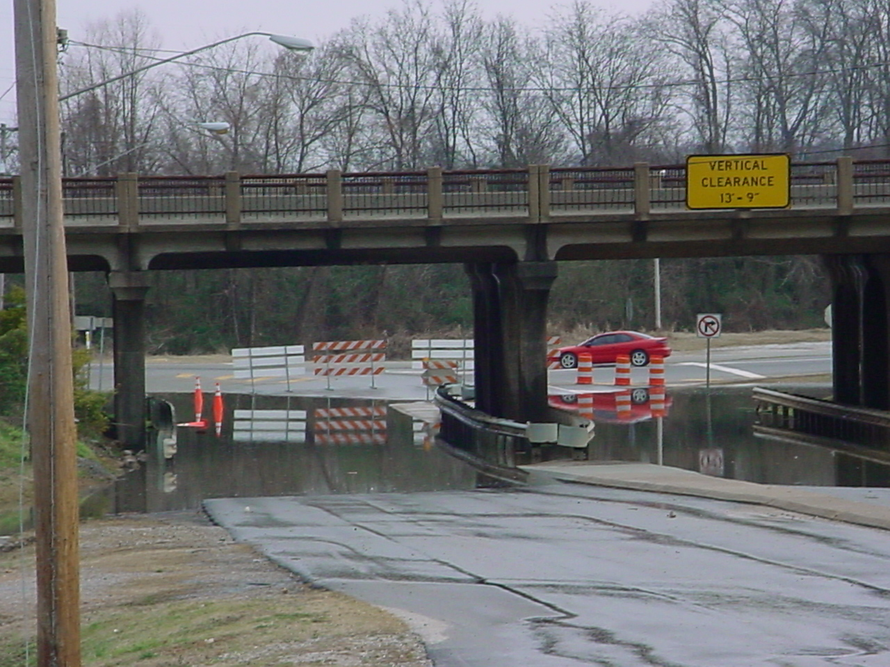
Flooding near the gage site.

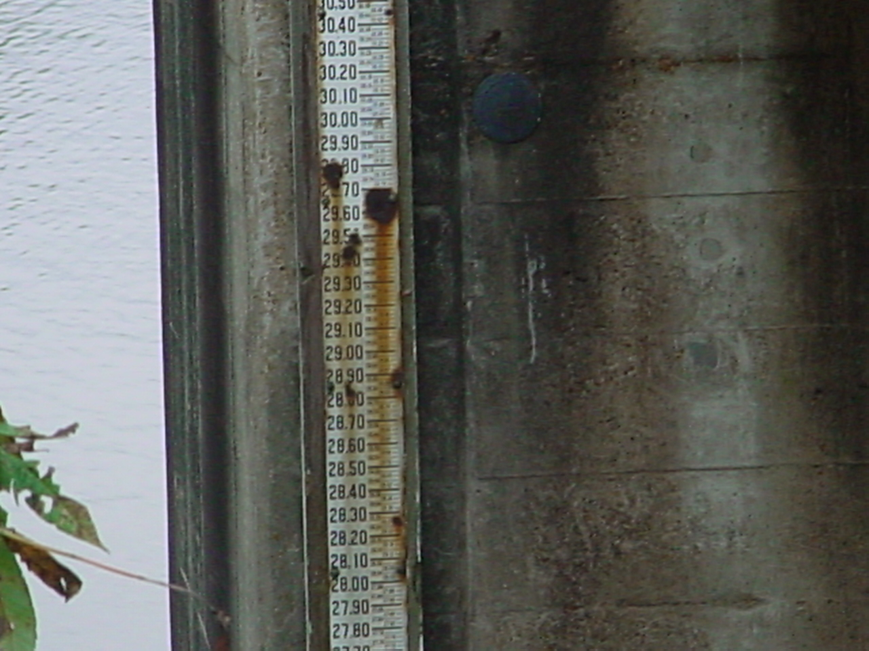
Section of staff gage.

