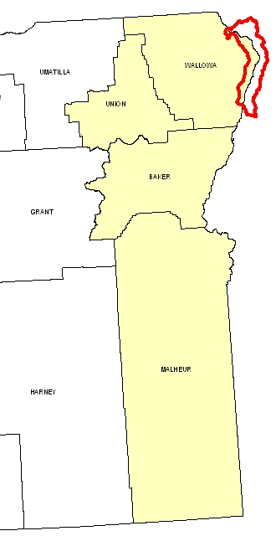
Introduction

Hells Canyon 8-Digit Hydrologic Unit Code (HUC) watershed is comprised of 348,179 acres. One-third of the watershed is in the extreme northeastern part of Oregon, and the remainder is in Idaho. The Oregon portion of the watershed is almost entirely publicly owned. There are no known farms or ranches on the privately owned land. Some public land is leased for grazing.

The Snake Basin has four NRCS service centers and seven soil and water conservation districts (SWCD).

Trees, grass, and shrubs cover ninety-nine percent of the part of the watershed in Oregon. The Snake River bisects the watershed. The Hells Canyon National Recreation Area is the dominant feature. The management policy for this area dictates land use in Hells Canyon.

Profile Contents

Introduction
Physical Description
Land Use Map & Precipitation Map
Common Resource Area
Resource Concerns
Census and Social Data
Progress/Status
Footnotes/Bibliography

Relief Map

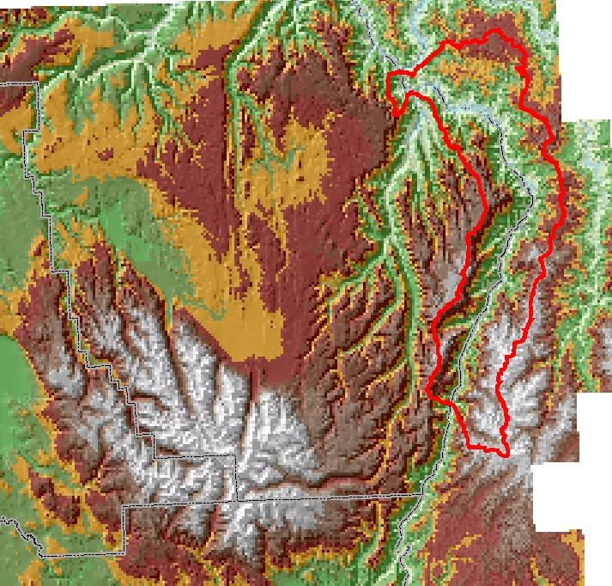
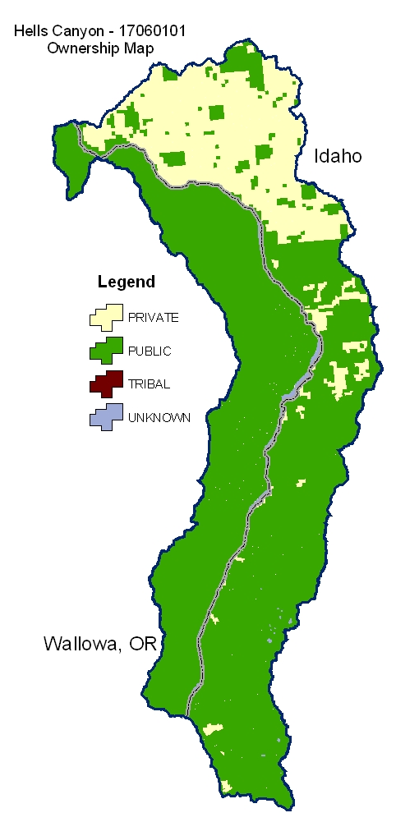

Produced by the Water Resources Planning Team Portland, OR
The United States Department of Agriculture (USDA) prohibits discrimination in all its programs and activities on the basis of race, color, national origin, sex, religion, age, disability, political beliefs, sexual orientation, and marital or family status. (Not all prohibited bases apply to all programs.) Persons with disabilities who require alternative means for communication of program information (Braille, large print, audiotape, etc.) should contact USDA’s TARGET Center at 202-720-2600 (voice and TDD).
To file a complaint of discrimination, write USDA, Director, Office of Civil Rights, Room 326W, Whitten Building, 14th and Independence Avenue, SW, Washington DC 20250-9410, or call (202) 720-5964 (voice and TDD). USDA is an equal opportunity provider and employer.

Physical Description Back to Contents
ALL NUMBERS WITHIN THIS PROFILE ARE FOR OREGON ONLY
Land Cover/Land Use  (NLCD^{/2}) |  | Ownership - (2003 Draft BLM Surface Map Set^{/1})
 |  | Public |  | Private |  | Tribal |  |  | Totals | %
 |  | Acres | % | Acres | % | Acres |  | % | Totals
Forest |  | 32,100 | 26% | * | --- | 0 |  | 0% | 32,300 | 26%
Grain Crops |  | * | --- | 0 | 0% | 0 |  | 0% | * | ---
Conservation Reserve Program Land ª |  | 0 | 0% | 0 | 0% | 0 |  | 0% | * | ---
Grass/Pasture/Hay |  | 57,600 | 46% | * | --- | 0 |  | 0% | 59,700 | 48%
Orchards/Vineyards |  | * | --- | 0 | 0% | 0 |  | 0% | 0 | 0%
Row Crops |  | * | --- | 0 | 0% | 0 |  | 0% | 0 | 0%
Shrub/Rangelands |  | 31,200 | 25% | * | --- | 0 |  | 0% | 32,100 | 26%
Water/Wetlands/Developed/Barren |  | * | --- | * | --- | 0 |  | 0% | * | ---
Oregon HUC Totals ^{b} |  | 121,700 | 97% | * | --- | 0 |  | 0% | 125,000 | 100%
*: Too few acres to report.
a: Estimate from Farm Service Agency records and includes CRP/CREP.
b: Totals are approximate due to rounding and small unknown acreages.
Special Considerations for This 8-Digit HUC:
- The Oregon portion of the Hells Canyon hydrologic unit includes only a very small, unaccountable amount of private land.
- The private land in Oregon portion consists primarily of small in-holdings in the Hells Canyon National Recreational Area.
- No known farms or ranches are present; however, some ranchers do have grazing allotments on the public land.

Irrigated Lands  (1997 NRI^{/3} Estimates for Non-Federal Lands Only) | Type of Land |  |  |  | ACRES |  | % of  Irrigated Lands |  |  |  | % of  HUC
 | Cultivated Cropland |  |  |  | 0 |  | --- |  |  |  | ---
 | Uncultivated Cropland |  |  |  | 0 |  | --- |  |  |  | ---
 | Pastureland |  |  |  | 0 |  | --- |  |  |  | ---
 | Total Irrigated Lands |  |  |  | 0 |  | --- |  |  |  | ---
(Continued on the following pages)

Back to Contents
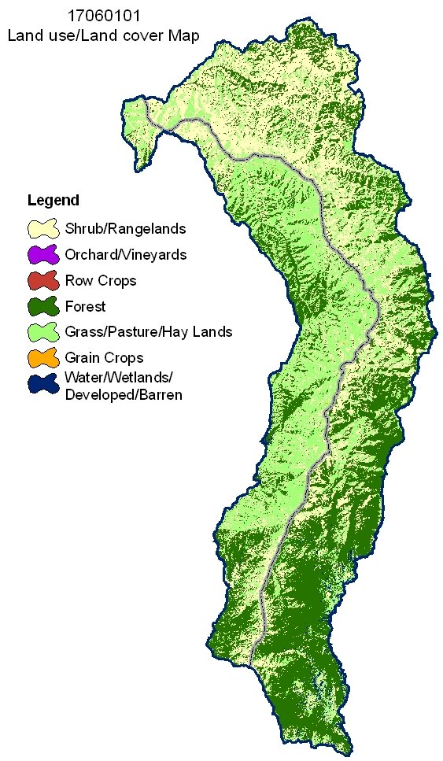

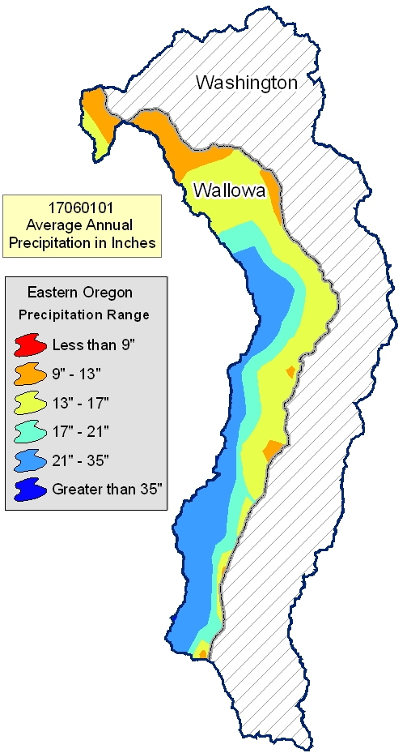
Idaho

Common Resource Area Map Back to Contents

Only the major units are described below - for descriptions of all units within the HUC, go to: http://ice.or.nrcs.usda.gov/website/cra/viewer.htm
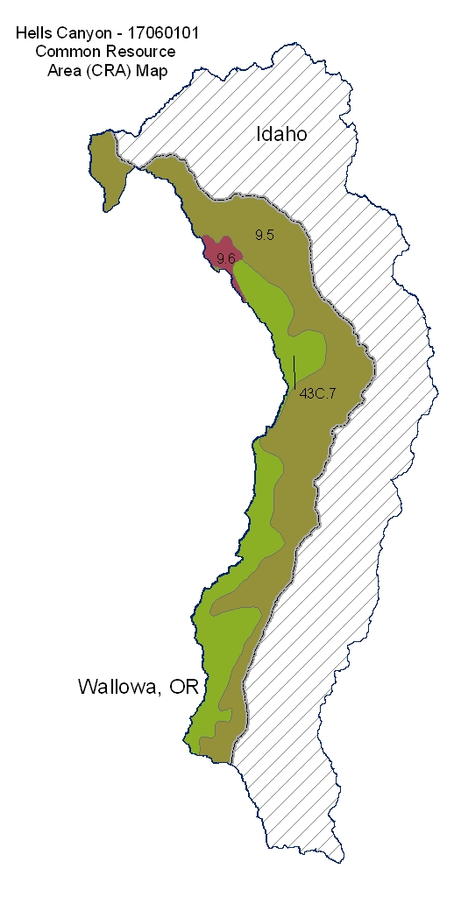

9.5 - Palouse and Nez Perce Prairies - Warm Canyons and Dissected Uplands: This unit is characterized by deep river canyons that divide the Blue Mountains from the Rocky Mountains. The Snake, Salmon, and Grande Ronde Rivers and their tributaries have cut the Columbia Plateau to a depth of 2,000 to 5,000 feet through metasedimentary and metavolcanic rock. The depth of the canyon and the exposed metamorphic rock result in stony soils on canyon slopes that retain little moisture. The dominant soils are those of the Dixiejett and Lickskillet series. The temperature regime is mesic, and the moisture regime is xeric and aridic. The mean annual precipitation is 12 to 16 inches. Bluebunch wheatgrass, Sandberg bluegrass, and spiny greenbush are adapted to these hot, dry conditions. Land use includes grazing and recreation on National forest land and in the Hells Canyon National Recreation Area.

9.6 - Palouse and Nez Perce Prairies - Cool Canyons and Dissected Highlands: This unit is characterized by deeply dissected, cool, moist canyonsides of the Snake River drainageway. This unit is at higher elevations but is adjacent to unit 9.5 and to forestland above the unit. The soils typically are moderately deep and shallow to bedrock. The dominant soil is that of the Snell series. The temperature regime is frigid, and the moisture regime is xeric. The mean annual precipitation is 14 to 25 inches. Most areas are used for livestock grazing and support dominantly Idaho fescue.

43C.7 - Blue and Seven Devils Mountains - Low Elevation Blue Mountain Forests: This unit is a forested, uplifted basalt plateau. It is characterized by forested plateaus and highly dissected canyons that have frigid temperatures. Slopes dominantly are nearly level to rolling but are very steep in the canyons. The moisture regime is xeric and udic. The vegetation is dominantly grand fir, Douglas-fir, and ponderosa pine. The soils typically have a mantle of ash as much as 20 to 30 inches thick.

Physical Description – Continued Back to Contents
 |  | ACRES | ACRE-FEET
Irrigated Adjudicated Water Rights (OWRD^{/4}) | Surface | 7 | 22
Irrigated Adjudicated Water Rights (OWRD^{/4}) | Well | 0 | 0
Irrigated Adjudicated Water Rights (OWRD^{/4}) | Total Irrigated Adjudicated Water Rights | 7 | 22
Stream Flow Data | USGS 14120000 HOOD RIVER AT TUCKER BRIDGE, NEAR HOOD RIVER, OR | Total Avg. Yield | 14,627,068
Stream Flow Data |  | May - Sept Yield | 5,496,694
 |  | MILES | PERCENT
Stream Data^{/5}  *Percent of Total Miles  of Streams in HUC | Total Miles – Major (100K Hydro GIS Layer) | 425 | ---
Stream Data^{/5}  *Percent of Total Miles  of Streams in HUC | 303d/TMDL Listed Streams (DEQ) | 71 | 17%
Stream Data^{/5}  *Percent of Total Miles  of Streams in HUC | Anadramous Fish Presence (StreamNet) | 26 | 6%
Stream Data^{/5}  *Percent of Total Miles  of Streams in HUC | Bull Trout Presence (StreamNet) | 59 | 14%
 |  | ACRES | PERCENT
Land Cover/Use^{/2} Based on a 100-foot stretch on both  sides of all streams  in the 100K Hydro GIS Layer | Forest | 3,299 | 32%
 | Grain Crops | 10 | 0%
 | Grass/Pasture/Hay | 3,315 | 32%
 | Orchards/Vineyards | 8 | 0
 | Row Crops | 3 | 0
 | Shrub/Rangelands – Includes CRP Lands | 3,128 | 30%
 | Water/Wetlands/Developed/Barren | 545 | 0%
 | Total Acres of 100-foot Stream Buffers | 10,309 | ---
Land Capability Class  (Croplands & Pasturelands Only)  (1997 NRI^{/3} Estimates for Non-Federal Lands Only) | 1 – slight limitations
 | 2 – moderate limitations
 | 3 – severe limitations
 | 4 – very severe limitations
 | 5 – no erosion hazard, but other limitations
 | 6 – severe limitations; unsuitable for cultivation; limited to pasture, range, forest
 | 7 – very severe limitations; unsuitable for cultivation, limited to grazing, forest, wildlife habitat
 | 8 – miscellaneous areas; limited to recreation, wildlife habitat, water supply
 | Total Croplands & Pasturelands

Confined Animal Feeding Operations – Oregon CAFO Permit – 12/2004
Animal Type | Dairy | Feedlot (Cattle) | Poultry | Swine | Mink | Other
No. of Permitted Farms | 0 | 0 | 0 | 0 | 0 | 0
No. of Permitted Animals | 0 | 0 | 0 | 0 | 0 | 0

Resource Concerns Back to Contents

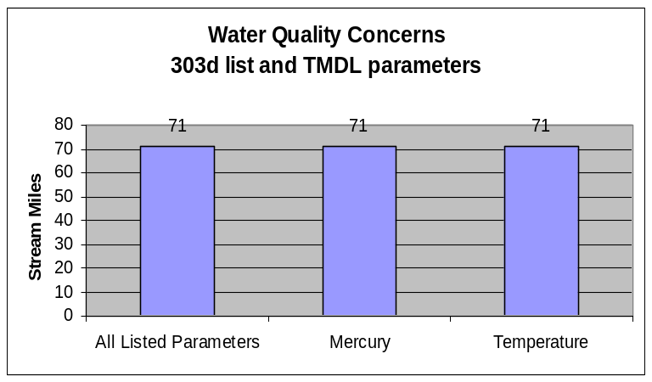
- Almost all listed stream miles exceed state water quality standards for temperature. Elevated stream temperatures may be due to inadequate riparian shade, stream channel widening, warm irrigation return flows, and other anthropogenic or natural causes.

Watershed Projects, Plans, Studies, and Assessments
NRCS Watershed Projects⁶ |  |  | NRCS Watershed Plans, Studies, and Assessments⁷
Name | Status |  | Name |  | Status
None |  |  | None
ODEQ TMDL’s⁸ |  |  | ODA Agricultural Water Quality Management Plans⁹
Name | Status |  | Name |  | Status
Snake River-Hells Canyon Reach | EPA Approved - 2004 |  | None
OWEB Watershed Councils¹⁰ |  | Watershed Council Assessments¹¹ |  | NWPCC Subbasin Plans & Assessments¹⁸
Grande Ronde Model Watershed |  | None |  | Snake Hells Canyon

Federally Listed Threatened And Endangered Species^{/12}
THREATENED SPECIES | CANDIDATE SPECIES
Marine - None  Mammals – Canada lynx  Birds - Bald eagle  Fish - Steelhead (Snake River Basin), Chinook salmon, Bull trout (Columbia River population)  Invertebrates – None  Plants – McFarlane's four o’clock, Spalding's catchfly, Howell's spectacular thelypody | Fish - None  Birds – Yellow-billed cuckoo
 | Amphibians and Reptiles – Columbia spotted frog
 | Plants – Slender moonwort
 | PROPOSED SPECIES None
Essential Fish Habitat^{/13} - Chinook

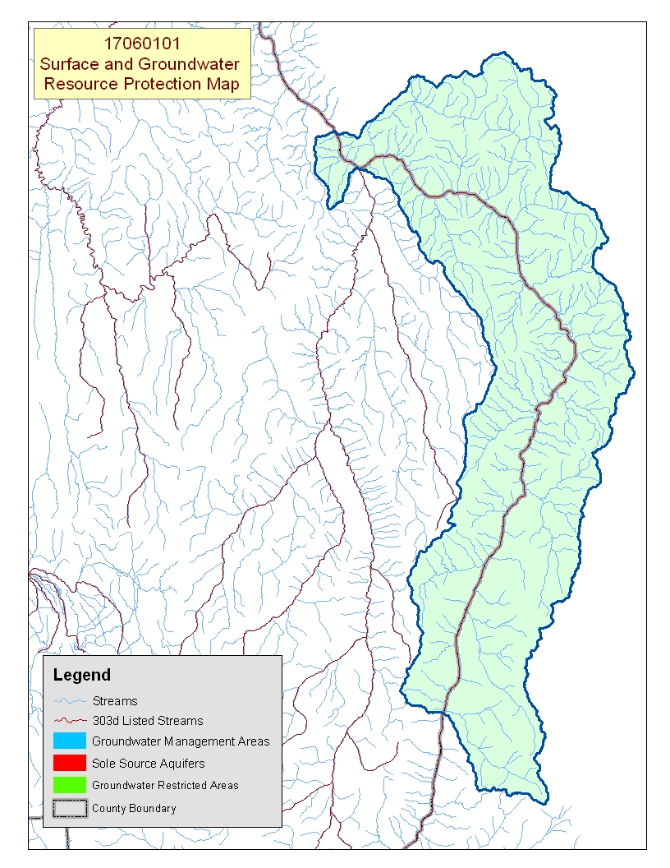
Idaho
Map Footnote ^{/17}

Census and Social Data^{/14} Back to Contents

There is no census or social data available for the Hells Canyon watershed because there is no private land in the Oregon part of the Hells Canyon watershed.

Number of Farms: 0
Number of Operators: 0
- Full-Time Operators: 0
- Part-Time Operators: 0

Estimated Level of Willingness and
Ability to Participate in Conservation^{/15}: n/a
Evaluation of Social Capital^{/16}: n/a

Progress/Status Back to Contents

PRMS Data | FY99 | FY00 | FY01 | FY02 | FY03 | Avg/Year | Total
Total Conservation Systems Planned (Acres) | 0 | 0 | 0 | 0 | 0 | 0 | 0
Total Conservation Systems Applied (Acres) | 0 | 0 | 0 | 0 | 0 | 0 | 0
Conservation Treatment
Waste Management (Number) | 0 | 0 | 0 | 0 | 0 | 0 | 0
Riparian Forest Buffers (Acres) | 0 | 0 | 0 | 0 | 0 | 0 | 0
Erosion Control (Acres) | 0 | 0 | 0 | 0 | 0 | 0 | 0
Irrigation Water Management (Acres) | 0 | 0 | 0 | 0 | 0 | 0 | 0
Nutrient Management (Acres) | 0 | 0 | 0 | 0 | 0 | 0 | 0
Pest Management (Acres) | 0 | 0 | 0 | 0 | 0 | 0 | 0
Prescribed Grazing (Acres) | 0 | 0 | 0 | 0 | 0 | 0 | 0
Trees and Shrubs (Acres) | 0 | 0 | 0 | 0 | 0 | 0 | 0
Conservation Tillage (Acres) | 0 | 0 | 0 | 0 | 0 | 0 | 0
Wildlife Habitat (Acres) | 0 | 0 | 0 | 0 | 0 | 0 | 0
Wetlands (Acres) | 0 | 0 | 0 | 0 | 0 | 0 | 0

Lands Removed from Production through Farm Bill Programs
- Conservation Reserve Program (CRP): none
- Wetland Restoration Program (WRP): none
- Conservation Reserve Enhancement Program (CREP): none

Footnotes/Bibliography Back to Contents
All data is provided “as is.” There are no warranties, express or implied, including the warranty of fitness
for a particular purpose, accompanying this document. Use for general planning purposes only.

- Ownership Layer – Source: The 1:24,000 scale public ownership layer is the land ownership/management for public entities, including Federal, Tribal, State, and local entities. This is a seamless, statewide Oregon Public Ownership vector layer composed of fee ownership of lands by Federal, State, Tribal, county, and city agencies. The layer is comprised of the best available data compiled at 1:24,000 scale or larger, and the line work matches GCDB boundary locations and ORMAP standards where possible. The layer is available from the State of Oregon GIS Service Center: http://www.gis.state.or.us/data/alphalist.html. For current ownership status, consult official records at appropriate Federal, State, and county offices. Ownership classes grouped to calculate Federal ownership vs. non-Federal ownership by the Water Resources Planning Team.

- National Land Cover Dataset (NLCD) - Originator: U.S. Geological Survey (USGS);
Publication date: 19990631; Title: Oregon Land Cover Data Set, Edition: 1;
Geospatial data presentation form: Raster digital data; Publisher: U.S. Geological Survey,
Sioux Falls, SD, USA; Online linkage: http://edcwww.cr.usgs.gov/programs/lccp/nationallandcover.html; Abstract: These data can be used in a geographic information system (GIS) for any number of purposes, such as assessing wildlife habitat, water quality, pesticide runoff, land use change, etc. The State data sets are provided with a 300-meter buffer beyond the State border to facilitate combining the State files into larger regions.

- ESTIMATES FROM THE 1997 NRI DATABASE (REVISED DECEMBER 2000) REPLACE ALL PREVIOUS REPORTS AND ESTIMATES. Comparisons made using data published for the 1982, 1987, or 1992 NRI may produce erroneous results. This is because of changes in statistical estimation protocols and because all data collected prior to 1997 were simultaneously reviewed (edited) as 1997 NRI data were collected. All definitions are available in the glossary. In addition, this December 2000 revision of the 1997 NRI data updates information released in December 1999 and corrects a computer error discovered in March 2000. For more information: http://www.nrcs.usda.gov/technical/NRI/

- Irrigated Adjudicated Water Rights – Water Rights Information System (WRIS), Oregon Water Resources Department, http://www.wrd.state.or.us/maps/wrexport.shtml

- StreamNet is a cooperative venture of the Pacific Northwest's fish and wildlife agencies and tribes and is administered by the Pacific States Marine Fisheries Commission. StreamNet provided data and data services in support of the region's fish and wildlife program and other efforts to manage and restore the region's aquatic resources. Official StreamNet website: http://www.streamnet.org/

- Natural Resources Conservation Service, Watershed Projects Planned and Authorized, http://www.nrcs.usda.gov/programs/watershed/Purpose.

- Natural Resources Conservation Service, Watershed Plans, Studies, and Assessments completed, http://www.nrcs.usda.gov/programs/watershed/Surveys_Plng.html#Watershed%20Surveys%20and%20Plan

- Oregon Department of Environmental Quality Total Maximum Daily Loads, http://www.deq.state.or.us/wq/TMDLs/TMDLs.htm

- Oregon Department of Agriculture, Agricultural Water Quality Management Plans, http://www.oregon.gov/ODA/NRD/water_agplans.shtml

Footnotes/Bibliography Continued Back to Contents
All data is provided “as is.” There are no warranties, express or implied, including the warranty of fitness
for a particular purpose, accompanying this document. Use for general planning purposes only.

- Oregon Watershed Enhancement Board, http://oregon.gov/OWEB/WSHEDS/index.shtml

- Watershed Assessments completed by local watershed councils following the Oregon Watershed Assessment Manual, http://oregon.gov/OWEB/docs/pubs/ws_assess_manual.shtml.

- NRCS Field Office Technical Guide, Section II, Threatened and Endangered List.

- Magnuson-Stevens Fishery Conservation and Management Act, Public Law 94-265. As amended through October 11, 1996.

- Data were taken from the 2002 Agricultural Census and adjusted by percent of HUC in the county or by percent of zip code area in the HUC, depending on the level of data available. Data were also taken from the U.S. Population Census, 2000.

- Conservation participation was estimated using NRCS Social Sciences Technical Note 1801, Guide for Estimating Participation in Conservation, 2004. Four categories of indicators were evaluated: Personal characteristics, farm structural characteristics, perceptions of conservation, and community context. Estimates are based on information received from local conservationists in the watershed.

- Social capital is an indicator of the community’s ability and willingness to work together to solve problems. A high amount of social capital helps a community to be physically healthy, socially progressive, and economically vigorous. A low amount of social capital typically results in community conflict, lack of trust and respect, and unsuccessful attempts to solve problems. The evaluation is based on NRCS Technical Report Release 4.1, March, 2002: Adding Up Social Capital: An Investment in Communities. Local conservationists provided information to measure social capital. Scores range from 0 to 76.

- Surface and Groundwater Resource Protection Map
  - 2002 303d Listed Streams designated by Oregon Department of Environmental Quality and approved by the Environmental Protection Agency, Section 303d Clean Water Act, http://www.deq.state.or.us/wq/303dlist/303dpage.htm
  - Groundwater Management Areas designated by the Oregon Department of Environmental Quality, Oregon Revised Statutes – Ground Water ORS 468B.150 to ORS 468B.190, http://www.deq.state.or.us/wq/groundwa/wqgw.htm
  - Groundwater Restricted Areas designated by Oregon Water Resources Commission, Oregon Department of Water Resources, http://egov.oregon.gov/OWRD/PUBS/aquabook_protections.shtml
  - The Sole Source Aquifer (SSA) Protection Program is authorized by Section 1424(e) of the Safe Drinking Water Act of 1974 (Public Law 93-523, 42 U.S.C. 300 et. seq), http://www.epa.gov/safewater/ssanp.html

- Subbasin assessments and plans are developed by local groups (SWCDs, watershed councils, tribes, and others) as part of the Northwest Power and Conservation Council’s fish and wildlife program in the Columbia River Basin. This program is funded and implemented by the Bonneville Power Administration. http://www.nwcouncil.org/fw/subbasinplanning/Default.htm.

