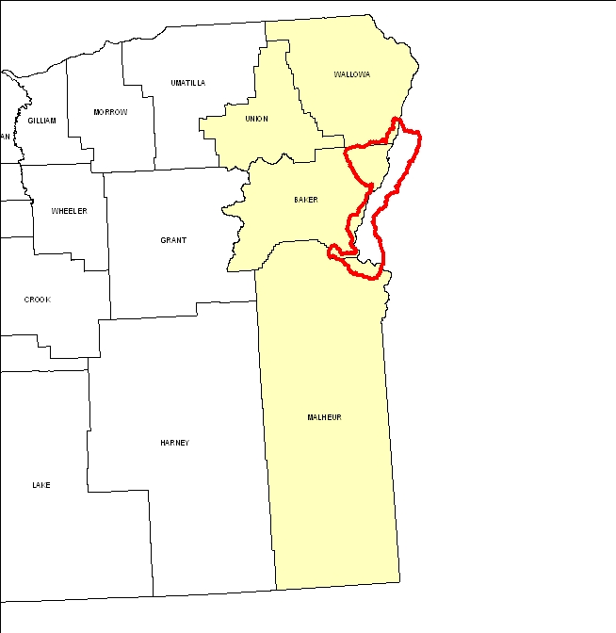
Introduction
The Oregon part of the Brownlee Reservoir 8-Digit Hydrologic Unit Code (HUC) subbasin is comprised of 414,000 acres in Baker, Malheur, and Wallowa Counties. Fifty percent of the subbasin is range, twenty-nine percent is forest, sixteen percent is hayland and pastureland, and a small amount of the remaining land is used for grain and row crops. Most of the forestland is grazed. There are six permitted Confined Animal Feeding Operations (CAFOs) and about 18,000 permitted animals in the subbasin. Major resource concerns include concentrated flow, streambank, and irrigation-induced erosion; invasive and noxious weeds; insufficient water to meet livestock, wildlife, and irrigation needs; impaired water quality; and loss of wildlife habitat. High costs, unreliable markets, inadequate incentives, and lack of technical assistance limit adoption of conservation practices among farmers and ranchers in the Brownlee Reservoir subbasin.

There are 239 operations and 403 farmers and ranchers in the subbasin. Most operators are well educated, aware of local resource concerns, and good stewards of the natural resources. Unfortunately, many are also part-time operators who do not have a conservation plan nor any experience with conservation practices. The perceived expense and risk of implementing conservation practices by these operators seem to limit adoption. To increase the diffusion of conservation in the subbasin, there is a need for additional technical and financial assistance, alternative risk-reducing incentives, and greater community support.

The Ontario and Baker NRCS Service Centers; Malheur, Eagle Valley, and Burnt River Soil and Water Conservation Districts; and Malheur Watershed Council provide much of the conservation assistance in the subbasin.

Profile Contents

Introduction
Physical Description
Land Use Map & Precipitation Map
Common Resource Area
Resource Concerns
Census and Social Data
Progress/Status
Footnotes/Bibliography

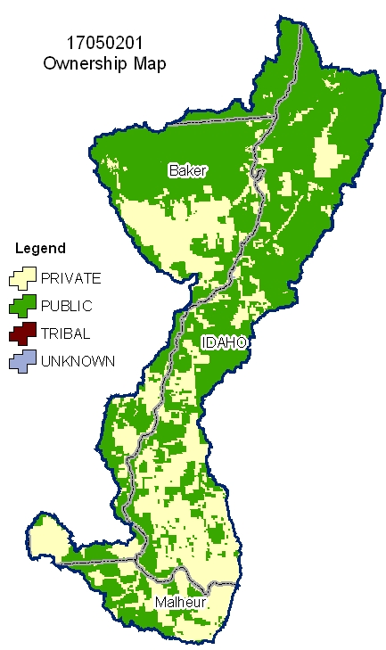
Relief Map
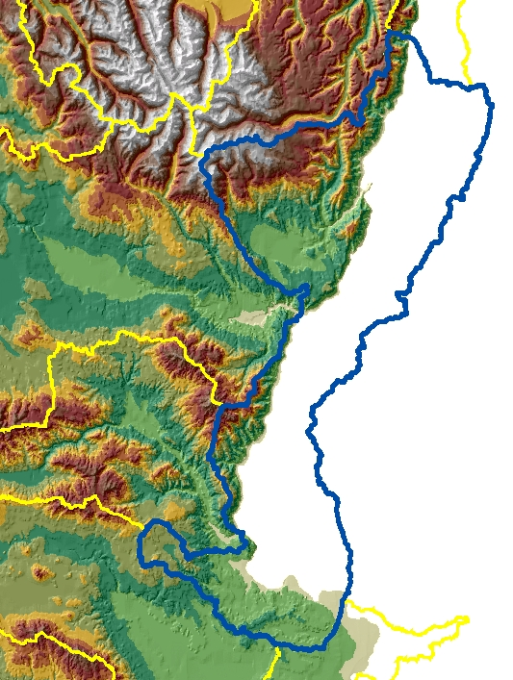

Produced by the Water Resources Planning Team Portland, OR
The United States Department of Agriculture (USDA) prohibits discrimination in all its programs and activities on the basis of race, color, national origin, sex, religion, age, disability, political beliefs, sexual orientation, and marital or family status. (Not all prohibited bases apply to all programs.) Persons with disabilities who require alternative means for communication of program information (Braille, large print, audiotape, etc.) should contact USDA’s TARGET Center at 202-720-2600 (voice and TDD).
To file a complaint of discrimination, write USDA, Director, Office of Civil Rights, Room 326W, Whitten Building, 14th and Independence Avenue, SW, Washington DC 20250-9410, or call (202) 720-5964 (voice and TDD). USDA is an equal opportunity provider and employer.

Physical Description Back to Contents
ALL NUMBERS IN THIS PROFILE ARE FOR OREGON ONLY
Land Cover/Land Use  (NLCD^{/2}) | Ownership - (2003 Draft BLM Surface Map Set^{/1})
Land Cover/Land Use  (NLCD^{/2}) | Public |  | Private |  | Tribal |  | Totals | %
Land Cover/Land Use  (NLCD^{/2}) | Acres | % | Acres | % | Acres | % | Totals | %
Forest | 109,800 | 27% | 10,100 | 2% | 0 | 0% | 119,900 | 29%
Grain Crops | * | --- | * | --- | 0 | 0% | * | ---
Conservation Reserve Program Land ª | * | --- | * | --- | 0 | 0% | * | ---
Grass/Pasture/Hay | 31,200 | 8% | 35,700 | 9% | 0 | 0% | 67,200 | 16%
Orchards/Vineyards | 0 | 0% | 0 | 0% | 0 | 0% | 0 | 0%
Row Crops | * | --- | * | --- | 0 | 0% | * | ---
Shrub/Rangelands | 112,800 | 27% | 95,200 | 23% | 0 | 0% | 208,300 | 50%
Water/Wetlands/Developed/Barren | * | --- | * | --- | 0 | 0% | 13,800 | 3%
Oregon HUC Totals b | 258,500 | 62% | 149,500 | 36% | 0 | 0% | 413,600 | 100%
*: Less than 1 percent of total acres. See below for special considerations.
a: Estimate from Farm Service Agency records and includes CRP/CREP.
b: Totals are approximate due to rounding and small unknown acreages.
Special Considerations for This 8-Digit HUC:

Field Office estimates:

- Less than 10 percent of the private forestland is under industrial ownership and management.

- 75 percent of the forestland is grazed by livestock.

Irrigated Lands  (1997 NRI^{/3} Estimates for Non-Federal Lands Only) | Type of Land | ACRES | % of  Irrigated Lands | % of  HUC
 | Cultivated Cropland | 4,700 | 27% | 1%
 | Uncultivated Cropland | 2,900 | 17% | <1%
 | Pastureland | 9,600 | 56% | 2%
 | Total Irrigated Lands | 17,200 | 100% | 4%
(Continued on the following pages)

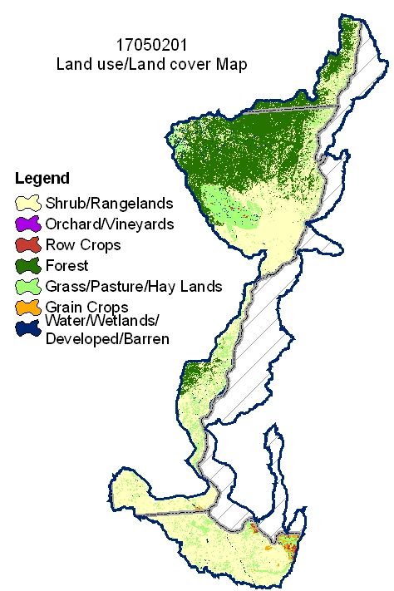
Back to Contents

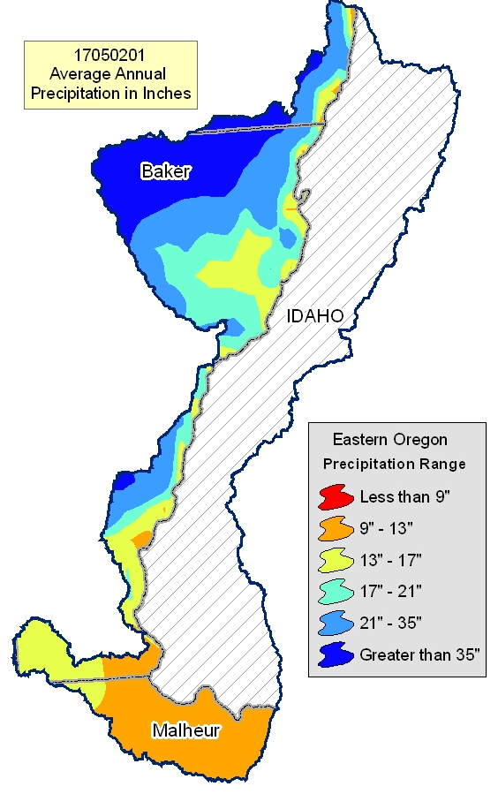

Common Resource Area Map Back to Contents

Only the major units are described below - for descriptions of all units within the HUC, go to: http://ice.or.nrcs.usda.gov/website/cra/viewer.htm
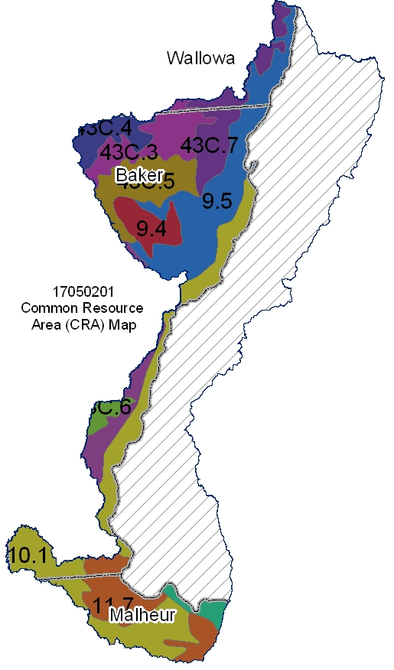
9.4 – Palouse and Nez Perce Prairies - Deep Loess Foothills: This unit is characterized by the lower, northwest-facing slopes of the eastern Blue Mountains. It consists of deep and very deep loess deposits on hills and terraces. The soils are dominantly those of the Athena, Imbler, Palouse, Lostine, and Ladd series. The temperature regime is mesic, and the moisture regime is xeric. The mean annual precipitation is 15 to 24 inches. Most areas are used as cropland.

9.5 – Palouse and Nez Perce Prairies - Warm Canyons and Dissected Uplands: This unit is characterized by deep river canyons that divide the Blue Mountains from the Rocky Mountains. The Snake, Salmon, and Grande Ronde Rivers and their tributaries have cut through the metasedimentary and metavolcanic rock of the Columbia Plateau to a depth of 2,000 to 5,000 feet. The deep canyon and exposed metamorphic rock have resulted in stony soils on canyonsides that retain little moisture. The dominant soils are those of the Dixiejett and Lickskillet series. The temperature regime is mesic, and the moisture regime is xeric and aridic. The mean annual precipitation is 12 to 16 inches. Bluebunch wheatgrass, Sandberg bluegrass, and spiny greenbush are adapted to these hot, dry conditions. Land uses include grazing and recreation on National Forest land and in the Hells Canyon National Recreation Area.

10.1 – Central Rocky and Blue Mountains Foothills - Warm Dry Blue and Seven Devils Mountains Foothills: This unit is between the Blue and Wallowa Mountains in Oregon and the northwestern part of the Snake River Plain. It is characterized by rangeland soils on hills and mountains associated with basalt and exposed tuffaceous sediment. The Cascade Range and the Blue and Wallowa Mountains block any maritime influence, creating a continental climate. As a result, plants are subject to wide temperature ranges, a high rate of evapotranspiration, and high early-season moisture stress. The dominant soils are those of the Brogan, Simas, Ruckles, and Ruclick series. The temperature regime is mesic, and the moisture regime is aridic. The mean annual precipitation is 9 to 12 inches. The vegetation is Wyoming big sagebrush and bluebunch wheatgrass (warm day climate).

11.7 – Snake River Plains - Dry Unwooded Alkaline Foothills: This shrub- and grass-covered unit is higher and more rugged than adjacent valley units. Unlike other units, this unit consists of terrace deposits of alkaline lacustrine and supports a unique flora. Shallow and moderately deep soils over a cemented pan are common. The potential natural vegetation is saltbush-greasewood and sagebrush steppe. Presently, cheatgrass and crested wheatgrass are also common, and the unit is used for livestock grazing.

43C.3 – Blue and Seven Devils Mountains - High Elevation Blue and Seven Devils Mountains Forests: This unit is characterized by forested plateaus that have cryic temperatures. It characteristically has deep snowpack and a very short growing season. The moisture regime is udic. The vegetation is dominantly subalpine fir, Engelmann spruce, and larch. Streams follow fault lines, have steep gradients, and have eroded, deep canyons. Land uses include grazing, logging, recreation, and wildlife habitat.

43C.7 – Blue and Seven Devils Mountains - Low Elevation Blue Mountains Forests: This unit is a forested, uplifted basalt plateau. It is characterized by forested plateaus and highly dissected canyons that have frigid temperatures. Slopes are nearly level to rolling, except in the canyons where they are very steep. The moisture regime is xeric and udic. The vegetation is dominantly grand fir, Douglas-fir, and ponderosa pine. The soils in this unit typically have a mantle of ash as much as 20 to 30 inches thick.

Physical Description – Continued Back to Contents

 |  | ACRES | ACRE-FEET
Irrigated Adjudicated Water Rights (OWRD^{/4}) | Surface | 25,545 | 77,738
Irrigated Adjudicated Water Rights (OWRD^{/4}) | Well | 1,487 | 4,527
Irrigated Adjudicated Water Rights (OWRD^{/4}) | Total Irrigated Adjudicated Water Rights | 27,032 | 82,264
Stream Flow Data | USGS 13290450 SNAKE RIVER AT HELLS CANYON DAM, ID-OR STATE LINE | Total Avg. Yield | 14,627,068
Stream Flow Data |  | May – Sept. Yield | 5,496,694
 |  | MILES | PERCENT
Stream Data^{/5}  *Percent of Total Miles  of Streams in HUC | Total Miles – Major (100K Hydro GIS Layer) | 421 | ---
Stream Data^{/5}  *Percent of Total Miles  of Streams in HUC | 303d/TMDL Listed Streams (DEQ) | 193 | 46%
Stream Data^{/5}  *Percent of Total Miles  of Streams in HUC | Anadromous Fish Presence (StreamNet) | 0 | 0%
Stream Data^{/5}  *Percent of Total Miles  of Streams in HUC | Bull Trout Presence (StreamNet) | 34 | 8%
 |  | ACRES | PERCENT
Land Cover/Use^{/2}  Based on a 100-foot stretch on both sides  of all streams in the  100K Hydro GIS Layer | Forest | 5,579 | 32%
 | Grain Crops | 118 | 0%
 | Grass/Pasture/Hay | 2,825 | 16%
 | Orchards/Vineyards | 0 | 0%
 | Row Crops | 90 | 0%
 | Shrub/Rangelands – Includes CRP Lands | 8,189 | 46%
 | Water/Wetlands/Developed/Barren | 854 | 5%
 | Total Acres of 100-foot Stream Buffers | 17,655 | ---
Land Capability Class  (Croplands & Pasturelands Only)  (1997 NRI^{/3} Estimates for Non-Federal Lands Only) | 1 – slight limitations | 0 | 0%
 | 2 – moderate limitations | 2,300 | 13%
 | 3 – severe limitations | 12,400 | 72%
 | 4 – very severe limitations | 1,700 | 10%
 | 5 – no erosion hazard, but other limitations | 0 | 0%
 | 6 – severe limitations; unsuitable for cultivation; limited to pasture, range, forest | 800 | 5%
 | 7 – very severe limitations; unsuitable for cultivation; limited to grazing, forest, wildlife habitat | 0 | 0%
 | 8 – miscellaneous areas; limited to recreation, wildlife habitat, water supply | 0 | 0%
 | Total Croplands & Pasturelands | 17,200 | ---

Confined Animal Feeding Operations – Oregon CAFO Permit – 12/2004
Animal Type | Dairy | Feedlot | Poultry | Swine | Mink | Other
No. of Permitted Farms | 4 | 2 | 0 | 0 | 0 | 0
No. of Permitted Animals | 955 | 17,000 | 0 | 0 | 0 | 0

Resource Concerns Back to Contents

Tons of Soil Loss by Water Erosion: Due to the limited amount of non-Federal cropland and pastureland within this HUC, no reliable NRI soil loss estimates are available.

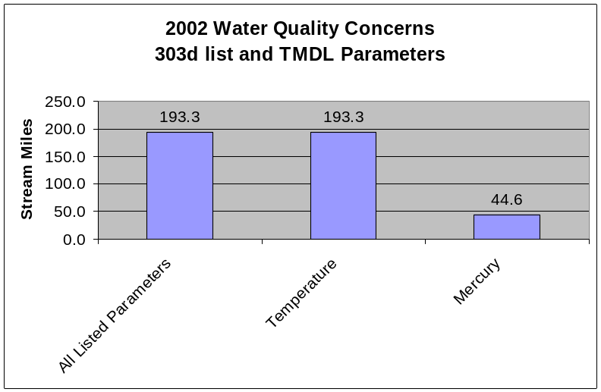
- All of the listed stream miles exceed state water quality standards for temperature. Elevated stream temperatures may be due to inadequate riparian shade, stream channel widening, and other anthropogenic or natural causes.

- High mercury levels are due in large part to past mining activities.

- Conservation practices that can be used to address these water quality issues include irrigation water management, grazing management, and use of riparian buffers.

Watershed Projects, Plans, Studies, and Assessments
NRCS Watershed Projects⁶ |  |  | NRCS Watershed Plans, Studies, and Assessments⁷
Name | Status |  | Name | Status
Pine Valley | Deauthorized 1970 |  | None | None
ODEQ TMDL’s⁸ |  |  | ODA Agricultural Water Quality Management Plans⁹
Name |  | Status | Name | Status
Columbia/Snake Rivers |  | Draft | Malheur  Powder/Brownlee | Completed  Completed
OWEB Watershed Council¹⁰ |  | Watershed Council Assessments¹¹ |  | NWPCC Subbasin Plans and Assessments¹⁸
Grande Ronde Model Watershed, Malheur Watershed Council, Powder Basin Watershed Council |  | Malheur Basin Watershed Action Plan & Assessment  Pine Creek Watershed Assessment |  | Lower Middle Snake

Federally Listed Threatened And Endangered Species¹²
THREATENED SPECIES | CANDIDATE SPECIES
Mammals-Canada lynx  Birds – Bald eagle  Fish – Bull trout  Plants – Howell's spectacular thelypody | Birds – Yellow-billed cuckoo  Amphibians and Reptiles – Columbia spotted frog  Plants- Slender moonwort
 | PROPOSED SPECIES None
Essential Fish Habitat¹³ - None

(Continued on page 8)

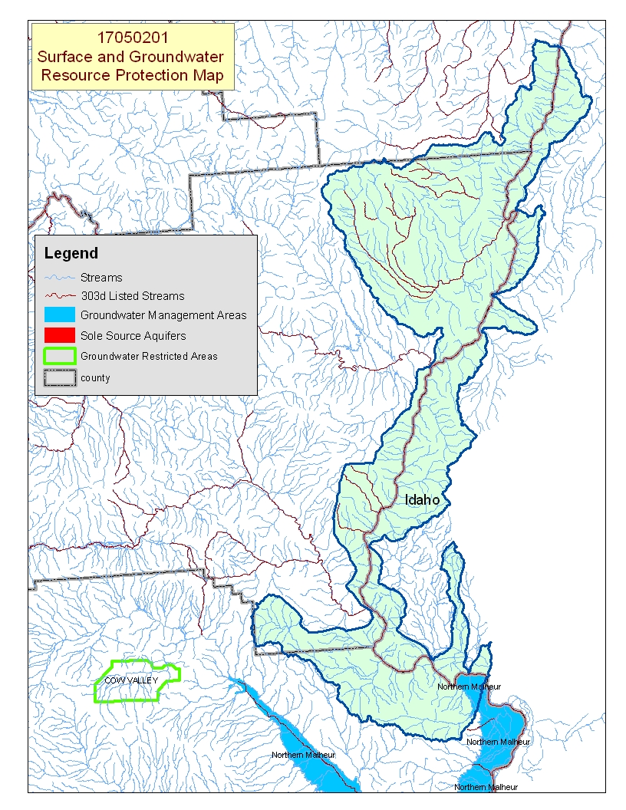
Map Footnote ^{/17}

Resource Concerns - Continued Back to Contents
Resource Concerns/Issues by Land Use
SWAPA +H Concerns | Specific Resource Concern/Issue | Grass\Pasture\Hay | Grain Crops | Row Crops | Perennial Crops (Orch/Vine/ Berries) | Shrub/Range | Forest
Soil Erosion | Streambank | X |  |  |  | X | X
Soil Erosion | Irrigation Induced | X | X
Soil Condition | Tilth, Crusting, Infiltration, Organic Matter |  | X | X
Soil Contamination | Excess Fertilizers and Pesticides |  |  | X
Water Quantity | Water Management For Irrigated Land | X | X | X
Water Quantity | Water Management For Nonirrigated Land |  |  |  |  | X
Water Quality, Groundwater | Pesticides |  |  | X
Water Quality, Groundwater | Nutrients and Organics |  | X | X
Water Quality, Groundwater | Pathogens |  |  | X
Water Quality, Surface | Pesticides |  |  | X
Water Quality, Surface | Nutrients and Organics |  |  | X
Water Quality, Surface | Suspended Sediments and Turbidity | X | X | X |  | X | X
Water Quality, Surface | Temperature | X | X |  |  | X | X
Water Quality, Surface | Pathogens |  |  | X
Plant Suitability | Site and Intended Use Suitability | X |  |  |  | X
Plant Suitability | Invasive Weeds | X |  |  |  | X
Plant Condition | Productivity, Health, and Vigor | X |  |  |  | X | X
Plant Management | Establishment, Growth, and Harvest |  |  |  |  |  | X
Animal Habitat, Domestic | Water - Quantity & Quality | X |  |  |  | X
Animal Habitat, Wildlife | Food, Cover, and/or Shelter |  |  | X |  | X | X
Human, Economics | High Risk & Uncertainty |  |  | X
Human, Economics | High Capital/Financial Costs | X | X | X
Human, Economics | High Management Level Required |  |  | X
Human, Economics | Low or Unreliable Profitability |  |  | X
Human, Political | Inadequate Availability of Cost Share Programs | X | X | X |  | X | X
Human, Political | Lack of Technical Assistance | X | X |  |  | X | X
Pasture/Hay
- Better irrigation water management is practiced in areas used for alfalfa than in areas of pasture.
- In some areas of pasture, a lack of proper grazing management has lead to its poor condition.
- Areas of pasture commonly are adjacent to streams, which can contribute to streambank erosion, sedimentation, and elevated temperatures as a result of loss of riparian vegetation.
Grain and Row Crops
- Most grain is produced in rotation with other crops (potatoes, corn, alfalfa, etc.)
- Irrigation-induced erosion may occur on fields used for crops such as potatoes or corn.
- Surface-irrigated areas of grain are also prone to irrigation-induced erosion.
- Water management is always a concern with irrigated crops, but irrigation water management is better in areas used for row crops than it is in areas used as pasture.
Rangeland/Forestland
- Rangeland can become infested with noxious weeds, annual grasses, and shrubs as a result of inadequate forage and grazing management.
- Loss of riparian vegetation contributes to the warming and nutrient-loading of streams.
- About 30 percent of the private forestland is managed by private industrial owners, who generally comply with State forest practice requirements.
- Private non-industrial forestland commonly is associated with grazed woodland; it is not managed primarily for timber production.
- Private forests are subject to damage from insects and disease, overstocking, and fuel buildup. Thinning is needed to increase productivity and reduce the risk of catastrophic fire.
- High cost, unreliable markets, and inadequate incentive programs limit forestland management activities.

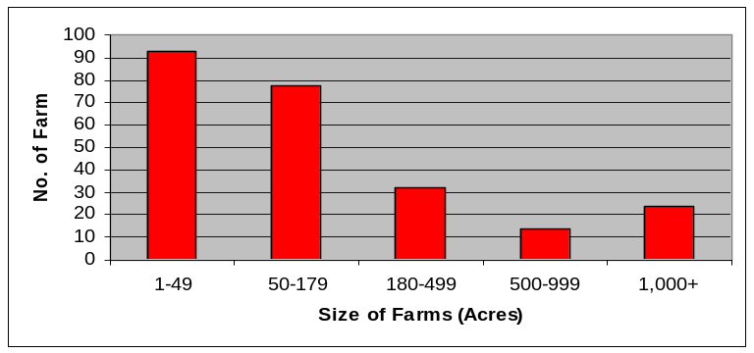
Census and Social Data^{/14} Back to Contents

Number of Farms: 239
Number of Operators: 403
- Full-Time Operators: 152
- Part-Time Operators: 251

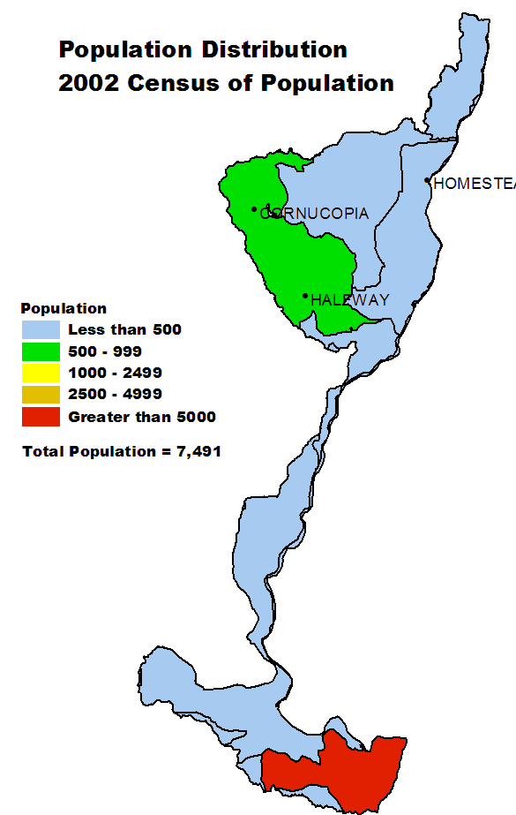
Estimated Level of Willingness and Ability to Participate in Conservation^{/15}: Moderate
Most operators in the Brownlee Reservoir subbasin are well educated, aware of local resource concerns, and appreciate the economic and environmental benefits of conservation. Most recommended conservation practices can be implemented incrementally and are compatible with local ranch and farm equipment and management systems. On the other hand, many operators in the subbasin are new, small acreage ranchers who do not have conservation plans and have little experience with natural resource management, agriculture, and conservation. The perceived high capital costs of conservation and risks associated with intense irrigated agriculture discourage many farmers and ranchers from adopting conservation systems.

Timely technical assistance, additional financial assistance, and other risk-reducing incentives may increase the adoption of conservation systems in the subbasin.

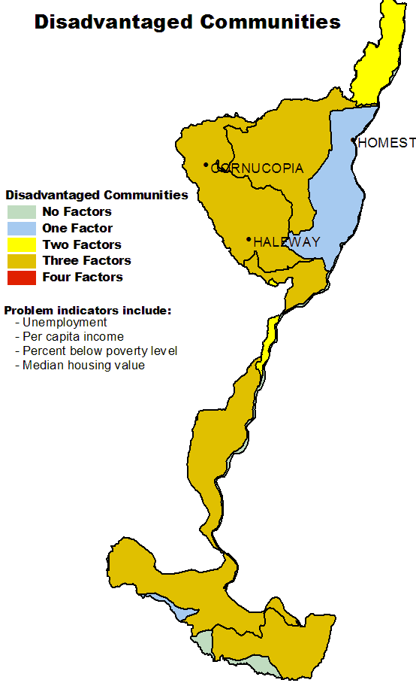

Evaluation of Social Capital^{/16}: Moderate
Social capital and the ability of the community to solve problems and support conservation are estimated to be moderate. Recent trends indicate that the population is increasing in the southern part of the subbasin, near the city of Ontario. The primary occupation of the new landowners commonly is not agricultural nor resource based. People moving to the area commonly do so for the rural, high-quality lifestyle and the relatively inexpensive housing and property. Newcomers to the area tend to look at natural resources as recreational opportunities not as a means for making a living. In part, this has resulted in community interest shifting from agricultural and natural resource concerns to issues related to improving schools, transportation, health services, etc.

Until resource management and agriculture regain the attention of the entire community, it is unlikely the community will be a significant partner in the diffusion of conservation in the agricultural community.
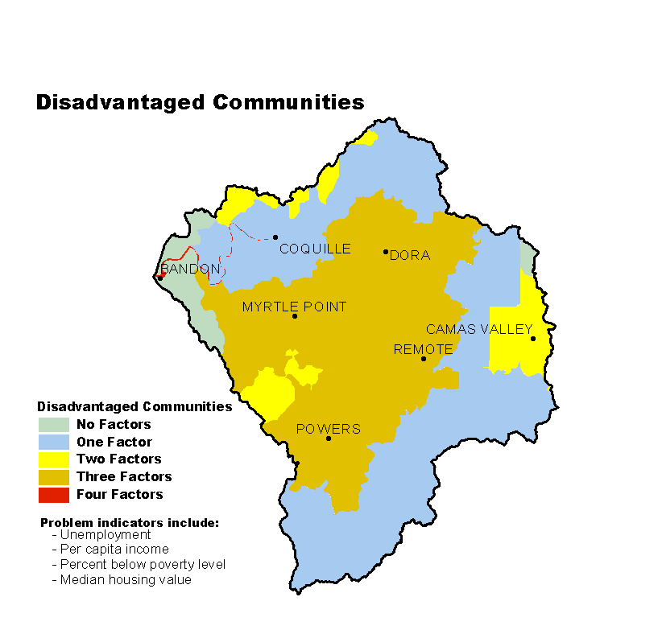

Progress/Status Back to Contents

PRMS Data | FY99 | FY00 | FY01 | FY02 | FY03 | Avg/Year | Total
Total Conservation Systems Planned (Acres) | 0 | 418 | 486 | 2,664 | 1,106 | 935 | 4,674
Total Conservation Systems Applied (Acres) | 0 | 618 | 486 | 114 | 119 | 267 | 1,337
Conservation Treatment (Acres)
Waste Management | 0 | 0 | 0 | 0 | 0 | 0 | 0
Buffers | 0 | 0 | 0 | 0 | 122 | 24 | 122
Erosion Control | 0 | 686 | 488 | 71 | 55 | 260 | 1,300
Irrigation Water Management | 0 | 35 | 486 | 433 | 160 | 223 | 1,114
Nutrient Management | 0 | 418 | 486 | 242 | 211 | 271 | 1,357
Pest Management | 0 | 151 | 486 | 0 | 0 | 127 | 637
Prescribed Grazing | 0 | 0 | 486 | 2,275 | 0 | 552 | 2,761
Trees & Shrubs | 0 | 75 | 0 | 0 | 17 | 18 | 92
Conservation Tillage | 0 | 113 | 0 | 0 | 0 | 23 | 113
Wildlife Habitat | 0 | 80 | 100 | 5 | 970 | 231 | 1,155
Wetlands | 0 | 1 | 0 | 0 | 4 | 1 | 5
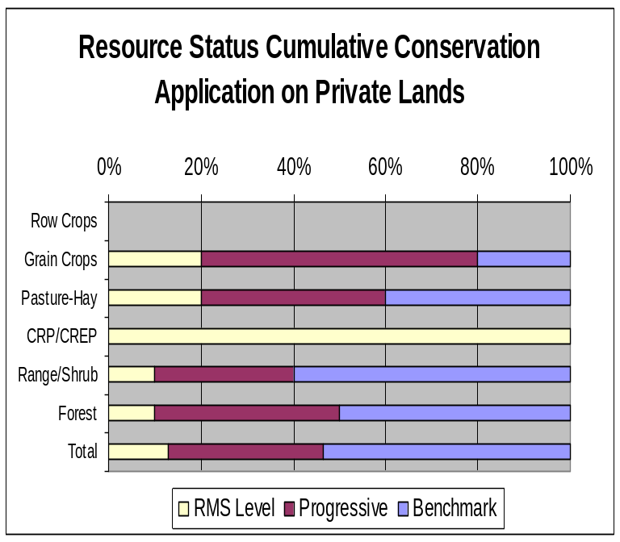
Progress over the last 5 years has been focused on:
- Erosion control and irrigation water management on grain crops.
- Nutrient management.
- Prescribed grazing on grazing land.
- Wildlife habitat management, including use of buffers, trees, and shrubs in riparian areas.
- Most grain producers practice conservation cropping and residue management.
- Most hay producers practice good irrigation water management; however, grazing and water management is inadequate on pastures.
- Most private industrial timber owners are doing good conservation work and are satisfying State forest practice requirements.
- Most private non-industrial woodlots are associated with forest grazing allotments that are not primarily managed for timber production.

Estimates are based on information received from local conservationists in the watershed.

Lands Removed from Production through Farm Bill Programs
- Conservation Reserve Program (CRP): 143 acres
- Wetland Restoration Program (WRP): None
- Conservation Reserve Enhancement Program (CREP): 42 acres

Footnotes/Bibliography Back to Contents
All data is provided “as is.” There are no warranties, express or implied, including the warranty of fitness
for a particular purpose, accompanying this document. Use for general planning purposes only.

- Ownership Layer – Source: The 1:24,000 scale public ownership layer is the land ownership/management for public entities, including Federal, Tribal, State, and local entities. This is a seamless, statewide Oregon Public Ownership vector layer composed of fee ownership of lands by Federal, State, Tribal, county, and city agencies. The layer is comprised of the best available data compiled at 1:24,000 scale or larger, and the line work matches GCDB boundary locations and ORMAP standards where possible. The layer is available from the State of Oregon GIS Service Center: http://www.gis.state.or.us/data/alphalist.html. For current ownership status, consult official records at appropriate Federal, State, and county offices. Ownership classes grouped to calculate Federal ownership vs. non-Federal ownership by the Water Resources Planning Team.

- National Land Cover Dataset (NLCD) - Originator: U.S. Geological Survey (USGS);
Publication date: 19990631; Title: Oregon Land Cover Data Set, Edition: 1;
Geospatial data presentation form: Raster digital data; Publisher: U.S. Geological Survey,
Sioux Falls, SD, USA; Online linkage: http://edcwww.cr.usgs.gov/programs/lccp/nationallandcover.html; Abstract: These data can be used in a geographic information system (GIS) for any number of purposes, such as assessing wildlife habitat, water quality, pesticide runoff, land use change, etc. The State data sets are provided with a 300-meter buffer beyond the State border to facilitate combining the State files into larger regions.

- ESTIMATES FROM THE 1997 NRI DATABASE (REVISED DECEMBER 2000) REPLACE ALL PREVIOUS REPORTS AND ESTIMATES. Comparisons made using data published for the 1982, 1987, or 1992 NRI may produce erroneous results. This is because of changes in statistical estimation protocols and because all data collected prior to 1997 were simultaneously reviewed (edited) as 1997 NRI data were collected. All definitions are available in the glossary. In addition, this December 2000 revision of the 1997 NRI data updates information released in December 1999 and corrects a computer error discovered in March 2000. For more information: http://www.nrcs.usda.gov/technical/NRI/

- Irrigated Adjudicated Water Rights – Water Rights Information System (WRIS), Oregon Water Resources Department, http://www.wrd.state.or.us/maps/wrexport.shtml

- StreamNet is a cooperative venture of the Pacific Northwest's fish and wildlife agencies and tribes and is administered by the Pacific States Marine Fisheries Commission. StreamNet provided data and data services in support of the region's fish and wildlife program and other efforts to manage and restore the region's aquatic resources. Official StreamNet website: http://www.streamnet.org/

- Natural Resources Conservation Service, Watershed Projects Planned and Authorized, http://www.nrcs.usda.gov/programs/watershed/Purpose.

- Natural Resources Conservation Service, Watershed Plans, Studies, and Assessments completed, http://www.nrcs.usda.gov/programs/watershed/Surveys_Plng.html#Watershed%20Surveys%20and%20Plan

- Oregon Department of Environmental Quality Total Maximum Daily Loads, http://www.deq.state.or.us/wq/TMDLs/TMDLs.htm

- Oregon Department of Agriculture, Agricultural Water Quality Management Plans, http://www.oregon.gov/ODA/NRD/water_agplans.shtml

Footnotes/Bibliography Continued Back to Contents
All data is provided “as is.” There are no warranties, express or implied, including the warranty of fitness
for a particular purpose, accompanying this document. Use for general planning purposes only.

- Oregon Watershed Enhancement Board, http://oregon.gov/OWEB/WSHEDS/index.shtml

- Watershed Assessments completed by local watershed councils following the Oregon Watershed Assessment Manual, http://oregon.gov/OWEB/docs/pubs/ws_assess_manual.shtml.

- NRCS Field Office Technical Guide, Section II, Threatened and Endangered List.

- Magnuson-Stevens Fishery Conservation and Management Act, Public Law 94-265. As amended through October 11, 1996.

- Data were taken from the 2002 Agricultural Census and adjusted by percent of HUC in the county or by percent of zip code area in the HUC, depending on the level of data available. Data were also taken from the U.S. Population Census, 2000.

- Conservation participation was estimated using NRCS Social Sciences Technical Note 1801, Guide for Estimating Participation in Conservation, 2004. Four categories of indicators were evaluated: Personal characteristics, farm structural characteristics, perceptions of conservation, and community context. Estimates are based on information received from local conservationists in the watershed.

- Social capital is an indicator of the community’s ability and willingness to work together to solve problems. A high amount of social capital helps a community to be physically healthy, socially progressive, and economically vigorous. A low amount of social capital typically results in community conflict, lack of trust and respect, and unsuccessful attempts to solve problems. The evaluation is based on NRCS Technical Report Release 4.1, March, 2002: Adding Up Social Capital: An Investment in Communities. Local conservationists provided information to measure social capital. Scores range from 0 to 76.

- Surface and Groundwater Resource Protection Map
  - 2002 303d Listed Streams designated by Oregon Department of Environmental Quality and approved by the Environmental Protection Agency, Section 303d Clean Water Act, http://www.deq.state.or.us/wq/303dlist/303dpage.htm
  - Groundwater Management Areas designated by the Oregon Department of Environmental Quality, Oregon Revised Statutes – Ground Water ORS 468B.150 to ORS 468B.190, http://www.deq.state.or.us/wq/groundwa/wqgw.htm
  - Groundwater Restricted Areas designated by Oregon Water Resources Commission, Oregon Department of Water Resources, http://egov.oregon.gov/OWRD/PUBS/aquabook_protections.shtml
  - The Sole Source Aquifer (SSA) Protection Program is authorized by Section 1424(e) of the Safe Drinking Water Act of 1974 (Public Law 93-523, 42 U.S.C. 300 et. seq), http://www.epa.gov/safewater/ssanp.html

- Subbasin assessments and plans are developed by local groups (SWCDs, watershed councils, tribes, and others) as part of the Northwest Power and Conservation Council’s fish and wildlife program in the Columbia River Basin. This program is funded and implemented by the Bonneville Power Administration. http://www.nwcouncil.org/fw/subbasinplanning/Default.htm.

