U.S. Department of Agriculture

real estate title clearance and loan closing

The provisions of this State Supplement do not apply to Multi-Family Housing (MFH) loans; MFH Loans will be closed in consultation with the State Office and Office of General Counsel

Sec. 1927.51 - General. This State Supplement supplements applicable portions of RD Instruction 1927-B and specifies how to close all types of real estate loans, assumptions, and credit sales.

Sec. 1927.52 - Definitions. As used in this State Supplement:

American Land Title Association (ALTA) Policy. ALTA Loan Policy-1992 with ALTA Endorsement Form 1 Coverage for other than leaseholds and ALTA Leasehold Loan Policy-1992 with ALTA Endorsement - Form 1 Coverage for leaseholds

Approval Official. The employee who has written loan approval authority and includes Community Development Manager or Rural Development Manager.

Title Company. A title insurance company or branch or affiliate thereof authorized by the Government to close the particular transaction, listed herewith in Exhibit A, Attachment 1.

Title Policy. The type of title insurance required by USDA for the particular transaction.

Title Report. A preliminary title report or BIA title status report.

Sec. 1927.54 (d) - Approval of title companies.

- The use of Form RD 1927-20 and approval and bonding requirements for title companies for each transaction under this Section is unnecessary since State laws in California impose stricter compliance and requirements. Title companies are also regulated by such departments or agencies as "Department of Insurance," "Department of Real Estate," and by-laws and rules of the California Land Title Association (CLTA), as well as State Statutes governing disbursement of funds and handling escrow accounts.

- Only title insurance companies or title and escrow companies approved in accordance with Exhibit A of this California Supplement and listed in Attachments 1 thereof, are authorized to close transactions. These are title insurance companies or title and escrow companies underwritten by a title insurance company where an "Indemnity Agreement" similar to Attachment 2 of Exhibit A of this California Supplement, or a “Closing Protection Letter”, has been executed to protect USDA against losses due to errors or omissions. Title insurance companies or title companies underwritten by a title insurance company are normally "regular" or "associate members" of the California Land Title Association. For new title company approval process, refer to the Exhibit A of this supplement.

Distribution: S,A,L Real Estate Title Closing
And Loan Closing

- Termination of "closing agents" will be handled as outlined in RD Instruction 1940-M. This is because authorization to close USDA transactions is provided to the title insurance company (governed by stricter State laws) or to the title company underwritten by a title insurance company, upon closing agents’ signing of Form CA 1927-4, “Request for Approval of Title Company Office.”

Sec. 1927.54(f) - Responsibility of Approval Official. The approval official will see that all transactions are closed by one of the following methods:

a. With the services of OGC:

(1) Real Estate transactions involving other than fee simple title (i.e. long term leasehold);

(2) Real estate loans and assumptions when:

- The USDA deed of trust will be junior to contract of sale, with exception of the SFH leveraged loans;

- The security property is or will be owned by an Indian(s) in trust or restricted status;

- The loan is to a homestead entryman who by closing will not have received a patent; or

(3) The loan will be secured by land in more than one State.

- By Community Development Manager and the title company, in accordance with Section 2 and 3 of Chapter 8, HB-1-3550, for all other real estate loans and credit sales to individuals, including assumptions with new loans. Where appropriate, ensure title companies execute or process Builder’s Warranty FmHA Form 1924-19 and Termite Soil Treatment Guarantee CA Form 1924-11.

Sec. 1927.55 (c) - Ordering title services. When it appears that the loan or credit sale can be approved and funded, the applicant or applicant's representative will be asked to obtain a Preliminary Title Report (PTR) from authorized title companies of his/her choice, listed in Exhibit A of this California Supplement. USDA cannot recommend one specific title company to close a particular transaction.

For loans on Indian Trust Lands, obtain a Title Status Report (TSR) from the Bureau of Indian Affairs Office listed in Exhibit F of this Supplement. The closing agent will not be able to provide title information on the tribal land. If you are working with a “compact tribe”, the tribe will be able to provide the TSR.

2

Sec. 1927.55(e) - Use of title insurance. For all loans and credit sales on non-Indian lands requiring title clearance, an ALTA policy, as defined in Sec. 1927.52, is required for the full amount of the loan or credit sale. Exceptions and further title insurance information is outlined as follows:

- If, in a specific case, the title company refuses to issue an ALTA policy, a standard policy may be authorized subject to the requirements below:

- Use of Form RD CA 1927-10, "Certificate of Inspection" (Loan Cases Only): This form will be used only when an ALTA policy will not be obtained. The inspection must be made not more than 3 days prior to loan closing. Title company will notify the Community Development Manager of the anticipated closing date so that the CDM can make the inspection. If the answers to the questions on the form indicate that the loan can be closed, promptly deliver the Certificate of Inspection to title-company, confirming an inspection within 3 days before closing. Otherwise, follow instructions in the last paragraph of Form CA 1927-10.

- Indorsements to title policies. For special protection, depending upon the transaction, order the appropriate "Indorsement”. The most common California Land title Association (CLTA) indorsement forms for lenders are described below:

(1) Required for all kinds of loans:

- CLTA Form 100 (for ALTA policies) or 100.1 (for standard "CLTA" policies) insures against present and certain future violations of CC&R's and gives certain protection against encroachments and damage to improvements due to sub surface entry for minerals, etc. This is frequently free or very inexpensive, especially with ALTA policies.

- CLTA Form 101 is for CLTA policies only and insures priority of a deed of trust over any mechanics and material liens at loan closing time. The cost is substantial. ALTA policies already cover this for construction done at or prior to closing.

- Required when buildings are finished before closing: CLTA Form 116 guarantees that the insured property is at the right street address, shows the type of improvements located there, and assures the map shows correct location and dimensions. It is available only with ALTA policies, usually at no extra cost. It could result in an extra inspection fee by the title company before issuing it.

- Required when construction will occur after closing: These forms can be used with ALTA or CLTA policies. Builders will often pay for them.

- CLTA Form 102.4 or 102.5 insures that the foundation is on the land described in the policy and does not violate the CC&R's. CLTA Form 102.5 also insures against its encroachment on any easements shown as Exceptions. Obtain promptly after the foundation is laid and before the first progress payment in new construction contract cases and before disbursing funds for initial materials for self-help housing loans.

- CLTA Form 101.2 insures the Government against mechanics and material liens. Obtain after the Notice of Completion is recorded and before making final payment. The borrower is not protected unless CLTA Form 101.1 is also purchased and attached to the owner's policy or joint lender-owner CLTA policy.

3

- To comply with Sec. 1924.6(a)(12)(vi) of CA Supplement 1924-A, obtain CLTA Form 101.2 and 101.1 or similar indorsements or title insurance such as "ALTA re-write" insuring both the owner and USDA against mechanics or material liens. If this cannot be obtained, wait until 30 days after recording the Notice of Completion and obtain CLTA Form 101.5 showing no mechanics or material liens before disbursing final contract payment.

- Required for manufactured (mobile) housing: When manufactured housing is financed by USDA (ownership or rentals) obtain CLTA Form 116.5 (ALTA INDORSEMENT - FORM 7), "Manufactured Housing Unit," at closing or prior to final or lump-sum payment if contract method is used. The approval official must be satisfied that the manufactured housing unit is located on the land prior to or at the date of the title insurance policy. This Indorsement guarantees that the term "land" as defined in the title insurance policy includes the manufactured housing unit (mobile home).

- Transfers with assumptions. The assuming party should be encouraged to obtain owner's title insurance.

- With new loans and/or additional land: For any new loans, the title policy must be in the amount of such new loans. When additional land is taken as security, the approving official must specify how much additional lender's title insurance will be required. If that amount is less than the loan balance being assumed, consult with the title company to determine if it is willing to issue a title policy in the reduced amount. If additional land is taken, always order a new title report covering both the land already taken as security and the additional land.

- With new loans: No new policy of title insurance is required unless a new deed of trust is to be obtained and if required by the appropriate program regulation. If so, proceed as if a new loan is being made. If the new owner is purchasing title insurance, obtain a copy of the title report and title policy. If the new owner is not obtaining title insurance, follow Sec. 1927.59 of this California Supplement and use Form CA 1927-11, "Warranty Deed," if necessary to convey title.

Sec. 1927.55 (f) - Approval official's responsibilities after receipt of preliminary title opinion or title insurance binder.

- Approval Officials will set forth all of USDA's requirements to the title company on Form RD 3550-25 and Form RD CA 3550-25, “Addendum to the Form 3550-25 ‘Loan Closing Instructions.’” This form ordinarily is transmitted to the title company at loan approval when funds are obligated or when ready to close. All instructions to the title company will be in writing.

b. Approval official's examination of title:

- Scope of Search: The preliminary title report must cover any water rights and outstanding mineral interest, including current oil and gas leases, as well as other outstanding interest and title defects.

- Water Rights. If water rights are involved, the title company will include in the preliminary title report a statement concerning the borrower's ownership of such water rights, or if to be acquired through purchase, will include instructions for completing such acquisition.

4
- Reserved Mineral Interests. Where mineral interests are outstanding in third parties and are not to be acquired by the borrower, only the nature and extent of such outstanding mineral interests need be shown in the title report.

- Oil and Gas Leases. Current oil and gas leases on property in which the borrower has or will acquire an interest should be included in the report. If any such lease has been assigned by the lessee, the name and address of any present assignee should be furnished.

- For prior liens to remain on record, obtain from the title company a copy of any other creditor's deed of trust, mortgage, or contract of sale, and/or any mineral or other lease or restrictive covenants, which will be or remain ahead of the USDA lien after the loan is closed. If the document refers to additional provisions incorporated by reference, also obtain a copy of those additional provisions.

(i) The Community Development Manager (OGC, and Community Development Manager in MFH cases) may waive the following exceptions to remain as public record:

- Property tax and assessment liens provided none are delinquent at closing.

B. Rights-of-way and assessments, if the specific recorded data is provided in the title report.

C. Other rights-of-way and easements, if the wording of the exceptions in the title report indicates, or the wording of the policy of title insurance will indicate, that they are (a) unrecorded, (b) existing, or (c) in place.

D. Covenants, conditions and restrictions (CC&R's) if approval official:

-- Has read a copy of them; and

-- Knows of no past, present or proposed violations of them (racial restrictions are unenforceable so violations of them may be disregarded); obtains CLTA Form 100 (Form CLTA 100.1 for non-ALTA policy).

E. Patent reservations.

F. Mineral leases and reservations if:

-- Applicable loan making instructions are followed;

-- Any requirement for an assignment of income on Form RD 443-16
California, "Assignment of Income from Real Estate Security," is met;
And

-- Indorsement CLTA Form 100 will be attached to the title policy (CLTA Form 100.1 for non-ALTA policy).

Other creditors' lien instruments, including but not limited to judgments and deeds of trust, subject to the requirements of:

-- Applicable loan making instructions;

5

-- The loan approving official; and

-- The required priority of the USDA lien.

Financing Statements, provided that the Community Development Manager has determined by examination of a copy of the statement and, when necessary, a written confirmation has been provided from the other creditor that the security interest will not interfere with carrying out the loan obligations.

Declarations of Homestead, provided they are or will be listed subordinate to the USDA deed of trust(s). If a declaration of homestead has been recorded, the title company must obtain the signatures of both the husband and wife on the USDA deed of trust, in order for the Homestead to be properly subordinated and executed. The signatures must be properly acknowledged on the title company's subordination form and USDA's deed of trust(s).

J. Leases, subject to the requirements of applicable loan making instructions.

K. County Hospital Lien(s), provided they are or will be subordinate to USDA deed of trust, and subject to the requirements of applicable loan making instructions.

L. Severance Agreements, provided the fixtures described therein have been excluded in appraising the USDA security.

(ii) Other exceptions the approval official is not authorized to waive and which cannot be removed, will be referred to the State Director (appropriate program section) for direction.

Sec. 1927.56 - Scheduling loan closing – Single Family Housing (only). The Automatic Clearing House (ACH) request will not be submitted until the approval official is assured all closing requirements on Form RD 3550-25 can be met. Refer to Exhibit B of this California Supplement for "General Closing Instructions."

Sec. 1927.57 (b) (1) – Preparation of mortgage forms. Form RD 3550-14CA, “Deed of Trust for California With Assignments of Rents” will be used for all single family housing direct loans.

Sec. 1927.57 (c) - Preparation of the promissory note. Unless otherwise authorized by the State Director, the signature of the obligors, including both spouses, will be obtained on the promissory note(s) and lien instrument(s). If one of the spouses is ineligible for the loan, then the ineligible spouse will not sign the note, but will sign the deed of trust along with the eligible spouse. Should there be any need for clarification as to who should sign the note, contact the State office or OGC.

Sec. 1927.57 (d) - Preparation of protective instruments.

- Prior lienholder’s agreement. Send Form RD CA 1927-5 (Letter of Notice) to the current mortgagee or beneficiary of record under the prior lien instrument after loan approval and before loan closing. In the case of the leveraged loans with private lenders, the RD Form 1927-8, Agreement with Prior Lienholder, must be executed by the lender at closing and recorded. (See enclosed revised form and sample)

6

- Notice of foreclosure or assignment agreements. The title company will record Form RD CA 1927-3, "Request for Notice of Default or Sale" on all loans where prior lien will exist ahead of the Agency lien.

Sec. 1927.58 - Closing the transaction. Loans will be closed following Sec. 1927.54 (f) and as modified below.

For those transactions closed under Sec. 1927.54(f) a., the approval official will:

Prepare Form RD 3550-25 and CA Form 3550-25 (except for date, expiration date, and
signature).

Sec. 1927.58 (h) - Final title opinion or mortgage title insurance policy.

a. Form RD 1927-10, “Final Title Opinion,” will not be used since title insurance is required.

b. Checking the title insurance policy. The Rural Development will normally, within 30 days
after closing, be responsible to see that:

(1) The policy of title insurance, compared with the title report, contains no unauthorized
exceptions that were added;

(2) Appropriate policy with indorsement was issued by the title insurance company.

(3) The policy was signed by an authorized representative of the title insurance company; and

The title insurer is named as trustee on the deed of trust.

c. If no discrepancies are noted, the policy will be accepted and an official with loan approval authority will sign and date the back of Form RD 3550-25. Exhibit C of this State Supplement will be used for checking to see that closing documents are received before placing the file in the "Active" loan files. The closing agent should be promptly notified to supply any missing documents.

d. Title vesting and information about real estate law. The title company will be responsible for preparing deeds and getting title properly vested in the borrower(s) name(s). Exhibit D of this Supplement is provided for general information about common real estate terms and title vestment. Care must be taken not to advise applicants or borrowers how they should or should not vest title. Refer all matters requiring legal advice to the Office of General Counsel (OGC).

Sec. 1927.59 - Subsequent loans and transfers with assumptions.

a. Subsequent Loans. Title insurance and clearance requirements for subsequent loans will be the same as for initial loans. The new policy of title insurance will be in the amount of the subsequent loan. A new title report will be obtained unless the previous policy of title insurance is not over six months old, in which event the previous policy may be used under this Supplement in place of a title report.

b. Transfers with assumptions. See Sec. 1927.54 (f) of this California Supplement to determine method of closing, and Sec. 1927.55 (e) of this California Supplement for title

7

insurance requirements. For assumptions on loans secured by Indian lands where no title insurance is available, see Exhibit E of this Supplement.

Sec. 1927.65 - Additional requirements in connection with loans to homestead entrymen, contract purchase of farm units from the Bureau of Reclamation, and certain Indians.

a. Homestead Etrymen. Follow Sec. 1927.55 (f) b. (2) (i) I. and (ii) of this California Supplement, except that OGC will prepare the deed of trust.

b. Contract purchasers from the Bureau of Reclamation. Not applicable in California.

NOTE: Retain All Exhibits Until Further Notice:

Exhibit A – Approval of Title Company Offices
Exhibit A, Attachment 1 – List of Approved title Companies
Exhibit A, Attachment 2 – Sample of Indemnity Agreement and Closing Protection Letter
Exhibit A, Attachment 3 – CA Form 1927-4, Request for Approval of Title Company
Exhibit B – General Closing Instruction for RHS Transactions
Exhibit B-1 – ACH Field Office Instruction
Exhibit B-1, Attachment A-K – ACH forms
Exhibit C – Check-sheet for Real Estate Closing Review
Exhibit D – General Information on Real Estate Law
Exhibit E – Tribal Land Financing for Section 502 Program
Exhibit E, Attachment 1 - Lease - Tribal
Exhibit E, Attachment 2 – Lease - Alloted
Exhibit E, Attachment 3 – Deed to Restricted Indian Land Special Form
Exhibit F – Directory of BIA Offices

Pertinent Forms and FMIs:

- Form RD CA 1927-3, Request for Notice of Default or Sale
- Form RD CA 1927-4, Request for Approval of Title Company Office
- Form RD CA 1927-5, Letter of Notice
- Form RD 1927-8, Agreement with Prior Lienholder (with a sample instead of FMI)
- Form RD CA 1927-10, Certificate of Inspection
- Form RD CA 1927-11, Warranty Deed

o0o

8
Approval of Title Company Offices

- This Exhibit shows the title company offices authorized to close RD loans and how to get new offices approved.

- Before going through the approval process, check to see if a branch office listed in Attachment 1 herewith can handle the closing.

- If not, obtain approval as follows:

- If the title company office is a title insurance company or a branch of an approved title company:

- Furnish the title insurance company office with:
- Form RD CA 1927-4, Request for Approval of Title Company Office. See attachment 3.
- One copy of Exhibit B of this supplement.
- One copy of Form RD 3550-25, Closing Instruction and Form RD CA 3550-25, Addendum to the Form 3550-25, “Loan Closing
Instructions”.
- Request the title insurance company sign and return the Form
RD CA 1927-4.
- The CDM and RDM will notify the title insurance company by signing
and returning one copy of the Form RD CA 1927-4. This authorizes the title company to close RD loans. Keep one copy of the executed form RD CA 1927-4 in an operational file “1927-B” and submit one copy to State Office.

- If the title company office is not a title insurance company:

- Obtain executed copies of Form RD CA 1927-4 completed and executed by a representative of the “approval seeking company.”
- Obtain either a “Closing Protection Letter (CPL)” or an “Indemnity
Agreement (IA)” executed by the insurance company (underwriter), to protect
RHS against loss due to errors and omissions of the title company office. See
Attachment 2 of Exhibit A for examples of CPL and IA.
3. When signing the Closing Protection Letter, note that some insurance companies may require Agency signature before the protection becomes effective. In such instance, the CDM may sign the form and send a copy to the title insurance company that originated the protection letter.

- If the title company office is a branch of an approved title company seeking to conduct only escrow function:

1. Obtain executed copies of Form RD CA 1927-4 completed and
executed by a representative of the “approval seeking company.”

2. Obtain a letter of protection from the approved title company office,
protecting the Agency against loss resulting from any errors and omissions
of the escrow office. The letter can be substituted with and indemnity
agreement.

D. If the title company changed name and/or ownership, notify the State Office
of the change of name or ownership by having the closing agent complete and
submit the changes on “Closing Agent Information Sheet for ACH
Disbursements,” Attachment A of Exhibit B-1 of this supplement.

Attachments: 1, 2, and 3

o0o

CALIFORNIA

TITLE INSURANCE COMPANY OFFICES AUTHORIZED TO
PREPARE RD DEEDS OF TRUST AND CLOSE LOANS

CAUTION: The approval of title companies does not authorize them to close loans statewide but only in those county(ies) where their names appear. The title insurance company or the underwriter shown in parenthesis below the named title company must be used as trustee on the deed of trust. Only title companies at the addresses listed below are authorized to handle RD transactions. If any title company listed below changes name or ownership, the company must be re-approved before it can be used for loan closing. If any title company changes underwriter (insurer), a new indemnity agreement must be obtained from the new underwriter covering the title company before the title company can be used for loan closing. Also, be sure to notify the State Office of any address changes, and/or send copies of Form RD CA 1927-4 and either and Indemnity Agreement or Closing Protection Letter, as appropriate to the State Director.

NAME AND BRANCH OF TITLE COMPANY COUNTY ( ) = (Underwriter) ADDRESS

 | * NOT LOCATED IN COUNTY WHERE LISTED
ALPINE | *First American Title Insurance Co. |  | 601 Court Street, Suite 100
 |  |  | Jackson 95642
 | *The Sterling Title Company |  | 444 East St. Charles St.
 | (Commonwealth Land Title Ins. Co.) |  | San Andreas 95249
AMADOR | Amador Title Company, Inc. |  | 500 South Avenue
 | (Stewart Title Guaranty Co.) |  | Jackson 95641
 | First American Title Ins. Co. |  | 601 Court St., Suite 100
 |  |  | Jackson 95642
 | Western Land Title Ins. Co., Inc. |  | 34 Summit Street
 | (Security Union Title Ins. Co.) |  | P.O. Box 605
 |  |  | Jackson 95642
BUTTE | Butte County Title Company |  | 475 Oro Dam Blvd
 | (Fidelity National Title Ins. Co.) |  | Suite A
 |  |  | Oroville 95966
 | Butte County Title Company |  | 194 E 6th 95928
 | (Fidelity National Title Ins. Co.) |  | P.O. Box 863
 |  |  | Chico 95927
 | Bidwell Title and Escrow Company |  | 500 Wall Street
 | (Ticor Title Insurance Company) |  | P.O. Box 5173
 |  |  | Chico, 95927
 | Bidwell Title and Escrow Company |  | 1835 Robinson St.
 | (Ticor Title Insurance Company) |  | Oroville 95965
 | Commonwealth Title & Escrow Co. of Butte County |  |  | 505 Wall Street
 | (Commonwealth Land Title Ins. Co.) |  |  | P.O. Box 63
 |  |  |  | Chico 95928
 | Commonwealth Title & Escrow Co. of Butte County |  |  | 479-B Oro Dam Blvd
 | (Commonwealth Land Title Ins. Co.) |  |  | Oroville 95965
 | Mid Valley Title and Escrow Co. |  |  | 183 E. Sixth St.
 | (First American Title Ins. Co.) |  |  | P.O. Box 3039
 |  |  |  | Chico 95926
CALAVERAS | Calaveras Title Company |  |  | 184 West St. Charles
 | (Chicago Title Ins. Co.) |  |  | P.O. Box 1148
 |  |  |  | San Andreas 95249
 | First American Title Insurance Co. |  |  | P.O. Box 772
 |  |  |  | 96 East St. Charles St.
 |  |  |  | San Andreas 95642
 | The Sterling Title Company |  |  | P.O. Box 807
 | (Commonwealth Land Title Ins. Co.) |  |  | 444 East St. Charles St.
 |  |  |  | San Andreas, 95249
COLUSA | Colonial Title Guarantee Company |  |  | 520 Market St.
 | (TRW Title Insurance Co.) |  |  | P.O. Box 870
 |  |  |  | Colusa 95932
 | North State Title Company |  |  | 249 5th Street
 | (Ticor Title Insurance) |  |  | Colusa 95932
CONTRA | Fidelity National Title Ins. Co. |  |  | 3100 Oak
COSTA | Main Office |  |  | Walnut Creek 94596
 | Fidelity National Title Ins. Co. |  |  | 1700 "A" Street
 |  |  |  | Antioch 94509
 | Fidelity National Title Co. |  |  | 3100 Oak Road #130
 | (Fidelity National Title Ins. Co.) |  |  | Walnut Creek 94596
 | First American Title Insurance Co. |  |  | 1855 Gateway BLD., Suite 360 Concord
 | North American Title Company, Inc. |  |  | 1280 Central Blvd. Suite E.
 | (North American Title Ins. Co.) |  |  | Brentwood, 94513
 | Old Republic Title Company |  |  | 2759 Lone Tree Way
 | (Old Republic National Title Ins. Co.) |  |  | Antioch 94509
 | Old Republic Title Company |  |  | 3000 Clayton Road
 | (Old Republic National Title Ins. Co.) |  |  | P.O. Box 1086
 |  |  |  | Concord 94519
 |  | Old Republic Title Company |  |  | 8440 Brentwood Blvd., Ste. F
 |  | (Old Republic National Title Ins. Co.) |  |  | Brentwood 94513
 |  | Placer Title Company |  |  | 3200 Lone Tree Way
 |  | (Stewart Title Guaranty Co.) |  |  | Antioch 94509
 |  | Stewart Title Co. of Contra Costa |  |  | 2901 Lone Tree Wy, Suite B
 |  | (Stewart Title Guaranty Co.) |  |  | Antioch 94509
DEL |  | Crescent Land Title Company |  |  | 711 J Street
NORTE |  | (Chicago Title Insurance Co.) |  |  | P.O. Box 1003
 |  |  |  |  | Crescent City 95531
 |  | First American Title Insurance Company |  |  | 501 H Street
 |  | (First American Title Ins. Co.) |  |  | P.O. Box 385
 |  |  |  |  | Crescent City 95531
EL |  | Chicago Title Company |  |  | 651 Main Street
DORADO |  |  |  |  | Placerville 95667
 |  | Fidelity National Title Ins. Co. |  |  | 573 Main Street
 |  |  |  |  | P.O. Box 552
 |  |  |  |  | Placerville 95667
 |  | Fidelity National Title Ins. Co. |  |  | 974 Bal Bijou Rd
 |  |  |  |  | P.O. Box AL
 |  |  |  |  | So. Lake Tahoe 95705
 |  | Fidelity National Title Co. |  |  | 4062 Flying C Road, #39
 |  |  |  |  | Cameron Park 95682
 |  | First American Title Ins. Co. |  |  | 3480 El Dorado Hills Blvd, Ste 102
 |  | (First American Title Ins. Co.) |  |  | El Dorado Hills 95762
 |  | First American Title Ins. Co. |  |  | 630 Main Street
 |  |  |  |  | P.O. Box 1237
 |  |  |  |  | Placerville 95667
 |  | First American Title Co. of Tahoe |  |  | 670 Placerville Drive
 |  | (First American Title Ins. Co.) |  |  | Placerville 95667
 |  | First American Title Co. of Tahoe |  |  | P.O. Box T
 |  | (First American Title Ins. Co.) |  |  | So. Lake Tahoe 95705
 |  | Founders Title Company |  |  | 183 Placerville Dr
 |  | (Title Ins. Co. of Minnesota) |  |  | P.O. Box 1565
 |  |  |  |  | Placerville 95667
 |  | Liberty Title and Escrow Co. |  |  | 344 Placerville Dr., Suite 2
 |  | (Chicago Title Insurance Co.) |  |  | Placerville 95660
 | Placer Title Company |  |  | 175 Placerville Dr
 | (Stewart Title Guaranty Co.) |  |  | P.O. Box 1086
 |  |  |  | Placerville 95667
 | Placer Title Company |  |  | 3330 Cameron Park, Suite 2000
 | (Stewart Title Guaranty Co.) |  |  | Cameron Park 95682
FRESNO | Central Title Company |  |  | 1155 W. Shaw
 | (Stewart Title Guaranty Co.) |  |  | Fresno 93711
 | Chicago Title Company |  |  | 2425 West Shaw
 | (Chicago Title Ins. Co.) |  |  | P.O. Box 60016
 |  |  |  | Fresno 93794
 | Chicago Title Company |  |  | 2133 High Street, Suite A
 | (Chicago Title Ins. Co.) |  |  | Selma 93662
 | Chicago Title Company |  |  | 1592 11th Street, Suite E
 | (Chicago Title Ins. Co.) |  |  | Reedley 93654
 | Fidelity National Title Ins. Co. |  |  | 222 W. Shaw Ave
 |  |  |  | Fresno 93704
 | FINANCIAL TITLE COMPANY |  |  | 2056 Second Street
 | (First American Title Ins. Co.) |  |  | Selma 93662
 | First American Title Ins. Co. |  |  | 2135 Fresno St., Suite 100
 |  |  |  | Fresno 93704
 | First American Title Co. |  |  | 1011 G Street
 | (First American Title Ins. Co.) |  |  | Reedley 93654
 | North American Title Co. |  |  | 2014 Second Street
 | (Transamerica Title Ins. Co.) |  |  | Selma 93662
 | North American Title Co. |  |  | 516 W. Shaw Ave., Suite 101
 | (Transamerica Title Ins. Co.) |  |  | Fresno 93704
 | Stewart Title of Fresno County |  |  | 618 E. Shaw Ave
 | (Stewart Title Guaranty Co.) |  |  | Fresno 93710
GLENN | Glenn County Title Company |  |  | 250 W. Sycamore
 | (First American Title Ins. Co.) |  |  | P.O. Box 187
 |  |  |  | Willows 95988
 | Glenn County Title Company (branch office) |  |  | 10 E. Walker Street
 | (First American Title Ins. Co.) |  |  | Orland 95963
 | North State Title Co. |  |  | 221 Walker Street
 | ( Ticor Title Insurance Co.) |  |  | Orland 95963
 | North State Title Co. |  |  | 360 W. Sycamore
 | (Ticor Title Insurance Co.) |  |  | P.O.Box 866
 |  |  |  | Willows 95988
HUMBOLDT | Fidelity National Title Ins. Co. |  |  | 404 H Street
 |  |  |  | P.O. Box 1002
 |  |  |  | Eureka 95501
 | First American Title Insurance Company |  |  | 735 Fourth Street
 |  |  |  | P.O. Box 88
 |  |  |  | Eureka 95501
 | First American Title Co. |  |  | 735 Fourth Street
 | (First American Title Insurance Co.) |  |  | Eureka 95501
 | First American Title Co. |  |  | 651 12th Street
 | (First American Title Insurance Co.) |  |  | Fortuna 95540
 | First American Title Co. |  |  | 1933 Central Ave
 | (First American Title Insurance Co.) |  |  | McKinleyville 95519
 | Humboldt Land Title Company |  |  | 611 "I" Streets
 | (Security Union Title Ins. Co.) |  |  | P.O. Box 102
 |  |  |  | Eureka 95501
IMPERIAL | Chicago Title Insurance Co. |  |  | 1196 Main Street
 |  |  |  | El Centro 92243
 | Commonwealth Land Title Ins. Co. |  |  | 1250 Main Street
 |  |  |  | El Centro 92243
 | First American Title Ins. Co. |  |  | 1425 W. Main Street
 |  |  |  | El Centro 92243
 | Northern Counties Title Insurance Companies |  |  | 1240 State Street
 |  |  |  | El Centro 92243
KERN | American Title Company |  |  | 201 New Stine Rd, Ste 300
 | (Chicago Title Ins Comp) |  |  | Bakersfield 93309
 | Century Title and Guaranty Co. |  |  | 5405 Stockdale Hwy
 | (Chicago Title Ins. Co.) |  |  | Bakersfield 93309
 | Chicago Title Ins. Co. |  |  | 4700 Stockdale Hwy., Ste. 100
 |  |  |  | Bakersfield 93309
 | Commonwealth Land Title Ins. Co. |  |  | 3300 Truxton Ave., Suite 100
 |  |  |  | Bakersfield 93301
 | Fidelity National Title Ins. Co. |  |  | 110 New Stine Road
 |  |  |  | Bakersfield 93309
 | First American Title Ins. Co. |  |  | 4540 California, Ste 100
 |  |  |  | Bakersfield 93309
 | Heritage Title Company |  |  | 5201 California
 | (Lawyers Title Ins. Co.) |  |  | Bakersfield 93309
 | Stewart-West Coast Title Co. |  |  | 5001 Commercenter
 | (Stewart Title Guaranty Co.) |  |  | Bakersfield 93309
 | Transamerica Title Ins. Co. |  |  | 3300 Truxton Ave.
 |  |  |  | Bakersfield 93301
KINGS | Chicago Title Co. |  |  | 208 West 7th St.
 | (Chicago Title Ins. Co.) |  |  | Hanford 93230
 | Cuesta Title Company |  |  | 106 E. Seventh Street
 |  |  |  | Hanford 93230
 | First American Title Co |  |  | 1479 West Lacey
 | (First American Title Ins. Co.) |  |  | P.O. Box 94
 |  |  |  | Hanford 93230
LAKE | Colonial Title Guaranty Co. |  |  | 390 North Main St.
 | (TRW Title Ins. Co.) |  |  | P.O. Box 908
 |  |  |  | Lakeport 95453
 | Lake County Title Co. |  |  | 180 Third Street
 | (First American Title Ins. Co.) |  |  | P.O. Box 9
 |  |  |  | Lakeport 95453
 | Fidelity National Title Ins. Co. |  |  | 14085 Lakeshore
 |  |  |  | Clearlake 95422
 | Fidelity National Title Ins. Co. |  |  | 901 South Main St.
 |  |  |  | P.O. Box 788
 |  |  |  | Lakeport 95453
LASSEN | Cal-Sierra Title Ins. Co. |  |  | 608 Court Street
 | (Stewart Title Guaranty Co.) |  |  | P.O. Box 1754
 |  |  |  | Susanville 96130
 | Chicago Title Ins. Co. |  |  | 65 South Lassen
 |  |  |  | P.O. Box 640
 |  |  |  | Susanville 96130
LOS ANGELES | South Coast Title Company |  |  | 4401 N. Atlantic Ave., 3rd Floor
 | (Northern Counties Title Insurance Company) |  |  | Long Beach 90807
 | South Coast Title Company |  |  | 1037 West Avenue N., Suite 201
 | (Northern Counties Title Insurance Company) |  |  | Palmdale 93551
 | Bankers Trust Escrow |  |  | 18850 Ventura Blvd, #208
 | (First American Title Insurance) |  |  | P.O.Box 571477
 |  |  |  | Tarsana 91356
MADERA | Chicago Title Co. |  |  | 441 East Yosemite
 | (Chicago Title Ins. Co.) |  |  | Madera 93638
 | Chicago Title Co. |  |  | 40459 Highway 41
 | (Chicago Title Insurance Ins. Co.) |  |  | Oakhurst 93644
 | Fidelity National Title Ins. Co. |  |  | P.O. Box 629
 | (Madera Main Office) |  |  | Madera 93639
 | First American Title Ins. Co. |  |  | 25916 Avenue 17, Suite B
 |  |  |  | Madera 93638
 | First American Title Ins. Co. |  |  | 40671 Hwy 41, Suite H
 |  |  |  | Oakhurst 93644
MARIN | Fidelity National Title Ins. Co. |  |  | 900 Fifth Avenue
 | (San Rafael) |  |  | San Rafael 94901
MARIPOSA | First American Title Ins. Co. |  |  | 5102 Hwy 140, Suite A
 |  |  |  | Mariposa 95338
 | Mariposa County Title Co. |  |  | P.O. Box 218
 | (First American Title Ins. Co.) |  |  | 5081 Bullion St.
 |  |  |  | Mariposa 95338
MENDOCINO | Fidelity National Title Ins. Co. |  |  | 101 North State St
 |  |  |  | P.O. Box 60
 |  |  |  | Ukiah 95482
 | First American Title Co. of Mendocino County |  |  | 221 E Pine St
 | (First American Title Ins. Co.) |  |  | Fort Bragg, 95437
 | First American Title Co. of Mendocino County |  |  | 551 S. Orchard Avenue
 | (First American Title Ins. Co.) |  |  | P.O. Box 969
 |  |  |  | Ukiah 95482
 | First American Title Co. of Mendocino County |  |  | 16 West Valley Street
 | (First American Title Ins. Co.) |  |  | Willits 95490
 | Redwood Empire Title Co. of Mendocino County |  |  | 45080 Little Lake Road
 | (Old Republic National Title Insurance Co.) |  |  | P.O. Box 653
 |  |  |  | Mendocino 95460
 | Redwood Empire Title Co. of Mendocino County |  |  | 376 E. Gobbi St.
 | (Old Republic National Title Insurance Co.) |  |  | P.O. Box 238
 |  |  |  | Ukiah 95482
 | Redwood Empire Title Co. of Mendocino County |  |  | 1764 South Main St
 | (Old Republic National Title Insurance Co.) |  |  | P.O. Box 459
 |  |  |  | Willits 95490
MERCED | Chicago Title Company |  |  | 1944 M Street
 | (Chicago Title Ins. Co.) |  |  | Merced 95340
 | Fidelity National Title Ins. Co. |  |  | 602 West 20th St.
 |  |  |  | P.O. Box 1492
 |  |  |  | Merced 95340
 | Fidelity National Title Ins. Co. |  |  | 863 I St., Ste. A
 |  |  |  | Los Banos 93635
 | Stewart Title of Central California |  |  | 744 West 20th St.
 |  |  |  | Merced 95340
 | Transamerica Title Ins. Co. |  |  | 630 West 19th St.
 |  |  |  | P.O. Box 1492
 |  |  |  | Merced 95340
 | Transcounty Title Co., Inc. |  |  | 635 West 19th St.
 | (Transamerica Title Ins. Co.) |  |  | Merced 95340
 | Transcounty Title Co., Inc. |  |  | 2553 First Street
 | (Transamerica Title Ins. Co.) |  |  | Atwater 95301
 | Transamerica Title Ins. Co. |  |  | P.O. Box 298
 |  |  |  | Atwater 95301
MODOC | Modoc County Title Company |  |  | 108 Modoc Street
 | (Stewart Title Guaranty Co.) |  |  | Alturas 96101
MONTEREY | Chicago Title Company |  |  | 50 Winham St
 | (Chicago Title Ins. Co.) |  |  | Salinas 93901
 | Fidelity National Title Ins. Co. |  |  | 945 South Main, Ste 210
 |  |  |  | Salinas 93901
 | First American Title Ins. Co. |  |  | 2 Salinas Street
 |  |  |  | P.O. Box 970
 |  |  |  | Salinas 93901
 | Old Republic Title Co. |  |  | 20 East Alisal
 | (Old Republic National Title Ins.) |  |  | Salinas 93901
NAPA | Chicago Title Ins. Co. |  |  | 2140 Jefferson St.
 |  |  |  | Napa 94558
 | Fidelity National Title Ins. Co. |  |  | 707 Randolph St.
 |  |  |  | P.O. Box 538
 |  |  |  | Napa 94559
 | First American Title Co. of Napa |  |  | 1346 Main Street
 | (First American Title Ins. Co.) |  |  | St. Helena 94574
NEVADA | California Land Title Co. of Nevada Co. |  |  | 120 N Auburn St.
 | (Title Ins. Co. of Minnesota) |  |  | P.O. Box 1102
 |  |  |  | Grass Valley 95945
 | Empire Title Co. |  |  | P.O. Box 988
 | (Chicago Title Ins. Co.) |  |  | 126 West Main St.
 |  |  |  | Grass Valley 95945
 | Fidelity National Title Ins. Co. |  |  | P.O. Box 1187
 |  |  |  | 126 West Main St.
 |  |  |  | Grass Valley 95945
 | Fidelity National Title Co. |  |  | P.O. Box 1089
 |  |  |  | Truckee 95734
 | First American Title Co. |  |  | 10124 Commercial Ave
 |  |  |  | Penn Valley, 95946
 | First American Title Co. |  |  | 12103 Sutton Way
 |  |  |  | Grass Valley 95945
PLACER | Alliance Title Company |  |  | 2150 Douglas Blvd, Suite 260
 | (First American Title Insurance) |  |  | Roseville 95661
 | Fidelity National Title Ins. Co. |  |  | P.O. Box 6855
 |  |  |  | Auburn 95603
 | Financial Title Co |  |  | 2241 Douglas Blvd, #100
 | (First American Title Ins. Co.) |  |  | Roseville 95661
 | First American Title Co. of Auburn |  |  | 13320 Lincoln Way
 | (First American Title Ins. Co.) |  |  | Auburn 95603
 | First American Title Co. of Tahoe |  |  | 500 Wall Street
 | (First American Title Ins. Co.) |  |  | P.O. Box 5046
 |  |  |  | Auburn 95604
 | First American Title Co. of Tahoe |  |  | 96 Sunrise Ave, Suite B
 | (First American Title Ins. Co.) |  |  | Roseville 95678
 | Founders Title Co. |  |  | 3017 Douglas Blvd.
 | (Old Republic National Title Ins. Co.) |  |  | Roseville 95661
 | Liberty Title and Escrow Co. |  |  | 1624 Santa Clara
 | (Security Union Title Ins. Co.) |  |  | Roseville 95678
 | Old Republic Title Company |  |  | 3017 Douglas Blvd #100
 |  |  |  | Roseville 95661
 | Old Republic Title Company  (Old Republic Nat’l Title Ins Co) |  |  | 183 Placerville Drive  Placerville 95667
 | Placer Title Company |  |  | 185 Fulweiler
 | (Stewart Title Guaranty Co.) |  |  | P.O. Box 6090
 |  |  |  | Auburn 95603
 | Placer Title Company |  |  | 333 So. Auburn St., Suite 4
 | (Stewart Title Guaranty Co.) |  |  | Colfax 95713
 | Placer Title Company |  |  | 150 G St., #109
 | (Stewart Title Guaranty Co.) |  |  | Lincoln 95648
 | Placer Title Company |  |  | 1010 Douglas Blvd.
 | (Stewart Title Guaranty Co.) |  |  | P.O. Box 1130
 |  |  |  | Roseville 95678
 | Transamerica Title Ins. Co. |  |  | 118 Sunrise Avenue
 |  |  |  | P.O. Box 998
 |  |  |  | Roseville 95678
 | Transamerica Title Ins. Co. |  |  | 11899 Edgewood Rd.
 |  |  |  | Auburn 95603
 | Sierra Valley Title |  |  | 3300 Douglas Blvd., Suite 205
 | (Stewart Title Guaranty) |  |  | Roseville 95661
PLUMAS | Cal-Sierra Title Company |  |  | 20 Crescent Street
 | (Stewart Title Guaranty) |  |  | P.O. 238
 |  |  |  | Quincy 95971
 | Cal-Sierra Title Company |  |  | 328 MAIN ST, Ste B
 | (Stewart Title Guaranty) |  |  | Chester 96020
 | Cal-Sierra Title Company |  |  | 330 Bonta St, Ste 6
 | (Stewart Title Guaranty) |  |  | Blairsden 96103
 | Chicago Title Ins. Co. |  |  | 295 Main Street
 |  |  |  | Quincy 95971
 | Chicago Title Ins. Co. |  |  | 401 Peninsula Dr.
 |  |  |  | Lake Almanor 96137
 | Fidelity National Title Ins. Co. |  |  | P.O. Box 1550
 |  |  |  | Chester 96020
 | Fidelity National Title Ins. Co. |  |  | P.O. Box 1046
 |  |  |  | Quincy 95971
 | North American Title Company |  |  | 1524 Eureka Road
 |  |  |  | Roseville 95661
RIVERSIDE | Benefit Land Title Insurance Co |  |  | 2080 South E. Street #200
 | (Benefit Land Title Insurance Co) |  |  | San Bernardino 92408
 | Commerce Title |  |  | 73161 Fred Waring Dr, #100
 | (Commerce Title Insurance Co) |  |  | Palm Desert 92260
 | California Land Title Company |  |  | 3579 Arlington Ave
 | (Title Ins. Co. of Minnesota) |  |  | P.O. Box 2738
 |  |  |  | Riverside 92506
 | Chicago Title Ins. Co. |  |  | 3880 Lemon Street
 | (Chicago Title Ins. Co.) |  |  | Riverside 92501
 | Chicago Title Ins. Co. |  |  | 72-980 Fred Waring Drive, Ste B
 | (Chicago Title Ins. Co.) |  |  | Palm Desert 92260
 | Commonwealth Land Title Co. |  |  | 3435 14th Street, Suite 101
 | (Commonwealth Land Title Ins. Co.) |  |  | Riverside 92501
 | Continental Land Title Company |  |  | P.O. Box 2738
 | (Lawyers Title Ins. Corp) |  |  | Riverside 92516
 | De Oro Escrow Service |  |  | 68828 Ramon Road
 | (Fidelity National Title Ins Co) |  |  | Cathedral City 92234
 | Fidelity National Title Ins. Co. |  |  | 7300 Magnolia Ave.
 |  |  |  | Riverside 92504
 | Fidelity National Title Co. |  |  | 72171 Highway 111, Ste 201
 | (Fidelity National Title Ins. Co.) |  |  | Palm Desert 92260
 | Fidelity National Title Co. |  |  | 74785 Highway 111, Ste 210
 | (Fidelity National Title Ins. Co.) |  |  | Indian Wells 92210
 | First American Title Ins. Co. |  |  | 3625 Fourteenth St
 |  |  |  | P.O. Box 986
 |  |  |  | Riverside 92502
 | Northern Counties Title Insurance Company |  |  | 1003 E. Cooley Dr. #108
 | (Northern Counties Title Insurance Company) |  |  | Colton 92324
 | Orange Coast Title Co. of Riverside |  |  | 3773 University Avenue
 | Stewart Title Co. of Riverside County |  |  | 81-557 Dr. Carreon Blvd, Ste A-2
 | (Stewart Title Guaranty Co.) |  |  | Indio 92201
 | Stewart Title Co. of Riverside |  |  | 3403 10th Street, Suite 400.
 | (Stewart Title Guaranty Co.) |  |  | Riverside 92501
 | Stewart Title Co. of Riverside |  |  | 44-350 Monterey Ave.
 | (Stewart Title Guaranty Co.) |  |  | Palm Dessert 92260
 | Transamerica Title Ins. Co. |  |  | 3767 Elizabeth St
 | (Riverside Main Office) |  |  | Riverside 92506
SACRAMENTO | Alliance Title Company |  |  | 9299 E. Stockton Blvd, #10
 | (First American Title Guaranty Co)  Chicago Title Insurance Co  (Chicago Title Ins Co)  Fidelity National Title Company  (Fidelity National Title Ins Co)  Fidelity National Title Insurance Company  Financial Title Company  (First American Title Insurance Co) |  |  | Elk Grove 95624  602 “C” Street, Ste 300  Galt 95632  8830 Elk Grove Blvd, Ste  1801 N. California Blvd  Walnut Creek 94596  8470 Elk Grove Blvd, Ste 135  Elk Grove 95758
 | First American Title Co |  |  | 9295 East Stockton Blvd, Ste 20
 | (First American Title Guaranty Co.) |  |  | Elk Grove 95624
 | Old Republic Title Company |  |  | 1000 C Street, Ste 20
 | (Old Republic Title Insurance Company) |  |  | Galt 95632
SAN | Chicago Title Company (Escrow) |  |  | 330 Tres Pinos Rd #C2
BENITO | (Chicago Title Ins Co) |  |  | Hollister 95023
 | Fidelity National Title Ins. Co. |  |  | 378 Fifth Street
 |  |  |  | Hollister 95023
 | San Benito Land Title Corp. |  |  | 260 Tres Pinos Rd
 | (First American Title Ins. Co.) |  |  | Hollister 95023
SAN | Benefit Land Title Insurance Co |  |  | 2080 S. E Street, Ste 200
BERNARDINO |  |  |  | San Bernardino 92408
 | California Land Title Co. |  |  | 325 Hospitality Lane, #112
 | (Lawyers Title Ins. Corp) |  |  | San Bernardino 92408
 | Chicago Title Company |  |  | 625 Carnegie Drive, Suite 100
 | (Chicago Title Ins. Co.) |  |  | San Bernardino 92408
 | Chicago Title Company |  |  | 44900 San Pablo
 | (Chicago Title Ins. Co.) |  |  | Palm Desert 92260
 | Commerce Title |  |  | 1461 E. Cooley Drive, Ste 200
 | (Commerce Title Insurance Company) |  |  | Colton 92324
 | Commerce Title |  |  | 14369 Park Avenue, Ste 201
 | (Commerce Title Insurance Company) |  |  | Victorville 92392
 | Commonwealth Land Title Company |  |  | 275 W. Hospitality Lane, Suite 200
 |  |  |  | San Bernardino 92408
 | Commonwealth Land Title Company |  |  | 12402 Industrial Blvd.
 | (Only ESCROW work will be done through this  office) |  |  | Victorville 92392
 | Fidelity National Title Ins. Co. |  |  | 57407 29 Palms Hwy
 |  |  |  | Yucca Valley 92284
 | Fidelity National Title Co. |  |  | 301 E. Vanderbilt Way, Ste 400
 |  |  |  | San Bernardino 92408
 | First American Title Ins. Co. |  |  | 323 Court Street
 |  |  |  | P.O. Box 6327
 |  |  |  | San Bernardino 92412
 | Northern Counties Title Insurance Company |  |  | 1003 E. Cooley Dr. #108
 |  |  |  | Colton 92324
 | Transamerica Title Ins. Co. |  |  | 14935 Circle Dr.
 |  |  |  | Victorville 92392
 | Transamerica Title Ins. Co. |  |  | 17245 Main Street
 |  |  |  | Hesperia 92345
 | Transamerica Title Ins. Co. |  |  | 577 North "D" St.
 |  |  |  | P.O. Box 660
 |  |  |  | San Bernardino 97402
SAN DIEGO | Chicago Title Ins. Co. |  |  | 925 B Street
 |  |  |  | San Diego 92101
 | Chicago Title Escrow Co. |  |  | 5575 Lake Park, Ste 111
 |  |  |  | La Mesa 91942
 | First American Title Ins. Co. |  |  | 411 Ivy Street
 |  |  |  | P.O. Box 808
 |  |  |  | San Diego 92101
 | Lawyers Title |  |  | 4542 Ruffner Street, Ste 200
 | (Lawyers Title Insurance Corp.) |  |  | San Diego 92111
SAN | Alliance Title Company |  |  | 701 S. Ham Lane, Ste A
JOAQUIN | (First American Title Guaranty Company) |  |  | Lodi 95242
 | Alliance Title Company |  |  | 3415 Brookside Rd., Ste 100
 | (First American Title Insurance Company) |  |  | Stockton 95219
 | Central Valley Title Company |  |  | 2800 W. March Lane, Suite 100
 | (Stewart Title Guaranty Co.) |  |  | P.O. Box 7826
 |  |  |  | Stockton 95207
 | Central Valley Title Company |  |  | 801 South Ham Ln, Suite G
 | (Stewart Title Guaranty Co.) |  |  | Lodi 95242
 | Central Valley Title Company |  |  | 725 North Main Street
 | (Stewart Title Guaranty Co.) |  |  | Manteca 95336
 | Chicago Title Company |  |  | 4612 McGraw Street
 | (Chicago Title Ins. Co.) |  |  | Stockton 95207
 | Chicago Title Company |  |  | 301 South Ham Lane, Suite D
 | (Chicago Title Ins. Co.) |  |  | Lodi 95242
 | Chicago Title Company |  |  | 1900 W. Grantline Rd
 | (Chicago Title Ins. Co.) |  |  | Tracy 95376
 | Fidelity National Title Ins. Co. |  |  | 2021 W March Ln #1
 |  |  |  | Stockton 95207
 | First American Title Co. of Stockton |  |  | 501 West Weber Ave. # 300
 | (First American Title Ins. Co.) |  |  | P.O. Box 7875
 |  |  |  | Stockton 95203
 | Old Republic Title Company |  |  | 5405 N. Pershing, Building A
 | (Old Republic National Title Ins. Co.) |  |  | P.O. Box 7759
 |  |  |  | Stockton 95207
 | Old Republic Title Company |  |  | 801 South Ham, Suite F
 | (Old Republic National Title Ins. Co.) |  |  | Lodi 95242
 | Old Republic Title Company |  |  | 3201 W. Benjamin Holt, Suite 133
 | (Old Republic National Title Ins. Co.) |  |  | Stockton 95219
 | Sacramento Title Company |  |  | 1000 C. St Ste 35
 | (TRW Title Ins. Co.) |  |  | Galt 95632
SAN LUIS | Cuesta Title Guaranty Company |  |  | 3450 Broad Street, Suite 101
OBISPO | (Stewart Title Guaranty Co) |  |  | San Luis Obispo 93401
 | Fidelity National Title Company |  |  | 704 Spring Street
 | (Fidelity National Title Insurance Company) |  |  | Paso Robles 93446
SANTA | Chicago Title Ins. Co. of Santa Barbara |  |  | 126 E. Carrillo St
BARBARA | (Chicago Title Ins. Co.) |  |  | Santa Barbara 93454-7874
 | Chicago Title Company |  |  | 2222 S. Broadway, Ste G
 | (Chicago Title Ins. Co.) |  |  | Santa Maria 93454-7874
 | Continental Lawyer Title Co. |  |  | 200 E. Carrillo St
 | (Lawyers Title Ins. Corp) |  |  | Santa Barbara, 93101
 | Fidelity National Title Ins. Co. |  |  | 2450 S. Professional Parkway, 120
 |  |  |  | Santa Maria 93455
 | First American Title Ins. Co. |  |  | 3780 State Street
 |  |  |  | P.O. Box 3977
 |  |  |  | Santa Barbara 93105
 | Lawyers Title Ins. Corp |  |  | 200 E. Carrillo St
 |  |  |  | P.O. Box 330
 |  |  |  | Santa Barbara 93102
SANTA CLARA | Chicago Title Company |  |  | 7881 Church Street
 | (Chicago Title Ins Co) |  |  | Gilroy 95020
SHASTA | Chicago Title Company |  |  | 2285 Hilltop Drive, Ste 100
 |  |  |  | Redding 96002
 | Chicago Title Ins. Co. |  |  | 1647 Court Street
 |  |  |  | Redding 96001
 | Fidelity National Title Ins. Co. |  |  | 1400 Oregon Street
 |  |  |  | Redding 96001
 | Fidelity National Title Ins. Co. |  |  | 2761 Bechelli Lane
 |  |  |  | Redding 96002
 | Fidelity National Title Ins. Co. |  |  | 2070 Churn Creek Road Ste C
 |  |  |  | Redding 96003
 | First American Title Ins. Co. |  |  | 1600 West Street
 |  |  |  | PO Box 277
 |  |  |  | Redding 96099
 | First American Title Ins. Co. |  |  | 2805 Bechelli Lane
 |  |  |  | Redding 96002
 | Placer Title Ins. Co. |  |  | 150 E Cypress Avenue, Ste 100
 | (Stewart Title Guaranty Co.) |  |  | Redding 96002
 | Placer Title Co. |  |  | 2150 Churn Creek Rd, Ste 200
 | (Stewart Title Guaranty Co.) |  |  | Redding 96002
 | Alliance Title Company |  |  | 444 E Cypress Avenue
 | (United General Title Ins. Co.) |  |  | Redding 96002
SIERRA | (Previous Approved Offices are Closed)
SISKIYOU | Mt. Shasta Title and Escrow Co. |  |  | 507 S Mt. Shasta
 | (First American Title Ins. Co.) |  |  | Mt. Shasta 96067
 | Mt. Shasta Title and Escrow Co. |  |  | 999 So. Main St.
 | (Fidelity National Title Ins. Co. of California) |  |  | P.O. Box 870
 |  |  |  | Yreka 96097
 | Siskiyou County Title Company  (Fidelity National Title Ins. Co, of California) |  |  | 206 Fourth St.  P.O. Box 189
 |  |  |  | Yreka 96097
 | Siskiyou County Title Company |  |  | 205 Chestnut
 | (Commonwealth Land Title Ins. Co.) |  |  | Mt. Shasta 96067
 | North American Title Company |  |  | 850 Merchant St.
 | (Transamerica Title Ins. Co.) |  |  | Vacaville 95688
SOLANO | Placer Title Company |  |  | 1115 Stratford Ave, #D
 | (Stewart Title Guaranty Company) |  |  | Dixon, 95620
 | First American Title Ins. Co. |  |  | 6650 Commerce Blvd, Suite 14
 |  |  |  | Rohnert Park 94928
SONOMA | First American Title Ins. Co. |  |  | 3333 Mendocino Ave
 |  |  |  | Santa Rosa 95404
 | First American Title Ins. Co. |  |  | 555 So. Main St.
 |  |  |  | Sebastopol 95472
 | First American Title Ins. Co. |  |  | 725 Broadway
 |  |  |  | P.O. Box 402
 |  |  |  | Sonoma 95476
 | Founders Title Company |  |  | 1301 Farmers Ln., Suite 303
 | (Title Ins. Co. of Minnesota) |  |  | Santa Rosa 95404
 | New Century Title Company |  |  | 439 College Avenue
 | (Stewart Title Guaranty Co) |  |  | Santa Rosa 95401
 | North American Title Company |  |  | 2755 Mendocino Avenue
 | (North American Title Insurance Company) |  |  | Santa Rosa 5403
 | North Bay Title Company |  |  | 431 "E" Street
 | (Chicago Title Ins. Co.) |  |  | Santa Rosa 95402
 | Sonoma Title Guaranty Company |  |  | 490 Mendocino Ave
 | (Security Union Title Insurance Company) |  |  | Santa Rosa 95402
STANISLAUS | Chicago Title Company |  |  | 1941 Mitchell Rd., Ste F
 | (Chicago Title Insurance Company) |  |  | Ceres 95307
 | Chicago Title Company |  |  | 1601 "I" Street, Ste 150
 | (Chicago Title Insurance Company) |  |  | Modesto 95354
 | Chicago Title Company |  |  | 2909 Coffee Rd., Ste 13
 | (Chicago Title Insurance Company) |  |  | Modesto 95355
 | Chicago Title Company |  |  | 502 E Main Street
 | (Chicago Title Insurance Company) |  |  | Turlock 95380
 | Fidelity National Title Co. |  |  | 3425 Coffee Road, Ste. C-1
 | (Fidelity National Title Ins. Co.) |  |  | Modesto 95355
 | Fidelity National Title Company |  |  | 1562 Tully Road, Suite C
 | (Fidelity National Title Ins. Co.) |  |  | Modesto 95350
 | Fidelity National Title Company |  |  | 605 Standiford Ave., Ste N
 | (Fidelity National Title Ins. Co.) |  |  | Modesto 95350
 | Fidelity National Title Company |  |  | 345 West F Street
 | (Fidelity National Title Ins. Co.) |  |  | Oakdale 95361
 | First American Title Co. of Modesto |  |  | 1506 "H" Street
 | (First American Title Ins. Co.) |  |  | Modesto 95354
 | North American Title Company |  |  | 3137 McHenry Avenue
 | (Common Wealth Land Title Insurance Company) |  |  | Modesto 95350
 | Stewart Title of Modesto |  |  | 822 12th Street
 | (Stewart Title Guaranty Company) |  |  | P.O. Box 3230
 |  |  |  | Modesto 95353
SUTTER | Fidelity National Title Ins. Co. |  |  | 1455 Butte House Rd
 |  |  |  | Yuba City 95993
 | First American Title Ins. Co. |  |  | 1103 Buttehouse Rd., Suite C
 |  |  |  | Yuba City 95991
 | North State Title Ins. Co. |  |  | 1455 Butte House Rd
 | (Ticor Title Ins. Co.) |  |  | Yuba City 95993
 | Placer Title Company |  |  | 1548 Starr Drive, Suite A
 | (Stewart Title Guaranty Co.) |  |  | Yuba City 95993
TEHAMA | Chicago Title Company |  |  | 355 Main Street
 | (Chicago Title Ins. Co.) |  |  | Red Bluff 96080
 | Fidelity National Title Ins. Co. |  |  | 710 Main St.
 |  |  |  | Red Bluff 96080
 | Northern California Title Co. |  |  | 406 Pine Street
 | (Security Union Title Ins. Co.) |  |  | Red Bluff 96080
 | Northern California Title Co. |  |  | 521 Walnut Street
 | (First American Title Insurance Company) |  |  | Red Bluff 96080
TRINITY | First American Title Ins. Co. |  |  | 229 Main Street
 |  |  |  | PO Box 1330
 |  |  |  | Weaverville 96093
 | Trinity County Title Company |  |  | 213 Main Street
 | (Stewart Title Guaranty Co.) |  |  | P.O.Box 160
 |  |  |  | Weaverville 96093
TULARE | Chicago Title Company |  |  | 531-A North Alta Ave.
 | (Chicago Title Insurance Co.) |  |  | Dinuba 93618
 | Chicago Title Ins. Co. |  |  | 1750 W. Walnut Ave.
 |  |  |  | Visalia 93277
 | Cuesta Title Company |  |  | 2025 W Feemster Ave
 | (Old Republic National Title Insurance) |  |  | Visalia 93277
 | Cuesta Title Company |  |  | 525 N. Main Street
 | (Old Republic National Title Insurance) |  |  | Porterville 93257
 | Fidelity National Title Ins. Co. |  |  | 409 N. Main Street
 |  |  |  | Porterville 93257
 | Fidelity National Title Ins. Co. |  |  | 99 S. Tower Square
 |  |  |  | Tulare 93274
 | Fidelity National Title Ins. Co. |  |  | 1770 W. Walnut Ave.
 |  |  |  | Visalia 93277
 | First American Title Company of Tulare County |  |  | 177 W. Henderson
 | (First American Title Ins. Co.) |  |  | Porterville 93257
 | First American Title Company of Tulare County |  |  | 99 S. Tower Square
 | (First American Title Ins. Co.) |  |  | Tulare 93274
 | First American Title Company of Tulare County |  |  | 3600 W. Mineral King Avenue
 | (First American Title Ins. Co.) |  |  | Visalia 93291
 | Chicago Title Insurance Co. |  |  | 39 E. Cleveland
 |  |  |  | Porterville 93257
 | Chicago Title Insurance Co. |  |  | 164 North M Street
 |  |  |  | Tulare 93274
 | Old Republic Title Co. |  |  | 2025 W. Feemster Ave.
 | (Old Republic National Title Ins. Co.) |  |  | Visalia 93277
TUOLUMNE | Fidelity National Title Ins. Co. |  |  | 185 S Washington
 |  |  |  | Sonora 95370
 | First American Title Company |  |  | 1311 Sanguinetti Road, Suite C
 | (First American Title Insurance Company) |  |  | Sonora 95370
 | First American Title Company |  |  | 22910 Twain Harte Drive
 | (First American Title Insurance Company) |  |  | Twain Harte 95383
 | Yosemite Title Company  (Chicago Title Insurance Co.) |  |  | 208 S. Washington Street  Sonora 95370
VENTURA | First American Title Company |  |  | 2520 Financial Blvd., Suite 20
 | (First American Title Ins. Co.) |  |  | Oxnard 93030
 | Lawyers Title |  |  | 445 Esplanade Drive Ste. 200
 | (Lawyers Title Insurance Corporation) |  |  | Oxnard 93030
YOLO | Fidelity National Title Ins. Co. |  |  | 285 W. Court Street Ste 100
 |  |  |  | Woodland 95695
 | First American Title Co. of Yolo |  |  | 812 Court Street
 | (First American Title Ins. Co.) |  |  | Woodland 95695
 | First American Title Co. of Yolo |  |  | 513 Second Street
 | (First American Title Ins. Co.) |  |  | Davis 95616
 | North American Title Guaranty Company |  |  | 11 West Court Street, Suite D
 | (First American Title Ins. Co.) |  |  | Woodland 95695
 | North American Title Company |  |  | 250 W. Main St.
 | (Transamerica Title Ins. Co.) |  |  | Woodland 95695
 | Placer Title Company |  |  | 222 "D" Street
 | (Stewart Title Guaranty Company) |  |  | Davis 95616
 | Placer Title Company |  |  | 220 Cleveland St.
 | (Stewart Title Guaranty Co.) |  |  | Woodland 95695
 | Fidelity National Title Ins. Co. |  |  | 120 Fifth Street
 |  |  |  | Marysville 95901
YUBA | First American Title Ins. Co. |  |  | 505 Sixth Street
 |  |  |  | Marysville 95901
 | North State Title Company of California, Inc. |  |  | 209 6th Street
 |  |  |  | Marysville 95901
 | Placer Title Company |  |  | 330 9th Street
 | (Stewart Title Guaranty Co.) |  |  | Marysville 95901
 | o0o

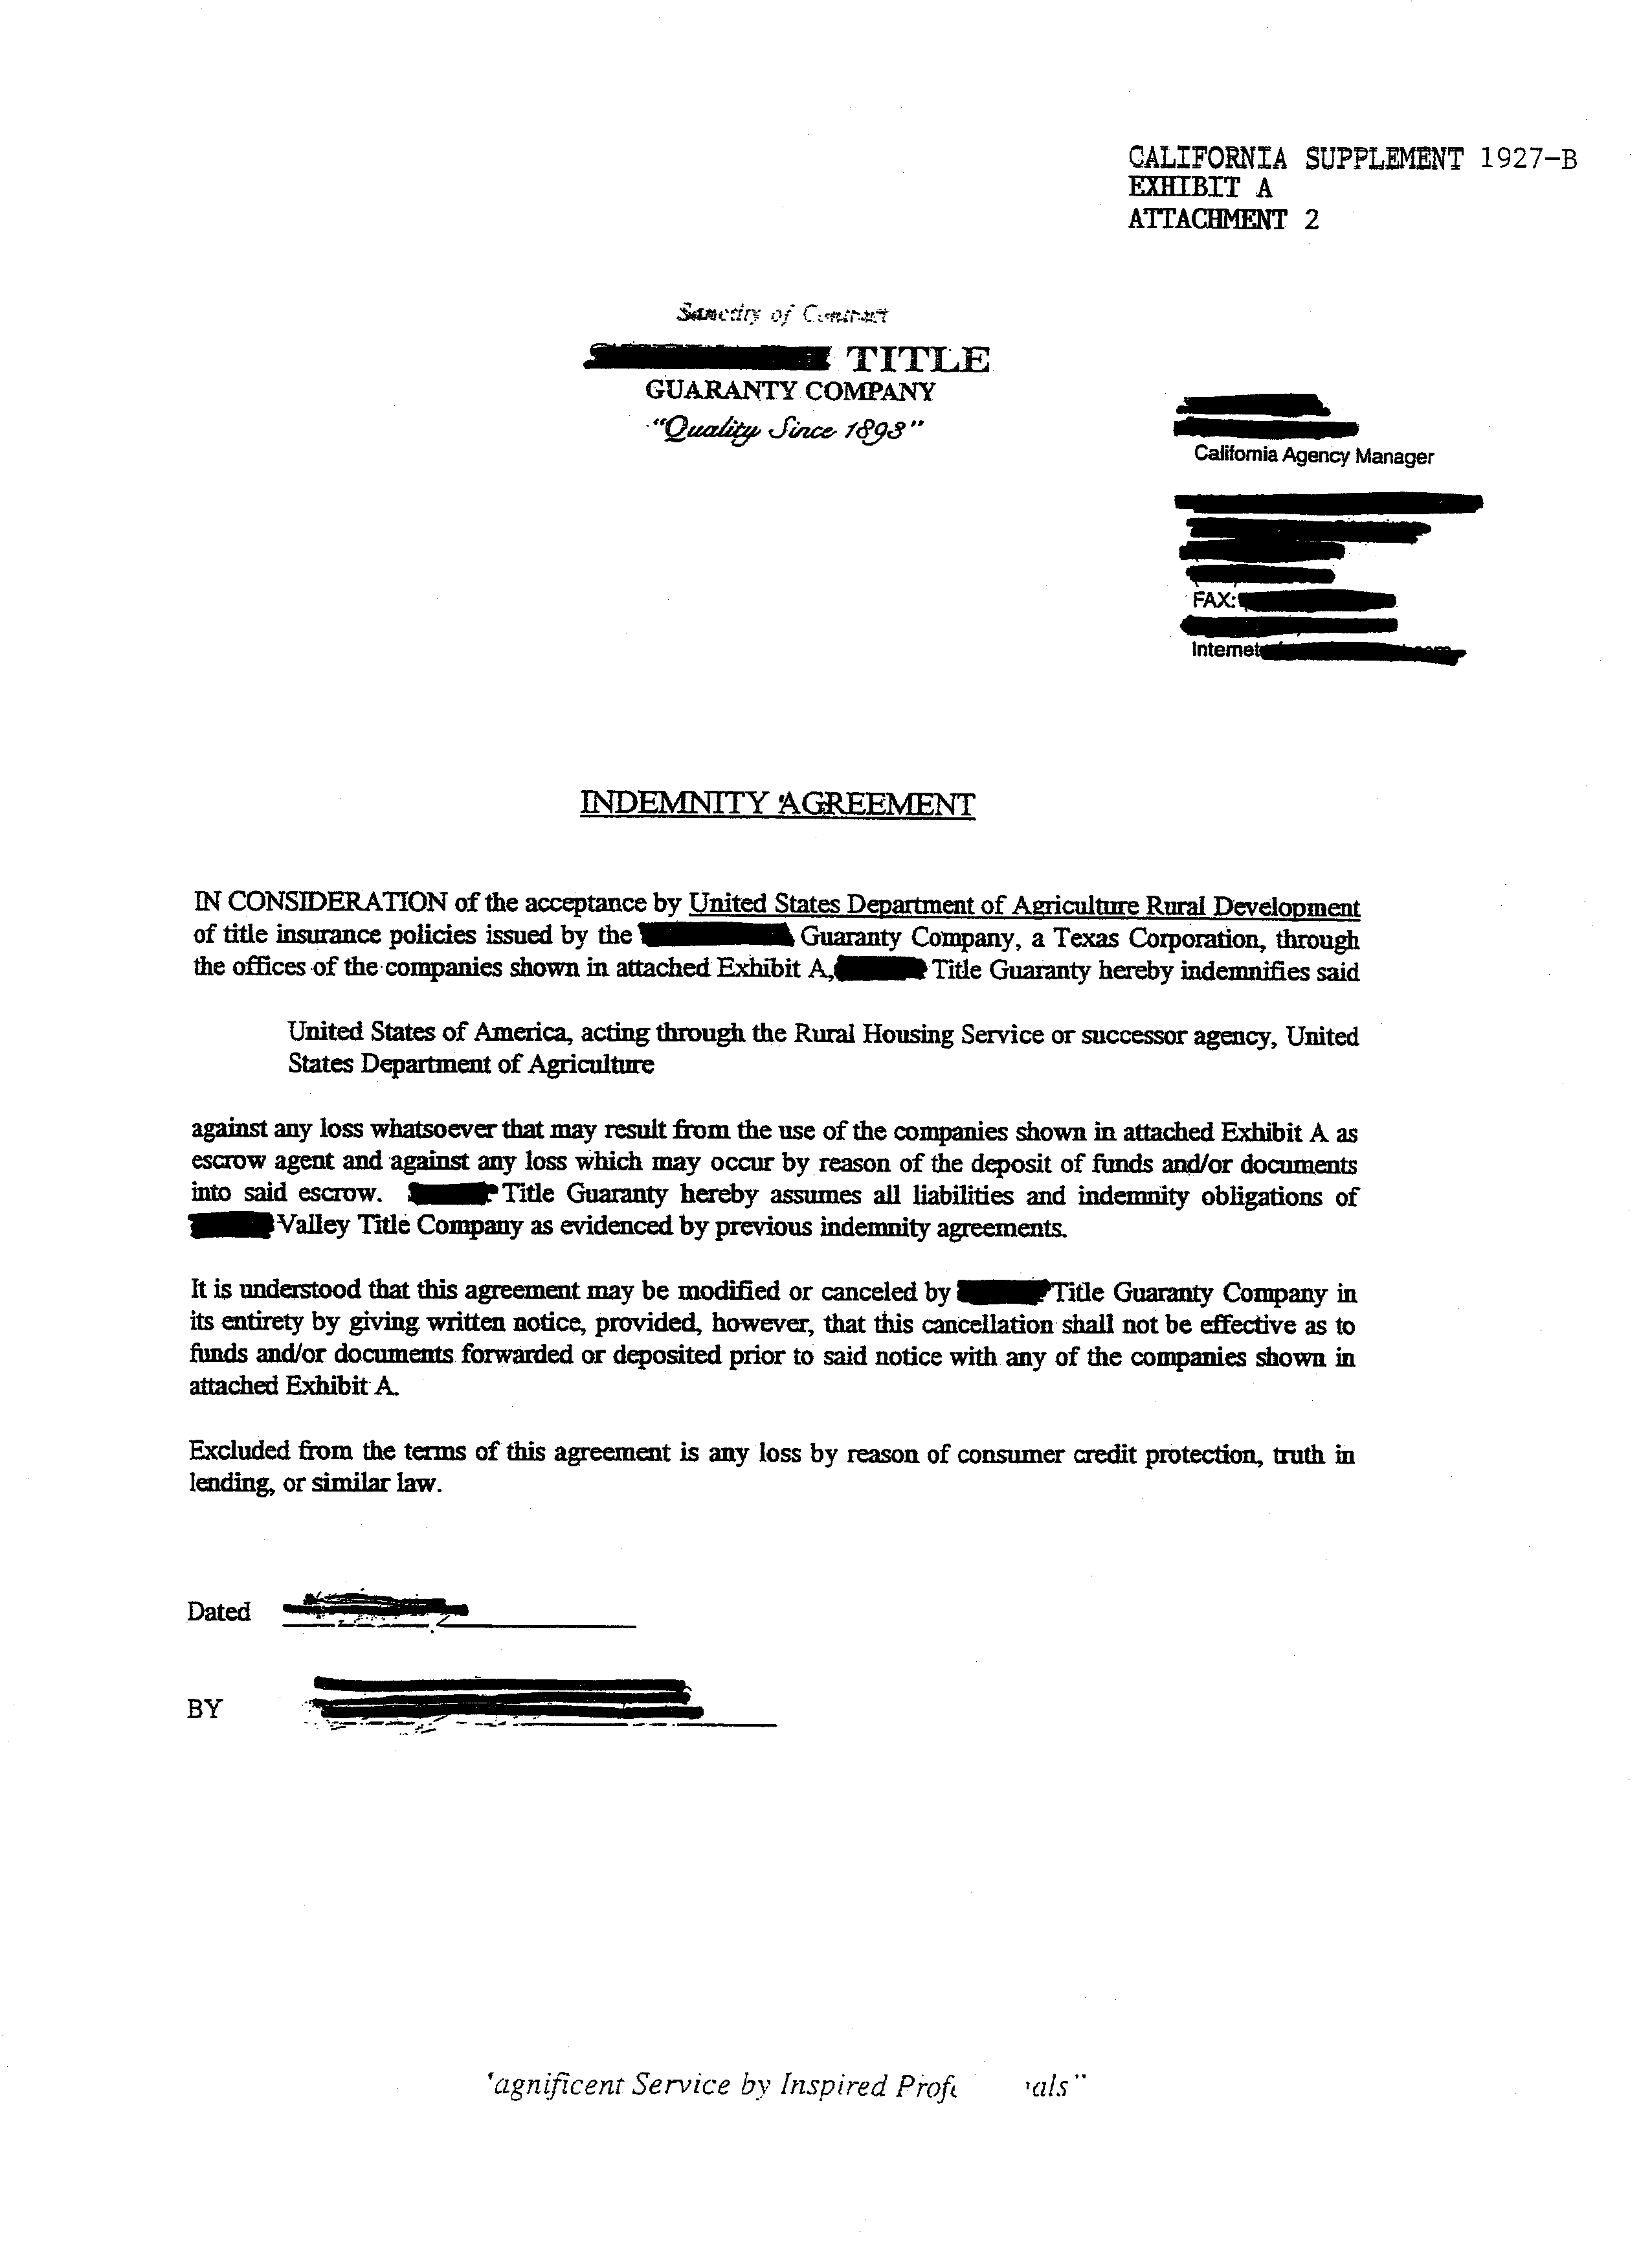

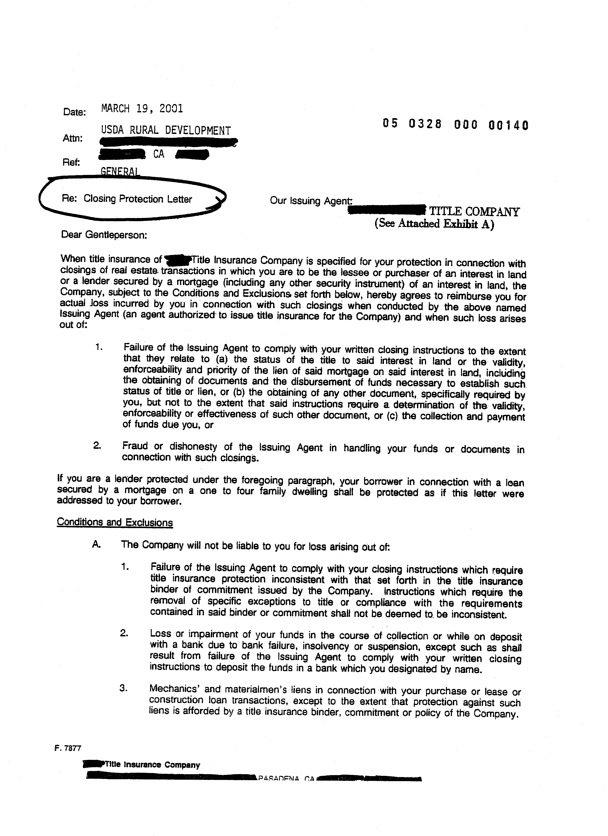
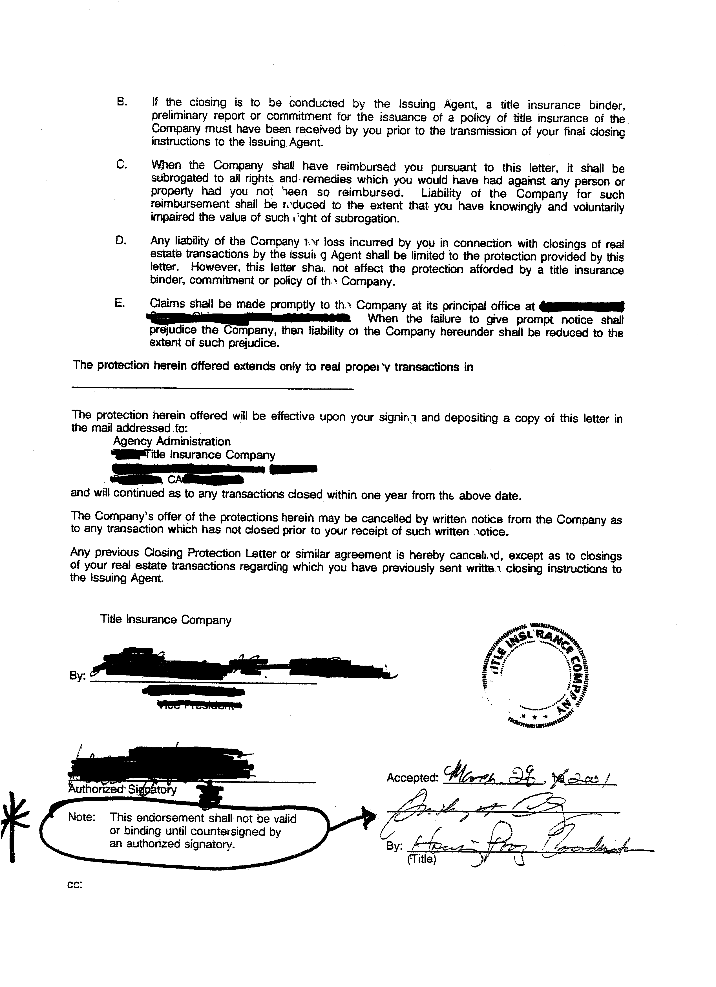

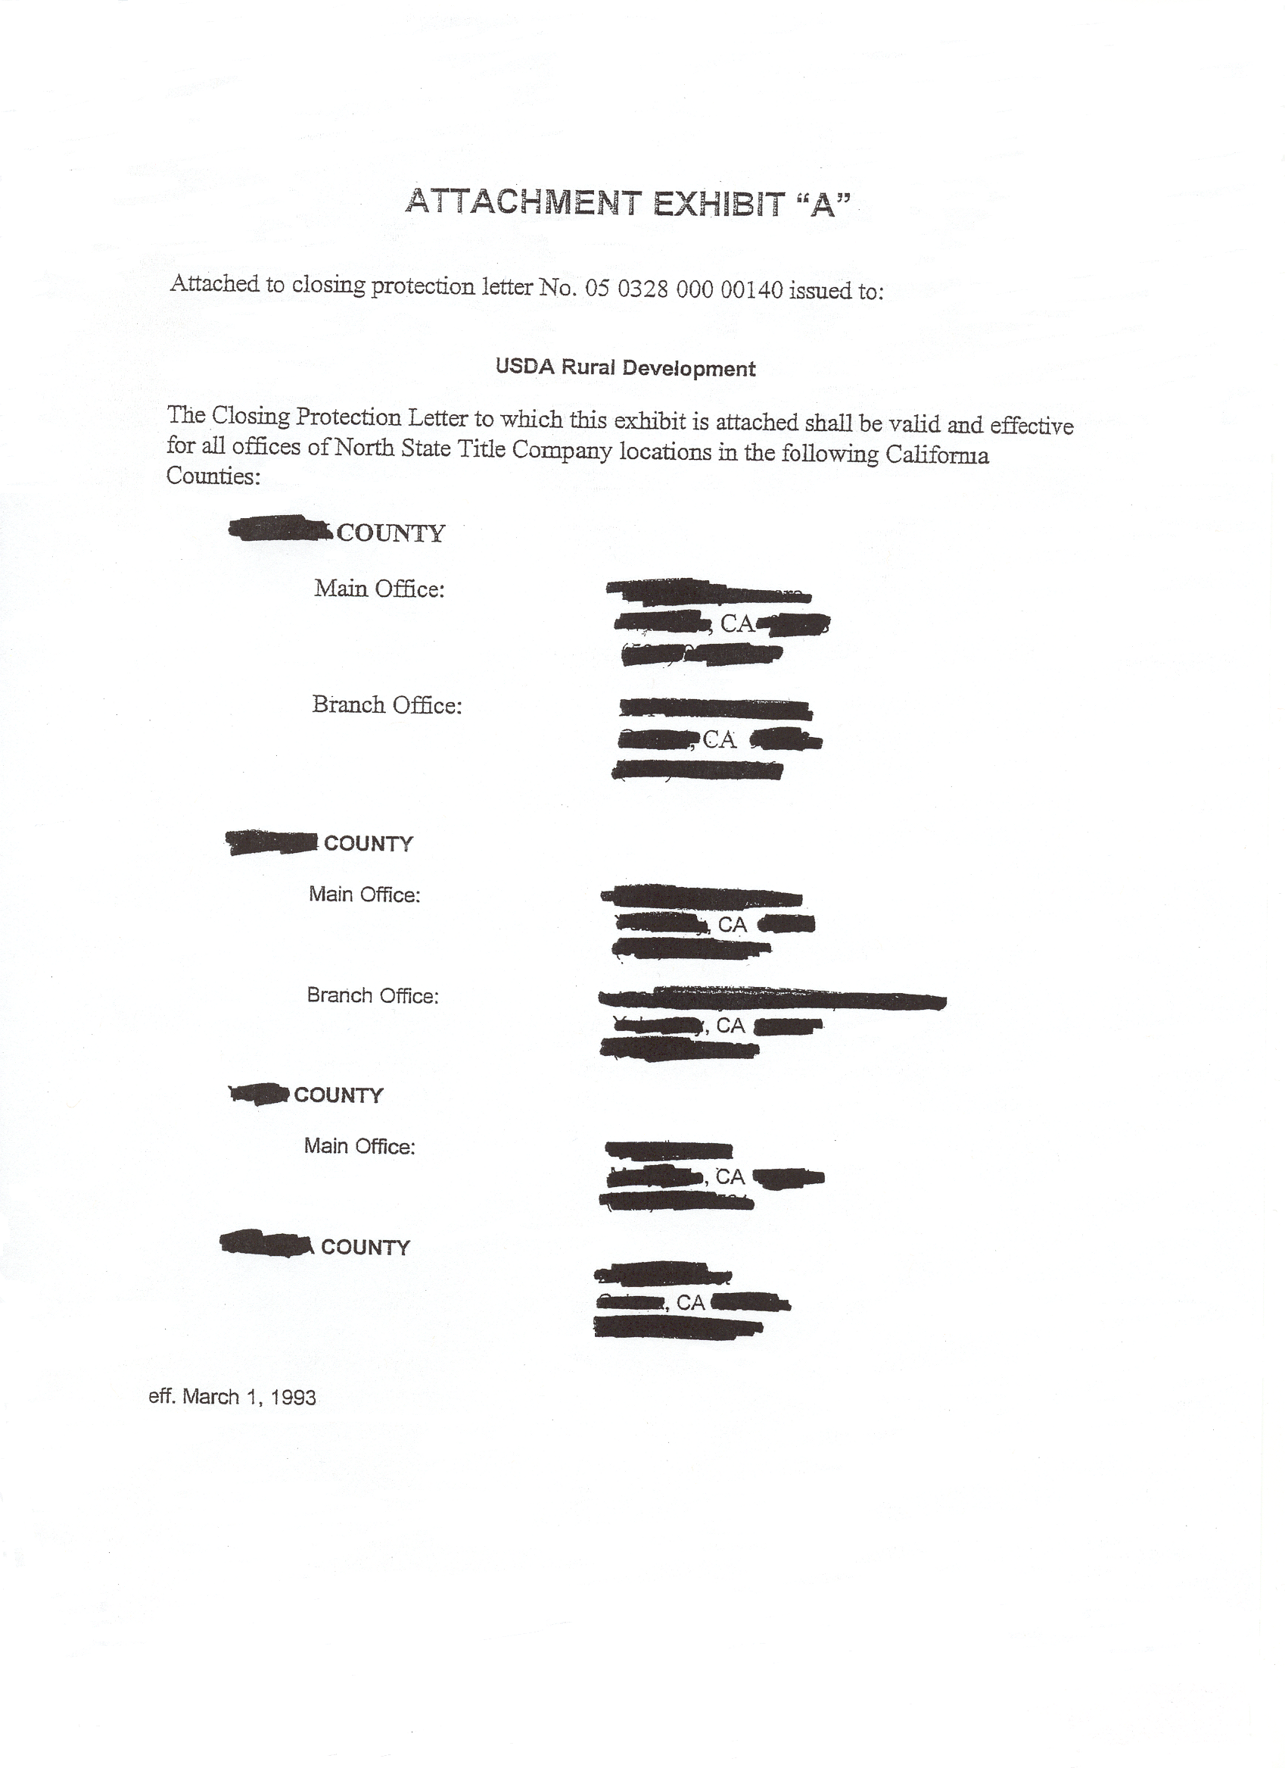

REQUEST FOR APPROVAL OF TITLE COMPANY OFFICE

USDA, RURAL HOUSING SERVICE Date:

Gentlemen:

We request your designation as an approved title clearance, loan closing and escrow services for USDA, Rural Housing Service (RHS) in County, in the State of California. The loans to be covered by this arrangement will be identified by your sending us a properly completed Form RD 1927-15, “Loan Closing Instructions and Loan Closing Statement” (with its addendum Form CA 1927-15), or Form FmHA-CA 1927-2A, “Multiple Family Housing FmHA Closing Instructions,” for each transactions.

If our request is approved, we agree:

- To close these loans or transactions in compliance with the general instructions in your HB-1-3550, Chapter 8, as the same may be modified by RHS from time to time (either by general revision or in a specific case) and your specific instructions on Form RD 1927-15 or Form CA 1927-2A.

- To charge only our regular published fees for the policy of title insurance you require and the necessary escrow services, plus the following special charges for the extra services identified below, when applicable:

- Not to incur without the prior written consent of both the borrower and RHS, liability of the borrower for attorney’s fees.

- That all costs or charges in connection with these transactions will be paid by parties other than the RHS (except when RHS is the seller, RHS will pay its customary share of closing costs). Under no circumstances will the United States or its officers or agents, or any lender insured by the United States, pay any such costs or charges involved in loan closings.

- That our representatives who will supervise the closing of these transactions are authorized to receive and give receipts for our charges.

- That you may withdraw this designation at anytime by sending us a written notice thereof.

We understand that RHS may also request our services in connection with transaction not covered by this agreement. Such other transactions will be sent to us with a copy of a memorandum to RHS from the Office of General Counsel, United States Department of Agriculture, setting forth specific closing requirements, instead of Form RD 1927-15 or Form CA 1927-2A. We agree to close those transactions in accordance with that memorandum and that the aforesaid Exhibit B and Paragraph 1 and 2 of this letter will not apply to them.

Sincerely yours,
(CORPORATE SEAL)

Name of Title Company

Branch Office

By:

Address:

APPROVED UNTIL FURTHER NOTICE:
UNITED STATES OF AMERICA

By:
Rural Housing Service

Date:

GENERAL CLOSING INSTRUCTIONS FOR
RURAL HOUSING SERVICE TRANSACTIONS
I GENERAL:

- Purpose: Unless modified by the Government in a specified case, this Exhibit contains general instructions to be followed by the title company in closing RHS transactions.

- Definitions: In this Exhibit:

1 CLOSING means recording the Government deed of trust

- GOVERNMENT means the UNITED STATES OF AMERICA, acting through the Rural Housing Service, United States Department of Agriculture.

- RHS means the local office of the Government which transmits the Form RD 3550-25, “Loan Closing Instructions and Statement” to the title company in a specific case.

- TITLE COMPANY means the company authorized by the Government to close the particular transaction.

- Selection of Trustee: The title company will name the title insurer shown in the title insurance policy as trustee in the Government deed of trust.

II RESPONSIBILITIES FOR CLOSING:

- Closing Costs: The Government, its officers or agents, and any lender insured by the Government, will never be responsible for closing costs.

- Exceptions in Preliminary Report: These will be handled as specified in
Form RD 3550-25 except that:

- All taxes and assessments delinquent on the date of closing must be paid even if the exception(s) for taxes is to remain. Direct questions about tax problems to RHS.

- If another creditor's real estate mortgage or deed of trust is to be ahead of the Government's, the title company must prepare Form RD-CA 1927-3, "Request for Notice of Default or Sale."

- Fire Insurance: The borrower will select any company authorized to do business in California which will issue the required insurance. Insurance must be either homeowner's or fire and extended coverage. The policy or binder must name the UNITED STATES OF AMERICA (RURAL HOUSING SERVICE) as lender. Existing policies must be indorsed in the same manner. Policy must be either continuous or for a minimum term of 3 years. A written receipt for at least one year's paid premium must be obtained before closing.

- Builder's Warranty: If required by Form RD 3550-25 the title company will:

- Have Form RD 1924-19, "Builder's Warranty," dated and executed;

- Attach thereto Form RD CA 1924-5, "Attachment to Builder's Warranty," and 4 copies of Form RD-CA 1924-5A, "Notice of Construction Deficiencies;"

- Complete the top of Form RD CA 1924-5A by inserting the date from Form RD 1924-19; and

- Have Form RD CA 1924-11, "Termite Soil Treatment Guarantee," dated and signed by builder.

- Promissory Note(s) and Related Instrument(s):

- RHS will furnish the title company with the Promissory Note(s) and, if applicable,
Payment Assistance/Interest Credit and Supplementary Payment Agreements completed except for certain date(s), names(s) typed beneath the signature lines, and signature(s).

- The title company will:

- Date the forms with the date of closing;

- Insert other dates as specified on Form RD CA 3550-25, “Addendum to Form 3550-25, ‘Loan Closing Instructions’”;

- Type the name(s) beneath the signature lines in a form that will not conflict with the deed of trust or the way title will be vested;

- Obtain the signature(s) on the originals and conform (/s/) the copies; and

- Complete and have executed the deed of trust being sure the title insurer is
named as trustee.

- ACH Transaction: The funds will be sent electronically to the prescribed financial institution of the title company. The electronic fund transmittal process is completed through a process known as Automatic Clearing House, which is not a “wire transfer.” (See Exh B-1 for further information on closing ACH process)

- Government Checks: When United States Treasury checks made payable to the
RHS borrower are deposited in escrow, the funds are available for withdrawal not later
than the second business day following the banking day. The funds are deposited
pursuant to 12 C.F.R. Sec. 229.12(a) and 12 C.F.R. Sec. 229.12(b)(2).

2

- Closing: The title company will not close:

- After the date the RHS Closing Instructions expire unless authorized by RHS in
writing.

- Until it can issue the following applicable policy insuring the UNITED STATES OF AMERICA as lender for the amount of the loan, credit sale, or amount specified on Form RD CA 3550-25.

- ALTA Loan Policy - 1992 with ALTA ENDORSEMENT-Form 1 Coverage,
for all property except leaseholds.

- ALTA Leasehold Loan Policy - 1992 with ALTA ENDORSEMENT - Form 1
Coverage, for leaseholds.

- Indorsements as specified on Form RD CA 3550-25.

- Unless the policy will insure all of the land described in the preliminary report subject only to:

The Government deed of trust and any assignment to the Government
recorded at closing.

J. Procedure After Closing: Upon recordation of Government Deed of Trust, compile required documents and mail to Centralized Servicing Center of RD, USDA in St. Louis, MO. Refer to the Closing Agent Document Checklist, Attachment F of Exhibit B-1.

o0o

3

ACH Field Office

Overview

- Enter required closing info into IN-1/CLOSING SELECT OR ADD AGENT screen and the IN-1/ CLOSING SELECT OR ADD AGENT pop-up screen.
- Fax Pre-Audit record to State Office (IN-1/Review/List ACH Disbursements) the same day the closing is posted on the IN-1 screen in FASTeller. (Schedule at least five days in advance; FASTeller requirement: State Office can override.)
- State Office to verify, conduct pre-audit and release the ACH disbursement for payment to closing agent.
- each pre-audit performed should be kept for six months
- Closing agent file should be maintained indefinitely

Acquiring Closing Agent Information Sheet

Closing Agent Information Sheet (Attachment A) should be sent in advance to all closing agents whose service is utilized regularly. The information must be kept at field office.

Schedule the Closing

- Field Office confirms that Closing Agents Information Sheet is current at the time the closing agent is contacted to schedule closing.
- Any changes must be reported to State Office via fax of the new Closing Agent Information. State Office must reflect the change on FASTeller.

Obtain Tax and Insurance Information - Prepare Section I and II of the Tax Information Sheet.

- Request hazard insurance (and any other insurance) binder and paid receipt from borrower.
- Contact all applicable Taxing Authorities and request copy of the current tax bill.
- Contact CSC 314-206-2060, Option 3 for acceptability of an equivalent information.
- Complete the Attachment B; “Attachment to Tax Information Worksheet”.

Preparing the Initial Escrow Disclosure

- Determine the First Pymt Due Date (same day of the following month; for loans closed on the 29th, 30th or 31st, the due date will be the 28th of the following month)
- For subsequent loans, due date will be the same as the prior loan.
- Determine the tax disbursement date against Attachment C, “Escrow Collections Quick Reference Guide” and Attachment D, “Escrow Collection Chart”.
- Verify the Loss Payee (Beneficiary) Clause on the insurance binder(s)/policy(ies). The Loss Payee Clause should read:

United States of America
Acting through the Rural Housing Service
or its successor agency
Box 66876
St Louis, MO 63166
- Determine the insurance disbursement date. The effective date of the insurance binder should be the closing date. The disbursement date will be 15 days prior to the expiration date.
- If effective date of the binder is between the 1st and the 15th, the disbursement date is the MONTH prior to the effective date of the Following Year.
- If effective date of the binder is between the 16th and the 31st, the disbursement date is the SAME MONTH of the Following Year.
- Prepare the Initial Escrow Disclosure Statement in accordance with field manual.

Review the Initial Escrow Disclosure Statement

- Ensure the information listed in the Initial Escrow Disclosure Procedure was entered accurately.
- The lowest point in the Escrow Account Balance Column of (Attachment E, Example A) should be equal to two monthly escrow payments (Attachment E, Example B).
- The lowest point on the Escrow Account Balance Column is the same as the Cushion selected by servicer (Attachment E, Exhibit C).
- If taxes have been pre-paid;
- The Starting Balance is to be reflected on the Initial Escrow Disclosure Statement (IEDS)
- Full year taxes should be reflected on the IEDS
- The correct amount to be collected from Borrower is calculated manually by subtracting the amount of tax pre-paid from the Starting Balance of the IEDS
- Do not collect anything if the balance is “0” or less than “0”.

2

- If taxes have not been pre-paid;
- Refer to Attachment E, Example D, Form RHS 3550-9.
- If taxes are due within 60 days of closing, the Starting Balance (Attachment E, Exhibit D) should be collected and the taxes paid by the closing agent, if the current tax bill has been released by the taxing authority.
- The remaining funds (starting balance minus the tax) should be sent to CSC
- Remaining funds would be the amount that is reflected as REASON CODE 40 on the Funds Transmittal Report Form.
- Indicate on transmittal form that tax has been paid
- If current tax bill has not been released by the taxing authority;
- Collect starting balance
- Document full amount on the Funds Transmittal Report form and send to CSC to be paid when the bill is released
- This information must be documented on the Tax Information Worksheet in order for the CSC to be aware the taxes are still due

- If taxes are NOT due within 60 days of closing;
- The Starting Balance (Attachment E, Example D) reflected on the IEDS is to be collected by the closing agent and sent in with the closing package to be deposited into Borrower’s escrow account.
- This will also be the amount that is reflected as Reason Code 40 on the Funds Transmittal Reports form and on the closing agents Settlement Statement on line 1000 “Reserves Deposited with Lender”.

Preparing Closing Package

The Local Office will prepare the loan closing document IAW the Field Manual.

The first payment coupon generated from UniFi must be included in the closing package to be issued to the Borrower at closing.

Closing Agent Document Checklist (Attachment F) must be included in the closing package, stapled to the corner of the sealed envelope addressed to CSC, and should be sent to the closing agent with the rest of the loan closing documents.

The Local Office will copy the following documents applicable to the loan:

- Appraisal Report Form 1922-8
- Transmittal-Closing Form RD 3550-19
- Hazard Insurance Binder (First Page) and Paid Receipt
- Flood Insurance Binder (First Page) and Paid Receipt
- Tax Bill or Acceptable Equivalent
- Initial Escrow Account Disclosure Statement Form RHS 3550-9

3

The COPIES of the above documents are to be sent with loan package to the closing agent in a sealed envelope labeled Centralized Servicing Center (Refer to Attachment G for preparation instruction).

Prepare the closing instructions specific to the loan. Prepare a mailing label for the closing agent. Attach the label to the Closing Agent Document Checklist (Attachment F).

Include the following statements in the closing instructions (Attachment H) to the Closing Agent:

- Collect overnight freight charge and reflect on the Settlement Statement.
- Issue First Payment Coupon to borrower at closing.
- Copy the documents reflected on the attached Closing Agent Required Document List.
- Send the package labeled Centralized Servicing Center, the Closing Agent Document List form and the copies of the closing documents overnight express within 24 hrs of closing to:
Centralized Servicing Center

New Loan Servicing Section
1520 Market Street, FC-202
St. Louis, MO 63103
- Return the original closing documents to USDA - Rural Development (insert Local Office address here).
- Notify (Local Office Contact Persons name and telephone # is inserted here) immediately if closing date or time changes.

Notification of Closing

The Local Office will complete the IN-1/Closing Select or Add Agent screen in FASTeller by selecting a closing agent previously established, or adding a new closing agent information consisting of the following fields:

- Name of the Title Company
- Address, City, State, Zip
- Phone Number, Fax Number
- Bank Transit Routing #
- Bank Account #
- Disbursement – (if construction – pre-closing draw only, not the total loan amount)
- Print screen before hitting the enter key
- HOME, SHIFT, TAB and ENTER

After the above info is completed, FASTeller will prompt the IN-1/Closing .... pop-up screen for info on the loan amount, and the closing date. Settlement Agent “00” will be reserved for the Local Office information at a later date

4

Establishing a New Closing Agent

The Field Office employee will enter the eight items listed above into FASTeller utilizing the Closing Agent Information Sheet (Attachment A).
- Field office enters 8 items in to FASTeller using the Closing Agent Information Sheet
- After data has been entered, complete part of the shaded portion of the Closing Agent Information Sheet (CAIS)
- Forward the CAIS to RDM or CDM for verification.
- RDM/CDM certify accuracy of the information entered
- State Office verifies the information once the information has been forwarded via FAX
- The State Office will verify all new Closing Agent records as part of the Pre-Audit
Process. The Closing Agent information will be verified by the State Office.

Change in Closing Agent Information

State Office must be contacted for any modification on the Closing Agent Information.
- FAX a copy of the most recent CAIS to State Office
- State Office reviews for accuracy and makes the modification

Scheduling the ACH Disbursement with the State Office

- Scheduling the ACH closing requires close coordination among the local RD office, RD State Office, borrower, lender (if applicable), title company, and bank.
- The originating office must complete the IN-1/Closing with the Closing/Disbursement Date at least 5 business days before the planned closing.
- FAX the appropriate documents to the State Office on the same day as the completion of IN-1 Screen.
- Following are items the State Office can revise upon request:
- Borrower’s Account Number
- Closing Agent Information – Company Name, Address and Phone numbers
- Routing and Bank Account Number
- Scheduled ACH release date and closing date
- Any other revisions must be completed either at the local office or by contacting the CSC

5

CRITICAL DOCUMENT LIST FOR NEW LOAN SETUP

The following documents have been identified as ‘Critical’ in the New Loan Audit/Set-up process at CSC:

- Promissory Note
- Payment Assistance Agreement
- Preliminary Title Report
- Tax Information sheet
- Initial Escrow Account Disclosure
- Settlement Statement
- Insurance Declaration Page with paid receipt
- Funds Transmittal Report

The following documents must be included for Assumption Loans:

- Assumption Agreement
- Uniform Residential Loan Agreement
- Uniform Residential Appraisal Report

For Leveraged Loans, include the following:

- Lender’s Promissory Note
- Lender’s Deed of Trust (recorded when available)

o0o

6

Closing Agent Information Sheet for ACH Disbursements

To Be Completed By Closing Agent
Existing Information |  |  |  | Category | Changes to Existing Info.
 |  |  |  | Closing Agent Info.
 |  |  |  | Name
 |  |  |  | Street Address
 |  |  |  | City, State, Zip Code
 |  |  |  | Phone #
 |  |  |  | Fax #
 |  |  |  | Bank Info
 |  |  |  | Bank Name
 |  |  |  | Street Address
 |  |  |  | City, State, Zip Code
 |  |  |  | Phone #
 |  |  |  | Payee Name (Name Acct. Under)
 |  |  |  | Bank Transit Routing # - ACH
 |  |  |  | Bank Transit Routing # - Wire
 |  |  |  | Closing Agent Bank Acct. #
There |  | Are  Are No  N/A | changes to the information listed above in the left column, and if changes have occurred, the changes have been listed in the right column above.  This choice would only be applicable the initial time you complete this form.
Please attach a voided escrow deposit slip or check for the initial submission, or if there is a bank/account change.
 |  |  |  | Completed By:
 |  |  |  | (Print Name)
 |  |  |  | (signature)
 |  |  |  | (Date)
To Be Completed By RHS Only (attach screen print)
Local Office (initial entries) |  |  |  |  | State Office (confirmation/changes)
 |  |  |  | Entered into System By:
 |  |  |  | (Print Name)
 |  |  |  | (Title)
 |  |  |  | (Date)
 |  |  |  | (Signature)
 |  |  |  | Verified By
 |  |  |  | (Print Name)
 |  |  |  | (Title)
 |  |  |  | (Date)
 |  |  |  | (Signature)

Attachment to Tax Information Worksheet (3550-15)
1) In completing the 3550-15,
• List all taxes on one sheet (if possible) - don’t use separate sheets for each taxing authority

• Authority Name should be the actual taxing authority name for the county, city, village, school, etc., not the person holding the office (i.e. David Anderson, Tax Collector)

• Next Due Date means the last day (month, day and year) the next payment due can be paid without being assessed a penalty

2) Discount date(s) for reduced amount of taxes due (where applicable)
No, this is not applicable
Yes, this is applicable, and listed in the Next Due Date column on the front

3) Taxes coming due -(as in the last date to pay without a penalty)
Taxing Authority |  | Taxes are due within 60 days of closing and the bill has not been issued
 |  | N/A = not due w/in 60 days
Town & County |  | YES NO N/A
Village |  | YES NO N/A
City |  | YES NO N/A
School |  | YES NO N/A
4) Loss or gain of exemptions

5) Temporary loss of exemption due to filing requirements

6) Assessment amount changes

7) If this loan involves construction
- Is this transaction breaking off a parcel of land from a larger one, and a new tax map number will be issued on this parcel? Yes No
- Is the taxing authority willing to tell you the new tax map number now? Yes No
- If so, what will it be - ______________________
- If there will be a substantial change of assessment, please use the “as improved” value (based on the appraisal done by Rural Development) listed below, and the current tax rates to calculate the anticipated tax bills at full assessment for 1 full year (break out below)
RE Tax Bill |  | Next Due |  | Appraised | % | Tax Rate |  | Estimated Full
 |  |  |  | Value | Valuation | / thousand |  | Assessment Tax Bill
Rural Development As Improved Appraisal Value: |  |  |  | $
Town & County
Village
City
School
Any other factors that will change or effect the tax collection.

Escrow Collections
Quick Reference Guide
Revised 6/17/97

Alabama Full Year 12/31
Taxes are collected one year in arrears.
Types of Taxes - County, City, Special District, Lighting
District.
System Date - Full Year 12/31

Alaska Full Year varies by collector from 6/15 - 9/30
Semi-annual varies by collector.
Types of Taxes - Borough, City.
System Dates - 6/15 through 9/30 full year varies by collector.
Some areas pay in 2 installments dates vary - Call the CSC at 314-206-2700, Option #1

Arizona 1st Half 11/1 2nd Half 5/1
Taxes are collected for the current year.
Types of Taxes - County, County Bond, City Bond
System Dates - 1st Half 11/1 2nd Half 5/1

Arkansas Full year 10/10 or 60 days from the date the bill is released
to the tax service or mortgage company - Starts paying in
March.
Taxes are collected one year in arrears.
Types of Taxes - County, Water, Special District
System Dates - Full year 5/10

California 1st Half 12/10 2nd Half 4/1
Taxes are collected for the current year.
Types of Taxes - County, Water, Irrigation District, Special
District, County Bond, City Bond, Reclamation District,
Levee District.
Other information - Supplemental, Additional, and Escaped
Bills are also collected, they can have various due dates
and are the borrowers responsibility to send to CSC.
System Dates - 1st Half 12/10 2nd Half 4/10

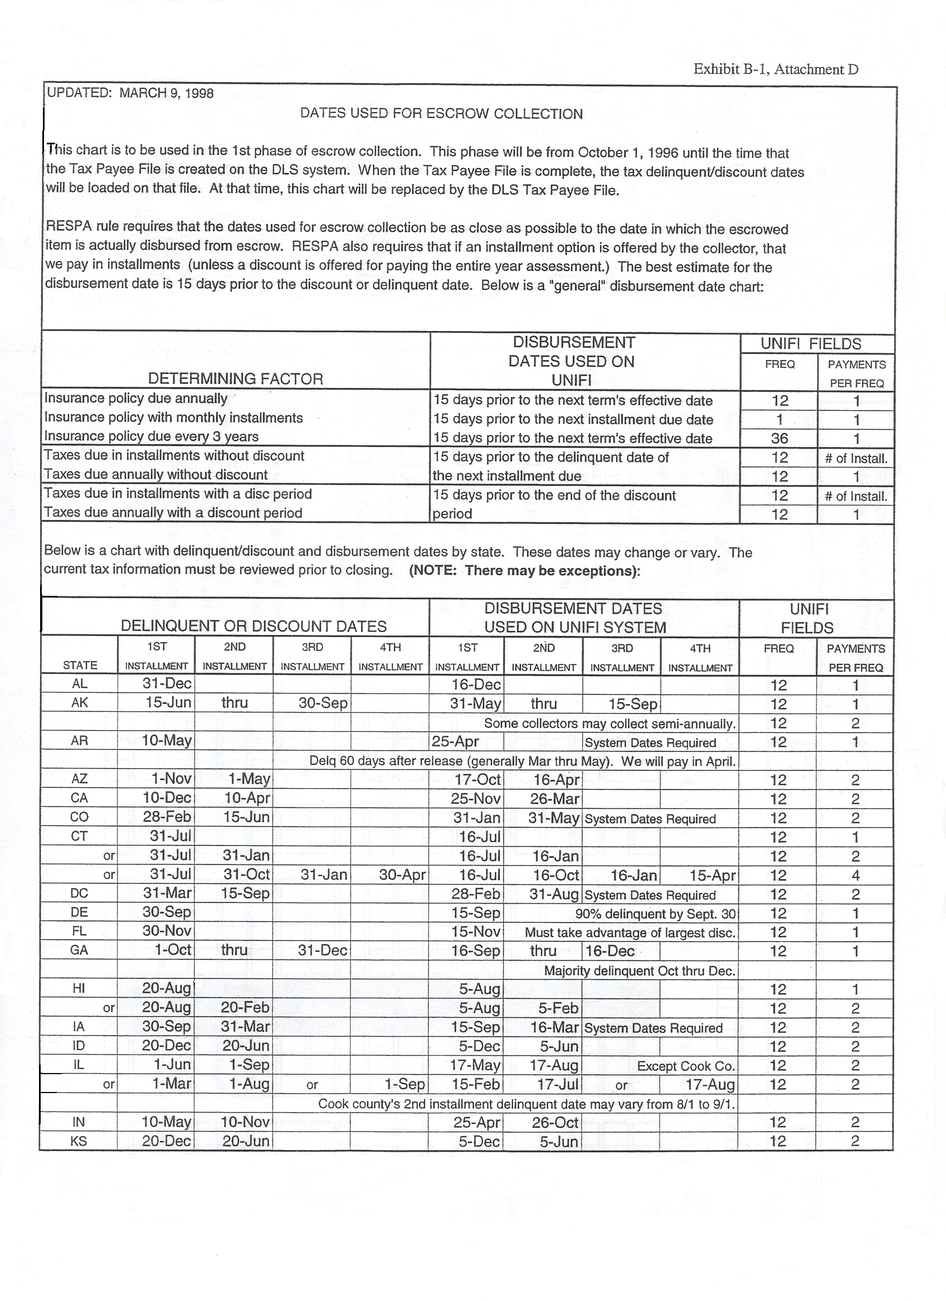
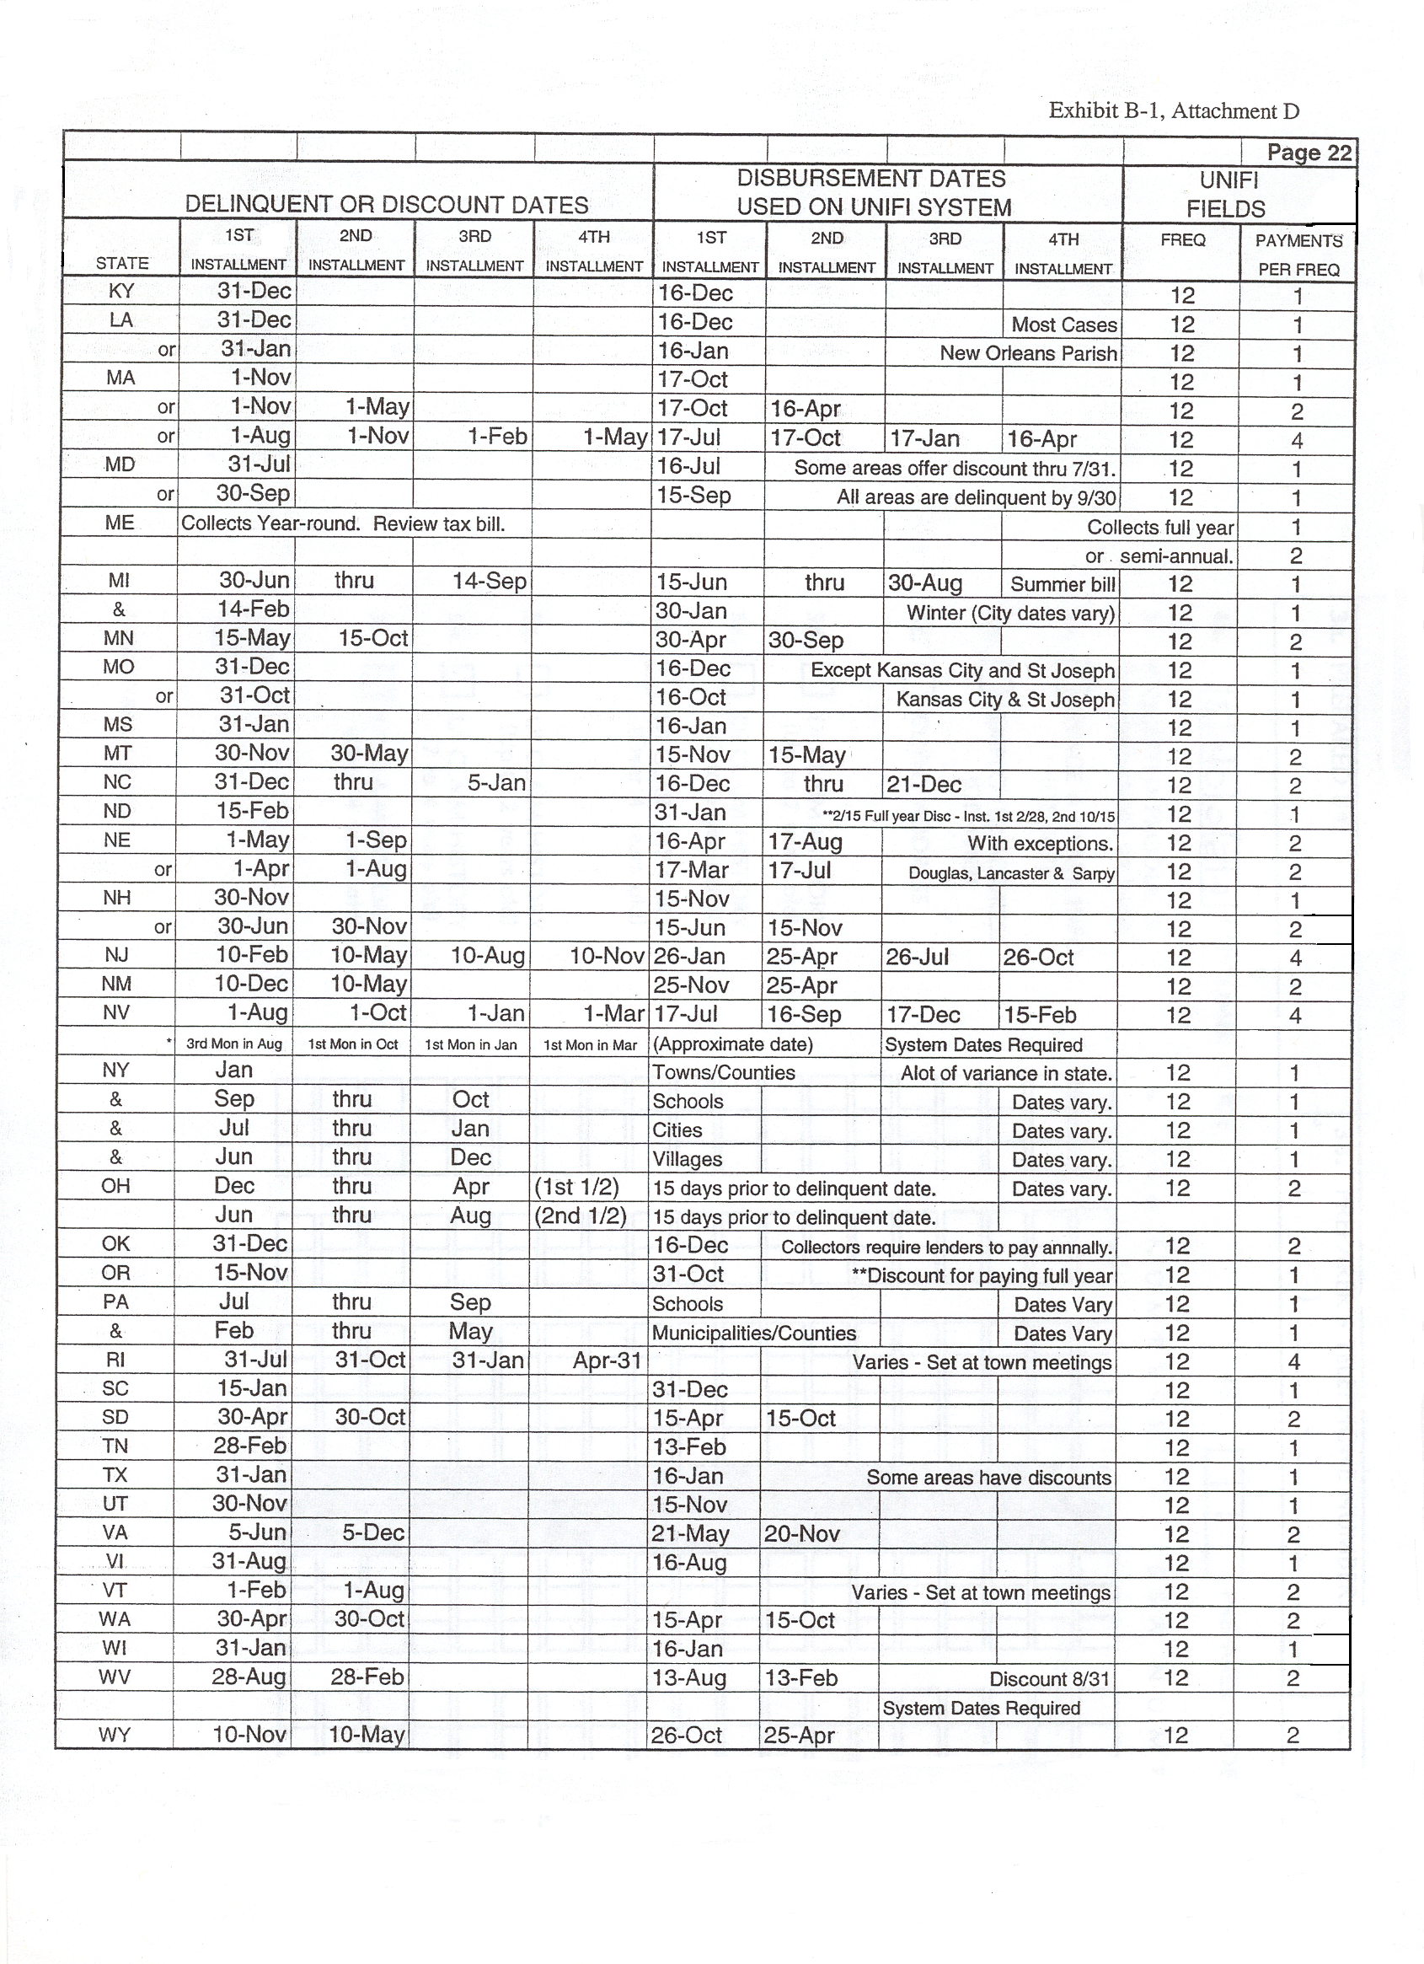

Form RHS 3550-9 Form Approved
(10/96) OMB No. 0575-0166
United States Department of Agriculture
Rural Housing Service

INITIAL ESCROW ACCOUNT DISCLOSURE STATEMENT Disclosure Date: 3/10/98 .
Borrower(s) Name and Address Lender/Servicer Name and Address
Jim Bob Carey and Melba Carey USDA - Rural Development
902 Cherry Lane 1001 Main Street
Alton, MO 65606 Alton, MO 65606

Loan No. Telephone No.
0005500245 417-555-9032
Your mortgage payment for the coming year will be $ 575.00 of which $ 445.84
F.
will be for principal and interest, and $ 129.16 will go into your escrow account.

Your first mortgage payment for the coming year will be $ of which $
will be for principal and interest, and $ will go into your escrow account. The terms of your loan may result in changes to the principal and interest payments during the year.

This is an estimate of the activity in your escrow account during the coming year based on payments anticipated to be made from your account.
Month/ Payments to Payments from Description Escrow Acct.
Payment No. Escrow Acct. Escrow Acct. Balance
D.
Starting Balance: $ 341.68
04/98 129.16 .00 470.68
05/98 129.16 .00 600.00
06/98 129.16 .00 729.16
07/98 129.16 300.00 City Property Taxes 558.32
A.
07/98 .00 100.00 County Property Taxes 458.32
07/98 .00 200.00 School District Taxes 258.32
08/98 129.16 .00 387.48
E.
09/98 129.16 .00 516.64
10/98 129.16 .00 645.80
11/98 129.16 00 774.96
B.
12/98 129.16 .00 904.12
01/99 129.16 300.00 City Property Taxes 733.28
01/99 .00 200.00 School District Taxes 533.28
02/99 129.16 .00 662.44
03/99 129.16 450.00 Hazard Insurance 341.60
Amount to be collected at closing to set up escrow account.

(Please keep this statement for comparison with the actual activity in your account at the end of the escrow accounting computation year.)
C.
Cushion selected by servicer: $ _258.32_

A. Low Point (should be twice the monthly payment to Escrow).

B. & F. Monthly Escrow Payment

C. Cushion Selected By Servicer (should be twice the monthly payment to Escrow).

D. Amount to be collected at closing by the Closing Agent.

E. Make sure all of the taxes and insurance disbursement amounts are shown and are correct
and disbursed in the correct month.
The lowest point on the Escrow Account Balance Column (which is the same as the Cushion selected by servicer) should be 2 times the monthly amount in the Payments to Escrow Account column.

Closing Agent Document Checklist
This document is included as part of the closing instructions. Please copy the following documents after closing and mail overnight express (including the sealed envelope Rural Development provided you) to:

Centralized Servicing Center
New Loans Services Section |  | Applicants Name
1520 Market Street, FC-202
St. Louis, MO 63103 |  | Account #
 |  | Close Date

If Rescission Rights are applicable, hold all paperwork until the funds are released, then mail.

(A mailing label with this address is attached for your convenience) | Attach label here
Sealed envelope attached to this checklist
RD 1944-6/1944-14 Signed Interest Credit /Payment Assistance Agreement
(Does not have to be approved/signed by RD to be included)
RD 3550-12 Signed Subsidy Repayment Agreement
FmHA 1940-16 Promissory Note
RD 1940-59 Settlement Statement
RD 3550-14 Signed Mortgage or Deed of Trust (copy of unfiled is OK for
mailing)
RHS 3550-15 Tax Information Sheet
RD 3550-17 Funds Transmittal Report, with check payable to RHS for total
listed on form.
Preliminary Title Policy (Marked Up) or Preliminary Title Opinion
(Show account number {listed above})
Homeowners Authorization Letter (Original for both Tax & Insure.)

The following are applicable only when USDA is taking 2nd lien position (leveraging)-
Participating Lender’s Promissory Note
Participating Lender’s Certified True Copy of Mortgage

The following are applicable only when an assumption of existing debt is involved -
FmHA 410-4 Signed Uniform Residential Loan Application
FmHA 1965-15 Signed Assumption Agreement

All originals of these documents should be forwarded to the local servicing office immediately

Call local office within 1 hour after closing, or if Rescission Rights are applicable, when funds are released.

If these documents are not received by Centralized Servicing Center (CSC) within 36 hours of closing, they will contact you directly. You can track the package using one of the following internet sites, and the tracking number shown on the receipt:
USPS Express Mail | http://www.usps.gov/cttgate/
FedEx | http://www.fedex.com/us/tracking/
UPS | http://www.ups.com/tracking/tracking.html

Field Office Document Checklist

Copies of the documents listed below are to be sent with the loan package to the Closing Agent in a sealed envelope labeled Centralized Servicing Center. You will staple one corner of the Closing Agent Document Checklist to this envelope.

Date Applicant’s Name

FmHA 1922-8 Uniform Residential Appraisal Report
(Pages 1 and 2)

RD 3550-19 Transmittal - Closing Documents (You should be using the
Draft Copy)

Hazard Insurance Binder (First Page) and Paid Receipt
(Write account # on both)

Flood Insurance Binder (First Page) and Paid Receipt
(Write account # on both). Submit only if applicable

Current Tax Bills or Acceptable Equivalent *

RHS 3550-9 Initial Escrow Account Disclosure Statement
(This is not provide to or signed by borrowers - CSC will forward them copies)

Any other CSC required document(s) not sent to closing agent.

*If new construction, make sure attachment to 3550-15 is completed based on as improved value of property.

The Closing Agent will forward the labeled sealed envelope along with copies of closing documents to the CSC after the loan closes.

Attachment to
Loan Closing Instructions

- Collect “overnight freight charge” and reflect on FmHA 1940-59 Settlement Statement, line 1303

- Issue First Payment Coupon to the borrower at closing

- Copy required documents request on attached Closing Agent Document Checklist (Attachment F)

- Send the package labeled Centralized Servicing Center, the Closing Agent Document Checklist form and the copies of the closing documents overnight express within 24 hours of closing (or the day the Right to Rescind expires, if applicable) to:

Centralized Servicing Center
New Loan Services Section
Market Street, FC-202
St. Louis, MO 63103

- Return the original closing documents to

USDA- Rural Development
(insert Local Office address here).

- Notify (local office contact person name and telephone number is inserted here) immediately if closing date or time changes.

CALIFORNIA
ACH STATE OFFICE PRE-AUDIT CHECKLIST
.
Documents |  | Y | N | N/A
Insurance | Does the declaration sheet show the amount of the annual premium?
Info. | Does the receipt match the figure shown on the declaration sheet?
 | Does the receipt match the figure used on the 3550-9?
 | Is there adequate insurance to cover our exposure?
Correct Address? | USDA - RD, CSC, ATTN: Ins. Dept; PO Box 66876, St. Louis MO 63166
3550-15 | Is the form completed by the Settlement Agents Office? (non RD)
 | Does it indicate that taxes will be increasing due to assessment changes etc.?
Tax Info | Is the parcel fully assessed?
 | If parcel is not fully assessed, is there verification why?
Sheet | Do taxing authorities match the bills?
 | Do the figures match the 3550-9?
 | Is the form correctly completed?
Tax Bills | Do you have a bill for each of the billing authorities listed on 3550-15?
 | Are these the most current bills?
 | If so, do these figures match the 3550-15?
 | Is the assessment figure the same on all bills?
 | If not, is there an explanation on 3550-15?
3550-9 | Are deposits starting the month after closing?
Initial | Are County taxes disbursed in correct months?
Escrow | Is insurance due 15 days prior to closing?
Disclosure | Is cushion 2x the monthly escrow deposit?
 | Is cushion = to lowest point in escrow balance?
 | Does starting balance match figure on 3550-17?
dis-ori | Is first payment date 1 month after closing (not later than 28th)? (Or on due date of original loan, if subsequent?)
Screen | Is Escrow consistent with monthly deposits to escrow on 3550-9?
cus nam | Does the mailing address match the property address, inc. zip?
3550-17 | Is form “generally” completed (field code, borrowers name, acct. # )?
 | Is this a leveraged loan?
Funds | If leveraged, is bank paying for appraisal?
Transmittal | Is appraisal fee of $280 listed, and coded #02? (N/A if leveraged)
Sheet | Is tax service fee of $95 listed, and coded #50?
 | Is escrow starting balance listed, and coded #40? (N/A if Part. lender escrowing)
 | Is pre-paid interest listed, and coded # 00 w/explanation (only for sub. loans)
 | Is schedule totaled?
Closing Agent | Was this agent entered into FASTeller for this loan? (Initial entry?)
Info Sheet & | Does the information on the sheet match the info on the screen?
IN-1 screen | Was this a subsequent submittal, with changes?
 | For Construction Loans, Only Complete Closing Agent Section
Date Received _______________ Verified By ______________
Date Verif. Complete: _______________ Borrower Name ___________
Closing Date ________________ Office ______________
Date Released ________________

ACH Pre-audit Release Request
Attention: RHS/SFH

Applicant Name: Account #:
Closing Date: Change Closing Date:

This office certifies that the subject ACH information obtained have been verified in accordance with the below checklist and the ACH instructions provided by the State Office. The required documents are attached with this request:

Construction Loan? Leveraged? RHS Escrow?
Amt. ordered $________________ $___________ $_______________

For the new closing agents, a completed Closing Information Sheet is attached. We have also verified that they are on the current “approved title company” list. If they do not appear on the current list, the required documents for title/title insurance company approval, per CA Supplement 1927-B, are attached with this document.

We have verified the below listed information on the insurance declaration to be correct, or if the information was not correct, we have confirmed that the declaration reflects the corrected information:
- Correct CSC Address: USDA - RD, CSC, ATTN: Ins. Dept; PO Box 66876, St. Louis, MO 63166
- Correct address of the property to be insured (check against the CUSTOMER NAME/ADDRESS Screen).
- Expiration date. The insurance premium has been inserted for the correct month (15 days prior to the expiration) on the form “Initial Escrow Account Disclosure Statement”
- Amount of annual premium, adequate coverage and the indication of its full payment.

The projected tax installment is supported by the documents obtained; tax bills, closing agent’s estimate, PTRs, and/or supporting calculation for tax projection (e.g. Appraised Value X 1.25%).

The Funds Transmittal reflects the correct starting balance as the Form 3550-17, and the appropriate fees with proper codes.

For DIS ORI Screen:
- For leveraged loan where lender is establishing the escrow account, Escrow is left blank.
- For all other loan requests, 1st Pymt Date is one month after the scheduled closing date, and the figure for Escrow must match the monthly escrow reflected on the Form RHS 3550-9, “Initial Escrow Account Disclosure Statement”.

RHC OBL Screen: Check for correct Program Type Code (Low, VL).

IN-1 Review Audit: Check for correct ACH disbursement amount (for Construction
Loan, should not be full disbursement).

All requirements on “California ACH State Office Pre-Audit Checklist” have been
addressed.

Community Development Manager , CA

Signature Date

RUSH CLOSING FORM

Date of Request:
Office Number:
Office Name:
Office Phone No.:

Borrower’s Name:
Account Number:
Date of Closing:

Attach copy of Closing Agent Information Sheet for ACH Disbursements

Reason for rush closing:________________________________________________________

___________________________________________________________________________

___________________________________________________________________________

___________________________________________________________________________

CERTIFICATIONS:

I certify the rush closing is necessary due to conditions as described above.

______________________________________ _________________________
Community Development Manager/Supervisor Date

I certify the pre-audit has been completed and approve the rush closing.

______________________________________ _________________________
State Director Date

Copy of completed form forwarded to RDM by S/O on

Internal use only

Processed By: _____________________________ Date/Time Processed: _____________________________

Note: Include copy of the Closing Agent Information Sheet if a wire transfer is requested from the CSC.
Position 5

CHECK SHEET FOR REAL ESTATE CLOSING REVIEW
(WITHIN 30 DAYS OF CLOSING)

Date of this Review ____________ Date of Closing ________________

Initials of a Loan Approval Official ________ (see CA 1927-B, Section 1927.58 (d) & (e)

Mailed to RHS on the Date of closing
Check items
received or
mark N/A
__________ Form RD 1940-16 Promissory Note

__________ Form RD 3550-22 Assumption Agreement

__________ Form RD 1944-6 Interest Credit Agreement

Form RD 1944-14 Payment Assistance Agreement

Received Within 10 Days After Closing

__________ Title Insurance Policy - No Unauthorized Title Exceptions, with Requested Endorsements

__________ Form RD 3550-14 CA Recorded Real Estate Deed of Trust (legal description and
other correct information)

__________ Form RD 1940-59 Settlement Statement

__________ Form RD CA 1951-1 Modification of Deed of Trust

__________ Form RD 1955-49 Quitclaim Deed - Recorded Copy
(Original to Borrower)

__________ Form RD 1924-19 Builder's Warranty

__________ Form RD 3550-12 Subsidy Repayment Agreement

Form RD 1927-8 Agreement with Prior Lienholder

__________ Form RD CA 1927-3 Request for Notice of Default or Sale

Page 2

__________ Termite Clearance Report - Existing Dwelling

__________ Form RD CA 1924-11 Soil Treatment Guarantee - New Construction

Form RD CA 1924-16 Health Authority Approval-Individual Water Supply and
Sewage disposal System

__________ Form RD 402-1 Deposit Agreement

__________ Form RD CA 1927-10 Certificate of Inspection (If CLTA Policy)

__________ Evidence of Tax Monitoring Service

====================================================================
(Enter [X] in Box when Action is Done)
___
/__/ Closing review accepted
___
/__/ Case file now placed in "active" file
___ OR
/__/ Closing review not accepted because:
___________________________________________________________
___________________________________________________________
___________________________________________________________

___
/__/ Title company notified of discrepancies, and
___
/__/ Follow up update posted for 30 days to correct

o0o

GENERAL INFORMATION ABOUT REAL ESTATE LAW

I PURPOSE: This Exhibit sets forth some general information about real estate law for the orientation of RHS employees. It is not intended for public use nor should it be relied upon as a complete coverage of the areas of law discussed. All matters requiring a legal opinion must be referred to OGC. Do not give legal advice to borrowers.

II DEFINITIONS:

A Encumber: To grant a lien on property by a deed of trust or mortgage.

B Convey: To transfer title to a freehold by deed or to transfer leasehold by assignment.

III TYPES OF ESTATES IN REAL PROPERTY:

A Leasehold: The right to use property for a stated period of time.

B Fee Simple: The right to use property forever.

C Life Estate: The right to use property for a person's life. This can be the life of the owner or of a different person.

D Freehold: Either fee simple or a life estate.

E Tenancy in Common: Two or more people have an undivided interest in the same property. The portions held by each need not be identical fractions. Any person's fraction passes on death to his/hers heirs unless otherwise disposed of by will. Probate proceedings in court are necessary to clear the title after death.

F Joint Tenancy: Two or more people hold property jointly in equal shares. If any person dies the survivor(s) take(s) all the property regardless of any will. Probate is not required. If any person conveys without being joined by the other(s), the joint tenancy is severed and a tenancy in common is created. If any person encumbers without being joined by the other(s), the joint tenancy remains, so the Lienholder takes the risk that its borrower may die first and lose the property, extinguishing the lien.

G Community Property: Property acquired during a marriage (including the earnings of either spouse) except that acquired by gift, inheritance, or contrary agreement between the spouses. Community property cannot be conveyed or encumbered without the signature of both spouses. Joint tenancies between spouses are considered community property when dissolving a marriage unless there is a clear written deed or agreement that they are separate property.

H Separate Property: Property acquired outside a marriage, by gift or inheritance during a marriage, or by agreement between spouses that it is separate property. Note: If separate property is improved, or co-mingled with proceeds of community property (e.g., earnings during a marriage), the improvements or co-mingled property may be community property, and if they cannot be traced, the entire property may become part of the community property.

IV SPOUSE'S RIGHTS: Upon the death of either spouse:

A Community Property: The surviving spouse gets all of the community property if there is no will and at least half of the community property regardless of any provisions in a will.

B Separate Property: This will be distributed as provided by the deceased spouse's will, if any. If none, it will be distributed:

1 Half to the surviving spouse and half to the child if there was a child.

2 One third to the surviving spouse and two thirds to the children if there was more
than one child.

3 In other ways prescribed by law if there is no spouse of children.

V RHS TITLE PREFERENCE: RHS's preference that property should go to the surviving spouse can be accomplished by holding title as community property "HERMAN HOUSEHOLDER and HENRIETTA HOUSEHOLDER, husband and wife" [or "his wife"] or in joint tenancy FRANK FARMER and FANNY FARMER" husband and wife, as Joint Tenants" [or "in joint tenancy"]. However, title may be held in any manner desired by the borrower and acceptable to the title company.

o0o

Tribal Land Financing for Section 502 Program

Security issue has always been a challenge when financing homes in tribal lands. Many authorities in the subject matter have asserted that it would be most impractical to take a deed of trust on a tribal land, due to its sovereign nature. In the event of a default, the anticipated time and effort to foreclose on a tribal land outweigh, in most cases, the benefit conferred to the government. The most practical solution is to obtain a leasehold on a proposed lot to be financed and take a deed of trust on the leasehold. Adhering to the Agency regulation, the term of the lease has to be 1.5 times the loan term. For a 33 year loan, the required term on the leasehold is 50 years, and 57 years for a 38 year loan.

Bureau of Indian Affairs must provide the Title Status Report (TSR), initially a non-certified TSR to be followed with a certified TSR. BIA may delegate the authority to the tribe to provide the TSR.

The local office must ensure that there is a working Eviction & Foreclosure Procedure established for the tribe.
- Typically, general tribal information may be obtained from the tribe, including Tribal Land Ordinance, Bylaws, and a Foreclosure & Eviction Ordinance. The foreclosure ordinance would be established only if the tribe is organized enough to have an active tribal court.
- An alternative to a foreclosure ordinance is to have the tribe allow for jurisdiction under State and Federal law, and allow the title companies to conduct non-judicial foreclosures.
- An MOU may be established explicating the specific process in the event of a default (e.g., a tribe may agree to buy back a REO, guaranteeing the Agency against losses).

Section 502/504 Loan Processing Steps

- Applicant submits application to Agency Office
- Local office review and determination of eligibility; issue Certificate of Eligibility
- Local office request to tribe for a lease agreement (or Land Assignment) and TSR

- The field office to obtain Lease Agreement (or Land Assignment) from the tribe
- Send lease agreement to OGC for approval, via State Office
- (See attached sample lease agreements)

- Obtain Title Status Report from BIA
- The local office is to work off the “non-certified” TSR. The turn around time should not be more than two working days.
- The request for TSR should be made in writing; request for a non-certified TSR as well as a certified TSR. A certified TSR must be in casefile prior to closing.

- TSR is handled by the Realty Department (Title Plant).
- If the tribe has a status of being a “compact” tribe, it can provide the TSR.

- The local office sends the casefile with appropriate recommendation to the State Office for review, and requests for closing instruction. Ensure that the unsigned Promissory Note and Deed of Trust, completed with pertinent information (e.g. legal description) is in the file. The casefile must also contain a lease agreement approved by OGC and a “certified” TSR.

- State Office reviews loan docket, ensuring that the docket contains TSR and a lease agreement. Upon loan approval, the State Office prepares the casefile to be submitted to BIA for approval. The following must be submitted to BIA:
- Loan Application
- Credit Report
- Appraisal
- A current BIA Title Status Report

- Once the casefile is returned from BIA with approval, the State Office prepares the loan closing instruction. The casefile is returned to the local office for closing.

- The Community Development Manager schedules and holds loan closing. Applicant signs the loan closing documents, including promissory notes and mortgages. CDM authorizes the release of funds for development work.

- Send the following form to BIA for verification and recordation:
- An original proposed Deed of Trust to be RECORDED at BIA.
- An original (or certified copy) of the Promissory Note for verification.
BIA will review and return the Promissory Note with the RECORDED Deed of Trust.

o0o

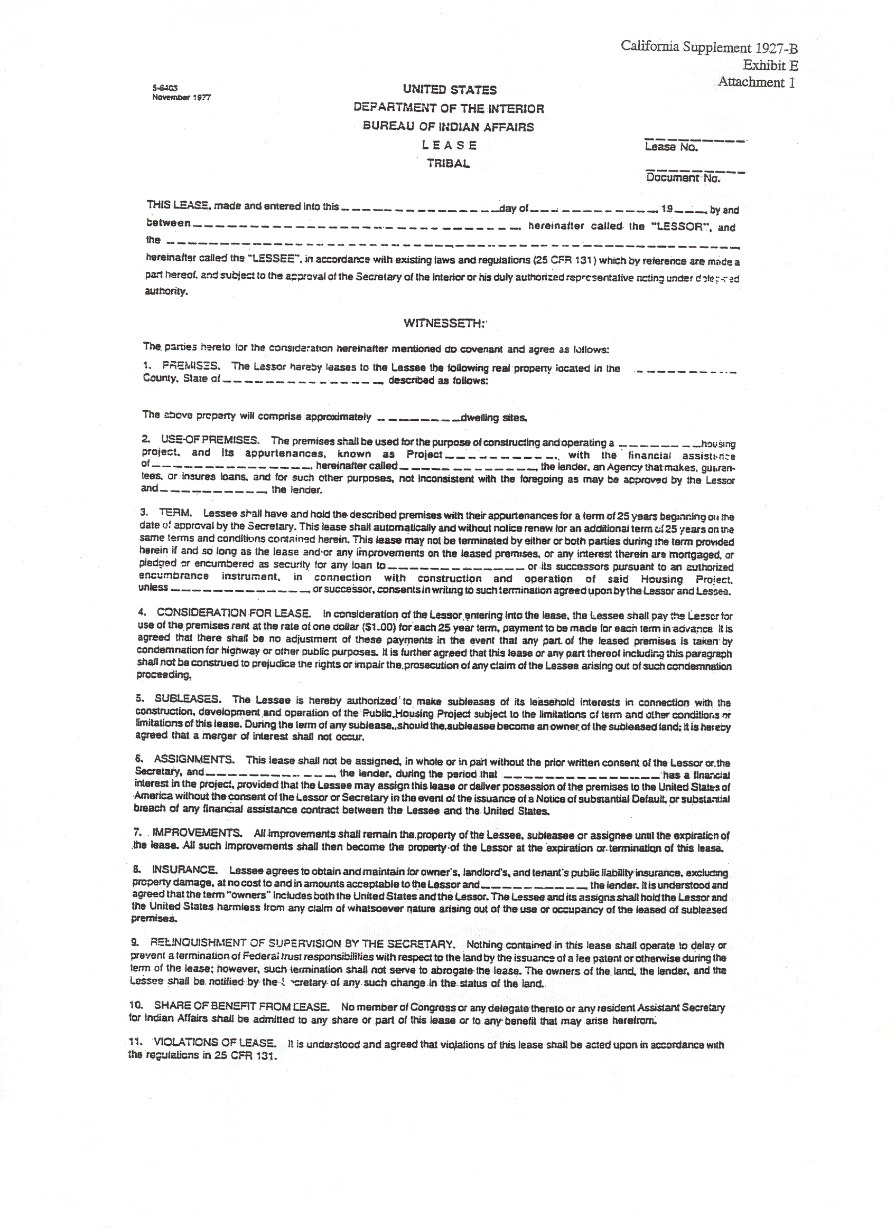
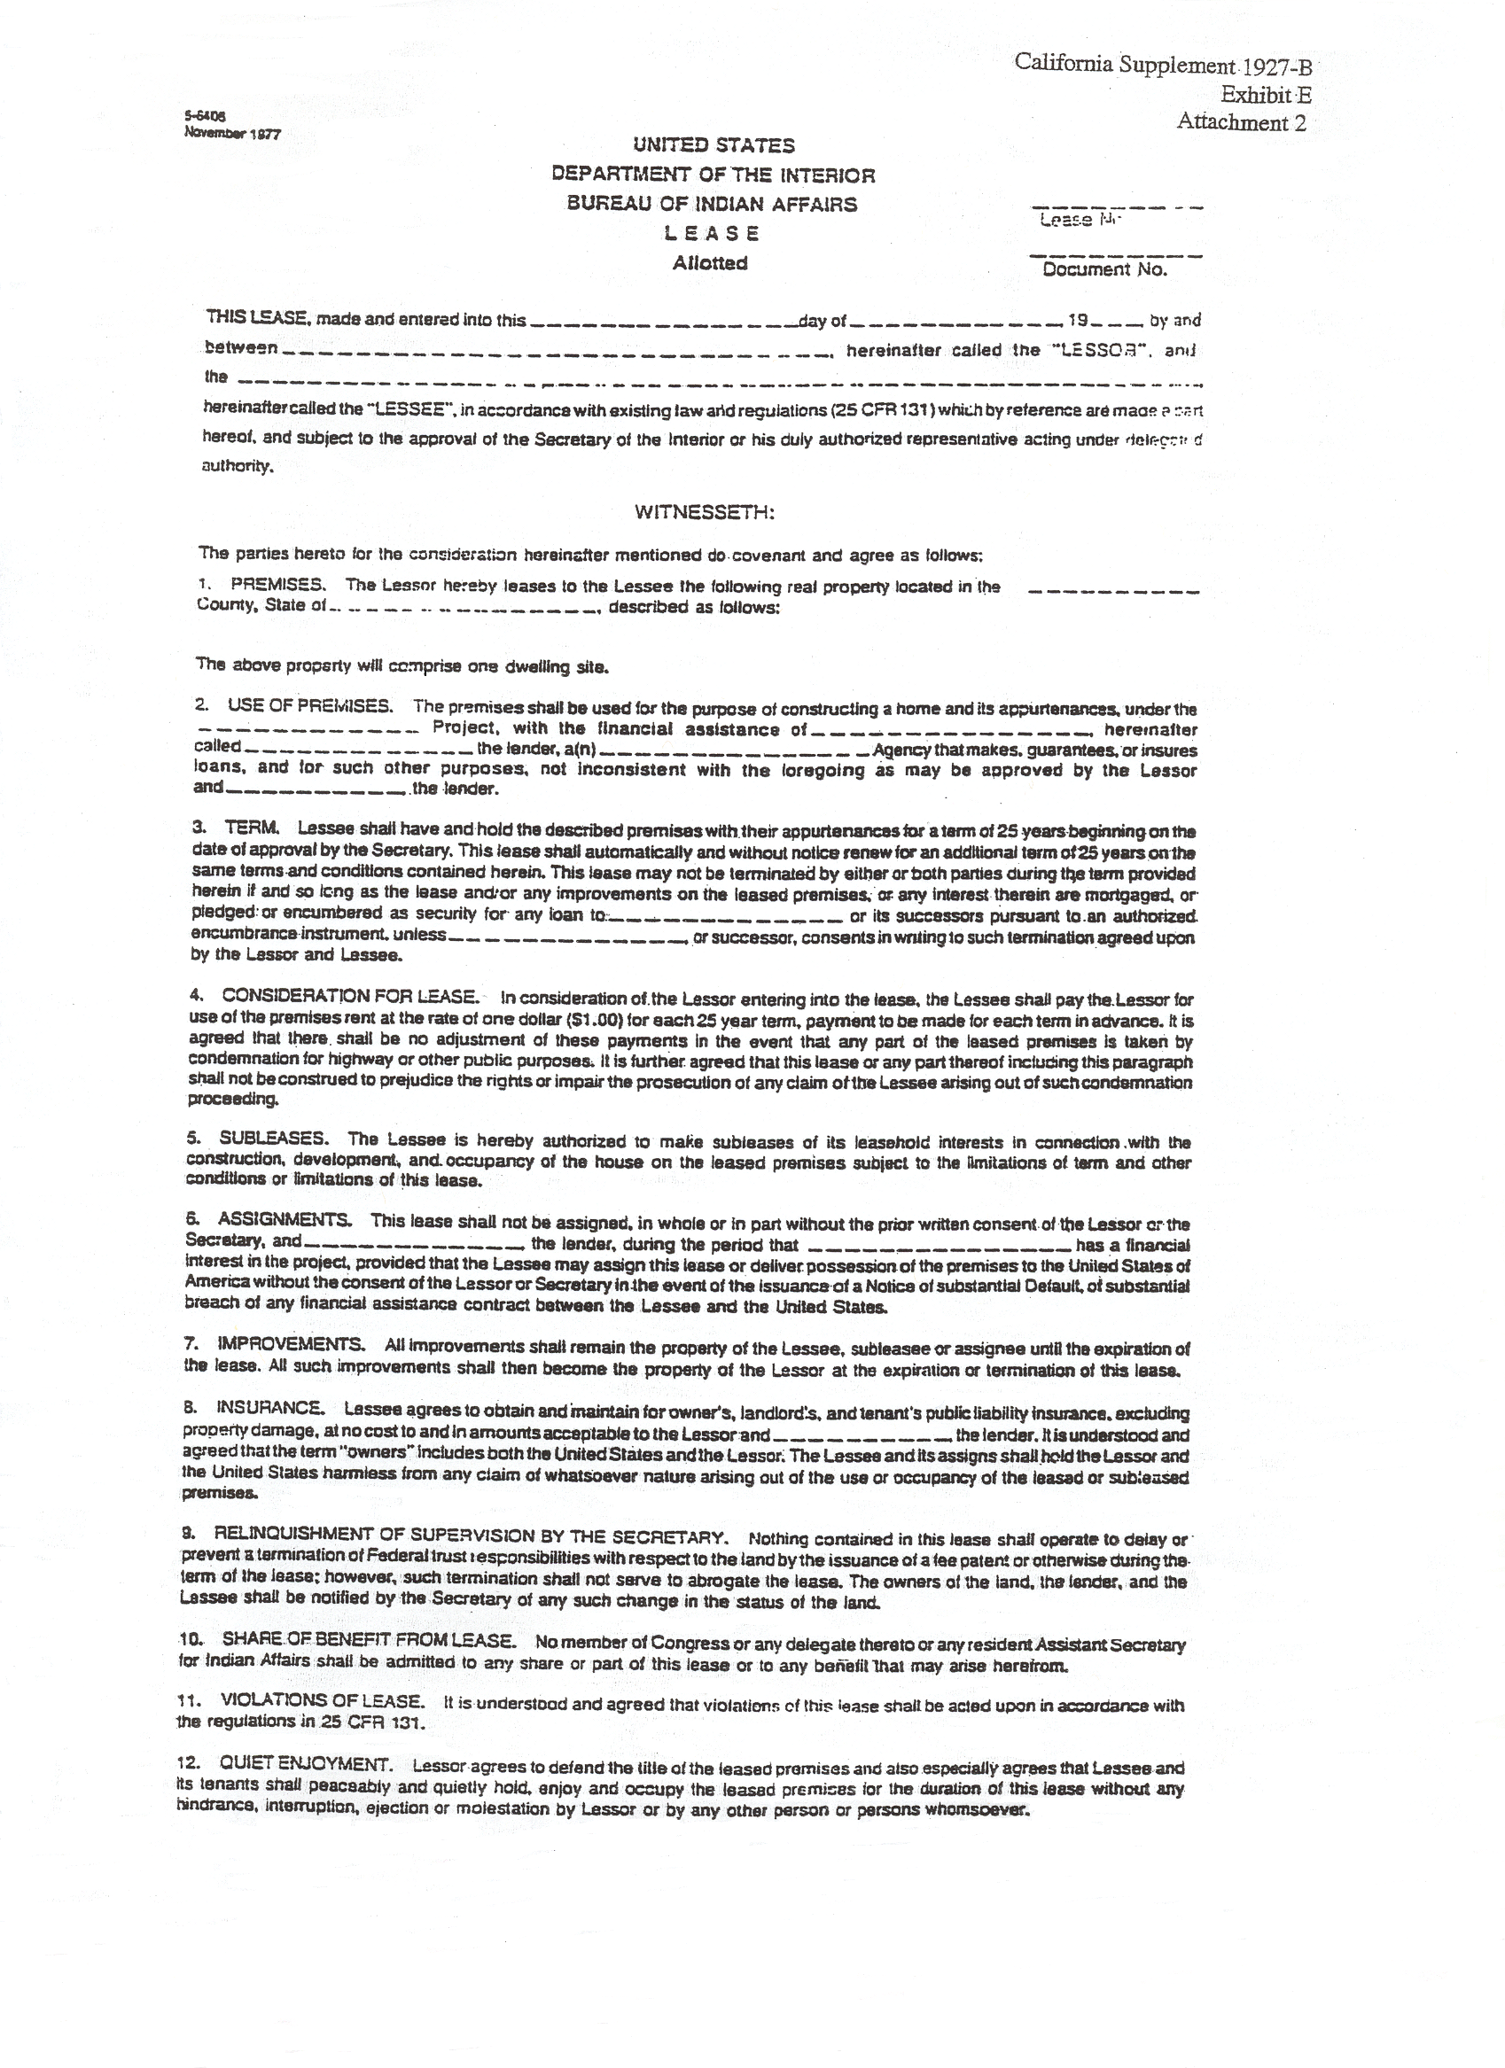
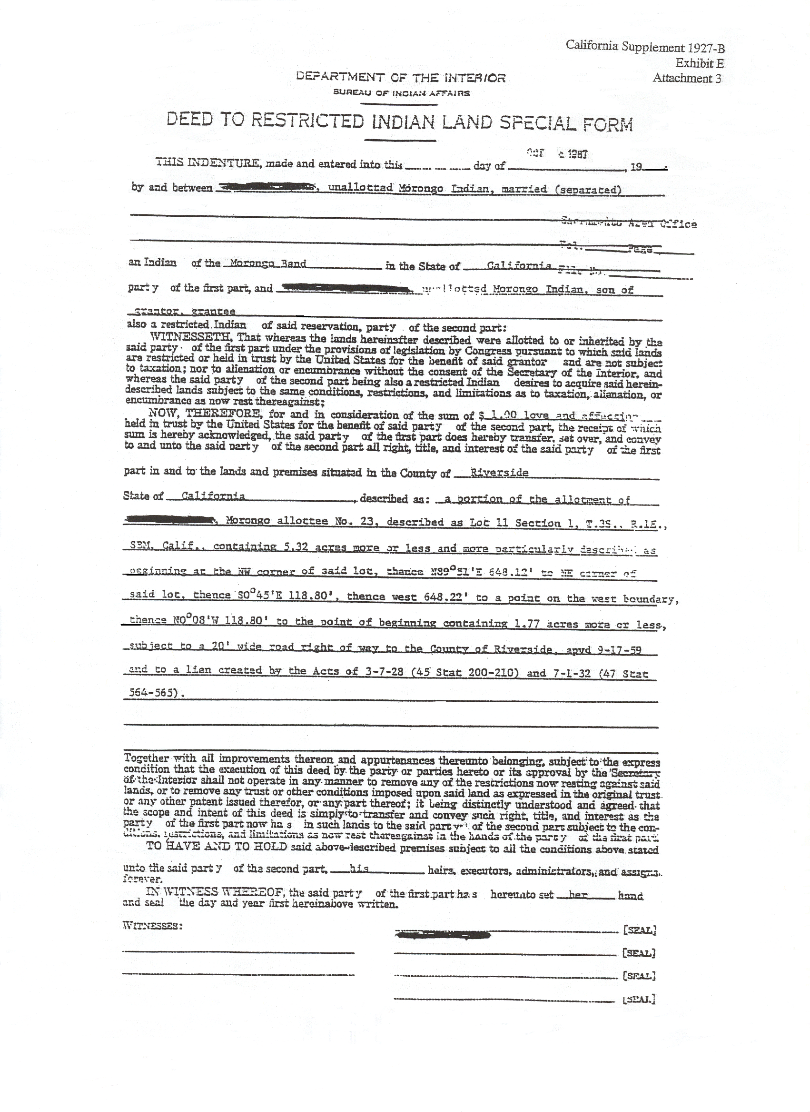

Directory of Bureau of Indian Affairs (BIA) Offices

Below is the list of BIA Offices to contact when requesting Title Status Report (TSR). As indicated below by the general organizational chart, there is one Area Office in the State of California which supervises/leads.

BIA Agencies

Area Director (Area Office)
↓
Superintendent (Local Office)
↓
Housing Officer ↔ Realty Specialist

Office of Area Director - Sacramento Area Office
- Carmen Facio (Area Realty Officer) 916-979-2585 Ext. 240

Northern California - Redding
- Kevin Bearquiver (Realty Specialist) 530-246-5141 Ext. 24
- Terry Lincoln (Self Determination Officer) 530-246-5141 Ext. 29
- Javin Moore (Housing Officer) 530-246-5167 Ext. 25

Central California - Sacramento
- Jim Brafford (Realty Officer) 916-566-7100/15
- Ben Charlie (Housing Officer)

Southern California
- Virgil Townsend (Superintendent) 909-276-6624/25
- Kim Yearyean (Realty Officer) 909-276-6626 Ext 244
- Sonny Magante (Housing Officer) 909-276-6628 Ext 252

Palm Springs Field Office
- Don Magee (Director) 760-416-2133 Ext 222
- Gloria Mesteth (Realty Officer) 760-416-2133 Ext 233

