OLD RIDGE ROUTE

(CA-LAn-990H)

TRANSPORTATION PLAN

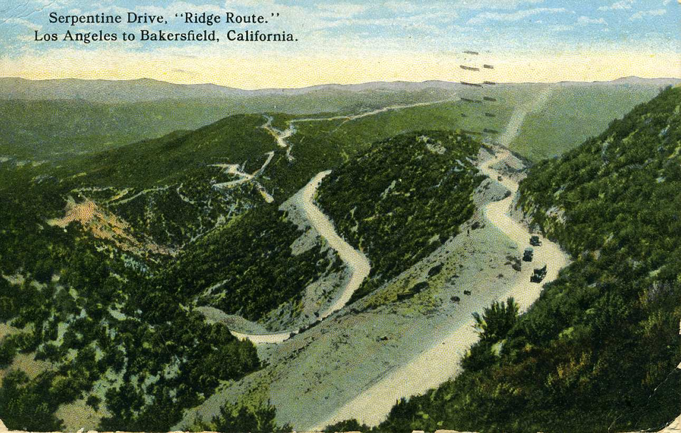

Heritage Resource Section

Angeles National Forest

September 2006

INTRODUCTION

The Old Ridge Route (ORR) first opened to traffic in 1915 as State Route 4 resulting in the most direct automobile and truck route connecting Los Angeles to northern California. The Route was approximately 115 miles and included some 30 miles of new roadway through the mountains between Castaic and Bailey’s Ranch. Most of this route lies within the administrative boundary of the Angeles National Forest (though during its main use, that portion of the Forest was part of the Santa Barbara National Forest).

The Old Ridge Route was in use for 1915 to 1933 when Highway 99 replaced it. Interstate 5 has replaced Highway 99 circa 1969 in the area of the Angeles National Forest.

The Old Ridge Route was placed on the National Register on September 4, 1997 based on its association with events that have made a significant contribution to the broad patterns of our history. Its opening was unquestionably important to the economic, social, political and recreational development of the Los Angeles and San Joaquin regions by providing much greater opportunities for trade, commerce, and public mobility. It also qualified based on its representation of a distinctive method of construction. The Old Ridge Route is an example of one of the earliest automobile highways constructed by the State of California and was a pioneer in the field of mountain highway construction. It was a daring engineering conception and a remarkable feat as it contains 642 narrow radius curves totaling 39,441 degrees (or about 110 concentric circles).

It appears in 1934 the State of California relinquished the portion of the Old Ridge Route, which includes the portion within the Forest to the County of Los Angeles. In 1982, the County Road Department petitioned the Department of Regional Planning requesting that portions of the Old Ridge Route be vacated. The Regional Planning Commission indicated that they would deny the request because of the roadway is designated as a scenic route and bikeway. Saugus District Ranger Dave Kohut provided recommendations to the Department of Regional Planning as part of this process. The County Road Department subsequently withdrew its request.

The Old Ridge Route has for at least the last twenty years (maybe as long as forty years) been maintained by the Forest Service basically within the Forest Administrative Boundary. The Forest also has required proponents (Exxon-Mobil, Pacific Pipeline, Southern California Gas Company, etc.) to protect the Old Ridge Route during their project implementation as they used it for access. The Forest also had a partnership with CORVA to provide interpretation along the Old Ridge Route. CORVA has secured a State Grant to fabricate and install signage.

The Old Ridge Route has long conveyed a romantic thread to the public. The Forest constantly receives calls from people who traveled the Route as a child and want to show their children something from their past. The individual who has taken on the task to try and help maintained the Old Ridge Route became involved through a reminiscent visit to the Old Ridge Route. Local historical societies hold auto tours and there are several web sites dedicated to the Old Ridge Route. It is high on the public radar.

The purpose of this Transportation Plan is to provide a baseline of stipulations and treatment measures designed to protect those characteristics of the Old Ridge Route that help define its historic property character. As projects or undertakings are submitted, then these stipulations and treatment measures will be drawn from, along with others crafted specifically to meet the needs of the particular project or undertaking, to protect the Old Ridge Route from any possible effects.

The defining characteristics of the ORR are the curves of the original road as well as the reinforced concrete roadbed. The focus of the treatment measures will be to protect those characteristics that help define the significant associations of the ORR. Project implementation has the potential to impact the roadway in two ways: 1) damage to the historic concrete and macadam roadway through trenching, and 2) damage to the roadway by the traffic associated with access of project vehicles to the job site as well as the weight of the project vehicles.

The above potential damage to the ORR can be prevented to the reroute of any trenching to avoid intact developed road surface, and to limit the weight of vehicles involved and the number of trips for each vehicle using the ORR. It is expected that once the original Transportation Plan has been reviewed by the State Historic Preservation Office and concurred with, that any undertaking that uses the stipulations listed in the General Stipulation and Treatment Measure section will not need to be consulted on. If additional treatment measures are developed, then consultation will occur with the State Historic Preservation Office with the new undertaking added to this Plan and submitted as a whole.

The Forest has consulted with the State Historic Preservation Office on previous Transportation Plans for the ORR (cf. USFS951219A), and this Plan is a further refinement those previous plans.

STANDARD STIPULATION AND

TREATMENT MEASURES

FOR THE

PROTECTION OF THE

OLD RIDGE ROUTE
For temporary construction purposes, the existing pavement along the ORR within the Angeles National Forest appears to be capable of supporting loads up to 10,000 pounds per axle without noticeable damage. The following protective measures and recommendations are provided to ensure the best effort in preserving ORR Pavement.

- A traffic control plan will be developed and implemented. Please see Table 1 for the proposed trips of equipment. The traffic plan will be submitted prior to the commencement of all field work associated with the project. The plan will focus on the pre-project education of all employees about the significance and fragility of the ORR, the traffic plan (including the need to follow the cones/stay on cement as opposed to asphalt) and speed limits, etc).

- Prior to any work, weights and number of vehicle trips will be verified with the Forest Heritage Resource staff for approval. The number of trips identified prior to the project will be the maximum, unless otherwise approved.

- In order to reduce the number of trips on the ORR, both in and out, the equipment will be transported one time in, moved from location to location, and transported out one time.

- ANF Heritage Resource Staff, a project construction representative, and project archaeologist/archaeological contractor will drive the ORR prior to any work, to establish cone diversion locations, designate appropriate areas for equipment staging, and designate Environmentally Sensitive Areas (ESAs) where staging will not occur.

- Areas of equipment, material, and vehicle staging, and access off the ORR, will be approved by ANF Heritage Personnel. Emphasis will be to stage and access via areas of previous disturbance. Dispersed staging will be preferred on the ORR rather than central staging areas. Approved staging and turnaround areas will be designated by appropriate temporary flagging or signage to be provided by project proponent. Staging areas will be identified on maps by the project proponent for approval and for use by project workers.

- The ORR should be avoided to the extent possible by utilizing alternative dirt access roads in the vicinity. Tracked vehicles shall not be operated on the ORR.

- Vehicles should avoid stopping and maneuvering on pavement that is in poor condition. The additional loading associated with braking and acceleration from a standing stop could cause additional damage to these fragile areas. Areas in poor condition will be marked with cones, flagging, spray chalk, or other identification or barrier measures to indicate avoidance prior to project implementation..

- The edge of the ORR along road intersections will be covered by rubber mats to provide protection to the road edge from the anticipated increased traffic across the road surface. Vehicle operators will be instructed to enter ORR pavement at a 90-degree angle.
- Any displaced concrete and asphalt fragments of the ORR should be recovered and set aside. The pieces will be identified to the Forest Heritage Resource staff who will try and replace the pieces in situ, or if that is not possible, collect the pieces and develop measures to reduce any damage to the area the pieces came from.

- A tire pressure Reduction Plan will be developed and implemented for vehicles utilizing any portion of the ORR. The plan will be submitted to the Forest Service prior to commencement of any field work associated with the project.

- In order to have no impacts to the ORR, rubber tired vehicles and equipment will be used to perform the work when possible. Permission for use of other than rubber-tired vehicles will need to be obtained prior to the use of any such vehicle.

- In order to have no impacts to the ORR, all tracked equipment and reconductoring materials will be transported to the locations on rubber tired lowboy trailers, following the aforementioned weight limits.

- In order to have no impacts to the ORR, tracked equipment needed to perform the emergency repairs will be required to be equipped with street pads, the type acceptable for working on pavement. Also at locations where tracked equipment may need to be on the ORR, 4’ of dry dirt will be place on top of the surface of the ORR for added protection. After completion of the work at any given location, the dirt will be cleaned up with a rubber tired backhoe leaving a ½-1 inch layer which will be removed by hand broom to avoid damaging the ORR.

- It is preferred that the ORR receive as little traffic as possible; all equipment as well as rubber tired vehicles that can travel the road will use Forest Roads FS6N43 (Fisher Spring), FS 7N26 (Posey Canyon), and FS8N01 (Liebre Gulch), when possible, to connect into the ORR. All construction equipment is to access the project sites from Posey Canyon and/or previously approved routes unless approved by the District Ranger as recommended by the Forest Heritage Resource Program Manager.

- Protective measures in the form of diversion cones will be placed along ORR to direct all vehicle traffic onto those areas of the ORR where the pavement is in the best condition. Each diversion location will be previously approved by ANF Heritage Resources Staff and will be checked daily to ensure diversions have not fallen or been removed or altered. The cone diversion method of protection approved by the ANF as an alternate to the application of geo-cloth and rock-free fill.

- Wherever possible, equipment loading and unloading should occur off the pavement. If tracked equipment must be unloaded on the pavement, the pavement should be protected using steel plates, plywood or other means to prevent damage to the pavement surface.

- Heavy vehicles (Gross Weight 8,500 pounds and over) will maintain a speed limit of 10 miles per hour. Light duty pickups and crew transports will maintain a speed limit of 15 miles per hour.

- Water trucks or mowers will not be using the ORR, as traffic on spur roads would not necessitate those vehicles. Any water truck required for Fire Protection will stage off the ORR on connecting dirt roads.

- Any road maintenance activities to the existing access routes to the ORR will comply with Forest Service guidelines. All drainage dips and drainage outlets will be left intact and will not be blocked. No blading of the ORR will be permitted and rock removal will be accomplished with rubber-tired vehicles.

- The Proponent will videotape the ORR before and after the project to help assess the successful project protection measures associated with the reconductoring project. The tapes will be provided to the Heritage Resource Section, Angeles National Forest within 15 days of completion of all construction activities associated with the project, as well as measures to repair any inadvertent damage to the ORR by vehicle traffic and/or construction activities.

- The Project Proponent will avoid impacting the Old Ridge Route, but in the case that damage does occur, the proponent agrees to repair any damage to the Old Ridge Route by their activities by restoring the Old Ridge Route to original grade, and to the historic concrete roadway, following the original specifications of construction (updated to meet current standards).

- It shall be part of the monitoring duties of the on-site archaeologist to monitor and curb excessive speeds on the ORR. If personnel continue to ignore the recommended speed limits on ORR, the archaeological monitor will report them to the construction manager who will pursue disciplinary action, which may result in dismissal from the project. If a vehicle is noted speeding on more than three occasions, then that vehicle is removed from further use within the project area.

- Archaeological Monitors will have the authority to stop or redirect any activities that are impacting the Old Ridge Route.

- Monitoring Protocol:
- It shall be part of the monitoring duties of the on-site archaeologist to track and document the numbers of vehicles and equipment, types and weights, traveling in and out to project locations.
- Archaeological Monitors may enter the ORR from Highway 138 or Templin Highway in addition to the dirt access roads.
- An archaeological monitor will be present at each entrance points to ORR pavement used by project equipment during periods of access.
- Archaeological monitors will communicate with project crews the day before so that they are positioned before vehicles deploy.
- The archaeological monitors will fill out a vehicle trip log, where vehicle types, license plate numbers, trip count, and date.
- Project Proponent will ensure the vehicle logs are submitted to the ANF Heritage Resources staff on a weekly basis.

- No blading of the ORR will be permitted without prior approval. All rock removal will be accomplished with rubber-tired vehicles.

- Any attempt to deviate from the recommendations/requirements in the ORR Protection Plan will result in a work stoppage, necessitate a project review by the ANF Heritage Resource Staff, and require a re-evaluation of project protective measures.

STIPULATION AND TREATMENT MEASURES

FOR THE PROTECTION OF

THE OLD RIDGE ROUTE

FROM PROJECTS ASSOCIATED

WITH 2004-2005 STORM DAMAGE
INTRODUCTION
In the winter of 2004-2005, southern California has experienced a series of significant storm events that has resulted in land slides, floods, and damage to the infrastructure on the Forest, both public and private. Rainfall amounts of over 30 inches were measured on Forest from individual storms with 70-90 inches of rainfall falling on southern California forests.
The Forest consulted with the State Historic Preservation Office regarding a state of emergency that existed due to winter storms causing pipelines to break (creating natural gas escapes and crude oil skills), transmission towers to fall over, and other urban infrastructure damage (USFS050112a).
Damage assessments indicate the need to do repairs to protect human life and property. Initial assessments have documented the following damage:
- Major road arteries, both County and Forest Service, have been washed away or covered with debris, resulting in people being isolated or having access for emergency situations eliminated as well as commute time for workers being doubled or tripled resulting in economic loss.
- Recreation residence cabins, nearly all are historic, may have issues of leaky roofs, damaged exteriors from water or sediment flow, or unstable soil for foundations or hillsides that pose a threat to occupants. Immediate remedial actions include repair and replacement of structural elements, and mechanical stabilization of creek banks or hill sides.
- Electrical distribution lines, nearly all the line routes are historic, have wooden poles damaged or destroyed, effectively eliminating electrical service to parts of the Forest. Immediate remedial actions include the replacement of the wooden poles though the original poles may be older than fifty years.
- Utility lines were heavily damaged with several natural gas and crude oil lines ruptured and a transmission line tower collapsed due to landslides. Service to the Los Angeles area was interrupted. It has since been restored with temporary above ground facilities but the need is to reinter the pipelines and reinforce towers.
For the reminder of 2006 and all of 2007, the Forest anticipates project submissions from the major utility companies in the corridor to address their permanent needs, some of which entails the relocation of lines from areas of risk due to land movement. Each submission will be evaluated as to potential effects to the Old Ridge Route, and the appropriate consultation with the State Historic Preservation Office completed.
Stipulation and Treatment Measures here will be developed for each specific undertaking and added to this Transportation Plan as a separate section. It will be assumed that the standard measures listed at the beginning of this Plan will be automatically incorporated unless revised or replaced by a measure developed specifically for the undertaking and listed in its section.

Pacific Pipeline Storm Damage Restoration

2006
The Forest has received the first proposal for a permanent repair from Pacific Pipeline, which has several crude oil lines buried along or adjacent to the Old Ridge Route (ORR), a National Register-listed property. Portions of Line 63 and Line 2000 were excavated and temporarily laid on the ground surface to reduce the threat to the lines by the eroding landscape. These lines were laid on the Old Ridge Route. There are three locations where Pacific Pipeline is requesting permission to reinstall their lines subsurface: Suspension Bridge, Bypass, and Osito Slide. They will be repairing the pipeline in two other places: Black Plastic, and South of Templin Highway.
Area of Potential Effect:
Suspension Bridge – Line 63 was buried on either side of the ORR. At the north end, it is located on the east side of the road and when it was installed, the ORR was trenched, the pipe installed crossing east to west through the ORR, and the ORR patched with asphalt instead of the original concrete. Line 63 then ran approximately 550 feet south along and under the west side of the ORR before crossing the ORR in a trench to reach the east side of the ORR. Pacific Pipeline is proposing to keep Line 63 on the east side of the ORR by cleaning up the slough from the eroding bank and putting in a trench that is off the paved ORR. Dirt from the trench will be spread over the ORR in this area to provide protective covering from the equipment that will be used to reinstall Line 63. Approximately 880 feet of pipeline will be reinstalled below ground. When the trench is backfilled, it will basically look the same as it did prior to the trenching.
Bypass – Line 63 will not be reinstalled back into the area of the ORR but will be installed within the Right-of-Way for Line 2000 and M-70 (Exxon-Mobil), which is located on a higher ridge adjacent to the ORR immediately on the east. This new route was been surveyed and consulted with your office for the installation of these two pipelines in the bypass (USFS951219A and USGS901029A) and will be installed in the same ROW that was described for the two previous undertakings.
Osito Slide- the Osito Slide damaged about 1000 feet of Line 2000 during the winter of 2004-2005. Emergency repair work early in 2005 removed the damaged pipe as well as portions of the ORR and surrounding soil to remove the threat to other pipelines in the area. Upon examining video from 1997 and 2000, most of the ORR that was removed appears to be portions that were previously disturbed with earlier pipeline installations and was a repaired asphalt road surface instead of the historic concrete. Line 63 was relocated to the east side of the ORR in 1978 and was covered with an asphalt road surface. The area of removed soil was reconstructed back to original grade for the ORR, and the slope stabilized so that Line 2000 could be laid on top of the ORR surface. Pacific Pipeline is proposing to trench in the ORR reconstructed roadway for approximately 980 feet and install the currently above ground Line 2000. The trench will be put at least three feet from the edge of any intact developed road surface, either asphalt or concrete.
Black Plastic – Emergency repairs replaced about 120 feet of pipe that is not currently tied-in or backfilled. This will be backfilled and tied in during this project.
Pacific Pipeline shall trench approximately 1,660 feet along their Line 2000 right-of-way, crossing the Old Ridge Route at one point, for the installation of four 2-inch HDPE conduits. Qwest will bring up additional equipment to install new fiber optic conduits and place new cable in the conduits between existing manholes
South of Templin Highway – A dent in a section of Line 63, located ¼ mile south of Templin Highway (identified during a smart pig run) will be repaired.
Project-specific Stipulations and Treatment Measures –

General Measures:

- A Forest Heritage Staff person will be on-site to monitor all activities that involve the ORR to ensure the protection measures are implemented correctly and effective so that the roadway does not get impacted.

- The ORR will be protected through the application of the Transportation Plan that will minimize the equipment traffic along the ORR for this project.

- Equipment or material storage will not occur directly on historic developed road surface.

- All staging areas will be surveyed and approved before construction activities begin. No staging will occur on the historic sites or areas previously closed to staging/storage in previous projects. The storage needs at each site will be identified and approved by the Forest Service.

- Measures highlighted under Daily Moves for the September 25, 2006 Revised Traffic Plan will be followed.

- All measures highlighted under Moves 1-19 for the September 25, 2006 Revised Traffic Plan will be followed.

Suspension Bridge - Use rubber tired front end loaders or backhoes to remove slough and preliminary trenching to obtain enough soil to cover the ORR with up to 4” of soil to protect it from the equipment that will be used to trench and install the pipe. Before the soil is applied, a geocloth will be laid down to help minimize any impacts from when the soil is too thin. The fill will be monitored constantly to ensure that the geocloth is not exposed.

Bypass – The site boundaries for CA-LAn-1834 (historic trash scatter) will be flagged in order for all construction activities to avoid the site area. All activities within 200 feet of the site will be monitored to ensure that if buried deposits are encountered, then work is halted and an immediate assessment of the nature of the deposits will occur.

Osito Slide – Maintain at least a three foot distance between the edge of historic developed road surface that the trench. Any reduction of buffer zone or impact to non-historic developed road surface must be approved by Forest Heritage Staff to ensure no effect to historic developed road surface.

Black Plastic – Trench dug for Qwest fiber optic lines will cross the ORR in areas where historic developed road surface is missing. Equipment is not to stage on asphalt or concrete roadway during trenching unless a geo-cloth and dirt fill pad is created.

South of Templin Highway - This portion of the ORR is not listed on the National Register but is assumed eligible for the National Register. Most of this portion of the ORR is covered by maintained asphalt so the historic developed road base is protected.
REVISED Transportation Plan
Pacific Pipeline Line 63 and Line 2000 Relocations in
AngelEs National Forest
September 25, 2006

This plan has been revised to reflect changes in the way that this project will be constructed:

Revision 1:
In an effort to reduce the duration of time that Pacific Pipeline’s Line 2000 will be taken out of service, Pacific will transport new pipe to Site 1 (Line 2000 worksite), install new pipe in a trench adjacent to the temporary pipeline, and tie-in the new pipeline section while Line 2000 is shutdown for a short amount of time. This will minimize the interruption of crude oil service to refineries by shortening the duration of shutdown construction work, thus limiting the impact of stringent Fire Plan PAL restrictions on the line’s operation.

Revision 2:
Qwest and Pacific Pipeline fiber optic conduits and cables were stretched as a result of the recent landslides in the Angeles National Forest area. These fiber optic lines parallel Pacific Pipeline’s 20” Line 2000 which was also damaged by the landslide activity. Pacific Pipeline and Qwest are proposing that the work be done concurrently with the Line 63 and Line 2000 pipeline relocation work. This will minimize the impact to the Old Ridge Route by allowing the work to be done without moving an entirely new fleet of construction equipment and crews along the Old Ridge Route in the future to perform the work separately.

Pacific Pipeline has three segments of Line 63 and a section of Line 2000 exposed at temporary relocations due to recent land movement incidents. In addition to these exposed pipelines, Pacific and Qwest fiber optic cables and conduits were also stretched and damaged by the land movements. Pacific Pipeline and Qwest will be required to bring the following equipment in to relay the temporary pipeline sections into permanent locations and to replace the damaged fiber optics lines.

The work will be completed in a series of staged equipment moves and construction activities. In general, all equipment will enter and leave the Angeles National Forest area via Fisher Springs Road or Templin Highway. The equipment will then be moved north and south to the six worksites along the Old Ridge Route (ORR). In all cases, tracked equipment will be moved over paved sections of the ORR on lowboy trailers.

In addition to the planned equipment moves (designated Moves 1 through 19), it will be necessary that select equipment/vehicles enter and leave the construction sites on a daily basis as well as travel between the sites daily for the duration of the construction work. The duration of the construction work is estimated to be 50 working days. Any delays of construction activities caused by weather, fire plan restrictions, or other outside entity will consequentially increase the number of trips made by daily equipment/vehicles by as many days as the delay(s).

Daily Moves, I-5 to All Work Sites and Travel Between Sites

Quantity | Equipment | Axles | Weight | Total Round Trips Per Vehicle | Total Round Trips (All Vehicles)
4 | 2500 Gal Water Truck | 2 | 33,000 | 100 | 400
1 | 3-Ton Fuel Truck | 2 | 30,000 | 150 | 150
2 | 2 Ton Flatbed Trucks | 3 | 19,500 | 50 | 100
1 | 1 Ton Flatbed Truck | 2 | 9,500 | 50 | 50
1 | Fireguard Truck | 2 | 8,000 | 50 | 50
2 | Passenger Van | 2 | 7,000 | 50 | 100
6 | Truck Mounted Welding Units | 2 | 6,000 | 50 | 300
4 | ¾ Ton Pick-up Trucks (Contractor) | 2 | 6,000 | 50 | 200
4 | ¾ Ton Pick-up Truck (Pacific) | 2 | 6,000 | 50 | 200
2 | ¾ Ton Pick-up Truck (Survey Crew) | 2 | 6,000 | 50 | 100
2 | ¾ Ton Pick-up Truck (Monitor) | 2 | 6,000 | 50 | 100

Two additional water trucks will also be used solely for the purpose of dust abatement along Fisher Springs Road between the I-5 Freeway and ORR. These two water trucks will not cross over or move along the ORR, but will travel up and down Fisher Springs road multiple times per day throughout the duration of the construction work.

Pacific Energy will also supply Traffic Control Guards at the steel gate located at the ORR near Templin Highway and at the steel gate entrance to Fisher Springs Road near I-5. These guards will ensure that civilian vehicles and pedestrians are kept out of the work areas during construction.
The following is the series of planned equipment moves associated with the pipeline and fiber optic line repairs. The timing and sequence of the moves is subject to change and will be determined in the field in accordance with construction requirements.

Move 1 Equipment List, I-5 to Fisher Springs and ORR Intersection:

Quantity | Equipment | Axles | Weight | Round Trips Per Vehicle
1 | 416 Cat Backhoe | 2 | 16,000 | 1
1 | 950 Cat Loader | 2 | 41,000 | 1
1 | 5 CY Dump Truck | 2 | 25,000 | 4
1 | Street Sweeper | 2 | 23,000 | 1
1 | 1 Ton Flatbed Truck | 2 | 9,500 | 1

Prior to moving equipment to the worksites, the intersection of Fisher Springs Road and the ORR will be swept, covered with geotextile fabric, and padded with approximately 4 inches of dirt for additional protection. Equipment for sweeping and spreading dirt will travel up Fisher Springs Road to the ORR.

Move 2 Equipment List, I-5 to Site 1 / Site A:
Quantity | Pacific Pipeline Equipment | Axles | Weight | Round Trips Per Vehicle
1 | 325 Cat Excavator | 7 | 101,760 | 0.5
3 | 572 Cat Sideboom | 7 | 112,000 | 0.5
1 | 18-Ton Hydro Crane | 2 | 36,000 | 0.5
1 | 950 Cat Loader | 2 | 41,000 | 0.5
1 | 12G Cat Motor Grader | 3 | 29,800 | 0.5
1 | 416 Cat Backhoe | 2 | 16,000 | 0.5
1 | Brush Hog Tractor | 2 | 17,500 | 0.5
1 | Air Compressor | 1 | 3,200 | 0.5

Quantity | Qwest Equipment | Axles | Weight | Round Trips Per Vehicle
1 | 1½ Ton Flatbed w/ Compressor | 2 | 18,800 | 5
1 | Trailer w/ Mini Excavator | 2 | 10,080 | 0.5
1 | 1 Ton Flatbed Truck | 2 | 9,860 | 5
1 | Fiber Trailer | 1 | 4,420 | 0.5
1 | ½ Ton Pick-up Truck | 2 | 6,000 | 5
1 | ¾ Ton Pick-up Truck | 2 | 9,200 | 5

Line 2000 in Osito Canyon (Site 1) will be relocated from its temporary above ground location to the new alignment located approximately five feet west of Pacific’s Line 63 in an unpaved section of the Old Ridge Route.

The construction equipment will be brought in from the I-5 Freeway along Fisher Springs Road (NF-6N43) to the ORR. Tracked equipment will be moved by low boy trailers approximately 1900 feet north along the ORR to the Line 2000 worksite (Site 1).

During the Line 2000 work at Site 1, equipment from the Site 1 pipeline work will be used to trench, install, and backfill the fiber optics lines at Site A. Four new 2-inch HDPE conduits will be installed in approximately 850 feet of common trench with the permanent Line 2000 installation along the Old Ridge Route at Site A. Approximately 200 additional feet of trench shall be dug each side of the Line 2000 and fiber optic common trench to connect new fiber optics conduits to the existing line. Qwest will bring up additional equipment to install new fiber optic conduits and place new cable in the conduits between existing manholes.

Move 3 Equipment List, I-5 to Fisher Springs Road and ORR intersection:

Quantity | Equipment | Axles | Weight | Round Trips Per Vehicle
1 | Tractor-Trailer with Pipe | 7 | 36,000 | 12

After the equipment has been brought to Site 1 in Move 1, Line 2000 line pipe will be hauled up on tractor-trailer trucks from I-5 along Fisher Springs and will stop just prior to reaching the ORR. The rubber tired hydraulic crane at Site 1 will then be used to hoist pipe over the ORR and onto Pacific Pipeline’s ROW. Sidebooms from Site 1 will move along Pacific Pipeline’s ROW to shuffle the line pipe from the unloading area to Site 1. The existing Line 2000 pipe will be removed from the area by the same process: the sidebooms will shuffle the used pipe back to Fisher Springs Road where the rubber tired hydro crane will hoist pipe over the ORR onto a tractor-trailer truck. The truck will haul the pipe back down Fisher Springs Road to I-5.

Move 4 Equipment List, Site A to Site I-5:
Qwest Equipment
Quantity | Equipment | Axles | Weight | Round Trips Per Vehicle
1 | 1½ Ton Flatbed w/ Compressor | 2 | 18,800 | 0.5
1 | Trailer w/ Mini Excavator | 2 | 10,080 | 0.5
1 | 1 Ton Flatbed Truck | 2 | 9,860 | 0.5
1 | Fiber Trailer | 1 | 4,420 | 0.5
1 | ½ Ton Pick-up Truck | 2 | 6,000 | 0.5
1 | ¾ Ton Pick-up Truck | 2 | 9,200 | 0.5

After completion of the relocation of Line 2000 at Osito Canyon (Site 1) and the fiber optics line replacements, the Qwest equipment used to install the fiber optics lines will be removed from the area until Pacific’s equipment can begin work at fiber optics Site B.

Move 5 Equipment List, Site 1 to I-5:

Quantity | Equipment | Axles | Weight | Round Trips Per Vehicle
1 | 325 Cat Excavator | 7 | 101,760 | 0.5
1 | 416 Cat Backhoe | 2 | 16,000 | 0.5
1 | Brush Hog Tractor | 2 | 17,500 | 0.5
1 | Air Compressor | 1 | 3,200 | 0.5

After completion of the relocation of Line 2000 at Osito Canyon (Site 1) and the fiber optics line replacements, some of the equipment used will move to I-5 via Fisher Springs Road. This equipment will then move to Site 2 during Move 6. Tracked equipment will be moved on lowboy trailers over the ORR. At the completion of the work, this equipment will be moved back to the Line 63 relocation (Site 3) in Osito Canyon north of the Line 2000 relocation.

Move 6 Equipment List, I-5 to Site 2:
ORR Sweeping and Dirt Padding
Quantity | Equipment | Axles | Weight | Round Trips Per Vehicle
1 | 416 Cat Backhoe | 2 | 16,000 | 1
1 | 950 Cat Loader | 2 | 41,000 | 1
1 | 5 CY Dump Truck | 2 | 25,000 | 4
1 | Street Sweeper | 2 | 23,000 | 2
1 | 1 Ton Flatbed Truck | 2 | 9,500 | 1

Site 2 Construction Equipment
Quantity | Equipment | Axles | Weight | Round Trips Per Vehicle
1 | D6R Cat Dozer | 7 | 82,000 | 0.5
1 | Pipe Bending Machine | 2 | 22,000 | 0.5
1 | 325 Cat Excavator | 7 | 101,760 | 0.5
1 | 416 Cat Backhoe | 2 | 16,000 | 0.5
1 | Brush Hog Tractor | 2 | 17,500 | 0.5
1 | Air Compressor | 1 | 3,200 | 0.5
3 | D5 Cat Sideboom | 7 | 88,000 | 0.5

The equipment listed above will enter the Forest along Templin Highway and move north along the ORR to the southern Line 63 worksite (Site 2) to supplement equipment moved from the Line 2000 worksite (Move 5). Tracked equipment will be moved on the ORR on lowboy trailers.

Prior to moving any construction equipment along the ORR between Templin Highway and Site 2, the ORR will be swept, and any potholes or pavement edges will be filled and padded with dirt to reduce risk of damage to the road.

Move 7 Equipment List, Site 2 to I-5:

Quantity | Equipment | Axles | Weight | Round Trips Per Vehicle
1 | D6R Cat Dozer | 7 | 82,000 | 0.5
1 | Pipe Bending Machine | 2 | 22,000 | 0.5
3 | D5 Cat Sideboom | 7 | 88,000 | 0.5
1 | Air Compressor | 1 | 3,200 | 0.5

Upon completion of the Line 63 work at Site 2, the equipment that will not be used during the fiber optics work will be moved back to I-5 by moving south along the ORR to Templin Highway.

Move 8 Equipment List, Site 2 to Site B:

Quantity | Equipment | Axles | Weight | Round Trips Per Vehicle
1 | 325 Cat Excavator | 7 | 101,760 | 0.5
1 | Brush Hog Tractor | 2 | 17,500 | 0.5
1 | 416 Cat Backhoe | 2 | 16,000 | 0.5

After work at the southern Line 63 worksite (Site 2) has been completed, the remaining equipment will move south along Pacific’s Line 63 right-of-way to fiber optics Site B. At Site B, Pacific Pipeline shall trench approximately 1,660 feet along their Line 2000 right-of-way, crossing the Old Ridge Route at one point, for the installation of four 2-inch HDPE conduits. Qwest will bring up additional equipment to install new fiber optic conduits and place new cable in the conduits between existing manholes.

Move 9 Equipment List, I-5 to Site B:

Quantity | Qwest Equipment | Axles | Weight | Round Trips Per Vehicle
1 | 1½ Ton Flatbed w/ Compressor | 2 | 18,800 | 5
1 | Trailer w/ Mini Excavator | 2 | 10,080 | 0.5
1 | 1 Ton Flatbed Truck | 2 | 9,860 | 5
1 | Fiber Trailer | 1 | 4,420 | 0.5
1 | ½ Ton Pick-up Truck | 2 | 6,000 | 5
1 | ¾ Ton Pick-up Truck | 2 | 9,200 | 5

Once the conduit has been installed and backfilled, Qwest will install the new fiber optic cable between existing manholes. Qwest equipment will move to Site B from I-5 using Templin Highway, then north along the ORR to Pacific’s Line 2000 right-of-way to Site B.

Move 10 Equipment List, Site B to I-5:
Quantity | Pacific Pipeline Equipment | Axles | Weight | Round Trips Per Vehicle
1 | 325 Cat Excavator | 7 | 101,760 | 0.5
1 | Brush Hog Tractor | 2 | 17,500 | 0.5
1 | 416 Cat Backhoe | 2 | 16,000 | 0.5

Quantity | Qwest Equipment | Axles | Weight | Round Trips Per Vehicle
1 | 1½ Ton Flatbed w/ Compressor | 2 | 18,800 | 0.5
1 | Trailer w/ Mini Excavator | 2 | 10,080 | 0.5
1 | 1 Ton Flatbed Truck | 2 | 9,860 | 0.5
1 | Fiber Trailer | 1 | 4,420 | 0.5
1 | ½ Ton Pick-up Truck | 2 | 6,000 | 0.5
1 | ¾ Ton Pick-up Truck | 2 | 9,200 | 0.5

After fiber optics work is completed at Site B, all equipment involved will move to I-5 by traveling south on ORR to Templin Highway. Some of this equipment will then move to the northern Line 63 worksite (Site 3) using I-5 and Fisher Springs Road.

Move 11 Equipment List, Site 1 to Site 3:

Quantity | Equipment | Axles | Weight | Round Trips Per Vehicle
3 | 572 Cat Sideboom | 7 | 112,000 | 0.5
1 | 950 Cat Loader | 2 | 41,000 | 0.5
1 | 12G Cat Motor Grader | 3 | 29,800 | 0.5
1 | 18-Ton Hydro Crane | 2 | 36,000 | 0.5

Work on the Line 63 relocation (Site 3) above the ORR and north of the Line 2000 relocation (Site 1) will begin with equipment that was not moved to the southern Line 63 relocation (Site 2) from Site 1. The following equipment will move from the north end of the Line 2000 relocation (Site 1) directly onto the Line 63 relocation (Site 3).

Move 12 Equipment List, I-5 to Site 3:

Quantity | Equipment | Axles | Weight | Round Trips Per Vehicle
3 | 325 Cat Excavator | 7 | 101,760 | 0.5
1 | 416 Cat Backhoe | 2 | 16,000 | 0.5
1 | 5 CY Dump Truck | 2 | 25,000 | 1
1 | Street Sweeper | 2 | 23,000 | 1
2 | D6R Cat Dozer | 7 | 82,000 | 0.5
1 | Pipe Bending Machine | 2 | 22,000 | 0.5
1 | Brush Hog Tractor | 2 | 17,500 | 0.5
1 | Air Compressor | 1 | 3,200 | 0.5

The equipment listed above will be moved along Fisher Springs Road to supplement the Line 63 relocation (Site 3) north of the Line 2000 relocation (Site 1). This includes equipment that was previously working at the southern Line 63 worksite (Site 2) and the southern fiber optics worksite (Site B). Tracked equipment will be moved by low boy over the ORR. Prior to moving equipment north to Site 4 along the ORR, the area where the Line 63 ROW meets the ORR will be swept and armored with 4 inches of dirt padding.

Move 13 Equipment List, Site 3 to Site 4:

Quantity | Equipment | Axles | Weight | Round Trips Per Vehicle
1 | 950 Cat Loader | 2 | 41,000 | 0.5
1 | 325 Cat Excavator | 7 | 101,760 | 0.5
1 | 18-Ton Hydro Crane | 2 | 36,000 | 0.5
1 | D6R Cat Dozer | 7 | 82,000 | 0.5
1 | Pipe Bending machine | 2 | 22,000 | 0.5
1 | 416 Cat Back Hoe | 2 | 16,000 | 0.5
1 | Brush Hog Tractor | 2 | 17,500 | 0.5
1 | Air Compressor | 1 | 3,200 | 0.5

Due to the ongoing construction activities associated with Line 63 (Site 3) on the ridge above the ORR, it will be necessary to maintain access to the northern Site 4 location at all times. Consequently, it will be necessary to construct two temporary shoefly roads around the existing landslide damaged portions of the ORR. It will also be necessary to construct a berm over the Gas Company pipeline where it crosses the ORR using dirt from construction of the temporary shoefly roads. Temporary shoefly roads will allow for emergency access in case of fire or accident as well as allowing equipment to be transported to Site 4. Tracked equipment will be moved over both the ORR and the temporary shoeflys on low boy trailers to Site 4.

In addition to the shoefly roads, Pacific will also need to need to construct a temporary access ramp from the ORR to Pacific’s right-of-way at the north end of Site 3. This will allow traffic to bypass Site 3 during construction activities, thus providing emergency and daily work related traffic access to Site 4. The temporary ramp will be removed once it is no longer in use.

Move 14 Equipment List, I-5 to Site 4:

Quantity | Equipment | Axles | Weight | Round Trips Per Vehicle
3 | D5 Cat Sideboom | 7 | 88,000 | 0.5

Additional equipment to be used to perform work at Site 4 will be brought in from I-5 at Fisher Springs Road, then along the ORR to Site 4. Tracked equipment will be moved by low boy over the ORR.

Move 15 Equipment List, Site 3 to I-5:

Quantity | Equipment | Axles | Weight | Round Trips Per Vehicle
1 | 12G Cat Grader | 3 | 29,800 | 0.5
2 | 325 Cat Excavator | 7 | 101,760 | 0.5
1 | D6R Cat Dozer | 7 | 82,000 | 0.5
3 | 572 Cat Sideboom | 7 | 112,000 | 0.5

Upon completion of construction activities, equipment not moved to the Line 63 Suspension Bridge Site (Site 4) will be removed from the forest from the Line 63 relocation worksite area (Site 3) south along the ORR, to Fisher Springs Road, then out to I-5. Tracked equipment will be moved by low boy over the ORR.

Move 16 Equipment List, Site 4 to I-5:

Quantity | Equipment | Axles | Weight | Round Trips Per Vehicle
1 | 950 Cat Loader | 2 | 41,000 | 0.5
3 | D5 Cat Sideboom | 7 | 88,000 | 0.5
1 | 325 Cat Excavator | 7 | 101,760 | 0.5
1 | Pipe Bending machine | 2 | 22,000 | 0.5
1 | 18-Ton Hydro Crane | 2 | 36,000 | 0.5
1 | 416 Cat Back Hoe | 2 | 16,000 | 0.5
1 | Brush Hog Tractor | 2 | 17,500 | 0.5
1 | Air Compressor | 1 | 3,200 | 0.5
1 | D6R Cat Dozer | 7 | 82,000 | 0.5

After completion of the relocation work for Line 63 at Site 4, the remaining equipment will be transported on low boy trailers out of the Angeles National Forest to the I-5 using Fisher Springs Road.

Move 17 Equipment List, I-5 to Site A:

Quantity | Equipment | Axles | Weight | Round Trips Per Vehicle
2 | Splice Truck (¾ Ton Pick-up) | 2 | 8,500 | 6 Nightly Round Trips
1 | ½ Ton Pick-up Truck | 2 | 6,400 | 6 Nightly Round Trips
1 | Ford Expedition | 2 | 6,500 | 6 Nightly Round Trips
1 | Fireguard Truck | 2 | 8,000 | 6 Nightly Round Trips
2 | ¾ Ton Pick-up Truck (Pacific) | 2 | 6,000 | 6 Nightly Round Trips
1 | 2500 Gal Water Truck | 2 | 33,000 | 6 Nightly Round Trips

Upon completion of the fiber optics conduit and cable installation, Qwest will mobilize a crew to splice the fiber optic lines together and place them into service. The crew will travel from I-5 to the ORR via Templin Highway. The crew will travel north along the ORR to Site 1, where they will conduct the splice work. The splice work will last approximately 6 nights, with the crew and splice equipment traveling back to I-5 at the end of each shift. Equipment included in the Daily Moves Equipment List will not pertain to work at this site.

Move 18 Equipment List, I-5 to Site B:

Quantity | Equipment | Axles | Weight | Round Trips Per Vehicle
2 | Splice Truck (¾ Ton Pick-up) | 2 | 8,500 | 6 Nightly Round Trips
1 | ½ Ton Pick-up Truck | 2 | 6,400 | 6 Nightly Round Trips
1 | Ford Expedition | 2 | 6,500 | 6 Nightly Round Trips
1 | Fireguard Truck | 2 | 8,000 | 6 Nightly Round Trips
2 | ¾ Ton Pick-up Truck (Pacific) | 2 | 6,000 | 6 Nightly Round Trips
1 | 2500 Gal Water Truck | 2 | 33,000 | 6 Nightly Round Trips

Following the splice work at Site 1, the crew will conduct the same splicing operating for 6 nights at Site 2, traveling to the ORR from Templin Highway, then north along the ORR to Site 2. Equipment included in the Daily Moves Equipment List will not pertain to work at this site.

Move 19 Equipment List, I-5 to Site 5

Quantity | Equipment | Axles | Weight | Round Trips Per Vehicle
1 | 325 Cat Excavator | 7 | 101,760 | 1
1 | 572 Cat Sideboom | 7 | 112,000 | 1
1 | 950 Cat Loader | 2 | 41,000 | 1
1 | D6R Cat Dozer | 7 | 82,000 | 1
1 | Brush Hog Tractor | 2 | 17,500 | 1
1 | 416 Cat Back Hoe | 2 | 16,000 | 1

In addition to the work at Sites 1 through 4, the replacement of a buckled section of Line 63 will take place at Site 5, south of Templin Highway. This work will utilize separate equipment from that used at Sites 1 through 4. All equipment to be used at Site 5 will be brought to the ORR from I-5 via Templin Highway. The equipment will travel south along the ORR approximately one mile and will then travel along a dirt road to reach the pipeline ROW. From this point, the equipment will arrive at Site 5 by heading north along Pacific’s pipeline ROW. Tracked equipment will be moved by low boy over the ORR.

Temporary Staging Areas

In addition to the work sites themselves, staging areas have been designated for the temporary storage of materials and equipment throughout the duration of the construction activities. See the attached photographs of the twelve designated staging areas identified as Staging Area 1 through Staging Area 12.

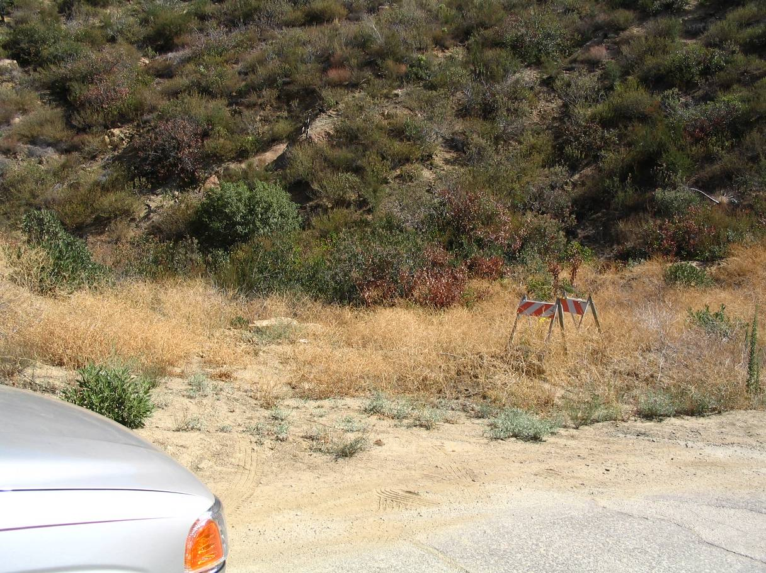

Staging Area 1

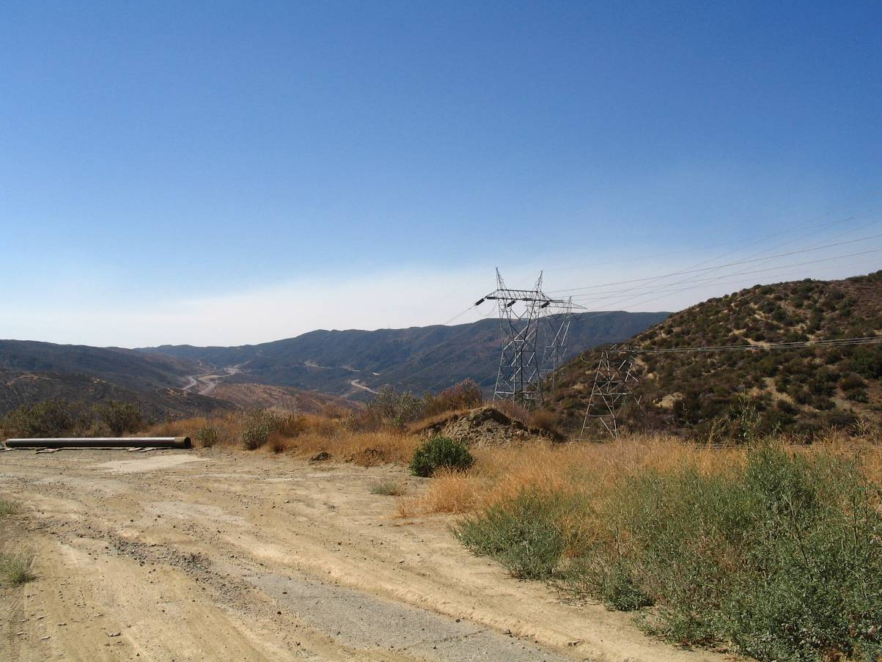

Staging Area 2

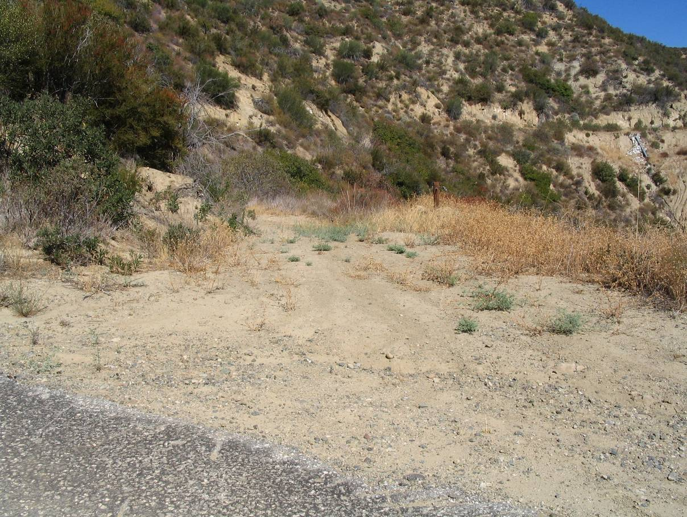

Staging Area 3

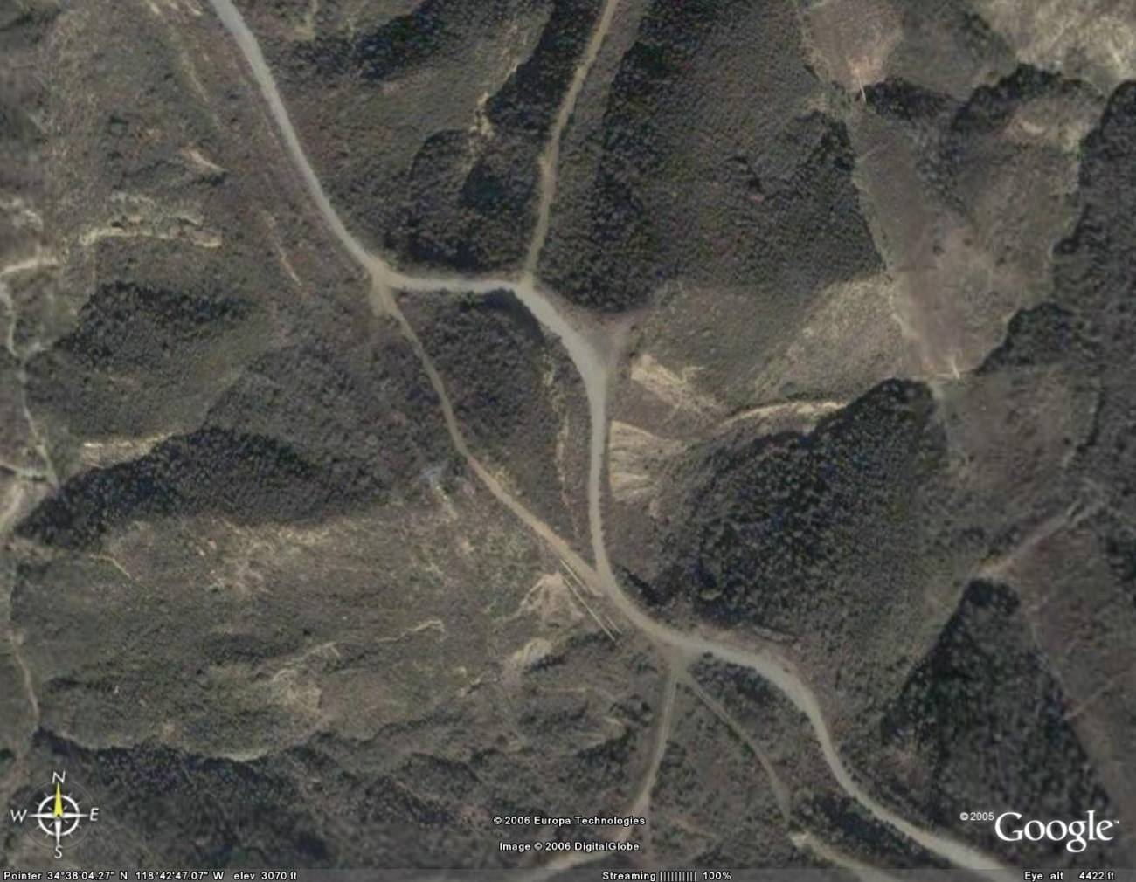

Staging Area 3B

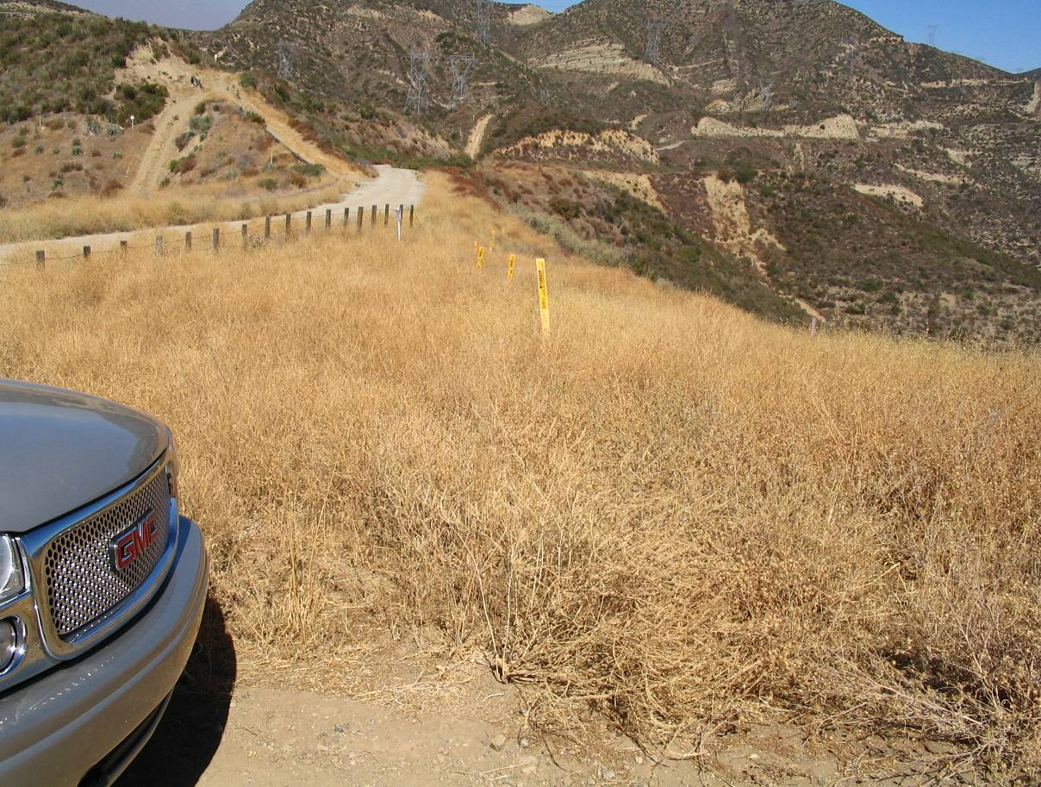

Staging Area 4

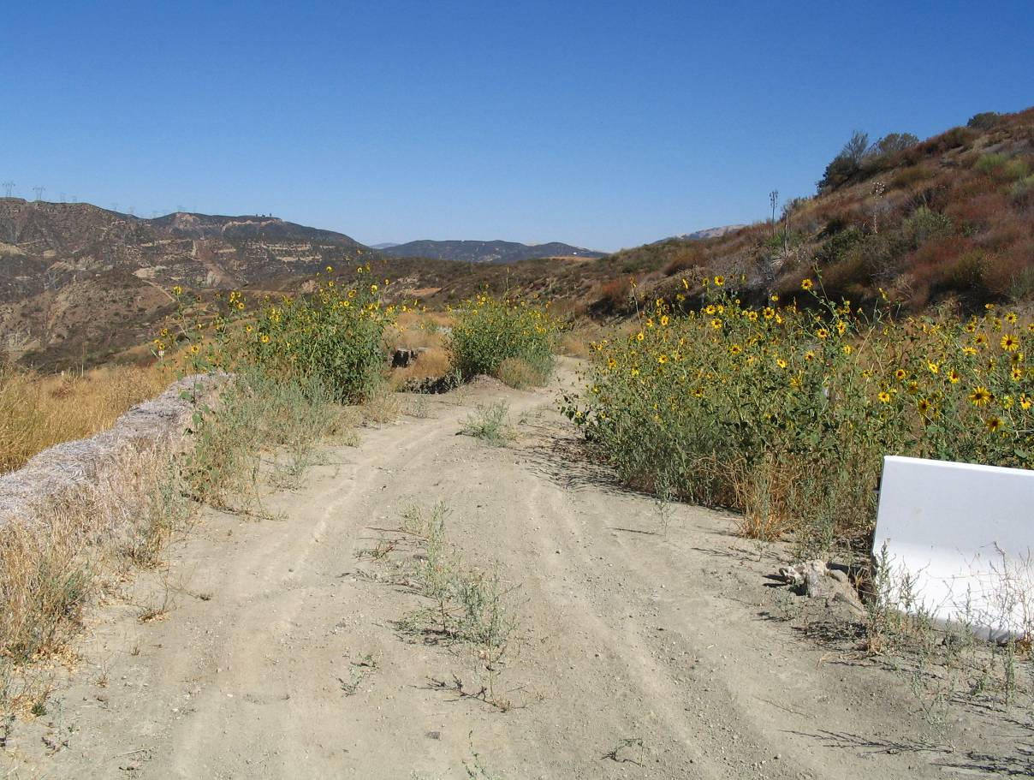

Staging Area 5

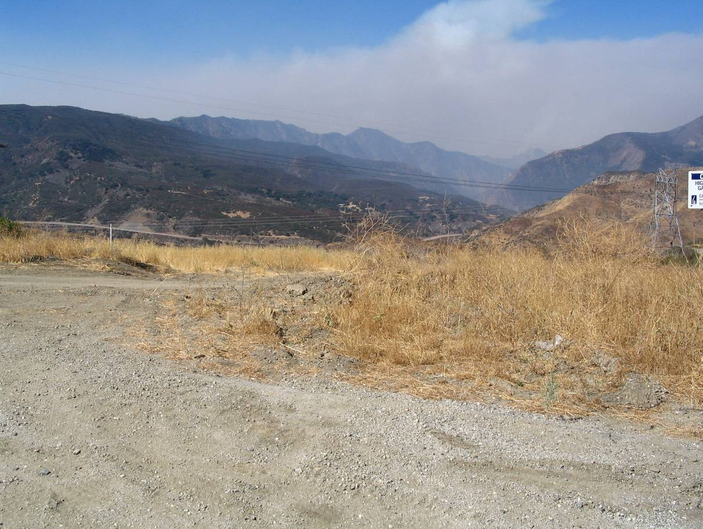

Staging Area 6

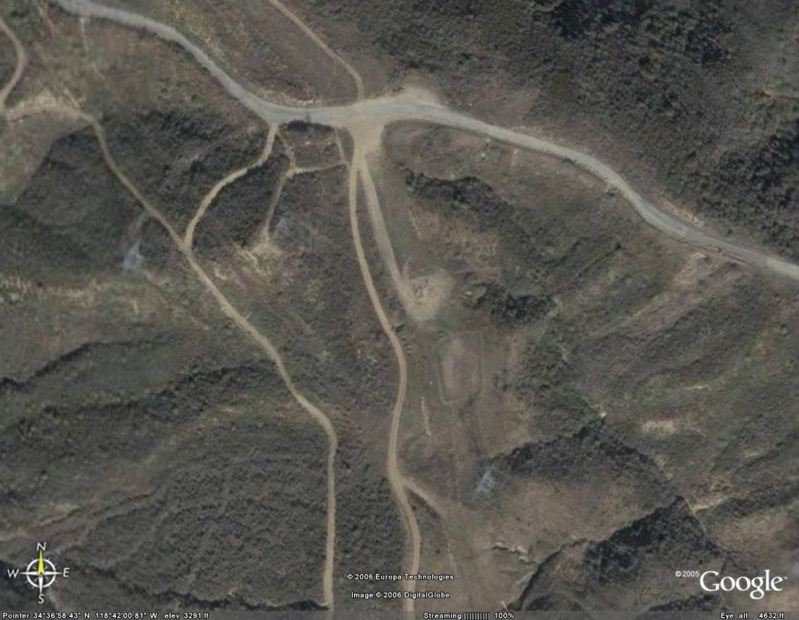

Staging Area 7

Staging Area 7
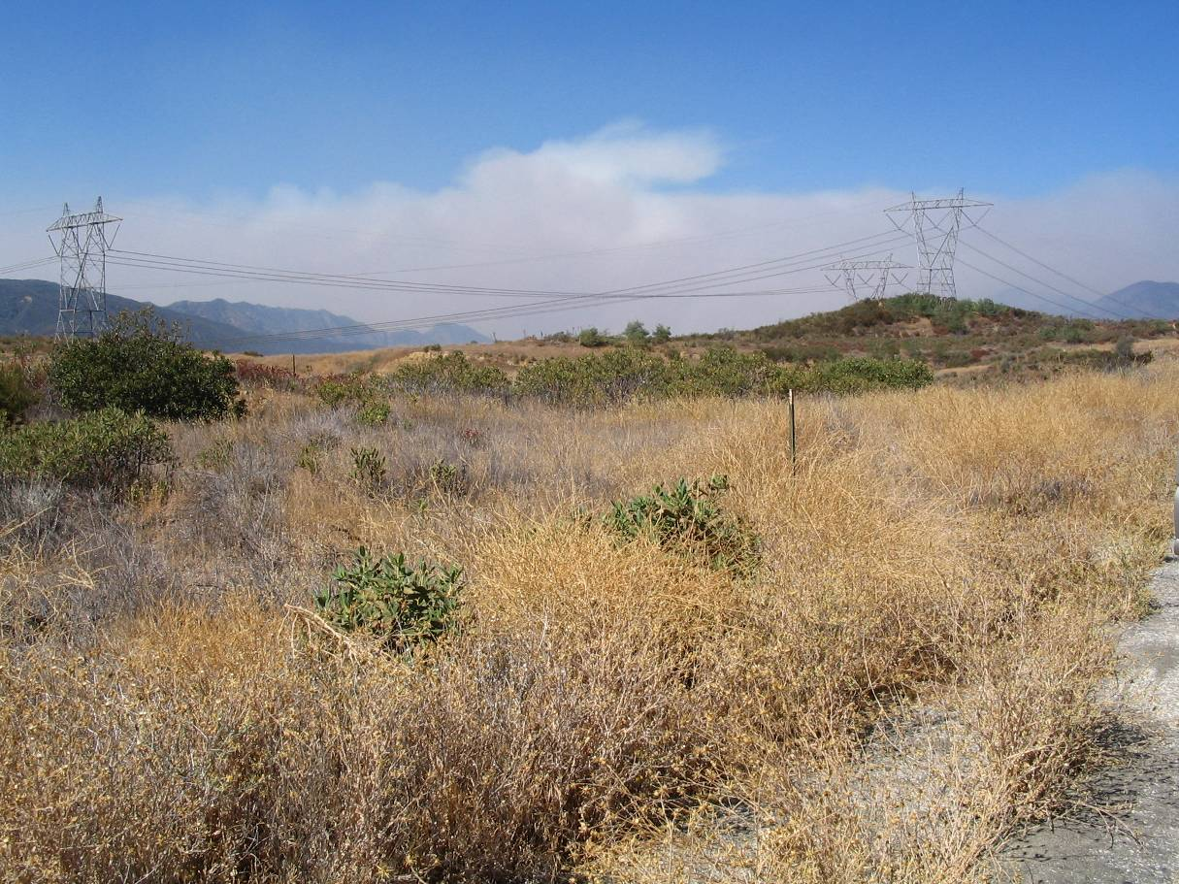

Staging Area 8

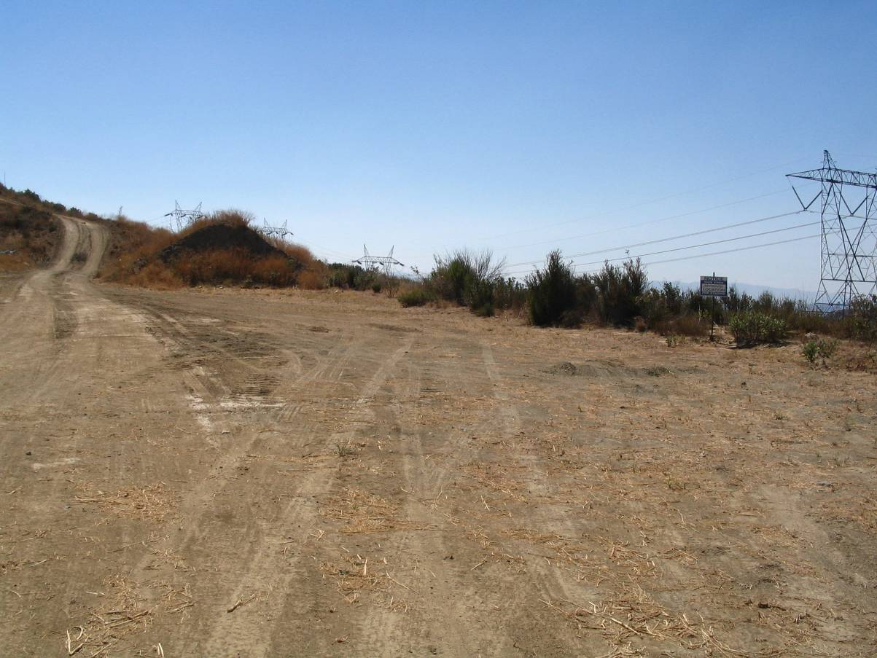

Staging Area 9

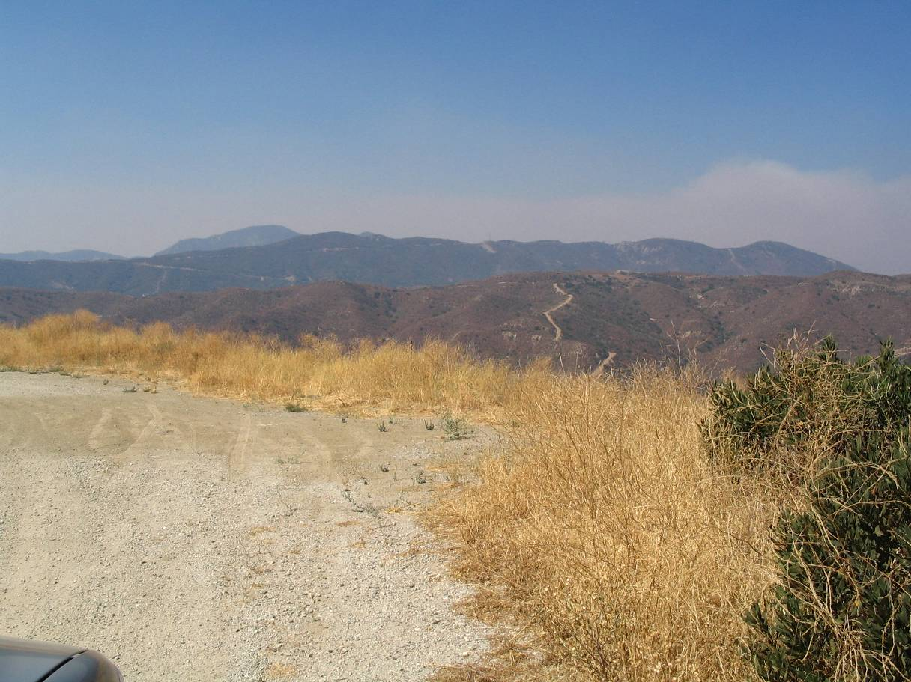

Staging Area 10

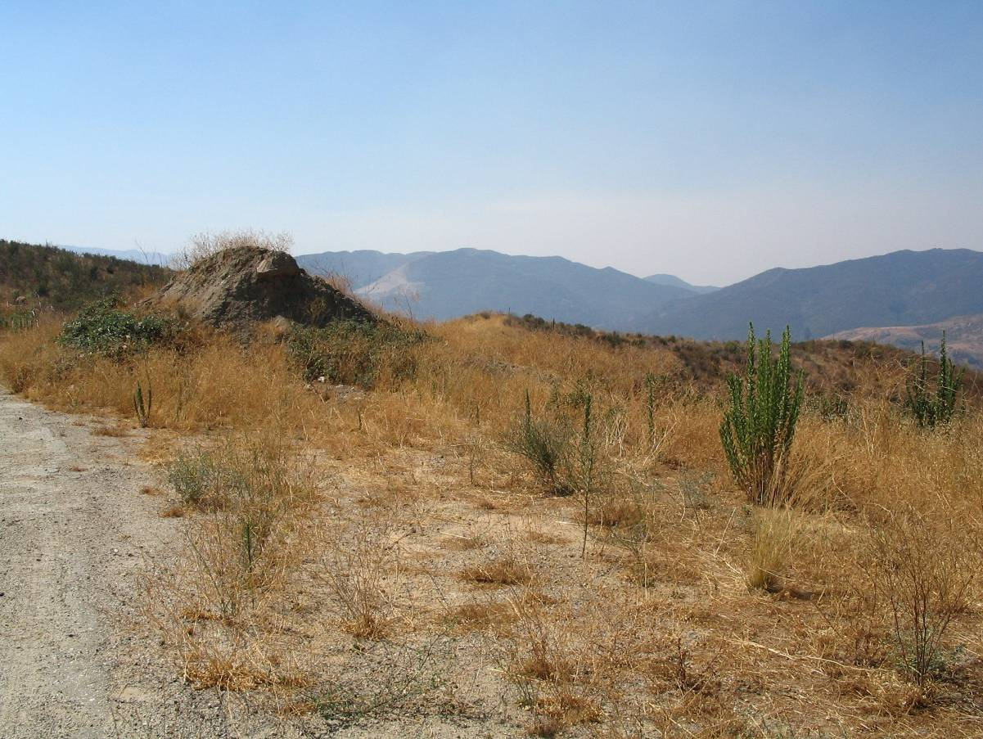

Staging Area 11

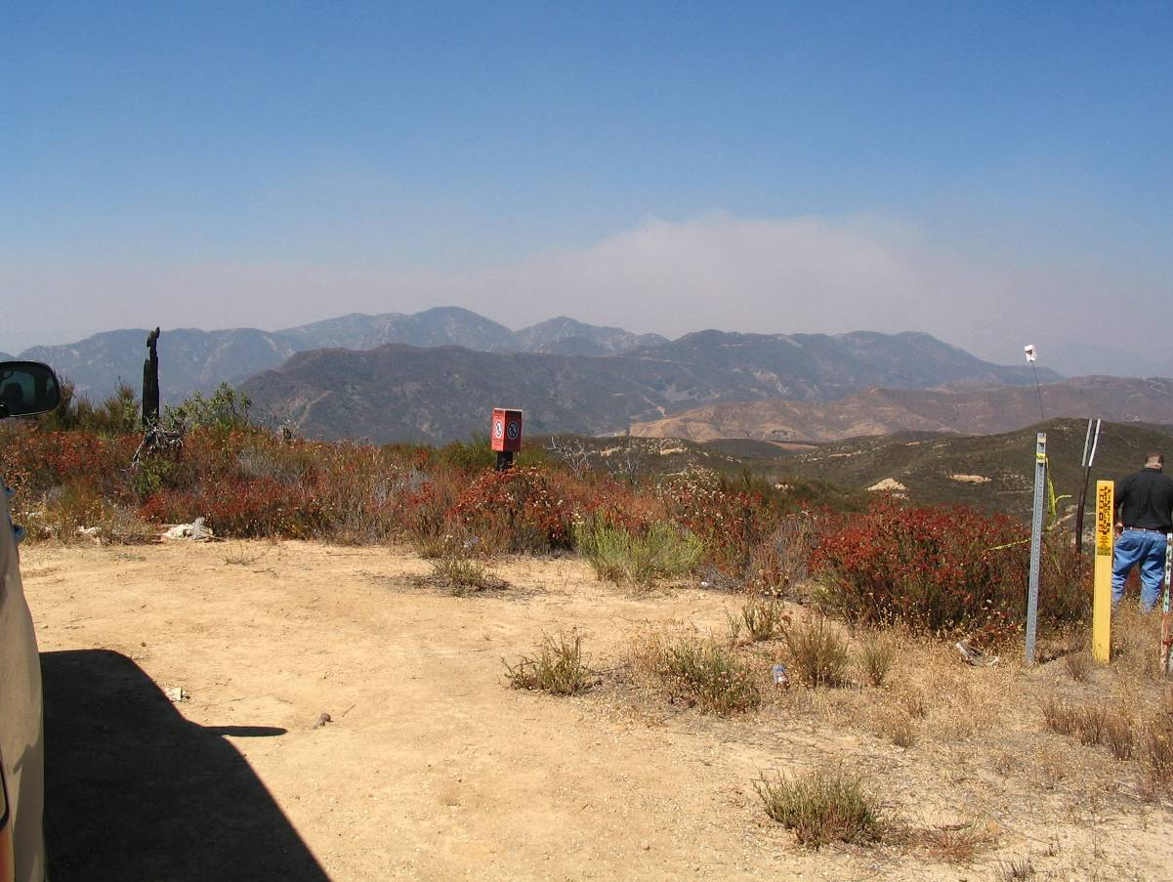

Staging Area 12

/tmp/lo/0000.doc

Transportation Plan – ADDENDUM 1
Pacific Pipeline Line 63 and Line 2000 Relocations in
AngelEs National Forest
September 22, 2006

The items included in this addendum accompany the Revised Transportation Plan dated September 7, 2006 and shall be considered as part of the executed plan.

- When tracked equipment is moved to Site 1 from I-5 using a lowboy trailer, the lowboy will unload equipment at the Fisher Springs Road and ORR intersection. The equipment will move along the Pacific Pipeline ROW to Site 1, and the empty lowboy will travel back down Fisher Springs Road to I-5. This will occur for each piece of tracked equipment. When the equipment is to be moved from the site to I-5, the empty lowboy will move along Fisher Springs Road to the ORR intersection where the equipment will then be loaded. Empty weight of lowboy tractor trailer (7 axle) is approximately 40,000 lbs.

- When tracked equipment is moved to Site 2 from I-5 using a lowboy trailer, the lowboy will unload equipment at the intersection of ORR the dirt road leading down to Site 2 at the bottom of the canyon. The empty lowboy will travel back down ORR to Templin Highway, then to I-5. This will occur for each piece of tracked equipment. When the equipment is to be moved from the site to I-5, the empty lowboy will move along Templin Highway to the ORR to the intersection of the dirt road (leading to Site 2) where the equipment will then be loaded. Empty weight of lowboy tractor trailer (7 axle) is approximately 40,000 lbs.

- When tracked equipment is moved to Site 3 from I-5 using a lowboy trailer, the lowboy will unload equipment at the Fisher Springs Road and ORR intersection. The equipment will move along the Pacific Pipeline ROW to Site 3, and the empty lowboy will travel back down Fisher Springs Road to I-5. This will occur for each piece of tracked equipment. When the equipment is to be moved from the site to I-5, the empty lowboy will move along Fisher Springs Road to the ORR intersection where the equipment will then be loaded. Empty weight of lowboy tractor trailer (7 axle) is approximately 40,000 lbs.

- When tracked equipment is moved to Site 4 from I-5 using a lowboy trailer, the lowboy will unload equipment at the Fisher Springs Road and ORR intersection. The equipment will move along the Pacific Pipeline ROW along the Site 1 and Site 3 worksites, to the intersection of the northern end of Site 3 and the ORR. The empty lowboy will move north along the ORR to the north end of Site 3, where the equipment will be reloaded onto the trailer. The loaded lowboy will then continue moving north along the ORR to Site 4 where the equipment will then be unloaded. The empty lowboy will move south along the ORR to Fisher Springs Road, then to the I-5. This will occur for each piece of tracked equipment. When the equipment is to be moved from the site to I-5, the empty lowboy will move to Site 4 along the ORR from Fisher Springs Road. The equipment will be loaded at Site 4 and transported to the north end of Site 3. Here, the equipment will be unloaded, and will travel along the Pacific Pipeline ROW to the Fisher Springs and ORR intersection. The empty lowboy will travel along the ORR to Fisher Springs Road where the equipment will then be reloaded onto the trailer. The loaded lowboy will then move to I-5 via Fisher Springs Road. Empty weight of lowboy tractor trailer (7 axle) is approximately 40,000 lbs.

- With the exception of vehicles and equipment listed in Moves 17 and 18, (Qwest fiber optic splicing work), no heavy equipment will be moved on the ORR between Site 1 and Site 2. The only vehicles that will move between Site 1 and Site 2 using ORR will be 4 pick-up trucks at 3 round trips per vehicle per day (total of 600 round trips made by pick-up trucks). These pick-up trucks will be used for inspection, supervision/management, and archaeological monitoring.

- The area around “Forest End” will be fenced with orange safety fencing.

- All staging areas will be cleared of existing brush using hand equipment (weed eaters) in order to leave root system intact.

- At Staging Area 3B (as designated in the field by Steve Barth on September 20, 2006), area will be graded to be as level as possible. The dirt from this grading will be hauled to Site 4 to pad the ORR along the Site 4 work area. Once work at Site 4 is completed, the dirt padding will be moved back to Staging Area 3B and compacted. This dirt transfer will add a 5 cubic yard dump truck making 10 round trips per day for 3 days (30 round trips total). The dump truck will move in from I-5 using Fisher Springs Road and will then move north along the ORR to Staging Area 3B and will move out of the Forest the same way when the dirt padding is placed. The dump truck will move to Site 4 again using Fisher Springs Road and the ORR when padding is to be returned to Staging Area 3B.

- The small landslide at the north end of Site 3 will be removed and reused to construct ramp over the So-Cal Gas pipeline that crosses the ORR. All pieces of asphalt and cement shall be carefully removed and stockpiled along the east sided of the ORR at the slide area as requested by Steve Barth in the field on September 20, 2006.

- In addition to those shown in the daily moves table of the Revised Transportation Plan, two 2500-gallon water trucks and two fireguard trucks shall be added for the purpose of fire prevention during simultaneous construction activities at the different work sites.

11. The following table summarizes the locations that each piece of equipment (except for those making daily round trips) will move to throughout the project.

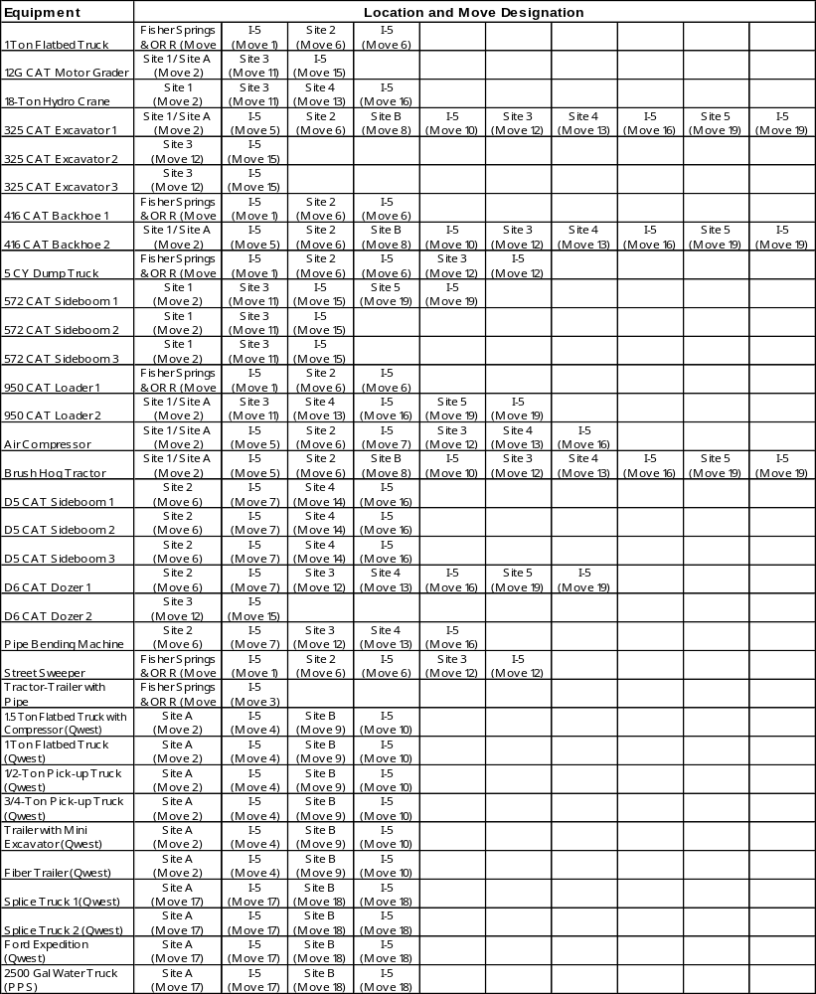

Figure 1 – Equipment Movement Diagram

