International Polar Year 2007 - 2008
Resources on Polar Research
in the NOAA Central Library Network

A. Fiolek
NOAA Central Library, National Oceanographic Data Center,
National Environmental Satellite, Data, and Information Service
SSMC3, 2ND Floor, 1315 East-West Highway
Silver Spring, MD 20910 USA

Abstract: The NOAA Library Network collections are unique: over 40% of the items in NOAALINC (the online catalog) and in WorldCat (the world’s largest bibliographic database) are not found anywhere else. The Central Library also has the original collections of the U.S. Weather Bureau and the Coast and Geodetic Survey – approximately 110,000 items which include documents related to the three preceding International Polar Years and related expeditions. Unique polar research materials contain historic and current reports from various polar expeditions, including the Arctic and Antarctic regions. The presence of these unique and historical resources in NOAA prompted the Library to participate in 4th International Polar Year (IPY) 2007-2008 activities.
In addition, unique and historically valuable NOAA polar research documents and scientific data, in the forms of digital videos, still images, and datasets, have also been entered into NOAALINC, the National Oceanographic Data Center (NODC) Ocean Archive System (OAC), and other oceanographic information catalogs and databases. These additional resources are possible thanks to the Library’s collaboration with other NOAA projects and programs, such as the Video Data Management System (VDMS), Climate Data Modernization Program (CDMP), and NODC Cruise Report Program.
Over one hundred fifty unique and historically valuable publications were selected, cataloged, imaged and entered into NOAALINC with online links to assure open access to these full-text documents. A comprehensive printed and online bibliography was created to provide additional resources to the polar material. The online bibliography also serves as an Internet locator for printed and related sources for polar research. It is available via the NOAA Central Library’s Bibliographies’ home page at: http://docs.lib.noaa.gov/rescue/Bibliographies/IPY2007.pdf
During the 4th International Polar Years 2007-2008, the NOAA Library Network collections are authoritative resources for polar data and research.
- introduction
The International Polar Year is a cooperative effort “to fully investigate every possible aspect of the Polar Regions - the seas, the land and the ice; the life and peoples who are at home at the Poles, and even the view of the universe from the ‘ends of the Earth’." [1] The 4th International Polar Year is an opportunity to increase public awareness of research into weather and climate conditions at the poles, including incremental temperature and ice thickness changes, and other phenomena. To better understand the historical patterns of climate change, early oceanographic and atmospheric observations and data are significant to this research. NOAA’s national data centers and their libraries are primary scientific resources in the search for the answers to global climatic anomalies.

The NOAA Central Library and Information Network maintains collections of over 3 million volumes in all formats from 30 NOAA libraries nationwide. Collections include books, technical reports, maps, scientific observations, photographs, professional journals, digital videos, images, and artifacts. Many are in electronic format and widely available to NOAA scientists and to the general public via NOAALINC, its online catalog at: http://www.lib.noaa.gov/uhtbin/webcat.

The online catalog contains links to over 45,000 full-text documents and other web resources. These include historical documents containing observations in climate, oceanography, fisheries, and early surveys of the coasts of United States. Over 40% of the NOAA libraries’ collections are unique. These include historical data from early polar expeditions, and polar cruises sponsored during the first three International Polar Years.

The NOAA Central Library considers participation in the 4th International Polar Year activities as an unique opportunity to support the NOAA scientists and the research community in their projects during IPY 2007-2008.

The events of the 4th IPY provided a great chance to better assess, catalog, preserve, archive and provide online access to historical documents concerned with polar regions. An objective of this project was to make rare and unique historical material available in full-text on Web. NOAA’s historical collections are in all formats: books, government reports, expedition reports, videos, photographs and other forms of documentation concerning explorers, scientists and organizations prominent in the advancement of knowledge about polar regions.

- historical polar documents
Located in Silver Spring, Maryland, the NOAA Central Library (NCL) networks over thirty NOAA libraries nationwide. NCL is considered the historically richest and most comprehensive multidisciplinary scientific collection in hydrographic surveying, oceanography, ocean engineering, atmospheric sciences (climatology and meteorology), meteorological satellite applications, living marine resources, geophysics, cartography, and mathematics in the Western Hemisphere. It incorporates holdings of NOAA’s predecessor agencies, including the Coast and Geodetic Survey, the Weather Bureau, and the Bureau of Fisheries. The collections reflect the history of these organizations, their scientific research, observations and data from 1820 to the present.

NOAA Central Library is also recognized as an important resource on history of polar discoveries and polar research. These historical publications include reports from early Arctic and Antarctic expeditions from the European countries, Australia, Canada, and the United States. Its Rare Books Collection offers unique accounts of early polar explorations from 1700s though 1950s when 3rd IPY activities concluded. Significant examples are:

- An Account of the Arctic Regions with a History and Description of the Northern Whale-Fishery. W. Scoresby. 1820 (see Fig.1).
- Narrative of a Second Voyage in Search of a North-West Passage: and of a Residence in the Arctic Regions During the years 1829, 1830, 1831, 1832, 1833.
- Arctic Explorations: the Second Grinnell Expedition in Search of Sir John Franklin, 1853, '54, '55.
- The Open Polar Sea: a Narrative of a Voyage of Discovery Towards the North Pole, in the Schooner "United States." 1867.
- Report of the Cruise of the U.S. Revenue-Steamer Corwin in the Arctic Ocean. 1881.
- Instructions for the Commanding Officers of the International Polar Stations Occupied by the Signal Service. 1881.
- International Polar Expedition to Point Barrow, Alaska. 1881.
- The Voyage of the Jeannette: the Ship and Ice Journals of George W. De Long, Lieutenant-Commander U. S. N., and Commander of the Polar Expedition of 1879-1881. (see Fig.2).
- Die meteorologischen Beobachtungen und die Analyse des Schiffcurses während der Polarexpedition unter Weyprecht und Payer, 1872-1874.
- Narrative of the North Polar Expedition: U.S. Ship Polaris, Captain Charles Francis Hall commanding. 1876.

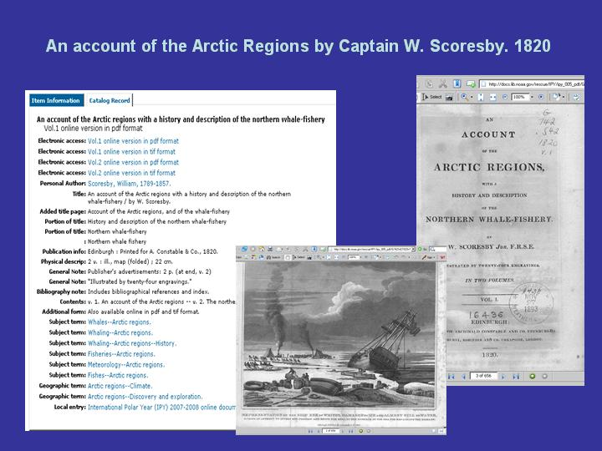

Fig. 1. An Account of the Arctic Regions with a History and Description of the Northern Whale-Fishery, W. Scoresby. 1820. Book in full-text available via NOAALINC

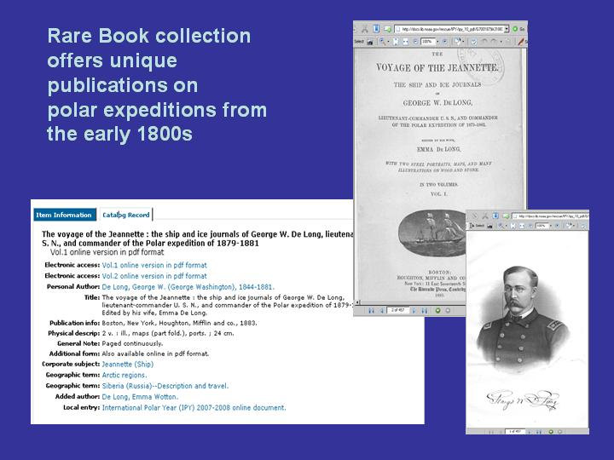

Fig. 2. The Voyage of the Jeannette: the Ship and Ice Journals of George W. De Long, Polar Expedition of 1879-188. Book in full-text
available via NOAALINC

The preceding figures are examples of the one hundred fifty polar-related documents that have been imaged and are available in full-text online via NOAALINC at http://www.lib.noaa.gov/uhtbin/webcat and the library’s IPY web site.

The International Polar Year (IPY) 2007-2008: Polar Resources in the NOAA Library Network Web site (see Fig. 3) supports the Agency's and NOAA Central Library (NCL) activities during International Polar Year 2007-2008. It displays a selection of exclusive online resources on exploration and research in Polar Regions. The collection includes library holdings from the 1st (1881-1883) through the 3rd (1957-1958) International Polar Years. The selected documents are available online full-text at: http://www.lib.noaa.gov/collections/ipy.html

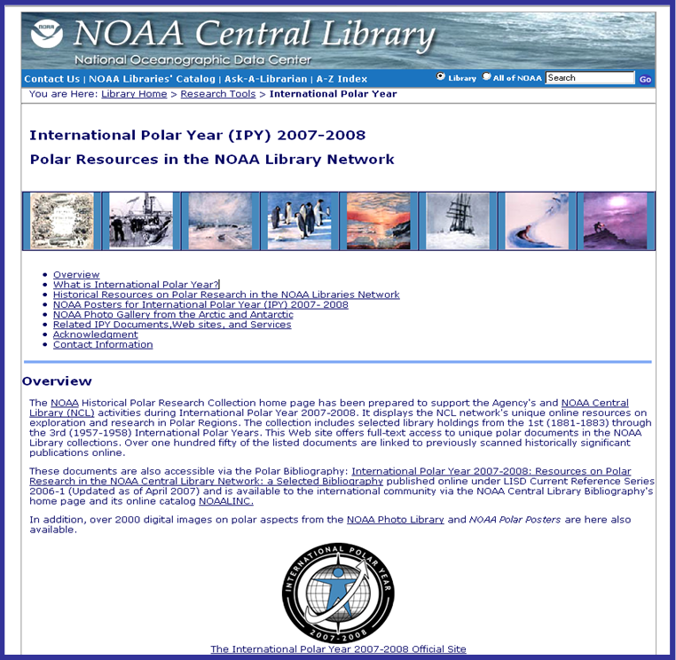

Fig. 3. Polar Resources home page developed in
the NOAA Central Library for IPY 2007-2008 (http://www.lib.noaa.gov/collections/ipy.html)

- printed and polar online publications
To provide additional access to NOAA’s polar resources beyond NOAALINC and WorldCat, a bibliography was compiled, entitled: International Polar Year (IPY) 2007-2008: Historical Documents on Polar Research in the NOAA Library Information Network. It reflects the NCL network’s unique print and online resources on this subject. This bibliography includes over 2000 citations and is organized by title. The data and listings are comprehensive from the 18th century to the present. The formats represented include print, CD-ROM, online full-text documents, digital videos, digital images, online cruise data and Web resources.

The bibliography is organized into four sections: I. What is the International Polar Year? II. Historical Resources on Polar Research in the NOAA Central Library Special Collections. III. Current Resources on Polar Research in the NOAA Central Library Network. IV. Internet Resources on Polar Research.

This publication was updated on April 2007 and is available online via the NOAA library’s home page at: http://docs.lib.noaa.gov/rescue/Bibliographies/IPY2007.pdf

- resources for current polar observations and cruise reports
In addition to historical polar documents, the National Oceanographic Data Center (NODC) and the NOAA Central Library provide access to contemporary oceanographic observations, cruise information, and digital video data. These cruise reports, digital videos, and scientific data sets are also available online via the NODC Ocean Archives System (OAS) at: http://www.nodc.noaa.gov/search/prod/, and also via NOAALINC, library online catalog at: http://www.lib.noaa.gov/uhtbin/webcat.

Fig. 5 is an example of NOAALINC metadata information on a cruise to the Antarctic Ocean in 1969 and 1970 (Eltanin reports. Cruises 37-39, 1969. 42-46, 1970 : hydrographic stations, bottom photographs, current measurements, nephelometer profiles). A hot link from the library record in MARC21 standards provides direct access to the raw observations from the same cruise via NODC OAS database displayed in Fig. 6.

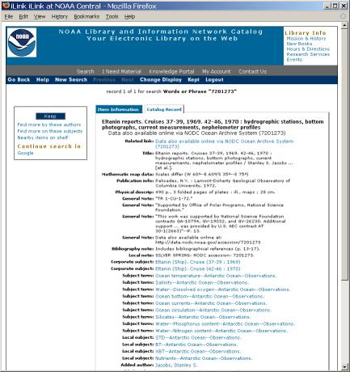

Fig. 5.The NOAALINC’s metadata provides access to the polar cruise report and to the NODC OAS database

NODC provides long term archival storage, management and stewardship of digital oceanographic data and metadata. Each new collection of data is assigned an NODC accession number as a tracking number for the collection. A copy of cruise reports and related data files from specific Ocean Exploration polar expeditions are placed in the associated NODC accession(s), with a link to the file established in the NOAALINC.

Another NOAA office, the NOAA Office of Ocean Exploration and Research (OER) provides information on various polar expeditions via the NOAA Ocean Explorer portal at http://oceanexplorer.noaa.gov/. These resources include cruise summaries, digital images, digital video clips, educational lesson plans, and daily logs of cruise activities.

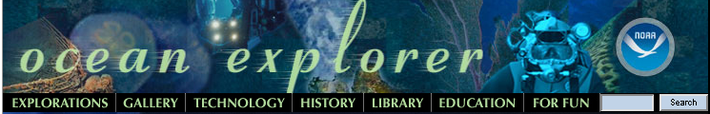

NOAA OER Web portal provides detailed information on the NOAA signature oceanographic expeditions and projects.

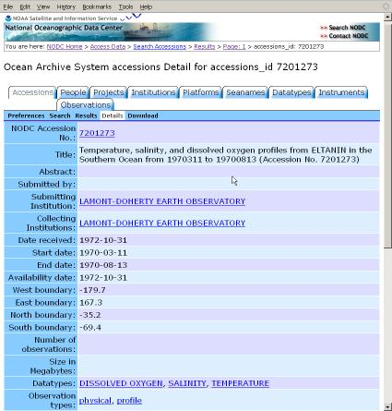

Fig. 6. NODC OAS’s Accession record providing access to raw observations from the polar cruise described in NOAALINC
- digital videos
To address an increasing interest for archiving, preserving and managing digital videos, the Library embarked on a collaboration with the NOAA Office of Ocean Exploration and Research (OER) to organize and assure the public access to the scientific digital video and image data. As a result of this collaboration the Video Data Management System (VDMS) has been developed featuring thousands of digital videos and images from the oceanographic cruises, including those from expeditions to the Arctic and the Antarctic. They have been preserved, archived, and their highlights offered online. (see Fig. 7.)

The VDMS team works closely with NOAA OE project scientists, oceanographers and IT specialists to develop and implement the data management requirements and strategies. This project also provides an ongoing opportunity to improve the quality and completeness of metadata information used in the NOAALINC catalog and NODC Ocean Archive System and to provide online access to NOAA ocean exploration video and related data to a global customer base.

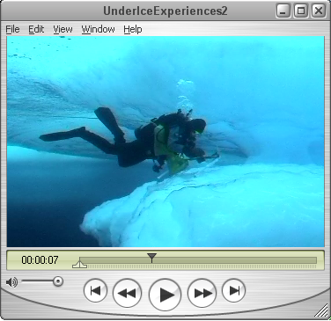

Fig. 7. NOAALINC provides access to hundreds of digital video clips ( “Under the Arctic Ice” captured during the NOAA OER Hidden Ocean 2005 Expedition.)
- digital photographs
The Library’s IPY home page, via the NOAA Photo Library, offers over 2000 digital images pertaining to the polar themes in both low and high resolutions that are available online for viewing and/or downloading. Most of the polar photos are included in two photo albums entitled NOAA at the ends of the Earth and NOAA’s Ark at: http://www.photolib.noaa.gov/.

The pictures were taken by NOAA scientists during their various field projects, oceanographic cruises, and assignments in the Arctic, Antarctic and other distant Polar Regions. The albums are part of the NOAA Photo Library, an online collection of over 35,000 photographs organized, digitized and annotated by the NOAA Central Library staff.

Polar images are also available via the NOAA Central Library’s IPY home page at: www.lib.noaa.gov/collections/polar/ipy.html

- polar poster
Library staff also developed a Polar Poster as a visual display of the library activities for IPY. It is available in PDF, JPEG, and TIFF formats for downloading from the library’s IPY home page at: http://www.lib.noaa.gov/docs/bibliographies.html (see Fig. 4)

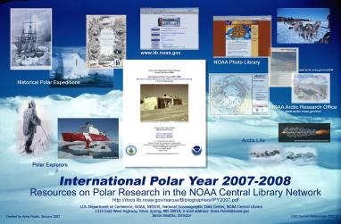

Fig. 4. Polar Poster developed in the NOAA Central Library for International Polar Year 2007-2008 (http://www.lib.noaa.gov/docs/bibliographies.html)

VIII. conclusion
The NOAA Central Library’s IPY project and products are excellent examples of how NOAA’s scientific data in both physical and online formats are archived and preserved to support a specific international initiative. The library and data center staff will continue to collaborate closely with NOAA scientists and educators to improve the quality and completeness of metadata and information used in NOAALINC and the NODC Ocean Archive System to improve access and use by NOAA’s global customer base to support this and other forthcoming international research initiatives.

To find more information on NOAA activities during 4th International Polar Year, contact the Agency’s IPY home page at: http://www.ipy.noaa.gov/
acknowlegements
The author wishes to thank Dr. Neal Kaske, Acting Director of NOAA Central Library; Doria Grimes, Chief of NOAA Central Library Contract Operations; and Donald W. Collins, Oceanographer of NOAA’s National Oceanographic Data Center, for their support, subject expertise, and editorial suggestions. Special thanks go to Diana Abney, Librarian for coordinating the imaging of the selected publications; and to the NOAA Climate Data Modernization Project (CDMP).

references
[1] International Polar Year: NOAA Explores the Poles. 2007. Silver Spring, MD: U.S. Department of Commerce, National Oceanic and Atmospheric Administration, August 2, 2007 < http://www.ipy.noaa.gov/>

