PUBLIC NOTICE
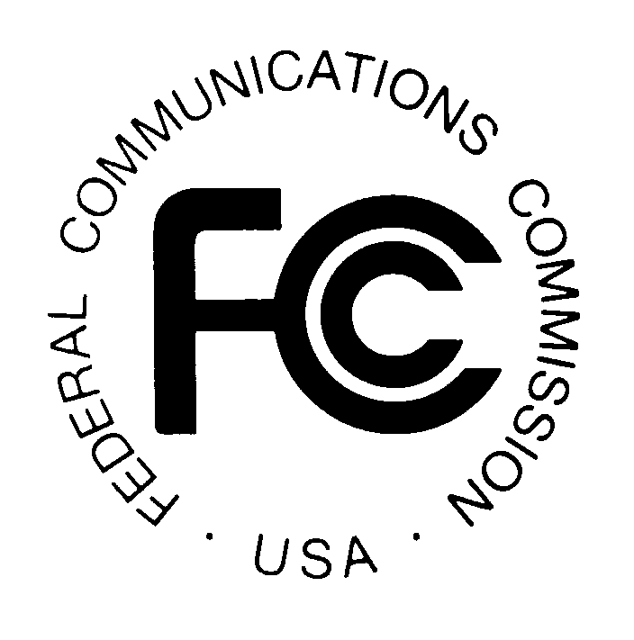
News media information 202 / 418-0500
Fax-On-Demand 202 / 418-2830
TTY 202 / 418-2555
Internet: http://www.fcc.gov
ftp.fcc.gov

Federal Communications Commission
445 12th St., S.W.
Washington, D.C. 20554

DA 08-1872

August 7, 2008

PUBLIC SAFETY AND HOMELAND SECURITY BUREAU ACTION

REGION 55 (NEW YORK – BUFFALO) PUBLIC SAFETY REGIONAL PLANNING COMMITTEES TO HOLD 700 MHZ REGIONAL PUBLIC SAFETY PLANNING AND 800 MHZ NPSPAC REGIONAL PUBLIC SAFETY PLANNING MEETINGS

PR Docket No. 92-287

The Region 55 (New York – Buffalo) Public Safety Regional Planning Committees will hold two consecutive planning meetings on Tuesday, September 23, 2008. Beginning at 10:00 a.m., the 700 MHz Public Safety Regional Planning Committee will convene at the Monroe County Public Safety Training Facility, 1190 Scottsville Road, 2nd Floor, Room 201, Rochester, New York.

The agenda for the 700 MHz meeting includes:
- Review and approval of the September 23, 2008 meeting agenda
- Review and approval of the June 10, 2008 meeting report
- New York State Interoperability Coordinator Meeting (Vincent Stile, Chief Thomas Roche)
- Old business
- Update on 700 MHz Working Group
- 700 MHz Status Report (Travis LePage)
- Review of open action items (Travis LePage)
- Update on 700 MHz band restructuring (Sean O’Hara)
- New business and opportunity for comments
- Schedule next meeting

Immediately following the 700 MHz Public Safety Regional Planning Committee meeting, the 800 MHz Public Safety Regional Planning Committee will convene at the same location.

The agenda for the 800 MHz meeting includes:
- Review and approval of the September 23, 2008 meeting agenda
- Review and approval of the June 10, 2008 meeting report
- Old business
- Update on Region 55 Window 3, 4, and 5 applications regional concurrence (Travis LePage)

- Review of open action items (Travis LePage)
- Update on Wave 4 Rebanding (Sean O’Hara)
- New business, and opportunity for comments
- Schedule next meeting

Both of the Region 55 Public Safety Regional Planning Committee meetings are open to the public. All public safety providers whose sole or principal purpose is to protect the safety of life, health, or property in Region 55 are eligible to utilize these frequencies. It is essential that public safety agencies in all areas of government, including state, municipality, county, and Native American Tribal, and non-governmental organizations eligible under Section 90.523 of the Commission’s rules, 47 C.F.R. § 90.523, be represented in order to ensure that each agency’s future spectrum needs are considered in the allocation process. Administrators who are not oriented in the communications field should delegate someone with this knowledge to attend, participate, and represent their agency’s needs.

All interested parties wishing to participate in planning for the use of public safety spectrum in the 700 MHz and 800 MHz bands within Region 55 should plan to attend. For further information, please contact:

Steven C. Sharpe, Chairman
700 MHz and 800 MHz Public Safety Regional Planning Committees
Genesee County
Director of Emergency Communications
165 Park Road
Batavia, New York 14020
(585) 345-3000, Ext. 3400
ssharpe@co.genesee.ny.us

Peter Stritzinger, Vice Chairman
Orleans County
Radio System Manager - Emergency Management
14064 West County House Road
Albion, New York 14411
(585) 589-4414
ocradio@orleansny.com

- FCC -

The Region 55 (New York – Buffalo) area includes the counties of Allegany, Cattaraugus, Chautauqua, Chemung, Erie, Genesee, Livingston, Monroe, Niagara, Ontario, Orleans, Schuyler, Seneca, Steuben, Wayne, Wyoming, and Yates.

