THE RIO GRANDE VALLEY CHRISTMAS SNOWSTORM: A ONCE IN LIFETIME EVENT

Kurt M. Van Speybroeck*, Jesus Haro, Andrew Patrick, and Jason Straub
National Weather Service Forecast Office, Brownsville, TX

Abstract

The snowstorm that developed over Deep South Texas on 24 December 2004 and persisted through the early morning hours of 25 December 2004 was truly an historic weather event. A review of climatological records reveals that snowfall is possible during the heart of winter in the northern hemisphere at the lower latitudes, with extremely rare snowfall events occurring in the latitudes ranging from 25 to 27 degrees north. The meteorological developments that lead to the snowfall in Deep South Texas, while not unique or individually significant, all contributed to a larger scale system that became favorable for a “once in a lifetime event.”
An analysis of the operational aspects of this event will be completed to evaluate and highlight the opportunities and best practices of operational meteorologists when forecasting a climatologically rare event. The analysis will begin with a review of the meteorological events preceding the snowfall, an analysis of the quality and consistency of the numerical models and guidance will also be performed. A thorough review of the synoptic, mesoscale, and microscale features will lead to the post event storm summary. Finally, an examination of the operational products, practices, and situational awareness aspects will be completed. The results will show that “significant impact weather events” can be predicted with a higher degree of confidence through situational awareness training, sound meteorological analysis, and an effort to collaborate the forecast internally and with neighboring National Weather Service Offices these

1. INTRODUCTION

The likelihood of receiving measurable snowfall in the eight counties of Deep South Texas is remote, at best. Snowfall has occurred in Deep South Texas less than 5 times since weather records began around 1870. These records have been compiled by the National Weather Service (NWS) in Brownsville, TX and archived at the National Climatic Data Center in Asheville, NC (2005). An examination of the geographic elements and topography across the region will demonstrate the rare nature of ____________________________________

*Corresponding author address: K. Van Speybroeck, 20 S. Vermillion, Brownsville, TX 78520; email: kurt.vanspeybroeck@noaa.gov

snowfall during any given winter season. A review of the climatological records will reinforce the fact that snowfall on Christmas Day is extremely rare. Next, the analysis of Numerical Weather Prediction (NWP) model guidance highlighting the consistency, timing, and accuracy of the model data will be explored. Using the NWS Weather Event Simulator, a reconstruction and analysis of the synoptic, mesoscale, and microscale aspects of the storm will illuminate the delicate balance and timing necessary to generate frozen precipitation in this temperate climate. A post event investigation of the operational aspects, including situational awareness, will identify several areas that meteorologists can focus on to correctly identify and properly forecast historic events.

2. CLIMATE INFORMATION

The geographical area of responsibility for NWS Brownsville (BRO) consists of the eight counties of Deep South Texas (Lower Rio Grande Valley) and the adjacent Gulf of Mexico from the lower Texas coast out to 60 nm. The topographic features of northeast Mexico also have a significant impact on the climate and weather of Deep South Texas. The Sierra Madre Oriental mountain range in northeast Mexico, with several ridges and peaks above 3500 m (11,480 ft) and a median elevation of 2200 m (7218ft) (Mexico: A Country Study) contributes heavily to historic weather events, from excessive heat, severe weather, and this most recent snowfall event. (Figure 1)

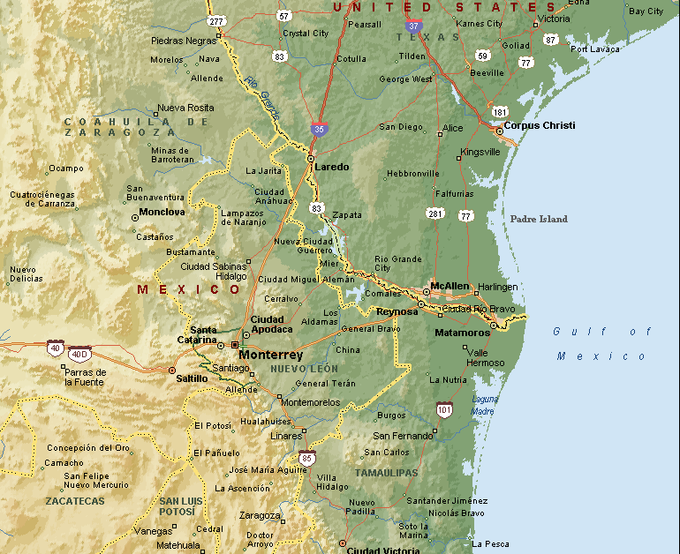
Figure 1. Low Resolution Topographic map of northeast Mexico and Deep South Texas.

a. December Climate Data

Brownsville’s average daily temperature during December is 16.2 degrees C (61.1degrees F), the average daily maximum temperature is 21.2 degrees C (70.2 degrees F) and the average daily minimum temperature is 11.1 degrees C (52.0 degrees F). The temperature extremes for Brownsville in December range from a minimum of -1.11 degrees C (30 degrees F), to a maximum of 34.4 degrees C (94 degrees F). (NWS Brownsville Station Records). Snowfall in this climatological regime is quite rare with measurable snowfall (accumulations greater than trace amounts) occurring within the city of Brownsville only twice since 1878. The most recent measurable snowfall was recorded in February 1895(Travis, NCDC station records). Frozen precipitation (i.e. snow flurries, ice pellets, or sleet) has been recorded 27 times from 1870-2005. Prior to the Christmas Eve snowfall event, the most recent occurrence of snow flurries occurred in December, 1997. Snow flurries have been recorded as early as November and as late in the season as March. As expected, these events are characterized as flurries or mixed precipitation, with no measurable accumulations. About 40 percent (11 of 27), of the frozen precipitation events occurred during the month of December. The average occurrence of snowfall in Brownsville, TX during any winter season is 3.7 percent. The average occurrence of snowfall on December 25th is 0.74 percent. (Percentages include the snowfall from December 25, 2004).

- Analyses

The meteorological events during the week of 19 – 25 December, 2004 were not singularly significant. However, the numerical model guidance suite available to NWS meteorologists in Deep South Texas began to suggest a possible, significant pattern change. The emerging pattern shift began to resemble an arctic outbreak signature, known as the McFarland pattern (1988) (Figure 2). This pattern is generally characterized by a high amplitude 500 hPa ridge over western North America, coupled with a significant 500 hPa cyclone centered over Hudson Bay or Greenland. A major short wave in the flow, generating lee side cyclogenesis is necessary for major freeze potential in the lower Rio Grande Valley. The recognition of this developing pattern began with the 0000 UTC Mid Range Forecast and Global Forecast System
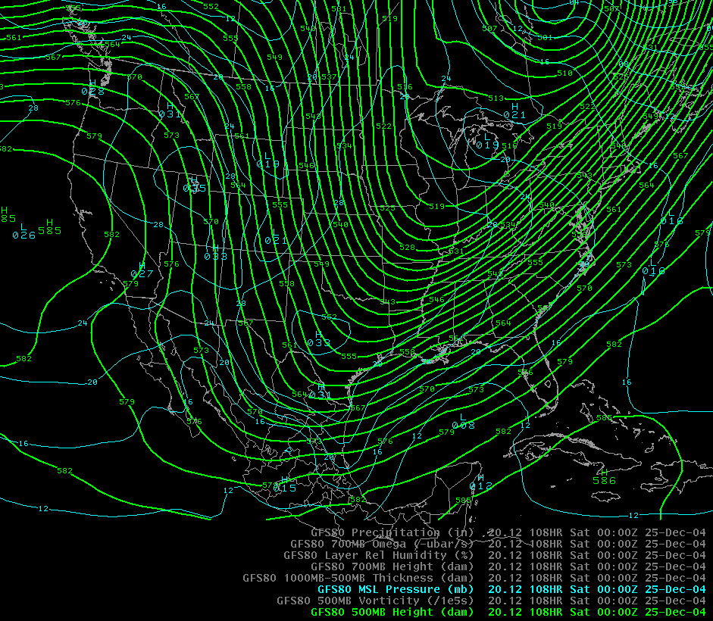
Figure 2. 12 UTC Dec 20 MRF/GFS 500hPa Heights and MSL Pressure valid 00 UTC Dec 25.

(MRF/GFS) model output from December 20. However, the presence of these freezing or sub freezing free air temperatures only set the stage for the possibility of snowfall.
The McFarland pattern guidance, in conjunction with reliable numerical weather prediction model guidance, is useful for anticipating a pattern shift and significant change of temperature regime. The predictability of snowfall however, is more unreliable, since the occurrence is extremely rare in the NWS Brownsville county warning area (CWA).
The NWP model guidance remained consistent, depicting a synoptic scale arctic outbreak pattern for the Lower Rio Grande Valley. As this scenario advanced in the model guidance, an additional 500 hPa low pressure system was forecast to move across northern Mexico and Deep South Texas. This combination of cold surface air and a relatively warm core trough, suggested that winter type precipitation was possible. This “TRough Of Warm air ALoft” system, known as a TROWAL, has been studied extensively in the central and northern plains region of the United States by Crocker et al. (1947). Significant snowfall totals have been associated with the TROWAL and their associated thermodynamic structure.

a. Model Interpretations

Meteorologists at NWS Brownsville began to recognize and describe the consistent pattern developing in the National Center for Environmental Prediction (NCEP) GFS model guidance. The depiction of a large scale pattern shift to a meridional trough over the eastern United States with a high amplitude ridge over the western United States was consistently advertised by consecutive cycles of the GFS and ETA (renamed North American Model NAM) models. The preliminary indications were evident during the 1200 UTC cycle on December 20, 2004. Each successive model cycle added definition and forecaster confidence, as the identifiable pattern shift was carried forward in time by each model suite member.
By midweek (Wednesday December 22, 2004), the GFS, NAM, and ensemble model suite were consistently projecting a sharp, cold outbreak as far south as northeast Mexico (Figures 3-4).
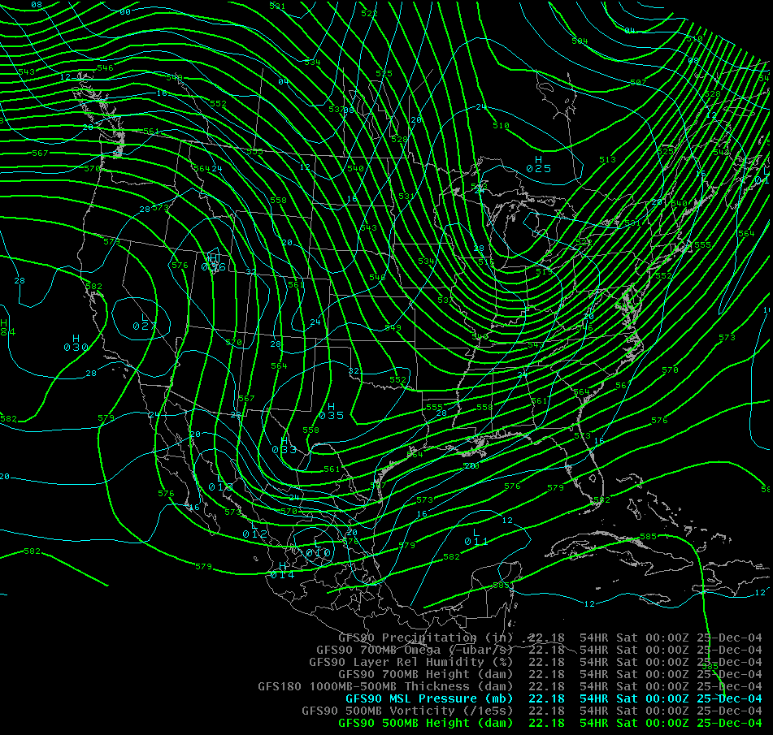
Figure 3. 18 UTC December 22 MRF/GFS 500 hPa Heights and MSL Pressure valid 00 UTC December 25.
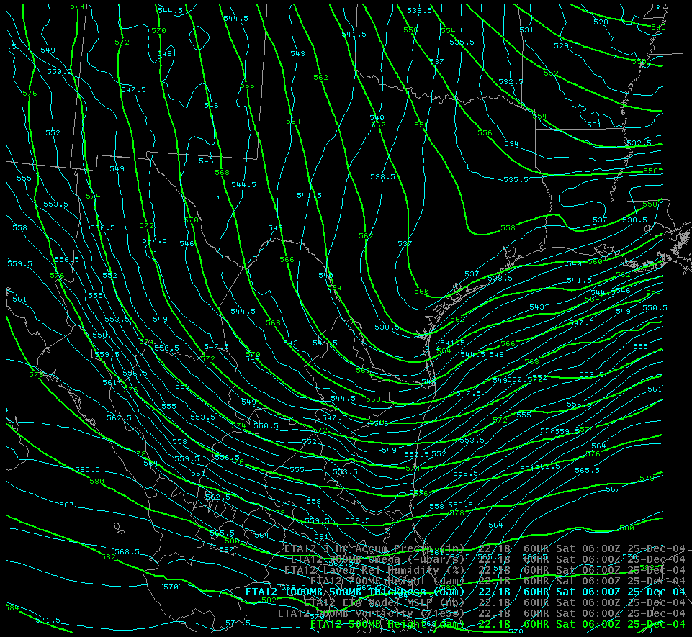
Figure 4. 18 UTC December 22 ETA/NAM 500 hPa Heights/MSL Pressure valid 00 UTC December 25.

Forecast model soundings were depicting a significant cold surface air mass from Corpus Christi through Brownsville, into the foothills of the Sierra Madre Oriental. The model guidance continued to forecast a 500 hPa closed low pressure system moving through the southwestern United States into northeast Mexico and Deep South Texas. This upper level system was expected to draw moisture and provide sufficient upward vertical motion to generate liquid precipitation above the deepening sub-freezing surface layer. By 1200 UTC Friday (December 24, 2004) both the observed and forecast sounding data were pointing to a significant (measurable) snowfall event for the area of Deep South Texas along the Rio Grande and Gulf Coast. (Figure 5 though 7)

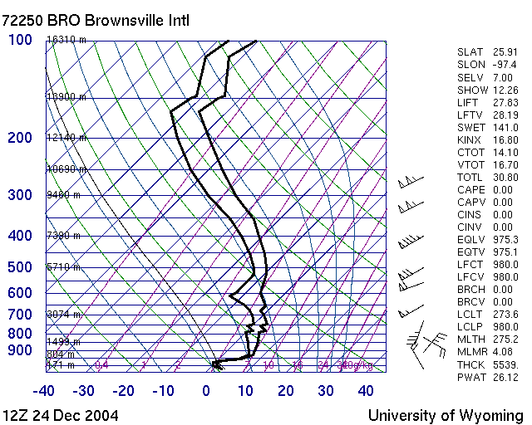
Figure 5. Observed Radiosonde data from Brownsville, TX 12 UTC 24 Dec 04.

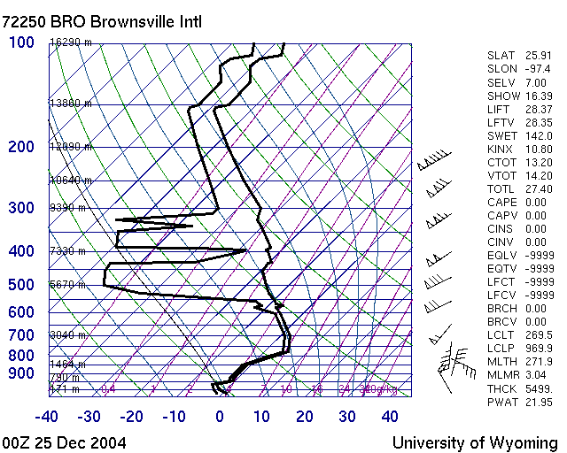
Figure 6. Observed Radiosonde data from Brownsville, TX 00 UTC 25 Dec 04.

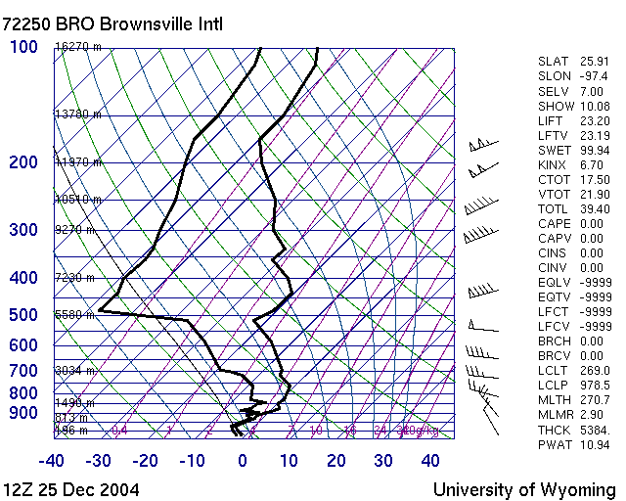
Figure 7. Observed Radiosonde data from Brownsville, TX 12 UTC 25 Dec 04.

Given the rarity of occurrences of frozen precipitation in the region, snow accumulation forecasts were developed with a consensus forecast effort to highlight the most significant temporal and areal impacts.

4. Synoptic/Mesoscale Observations

National Weather Service network observations show the development of the McFarland pattern, the progression of the surface cold air through Deep South Texas, and the storm track of the 500 hPa low pressure system across northeast Mexico through the Gulf Coast region of Texas. These components merged along the Rio Grande and in Deep South Texas generating a swath of snowfall that extended west to east from Laredo, TX to Brownsville and South Padre Island, TX. The area extended from south to north from Matamoros, Tamaulipas, Mexico to the Houston/Galveston metropolitan area.
The heaviest snowfall was recorded along the coastal counties, where greater amounts of available atmospheric moisture were tapped from the adjacent Gulf of Mexico. A swath of one to three inches of snow blanketed the Rio Grande Valley from Rio Grande City to South Padre Island. An interesting feature developed over northern Cameron and southern Willacy counties. NWS Doppler radar images from Brownsville (KBRO) show a slight increase in reflectivity between 06 and 09 UTC December 25, (Figure 8), which corresponded to

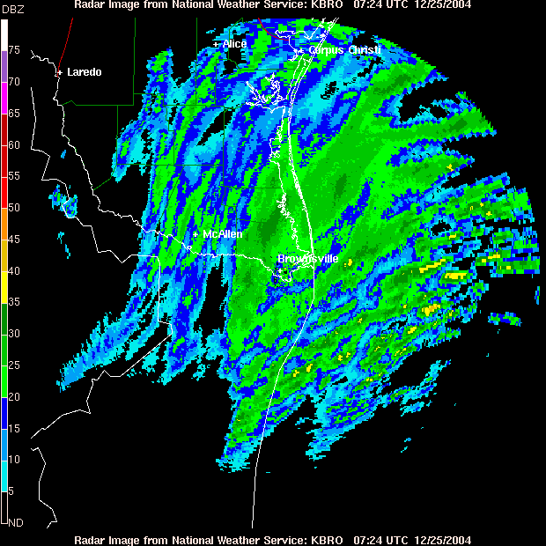
Figure 8. KBRO WSR-88D Reflectivity image showing slightly higher return energy north of Brownsville. Observers reported seven inches of snow in this area.

isolated higher snowfall totals. A National Park Service Ranger and part time weather observer recorded nearly seven inches of snow at the Palo Alto National Park and at another location near Rio Hondo, TX.
Reports of four to six inches of snow were received from weather service cooperative spotters and the general public from Raymondville to Kingsville, TX. As the storm moved northeast along the Gulf Coast, snowfall amounts increased, with up to 14 inches of snow being recorded northeast of Corpus Christi, TX near the town of Victoria (Table 1).
The storm accelerated northeast into southwest Louisiana by 1300 UTC on December 25. Conditions in the wake of the snowfall event transitioned quickly. Rapidly clearing skies and nearly full sun on December
25 produced a maximum temperature of 11.1 degrees C (52 degrees F) in Brownsville, causing a rapid melting of the first “White Christmas” or “Blanca Navidad” in recorded history (Figure 9).

Location | Total Snowfall (in inches)
Brownsville | 1.5
Harlingen | 1.5
San Benito | 1.5
La Joya | 1.5
South Padre Island | 2.5
Port Isabel | 3
Rio Grande City | 3
Sarita | 3
McAllen | 3.5
Raymondville | 3.5
Hebbronville | 5
Corpus Christi | 4
Victoria, TX | 11
Brazoria, TX | 13
Table 1. Observed/Reported storm total snow accumulations along the Texas Gulf Coast.

5. Operational Products

The number of NWS products issued for this event, show that the operational and situational awareness of the forecast team at NWS Brownsville were both elevated during the week preceding the snowfall.
The product suite began with a series of Special Weather Statements (SWS) and Hazardous Weather Outlook (HWO) statements during the afternoon forecast suite. The first SWS was issued at 510 PM CST Monday December 20, 2004. This initial weather product highlighted the significant weather changes including the drastic temperature change, potential freeze, and “In addition to freezing temperatures…there will be the potential for a mixture of wintry precipitation late Thursday night and early Friday.” Although the forecast was nearly four to five days (eight to ten forecast periods) away, the idea that a potentially significant impact weather
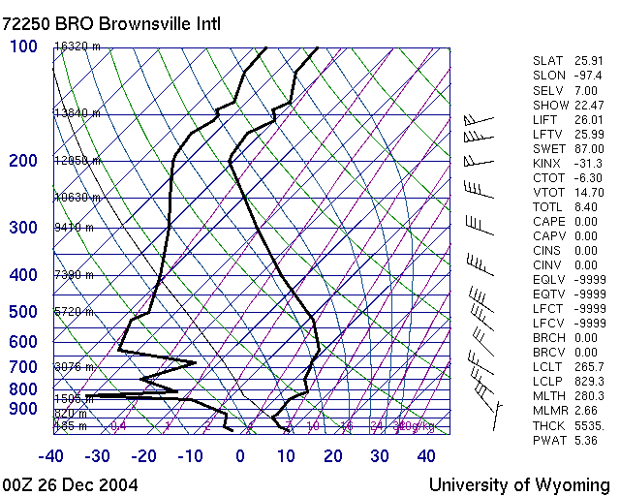
Figure 9. Observed Radiosonde data from Brownsville, TX 00 UTC 26 Dec 04.

event was likely is the message that our partners received.
A total of 10 Special Weather Statements were issued between December 20 and 25 highlighting the potential for a high impact winter weather event in Deep South
Texas. In addition, 12 Urgent Weather Messages, (identified as Non Precipitation Warnings or NPW), were issued highlighting the timing of the event, the onset of freezing or below freezing temperatures, frost formation, and the increased potential for snowfall and freezing precipitation. As the event became imminent, two Winter Weather Messages were issued approximately 12 hours prior to the onset of accumulating snowfall.
There were no NWS equipment failures noted that were directly attributed to the freezing temperatures or snow accumulation.

6. Conclusion

The increasing accuracy of numerical weather prediction model output and guidance has increased the overall productivity of the line office operational meteorologist throughout the NWS. However, NWP model forecast continue to generate many opportunities for operational meteorologists to add value by improving accuracy and highlighting significant weather impacts.
The “Christmas Blizzard of 2004”, as it is known in the Rio Grande Valley is an excellent example of these opportunities. The combination of machine generated forecasts and the subjective analyses added by the human element can produce truly impressive results.
By utilizing the developed local expertise or knowledge base, in concert with the object NWP model guidance, operational meteorologists were able to forecast a “once in a lifetime” event with confidence and accuracy. By maximizing local knowledge, the proper application of pattern recognition, awareness of NWP model biases and performance the meteorological team was able to issue a series of products and forecasts that increased awareness and allowed for several days of preparations before the impact weather changes occurred.
In addition, the collaborative efforts of the NWS Brownsville team facilitated the concept of consensus forecasting both internally and regionally. Using sound meteorological reasoning, diplomatic discussion, and brainstorming sessions, the individual meteorologists all contributed to a more consistent and eventually more accurate depiction of the upcoming weather events.
Finally, the continuous training efforts of operational meteorologists played a key role in predicting this major weather event. The NWS Weather Event Simulator (WES) has been instrumental for individual case review, and for “practicing” operational meteorology during seasonal weather minima. The review of previous case studies and the availability of reference materials was also a useful element during the initial forecasting of this one in a lifetime weather event with confidence.

7. References

Crocker, A. M., W. L. Godson, and C. M.
Penner, 1947: Frontal Contour Charts. J.
Meteor., Vol. 4, 95-99.

McFarland, M. J., 1988: Useful Relationships
Between 500 mb Features and Major Freeze
Events in the Lower Rio Grande Valley.
NWS SR Technical Memorandum.

Mexico: A Country Study, 1998: Federal
Research Division of the Library of
Congress.

NCDC, 2005: National Climatic Data Center,
Asheville, NC.

NWS Brownsville, TX 2005: Local Station
Climate Records Database.

Travis, R., History of Freezes in the Lower Rio Grande Valley Parts I-III. Palm Society of South Texas Bulletin.

