Jim Hylen
February 7, 2003

DRAFT - Leakage Current between Horn Stripline Conductors

The purpose of this note, which is currently a work in progress, is to estimate or at least set a bound on the expected leakage current between horn stripline conductors, to determine if a design modification is necessary. The cause of the leakage current is the beam ionization of the air between the striplines.

Two concerns are possible:
- breakdown (sparking)
- diversion of enough current from horn to affect beam focusing
The NuMI horn current peaks at 200 kA, and if the leakage current was greater than 0.5% one would need to do a more detailed circuit model to see if the magnetic focusing field would be affected.

NuMI Environment. There are four 8 inch wide striplines feeding the horn, each with about 1 m length in the high radiation area, as illustrated in Figure 1. Figures 2 and 3 show the current pulse and voltage between striplines for the high energy and low energy neutrino beam configurations of the horns. The beam spill lasts for a maximum of 10 micro-seconds, and occurs at the peak of the current pulse. At that time there is about 50 Volts across the 3/8 inch air gap between stripline conductors. A MARS model of the stripline beam energy deposition has not been done, however the radiation environment near the end of the horn ranges from order of 1 J/g/spill near the beamline (Byron Lundberg MARS model of cross hair system) to 0.09 J/g/spill at the horn outer conductor and 0.02 J/g/spill at the horn/module support hanger (C. James MARS model of horn clamp) to 0.007 J/g per beam spill at the bottom of support module (Igor S.Tropin MARS model of module). The stripline starts basically at the radius of the horn outer conductor, and 0.07 J/g is taken as a rather conservative estimate of the average beam energy deposition.

Breakdown. With reference to concern (i), the general lore is that ionizing radiation causes faster initiation of breakdown, but does not significantly reduce the voltage at which breakdown (caused by avalanching of charges) occurs. Our 50 Volt/cm field is far too low to cause breakdown. Even the maximum potential in the system, which is less than 1000 Volts at the power supply, is an order of magnitude below what would be required to cause arcing between stripline plates. Further confidence in this statement is provided by a test done by F.M. Bieniosek where he set up parallel plates 3 cm apart in the high radiation area after the AP0 target (Pbar Note #556 Summary of Results from the Beam Sweep Test Module, 1-June-95). With 16 kV potential difference between the plates, and nearly an order of magnitude higher particle flux than expected for the NuMI stripline region, there was no sign of avalanching. Data from the Bieniosek Note are reproduced in Figure 4.

Leakage Current. In addressing concern (ii), we can first repeat the calculation Bieniosek did to roughly estimate the expected current for his configuration (F.M. Bieniosek, A Beam Sweeping System for the Fermilab Antiproton Production Target, FERMILAB-TM-1857, August 1993). The calculation is based on a simple balance between ionization rate and recombination rate giving the charge density (see formula (i)), combined with a parameterization of the electron drift velocity (see formula (ii)). Table 1 lists the parameters as given in the TM, as modified for the conditions of the highest and lowest voltage data points of the test, and as modified for the conditions of the NuMI stripline. For the NuMI calculation, the drift velocity is taken from Figure 5 rather than formula (ii), as NuMI is below the E/p region where that formula is a good description; additionally the reduction in drift velocity due to the magnetic field is estimated for NuMI conditions.

As shown in the table, this calculation overestimated the current in the test by factors of 2 to 7. A further problem is that the data in Figure 4 show a higher than linear behavior on E/p, whereas the calculated value is proportional to the electron drift velocity which is less than linear in that region. As noted in the TM, the current also showed a somewhat stronger dependence on intensity than the square root dependence in the plasma model (see formula (viii)).

One possible effect is due to space charge. The electron drift velocity is of order 1000 times larger than the positive ion velocity, and unless electrons can be ejected from the negatively charged plate at the rate that they captured on the positively charged plate, the process becomes space charge limited on a very short (nanosecond) time scale. During the beam spill, this may be provided by delta rays knocked out of the negatively charged plate by the beam spray, but I have not yet attempted to calculate this rate.

Because the calculation does not track the data very well, the extrapolation to the NuMI conditions by the above calculation may not give one confidence. A reasonably straight-forward bound is set by the following argument. The NuMI conditions have a smaller V, smaller E/p, and smaller beam radiation level, but a factor of 250 larger surface area. If we take the lowest test point of 10 amps leakage, scale up by the area, and take credit for a no worse than square-root dependence on the beam intensity, we get a bound of 375 Amps. Given that the NuMI E/p is an order of magnitude smaller, the current is likely to be substantially less than this.

Available mitigation. Two available mitigation methods, if the above currents are deemed to be too large, are:
- insulate by aluminum striplines by anodizing them. One might still leave the high stress bend regions bare, as the anodized surface is more prone to cracking.
- tune the beam spill to occur slightly after the peak horn current, so that the voltage between the sripline plates is zero. The resulting 2 to 3% drop in horn focusing power has only a minor effect on the beam neutrino intensity, but does make the beam spectrum somewhat more sensitive to precise timing between beam spill and horn pulse.

Conclusion. At this point we are not motivated to take mitigating action, as neither breakdown or leakage current appear to be a significant problem.

Appendix: Formulae

Balance between ionization and recombination of electrons. (Assumes no avalanche).
(dU/dt)/W_{i} = α n_{e}² (i)
U = beam energy deposition per unit volume per spill
t = time (length of beam spill)
W_{i} = mean energy to produce an electron-ion pair
α = recombination coefficient
n_{e} = number of electrons per unit volume

Electron drift velocity as parameterized in TM-1857
V_{d} = 7x10⁵ + 5x10⁵ (E/p) cm/sec (ii)
(E/p) = (Electric field / pressure) in volts/cm/Torr

Momentum-transfer collision frequency for electron-neutral collisions
ν_{m} = e E / (m_{e} V_{d} ) (iii)
E = electric field

Plasma conductance
σ = n_{e} e² / m_{e} ν_{m} (iv)
e = electron charge
m_{e} = electron mass
“Resistance” between plates from TM-1857
R = 4 a / ( σ L d ) (v)
a = width of gap between plates
4 = relation between applied voltage and field for sweeping magnet?
Leakage current between plates
I = σ E L d (vi)
L = length of stripline
d = width of stripline
I = n_{e} V_{d} A (vii)
A = L d = area of stripline
I = ( (dU/dt) / (α W_{i}) )^{1/2} V_{d} A (viii)
Magnetic field between striplines
B = μ₀ I_{S} / d (ix)
I_{S} = current in stripline
Drift angle in magnetic field, for orthogonal B and E
Tan(α_{B}) = 2 B V_{d} / E (x)
V_{d}’ = V_{d} cos(α_{B}) (xi)
α_{B} = drift angle w.r.t. E field direction
V_{d}, V_{d}’ = drift velocity without and with effect of field

 | units | TM-1857 | Bieniosek test Hi | Bieniosek test Lo | NuMI stripline
W_{i}, energy to produce ion pair in air | eV | 33 | 33 | 33 | 33
Beam protons on target / spill | pot/pulse | 5.00E+12 | 2.60E+12 | 1.80E+12 | 4.00E+13
U, deposited energy density / spill | J/g | 1.5 | 0.78 | 0.54 | 0.07
air denisity | g/cm3 | 1.20E-03 | 1.20E-03 | 1.20E-03 | 1.20E-03
Conversion factor Joules/eV | J/eV | 1.60E-19 | 1.60E-19 | 1.60E-19 | 1.60E-19
beam spill length | sec | 1.60E-06 | 1.60E-06 | 1.60E-06 | 8.00E-06
dU/dt | eV/cm3sec | 7.03E+21 | 3.66E+21 | 2.53E+21 | 6.38E+19
Total N_{e} electron produced | e/cm3 | 3.41E+14 | 1.77E+14 | 1.23E+14 | 1.55E+13
production dN_{e}/dt | e/cm3/sec | 2.13E+20 | 1.11E+20 | 7.67E+19 | 1.93E+18
Recombination coefficient α | cm3/sec | 2.20E-06 | 2.20E-06 | 2.20E-06 | 2.20E-06
equilibrium N_{e} | e/cm3 | 9.84E+12 | 7.10E+12 | 5.90E+12 | 9.37E+11
applied Voltage | V | 2500 | 16000 | 2000 | 50
a (gap) | cm | 3 | 3 | 3 | 0.9525
E=V/a | V/cm | 833 | 5333 | 667 | 52
E/p | V/cm/Torr | 1.10 | 7.02 | 0.88 | 0.07
Vd | cm/sec | 1248246 | 4208772 | 1138596 | 438141
Drift distance during spill length | cm | 2.0 | 6.7 | 1.8 | 3.5
e | coulomb | 1.60E-19 | 1.60E-19 | 1.60E-19 | 1.60E-19
m_{e} | kg | 9.10E-31 | 9.10E-31 | 9.10E-31 | 9.10E-31
collision freq. ν_{m} | 1/sec | 1.17E+12 | 2.23E+12 | 1.03E+12 | 2.11E+11
conductance σ | mho/m | 2.36E-01 | 8.96E-02 | 1.61E-01 | 1.25E-01
L, plate length | cm | 30 | 21.59 | 21.59 | 800
d, plate width | cm | 3 | 3 | 3 | 20.32
R=4a / sigma L d | ohm | 57
R Without inductive factor of 4 | ohm |  | 51.69 | 28.71 | 0.05
leakage current | amps |  | 310 | 70 | 1068
measured current | amps |  | 160 | 10
Stripline current per quadrant | amps |  |  |  | 50000
d, stripline width | m |  |  |  | 0.2032
μ₀ | Tesla m / amp | 1.26E-06 |  |  | 1.26E-06
B between stripline plates | Tesla |  |  |  | 3.10E-01
Tan (α_{B}) |  |  |  |  | 0.518
α_{B} (the drift angle) |  |  |  |  | 0.478
cos (α_{B}) = V_{d}’ / V_{d} |  |  |  |  | 0.888
Leakage current including B field | Amp |  |  |  | 842

Table 1. Calculation of leakage currents due to ionization by beam showering.

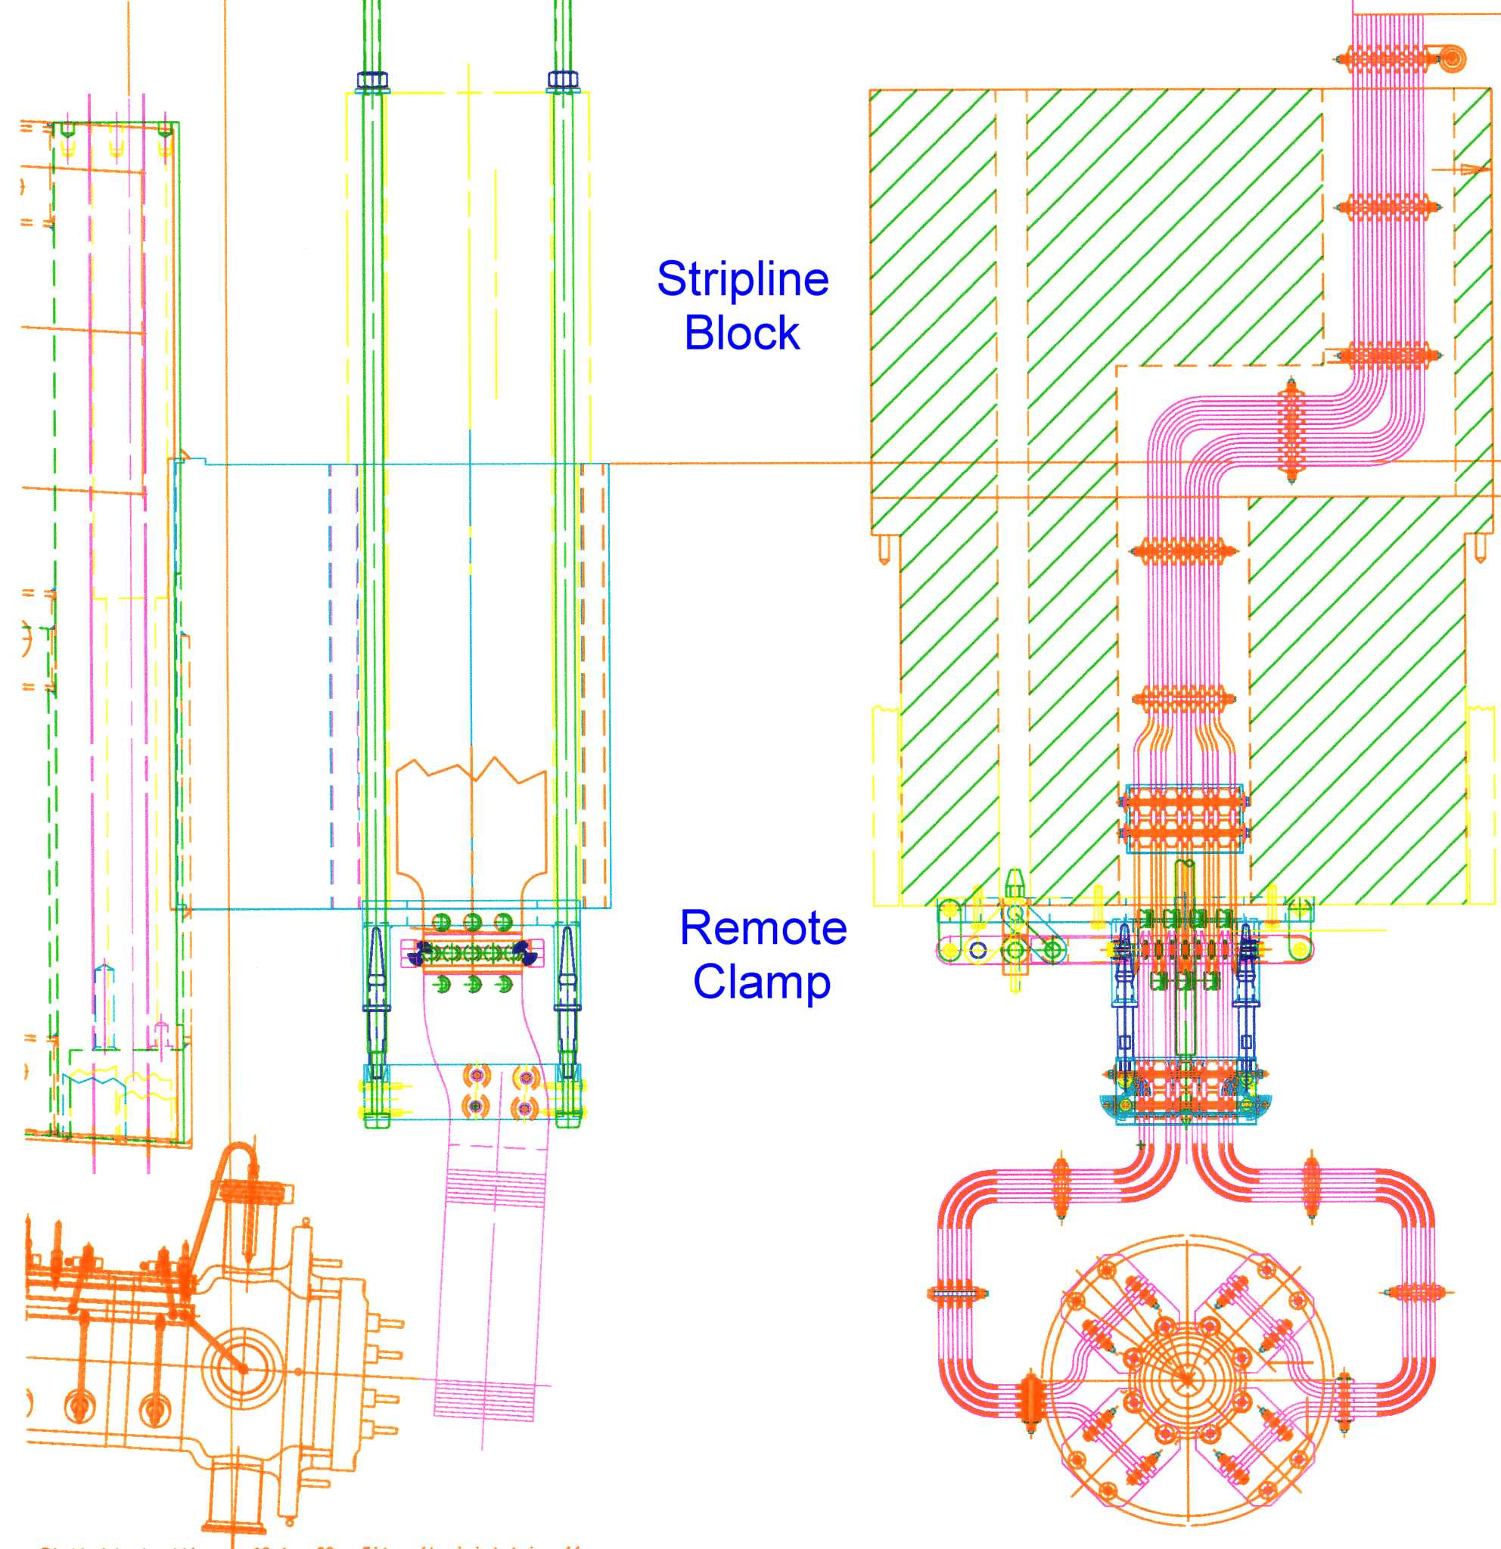
Figure 1. Stripline through radiation shielding block to focusing horn.
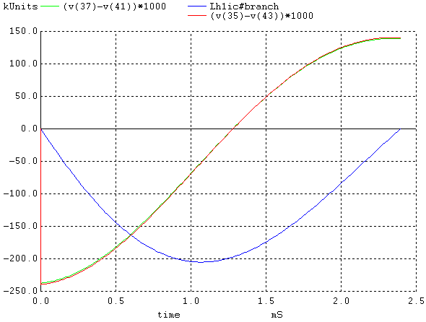
Thslcm_2-1-2001.cir Run date 2-3-03, krb

Figure 2. Plot of Voltage on the terminals of Horn-1 (Green – 235 V.) and Voltage across stripline conductors at remote release clamp (Red – 237 V.) vs: Horn-1 current (Blue) for the Target Hall installation with the full length stripline (LE, ME, and HE taps). (Ken Bourkland, 2/3/03)

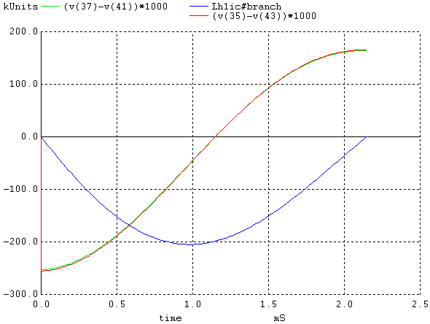
Thslcm_2-1-2001.cir Run date 2-3-03, krb

Plot of Voltage on the terminals of Horn-1 (Green – 253 V.) and Voltage across stripline conductors at remote release clamp (Red - 255 V.) vs: Horn-1 current (Blue) for the Target Hall installation for truncated length stripline (completed only to Horn-2). (Ken Bourkland, 2/3/03).

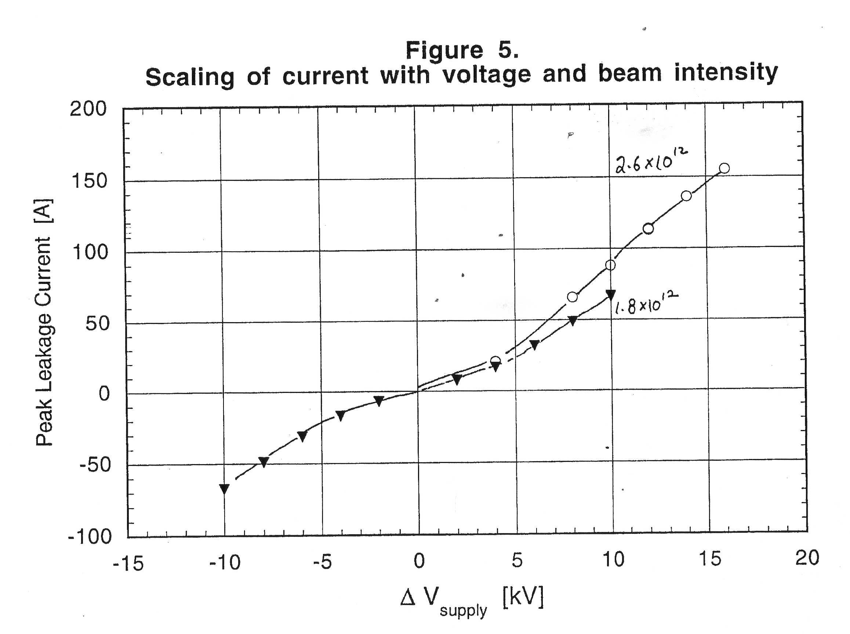
Figure 4. Leakage current between parallel plates as a function of applied voltage, for two proton beam intensities. (from F.M. Bieniosek, Pbar Note #556).

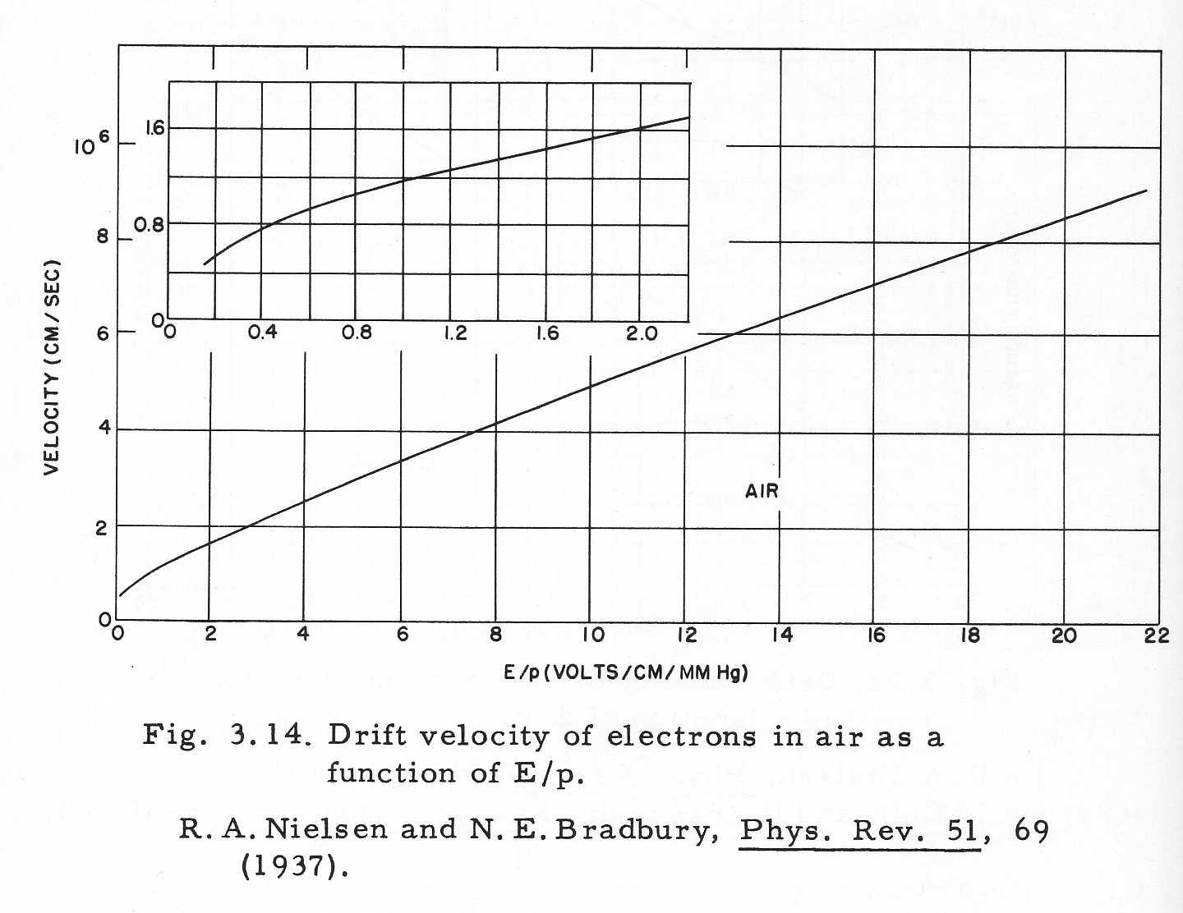
Figure 5. Electron Drift Velocity as function of E/p.
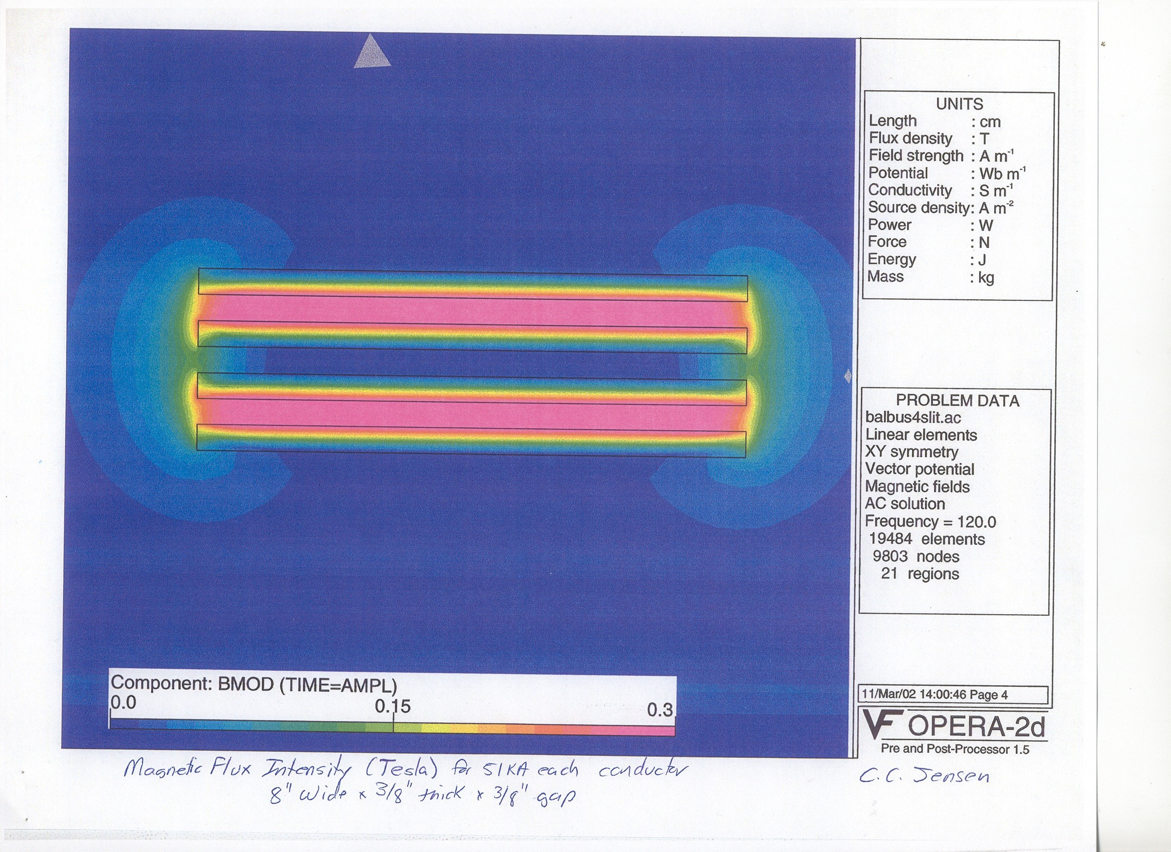

Figure 6. Magnetic field around stripline at peak current. (Chris Jensen)

