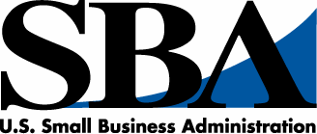

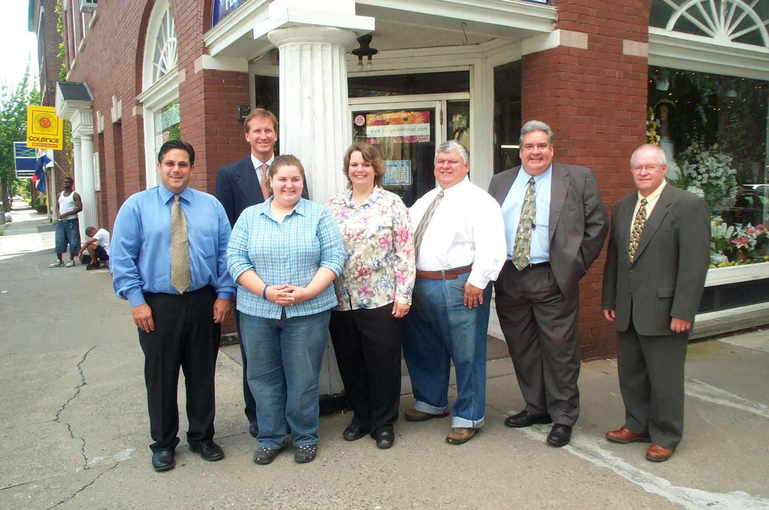
New York

Inside
the New York District Office

Office
Issue No. FY07-01, December, 2006

U.S. Small Business Administration
New York District Office
26 Federal Plaza, Ste. 3100
New York, NY 10278

Jose R. Sifontes, District Director
Tel: 212-264-4354
Fax: 212-264-4963
TDD: 704-344-6640
Web: www.sba.gov/ny/ny
The SBA New York District encom-passes the area of New York City, Long Island and the downstate counties of Dutchess, Orange, Putnam, Rockland, Sullivan, Ulster and Westchester.

In this Issue:

Message from the District Director.....Pg 2

Upcoming Events................................Pg 3

New SBA Deputy Administrator…….Pg 3

Top Ten Lenders..................................Pg 3

SBA Comes to Queens........................Pg 4

To ensure you receive future newsletter editions you must subscribe at: http://web.sba.gov/list

Inside the New York District
John J. Miller, Editor

All of the SBA’s programs and services are provided to the public on a nondiscriminatory basis

Your Small Business Resource
Small Business Providing Flowers for
Every Occasion... Since 1852

ply his retail stores in the New York towns of Poughkeepsie, Catskill and Ellenville among others. Generations of the family maintained ownership of the business until 1960 when it passed to former employees of the company.

The Burgevin building is surrounded by the neighborhood’s similarly quaint and well-maintained period buildings. Its historical significance and the storied ownership of the company were significant factors in history-buff Bennie’s decision to buy the business.

The Carlos’ also retain a bit of living
Cont’d page 2
Standing in front of historic Burgevin Florist (L to R): Robert Weiner, Small Business Relationship Manager, HSBC Bank; daughter Heather Carlos; SBA Regional Administrator Bill Manger; Burgevin Owners Bennie and Linda Carlos; SBA District Director Jose Sifontes; George Voegler, Assistant Vice President and Branch Manager, HSBC Bank.

Kingston, NY— Thanks to small business owners Linda and Bennie Carlos, a Mid-Hudson Valley florist steeped in tradition continues to provide local residents with flowers for every occasion.

Originally founded by French immigrant Valentine Burgevin in 1852, Burgevin Florist continues a proud heritage from the original Burgevin Building in the historic Stockade section of Kingston, NY. Over his lifetime Burgevin had built a floral empire in the area by establishing 15 green-houses to sup-

Inside the New York District Office Page 2

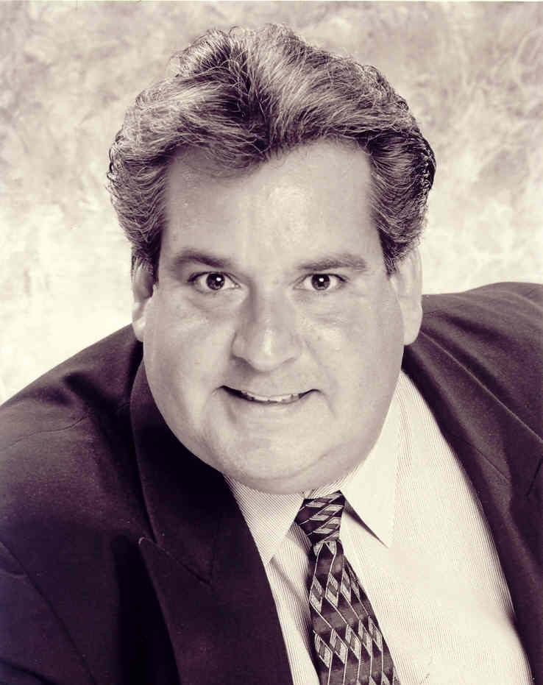
Your Office • Page number
Bennie’s and Linda’s dream of owning their own floral shop became a reality when they secured a loan from HSBC Bank that was guaranteed by the U.S. Small Business Adminstration. “We couldn’t have done it without the SBA, and getting the loan was made that much easier because of the guidance we received from Al Griggs of business resource center,” said Linda. The Mid-Hudson Business Resource Center is funded by the SBA and provides free counseling to the area’s business owners and aspiring entrepreneurs.

The floral business has changed since Valentine’s days. All the Burgevin greenhouses were closed by the 1960s for greater efficiencies and the company now sources its products from vendors in Albany, NY, Connecticut and northern New Jersey. The company also sells via the international Teleflora network and has its own Web site---business processes Valentine couldn’t have imagined.

But some things might not have changed much from the florist’s first days. For example, it might not be a bad bet that the product mix has stayed the same for decades--- approximately 30 percent of sales are from funeral arrangements and 20 percent from weddings, with the remaining 50 percent divided between holidays, birthdays and other special occasions.

The Carlos’ daughter, Heather, works in the business and she is an instructor for the free flower-arranging courses the business provides for local youngsters. Who knows? If Heather decides to succeed her parents in the business, someone might be reading in 2052 of the 200 year-old Burgevin Florist business.

Burgevin Florist can be visited at www.burgevinflorist.com.
Special Achievement Award for being the Number One Microlender:
New York Association for New Americans.

Bronze Award for 50 or More Loans:
North Fork Bank with 51 loans;
Unity Bank with 52 loans;
Greater New York Development Corporation/Long Island Development Corporation/ with 71 loans;
Commerce Bank with 90 loans.

Silver Award for 100 or More Loans:
Flushing Savings Bank with 110 loans;
Citizens Bank with 161 loans;
Manufacturers and Traders Trust with 166 loans;
Broadway National Bank for 167 loans;
Citibank with 189 loans.

Gold Award for 200 or More Loans:
Washington Mutual Bank with 204 loans;
Banco Popular North America with 224 loans;
Capital One Federal Savings with 236 loans.

(Cont’d page 3)
______________________________

Burgevin… Cont’d from page 1

history because they have floral arranger and 50-year employee of the company, Henry Peyer, working for them.

The Carlos’ had a circuitous trip before settling in Kingston. Bennie, an Arizona native, met native Virginian Linda, when they attended Brigham Young University in Utah. They married in Maryland and then settled in Kingston to be close to Linda’s family in northern New Jersey. Upon arriving in New York Bennie decided to pursue his lifelong passion for flowers and greenery and obtained his degree in horticulture from the State University of New York in Cobleskill, NY. He then put his degree to practice by working at the SUNY Cornell Cooperative Extension, always with the idea of someday having his own business.

(Cont’d next column)

A Message from the
District Director
Jose R. Sifontes

You may recall that in our last newsletter I announced that this office wrote the most 7(a) loans in fiscal 2006 than any district office in the agency’s 53-year history.

Now I would like to take this opportunity to recognize some of the lenders who made that accomplish-ment possible. We presented our annual lender awards last month at an event in Queens, about which you can read more on page four. The awards presented were:

Certificate of Achievement for Largest Percentage Increase in Loans:
Washington Mutual;
Banco Popular.

Special Achievement Award for Total Loans in the Small Bank Category:
Broadway National Bank with 167 loans.

Special Achievement Award for Most 504 Loans as First Mortgage Lender:
Citibank with 16 loans.

(Cont’d next column)

Inside the New York District Page 3

Upcoming Events

Looking for low- or no-cost business management training opportunities to start or grow your business...or business networking opportunities? Then be sure to check out our Calendar of Events at www.sba.gov/ny/ny for more information.

SBA 8(a), HubZone, SDB Pre-Certification Orientation Seminars
Dates: December 20
Time: 5:00 p.m. - 7:00 p.m.
Place: New York, NY
Info: 212-264-4322

SBA 8(a), HubZone, SDB Pre-Certification Orientation Seminars
Dates: December 21
Time: 9:30 a.m. - 1:00 p.m.
Place: New York, NY
Info: 212-264-4322

__________________________________

Credit Scoring Can Increase Access to Credit
For Small Business

Washington, DC--- The introduction of credit scoring by banks for small business loans may help increase small businesses’ access to credit, according to a study released this month by the Office of Advocacy of the U.S. Small Business Administration. The report also found that relationships continue to be the dominant factor in banks’ decisions to lend to small businesses.

“The report documents how the use of credit scoring can lead to risk-based pricing of loans which ‘democratizes’ lending, meaning that riskier loans can now be made to start-ups or small business owners with little credit history,” said Dr. Chad Moutray, Chief Economist for the Office of Advocacy.

For more information and a complete copy of the report, visit the SBA Office of Advocacy website at www.sba.gov/advo.
New York District Top Ten Lenders
(By number of loans)
09/30/06-11/30/06
Lender | No. of Loans | Amt.
JP Morgan Chase | 358 | $14,781,600
Bank of America | 99 | $2,810,700
Washington Mutual | 59 | $2,344,000
Citibank | 50 | $2,426,200
HSBC | 49 | $2,761,700
Capital One | 46 | $2,125,000
Banco Popular | 37 | $1,070,000
Manufacturers & Traders | 30 | $1,240,000
BNB | 27 | $4,951,000
Citizens Bank | 18 | $800,000

Senate Confirms President’s Choice of Jovita Carranza
As Deputy Administrator

Washington, DC--- Jovita Carranza, an experienced Latina business executive nominated by President George W. Bush to be the U.S. Small Business Administration’s deputy administrator, was confirmed this month by the U.S. Senate. She had been unanimously endorsed by the Senate Committee on Small Business and Entrepreneurship.

Named Hispanic Woman of the Year by Hispanic Business Magazine in 2004, Carranza said she is enthusiastic about transferring her 30 years of experience at UPS to the SBA.
District Director… Cont’d from page 2

Platinum Award for 500 Loans or More:
HSBC Bank for 813 loans;
JP Morgan Chase Bank for 1,039 loans.

Pinnacle Award for Most Loans:
Empire State Certified Development Company for most 504 loans with 84;
Bank of America for most 7(a) loans with 1,218.

Congratulations once again to our winners, and I wish all of you and your families all the best for this holiday season.

Inside the New York District Page 4

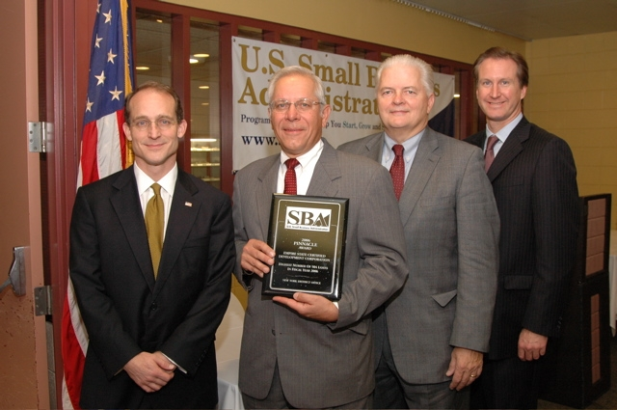
District Office Conducts ‘SBA Comes to Queens’ Day

Queens, NY--- The SBA New York District Office swept through Queens last month in its SBA Comes to Queens Day to promote the agency’s programs and services as well as honor and acknowledge its small business success stories, participating lenders and resource partners.

The office conducted three different events in one day to accomplish that task and was joined by SBA Administrator Steven Preston.

The day began in Jamaica with the Annual Lenders Award Ceremony hosted by the York College Small Business Development Center. After presenting awards to its top lenders for fiscal 2006 (see Message from the District Director on page 2) the district office staff moved on to the Citigroup Building in Long Island City where awards were presented to four Queens small businesses: Cake Mio Bakery of Corona; Isis Plumbing, Inc., of Long Island City; the law firm of Kazmierczuk & McGrath in Richmond Hills; and D & S Electrical Corporation of Far Rockaway. Borough President Helen Marshall welcomed the attendees and provided the keynote address.

Finally, in an effort to cement closer ties with the Asian-American community, district staff landed at Flushing Town Hall to sign a strategic alliance memorandum with the Asian American Business Development Corporation, the Flushing Chinese Business Association and the Long Island City Business Development Corporation. Congressman Gary Ackerman and New York City Councilman John Liu joined the event.

“We saw an increase in the number of loans we approved to small businesses in Queens after we conducted an SBA Comes to Queens Day two years ago,” said SBA New York District Director Jose Sifontes. “We repeated the initia-tive this year to build upon that success.”

At the Annual SBA Lenders Awards Ceremony, Dave Terrenzio, Executive Vice President (2nd from left) and Chet Sadowski, Senior Vice President of the Empire State Development Corporation accept the SBA Pinnacle Award from (Left) SBA Administrator Steven Preston and (Right) SBA Regional Administrator Bill Manger.

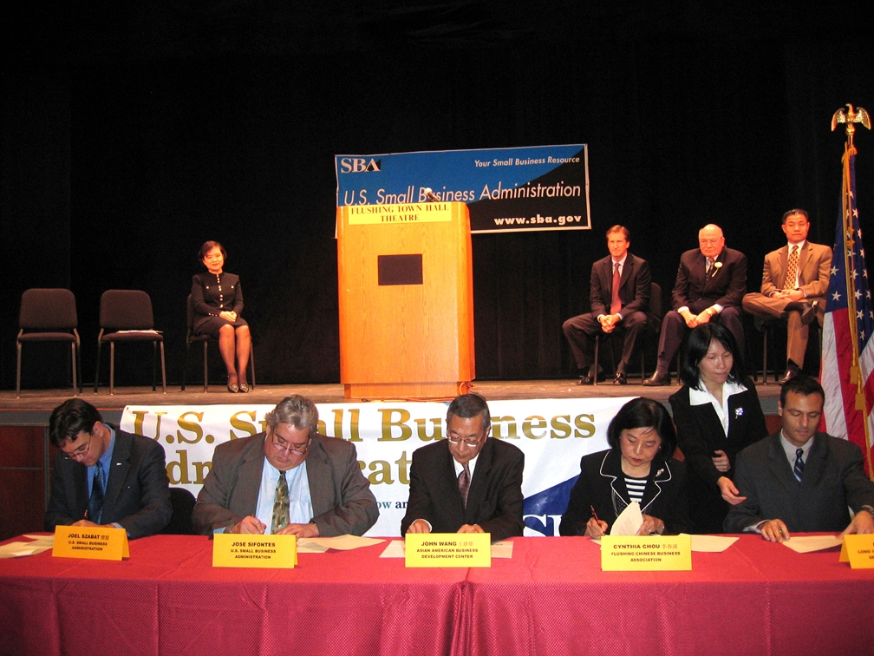

Signing SBA Strategic Alliance Memorandum are (Seated L to R): SBA Chief of Staff Joel Szabat; SBA New York District Director Jose Sifontes; John Wang, President, Asian American Business Development Center; Cynthia Chou, Executive Director, Flushing Chinese Business Association; Dan Miner, Senior Vice President, Long Island City Business Development Corporation. Standing is Man-Li Lin, Business Development Specialist, SBA. On stage L to R are: Chiling Tong, Associate Director, MBDA, U.S. Department of Commerce; SBA Regional Administrator Bill Manger, United States Congressman Gary Ackerman, New York City Councilman John Liu.

