RCG-17

Preliminary Parametric Study of the Bandwidth Requirements for FM modulated Pulse Radar Waveforms.

Wednesday, 18 June 2003

John Holloway

Senior Consultant

Systems Engineering Dept

AMS Radar Systems Division.

Cowes I.o.W

1) Introduction

Recommendation ITU-R SM.1541 - Unwanted emissions in the out-of-band
domain - contains in Section 6 of Annex 8 a design objective for future
radars, this objective increases the roll-off in the OOB domain from the
current 20 dB/dec to 40 dB/dec. The next WRC (06?), may discuss the adoption of this design objective in one form or another and this discussion needs to be supported by inputs from the radar community as to what is achievable.

Modern professional and military radar systems tend to make use of driven transmitters mainly because of their wide agile bandwidths. Such systems almost exclusively make use of pulse compression techniques as their peak power is not high enough to deliver the required energy to detect a target in a time period commiserate with the require range resolution. This trend extended further with the introduction of solid state power amplifier based systems. In such systems an inherent wide bandwidth is accompanied by relatively low peak power capabilities. The development of programmable and eventually adaptive digital waveform generation leads to a multiplicity of available waveforms limited only in the end by the maximum usable pulse length and transmitter duty cycle. FM chirped waveforms are one common method of achieving pulse compression and these are widely used.

This paper discusses the theoretical bandwidth requirements for FM pulsed radar waveforms and compares them to the current ITU recommendations and the design objective, with the aim of ascertaining what bandwidth limits are set by the basic waveform design. In practice however due allowance will have to be made for the implementation effects on the final spectrum output, caused by real transmitting and radiating systems.

2) Current ITU OOB Requirements

The current OOB emission limits are based on the calculated -40dB spectral bandwidth, Bw(-40). The limit line rolls off from this point at 20 dB/dec until it meets the Cat A level of -60dB. This results in the Bw(-60) being 10 times the Bw(-40).

$$\text{Bw}(−\text{60})=\text{Bw}(−\text{40})×{\text{10}}^{\left(\frac{\text{20}}{\text{20}}\right)}=\text{Bw}(−\text{40})×\text{10}$$

The new design objective increases this roll-off rate to 40 dB/dec this results in a Bw(-60) of:

$$\text{Bw}(−\text{60})=\text{Bw}(−\text{40})×{\text{10}}^{\left(\frac{\text{20}}{\text{40}}\right)}≈\text{Bw}(−\text{40})×3\text{.}2$$

The two limit lines are shown graphically in Figure 1 below.

Figure 1 Current and Proposed OOB Emission Masks Cat A Emissions

The Bw(-40) is calculated based on the radar parameters using the following equation as given in 1541.

For FM-pulse radar waveforms, the -40 dB bandwidth is given as:

$$\text{Bw}(−\text{40}) = \frac{K}{\sqrt{t ⋅ t_{r}}}+2 \left(B_{c}+\frac{A}{t_{r}}\right)$$

A is 0.105 when K = 6.2, and 0.065 when K = 7.6 ,where t is the pulse duration (at half amplitude) and t_{r} is the rise time, both in seconds and B_{c} is the total frequency shift during the pulse duration.

In order to consider the efficacy of these equations in calculating the OOB limit parameters, and the applicability of the proposed design objective. It was decided to compare the results obtained with the results achieved from a model that produces a theoretical value obtained by a Fourier transform of a radar pulse time waveform.

The model, which was developed in Microsoft "Visual Basic" carries out a discreet FFT on a time waveform specified by the user. The parameters of the waveform are as defined by the ITU based on the 50% voltage pulse width and the 10 to 90% voltage rise/fall time.

Below Figure 2 is an example of the output.

By running this model for various time waveforms it is possible to compare the results against the calculated values given by the equations in ITU-R M.1541 and to assess the likely level of performance that could be achieved from these waveforms against the design objective.

Figure 2 Example of the output of the Model
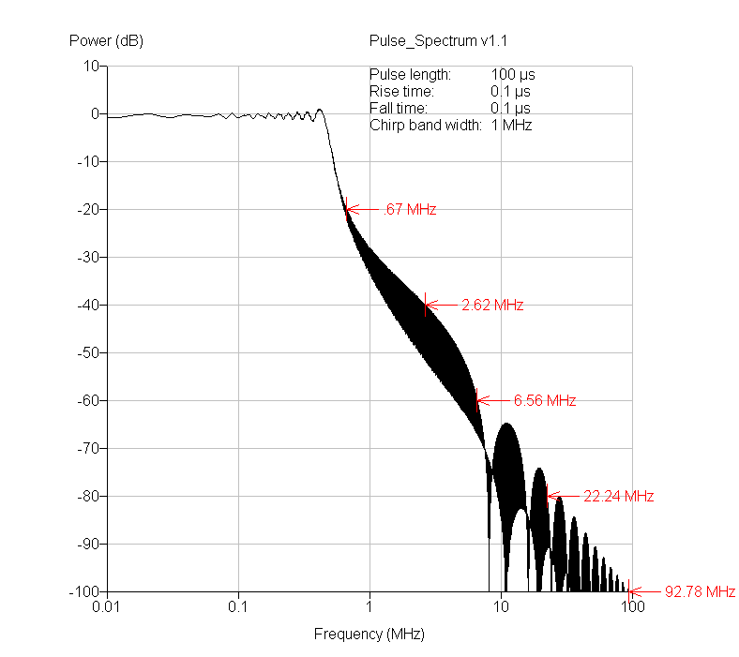

3) Necessary Bandwidth B_{N} or Bw(-20)

Recommendation 1541 also gives an equation for the "Necessary Bandwidth B_{N} or Bw(-20) of these types of radar waveforms. If we consider this equation we can see that by inspection that for in the types of radar waveforms being considered in this paper (pulse compression waveforms), which tend to have relatively long pulses with large chirps.

$$B_{N}≈\text{Bw}(\text{20}) = \frac{1\text{.}\text{79}}{\sqrt{t ⋅ t_{r}}} + 2 B_{c}$$
The equation tends to B_{N} ≈ 2B_{c}.

This equation also goes unstable when t_{r} approaches zero and gets very large when t_{r} is small. For rise times < 100 nS the equation below based on ITU formula for rectangular pulses might be considered a better approximation.

$$B_{N}≈\text{Bw}(\text{20}) = \frac{6\text{.}\text{36}}{t} + 2 B_{c}$$

This author has maintained for some time , that for real radar waveforms with a moderate to large time bandwidth product say > 10 then then N_{B} → Bc, not as the equation below gives N_{B}→ 2xBc.

$$B_{N}≈\text{Bw}(\text{20}) = \frac{1\text{.}\text{79}}{\sqrt{t ⋅ t_{r}}} + 2 B_{c}$$

Observation of the results of the model showed that in the waveforms under consideration the B_{N} was not very dependent on the rise time where the rise time was short compared to the pulse length. Taking this in to consideration two empirical equations were investigated. These were modifications of the current ITU equations for unmodulated pulses.

These were called ITU 1:

$$B_{N}≈\text{Bw}(\text{20}) = \frac{6\text{.}\text{36}}{t} + 2 B_{c}$$
and ITU 2:

$$B_{N}≈\text{Bw}(\text{20}) = \frac{6\text{.}\text{36}}{t} + B_{c}$$

The waveforms considered have pulse lengths varying between 1 → 500 μS chirps of 1,5 & 10 MHz and rise times between 0 and 500 nS. These parameters it is believed cover most of those used by modern surveillance and TI radars using solid state or TWT type transmitters.
The results are shown in Table 1.
This shows that the current ITU equation leads to errors of up to 195% and fails for waveforms of large time bandwidth products and waveforms with short rise times. This effect being due to the 1/√(t x t_{r}) term.
ITU 1 gives a better approximation with maximum error of ≈ 90% for large time bandwidth products mainly due to the effect of the 2xBc term.
ITU 2 gets the error to ≈ 30% by replacing the 2xBc term with Bc.
A better approximation has been devised this is called "NEW" this gets the error to < 5% on most of the waveforms tested. This equation is given below:
$$B_{N}≈\text{Bw}(\text{20}) = \text{Bc}×\left(1+\frac{3\text{.}7}{{\left(t×\text{Bc}\right)}^{0\text{.}\text{52}}}\right)$$
This and all equations lead to larger errors when the chirp is small and the rise time > 1% of the pulse length.
These results also show that as the time x bandwidth product increases the B_{N} does tend to 2xB_{c} they also show that for the faster rise times the B_{N} calculated by the ITU equation is considerably larger than that achieved from the model.

Table 1 Necessary Bandwidth B_{N} Equation Results

4) -40 dB Bandwidth Bw(-40)

The Bw (-40) is key to the OOB emission limits as it sets the Bw(-60) which gives the boundary between the OOB and SE domains. Because the Bw(-60) is derived by multiplying the Bw(-40) by a factor of 10 thus giving rise to the magnification of any errors.

Results of the modelling show that this -40 dB area is much more effected by the rise time. Figures 3 & 4 illustrate the effect. The larger the time bandwidth product and the slower the rise-time the more "rectangular" the spectrum. Rectangular being defined as when the Bw(-40) and Bw(-60) → Bc.

Figure 3 Waveform Spectrum

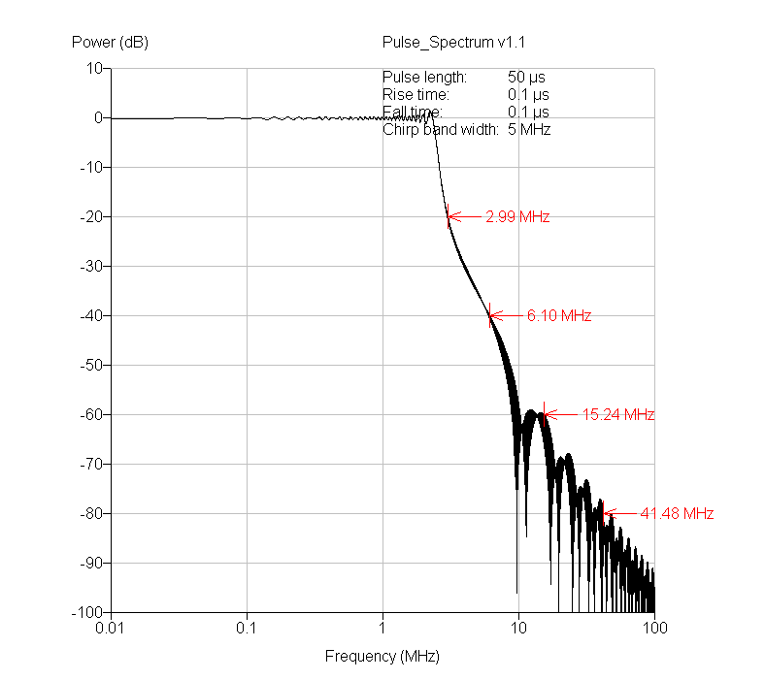

Figure 4 Waveform Spectrum

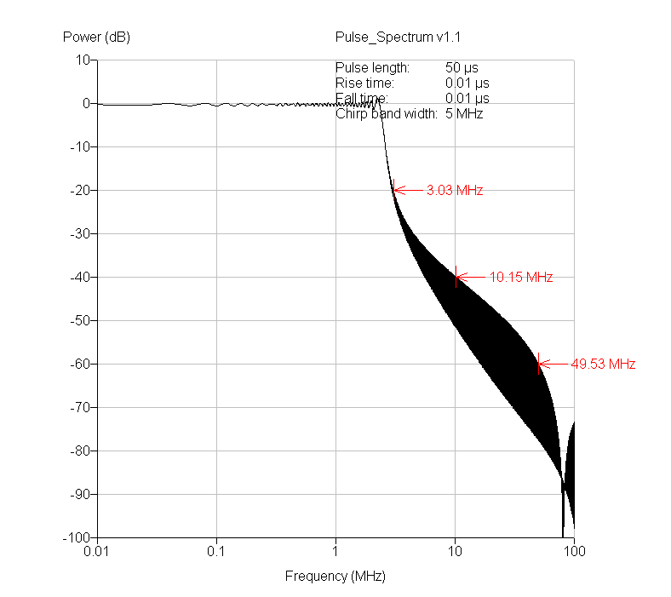
In Figure 3 & 4 the rise time is varied from 0.1 to 0.01 this results in an Bw(-20) which varies from 5.98 to 6.06 MHz whilst the Bw(-40) varies from 12.2 to 20.3 MHz. The change in Bw(-60) is more pronounced being affected by the first null and the first spectral sidelobe. This varies from 30.48 to 99.06 MHz.

Figure 5 shows a typical waveform for a surveillance radar.

To date the analysis of the sensitivity of the spectrum to the various parameters has not yet been completed.

The Bw(-40) depends on all the parameters unlike the Bw(-20) the sensitivity has as yet to be determined. The Bw(-60) also appears to be highly dependent on the position of the first null in the pattern and the level of the first secondary lobe of the spectrum.

If we compare the results calculated for the Bw(-40) using the ITU equation:

$$\text{Bw}(\text{40}) = \frac{K}{\sqrt{t ⋅ t_{r}}}+2 \left(B_{c}+\frac{A}{t_{r}}\right)$$

against those produced by the model for various sets of pulse parameters, the accuracy of the ITU equation can be assessed.

The parameters chosen to model where in the range:

- Chirp 1,5 & 10 MHz,
- Pulse length 1 → 500μS
- Rise time 0→160 nS.

The results for the Bw(-40) comparison is given in Tables 2 to 4.

Figure 5 Surveillance Radar Waveform Spectrum

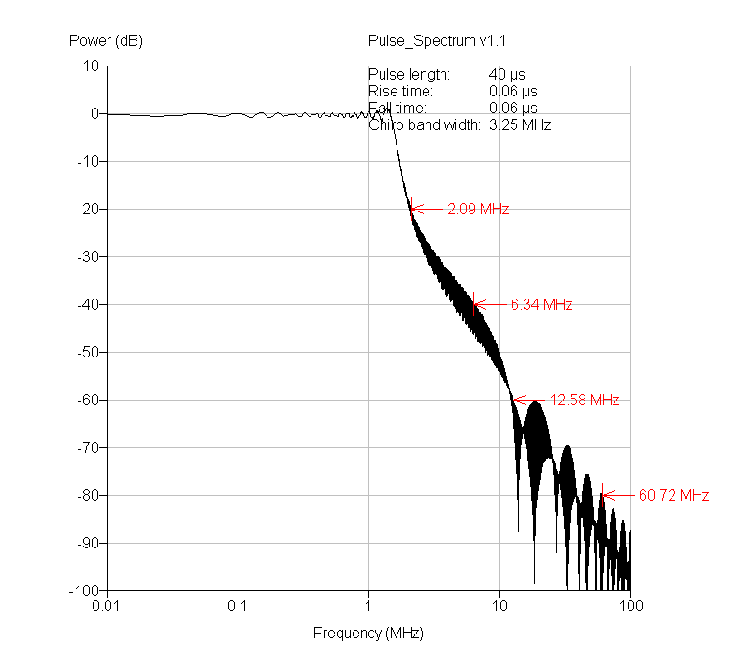

In these tables the value calculated using the ITU equation is compared to that produced from the model. The calculation is carried out using the two values of the constants A & K. The value calculated by the model is given in bold.

The results show errors from a few 10's % to 500% it appears on first investigation that the pulse length and rise time terms, are over estimating for short fast rise pulses whilst for the larger chirped pulses the 2Bc term in the equqtion is again over estimating the Bw.

Table 2 Comparison of Bw(-40) 1 MHz Chirp

Table 3 Comparison of Bw(-40) 5 MHz Chirp

Table 4 Comparison of Bw(-40) 10 MHz Chirp

The results show that the closest match between the calculated and modelled results when the chirp is small and the rise-time is long. ATC radars tend to operate with compressed pulse lengths between 0.75 and 1 μs this requires chirps of the order of 1 to 1.5 MHz. Some of these systems also operate with relatively long rise-time inspection of Table 2 would indicate that these waveforms come close to the predicted Bw(-40) limit.

Two special cases are shown for comparison in Table 5 :

Table 5 Comparison of two ATC type Waveforms

The model outputs are shown in Figures 6 & 7 Below:

Figure 6 Waveform 1

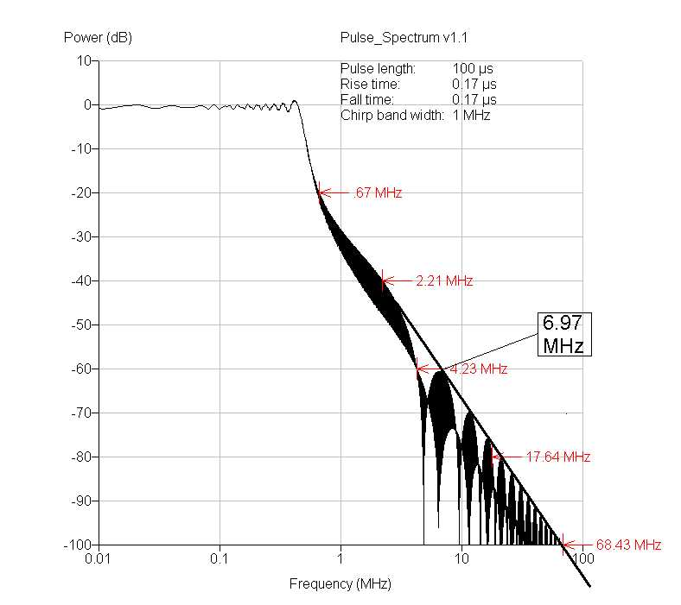

Figure 7 Waveform 2

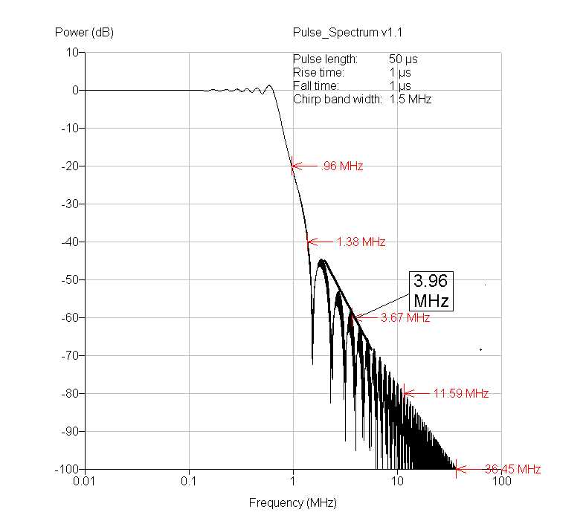

For waveform 1 the calculated and modelled Bw(-40) are very close to each other 4.61 to 4.42 when the practical implementation is considered then this could be close to or outside the current Bw(-40) limit. The spectrum however outside this region rolls of quickly at 40 dB/dec.

Waveform 2 has a narrower Bw(-40) than predicted by the ITU equation 2.72 MHz Vs 4.2 MHz outside this it then rolls off at ≈ 40 dB/dec.

5) Design Objective & Bw(-60)

The Bw (-60) sets the boundary of the OOB and the SE region, currently the formula for Bw(-60) is defined by the Bw(-40) value and the 20dB/dec roll off, this results in a bandwidth of:

$$\text{Bw}(\text{60}) = \text{10}×(\frac{K}{\sqrt{t ⋅ t_{r}}}+2 \left(B_{c}+\frac{A}{t_{r}}\right))$$

However the design objective requires this bandwidth to be reduced to:

$$\text{Bw}(\text{60}) = 3\text{.}2×(\frac{K}{\sqrt{t ⋅ t_{r}}}+2 \left(B_{c}+\frac{A}{t_{r}}\right))$$

as a result of the adoption of the increased roll-off of 40 dB/dec out side the Bw(-40) region.

The initial question that needs to be asked is what roll-off can be achieved by the waveforms under consideration and given that a suitable equation can be found to describe the Bw(-40) the question is then can these waveforms meet the new requirement. This means investigating the "natural roll-off " of these types of waveforms.

5.1 Natural Roll-off of Chirped Waveform Spectra

In order to investigate this the Bw(-40) and Bw(-60) was calculated and the ratio of the two beamwidths determined. To meet the new design objective this ratio must be < 3.2:1.

Table 6 below gives the ratio of the calculated Bw(-60)/Bw(-40) the areas highlighted show where the ratio exceeded 3:1 this shows waveforms with low chirps will have difficulty in meeting the roll-off. Note however how the ATC waveform shown earlier sits in a region where a 1 MHz chirp will exceed the requirements. Longer chirps tend to fail the 3:1 test when the rise time is very short or the pulse is very short. These waveforms which may not be that interesting in may applications. The anomalies or "jumps" in the table seem to be related to the position and height of the first side lobe this can appear > then -60 dB resulting in a consequential widening of the Bw(-60). If however the "envelope" of the spectrum of the waveform is plotted the "jumps" are smoothed out. In the time frame of this study it was not possible to develop a mathematical method of determining the "envelope" time pressure excluded the alternative "manual" estimation of the envelope Bw being determined.
Figure 8 shows an example of a waveform that does not meet the 3.2:1 criterion. This appears on initial inspection to be caused by the position of the first null that is not increasing the roll-off around the Bw(-40) point. Figure 9 shows that by increase the rise-time from 60 to 120 ns the Bw ratio is reduced.

  - ITU Calculation of Design Objective Bw(-60)

As an alternative test it was decided to calculate the required Bw(-60) for the increased roll-off using the ITU equation. The equation has been shown to over estimate the Bw(-40) so will give a greater margin at the Bw(-60) level.

These results are shown in Tables 7-9 below.

The results in these tables show a 100% compliance indicating that the modulation scheme alone is capable of meeting the design objective by a large margin. This compliance however is based on the fact the ITU formula for the Bw(-40) over estimates and this over estimate is multiplied by 3 when calculating the Bw(-60).
Figure 8 Waveform that Fails 3.2:1 Roll-off
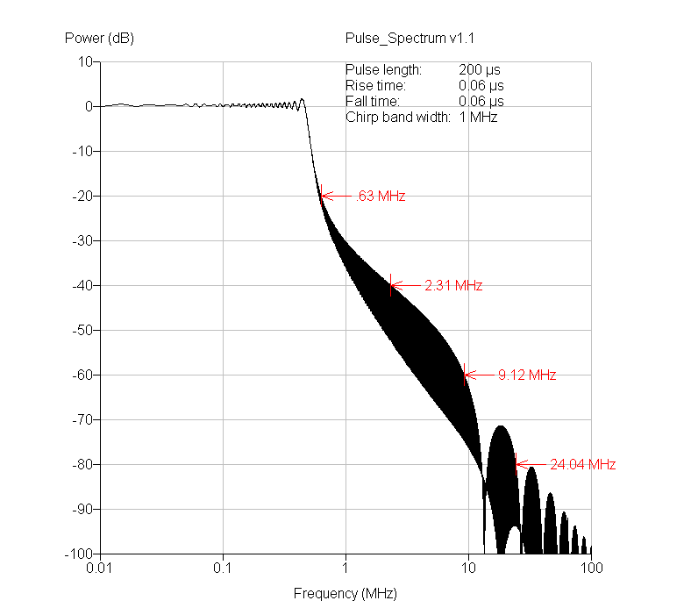

Figure 9 Waveform that Meets 3.2:1 Roll-off

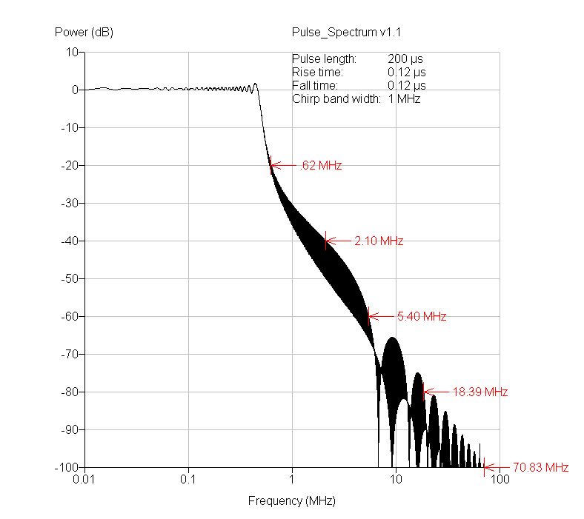

Table 6 Ratio of Bw(-60) to Bw(-40)

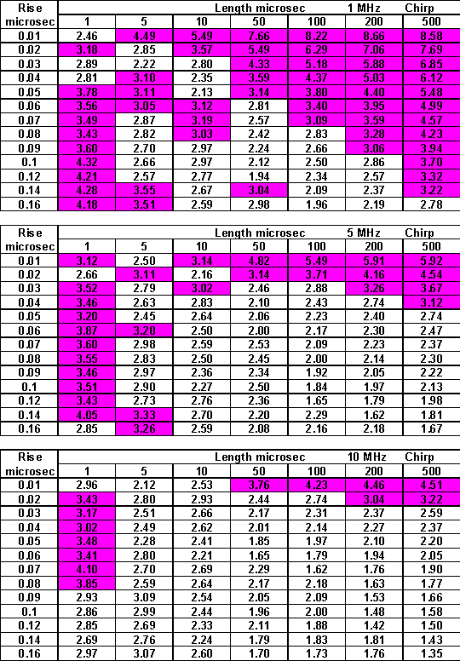

Table 7 Calculated Bw(-60) Vs Model 1 MHz Chirp

Table 8 Calculated Bw(-60) Vs Model 5 MHz Chirp

Table 9 Calculated Bw(-60) Vs Model 10 MHz Chirp

Thus it would appear that when considering the waveform alone the design objective can be met when the current ITU formula is used to calculate the Bw(-40) and Bw(-60) limits. This however is a consequence of the errors in the Bw(-40) and Bw(-20) formulea.

If however a realistic estimate of Bw(-40) is used then not all the waveforms can meet the design objective. When the further distortion of real waveform generation and amplification is added some of the waveforms currently on the borderline will not meet the objective.

6) Conclusions

The method given in the current ITU recommendations for calculating the bandwidth limits for OOB emissions for radar systems using FM pulsed waveforms lead to large errors on all the bandwidths considered for some combination of parameters. This is particularly true where the rise time is fast and the time bandwidth products are large or where the chirp is small and the rise time is significant portion of the pulse length >1%.

These errors when multiplied up to achieve the OOB/SE boundary conditions result in an excessively large bandwidth.

The properties of the pulses are such that even when an accurate assessment of the Bw (-40) is sued then the current 20 dB/dec roll-off is relatively easily achieved.

The proposed 40 dB/dec is difficult to achieve just from the natural spectrum of the waveform, particularly for some combinations and especially when the effects of practical distortions are considered. It is known that these can have a great effect at the -60dB level.

If an accurate calculation of the Bw(-40) is used then the achievement of the 40 dB/dec is as yet not fully proven although some waveforms show possibilities.

If the current ITU formula for Bw(-40) is maintained then the 40dB/dec is achievable in all cases considered.

It must be remembered however that these conclusions are based on theoretical waveforms some allowance for practical implementation will be required.

7) Future Work

The following further work needs to be carried out.

Further work on defining the appropriate formula for specifying the bandwidths and the roll-offs need to be further investigated in particular the sensitivity of the -40 and -60 dB levels to the pulse shape parameters.

Most radars do not use linear FM chirps, these do not have low enough time sidelobes, to reduce the level of time sidelobes non-linear FM chirps are used. An example of the effect of non-linear FM is shown in Annex 1. When comparing non-linear FM chirps the concept of compression ratio C is better than bandwidth, as in non-linear FM C≠1/Bc, which is the case for linear FM systems. The method of calculating the bandwidths and roll-offs for these types of modulation is required.

The trapezoidal pulses considered so far have sharp changes of direction at the edges, in practice these do not occur. The corners of the pulse can be rounded by replacing the linear ramp by a modified Cosine function, the effect of this needs some consideration.

An example of the effects of Non-linear FM chirps is shown in Annex 1. The properties of these waveforms have not yet been fully assessed in relation to the relationships between the Bw(-20), Bw(-40) and Bw(-60).

Annex 1

Practical Example
Consider the spectrum above, this is a FM modulated pulse radar with 25 μS pulse and a rise time between 15 to 18 ns and a 2.5 MHz chirp. Although this result is noise limited the following bandwidths have been estimated from this measurement. These are compared with those calculated using the ITU equations.

The measured Bw (20) is < 50% that calculated, the Bw (40) < 50% calculated and the Bw (60) ≈ 8 % of that calculated if the new design aim was used then the result would be < 50% of that calculated.

Table 1 Annex 1
This spectrum well exceeds both the current requirements and the design aim. This is a result of an over estimation of the 20 and 40 dB bandwidths giving rise to a very generous 60 dB requirement. If a more accurate calculation of the Bw(40) could be achieved say for example 10 MHz then the Bw(60) at ≈ 35 MHz would be close to the 3.2 ratio required by the design aim.

The FigureA1 below shows a comparison of several pulses all with the same Chirp or bandwidth with various modulations. It can be seen that at the Bw(-20) level the non-linear FM pulse is narrower but the effect at the Bw(-40) is not so pronounced.

Figure A1-Comparison of Chirp Types
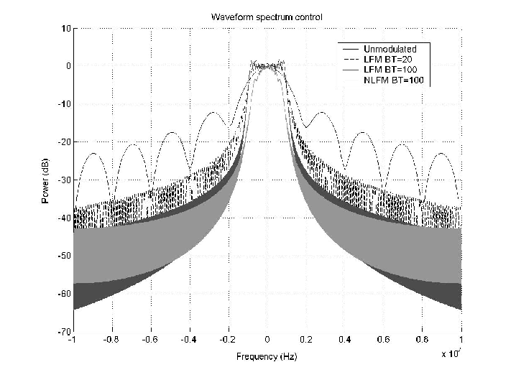

Tel: 44 (0) 1983 202577 Email: john.r.holloway@amsjv.com
The types of radar discussed in this paper are generally have to meet exclusively Cat A SE limits.
Comments on Reference and Measurement Bandwidths and Application of SE and OOB Limits & Masks for Radiodetermination Systems.Input to RCG Meeting 20th to 23rd August, Bolder USA John Holloway:AMS Cowes Monday, 12 August 2002 The Report of an Investigation into the Characteristics, Operation and Protection Requirements of Civil Aeronautical and Civil Maritime Radar Systems October 2002. Public Domain Report UK Radiocommunications Agency.
These are the waveforms most likely to be used for radar as FM modulation is used for the purpose of pulse compression.

