USDA Foreign Agricultural Service
GAIN Report

Template Version 2.09

Global Agriculture Information Network

Voluntary Report - public distribution
Date: 12/15/2006
GAIN Report Number: CH6117
CH6117
China, Peoples Republic of
Poultry and Products
Challenges to Increasing U.S. Sales of Chicken Paws to China
2006

Approved by:
Maurice House
U.S. Embassy
Prepared by:
Casey Bean and Suzanne Ryan

Report Highlights:
Although the U.S. is still the largest chicken paw supplier to China and total U.S. poultry product sales will exceed $200 million in 2006, many challenges threaten this position, including competition from Brazil and Argentina, stricter inspections at China's ports, FSIS's inspection mandate, and the cost of new "China" production lines at U.S. plants. Further, as more and more product moves through the Mainland ports and away from Hong Kong, U.S. product will be more carefully inspected to ensure China’s import requirements are met. According to the trade, increasing U.S. market share hinges on addressing these challenges, in addition to improving U.S. paw quality.

Includes PSD Changes: No
Includes Trade Matrix: No
Unscheduled Report
Beijing [CH1]
[CH]
Table of Contents
Executive Summary 3
China’s Domestic Paw Production 3
China imports over 300,000 MT of paws each year due to limited domestic supplies 3
Consumption Trends 4
Consumer preferences depend upon geographic location 4
Trade 4
Paws account for over half of China’s total poultry imports 4
Wholesale price of paws has increased during past two years 7
U.S. faces fierce market competition from Brazil and Argentina 7
Elimination of “Hong Kong Standard” caused severe shortage of paws 8
Processors risk financial losses due to China’s “zero” tolerance for pathogens 9
Policy changes, still reported as “internal” by the poultry trade, may impact imports 10
Pre-Inspection law and other measures “encourage” direct shipments to China 10
Volume of U.S. paws imported through official channels increasing; less so for other suppliers 11
Changes in import permit poses barrier to traders 11
Marketing 12
U.S. market share affected by competitor focus on product quality and packaging 12
Traders look for high-quality paws which meet their specific requirements 13
Implementation of grading system by competitors 13
Market Outlook 13
Outlook and opportunities to expand U.S. paw sales in China 14

Executive Summary
Although the U.S. is still the largest chicken paw supplier to China and total U.S. poultry product sales will exceed $200 million in 2006, many challenges threaten this position, including competition from Brazil and Argentina, stricter inspections at China's ports, FSIS's inspection mandate, and the cost of new "China" production lines at U.S. plants. Further, as more and more product moves through the Mainland ports and away from Hong Kong, U.S. product will be more carefully inspected to ensure China’s import requirements are met. According to the trade, increasing U.S. market share hinges on addressing these challenges, in addition to improving U.S. paw quality.

In 2004, China banned U.S. poultry due to highly pathogenic avian influenza (HPAI). During this time Brazil’s poultry exports to China increased over 600 percent and Argentina’s poultry exports increased over 900 percent. Brazil and Argentina shipments continue to limit the recovery of U.S. poultry product trade due to competitive prices and quality advantages. The resulting supply shortfall and reduced sale of U.S. paws for sale to China is estimated to have cost the U.S. poultry industry more than $400 million in revenue.

According to the trade in China, increasing U.S. market share depends on improving paw quality, continued investment in U.S. plant modifications, and revisions to the FSIS inspection mandate.

China’s Domestic Paw Production

China imports over 300,000 MT of paws each year due to limited domestic supplies
China’s domestic broiler production is centered in the northeast and central provinces of China (Shandong and Henan). Domestic processors cite production costs, demand and lack of profitability as reasons to produce chicken feet rather than chicken paws (feet are longer than paws). The northern provinces, with concentrated broiler production, tend to produce chicken feet, while the southern provinces (Fujian, Guangdong, Zhejiang and Shanghai), with less concentrated broiler production, tend to produce chicken paws.

The majority of the domestically produced paws are exported to Japan or Korea where processors get higher prices. Due to small domestic supply, China is forced to import approximately 300,000 to 350,000 MT of chicken feet and paws annually. Currently, the supply of domestic paws is at less than 40 percent of the U.S. volume shipped to China. The Trade reports wholesale prices are $60 to $100/MT higher than U.S. products for the same grade. The wholesale price for imported chicken paws is $1,500 to $1,600/MT.

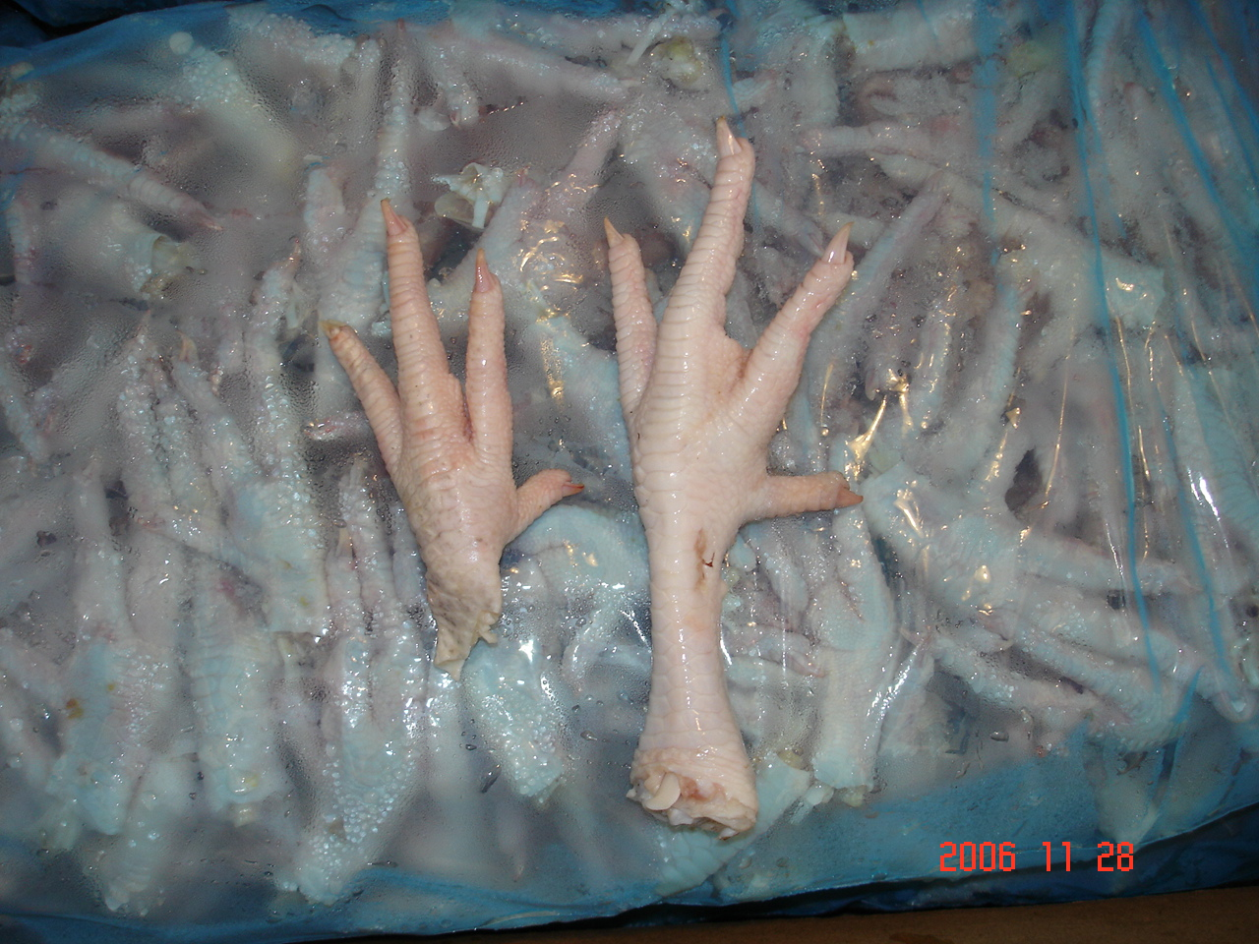
The picture below illustrates the difference between a chicken paw (left) and a chicken foot (right).

Consumption Trends

Consumer preferences depend upon geographic location
The peak season for chicken paws is the warmer months from April to October. During cold winter weather, the paw market generally weakens and prices continue to drop until warmer weather.

Imported chicken paws are primarily destined for central and southeast coastal regions of China (Guangdong, Fujian, Zhejiang, Sichuan and Jiangsu Provinces). Most paws are sold in the wholesale markets and distributed to restaurants. Some paws are further processed before being moved to the wholesale market. Each market accepts its own size of chicken paws, depending on the consumption habits and living standards of the consumers. Suzhou, Kunming and Guangzhou markets prefer larger-sized chicken paws, while Chongqing, Chengdu and Anhui markets prefer small to medium-sized chicken paws.

The market for chicken feet is more varied than that of chicken paws. Chicken feet vary widely in size, and they are sold to different marketing channels. Bigger feet are sold to wholesale and retail markets (for family consumption and retail in barbecue stores), while smaller feet are typically further cooked in processing plants. Northeast and northwest Chinese consumers tend to favor chicken feet over chicken paws.

Chicken Paw Imports, by province 2005-2006
 | January-September |  | January-September
 | Quantity, MT |  | Percent Change
 | 2005 | 2006 | 2006/05
All Provinces | 129,060.57 | 204,684.50 | 58.60
Guangzhou | 27,559.30 | 86,850.49 | 215.14
Shenzhen | 19,432.76 | 62,370.51 | 220.96
Shanghai | 51,830.25 | 30,415.68 | -41.32
Huangpu | 4,948.81 | 8,580.88 | 73.39
Nanjing | 5,925.19 | 7,884.86 | 33.07
Qingdao | 4,733.38 | 3,112.21 | -34.25
Dalian | 4,659.14 | 3,010.02 | -35.40
Fuzhou | 1,339.68 | 2,248.32 | 67.83
Gongbei | 2,031.02 | 184.54 | -90.91
Shanton | 6,355.48 | 27.00 | -99.58
Tianjin | 123.07 | 0 | -100.00
Xiamen | 122.50 | 0 | -100.00
HS code: 020714.22
Source: WTA China Customs

Trade

Paws account for over half of China’s total poultry imports
Despite domestic production increases, China’s chicken paw supplies lag consumer demand. Chicken paw imports account for approximately half of China’s total poultry imports. In the first half of 2005, chicken paw imports accounted for 46 and 62 percent respectively of China’s total poultry imports directly and indirectly through Hong Kong. This pattern will likely continue into the future as long as the supply and demand gap exists.

During the first half of 2006, the volume of chicken paws exported to China and Hong Kong was 74,954 MT, with U.S. product comprising 80 percent import market share. In 2005, the U.S. exported 137,202 MT of chicken paws accounting for 65 percent of total poultry products exported to China. Fierce competition from Brazil and Argentina, as well as domestic product in China has caused the U.S. market share to decrease over time. Although Brazil and Argentina reduced the U.S. market share from 96 percent in 2003 to only 46 percent in 2005, in 2006, the U.S. still remains the top supplier of imported poultry products.

China Chicken Paw Imports, by country 2005-2006
 | January-September |  | January-September
 | Quantity, MT |  | Percent Change
 | 2005 | 2006 | 2006/05
World | 129,060.57 | 204,684.50 | 58.60
United States | 67,175.10 | 112,963.92 | 68.16
Brazil | 44,016.57 | 67,210.13 | 52.69
Argentina | 17,334.72 | 18,094.52 | 4.38
Chile | 487.21 | 6,415.93 | 1216.88
Thailand | 22.98 | 0 | -100.00
Canada | 24.00 | 0 | -100.00
 | January-September |  | January-September
 | Value, Millions of U.S. Dollars |  | Percent Change
 | 2005 | 2006 | 2006/05
World | 129,060,570 | 204,684,496 | 58.60
United States | 67,175,097 | 112,963,917 | 68.16
Brazil | 44,016,568 | 67,210,129 | 52.69
Argentina | 17,334,720 | 18,094,524 | 4.38
Chile | 487,205 | 6,415,926 | 1216.88
Thailand | 22,980 | 0 | -100.00
Canada | 24,000 | 0 | -100.00
HS Code: 020714.22
Source: WTA China Customs

U.S. Chicken Paw Exports
 | January-December |  |  |  |  |  | January-December
 | Value, in 1000 U.S. Dollars |  |  |  |  |  | Value Comparisons
 | 2001 | 2002 | 2003 | 2004 | 2005 |  | 2005 | 2006 | Percent Change
China | 9,163 | 6,051 | 29,501 | 4,414 | 55,144 |  | 35,677 | 87,105 | 144.15
Hong Kong | 126,312 | 76,962 | 97,958 | 65,379 | 48,826 |  | 38,463 | 20,924 | -45.60
Russian Federation | 75 | 46 | 2,536 | 4,135 | 12,003 |  | 8,523 | 10,320 | 21.08
Singapore | 138 | 125 | 3,760 | 3,058 | 5,298 |  | 4,164 | 2,961 | -28.89
World | 137,876 | 84,369 | 149,771 | 95,074 | 135,714 |  | 100,213 | 127,200 | 26.93
 | January-December |  |  |  |  | January-December
 | Quantity, MT |  |  |  |  | Quantity Comparisons
 | 2001 | 2002 | 2003 | 2004 | 2005 | 2005 |  | 2006 | Percent Change
China | 18,154.7 | 13,380.9 | 46,281.0 | 6,460.0 | 64,006.0 | 42,600.1 |  | 99,082.5 | 132.59
Hong Kong | 261,286.2 | 144,319.5 | 155,409.7 | 101,964.3 | 65,450.2 | 55,589.8 |  | 23,354.7 | -57.99
Russian Federation | 188.7 | 99.8 | 3,679.0 | 6,455.3 | 15,728.4 | 11,453.6 |  | 12,518.1 | 9.29
Singapore | 328.0 | 221.0 | 4,965.6 | 3,253.0 | 4,889.8 | 3,975.8 |  | 3,642.4 | -8.39
World | 282,560.2 | 161,974.2 | 240,549.2 | 147,046.7 | 170,422.6 | 132,719.1 |  | 146,988.4 | 10.75
Source: Department of Commerce, U.S. Census Bureau, Foreign Trade Statistics
HS code: 0207140045

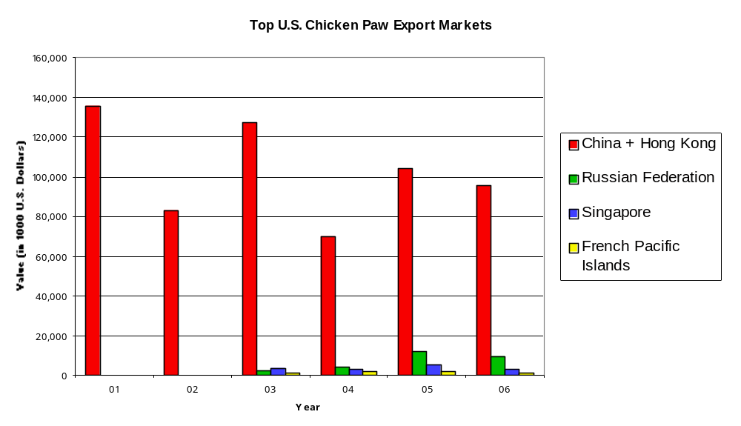

Wholesale price of paws has increased during past two years
The wholesale price of chicken paws has increased remarkably during the last two years. Jumbo-sized chicken paws reached $1,900 to $2,275/MT in the main markets with an average price of $1,500 to $1,600/MT. The trade believes the increase in wholesale price is primarily due to short supply from the U.S. and the increasingly strict quarantine inspection at China’s ports. According to feedback from importers at major wholesale markets, demand for chicken paws is relatively lower than it was in August 2006 as the weather started to cool down across China. The trade saw prices drop by 3 to 5 percent or roughly $60 to $75/MT compared to a couple of months earlier.

Chicken Paw Prices in China, by country 2005-2006 (U.S. Dollars)
 | January-September | January-September | January-September
 | $/KG | $/KG | Percent Change
 | 2005 | 2006 | 2006/05
World | 0.84 | 0.86 | 2.38
United States | 0.87 | 0.88 | 1.15
Brazil | 0.83 | 0.81 | -2.41
Argentina | 0.77 | 0.89 | 15.58
Chile | 0.80 | 0.80 | 0.00
Thailand | 0.51 | N/A | N/A
Canada | 0.80 | N/A | N/A
HS Code: 020714.22
Source: WTA China Customs

U.S. faces fierce market competition from Brazil and Argentina
Despite increased wholesale and retail prices, paw demand has remained nearly level. Many U.S. plants are still not able to meet FSIS inspection requirements for paws because an entire run of paws must be destroyed if one chicken carcass does not pass inspection (see the next section). As a result, the supply of paws available for export has fallen. The reduced volume and increased wholesale prices has encouraged traders to seek sources other than the U.S.

Brazil is the primary competitor for big and medium-sized paws, while Argentina supplies China small-sized paws. Paws from Brazil make up about 70 percent of the Suzhou market, one of the most important paw markets in China. According to the trade, the quality and packaging of Brazil paws is better than that used for U.S. product, and the Brazilian suppliers are more custom-oriented. Argentina’s paw sales to China are rapidly expanding and offer a price advantage over U.S. paws. On average, Argentine paws are $ 0.04/lb cheaper than U.S. paws.

The following picture shows a Brazilian paw (left) and a U.S. paw (right).
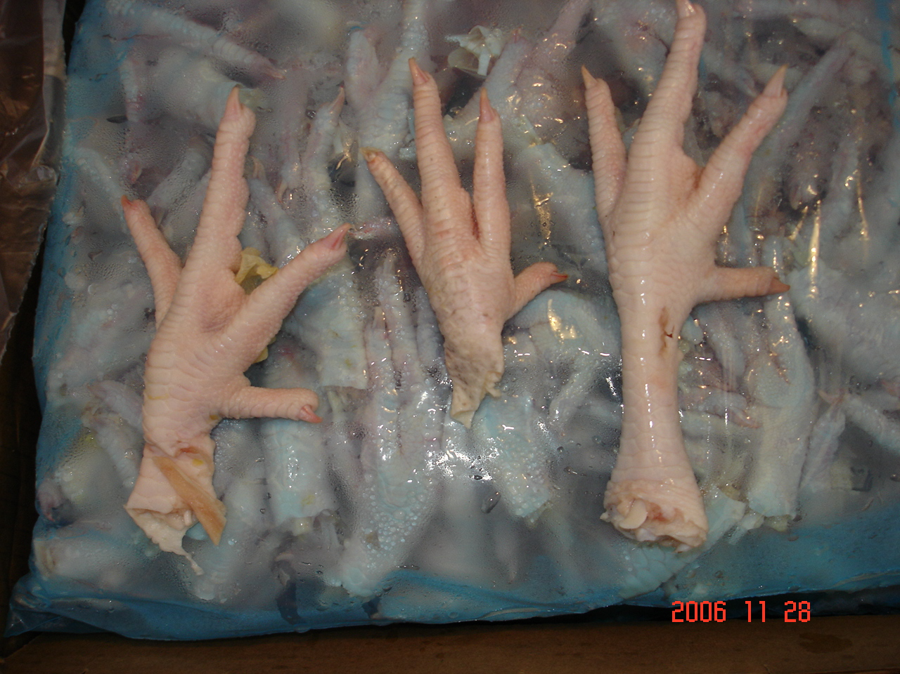

According to the trade, the demand for paws in China is so strong that even non-traditional suppliers are entering the market like Chile, the EU, Peru, Iran and Turkey. Chile currently ships about 40 containers a month, and its market share is growing. The EU is a limited supplier and ships very little product to China, though the industry there exports more feet than paws due to profitability. Iran has stepped-up supplies of chicken paws, now shipping around 50 to 80 loads a month to China. Turkey ships about 100 containers a month to China.

Elimination of “Hong Kong Standard” caused severe shortage of paws
Since 2005, the elimination of the “Hong Kong Standard” for chicken paws has reduced the supply of U.S. chicken paws for the China market. Effective April 30, 2005, China unified the chicken paw standard for Hong Kong and the Mainland as an “edible product”. Previously, chicken paws exported to Hong Kong could be certified as “not fit for human consumption”.

As the result of the new standard, the U.S. Department of Agriculture’s (USDA) Food Safety and Inspection Service (FSIS) must certify ante mortem and postmortem inspection. The trade indicates this new requirement is impacting the volume and price of U.S. chicken paw exports to China because some U.S. plants have decided the investment to change production lines is too costly, coupled with the perception that China’s regulatory uncertainty introduces too much supplier risk.

Until last year, chicken feet and paws were not inspected by USDA and were plant-graded. Now, FSIS inspectors must “associate” the feet with carcasses in order to make sure they are not from diseased or condemnable birds. Feet, however, are separated from the carcass before arriving at inspection stations. As a result, a batch inspection system was implemented, which associated a batch of feet or paws with a group or lot of carcasses processed within a certain period of time. The problem with this system is if one carcass within the lot is condemned, the entire batch of feet and paws are also condemned. The traders inform FAS Beijing that processors need to slaughter 400,000 or more broilers in order to make one container of chicken paws. These requirements have kept limits on the U.S. supply of paws.

FSIS’s inspection standards for chicken paws, in addition to disparity in the application of defect classification on the part of local USDA inspection personnel, has led many U.S. producers to decrease or even shut down their paw production. Processors have chosen this route because of the high cost associated with modifying their equipment in order to produce USDA FSIS inspected paws. Some processors also cite their lack of confidence in a smooth trading environment as a reason to suspend their paw production. After several millions of dollars in investments, some plants are beginning to resume production, however, the output is far from reaching previous levels.

As an example, one U.S. producer used to ship more than 300 loads a month of chicken paws to China, but after elimination of the Hong Kong standard, they stopped packing paws in many of their plants, and now only ship 50 loads a month. The new inspection requirements and the production line alterations have reportedly raised costs, thus passed on to the customer in China.

Processors risk financial losses due to China’s “zero” tolerance for pathogens
On January 1, 2006, China implemented a new national standard, GB 16869-2005, for fresh and frozen poultry products (see CH6001), replacing the GB 16869-2000 standard. The standard reinforces a “0” tolerance for the pathogens Salmonella enteritidis and Escherichia coli O157:H7 on fresh and frozen poultry products. The following chart is a translation of the microbial requirements. Under Salmonella and O157:H7, “0/25g” means no pathogens detected in five, 25-gram samples.

Microbial Test Requirements
Item | Index
Item | Fresh Poultry Products | Frozen Poultry Products
Total number of bacteria | 1 X 10⁶ | 5 X 10⁵
Coliform (MPN/100 g) | 1 X 10⁴ | 5 X 10³
Salmonella | 0/25 gª | 0/25 gª
E. coli O157:H7 | 0/25 gª | 0/25 gª
ª 5 total samples

The “zero” tolerance standard for pathogens on raw poultry will impact all imported products. But according to the trade, the lower moisture tolerance will impact U.S. products more than Brazilian products, because most U.S. plants use ice cooling during processing and U.S. moisture tolerance is reported as higher than the Chinese tolerance. Brazilian plants use air chilling. As a result, their poultry products more easily meet the Chinese specifications.

“Zero” tolerance (0/25g from 5 samples) on pathogens for imported raw poultry products is difficult for processors to meet and they risk considerable financial losses if products fail inspection at the China port CIQ based on this requirement. Besides China’s “zero” tolerance (0/25 g from 5 samples) on pathogens for imported raw poultry products explained in FAS Beijing’s 2006 semi-annual poultry report CH6004, U.S. exporters should also pay attention to the following items:

Item | Maximum Level
Clopidol | 0.01 (mg/kg)
Moisture | 6 (percent)
Lead | 0.2 (mg/kg)
Mercury, meat | 0.05 (mg/kg)

China suspended export eligibility for 11 U.S. poultry plants for pathogen and residue violations at the beginning of 2005. After a field study by AQSIQ officials in March 2006, the suspension was lifted. As a result of a USDA/AQSIQ Memorandum and FAS/FSIS technical talks, AQSIQ now allows up to 45 days for corrective actions instead of delisting plants immediately.

Policy changes, still reported as “internal” by the poultry trade, may impact imports
AQSIQ continues to administer the issuing of Meat Import Quarantine Permits (MIQP) for meat and poultry products. AQSIQ also told the trade it will re-evaluate and accredit eligible meat importers and will begin listing their names on its website on September 1, 2006 (www.aqsiq.gov.cn). Contacts report officials have apparently instructed trader they must fully utilize the previous year’s MIQP in order to receive a new MIQP with an approved import quantity exceeding the actual volume imported from the previous year. Further, AQSIQ will only accept an application for a new IMQP for the same type of product from the same origin after they have fulfilled 75 percent of the import quantity approved in the MIQP. AQSIQ will wait to issue new MIQP’s until the importer uses up the remaining MIQP to trade in for a new one.

Though still unofficial, these policies could impact poultry product imports and raise costs during 2007. Another possibility is that most eligible importers may not be end users. Importers holding MIQP’s that have not been filled may enter into arbitrage by auctioning the MIQP to end users at a much higher price as many of them are not eligible to apply for their own MIQP. As a result, the additional cost may limit imported poultry product competitiveness with the trade, ultimately passing the higher costs to consumers.

Pre-Inspection law and other measures “encourage” direct shipments to China
Direct shipments to China’s ports have been increasing since 2000 and are forecast to increase again in 2007 due to stricter requirements imposed by China to eliminate smuggling from Hong Kong. As of November 1, 2004, all meat re-exported to China through Hong Kong should be pre-inspected by the China Hong Kong Inspection Company (CIC). Containers must be moved from the entry port to the CIC inspection place within 2 hours to avoid repacking or re-labeling for smuggling. The inspection cost for one container is approximately $500. The extra cost and burden has shifted direct trade up the Mainland coast ports, a trend likely to continue into the future.

Imported paws are subject to a $60/MT duty plus a 13 percent VAT (value added tax). China’s tariff reductions on poultry products have increased trader profit margins for direct shipments, and the trade is bringing in less volume from Hong Kong. China’s inspection officials are now clearing more U.S. poultry product in Shanghai ports than held in Hong Kong ports. Additionally, the trade believes increased transportation costs in Shenzhen, new import regulations and chicken feet certification requirements have made costs of re-exporting from Hong Kong comparable to direct shipments to China. China’s pre-inspection fee alone is an important cost factor that will continue to encourage direct shipments to mainland China.

Effective May 2005, Hong Kong traders can be eligible consignees on bill of lading and health certificates for China-bound shipments transshipped through Hong Kong. Traders can import and stocks paws in Hong Kong and later look for a mainland importer. Though this change makes Hong Kong re-exports more convenient, the general trend favors trade shifting to direct shipments as it becomes less and less profitable to ship through Hong Kong. See the FSIS Export Library for more information.

Volume of U.S. paws imported through official channels increasing; less so for other suppliers
The majority of U.S. paws are now inspected and imported at the coastal ports of China. One Brazilian plant is currently approved to export to China, but the volume of Brazilian product in China suggests a significant volume comes in to China via unofficial channels. According to the trade, Brazilian officials are trying to remedy this situation by seeking approval for an additional 20 or more plants by the end of 2006.

Hong Kong Chicken Paw Imports
 | January-September
 | Quantity, MT |  |  | Percent Change
 | 2004 | 2005 | 2006 | 2006/05
World | 149,197.86 | 147,917.40 | 131,405.71 | -11.16
Brazil | 44,627.92 | 33,105.29 | 78,924.92 | 138.41
United States | 72,231.30 | 73,927.20 | 24,240.68 | -67.21
Argentina | 2,130.14 | 5,314.97 | 11,587.35 | 118.01
Chile | 4,925.13 | 6,026.74 | 5,574.13 | -7.51
Iran | 7,153.58 | 9,932.24 | 3,252.77 | -67.25
United Kingdom | 1,275.91 | 1,841.26 | 2,189.79 | 18.93
Australia | 1,205.16 | 979.73 | 1,335.31 | 36.29
Japan | 32.48 | 606.20 | 779.45 | 28.58
Poland | 97.20 | 91.69 | 574.20 | 526.21
France | 332.63 | 938.98 | 518.67 | -44.76
Source: Hong Kong Census and Statistics Department
HS code: 02021410

Hong Kong Chicken Paw Re-Exports
 | January-September
 | Quantity, MT |  |  | Percent Change
 | 2004 | 2005 | 2006 | 2006/05
World | 55,639.80 | 70,355.06 | 109,232.24 | 55.26
China | 46,928.47 | 48,357.32 | 86,245.83 | 78.35
Taiwan | 916.38 | 20,362.16 | 22,665.78 | 11.31
Macau | 583.61 | 439.79 | 243.11 | -44.72
Vietnam | 6,841.90 | 1,193.13 | 72.01 | -93.96
Malaysia | 0 | 0 | 5.20 | 0.00
Indonesia | 2.41 | 2.66 | 0.32 | -87.97
United States | 0 | 0 | 0 | 0.00
Source: Hong Kong Census and Statistics Department
HS code: 02071410

Changes in import permit poses barrier to traders
Two permits are required to import chicken paws into the China market: the Quarantine Import Permit, issued by AQSIQ, and the Automatic Import Registration Form (ARF), issued by MOFCOM. Currently, there are around 200 MOFCOM accredited importers whom are also eligible for ARF allocation. After the trader gets these two permits, they have the right to take an order with foreign suppliers. When the products arrive at the port, the China Customs imposes the taxes and CIQ checks the documents and does the quarantine inspection. Recently, AQSIQ has implemented some new policies with regards to Import Permit issuance, which has posed barriers to traders. Because of the new policy, traders may only do business with one supplier at a time and cannot buy different items simultaneously. The volume for each import permit is set at 400 MT and importers are now required to use 75 percent of the existing import permit volume before they can make a new application. Importers are allowed to make an application for a single item from one country only. Traders have complained that these new policies have made their business very difficult and extremely inflexible and believe these policies are not in line with World Trade Organization (WTO) regulations.

Marketing

U.S. market share affected by competitor focus on product quality and packaging
Characteristics such as “yellow paws” (the outer layer of skin is not properly removed), inflexible package sizes and excess package moisture are reported as factors driving Chinese buyers to switch to supplier other than the United Stats. U.S. producers first pack their paws in small boxes, then place 5 or 6 of the boxes in containers weighing 11 pounds on average. Generally, there is a great deal of weight in the form of excess moisture or ice. Brazilian processors hand pack paws into smaller 2 to 4 pound containers. In addition, Brazilian poultry is air chilled, so shipments rarely have a problem with excess moisture or ice. Most U.S. poultry is water chilled, and in the end, the buyer pays for the excess moisture--a costly and unwanted expense.

U.S. chicken paws (top right) packages contain more ice compared to the air chilled Brazilian chicken feet (left). Brazilian poultry product (bottom left) is air chilled and packaged by hand while U.S. poultry product (right) is water chilled and packaged by machinery. There is a considerably greater amount of ice in U.S. poultry product as compared to Brazilian products.
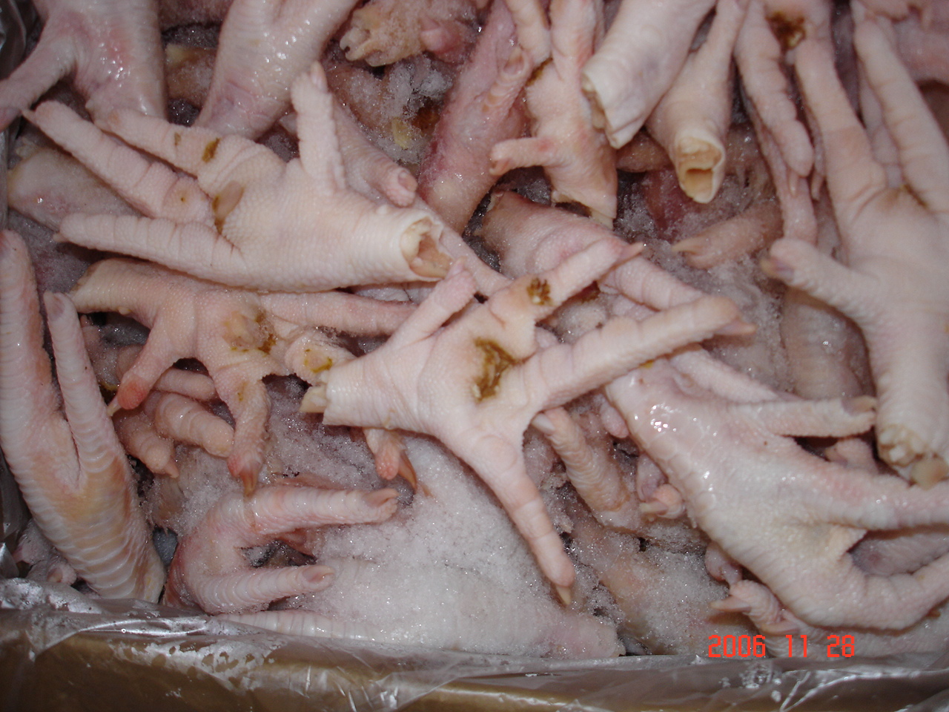
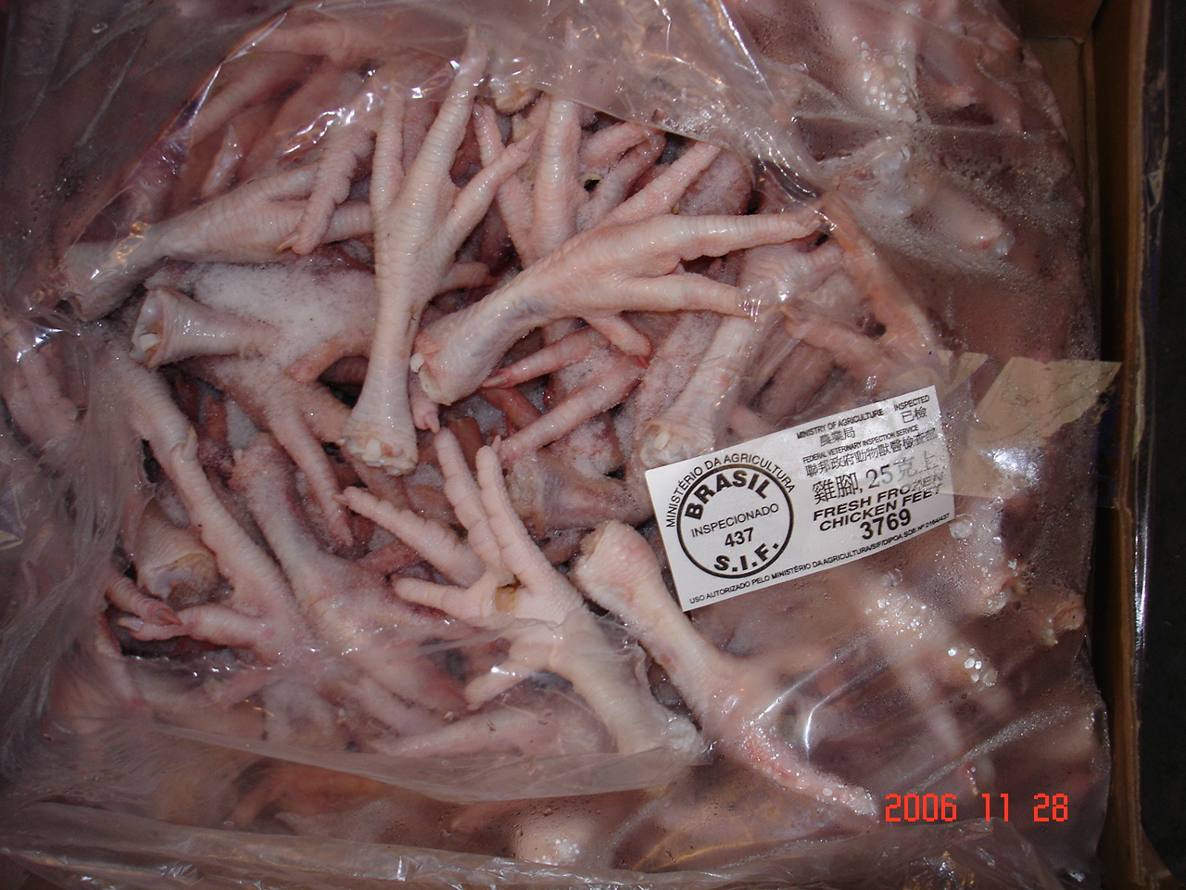

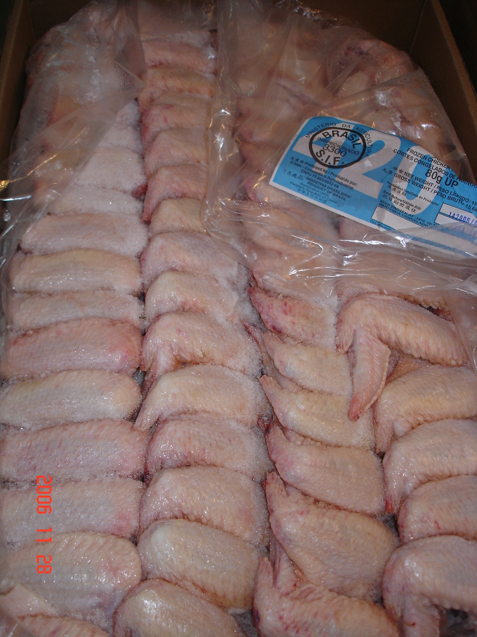
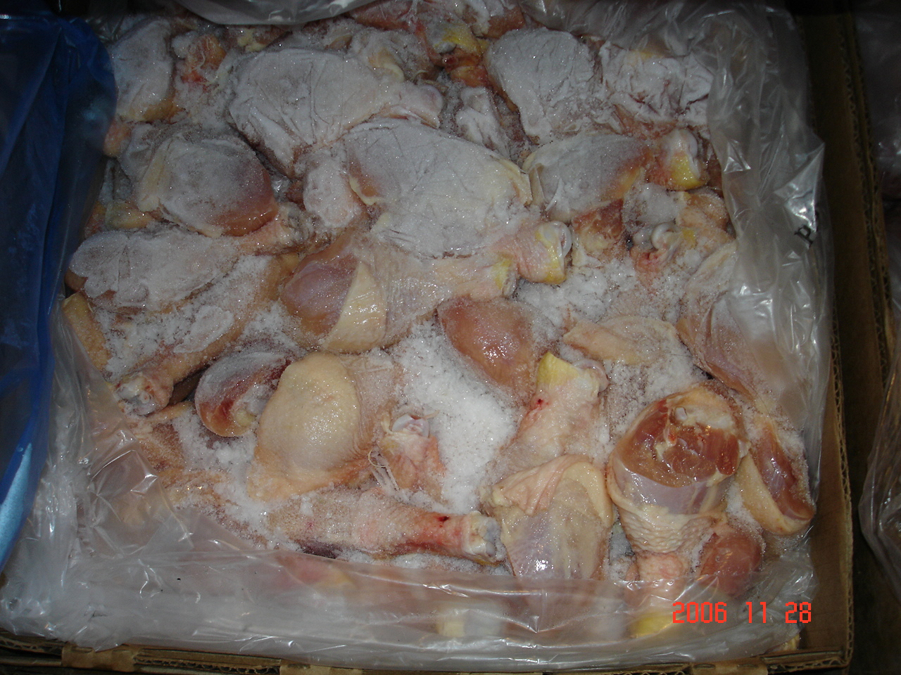

Traders look for high-quality paws which meet their specific requirements
Domestic traders prefer the following characteristics when purchasing paws:

Moisture: Moisture no greater than 8 percent, a maximum based on China’s national standard. The trade reports that U.S. paws often have higher moisture percentage compared with Brazilian products. U.S. plants utilize ice cooling after harvest, while Brazilian plants utilize air-cooling.

Size of paws: Large cities and wealthier consumers prefer U.S. jumbo-sized chicken paws because they contain more meat. Medium-sized Brazilian paws, typically 25 grams each, are well accepted by lower-income consumers.

Packaging: Domestic traders prefer Brazil’s packing by hand in smaller bags compared with U.S. layer packing by machinery in large bags. Smaller bags are easier and more convenient for supermarkets to use.

Prices: The paw market is an extremely price-driven market; both traders and consumers are price sensitive. Brazil and Argentine paws have cut into the U.S. market share because of their very competitive, lower pricing.

Color: Lighter color paws are preferred.

The following picture compares the larger U.S. paw packages (left) to the smaller packages that are typical of our competition (right).
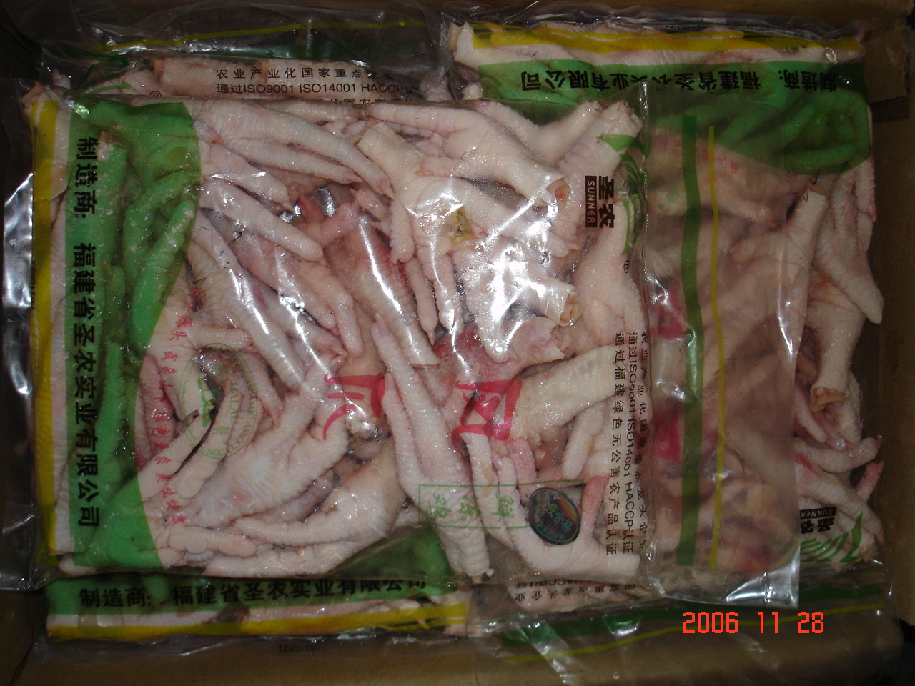
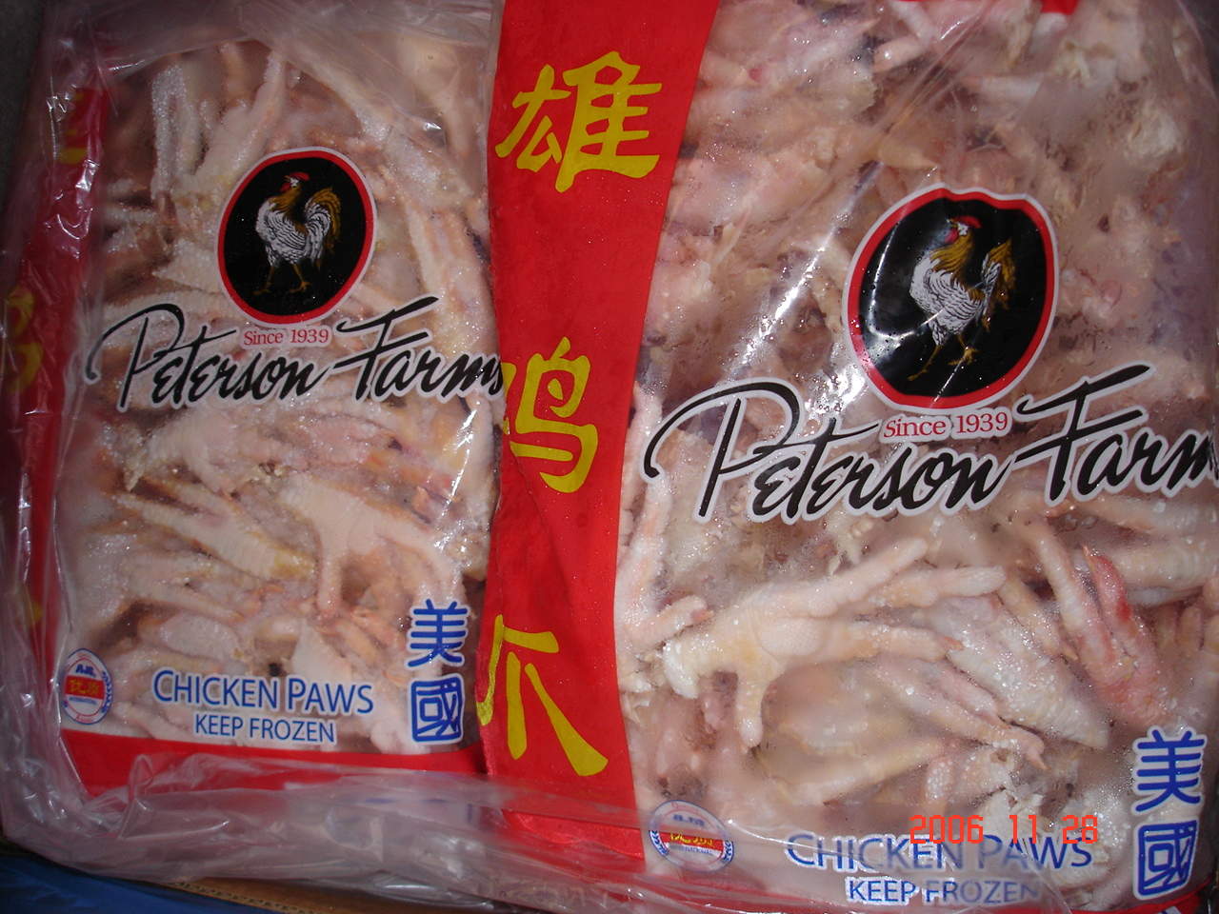

Implementation of grading system by competitors
In 2004, China signed meat quarantine protocols with processors in Argentina and Brazil to meet Chinese quarantine requirements. In addition, Brazil and Thailand’s certified system for grading feet and paws offers buyers more options in how to market their product. For example, grade “A” Brazilian feet are select product uniform in size, a heavy meat content and has specialized packaging. Grade “B” paws have lower quality and are smaller in size.

The lack of a grading system for U.S. chicken paws poses the question to buyers whether U.S. paws can compete with graded Brazilian paws. Some traders indicate that U.S. paws are sometimes packaged without any grading and contain paws of all different sizes and quality.

Market Outlook

Outlook and opportunities to expand U.S. paw sales in China
China’s domestic chicken paw supplies will lag overall demand for the foreseeable future, despite increases in domestic paw production. China imports over 300,000 MT of chicken paws annually, accounting for over half of China’s total poultry imports. This pattern will likely continue into the future as long as the supply and demand gap exists.

Although the U.S. is still the largest chicken paw supplier to China and total U.S. poultry product sales will exceed $200 million in 2006, many challenges threaten this position, including competition from Brazil and Argentina, stricter inspections at China's ports, FSIS's limited inspection mandate, and the cost of new "China" production lines at U.S. plants. Further, as more and more product moves through the Mainland ports and away from Hong Kong, U.S. product will be more carefully inspected to ensure China’s import requirements are met. According to the trade, increasing U.S. market share hinges on addressing these challenges, in addition to improving U.S. paw quality.

The poultry trade in China indicates that U.S. chicken paws can only increase market share against Brazil and Argentina by addressing quality concerns. Other factors include utilizing smaller packages for paws, reducing package moisture (especially ice), reducing product defects and implementing a more economical paw grading system. Continued industry investment in plant renovations in order to meet the FSIS inspection process will also facilitate trade and assure Chinese buyers the United States is a reliable supplier.

End of report.

