LA-UR-08-1808
Approved for public release;
distribution is unlimited.

Title:

Authors:

Intended for:

MCNPX 26F Extensions

John S. Hendricks
Gregg W. McKinney
Michael L. Fensin
Michael R. James
Russell C. Johns
Joe W. Durkee
Joshua P. Finch
Denise B. Pelowitz
Laurie S. Waters
M. William Johnson

Los Alamos National Laboratory

Franz X. Gallmeier
Oak Ridge National Laboratory

http://mcnpx.lanl.gov



Los Alamos National Laboratory, an affirmative action/equal opportunity employer, is operated by the Los Alamos National Security, LLC for the National Nuclear Security Administration of the U.S. Department of Energy under contract DE-AC52-06NA25396. By acceptance of this article, the publisher recognizes that the U.S. Government retains a nonexclusive, royalty-free license to publish or reproduce the published form of this contribution, or to allow others to do so, for U.S. Government purposes. Los Alamos National Laboratory requests that the publisher identify this article as work performed under the auspices of the U.S. Department of Energy. Los Alamos National Laboratory strongly supports academic freedom and a researcher’s right to publish; as an institution, however, the Laboratory does not endorse the viewpoint of a publication or guarantee its technical correctness.

MCNPX 26F Extensions

by

John S. Hendricks
Gregg W. McKinney
Michael L. Fensin
Michael R. James
Russell C. Johns
Joe W. Durkee
Joshua P. Finch
Denise B. Pelowitz
Laurie S. Waters
M. William Johnson
Los Alamos National Laboratory

Franz X. Gallmeier
Oak Ridge National Laboratory

March 24, 2008

Copyright 2008. Los Alamos National Security, LLC. All rights reserved.

This material was produced under U.S. Government contract DE-AC52-06NA25396 for Los Alamos National Laboratory, which is operated by Los Alamos National Security, LLC for the U.S. Department of Energy. The Government is granted for itself and others acting on its behalf a paid-up, nonexclusive, irrevocable worldwide license in this material to reproduce, prepare derivative works, and perform publicly and display publicly. Beginning five (5) years after (insert date permission to assert copyright was obtained), subject to additional five-year worldwide renewals, the Government is granted for itself and others acting on its behalf a paid-up, nonexclusive, irrevocable worldwide license in this material to reproduce, prepare derivative works, distribute copies to the public, perform publicly and display publicly, and to permit others to do so.
NEITHER THE UNITED STATES NOR THE UNITED STATES DEPARTMENT OF ENERGY, NOR LOS ALAMOS NATIONAL SECURITY, LLC, NOR ANY OF THEIR EMPLOYEES, MAKES ANY WARRANTY, EXPRESS OR IMPLIED, OR ASSUMES ANY LEGAL LIABILITY OR RESPONSIBILITY FOR THE ACCURACY, COMPLETENESS, OR USEFULNESS OF ANY INFORMATION, APPARATUS, PRODUCT, OR PROCESS DISCLOSED, OR REPRESENTS THAT ITS USE WOULD NOT INFRINGE PRIVATELY OWNED RIGHTS.

CONTENTS

1.0. Introduction 1
1.1. Summary of New MCNPX Features 1
1.2. Availability 2
1.3. Documentation 3
1.4. Cash Awards Quality Assurance Program 3
2.0. Description of new MCNPX Features 4
2.1. Depletion/Burnup 4
2.1.1. Depletion Process 5
2.1.2. CINDER90 approach to temporal nuclide inventory calculations 5
2.1.3. Collision Density Generation 6
2.1.4. The Cross-Section Averaging for Depletion Acceleration Method (CSADA) 7
2.1.5. BURN Card Setup 8
2.1.6. Burn Time, Total System Power, and Power Fraction 10
2.1.7. Flux Normalization Parameters 11
2.1.8. Burn Materials 12
2.1.9. Automatic Fission Yield Selection Process 14
2.1.10. Metric Tonnes of Uranium (MTU) 14
2.1.11. Isotope Reactivity Options 15
2.1.12. Models Option 15
2.1.13. Fission Product Tracking/Output Frequency 15
2.1.14. The Isotope Generator Algorithm 17
2.1.15. Proper Tracking of Entire Decay Chains 18
2.1.16. Burnup/depletion with repeated structures 19
2.1.17. Time Dependent Concentration Changes: MATMOD keyword 19
2.1.18. Metastable Isotope Representation 20
2.1.19. Examples 21
2.2. Heavy Ion Transport 23
2.2.1. Input 23
2.2.2. Tallies 24
2.2.3. Other Input 24
2.2.4. Variance Reduction. 25
2.2.5. Changes to PRINT Tables. 25
2.2.6. Limitations 26
2.3. LAQGSM Physics. 26
2.4. CEM03 Upgrade 27
2.4.1. Intra Nuclear Cascade (INC) 28
2.4.2. Preequilibrium (PREC) 28
2.4.3. Evaporation and/or Fission 29
2.4.4. Coalescence 29
2.4.5. Fermi Breakup 29
2.4.6. Additional Notes 29
2.5. Long File Names 29
2.6. Terminate Tallies at Desired Precision 30
2.7. Spherical Mesh Weight Windows 31
2.7.1. User Interface 31
2.7.2. Plotting 32
2.8. Energy-Time Weight Windows 35
2.8.1. Cell-Based Example 36
2.8.2. Mesh-Based Example and WWOUT File Changes 36
2.9. Charged Ions from Neutron Capture in Table Range 37
2.9.1. User Interface 37
2.9.2. Diagnostics 38
2.9.3. Important Considerations 38
2.10. Delayed-Gamma Emission. 39
2.10.1. The Products of Fission: Residual Nuclides and Radiation 40
2.10.2. Decay Chains and Emission Sampling 41
2.10.3. Simple Multi-Particle Reactions 42
2.10.4. User Interface 43
2.10.5. Sampling and Execution 44
2.10.6. Fission Yield Data 45
2.11. Criticality Source Convergence Acceleration 45
2.11.1. Example 45
2.11.2. User Interface 47
3.0. MCNPX Feature EXTENSIONS and Enhancements 48
3.1. Proton Step-Size Control 48
3.2. New Photon Emission Data 49
3.3. New S(α,β) Scattering Law 49
3.4. Differential Data Tallies Extended to Table Physics 49
3.5. Neutron models produce light (A<4) nuclei < 100 MeV 50
3.6. Weight-Window Upper Bounds Limiter 50
3.7. Separate Printout of Induced Fission Multiplicity 50
3.8. Weight-Window MESH Angles in Radians and Degrees 51
3.9. Interrupts in Electron Tracking 51
3.10. Extended ZAID Identifiers 51
3.11. LINLIN Contour Plot Default 51
3.12. Weight-Window Contour Plot Improvement 52
3.13. Allow Deleted Segmenting Surfaces 52
3.14. Improved Windows Installation 52
3.15. Spherical GRIDCONV 53
3.16. Spherical Mesh Tally Plots 54
3.17. Delayed-Gamma Enhancements 54
3.18. Photofission Yield Data 55
3.19. Decay Omitted from LCA NOACT=-2 Option 55
3.20. Piping PTRAC Results 55
3.21. Muon Capture Secondary Particle Production 55
3.22. Additional Enhancements 56
3.22.1. ILOG interpolation 56
3.22.2. MODE J R 57
3.22.3. Photofission prompt gamma warning 57
3.22.4. NNDC Delayed-Neutron Emission Probabilities 57
4.0. MCNPX Corrections 57
4.1. Significant Problem Corrections 57
4.1.1. Auger Electrons Below Energy Cutoff 57
4.1.2. Detectors in Lattice Geometries 57
4.1.3. KCODE/PRDMP 5th Entry 57
4.1.4. CEM03 Corrections 58
4.1.5. SDEF Fails with SP -31 x for Equiprobable Bins Sampling 58
4.1.6. Surface Sources in Repeated Structures 58
4.1.7. Periodic Boundary Conditions in Repeated Structures 58
4.1.8. Delayed Neutrons/Gammas with Biased Photonuclear 58
4.1.9. Delayed Neutrons/Gammas Inelastic Scatter 58
4.1.10. Delayed Neutrons/Gammas from (n,p) Reactions 58
4.1.11. Delayed Neutrons/Gammas with Biased Photonuclear 59
4.1.12. Parallel Burnup/Depletion Calculations with Model Cross Sections 59
4.1.13. Surface Sources in Repeated Structures 59
4.1.14. No Fatal Error for LAT without FILL 59
4.1.15. Double Fluorescence with Pulse Height Tallies and WWP or ESPLT 59
4.1.16. Burnup of 1000 or More Materials without MAT Keyword 59
4.1.17. Power Fraction Calculation for Burnup 59
4.1.18. DATAPATH Sometimes Chosen Incorrectly 59
4.1.19. SSW s(-c) Can Fail with Repeated Structures 60
4.1.20. F6 Heating Tallies Wrong for Photonuclear 61
4.1.21. Heavy Ion Directions 61
4.1.22. Photonuclear Mix and Match 61
4.1.23. Mesh Tally Gaps 61
4.2. Minor Problem Corrections 62
4.2.1. Cylindrical Weight-Window Mesh 62
4.2.2. I8 Mesh Tally Plots 62
4.2.3. Continue Cards for Input with FATAL Errors 62
4.2.4. Sometimes Can Plot Only First Mesh Tally 62
4.2.5. Incorrect KCODE/Message Passing Interface (MPI) Error Message 62
4.2.6. Incorrect LCS Error Message 62
4.2.7. Mesh Tally Writing to Backup RUNTPE 62
4.2.8. Pulse-Height-Tally Variance Reduction Techniques with MPI 63
4.2.9. PTRAC and Event Log Omission 63
4.2.10. FM Tally Multiplier in Model Physics Regime 63
4.2.11. Make Clean Enabled for PC Build 63
4.2.12. Zero Electron Mesh Tallies 63
4.2.13. Universe Map 63
4.2.14. Tally Storages 63
4.2.15. Lost Particles with Coincident REC Surfaces 64
4.2.16. GRIDCONV Compiler Bug 64
4.2.17. Geometry Plot Basis Vectors 64
4.2.18. WWN Label Error 64
4.2.19. READ Card Placements 64
4.2.20. Residual Nucleus Warning 64
4.2.21. S(α,β) Ultra-Low Energies 64
4.2.22. Large Problem Sizes for Parallel Execution 65
4.2.23. Mesh Tally TR Option 65
4.2.24. Crash for non-orthogonal spherical mesh direction cosines 65
4.2.25. Mesh Tallies Keyword Capitalization 65
4.2.26. Mesh Tallies Data Interpolation 65
4.2.27. Power Fraction Calculation for Individual Burn Materials 66
4.2.28. Negative MAT Numbers on the BURN card 66
4.2.29. Print LAQGSM Flag 66
4.2.30. Internal Corrections 66
5.0. Future work 67

MCNPX 26F Extensions

ABSTRACT

MCNPX is a Fortran90 Monte Carlo radiation transport computer code that transports nearly all particles at nearly all energies for nearly all applications. The new capabilities of the latest version, MCNPX 26F, beyond those in MCNPX 2.5.0, are described.

Introduction
MCNPX (MCNP eXtended) is a Fortran90 (F90) Monte Carlo radiation transport computer code that transports nearly all particles at nearly all energies. It is a superset of MCNP4C3 and has many capabilities beyond MCNP4C3. MCNPX is a production computer code that models the interaction of radiation with matter. Its quality is highly regarded and cash awards (described in Section 1.4) are offered for bugs.

Summary of New MCNPX Features
The new capabilities and enhancements of MCNPX 26F beyond MCNPX 2.5.0 are listed below. (Where applicable, the initials of the principal developers are shown in parentheses.) Note that the delayed-gamma emission and criticality source convergence acceleration capabilities are developmental. They are not backed by the MCNPX cash awards quality assurance program and must be used cautiously. However, these capabilities are considered of such significance that they are included. Note also that total ν (not prompt ν) is the default for fission neutrons. The new MCNPX 26F beyond MCNPX 2.5.0 capabilities include the following:
- Depletion/burnup(MLF);
- Heavy-ion (Z>2) transport (MRJ + LSW/GWM/JSH);
- LAQGSM physics model (MRJ);
- CEM03 physics;
- Long file names (JSH);
- Delayed-gamma emission (JWD);
- Criticality source convergence acceleration (JPF);
- Energy-time weight windows (JSH);
- Spherical mesh weight windows (JSH);
- Charged ions from neutron capture in table range (MRJ);
- Tallies terminated at desired precision: STOP card (JSH);
- Corrections/enhancements/extensions:
  - Weight-window MESH angles in radians and degrees (JSH);
  - Piping PTRAK results (RCJ);
  - Photofission yield data (JWD);
  - Decay omitted from LCA NOACT=-2 option (GWM);
  - Pulse-height tally variance reduction fix for double fluorescence (JSH);
  - Weight-window contour plot improvement (GWM);
  - Improved windows installation (MRJ/GWM);
  - Spherical GRIDCONV (MRJ);
  - Spherical mesh tally plots (GWM);
  - Proton step size control: HSTEP on M card (GWM);
  - New photon emission data: PHTLIB (REP/GWM);
  - New S(α,β) scattering law (REM/GWM/JSH);
  - Muon capture secondary particle production (GWM/RCJ/MRJ/MWJ);
  - Differential data tallies extended to table physics (GWM);
  - Separate printout/calculation of induced fission multiplicity (JSH);
  - Interrupts in electron tracking (GWM);
  - Extend ZAID identifiers (GWM);
  - LINLIN contour plot defaults (GWM);
  - Allow deleted segmenting surfaces (FXG);
  - Weight-window upper bounds limiter (GWM/JSH);
  - F6 heating fix for photonuclear problems (JSH);
  - Neutron models produce light (A<4) nuclei <100 MeV (REP/GWM);
  - Additional enhancements and corrections.

Availability
The latest general-release version of MCNPX is MCNPX 2.5.0, which is available from the Radiation Safety Information Computational Center (RSICC) and the Office of Economic Cooperation and Development/Nuclear Energy Agency (OECD/NEA) in Paris, France.

For approved users, beta test program versions, including MCNPX 26E, may be downloaded from the MCNPX website. Approximately 1800 MCNPX beta test users are an essential part of the MCNPX software quality assurance program. To become a new beta test user usually requires being an MCNPX sponsor, collaborator, or participant in an MCNPX workshop training course. For more information, contact us at the following email address: mcnpx@lanl.gov.

MCNPX is U.S. export controlled. Generally, MCNPX is easy to obtain for legitimate purposes, but restrictions protect the code, data, and documentation once it is acquired.

Documentation
Restricted Documentation:

Complete MCNPX documentation is available in the “MCNPX™ User’s Manual,” which comes with MCNPX from RSICC or OECD/NEA and is available to MCNPX beta testers from the Worldwide Web (WWW).

Unrestricted Documentation:

Documentation of MCNPX features in MCNPX 2.5.0—that is, all MCNPX features beyond MCNPX 2.3.0 and MCNP4C—is provided in “MCNPX Extensions, Version 2.5.0.”

MCNPX capabilities developed since the previous RSICC or OECD/NEA international release version, MCNPX 2.5.0 (namely, the additional capabilities of MCNPX 26F), are documented in this report.

All of the extended MCNPX capabilities are summarized in the one-page MCNPX features list.

Cash Awards Quality Assurance Program
We are so confident in the quality of MCNPX that John Hendricks offers cash awards to the first person who finds any bug in the code. He will pay $20 to the first person finding anything that does not meet or exceed the capabilities of MCNPX 2.3.0 and MCNP4C3. European users will be awarded €20. He also will pay a brand new $2 bill for any error in MCNPX that has been inherited from its constituent codes. A list of all winners since June 2001 can be found on the MCNPX WWW site.

Description of new MCNPX Features
Total ν (not prompt ν) is now the default for fission neutrons. To track previous problems with the prompt ν default, turn off total ν with the TOTNU NO card and command.

Note that the new delayed-gamma emission and criticality source convergence acceleration capabilities are developmental. These capabilities are not backed by the MCNPX cash awards program and must be used cautiously. Nevertheless, they are considered of such significance that they are included.

The principal new capabilities of MCNPX beyond MCNPX 2.5.0 described in detail in this section are

- Depletion/burnup,
- Heavy-ion transport,
- LAQGSM physics model,
- CEM03 physics,
- Long file names,
- Tallies terminated at desired precision: STOP card,
- Spherical mesh weight windows,
- Energy-time weight windows,
- Charged ions from neutron capture in table range,
- Delayed-gamma emission, and
- Criticality source convergence acceleration.

Depletion/Burnup
The depletion/burnup capability is based on CINDER90, which was written by William B. Wilson, and MonteBurns, which was written by Holly R. Trellue. The initial patch to MCNPX was developed by Joe W. Durkee and Gregg W. McKinney. Most of the corrections and enhancements to MCNPX 26A, 26B, 26C, 26D, and 26E were developed by Michael L. Fensin and integrated by John S. Hendricks.,, Currently, the depletion/burnup/transmutation capability is limited to criticality (KCODE) problems.

The new MCNPX 2.6.F capabilities are
- The second entry on the AFMIN keyword is now used to set decay chain tracking criteria in CINDER90. Note that “AFMIN 1.E-10 1.E-4 ” on the BURN card will restore tracking and run CINDER much faster than the current default value:
AFMIN 1.E-10 1.E-10
However, transport of histories, not CINDER, is what slows most problems and the new default value of 1.E-10 is much more accurate.
- Atom and mass fractions specified in the output are now the atom and mass fractions of each isotope for the entire burn material instead of the atom and mass fraction contributions to the actinide and nonactinide portions of the material.

    - Depletion Process
MCNPX depletion is a linked process involving steady-state flux calculations in MCNPX and nuclide depletion calculations in CINDER90. MCNPX runs a steady-state calculation to determine the system eigenvalue, 63-group fluxes, energy-integrated reaction rates, fission multiplicity (ν), and recoverable energy per fission (Q values). CINDER90 then takes those MCNPX-generated values and performs the depletion calculation to generate new number densities for the next time step. MCNPX takes these new number densities and generates another set of fluxes and reaction rates. The process repeats itself until after the final time step specified by the user.

MCNPX calculates parameters only for those materials listed on the MCNPX material cards, produced by the isotope generator algorithm, or selected by the specified fission-product tier. When the information is not specified from MCNPX, CINDER90 tracks the time-dependent reactions of 3400 isotopes using intrinsic cross-section and decay data inherent in the CINDER90 code. MCNPX is only capable of tracking energy-integrated reaction-rate information for those isotopes containing transport cross sections. For those isotopes not containing transport cross-section information, MCNPX calculates a 63-group flux that is sent to CINDER90 and matched with a 63-group cross-section set inherent in CINDER90 to generate 63-group reaction rates. Those reaction rates are then energy integrated to determine the total reactions occurring.

For MCNPX to burn materials properly, the user must point to the CINDER.dat library file. This file contains decay, fission yield, and 63-group cross-section data not calculated by MCNPX. The CINDER.dat library file will be accessed properly by the code if the file is placed in the working directory in which the user is executing MCNPX or in a directory in which the command window PATH is set to the directory where CINDER.dat resides. If MCNPX cannot find the CINDER.dat, a fatal-error message will be printed and the case will cease calculation.

    - CINDER90 approach to temporal nuclide inventory calculations
CINDER90 utilizes decay and energy integrated reaction-rate probabilities along with fission yield information to calculate the temporal nuclide buildup and depletion. The library of data in CINDER90, residing in the CINDER.dat library file, includes isotope decay and interaction probability data for 3400 isotopes including, ~30 fission yield sets, and yield data for 1325 fission products.

The depletion equation for a specified isotope is
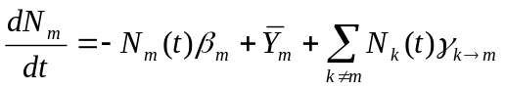 , where
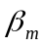 = the total transmutation probability of isotope m
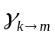 = the probability of isotope k transmuting, by either decay or absorption, into isotope m,
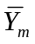 = the production rate, and
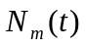 = the time-dependent atom density of isotope m.

This equation is nonlinear because the transmutation probabilities rely on the time-integrated flux, which is also dependent upon time-dependent number densities. To linearize the process, the transmutation probabilities are set to a constant value over the time step. The set of differential equations utilized to solve for temporal nuclide buildup/depletion of a system of isotopes is coupled since each equation contains time-dependent isotope density information from other nuclides. Instead of trying to solve the large sparse matrix of equations using the matrix exponential method, the set of coupled equations in CINDER90 is reduced to a set of linear differential equations using the Markov method. Linear chains are created for each isotope transmutation path, starting from initial specified isotope concentrations, generating the following equations:
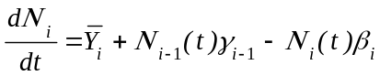 ,
where quantities are now indexed by the order in which they appear within a given sequence and 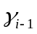 is the transmutation probability of forming nuclide element 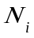. The solutions of each linear chain determines a partial nuclide density, , and is computed by the following equation
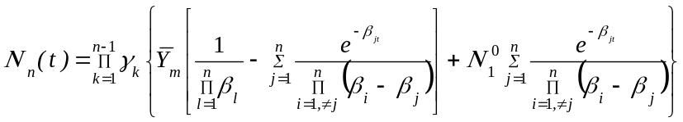 .
Each calculated partial nuclide density, , computed from a linear chain, is then summed to obtain the total nuclide inventory of nuclide 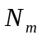. The differential equation governing the computation of 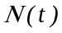 is therefore only coupled to any preceding elements in the sequence leading to the i^{th} element.

The test for significance in CINDER90 involves calculating the passby quantity, 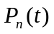. The passby of a nuclide is the time-integrated transmutation of that nuclide for a specified time interval:
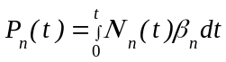 .
The passby therefore may be thought of as possible progeny of nuclides generated from a specific isotope.

    - Collision Density Generation
MCNPX calculates continuous energy-integrated reaction rates for all isotopes containing transport cross-section information, for the following reaction rates: (n,gamma), (n,f), (n,2n), (n,3n), (n,alpha) and (n,proton). CINDER90 must use the MCNPX-calculated 63-group fluxes to determine the rest of the interaction rates that accumulate in the transmutation process, as well as determine reaction-rate information for isotopes not containing cross-section information.

For example, MCNPX currently does not calculate the continuous (n,beta) reaction rates. CINDER90 must take the 63-group flux calculated by MCNPX and multiply its inherent 63-group (n,beta) cross section to determine the amount of (n,beta) reactions in the system. Furthermore, many nuclides may be created during the transmutation process that do not possess transport information in MCNPX for particle tracking. For these isotopes, a 63-group flux calculated in MCNPX will be matched to a 63-group cross-section set in CINDER90 to determine reaction-rate information. The energy group structure used for the 63-group set may be found at the top of the CINDER.dat file. The 63-group cross sections in CINDER90 were collapsed over a generic spectrum that may or may not be representative of the system to be analyzed and thus may lead to large discrepancies in the isotope inventory of daughter products from these reactions.

The energy integrated total collision rates calculated in MCNPX for use in the CINDER90 code for depletion are printed at the end of each KCODE cycle. The units of these reaction rates in MCNPX 2.6.D are [collisions/second] (in MCNPX 2.6.C the units of these reactions were collisions/(atom-second)]). Reaction rates are printed only for those isotopes also used in the transport calculation. The calculated relative errors of these reaction rates correspond only to the current cycle calculation and are not the propagated errors of the reaction rates over the entire depletion calculation.

    - The Cross-Section Averaging for Depletion Acceleration Method (CSADA)
The depletion equations use fluxes, nuclide number densities, and cross sections to determine the time-dependent nuclide inventory. The simplified one-group consumption equation, without decay, is

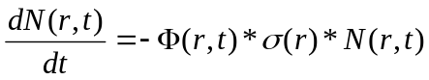 .

The corresponding solution for nuclide density is

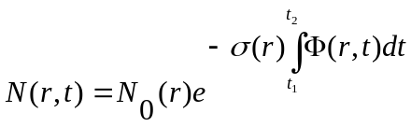 .

Therefore, the change in nuclide concentration is dependent on the time-integrated flux. Unfortunately, the time-dependent flux (integrated to get the time-integrated flux) also is dependent on the nuclide density, which makes the above equation nonlinear. To make the above equation linear, an assumption must be made about the time-dependent flux. MCNPX currently assumes that the flux is constant throughout the burn step:

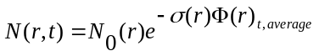 .

This approximation is true only if the average flux used in the calculation is the “true average” flux over the burn step, and the spectral change over the time step is linear.

MCNPX makes an approximation of the average flux behavior by using the CSADA technique. This technique involves the following multistep process:

- A burnup calculation is completed in CINDER90 to the half time step [t(i)→t(i+1/2)] (Predictor Step).

- Fluxes and collision densities are recalculated in a steady-state MCNPX calculation at the half-time step.

- The recalculated fluxes and collision densities then are used to burn over the full time step [t(i)→t(i+1)] (Corrector Step).

The fluxes and collision densities recalculated at the half time step are assumed to be the average fluxes and collision densities encountered during the entire time step. This approximation is true only if the flux shape change between the two time steps varies linearly; this technique is usually an acceptable approximation. Implementing this technique allows the user to burn a system using fewer burn steps than if no approximation were made on the average flux behavior.

However, even with this approximation, burning with large time steps that encounter large flux-shape changes during the time step will lead to inaccurate calculations. Therefore, the user must use time steps that are small enough to capture the flux-shape change accurately over time.

    - BURN Card Setup
The following example explains the setup for a BURN card.

BURN TIME=T₁,T₂,T₃,...
PFRAC=F₁,F₂,F₃,...
POWER=P
MAT=±M₁,±M₂,±M₃,...
OMIT=J₁,N₁,I₁₁,I₁₂,...,J₂,N₂,I₂₁,I₂₂,...
AFMIN=A1 A2
MATVOL= V₁, V₂, V₃, ..., V_{n}
MATMOD= ...
BOPT=B1,B2,B3,B4 ,

where

T_{i} = duration of burn step i (days). Default is one time step of one day.

F_{i} = power fraction of each time step. The default for this parameter is to assume F_{i} = 1.0 for each time step if a PFRAC keyword is not specified at all.

P = power level (MW). Default is 1.0 MW.

M_{i} = list of material numbers to include in the burn. The default for this parameter is to burn all materials. If a MAT number is negative, recoverable energy per fission and neutrons per fission (flux normalization parameters) are tallied, however, the material is not burned. A fatal error results if every MAT number is negative.

J_{i} = i^{th} material for which to omit nuclides I_{i1}, I_{i2}, etc. Currently, there is no default for this parameter.

N_{i}= number of omitted nuclides listed for the i^{th} material. Currently, there is no default for this parameter.

I_{i1}, I_{i2}, ... = 1st, 2nd, etc. omitted nuclides for the i^{th} material. Currently, there is no default for this parameter.

A1 = atom fraction minimum below which the atom fraction is set to zero. Default is 1.0e-10.

A2 = Depletion chain convergence criteria in CINDER90.Default value is 1e-10. Setting this value to a higher number (i.e. 1e-4 instead of 1e-10) causes CINDER90 to run faster with poorer accuracy in decay chain tracking.

V_{i} = Total volume of all cells [cm³] containing burn material, M_{i}, on the MAT keyword of the BURN card

B1 = Q value multiplier. Default is 1.0.

B2 = burn table output frequency, ordering, and content flag.
Input Value Output Inventory Ordering
1 High to low, based on mass (Default)
2 High to low, based on activity
3 High to low, based on specific activity
4 Increasing zaid

Positive input values cause output to be printed only at the end of the entire job. Negative input values cause output to be printed at the end of each burn step. Three tiers of fission-product content are available. To specify the content, add zero (default), 10, or 20 to the magnitude of the B2 input value.

TIER Fission-product content.
1 Zr-93, Mo-95, Tc-99m, Ru-101, Xe-131, Xe-134,
Cs-133, Cs-137, Ba-138, Pr-141, Nd-143, Nd-145. (Default)
2 All incident neutron cross sections contained in the Fp array included in
the current (v. 2.5.0) XSDIR.
3 All isotopes contained in the Fp array.

B3 = Models option
-1 Fatal error if models are used in the problem.
0 Zeros out the atom fraction of any data using a model. It is preferable to determine which isotopes are needed to be zeroed out and place them on the omit keyword for the burned material; however, this option exists as a simpler alternative to the omit keyword.
1 Runs with models.

A blank BURN card will run a case for 1 day, at 1 MW, with a corresponding PFRAC=1.0, burning all materials, using the TIER 1 fission products, and listing the nuclide output in high-to-low mass (as long as the isotope generator algorithm does not generate a nuclide in which there exists no transport cross sections in the XSDIR, which ultimately would lead to a fatal error).

    - Burn Time, Total System Power, and Power Fraction
The TIME keyword corresponds to the incremental time duration for each depletion step. Each “T_{i}” listed in this keyword corresponds to a time duration (days) in which the system is burned.

For example:

TIME = 10, 100, 15 .

The system is first burned for 10 days, followed by a 100-day burn, followed by a 15-day burn, for a total burn of 125 days.

The POWER keyword is the total system power level (in megawatts). Because this value corresponds to the total recoverable energy from the system, the value entered on this keyword should correspond to the total recoverable thermal system power.

For example:

POWER = 100 .

In this case, the total recoverable thermal system power is assumed to be 100 MW.

The PFRAC keyword corresponds to the fractional value of total system power (POWER) in which to burn the system for the equivalent time duration. The PFRAC option only changes the total magnitude of power used to normalize the flux, and does not account for possible temperature changes in an actual power change. For each T_{i} value listed on the TIME keyword, a corresponding F_{i} value listed on the PFRAC keyword must exist. For each T_{i} value that does not contain a corresponding F_{i} value, F_{i}=0 for that time step. The exception is when the PFRAC keyword is not specified at all, and then each F_{i}=1 for every time step.

If F_{i}=0 for a time step, then the following will occur:

- A reaction-rate calculation is completed at the beginning of the step
- A decay from T_{i} to T_{i+1} is completed without a CSADA calculation
- If it is determined that both T_{i} to T_{i+1} have both F_{i}=0 to F_{i+1}=0 then a reaction-rate calculation is only competed at T_{i}, and at T_{i+1} an eigenvalue calculation is completed without tallies

For example:

TIME = 11, 33, 22, 44, 45
PFRAC = 1.0, 0, 0, 0.9, 1.2
POWER = 10

For the first 11 days of system life, the system is burned at 1.0*10 MWth of the total system power at 10 MWth. For the next 33 days, the system is only decayed and the power is set to 0 MWth. A reaction-rate calculation is completed for the 11th day; however, these reaction rates do not affect the burnup and are used to determine system parameters at the 11th day. An eigenvalue calculation without reaction-rate tallying is completed at the 44th day. For the next 22 days, the system is only decayed and the power is set to 0 MWth. For the next 44 days of system life, the system is burned at 0.9*10 MWth of the total system power at 9 MWth. For the final 45 days of system life, the system is burned at 1.2*10 MWth of total system power at 12 MWth.

    - Flux Normalization Parameters
MCNPX generates collision densities for the CINDER90 depletion calculation. These generated collision densities are normalized per source neutron. CINDER90 requires a total flux to deplete the system properly The following flux multiplier transforms the MCNPX normalized flux into a total flux for the CINDER90 depletion calculation:

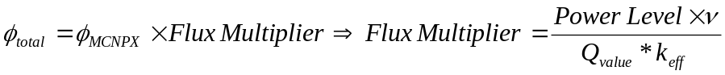 .

MCNPX calculates the system-averaged ν and Q value. The power level used for the flux multiplier calculation is the power entered on the POWER keyword. The Q value used in the calculation is an estimate of the recoverable energy per fission event. Currently, MCNPX takes the prompt recoverable energy per fission (Q-prompt) and multiplies that value by the constant normalization factor 1.111 that was calculated by dividing 200 MeV by the prompt fission energy release of U-235. The constant normalization factor 1.111 is an estimate of the delayed fission energy contribution and capture-gamma energy contribution.

The capture-gamma energy contribution is highly dependent upon system geometry and therefore the normalization constant may or may not estimate the actual Q value properly. Underestimating the Q value leads to an overestimation of the system fluxes and thus, an overestimation of the system collision densities. Because the equation for nuclide depletion,

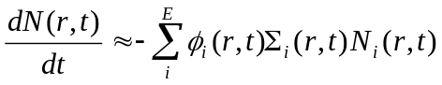 ,

is highly dependent on the collision densities, increasing the collision density leads to an overestimation of the material burnup. In the current depletion capability, three methods are used to correct this overestimation:

1. Adjusting the Q value multiplier (B1 value on the BOPT keyword; default = 1.0),
2. Modifying the total thermal system recoverable energy by adjusting the power level entered on the POWER keyword, and
3. Altering the system power on the PFRAC keyword.

    - Burn Materials
The materials to be burned must be listed on the MAT keyword. Each “M_{i}” entry corresponds to the material number listed in data cards section of the input deck.

For example:

BURN TIME=100,70
MAT=1,3,4
POWER=1.0
PFRAC=1.0,1.0
BOPT=1.0 -12 1.0
C Material Cards
m1
8016.60c 4.5854e-2
92235.60c 1.4456e-4
92238.60c 1.9939e-2
94238.60c 1.1467e-4
94239.60c 1.0285e-3
94240.60c 7.9657e-4
94241.60c 3.3997e-4
94242.60c 5.6388e-4
m2 2004 -1.0
m3 40000.60c -1.0
m4 1001.60c 4.7716e-2
8016.60c 2.3858e-2
5010.60c 3.6346e-6
5011.60c 1.6226e-5
mt4 lwtr.01t

In this example, materials m1, m3, and m4 will be burned.

Burnup is calculated for the entire system of materials listed on the MAT keyword, as well as for each individual material listed on the MAT keyword containing a fissile actinide.

NOTE: For negative material numbers, the recoverable energy per fission and neutrons per fission tallied are then utilized in the power normalization and the calculation of fission power fractions. Actinide and non-actinide buildup/depletion information for negative MAT numbers is not displayed in the output file because the negative MAT numbered materials are not burned. The global system burnup displayed in print table 210 is nonphysical when using negative MAT numbers, however, the individual material burnup listed in the INDIVDUAL MATERIAL BURNUP section is the expected burnup of the rest of the materials in the system.

The total system burnup, as well as other important time-dependent parameters, is listed on the burn table.

For example:

neutronics and burnup data

step duration time power keff flux ave. nu ave. q burnup Source
(days) (days) (MW) (GWd/MTU) (nts/sec)
0 0.000E+00 0.000E+00 1.000E+00 1.15793 4.428E+15 2.878 209.106 0.000E+00 8.591E+00
1 1.000E+02 1.000E+02 1.000E+00 1.00865 5.157E+15 2.900 209.094 5.892E+01 8.658E+00
2 7.000E+01 1.700E+02 1.000E+00 0.98152 5.465E+15 2.920 208.965 1.002E+02 8.722E+00

For each individual material, another burn table is created that lists the fraction of fission power created by that specific material, as well as the individual burnup of that material. The power fraction is calculated for an individual material using the following methodology:

- Determine if the material contains an actinide.
- If yes, sum the continuous energy fission energy created to obtain individual burn material fission energy.
- Sum all of the total material fission energy contributions for each material that contains an actinide.
- Calculate the power fraction as

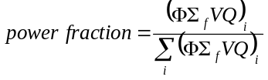 .

The burnup for each individual material then is calculated using

.

[MTU = MTHM (metric tonnes of heavy metal) and is explained further in the section on Metric Tonnes.]

For example (corresponding to the BURN and material cards listed above):

Individual Material Burnup

Material #: 1

step duration time power fraction burnup
(days) (days) (GWd/MTU)
0 0.000E+00 0.000E+00 1.000E+00 0.000E+00
1 1.000E+02 1.000E+02 1.000E+00 5.892E+01
2 7.000E+01 1.700E+02 1.000E+00 1.002E+02

Material #: 3

step duration time power fraction burnup
(days) (days) (GWd/MTU)
0 0.000E+00 0.000E+00 0.000E+00 0.000E+00
1 1.000E+02 1.000E+02 0.000E+00 0.000E+00
2 7.000E+01 1.700E+02 0.000E+00 0.000E+00

Material #: 4

step duration time power fraction burnup
(days) (days) (GWd/MTU)
0 0.000E+00 0.000E+00 0.000E+00 0.000E+00
1 1.000E+02 1.000E+02 0.000E+00 0.000E+00
2 7.000E+01 1.700E+02 0.000E+00 0.000E+00
…

In this example, materials 1, 3, and 4 were burned, and only material 1 contained fissionable actinides. The stated power fraction for material 1 is 1.000E+00 because material 1 supplied all of the fission power to the system.

    - Automatic Fission Yield Selection Process
The CINDER90 code offers a thermal, fast, high-energy fission yield for each fissile isotope contained in the CINDER.dat library file. The proper fission yield to be used for a specified problem is dependent on the impinging neutron energy at the interaction site. Because CINDER90 is a deterministic code that uses one-group constants and does not account for multi-energy behavior, knowledge of the neutron spectrum must be imported from the steady-state continuous energy calculation.

MCNPX determines which fission yield to use for a specified problem by calculating the integral fission rate for the defined energy boundaries (thermal, fast, and high energy), determining which energy range contains the majority of fissions, and then selecting the appropriate fission yield corresponding to the energy range containing the majority of fissions at each time step.

This calculation is completed separately for each burn material. Therefore, if a specific calculation warrants a thermal fission yield for one burn material and a fast fission yield for another burn material, MCNPX will be able to implement a thermal fission yield for the burn material experiencing a thermal spectrum and a fast fission yield for the burn material experiencing a fast spectrum. The process is automatic; thus, users do not have to worry about selecting an appropriate fission yield that best represents their system because MCNPX will determine the correct fission yield automatically.

    - Metric Tonnes of Uranium (MTU)
MCNPX lists burnup in units of GWD/MTU. The MTU term calculated in MCNPX is actually the sum of the masses of isotopes containing >90 protons. Therefore, thorium and plutonium contribute to the MTU calculation. It is possible for elements containing >82 protons to fission; however, the probability of fission is very low. If a fuel (82 < Z < 90) is analyzed, the burnup must be adjusted to reflect appropriately the nature of how the burnup calculation is completed.

    - Isotope Reactivity Options
The OMIT keyword allows the user to run a transport calculation without including the transport data from a specified isotope. If an omit keyword is used, then the isotope is omitted from the transport calculation and omitted from the output file. Reaction rates are still generated for the isotope by importing a 63-group flux into CINDER90, matching the 63-group flux calculated from MCNPX to a 63-group cross-section set inherent within CINDER90, energy integrating the reaction rates, and then producing a total collision rate for each collision type tracked.

The OMIT keyword has the following format: OMIT=J₁,N₁,I₁₁,I₁₂,...,J₂,N₂,I₂₁,I₂₂,...

J_{i} = i^{th} material for which to omit nuclides I_{i1}, I_{i2}, etc.
If J₁=-1, then the omitted nuclide list is applied to all materials and J₂, J₃, etc., are not allowed. No default.

N_{i} = number of omitted nuclides listed for the i^{th} material. No default.

I_{i1}, I_{i2}, …= 1st, 2nd, etc., omitted nuclide for the i^{th} material. No default.

The AFMIN keyword allows the user to determine below which mass fraction an isotope will be excluded from the transport calculation. The A value of AFMIN keyword signifies the minimum atom fraction for all isotopes in which isotopes below that atom fraction will have their atom fraction set to zero. The default is A = 1.0E-10. The B value of AFMIN signifies the concentration below which CINDER will no longer follow a nuclide chain. The default is B = 1.0E-10 for burnup (1.0e-4 for delayed neutrons / gammas.) The B value greatly affrects the speed of CINDER and should be set to 1.e-4 (less accurate) for short test problems when the time required for CINDER is comparable to that required in MCNPX transport.

    - Models Option
The B3 section of the BOPT keyword invokes the models option. Cross-section models are a heritage of the high energy physics capabilities of MCNPX. The models are benchmarked for a variety of problems for neutron energies >150 MeV. The B3 section of the BOPT keyword allows the user to disallow the use of models if the cross-section energy of interest is below the benchmarked value.

For the B3 section of the BOPT keyword, the following options exist:

B3=-1 Fatal error if models are used in the problem.
B3=0 Zeros out the atom fraction of any isotope using a cross-section model. It is preferable to determine which isotopes are needed to be omitted and to place them on the OMIT keyword for the burned material. This option zeroes out the atom fraction thereby sending a zeroed out reaction rate for further calculation.
B3=1 Runs with models.

    - Fission Product Tracking/Output Frequency
The B2 value on the BOPT keyword corresponds to the selected fission products used in the MCNPX transport process, as well as the format for the nuclide concentrations in the output file. MCNPX reports nuclide concentrations only isotopes that are listed on the material cards, generated by the isotope generator algorithm, and/or selected from a fission product tier.

B2 = burn table output frequency, ordering, and content flag.
Input Value Output Inventory Ordering
1 High to low, based on mass (default)
2 High to low, based on activity
3 High to low, based on specific activity
4 Increasing zaid

Positive input values cause the output to be printed to the output file only at end of an entire job. Negative input values cause output at the end of each burn step.

Three tiers of fission-product content are available. Each tier corresponds only to those isotopes that are used for particle transport in MCNPX and the nuclide densities, which are reported in the output file. To select a specific tier, add zero (default), 10, or 20 to the magnitude of the B2 input value.

TIER Fission-Product Content
1 Zr-93,Mo-95,Tc-99m,Ru-101,Xe-131,Xe-134,
Cs-133,Cs-137,Ba-138,Pr-141,Nd-143,Nd-145. (default)
2 All Incident Neutron Cross Sections contained in Fp Array included in
current (v. 2.5.0) XSDIR
- All isotopes contained in Fp Array

The fission product array for MCNPX includes all fission products available in ENDF VII.0 that have yield information in CINDER90:

31069,31071,32070,32072,32073,32074,32076,33074,33075,34074,34076,34077,34078,34079,
34080,34082,35079,35081,36078,36080,36082,36083,36084,36085,36086,37085,37086,37087,
38084,38086,38087,38088,38089,38090,39088,39089,39090,39091,40090,40091,40092,40093,
40094,40095,40096,41093,41094,41095,41097,42092,42094,42095,42096,42097,42098,42099,
42100,43099,44096,44098,44099,44100,44101,44102,44103,44104,44105,44106,45103,45105,
46102,46104,46105,46106,46107,46108,46110,47107,47109,47111,48106,48108,48110,48111,
48112,48113,48114,48116,49113,49115,50112,50113,50114,50115,50116,50117,50118,50119,
50120,50122,50123,50124,50125,50126,51121,51123,51124,51125,51126,52120,52122,52123,
52124,52125,52126,52128,52130,52132,53127,53129,53130,53131,53132,53133,53134,53135,
54123,54124,54126,54128,54129,54130,54131,54132,54133,54134,54135,54136,55133,55134,
55135,55136,55137,56130,56132,56133,56134,56135,56136,56137,56138,56140,57138,57139,
57140,58136,58138,58139,58140,58141,58142,58143,58144,59141,59142,59143,59145,60142,
60143,60144,60145,60146,60147,60148,60150,61147,61148,61149,61151,62144,62147,62148,
62149,62150,62151,62152,62153,62154,63151,63152,63153,63154,63155,63156,63157,64152,
64153,64154,64155,64156,64157,64158,64160,65159,65160,66156,66158,66160,66161,66162,
66163,66164,67165,68162,68164,68166,68167,68168,68170,69169,

For example:

BOPT 1.0 -14 1.0 .

In this case, Tier-2 fission products were selected, and the fission product and actinide concentrations, as well as the burn tables, are listed at the end of each time step in increasing zaid order with cross-section models being implemented for isotopes not containing tabular cross-section data:
- = list at the end of each time step,
- = list isotope concentrations in increasing zaid, and
4 + 10 = use Tier-2 fission products.
B3 = 1.0, use cross-section models for isotopes no containing tabular data

    - The Isotope Generator Algorithm
Capturing every decay chain product from every initial parent isotope for transport in MCNPX would be a very memory intensive process. Also, although CINDER90 tracks decay and depletion cross-section data for 3400 isotopes, many of these isotopes do not contain useful transport information for MCNPX. To save computation time and reduce the influx of unimportant information, if an isotope is specified on an MCNPX material card, only the immediate daughter products are tracked in MCNPX for particle transport. CINDER90 still tracks all of the daughter/granddaughter/great-granddaughter/etc., decay reactions for 3400 isotopes; therefore, the total isotopic concentrations listed in MCNPX are the true concentrations from the depletion process. However, the steady-state particle transport model includes only those isotopes listed on the material cards, selected from a fission product Tier, and/or produced by the isotope generator algorithm.

The following chart displays the isotopes generated for an isotope that has a Z > 4. The location of each generated isotope corresponds to the position of that isotope as it would appear in the Chart of the Nuclides:
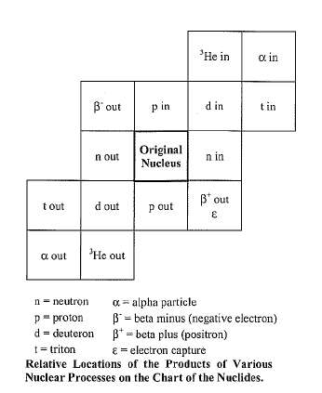

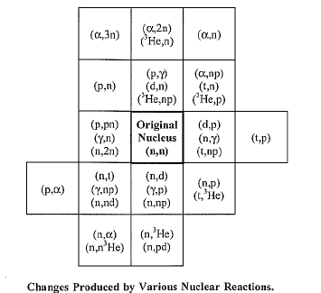

    - Proper Tracking of Entire Decay Chains
Because the isotope generator algorithm captures only the daughter reactions of the isotopes specified on the material card, the entire isotope decay chain will not be implemented into the MCNPX transport model and subsequently will not be tracked in the MCNPX output file.
For MCNPX to track a decay chain member, that isotope must be listed on the material card at beginning of life (BOL). Because the decay chain members will not be present at BOL, the decay chain member’s zaid is automatically put on the corresponding Mn material card, with an atom density of 1E-36. Therefore, the buildup of that specific decay chain member will be tracked in the MCNPX transport calculation and the corresponding nuclide mass will be listed in the output file.

    - Burnup/depletion with repeated structures
Burnup/depletion requires that the volumes of the burn materials be known in order to compute isotopic masses and fluxes. For burnup regions without repeated structures, MCNPX will try to calculate a volume and, if unsuccessful, a fatal error is generated and the user is required to then specify the material volume using a VOL card. In the case of cells in a lattice, MCNPX is only capable of successfully accounting for the volumes of materials if each cell is used only once in the lattice. Otherwise, if certain cells are repeated in a lattice, MCNPX is unable to determine the total volume of everywhere the material is repeated.

The MATVOL keyword is used to account for the volume of materials listed in a repeated structure.

MATVOL = V₁, V₂, V₃, …, V_{n}

V_{i} = Total volume of all cells [cm³] containing burn material, M_{i}, on the MAT keyword of the BURN card

If the MATVOL keyword is utilized on the BURN card then there must exist a corresponding MATVOL entry for every entry on the MAT keyword of the BURN card. If repeated structures are used without a MATVOL keyword, MCNPX either will not be able to calculate a volume or will incorrectly calculate the volume, assuming that the total volume for the entire burn material is equal to the volume stated on the VOL card rather than the cumulative volume for all repeated cells containing the material.

    - Time Dependent Concentration Changes: MATMOD keyword
To model real life depletion systems, isotopes may have to be added or extracted in order to the conditions of the operating strategies. For example, in a pressurized water reactor, boron must be diluted as fuel is depleted in order to maintain criticality.

The MATMOD keyword is used to account for manual concentration changes of particular isotopes of specific materials at certain time steps.

MATMOD= NT TS₁ NM₁ MT_{1,1} K_{1,1} 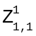 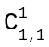 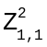 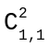. . .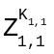 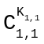
MT_{1,NM1} K_{1,NM1} 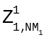 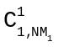 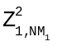 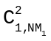 . . . 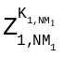 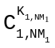
TS_{NT} NM_{NT} MT_{NT,1} K_{NT,1} 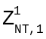 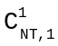 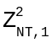 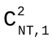 . . . 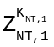 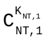
MT_{NT,NMNT} K_{NT,NMNT} 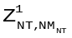 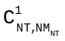 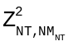 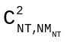 . . . 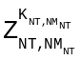 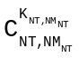

NT = Number of time steps (1 through NT)

TS_{NT} = Time step (1..NT) for which to manually change nuclide concentrations of material MT_{NT,NMNT .} Enter “1” for 2nd, etc. (If positive, apply concentrations discretely at T_{i} and T_{i+1/2}. If negative, apply at T_{i}, and make linear interpolation between T_{i} and T_{i+1} to determine the concentration at T_{i+1/2}. If TS is negative at T_{i} and the concentrations of any of the altered isotopes at T_{i+1} is equal to the concentration set at T_{i}, then the concentrations of the altered isotopes will be set to the value at T_{i} for T_{i}, T_{i+1/2}, T_{i+1}. At T_{i+3/2} the isotopes will undergo a normal depletion and the concentrations will not be set to the value at T_{i+1}.

NM_{NT} = Number of materials at time step “NT” that incur nuclide concentration changes

MT_{NT,NMNT} = NMth material number for which to manually change nuclides at time step “NT”. Positive value indicates atom/wt. fraction and negative value indicates atom/gram densities.

K_{NT,NMNT} = Number of nuclides to manually change for the NMth material

= 1st, 2nd,.. Kth nuclide of the MT_{NT,NMNT} th material at time step “NT” for which a concentration will be specified. List as a ZA value.

= Concentration for the Kth isotope in material MT_{NT,NMNT} at time step “NT”. Enter positive values for atom fractions or atom densities, and enter a negative value for wt. fractions or gram densities. See sign of MT_{NT,NMNT} to specify either fraction or density

NOTE: When using the MATMOD keyword, if a burn material is set to have a concentration change at T₁, the atom density of that isotope at T_{1/2} is set to the initial value specified at T₀. This is only set for the initial midpoint time step, the rest of the calculation will follow the procedure mentioned above.

    - Metastable Isotope Representation
A convention for naming metastable isotopes in the XSDIR cross-section library file for use in MCNPX has been determined. In the past, users created their own naming convention for metastable isotopes to be used in MCNPX, and as long as a tabular cross-section file was referenced in the XSDIR for these types of isotopes, any naming convention could be accepted [That is, to represent Ag-110m, ZA=47210, Z=47 and A=110+100*(metastable state)]. However, because MCNPX is linked to the CINDER90 code which uses a different naming convention than MCNPX, an MCNPX standard convention for naming metastable isotopes is required. The identification of metastable isotopes, ZA, uses the following equation:

A' = (A+300) + (m*100)
m=1,2,3,4

Example:
Ag-110m = 47510 → 47510 = 47110 + 1st metastable

MCNPX will convert the above naming convention to the naming convention needed within CINDER90.

    - Examples
The following example explains the input setup for the burn card:

BURN TIME=15.0,30.0,30.0 MAT=3,4 POWER=2.0
OMIT=3,3,8017,92234,92239,4,1,92234
BOPT=1.0 -11

This card specifies a power level of 2 MW, with time steps of 15 days, 30 days, and 30 days, for a total of 75 days. Materials 3 and 4 are included in the burn with isotopes 8017, 92234, and 92239 excluded from material 3 and isotope 92234 excluded from material 4. Output will be produced at the end of each burn step and ordered by decreasing mass, and Tier-2 fission products will be treated.

Print Tables 40 and 50 are repeated in the output file for each time step, giving the updated atom fractions and densities. Print Table 55 provides the burnup results at the end of each time step.

This next example explains the necessary keyword implementation for burning a repeated structure while also utilizing manual concentration changes at specific time steps. This example models a 4 X 4 fuel pin array

…
1 1 6.87812e-2 -1 u=2 imp:n=1 vol=192.287 $ fuel
3 2 4.5854e-2 1 -2 u=2 imp:n=1 vol=66.43 $ clad
4 3 7.1594e-2 2 u=2 imp:n=1 vol=370.82 $ water
6 4 6.87812e-2 -1 u=3 imp:n=1 vol=192.287 $ fuel
7 5 4.5854e-2 1 -2 u=3 imp:n=1 vol=66.43 $ clad
8 6 7.1594e-2 2 u=3 imp:n=1 vol=370.82 $ water
10 0 -3 4 -5 6 u=1 imp:n=1 lat=1 fill=0:1 0:1 0:0
2 3
2 3
...

...
BURN TIME=50,10,500
MAT= 1 4
POWER= 1.0
PFRAC= 1.0 0 0.2
OMIT= 1,8,6014,7016,8018,9018,90234,91232,95240,95244
4,8,6014,7016,8018,9018,90234,91232,95240,95244
BOPT= 1.0, -4
AFMIN= 1e-32
MATVOL= 384.57 384.57
MATMOD= 2
1
1 -4 1 94238 1e-6
2
2 -1 2 94238 1e-6 94241 1e-6
-4 1 94238 1e-6
...

The following example utilizes a lattice containing universes 2 and 3, which are both repeated twice in the lattice. Universe 2 is comprised of cells 1, 3, and 4, where cell 1 contains material 1, and universe 3 is comprised of cells 6, 7, and 8, where cell 6 contains material 4. The MAT keyword specifies that both materials 1 and 4 will be burned. The combination of the TIME, POWER, and PFRAC keywords specify that these materials will be burned first for 50 days at 100% of 1MW, then decayed for 10 days, and then finally burned for 500 days at 20% of 1 MW.

The BOPT keyword specifies that the following options will be invoked: Q-value multiplier = 1.0, tier 1 fission products, output ordered by zaid, the output is printed at the end of each KCODE run and only tabular transport cross sections are utilized. Because tabular transport cross sections do not exist for every isotope generated, an OMIT keyword is required in order to omit these isotopes from the transport process. The transmutation of these isotopes is accounted for by sending a 63-group flux from MCNPX to be matched to a 63-group cross-section set within CINDER90 which will be energy integrated to determine a total collision rate. The OMIT keyword in the example omits 8 isotopes from material 1 and 8 isotopes from material 4. The AFMIN keyword states that only isotopes possessing an atom fraction below 1e-32 will be omitted from the transport calculation.

Since repeated structures are utilized in the example, a MATVOL keyword is required in order to calculate the track length estimated reaction rates in each repeated structure. In this example, because material 1 and 4 are repeated twice and each material possesses a volume of 192.287, MATVOL keyword entries of 384.57 (192.287*2) were required for each material being burned.

A MATMOD keyword is used in order to manually change the concentration of certain isotopes at specified time steps. In this example, manual isotope concentration changes are to be completed at 2 time steps. At time step 1, material 4 will have the atom density of 1 isotope changed: 94238 will be set to 1e-6 atoms/b-cm. At time step 2, material 1 will have the atom densities of 2 isotopes changed: material 1 will have isotope 94238 changed to 1e-6 atoms/b-cm and isotope 94241 will be changed to 1e-6 atoms/b-cm, material 4 will have the atom density of 1 isotope changed: 94238 will be set to 1e-6 atoms/b-cm.

Heavy Ion Transport
MCNPX can transport heavy ions,, such as iron, lead, and gold, above 5 MeV.

    - Input
To transport heavy ions, add the particle type “#” on the MODE card. The particle-type symbol “#” is used to represent heavy ions on nearly all MCNPX input cards where particle types are designated. The “#” represents all possible heavy ion types (basically any ion that is not one of the light ion types in MCNPX which are deuterons, tritons, He-3 and alpha particles). Although the ‘#’ is generic to all heavy ions, the individual heavy ions are tracked by their appropriate Z (charge) and A (mass number). The user cannot choose to transport any particular heavy ions (other than specific source particles) although tallies can be made for specific ions.

MCNPX Particles

IPT* | Name of Particle | Symbol | Mass  (MeV) | Low Kinetic Energy Cutoff  (MeV) | Mean Lifetime  (seconds)
35 | heavy ion | # | varies | 5.0 | Huge

The “#” may be used wherever a normal particle type is called for. If placed on the MODE card with other particles types, heavy ion transport is turned on. If placed in a tally such as F4:#, a track length tally of the heavy ions will be printed in the output. The “#” may also be used in mesh tallies.

To use a heavy ion as a source particle, the ZA identifier is put into the PAR keyword field of the SDEF card such as SDEF PAR = 6012 which will start a C-12 ion. Note that the energy is still input as total energy and not energy/nucleon.
Heavy ions can also be used as a distribution of source particle types. The specification:

sdef par = d1
si1 L 1 9 3006 26056 92238
sp1 1 1 0.1 0.3 0.5

samples five different source particles: neutron, proton, Li-6, Fe-56, and U-238 in the relative frequencies given on the SP card. Dependent distributions can be used to specify different energies for different heavy ions.

The heavy ions use LAQGSM as the default nuclear cascade/evaporation model. The LAQGSM model can be used for other particles by setting the 10th entry on the LCA card to 1. There are no ENDF data tables for the heavy ion reactions, so there is no transition energy between table and model physics as there is for protons and neutrons.

When running with heavy ions turned on (‘#’ on the MODE card), any residuals that are produced from any model physics (such as CEM, Bertini, etc.) will be transported even if the source particle is not a heavy ion. For example, a proton source that is directed into a target and uses CEM as the model physics will produce residuals from the nuclear reactions. If the “#” sign is on the MODE card, these residuals will be banked and transported. Note that the table physics regime does not normally create residuals, so any interaction using proton and neutron libraries will not produce transportable heavy ions.

The MCNPX heavy ion algorithm requires that the list of possible heavy ions that can be transported is pre-defined. However, the list is quite large. Most isotopes in the Table of Isotopes (~2205 isotopes) are available to be tracked. On the rare occasion when an isotope is created that is not on this list (e.g., something far from the line of stability) the ion is stopped immediately and its energy is deposited at the stopping point.

    - Tallies
The FT RES special-treatments tally option enables creation of user bins for tallying specific isotopes of heavy ions. The general form is FTn:<pl> RES where n is the tally number and <pl> is the particle type, #. Inputs to the FT RES option can be made in three ways:
- Specifying FT RES with no isotopes listed automatically creates a bin for each of the 2205 ion types.
- Specifying FT RES z1 z2 will create user bins for all isotopes between the proton numbers z1 and z2.
- ZA identifiers can be explicitly listed after the RES keyword for each user bin.
For example:
F4:# 6
FT4 RES 8016 20040 26000 92238
creates a track length tally in cell 6 and then separately tallies isotopes 8016, 20040, 26000 and 92238. Specifying the elemental ZAID for Fe (26000) will lump all Fe isotopes into one bin. The FT RES option works with type 1, 2, 4 and 6 tallies for heavy ions. For F8 tallies, the FT RES option still works as a residual tally.

For mesh tallies, type 1 (particle track) and type 3 (energy deposition) work with heavy ions although there is no capability to separate out contributions from specific heavy ion species.

    - Other Input
PHYS:# has the input features for a generic charged particle. Note: Light-ion recoil control still only applies to light ions. There is no heavy ion recoil for proton elastic scattering events.

SSR, SSW: Surface source reading and writing. The charge and mass for each heavy ion are stored in the surface source file, WSSA, and will be read back to reconstruct the proper source distribution.

M: The HSTEP step size parameter applies to all charged particles (except electrons which use ESTEP) including heavy ions.

    - Variance Reduction.
Heavy ions, similar to light ions, are able to use any variance reduction technique that is applicable to charged particles that use physics models for interactions. Any variance reduction technique used for heavy ions will apply equally to all heavy ion particles.

Weight windows, Cell importance, SPABI, ESPLT: All work with heavy ions

FCL, EXT: Only apply to neutral particles; not functional with charged particles and heavy ions.

DD, PD, DXTRAN: Only apply to neutral particles; not functional with charged particles and heavy ions.

    - Changes to PRINT Tables.
The stopping powers for the primary or default Heavy Ion are printed with the normal stopping power tables in Print Table 85. An optional table, Print Table 87, prints the stopping powers that are generated for all of the secondary heavy ions. Stopping powers for secondary heavy ions are only calculated on an elemental, not isotopic basis, so only the proton number of the heavy ion will determine which table is printed. Note that all heavy ions specified with a distributed source will use the secondary stopping power tables. The Z and A identifier for each table are shown in the particle identity field at the top of the table.

Print Table 87 does not follow the standard default convention of most other MCNPX print tables because stopping powers for all 100 elements for each material would result in huge output files. To print table 87 it must be specified specifically on the PRINT card:

PRINT n n 87 n

Where the values of n are other tables desired for printing.

To print all output including Print Table 87 the PRINT card is:

PRINT -1 87

The -1 turns off print table 1 (which does not exist) and turn on all other prints; then 87 turns on print table 87 as well. Thus all tables and print table 87 will be printed.
PRINT as an execution-line option, PRINT in the Message Block, and a blank PRINT card in the input will not result in the output of Print Table 87.

MCNPX Output Tables

Table Number | Type | Table Description
87 | optional | Secondary heavy ion stopping powers and straggling

Changes have also been made to the Print Table 110 (the first 50 particle histories) so that when a distributed source of heavy ions is requested, the Z and A identifiers for the sampled source particle are printed in the source particle field.

    - Limitations
The heavy ion capability has some restrictions when used with other features in MCNPX. No heavy ion transport information is written to the HISTP file (aside from the usual recoils from which the heavy ions are started). The PTRAC file contains the heavy ion particles and their track information but the individual heavy ion identity (Z and A) are not recorded.

The summary tables contain all the heavy ion information summed together; there is no way to break out individual heavy ion contributions for these tables.

LAQGSM Physics.
The Los Alamos Quark-Gluon String Model v. 3.01 in MCNPX contains elements of the CEM INC physics model (see following section) and GEM evaporation model but is intended to handle a wider variety of particles and energies. LAQGSM can simulate the interactions of A1+A2 interactions, and well as nucleons (protons and neutrons) and gammas. By default, LAQGSM handles all the heavy-ion interactions as well as light-ion interactions above 1 GeV/nucleon (below this, ISABEL is still the default model). However, setting the 10th entry (ilaq) on the LCA card to 1, redirects all light ions to LAQGSM. Neutrons and protons are also sent to LAQGSM (instead of FLUKA) when their energies are above the transition energy.

LAQGSM physics is controlled by the 10th LCA input parameter, ilaq.

Input Parameter | Description
ilaq | Choose light ion and nucleon physics modules.  If ilaq=0, use LAQGSM for light-ion interactions only above 940 MeV/nucleon. ISABEL will handle light-ion interactions below this energy. Use FLUKA for protons and neutron interactions above the energy cutoff specified by flenb1 and flenb2 on LCB card. LAQGSM will be used for heavy ion interactions at all energies (DEFAULT)  if ilaq=1, use LAQGSM for all light-ion interactions as well as all heavy-ion interactions. LAQGSM also replaces FLUKA for high-energy proton and neutron reactions.

LAQGSM requires two data files (atab.dat and channel1.tab) in addition to 3 of the standard CEM data files (shell.tbl, gamman.tbl and mass.tbl). Note that LAQGSM is used even when the ilaq variable is not 1 to transport light ions that otherwise would not be transported.

CEM03 Upgrade
The CEM2K physics package has been replaced with the CEM03 physics package. The MCNPX user interface is unchanged: if the 9th entry on the LCA card is 1, then CEM03 will be used.

CEM03.01 is a version of the Cascade-Exciton Model (CEM). It is a completely new, updated, and modified version, not just an incremental improvement, in comparison to its predecessors, CEM2k+GEM2,, CEM2k, CEM98, CEM97, and CEM95.

CEM03.01 describes reactions induced by nucleons, pions, and photons as a three-stage process: IntraNuclear Cascade (INC), followed by preequilibrium emission of particles during the deexcitation of the excited residual nuclei formed during the INC, followed by evaporation of particles from or fission of the compound nuclei. If the excited residual nucleus produced after the INC has a mass number A < 13, CEM03.01 uses a recently updated and improved version of the Fermi Breakup model to calculate its decay instead of considering a preequilibrium stage followed by evaporation from compound nuclei. CEM03.01 considers also coalescence of complex particles up to ⁴He from energetic nucleons emitted during the INC.

The main improvements of CEM03.01 in comparison with its predecessors are described in the following sections.

    - Intra Nuclear Cascade (INC)
We developed new approximations to describe more accurately experimental elementary energy and angular distributions of secondary particles from hadron-hadron and photon-hadron interactions using available data and approximations published by other authors. We have normalized photonuclear reactions to detailed systematics developed by others., The condition for transition from the INC stage of a reaction to preequilibrium was changed; on the whole, the INC stage in CEM03.01 is longer, whereas the preequilibrium stage is shorter in comparison to previous versions. The algorithms of many INC routines were changed and almost all INC routines were rewritten, speeding up the MCNPX INCL algorithm significantly. Also, some preexisting bugs in the INC were fixed.

    - Preequilibrium (PREC)
The condition for transition from the preequilibrium stage of a reaction to evaporation/fission was changed; on the whole, the preequilibrium stage in CEM03.01 is shorter, whereas the evaporation stage is longer in comparison to previous versions. The widths for complex-particle emission were changed by fitting the probability of several excitons to “coalesce” into a complex particle that may be emitted during the preequilibrium stage to available experimental data on reactions induced by protons and neutrons. Algorithms of many PREC routines were changed and almost all PREC routines were rewritten, speeding up the code significantly. Some bugs were discovered and fixed.

    - Evaporation and/or Fission
The evaporation and fission stages of reactions are calculated by CEM03.01 with an updated and improved version of the Generalized Evaporation Model code GEM2 by Furihata, which considers evaporation of up to 66 types of different particles and light fragments (up to ²⁸Mg). In comparison to GEM2, the calculation of fission widths in CEM03.01 was changed by fitting the ratio of the level-density parameters at the saddle point to that in the evaporation channel to the systematics of proton-induced fission cross sections by Prokofiev., Several routines by Furihata from GEM2 were slightly modified in CEM03.01 and some bugs found in GEM2 were fixed.

    - Coalescence
The coalescence model implemented in CEM is improved. In comparison with its initial version, we have changed the coalescence momentum radii p_0 for the various light composite particles up to ⁴He by fitting them to measured data on nucleon-induced reactions at energies up to 1 GeV.

    - Fermi Breakup
The Fermi Breakup model used in CEM is improved., In comparison to its initial version, we have modified the model to decay some unstable light fragments that could be produced by the original Fermi Breakup model. Several bugs observed in the original version [12] were fixed.

    - Additional Notes
Almost all routines of CEM03.01 were rewritten and many algorithms were changed so that the code is much faster now than all of its predecessors. In comparison to its predecessors, the output of CEM03.01 was significantly extended, allowing us to calculate with the standard CEM03.01 many additional characteristics of nuclear reactions.

CEM03 is more accurate but somewhat slower than the CEM2K it replaces. CEM problems no longer track – that is, the results from CEM2K do not match the results of CEM03 for the same input decks. Problems using model physics and having photonuclear reactions also no longer track.

Long File Names
MCNPX file names may now be 40 characters long. The execute line message may now be 240 characters long. File names also may be paths.

For example:

MCNPX name = ..\..\destination_output_files. inp = ..\input_file

In this example, the input file is named input_file and is located in the next directory up.

MDATA Files

Mesh tally MDATA files now use the name option. In the above example, the MDATA file would be named destination_output_files.d and would be put in the directory ..\..\ .

Implementation Details

The 40-character length is set by the parameter lfilen = 40 in module_global_parameters, GLOBAL1_zc.F . Thus, longer file names should be possible but have not been tested.

In some cases, warnings and fatal-error messages will give only the first eight characters of a file name because of format constraints. In most cases, the rewriting of all formats containing file names result in cleaner output. The full file name usually is allowed. Short file names no longer are followed by blanks to achieve the old eight-character file name length.

Terminate Tallies at Desired Precision
A new input card, “STOP”, has been added to enable stopping of calculations when a desired tally precision is reached:

STOP NPS n CTME m Fk e .

This card will cause MCNPX to stop after n histories, after m minutes, or when the tally fluctuation chart bin of tally k has a relative error less than e.

MCNPX will stop at the first met criteria.

For radiography problems, the second NPS card entry, n, may be provided to specify how many histories are used for direct radiography tally contributions:

STOP NPS n m .

For multitasking calculations, CTME will be checked only at rendezvous points, where all tasks rendezvous for tally fluctuations and other activities.

The tally precision stop will be checked only at rendezvous points for the tally bin of the tally fluctuation charts. Thus, the calculation usually will proceed for a short time after the desired error is achieved. Thus,

STOP F111 .05

will cause MCNPX to stop at the first rendezvous for which the relative error is less than 0.05. That is, MCNPX may stop at error = 0.048 or other value slightly less than 0.05.

Spherical Mesh Weight Windows
The mesh-based weight window and the weight-window generator are now available in spherical geometry (X-3:JSH-2006-68). The spherical mesh geometry may be thought of as an orange where the theta (θ) azimuthal angles are the bounds between slices. Or the spherical mesh geometry may be thought of as a globe where the phi (φ) polar angles are latitude and the theta (θ) azimuthal angles are longitude. The north pole is at φ = 0 degrees; the south pole is at φ = 180 degrees; London is at θ = 0 degrees and all the way around the globe at θ = 360 degrees.

For problems that are best described in the R-φ-θ spherical geometry coordinate system, spherical mesh weight windows can offer variance reduction speedups of orders of magnitude compared to less suitable rectangular and cylindrical meshes. A speedup of six orders of magnitude over analog has been observed by using spherical mesh weight windows. Note that rectangular mesh windows are about 30% slower than cell-based windows and cylindrical and spherical mesh windows run about 60% slower than cell-based windows. Problems with spherical geometry that may benefit from spherical mesh weight windows include spherical detectors, unknown materials hidden in spherical geometries, distant sources and detectors in air, spherical satellite geometries, modeling planets, and more.

    - User Interface
Mesh Specification

The weight-window generator mesh is specified with the MESH card. The “GEOM” keyword now has the following possible entries:

XYZ or REC Cartesian coordinate rectangular mesh (unchanged)
RZT or CYL R-Z-θ cylindrical mesh (unchanged)
RPT or SPH R-φ-θ spherical mesh (new)

The RPT and SPH entries are new. The phi (φ) polar mesh bounds are specified with the JMESH keyword. As with the cylindrical mesh, the theta (θ) azimuthal mesh bounds are specified with the KMESH keyword. Also consistent with the cylindrical mesh, the lower radial and angular mesh bounds (R-φ-θ) are all implicitly zero.

Example:

Mesh geom sph origin 7 -9 -12 ref -23 39 -10 axs .4 -.5 .2 vec .1 -.2 -.7
imesh 60. iints 3
jmesh .1 .35 .5 jints 1 1 1
kmesh .2 .85 1 kints 1 1 1

In this example a spherical mesh is located at origin=7 -9 -12. The reference location in the XYZ coordinate system of the problem is at ref=-23 39 -10. The weight-window generator lower weight-window bound will be W for whatever mesh cell contains this location, where W is half the source weight by default or whatever is the 3rd entry on the WWG weight-window generator card. The polar (φ) axis of the spherical mesh (as in latitude on the globe) is axs=.4 -.5 .2, which MCNPX will normalize to a unit vector. The azimuthal planes (as in longitude on a globe, or orange slices, or cylindrical mesh theta bins) are measured relative to the azimuthal vector, theta (θ), vec=.1 -.2 -.7. VEC will also be renormalized by MCNPX and must be orthogonal to φ. The radial mesh bins have 3 interpolates between 0 and 60—that is, the mesh bounds are at 0, 20, 30, and 60 cm. The polar angles (φ) are at .1, .35, and .5 revolutions from the axs vector. The azimuthal angles (θ) are at .2, .85. and 1 revolutions from the vec vector. Note that 0 ≤ φ ≤ .5 and 0 ≤ θ ≤ 1 are always required.

The polar and azimuthal angles may also be specified in radians or degrees. For example, the JMESH and KMESH entries for the above example in degrees would be:

jmesh 36 126 180 jints 1 1 1
kmesh 72 306 360 kints 1 1 1

    - Plotting
The interface for geometry plots of the spherical mesh window boundaries is the same as for cylindrical mesh boundaries. Geometry plots are colored by the input weight windows from the WWINP file by selecting WWN as the color option. The weight window and weight-window generator mesh boundaries are plotted by clicking “CellLine” to get to the WWG or WW options. The command-prompt plot commands would be “LA 0 1 wwn COLOR on LA 0 0” to color by input windows. The commands “MESH 2” and “MESH 4” plot the generator mesh from the MESH card and weight-window mesh from the WWINP file.

Figures 1–3 illustrate three views of a geometry divided into cells coincident with the spherical mesh, so that each color represents a specific geometry and mesh cell in each view. Figures 2 and 3, drawn through the mesh sphere origin and normal and orthogonal to the polar axis, give the intuitive polar (Figure 2) and azimuthal (Figure 3) views. However, skewed, off-center plots of spherical meshes with skew axes give very non-intuitive plots as illustrated in Figure 1.

The most challenging part of the spherical mesh weight-window capability was the plotting because the spherical mesh may be in one skew coordinate system and the plot frame in another skew coordinate system which has an “s,t” auxiliary coordinate system. In the most complicated case, equations with hyperbolic sinh and cosh functions must be simultaneously solved with trigonometric equations with sin and cos functions. Iterative solutions were used in these special cases out of desperation. And even these iterative solutions fail to draw mesh boundaries correctly in some instances when both the plot extents are unequal and the geometries are skew creating hyperbolas and intersecting ellipses. Further, polar mesh boundaries looking down into the polar angle sometimes plot incorrect ellipses when the ellipse is partially (but not mostly) out of bounding radial sphere. Note that cylindrical geometries are considerably simpler to plot because they never have to plot hyperbolas and the ellipses, if any, do not intersect each other.

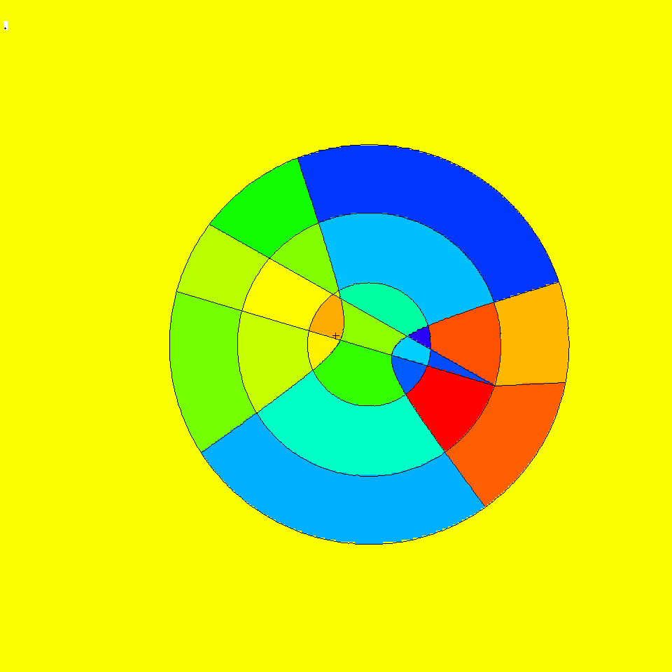

Figure 1. Plot view: basis .84514 -.0507093 .169031 .408248 .408248 -.816497, or = -3 -9 -20, ex 100. Spherical mesh orientation: origin 7 -9 -12, axs .4 -.5 .2, vec .1 -.2 -.7.

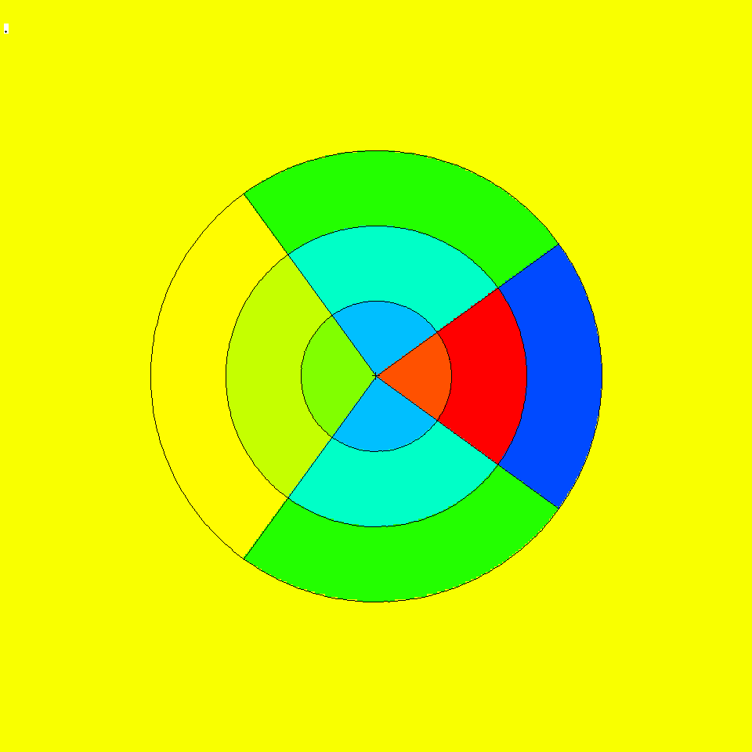

Figure 2. Plot view orthogonal to polar axis showing polar bins jmesh = 36 and 126 degrees. The polar axis (0 degrees) is to the right and is not plotted.

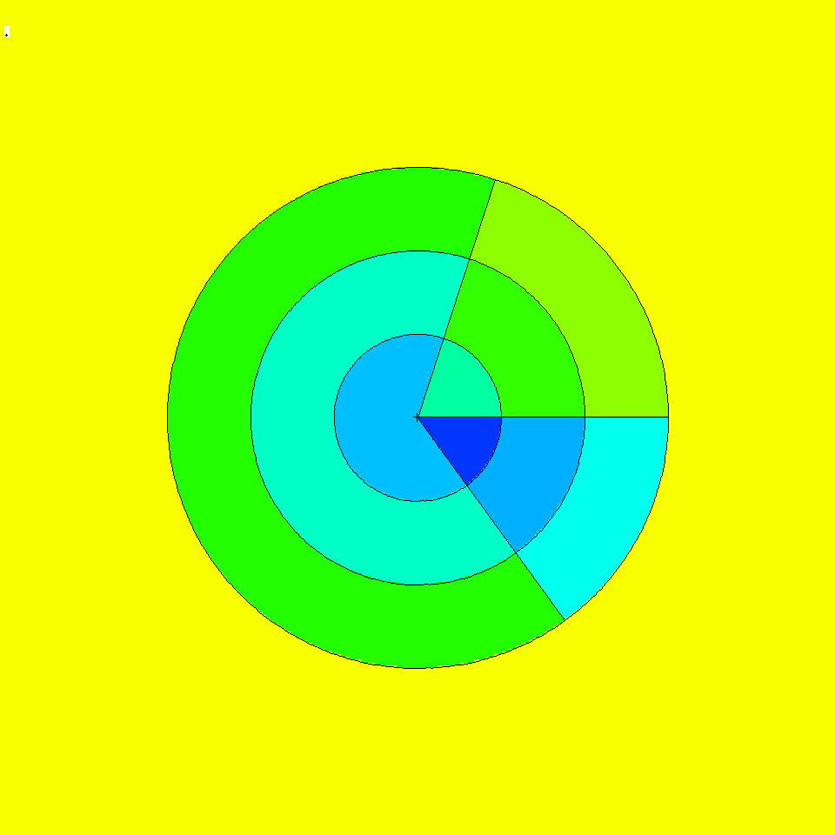

Figure 3. View normal to polar axis at origin showing azimuthal planes at kmesh = 72, 306, and 360 degrees. The azimuthal vector, vec, is to the right (360 degree plane).

Energy-Time Weight Windows
MCNPX can now generate and utilize weight windows that are both energy- and time-dependent. Previously, MCNP/X could do energy-dependent or time-dependent windows, but not together. The new capability is fully backwards compatible, including the 8th WWG entry and 6th WWP entry, which convert energy-dependent windows to time-dependent windows. However, time-dependent windows may be specified directly by using the new WWT and WWGT input cards. These new input cards are directly analogous to the WWE and WWGE cards for energy-dependent weight windows and are the following:

WWT:p t₁ t₂ t₃ …
WWGT:p t₁ t₂ t₃ …

Where p is the particle type, and the t_{N} values are times in shakes.

The WWNn:p cards are numbered as before, where n=1,NE for NE energy groups or n=1,NT for NT time groups. Where there are both time and energy groups, then n=1,NE for time group 1; n=NE+1,2*NE for time group 2; n=2*NE+1,3*NE for time group 3; and so forth.

If a time or energy is above the upper time or energy bin range it will be treated as if it were in the top time or energy bin. This has always been the case in all MCNP/X versions.

    - Cell-Based Example
The following generates a 2-energy group, 3-time group weight window. In particular, the WWG card would generate weight windows to optimize tally 111. The lowest weight-window bound in any energy-time bin group in cell 45 (the reference cell) would be .25. The WWGE and WWGT cards would generate 2 energy bins and 3 time bins for photons.

WWG 111 45 .25
WWGE:p 1 100
WWGT:p 1 100 1.e20

The cell-based windows generated from the above cards would look like:

WWP:p 5 3 5
WWE:p 1 100
WWT:p 1 100 1.e20
WWN1:p W W W ... $ energy 1 time 1
WWN2:p W W W ... $ energy 2 time 1
WWN3:p W W W ... $ energy 1 time 2
WWN4:p W W W ... $ energy 2 time 2
WWN5:p W W W ... $ energy 1 time 3
WWN6:p W W W ... $ energy 2 time 3

    - Mesh-Based Example and WWOUT File Changes
Mesh-based weight windows are generated on the WWOUT file and input is from the WWINP file. If there are energy or time dependent windows then a WWONE file is also generated, but its format is unchanged. If the name option is used on the execute line, the WWOUT and WWONE file names end in e and 1, respectively. The WWOUT file format is changed if time or energy-time windows are used. But it is backwards compatible with upgrades.

The changes are marked in boldface in the following example. The 2nd entry on the header (iv in subroutine WWFILE), which formerly was always 1, can now be 2 if time-dependent windows are present. When time-dependent windows are present (iv=2) then the next line of integers is the number of time bins for each particle type. This is followed as always by the line of integers which is the number of energy bins for each particle type. This line of energy bins per particle has always been present regardless of how many energy bins are used. Further, only for particle types with time-dependent windows, there is a line preceding the list of energy bin upper bounds that lists the time bin upper bounds. In this example it is 0.10000E+07 0.10000E+13. This is followed by the always present list of upper energy bounds, in this case 100.00. For example:

1 2 2 16
2 1
1 1
20.000 12.000 1.0000 0.0000 0.0000 0.0000
2.0000 2.0000 1.0000 101.00 0.0000 0.0000
0.0000 101.00 0.0000 3.0000
0.0000 4.0000 3.0100 1.0000 16.000 101.00
1.0000
0.0000 4.0000 0.25000 1.0000 8.0000 0.50000
1.0000
0.0000 1.0000 1.0000 1.0000
0.10000E+07 0.10000E+13
100.00
0.20290E-04 0.21675E-04 0.26245E-04 0.35285E-04 0.17419E-03 0.48374E-02

Charged Ions from Neutron Capture in Table Range
MCNPX can now produce light ions from neutron capture reactions in certain isotopes in the table energy range when such data are not available in the libraries. The optional “neutron capture ion algorithm” (NCIA) is called for neutron capture in He-3, Li-6, and B-10 producing protons, tritons, deuterons, and alphas according to the following table:

Table 1. Available Reactions

Isotope | Reactions
He-3 (2003) | n(He-3,h)t  n(He-3,d)d
Li-6 (3006) | n(Li-6,t)a
B-10 (5010) | n(B-10,g)a

The optional NCIA would not be needed if the nuclear data libraries were complete and contained these data. If these data are in the data tables then the library physics produces the secondary ions instead of the NCIA.

    - User Interface
The NCIA capability is controlled by the PHYS:N card 7th entry which also controls light-ion recoil:

PHYS:N 6J L

where:
L = 3 NCIA on: create charged ions from neutron capture in the table energy range if the library does not have secondary particle production data for these ions. No light-ion recoil.
0 <L ≤1 Light ion recoil with biasing factor L (produced L elastic scatter recoil
ions per incident neutron.)
1 <L ≤2 Light ion recoil with biasing factor L-1 and NCIA on.

Light ion recoil will only occur for neutrons and protons colliding with H, D, T, He-3 and He-4. Neutron capture ions (NCIA) will only occur for neutrons colliding with He-3, Li-6, and B-10 and only if the ion production cross sections are unavailable in the data tables.

The 7th PHYS:N or PHYS:H entry is ignored for collisions in the physics model energy range because the models produce the required elastic and inelastic ions automatically.

The default is L = 0 : no light ion elastic recoil and no neutron capture ions.

    - Diagnostics
The diagnostic indicating the NCIA has been used is in Print Table 100 of the OUTP file.

For example, when using He-3 (2003) as a material and specifying h, d, and t on the mode card with NCIA turned on, Print Table 100 will show:

particle-production data for ipt= 34 being used from 2003.66c
no particle-production data for ipt= 9 from 2003.66c
using aceion for particle production for ipt= 9 in zaid 2003
no particle-production data for ipt= 31 from 2003.66c
using aceion for particle production for ipt= 31 in zaid 2003
no particle-production data for ipt= 32 from 2003.66c
using aceion for particle production for ipt= 32 in zaid 2003
2003.66c 5535 2-he-3 at 293.6K from endf-vi.1 njoy99.50

In this example, ipt=34 (alpha) production data is found. No data is found for ipts 9 (protons), 31 (deuterium) and 32 (tritium).

    - Important Considerations
Energy Cutoff: The energies of the light ions are often very low, especially for thermal neutron captures. To enable transport of these secondaries, use the CUT card to reduce the low energy cutoff.

Secondary Production Correlations: Unlike most secondary particle production in the table region, NCIA particles are coupled. Capture in He-3 produces a triton and proton. If the data library already had proton production, the library would be used for the proton but the tritons would be produced by NCIA. The NCIA correlation between the triton and proton would be lost. Note that if the triton and proton are both produced by the library there is no correlation, either.

Heating Tallies: Because neutron energy deposition is physically mediated in most cases by the secondary particle emission, NCIA may be inconsistent for heating calculations. Neutron heating is done with kerma factors (heating numbers) whereas heating from the charged secondaries is done at collisions. For +f6 tallies and type 3 mesh tallies the charged ion heating is subtracted from the neutron heating and thus is counted only once but inconsistently. For F6:n and F6:h,d,t,a tallies the heating is counted once for each particle type. If heating tallies are done in cells where charged ions are produced, either turn off NCIA or remove the light ions from the MODE card.

Delayed-Gamma Emission.
Warning! The new delayed-gamma emission capability and delayed-neutron capability is preliminary and not covered by the MCNPX cash awards program. It has been included in MCNPX because of user and sponsor demand.

The radioactive decay of fission products, or residual nuclides excited by neutron or photonuclear interaction, frequently results in the emission of gamma/x-rays at times appreciably later than the initiating event. These photon emissions are referred to here as “delayed gammas.”
MCNPX already treats delayed neutrons from fission with both delayed-neutron model physics and delayed-neutron library physics from data tables.

MCNPX enables the automated calculation of delayed-gamma signatures emitted due to (1) the decay of radioactive fission products created by neutron fission or photofission, or (2) residual nuclides created by simple multi-particle interactions (SMRs). The delayed-gamma capability uses CINDER90, which was written by William B. Wilson, modified by Holly R. Trellue to disable flux-induced transmutation. The initial multigroup patch for fission-induced delayed-gamma emission was developed by Gregg W. McKinney, Holly R. Trellue, and Laurie S. Waters. Joe W. Durkee developed the modifications to enable line emission for fission and SMRs.

The delayed-gamma capability has been developed for pulsed or low-flux modeling. Thus, CINDER90 nuclear transmutation is limited to decay chains only—neutron-induced transmutation is inactive. In contrast to the KCODE isotopic burn capability, the delayed-gamma emission modeling does not include neutron- (or photon-) induced isotopic transmutation by CINDER90. However, SMR treatment for selected reactions of nuclides present on the MCNPX material cards is treated. Execution of the delayed-gamma capability is limited to fixed sources (SDEF) and surface sources (SSW, SSR).

Additional documentation may be found in LA-UR-07-6302.

    - The Products of Fission: Residual Nuclides and Radiation
The relative amounts of fission products vary with the fissioning isotope and the particle (i.e., neutron, photon, etc.) inducing the fission. To illustrate this behavior, Fig. 4 shows CINDER90 ²³⁵U fission-yield data for thermal and high energy neutron-induced fission.

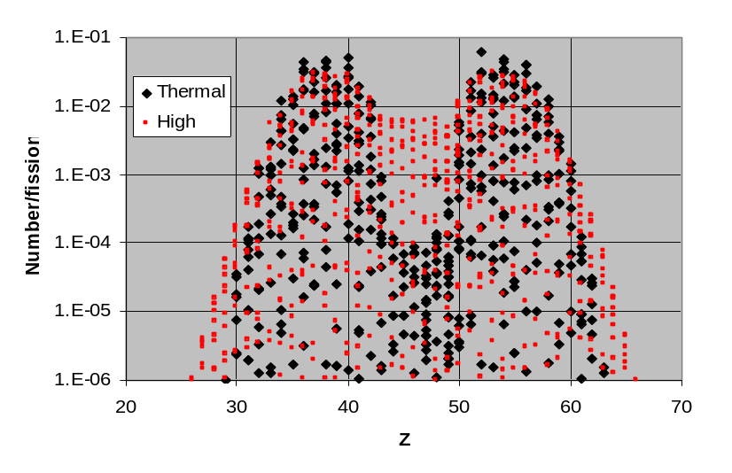

Figure 4. Thermal and fission-spectrum yield curves for ²³⁵U.

For sub-20-MeV neutrons, fission-product sampling is done for thermal, fission, and 14-MeV neutrons and isotopes of uranium, plutonium, thorium, americium, californium, curium, einsteinium, fermium, and neptunium. At high energies (En>20 MeV), LAHET is used to produce a list of residual nuclides.

Many fission products are unstable. As part of their decay process, photons are emitted. The delayed-photon emissions occur with intensities and at energies that are unique to each radionuclide. As examples, Fig. 5 shows the 25-group and line emission spectra for ¹³⁹Xe and ⁹⁴Sr.

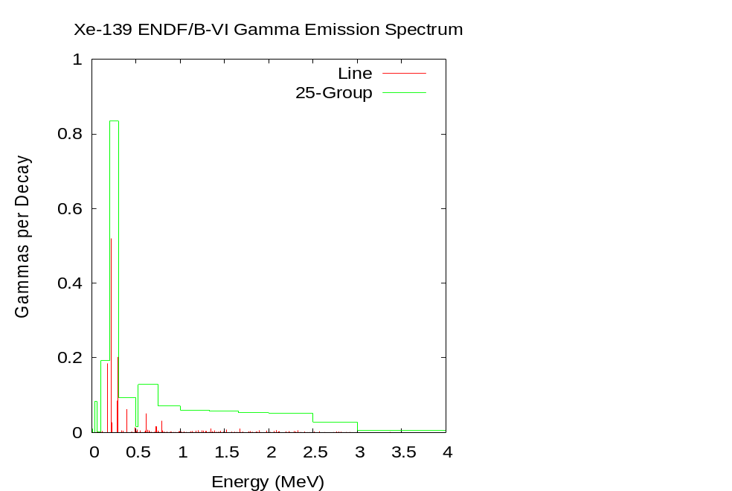
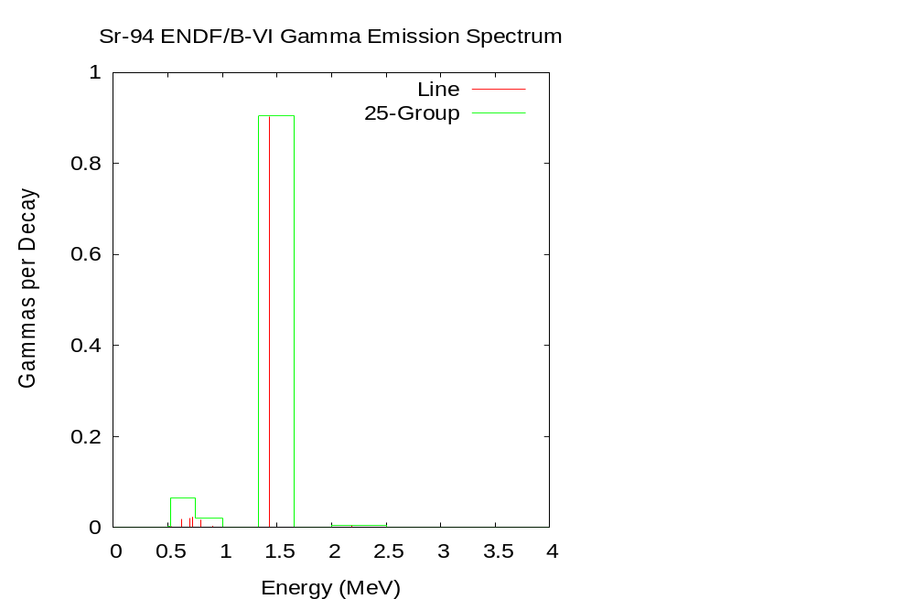

Figure 5. 25-group and line emission photon spectra for ¹³⁹Xe and ⁹⁴Sr.

    - Decay Chains and Emission Sampling
Not only are the fission-products and residual nuclides radioactive sources, but so too are their decay products. Each contributes to the delayed signature. Thus, a fission event may have hundreds or thousands of lines contributing to its signature.

CINDER90 has been integrated into MCNPX to calculate the radioactive decay-chain nuclide densities as a function of time. The nuclide densities, decay constants, and particle (neutron, photon) emission probabilities are used to calculate distributions that are sampled for particle emission energy and delay time (direction is sampled isotropically).

Photon emission data are available for 979 nuclides. These data are comprised of (1) line (discrete) data and (2) continuous data. The continuous component of the line data was developed using computational physics models to augment “missing” measured data so as to create an evaluated dataset whose calculated decay heats agreed with measured values. These data are stored in file cindergl.dat. The composition of the line data is listed in Table 2

Table 2. Cindergl.dat Delayed-Gamma Data Composition

Composition by Data Component
Data component | Quantity
Total | 282035
Discrete | 24199
Continuous | 257836
ASCII lines | 747730
Composition by Nuclide
 | Nuclides | Quantity
Discrete Only | 526 (54%) | 19821
Continuous Only | 292 (30%) | 214293
Discrete and Continuous Mix | 161 (16%) | 47921 total  4378D,67742C

All remaining nuclides, of the 3400 treated by CINDER90, require treatment using the CINDER.dat 25-group data.

    - Simple Multi-Particle Reactions
The delayed-gamma simulation capability includes the treatment of simple multi-particle reactions (SMRs). These are reactions in which only two to four particles, a residual nucleus, and photons are present in the final state. The reactions are designated using the ENDF “MT” identifier. Presently, MCNPX treats eight such reactions, which are listed in Table 3. Not all SMR types are available for all nuclides in the MCNPX data library.

Table 3. Available Reactions

ENDF/B-VI MT | Reactions
16 | (n,2n)
17 | (n,3n)
37 | (n,4n)
102 | (n,g)
103 | (n,p)
104 | (n,d)
105 | (n,t)
106 | (n,³He)
107 | (n,alpha)

For nuclides (present in MCNPX problem input files) experiencing SMRs, delayed emission is treated in the same manner as fission products. However, there is presently no treatment of target-nuclide depletion (mass is not conserved).

Figure 6 illustrates the results of an SMR calculation involving the bombardment of a sphere of ¹⁶O by 15-MeV neutrons. The ¹⁶O (n,p) ¹⁶N (t_{1/2}=7.1 s) reaction produces a set of prominent photon lines due to the decay of ¹⁶N.

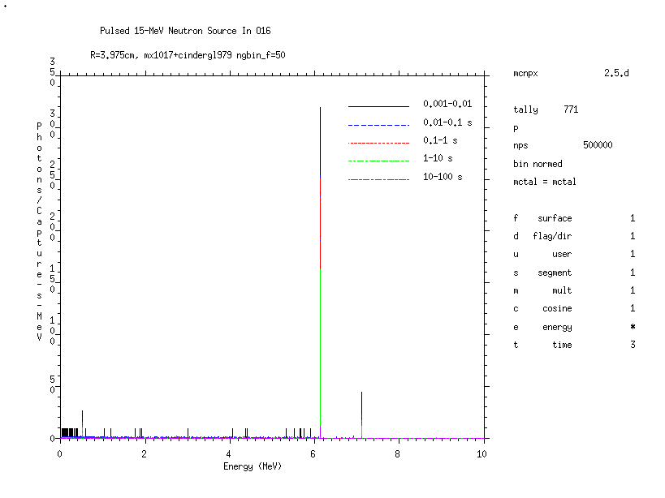

Figure 6. Delayed-gamma signature produced by ¹⁶N as a result of the (n,p) reaction for a pulsed 15-MeV neutron source (500000 source neutron histories) surrounding a 3.975-cm-radius sphere of ¹⁶O. Shown is the MCNPX F1 tally on the surface of the ¹⁶O sphere using time bins of 0.001–0.01 s, 0.01–0.1 s, 0.1–1.0 s, 1–10 s, and 10–100 s with uncertainty suppressed (noerr mcplot option).

    - User Interface
Total ν is now the default for neutron fission. Thus the TOTNU card is no longer needed unless only prompt ν is desired. To have only prompt fission, use:

TOTNU NO

Delayed-neutron physics is controlled with the 4th entry, DNB, on the PHYS:N card. DNB (delayed-neutron bias) has the following options, where negative entries do analog sampling (simulate nature), and positive entries bias delayed-neutron production:

-1001 Analog sampling, models when libraries missing
-101 Analog sampling, models only
-1 Analog sampling, libraries only (Default)
0 None -- do not create any delayed neutrons
N Create N delayed neutrons (1-15), libraries only
100+N Create N delayed neutrons (1-15), models only
1000+N Create N delayed neutrons (1-15), models when lib missing

Delayed-gamma physics is controlled with the 6th entry, DGB, on the PHYS:P card. DGB (delayed-gamma bias), has the following options:

0 None -- do not create any delayed gammas (Default)
-101 Analog sampling, models only, multigroup-only emission
-102 Analog sampling, models only, multigroup + line emission
-103 Analog sampling, models only, line-only emission (fragile/fatal)

Line-only emission (DGB = -103) is “fragile” (untested capability and is a fatal error).

Multigroup + line emission (DGB = -102) is most useful because line data exist for only 979 nuclides and the remaining nuclides are treated with multigroup-emission data.

Multigroup-only emission (DGB = - 101) is good for many applications where individual line signatures are not required and runs about 5 times faster than the line emission options. In addition, the multigroup emission spectra converge much faster—sometimes orders of magnitudes faster—than the individual line spectra emission as discussed in the following section.

All options produce delayed-emission spectra for all radioisotopes tracked by CINDER90.

    - Sampling and Execution
Delayed-gamma simulation by MCNPX is memory and execution-time intensive. Both demands stem from the calculation of the time-dependent atom densities and the use of the photon line-emission data to create energy and time cumulative distribution functions (CDFs). These CDFs are sampled for the energy and time of emission of each delayed gamma (directional emission is taken to be isotropic in the laboratory system).

Measures are taken in MCNPX to eliminate redundant calculations so as to reduce execution time. These measures include the one-time calculation of time-dependent atom densities by CINDER90, and the one-time calculation and array storage of some CDF values. This comes at the expense of memory. Modern desktop PCs and clusters having 1–2 Gbyte of memory lack the necessary memory to store all of the required CDF information.

Despite the use of execution-time reduction measures, time consuming tasks remain. For instance, the emission energies of each radioactive decay-chain nuclide must be loaded (from the master array into which all cindergl.dat line data is saved during initialization) and sorted (for line-emission purposes) for each fission event. This is necessary because mass conservation involving fission, inclusive of the number of prompt neutrons emitted, means that any fission product may have several other “siblings” for a series of fission events. There is insufficient storage on modern computers to store the line data for the assortment of combinations of fission-product pairs and their associated decay chains.

Another major time-intensive task involves the identification of the line at which a delayed gamma is emitted. Once the energy CDF is sampled for a proposed emission energy, that energy is forwarded to a routine along with an array containing all line-emission energies for the fission event. That array is searched for the nearest-neighbor emission energy corresponding to the proposed emission energy. This search task adds appreciable time to the calculation—this search is not done for multigroup delayed-gamma emission.

Because MCNPX is a Monte Carlo code, applications needing high-fidelity line signatures may require billions of source particles to achieve relatively stable signatures. Even then, lines may fluctuate appreciably when relatively rare emission paths are sampled. Tallies should be examined carefully to ensure that they are statistically robust.

    - Fission Yield Data
Fission-yield data are available for ²³³U, ²³⁴U, ²³⁵U, ²³⁶U, ²³⁸U, ²³⁷Np, ²³⁸Pu, ²³⁹Pu, ²⁴⁰Pu, ²⁴¹Pu, ²⁴¹Am, and ²⁴³Am. The data for both neutron and photon induced fission reside on the cinder.dat file. These data are used to generate delayed neutrons and gammas.

Criticality Source Convergence Acceleration
Warning! The new criticality source convergence capability is preliminary and not covered by the MCNPX cash awards program. It has been included in MCNPX because of its significance to criticality calculations.

In Monte Carlo criticality calculations the eigenvalue, keff, usually converges much faster than the eigenfunction which is the source distribution or neutron flux in the system. The problem is acute for loosely-coupled systems such as power reactors. MCNPX includes the “Vacation Matrix” capability to better converge source distributions in criticality calculations. The method has been developed by Joshua Finch (Purdue University/LANL) in collaboration with John Hendricks and Chan Choi (Purdue University.)

    - Example

Figures 7–9 show results for a 35×35 lattice of fuel pins: each pin is 330 cm long and has a 0.8-cm radius region of UO₂ fuel enriched to~3%. Although a “standard” Monte Carlo calculation with many millions of histories gives a good answer (Figure 7), a shorter calculation (Figure 8) does not correctly model the fission distribution. The estimate using the Vacation Matrix method (Figure 9) is much better.

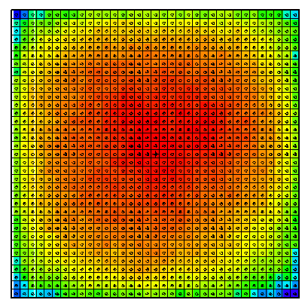

Figure 7: Standard Monte Carlo, “Converged” with 2 million histories

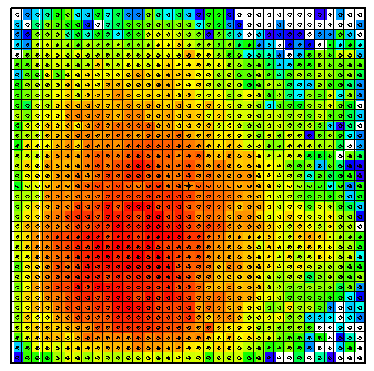

Figure 8: Standard Monte Carlo, 50K histories (poor convergence)

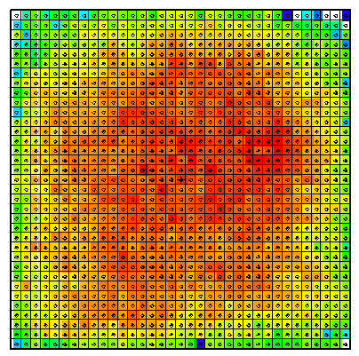

Figure 9: Vacation Matrix method, 50K histories (adequate convergence)

    - User Interface
The 24th entry of the DBCN card is used to toggle between different matrix implementations. The default value of DBCN(24) is zero, when no matrix method is used. The IDUM card is used in conjunction with the DBCN card to produce more options, as described.

DBCN(24) Table |  | Geometry Specification
 |  | cell | mesh
Fission Estimate | collision | 2 | 3
Fission Estimate | track-length  [IDUM(3)=0] | 5 | 4
Fission Estimate | combined [IDUM(3)≠0] | 5 | 4

(Special diagnostics to the screen terminal are also available. If DBCN(24)=-1, the cell based collisional vacation matrix will be written to the screen. If DBCN(24)=1, the cell based collisional vacation matrix will be used and written to the screen.)

The optional IDUM card entries have the following functions:

IDUM(1) = 0 : bias B range of 0.7 < B < 2.3 (default)
≠ 0 : bias B range of 0.1·idum(1) < B < 3.0 – 0.1·idum(1)

IDUM(2) = 0 or 6 : average vacation matrix (default)
= 5 : raw (cycle) vacation matrix
= 4 : average fission matrix

IDUM(3) = 0 : no change to fission estimate (default)
≠ 0 : used with DBCN(24)= 4 or 5, combined fission estimate

If the cell based geometry is used, each fissionable cell defined in the problem occupies one dimension of the solution matrix. If the mesh based geometry is used, the MESH card must be used to define the superimposed mesh, and the WWG card must be used with an arbitrary tally (1st entry equal to tally number, 2nd entry zero). The mesh is defined exactly as for the weight-window generator, and it must overlay all fissionable material. When the mesh based geometry is used, the solution matrix is dynamically accumulated according to whether each mesh zone through which the tracked particles pass is fissionable.

MCNPX Feature EXTENSIONS and Enhancements
Several MCNPX features have been extended and have included changes or additions to the user interface:

- proton step-size control: HSTEP on M card (GWM),
- new photon emission data: PHTLIB (REP/GWM),
- new S(α,β) scattering law (REM/GWM/JSH),
- differential data tallies extended to table physics (GWM),
- neutron models produce light (A<4) nuclei < 100 MeV (REP/GWM),
- weight-window upper bounds limiter (GWM/JSH),
- separate printout of induced fission multiplicity (JSH),
- weight-window MESH angles in radians and degrees (JSH),
- interrupts in electron tracking (GWM),
- extension of ZAID identifiers (GWM),
- LINLIN contour plot defaults (GWM),
- weight-window contour plot improvement (GWM),
- allow deleted segment surfaces (FXG),
- improved Windows installation (MRJ/GWM),
- spherical GRIDCONV (MRJ),
- spherical mesh tally plots (GWM),
- delayed-gamma enhancements (JWD),
- photofission yield data (JWD),
- decay omitted from NOACT=-2 LCA option (GWM);
- piping PTRAK results (RCJ);
- muon capture secondary particle production (GWM/RCJ/MRJ/MWJ); and
- additional enhancements.

Proton Step-Size Control
The proton step size can be controlled by a new keyword, hstep, on the material Mn card:

Mn hstep = m .

For example,

M123 estep = 10 hstep = 15 .

The hstep keyword for protons works just like the estep keyword for electrons. The hstep keyword causes the number of proton substeps per energy step to be increased to m (15 in the above example) for the material (123 in the above example). If n is smaller than the built-in default found for this material, the entry is ignored. Both the default value and the estep value actually used are printed in Print Table 85 in the MCNPX output file.

The estep keyword is used only for electrons, and hstep is used for all other charged particles. If estep is specified and hstep is not, then the estep value is used for hstep to preserve backward compatibility.

New Photon Emission Data
The “new” Nov 2001 BCDLIB gamma emission data—which becomes PHTLIB in binary form—are now the default. The BCDLIB library contains a better description of the gamma decay process and produces a better gamma decay spectrum. Gamma emission from metastable states is blocked for half-lives >1 ms. Thus, MCNPX consistently provides the prompt emission spectra. The BCDLIB data contain the nuclear structure data needed to generate deexcitation photons.

The BCDLIB file is found in the MCNPX source directory under Data/LCS. When MCNPX is compiled, the PHTLIB (binary version) is created. The PHTLIB creation also has been corrected to eliminate several long-lived decay gammas that were >1 ms.

Users of executable MCNPX versions should use the latest PHTLIB file. After unzipping Win32.zip or Linux.tar.gz, etc., the files PHTLIB and BERTIN in the data directory should be used and put in with the other cross sections from ENDF, etc.

Users who compile MCNPX should get the latest PHTLIB from their build directory,
Build_directory/src/phtlib/phtlib .

New S(α,β) Scattering Law
A new S(α,β) tabular data scattering law from NJOY (REM, T-16) was added for compatibility with forthcoming ENDF/B-VII data libraries.

Differential Data Tallies Extended to Table Physics
Differential cross-section data now may be calculated and tallied in the table physics region. When noact=-2 (8th entry on the LCA card), the sourced particle immediately collides in the source material. All subsequent daughter particles then are transported without further collision, as if in a vacuum. Differential cross sections (secondary energy and/or angle distributions, residual nuclei and light ions, and other information) then can be calculated and tallied with an F1 or F8 tally. The tallied data then can be plotted.

The noact=-2 option no longer automatically sets all physics to model physics. Now, table physics is used whenever possible to get the differential data actually used in a given problem. To get the differential data with models only, the use of table data can be turned off with the PHYS:pl card, 5th entry.

Neutron models produce light (A<4) nuclei < 100 MeV
It has been a long-standing issue that the MCNPX physics models will not produce a neutron interaction for some light nuclides (e.g., A=3) below ~100 MeV. Now such production is the default. Although the cross sections are not the best, one can now use models for things like n+He-3 which will then produce correlated secondaries.

Weight-Window Upper Bounds Limiter
An 9th entry has been added to the weight-window parameter card to limit the maximum lower weight-window bound. The WWP card is as follows, with the changes in boldface:

WWP:p Wup Wsurv MXSpl Mwhere Switch Mtime Wnorm ETsplt WU

where
Wup = upper bound is Wup times lower bound from WWN or MESH (default = 5)
Wsurv = Russian roulette survivors get this weight times lower bound (default = 3)
MXSpl = never split or roulette more than MXSpl for 1 (default = 5)
Mwhere = -1/0/1 = check windows at surfaces/surfaces and collisions (default)/collisions
Switch =-1/0/S = get windows from file/WWN (default)/S divided by IMP value
Mtime = 0/1 interpret WWE energies as time bins (obsolete – use WWT)(default = 0)
Wnorm = multiply all window bounds by Wnorm (0 default = 1.0)
ETsplt = MCNP5 only
WU = lower window lower bounds will never exceed WU (0 default = no limit).

In many problems tracks passing through a cell will only rarely score or will score very low, resulting in a very large generated weight-window bound. Also adjoint Monte Carlo generation of weight-windows results in unreasonably high weight-window bounds. When these windows are used (WWP card) in a subsequent run the ultra-high windows roulette nearly all particles in those phase space regions resulting in no future estimate for the WWG and potentially biasing results. The 9th entry on the WWP card limits the maximum lower weight-window bound for any particle, energy, or time, to WU. If WU is zero or unspecified, then there is no limit.

Separate Printout of Induced Fission Multiplicity
Induced fission multiplicity now is printed separately instead of being combined with spontaneous fission in Print Table 117.

Weight-Window MESH Angles in Radians and Degrees
The mesh-based weight-window generator required that azimuthal angles for cylindrical meshes be specified in revolutions. Now these angles and the polar and azimuthal angles of spherical meshes may be specified in revolutions, radians, or degrees. For example, consider the following spherical geometry MESH card on which the polar (JMESH) and azimuthal (KMESH) angles are specified in revolutions.

MESH geom SPH origin 7 -9 -12 ref -23 39 -10 axs .4 -.5 .2 vec .1 -.2 -.7
imesh 60. iints 3
JMESH .1 .35 .5 jints 1 1 1
KMESH .2 .85 1 kints 1 1 1

These angles may now be specified in degrees or radians as well as revolutions. Thus the jmesh and kmesh entries for the above mesh card specified in degrees would be:

jmesh 36 126 180 jints 1 1 1
kmesh 72 306 360 kints 1 1 1

The jmesh and kmesh entries for the above mesh card specified in radians would be:

jmesh .6283185 2.199114 3.141592 jints 1 1 1
kmesh 1.256637 5.340707 6.283185 kints 1 1 1

MCNPX recognizes the appropriate units by looking for .5, 3.14, or 180 for the last spherical geometry jmesh entry and for 1, 6.28, or 360 for the last spherical or cylindrical kmesh entry.

Interrupts in Electron Tracking
The <ctrl-c> interrupts now work during electron tracking. Normally, at the start of each <ctrl-c> particle track, or trajectory, MCNPX checks to see if the interrupt flag has been set. However, for electrons that may have many substeps, another tracking algorithm, DBMIN, has interrupts that previously were not checked. DBMIN finds the minimum distance to a boundary from a point, and then all tracking (substeps) within that distance of the point does not have to check bounding surfaces. By checking for <ctrl-c> interrupts in DBMIN, these interrupts now work better for electron problems (GWM, 4/19/06).

Extended ZAID Identifiers
The ZAID identifier may now be alphanumeric to allow more nuclides. Examples would be 1001.abc or 1001.xyc or 1001.a9c, all of which are continuous-energy neutron libraries.

LINLIN Contour Plot Default
The default interpolation scheme for tally contour plots (FREE SC) is now LINLIN to avoid carrying over a default of LINLOG, LOGLIN, or LOGLOG, which then truncates out all the values less than zero. This extension was suggested by Róbert Kákonyi at the University of Szeged, Hungary.

Weight-Window Contour Plot Improvement
The weight-window contour plots now plot white instead of blue for zero (no window game played) and negative (zero importance) windows instead of blue for zero windows (GWM 4/3/06).

Allow Deleted Segmenting Surfaces
The tally segmenting capability (FSn tally card) was extended to work for segmenting surfaces that are deleted duplicate surfaces. The undeleted duplicate surface then is used automatically. This enhancement was suggested by Jeff Bull. (Franz X. Gallmeier/GWM, 4/24/06).

Improved Windows Installation
The windows configuration and installation has been improved (MRJ, GWM 6/2/06.)

A new version of GNU Make is included in the MCNPX source files. The upgrade from 3.79 to 3.81 fixes the problem of having a PATH environmental variable that exceeds 255 characters. This eliminates the need for running "Makepath" before building the MCNPX executable on Windows; however, this assumes that the person who installed your MSVC and Intel compilers requested the installer to update your environment variables. If you use this new version of Make and get a compile/link error during the build (e.g., can't find some library), most likely your environment variables are not permanently set. You have 3 options:

1) Permanently update your environment variables using the My Computer (right click) => Properties => Advanced => Environment Variables. The important variables are: INTEL_COMPILER8.0 (or perhaps INTEL_FORTRAN80), INTEL_SHARED, INTEL_LICENSE_FILE, PATH, LIB, and INCLUDE. You should see these set in your MAKEPATH.BAT file as well. Simply create or edit these environment variables and set them to the values listed in your MAKEPATH.BAT file. The one I found missing from my LIB variable was the following (note you do not have to worry about the length of these paths anymore):

D:\Program Files\Microsoft Visual Studio .NET 2003\Vc7\PlatformSDK\Lib

2) Run the MSVC and Intel batch files to set your environment variables before building MCNPX (vcvars32.bat for MSVC and ifortvars.bat for Intel). Of course this is just as much of a hassle as running MAKEPATH.BAT each time.

3) Continue executing MAKEPATH.BAT before you compile.

Also, execution of the test problems in parallel has been improved by forcing problems 18 and 36 to run sequentially.

Spherical GRIDCONV
The GRIDCONV auxiliary code, which takes MCNPX mesh tallies from the MDATA files and processes them into a usable form for Tecplot and other graphics packages, has been extended to plot spherical mesh tallies. The GRIDCONV modification is to provide all three coordinates in spherical meshes to Tecplot.

To plot the spherical mesh in Tecplot do the following:

use the Data->Alter->Transform Coordinates menu option.
In the menu box, set Transformation to "Spherical to Rectangular"
Set the Theta variable to "A"
Set the Radius variable to "R"
Set the Psi variable to P
Leave the default to Create New Variables
Set Angles to "Degrees"
Hit "Compute" button.

Once the transformation is complete, hit "Close" and go to the upper left hand corner and change the pull down menu from 2-D Cartesian to 3-D Cartesian. From there, under Plot->Assign XYZ, set the X, Y and Z variables to the variables you just created and you should get a nice global style plot. Make sure when you specify a Contour plot that you’re plotting the "flux" variable (or whatever variable is of interest).

An example is illustrated below. (MRJ, 7/20/06)

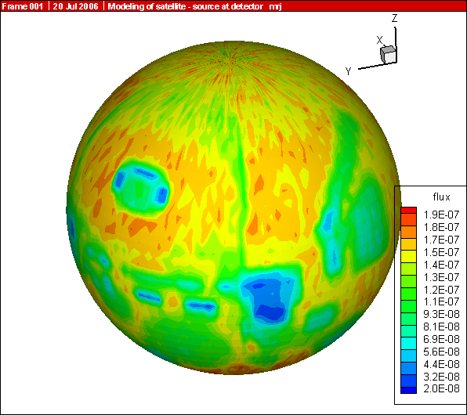
p_1MeV.png

Spherical Mesh Tally Plots
Spherical mesh tally grids may now be plotted just like cylindrical mesh tallies. (GWM, 10/31/07)

Delayed-Gamma Enhancements
Delayed-gamma emission now works with nuclides having delayed-neutron table data as in the .66c data libraries. Further, analog capture no longer needs to be forced with the 3rd entry of the CUT:N card for delayed-gamma emission. Thus MCNPX will now execute when the user uses default delayed-neutron gamma settings. (JWD, 7/02/07)

Photofission Yield Data
New photofission-yield data have been calculated using CEM for 12-MeV photons. These data are available for ²³³U, ²³⁴U, ²³⁵U, ²³⁶U, ²³⁸U, ²³⁷Np, ²³⁸Pu, ²³⁹Pu, ²⁴⁰Pu, ²⁴¹Pu, ²⁴¹Am, and ²⁴³Am. These data reside after the neutron-fission-yield data on the cinder.dat file. (JWD, 10/17/07)

Decay Omitted from LCA NOACT=-2 Option
The LCA 8th entry is noact. If noact = -2, source particles immediately collide; all secondary particles produced are then transported with no interactions and, as of MCNPX26E, no decay. The noact = -2 option is used to compute, tally, and plot double-differential cross sections and residual nuclei with an F1 or F8 tally in conjunction with the FT RES option. (GWM, 10/2/07)

26F

Piping PTRAC Results
PTRAC results may be piped to a second code receiving periodic updates of Monte Carlo histories while MCNPX is generating them. Unix Named pipes are considered more reliable than attempting to have two processes writing and reading from a potentially huge file. Pipes are also less system dependent than MPI or PVM message passing.

PTRAC piping is controlled by two new options for the FILE keyword on the PTRAC input card:

PTRAC file=AOV

PTRAC file=BOV

The FILE keyword options are ASC, BIN, AOV, and BOV. ASC and AOV write ASCII PTRAC information; BIN and BOV write binary information. AOV or BOV will overwrite an ASCII or binary file to a named pipe on unix systems. AOV and BOV options are identical to the respective ASC and BIN options, other than they require the PTRAC file to exist prior to execution. The PTRAC file, if it is a regular file, will be overwritten. (RCJ, 11/29/07)

Muon Capture Secondary Particle Production
To simulate the production of muonic X-rays, MCNPX has been extended to account for particle production from negative muon capture. This includes not only the X-ray component, but secondary particle production from the decay or fission of the nucleus, should an X-ray be absorbed in the nucleus, or should the muon undergo capture on a proton in the nucleus. Currently hyperfine-split K- and L-shell X-ray lines are hardwired into the code for B-10, B-11, C-12, C-13, O-16, O-17, O-18, Fe-54, Fe-56, Fe-57, Fe-58, I-127, Cs-133, Pb-204, Pb-206, Pb-207, Pb-208, U-235, and U-238. Please contact the MCNPX team if you would like additional lines; we have an active program to calculate new lines. A warning is given if the muon captures on a nuclide where no X-ray lines are available. In these cases, no further muon-nucleus capture will take place. (This will be changed in future versions of the code.) In cases where the muon does capture on a nucleus, CEM physics is used for the nuclear de-excitation or fission.

In previous versions of MCNPX, muons have undergone only slowing down from ionization, and decay in flight with a half-life of 2.19703e-6 seconds. In decay, the electron, muon neutrino and anti-electron neutrino are banked for transport if these particles appear on the MODE card. The default lower energy cutoff for muon transport is 0.113 MeV; a value that can be changed with the second entry on the cut:| card. In the current version of the code, once the muon reaches the energy cutoff, it enters into the new muon capture physics routines. The capture nuclide is sampled from all nuclides in the material using F*Z weighting, where F is the atomic fraction of all elements with atomic number Z. One or more L-shell X-rays are sampled and banked for further transport. Next, one or more K-shell X-rays are sampled. A K-shell X-ray may be emitted, in which case it is banked for future transport, or the X-ray may be absorbed by the nucleus with a probability of absorption that varies by Z for Z~>82. Less than Z~82, the energy of the X-ray is too small to make a significant contribution to absorption. We do intend to revisit the question of resonant absorption on light nuclei in the future. If the X-ray is absorbed, CEM is called to calculate the de-excitation (by neutron emission) or fission of the excited nucleus. The excited nucleus has no change in Z or A from the original capture nuclide, but it will have the muon attached. If fission occurs, the muon attaches to the larger of the two fragments.

The negative muon attached to the nucleus may decay or may be captured by a proton in the nucleus. A lookup table based on the Primakoff relationship is used to calculate the lifetime of the muonic atom. A bound muon disappears at a different rate than a free muon, since both capture and annihilation channels are open. If it decays, the electron and neutrinos are banked for further transport. If it is captured, the residual is set to (Z-1, A), indicating the preferred channel of capture on a proton. Currently a single excitation distribution is used for all nuclides to assign a nuclear excitation, and CEM is used to determine the subsequent decay or fission of the excited residual. Improvements in the muon capture routines will be made in the future, especially for the excitation function and for the fission barriers which are affected due to the modified charge distribution induced by the presence of the muon in the nucleus.

There is no change to the MCNPX user interface, this capability is turned on at all times. (GWM/RCJ/MRJ/MWJ, 10/26/07)

Additional Enhancements
    - ILOG interpolation
MCNPX now recognizes either log (MCNPX) or ilog (MCNP5) notation for logrithmic interpolation on input cards. For example,

E99 1.e-6 4log .1 4ilog 1e4

Either log or ilog may be used interchangeably. (JSH, 11/30/07)

    - MODE J R

MCNPX now allows I J M R particle types on mode card instead of interpreting these as special input characters for interpolate, jump, multiply, and repeat. (JSH, 11/30/07)

    - Photofission prompt gamma warning

Use of photonuclear data libraries for Z > 89 now causes the following warning error message:

Warning. "z>90 has no photofission prompt gammas - use model."

Presently all photonuclear data tables do not include prompt gammas from photofission. (JSH, 11/30/07)

    - NNDC Delayed-Neutron Emission Probabilities

Delayed-neutron emission probabilities from the National Nuclear Data Center (NNDC) at Brookhaven National Laboratory (BNL) have be added to the CINDER database in file cinder.dat. The NNDC data covers all nuclides with Z<26. Of the ~80 nuclides on the NNDC list with nonzero delayed-neutron emission values, only ~40 of these were included in the CINDER database. The NNDC data make it possible to model neutron activation of O-17 to produce delayed neutrons from O-17[n,p]N-17. (GWM, 12/17/07)

MCNPX Corrections

Significant Problem Corrections
The following problems could cause incorrect answers. Fortunately, they occur only in very special situations and affect only a few MCNPX users.

    - Auger Electrons Below Energy Cutoff
Auger electrons were not made from photoelectric fluorescence, and tally heating from fluorescence was neglected when produced by photons below the photon energy cutoff. The effect is small and has been found in all previous MCNP and MCNPX versions. The affected tallies are the MCNPX +F6 and F6:e tallies. A $2 award was made to Greg Cunningham (ISR-1, LANL) (D-5:JSH-2006-18) (GWM).

    - Detectors in Lattice Geometries
Point detectors in lattice geometries could cause a crash. Possibly answers could be wrong without a crash. The error results because the levp variable could be changed erroneously in (and thus needed to be restored after) the do 695 loop in subroutine tallyd. The possible problem has occurred in all previous MCNP and MCNPX versions. A $2 award was made to Kin Yip (Brookhaven National Laboratory) (D-5:JSH-2006-111) (GWM, 3/7/06).

    - KCODE/PRDMP 5th Entry
If the PRDMP 5th entry is not one for KCODE problems, then RUNTPE files can crash and other problems can occur because an array overflows. The problem occurs only if the TFC update frequency, NPD, the 5th entry, is larger than the current KCODE cycle, KCY, when adding to the tally fluctuation charts. In most cases, this is not a problem because the default value for NPD with KCODE is “1”. A €20 award was made to Sergey Belousov (INRNE-BAS, Sophia, Bulgaria) (D-5:JSH-2006-112) (GWM 4/19/06).

    - CEM03 Corrections
A number of small corrections were made to CEM03 by Dick Prael and Gregg McKinney to correct for Z/A imbalances (REP/GWM 6/2/06).

    - SDEF Fails with SP -31 x for Equiprobable Bins Sampling
Exponential sampling (SPn -31 x) failed for equiprobable bins (SIn a1 a2 a3 …) if there were fewer than three entries on the SP card. The problem has been in all previous MCNP/X versions and only affects AXS and VEC keywords in the rare use of the equiprobable bin (partial range on SI) treatment (GWM 2/27/07).

    - Surface Sources in Repeated Structures
Surface sources fail in repeated structures. When the surface source particles are read for a history, the coordinates of the first one are saved and then the subsequent particles from that history are put into the bank. When the first particle of the history is retrieved for transport the coordinates in all but the lowest level have been forgotten. Instead, coordinates are used for other particles that were banked. Eventually this causes the particle to get lost or have a “zero lattice element hit error.” The problem is in all MCNP4C and later MCNP and MCNPX versions. A $2 award was made to Steven Van Der Marck, NRG, Netherlands, X-3-MCC:2007-057 (GWM 4/16/07)

    - Periodic Boundary Conditions in Repeated Structures
Periodic boundary conditions in repeated structures can lose particles or have “zero lattice element hit” errors due to a bug in all MCNP and MCNPX versions. A $2 award was made to Phillipe Maes, Tractebel, Brussels, Belgium, X-3-MCC:2007-055 (GWM 4/18/07)

    - Delayed Neutrons/Gammas with Biased Photonuclear
The delayed-neutron/gamma treatment is wrong with biased photonuclear production turned on and with photonuclear libraries. This is because the particle weight is not properly reset after the photonuclear biasing. The problem only affects MCNPX 26C for this developmental feature. The correction has been made in MCNPX 26D to reset the particle weight to the incident photonuclear photon weight before calling the delayed-neutron gamma model (DNG_MODEL) (Ken Adams, SAIC, San Diego, GWM 1/6/07).

    - Delayed Neutrons/Gammas Inelastic Scatter
The delayed-neutron/gamma treatment (DNG_MODEL) was wastefully and perhaps incorrectly called for center-of-mass inelastic scatter collisions (one particle out) and elastic scatter collisions (GWM 4/6/07).

    - Delayed Neutrons/Gammas from (n,p) Reactions
The delayed-neutron/gamma treatment (DNG_MODEL) did not generate delayed neutrons and gammas from (n,p) (MT102) reactions (JWD 5/29/07).

    - Delayed Neutrons/Gammas with Biased Photonuclear
The delayed-neutron/gamma treatment now selects the "A-1" fissioning nuclide rather than the "A" nuclide sent by ACECOL for photonuclear reactions, significantly affecting spectral output (JWD 06/13/07).

    - Parallel Burnup/Depletion Calculations with Model Cross Sections
The atom fractions of isotopes using model cross sections in a parallel burnup/depletion calculation were not updated at the end of each time step due to a bug in Versions 26C and earlier. Versions 26D corrects this bug and updates the atom fractions of isotopes using model cross sections in a parallel burnup/depletion calculation at the end of each time step (MLF 4/01/07).

    - Surface Sources in Repeated Structures
Surface source particles in repeated structures geometries (using universe U= and FILL=) could lose particles and/or with lattices have “zero lattice element hit” bad trouble errors. $2 awarded to Steven C. van der Marck, NRG, Netherlands, X-3-MCC:2007-057. (GWM, 6/13/07)

    - No Fatal Error for LAT without FILL
Specifying a lattice (LAT=) without a FILL generally makes no sense and could cause wrong answers. It is now a fatal error for a cell card to have LAT but not FILL. Previously, omitting the FILL parameter was accepted and worked correctly for a “real world infinite lattice” (U=0), in which case the lattice elements were filled with the material and density of the lattice cell. But for an infinite lattice that filled a cell (U≠0), trying to fill the lattice with its own universe or material gave a fatal error if a FILL parameter was used and wrong answers if a FILL parameter was omitted. $2 awarded to Mathieu Agelou, CEA-Saclay, France, X-3-MCC: 2007-061 (GWM, 7/9/07)

    - Double Fluorescence with Pulse Height Tallies and WWP or ESPLT
Double florescent photons scored incorrectly to pulse height tallies when either weight windows (WWP) or energy/time splitting (ESPLT) was used in the problem. Reported by Jeff Bull, LANL X-3-MCC (JSH, 8/16/07)

    - Burnup of 1000 or More Materials without MAT Keyword
The burnup was not capable of burning more than 1000 burn materials when a MAT keyword was not specified on the BURN card due to a limit set in MCNPX 2.6.D. MCNPX 2.6.E corrects this limit and allows the user to examine as large a problem as computer memory permits (MLF 7/10/07).

    - Power Fraction Calculation for Burnup
The power fraction calculation in MCNPX26D was not properly volume weighted. MCNPX 2.6.E properly volume weights the power fraction calculation (MLF 08/17/07).

    - DATAPATH Sometimes Chosen Incorrectly
The DATAPATH tells the code where to get cross-section information. The hierarchy for locating the cross sections is the following:
- The current working directory;
- The directory specified by the DATAPATH variable on the MCNPX execution line;
- The directory specified by the DATAPATH variable in the Message Block in the input file;
- The DATAPATH environmental variable;
- The DATAPATH in the XSDIR file;
- The DATAPATH hardwired in the MCNPX source (/usr/local/lib for Unix, or C:\MCNPX\XS for Windows).
Both MCNP and MCNPX have always incorrectly set the DATAPATH in the case where (a) no environmental variable is set, (b) no path is input in the Message Block/execute line, and (c) the hardwired DATAPATH contains data. In this case, the DATAPATH specified in the XSDIR file can be overlooked. Note that as always, only the first two valid DATAPATHs will be used by the code, so if XSDIR is not in the local directory and the DATAPATH on the execution line, message block, or environmental variable is set but incorrect, then the hardwired DATAPATH will not be checked. $2 awarded to David Dixon, LANL D-5, X-3:2008-001 (GWM, 10/3/07)

    - SSW s(-c) Can Fail with Repeated Structures
The SSW surface source write enables writing particles to a surface source that cross a specified surface, s. The particles may be filtered (omitted) if they do not enter or leave specified cells on the other side of specified surfaces. A cell may specified, SSW s(c), where c is the cell on the other side of surface s into which particles enter, or SSW s(-c) where c is the cell on the other side of surface s from which particles depart. In repeated structures, if c4 < c3 < c2 < c1 < c0 are cells at levels 4, 3, 2, 1, 0 from which a particle departs, suppose a particle in lev = 4 in cell c4 crosses a surface at lev = 2, thus exiting cell c2. In MCNPX25E and MCNP (all versions) c = c2 and specification of c4 would only work if c4 and c2 shared the common surface, s. In MCNPX25F – MCNPX26D, c = c4. The change was inadvertently introduced on January 27, 2005, when MCNPX was corrected to enable pulse-height tallies in repeated structures. Generally, c = c2 would be the desired case, though specifying c = c4 is usually easier.

MCNPX is now extended to allow either c = c4 or c= c2 to be specified to write particles crossing surface s in the lowest level cell (c4) but crossing surface s at a higher level leaving higher level cell (c2). User caution is advised because the code only knows which s(c) or s(-c) combinations are correct during particle transport; incorrect user specification cannot be identified with an error message when reading the input file. The user can either specify the lowest level cell which may or may not bound surface s; or the user must know the departing cell at a higher level where the surface crossing is made which is the level of the cell into which the particle crossing surface s enters. This is obvious only if surface s is specified only at one level.

Note that the change from c = c2 to c = c4 in MCNPX25F could be considered an undocumented feature change rather than a bug. And the MCNPX26E change to accept both constructs could be considered a feature extension. Nonetheless, €20 was awarded to Steven van der Marck (NRG, Petten, Netherlands) (X-3:JSH-2008-002) (JSH).

    - F6 Heating Tallies Wrong for Photonuclear
Heating tallies have always been wrong (all MCNP and MCNPX prior to MCNPX 26E) for photonuclear events. The code sets a flag when electrons are produced so that their progeny photons are not counted twice in F6 heating tallies. The flag is now reset for photonuclear events so that neutrons, photons, and other photonuclear particles and their progeny score to F6 heating tallies. Once photons produce electrons they and their progeny photons no longer score to F6 heating tallies to avoid being double counted.

The error is usually unnoticeable unless photonuclear production makes significant contributions to F6 heating tallies. The error is most pronounced in electron source problems with neutron heating tallies. $2 awarded to Yousry Gohar, ANL, X-3-MCC:JSH-2008-003 (JSH) 10/5/07

26F

    - Heavy Ion Directions
Heavy ion residual particle directions are now set correctly. In MCNPX 26E they are wrong and usually led to lost particles or direction cosines summing to zero. (MRJ) 12/04/07

    - Photonuclear Mix and Match
Photons at exactly the maximum photonuclear table energy or below the model physics range erroneously had a zero photonuclear production cross section. This is rare and so far has only happened when the source is specified exactly at the maximum photonuclear data table energy.
Photonuclear library cross sections were always used below the maximum table energy and photonuclear models were always used above. MCNPX has been corrected so that when a photonuclear library is specified (M, MX cards) the library data will be used at or below the maximum table energy. Model cross sections are used above the model physics range. The highest table value will be used at the maximum table value and if an energy is ever between the maximum table value and the minimum model physics range. (JSH, 12/05/07)

    - Mesh Tally Gaps
Mesh tally tracking in all code versions could prematurely stop and return to particle tracking in some cases. This premature stopping would underestimate fluxes, heating, and other quantities and show up as a gap in the plot. Because the problem so clearly shows up in mesh tally plots, it probably does not affect anyone who has had a reasonable plot picture.

The problem arises when a particle enters a cell and begins checking for intersections with mesh tallies along its track (this effects all particles). The particle only looks for a crossing on the current plane of the mesh. Once it finds that stepping the particle to that plane means that the particle is still not in the mesh, it gives up and returns to transporting of the particle history. Intersections with other mesh planes are never checked. It is only when the particle has another interaction or surface crossing that the track is rechecked and it finds the mesh tally properly.

The solution in MCNPX26F is to force the particle to check all the outer surfaces of a Cartesian mesh before returning.

$2 awarded to Michal Mocko, LANCE-LC, LANL, X-3-MCC:JSH-2008-038 (MRJ) 2/22/08

Minor Problem Corrections
The following problems do not cause wrong answers, but they may cause crashes when encountered. In any case, they occur only in very special situations and affect only a few MCNPX users.

    - Cylindrical Weight-Window Mesh
Neither the weight window nor the weight-window generator cylindrical meshes properly used the theta bin. The improper use affected using, generating, and plotting these weight-window meshes. Cylindrically symmetric meshes (no theta bins) were unaffected. Answers also were not affected because variance reduction affects only efficiency (GWM/JSH).

    - I8 Mesh Tally Plots
Improper initialization caused mesh tallies not to plot in MCNPX versions compiled with the I8 configuration option, namely, 64-bit integer code versions. A $20 award was made to Bill Schmitt (Draper Labs, Massachusetts) (D-5:JSH-2005-190) (GWM/JSH).

    - Continue Cards for Input with FATAL Errors
Continue cards failed for input with FATAL errors. A $2 award was made to Valery Taranenko (GSF, Germany) (D-5:JSH-2005-191).

    - Sometimes Can Plot Only First Mesh Tally
Geometry plots in the command mode (the mode with the PLOT> prompt) for mesh tallies failed in some cases:

PLOT> TALnn.m .

The above command would plot only the first mesh tally if there were non-mesh tallies in the same problem (JSH).

    - Incorrect KCODE/Message Passing Interface (MPI) Error Message
The warning error message, “KCODE with load balancing is very inefficient,” had a bad format that caused a crash whenever criticality problems were run in parallel with load balancing. A €20 award was made to Steven van der Marck (NRG, Petten, Netherlands) (D-5:JSH-2005-239) (GWM).

    - Incorrect LCS Error Message
The LAHET (LCS) diagnostic message for “projectile negatives” and “target negatives” incorrectly listed the atomic number twice rather than the Z-number and then the atomic number. A $2 award was made to Igor Remec (ORNL) (D-5:JSH-2005-238) (GWM).

    - Mesh Tally Writing to Backup RUNTPE
The mesh tallies could cause a crash when writing to backup runtpe files. The backup runtpe files are those temporarily created for the PRDMP 3J N option, which allows overwriting the runtpe file with only the last N dumps to conserve space. A €20 award was made to Steven Van der Marck (NRG, Netherlands) (D-5:JSH-2006-005), who also provided the correction.

    - Pulse-Height-Tally Variance Reduction Techniques with MPI
Pulse-height tallies (F8) with variance reduction techniques crashed when run in parallel with MPI. A $20 award was made to Ronald McConn (PNL) (D-5:JSH-2006-019) (GWM).

    - PTRAC and Event Log Omission
Both PTRAC (PTRAC card) and Event Logs (DBCN card) write the individual events of a history. Neither wrote collisions using physics models (rather than data tables) in the mix-and-match energy range. (GWM, 4/12/06)

    - FM Tally Multiplier in Model Physics Regime
The FM (tally multiplier) multiplies tallies by cross sections and other quantities from the MCNPX data libraries. If the tally is at an energy above the highest energy in the data tables, that is, in the model physics energy region, then MCNPX (like MCNP) uses the cross section at the highest energy of the table. However, when a model is used instead of a data table, then no data table values are available at lower energies and MCNPX may crash or get erroneous answers. In some cases, this crash happens in the mix/match energy region between the lowest data table energy and the highest data table energy. The new approach (starting with MCNPX 26B) is to issue an error message at the first occurrence of an FM multiplier above the energy range of a data table and then to return a zero multiplier (MRJ, 4/18/06).

    - Make Clean Enabled for PC Build
The Make Clean command now works at all levels of the build system on PCs (GWM, 5/25/05).

    - Zero Electron Mesh Tallies
Electron mesh tallies gave all zeroes in void regions. Corrected by GWM, 2/23/06, and $2 awarded to Carlo Petrovich (ENEA, Bologna, Italy) (D-5:JSH-2006-101, 4/24/06).

Note that a low-density issue also exists in the workaround, namely adding materials of very low densities. For heavier-charged particles, a numerical problem occurs in the straggling routines with densities <~1e-9 g/cm³ and with densities <~1e-15 g/cm³ for electrons. For now, users should avoid such low densities.

    - Universe Map
The universe map for lattice/repeated structures geometries, Print Table 128, could occasionally have an array overflow that caused a crash in rare cases, thus affecting all previous code versions. A $2 award was made to Benjamin Amiri, LANL, D-5 (D-5:JSH-2006-142) (GWM 5/26/06).

    - Tally Storages
Some tallies with large numbers of cells and surfaces can cause a “bad trouble” exit in MCNP with the message, “li>lit+1 the trouble is in the code, not in your problem.” The problem is that insufficient space is set aside for the TALLOC pointers to ITDS in OLDCD1 where there is a “T” (totals bin) on the F card. A $2 award was made to Benjamin Amiri, LANL, D-5 (X-3:JSH-2006-053) (GWM 7/13/06).

    - Lost Particles with Coincident REC Surfaces
If the REC (rectangular surface) macrobody has coincident surfaces particles could get lost. A $2 award was made to Richard Starr, NASA-Goddard (X-3:JSH-2006-069) (GWM 9/11/06)

    - GRIDCONV Compiler Bug
The auxiliary program GRIDCONV (for plotting mesh tallies) would crash for the Intel 9.1 complier because of the over-complexity of some write statements. These have now been simplified. (GWM 7/13/06)

    - Geometry Plot Basis Vectors
MCNPX now forces the geometry plot coordinate system always to be right-handed. Previously, it was possible to specify left-handed coordinate systems in some cases, which led to plotting errors or easily misinterpreted plots. (GWM/JSH 5/6/05)

The “Theta” command after the command prompt and the “Rotate” button in the interactive geometry plotter enable rotation of a geometry plot frame. The “PX”, PY”, and “PZ” commands after the command prompt and the “XY”, “YZ”, and “XZ” buttons in the interactive geometry plotter enable changing the view of a geometry plot frame. Because these commands only changed the first two basis vectors of the plot, and not necessarily the third, a left-handed geometry would sometimes result. This in turn sometimes caused improper drawing of cell or mesh boundaries. Now whenever the first two basis vectors are changed the third is always generated as the cross product ensuring a right-handed coordinate system only. (JSH 9/27/06)

    - WWN Label Error
If “WWN” is selected as the label quantity in the interactive geometry plotter, the values displayed would not be the weight windows. (JSH 8/1/06)

    - READ Card Placements
If the READ card is part of a continued line in the cell cards an index was out of range which could cause a crash. (RCJ 10/5/06)

    - Residual Nucleus Warning
Print only the first warning message instance of “residual nucleus out of ft8 res bin range” and then count the occurrences in the out-of-range user bin count. This prevents getting excessive warnings, particularly when only part of the residual nucleus range is being examined and for delayed-neutron/gamma problems (GWM 02/14/07).

    - S(α,β) Ultra-Low Energies
The new ENDF/B-VII data enables neutrons to downscatter below 1.e-11 MeV which causes the S(α,β) physics to crash. The reaction where this occurred was a non- S(α,β) elastic scatter off oxygen. The following possible fixes were not made:
- only call SABCOL S(α,β) for neutrons with E > 1.e11 MeV ;
- return from SABCOL without doing S(α,β) physics if E < 1.e11 MeV.
We chose to reset the energy to 1.e-11 MeV and then do the S(α,β) physics. This is reflected in the summary table as an upscatter and with this approach the molecular binding effect is not neglected. The problem of such ultra-low energy neutrons must be very rare for this crash not to have happened earlier (GWM 4/6/07).

    - Large Problem Sizes for Parallel Execution
The maximum message size limit in the MPI implementation in MCNPX caused problems to crash or hang when the arrays being passed exceeded it. In particular, problems involving many tallies and/or burnup problems with many materials would exceed the message size limit and fail. Now MCNPX segments the cross-section array into manageable sizes (less than the message size) when passing through an MPI call (MLF 05/20/07) times.

    - Mesh Tally TR Option
Mesh tallies using the TR card translate properly, but sometimes do not rotate properly. A $2 award was made to Choonsik Lee, University of Florida, X-3-MCC:2007-056 (GWM 5/14/07)

    - Crash for non-orthogonal spherical mesh direction cosines
The error message for non-orthogonal direction cosines for the spherical mesh weight-window generator had a typo causing MCNPX to crash whenever the user incorrectly specified AXS and VEC on the MESH card. MCNPX26C and 26D only. $20 awarded to Dudley A. Raine, III, SAIC, McLean, VA, X-3-MCC:2007-62. (GWM, 7/2/07)

26F

    - Mesh Tallies Keyword Capitalization
Mesh tallies may now use capitalized keywords. For example,

RMESH11:E PEDEP

Would result in

fatal error. illegal keyword: PEDEP

Now PEDEP, pedep, Pedep, etc., all work.

$2 Awarded Vitaly Kovaltchouk, Bubble Technology Industries, Chalk River, Ontario, Canada. X-3-MCC:JSH-2008-013 (GWM, 11/28/07)

    - Mesh Tallies Data Interpolation
The I notation for linear interpolation between entries in mesh tallies now works. Note that J (jump) and M (multiply) do not make sense. Further note that log and ilog interpolation and $ comments still do not work for MCNPX mesh tallies. $2 awarded to Brad Micklich, ANL, X-3-MCC:JSH-2008-019 (GWM, 12/04/07)

    - Power Fraction Calculation for Individual Burn Materials
The power fraction calculation for versions 2.6.d and 2.6.e was incorrectly referencing the xsec array causing all individual material power fractions to be set to zero. This referencing issue has been resolved and now the code properly calculates the power fraction of each individual burn material.

    - Negative MAT Numbers on the BURN card
Negative MAT numbers on the BURN card are used to allow a material to contribute to the flux normalization parameters without being burned in CINDER90.This feature was platform and compiler dependent for versions 2.6.d and 2.6.e. A fix has been implemented to make this feature platform and compiler independent. $20 awarded to Bruce Wilkin, Atomic Energy of Canada Limited, Chalk River Laboratories, Ontario, Canada, X-3-MCC:JSH-2008-029 (MLF, 2/8/08)

    - Print LAQGSM Flag
MCNPX26E gave no indication when LAQGSM is turned on. The LAQGSM flag, ILAQ, is now shown in Print Table 41 of the MCNPX output file. $20 awarded to Kin Yip, BNL, X-3-MCC:JSH-2008-044 (MRJ, 3/18/08)

    - Internal Corrections
- The 20th entry on the DBCN card now causes MCNPX 2.6.0 to track MCNPX 2.5.0 instead of MCNP4C3 and MCNPX 2.4.0. (JSH 4/7/05)
- The algorithm to change the size of singly-dimensioned integer arrays during the course of particle transport was corrected so that it no longer could cause array overflows. (RCJ 9/6/06)
- Out-of-bounds conditionals which fail on some compilers but have been in MCNPX forever were corrected. For example,
if (k.gt.0.and.t(k).eq.zero) …
will work on older compilers, but on new compilers if k=0 then t(k) will fail because both conditions are treated together. (RCJ 10/16/06)
- All references to the UNICOS operating system were deleted. (JSH 10/24/06)
- HTAPE3X had the appropriate I4 formats changed to I6 so that HTAPE3X could accommodate 5-digit cell and surface numbers. (FXG 9/12/06)
- Comments extending to column 80 were revised to prevent processing errors when updating (RCJ 5/15/07)
- Several FORTRAN90 constructs were fixed so that an array would not appear in an IF statement if it had not been dimensioned due to a conditional dimension (RCJ 5/15/07). For example,
if (ntburn.gt.0.and.kc8.le.0.and.matburn(icl).ne.0) call burn_trk(d,mk)
fails when matburn is not dimensioned. So the new construct is:
if (ntburn.gt.0.and.kc8.le.0) then
if (matburn(icl).ne.0) call burn_trk(d,mk)
endif
- The printout of CTM (computer time elapsed in a run) overflowed for very long. Now the printout has been expanded so the print will not overflow until after 19 years. (GWM, 7/2/07)
- Some large arrays for delayed neutrons/gammas were dynamically allocated (JWD, 7/2/07). Other corrections were made to allow problems to continue with a warning rather than a “hard stop.” (JWD, 10/03/07)
- Autoconfiguration was modified (config.guess) to enable compilation on 64-bit AMD linux systems or any system with x86_64 chips. (RCJ, 10/10/07)

26F

- G95 compiler optimization bug: a workaround to enable heavy ions transport was made by renaming function SIGMAD as function FSIGMAD to avoid a conflict with the LAQGSM variable SIGMAD. (GWM/JSH, 12/04/07)
- AIX compiler optimization bug: a workaround to an optimization error on AIX computers was added at the suggestion of Francisco Ogando (UNED, Spain): the IV variable in routine SOURCB is set with an IF rather than a mathematical expression (which has been used since MCNP4.) Thus specification of VEC on the SDEF card now works on his and possibly other systems at optimization level 3.
- Some heavy ion problems hung when the old version of the CEM data file level.tbl was read by LAQGSM. MCNPX will now ignore comments at the end of the level.tbl file.
- I8 compilation failed for LAQGSM because LAQGSM declared the variable istop to be integer*4. $2 awarded to William M. Schmitt, Draper Laboratory, Cambridge, MA, X-3-MCC:JSH-2008-028 (GWM, 2/8/08)
Plotting hung on 64-bit Linux compilers because of an uninitialized value of “*error flag” in C-routine gawk of MCNPC.C. $2 awarded to Rainer Wilcke, Scientific Software Support Group, ESRF, Grenoble, France, X-3-MCC:JSH-2008-030 (GWM, 2/8/08)

Future work
The following projects are at least partially funded and are actively being developed. These capabilities should be available soon in a future MCNPX version:

  - additional CINDER90 capabilities: fixed-source depletion,
- improved convergence of eigenfunctions in criticality problems,
- integration of HTAPE tallies directly into MCNPX, including continue runs,
- electric and magnetic field tracking.

The following projects are on our wish list. Some have been partially developed but await further funding.

- detectors and DXTRAN for all neutral particles at all energy ranges with anisotropic scattering (currently approximated as isotropic for models),
- CAD link,
- secondary particle angle biasing for isotropic distributions,
- neutral particle perturbation techniques extended to physics model region,
- plotting of physics model total and absorption cross sections, and
- forced collisions for neutral particles extended to physics models.

John S. Hendricks (JSH, LANL, X-3-MCC); Gregg W. McKinney (GWM, LANL, X-3-MCC), Joseph W. Durkee (JWD, LANL, D-5), Michael L. Fensin (MLF, LANL, X-3-MCC), Joshua P. Finch (JPF, LANL, P-23 – now GE Nuclear Energy, Wilmington, NC), Michael R. James (MRJ, LANL, D-5), Russell C. Johns (RCJ, LANL, D-5), Robert E. MacFarlane (REM, LANL, T-16), Denise B. Pelowitz (DBP, LANL, D-5), Laurie S. Waters (LSW, LANL, D-5), Franz X. Gallmeier (FXG, ORNL), M. William Johnson (MWJ, LANL, D-5)
The depletion/burnup capability is based on CINDER 90, which was written by William B. Wilson (LANL, T-16), and MonteBurns, which was written by Holly R. Trellue (HRT, LANL, X-1). The initial patch to MCNPX was developed by Gregg W. McKinney (GWM, LANL, X-3-MCC) and Joe W. Durkee (JWD, LANL, D-5). MCNPX 26A, 26B, 26C, 26D, and 26E were written mainly by Michael L. Fensin (MLF, LANL, X-3-MCC).
CEM03 was developed mostly by Stepan G. Mashnik (LANL, X-3), with algorithms developed by Arnold J. Sierk (LANL, T-16). LAHET was written by Richard E. Prael (REP, LANL, X-3) and adapted into MCNPX 26B by Gregg W. McKinney (GWM, LANL, X-3-MCC).
The delayed-gamma capability utilizes CINDER 90, which was written by William B. Wilson (LANL, T-16), modified by Holly R. Trellue (HRT, LANL, X-1) and Joe W. Durkee (JWD, LANL, D-5). The multigroup patch to MCNPX was developed by LSW, HRT, and GWM; the line-emission upgrades were written primarily by JWD.
http://www-rsicc.ornl.gov/
http://www.nea.fr/
http://mcnpx.lanl.gov/beta/
http://mcnpx.lanl.gov/docs/MCNPX_2.6.0_Manual.pdf/.
http://mcnpx.lanl.gov/.
http://mcnpx.lanl.gov/opendocs/reports/Interface.pdf/.
http://mcnpx.lanl.gov/opendocs/misc/FeaturesList.pdf/
Cash Award Fine Print: This offer is subject to cancellation or modification without notice. A bug is defined as an error we choose to correct in the source code. We make awards even for the most trivial or insignificant of problems, but not for proposed code enhancements or proposed extended capabilities. Awards are given only to the first MCNPX user reporting a problem. MCNP/X development team members are ineligible. Reported problems must be reproducible, and awards are paid when the correction is integrated into a forthcoming MCNPX version. We endeavor to make MCNPX the most error-free and robust Monte Carlo radiation-transport code possible, and we back this code with a cash award.
http://mcnpx.lanl.gov/opendocs/misc/Cashbugs.pdf/.
Michael L. Fensin, John S. Hendricks, and Samim Anghaie, “Enhanced Monte Carlo Linked Depletion Capabilities in MCNPX,” Los Alamos National Laboratory report abstract LA-UR-05-9559, 2006 International Congress on Advances in Nuclear Power Plants, Embedded International Topical Meeting at the 2006 ANS Annual Meeting, ICAPP '06, Reno, Nevada (June 4–8, 2006).
Michael L. Fensin, John S. Hendricks, Gregg W. McKinney, and Holly Trellue, “Advances in Monte Carlo Depletion Capabilities for MCNPX,” Los Alamos National Laboratory report abstract, LA-UR-05-7895, full paper, LA-UR-06-0629. American Nuclear Society 14th Biennial Topical Meeting of the Radiation Protection and Shielding Division, Carlsbad, New Mexico (April 3–6, 2006).
Michael L. Fensin, John Hendricks, Holly Trellue, Gregg McKinney, “Advances in Monte Carlo Depletion Capabilities for MCNPX,” Los Alamos National Laboratory Report LA-UR-06-3920, Transactions of the American Nuclear Society, 95, 497, 2006 Winter Meeting, Albuquerque, New Mexico (November 12–16, 2006).
Michael L. Fensin, John Hendricks, Holly Trellue, Samim Anghaie, “Incorporation of a Predictor-Corrector Methodology and 1-Group Reaction Rate Reporting Scheme for the MCNPX Depletion Capability,” Los Alamos National Laboratory Report LA-UR-06-3925, Transactions of the American Nuclear Society, 95, 317, 2006 Winter Meeting, Albuquerque, New Mexico (November 12-16, 2006).
James, MR; McKinney, GW; Hendricks, JS; Moyers, M, “Recent enhancements in MCNPX: Heavy-ion transport and the LAQGSM physics model,” Nuclear Instruments & Methods in Physics Research, Section A (Accelerators, Spectrometers, Detectors and Associated Equipment vol.562, no.2, p.819-22 (23 June 2006)
M. James, G. McKinney, J. Hendricks, and M. Moyers, ‘Heavy-Ion Transport in MCNPX,” Los Alamos National Laboratory Report, LA-UR-05-8338, American Nuclear Society 14th Biennial Topical Meeting of the Radiation Protection and Shielding Division, Carlsbad, New Mexico (April 3-6, 2006)
Mashnik, S G, Sierk, A J; Gudima, K K; Baznat, M I, “CEM03 and LAQGSM03—new modeling tools for nuclear applications,” Journal of Physics - Conference Series, Institute of Physics, vol:41 iss:1 pg:340 -351 (2006)
S. G. Mashnik, K. K. Gudima, M. I. Baznat, A. J. Sierk, R. E. Prael, and N. V. Mokhov, “CEM03.S1, CEM03.G1, LAQGSM03.S1, and LAQGSM03.G1 Versions of CEM03.01 and LAQGSM03.01 Event-Generators,” Los Alamos National Laboratory report LA-UR-06-1764 (March 6, 2006), also available at http://mcnpx.lanl.gov > documents.
Stepan G. Mashnik, Konstantin K. Gudima, Arnold J. Sierk, Mircea I. Baznat, and Nikolai V. Mokhov, “CEM03.01 User Manual,” Los Alamos National Laboratory report LA-UR-05-7321 (2005); RSICC Code Package PSR-532, http://www-rsicc.ornl.gov/codes/psr/psr5/psr-532.html/ (2006).
S. G. Mashnik, K. K. Gudima, and A. J. Sierk, “Merging the CEM2k and LAQGSM Codes with GEM2 to Describe Fission and Light-Fragment Production,” Los Alamos National Laboratory report LA-UR-03-2261 (2003); E-print: nucl-th/0304012; Proc. 6th Int. Workshop on Shielding Aspects of Accelerators, Targets and Irradiation Facilities (SATIF-6), April 10–12, 2002, Stanford Linear Accelerator Center, CA 94025, USA, NEA/OECD, Paris, France, 2004, pp. 337–366.
Stepan G. Mashnik, Arnold J. Sierk, and Konstantin K. Gudima, “Complex Particle and Light Fragment Emission in the Cascade-Exciton Model of Nuclear Reactions,” Los Alamos National Laboratory report LA-UR-02-5185 (2002); E-print nucl-th/0208048.
S. G. Mashnik and A. J. Sierk, “CEM2k—Recent Developments in CEM,” Los Alamos National Laboratory report LA-UR-00-5437 (2000); Proc. of the 2000 ANS/ENS Int. Meeting, Embedded Topical Meeting Nuclear Applications of Accelerator Technology (AccApp00), November 12–16, 2000, Washington, DC (USA), American Nuclear Society, La Grange Park, IL, 2001, pp. 328–341; E-print: nucl-th/0011064.
A. V. Prokofiev, S. G. Mashnik, and A.J. Sierk. “Cascade-Exciton Model Analysis of Nucleon-Induced Fission Cross Sections of Lead and Bismuth at Energies from 45 to 500 MeV,” Los Alamos National Laboratory report LA-UR-98-0418 (1998); E-print: nucl-th/9802027; Nucl. Sci. Eng. (1999), Vol. 131, No. 1, pp. 78–95.
S. G. Mashnik and A. J. Sierk, “Improved Cascade-Exciton Model of Nuclear Reactions,” Los Alamos National Laboratory report LA-UR-98-5999 (1998); E-print: nucl-th/9812069; Proc. Forth Int. Workshop on Simulating Accelerator Radiation Environments (SARE-4), Knoxville, TN, September 13–16, 1998, Oak Ridge National Laboratory, 1999, pp. 29–51.
S. G. Mashnik, “User Manual for the Code CEM95,” Bogoliubov Laboratory of Theoretical Physics, Joint Institute for Nuclear Research, Dubna, Russia (1995), CEM95 Code Package IAEA1247 distributed by the OECD Nuclear Energy Agency, Paris, France, 1995, http://www.nea.fr/abs/html/iaea1247.html.
S. G. Mashnik, K. K. Gudima, M. I. Baznat, A. J. Sierk, R. E. Prael, and N. V. Mokhov, “CEM03.01 and LAQGSM03.01 Versions of the Improved Cascade-Exciton Model (CEM) and Los Alamos Quark-Gluon String Model (LAQGSM) Codes,” Los Alamos National Laboratory Research Note X-5-RN (U) 05-11; Los Alamos National Laboratory report LA-UR-05-2686 (2005).
S. G. Mashnik, M. I. Baznat, K. K. Gudima, A. J. Sierk, and R. E. Prael, “CEM03 and LAQGSM03: Extension of the CEM2k+GEM2 and LAQGSM Codes to Describe Photo-Nuclear Reactions at Intermediate Energies (30 MeV to 1.5 GeV),” E-print: nucl-th/0503061, J. Nucl. and Radiochem. Sci., Vol. 6, No. 2, pp. A1–A19 (2005).
S. G. Mashnik, M. I. Baznat, K. K. Gudima, A. J. Sierk, ”CEM03.01 and LAQGSM03.01 Improvement for Gas-Production Cross Section Calculations,” Los Alamos National Laboratory report LA-UR-05-8447 (2005); Proc. 14th Biennial Meeting on the Radiation Protection and Shielding Division, Carlsbad, New Mexico, USA, April 3–6, 2006, CD with the RPSD2006 Procs., ANS, La Grange Park, IL, USA, 2006, ISBN: 0-89448-693-4, pp. 169–172.
S. Furihata, “Statistical Analysis of Light Fragment Production from Medium Energy Proton-Induced Reactions,'” Nucl. Instrum. Methods B 171 (2000) 252–258; PhD thesis, Tohoku University, March, 2003 (and references therein).
A. V. Prokofiev, “Compilation and Systematics of Proton-Induced Fission Cross-Section Data,” NIM, A463 (2001) 557–575.
A. V. Prokofiev, S. G. Mashnik, and W. B. Wilson, “Systematics of Proton-Induced Fission Cross Sections for Intermediate Energy Applications,” Los Alamos National Laboratory report LA-UR-02-5837 (2002), E-print: nucl-th/0210071.
V.D. Toneev, K.K. Gudima, “Particle Emission in Light and Heavy-Ion Reactions,” Nucl. Phys. A400 (1983) 173c–190c.
N. Amelin, “Physics and Algorithms of the Hadronic Monte-Carlo Event Generators. Notes for a Developer,” CERN/IT/ASD Report CERN/IT/99/6, Geneva, Switzerland (1999).
“GEANT4, Users's Documents, Physics Reference Manual," December 8, 1998, http://wwwinfo.cern.ch/asd/geant4/G4Users Documents/UsersGuides/PhysicsReferenceManual/html/PhysicsReferenceManual.html.
M. Herman, editor, ENDF-6 Formats Manual, Document ENDF-102, Report BNL-NCS-44945-05-Rev (June 2005).
Joe W. Durkee, Jr., Gregg W. McKinney, Holly R. Trellue, Laurie S. Waters, and William B. Wilson, “Delayed-Gamma Signature Calculation for Neutron-Induced Fission Using MCNPX,” Los Alamos National Laboratory report LA-UR-07-6302, in preparation for publication in Progress in Nuclear Energy (November, 2007).
T. R. England and B. F. Rider, “Evaluation and Compilation of Fission Product Yields,” Los Alamos National Laboratory report LA-UR-94-3106 (October, 1994).
W. B. Wilson, T. R. England, E. D. Arthur, C. A. Beard, C. D. Bowman, L. N. Engel, A. Gavron, D. C. George, L. L. Daemen, H. G. Hughes, III, W. W. Kinnison, R. J. LaBauve, D. M. Lee, H. Lichtenstein, P. W. Lisowski, D. W. Muir, A. P. Palounek, R. T. Perry, E. J. Pitcher, R. E. Prael, G. J. Russell, G. Sanders, L. S. Waters, P. G. Young, and H. J. Ziock, “Accelerator Transmutation Studies at Los Alamos with LAHET, MCNP, and CINDER90,” Proceedings of the Workshop on Simulating Accelerator Radiation Environments (January 11–15, 1993).
J. Katakura and T. R. England, “Augmentation of ENDF/B Fission Product Gamma-Ray Spectra by Calculated Spectra,” Los Alamos National Laboratory report LA-12125-MS (1991).
M. Herman, editor, ENDF-6 Formats Manual, Document ENDF-102, Report BNL-NCS-44945-05-Rev (June 2005).
Joshua P. Finch, acation Matrix Method for Fission Source Convergence in Monte Carlo Criticality Calculations,”PhD Dissertation, Purdue University, West Lafayette, Indiana (December 2006)

