WFO BGM LOCAL CASE STUDY – MARCH 30, 2003.

- Introduction.

A moderately heavy band of snow developed across central Pennsylvania and central New York during the early morning on the 30th, and continued through most of the day. Accumulations across central New York ranged from 4 to 8 inches in a band from Elmira and Binghamton north to Syracuse. The storm was particularly noteworthy for two reasons. First, the surface low associated with this system was very weak and remained well to the east of the area. The main forcing for upward motion for this case was very strong mid-tropospheric frontogenesis. Secondly, the models consistently forecast the heaviest snowfall to occur over the Poconos and western Catskill mountains, yet less snow fell over those areas than over central New York.

Sections 2 through 4 of this paper will examine this storm in more detail. In section 2, basic weather maps associated with the case will be shown, along with satellite, radar, snowfall and rainfall totals. In section 3, the meteorological factors that resulted in the observed distribution of snow and rain will be examined in greater detail. In section 4, a hypothesis on the reason for the Eta’s error in placing the heaviest precipitation too far to the southeast will be given. Finally, a brief summary will be given in section 5.

- Basic Weather Maps and Observations

Low pressure developed east of the mid-Atlantic coast during the morning on the 30th, and tracked northeast along the coast during the day. An associated area of precipitation developed over the central Appalachian mountains early on the 30th, and continued into the evening hours. The next two figures show the 6 and 12-hour mean sea-level pressure forecast from the Eta model for the times verifying at a) 1800 UTC on the 30th and b) 0000 UTC on the 31st.

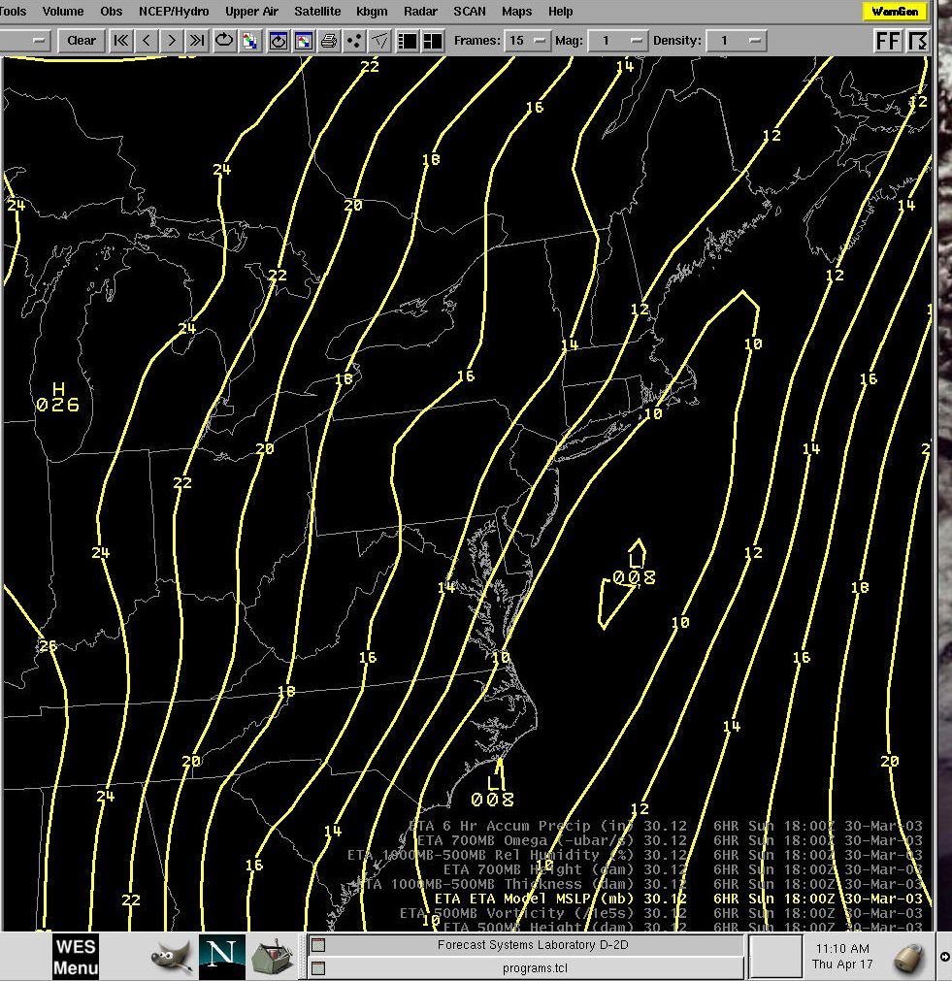

Figure 1a 6-hour Eta forecast mean sea-level pressure verifying at 1800 UTC on the 30th.

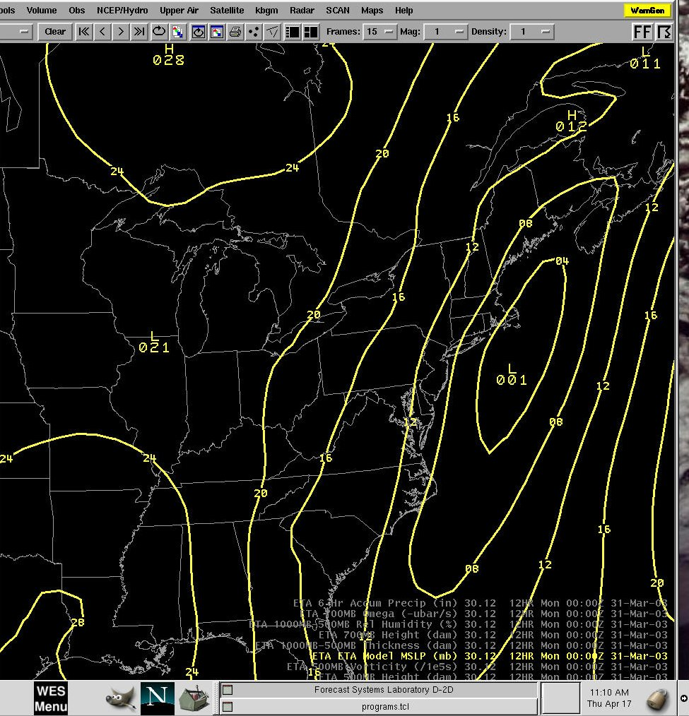

Figure 1b. 12-hour Eta forecast mean sea-level pressure verifying at 0000 UTC, March 31st.

These figures indicate that the surface low-pressure center was weaker and farther off-shore than what would normally be associated with a significant snowstorm for central New York. Figures 2a and b show the associated Eta forecast 500 mb height fields.

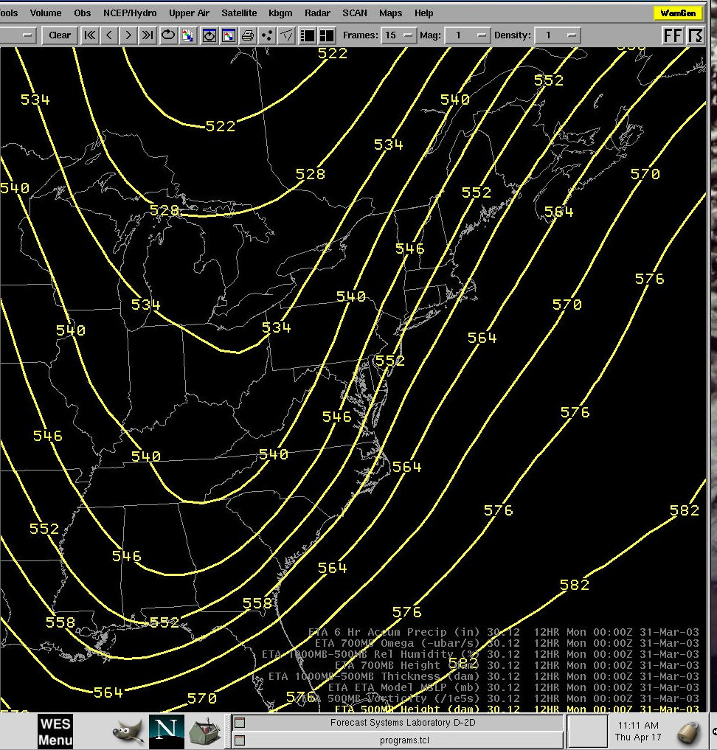

Figure 2a. 6-hour Eta forecast 500 mb heights verifying at 1800 UTC March 30th.

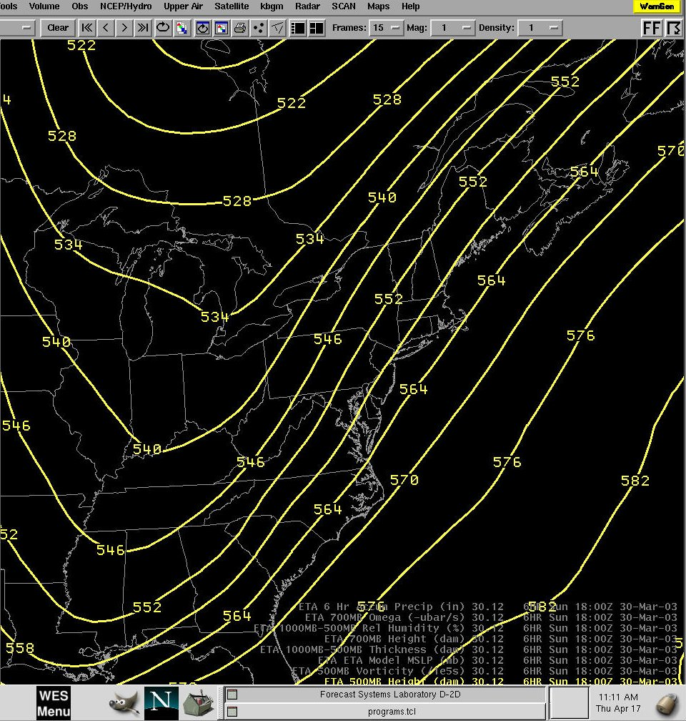

Figure 2b. 12-hour Eta forecast 500 mb heights verifying at 0000 UTC March 31st.

These figures indicate a neutrally tilted wave with moderately high amplitude. The next two figures show the corresponding 250 mb wind speed forecasts from the Eta model.

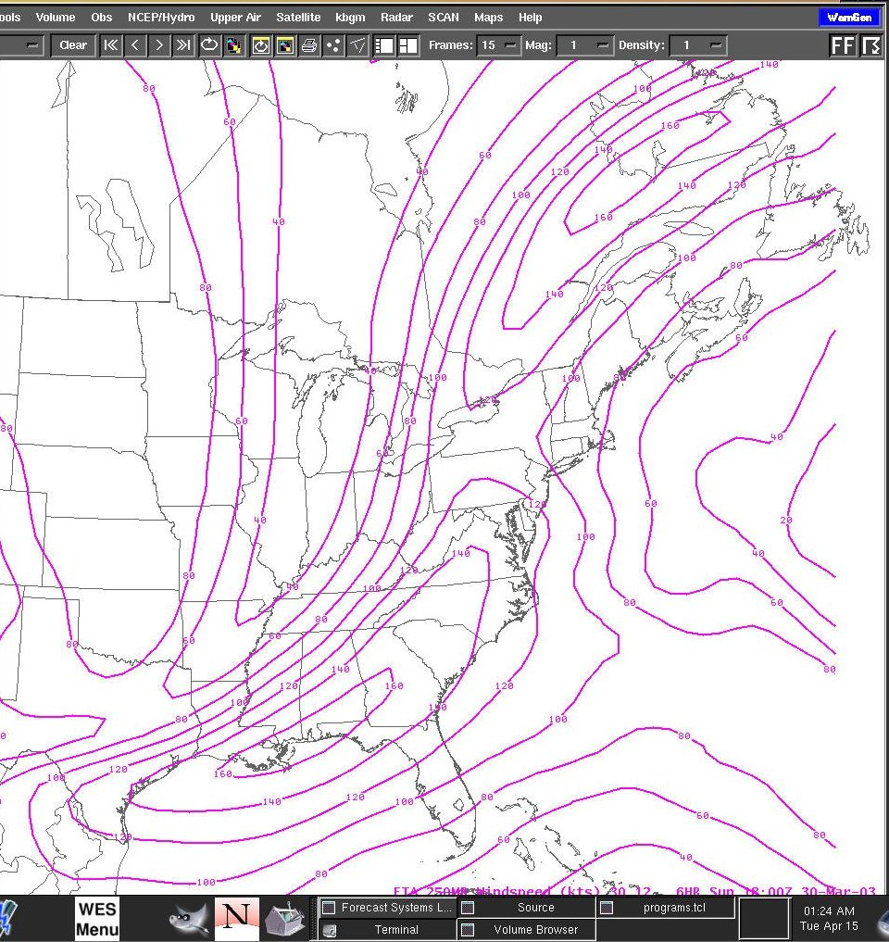

Figure 3a. 6-hour Eta forecast 250 mb wind speed verifying at 1800 UTC, March 30th.

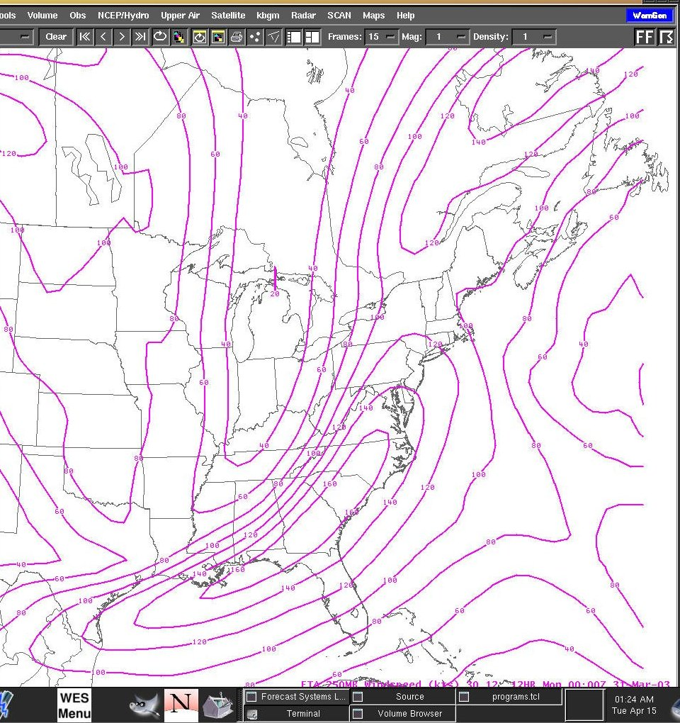

Figure 3b. 12-hour Eta forecast 250 mb wind speed verifying at 0000 UTC, March 31st.

Pennsylvania and New York appear to be under the influence of coupled jet streaks at 250 mb, with the area located in the left-exit region of a southern maximum over the southeastern U.S., and the right entrance region of an upper maximum over eastern Canada.

Figures 4a and b show infrared satellite imagery at 1200 UTC on the 30th and 0000 UTC on the 31st.

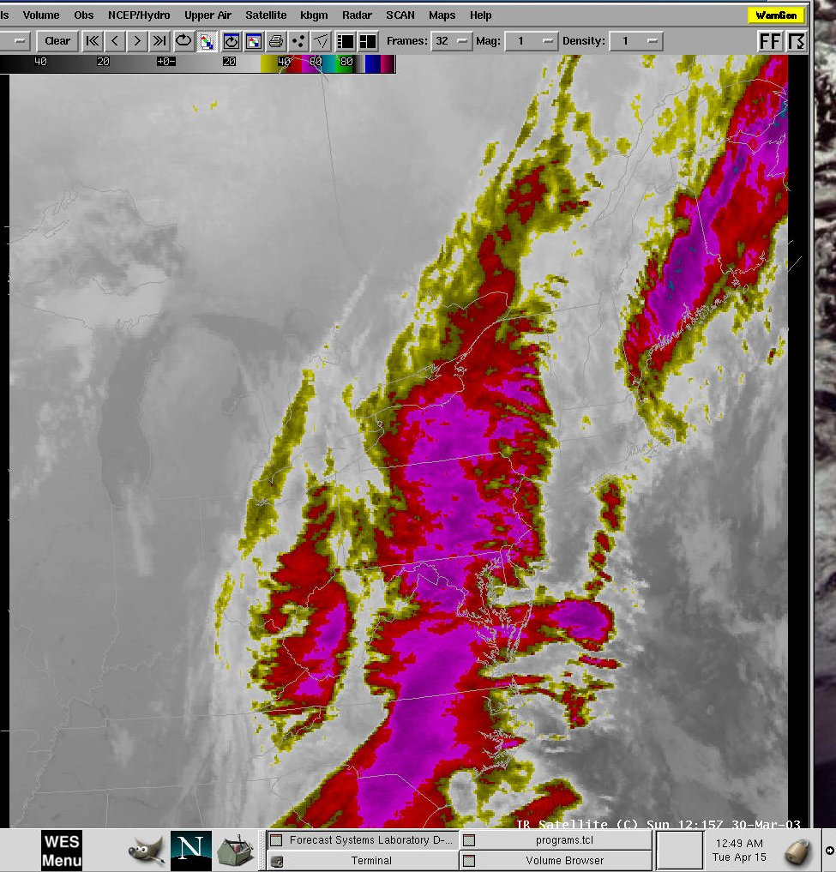

Figure 4a. Infrared satellite imagery at 1200 UTC on the 30th.

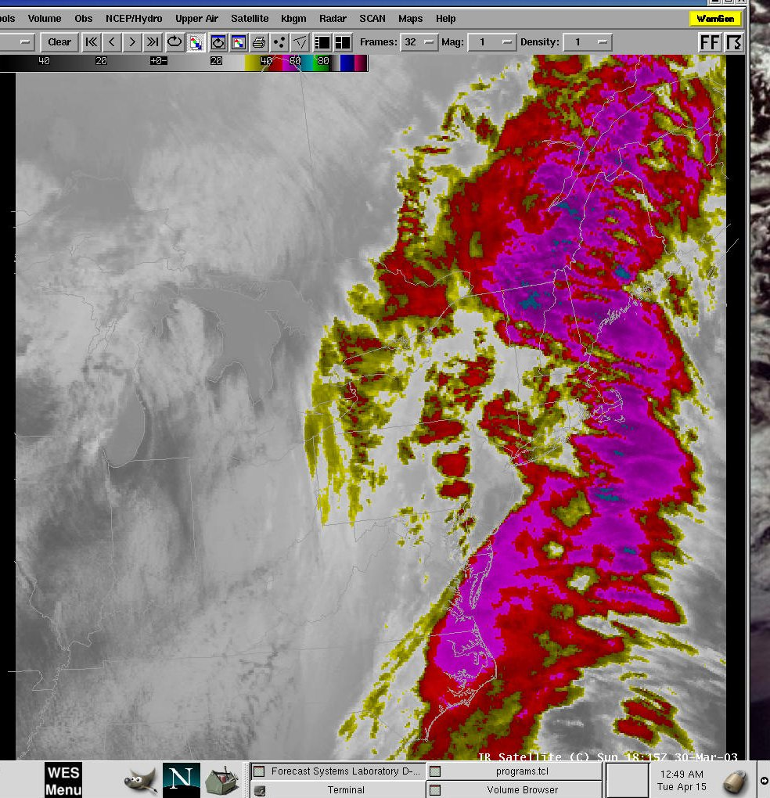

Figure 4b. Infrared satellite imagery at 1800 UTC on the 30th.

At 1200 UTC on the 30th, a long-north south band of enhanced clouds was evident on the infrared imagery. By 1800 UTC on the 30th, the deepest moisture appeared to be pulling off to the east, however a south to north band of lower to mid-level clouds was still evident across Pennsylvania and New York.

The next series of images show radar imagery from the KBGM WSR-88D.

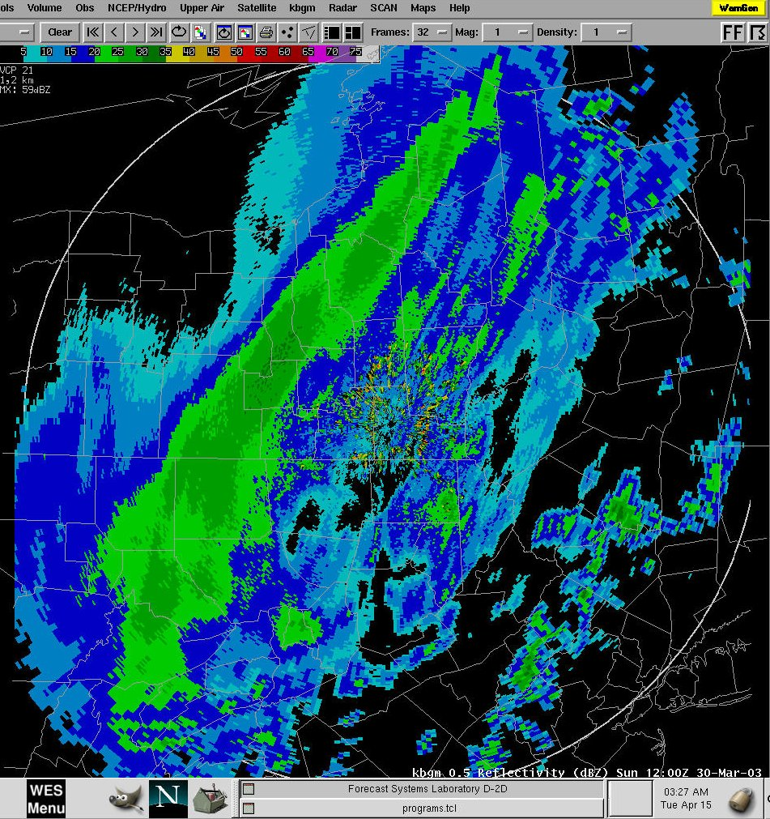

Figure 5a. KBGM 0.5 reflectivity at 1200 UTC on the 30th.

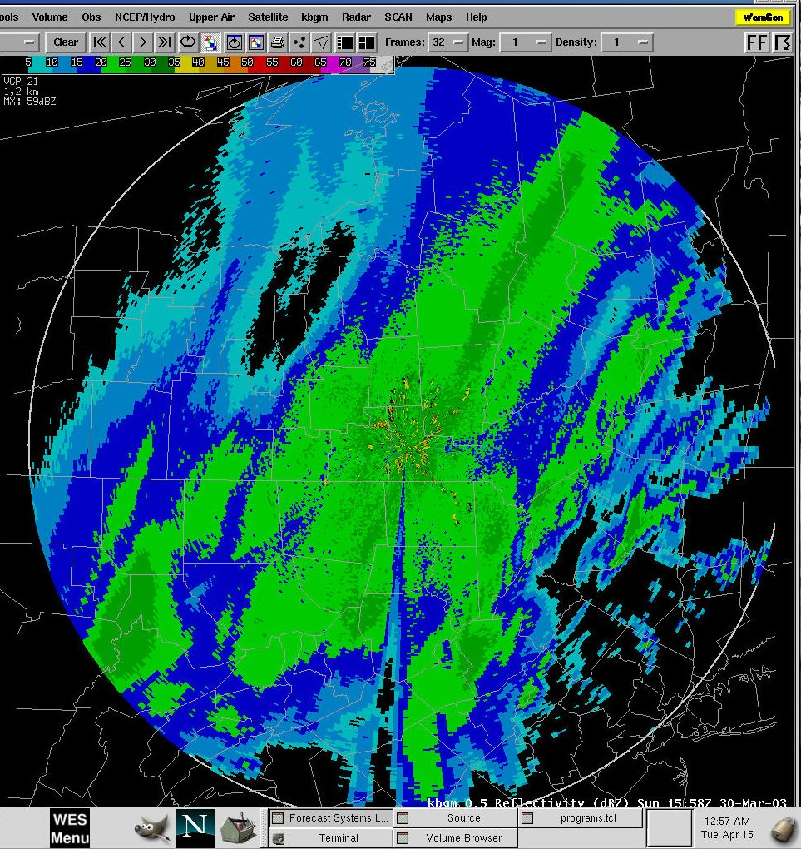

Figure 5b. KBGM 0.5 reflectivity at 1600 UTC March 30th.

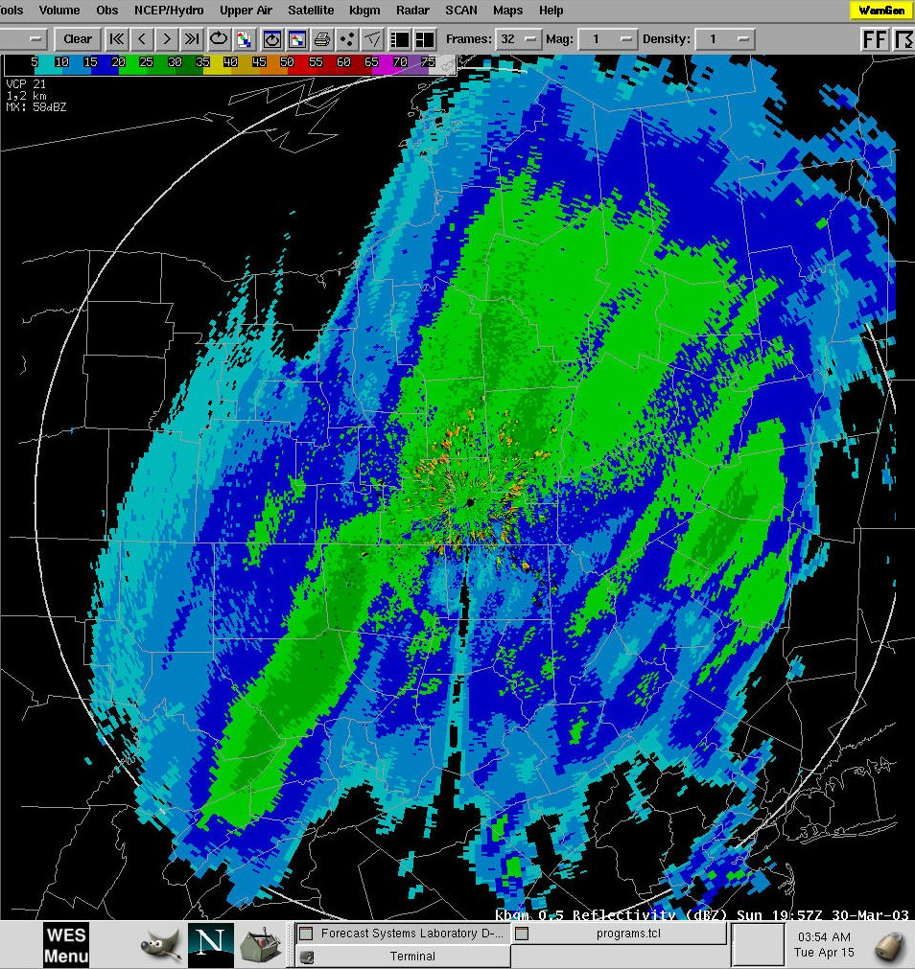

Figure 5c. KBGM 0.5 reflectivity at 2000 UTC, March 30th.

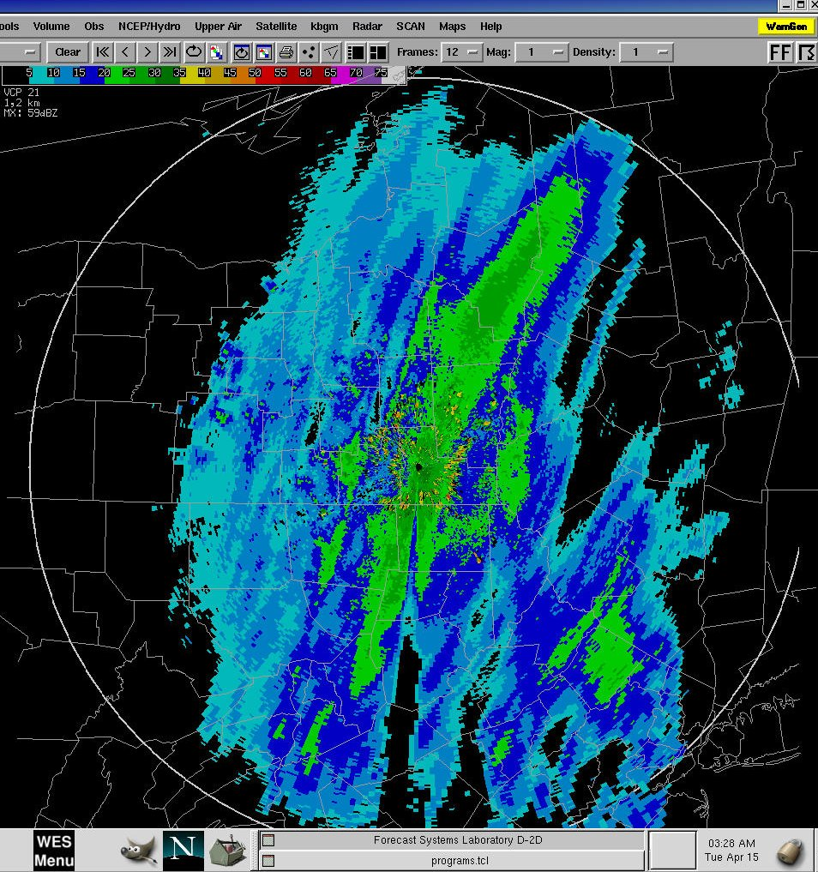

Figure 5d. KBGM 0.5 reflectivity at 2200 UTC, March 30.

These series of images indicate that a band of moderately heavy snow developed west of BGM by 1200 UTC. The band widened and moved east to cover much of central New York by 1600 UTC, then began to decrease in both width and intensity by 1800 UTC. By 2200 UTC, the band had again begun to move east with a continued decrease in both width and intensity.

The final two figures in this section show the observed snowfall and rainfall associated with this system.

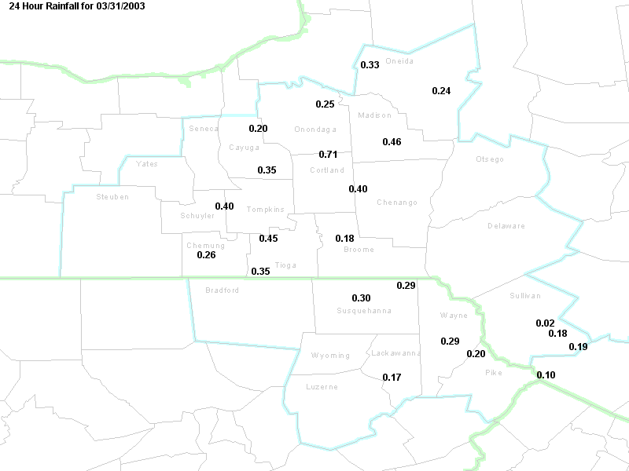

Figure 6a. Observed 24-hour snowfall through 11 pm on March 30th.

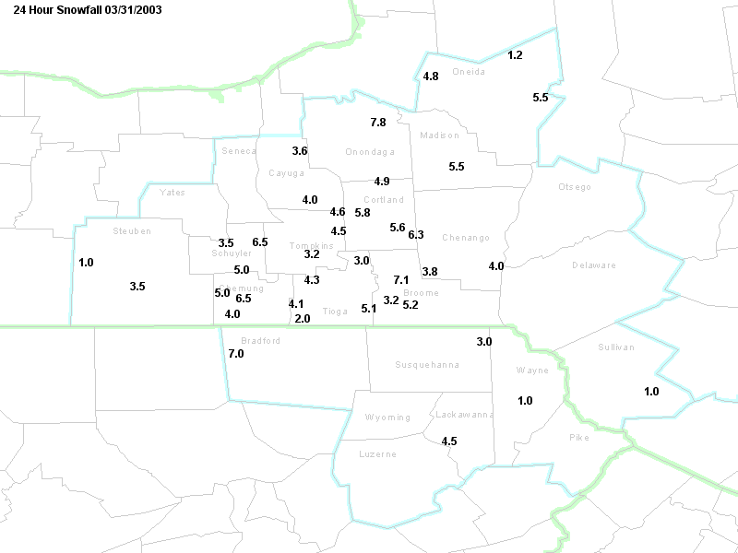

Figure 6b. Observed rainfall from 1200 UTC on the 30th through 1200 UTC on the 31st.

In summary, this event was characterized by a moderately intense band of snow, with a width varying from around 50 to 150 km. The band wobbled back and forth during the day across central Pennsylvania and New York. Snowfall amounts underneath the band ranged mostly from 4 to 8 inches. Outside of the main band, lighter snows occurred, with amounts ranging from 1 to 4 inches. The band remained west of the Poconos and Catskills until the evening of the 30th, by which time it had become relatively weak and narrow.

3) A review of the forcing mechanisms that created the observed snowfall distribution.

Figure 7 shows the 6-hour Eta forecast large-scale forcing (q-vector convergence) and omega verifying at 1800 UTC on the 30st.

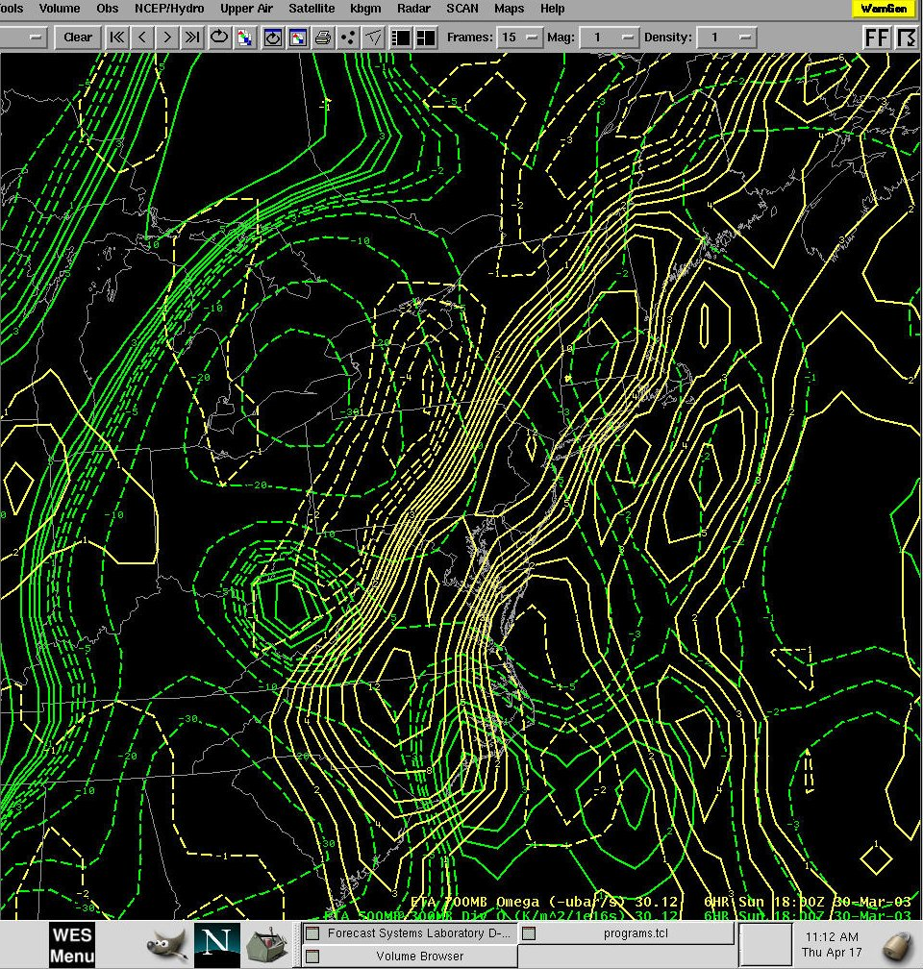

Figure 7. 6-hour Eta forecast large-scale forcing (300-500 mb q-vector convergence) (green lines), and 700 mb omega (yellow lines, verifying at 1800 UTC on March 30th).

The data in Figure 7 indicates that, while the large-scale forcing with this event was widespread across a large portion of the mid-Atlantic and northeast U.S. at 1800 UTC, the model omega was forecast to be much more intense and narrow. The next figure shows the 6-hour Eta forecast 700 mb 2-D frontogenesis and 700 mb omega verifying at 1800 UTC on the 30th.

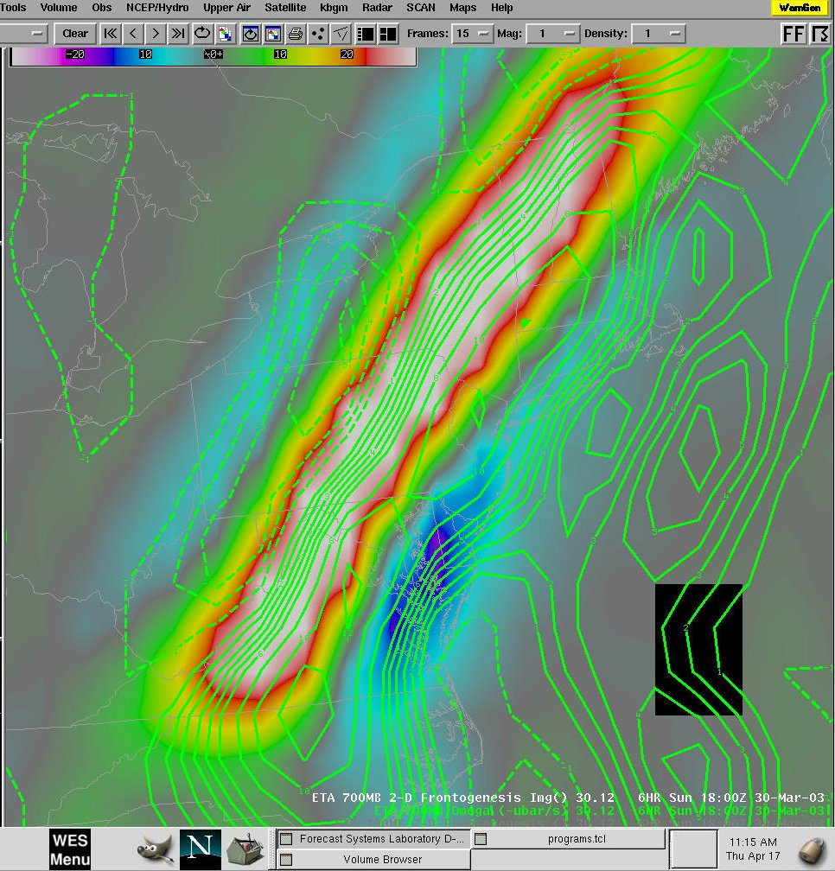

Figure 8. 6-hour Eta forecast 700 mb 2-D frontogenesis(image) and 700 mb omega (green lines).

The data in Figure 8 show that the frontogenesis and omega were forecast to be strongly correlated at 1800 UTC. The maximum of lift was forecast to be just to the southeast (on the warm side) of the frontogenesis. This would indicate that the band of heaviest snow could have been anticipated to be located along a line from eastern Pennsylvania northeast to western Massachusetts. The next figure shows the Eta 12-hour quantitative precipitation forecast for the period ending 0000 UTC on the 31st.

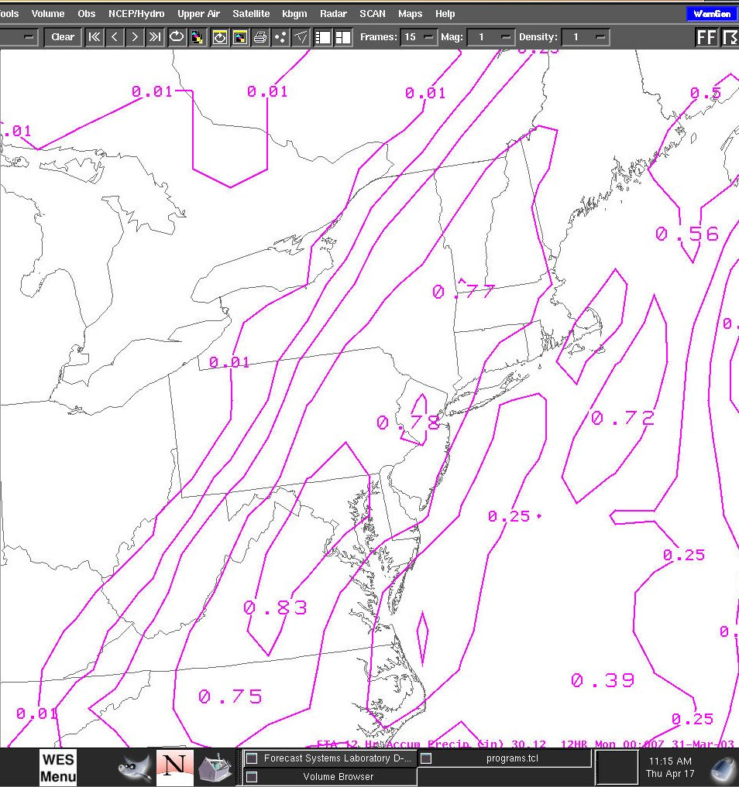

Figure 9. 12-hour Eta 12 hour precipitation forecast verifying at 0000 UTC on the 31st.

The data shown in Figure 9 indicates that the Eta was forecasting an axis of maximum precipitation of around 0.75 inches across eastern Pennsylvania, the Catskill mountains and western New England. The axis of maximum precipitation corresponded to the Eta’s forecast axis of maximum lift at 1800 UTC. The observed maximum of precipitation and snowfall was approximately 100 km to the northwest of the Eta forecast.

The next figure shows a cross-section of frontogenesis and omega verifying at 1800 UTC, taken along a southeast to northwest line from near New York City to near Rochester, New York.

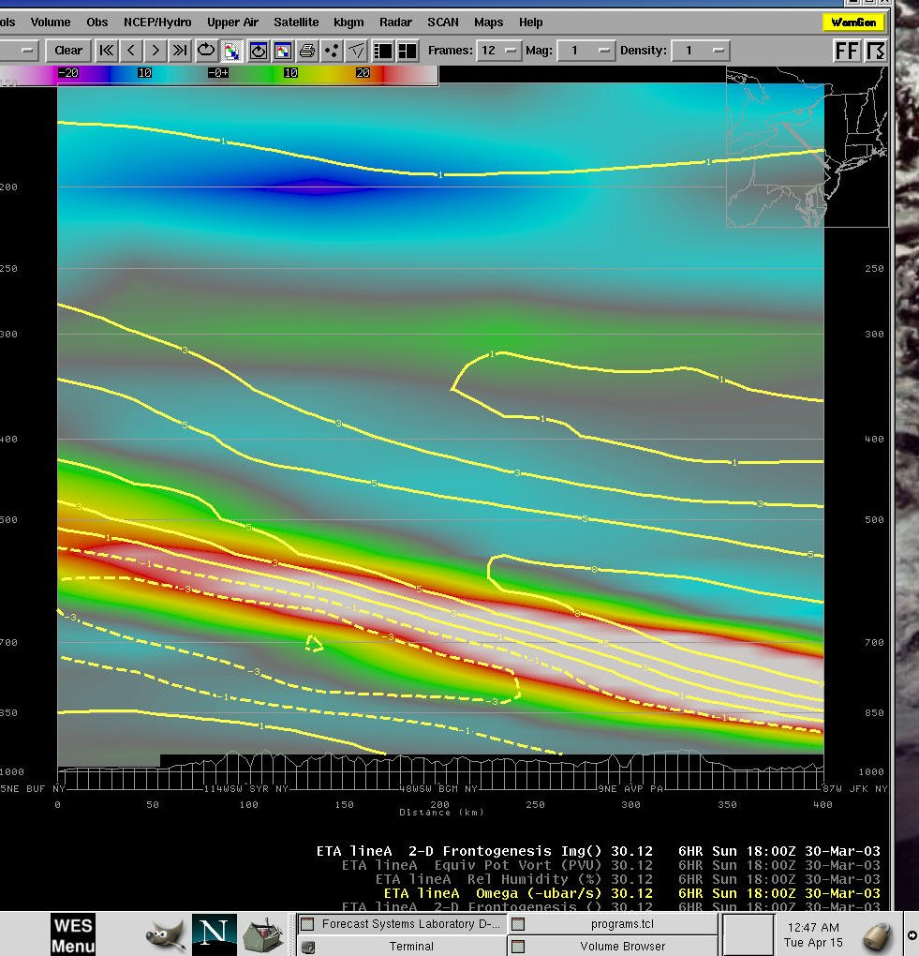

Figure 10. 6-hour Eta forecast cross-section of 2-D frontogenesis (shaded) and omega (yellow lines) verifying at 1800 UTC on the 30th, taken along a line from near New York City to near Rochester, New York.

This figure again demonstrates the close correlation between the frontogenesis and the lift in this case. The strongest frontogenesis and strongest lift appear to be in the layer from 900 mb to 700 mb. Again, this corresponded to the area from northern New Jersey through the Poconos, or around 100 km southeast of what was actually observed.

In summary, the precipitation distribution with this event appeared to be governed primarily by the location and orientation of a strong region of lower to mid-tropospheric frontogenesis. The Eta model appeared to forecast the upward omega associated with this region of frontogenesis too far to the southeast (by about 100 km).

4. A Possible Source of Model Error.

Identifying the reasons for error models is always difficult. In this case, one hypothesis for the error in the Eta model forecasts may be that the model had trouble initializing the strong temperature gradient that was located over the northeast United States during the event. Problems initializing the temperature gradient would have led to problems initializing the frontogenesis, which appeared to be the key to forecasting the distribution of lift and precipitation. The next figure shows the Eta 00-hour 850 mb temperature forecast, along with the observed temperatures from the RAOB network, both taken at 1200 UTC on the 30th.

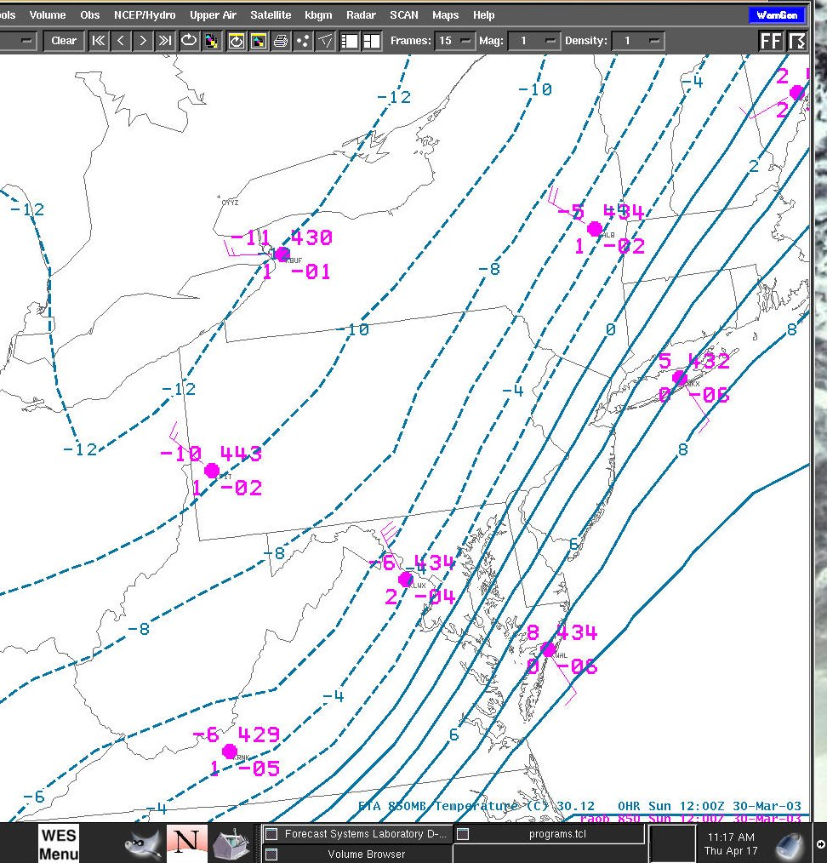

Figure 11. 850 mb RAOB data and the corresponding 00-hour Eta forecast verifying at 1200 UTC, March 30th.

In this case, the temperature gradient appears to be initialized reasonably well across the mid-Atlantic region. The gradient may be underestimated by one or two degrees C from SBY to IAD, and looks to be accurate within a degree from ISP to ALB. The next figure shows the same data, except at 700 mb.

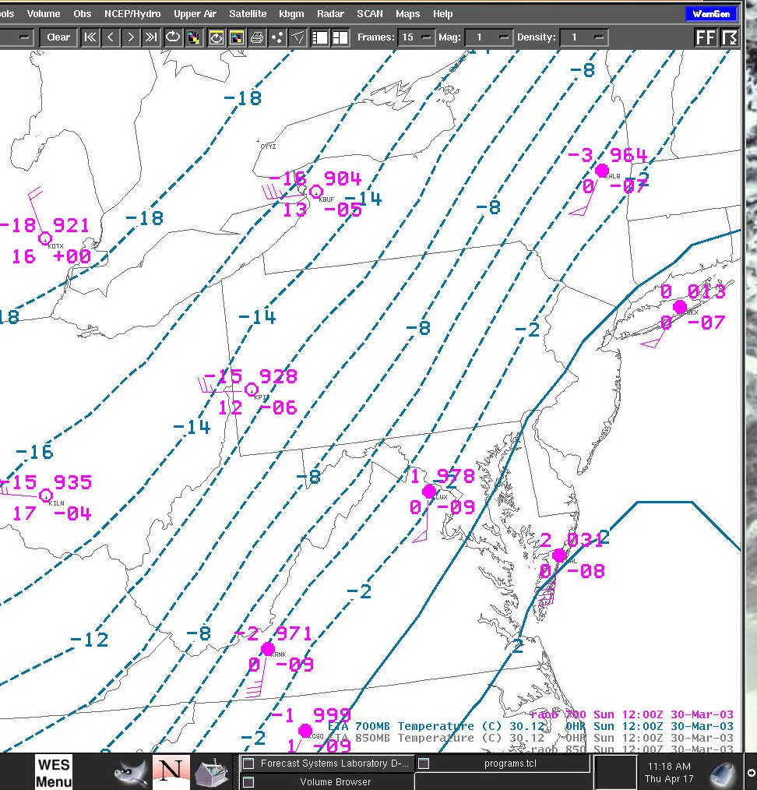

Figure 12. 700 mb RAOB data and the corresponding 00-hour Eta forecast verifying at 1200 UTC, March 30th.

In contrast to the data shown in Figure 16, there appears to be some problems with the model initialization at 700 mb. Note that, at IAD, the observed temperature is +1 degree C, while the model is initializing the temperature at around –3 degrees C. Meanwhile, at PIT, the observed temperature is –15 degrees C, while the model is initializing with a
–13 degrees C. Therefore, it appears that the observed temperature gradient from IAD to PIT is about 6 degrees C stronger than the 00-hour forecast in the model. Farther north, the Eta appears to be better initialized with the gradient from ALB to BUF.

In summary then, the Eta 00-hour forecast appears to be about right with the temperature gradient across the mid-Atlantic region at 850 mb, but too weak at 700 mb. It would follow then, that the frontogenesis may have also been too weak at 700 mb. Stronger frontogenesis at 700 mb with no change in the magnitude of frontogenesis at lower levels could have resulted in the maximum of upward motion shifting to the northwest, to be more co-located with the 700 mb frontogenesis (located northwest of the 850 mb frontogenesis along the sloping frontal boundary). See the figure below for an illustration:

700 mb
X
Frontogenesis
Frontogenesis
Max.
Lift
Max.
Lift
X

850 mb

Eta Initialization
Observations
SE
NW
SE
NW

a.
b.

Figure 13. (a) Orientation of frontogenesis and associated omega as forecast by the Eta. (b) Orientation of frontogenesis and associated omega based on observations indicating stronger frontogenesis at 700 mb. The maximum lift is shifted upward and toward the northwest in (b).

Whatever the reason, the Eta model forecast lift and precipitation too far to the northwest with this system. Areas outside of the main snow band (such as the Pocono and Catskill mountains) were left in a zone of relatively light precipitation.

A final aspect of this event that was likely a contributing factor to the observed snowfall distribution was the thermodynamic profile across the area. The next two figures show Eta forecast data from BUFKIT forecast soundings at a) BGM where moderate snow fell, and b) Avoca, where much less snow fell.

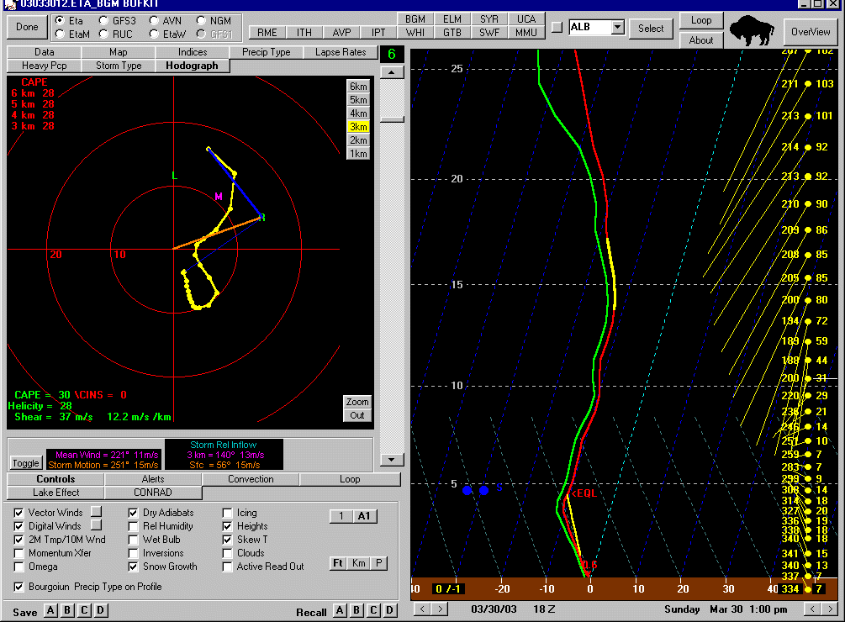

Figure 14a. BUFKIT Eta forecast sounding at BGM, verifying at 1800 UTC on March 30th.

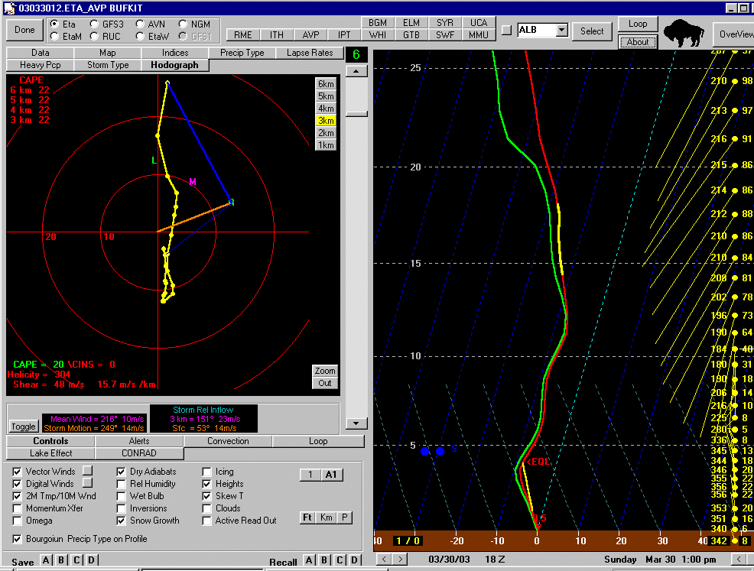

Figure 14b. BUFKIT Eta forecast at AVP verifying at 1800 UTC, March 30th.

The data in Figure 14a indicates that the sounding at BGM exhibited a deep layer with a temperature around –12 degrees C. This is near the top end of the range considered favorable for snow flake production due to growth of dendrites. By contrast, the data in Figure 14b indicates that the forecast sounding at AVP exhibited a deep layer with a temperature between –5 and –10 degrees C, much less favorable for snowflake growth.

5. Summary

The snow event on March 30th, 2003 was noteworthy for two main reasons. First, a significant snow event occurred despite the fact that the accompanying surface low pressure center was weaker and farther to the east than is typical for significant snowfall across central New York. In this case, the main forcing for upward motion across central New York was strong lower to middle-tropospheric frontogenesis.

The second interesting aspect of this case was that, despite model forecasts to the contrary, heavier snow fell across central New York than over northeast Pennsylvania and the western Catskills. Both the Eta and Avn (which was not shown in this study) indicated that the heaviest precipitation would occur over the Poconos and Catskill mountains in association with strong lower-tropospheric frontogenesis. Evidence was shown that the Eta model may have under-estimated the mid-tropospheric frontogenesis in this case, which may have resulted in the associated lift being focused farther to the northwest than what the model was forecasting. Another factor which may have led to lower snowfall amounts over the Poconos and Catskill mountains may have been a less favorable thermodynamic environment for snow growth in those areas.

