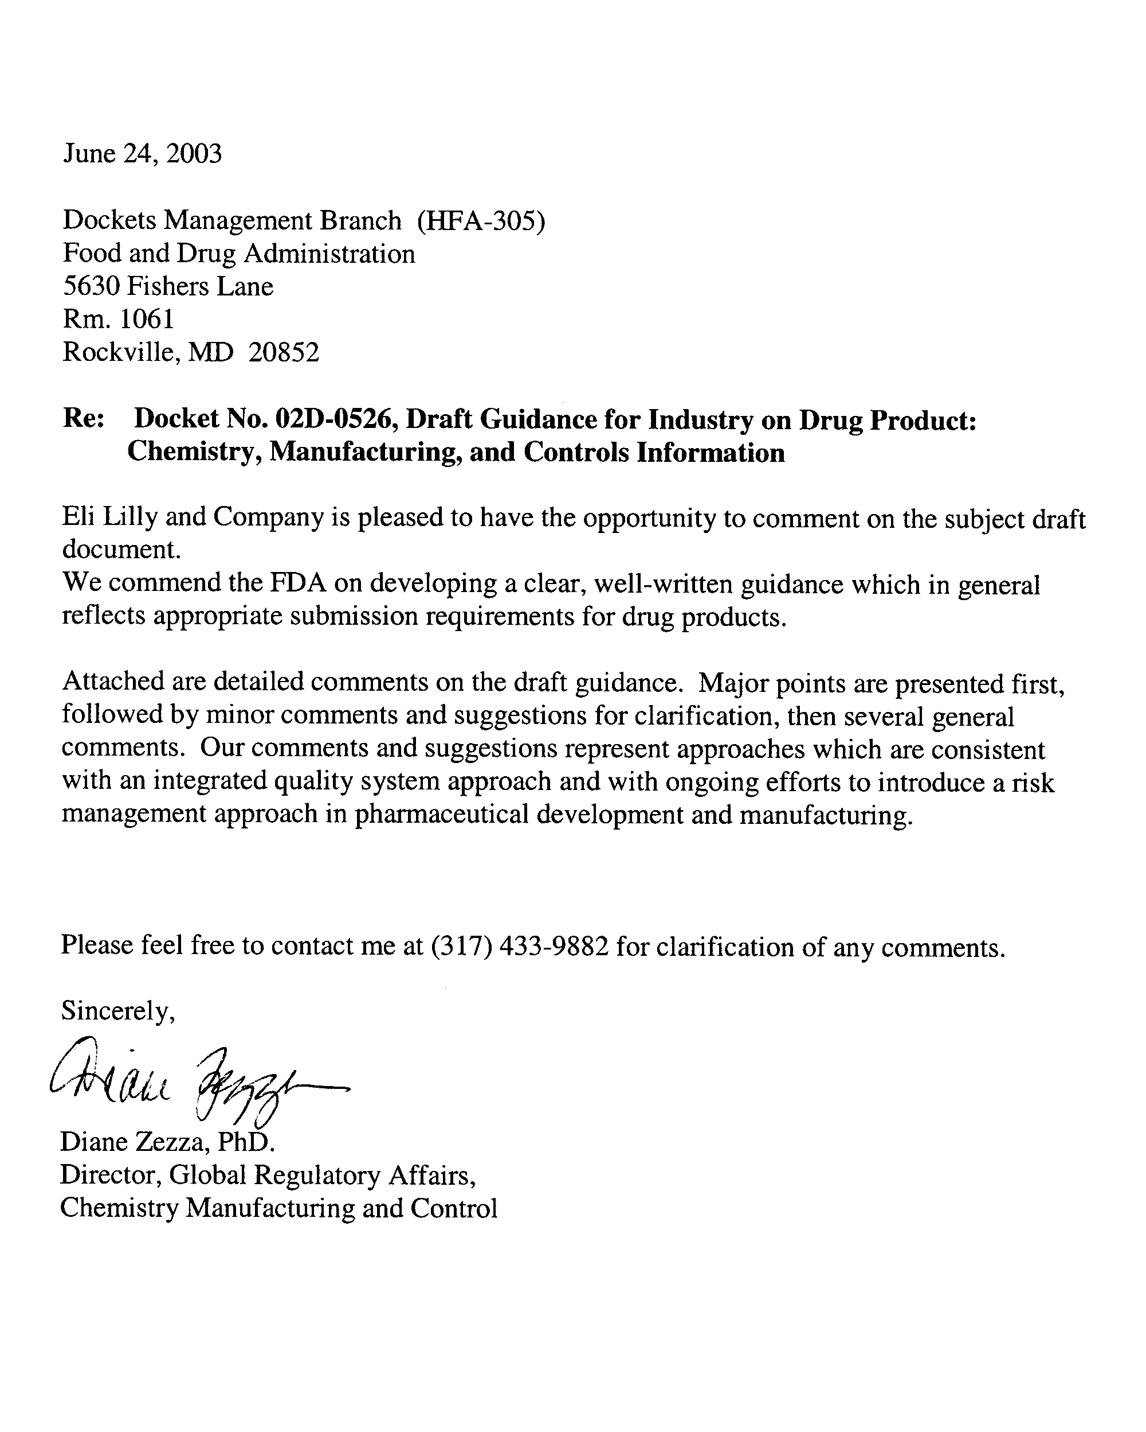

Major Issues:

Page 50 Line 1793-1795 Executed Production Records: “Executed Production Records (EPRs) for representative batches used in Phase III clinical, bioavailability, bioequivalence, or primary stability studies and supporting production information must be provided (21 CFR 314.50(d)(1)(ii)(b)).”  Page 50 Lines 1799-1801 Executed Production Records: “For NDA submissions, an EPR for a batch manufactured on at least a pilot scale should be submitted. In cases where clinical batches used in Phase III trials were less than pilot scale, submission of the EPR for the largest scale clinical batch is also recommended.” | Lilly Comment: The cited CFR requirement for executed production records states: “(b) Unless provided by paragraph (d)(1)(ii)(a) of this section, for each batch of the drug product used to conduct a bioavailability or bioequivalence study described in Sec. 320.38 or Sec. 320.63 of this chapter or used to conduct a primary stability study: The batch production record; the specifications and test procedures for each component and for the drug product; the names and addresses of the sources of the active and noncompendial inactive components and of the container and closure system for the drug product; the name and address of each contract facility involved in the manufacture, processing, packaging, or testing of the drug product and identification of the operation performed by each contract facility; and the results of any test performed on the components used in the manufacture of the drug product as required by Sec. 211.84(d) of this chapter and on the drug product as required by Sec. 211.165 of this chapter.”  The expansion of the current CFR requirement to representative Phase III clinical batches is inconsistent with current regulation and will add no value to the review process. Information on formulation development is provided in the Pharmaceutical Development Section. We support providing adequate information to thoroughly explain and justify the development of the product, but that information is more appropriately summarized within the application, not in providing additional volumes of batch records.

Pages 27-28 (Excipients) | Lilly Comment: Several citations require distinctions to be made for whether the applicant or the excipient supplier performs the monograph testing for compendial excipients. Only if the applicant performs full testing on each batch can they simply list the excipient (Lines 982-983). Otherwise, the FDA is requesting in this guidance that the applicant designate what results will be accepted on the basis of a COA.  Reliability of vendor testing is a GMP issue, and the information being requested is more appropriately handled under established GMP programs.  CFR 211.84(d)(2) states that "a report of analysis may be accepted from the supplier of a component, provided that at least one specific identity test is conducted on such component by the manufacturer, and provided that the manufacturer establishes the reliability of the supplier's analysis through appropriate validation of the supplier's test results at appropriate intervals."  As long as the standard the excipient will meet is submitted (e.g. NF, USP), the delineation of who does what specific test is unnecessary. It is the responsibility of the applicant, as required by cGMP’s, to verify the acceptability of the vendor testing, and to determine what tests they may choose to conduct in-house.
Pages 27-28 (Excipients) | Lilly Comment: An applicant will often perform additional tests on an excipient in order to meet requirements for compendia other than USP in order to support global supplies. These types of additional tests should be outside the scope of “additional tests” required to be submitted.  Additionally, in order to support global submissions and reduce redundant testing, an applicant may utilize a modified testing protocol which is equivalent to the USP, but not identical. These modifications provide a harmonized test scheme which ensures full compliance with two or more compendia. These harmonized test procedures used for routine testing which ensure compliance with the USP need not be submitted as long as the requirements of the USP are met. It is clearly stated in the General Notices to the USP that “it is not to be inferred that application of every analytical procedure in the monograph to samples from every production batch is necessarily a prerequisite for assuring compliance with Pharmacopeial standards before the batch is released for distribution…. Compliance may be determined also by the use of alternative methods, chosen for advantages in accuracy, sensitivity, precision, selectivity, or adaptability to automation or computerized data reduction or in other special circumstances.”  Reference to the USP requirement is sufficient, when compliance with the current USP requirements is in fact met by the modified testing program utilized by the applicant. This provides an acceptable risk approach for the pharmaceutical industry and minimizes numerous and burdensome submissions to product applications. One excipient may be utilized in many products owned by the applicant, and minor and insignificant changes to a testing scheme for one excipient could trigger numerous modifications to applications, creating a non-value added activity for both the applicant and the FDA.

Page 30 Lines 1089-1092 Justification for Proposed Excipient Specifications and Page 50 Lines 1817-1819 Executed Production Records: “1089-1092- A certificate of analysis (COA) from the manufacturer and the test results for the same batch from the drug product manufacturer should be provided for the components described in P.4. The information should be for the materials used to produce the batch described in the executed production record (R.1.P).”  “1817-1819- Results of any test performed on the components. This should include a certificate of analysis (COA) from the component manufacturer and the test results for the same batch from the drug product manufacturer.” | Lilly Comment: As noted above, the request for both vendor COA results and drug product manufacturers results for components used in lots provided in the executed batch record(s) is an encroachment into the GMP responsibility of the applicant to establish the reliability of the supplier's analysis. The applicant may choose to perform comparative testing to establish vendor reliability for excipient lots other than those presented in the executed production records and at a time after submission or approval of the application. The results used to accept the material, regardless of who performed the testing, are available in the executed production record. As such, we do not support submission of the information in the noted section.

Page 13 Lines 495-503:  A summary of all formulations used in clinical trials should be provided. The differences between clinical formulations and the proposed commercial formulation described in P.1 (i.e., composition statement) should be discussed. Any changes between the proposed commercial formulation and those formulations used in clinical batches and primary  stability batches should be clearly described and the rationale for the changes provided. | Lilly Comment: As we have stated previously, we strongly support providing adequate information to thoroughly explain and justify the development of the product. We suggest caution in providing too much extraneous information as could occur in a strict interpretation of the noted section. The detailed comparison of batches and supporting rationale for changes should be limited to the clinical efficacy, bioequivalence and primary stability batches (in comparison to the proposed commercial formulation). We suggest the following wording:  “Any significant changes between the proposed commercial formulation and those formulations used in clinical efficacy, bioequivalence and primary stability batches (pivotal batches) should be clearly described and the rationale for the changes provided. Results from comparative in vitro studies (e.g., bioequivalence) that link pivotal batch formulations to the proposed commercial formulation described in P.1 should be summarized and a cross-reference to the studies (with study numbers) should be provided.”

Minor Comments and Clarifications:

Page 6 (Drug Master Files): “Under FDA's regulations, an application may incorporate by reference all or part of the contents of any drug master file (DMF) to address particular drug product issues if the DMF holder provides written authorization to the applicant and the authorization is included in the application (Module 1).” | Lilly Comment: We suggest for the convenience of the FDA and the applicant, a more efficient place to include the letters of authorization for DMF’s is within Module 3 in a Regional Appendix. Reference would be made from the relevant section in the body of Module 3 to the Appendix.
Page 8 Lines 326-328  The target amount of each component by definite weight or other measure should be provided on a per unit basis. The amount of weight per unit volume should be on the  per milliliter (mL) basis regardless of the size of the container. | Lilly Comment: For lyophilized vials, providing component amounts on a per vial basis may be more appropriate.
Page 9 Line 337 | Lilly Comment: For clarification, we suggest adding dimethicone used for processing stoppers as an example of a processing agent for parenteral products

Page 9 Lines 341-342 (Unit Formula):  “The amount of drug substance in the specified unit, including any overages, should be listed. An explanatory note should identify any justified overages.”  Page 14 Lines 529-539 Pharmaceutical Development; Overages:  “An overage is a fixed amount of the drug substance in the dosage form that is added in excess of the label claim. Any overages included in the formulations described in P.1 should be justified. Information should be provided on the: (1) amount of overage, (2) reason for overage (e.g., compensate for expected and documented manufacturing losses, ensure proper dose delivery), and (3) justification for the amount of the overage. The overage should be included in the amount of drug substance listed in the composition statement (P.1) and the representative batch formula (P.3.2). In general, use of an overage of a drug substance to compensate for degradation during manufacture or a product’s shelf life, or to extend the expiration dating period, is not appropriate.” | Lilly Comment: Distinction should be made between “overage” to compensate for manufacturing losses, “overage” to compensate for degradation, and “overfill” to ensure proper dose delivery. Inclusion of associated definitions in the glossary would be useful. Manufacturing overages are utilized to achieve the target amount reflected in the unit formula and label, and therefore could not be reflected in the unit formula. It is unclear how, and for what reason, an overfill would be reflected in the unit formula. We suggest removing the example of “ensure proper dose delivery” from this section.
Page 15 Manufacturing Process Development (P 2.3) | Lilly Comment: We suggest including the following statement within this section:  “The rationale for the selected method of sterilization should be explained and justified.”
Page 16 Lines 610-611 | Lilly Comment: Change to read:  “. . .are more readily leached into lipid-containing systems such as blood…”

Page 19 (Addresses) Lines 692-697 and  Lines 710-713:  “Building numbers or other specific identifying information should be provided for multifacility campuses. For sites processing sterile drug substances, drug products, or packaging components, the sterile processing area (e.g., room, filling line) should also be included. Addresses for foreign sites should be provided in comparable detail, and the name, address, and phone number of the U.S. agent for each foreign drug establishment,  as required under 21 CFR 207.40(c), should be included.”  “To facilitate preapproval inspection related activities, it is recommended that the name, telephone number, fax number and e-mail address of a contact person be provided for each site listed in the application. Facilities should be ready for inspection when the application is submitted to FDA.” | Lilly Comment: Contact names, addresses, phone numbers, e-mail addresses etc. are provided in the 356H form. Maintenance of this type of information within the application is redundant and will result in unnecessary application updates.
Page 22 Lines 826-828: | Lilly Comment: Clarification should be provided that the facility information requested for multi-use facilities is applicable only to biotechnology-derived drug products.

Page 24 Lines 887- 901 Reprocessing and Reworking | Lilly Comment: Additional clarification and examples regarding reprocessing which is not required to be described in the application and that which is required to be described in the application needs to be provided. It is unclear if the distinction is intended to be based on the type of drug product, or the type of reprocessing. The very general criteria given provides insufficient guidance to determine the expected reporting requirement.
Page 26 Lines 958-960 Process Validation: “Validation information relating to the adequacy and efficacy of any sterilization process (e.g., drug product, packaging components) should be submitted in this section of the application.” | Lilly Comment: We suggest that reference may be made in this section of the application to an Appendix which contains stand-alone information on Sterilization Validation as outlined in the FDA Guidance: Submission of Documentation for Sterilization Process Validation in Applications for Human and Veterinary Drug Products.

Page 37 Lines 1329 – 1334: Collated Batch Analyses Data:  “Presentation of results from all batches for a particular test in tabular and/or graphical format is often helpful in justifying the acceptance criteria. Collated batch analyses data are not warranted for all tests. However, collated data should be provided for assay and impurities (e.g., degradation products, residual solvents) and should be considered for other tests such as water content.” | Lilly Comment:  This is a repetition of information already provided in other sections of the application. We suggest removing this paragraph.

Page 37 Lines 1317-1326  A summary of any changes in the analytical procedures should be provided if the analytical procedures (1) changed over the course of generating the batch analyses data and/or (2) are different from the analytical procedure included in P.5.2. The summary should identify when an analytical procedure changed, the differences between the analytical procedures, and the impact of the differences with respect to the data being reported. For example, a summary could state that the solvent system for the assay was changed on December 15, 1999, from A to B so that impurities Y and Z that co-elute using System A could be quantitated separately. If there are significant differences in the analytical procedures (e.g., different fundamental principles such as titration and HPLC), a more detailed summary describing the changes may be warranted.  And Page 44 Lines 1584-1593  A summary of any changes in the analytical procedures should be provided if the analytical procedure was changed over the course of generating the stability data.  The summary should identify when an analytical procedure changed, the differences between the analytical procedures, and the impact of the differences with respect to  the data being reported. For example, a summary could state that the solvent system for the assay was changed on December 15, 1999, from A to B so that impurities Y and Z that co-elute using System A could be quantitated separately. If there are significant differences in the analytical procedures (e.g., different fundamental principles such as titration and HPLC), a more detailed summary describing the changes may be warranted. | Lilly Comment: Analytical method changes that have no significant potential to impact the results need not be summarized in the batch analysis or stability data reports. To aid in interpretation of the batch or stability results, only those method changes which have impacted the results need be described.  While we strongly support providing sufficient information to thoroughly explain the development of the process and methods, providing extraneous data which does not aid in the interpretation of results undermines the ability to present information clearly. We suggest the section be revised to read:  “A summary of significant changes in the analytical procedures which impact the data being reported should be provided if the analytical procedures (1) changed over the course of generating the batch analyses data and/or (2) are different from the analytical procedure included in P.5.2. The summary should identify when an analytical procedure changed, the differences between the analytical procedures, and the impact of the differences with respect to the data being reported. For example, a summary could state that the solvent system for the assay was changed on December 15, 1999, from A to B so that impurities Y and Z that co-elute using System A could be quantitated separately. If there are significant differences in the analytical procedures (e.g., different fundamental principles such as titration and HPLC), a more detailed summary describing the changes may be warranted.”

Page 38 Lines 1341-1358 List of Expected (Drug Product) Impurities:  “All expected drug product impurities (e.g., degradation products of the active ingredient, residual solvents, enantiomeric impurities, excipient degradants, leachables from the container closure system) should be listed in this section of the application whether or not  the impurities are included in the drug product specification. For example, drug substance process impurities that could carry over to the drug product should be listed  here even if they are normally controlled during drug substance testing and will not be  included in the drug product specification. When qualified, the qualified level of an  expected impurity with a cross reference to the appropriate studies (include study  numbers) should be provided.” | Lilly Comment: The replication of drug substance impurity information here is unnecessary. Reference to the relevant portion of the drug substance section should be sufficient unless additional impurities result from the drug product manufacturing or from interaction of the drug substance with the excipients.
Page 44 Line 1567: Formal Stability Studies: | Lilly Comment: We suggest the title of this section read “Primary Stability Studies” for consistency with accepted terminology.
Page 46 Lines 1636 – 1678 Appendix I: | Lilly Comment: The organization of the guidance for Appendix I is confusing. The ICH CTD guidance clearly specifies Appendix I (Facilities and Equipment) as applicable to Biotech products only. It is unclear if the FDA is expanding the scope of this section to encompass other product types, which would be unwarranted.

General Comments:

1. In order to improve the clarity of the guidance, we suggest a closer alignment with the format provided in the ICH Common Technical Document Guidance. Also, in many sections of the guidance, it is unclear if the subheadings used for the detailed content guidance are intended as format guidance to applicants or simply to organize the guidance.

2. Location of Information on Devices for Combination Products: We suggest that the FDA specify the preferred location for information on devices when part of a Combination Product. We propose that a stand-alone section such as an Appendix to the drug product section would provide the best submission approach.

