4. Ocean Colour and Fisheries

Cara Wilson
NOAA/NMFS/SWFSC ERD, 1352 Lighthouse Ave., Pacific Grove, CA 93950

4.1 Introduction
In the last half century the world fish harvest has increased more than four-fold from 20 million tons in 1950 to over 80 million tons in 2000 [FAO Fisheries Department, 2004]. At the same time the number of overexploited and depleted stocks have increased, and an expanding population and problems with food supply have increased the pressure on fisheries resources. Better management and understanding of fisheries are needed to both maximize the utility of the current resources, and to ensure their sustainability into the future. However, these issues are complicated by the significant interannual variations that occur in fish populations, and sorting out fluctuations caused by anthropogenic effects (overexploitation, habitat alteration, pollution, etc.) from those caused by natural environmental variability is not trivial. The fundamental question of what drives the interannual variability of fish stocks was first posed over 100 years ago with the formation of the International Council for the Exploration of the Seas (ICES), and still has not been adequately resolved [Bakun and Broad, 2003; Kendall and Duker, 1998].

Satellite data provide an environmental context within which to examine these issues, by measuring parameters of the habitat and ecosystems that influence marine resources at high temporal and spatial scales. In the broadest sense fisheries encompasses not just commercial fish stocks, but all living marine resources, which for threatened and endangered species involves efforts to help the populations recover. There are two primary ways that ocean colour data are used within fisheries. One is to find populations, usually a commercial fish stock to increase fishing efficiency, but also in some cases for conservation, for example trying to identify locations of endangered right whales in order to minimize the number of lethal interactions with ships. A second application is characterizing and monitoring the environment of living marine resources. For example, satellite chlorophyll can be used to observe changes in the timing of the spring bloom that can effect recruitment [Platt et al., 2003], to classify the productivity of the oceans [Sherman et al., 2005], to detect interannual differences in the frontal structures that are important to fisheries [Bograd et al., 2004; Polovina et al., 2001] and to map the spatial extent of the ocean experiencing lower productivity during an El Niño event [Wilson and Adamec, 2001]. Additionally, ocean colour data is used to monitor a number of issues that impact fisheries, such as harmful algal blooms, coastal pollution, and derelict fishing gear (if moved out of this chapter) that are discussed in further detail elsewhere in this volume.

4.2 Ocean colour and the oceanic food web
Satellite chlorophyll provides an index of phytoplankton biomass, which is the base of the oceanic food chain, or food web, as depicted in simplified form in Fig 4.1. The relationship between satellite chlorophyll data and a specific fish stock depends upon the number of linkages between phytoplankton and the higher trophic level. For some species, such as anchovies and sardines, which eat phytoplankton at some points in their life cycle, the linkage can be direct [Ware and Thomson, 2005], whereas for other species there are many trophic levels in between and the relationship can be quite non-linear. There can also be spatial disconnects between satellite measurements of the ocean surface and demersal and deep-water species. Nonetheless, chlorophyll is the only biological component of the marine ecosystem accessible to remote sensing, and as such it provides a key metric to measuring ecosystems on a global scale. As discussed in chapter 2, satellite chlorophyll measurements are the primary component in algorithms to calculate the primary productivity (PP) of the ocean. Global PP measurements, in conjunction with fish catch statistics and food web models, such as shown in Fig 4.1, can be used to estimate the carrying capacity of the world’s fisheries. In the open ocean 2% of the PP is needed to support the fishery catch, but in coastal regions the requirement ranges from 24-35%, suggesting that these systems are at or beyond their carrying capacity [Pauly and Christensen, 1995], which is cause for concern as the bulk of the world’s fish catch comes from coastal areas. In a similar manner, discrepancies between the values of satellite derived PP and reported fish catches have been used to demonstrate spurious trends in global fish catches as reported by the Food and Agriculture Organization (FAO) of the United Nations [Watson and Pauly, 2001]. In this instance satellite ocean colour data provide an important objective baseline against which to gauge data that can have socio-economic biases.

4.3 Harvesting
Locating and catching fish is becoming more challenging as fish stocks dwindle and move further offshore, thus increasing the search time, cost and effort. Satellite data can help to increase the efficiency of fishing efforts by identifying oceanographic features that are often the sites of fish stock congregation and migration such as temperature fronts, meanders, eddies, rings and upwelling areas [Chen et al., 2005; Fiedler and Bernard, 1987; Laurs et al., 1984]. Both satellite ocean colour and sea surface temperature (SST) data have been used for this purpose. SST and ocean colour often have similar patterns as generally warm, nutrient-depleted water has low chlorophyll concentrations and cold, nutrient-rich water has high chlorophyll. SST can also be an important factor for determining potential fishing grounds since different fish species have different optimal temperature ranges. Generally SST data have been used more often than ocean colour data in fisheries applications. There are two main reasons for this. One, satellite SST are a more established data source, with data going back to 1985, whereas SeaWiFS, the first satellite to consistently provide satellite chlorophyll data on a global basis, was not launched till 1997. Secondly, SeaWiFS is a privately owned satellite, and while its data have always been freely available, with a time delay, to the research community, the availability of real-time data needed by fishers for identifying potential fishing areas has only been available on a commercial basis. For economic reasons this has resulted in SeaWiFS data being unavailable to many fishers in the world, as the commercial costs of the real-time data can be prohibitive, particularly for those in under-developed countries, where 70% of the fish for human consumption comes from [FAO Fisheries Department, 2004].
However, satellite ocean colour data offer additional information that SST does not provide. As discussed above chlorophyll, unlike SST, directly measures the component of the ecosystem that supports the oceanic food web, and it has an important role to play in fisheries applications and fisheries science. For example, there can be fronts and features evident in chlorophyll data that are not seen in SST data [Laurs et al., 1984; Solanki et al., 2001]. The Transitional Zone Chlorophyll Front (TZCF) in the North Pacific is an important feature easily visible by ocean colour, separating low productivity waters of the central gyre from more productive waters in the North Pacific, but it is not as easily detectable by SST. The TZCF and the eddies associated with it are an important foraging ground for many commercial fish such as swordfish and tuna [Laurs and Lynn, 1991].
Obviously to effectively help fishers more easily locate fish schools, satellite ocean colour data must be available in a near-real time basis. There are international differences in how this satellite data is disseminated to fishers. For example the SeaWiFS satellite is privately owned, and its chlorophyll data is only available on a real-time basis to fishers on a commercial basis from the SeaStar company. Customers of this service can receive custom-tailored maps of ocean colour, as well as other oceanic parameters derived from satellite data, directly onboard their fishing vessel. In contrast, data from the Indian IRS-P4 ocean-colour (in conjunction with satellite SST from AVHRR) is used by the Indian National Center for Ocean Information Services (INCOIS) to make maps of potential fishing zones (PFZ, see Fig 4.2), which are freely disseminated several times a week throughout coastal India by fax, phone, internet, electronic display boards, newspaper and radio broadcasts. Studies on the effectiveness of the PFZ advisories have suggested that they have helped reduce search time by up to 70%, and have significantly increased the catch per unit effort (CPUE) [Solanki et al., 2003; Zainuddin et al., 2004].

National agencies also serve different constituencies. The mandate of NOAA Fisheries in the USA for example, is to manage and conserve marine resources, and they are not allowed to provide services such as distributing ‘fish finding maps’ that would compete with commercial interests. However in other countries, notably Japan and India, the national fisheries agencies are actively involved with helping increase the efficiency of their fishing fleets.

4.4 Ecosystem-Based Management
There is growing awareness that the traditional approach of focusing on a specific species is inadequate to successfully manage them [Browman and Stergiou, 2005; Sherman et al., 2005]. Interactions with other species, complex predator-prey dynamics, and temporal and spatial variability in physical aspects of the ecosystem all need to be incorporated into an ecosystem-based approach to management. While obviously not all of these aspects can be addressed by satellite data, the high spatial and temporal resolution of satellite ocean colour data makes it an efficient tool to characterize and monitor marine ecosystems in order to better manage them. For example, satellite derived primary productivity is a one of the indicators used in the assessment of Large Marine Ecosystems (LME) [Sherman et al., 2005].

4.4.1 Habitat Assessment

Recruitment
A fundamental issue in fisheries oceanography is understanding how environmental variability affects annual recruitment, the number of new individuals entering a stock. Recruitment is an important parameter because the bulk of mortality occurs in the development of larvae from eggs. Most fish have planktonic larval stages that are strongly influenced by ocean circulation and can have narrow ranges of optimal thermal conditions. Availability of a good food source is important for successful recruitment and hence many fish reproduce near the seasonal peak in phytoplankton abundance. A long-standing hypothesis in fisheries has been that recruitment success is tied to the degree of timing between spawning and the seasonal phytoplankton bloom, the Cushing-Hjort or match-mismatch hypothesis. This hypothesis has been difficult to address with traditional shipboard measurements that have limited spatial and temporal resolution, but with satellite ocean colour data, interannual fluctuations in the timing and extent of the seasonal bloom can be clearly seen. In an application on the Nova Scotia Shelf, the timing of the spring bloom determined from satellite ocean colour was compared with available in situ data on larval survival of haddock, an important commercial fish species. Comparison of these two independent data sets indicated that highly successful year classes of haddock are associated with exceptionally early spring blooms of phytoplankton (Fig 4.3), confirming the match-mismatch hypothesis [Platt et al., 2003]. A comparable study has also documented a relationship between the timing of the spring bloom and the growth rate of shrimp [Fuentes-Yaco et al., in press]. These studies demonstrate that it can be possible to separate ecosystem-associated variability in fish stocks from other components such as human exploitation or predation effects. The satellite time series permits the extraction of value-added products, in this case the timing of the seasonal biological cycle.

Animal habitat: the TZCF
Satellite ocean colour data, in conjunction with telemetry data from tagged sea turtles have shown that in the North Pacific the Transitional Zone Chlorophyll Front (TZCF) is an important foraging ground and migration pathway for endangered loggerhead turtles [Polovina et al., 2004]. As seen in Fig 4.4 these turtles follow the TZCF, and spend time foraging in the high chlorophyll eddies that are associated with meandering of the front. Other apex predators such as albacore tuna also use the front as a migratory corridor [Laurs and Lynn, 1991; Polovina et al., 2001]. The degree of meandering of the TZCF seems to impact trophic transfers and the level of productivity associated with the front. Periods with more meandering of the front have had significantly higher CPUE of albacore, suggesting that the enhanced convergence creates more productive foraging grounds [Polovina et al., 2001].

Extracting information about animal habitat by using satellite telemetry location information in conjunction with environmental satellite data, such as tracking sea turtles along the TZCF, has been used on an extensive array of animals. For example the Census of Marine Life program Tagging of Pacific Pelagics (TOPP) is involved with tagging a suite of more than 20 marine predators and integrating the tagging information with satellite data to better understand the animals habitat usage [Block et al., 2003]. Relating the movements and activities of these animals to satellite-derived features is an important advancement toward understanding environment-population linkages in marine ecosystems.

Survey support
Fishery independent surveys are a crucial part of stock assessment. Just as ocean colour data can be used to increase fishing CPUE by identifying front locations, and other features where fish tend to congregate, these data are also routinely used by fisheries cruises doing survey assessments for management and stock assessment. The near real-time data are valuable for locating fronts and other relevant features to sample across, as well as placing the results in a larger spatial context.

4.4.2 Conservation & Management

Right Whales
One of the most endangered marine species is the Northern right whale (Eubalaena glacialis), with an estimated population of 300 individuals [International Whaling Commission, 1998; Kraus et al., 2005]. While historically, right whale populations were severely depleted by commercial whaling, at present the primary cause of mortality in the North Atlantic is from ship strikes [National Marine Fisheries Service, 2005]. The primary habitat of the North Atlantic right whale is in coastal or shelf waters, which also have heavy amounts of ship traffic. The recovery plan of NOAA (USA) for this species has focused on developing methods to identify the locations of right whale populations, in order to reduce ship traffic in these regions and lessen the number of whale-vessel collisions. This plan involves both limiting fishing in certain areas when whales are typically abundant, a procedure known as "seasonal area management" (SAM), and another strategy known as dynamic area management (DAM), with a synoptic level of control. Under DAM, if a group of whales is identified, NOAA Fisheries will limit activities in the area. Currently research is underway to improve both management strategies by predicting the location of right whale congregations using satellite measurements of sea surface temperature and ocean colour [Monger, 2006]. Because the distribution of right whales is strongly correlated with the distribution of their prey, which appears to be primarily calanoid copepods [Kenney et al., 2001], satellite chlorophyll data is a reasonable proxy for their food source. SST data is used in this method to estimate the development time of the copepods and to determine fronts where whale aggregation is likely. Currently the project is in the proof of concept stage, with the aim of being incorporated into management decisions.

Ghost nets
Marine debris and abandoned fishing nets, “ghost nets”, pose a serious hazard to many marine mammals and sea birds. Endangered sea turtles, seals, and whales are among the species that can get entangled in these nets, with often-lethal results. The nets also get ensnared on coral reefs, physically damaging the reef structure and destroying the flora and fauna dependent upon a healthy reef ecosystem [Donohue et al., 2001]. Subsequently, management efforts are being lead to develop methods to identify and prioritize the likely locations of marine debris to facilitate finding and removing marine debris and ghostnets. Satellite ocean colour data have been used in the subtropical North Pacific to identify likely locations of debris convergence, which were used in directing a field observation program to ground-truth the detection method [Pichel et al., 2003]. Satellite measurements of SST, chlorophyll, and chlorophyll gradient, analyzed in conjunction with observer sightings per unit effort were combined to generate a map of the likelihood of debris density, as seen in Fig. 4.5. Ocean colour data were an important component to this identification method; initial efforts using just satellite SST data were significantly less effective.

4.5 Fisheries and Climate
The SeaWiFS ocean colour sensor was launched in August of 1997, just prior to the 1997/98 El Niño which was one of the strongest ENSO (El Niño Southern Oscillation) events of the century. This satellite data, in synergy with data from an extensive array of moorings across the equatorial Pacific, has contributed enormously to our understanding of ENSO dynamics and their ecosystem impacts. Deepening of the thermocline, and cessation of upwelling along the equator and in the coastal ecosystems lowers ocean productivity and causes significant drops in the anchovy fisheries of Peru and Chile [Alamo and Bouchon, 1987; Escribano et al., 2004]. However, other species are positively impacted by El Niño, for example increases are observed in the biomass of sardine and mackerel [Bakun and Broad, 2003; Niquen and Bouchon, 2004]. Satellite ocean colour data has demonstrated that the effects of El Niño are not constrained to just the equatoral and coastal upwelling regions, but extend throughout most of the Pacific Ocean. For example during the 1997/98 event the TZCF was shifted ~5° south of it regular position [Bograd et al., 2004], and lower chlorophyll values occurred across most of the subtropical Pacific [Wilson and Adamec, 2001].

The longest currently operating ocean colour sensor was launched in 1997, so it is presently impossible to detect decade-scale variability with just this data. However it is possible to observe long-term changes by comparing climatological SeaWiFS data against data from the Coastal Zone Color Scanner (CZCS), which operated between 1979-1985. For example the present wintertime position of the TZCF in the Pacific is about 5° further north than it was during CZCS time period (Fig 4.6). This shift has also been seen in SST data used as a proxy for the TZCF [Bograd et al., 2004]. Data from these two different satellites have also been used to demonstrate regions of the ocean which have experienced significant changes in the amount of chlorophyll and primary productivity in the past twenty years [Gregg and Conkright, 2002; Gregg et al., 2003].

There is significant long-term temporal variability in fish stocks, and for over 150 years scientists have been trying to differentiate the effects of interannual variability, overfishing and long-term changes such as regime shifts, which are characterized by relatively rapid changes in the baseline abundances of both exploited and unexploited species [Polovina, 2005]. Long-term variations in ecosystems often follow trends or patterns also observed in ocean and atmosphere parameters [Hare and Mantua, 2000; Mantua et al., 1997; Peterson and Schwing, 2003]. For example, as seen in Fig 4.7, a shift in the North Pacific in the 1970’s between a shrimp dominated ecosystem to one populated primarily by several species of bottom-dwelling groundfish species coincided with a regional change from a cool to a warm climate [Anderson and Piatt, 1999; Botsford et al., 1997]. While similar phenomena have been seen for many different stocks, and in all ocean basins, the mechanisms that link large-scale ocean and atmosphere dynamics to changes in population abundances are not always clear [Baumann, 1998; Botsford et al., 1997] and the relationships are not always constant over time [Solow, 2002]. Ecosystem changes related to regime shifts are not in themselves harmful to the ecosystems as a whole [Bakun and Broad, 2003], but in order to maintain sustainability, management practices must be flexible enough to recognize and accommodate them [Polovina, 2005]. One of the current limitations of satellite data is their relatively short time-spans. For fisheries applications it is crucial that climate quality records of ocean colour be maintained so that existing satellite records will be able to serve as a benchmark against which to gauge future changes.

4.6 Summary and Conclusions

- Satellite data measures oceanic parameters of habitat and ecosystems that influence marine resources at spatial and temporal resolutions that are impossible to achieve any other way.
- The high spatial resolution provides an important geographical context for interpreting other data and results.
- The daily to weekly temporal resolution allows for effective monitoring of many oceanic features and permits the extraction of value-added products such as the timing of seasonal events.
- Near real time satellite data is crucial for optimizing sampling for fisheries survey cruises for management and stock assessment and also for increasing the efficiency of fishing effort.
- Timeseries of science quality satellite data are needed to understand linkages between climate and ecosystems, and to characterize and monitor ecosystems as part of an ecosystem based approach to fisheries management.

Acknowledgements

Ishio Asanuma, Gene Feldman, Jesus Morales and Shalesh Nayak made contributions to an earlier version of this chapter.

References

Alamo, A., and M. Bouchon (1987), Changes in the food and feeding of the sardine (Sardinops sagax) during the years 1980-1984 off the Peruvian coast, J. Geophys. Res., 92, 14411-14415.
Anderson, P.J., and J.F. Piatt (1999), Community reorganization in the Gulf of Alaska following ocean climate regime shift, Mar. Ecol. Prog. Ser., 189, 117-123.
Bakun, A., and K. Broad (2003), Environmental ‘loopholes’ and fish population dynamics: comparative pattern recognition with focus on El Niño effects in the Pacific, Fish. Oceanogr., 12, 458–473.
Baumann, M. (1998), The fallacy of the missing middle: physics -> ... -> fisheries, Fish. Oceanogr., 7, 63-65.
Block, B.A., D.P. Costa, G.W. Boehlert, and R.E. Kochevar (2003), Revealing Pelagic Habitat Use: The Tagging of Pacific Pelagics Program, Ocean. Acta, 25, 255–266.
Bograd, S., D.G. Foley, F.B. Schwing, C. Wilson, J.J. Polovina, and E.A. Howell (2004), On the seasonal and interannual migrations of the Transition Zone Chlorophyll Front, Geophys. Res. Lett., doi: 10.1029/2004GL020637.
Botsford, L.W., J.C. Castilla, and C.H. Peterson (1997), The Management of Fisheries and Marine Ecosystems, Science, 277, 509-515.
Browman, H.I., and K.I. Stergiou (2005), Politics and socio-economics of ecosystem-based management of marine resources Mar. Ecol. Prog. Ser., 300, 241-242.
Chen, I.-C., P.-F. Lee, and W.-N. Tzeng (2005), Distribution of albacore (Thunnus alalunga) in the Indian Ocean and its relation to environmental factors, Fish. Oceanogr., 14, 71-80.
Donohue, M.J., R.C. Boland, C.M. Sramek, and G.A. Antonelis (2001), Derelict fishing gear in the Northwestern Hawaiian Islands: Diving surveys and debris removal in 1999 confirm threat to coral reef ecosystems, Marine Pollution Bulletin, 42, 1301-1312.
Escribano, R., G. Daneri, L. Farías, V.A. Gallardo, H.E. González, D. Gutiérrez, C.B. Lange, C.E. Morales, O. Pizarro, O. Ulloa, and M. Braun (2004), Biological and chemical consequences of the 1997–1998 El Niño in the Chilean coastal upwelling system: a synthesis, Deep-Sea Res., II, 51, 2389-2411.
FAO Fisheries Department, The State of World Fisheries and Aquaculture (SOFIA) 2004, 153 pp., U.N. Food and Agriculture Organization, Rome, Italy, 2004.
Fiedler, P.C., and H.J. Bernard (1987), Tuna aggregation and feeding near fronts observed in satellite imagery, Cont. Shelf Res., 7, 871-881.
Fuentes-Yaco, C., P.A. Koeller, S. Sathyendranath, and T. Platt (in press), Shrimp (Pandalus borealis) growth and timing of the spring phytoplankton bloom on the Newfoundland-Labrador Shelf, Fish. Oceanogr.
Gregg, W.W., and M.E. Conkright (2002), Decadal changes in global ocean chlorophyll, Geophys. Res. Lett., 29, 10.1029/2002GL014689.
Gregg, W.W., M.E. Conkright, P. Ginoux, J.E. O'Reilly, and N.W. Casey (2003), Ocean primary production and climate: global decadal changes, Geophys. Res. Lett., 30 (15), 1809, 10.1029/2003GL016889.
Hare, S.R., and N.J. Mantua (2000), Empirical evidence for North Pacific regime shifts in 1977 and 1989, Prog. Oceanogr., 47, 103-145.
International Whaling Commission, Report of the workshop on the comprehensive assessment of right whales: A worldwide comparison, SC/50/REP 4, 1998.
Kendall, A.W., Jr., and G.J. Duker (1998), The development of recruitment fisheries oceanography in the United States, Fish. Oceanogr., 7, 69-88.
Kenney, R.D., C.A. Mayo, and H.E. Winn (2001), Migration and foraging strategies at varying spatial scales in western North Atlantic right whales: a review of hypotheses, Journal of Cetacean Research and Management, Special Issue, 2, 251-260.
Kraus, S.D., M.W. Brown, H. Caswell, C.W. Clark, M. Fujiwara, P.K. Hamilton, R.D. Kenney, A.R. Knowlton, S. Landry, C.A. Mayo, W.A. McLellan, M.J. Moore, D.P. Nowacek, D.A. Pabst, A.J. Read, and R.M. Rollan (2005), North Atlantic Right Whales in Crisis, Science, 309, 561-562.
Laurs, R.M., P.C. Fiedler, and D.R. Montgomery (1984), Albacore tuna catch distributions relative to environmental features observed from satellites, Deep-Sea Research, 31, 1085-1099.
Laurs, R.M., and R.J. Lynn, North Pacific albacore ecology and oceanography, in Biology, oceanography ad fisheries of the North pacific Transition Zone and Subarctic Frontal Zone, edited by J.A. Wetherall, pp. 69-87, NOAA Technical Report. NMFS 105., 1991.
Mantua, N.J., S.R. Hare, Y. Zhang, J.M. Wallace, and R.C. Francis (1997), A Pacific interdecadal climate oscillation with impacts on salmon production, Bull. Am. Meteorol. Soc., 78, 1069-1079.
Monger, B., Use of Near-Real-Time Satellite Observations to Forecast Right Whale Foraging Areas in the Gulf of Maine, in AGU Ocean Sciences, Honolulu, HI, 2006.
National Marine Fisheries Service, Recovery Plan for the North Atlantic Right Whale (Eubalaena glacialis), NOAA/NMFS, Silver Spring, MD, 2005.
Niquen, M., and M. Bouchon (2004), Impact of El Nino events on pelagic fisheries in Peruvian waters, Deep-Sea Research, II, 51, 563-574.
Pauly, D., and V. Christensen, Stratified models of large marine ecosystems: a general approach and an application to the South China Sea, in Large marine ecosystems: stress, mitigation and sustainability, edited by B.D. Gold, pp. 148-174, AAAS Press, Washington, D.C., 1993.
Pauly, D., and V. Christensen (1995), Primary production required to sustain global fisheries, Nature, 374, 255-257.
Pavan Dayarek, T.K. (2003), Mapping of potential fishing zones using OCM data of IRS-P4 and geographic information system, Environmental Informatics Archives, 1, 475-480.
Peterson, W.T., and F.B. Schwing (2003), A new climate regime in Northeast Pacific ecosystems, Geophys. Res. Lett., 30 (17), 1896, doi:10.1029/2003GL017528.
Pichel, W.G., T. Veenstra, J. Churnside, E. Arabini, K.S. Friedman, D.Foley, R. Brainard, D. Kiefer, S. Ogle, P. Clemente-Colon, X. Li, and J. Nicoll, GhostNet-derelict net detection in the North Pacific and Alaska waters using satellite and airborne remote sensing and surface drifters, in 30th International Symposium on Remote Sensing of Environment, Honolulu, Hawaii, 2003.
Platt, T., C. Fuentes-Yaco, and K.T. Frank (2003), Spring algal bloom and larval fish survival, Nature, 423, 398-399.
Polovina, J.J. (2005), Climate variation, regime shifts, and implications for sustainable fisheries, Bull. Mar. Sci., 76, 233-244.
Polovina, J.J., G.H. Balazs, E.A. Howell, D.M. Parker, M.P. Seki, and P.H. Dutton (2004), Forage and migration habitat of loggerhead (Caretta caretta) and olive ridley (Lepidochelys olivacea) sea turtles in the central North Pacific Ocean, Fish. Oceanogr., 13 (1), 36-51.
Polovina, J.J., E. Howell, D.R. Kobayashi, and M.P. Seki (2001), The transition zone chlorophyll front, a dynamic global feature defined migration and forage habitat for marine resources, Prog. Oceanogr., 49, 469-483.
Sherman, K., M. Sissenwine, V. Christensen, A. Duda, G. Hempel, C. Ibe, S. Levin, D. Lluch-Belda, G. Matishov, J. McGlade, M. O'Toole, S. Seitzinger, R. Serra, H.R. Skjoldal, Q. Tang, J. Thulin, V. Vandeweerd, and K. Zwanenburg (2005), A global movement toward an ecosystem aproach to management of marine resources, Mar. Ecol. Prog. Ser., 300, 275-279.
Solanki, H.U., R.M. Dwivedi, and S.R. Nayak (2001), Synergistic analysis of SeaWiFS chlorophyll concentration and NOAA-AVHRR SST features for exploring marine living resources, Int. J. Remote Sens., 22, 3877-3882.
Solanki, H.U., R.M. Dwivedi, S.R. Nayak, V.S. Somvanshi, D.K. Gulati, and S.K. Pattnayak (2003), Fishery forecast using OCM chlorophyll concentration and AVHRR SST: validation results off Gujarat coast, India International Journal of Remote Sensing, 24, 3691-3699.
Solow, A.R. (2002), Fisheries recruitment and the North Atlantic Oscillation, Fish. Res., 54, 295-297.
Ware, D.M., and R.E. Thomson (2005), Bottom-Up Ecosystem Trophic Dynamics Determine Fish Production in the Northeast Pacific, Science, 308, 1280-1285.
Watson, R., and D. Pauly (2001), Systematic distortions in world fisheries catch trends, Nature, 414, 534-536.
Wilson, C., and D. Adamec (2001), Correlations between surface chlorophyll and sea surface height in the tropical Pacific during the 1997-1999 El Niño-Southern Oscillation event, J. Geophys. Res., 106 (12), 31,175-31,188.
Zainuddin, M., S.-i. Saitoh, and K. Saitoh (2004), Detetion of potential fishing ground for albacore tuna using synoptic measurements of ocean color and thermal remote sensing in the northwestern North Pacific, Geophys. Res. Lett., 31 (20), L20311, doi: 10.1029/2004GL021000.

Acronyms

AVHRR Advanced Very High Resolution Radiometer
CPUE Catch per Unit Effort
CZCS Coastal Zone Color Scanner
DAM Dynamic Area Management
EFH Essential Fish Habitat
ENSO El Niño Southern Oscillation
FFM Fish Finding Maps
FAO Food and Agriculture Organization
ICES International Council for the Exploration of the Seas
IRS-P4 Indian Remote Sensing Satellite
LME Large Marine Ecosystem
OCM Ocean Colour Monitor (on IRS-P4)
NMFS National Marine Fisheries Service (USA)
NOAA National Ocean and Atmospheric Administration (USA)
PDO Pacific Decadal Oscillation
PFZ Potential Fishing Zone
SAM Seasonal Area Management
SST Sea Surface Temperature
TZCF Transitional Zone Chlorophyll Front

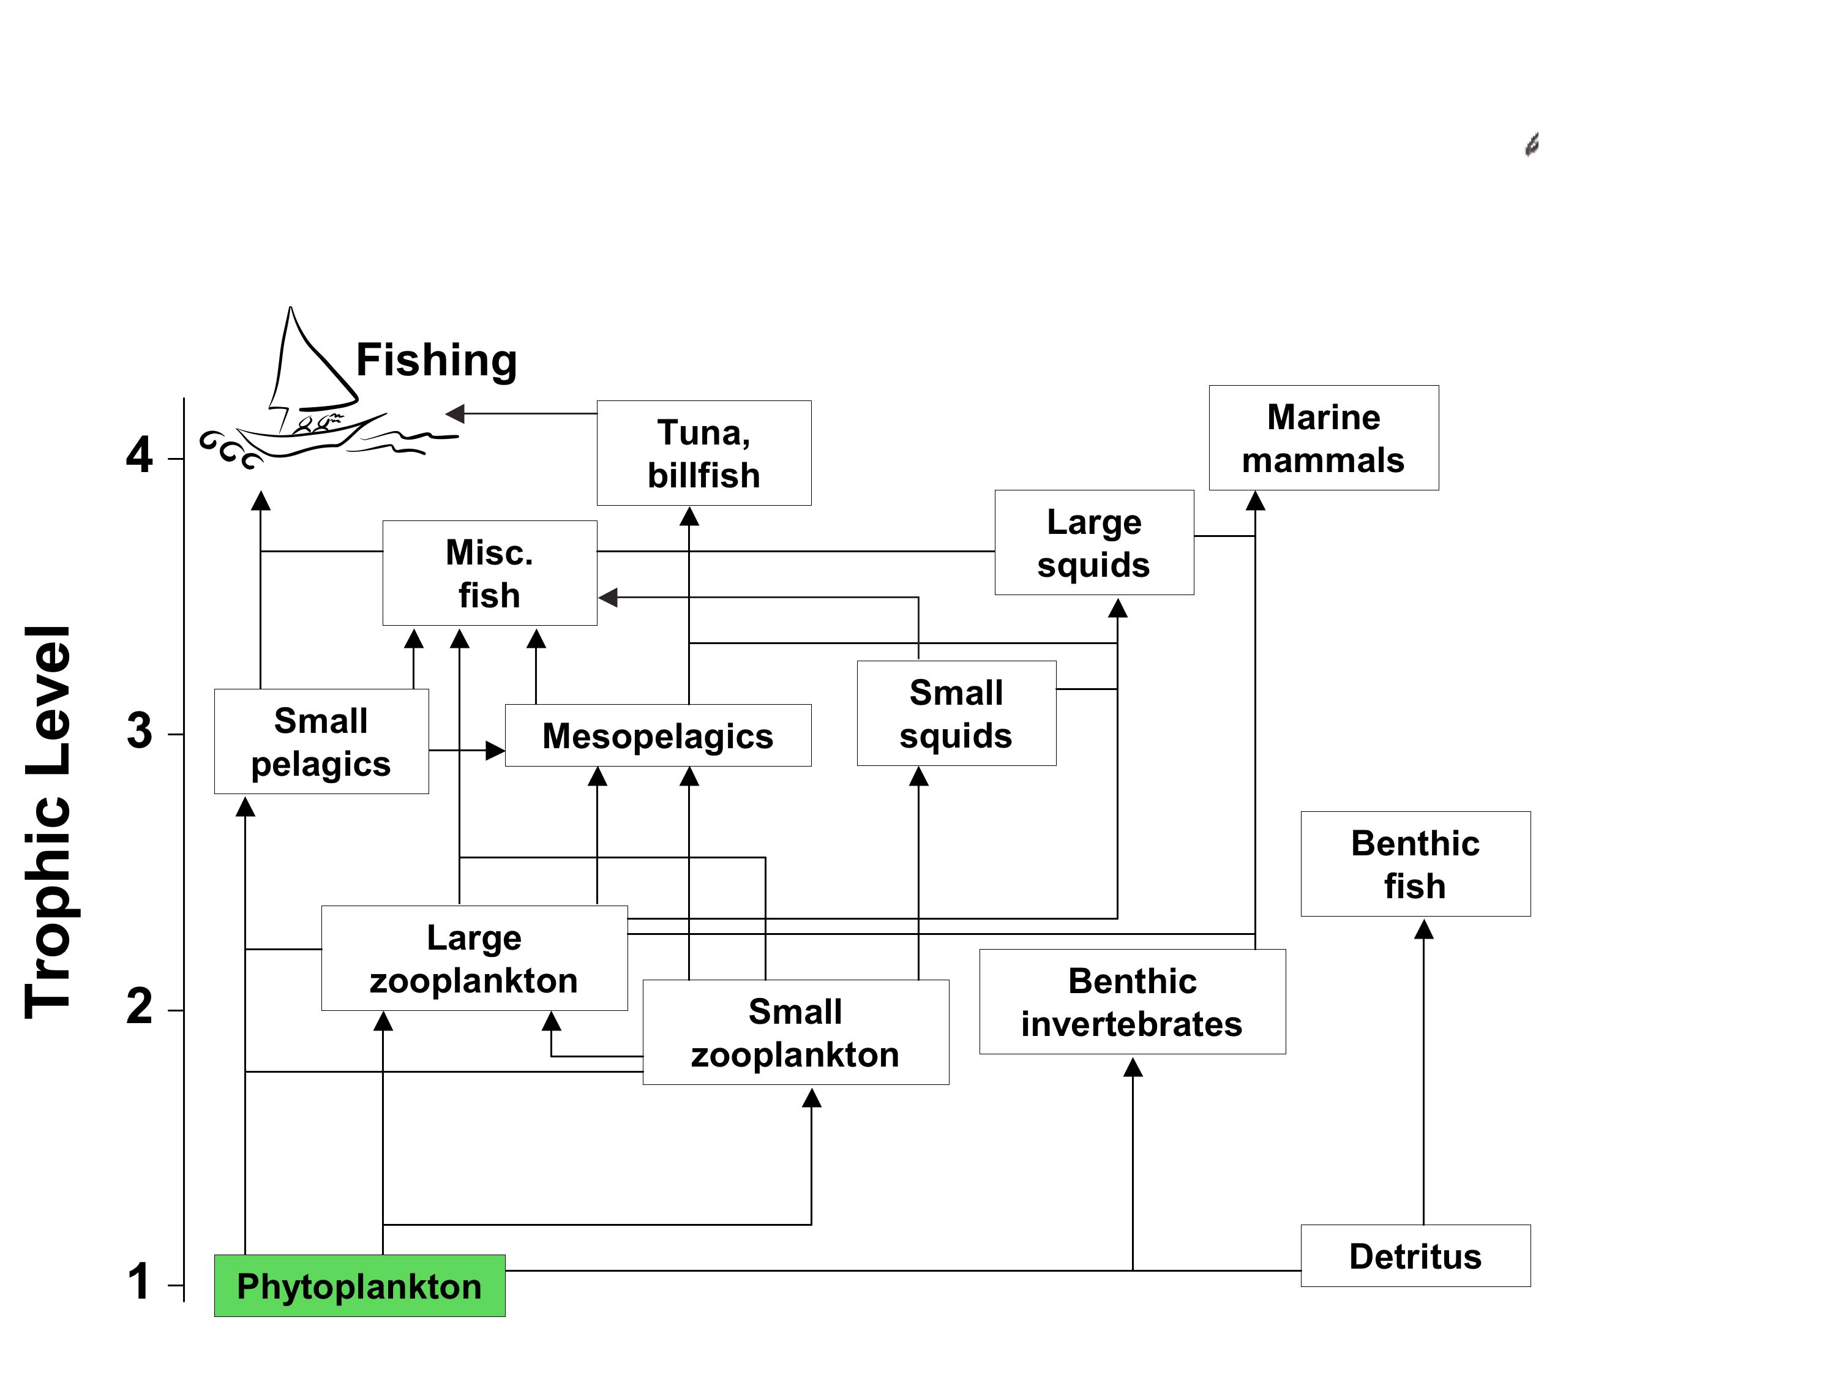

Figure 4.1 Simplified oceanic food web, showing the varying complexities in the linkages between phytoplankton, which is measured by satellite ocean colour data, and higher trophic levels. Modified from Pauly and Christensen [1993].

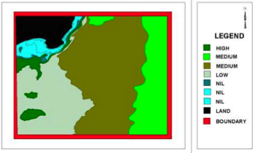
Figure 4.2. Map showing potential fishing zones (PFZs) off of the Bay of Bengal, derived from ocean colour data from India’s Ocean Colour Monitor (OCM) sensor. Figure reproduced from Pavan Dayarek [2003].

Need better figure! They claim PFZs are distributed on the web, but they don’t appear to be.
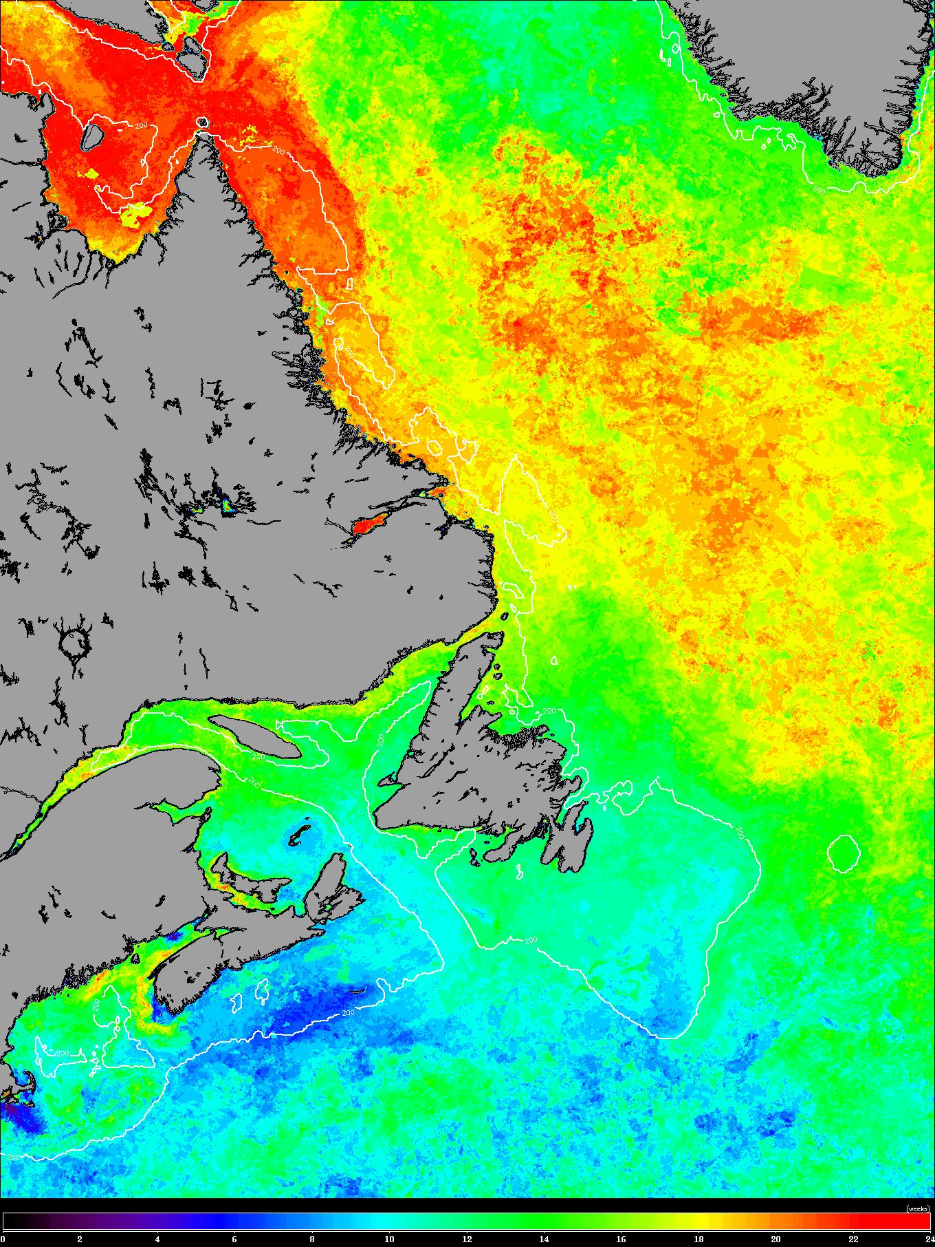
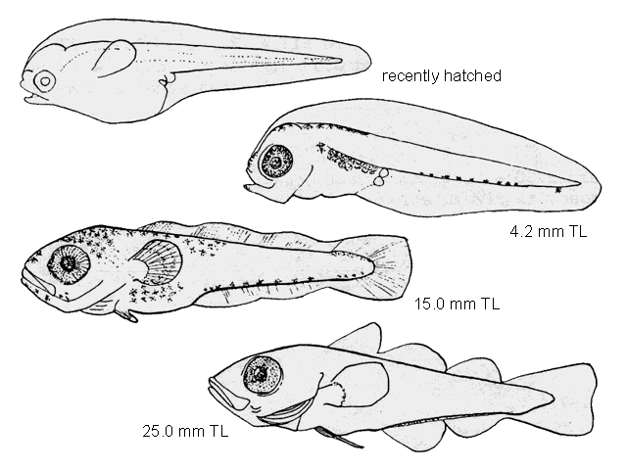
a
Haddock larvae

99
81
98
00
97
79
80
01
b

Figure 4.3 The timing of the spring phytoplankton bloom peak in the Northwest Atlantic is shown on the left derived from SeaWiFS ocean colour data. Colours change from blue indicating early (March) to red indicating late (July). On the right is the relationship between survival index (normalized to recruitment) of haddock larvae and the local anomalies in bloom timing. Data from the continental shelf east of Southern Nova Scotia (Canada) for the periods 1979–1981 and 1997–2001. Adapted from Platt et al [2003].
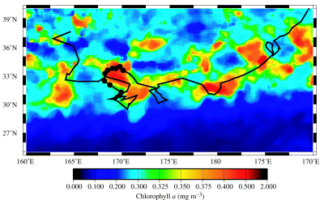

Figure 4.4. Track of a tagged Loggerhead turtle (black line) overlain on SeaWiFS chlorophyll data along the Transitional Zone Chlorophyll Front in the North Pacific Ocean. Figure reproduced from Polovina et al. [2004].

Permission to use figure received from FO, though not needed, US gov work.
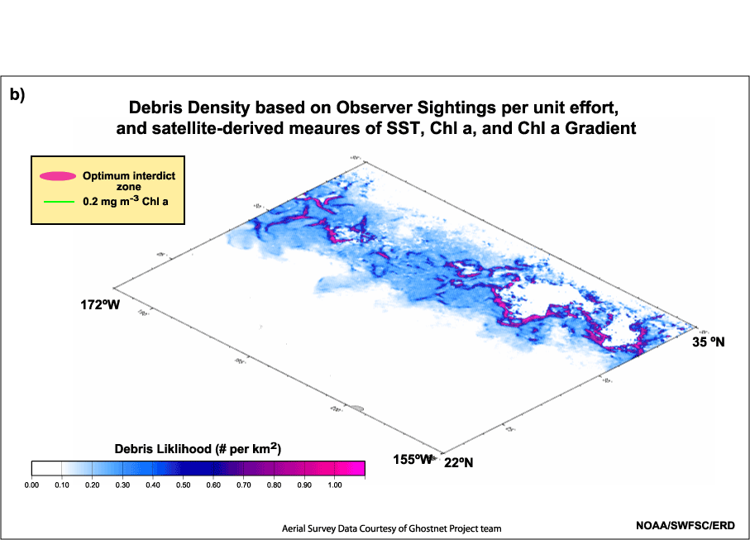
Fig. 4.5. Likelihood of debris density (derelict fishing nets, etc.) in the North Pacific subtropical convergence zone, based upon satellite measurements of chlorophyll, SST and observer sightings. Figure courtesy of Dave Foley (JIMAR).

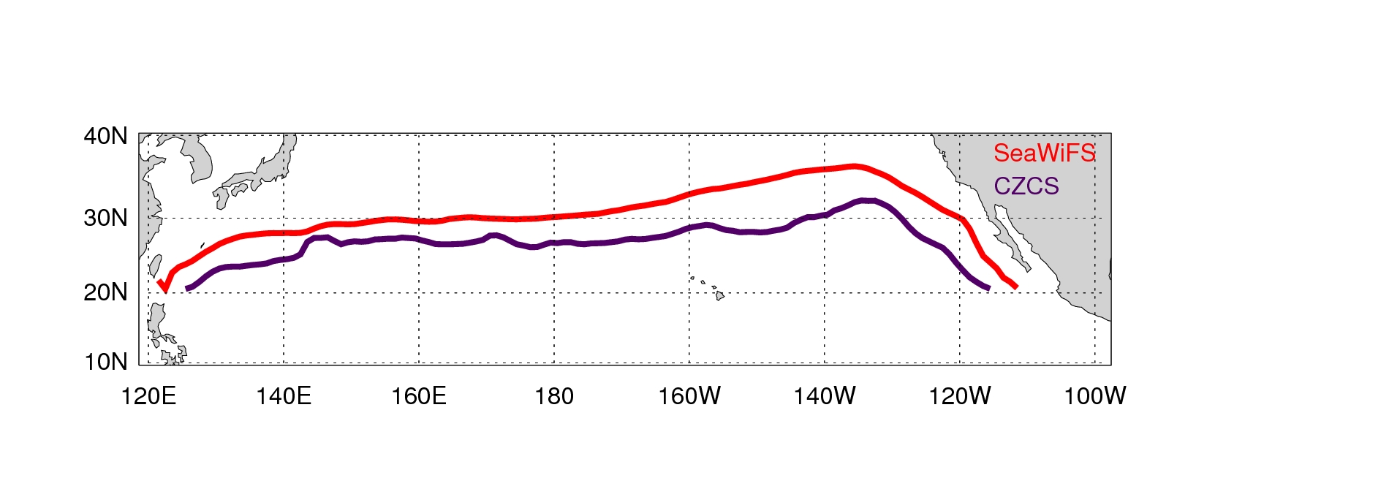
Fig 4.6 Interannual variation in the position of the TZCF indicated by the mean January position from CZCS data (1979-1985) in purple, and from SeaWiFS data (1998-2004) in red. The winter TZCF is presently ~5° further north from its position during the CZCS era.

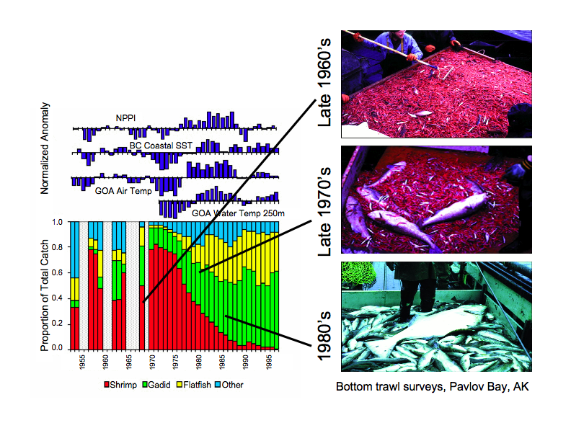

Fig 4.7 Changes in the composition of small-mesh trawl catches in the Gulf of Alaska between 1953 and 1997, in relation to climate indices (left) and shown visually in photos of bottom trawl surveys on the right. Figures reproduced from [Anderson and Piatt, 1999] and [Botsford et al., 1997].

Permission to use bar graph figure received from MEPS, though not needed, US gov work. Permission asked from Science for the photos published in the Botsford paper.

