PUBLIC NOTICE
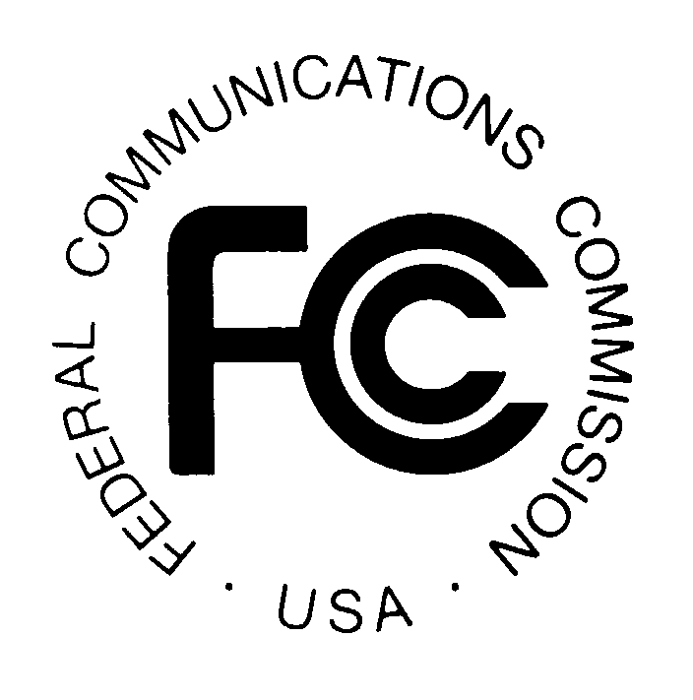

Federal Communications Commission
News media information 202 / 418-0500
Fax-On-Demand 202 / 418-2830
Internet: http://www.fcc.gov
TTY 202 / 418-2555
445 12th St., S.W.
Washington, D.C. 20554

DA 04-1759
June 21, 2004

CROWN CASTLE INTERNATIONAL CORP. DE PUERTO RICO,
CROWN COMMUNICATIONS, INC., CROWN CASTLE PT, INC., CROWN CASTLE GT COMPANY LLC, CROWN ATLANTIC COMPANY, LLC, CROWN CASTLE UK LIMITED AND CROWN CASTLE AUSTRALIA PTY LTD
SEEK Commission Determination of "Exempt
Telecommunications Company" Status
Under the Public Utility Holding Company Act

Comp. Pol. File No. ETC 04-02
Pleading Cycle Established

Comments Due: July 7 , 2004 Reply Comments Due: July 14, 2004

On June 8, 2004, Crown Castle International Corp. de Puerto Rico (CCPR), Crown Communications, Inc. (CCom), Crown Castle PT, Inc. (CCPT), Crown Castle GT Company LLC (CCGT), Crown Atlantic Company, LLC (CAC), Crown Castle UK Limited (CCUK) and Crown Castle Australia Pty Ltd (CCAL) (individually, as Applicant, and collectively, Applicants), located at 510 Bering Drive, Suite 500, Houston, TX 77057, submitted an application requesting a determination by the Federal Communications Commission (FCC or Commission) that each Applicant is an “exempt telecommunications company” (ETC), pursuant to section 34(a)(1) of the Public Utility Holding Company Act of 1935 (PUHCA), 15 U.S.C. §§ 79 et seq., as amended by section 103 of the Telecommunications Act of 1996, Pub. L. No. 104-104, and section 1.5002 of the Commission’s rules, 47 C.F.R. § 1.5002.

The application indicates that the Applicants (other than CAC and CCAL) are wholly-owned indirect subsidiaries of Crown Castle International Corp. (CCIC), a publicly-traded holding company organized under the laws of Delaware. The application further indicates that CCIC indirectly holds an approximately 62.5% equity interest in CAC (Verizon Communications holds approximately 37.5%) and an approximately 77.6% equity interest in CCAL (New Zealand Venture Capitalists hold approximately 22.4%). Applicants state that each is engaged directly, or indirectly through one or more affiliates exclusively in the business of providing: (a) telecommunications services; (b) information services; (c) other services or products subject to the jurisdiction of the Commission; and/or (d) products or services that are related or incidental to the provision of the products or services described in (a), (b), or (c).

Specifically, Applicants indicate that CCom, CCPT, CCGT and CAC are corporations organized under the laws of Delaware whose primary assets are communications towers in the United States, and whose primary business is the leasing of antenna space for the provision of wireless services on such towers. Applicants state that CCPR is a corporation organized under the laws of Puerto Rico whose primary assets are communication towers in Puerto Rico, and whose primary business is the leasing of antenna space for the provision of wireless services on such towers. In addition, the application indicates that CCPR owns a microwave and SMR system in Puerto Rico.

Applicants state that CCUK is organized under the laws of England and Wales, and that its primary assets are communication towers and rooftops plus analog and digital RF transmission networks in the United Kingdom. The application indicates that CCUK’s primary businesses are the leasing of antenna space for wireless services on such towers and rooftops, and the RF transmission of audio, video and data for customers in the UK. It further indicates that CCUK provides certain ancillary network-related services, including site design and antenna installation for wireless infrastructure, cell planning, acquisition, design, build, operation and maintenance services relating to the network (including provision of backhaul and signal monitoring), and 3G radio frequency network optimization and program management support services. Applicants state that CCAL is a corporation organized under the laws of New South Wales, Australia. The application indicates that the primary assets of CCAL are communication towers in Australia, and that CCAL’s primary business is the leasing of antenna space to wireless services on such towers. Additionally, the application states that in addition to, or in lieu of, these activities, all of the above listed companies may engage in the future in such other business activities as are consistent with the definition of an ETC set forth in section 34(a)(1) of the PUHCA.

In accordance with section 1.5003, 47 C.F.R § 1.5003, a person applying in good faith for a Commission determination of ETC status is deemed to be an ETC from the date of receipt of the application, in this case June 8, 2004, until the date of Commission action pursuant to section 1.5004. In accordance with section 1.5004 of the Commission’s rules, 47 C.F.R § 1.5004, if the Commission does not take action by issuing an order denying an ETC application within sixty (60) days of receipt of an application, in this case August 7, 2004, the application will be deemed granted as a matter of law. In accordance with section 1.5005, 47 C.F.R. § 1.5005, the Secretary of the Commission will notify the Securities and Exchange Commission (SEC) if any of the Applicants are determined to be an Exempt Telecommunications Company.

This proceeding is considered a "permit but disclose" proceeding for purposes of the Commission's ex parte rules, 47 C.F.R. §§ 1.1200 - 1.1216. Pursuant to section 1.5007 of the Commission's rules, 47 C.F.R. § 1.5007, interested parties may file comments on or before July 7, 2004 and reply comments are due on or before July 14, 2004. Comments in this proceeding may not be filed using the Commission's Electronic Comment Filing System (ECFS). All filings concerning any of the matters referenced in this Public Notice should refer to Comp. Pol. File No. ETC 04-02. All comments should also be served on the Applicants at the address listed above.

Interested parties should file an original and four (4) copies of their comments with the Office of the Secretary, Federal Communications Commission, 445 12th St., S.W., Room TW-A325, Washington, D.C. 20554. In addition, parties should send one (1) copy to Best Copy and Printing, Inc., Portals II, 445 12th Street, S.W., Room CY-B402, Washington, D.C., 20554, telephone 1(800) 378-3160, or via e-mail at FCC@BCPIWEB.COM, and two (2) copies to Carmell Weathers, Competition Policy Division, Wireline Competition Bureau, Federal Communications Commission, Portals II, 445 12th Street, S.W., Room 6-A423, Washington, D.C. 20554. Commenters are also requested to fax their comments to the FCC at (202) 418-2345, Attention: Carmell Weathers.

Filings can be sent by hand or messenger delivery, by commercial overnight courier, or by first-class or overnight U.S. Postal Service mail (although we continue to experience delays in receiving U.S. Postal Service mail). The Commission's contractor, Natek, Inc., will receive hand-delivered or messenger-delivered paper filings for the Commission's Secretary at 236 Massachusetts Avenue, N.E., Suite 110, Washington, D.C. 20002. The filing hours at this location are 8:00 a.m. to 7:00 p.m. All hand deliveries must be held together with rubber bands or fasteners. Any envelopes must be disposed of before entering the building. Commercial overnight mail (other than U.S. Postal Service Express Mail and Priority Mail) must be sent to 9300 East Hampton Drive, Capitol Heights, MD 20743. U.S. Postal Service first-class mail, Express Mail, and Priority Mail should be addressed to 445 12th Street, S.W., Washington, D.C. 20554. All filings must be addressed to the Commission’s Secretary, Office of the Secretary, Federal Communications Commission.

The application will be available for review and copying during regular business hours at the FCC Reference Center, Portals II, 445 12th Street, S.W., Room CY-A257, Washington, D.C. 20554, telephone (202) 418-0270. A copy of the application may also be purchased from the Commission’s copy contractor, Best Copy and Printing, Inc., Portals II, 445 12th Street, S.W., Room CY-B402, Washington, D.C. 20554, telephone 1(800) 378-3160, or via e-mail at FCC@BCPIWEB.COM.

For further information, contact Carmell Weathers, (202) 418-2325 (voice), carmell.weathers@fcc.gov, or Rodney McDonald, (202) 418-7513 (voice), rodney.mcdonald@fcc.gov, of the Competition Policy Division, Wireline Competition Bureau. The TTY number is (202) 418-0484.

-FEDERAL COMMUNICATIONS COMMISSION-

