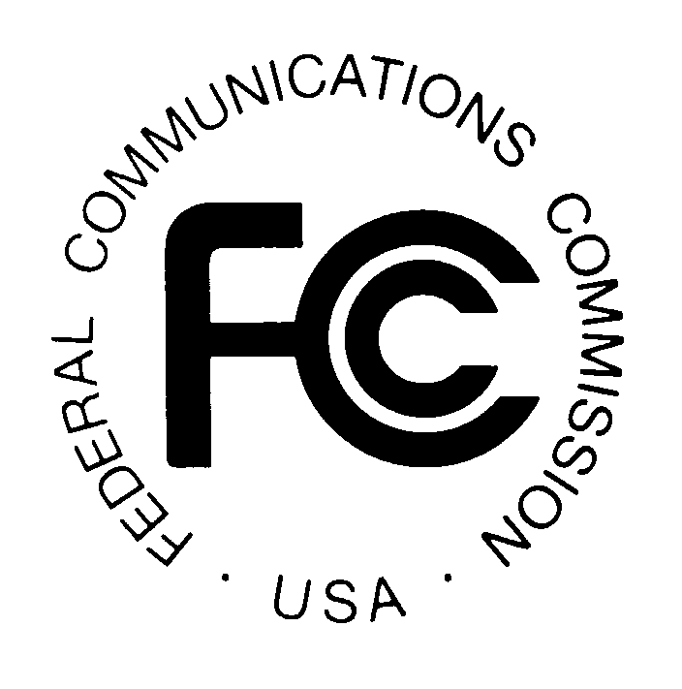PUBLIC NOTICE
FEDERAL COMMUNICATIONS COMMISSION
445 12th Street, S.W., TW-A325
WASHINGTON, DC 20554 DA 01-1963
News media information 202/418-0500 Fax-On Demand 202/418-2830 Internet: http://www.fcc.gov ftp.fcc.gov

Released: August 21, 2001

WIRELESS TELECOMMUNICATIONS BUREAU GRANTS REQUEST
OF JOSEPH J. SIMONS, ESQ., TRUSTEE, TO EXTEND DIVESTITURE TRUST

Pursuant to sections 4(i) and 310(d) of the Communications Act of 1934, as amended, 47 U.S.C. §§ 154(i), 310(d), and sections 0.331 and 20.6 of the Commission’s rules, 47 C.F.R. §§ 0.331, 20.6, the Wireless Telecommunications Bureau (“Bureau”) grants the request of Joseph J. Simons, Esq., Trustee, to extend the duration of the wireless asset divestiture trust involving PCS license WPQL237 held by Chicago 20 MHz, LLC until fifteen business days following the date when the grant of the application to transfer control to PrimeCo Acquisition LLC (ULS File No. 0000499462) becomes final. The application appeared as consented on WTB Report No. 935, rel. August 8, 2001. No comments were received in response to the public notice of the request to extend the trust. See Joseph J. Simons, Trustee, Seeks Extension of Wireless Assets Trust, Public Notice, DA 01-1757 (WTB, rel. July 24, 2001).

The Bureau finds that extending the trust under these circumstances serves the public interest and grants the extension through October 9, 2001.

Pursuant to section 1.103 of the Commission’s rules, 47 C.F.R. § 1.103, the consent granted herein is effective upon release of this Public Notice. Pursuant to sections 1.106(f) and 1.115(a) of the Commission’s rules, 47 C.F.R. §§ 1.106(f), 1.115(a), petitions for reconsideration and applications for review may be filed within thirty days of the release of this public notice.

For further information, contact Lauren Kravetz Patrich or John Branscome, Wireless Telecommunications Bureau, Commercial Wireless Division, at (202) 418-7240.

-FCC-

