Field Report
Okefenokee National Wildlife Refuge

■ 1.0 Summary
View of Okefenokee Swamp from Observation Tower
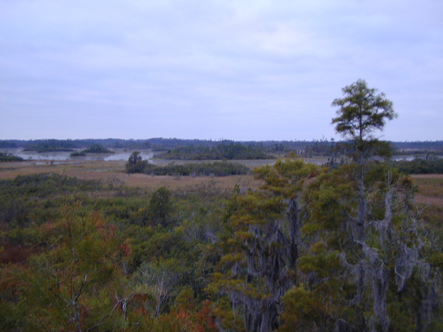
The Okefenokee National Wildlife Refuge (NWR) is located in southeastern Georgia at the Florida-Georgia state line. The eastern entrance is the main USFWS entrance and is located southwest of Folkston, Georgia. The west entrance, located east of Fargo, Georgia, is the primary access to the Stephen C. Foster State Park. The north entrance, located south of Waycross, Georgia, is the entrance to the Okefenokee Swamp Park, a privately owned facility.
Okefenokee NWR was established in 1937 1) as a refuge for waterfowl and 2) to preserve the rare and beautiful Okefenokee Swamp. About 90 percent of the 396,000 acres in the refuge are designated as a National Wilderness Area. The Stephen C. Foster State Park, operated by the state of Georgia, is located in the western portion of the refuge.
Okefenokee NWR is a bog inside a huge, saucer-shaped depression that was once part of the ocean floor. The main outlet of the swamp, the Suwannee River, begins in the heart of the Okefenokee Swamp and drains southwest into the Gulf of Mexico. The St. Marys River, which forms the boundary between Georgia and Florida, drains the southeastern portion of the refuge.
The swamp is composed of islands, lakes, cypress forests, scrub-shrub areas and open wet “prairies.” The waters of the Okefenokee are tea-colored due to tannic acid, which also make the swamp water nearly as acidic as cola. The refuge remains one of the most well preserved freshwater areas in America.
The refuge’s primary goal is to protect wildlife and habitat, with a secondary emphasis on educating the public on wildlife management and providing recreational opportunities that are compatible with the refuge’s mission. In 1998, over 330,000 people visited the refuge. Most of the visitors entered either the east or west entrance. During peak season weekends, particularly during special events, the parking lots in the refuge are filled to capacity.
The town of Folkston, Georgia, the gateway community located at the east entrance to the refuge, is very interested in promoting ecotourism and is planning an Educational Research Center in the downtown area. The community would like to further connect the new community developments with the refuge via a transit system.
The Okefenokee Swamp is one of the world’s largest intact freshwater ecosystems. It is known for having one of the most well balanced ecological systems in existence. There are 621 species of plants growing in the swamp, as well as 39 fish, 37 amphibians, 64 reptiles, 234 birds, and 50 mammal species. The wildlife located in the refuge includes threatened and endangered species, such as the Indigo Snake, Red-Cockaded Woodpecker, Wood Stork, and Gopher Tortoise.
Billy’s Island, in the western portion of the refuge, contains remnants of an early 1900s logging community. The Chesser Island Homestead, accessible from the Swamp Island Drive auto trail, is an historic property that portrays the life of swamp pioneers in the early 1900s.
Recreational activities at the refuge include observing and photographing wildlife, an auto tour, canoeing, hiking, guided tours, fishing, special events and programs, and ecosystem education. Both the Refuge and the State Park have a number of special events each year to interpret their resources to the public.
Recommended Alternative Transportation Systems (ATS) include a bus shuttle system that operates between the Educational Research Center and the historic railroad station in Folkston, Georgia, and the Richard S. Bolt Visitor Center in the eastern portion of the refuge, reinstitution of the tram on Swamp Island Drive, and a bus shuttle system that operates between Fargo, Georgia and the Stephen C. Foster State Park.
■ 2.0 Background Information

2.1 Location
The Okefenokee NWR is located in southeastern Georgia in Charlton, Ware, and Clinch Counties; and in northeastern Florida in Baker County. The eastern entrance is the main USFWS entrance and is located about 11 miles southwest of Folkston, Georgia off Georgia Highway 121/23. The west entrance is located 17 miles east of Fargo, Georgia off Highway Spur 177 and is the primary access to the Stephen C. Foster State Park. The north entrance is located eight miles south of Waycross, Georgia off U.S. 1 and is the entrance to the Okefenokee Swamp Park (see Figure 1).
Figure 1. Map of Okefenokee National Wildlife Refuge
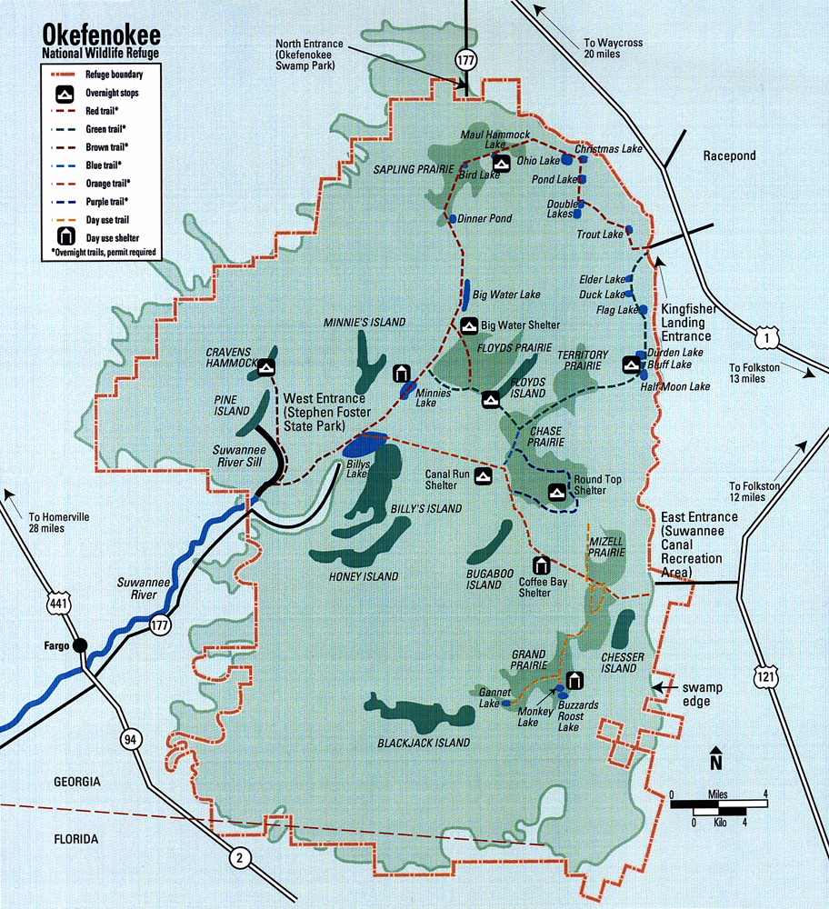

2.2 Administration and Classification
Okefenokee NWR was established in 1937 by President Franklin D. Roosevelt to preserve the rare and beautiful Okefenokee Swamp. About 90 percent of the 396,000 acres in the refuge are designated as a National Wilderness Area. The Stephen C. Foster State Park, operated by the state of Georgia, is located in the western portion of the refuge on approximately 82 acres. Entrance fees to the refuge and State Park are $5.00 per vehicle and is good for admission for one week. The management of Okefenokee NWR also manages the Banks Lake NWR, located to the west of Fargo, Georgia.
The refuge has 30 full time employees. In addition, the refuge has an active volunteer program. In fiscal year 1999, over 200 volunteers provided nearly 16,000 hours of service for the refuge.

2.3 Physical Description
Okefenokee NWR is a vast bog inside a huge, saucer-shaped depression that was once part of the ocean floor. The word “Okefenokee” is a European rendition of the native American words meaning “land of the trembling earth.” Peat deposits up to 15 feet thick cover much of the swamp floor. These deposits are so unstable in spots that a person can cause trees and surrounding bushes to tremble by stomping the surface. The main outlet of the swamp, the Suwannee River, begins in the heart of the Okefenokee Swamp and drains southwest into the Gulf of Mexico. The St. Marys River, which forms the boundary between Georgia and Florida, drains the southeastern portion of the refuge.
The swamp is not one continuous type of habitat. Islands, lakes, cypress forests, scrub-shrub areas, and open wet “prairies” form a mosaic of habitats on which wildlife depend. Fire and water define the swamp’s habitats. Lakes and prairies are created after long droughts when fire burns out vegetation and top layers of peat. The slow moving waters of the Okefenokee are tea-colored due to the tannic acid released from decaying plants, which also make the swamp water nearly as acidic as cola.
Open Swamp Prairie
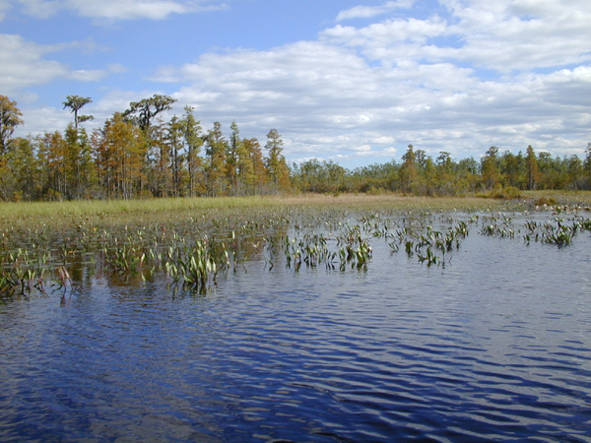
The 396,000-acre refuge remains one of the most well preserved freshwater areas in America. Approximately 90 percent of the refuge is also designated as a National Wilderness Area, which further protects the site.

2.4 Mission and Goals of the Refuge
As with most refuges, the Okefenokee NWR’s primary goal is to protect wildlife and habitat, with a secondary emphasis on educating the public on wildlife management and providing recreational opportunities that are compatible with the refuge’s mission. The refuge also has developed some objectives to guide its resource management. A summary of these objectives follows:
- To provide protection to the unique environmental qualities of the Okefenokee ecosystem;
- To provide optimum habitat and protection for endangered and threatened species;
- To provide optimum habitat for a wide diversity of fish, birds, mammals, reptiles, and amphibians; and
- To provide opportunities for fish and wildlife-oriented recreation, interpretation, and environmental education.

2.5 Visitation Levels and Visitor Profile
The Okefenokee NWR has the sixteenth highest visitation level of the refuges in the NWR system. Visitation at the refuge in 1998, 330,000 people, was higher than the 1997 visitation level, but lower than other years in the mid-1990s. The visitation was equally split between the east and west entrances, with approximately 128,000 visitors at each entrance, although the refuge considers the east entrance the primary entrance for the refuge. The north entrance had approximately 74,000 visitors. The peak season for visitation to the refuge is February through May. Visitors normally stay in only one area of the refuge (east, west, or north) during a visit. A day visitor to the east entrance will normally leave the area after his day in the refuge is completed.
The visitors in the Stephen C. Foster State Park (west entrance) are both day visitors and overnight campers. Visitors who stay in the cabins or campgrounds usually stay two to three days. The peak visitation period at the State Park is March through May. The State Park experiences full parking lots on 20 to 24 days during their peak season.
While the majority (57 percent) of the visitors to the refuge (including the State Park) come from Florida and Georgia, approximately 13 percent come from northern Atlantic coast states, 12 percent come from the central United States, and nine percent are from the mid southern states. Approximately four percent of the visitors come from foreign countries and the remainder comes from other states in the United States.
Stephen C. Foster State Park
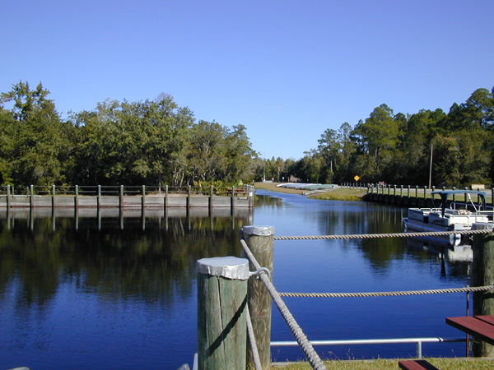
Visitor activities at the refuge include observing and photographing wildlife, an auto tour, canoeing, hiking, guided tours, fishing, special events and programs, and ecosystem education. Guided boat tours through the Okefenokee Swamp are popular, with over 6,000 visitors taking the guided tours during peak months. The Swamp Island Drive is also very popular with visitors. Visitors may also paddle their own canoes or rental canoes on daily or overnight canoe trails.
Although the refuge has 120 miles of canoe trails, visitors are concentrated in a relatively small portion of the refuge in order to accomplish its primary mission – wildlife management. The area is being promoted for ecotourism and that is expected to increase tourism significantly in the future. Management plans indicate that the refuge could accommodate nearly 800,000 annual visitors. The capacity of the State Park (which is included in the 800,000) is about 180,000 annual visitors.
■ 3.0 Existing Conditions, Issues and Concerns

3.1 Transportation Conditions, Issues and Concerns
There are three major entrances to the Okefenokee NWR. The east entrance is located 11 miles southwest of Folkston, Georgia off Georgia Highway 121/23. This is the main USFWS entrance and provides access to Swamp Island Drive, the Richard S. Bolt Visitor Center, hiking trails, boardwalk and tower, boating trails, guided boat tours, motor boat and canoe rentals, and a restored homestead.
The 300-space parking lot for the Visitor Center also serves the concession for the boat rentals and boat tours. The Visitor Center is located away from the parking lot and is easily overlooked by visitors that are using the concession. During peak season weekends, particularly during events, the parking lot is filled to capacity, as are other parking facilities in the refuge. On average weekends, the lot is approximately half full. Refuge officials estimate that if visitors parked and used mass transit to access Swamp Island Drive, the lot would be approximately three-fourths filled. During the annual Okefenokee Festival, buses are rented for guided tours of Swamp Island Drive. However, the drive is narrow and a bus and car cannot pass without one of the vehicles leaving the road. The refuge used trams to shuttle visitors around the nine-mile Swamp Island Drive between 1978 and 1982, which provided an interpretive tour of the refuge. The trams were abandoned in 1982 due to maintenance problems and lack of staff. While this saved costs, the visitor experience suffered as they lost the interpretation of the guided tour.
The west entrance is located 17 miles east of Fargo, Georgia off Georgia Highway Spur 177. The State Park contains boardwalks, boating trails, fishing, guided boat tours, motorboat and canoe rentals, camping, cabins, interpretive programs, and a museum. During peak season weekends, the State Park parking facilities are also filled to capacity. Park officials estimate that this occurs approximately 20 to 24 days during the peak season, which is nearly every weekend from March to May.
The north entrance is located eight miles south of Waycross, Georgia off U.S. 1. This is the location of the Okefenokee Swamp Park, a privately owned facility containing interpretive displays, boardwalk and tower, boat tours, animal habitats, and lectures.
There is an unpaved perimeter road around the entire refuge, just outside the refuge boundary. It is 170 miles long and is gated so unauthorized persons cannot gain access to the road. The refuge maintains the bridges and the landowners and refuge maintain the roadway.
There is no scheduled transit service in the area, but the Southeast Georgia Regional Development Center provides demand-responsive transportation to elderly persons in the area.

3.2 Community Development Conditions, Issues and Concerns
The primary gateway community to the refuge is the town of Folkston, Georgia. The state of Georgia awarded Folkston the “Better Hometown” award in 1999, which designates Folkston as a preferred community to live in. The town has about 2,300 population, and Charlton County has about 9,200 persons. The city of Folkston markets itself as the “Gateway to the Okefenokee” and is in the process of developing new attractions to boost the tourist length of stay in the area. The new tourist developments in the city of Folkston include the Educational Research Center and the Historic Train Station. The privately funded Educational Research Center will be constructed in an old school building in downtown Folkston and will focus on the Okefenokee Swamp environment. The Educational Research Center will provide environmental education displays, classrooms, and laboratories for students throughout the state.
The town would like to have a transit system that connects the Educational Research Center with the refuge, with stops at other local attractions. Folkston has an historic railroad station that could serve as a transportation hub in the community, as well as a local attraction. The city would also like to see visitors park their cars at the train station, or Educational Research Center, and bicycle or take transit to the refuge.
Former School Building to House New Educational Research Center
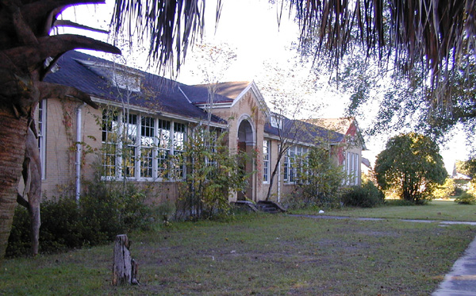
The city and refuge have a good relationship and the refuge welcomes increased visitation prompted by the city’s economic development efforts if increased tourism does not overburden the refuge’s resources.
It has been estimated that the economic impact of tourism in Charlton, Ware, and Clinch Counties in Georgia is over $77 million. The specific economic impact of the refuge was not isolated, but it is estimated to be a large share of this figure.
The rural community of Fargo, Georgia also is interested in taking advantage of the resources of the refuge to help boost its economy.

3.3 Natural or Cultural Resource Conditions, Issues and Concerns
The Okefenokee Swamp is one of the world’s largest intact freshwater ecosystems, with over 350,000 acres of the refuge designated as Class 1 Wilderness. It is known for having one of the most well-balanced ecological systems in existence and has been designated a Wetland of International Importance by the United Nations in 1981. The swamp is world renowned for its amphibian populations that are bio-indicators of global health.
The Suwannee Canal Company purchased most of the Okefenokee Swamp from the state of Georgia in 1891. Their intent was to drain the land for logging and to grow crops. The company spent three years digging the Suwannee Canal over 11 miles into the swamp. The company was sold to the Hebard Cypress Company in 1899 and a railroad was built into the west edge of the swamp to assist in logging operations. Logging operations ceased in 1927 after hundreds of millions of board feet of lumber, primarily cypress, was removed from the area. In addition to the remains of elevated railroad stakes, there are scattered remnants of the logging community that was created on Billy’s Island.
Another historic resource is the Chesser Island Homestead, accessed from Swamp Island Drive. This homestead was built by the Chesser family in 1927 and serves as an example of swamp pioneer lifestyle during that period. The family lived off the land by hunting, tending livestock and beehives, and growing a garden, with their only cash crops being sugar cane from which they made cane syrup.
Chesser Family House
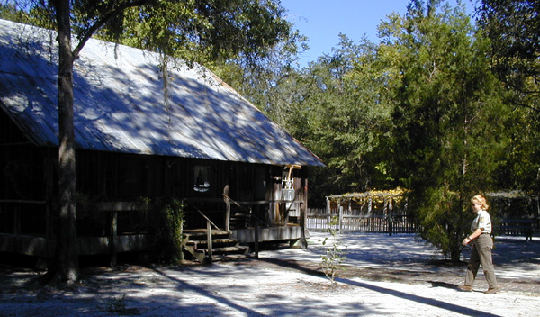
The refuge staff and volunteers work to preserve the natural qualities of the swamp, provide habitat for a variety of wildlife, and provide recreational opportunities for visitors. Brochures, exhibits, audio/visual aids and other media are available at the refuge interpretive center and along trails to inform and educate visitors about the refuge wildlife, as well as the unique environmental qualities of the Okefenokee Swamp.
The staff research a number of the resources of the refuge, ranging from bacteria to black bears. They also conduct wildlife censuses, vegetative transects, and water level surveys. The refuge also conducts prescribed burns in upland areas, thin forests, create wildlife openings, and plant longleaf pines. The staff monitors, manages, and improves wildlife populations and habitat, placing special emphasis on endangered species.
As the refuge contains a variety of habitats, there is an abundance of plants and animals located in the refuge. There are 621 species of plants growing in the swamp, as well as 39 fish, 37 amphibians, 64 reptiles, 234 birds, and 50 mammal species. Plantlife includes pine and hardwood forests, cypress forests, water oak, wild grape, carnivorous pitcher plants, and bladderworts. The wildlife located in the refuge includes threatened and endangered species, such as the Indigo Snake, Red-Cockaded Woodpecker, Wood Stork, and Gopher Tortoise. Other wildlife that is found in the refuge includes Black Bear, Gray Fox, Long-Tailed Weasel, Mink, River Otter, Bobcat, White-Tailed Deer, Sandhill Crane, and Great Blue Heron.
The main thrust of the refuge’s vegetation management activities in upland areas is the restoration, management, and protection of longleaf pine communities. This habitat has degraded over the years and is a habitat that supports a vast association of wildlife species. Much of the refuge’s wildlife management activities in uplands centers around the endangered Red-Cockaded Woodpecker.
A five-year study was initiated in 1995 to analyze the black bear population in the area. This study is being done by the refuge, United States Geological Survey Biological Resource Division, University of Tennessee, and the University of Florida. The objectives of the study are to determine population size, density, reproduction and mortality rates, food habits, and habitat use in order to formulate best management practices.
Pine Forest in Uplands
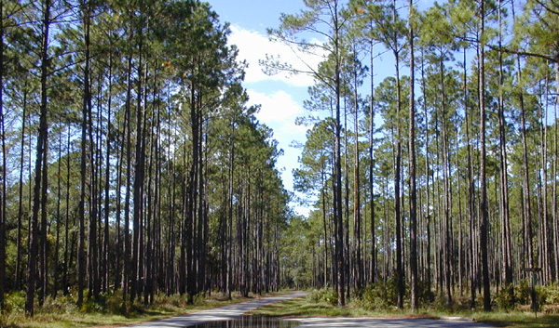
The proposed DuPont titanium dioxide strip mine, adjacent to the refuge’s eastern boundary, threatens to permanently alter the swamp’s hydrology, impact endangered species, and affect the wilderness experience of thousands of visitors. The refuge anticipates that the runoff from the strip mine will flow into the refuge. The DuPont Company is continuing with their plan to mine, despite protests by federal and state agencies and a variety of environmental organizations. According to a nationwide survey, 78 percent of Americans oppose the DuPont project.
The refuge engages in both prescribed burning and firefighting. Firefighting in the refuge is very difficult due to the extensive swamp area. Fires must be detected very early in order to be extinguished fairly quickly. Fires that are started naturally are usually left to burn unless they begin to leave the refuge and threaten private land. The Greater Okefenokee Association of Landowners (GOAL), consisting of individuals, agencies, and companies that own property adjacent to the refuge, was formed in the early 1990s to improve communications among and between surrounding landowners, particularly when a fire threatens to leave the refuge and enter private property. The refuge has constructed dip sites every few miles around the refuge, which are open ponds that allow helicopters to fill dip buckets during firefighting procedures.
Resource damage from visitors is minimal. Most of the damage is temporary, such as trash that is scattered instead of deposited in receptacles. Due to noise and exhaust emissions, the refuge no longer allows buses or other vehicles with diesel engines to idle in parking lots. Other damage is created by cars that get stuck in ditches when parking lots are filled. Most of the resource damage in the refuge is created from outside sources, such as emissions from smokestacks, chicken farms, pesticides and herbicides.

3.4 Recreation Conditions, Issues and Concerns
Recreational activities at the refuge include observing and photographing wildlife, an auto tour, canoeing, hiking, guided tours, fishing, special events and programs, and ecosystem education. Overnight camping is permitted only on overnight canoe trips or at designated areas in the Stephen C. Foster State Park that is located within the refuge. There are 120 miles of boat trails in the refuge, accessible by canoe. A portion of the boat trails is also open to small boats with a 10 horsepower outboard motor limitation. Approximately 25 miles of the boat trails are accessible from the State Park.
Concessionaire Boats and Building (Left) and Boat Tour (Right)
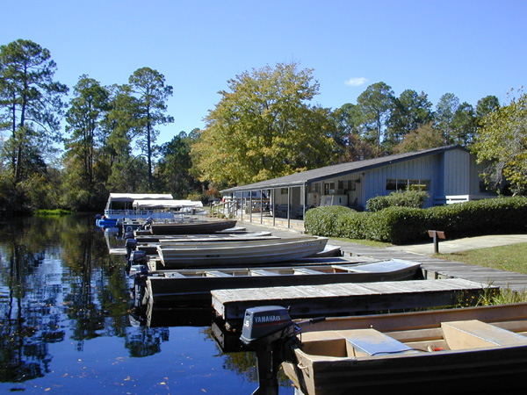 | 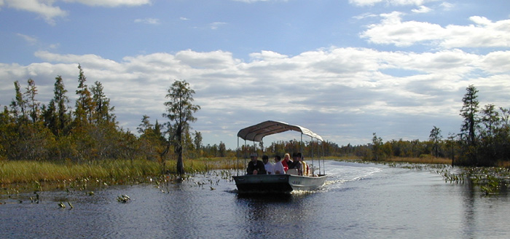

The Swamp Island Drive is a nine-mile round-trip driving, biking, and walking loop with a number of stops along the drive to experience the resources of the refuge, including the Suwannee Canal, wildlife and plantlife observation points, the Chesser Island Homestead, and a boardwalk and observation tower.
Guided boat tours are very popular in the refuge and State Park. In April 1999, over 6,000 visitors took advantage of the guided boat tours in the Refuge, State Park, and Okefenokee Swamp Park.
The refuge has a number of special annual events for the public. These include:
- February | Wings Over the Swamp Festival
- March | St. Marys River Clean-up
- April | National Wildlife Week Celebration/Earth Day Art Festival
- May | International Migratory Bird Day
- June | National Fishing Day
- October | National Wildlife Refuge Week
 | Okefenokee Festival
 | Halloween Program
 | Deer Hunting
- December | Yule Log Ceremony

The 82-acre Stephen C. Foster State Park contains 66 tent, trailer and RV sites, nine cottages, picnic shelters, pioneer camping, boat ramp and rental, nature trails, boat trails, and an interpretive center and museum. The State Park is unable to increase its facilities as there is no land available for expansion within the 82-acre site. The camping areas are filled about 20 to 24 days each year. As natural resources in camping areas become damaged, those camping areas are closed for the winter. In addition, the State Park has several annual events scheduled throughout the year:
- March | Birding Weekend
- April | Wildflower Weekend
- June | Reptile Weekend
- November | Man in the Swamp
There are sometimes conflicts between the canoeists and the small outboard boaters. The canoeists feel that the outboard motors are violating the sanctity of the area. Approximately 41 percent of the boat trails are off limits to mechanically powered boats.
■ 4.0 Planning and Coordination

4.1 Unit Plans
The Okefenokee NWR has developed an Interpretive Concept Plan that calls for a major renovation of the Richard S. Bolt Visitor Center. The plan identifies major themes and subthemes, interactive exhibits, and multimedia programs. The traffic patterns will also be reviewed in order to get more visitors into the center. The renovation is anticipated to be completed in fall 2000.
In the eastern area, the refuge also plans to resurface Swamp Island Drive and to rebuild the tram shelters that are alongside the drive. The boardwalk accessed from the drive will also be rebuilt. The concession building will be replaced and a new boardwalk may be added in the area.
The refuge recently completed an Environmental Assessment to examine the impacts of removing all or part of the Suwannee River Sill. The sill was constructed to try to hold water back in the swamp to reduce the potential of wildfire. The sill only affected water levels in a small portion of the swamp. It was decided that a phased removal of the sill was the recommended alternative. The effects of implementing this alternative will be examined in more detail in the future before implementation of the plan is begun.
The refuge will be investigating the possibility of constructing another entrance road to access the State Park on the west side of the refuge. This is in part due to the evacuation needs during wildfires. A satellite park to the Stephen C. Foster State Park may be constructed near Fargo, Georgia. This satellite park will not be constructed on refuge property.
The current Refuge Management Plan was developed in 1980. This plan will be revised in 2001. A Public Use Management Plan was developed in 1981. This plan was amended in 1994.

4.2 Public and Agency Coordination
The refuge has formed a number of partnerships to assist in accomplishing its mission. The refuge leases the 82-acre site of the Stephen C. Foster State Park to the state of Georgia. The lease is for a period of 50 years and includes only the land. The state of Georgia owns the buildings in the State Park.
The Suwannee Basin Interagency Alliance includes the NWR, along with a number of federal, state of Georgia, and state of Florida agencies that are concerned with the refuge. The purpose of the Alliance is to promote effective communication and coordination, and develop a comprehensive natural resources plan for the Suwannee Basin.
The Tri-Agency Agreement was executed by the NWR, Osceola National Forest, and Cumberland Island National Seashore. The purpose of this agreement is to provide for mutual assistance among the three agencies in the form of personnel, services, and equipment required for wildfire prevention/suppression, prescribed burning, resource management, law enforcement, and the protection of life and property due to natural disasters.
GOAL, consisting of individuals, agencies, and companies that own property adjacent to the refuge, was formed in the early 1990s to improve communications among and between surrounding landowners, particularly when a fire threatens to leave the refuge and enter private property. GOAL has also worked together on other issues, including black bears, roads, and bridges.
The Okefenokee Wildlife League (OWL) is a nonprofit cooperating association organized to promote better understanding, appreciation, and conservation of the natural history and natural environment of the refuge. OWL has a bookstore in the Visitor Center and profits from the bookstore help to fund public use and research programs.
The NWR also partners with Zoo Atlanta to promote the refuge at the zoo. The zoo has constructed a building that contains exhibits about the refuge and also hosts an annual Okefenokee Swamp Festival at the zoo.
The refuge also has exhibits promoting the refuge at local fairs, including Valdosta and Waycross, and at annual outdoor events, including the Buck-a-rama and Fish-a-rama held in both Atlanta and Perry, Georgia.
The refuge has an agreement with the Georgia Statewide Academic and Medical Systems (GSAMS) to provide interpretive programming that is transmitted by satellites to schools. Children can ask questions and the refuge can provide immediate answers to those questions. In a similar nature, Turner Broadcasting System (TBS) came to the refuge in 1995 and conducted a four-day live interactive program that was televised to students around the nation. The refuge hosted a number of guest speakers and also broadcast the program over the Internet.
The universities and colleges of Florida and Georgia, along with other schools around the United States, conduct research within the swamp and its surrounding ecosystem.
The U.S. Department of Justice and U.S. Department of the Interior have renewed an agreement to allow at-risk juveniles to live, work, and go to school on wildlife refuges in exchange for a manual labor force. The Youth Environmental Services (YES) program is in the pre-planning stages and should be operational soon.
Egret in Swamp
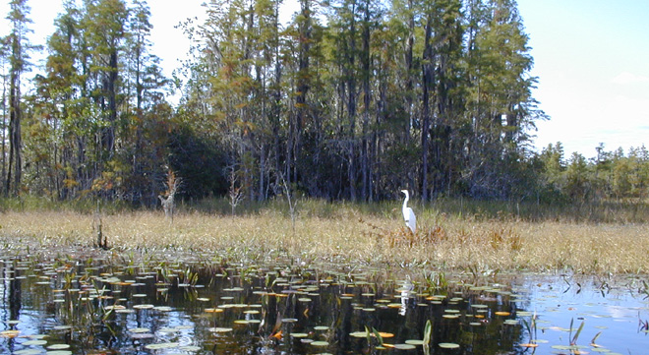
■ 5.0 Assessment of Need

5.1 Magnitude of Need
Alternative transportation may have the potential to enhance the experience of visitors to the refuge, as well as protecting the resources within the refuge. As parking appears to be the primary transportation-related problem associated with the Refuge and the State Park, opportunities to reduce the need to use private motor vehicles to access the refuge and attractions within the refuge could reduce impacts on refuge resources. This could also enhance the visitor experience by providing interpretive programs as part of the shuttle service and to ensure that the visitor will gain access to the facilities.

5.2 Feasible Alternatives
- A bus shuttle system that operates between the Educational Research Center and the historic railroad station in Folkston, Georgia, and the Richard S. Bolt Visitor Center in the eastern portion of the refuge. The shuttle system would operate primarily on weekends throughout the year and will also be available for visiting school groups. The shuttle would be operated by an interpretive guide who provides information about the refuge during the trip. During peak periods when parking is unavailable, ITS signs would be located in Folkston and at the refuge entrance that would direct visitors to the parking facilities in Folkston. The sign would inform visitors that parking is unavailable at the refuge and that access to the refuge is by shuttle only.
- Reinstitution of the tram on Swamp Island Drive. The tram would operate from the Richard S. Bolt Visitor Center in the eastern portion of the refuge and transport visitors along Swamp Island Drive. Visitors may leave the shuttle at designated stopping points along the drive and pick up the tram at a later time. The tram operator would provide interpretive information about Swamp Island Drive, as well as the remainder of the refuge during the tour. It is suggested that the tram is the only motorized vehicle allowed on the drive, but bicyclists and pedestrians are welcome. As peak season weekends will result in filled refuge parking facilities, this alternative will require either the construction of additional parking facilities at the refuge, or the implementation of the first alternative, as well.
- A bus shuttle system that operates between Fargo, Georgia and the Stephen C. Foster State Park. This shuttle would operate only during peak season weekends. The shuttle would be operated by an interpretive guide who provides information about the State Park and the refuge during the trip. A parking facility/Visitor Center would need to be designated in Fargo. During peak periods when parking is unavailable, ITS signs would be located in Fargo and at the southern terminus of Georgia Highway Spur 177 that would direct visitors to the parking facilities in Fargo. The sign would inform visitors that parking is unavailable at the State Park and that access is by shuttle only.

■ 6.0 Bibliography
Georgia Department of Natural Resources, brochure on Stephen C. Foster State Park. Fargo, Georgia, 1998.
Okefenokee National Wildlife Refuge, Web site from USFWS home page, Folkston, Georgia, 1999.
U.S. Fish and Wildlife Service, brochures on Okefenokee National Wildlife Refuge. Folkston, Georgia, 1999.
Okefenokee Chamber of Commerce, brochure on Okefenokee National Wildlife Refuge. Folkston, Georgia, undated.
Okefenokee Swamp Park, brochure on Okefenokee Swamp Park. Waycross, Georgia, undated.
U.S. Fish and Wildlife Service, brochures on Okefenokee National Wildlife Refuge – Bird List. Folkston, Georgia, 1998.
U.S. Fish and Wildlife Service, brochures on Okefenokee National Wildlife Refuge – Amphibians, Fish, and Reptiles List. Folkston, Georgia, 1998.
U.S. Fish and Wildlife Service, brochures on Okefenokee National Wildlife Refuge – Swamp Walk Trail Guide. Folkston, Georgia, 1999.
U.S. Fish and Wildlife Service, brochures on Okefenokee National Wildlife Refuge – the Swamp Island Drive Trail Guide. Folkston, Georgia, 1999.
U.S. Fish and Wildlife Service, brochures on Okefenokee National Wildlife Refuge – Wilderness Canoeing. Folkston, Georgia, undated.
Okefenokee National Wildlife Refuge, Amended Public Use Plan. Folkston, Georgia, undated.
U.S. Fish and Wildlife Service, miscellaneous papers on Okefenokee National Wildlife Refuge – Population Ecology of Black Bears, Red Cockaded Woodpeckers, GOAL, Fire Management, Upland Forest Management, Economic Impact, Suwannee River Sill, Environmental Education Project, Partners, Proposed Titanium Strip Mine, Significance. Folkston, Georgia, undated.

■ 7.0 List of Persons Interviewed
Skippy Reeves, Refuge Manager, Okefenokee National Wildlife Refuge
Melinda Gautreaux, Assistant Refuge Manager, Okefenokee National Wildlife Refuge
Maggie O’Connell, Public Use Specialist, Okefenokee National Wildlife Refuge
Jim Burkhart, Refuge Ranger, Okefenokee National Wildlife Refuge
Shaw Davis, Deputy Project Leader, Okefenokee National Wildlife Refuge
Dixie McGurn, Mayor, City of Folkston
Sonny Marshall, Manager, Stephen C. Foster State Park

