Abstract—The 3.7 m long quadrupole magnet LQS01 represents a major step of the US LHC Accelerator Research Program (LARP) towards the development of long Nb3Sn accelerator quadrupole magnets for a LHC Luminosity upgrade. The magnet support structure is a scale up of the 1 m long Technology Quadrupole TQS design with some modifications suggested by TQS model test results. It includes an aluminum shell pre-tensioned over iron yokes using pressurized bladders and locking keys (bladder and key technology). The axial support is provided by two stainless steel plates compressed against the coil ends by four stainless steel rods. The structure, instrumented with strain gauges, has been fabricated and assembled around four aluminum “dummy coils” in order to determine pre-load homogeneity and mechanical response during cool-down. After presenting the main magnetic and mechanical parameters of LQS01, we report in this paper on design, assembly, and test of the support structure, with a comparison between strain gauges results and 3D numerical predictions.
Fabrication and Test of a 3.7 m Long Support Structure for the LARP Nb₃Sn Quadrupole Magnet LQS01
P. Ferracin, G. Ambrosio, M. Anerella, E. Barzi, R. Bossert, S. Caspi, D. W. Cheng, D. R. Dietderich, H. Felice, A. Ghosh, A. R. Hafalia, V. V. Kashikhin, M. Lamm, J. Muratore, F. Nobrega, I. Novitski, S. Prestemon, G. L. Sabbi, J. Schmalzle, P. Wanderer, A.V. Zlobin

Index Terms— LARP, Nb₃Sn, Quadrupole magnet

INTRODUCTION
AS part of the LHC Accelerator Research Program (LARP [1], [2]), three US national laboratories (BNL, FNAL, and LBNL) are developing the Long Quadrupole magnet LQ, the first 4 m long Nb3Sn quadrupole magnet ever built and a fundamental step toward the development of Nb3Sn magnet for a future LHC luminosity upgrade. LQ will implement four cos-theta type coils fabricated at BNL and FNAL [3]-[5], at it will be firstly tested in a shell-based support structure designed, fabricated, and assembled at LBNL. Shell-based support structures have been originally adopted by the LBNL Superconducting Magnet Program to cope with the needs of high field Nb3Sn magnets, which, because of large e.m. forces acting on a brittle superconducting material, require a precise control of the coil pre-load [6], [8]. The main components and features of these structures are the following:
- external segmented aluminum shell;
- 4-piece iron yoke with gaps open during all operations;
- assembly performed through two sub-assemblies;
- pre-loading obtained with water pressurized bladders;
- maximum coil stress reached after cool-down;
- axial coil support provided by end-plate and axial rods.
The LQ support structure design builds upon several shell type support structure adopted by the LARP Program. The Sub-scale Quadrupole magnet SQ [9]-[12], developed in 2005, was the first racetrack quadrupole magnet assembled in a shell-based structure, with alignment of all the components. The Technology Quadrupole Shell-type magnet TQS [13]-[19], assembled and tested in 2005, featured 4 cos-theta type coil in a shell-based structure. In 2006 the Long Racetrack shell-type magnet LRS [20]-[24] was fabricated: it was the first magnet adopting these types of structure with 3.6 m long racetrack coils assembled in a common-coil configuration. The structure designed for the LQ is going to apply the design features of the previous structure to 3.5 m long cos-theta type coils, and with some additional components to improve coil stress distribution and facilitate alignment and assembly of the 4 m long structure. The alignment of the coil with the structure, not addressed in the LQ magnet, is under study as part of the development of the HQ magnet [25], [26].
In this paper, we provide a detailed description of the magnet and cable design in Sec. II. The results of the magnetic and mechanical analysis are presented in Sec. II and Sec. III, while the assembly procedure is discussed in Section IV. Finally, Sec. IV deals with the results of a cool-down test of a 0.8 m long version of the structure assembled with aluminum dummy coils.

Cable and Magnet Design
The LQ magnet features the same coil cross-section design as the TQ program, with three conductor block wound around Titanium alloy pole pieces. The strand and cable parameters are given in Table I.

TABLE I Cable Design Parameters
Parameter | Unit
Strand diameter | mm | 0.7
Process |  | RRP
Stack |  | 54/61
No. strands |  | 27
Cable width (bare) | mm
Cable thickness (bare) | mm
Insulation thickness | mm
No. turns/quadrant (layer 1)
No. turns/quadrant (layer 2)

The support structure (see Fig. 1) comprises of four main components: iron pads, iron masters, iron yokes, and aluminum outer shell. As a first step in the assembly, the four pads are bolted around the coil, while the yoke pieces are inserted inside the 20 mm thick shell (with an outer diameter of 496 mm) and locked by gap keys. The coil-pad assembly is then inserted into the shell-yoke sub-assembly. To provide alignment between the coil-pack and the shell/yoke subassemblies, a set of “master” assemblies are incorporated. These masters are matched and nested into precision-machined features in the load pads and yokes. A central key provides alignment between the two masters, while four pins, located at the four mid-planes, align azimuthally the yokes with the shell.
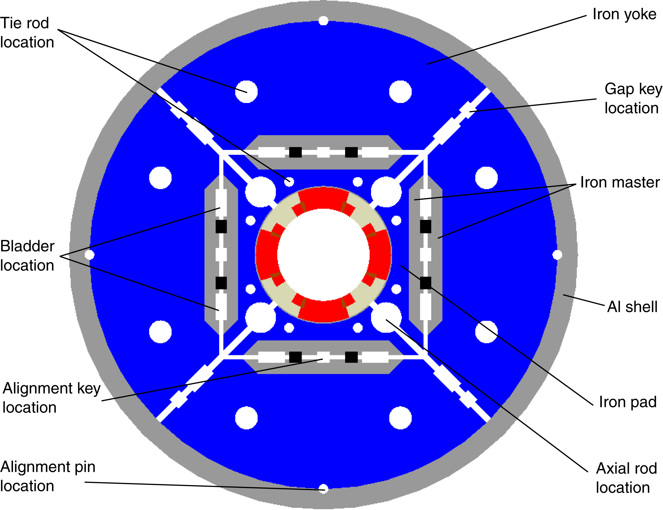
Fig. 1. LQS01 cross-section.

Based on the experience learned from LRS magnet LR tests [23], [24], in order to improve coil stress homogeneity along the longitudinal axis, the shell has been segmented in four equal-length parts (segment). The 50 mm thick yoke and pad laminations are stacked and pre-compressed by full-length stainless steel tie rods. In order to provide continuous surfaces for the pairs of water pressurized bladders (used to azimuthally preload the structures) and the load keys (used to lock-in the preload) the masters are machined from 1.8 m long iron plates.
The coil end support system, similarly as the one previously implemented in the HD1 magnet [27], is composed by four aluminum rods, with a diameter of 25.4 mm, inserted in the four holes of the pads, and bolted to two 50 mm thick stainless steel end plates (see Fig. 2). The rods are pre-tensioned with an axial piston at room temperature.

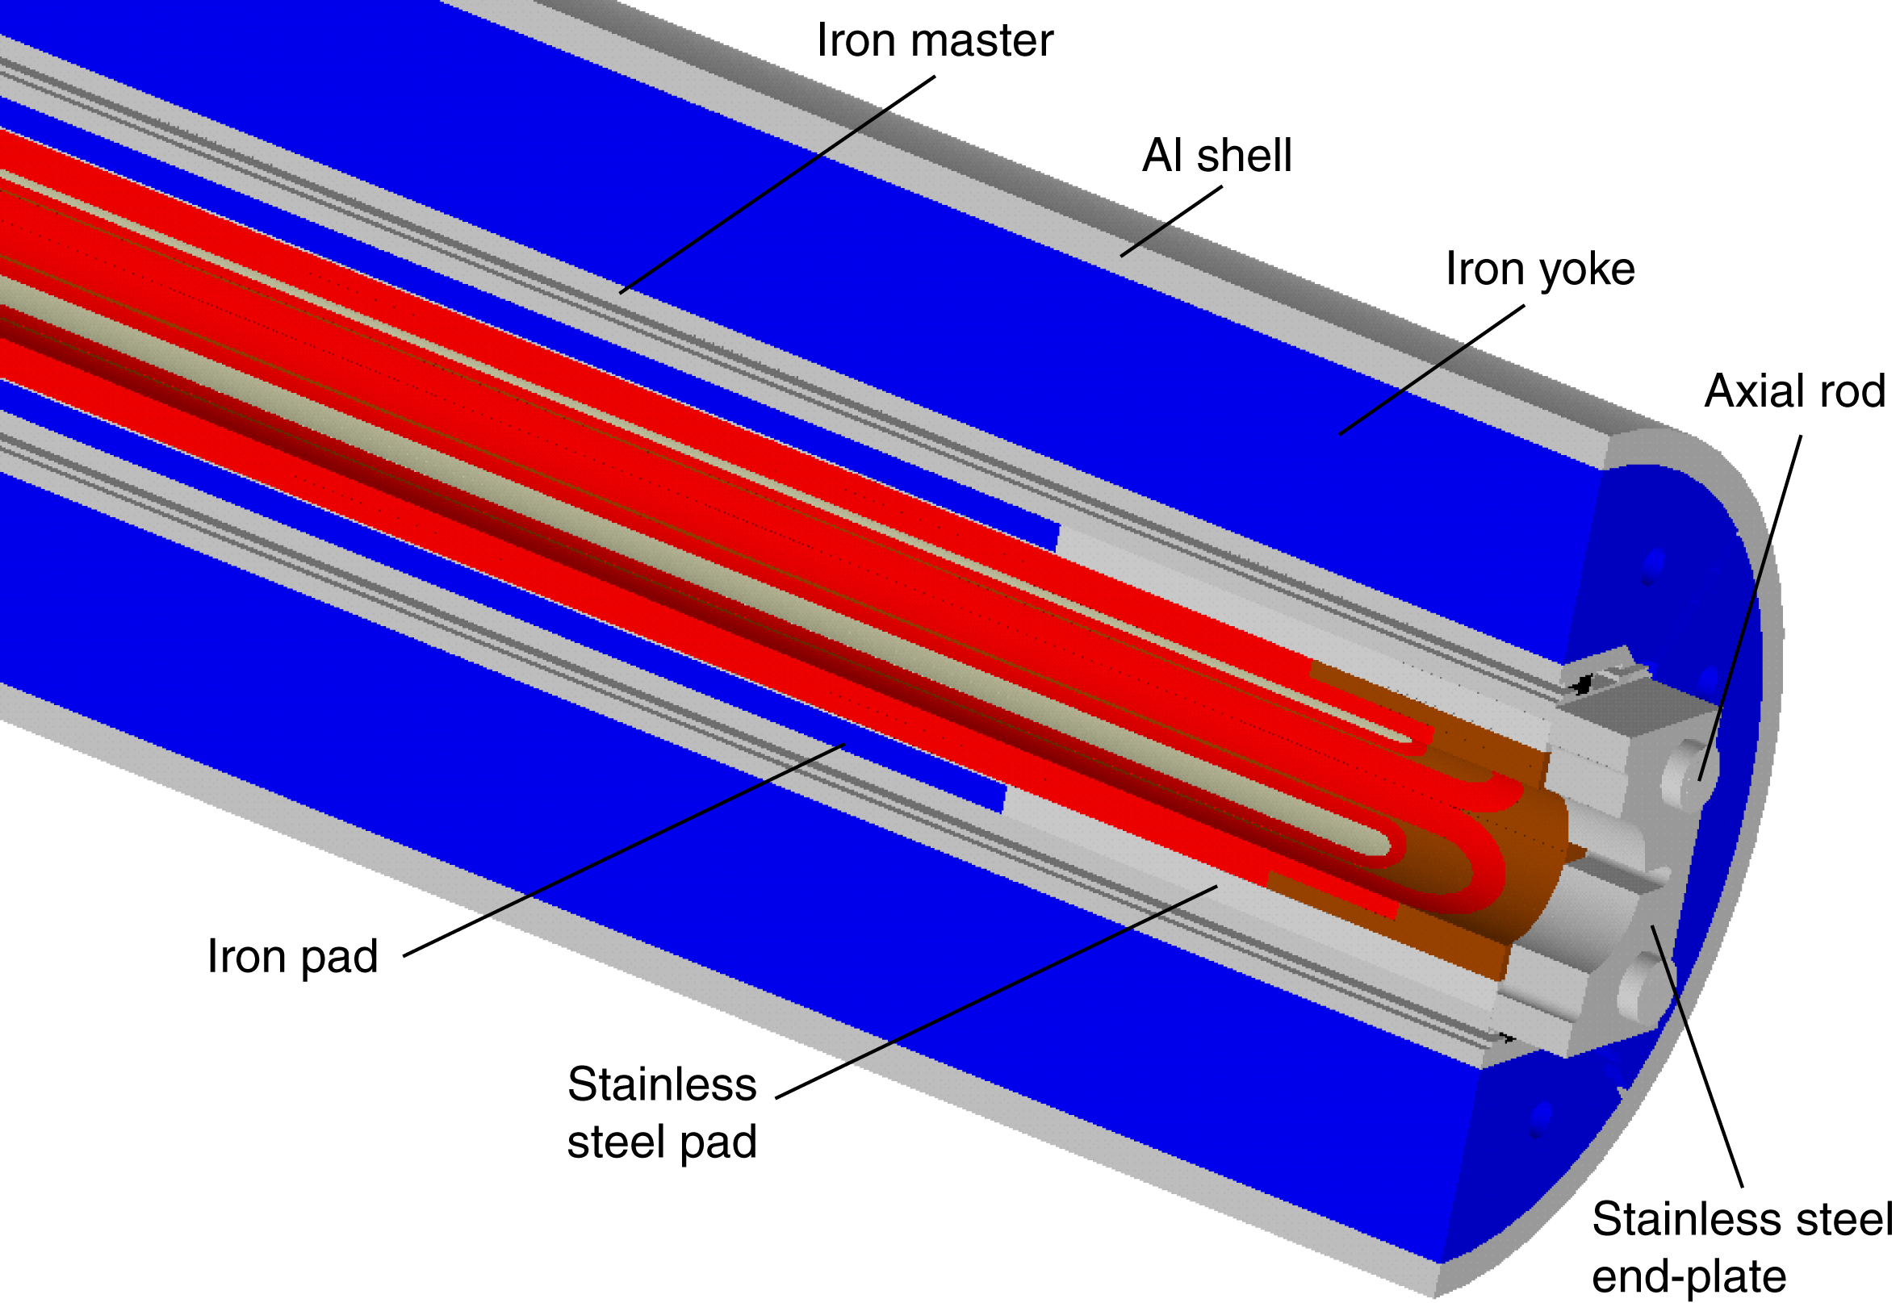
Fig. 2. LQS01 structure end design.

Based on detailed FEA analysis, and taking into account the requirements for a long structure and the TQS program experience, several improvements and optimizations were included in the LQS design: Load keys are located closer to the mid-plane, resulting in an improved coil stress distribution Two bladders per quadrant provide larger surface and better control during assembly Axial rods located next to the coils reduce the end plate deflections and overall thickness Iron masters located between pad and yoke provide a flat and precise surface for bladders and keys. This solution is compatible with the use of laminated pads and yokes, and is suitable for providing structure alignment during assembly, cool-down and operation. Aluminum shell thickness of 20 mm was selected for optimal balance between pre-load at room temperature, cool-down and operation, taking into account the assembly requirements.

Magnetic Analysis
The field in the conductor has been computed by a 2D finite element magnetic model of the magnet cross-section, where each individual turn has been considered. The assumed critical current density in the superconductor of 2800 A/mm² (12 T, 4.2 K) is based on measurements from the TQS02 magnet [18], which used the same conductor and heat treatment as the one considered for LQ. The highest field of 13.4 T (see Table II) at the 1.9 K short sample current is located in layer 1, on the pole turn. The peak field in layer 2, also located in the pole turn, is about 2 T then layer 1. For a field quality measurements performed on the TQ series we refer to [28]-[30].
TABLE II Magnetic Design Parameters
Parameter | Unit | 4.5 K | 4.2 K | 1.9 K
Short sample current I_{ss} | kA | 13.76 | 13.96 | 15.16
Gradient at I_{ss} | T/m | 240 | 244 | 262
Coil peak field (layer 1) at I_{ss} | T | 12.29 | 12.46 | 13.43
Coil peak field (layer 2) at I_{ss} | T | 10.52 | 10.66 | 11.48
Stored energy at I_{ss} | kJ/m | 457 | 479 | 559
Inductance | mH/m | 4.9
Values computed assuming critical current density in the superconductor of 2800 A/mm² (12 T, 4.2 K).

In order to investigate the field in the end and its dependence on the iron design, we analyzed with a 3D magnetic finite element model several cases using different yoke, pad and master configurations and materials.
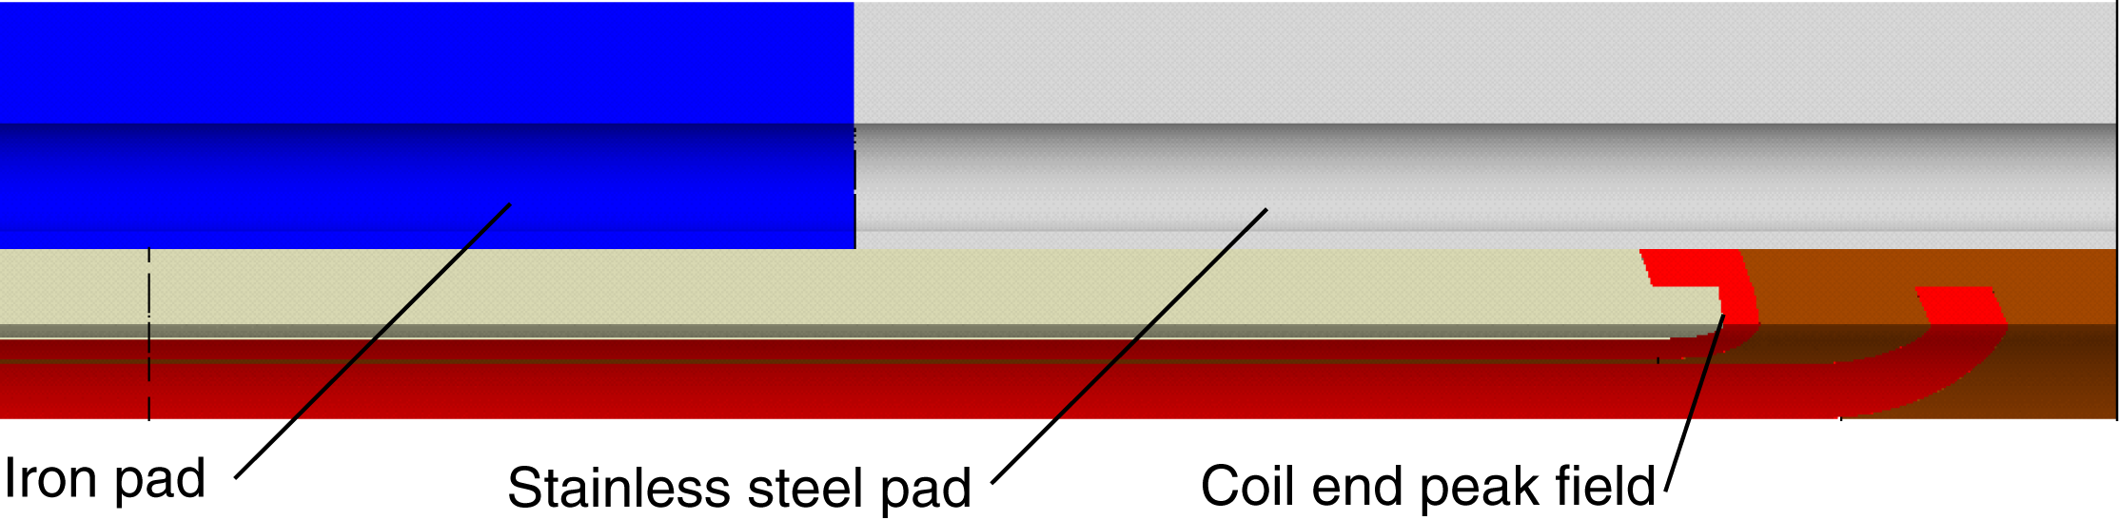
Fig. 3. LQS01 coil end region design.

The final choice is shown in Fig. 3, with stainless steel pads covering the coil end region. In these conditions, the peak field in the end region, which is located in the pole turn of layer 1 (right below the region where the pole turn of layer 2 is bent around the pole, is the same as the peak field in the straight section.

Mechanical Analysis

Cross-section
The stresses in coil and support structure were computed with a 2D finite element mechanical model. The contact surfaces of the impregnated coil (i.e. coil blocks and pole pieces) are assumed bonded, while all the other surfaces are modeled under the assumption of “sliding with separation allowed” with a friction factor of 0.2. The shell pre-load is chosen so that the contact region between the pole turns and the pole pieces does not exhibit tension larger than 20 MPa when electro-magnetic forces, generated at a gradient of 240 T/m, are applied. The e.m forces are given in Table III, and the computed stresses for shell and coil layer 1 (where higher stresses are observed) are plotted in Fig. 4, Fig. 5, and Fig. 6. During bladder operation the shell is pre-tensioned to 51 MPa and the coil compressed to a maximum stress of 99 MPa. Once the load keys are inserted and the bladder deflated, a spring-back is expected in the structure, due to the clearance necessary to slide the keys between the masters.
TABLE I Electro-magnetic Forces
 | Unit | F_{x} | F_{y} | F_{r} | F_{θ}
Layer 1 | N/mm | +1673 | -1124 | +1148 | -1503
Layer2 | N/mm | -32 | -1039 | -311 | -1018
Values are computed for a gradient of 240 T/m.
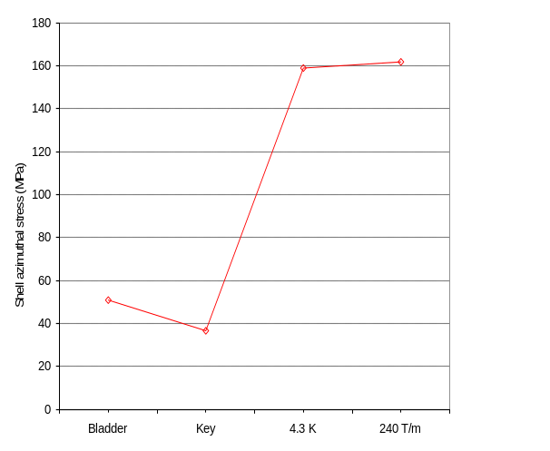
Fig. 4. Shell azimuthal stress during bladder operation, after key insertion and bladder deflation, after cool-down and at 240 T/m.

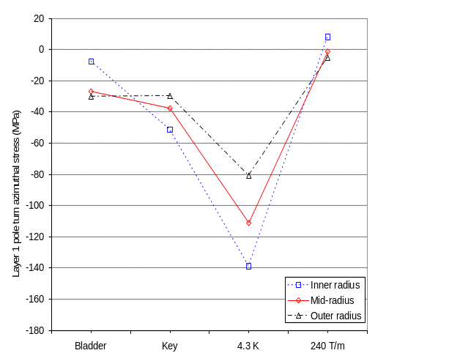
Fig. 5. Coil azimuthal stress in layer 1 pole area during bladder operation, after key insertion and bladder deflation, after cool-down and at 240 T/m.
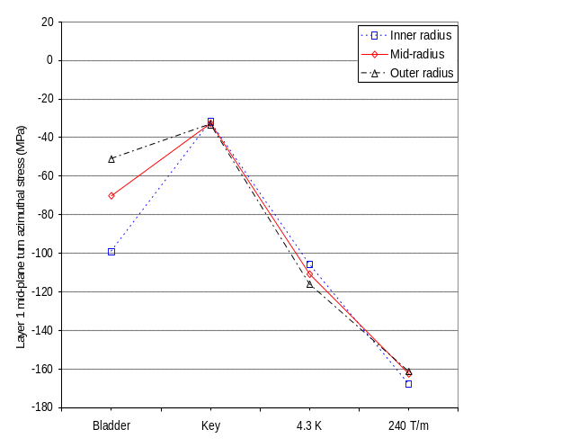
Fig. 6. Coil azimuthal stress in layer 1 mid-plane during bladder operation, after key insertion and bladder deflation, after cool-down and at 240 T/m.

After cool-down, the shell tension increases to 159 MPa, while the coil pole reaches a peak stress of 139 MPa. As the e.m. forces are applied the unloading of the coil pole results in a increase of stress on the mid-plane, while marginal variation of shell stress are observed.

End region
The mechanical behavior of the magnet ends was analyzed with a 3D finite element mechanical model, following the integrated modeling technique described in [31]. Similarly to the 2D model, the axial pre-load provided to the coil by the end support has been chosen in order to minimize the contact tension between coil and end parts when the electro-magnetic forces (directed outwardly in the longitudinal direction) for a gradient of 240 T/m are applied. According to the model, the contact area between layer 2 pole turn and pole piece in the end region (see Fig. 3) is the one more likely to undergo high tension separate under the action of the e.m. axial forces. In order to withstand a total e.m axial force of 474 kN, 25.4 mm diameter stainless steel axial rods are pre-tensioned to 88 MPa, corresponding to 180 kN of total axial force, to reach after cool-down a tension of 240 MPa, corresponding to 480 kN of total axial force (Fig. 7). The force provided by the rods compress the pole turn against the pole piece with a contact pressure of 65 MPa, which reduces to 7 MPa at 240 T/m. As observed in the shell, minimum rod stress variations are observed during excitation.
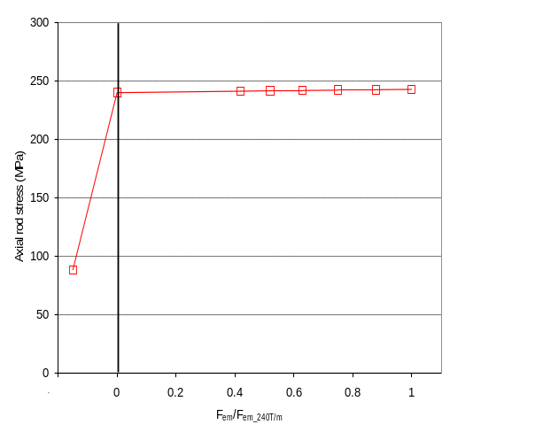
Fig. 7. Axial rod stress after loading at 293 K and as a function of the fraction of e.m. force with respect to the 240 T/m level.
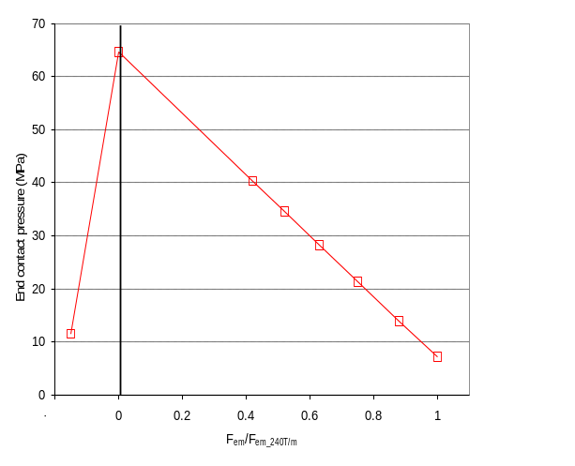
Fig. 8. Contact pressure between layer 2 pole turn and pole piece after loading at 293 K and as a function of the fraction of e.m. force with respect to the 240 T/m level.

Assembly Procedure and Tooling
The LQ magnet support structure is composed of four, equal-length yoke-shell, or segments. Each of these segments are individually assembled and pre-loaded, and then combined in a full-length structure. The assembly procedure starts by pre-assembly four 0.8 m long stacks of pad and yoke laminations (see Fig. X, top). The laminations aligned with bushings and compressed with an hydraulic cylinder. The pre-load is locked-in with stainless steel tie-rods and nuts. The yoke-stacks are aligned and keyed in place within the shell near both ends of the subassembly by internal alignment pins (see Fig. 1) set in precision-machined grooves in each of the yoke laminations and shell inside diameter. The pad stacks are instead bolted around four aluminum dummy coils. The coil-pack subassembly used to preload each shell/yoke segment (see Fig. X). The yoke stacks are locked into place with yoke-gap keys via pressurized bladder & key operations around the pre-assembled 1-m dummy coil-pack sub-assembly.
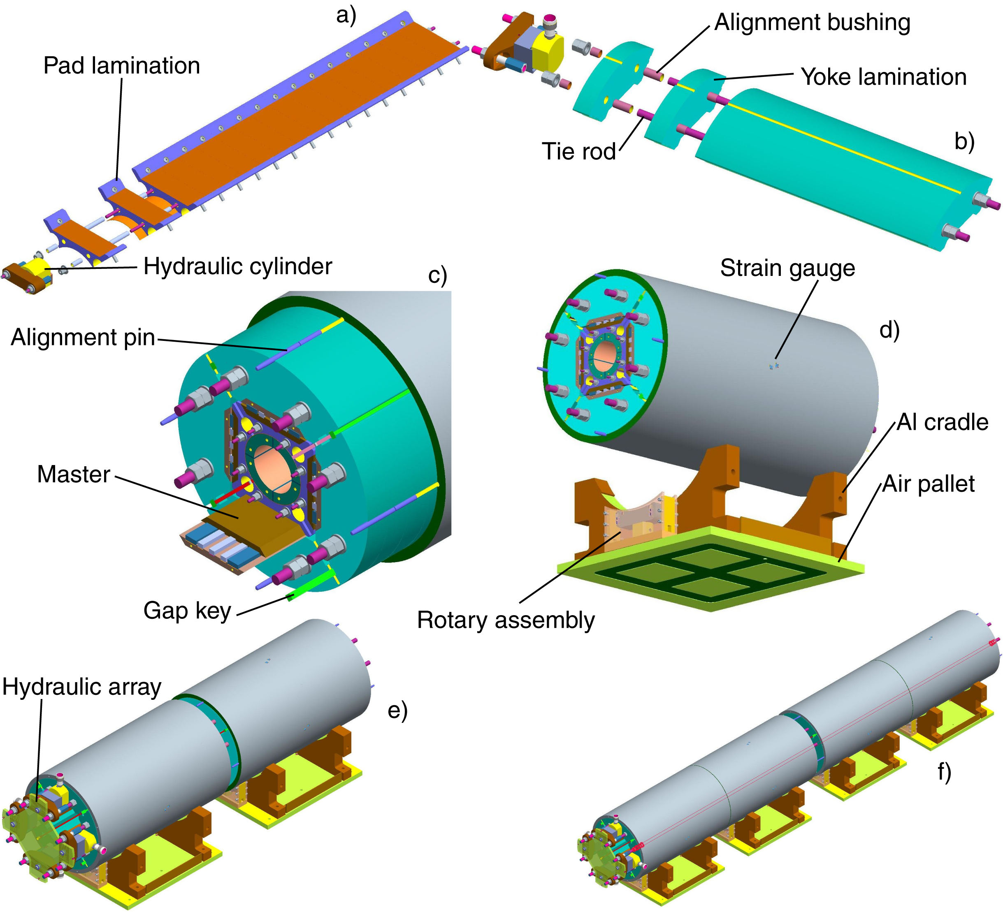
Fig. X. Assembly steps: pad lamination stacking (top left); yoke lamination stacking (top right); assembly of first segment (center);.

The same operation is executed for the second shell-yoke segment. In order to accurately support and handle each assembled segment, they are mounted on aluminum cradles which are bolted to a specially designed and fabricated “air pallet”. This air pallet will raise the full weight of the 1000 kg [2200 lb.] subassembly approximately 0.07 mm on a cushion of air at 500kPa [70 psi). A rotary assembly was designed to hydraulically raise the shell/yoke segments to orient the segment-to-segment alignments pins, azimuthally so that each segment can engage the other as they were floated together on the air pallets. After removing the 0.8 m long tie rods, the first two Shell/Yoke Segments are drawn together with the 2-m tie-rods by using a hydraulics array. .
The following describes the 2-segment assembly process. The 1-m yoke tie-rods are removed from each of the two segments. The completed Segment 2 subassembly, mounted on its air pallet support, is floated to the stationary Segment 1, also mounted on its air pallet support. The hydraulics of the rotary assembly on Segment 2 is energized to allow rotation of the shell to align and engage the four segment-to-segment pins.
Once the pins are engaged, the eight, temporary 2-m yoke tie-rods are inserted and the two segments are drawn together by the hydraulics array assembly. then the nuts are tie-rod nuts are torqued and the hydraulics assembly depressurized and removed. The same procedure is used on Segments 3& 4.
For the full-length assembly, the same procedure is performed except the air pallets supporting Segments 3 & 4 subassembly are pressurized simultaneously and floated into alignment with the Segment 1 & 2 subassembly. The 4-m yoke tie-rods are inserted and the hydraulics array is used, again, to draw the total assembly together
The full-length dummy coil pack is assembled on a specially designed “insertion” structure that is accurately placed in line with the fully assembled shell/yoke structural subassembly. (Fig)
The completed coil-pack subassembly is pulled into the full-length shell/yoke structure on the keys in the bottom master key blocks (already installed in the shell/yoke structure) with a powered winch assembly. (Fig)
Next, the sides and top master key blocks, alignment keys and bladders with pull shims are inserted from both ends of the assembly.
Preloading of the magnet structure is done in three phases. Phase One is a nominal azimuthal preload operation – done with the bladders and load keys. This operation seats (“de-fluffs”) all the components in the structure. Phase Two is the axial loading procedure – where the final end preload is applied to the coils in the coil-pack. Phase Three is the final azimuthal loading applied by the bladders and keys.
Before pressurizing the bladders for Phase One, the strain gage monitoring system is connected to the strain gage arrays mounted to the shells and coils to monitor strain states during all the phases of loading.. The bladders are then pressurized to exert a nominal preload on both the coilpack and the shell/yokes until the yoke keys are loose. The gap keys are left inserted as a safety stop if there is a bladder failure The pressure is held until more shims are inserted at the load keys. Then, pressure is incrementally increased and more load pad shims are inserted until the target shell strain is attained. Then the yoke gap keys are removed.
To axially preload the four quadrupole coils held inside the coil-pack, four 4 m, 19.05 mm [.75”] diameter, stainless steel axial load rods are inserted in the clearance cavities created by the assembled coil-pack. (Fig) Then the axial load endplate assemblies are inserted over the rods at both ends with the “bullets” engaged in insulated, load-bearing receptacle-blocks attached to each coils’ end shoes. The bullets are screwed into the endplates for adjustment. (Fig) These endplates and bullets are temporarily held against the coils with nuts.
A 25-ton capacity, hydraulic cylinder assembly is installed on the lead ends of the axial rods. The hydraulic cylinder will pull/stretch the axial rods, as it bears against the endplate, thus simultaneously compressing the coils axially.

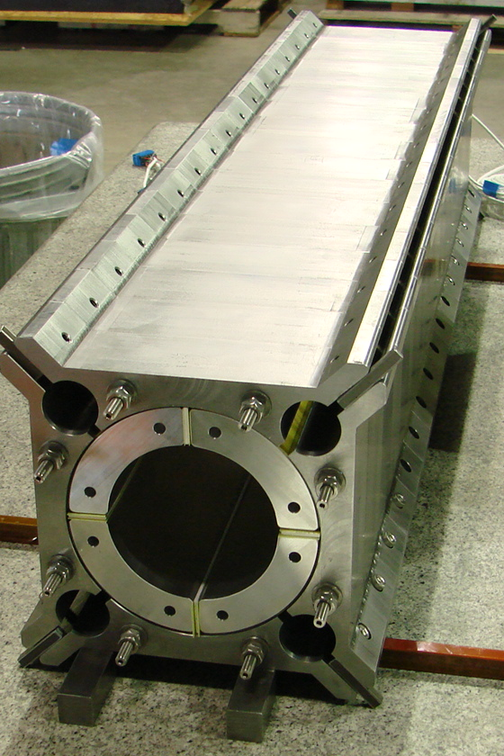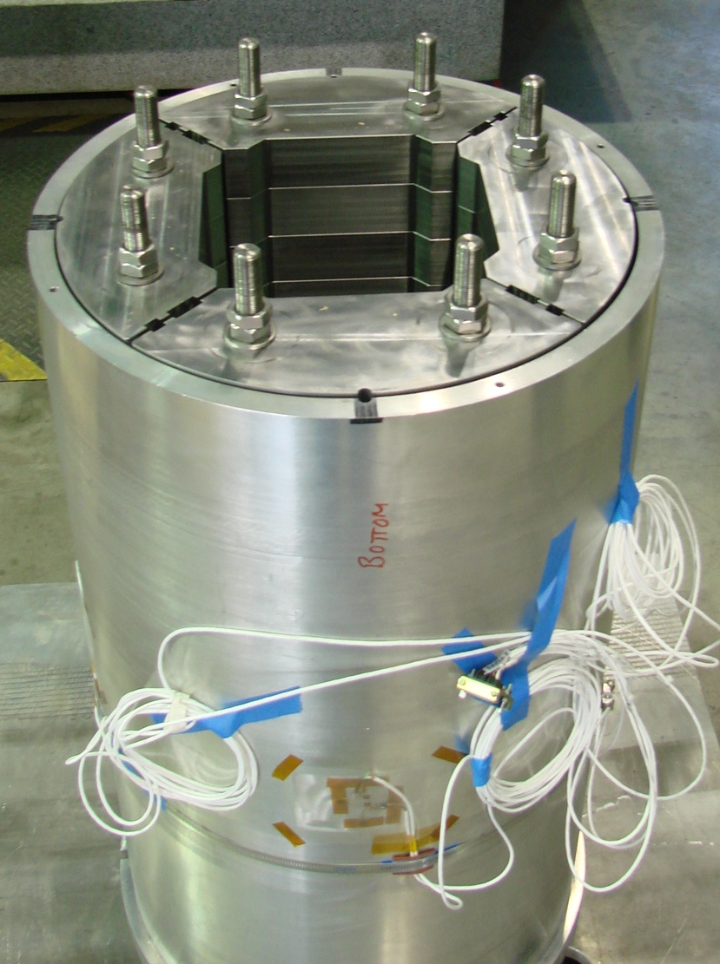
Fig. 8. Section 2 dummy coil–pad sub-assembly (left) and yoke-shell sub-assembly (right) instrumented for cool-down test.

Cool-down Test
A 0.8 m long segment (Segment 2) of the structure was assembled with four aluminum dummy coils and cooled-down to 77 K to characterize the structure. The shell was instrumented with four half-bridge strain gauges placed on the the four magnet mid-planes. An identical strain gauge set-up was mounted on the dummy coils.

The gauges measured the azimuthal and axial strain at the shell’s longitudinal center. In total, 16 gauges, all thermally compensated by gauges mounted on stress-free aluminum elements, were mounted on the structure. The measured strain in the azimuthal and axial directions (ε_{θ} and ε_{z}) was converted into stress (_{θ} and _{z}) using the relation
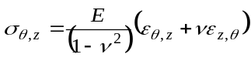, (1)
where E and ν are, respectively, the elastic modulus (78 GPa at 77 K) and the Poisson’s ratio (0.34) of aluminum. The gauge measurements of the shell and dummy coil gauges, both in term of micro-strain and stress, are shown in Fig. X to Fig. X (markers), and compared with values expected from a 3D finite element model of the segment (dashed line). After cool-down the shell stress in the shell raised to +138 ± 6 MPa (1 × rms) and +41 ± 13 MPa , in the azimuthal and axial direction, while the stress in the dummy coils reached azimuthally -231 ± 23 MPa and axially +74 ± 7 MPa. In both case data are weel reproduced by model results.

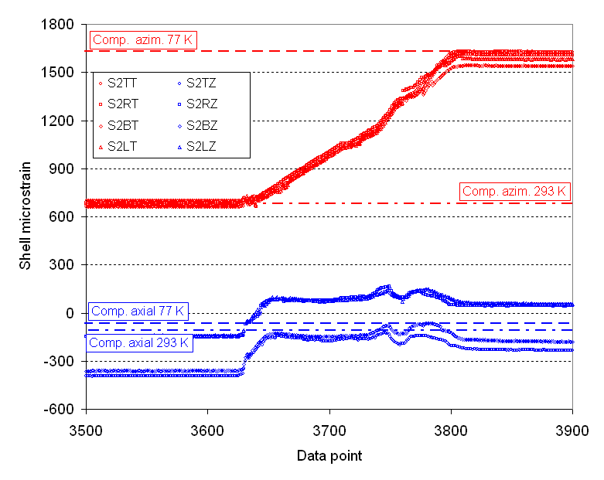
Fig. 8. Gauge measurements of azimuthal and axial strain in the shell (markers) and comparison with computed values (dashed lines).
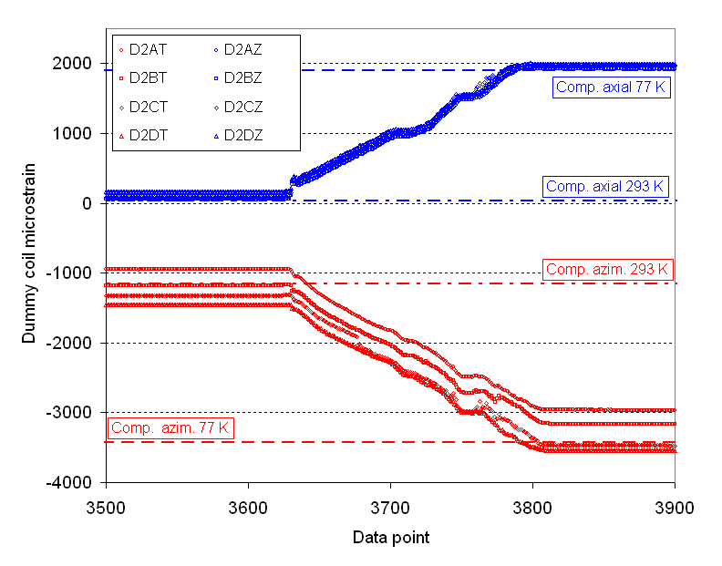
Fig. 9. Gauge measurements of azimuthal and axial strain in the dummy coils (markers) and comparison with computed values (dashed lines).

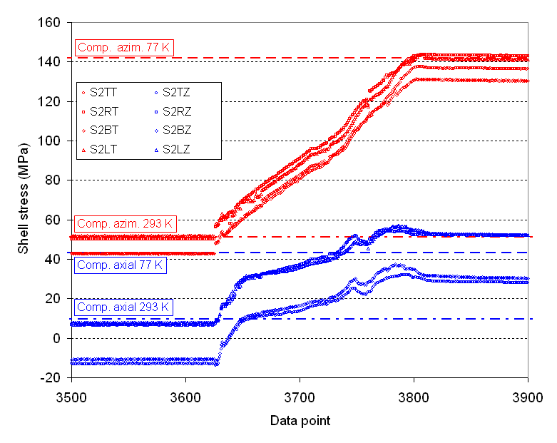
Fig. 8. Gauge measurements of azimuthal and axial stress (MPa) in the shell (markers) and comparison with computed values (dashed lines).
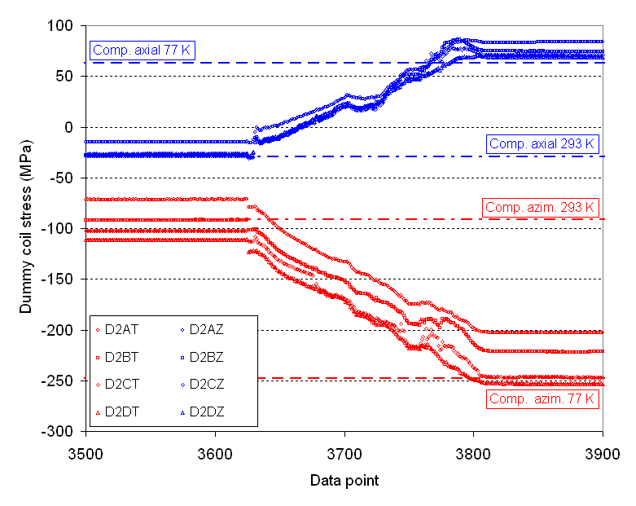
Fig. 8. Gauge measurements of azimuthal and axial stress (MPa) in the dummy coils (markers) and comparison with computed values (dashed lines).

Conclusions and Next Steps
The LQS magnet is goin to be the first long cos-theta type quadrupole assembled in a shell-type support structure. At 4.5 K, the quadrupole is expected to generate a gradient of 240 T/m, with peak field in the straight section of the layer 1 pole turn. The structure provides enough support to the coil so that no separation is expected between conductor and pole pieces both in the straight section and in the ends. A new assembly procedure featuring four 0.8 m long segment of the structure pre-assembled individually and then combined together. Excellent agreement has been obtained between model prediction and strain gauge measurements performed during cool-down of a short section of the structure. At the time of the submission of this paper, all the components of the structure have been fabricated. Two yoke-shell segments (1 and 2) have been assembled. As a next step the two sub-assemblies will be connected with 2 m long tie rods. Segments 3 and 4 shall be pre-assembled the same way. Both segment pairs will be connected by the final 4-meter long yoke tie-rods. Before the final pre-load with the LQS01 coils, a completed, full-length, dummy coil-pack subassembly will be pulled in and bladder operation will be performed.
References
- S. A. Gourlay, et al., “Magnet R&D for the US LHC Accelerator Research Program”, IEEE Trans. Appl. Supercond., vol. 16, no. 2, June 2006, pp. 324-327.
- P. Wanderer, “Overview for LARP Magnet R&D”, presented at 2008 Applied Superconductivity Conference, Chicago, IL, USA, August 17-22, 2008.
- G. Ambrosio, et al., “Design of Nb₃Sn Coils for LARP Long Magnets”, IEEE Trans. Appl. Supercond., vol. 17, no. 2, June 2007, pp. 1035-1038.
- G. Ambrosio, et al., “LARP Long Nb₃Sn Quadrupole Design”, IEEE Trans. Appl. Supercond., vol. 18, no. 2, June 2008, pp. 268-272.
- G. Ambrosio, et al., “Development of LARP 3.7 m Long Nb₃Sn Quadrupole Models”, presented at 2008 Applied Superconductivity Conference, Chicago, IL, USA, August 17-22, 2008.
- S. Caspi, et al., “The use of pressurized bladders for stress control of superconducting magnets”, IEEE Trans. Appl. Supercond., vol. 11, no. 1, March 2001, pp. 2272-2275.
- A. R. Hafalia, et al., “A new support structure for high field magnets” IEEE Trans. Appl. Supercond., vol. 12, no. 1, March 2002, pp. 47-50.
- A. R. Hafalia, et al., “An approach for faster high field magnet technology development”, IEEE Trans. Appl. Supercond., vol. 13, no. 2, June 2003, pp. 1258-1261.
- P. Ferracin, et al., “Development of a large aperture Nb₃Sn racetrack quadrupole magnet”, IEEE Trans. Appl. Supercond., no. 2, June 2005, pp. 1132-1135
- P. Ferracin, et al., “Assembly and test of SQ01b, a Nb₃Sn quadrupole magnet for the LHC Accelerator Research Program”, IEEE Trans. Appl. Supercond., vol. 16, no. 2, June 2006, pp. 382-385.
- P. Ferracin, et al., “Assembly and Tests of SQ02, a Nb₃Sn Racetrack Quadrupole Magnet for LARP”, IEEE Trans. Appl. Supercond., vol. 17, no. 2, June 2007, pp. 1019-1022.
- P. Ferracin, et al., “Effect of Axial Loading on Quench Performance in Nb3Sn Magnets”, IEEE Trans. Appl. Supercond., vol. 18, no. 2, June 2008, pp. 285-288.
- G. Sabbi, et al., “Nb₃Sn quadrupole magnets for the LHC IR”, IEEE Trans. Appl. Supercond., vol. 13, no. 2, June 2003, pp. 1262-1265.
- S. Caspi, et al., “Mechanical design of a second generation LHC IR quadrupole”, IEEE Trans. Appl. Supercond., vol. 14, no. 2, June 2004, pp. 235-238.
- A. R. Hafalia, et al., “Structure for an LHC 90 mm Nb3Sn quadrupole magnet”, IEEE Trans. Appl. Supercond., vol. 15, no. 2, June 2005, pp. 1444-1447.
- S. Caspi, et al., “Design and analysis of TQS01, a 90 mm Nb3Sn model quadrupole for the LHC luminosity upgrade based on a key and bladder assembly”, IEEE Trans. Appl. Supercond., vol. 16, no. 2, June 2006, pp. 358-361.
- S. Caspi, et al., “Fabrication and Test of TQS01—A 90 mm Nb3Sn Quadrupole Magnet for LARP”, IEEE Trans. Appl. Supercond., vol. 17, no. 2, June 2007, pp. 1122-1125.
- S. Caspi, et al., “Test and Analysis of Technology Quadrupole Shell (TQS) Magnet Models for LARP”, IEEE Trans. Appl. Supercond., vol. 18, no. 2, June 2008, pp. 179-183.
- S. Caspi, et al., “Test results of LARP Nb₃Sn quadrupole magnets using a shell-based support structure (TQS)”, presented at 2008 Applied Superconductivity Conference, Chicago, IL, USA, August 17-22, 2008.
- P. Ferracin, et al., “Design and Fabrication of a Supporting Structure for 3.6 m Long Nb₃Sn Racetrack Coils”, IEEE Trans. Appl. Supercond., vol. 17, no. 2, June 2007, pp. 1023-1026.
- P. Wanderer, et al., “LARP Long Nb₃Sn Racetrack Coil Program”, IEEE Trans. Appl. Supercond., vol. 17, no. 2, June 2007, pp. 1140-1143.
- P. Ferracin, et al., “Assembly and Test of a Support Structure for 3.6 m Long Nb₃Sn Racetrack Coils”, IEEE Trans. Appl. Supercond., vol. 18, no. 2, June 2008, pp. 167-170.
- P. Wanderer, et al., “Construction and Test of 3.6 m Nb₃Sn Racetrack Coils for LARP”, IEEE Trans. Appl. Supercond., vol. 18, no. 2, June 2008, pp. 171-174.
- J. F. Muratore, et al., “Test Results of LARP 3.6 m Nb₃Sn Racetrack Coils Supported by Full-Length and Segmented Shell Structures”, presented at 2008 Applied Superconductivity Conference, Chicago, IL, USA, August 17-22, 2008.
- H. Felice, et al., “Magnetic and Mechanical Analysis of the HQ Model Quadrupole Designs for LARP”, IEEE Trans. Appl. Supercond., vol. 18, no. 2, June 2008, pp. 281-284.
- H. Felice, et al., “Design of HQ - a High Field Large Bore Nb₃Sn Quadrupole Magnet for LARP”, presented at 2008 Applied Superconductivity Conference, Chicago, IL, USA, August 17-22, 2008.
- A. R. Hafalia, et al., “HD1: design and fabrication of a 16 T Nb₃Sn dipole magnet”, IEEE Trans. Appl. Superconduct., vol. 14, no. 2, June 2004, pp. 283-286.
- G. V. Velev, et al., “Field Quality Measurements and Analysis of the LARP Technology Quadrupole Models”, IEEE Trans. Appl. Supercond., vol. 18, no. 2, June 2008, pp. 184-187.
- G. V. Velev, et al., “Field Quality of LARP Nb3Sn TQ Series Quadrupole Models”, presented at 2008 Applied Superconductivity Conference, Chicago, IL, USA, August 17-22, 2008.
- F. Borgnolutti, et al., “Reproducibility of the coil positioning in Nb₃Sn magnet models through magnetic measurements”, presented at 2008 Applied Superconductivity Conference, Chicago, IL, USA, August 17-22, 2008.
- S. Caspi, and P. Ferracin, “Towards integrated design and modeling of high field accelerator magnets”, IEEE Trans. Appl. Supercond., vol. 16, no. 2, June 2006, pp. 1298-1303.

 Manuscript received 19 August 2008. This work was supported by the Director, Office of Energy Research, Office of High Energy and Nuclear Physics, High Energy Physics Division, U. S. Department of Energy, under Contract No. DE-AC02-05CH11231. P. Ferracin, S. Caspi , D.W. Cheng, D. R. Dietderich, S. A. Gourlay, A. R. Hafalia, C.R. Hannaford, A. F. Lietzke, and G. L. Sabbi are with Lawrence Berkeley National Lab, Berkeley, CA 94720, USA (phone: 510-486-4630; fax: 510-486-5310; e-mail: pferracin@lbl.gov). G. Ambrosio, E. Barzi, A.R. Nobrega, and A.V. Zlobin are with Fermilab National Accelerator Laboratory, Batavia, IL 60510, USA. M. Anerella, J. Schmalzle, and P. Wanderer are with Brookhaven National Laboratory, Upton, NY 11973-5000, USA.

