Function Express Server

Software Design Description

Version 1.0

Approved 6/23/2005
Adopter: John Rux & Harold Riethman, Wistar
Architecture Reviewer: Arumani Manisundaram
V/CDE Reviewer: Brian Davis

Document Change Record
Version Number | Date | Description | Author
0.1 | 16th May 2005 | First draft of Function Express Server design | Srikanth Adiga
0.2 | 17th May 2005 | Added outline of design document | Pratibha Dhok
0.3 | 18th May 2005 | Added design details of Entrez gene, UniSTS, UniGene parsers | Anuj Tiwari
0.4 | 19th May 2005 | Added design details of Homologene, Gene Ontology, PubMed parsers | Sreekanth Reddy
0.5 | 20th May 2005 | Added design details of Postwork processing | Pratibha Dhok
0.6 | 23rd May 2005 | Integrated review comments suggested by Srikanth | Pratibha Dhok
0.7 | 23rd May 2005 | Few more changes | Srikanth Adiga
0.8 | 23rd May 2005 | Document Review | Janet Stone
0.9 | 23rd May 2005 | Document Review | Rakesh Nagarajan
1.0 | 24th May 2005 | Incorporated review comments | Sreekanth Reddy, Pratibha Dhok, Srikanth Adiga
1.1 | 21st June 2005 | - Incorporated Wistar’s comments  - Added more detailed design for post work component  - Added description about classes in the Appendix | Pratibha Dhok, Anuj Tiwari, Srikanth Adiga
1.2 | 23rd June 2005 | - Incorporated review comments suggested by Rakesh | Pratibha Dhok

TABLE OF CONTENTS
1. Introduction 5
1.1 References 5
1.2 Document Overview 5
2. SYSTEM ARCHITECTURE 6
2.1 System Overview 6
2.2 CONFIGURATION DETAILS 6
2.2.1 Command file 7
2.2.1.1 Retrieve Annotation Mode (Annotation Update) 7
2.2.1.2 Add Chip library mode 8
2.2.1.3 GO Properties file 8
2.2.1.4 Database Support 9
3. COMPONENTS 10
3.1 schema creation 10
3.2 Retrive annotations 10
3.2.1 Download and process 10
3.2.1.1 Download manager 11
3.2.1.2 Parser manager 12
3.2.1.3 Database Loader: 12
3.2.1.4 (UML) Universal Modeling Language Class diagrams 12
3.2.1.5 Data Sources downloaded and processed 15
3.2.1.5.1 Entrez Gene 15
3.2.1.5.2 UniGene 21
3.2.1.5.3 UniSTS 25
3.2.1.5.4 Gene Ontology 28
3.2.1.5.5 HomoloGene 31
3.2.1.5.6 PubMed 35
3.2.1.6 Revision History 39
3.2.2 Post data processing (Post work) 40
3.2.2.1 Chip-Description 41
3.2.2.2 Gene-Info 43
3.2.2.3 Gene-Info Summary 45
3.2.2.4 Gene-Info Microarray Summary 46
3.2.2.5 Chipinfo-Homolo 47
3.2.2.6 Chipinfo-Term 48
3.2.2.7 Chipinfo-OMIM 50
3.3 add chip library 50
3.3.1 Add Affymetrix chip library 52
3.3.2 Add caARRAY chip library 53
3.4 Query interface 53
3.4.1 Basics of Struts 53
3.4.1 Basics of Struts 54
3.4.1.1 Action class 54
3.4.1.2 Controller 54
3.4.2 API Access 54
3.4.3 Gene Search Query Interface 55
3.4.3.1 Probe centric search 55
3.4.3.2 Gene centric Search 55
3.4.4 Literature Network Query Interface 55
3.4.4.1 Probe centric search 55
3.4.4.2 Gene centric search 56
APPENDIX A – DOCUMENT TERMINOLOGIES AND ACRONYMS 57
APPENDIX B – ORTHOLOG COMPUTATION DETAILS AND EXAMPLE 58
APPENDIX C – CLASSES 60

Introduction
The Function Express (FE) Software Design Description (SDD) describes the design decisions, architectural design, and the detailed design needed to implement the FE software. It provides the required visibility into the design and details information needed for software support.

References
- FE Server Use Case document
- FE Server Requirements Specifications document
- Other documents

Document Overview
This document captures design descriptions for the FE project. The remaining design sections are organized as follows:
- SYSTEM ARCHITECTURE: Describes the overall architecture of the system.
- COMPONENTS: Describes the design of all the components of FE Server. It includes individual parsers, post work, query interface and so forth.
- APPENDIX A – DOCUMENT TERMINOLOGIES AND ACRONYMS: Various abbreviations and terminologies used in this document.
- APPENDIX B – ORTHOLOG COMPUTATION DETAILS AND EXAMPLE

SYSTEM ARCHITECTURE

System Overview
This release of FE Server is comprised of the following three components:
- A command-prompt based server application which runs in the following three modes:
  - Create database schema mode
  - Annotations Update mode
  - Add chip library mode
- A Java Struts based web interface to query annotations
- HTTP (API) Application Programming Interface based access to query annotations.

The following block diagram outlines the high level architecture of the three components.

WEB INTERFACE

PUBLIC DATA SOURCES
UniGene
PubMed
Homologene
EntrezGene

CHIP LIBRARIES
Affymetrix
caARRAY

FUNCTION EXPRESS SERVER

RETRIEVE ANNOTATIONS MODE
ADD CHIP LIBRARY MODE
CREATE SCHEMA MODE
FUNCTION EXPRESS
SERVER
SCHEMA
Web- Server
Struts
Framework
Action
ActionServlet
ActionForm
Tiles
Engine
JSP
Engine
HTML
Object
Web
Browsers
JAVA
Apps
Data Access Object
Business Logic
GO
UniSTS

CONFIGURATION DETAILS
The command prompt based server application takes the following parameters as command line arguments:
<mode> <dbUserID> <dbUserPassword> <dbName> <driverName> <dbURL> <ftpCommandFile>
The command line parameters specify the mode in which the server should run.
Parameter | Value
mode | mode [1=Annotation Update , 2=Add Chip,3=createDBSchema]
dbUserID | database user name
dbUserPassword | database user's password
dbName | database (SID) System Identifier
drivername | Oracle driver name [oracle.jdbc.driver.OracleDriver] (Similar, MySQL)
dbURL | URL for database constructed with passed parameters
ftpCommandFile | CommandFile.txt (Optional parameter- Annotation Update / Add Chip mode require this parameter)

Command file
The section below describes the details of the CommandFile.txt file for Annotation Update and Add Chip Library modes.

Retrieve Annotation Mode (Annotation Update)
The CommandFile.txt file contains the details about the annotation data sources to download. For each data-source, it specifies protocol to use for download, location of the data source, file name to download etc. The record of each data source is terminated by ####.
The table below lists the details of parameters to be specified in the Command file for each data source.
Field | Description | Permissible Values
TYPE | Data source type | HTTP, FTP
SITE_URL | URL of FTP/HTTP server
BASE_DIR | Directory on FTP/HTTP server which holds the data files
FILE_NAME | The data file name
USER_ID | Username to access FTP data files
PASSWD | Password of the user to access remote data files
LOCAL_FILE | The data file name on the local machine  Note: This field is used only while running the FE Server on machines where the data files to be processed are present on the same machine.
PROXY_HOST | Proxy machine name or IP address
PROXY_PORT | Proxy machine port number
DATABASE | The external database name | CHIPINFORMATION  UNIGENE  ENTREZGENE  HOMOLOGENE  UNISTS  PUBMED  GO

Add Chip library mode
For add chip library mode, the command file contains the following parameters.
Field | Description | Permissible Values
LOCAL_FILE | The chip library file name with path
DATABASE | This is set to keyword “CHIPINFORMATION” to indicate that FE Server should be run in add chip library mode. | CHIPINFORMATION
INPUT_FORMAT | Input format of Chip library file | One or more of:  A (Accession Number)  U (UniGene ID)  G (Entrez GeneID)

GO Properties file
The GO parser requires GO configuration file to get the term identifier associated with the root node ‘Gene_Ontology’. The configuration file has the following parameters.
Field | Description | Permissible Values
XML_ROOT | The value root node in GO XML data source file. | ALL
PARENT_TERMID | The term ID to be associated with the root node.  Note: This is set to a deprecated term ID so that it does not clash with the current term IDs. | GO:0003673
PARENT_TERMNAME | The term name of the root node | Gene_Ontology
The following diagram outlines the high-level block diagram of FE Server in the update mode

ANNOTATIONS DATA SOURCES
UniGene
Pubmed
Entrez Gene
FE SERVER DATABASE
DOWNLOAD AND PROCESS
CORELATE ANNOTATIONS
Read base tables
Write summary tables
Write base tables
- Create intermediate base tables
  - Download and process raw data
  - Load data into base tables
- Create final summary tables
  - Read and correlate base tables’ data
  - Load data into summary tables

Database Support
The FE Server will support MySQL 4.1 and Oracle 9i databases. All the database specific queries in FE server will be moved to a properties file. Also every database will have different set database creation scripts.

COMPONENTS

schema creation
This component creates the database schema to store microarray chip libraries information along with annotations. The table scripts required to create Function Express server schema are in an XML format. Table creation scripts differ from database to database. Hence according to the choice of database this module will read appropriate schema creation script, will parse them and execute DDL statements. This component also adds default entries into tables.
SCHEMA CREATION SCRIPTS
PARSER MANAGER
DDL STATEMENTS
DATABASE MANAGER
BASE TABLE CREATION
When FE server runs in this mode it requires the following parameters as command line arguments.
<mode> <dbUserID> <dbUserPassword> <dbName> <driverName> <dbURL>
Where mode=3 for schema creation mode.
This FE Server reads the table creation scripts from the ‘scripts’ folder under BASE_DIR where BASE_DIR is specified in the configuration file.

Retrive annotations
This component retrieves annotation data from public data sources and populates the database tables appropriately. It has two main components:
- Download and process
- Post data processing

Download and process
Some important points of this component:
- Responsible for downloading, parsing and loading of data into the database base tables.
- Handles different access mechanisms like HTTP, FTP, APIs
- Handles different data formats like text, XML
The following block diagram outlines the high level architecture of this component

J
O
B

M
A
N
A
G
E
R
DOWNLOAD MANAGER
DATA FILES
PARSER MANAGER
BASE DATA
DATABASE LOADER
- The download manager downloads the data from different data sources and copies the data on the local machine.
- The parser manager processes the downloaded data and writes the output into text files.
- The database loader uploads the data into text files using high throughput load mechanisms like Oracle SQL Loader or MySQL Bulk Loader.
- All the modules are multi-threaded.
- The database loader will start its job after download manager and parser manager finish their jobs.

Download manager
Spawn a download thread for every data source
For every data source, download file in a thread
Copy files downloaded in a local directory
END
Send signal to parser thread
- The download manager is a multi-threaded component, responsible for downloading data from the configured data sources.
- Spawns a thread for every data source.
- If a source has more than one file, a download thread is spawned for every file to be downloaded.
- There are two types of downloaders: HTTPDownLoader and FTPDownLoader. The HTTPDownLoader can be used to download files from the HTTP Server while the FTPDownLoader downloads files from the (FTP) File Transfer Protocol Server.
- The DownLoaderFactory can be used to give appropriate instances of different downloaders.
- Once a file is downloaded, a signal is sent to the parser thread to indicate that it can start processing the files.
- After downloading all files, a signal is sent to the database loader as well as the parser manager.

Parser manager
Spawns a parser thread per data source
Parse file based on the format
Write output into a text file
Send signal to the database thread
END
Parser manager is a multi-threaded component responsible for parsing the downloaded files.
- Depending on the source of data (i.e. Entrez Gene, or UniGene etc), the appropriate parser thread is spawned.
- For every data source, there is a corresponding parser.
- The ParserFactory class is used to get instances for the appropriate parser.
- The parser threads parse the files and write the output in a text file.
- After parsing all source data files, a signal is sent to the database loader module.

Database Loader:
- Responsible for uploading the data from text files into the database
- Uses high throughput uploading mechanisms to load the data
- There are two types of database loaders: OracleDatabaseLoader and MySQLDatabaseLoader. OracleDatabaseLoader uses Oracle sqlldr utility to load the data from a file and MySQLDatabaseLoader uses MySQL bulk loader.

(UML) Universal Modeling Language Class diagrams
The UML class diagrams below specifiy the interaction between the different classes of download and process components.
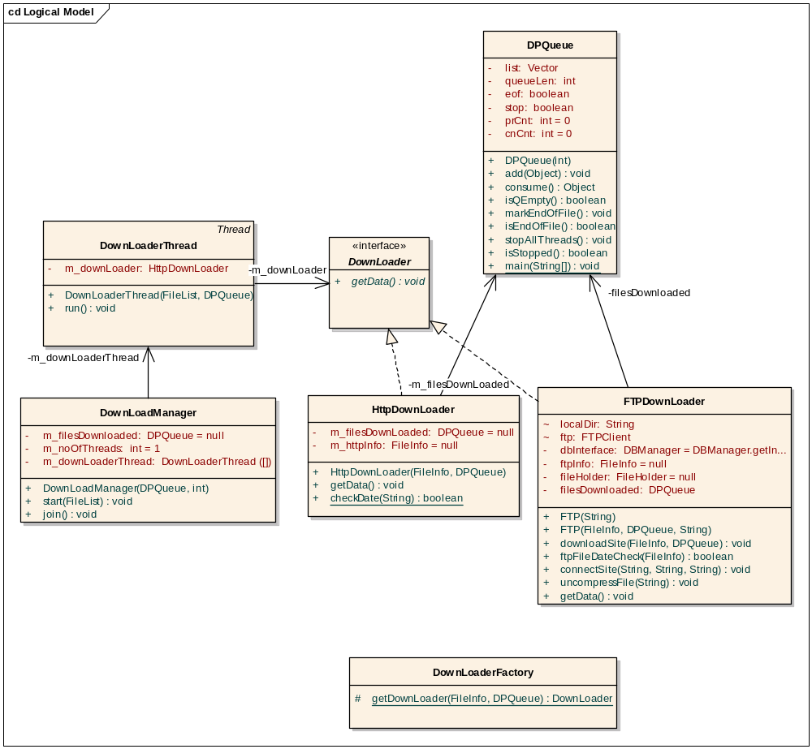
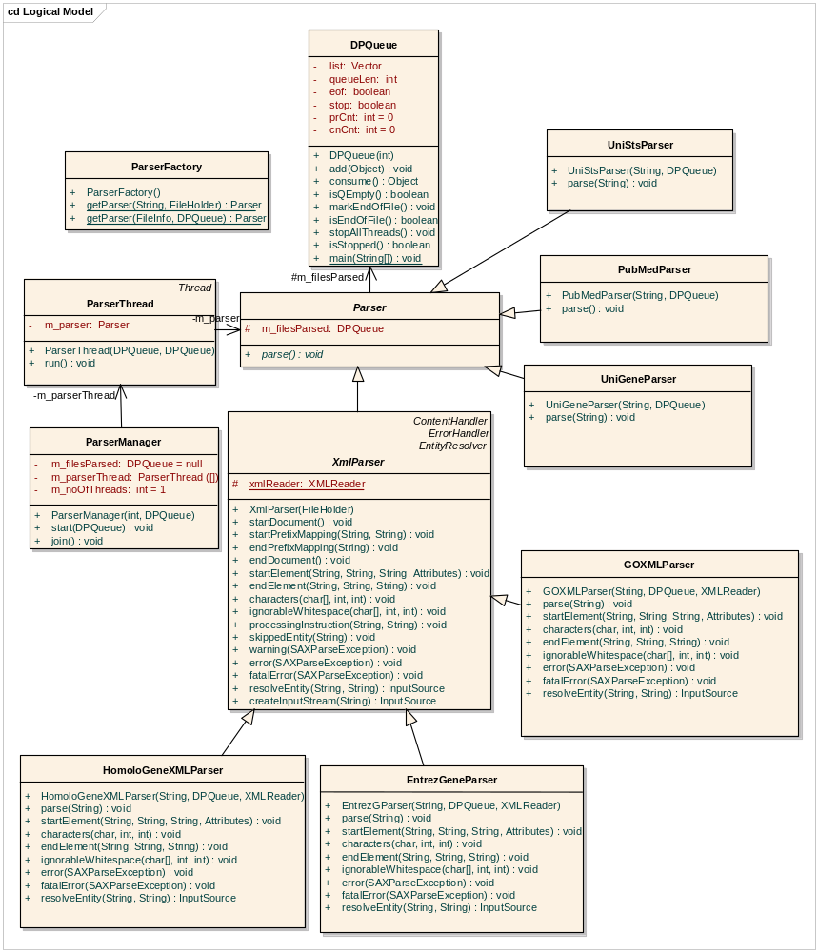
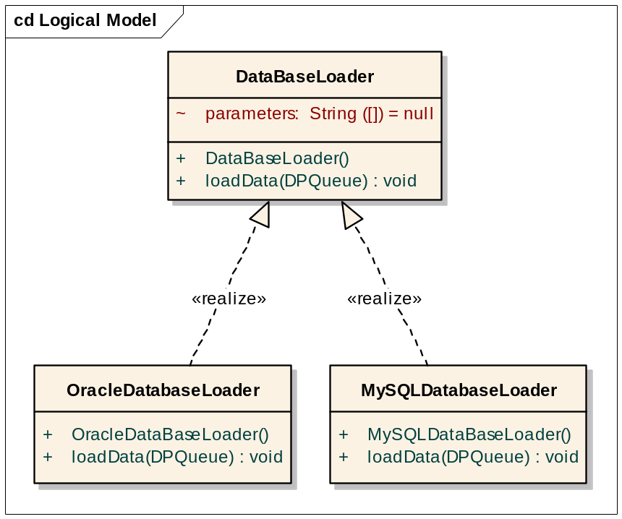

Data Sources downloaded and processed
This section of the design document describes the parser design of each data source.
In this release, the following annotations sources are processed:
- Entrez Gene
- UniGene
- UniSTS
- Gene Ontology
- Homologene
- Pubmed

The following sections describe the design for processing each section in detail.

Entrez Gene
The NCBIs’ Entrez Gene data source file is in .ASN file format. Along with this NCBI also provides a utility called ‘gene2xml.exe’ which converts the ASN file input into an XML file. The converted XML file can be parsed easily.
An issue with this approach is when the input ASN file is converted to an XML format, the resultant XML file size increases to 20GB. In some cases, it might be difficult for the machine running the parser to arrange for this large space. This problem is addressed by using JAVA’s ‘pipe’ functionality available through PipedInputStream/PipedOutputStream classes. The parser will connect the OutputStream of the process converting the input .ASN file to XML, to the InputStream in XmlParser class. By doing this, the ASN data will be converted to XML format and will dynamically be fed to the parser. This will eliminate the need to store the XML input file onto the hard disk. Every <Entrezgene> node in XML file is parsed and corresponding values are inserted into appropriate tables.
The command file of Function Express server has following entry for Entrez Gene data source.
#####################################################################
TYPE FTP
SITE_URL ftp.ncbi.nih.gov
USER_ID anonymous
PASSWD mail-ID of user
BASE_DIR /gene/DATA/ASN_BINARY/
FILE All_Data.ags.gz
FILE ../gene_history.gz
DATABASE ENTREZGENE
#####################################################################

The fields that are extracted from the Entrez Gene data source file ‘FILE All_Data.ags.gz ‘ are listed in the table below.
Field | Corresponding tag in input file | Description | Data Type
GeneID | Gene-track_geneID | The unique ID | Long
Taxname | Org-ref_taxname | Source species (Homo sapiens, Rattus norvegicus, etc.), based on NCBI's Taxonomy. The first letter of each word in the value is stored. | String
PMID  (multi-valued field) | PubMedID | A subset of publications associated with this gene. The multiple values are separated by ‘,’. | Long
Post-text of Protein db in Product (multi-valued) | Prot-ref_name_E | The name of the product of this transcript | String
Official full Name | Gene-commentary_text (if Gene-commentary_label is ‘Official Full Name’) | Gene Name; The gene description, validated by the appropriate nomenclature committee, used for gene reports | String
Official Symbol | Gene-commentary_text (if Gene-commentary_label is ‘Official Symbol’) | Gene symbol; validated by the appropriate nomenclature committee, used for reports | String
Maploc | Gene-ref_maploc | Cytogenetic location on which gene is located | String
Name of Chromosome | SubSource_name | The chromosome where the gene is found | String
Tag ID of MIM db | Object_ID (If Dbtag_db is ‘MIM’) | OMIM ID | Long
Syn | Gene-ref_syn_E | Other symbols associated with the gene. This is a multi-valued field, with each value separated by a ‘,’ | String
Tag ID of GO db  (multi-valued field) | Object_ID (If Gene-commentary_label is Process/Component/Function & Dbtag_db is ‘GO’) | GO term identifier. | String
Summary | Entrezgene_summary | Summary description of the gene, its products, its significance, and mutant phenotypes | String
Tag ID of UniSTS db (multi-valued field) | Object_ID (if Gene-commentary_heading is ‘Markers (Sequence Tagged Sites/STS)’ and Dbtag_db is ‘UniSTS’) | STS marker identifier in UniSTS database | Long
FlyBase ID | Object-ID_str (If the Dbtag_db is ‘FLYBASE’) | FlyBase identifier in Locus_Fly | String
Anchor (multi-valued field) | Other-source_anchor (if Gene-commentary_heading is ‘Markers (Sequence Tagged Sites/STS)’) | STS Marker Name | String
Tag str of Unigene db  (multi-valued field) | Xtra-Terms_value ( if Xtra-Terms_Tag is ‘UNIGENE’ & Gene-commentary_text is ‘UniGene’ ) | UniGene Cluster ID associated with this gene | String
Text of Phenotype (multi-valued field) | Gene-commentary_text (if Gene-commentary_heading is ‘Phenotypes’ and Gene-commentary_type value = "phenotype".) | A phenotype associated with a mutation in this gene. | String
current-id | Tag id of “GeneID” db of the current-id node | New gene id assigned to the retired gene | Number

The tables that are populated from these data sources are listed below.
1. ENTREZGENE
Field | Data Type | Constraints
EGE_GENEID | Number | Not null, Primary key
EGE_ORGANISM | Char | Not null
EGE_SYMBOL | String
EGE_GENE_NAME | String
EGE_SUMMARY | String
EGE_CHROMOSOME_MAP | String
EGE_CHROMOSOME | String

2. ENTREZ_UNIGENE
Field | Data Type | Constraints
EUG_GENEID | Number | Not null, Primary key
EUG_ORGANISM | String | Not null
EUG_UGID | String | Not null, Primary key

3. ENTREZ_MAP
Field | Data Type | Constraints
EMA_GENEID | Number | Not null, Primary key
EMA_ORGANISM | String | Not null
EMA_MAPID | String | Not null, Primary key

4. ENTREZ_STS
Field | Data Type | Constraints
EST_GENEID | Number | Not null, Primary key
EST_ORGANISM | String | Not null
EST_STSID | String | Not null, Primary key

5. ENTREZ_GOID
Field | Data Type | Constraints
EGO_GOID | String | Not null, Primary key
EGO_GENEID | Number | Not null, Primary key
EGO_ORGANISM | String | Not null

6. ENTREZ_OMIM
Field | Data Type | Constraints
EOM_GENEID | Number | Not null, Primary key
EOM_ORGANISM | String | Not null
EOM_OMIM | String | Not null

7. ENTREZ_PMIDS
Field | Data Type | Constraints
EPI_GENEID | Number | Not null, Primary key
EPI_ORGANISM | String | Not null
EPI_PUBMEDID | String | Not null, Primary key

8. ENTREZ_GENENAMES
Field | Data Type | Constraints
EGE_GENEID | Number | Not null, Primary key
EGE_ORGANISM | String | Not null
EGE_GENE_NAME | String | Not null, Primary key

9. SYSTEM_TERMTREE
The values of <Gene-ref_maploc> and < Object-ID_ID> nodes are parsed and corresponding entries are added to SYSTEM_TERMTREE.
Field | Data Type | Constraints
STT_CHILD_TERMID | String | Not null, Primary key
STT_PARENT_TERMID | String | Not null, Primary key
STT_ISPARENT | Char | Not null

10. SYSTEM_TERMDATA
The values of <Gene-ref_maploc> and < Object-ID_ID> nodes are parsed and corresponding entries are added to SYSTEM_TERMDATA.
Field | Data Type | Constraints
STD_TERMID | String | Not null, Primary key
STD_TERM | String | Not null

11. ENTREZ_FLY
Field | Data Type | Constraints
EFY_GENEID | Number | Not null, Primary key
EFY_FLYID | String | Not null, Primary key

12. ENTREZ_PHENOTYPE
Field | Data Type | Constraints
EPH_GENEID | Number | Not null, Primary key
EPH_ORGANISM | String | Not null
EPH_ PHENOTYPE | String | Not null, Primary key

The gene_history.gz file contains information about GeneIDs that are no longer current. It’s a tab-delimited file which contains following fields
Field | Description | Data Type
tax_id | the unique identifier provided by NCBI Taxonomy for the species or strain/isolate | Number
GeneID | the current unique identifier for a gene | Number
Discontinued GeneID | the GeneID that is no longer current | Number
Discontinued Symbol | the symbol that was assigned to the discontinued GeneID, if the discontinued record was not replaced with another | String

The GENE_HISTORY table is populated from this file by extracting <Discontinued GeneID, GeneID> fields from the file.

Field | Data Type | Constraints
GHI_RETIRED_GENEID | Number | Not null, Primary Key
GHI_NEW_GENEID | Number

Class diagram:
The UML class diagram for Entrez Gene is as follows.
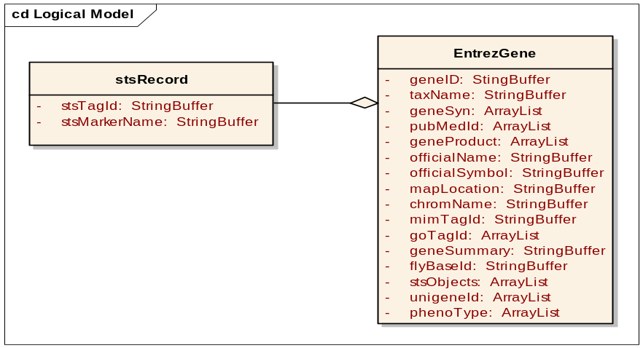

UniGene
The UniGene data source provides a separate file for each species where the first two characters of the filename specify the organism name. The UniGene data file for any species is a compressed (.gz) file, which contains data for each UniGene cluster in text format. Each UniGene entry consists of some key-value pairs. Each key is separated from its value by ‘\t’ and each key-value pair is separated by ‘\n’. While every UniGene record is separated from the next record by a ‘\\’. The UniGene parser reads input files for multiple organisms, parses the key-value pairs stored in each file and populates the base tables. The command file has the following entry for the UniGene data source.
########################################################################
TYPE FTP
SITE_URL ftp.ncbi.nih.gov
USER_ID anonymous
PASSWD mail-ID of user
BASE_DIR /repository/UniGene/
FILE Dr.data.gz
FILE Mm.data.gz
FILE Hs.data.gz
FILE Rn.data.gz
FILE Xl.data.gz
FILE Bt.data.gz
FILE Dr.retired.lst.gz
FILE Mm.retired.lst.gzFILE Hs.retired.lst.gz
FILE Rn.retired.lst.gz
FILE XI.retired.lst.gz
FILE Bt.retired.lst.gz
DATABASE UNIGENE
########################################################################

The algorithm used to parse a UniGene *. data.gz file is as follows:
- If the key is one of ‘ID’,’TITLE’,’GENE’,’CYTOBAND’,’ENTREZGENE’, or ’CHROMOSOME’ then store the corresponding values in the UNIGENE table.
- Else if the key is ‘EXPRESS’, then fetch all the unique tissue-terms from the value field and store it in the UG_EXPRESS table.
- ELSE if the key is ‘PROTSIM’ then extract the values of ORG, PROTGI, and PROTID sub fields. The first characters from each of the words in ORG value are concatenated and stored in the UGE_ORGANISM field of UG_PROTSIM table.
- ELSE if the key is ‘SEQUENCE’, then extract values of ACC, NID and PID sub fields. Store NULL for records not having a PID value into UG_SEQUENCE table.

The fields extracted from UniGene *. data.gz files are listed below.
Field | Description | Data Type
ID | UniGene cluster ID | String
TITLE | Title for the cluster | String
GENE | Gene symbol | String
CYTOBAND | Cytological band | String
EXPRESS | - Tissues of origin for ESTs in cluster  - Multi value comma separated field | String
ENTREZGENE | EntrezGene identifier associated with at least one sequence in this cluster (Hs only) | String
CHROMOSOME | Chromosome in which gene is found. For plants, CHROMOSOME refers to mapping on the Arabidopsis genome. | String
PROTSIM (Multi-Value field)
Protein similarity data for the sequence with highest-scoring protein similarity in this cluster.
- Is a multi-value field with each sub-value of the format “key=value” format.
- Each sub value is separated by a semi-colon.
ORG | Organism | String
PROTGI | Sequence GI of protein | String
PROTID | Sequence ID of protein and is one of  - SP: SwissProt  - Ref: RefSeq  - PRF: Protein Research Foundation  - PIR: Protein Information Resource  - PDB: Protein Data Bank  PID: GenPept | String
SEQUENCE (Multi-Value field)
Sequence: Nucleotide sequences belonging to each UniGene cluster.
- Is a multi-value field with each sub-value of the format “key=value” format.
- Each sub value is separated by a semi-colon.
ACC | GenBank/EMBL/DDBJ accession number of sequence | String
NID | Unique nucleotide sequence identifier (gi) | String
PID | Unique protein sequence identifier (used for non-ESTs) | String

The tables populated by the UniGene data source are listed below
1. UNIGENE
Field | Data Type | Constraints
UGE_UGID | String | Not null, Primary key
UGE_ORGANISM | Character(2) | Not null
UGE_TITLE | String
UGE_GENE | String
UGE_CYTOBAND | String
UGE_LOCUSID | String
UGE_CHROMOSOME | String

2. UG_EXPRESS
Field | Data Type | Constraints
UEX_UGID | String | Not null, Primary key
UEX_TISSUEID | String | Not null, Primary key

3. UG_SEQUENCE
Field | Data Type | Constraints
USE_UGID | String | Not null, Primary key
USE_ACC_NO | String | Not null, Primary key
USE_NID | String
USE_PID | String

4. UG_PROTSIM
Field | Data Type | Constraints
UPR_UGID | String | Not null
UPR_ORGANISM | Character(2) | Not null
UPR_PROTGI | String
UPR_PROTID | String

5. SYSTEM_TERMTREE
The value of ‘EXPRESS’ field is inserted into SYSTEM_TERMTREE.
Field | Data Type | Constraints
STT_CHILD_TERMID | String | Not null, Primary key
STT_PARENT_TERMID | String | Not null, Primary key
STT_ISPARENT | Character(1) | Not null

- SYSTEM_TERMDATA
The value of ‘EXPRESS’ field is inserted into SYSTEM_TERMDATA.
Field | Data Type | Constraints
STD_TERMID | String | Not null, Primary key
STD_TERM | String | Not null

The *.retired.lst.gz files contain details about retired Unigene IDs. These are the tab-delimited files which allow a comparison of the current UniGene release with the previous version. It is a list of the previous UniGene clusters, their composite sequences, and the current UniGene cluster for each sequence. The UNIGENE_HISTORY table is populated from these files.
UNIGENE_HISTORY
Field | Data Type | Constraints
UGH_CURRENTUGID | String | Not null
UGH_PREVUGID | String | Not null
UGH_ACCESSIONNUMBER | String | Not null

Class diagram: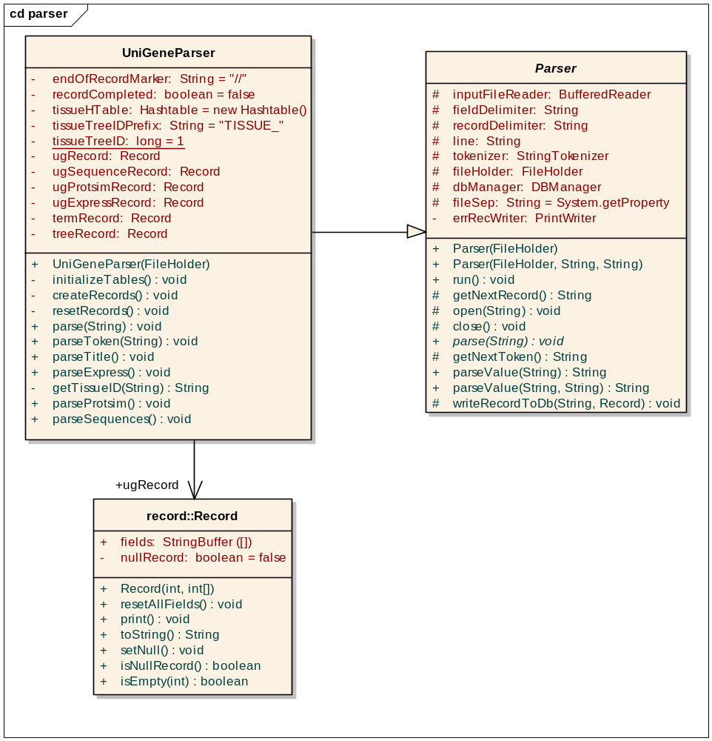

UniSTS
The input data for UniSTS comes in two text files (UniSTS.sts and UniSTS.aliases). The UniSTS.sts contains all the markers in UniSTS that have PCR product size information. The UniSTS.aliases file contains unique identifiers and their aliases. Both the files are in text format where each record is separated by a new line (\n) character and each field within a record is separated by TAB (\t). The command file has the following entry for a UniSTS data source.
##################################################
TYPE FTP
SITE_URL ftp.ncbi.nih.gov
USER_ID anonymous
PASSWD email address of user
BASE_DIR repository/UniSTS/
FILE UniSTS.sts
FILE UniSTS.aliases
DATABASE UNISTS
##################################################

The algorithm used to parse UniSTS data sources is shown below.
- For every record in UniSTS.sts file, tokenize the fields. Fields are in < Unique ID, Name, Organism, semicolon separated Accession Numbers) format.
  - Insert Unique ID, Name, Organism fields into the UniSTS table
  - For every accession number insert < Unique ID, accession number> entry into UniSTS_ACCESSION table
- For every record in UniSTS.aliases file
  - Tokenize the fields in the record. The fields are Unique ID, semicolon separated alias names.
  - For every alias name insert < Unique ID, alias> entry into UniSTS.aliases table

The fields extracted from UniSTS.sts file are listed in the following table.
Field | Description | Data Ttype
Unique ID | Unique ID of the (STS) Sequence Tag Site | Number
Name | Name of the STS | String
Organism | Organism from which STS is derived | String
Accession Number (multiple values) | Accession number used in deriving STS GenBank  NOTE: Accession number values will be separated by ‘;’ in case more than one value is associated. In such cases all accession numbers should be extracted. | String

The fields extracted from UniSTS.aliases are listed in the following table.
Field | Description | Data Type
Unique ID | Unique ID of the STS | Number
Aliases (multiple values) | The list of aliases for the given STS ID  NOTE: Multiple aliases are separated by ‘;’ character. | String

The tables populated by UniSTS parser are listed below
- UniSTS
This table holds data obtained from the UniSTS.sts file.
Field | Data Type | Constraints
UST_STSID | Number | Not null, Primary key
UST_NAME | String
UST_ORGANISM | Character(2)

- UniSTS_ACCESSION
This table contains UniSTS unique identifier to Access number mapping.
Field | Data Type | Constraints
UST_STSID | Number | Not null, Primary key
UST_ACC_NO | String | Not null, Primary key

- UniSTS_Alias
This table holds data obtained from the UniSTS.aliases file.
Field | Data Type | Constraints
USA_STSID | Number | Not null, Primary key
USA_ALIAS | String | Not null, Primary key

Class diagram
The following is the UML class diagram of UniSTS Parser.
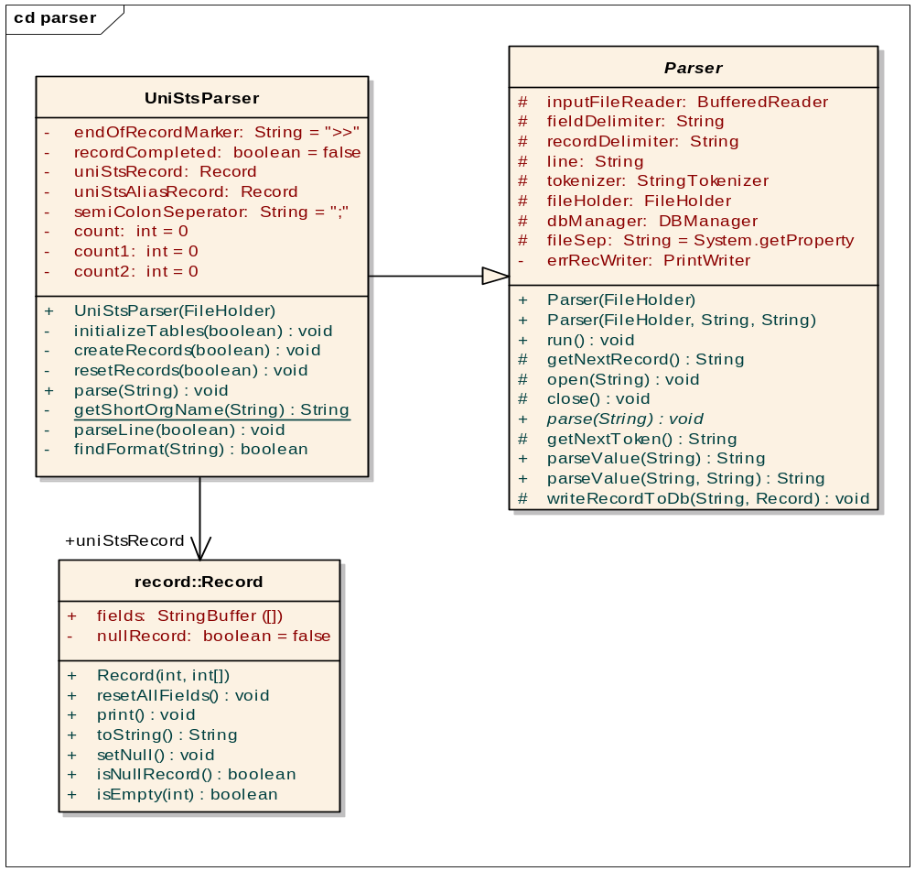

Gene Ontology
The Gene Ontology (GO) parser processes the GO data source file specified in the command file and stores processed data into the database tables. The command file has the following entry for the GO data source that specifies the protocol to download source file (HTTP), the site URL from where to download the data file and other parameters like proxy host and proxy port number.
########################################################################
TYPE HTTP
SITE_URL http://www.archive.godatabase.org/latest/go_200504-termdb.rdf-xml.gz
PROXY_HOST 128.252.198.254
PROXY_PORT 80
DATABASE GO
########################################################################
The GO parser also reads the GO configuration file to get the term identifier associated with the root node ‘Gene_Ontology’. The configuration file has the following entry:
XML_ROOT=ALL
PARENT_TERMID=GO:0003673
PARENT_TERMNAME=Gene_Ontology
The fields that are extracted are listed in the following table.
Node | Description | Data type
<go:term>: Parent node in XML
GO controlled vocabulary term description
<go:accession> | GO term identifier | String
<go:name> | GO term name | String
<go:is_a> | The parent GO term identifier | String
<go:part_of> | The parent GO term identifier | String

The table below explains the algorithm used to parse the GO source file.
- For the root node,
  - Insert PARENT_TERMID and PARENT_TERMNAME parameter values read from the GO configuration file (example: GO:0003673, Gene_Ontology) into the SYSTEM_TERMDATA table.
  - Insert STT_CHILD_TERMID as termID read from the GO configuration file, STT_PARENT_TERMID as 0 and STT_ISPARENT as 1 into the SYSTEM_TERMTREE table.
- For every go:term node
  - Fetch go:accession node value as STT_CHILD_TERMID and STD_TERMID
  - Fetch go:name value as STD_TERM
  - Insert STD_TERMID, STD_TERM into SYSTEM_TERMDATA table
  - For every go:is_a or go:part_of node
    - Fetch rdf:resource attribute value. This value is a URL having term ID string at the end separated by # from main URL (Example: http://www.geneontology.org/go#GO:0005634). Parse the attribute value to get STT_PARENT_TERMID (e.g. GO:0005634).
    - If STT_PARENT_TERMID is equal to XML_ROOT in GO configuration file, then set STT_PARENT_TERMID to PARENT_TERMID in GO configuration file.
    - If STT_PARENT_TERMID is not obsolete term, then insert <STT_CHILD_TERMID, STD_TERM, 1> into SYSTEM_TERMTREE table.

The tables populated by the GO parser are listed below.
- SYSTEM_TERMDATA
This table holds GO term ID to term name mapping.
Field | Data Type | Constraints
STD_TERMID | String | Not null, Primary key
STD_TERM | String | Not null

- SYSTEM_TERMTREE
This table holds parent child relationship between GO terms.
Field | Data Type | Constraints
STT_CHILD_TERMID | String | Not null, Primary key
STT_PARENT_TERMID | String | Not null, Primary key
STT_ISPARENT | Character(1) | Not null

Class Diagram:
The following is the UML Class diagram of GO Parser.
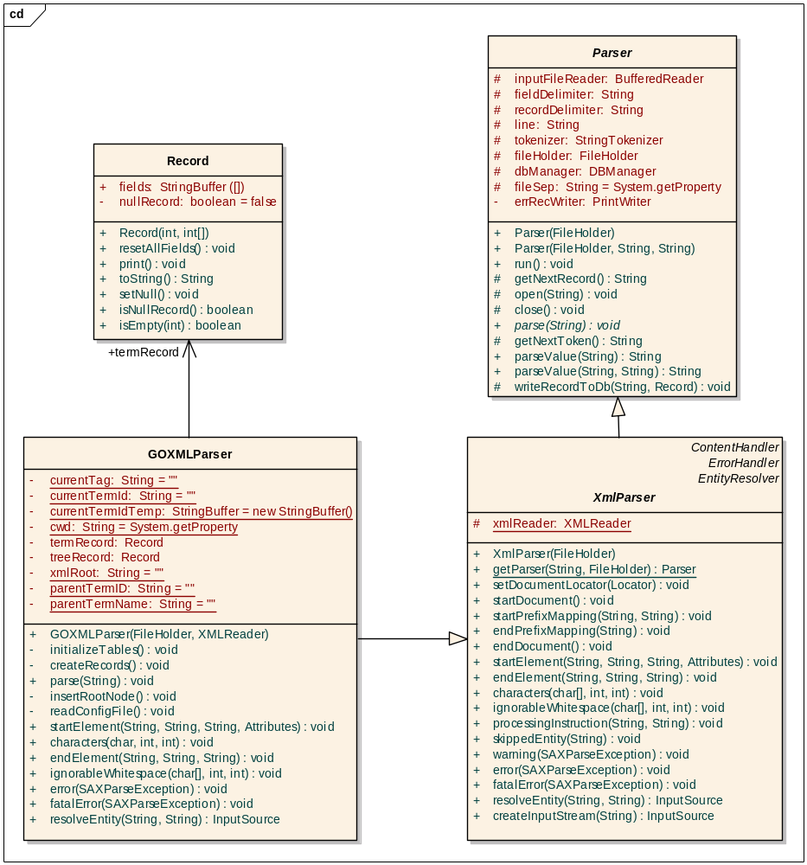

HomoloGene
HomoloGene provides all the system information in a single file hosted on an FTP Server. FE Server has to fetch this file, parse it and load the data into the database. The file contains a GZip’ed dump of XML data. After loading the data, orthologs are computed and stored in the database.
The HomoloGene data file HomoloGene.xml.gz is a GZip'ed file containing an XML dump of the HomoloGene build. The Document Type Descriptor (DTD) of the file can be found at ftp://ftp.ncbi.nih.gov/pub/HomoloGene/HomoloGene.dtd.tar.
The file contains many individual HomoloGene entries with data such as gene ID, taxonomy ID, protein gene index etc of participating genes and statistics like alignment similarity between two genes.
The following table describes the fields that will be extracted.
Node | Description | Data Type
<HomoloGeneEntry> | The details of HomoloGene Entry | String
<HomoloGeneEntry_hg-ID> | HomoloGene Entry ID | Number
<HomoloGeneEntry_genes>
Parent node in XML
Set of genes in the corresponding HomoloGene Entry
<Gene> | Description of the Gene | String
<Gene_geneID> | Gene ID (Entrez Gene ID) | Number
<Gene_taxID> | Taxonomy ID of the gene | Number
<Gene_prot-gi> | Protein Gene Index | String
<HomoloGeneEntry_distances>
Parent node in XML
HomoloGene Entry Distances
<Stats> | Statistical details of HomoloGene Entry distances between a pair of genes (gene 1, gene 2)
<Stats_gi1> | Gene Index of the gene 1 | String
<Stats_gi2> | Gene index of the gene 2 | String
<Stats_prot-change> | Protein change value between gene 1 and gene 2 | Real
<Stats_recip-best> | The reciprocality value | boolean

Parser details:
The algorithm for parsing each HomoloGene group is as follows:
  - Create an in-memory associative array (map) to store mappings between protein gene indices and gene details.
Note: This map is truncated at the beginning of the exploration of each homologene group.
  - Create a list of all records corresponding to one HomoloGene entry node with each record containing the following fields: gene ID1, taxonomyID1, gene ID2, taxonomy ID2, alignment and reciprocal.
Note: The list is symmetric i.e. for any record <geneID1, taxonomyID1, geneID2, taxonomyID2, alignment, reciprocal> in the list, you will find its symmetrical record <geneID2, taxonomyID2, geneID1, taxonomyID1, alignment, reciprocal>.
  - Compute orthologs as described below
  - Write the list to the homologene_xml table

There are two types of ortholog groups:
- Strict ortholog group: Contains genes only with reciprocal value equal to true. These are genes in two or more organisms whose protein sequences are most similar to each other given all the other genes in all genomes.
- Loose ortholog group: Contains genes with reciprocal value either true or false. Additionally, if there are multiple genes from the same organism, then only the gene with the highest alignment value should be considered. These are genes where one or more gene-gene relationships is NOT reciprocal, indicating that at least one pair of genes is not most similar to each other in BOTH directions.

The algorithm for computing orthologs is as follows:
For each HomoloGene group in the input file:
- Ignore the following:
  - All paralogs i.e. the records which have the two participating genes from the same species.
  - All ortholog pairs with a reciprocal value of false AND alignment value less than the user configured cutoff.
- For genes with reciprocal value true, create strict ortholog groups.
- For genes with reciprocal value false:
  - Create loose ortholog groups (i.e. genes with reciprocal value equal to false plus the genes belonging to the corresponding strict ortholog group).
  - If multiple genes of the same organism are associated, consider only the gene with the highest alignment value to be part of the group.
The corresponding data is stored in the following tables.
1. Homologene_XML
Field | Type | Constraint
HGE_HOMOLOGENE_ID | Number | not null
HGE_GENEID1 | Number | not null
HGE_TAXID1 | Number | not null
HGE_GENEID1 | Number | not null
HGE_TAXID1 | Number | not null
HGE_ALIGNMENT | Number | not null
HGE_RECIPROCAL | Character(1) | not null

2. Ortholog
Field | Type | Constraint
OTH_ORTHOLOG_ID | Number | not null
OTH_GENEID | Number | not null

3. OrthologStartGene
Field | Type | Constraint
OSL_ORTHOLOG_ID | Number | not null references Ortholog(oth_orthologID)
OSL_GENEID | Number | not null
OSL_TRUEORTHOLOG | char(1) | not null

4. Homologene_tmp
Homologene_tmp table is also filled during ortholog computation. The HomoloGene records that constitute orthologs are inserted into the homologene_tmp table. The paralogs are also inserted using the following query. Namely, genes within the same HomoloGene group with the same taxonomy ID having reciprocal equal to True or with their alignment greater than or equal to the cutoff are inserted. The following query accomplishes this:
insert into homologene_tmp
select * from homologene_xml where hge_taxID1 = hge_taxID2 and (hge_reciprocal = ‘T’ or hge_alignment > cutoff)
Field | Type | Constraint
HGT_GENEID1 | Number | not null
HGT_ORGANISM1 | Char | not null
HGT_GENEID2 | Number | not null
HGT_ORGANISM2 | Char | not null
HGT_ALIGNMENT | Number | not null
HGT_RECIPROCAL | Char | not null

5. HomoloGene
The only difference between homologene_tmp and homologene table is that the former has two more columns hge_ugID1, hge_ugID2. To fill these UniGene ID values, the homologene_tmp table is joined to the locus_unigene table using the Entrez Gene ID. Thus, following SQL query is used to populate the homologene table.
insert into homologene
Select hgt_geneID1, hgt_org1, a.lug_ugID, hgt_org1, hgt_geneID2, hgt_org2, b.lug_ugID, hgt_alignment, hgt_reciprocal from (homologene_tmp left join locus_unigene a on (hgt_geneID1 = a.lug_locusID)) left join locus_unigene b on (hgt_geneID2 = b.lug_locusID)
Field | Type | Constraint
HGE_GENEID1 | Number | not null
HGE_ORGANISM1 | Char | not null
HGE_UGID1 | String
HGE_GENEID2 | Number | not null
HGE_ORGANISM2 | Char | not null
HGE_UGID2 | String
HGE_ALIGNMENT | Number | not null
HGE_RECIPROCAL | Char | not null

Class diagram
The following is the UML Class diagram of HomoloGene Parser.
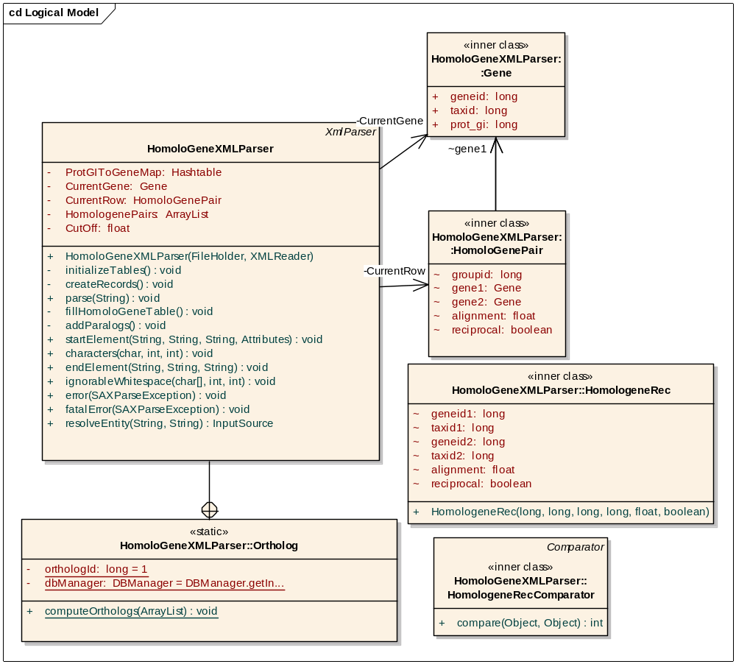

PubMed
From Entrez Gene data source, for each gene, its official name, official symbol, aliases, product names will be parsed and stored in the database. For each gene, the PubMed database is queried for PMIDs of the articles in which the gene is mentioned by one of its several names. PubMed has provided a web based search utility called esearch for querying. See http://eutils.ncbi.nlm.nih.gov/entrez/query/static/esearch_help.html for help.
.
Based on HomoloGene data, orthologous genes are grouped together and PMIDs are associated with these groups. The correlation among gene groups is computed and from these results correlations between two pairs of genes is calculated.
For the incremental update of PubMed data, initially data of ENTREZ_GENENAMES table is replicated into the ENTREZ_GENENAMES_COPY table with Ege_lastupdated value set as NULL. The Ege_lastupdated field indicates the date on which the PubMed data is fetched for that gene name. For every subsequent runs data is fetched for the publications having publication date later than Ege_lastupdated.
The implementation of the PubMed parser is also aimed at taking care of the following two issues:
- Some of the names assigned to a gene can be dropped later.
- Some genes get retired.

Fetching PubMed data
The following table lists the various options that are used by the esearch tool to fetch PubMed data.
Option | Purpose
Database | Restricts the search in the specified database.  Example: db=PubMed
Term | Searches for the specified term in the database. Example term=”Egr1”
Rettype | To retrieve either count of PMIDs (rettype=count) or list of PMIDs (rettype=uilist) for the given search criterion. Example ret=
Retstart | To specify to retrieve PMIDs starting from the given index. Example retstart=5000 will fetch 5000th PMID onwards.
Retmax | To specify the max number of PMIDs to retrieve in the search. Example retmax=5000
Mindate | Minimum publication date
Maxdate | Maximum publication date
Retmode | To specify either xml or html format of the result  Example retmode=xml

The algorithm used to populate the Gene_pmids table is shown below.
- For each name(key word) of a Gene ID in entrez_genenames_copy table, get Ege_lastupdated value (last_update)
- If Ege_last_update is not NULL, get the data for the period post last_update
The URL is http:// ://www.ncbi.nlm.nih.gov/entrez/eutils/esearch.fcgi?db=PubMed&term=”key word”&minpubmedate=”last_update”&retype=xml
- Else, get ALL data
The URL is http:// ://www.ncbi.nlm.nih.gov/entrez/eutils/esearch.fcgi?db=PubMed&term=”key word”&retype=xml
- Parse the output of the URL and insert Gene ID and PMIDs in the output into the Gene_pmids table.
- Set Ege_last_updated value to the current date for each new row in the Entrez_genenames_copy table.
- Repeat above steps for all Gene IDs in the Entrez_genenames_copy table.

Data Synchronization
The data in tables Entrez_genenames_copy and entrez_pmids used by PubMed Parser needs to be synchronized with data in entrez_genenames and gene_history tables populated by Entrez Gene Parser because some gene names might be dropped and some genes might be retired. Synchronization is done in the following two steps.
Step #1
After parsing Entrez Gene data source, the Entrez_genenames table is updated. The data in the Entrez_genenames_copy table needs to be consistent with the Entrez_genenames table data because new names may have been added to a Gene ID or some names may have been dropped. The following algorithm will be used to synchronize data between the Entrez_genenames and Entrez_genenames_copy tables.
- For each Gene ID in Entrez_genenames table, compare its gene names set (say A) with the corresponding set of gene names (say B) in Entrez_genenames_copy table.

Check for NEW genes
- If A is a super set of B, add the gene names in A - B to Entrez_gene_names_copy table and set the Ege_last_update to NULL.

Check for DROPPED genes
- Else if A is a sub set of B, remove the records corresponding to the Gene ID from the Entrez_genenames_copy table as well as from the Gene_pmids table and add the gene names in A to Entrez_genenames_copy table and set Ege_last_update to NULL.

New Entrez Gene ID
- From Entrez_genenames table, add to Entrez_genenames_copy table all the records corresponding to Gene IDs that are not present in the latter table.

Step #2
The data in Entrez_genenames_copy and Gene_pmid tables needs to be synchronized with Gene_history table so as to take care of retired Gene IDs. The Gene_history table is updated after parsing Entrez Gene data source. The following algorithm will be used to synchronize data between Entrez_genenames_copy and Gene_history table.
- For each retired Gene ID G1, compare its set of gene names (A) in Entez_genenames_copy table with the set of gene names (B) of the new Gene ID G2, to which the first Gene ID is retired, in the Entrez_genenames_copy table.
- If A is subset set of B, add the gene names in B - A to Entrez_gene_names_copy table for G1 with the Ege_last_update to NULL. Delete records corresponding to G2 from both the tables Entrez_genenames_copy and Gene_pmid and set the Gene ID value to G2 for all records corresponding to G1 in both the tables.
- Else delete records corresponding to G1 from both the tables.

Correlation Computation
Populating geneidgroups table
Orthologs calculated using HomoloGene are used to group PMIDs. Thus, the relationship of two orthologous genes in the literature will be the same.
After synchronizing data between PubMed and Entrez Gene sources, PubMed data is associated with GeneID groups using the following algorithm.
- For each GeneID in a group in the geneidgroups table, get PMIDs from the gene_pmids table.
- Insert group ID, and PMIDS into geneidgroups_pmids.
For each gene ID group, the no of PMIDs associated is counted and stored in the GeneIDgroup_pubmedcount table. The correlation weight between any two GeneID groups is the number of PMIDs common in those two groups. Thus the correlation weights are computed for all GeneID group pairs and stored in GeneIDgroups_pmid_weights table. The correlation between two gene IDs of the same organism is calculated as the correlation of the corresponding equivalent gene ID groups and are stored in Gene_pmid_weights.

The tables used / populated by PubMed data-source are listed below.
1. Entrez_genenames (populated by EntrezGene data-source)
Field | Data Type | Constraints
EGE_GENEID | Number | Not null
EGE_ORGANISM | Character(2) | Not null
EGE_GENE_NAME | String | Not null
This table stores gene aliases, official gene name, official gene symbol, and gene product name assigned for each gene ID.

2. Entrez_genenames_copy
Field | Data Type | Constraints
EGE_GENEID | Number | Not null
EGE_ORGANISM | Character(2) | Not null
EGE_GENE_NAME | String | Not null
EGE_LASTUPDATED | DATE
This table is similar to Entrez_genenames except that it stores the date on which the corresponding PubMed data is fetched for the name. Initially the entire Entrez_genenames table is replicated into this table with Ege_lastupdated value set as NULL.

3. Gene_history
Field | Data Type | Constraints
GNH_OLDGENEID | Number | Not null
GNH_NEWGENEID | Number
This table contains the history of retired Gene IDs.
4. Gene_pmids
Field | Data Type | Constraints
GPI_GENEID | Number | Not null
GPI_ORGANISM | CHAR (2) | Not null
GPI_PMID | NUMBER | Not null

5. Geneidgroups
Field | Data Type | Constraints
GEG_GROUPID | NUMBER | NOT NULL
GEG_GENEID | Number | NOT NULL
In this table, equivalent geneIDs are grouped together. Equivalency is determined from the HomoloGene data. Population of this table is explained in section “populating geneIDgroups table”.

6. Geneidgroup_pubmedids
Field | Data Type | Constraints
GGP_GROUPID | NUMBER | NOT NULL
GGP_PMID | NUMBER | NOT NULL

7. Genegroup_pmid_weights
Field | Data Type | Constraints
GGW_FROMGROUP | NUMBER | NOT NULL
GGW_TOGROUP | NUMBER | NOT NULL
GGW_WEIGHT | NUMBER | NOT NULL

8. Gene_pmid_weights
Field | Data Type | Constraints
GPW_FROMGENEID | NUMBER | NOT NULL
GPW_FROMSYMBOL | String | NOT NULL
GPW_TOGENEID | NUMBER | NOT NULL
GPW_TOSYMBOL | String | NOT NULL
GPW_WEIGHT | NUMBER | NOT NULL
GPW_FROMPUBCT | NUMBER | NOT NULL
GPW_TOPUBCT | NUMBER | NOT NULL

9. Geneidgroup_pubmedidcount
Field | Data Type | Constraints
LPC_GROUPID | NUMBER | NOT NULL
LPC_COUNT | NUMBER | NOT NULL

Revision History
The revision history component keeps track of the version and the release dates of the external databases used to refresh/populate the annotation schema. The SERVER_FILE_STATUS table stores the revision history of every data source. The revision number (REVISION_NUMBER) field, wherever supplied by the data provider, will be the actual build data of the data source or a sequence number generated by FE Server.
Field | Data Type | Constraints
SFS_ID | NUMBER
SFS_MODIFY_DATE | DATE
SFS_FILENAME | STRING | NOT NULL
SFS_FILETYPE | STRING
SFS_DATABASE | STRING
REVISION_NUMBER | STRING

The query interface and HTTP APIs will provide revision details for every external data source.

Post data processing (Post work)
This component performs the post–data processing of data populated by the Download and Process components and then populates the summary tables.
ENTREZ GENE
UNIGENE
HOMOLOGENE
CHIP LIBRARIES
SUMMARY TABLES
PUBMED

Chip-Description
The chip library contains the mapping between probes and any combination of <accession numbers, UnigeneIDs, EntrezGeneID> values. CHIPINFORMATION table stores these mapping details. However, the details provided by vendor and hence the details in chipinformation table may not be complete and up-to-date. For instance, the chip-library file, which is loaded into chipinformation table may or may not contain complete mapping between accession number, Entrez Gene ID, UnigeneID and organism value. Also, the fact that UnigeneIDs, Entrez Gene IDs do get retired, it is necessary to take care of retired Entrez GeneIDs and UniGeneIDs.
CHIPINFORMATION
ENTREZ_FLY
UG_SEQUENCE
UNIGENE
CHIPDESCRIPTION
In view of above facts, the Chip-Description component creates a new table called CHIPDESCRIPTION, which has the format similar to chipinformation. The fields Entrez Gene ID, Unigene ID and organism in chipdescription table are re-calculated by joining chipinformation table with ug_sequence, unigene, entrezgene, and ENTREZ_fly tables. The retired IDs are replaced with new IDs by joining chipinformation table with GENE_history, unigene_history tables.

ALGORITHM
- Prepare an empty chipdescription record (chipdesc_record.)
- For each row in chipinformation table, follow the below given steps:
I. If “Acc No is not null” and “UniGene ID is null or not null” and “Entrez Gene ID is null or not null”
- If the accession number is a flybase identifier (starting with ‘FB’),
- Retrieve Entrez Gene ID from Entrez_fly table corresponding to the accession number and store it into the chipdesc_record.
- Store the organism value for this record as ‘Dm’.
- Copy the rest of the information from current row of chipinformation table into chipdesc_record.
- Else:
- Retrieve UniGene ID from UG_SEQUENCE table corresponding to the accession number
- Retrieve Entrez Gene ID and organism value from UniGene table for the UniGene ID calculated in previous step.
- Copy the rest of the information from the current row of the chipinformation table into chipdesc_record.
II. If Acc No is null, UniGene ID is not null, Entrez Gene ID is not null:
- From unigene table fetch Entrez Gene ID and organism value for the corresponding UniGene ID.
- Populate chipdesc_record with above calculated information and fill the remaining fields from current row of chipinformation table.
III. If Acc No is null, UniGene ID is not null, Entrez Gene ID is null:
- From unigene table fetch Entrez Gene ID and organism value for the corresponding UniGene ID.
- Populate chipdesc_record with above calculated information and fill the remaining fields from current row of chipinformation table.
IV. If Acc No is null, UniGene ID is null and Entrez Gene ID is not null:
- From GENE_HISTORY table check if the Entrez Gene ID is retired. If yes, then replace it with an updated Entrez Gene ID.
- From Entrez_uniGene table, fetch corresponding UniGene ID and organism value for the given Entrez ID.
- Populate chipdesc_record with above calculated information and fill the remaining fields from current row of chipinformation table.
V. If All Accession Number, UniGene ID and Entrez Gene ID are null:
- Copy the entire chipinformation row to chipdesc_record.
- Insert the chipdesc_record populated in previous steps into chipdescription table.

The table description for the CHIPDESCRIPTION table is shown below:
Field | Data Type | Source Table Name
CDE_CHIPTYPEID | Number | CHIPINFORMATION
CDE_PROBESET | Number | CHIPINFORMATION
CDE_ACC_NO | String | CHIPINFORMATION, UG_SEQUENCE
CDE_UGID | String | UNIGENE
CDE_OGRANISM | Char | UNIGENE, ENTREZ_FLY
CDE_GENEID | Number | UNIGENE, ENTREZ_FLY
CDE_CHIP_DESCRIPTION | String | CHIPINFORMATION

Gene-Info
After the associations among probes, UniGene IDs, and Entrez Gene IDs are computed (refer to section 3.2.2.1) the probes are then linked with annotations from UniGene and Entrez Gene and the GENEINFO table is populated to hold these details.
CHIPDESCRIPTION
ENTREZGENE
UNIGENE
GENEINFO

ALGORITHM
Insert all the records from chipdescription table into geneinfo table and fill Unigene ID, title, gene, cytoband details from unigene and chromosome, symbol, gene name, gene summary, summary function fields from EntrezGene table.
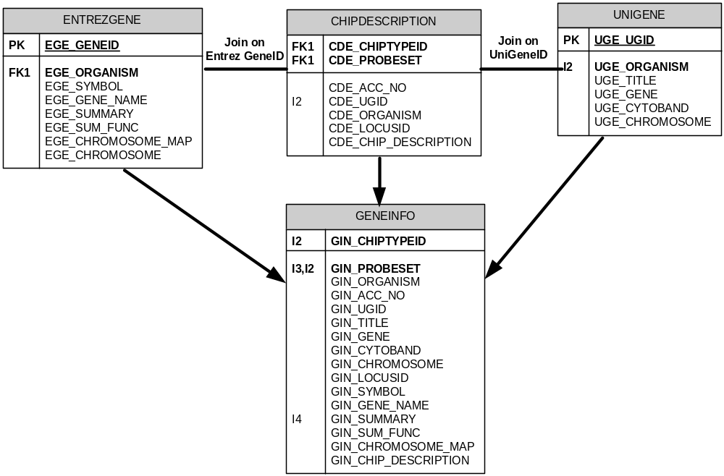

The table description of GENEINFO is shown below.
Field | Data Type | Source Table Name
GIN_CHIPTYPEID | Number | CHIPDESCRIPTION
GIN_PROBESET | Number | CHIPDESCRIPTION
GIN_OGRANISM | Char | CHIPDESCRIPTION
GIN_ACC_NO | String | CHIPDESCRIPTION
GIN_UGID | String | CHIPDESCRIPTION
GIN_TITLE | String | UNIGENE
GIN_GENE | String | UNIGENE
GIN_CYTOBND | String | UNIGENE
GIN_CHROMOSOME | String | UNIGENE
GIN_GENEID | Number | CHIPDESCRIPTION
GIN_SYMBOL | String | ENTREZ_GENE
GIN_GENE_NAME | String | ENTREZ_GENE
GIN_SUMMARY | String | ENTREZ_GENE
GIN_SUM_FUNC | String | ENTREZ_GENE
GIN_CHROMOSOME_MAP | String | ENTREZ_GENE
GIN_CHIP_DESCRIPTION | String | CHIPDESCRIPTION

Gene-Info Summary
The Entrez Gene parser stores the mapping between Entrez Gene IDs and GO term IDs. Using this data, the component provides a link between the Entrez Gene ID, Symbol, Gene Name, ChromosomeMap and Gene Summary to GO terms and UniGene. The summary table GENEINFO_SUMMARY is populated to store these links.
ENTREZGENE
ENTREZ_GOID
UNIGENE
GENEINFO_SUMMRAY
SYSTEM_TERMDATA

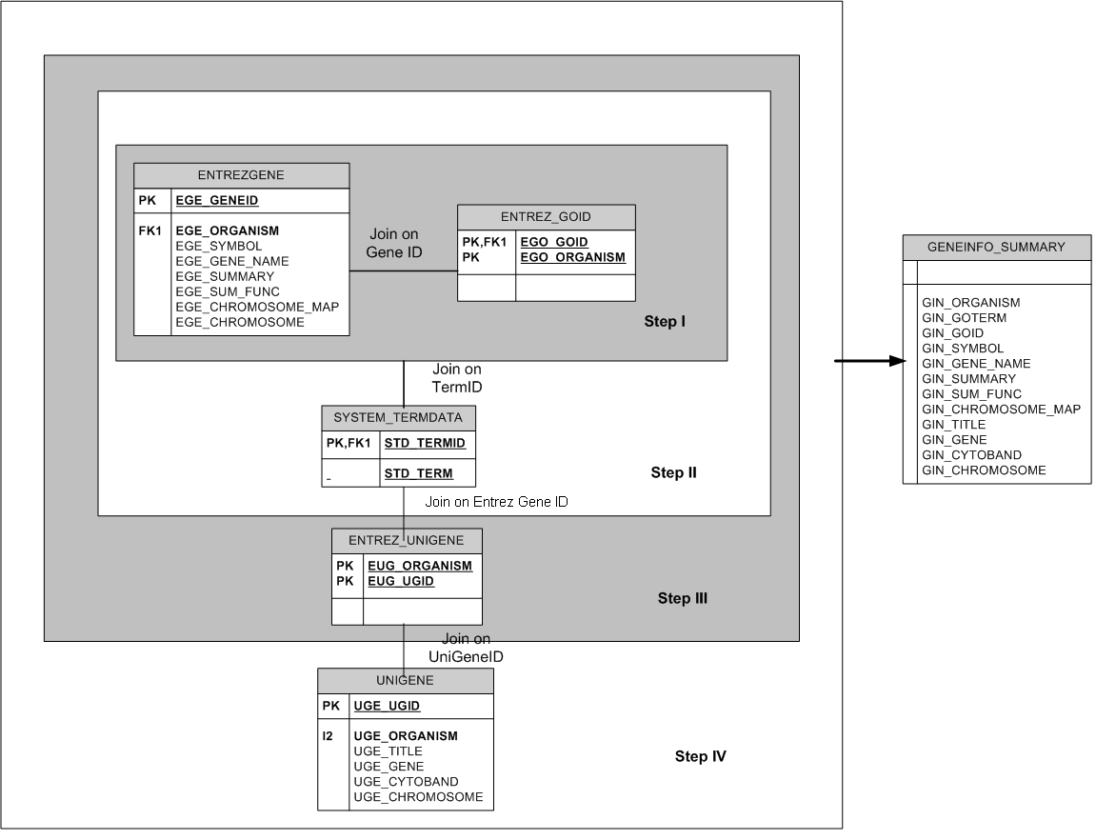The table below describes the GENEINFO_SUMMARY table details.
Field | Data Type | Source Table Name
GIN_GENEID | Number | ENTREZ_GENE
GIN_UGID | Number | UNIGENE
GIN_OGRANISM | Char | UNIGENE
GIN_GOTERM | String | SYSTEM_TERMDATA
GIN_GOID | String | ENTREZ_GO
GIN_SYMBOL | String | ENTREZ_GENE
GIN_GENE_NAME | String | ENTREZ_GENE
GIN_SUMMARY | String | ENTREZ_GENE
GIN_SUM_FUNC | String | ENTREZ_GENE
GIN_CHROMOSOME_MAP | String | ENTREZ_GENE
GIN_TITLE | String | UNIGENE
GIN_GENE | String | UNIGENE
GIN_CYTOBND | String | UNIGENE
GIN_CHROMOSOME | String | UNIGENE

Gene-Info Microarray Summary
The associations among Entrez Gene, UniGene, GO and probes is computed by joining the GENEINFO and GENEINFO_SUMMARY tables.
GENEINFO_SUMMRAY
GENEINFO
GENEINFO_MICROARRAY_SUMMARY

The table description of GENEINFO_MICROARRAY_SUMMARY is shown below.
Field | Data Type | Source Table Name
GIN_CHIPTYPEID | Number | CHIPDESCRIPTION
GIN_PROBESET | Number | CHIPDESCRIPTION
GIN_OGRANISM | Char | CHIPDESCRIPTION
GIN_GOTERM | String | GENEINFO_SUMMARY
GIN_GOID | String | GENEINFO_SUMMARY
GIN_ACC_NO | String | CHIPDESCRIPTION
GIN_UGID | String | GENEINFO_SUMMARY
GIN_TITLE | String | GENEINFO_SUMMARY
GIN_GENE | String | GENEINFO_SUMMARY
GIN_CYTOBND | String | GENEINFO_SUMMARY
GIN_CHROMOSOME | String | GENEINFO_SUMMARY
GIN_GENEID | Number | GENEINFO_SUMMARY
GIN_SYMBOL | String | GENEINFO_SUMMARY
GIN_GENE_NAME | String | GENEINFO_SUMMARY
GIN_SUMMARY | String | GENEINFO_SUMMARY
GIN_SUM_FUNC | String | GENEINFO_SUMMARY
GIN_CHROMOSOME_MAP | String | GENEINFO_SUMMARY
GIN_CHIP_DESCRIPTION | String | GENEINFO_SUMMARY

Chipinfo-Homolo
The Homologene annotations are linked to probes by joining CHIP_DESCRIPTION with the HOMOLOGENE table. This link is stored in the CHIPINFO_HOMOLO table.
CHIP_DESCRIPTION
HOMOLOGENE
CHIPINFO_HOMOLO

ALGORITHM:
The chipinfo_homolo table is populated by joining CHIPDESCRIPTION table with HOMOLOGENE
- If CDE_GENEID field in CHIPDESCRIPTION is not null:
Then join CHIPDESCRIPTION and homologene tables such that CDE_GENEID = HGE_GENEID1.
- If CDE_GENEID is null but CDE_UGID is not null:
Then join chipdescription and homologene tables such that CDE_UGID = HGE_UGID1.
- Populate the resulting information into chipinfo_homolo table:
Insert into chipinfo_homolo table, the record (CDE_CHIPTYPEID, CDE_PROBESET, HGE_ORGANISM1, HGE_GENEID1, HGE_UGID1, HGE_ORGANISM2, HGE_GENEID2 and HGE_UGID2.)

The table description of CHIPINFO_HOMOLO is shown below.
Field | Data Type | Source Table Name
CIH_CHIPTYPEID | Number | CHIPDESCRIPTION, CHIPINFO_HOMOLO
CIH_PROBESET | String | CHIPDESCRIPTION, CHIPINFO_HOMOLO
CIH_ORGANISM1 | Character(2) | ENTREZ_GO, ENTREZ_MAP, UG_EXPRESS, CHIPINFO_HOMOLO
CIH_GENEID1 | Number | ENTREZ_GO, ENTREZ_MAP,UG_EXPRESS, CHIPINFO_HOMOLO
CIH_UGID1 | String | CHIPDESCRIPTION, CHIPINFO_HOMOLO
CIH_ORGANISM2 | String | CHIPDESCRIPTION, CHIPINFO_HOMOLO
CIH_GENEID2 | Number | ENTREZ_GO, ENTREZ_MAP, UG_EXPRESS, CHIPINFO_HOMOLO
CIH_UGID2 | String | ENTREZ_GO, ENTREZ_MAP,UG_EXPRESS, CHIPINFO_HOMOLO

Chipinfo-Term
The CHIPINFO_TERM table stores the associations between probes GO terms, Chromosome Map and the Tissue Expression.
CHIPDESCRIPTION
ENTREZ_GOID
CHIPINFO_TERM
ENTREZ_MAP
UG_EXPRESS
CHIPINFO_HOMOLO

Algorithm
1. Fill information from Entrez_goid table:
Insert records into chipinfo_term from chipdescription, ENTREZ_goid where geneid from chipdescription = GENEID from ENTREZ_GOID

2. Fill information from Entrez_map table:
Insert records into chipinfo_term from chipdescription, locus_map where where geneid from chipdescription = GENEID from ENTREZ_MAP

3. Fill information from ug_express table:
Insert records into chipinfo_term from from chipdescription, ug_express where UniGeneID from chipdescription = UniGeneID from ug_express

4. Fill information from homologene and entrez_goid:
Insert records into chipinfo_term from chipinfo_homolo, entrez_goid where geneid from chipinfo_homolo = geneid from entrez_goid

5. Fill information from homologene and ug_express:
Insert records into chipinfo_term from from chipinfo_homolo, ug_express where UniGeneID from chipdescription = chipinfo_homolo from ug_express

The table description of CHIPINFO_TERM is shown below.
Field | Data Type | Source Table Name
CIT_CHIPTYPEID | Number | CHIPDESCRIPTION, CHIPINFO_HOMOLO
CIT_PROBESET | String | CHIPDESCRIPTION, CHIPINFO_HOMOLO
CIT_ORGANISM | Character(2) | ENTREZ_GO, ENTREZ_MAP, UG_EXPRESS, CHIPINFO_HOMOLO
CIT_TERMID | Number | ENTREZ_GO, ENTREZ_MAP,UG_EXPRESS, CHIPINFO_HOMOLO

Chipinfo-OMIM
CHIPDESCRIPTION
CHIPINFO_HOMOLO
CHIPINFO_OMIM
ENTREZ_OMIM
The mapping between probes and OMIM IDs can be computed by joining the entrez_omim table with chipdescription and CHIPINFO_homolo.

Algorithm:
1. Fill information from Entrez_omim table:
Insert records into chipinfo_omim from chipdescription and locus_omim where geneid from chipdescription table = geneid from entrez_omim table

2. Fill information from chipinfo_homolo
Insert records into chipinfo_omim from chipinfo_homolo, entrez_omim where geneid from chipinfo_homolo table = geneid from entrez_omim table

The table description of CHIPINFO_OMIM is shown below.
Field | Data Type | Source Table Name
CIT_CHIPTYPEID | Number | CHIPDESCRIPTION
CIT_PROBESET | String | CHIPDESCRIPTION
CIT_ORGANISM | Character(2) | CHIPDESCRIPTION
CIT_OMIMID | Number | ENTREZ_OMIM

add chip library
This component of Function Express server adds details of new chip libraries to the database. The Chip library contains details for probes, any combination of <accession numbers, UniGeneID, EntrezGeneID> and probe descriptions. This component parses the chip library file and stores data into the database. Then probes get annotated with the up-to-date information by the retrieve annotations component.
The new chip library is registered into the database by adding library details into a CHIPTYPES table. Every chip library file should contain the chip name and corresponding species in the first line. Function Express server parser chip library file, reads the chip name, species value and inserts a new row into the CHIPTYPES table by assigning a unique identifier for this chip. The fields in the CHIPTYPES table are mentioned in the table below.
Field | Data Type | Constraints
CTY_CHIPTYPEID | Number | NOT NULL, Primary key
CTY_CHIPNAME | String | NOT NULL
CTY_SPECIES | String
CTY_INPRODUCTION | Character (2)

The add chip library mode of the Function Express server populates the following table.
- CHIPINFORMATION
This table stores the <probeset, chiptypeID, accession number, UniGene ID, and/or Entrez Gene ID> association for each chip library.
Field | Data Type | Constraints
CIN_CHIPTYPEID | Number | NOT NULL, Primary key
CIN_PROBESET | Number | NOT NULL, Primary key
CIN_ACC_NO | String
CIN_UGID | String
CIN_ORGANISM | Character(2)
CIN_GENEID | Number
CIN_CHIP_DESCRIPTION | String

The diagram below shows the workflow of the add chip library component.
New Chip Library file
PARSER MANAGER
DATA FILE
DATA LOADER
DATABASE
(ChipInformation table)
Retrieve Annotations Component
DATABASE
(Probes linked to annotations)

Add Affymetrix chip library
The Affymetrix chip library file is a structured text file, which has one record per line, and the record holds the values of probe identifier, accession number, and/or UniGene ID, and/or Entrez Gene ID and probe description fields that are separated by TAB.
Following steps are followed to add an Affymetrix chip library.
- Register Chip library by inserting a new row into the CHIPTYPES table by reading first line of chip library file.
- Parse the chip library file and insert details into the CHIPINFORMATION table. The CIN_CHIPTYPEID value for this library comes from the CHIPTYPES table.
- Annotated newly added probes with current information by running server in the update mode.

Add caARRAY chip library
caARRAY informatics provides MAGE-OM (Object Model) APIs to connect to the caArray database and search for the list of arrays. The result returned is loaded into the CHIPINFORMATION table. Then the retrieve annotations module links these probes to the available annotations.
caARRAY
MAGE-OM API Jar
MAGE-OM OBJECTS
caArray
DB
Function Express Server
Probes
annotated
caArray Interface
ADD CHIP LIBRARY MODE
Function Express DB

Query interface
The following diagram outlines the high level architectural design of the query interface.
Web
Browsers
JAVA
Apps
HTML
Object
Web- Server
Data Access Object
Struts
Framework
Action
ActionServlet
Hibernate
JDBC
FE Server Database
Domain Objects
Domain Objects
Domain Objects
EVS caDSR Interface
NCICB
caDSR/EVS
Database
caCORE
API
ActionForm
Client Layer
Presentation Layer
Object Layer
Data sources
Business Logic
Tiles
Engine
JSP
Engine

Basics of Struts
The query interface is a web based API implemented using a Java Struts framework. This section briefly describes various facets of the Struts framework.
In a Java Struts framework, the typical flow of events is as follows:
- User enters the information into the web page.
- Upon submission, the action form containing the information is passed onto the action class.
- The action class performs the necessary validation and creates the domain objects.
- The domain objects are then passed onto the data access class which retrieves the data in the database.

The following sections introduce some of the basic components of Struts:

Action class
The action class is the link between the model and the view. The primary responsibility of this class is to:
- Retrieve information from the web page (ActionForm object) and create the appropriate domain objects.
- Perform the action (e.g. searching the database based on an identifier).
- Return results back to the web page.

Controller
The Controller component of the Struts Framework is the backbone of all Struts based applications. It is implemented using a Servlet named ActionServlet.
- This servlet receives all client requests, and delegates the control of each request to a RequestProcessor class.
- The RequestProcessor processes each request by initializing the ActionForm associated with the web page and then delegates the control of the request to a user defined Action class.
ActionForm: The ActionForm object contains inputs supplied by the user. The RequestProcessor prepares an ActionForm object from the HttpRequest and forwards it to the action classes for validation of the business requirements.
Domain Object: The domain objects are value objects of the application e.g. Gene, Probeset etc. The domain objects are populated by the Action classes, and are then passed to the Data Access Object class.

API Access
The main goal of caBIG is to create a network or grid of applications, sharing data and tools, thereby creating a World Wide Web of cancer research. In order to achieve this, the FE server application provides an API so that others can access meaningful data, correlate data with other applications or create new applications.
HTTPClient: HttpClient is a wrapper class over an HTTP API that provides APIs to connect and access the FE Application through other applications. To use a FE server API through Java applications, the HttpClient follows two methods:
- connect:
- This method connects to the server and authenticates the user.
- After successful authentication of the user, the server sends a session ID to the client.
- HttpClient class stores the session ID for subsequent use.
- doOperation: This method performs the specified action on a given form object. The user creates a new instance of the desired ActionForm object and passes this object and action name to this method. The method then performs the following steps:
- Sends previously stored session ID and ActionForm to the server.
- On successful completion of the operation it returns a list of resultant objects.
In case of error it throws an exception.

Gene Search Query Interface
The gene search query interface provides a case insensitive search, which can be gene centric or probe centric.

Probe centric search
- The probe centric search results are displayed as a list of all probes satisfying the search criteria entered by the user. Search results also contain links to all associated annotations. The annotations are obtained by querying the GENEINFO_MICROARRAY_SUMMARY table.
- Clicking on a specific probe identifier show detailed annotations about the selected probe. The details page also provides links to the respective data source such as UniGene, Entrez Gene, and Gene Ontology. The tables used for getting these details are the UG_EXPRESS (to get tissue expression details), ENTREZ_STS (to get STS data), ENTREZ_PHYNOTYPE (phenotype details), and ENTREZ_OMIM table (to get associated OMIM ID).
- Clicking on the Pubmed link will display the literature network query interface page. This is used to get literature network details for a probe.

Gene centric Search
- The gene centric search results are displayed as a list of all probes satisfying the search criteria entered by the user. Search results also contain links to all associated annotationsThe annotations are obtained by querying to the GENEINFO_SUMMARY table.
- Clicking on a specific GeneID shows the detailed annotations about the selected gene. The details page also provides links to the respective data source such as UniGene, Entrez Gene, and Gene Ontology. The tables used for getting these details are UG_EXPRESS (to get tissue expression details), ENTREZ_STS (to get STS data), ENTREZ_PHYNOTYPE (phenotype details), ENTREZ_OMIM (to get associated OMIM ID).
- Clicking on Pubmed link, the literature network query interface page is displayed to get the literature network details for a gene.

Literature Network Query Interface

Probe centric search
- Get the user specified values for chip name, unique probe identifier, minimum correlation and depth of the network.
- Find the corresponding Entrez Gene ID from the GENEINFO table and add it to the genes List. Current depth is initialized to 1.
- Get records from the Gene_pmid_weights table whose from_geneid is in the genes List with the correlation greater than the minimum_correlation.
- For each pair of genes in the above result set, get the common PMIDs from genegroup_pmids table and show them.
- Truncate the genes list and add all to_geneids from the result set of step #3. Increment current depth.
- Repeat steps 3 through 4 until current depth is equal to depth of the network.

Gene centric search
- Get the user specified values for gene name/ gene id, minimum correlation and depth of the network.
- Find the corresponding Entrez Gene ID from the GENEINFO table and add it to the genes list. Current depth is initialized to 1.
- Get the records from Gene_pmid_weights table whose from_geneid is in genes list and correlation is greater than minimum correlation.
- For each pair of genes in the above result set, get the common PMIDs from genegroup_pmids table and show them.
- Truncate genes list and add all to_geneids from the result set of step #3. Increment current depth.
- Repeat steps 3 through 4 until current depth is equal to depth of the network.

APPENDIX A – DOCUMENT TERMINOLOGIES AND ACRONYMS
Acronym | Description
ACC | Accession Number
API | Application Programming Interface
caDSR | Cancer Data Standards Repository
CDE | Common Data Element
DAO | Data Access Object
EVS | Enterprise Vocabulary Services
FE | Functional Express
FTP | File Transfer Protocol
GO | Gene Ontology
ID | Identifier
NCICB | National Cancer Institute Center for Bioinformatics
NID | Nucleotide Sequence Identifier
OM | Object Model
PID | Protein Sequence Identifier
PV | Permissible Value
SDD | Software Design Description
SID | System Identifier
STS | Sequence Tag Site
UML | Universal Modeling Language

APPENDIX B – ORTHOLOG COMPUTATION DETAILS AND EXAMPLE
The following algorithm is used to compute ortholog groups from the sorted list.
- Create a list of sets of gene IDs call it geneID_list. Initially geneID_list is empty.
- Create a map ortholog_map that stores mappings between Ortholog Set and OrthologID. Initially ortholog_map is empty.
- ortholog_ID is a static variable whose initial value is 1. This is a FE Server generated ID for each ortholog.
- For each geneID1 get the list of geneID2 with reciprocal value TRUE and create an ortholog_set that includes geneID1 and the list of geneID2

COMPUTE STRICT ORTHOLOGS
- If strict_ortholog_set exists in geneID_list,
  - Find its ortholog_ID
  - insert into table orthologstartlocus (ortholog_ID, geneID1, ‘T’)
ELSE
- Insert strict_ortholog_set, ortholog_ID into ortholog_map
- Insert all genes in strict_ortholog_set and ortholog_ID into ortholog table
- Insert into orthologstartlocus (ortholog_ID, geneID1, ‘T’)
- Increment ortholog_ID;

COMPUTE LOOSE ORTHOLOGS
- For each geneID1 get the list of geneID2 with reciprocal value FALSE and create a loose_ortholog_set.
- If there are multiple gene IDs whose organism is same in the list of geneID2, consider only the one with highest alignment value.
- Add geneID1, list of geneID2 and each gene ID in strict_ortholog_set to lose_ortholog_set.
- If loose_ortholog_set exists in geneID_list,
  - Find its ortholog_ID
  - insert into table orthologstartlocus (ortholog_ID, geneID1, ‘T’)
ELSE
- Insert loose_ortholog_set, ortholog_ID into ortholog_map
- Insert all genes in loose_ortholog_set and ortholog_ID into ortholog table
- Insert into orthologstartlocus (ortholog_ID, geneID1, ‘F’)
- Increment ortholog_ID;

A sample-sorted list is shown in the following table.

NOTE: Each color indicates an ortholog group.
GeneID1 | TaxID1 | GeneID2 | TaxID2 | Reciprocal | Alignment
355 | 9606 | 395274 | 9031 | true | 0.36024845
355 | 9606 | 14102 | 10090 | true | 0.506135
355 | 9606 | 466149 | 9598 | false | 0.97342193
14102 | 10090 | 395274 | 9031 | true | 0.34628975
14102 | 10090 | 466149 | 9598 | true | 0.48333335
14102 | 10090 | 355 | 9606 | true | 0.506135
14102 | 10090 | 365454 | 10116 | true | 0.6292517
365454 | 10116 | 395274 | 9031 | true | 0.36904764
365454 | 10116 | 14102 | 10090 | true | 0.6292517
365454 | 10116 | 466149 | 9598 | true | 0.50530034
395274 | 9031 | 355 | 9606 | true | 0.36024845
395274 | 9031 | 466149 | 9598 | true | 0.42510122
395274 | 9031 | 14102 | 10090 | true | 0.34628975
395274 | 9031 | 365454 | 10116 | true | 0.36904764
466149 | 9598 | 395274 | 9031 | true | 0.42510122
466149 | 9598 | 14102 | 10090 | true | 0.48333335
466149 | 9598 | 365454 | 10116 | true | 0.50530034
466149 | 9598 | 355 | 9606 | false | 0.97342193

APPENDIX C – CLASSES
- DOWNLOAD MANAGER
The input data files are downloaded from public sources using FTP and HTTP protocols. Both HttpDownLoader and FTPDownLoader make use of a queue to hold and efficiently use the downloaded files.
- HttpDownLoader
This class downloads the files from public data sources using HTTP protocol.
checkDate(): This function checks the file date on the HTTP server and compares it to the date stored in the database.
getData(FileInfo httpInfo,FileHolder fileHolder):This function is used to download the data file from Http Source. fileHolder object holds the downloaded file and httpInfo object holds all the HTTP details for the file to be downloaded.
- FTPDownLoader
This class downloads the data files from public data sources using FTP protocol.
downloadSite(FileInfo ftpInfo, FileHolder fileHolder): It downloads the data file from FTP source.
boolean ftpFileDateCheck(FileInfo ftpInfo): determines if files of a particular db need to be ftp'd or not.
- DownLoadFactory
getDownloader(FileInfo, DPQueue): Returns a Downloader object for files stored in FileInfo object. The function also accepts as input a DPQueue object to manage the downloaded files.
- PARSER MANAGER
It’s a multithreaded component which parses the downloaded files.
- ParserManager
getParser(String, FileHolder): This function accepts the type of data source and a FileHolder which holds the downloaded files and returns a Parser Instance.
- Parser
Parses the database and passes the parsed record to the database loader.
parse(String fileName): It is an abstract function declared by Parser which must be defined by each individual parser.
- XmlParser
This class extends Parser and provides XML parsing functionality using SAX API.
startElement(String namespaceURI,String localName,String qName, Attributes atts): Specifies the action to be taken when the start of a tag is encountered.
endElement(String namespaceURI,String localName,String qName): Specifies the action to be taken when the end of a tag is encountered.
characters(char[] ch,int start,int length): Specifies the action to be taken when the content of a tag is encountered.
- HomologeneXMLParser
Parser for the HomoloGene data files in XML format. It extends the XmlParser class and overrides the functions like startElement(), endElement(), charactors().
addParalogs(): Adds paralogs to Homologene_Tmp table.
initializeTables(): Initialise homologene database table.
fillHomoloGeneTable(): Populates the homologene table from homologene_tmp table.
- HomologeneRecComparator
compare(Object o1, Object o2): This function compares two homologene records and is used to sort the collection of HomologeneRecords order by geneid1, reciprocal, taxid2, alignment
- Ortholog
computeOrthologs(ArrayList list): Calculates the orthologs among the list of HomologeneRec tuples sorted in the the order of geneid1, reciprocal, taxid2 and alignment.

- GOXMLParser
It parses the Gene Ontology data stored in XML input files. And populates the tables system_termdata and system_termtree. It extends the XmlParser class and overrides the functions like startElement(), endElement(), charactors().

insertRootNode(): Inserts the root nodes in system_termdata and system_termtree tables.
initializeTables(): Initialises system_termdata and system_termtree tables.
readConfigFile(): Reads the GOConfig file and determines the parent term id and parent term name.

- EntrezGeneXMLParser
Parses the Entrez gene input file in XML format and populates the associated base tables. It extends the XmlParser class and overrides the functions like startElement(), endElement(), & charactors().
initializeTables(): Initialises all the base tables like EntrezGene, Entrez_Fly, Entrez_GOID etc.
- UnigeneParser
It parses the unigene text input-data coming in separate files for different organism.
parseExpress(): Tokenizes the input line into Express records and populates them into ug_express table.
initializeTables(): Initialises the tables unigene,ug_sequence,ug_protsim, ug_express,system_termdata and system_termtree tables
parseProtsim(): Parses the prot-sim record.
getTissueID(String tissue) :Returns an id for a tissue.

- UniStsParser
It parses the STS tags data available in the text input files and populates UniSTS and UniSTS.aliases.
getShortOrgName(String org): returns the two-character short name for Organism
initializeTables(): Initialises the tables UniSTS and UniSTS_alias
findFormat(String fileName): This Function returns true if file is UNISTS false for UNISTS.Alias

