From: | "Jin Wang" <wangj@aps.anl.gov> Add to Address Book
Subject: | picture
To: | "Dohn Arms" <dohnarms@mhatt.aps.anl.gov>
Cc: | "Eric Dufresne" <dufresne@aps.anl.gov>
I forgot to attached the picture. -Jin

Open Attachment: | image/jpg, 1,381,418 bytes, DSCN0593.JPG
Top of Form

Move message to: 

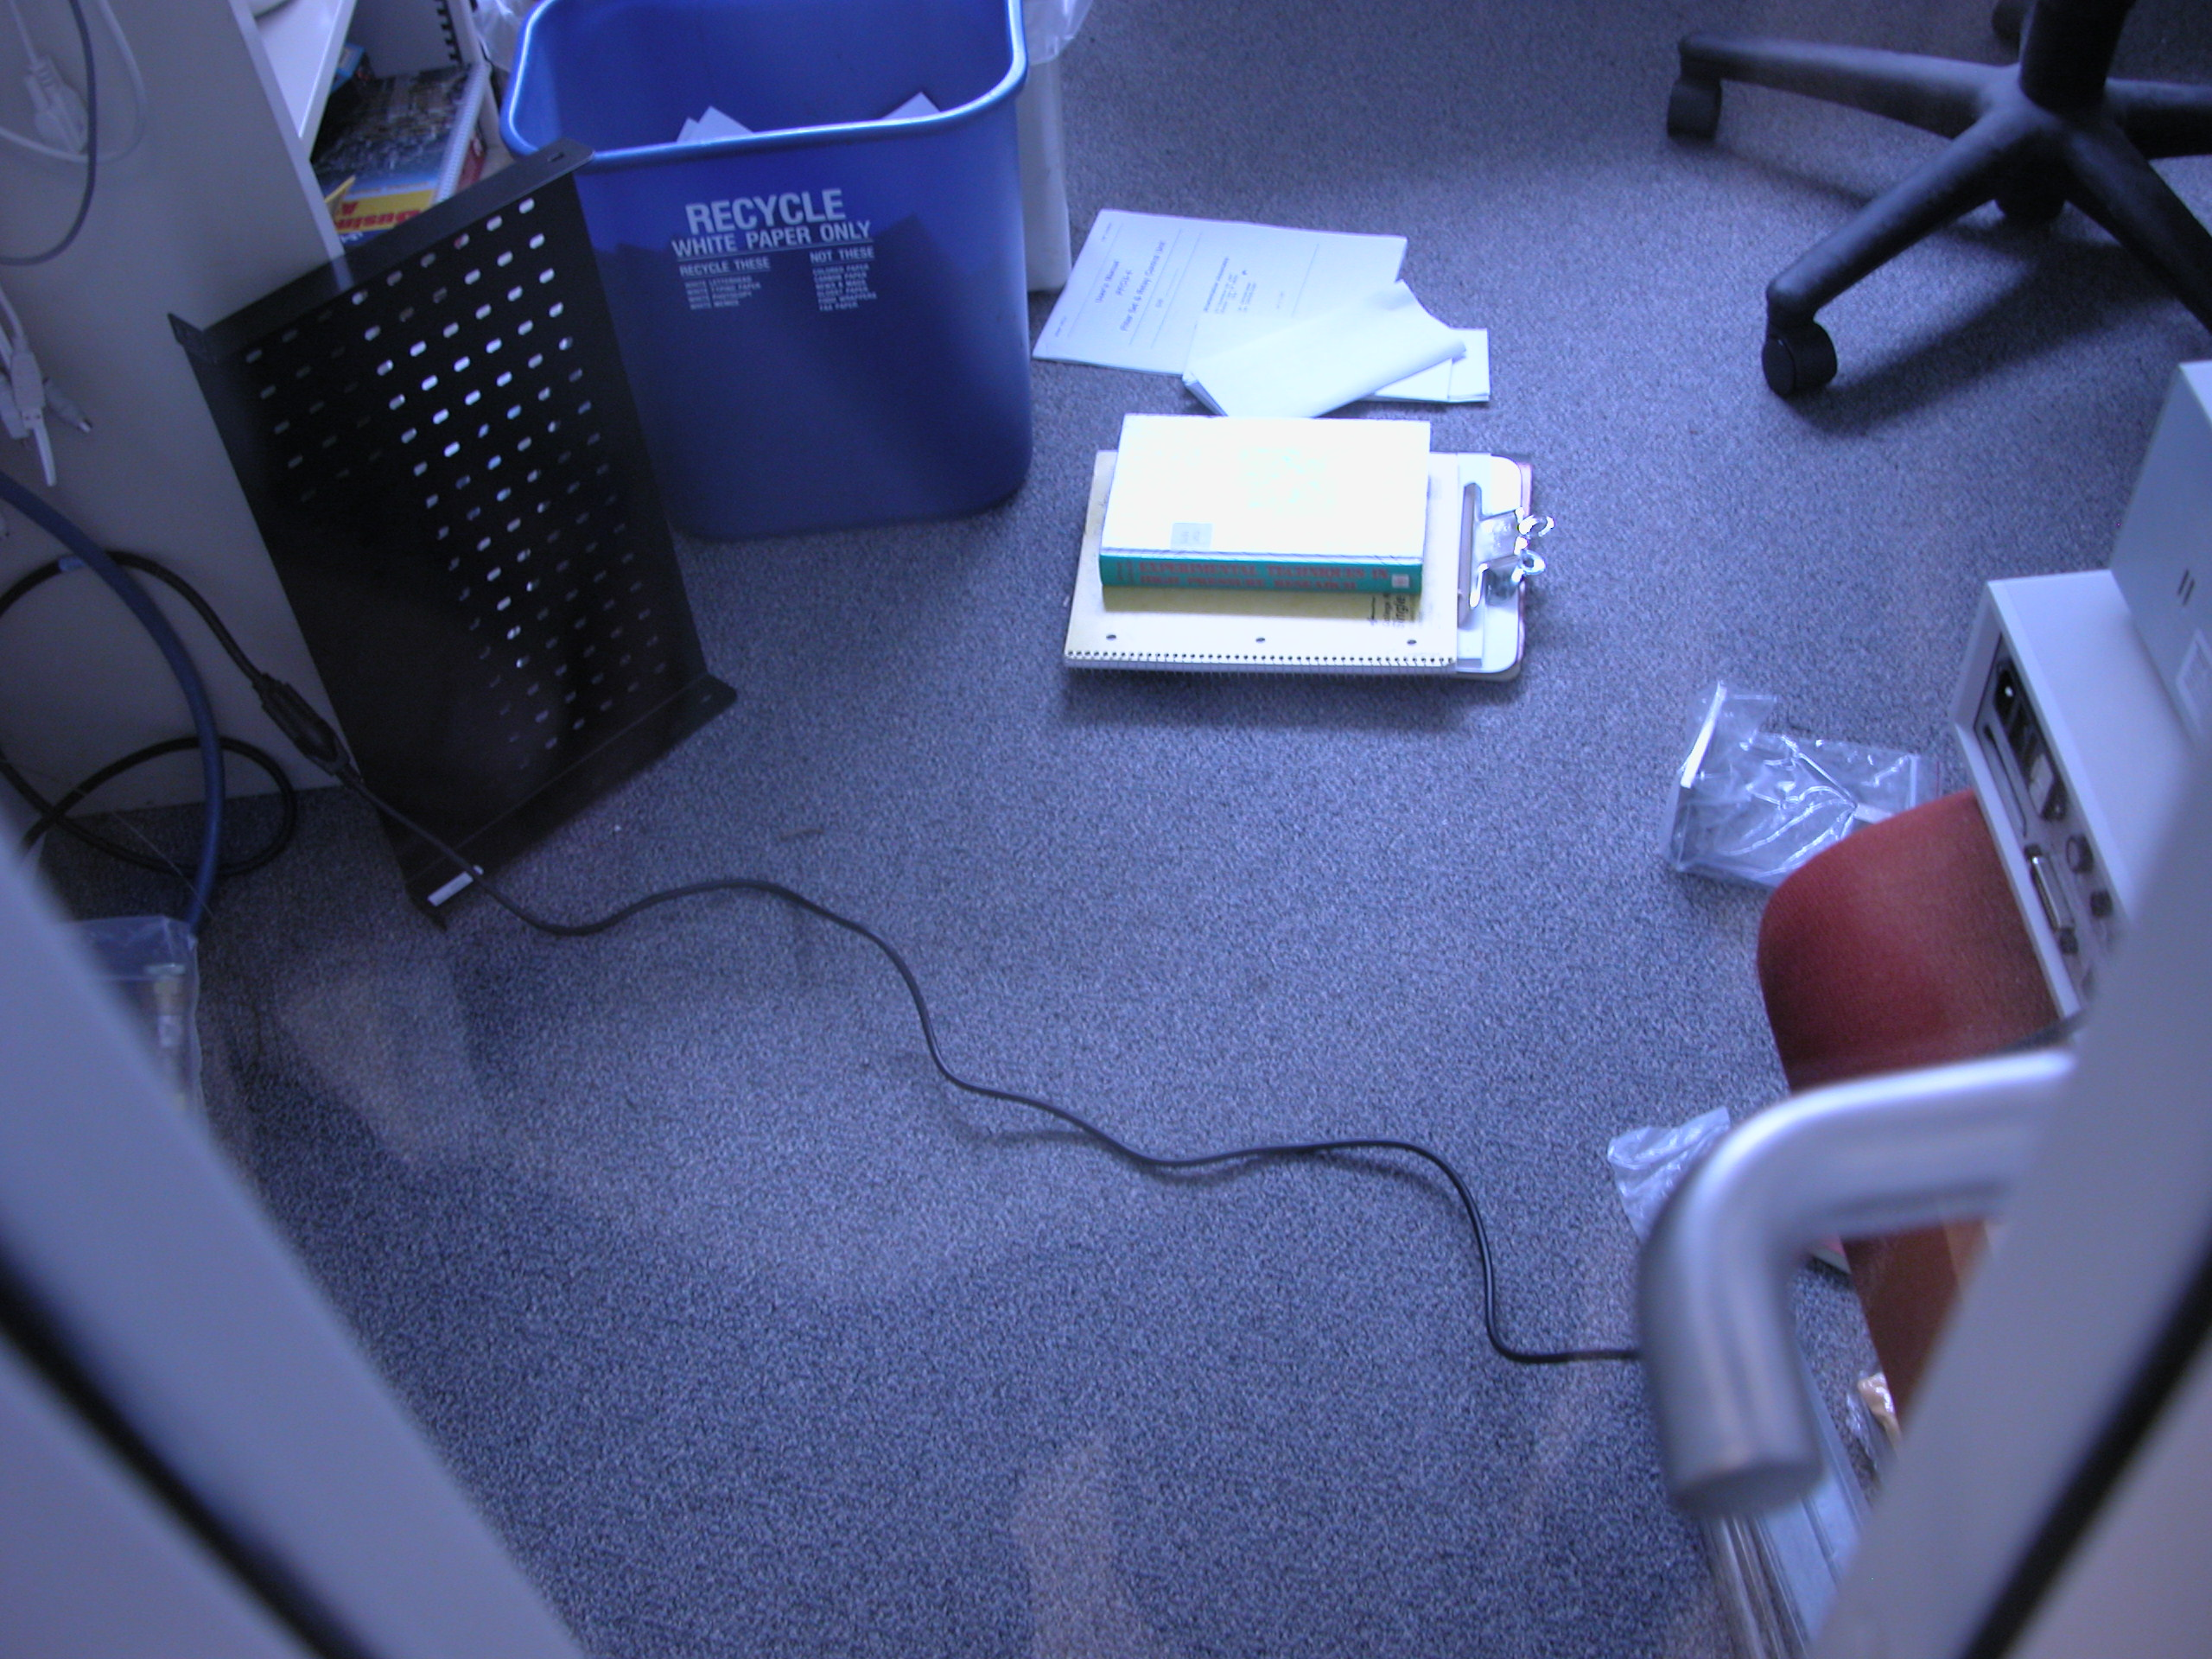

Date: Mon, 27 Jun 2005 14:09:12 -0500
From: Jin Wang <wangj@aps.anl.gov>
To: Dohn Arms <dohnarms@mhatt.aps.anl.gov>
Cc: Eric Dufresne <dufresne@aps.anl.gov>
Subject: power cable

a power cable running across the office behind a closed door is not very
nice. -JinBottom of Form

