Peshastin Creek Smolt Monitoring Program

Annual Report

March 2004 – December 2004

Prepared by:

Matt Cooper and Steve Mallas

Mid-Columbia River Fishery Resource Office
United States Fish and Wildlife Service
Department of Interior
Leavenworth, WA 98826

Funded by

United States Fish & Wildlife Service
Fisheries Operations Needs System

Project No. 2002-001

And

U.S. Department of Energy
Bonneville Power Administration
Division of Fish and Wildlife
Portland, Oregon 97208-3621

Project No. 2003-017-00
Intergovernmental Contract (IGC) No. 18165

January 2004

EXECUTIVE SUMMARY

Beginning in 2001 and continuing each year through 2004 a portion of the adult hatchery spring Chinook salmon that returned to Leavenworth National Fish Hatchery (NFH) have been live outplanted to Peshastin Creek within the Wenatchee River watershed. This outplanting effort is a component of the Biological Opinion for Leavenworth NFH to evaluate the natural spawning/reproductive success of hatchery adults. Outplanting is expected to occur in 2005, however, the future of this program after this time is uncertain.

In 2004, smolt production monitoring began in Peshastin Creek by the USFWS, Mid-Columbia River Fisheries Resource Office (MCRFRO). The initial purpose of this monitoring by MCRFRO was to evaluate the productivity and progeny characteristics of outplanted spring Chinook hatchery adults from Leavenworth NFH. This type of monitoring was quickly recognized as critical in implementing the 2000 NMFS FCRPS Biological Opinion RPA Actions which seeks to develop basin-scale monitoring and evaluation programs for the Wenatchee, John Day, and Upper Salmon River basins. Subsequently, the Peshastin Smolt Monitoring Program was expanded in a joint effort to meet both the requirements set forth in the Leavenworth NFH and the NMFS FCRPS BiOp’s.

To meet the programs goals an instream rotary screw trap was chosen and utilized to capture downstream migrant juvenile fishes in Peshastin Creek. The rotary screw trap is located at river mile 6.3 (river kilometer 10.2) near the Camas Creek confluence (47⁰ 29’ 32.171”N; 120⁰ 38’ 16.18”W). This report summarizes the operation of the Peshastin Creek smolt trap from March 18 to November 21, 2004. During this time period there were 208 days of complete sampling.

A total of 8,955 individuals were sampled throughout the trapping season. Spring Chinook and steelhead/rainbow trout (SRT) represented 48.2% (4,319) and 48.0% (4,302) of the total catch, respectively. The remaining catch consisted of 112 bull trout, 58 coho salmon, 155 sculpin, and 9 adult fall-back salmonids.

A total of 1,712 spring Chinook salmon juveniles captured at the trap were PIT-tagged. An additional 314 spring Chinook were captured at the trap site by seine net and PIT-tagged on August 20. A total of 228 spring Chinook juveniles and 100 steelhead/rainbow trout were non-lethally tissue sampled for genetic analysis.

Trap efficiency trials were conducted throughout the season. Emigrational spring Chinook and steelhead juveniles of varying size and age classes were used in these efficiency trials. A total of 1,391 Chinook and 194 steelhead/rainbow trout were released for efficiency trials with a total of 379 and 42 recaptures, respectively. A total of 61 releases were made for efficiency trials throughout the trapping season.

The average trapping efficiency for the season was 21.4% and 15.7% for spring Chinook and steelhead/rainbow trout juveniles, respectively. It is estimated that 66,395 (±20,147 95%CI) sub-yearling (age 0) Chinook and 16,082 (±3,982 95%CI) steelhead/rainbow trout, representing three age-classes, emigrated from Peshastin Creek during the 2004 sampling period. Steelhead/rainbow trout age-0, age-1, age-2 are estimated to represent 52% (8,419), 42% (6,770), and 6% (893) of the population estimate, respectively. Only one yearling (age-1) spring Chinook was captured in the 2004 season. Therefore, a production estimate for this age class could not be generated.

TABLE OF CONTENTS

EXECUTIVE SUMMARY i

TABLE OF CONTENTS iii

LIST OF TABLES iv

LIST OF FIGURES iv

LIST OF APPENDICES v

ACKNOWLEDGMENTS vi

INTRODUCTION 1
Background Details: Smolt Production Monitoring 1
Project Purpose / Justification 2

METHODS 3
Methodology 3
Trap Design and Study Duration 3
Trap Operation 4
Biological Sampling 4
Age Determination 5
Production Estimates 6

RESULTS 8
Spring Chinook 9
Steelhead / Rainbow Trout 12
Incidental Species 15
Production Estimates 16
Data Entry 19
Trapping Frequency Evaluation 19

DISCUSSION 20

REFERENCES 23

LIST OF TABLES

Table 1. Summary of trapping dates by strata for Peshastin Creek, 2004. 4

Table 2. Peshastin Creek catch summary for 3/18/04 to 11/21/04. 8

Table 3. Fork length, weight, and condition factor for sub-yearling spring Chinook emigrating from Peshastin Creek, 2004 11

Table 4. Steelhead/rainbow trout trap counts by life stage and seasonal strata, 2004 (Fish of adequate size for PIT-tagging by strata indicated) 12

Table 5. Fork length, weight, and condition factor by age-class for steelhead/rainbow trout juveniles emigrating from Peshastin Creek, 2004. 14

Table 6. Peshastin Creek juvenile Chinook population estimate and error by seasonal strata for 3/18/04 to 11/21/04. 17

Table 7. Peshastin Creek juvenile steelhead/rainbow trout (SRT) population and error estimate by seasonal strata for 3/18/04 to 11/21/04. 17

Table 8. Alternative schedules and the estimated population estimate for Chinook and steelhead/rainbow trout compared against the actual 2004 trapping schedule/population estimate. 20

LIST OF FIGURES

Figure 1. Map of Peshastin Creek smolt trap location, 2004. 2

Figure 2. Peshastin Creek rotary screw trap in operation during spring, 2004. 3

Figure 3. Example of various life stages of steelhead/rainbow trout captured in Peshastin Creek, 2004. 5

Figure 4. Example of a steelhead/rainbow trout monthly length frequency graph illustrating significant changes in fish length to determine age class. These results were confirmed with scale analysis. 5

Figure 5. Steelhead/rainbow trout age classes determined by monthly length frequency graphs and scale analysis. 6

Figure 6. Relative abundance of fish captured in the Peshastin Creek smolt trap, 2004. 9

Figure 7. Peshastin Creek estimated sub-yearling Chinook daily emigration rate vs. flow, 2004. 10

Figure 8. Average fork lengths of spring Chinook sub-yearlings in Peshastin Creek, 2004. 11

Figure 9. Peshastin Creek estimated juvenile steelhead/rainbow trout daily emigration rate vs. flow, 2004. 13

Figure 10. Length frequency of sub-adult bull trout captured at Peshastin smolt trap, 2004 15

Figure 11. Length frequency of sculpin captured at Peshastin smolt trap, 2004. 16

Figure 12. Peshastin Creek sub-yearling spring Chinook and steelhead/rainbow trout catch (top) and population estimate (bottom) with 95% CI by seasonal strata, 2004. 18

Figure 13. A graphical comparison of the cumulative population estimate and temporal migration patterns by age-class for Peshastin Creek steelhead/rainbow trout, 2004. 19

LIST OF APPENDICES

Appendix A. Daily catch of sub-yearling spring Chinook (top graph) and steelhead/rainbow trout (bottom graph) compared with Wenatchee River discharge. 24

Appendix B. Daily catch of bull trout (top graph) and coho (bottom graph) compared with Wenatchee River discharge 25

Appendix C. Peshastin Creek mark-recapture efficiency trials with trap efficiency percentages relative to flow 26

Appendix D. Peshastin Creek subyearling Chinook catch and total number PIT-tagged by seasonal strata. Peshastin Creek steelhead/rainbow trout catch and total numbers that were of taggable size 28

ACKNOWLEDGMENTS

Numerous individuals helped with the development and implementation of this project. We thank our dedicated crew, Becky Christopherson and Hillary Kleeb, for their hard work with trap operations and data entry. We appreciate the support of Owen Parsley, Terry DellaPenna, and Earl Pruitt, whose assistance made the project run smoothly. Special thanks go to Charles Hamstreet for his expert advice, logistical support, and assistance with data analysis. We sincerely appreciate the cooperation and hospitality of the private landowner, Robert Graves and the entire Drury-Graves family. We thank the biology students from Cascade High School for assisting with data collection. Thanks go to Jim Craig for reviewing a draft version of this report. This project was funded, in part, by Bonneville Power Administration (Contract Agreement #00018165) and the USFWS Fisheries Operations Needs System (FONS).

The correct citation for this report is:

Cooper, M. and S. Mallas, 2004. Peshastin Creek Smolt Monitoring Program, Annual Report 2004. U.S. Fish and Wildlife Service, Mid-Columbia River Fishery Resource Office, Leavenworth, WA.

INTRODUCTION

Background Details: Smolt Production Monitoring

Peshastin Creek is a fifth order class I stream which originates at Blewett Pass, Washington (T22N R17E) and runs northeast until it flows into the Wenatchee River at river kilometer (rkm) 29 (T24N R18E S22) (Figure 1). Primary discharge to Peshastin Creek comes from Ingalls Creek (15%) a tributary entering at rkm 10.6. The Peshastin Creek watershed encompasses 78,780 acres. The watershed is divided in ownership with 82% (of this 29% is managed as wilderness in the Ingalls Creek watershed) owned by the US Forest Service and 18% (primarily the lower 12.1 km) is privately held (Cappellini, 1997). Peshastin Creek is characterized as a high gradient, boulder cobble stream that is potentially more suited for steelhead than Chinook. However, the stair stepping nature of Peshastin Creek creates numerous small pools in the upper reaches and tributaries such as Ingalls Creek. These microhabitats are thought to have the potential to provide excellent habitat for the rearing of small salmonids (Mullan et al 1992).

Current salmonid fish use of this system includes rainbow, cutthroat trout and ESA listed steelhead and bull trout (Ringel, 1997). Spring Chinook salmon historically utilized Peshastin Creek, however the best estimates indicate this population is either very small or nonexistent. Spawning ground surveys are conducted annually by Chelan County Public Utility District and the Washington Department of Fish & Wildlife to document spring Chinook and steelhead redd development. These surveys indicate no spring Chinook redds were identified from 1997-2000 (Mosey & Murphy 2000). It is believed spring Chinook have been extirpated from this watershed due to irrigation diversions in the lower 7.8 km of Peshastin Creek and these diversions may block passage during low water periods when spring Chinook are migrating (Rife, 1999).

Only recently has spring Chinook been reintroduced to the watershed from natural spawning by non ESA-listed Leavenworth NFH outplants. Beginning in 2001 and continuing annually through 2004 a portion of the adult hatchery spring Chinook that returned to Leavenworth National Fish Hatchery (NFH) were outplanted to Peshastin Creek in a joint effort by the United States Fish & Wildlife Service and the Yakama Indian Nation.

Although Peshastin Creek contains three “significant subwatersheds” as identified by the Upper Columbia Regional Technical Team (RTT), little was known about the specific life history strategies and outmigration timing of fish utilizing this stream. In addition, landscape-level attributes of Peshastin Creek (e.g., hydrology, topography, temperature regime, etc.) vary significantly from other Wenatchee Subbasin watersheds. These differences provide an important opportunity to assess the contribution that Peshastin Creek (and other similar streams) provides to the overall production of spring Chinook and steelhead to the Wenatchee Subbasin.

Smolt production monitoring in Peshastin Creek was initiated by USFWS for the first time in March, 2004. This limited monitoring program was funded by the USFWS Fisheries Operations Needs System (FONS) Program with a focus solely on evaluating the hatchery adult outplant program. Additional funding from Bonneville Power Administration (BPA) was secured to expand the scope of the Peshastin Creek monitoring program to meet the needs of BPA Project #2003-017-00.

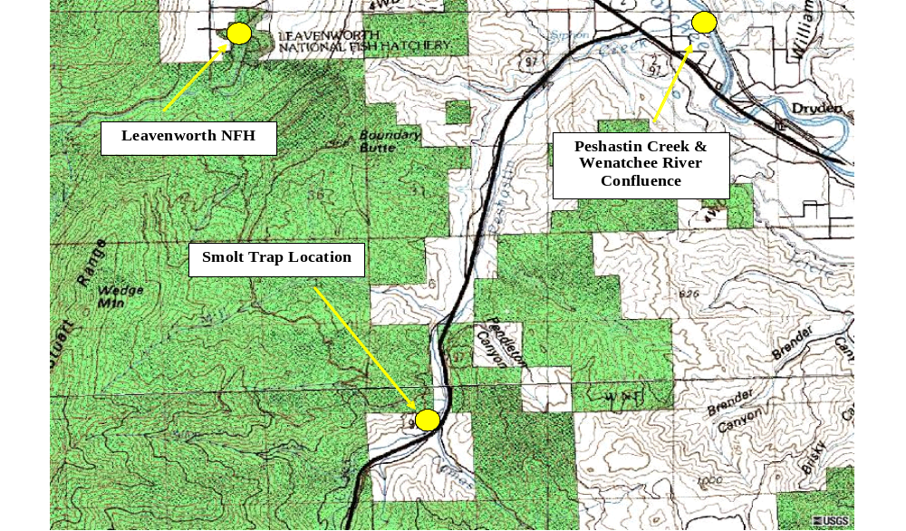

Figure 1. Map of Peshastin Creek smolt trap location, 2004.

Project Purpose / Justification

The Peshastin Creek smolt monitoring and evaluation program has three primary objectives: 1) estimate the smolt production of spring Chinook salmon and steelhead/rainbow trout 2) describe the temporal variability of outmigrating spring Chinook and steelhead/rainbow trout, 3) evaluate the reproductive success, productivity and performance of spring Chinook progeny from the hatchery adult outplant program.

METHODS

Methodology

Technical methodologies followed protocols specified in Hillman (2004) who developed a monitoring strategy for the Upper Columbia Basin. Additionally, this project used the same procedures and equipment utilized by WDFW at other smolt trapping sites within the Wenatchee Subbasin (Murdoch et al. 1999, 1998a, 1998b, and 1997) except in certain instances to conform to site-specific needs.

Trap Design and Study Duration

A floating rotary screw trap (RST) was installed in Peshastin Creek at river kilometer 10.2 (river mile 6.3) near the Camas Creek confluence (47º 29’ 32.171” N, 120º 38’ 16.18” W) (Figure 1). This site is situated immediately upstream of a private bridge at the head of a large pool. The advantages to this site include ease of trap installation, convenient access, substantial water depth throughout the trapping season, and an adjacent eddy where extreme discharge events could be avoided (Figure 2). USFWS operated the trap in accordance with all required permits and landowner specifications.

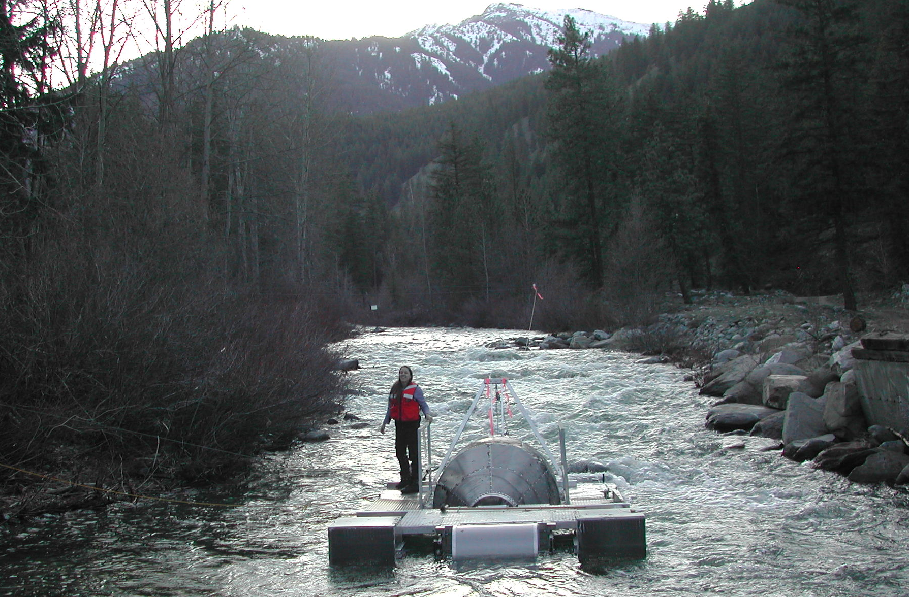

Figure 2. Peshastin Creek rotary screw trap in operation during spring, 2004.

Trap Operation

The smolt trap on Peshastin Creek operated from March 18 – November 21, 2004. Trapping occurred 24 hours per day during a regular 5-day work week (Sunday evening through Friday morning) until BPA funding began on June 1. From June onward, all attempts were made to operate the trap on a continuous seven day per week schedule, excluding holidays and extreme discharge/debris events. A total of 208 days of complete sampling occurred in 2004, with 7 days of incomplete sampling (due to extreme discharge/debris events) and 34 days where the trap was pulled for holidays or weekends (Table 1). During days when the trap was not operational the daily catch was estimated using an average of the two most recent pre and post catch days.

Table 1. Summary of trapping dates by strata for Peshastin Creek, 2004.
 |  |  | Number of days
Strata | Dates | Complete | Incomplete | Pulled
Spring | Mar 17 – Jun 21 | 64 | 5 | 27
Summer | Jun 22 – Sep 9 | 78 | 0 | 2
Fall | Sep 10 – Nov 21 | 66 | 2 | 5
Total (Percent) |  | 208 (83.5) | 7 (2.8) | 34 (13.7)

Biological Sampling

The trap was checked a minimum of every 24 hours. All fish removed from the live box were anesthetized with tricaine methanesulfonate (MS-222), measured to fork length, weighed, examined for identifying marks or injuries, and assigned to an age class. Spring Chinook and steelhead/rainbow trout juveniles were identified to age class as either sac-fry (visible yolk, not completely buttoned), fry (<60mm, no visible yolk and completely buttoned), parr (≥60mm with distinctive parr marks), transitional smolt (≥60mm with silver sheen and visible parr marks), or smolt (≥60mm with silver sheen and partial to mostly absent parr marks). All fish mortalities were enumerated. Incidence of mortality in excess of 1% of the daily catch was evaluated and appropriate trap modifications were made.

Tissue samples for genetic analysis were taken from both spring Chinook and steelhead/rainbow trout. A portion (1mm x 1mm) of the caudal or ventral fin tips were taken and preserved in 100% ethanol. All samples are housed at MCRFRO until such time that a molecular analysis can be done to characterize each population.

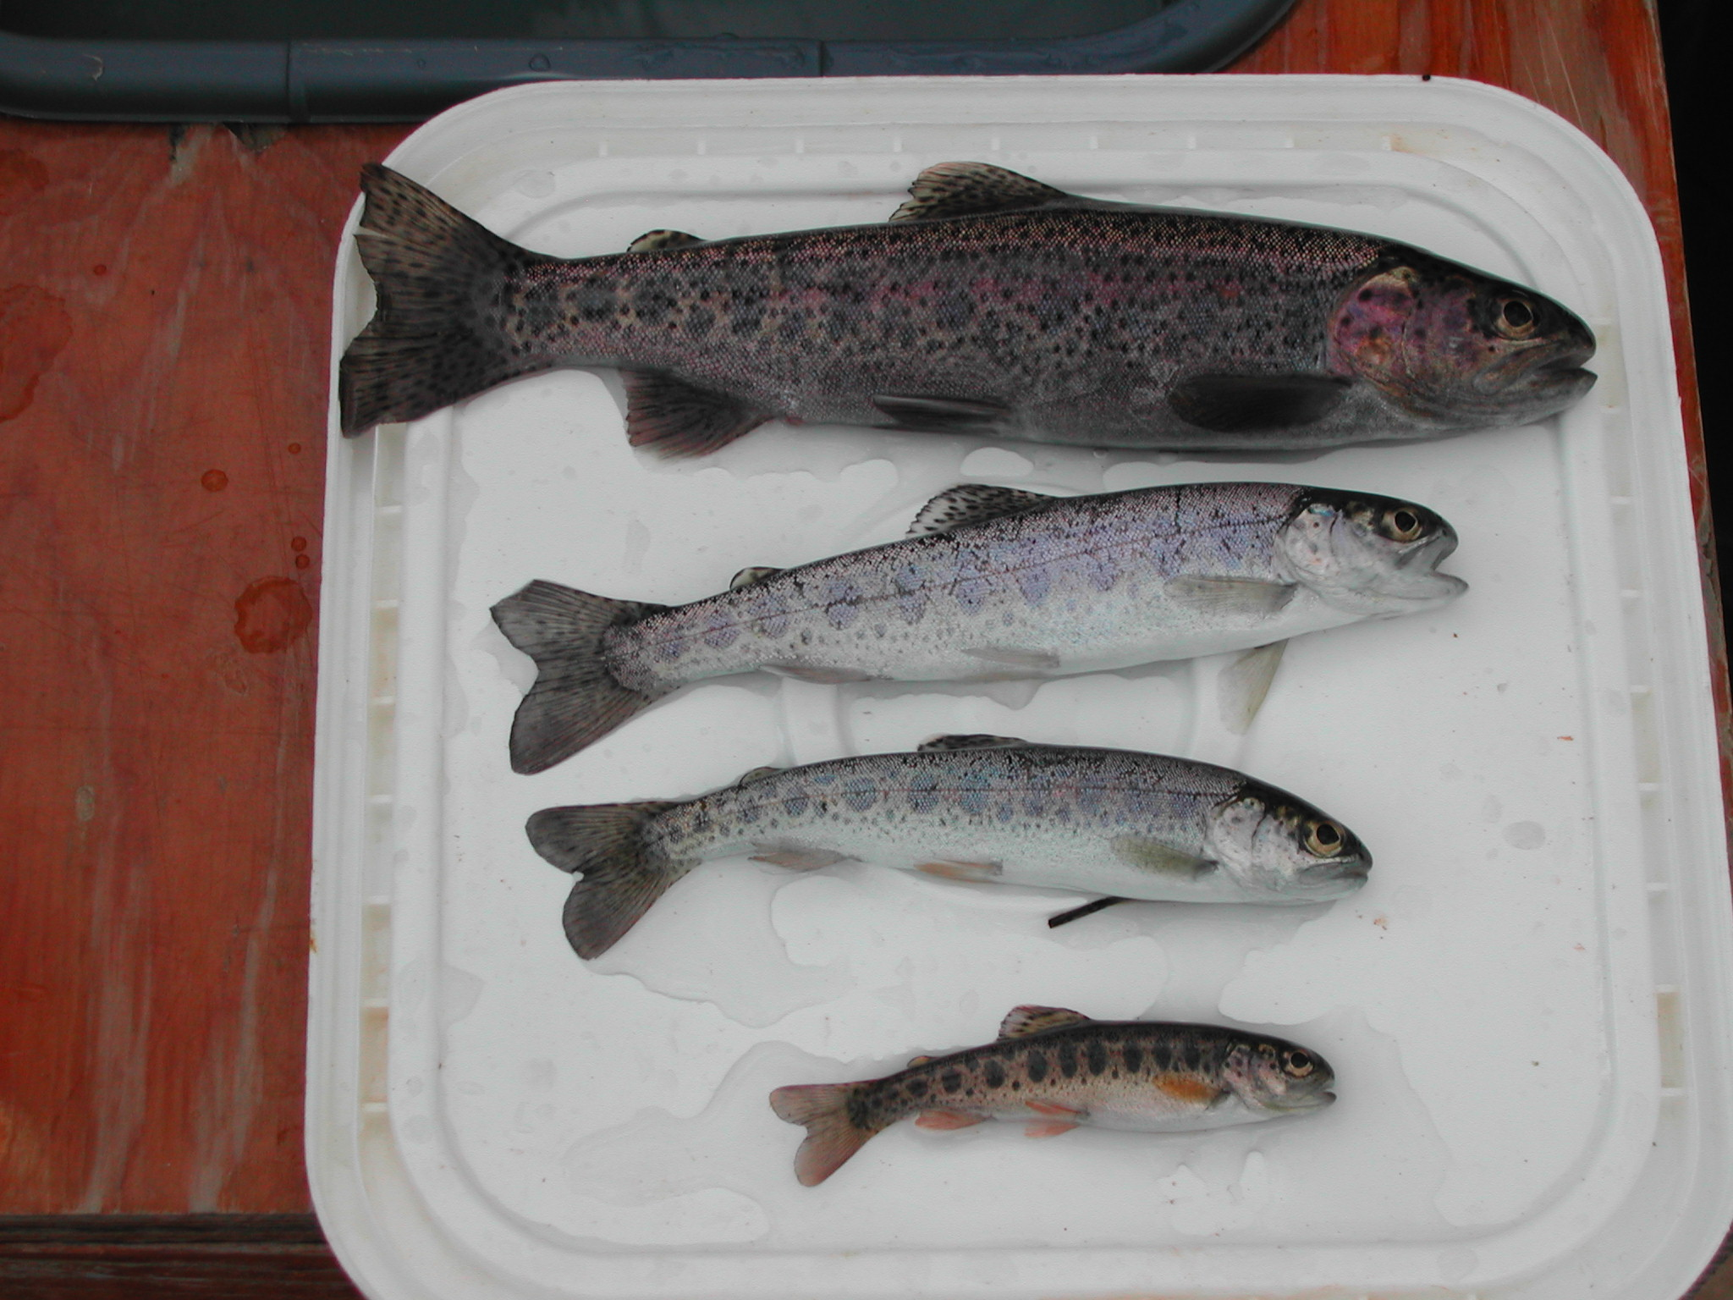
Figure 3. Example of various life stages of steelhead/rainbow trout captured in Peshastin Creek, 2004.

Age Determination

Various life stages of steelhead/rainbow trout were captured during the trapping season (Figure 3). To determine age class, length frequency graphs were plotted monthly. Each significant change in length indicated a probable change in age class (Figure 4). Additionally, scale samples were taken from 135 steelhead/rainbow trout of various sizes from throughout the year. The results of this scale analysis were used to confirm the age determinations made by the length frequency graphs. Figure 5 represents the sizes of steelhead/rainbow trout as age-0, age-1, and age-2 throughout the trapping season.

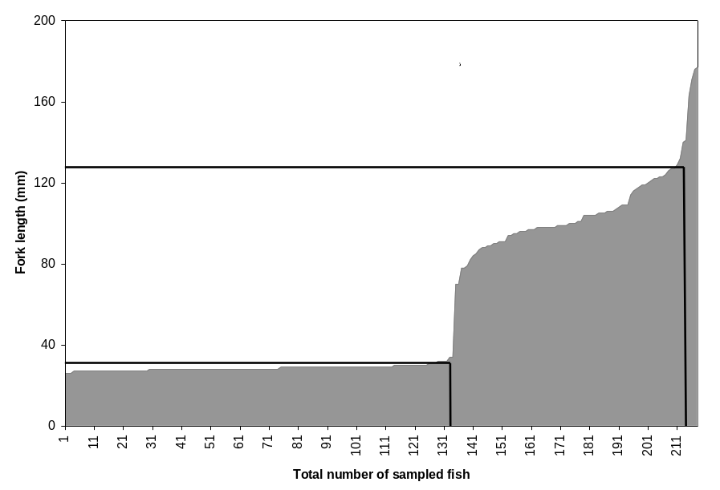

Figure 4. Example of a steelhead/rainbow trout monthly length frequency graph illustrating significant changes in fish length to determine age class. These results were confirmed with scale analysis.

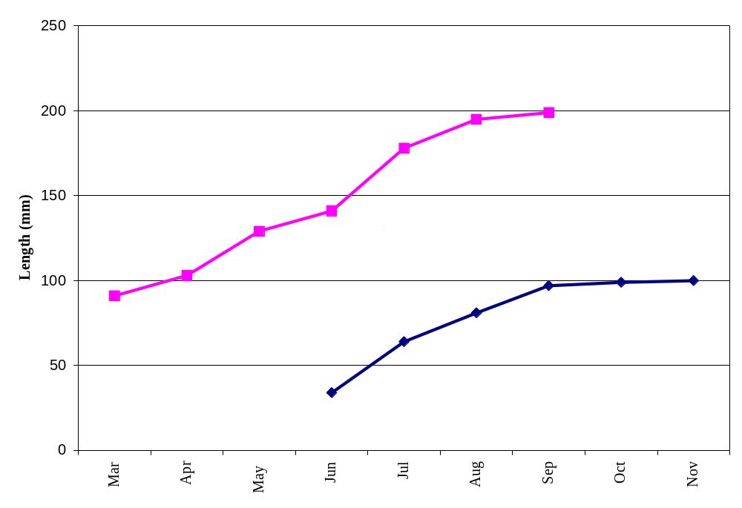

Figure 5. Steelhead/rainbow trout age classes determined by monthly length frequency graphs and scale analysis.

Production Estimates

Mark-recapture techniques were utilized in an effort to estimate the daily abundance and total emigrant populations of spring Chinook and steelhead/rainbow trout (Appendix C). Throughout the study, fish were collected over a 72-hour period and marked prior to release. A variety of marking methods were utilized depending on species, size of fish, and age class. Marked groups were released along a transect 1.6 miles upstream of the trap. A successful efficiency trial was indicated by all marked fish captured within 48 hours. Marked fish captured after 48 hours were considered non-migratory and removed from that particular trial.

All sub-yearling spring Chinook fry (<60mm) captured in the spring were marked through immersion in dye (6g Bismark Brown dye in 180L aerated water for ~30 minutes) (Todd 1994). This type of marking was utilized only for fish deemed too small to PIT-tag or fin clip without undue harm or handling stress. Dye marking was minimized due to limitations in duration of mark (visible for approximately 5 days) and the inability to differentiate between subsequent release groups. All juvenile spring Chinook greater than 65mm were marked with a PIT-tag, providing a permanent, individually distinguishable identifier.

Limited numbers of steelhead were available for mark-recapture efficiency trials. Steelhead and rainbow trout data were combined due to the inability to differentiate the two by visual examination. Migratory fish, however, were identified by the presence of certain characteristics (i.e., silver body sheen, faded or absent parr marks, scale slippage, black tips on the caudal fin, and elongate body form). During 2004, steelhead/rainbow trout were marked using a fin clip of either the pelvic (right/left) or the caudal (upper lobe/lower lobe) fin. Using one of the four different fin clip locations, crews were able to differentiate between release groups upon recapture.

Trap efficiency was calculated using a method employed by Murdoch et al. (1999) to quantify emigrant spring Chinook on the Chiwawa River. The method borrows from Rawson (1984) and is calculated as follows:

N_{i} = C_{i}M_{i} / [1 + M_{i} – R_{i} / M_{i}R_{i}]

Var[N_{i}] = C_{i}(C_{i} + R_{i})M_{i}(M_{i} – R_{i}) / R_{i}³

SD = sqrt(Var[N_{i}])

95% CI for Ni = Ni±1.96(SD)

N_{i} = population estimate for time period i,
C_{i} = number of fish captured during time period i,
M_{i} = number of marked fish released and assumed to have passed by the trap for
recapture during time period i,
R^{i} = number of fish recaptured during time period i.

The above methodology assumes that all released marked fish (M_{i}) incur no mortality, have the same probability of capture as non-marked fish (C_{i}), and all pass the trap during time period i.

It is possible that regression models can be utilized to provide estimates of daily emigration. This occurs when trap efficiency trials exhibit a significant relationship to an independent variable collected throughout the trapping period (e.g., stream discharge, staff gage height). The independent variable in the model can then generate predicted trap efficiencies at times when a trial was not conducted. Daily emigration indices can be quantified by expanding the number of fish trapped by the corresponding trap efficiency.
This method is currently being used by WDFW in the Wenatchee Basin and the USFWS in the Entiat Basin to provide daily abundance and annual population estimates with associated confidence intervals.

At the end of the study season, trap efficiency estimates were correlated with stream discharge and staff gage height in an attempt to create a regression model for each species and age class. Models were only used if a significant (p<0.05) relationship existed between discharge/staff height and trap efficiency, the correlation coefficient was greater than 0.5 (+ or -), and the model as fitted explains greater than 50% of the variability.
In 2004, no models were generated that met the above criteria. In addition, independent variables such as discharge and staff gage height for Peshastin Creek were inconsistent in availability. The limited numbers of available migratory spring Chinook and steelhead/rainbow trout (primarily in the spring and summer months), forced us to pool mark-recapture trials over periods throughout the season. With these limitations, we generated strata for Chinook representing spring (3/17 – 6/21), summer (6/22 – 9/9), and fall (9/10 – 11/21) seasonal emigration periods. Steelhead/rainbow trout seasonal strata were very similar except for the break between summer and fall occurred on August 26th for this species. Trap efficiency trials were then grouped into one of three strata and used to generate population estimates.

RESULTS

The 2004 Peshastin Creek trapping season began on March 18th and extended through November 21st. A total of 8,955 individuals were sampled. Spring Chinook and steelhead/rainbow trout represented 48.2% (4,319) and 48.0% (4,302) of the total catch, respectively. The remaining catch consisted of 112 bull trout, 58 coho salmon, 155 sculpin, and 9 adult fall-back salmonids (Table 2 and Figure 6).

To aid in estimating total production of spring Chinook and steelhead/rainbow trout (SRT), the 9-month trapping season was divided into three strata: spring (March 18-June 21), summer (June 22-September 9), and fall (September 10-November 21). The following section details the target catch per strata.

Table 2. Peshastin Creek catch summary for 3/18/04 to 11/21/04.
SPECIES | TOTAL  CAPTURED | TOTAL  PIT-TAGGED | NUMBER RELEASED FOR EFFICIENCY | NUMBER  RECAPTURED
Spring Chinook | 4,319 (5,109) | 1,712 | 1,508 | 466
Steelhead/Rainbow Trout | 4,302 (4,564) | 0 | 195 | 42
Coho Salmon | 58 | 2 | 0 | 0
Bull Trout | 112 | 0 | 0 | 0
Sculpin spp. | 155 | 0 | 0 | 0
Hatchery Chinook Jack | 2 | 0 | 0 | 0
Adult Steelhead | 1 | 0 | 0 | 0
Adult Chinook | 6 | 0 | 0 | 0
TOTALS | 8,955 | 1,714 | 1,703 | 508
( ) = Estimated catch assuming continuous trapping

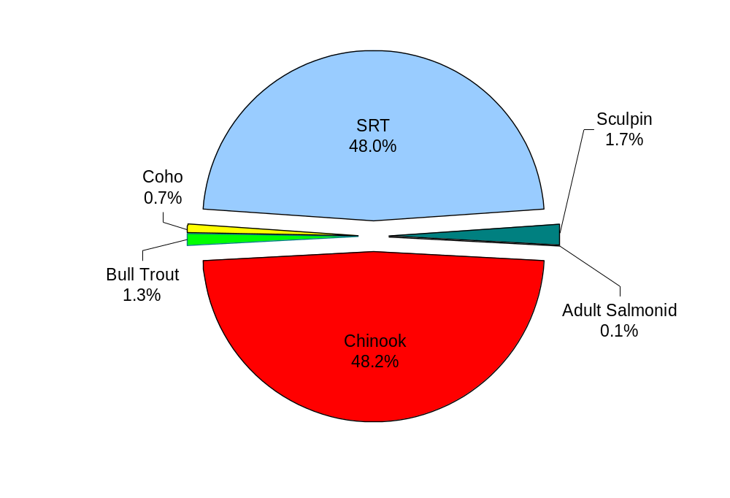
Figure 6. Relative abundance of fish captured in the Peshastin Creek smolt trap, 2004.

Spring Chinook

For the trapping period of March 18 to November 21, a total of 4,319 spring Chinook were captured in Peshastin Creek. Of those, only one yearling spring Chinook was captured (March 25), therefore no population estimate for this life stage was generated. The remaining catch of 4,318 spring Chinook individuals were sub-yearling (Appendix D). This sub-yearling Chinook migration exhibited a bi-modal timing distribution (Figure 7 and Appendix A). The first major emigration period occurred in March and early April possibly as newly emerged fry were being dispersed downstream as a result of high stream discharge events. The second major emigration period occurred over a two day period in mid-September as freshets and decreased water temperatures may have triggered downstream movement. If the trap had operated every day throughout the entire season we estimated a total capture of 5,109.

During the spring stratum the trap captured a total of 2,562 spring Chinook. These sub-yearling Chinook were classified as fry. Peak fry emigration occurred between March 18 and April 7, where 1,302 (30.1% of total Chinook catch) sub-yearling Chinook fry were captured. Due to their small size and the risk of undue harm or handling stress, fry could not be PIT-tagged or fin-clipped for use in trap efficiency trials. Instead, fry were dye-marked with a Bismark Brown solution. Four separate dye-mark releases occurred during the spring stratum with a total of 792 fry released. Thirty-two marked individuals were recaptured, all within 48 hours of release, for an average efficiency of 4.0% for the stratum.

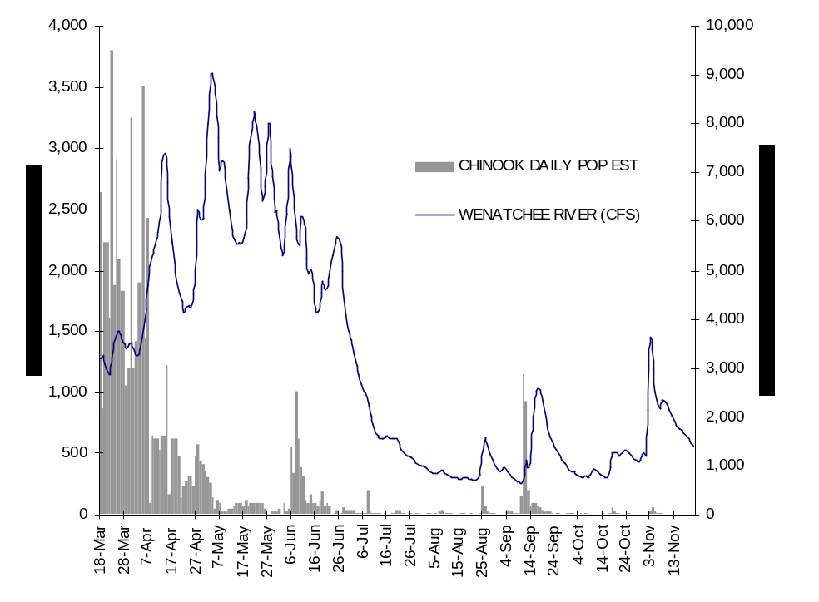

Figure 7. Peshastin Creek estimated sub-yearling Chinook daily emigration rate vs. flow, 2004.

The total sub-yearling Chinook catch for the summer stratum was only 194 individuals (4.5% of total Chinook catch). Growth was rapid during the summer stratum, with average lengths increasing from less than 60mm to over 80mm (Table 3, Figure 8). Condition factor tended to decrease by month throughout the trapping season. The number of PIT-tagged fish increased from 10 to 123 from the spring to summer strata, respectively. To supplement and increase the total number of PIT-tagged fish released from Peshastin Creek, USFWS crews seine-netted and tagged 314 additional sub-yearling Chinook. This tagging effort occurred at the trap site on August 20. During the summer stratum, a total of 107 PIT-tagged fish were released upstream of the trap for efficiency trials. Thirteen marked individuals were recaptured, all within 48 hours of release, for an average trap efficiency of 12.1% for the stratum.

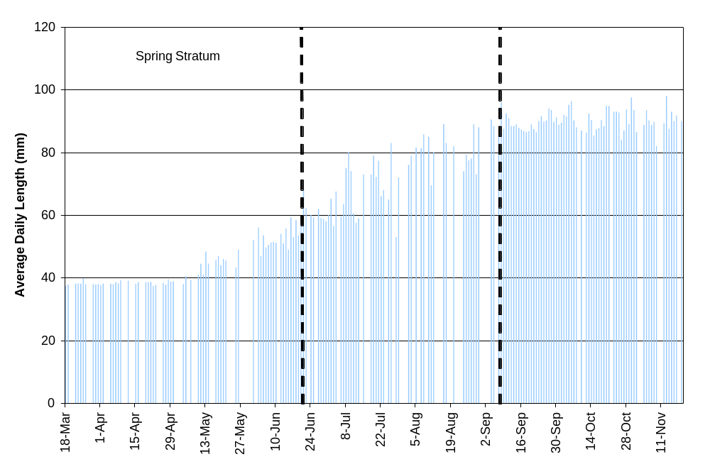
Figure 8. Average fork lengths of spring Chinook sub-yearlings in Peshastin Creek, 2004.

During the fall stratum, the trap captured a total of 2,353 spring Chinook sub-yearlings. The peak of emigration occurred during a two-day interval (September 11-12) where 1,418 individuals (32.8% of total Chinook catch) were captured. A total of 1,505 fish were PIT-tagged during this trapping period. During this fall stratum, 10 separate trap efficiency trials were conducted, of which, 609 PIT-tagged fish were released. A total of 421 individuals were recaptured, all within 48 hours of release, for an average trap efficiency of 69.1% for the stratum.

Table 3. Fork length, weight, and condition factor for sub-yearling spring Chinook emigrating from Peshastin Creek, 2004
Month |  | Total Captured |  | Fork Length (mm) |  |  |  | Weight (g) |  |  |  | Condition Factor
Month |  | Total Captured |  | Mean | SD | N |  | Mean | SD | N |  | Mean | SD | N
March |  | 886 |  | 37.9 | 1.1 | 267 |  | -- | -- | -- |  | -- | -- | --
April |  | 689 |  | 38.4 | 1.5 | 397 |  | -- | -- | -- |  | -- | -- | --
May |  | 49 |  | 43.7 | 5.4 | 49 |  | -- | -- | -- |  | -- | -- | --
June |  | 210 |  | 55.9 | 6.7 | 151 |  | 2.2 | 0.8 | 151 |  | 1.24 | 0.19 | 151
July |  | 74 |  | 71.7 | 9.2 | 67 |  | 4.8 | 1.9 | 67 |  | 1.23 | 0.11 | 67
August |  | 69 |  | 80.2 | 9.5 | 63 |  | 6.5 | 3.3 | 63 |  | 1.19 | 0.08 | 63
September |  | 2,072 |  | 89.3 | 6.9 | 1362 |  | 8.4 | 2.1 | 1362 |  | 1.16 | 0.07 | 1362
October |  | 168 |  | 91.0 | 6.6 | 163 |  | 8.6 | 1.8 | 163 |  | 1.13 | 0.06 | 163
November |  | 102 |  | 89.9 | 5.7 | 100 |  | 8.1 | 1.6 | 100 |  | 1.11 | 0.06 | 100
TOTAL |  | 4,319

Steelhead / Rainbow Trout

Steelhead and rainbow trout data were combined because both forms of Oncorhynchus mykiss are present in Peshastin Creek and undistinguishable by visual examination during most of their freshwater phase. Every effort was made, however, to determine the degree of smoltification and their migrational propensity based upon the same criteria used for spring Chinook salmon juveniles. Gauging the degree of smoltification was critical in determining which fish were to be used in trap efficiency trials. Only fish that exhibited smolt or pre-smolt transitional characteristics were used in mark-recapture releases.

For the entire trapping period of March 18 to November 21, a total of 4,302 steelhead/rainbow trout were captured in Peshastin Creek (Table 4 and Appendix D). If the trap had operated every day throughout the entire season we estimated a total capture of 4,564. With such complex and varied life history patterns, steelhead/rainbow trout did not exhibit well-defined outmigration patterns or timing as did the sub-yearling spring Chinook (Figure 9 and Appendix A). Table 5 illustrates fork length, weight and condition factor by month for each steelhead/rainbow trout age-class.

During the spring stratum, only 318 steelhead/rainbow trout were captured. Emigrational steelhead and resident parr/fry represented 38.0% and 62.0% of the catch, respectively. A total of 70 outmigrant steelhead individuals were marked with an identifiable fin clip and released upstream of the trap for efficiency trials. Ten marked individuals were recaptured, all within 48 hours of release, for an average trap efficiency of 14.3% for the stratum. Our permits do not currently allow for tagging of steelhead, however, beginning in 2005 the Peshastin Creek trapping operations will include the potential of PIT-tagging of O. mykiss individuals. There were a total of 248 individuals large enough (≥65mm) to PIT-tag in the summer stratum.

Table 4. Steelhead/rainbow trout trap counts by life stage and seasonal strata, 2004 (Fish of adequate size for PIT-tagging by strata indicated)
Spring |  |  |  | Summer |  |  |  | Fall
3/17 - 6/21/04 |  |  |  | 6/22 - 9/9/04 |  |  |  | 9/10 - 11/21/04
Sac Fry | 1 | 0.3% |  | Sac Fry | 0 | 0.0% |  | Sac Fry | 4 | 0.2%
Fry | 63 | 19.8% |  | Fry | 910 | 63.7% |  | Fry | 57 | 2.2%
Parr | 133 | 41.8% |  | Parr | 380 | 26.6% |  | Parr | 1,765 | 69.0%
Transitional | 44 | 13.8% |  | Transitional | 130 | 9.1% |  | Transitional | 717 | 28.1%
Smolt | 77 | 24.2% |  | Smolt | 8 | 0.6% |  | Smolt | 13 | 0.5%
Total | 318 |  |  | Total | 1,428 |  |  | Total | 2,556
PIT size (≥65mm) | 248 | 78.0% |  | PIT size (≥65mm) | 412 | 28.8% |  | PIT size (≥65mm) | 2,312 | 90.5%

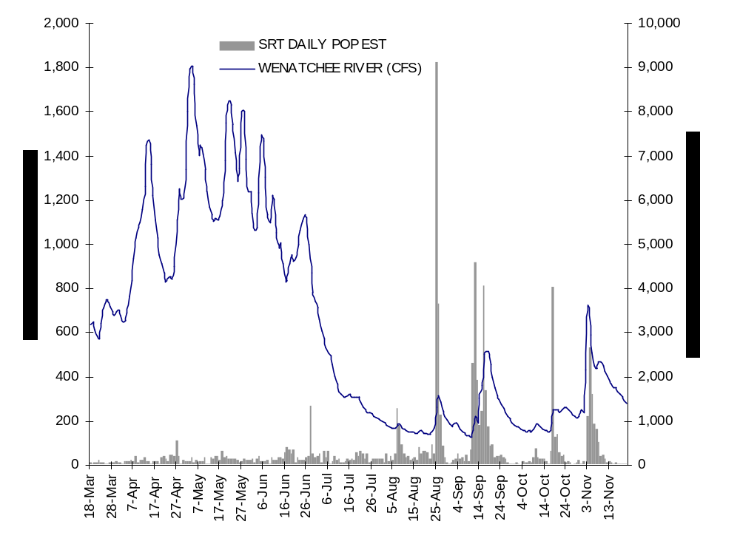
Figure 9. Peshastin Creek estimated juvenile steelhead/rainbow trout daily emigration rate vs. flow, 2004.

A total of 1,428 steelhead/rainbow trout were captured during the summer stratum. Newly emergent fry made up the majority (63.7%) of the catch during this trapping period. The first fry was captured June 16. The peak of fry movement occurred on August 25, with a total of 226 fry captured. During this stratum, 124 steelhead/rainbow trout were marked and released upstream of the trap for efficiency trials. Thirty-two individuals were recaptured, all within 48 hours of release, for an average trap efficiency of 25.8% for the stratum. There were a total of 412 steelhead/rainbow trout individuals large enough to PIT-tag during this period.

The catch during the fall stratum totaled 2,556 steelhead/rainbow trout. Non-migrational residents made up the majority (69.0%) of the catch for this period. The peak of emigration for migratory fish occurred during a two-day interval (September 11-12). A total of 379 smolts/pre-smolt transitionals were captured during this two-day period. Since the majority of migrational fish moved during a short window, crews were unable to conduct any mark-recapture trials during this stratum. A total of 2,312 steelhead/rainbow trout individuals were large enough to PIT-tag during this trapping period.

Table 5. Fork length, weight, and condition factor by age-class for steelhead/rainbow trout juveniles emigrating from Peshastin Creek, 2004.
 |  |  |  |  | Fork Length (mm) |  |  |  | Weight (g) |  |  |  | Condition Factor
Month |  | Total Captured |  | Mean | SD | N |  | Mean | SD | N |  | Mean | SD | N
Age 0 emigrants
March |  | 0 |  | -- | -- | -- |  | -- | -- | -- |  | -- | -- | --
April |  | 0 |  | -- | -- | -- |  | -- | -- | -- |  | -- | -- | --
May |  | 0 |  | -- | -- | -- |  | -- | -- | -- |  | -- | -- | --
June |  | 163 |  | 28.5 | 1.4 | 134 |  | -- | -- | -- |  | -- | -- | --
July |  | 168 |  | 53.6 | 4.4 | 14 |  | 1.7 | 0.5 | 14 |  | 1.06 | 0.13 | 14
August |  | 810 |  | 57.6 | 5.9 | 511 |  | 2.2 | 0.7 | 511 |  | 1.15 | 0.15 | 511
September |  | 597 |  | 68.7 | 9.5 | 308 |  | 3.7 | 1.6 | 308 |  | 1.09 | 0.11 | 308
October |  | 224 |  | 75.2 | 9.7 | 152 |  | 4.8 | 1.8 | 152 |  | 1.10 | 0.11 | 152
November |  | 347 |  | 72.7 | 9.1 | 341 |  | 4.3 | 1.6 | 341 |  | 1.08 | 0.09 | 341
TOTAL |  | 2,309
Age 1 emigrants
March |  | 7 |  | 80.7 | 7.7 | 6 |  | 5.7 | 1.6 | 6 |  | 1.06 | 0.04 | 6
April |  | 30 |  | 79.8 | 11.4 | 30 |  | 6.1 | 2.7 | 30 |  | 1.13 | 0.09 | 30
May |  | 55 |  | 98.6 | 17.8 | 53 |  | 12.5 | 6.9 | 53 |  | 1.17 | 0.09 | 53
June |  | 80 |  | 102.7 | 14.9 | 78 |  | 13.4 | 6.2 | 78 |  | 1.17 | 0.09 | 78
July |  | 40 |  | 139.8 | 27.0 | 40 |  | 35.4 | 18.6 | 40 |  | 1.17 | 0.08 | 40
August |  | 204 |  | 140.5 | 21.9 | 141 |  | 31.7 | 15.6 | 141 |  | 1.06 | 0.07 | 141
September |  | 910 |  | 140.6 | 19.1 | 484 |  | 29.7 | 13.1 | 484 |  | 1.01 | 0.07 | 484
October |  | 363 |  | 129.4 | 16.9 | 247 |  | 22.8 | 9.5 | 247 |  | 1.00 | 0.06 | 247
November |  | 189 |  | 130.7 | 19.5 | 187 |  | 23.6 | 11.6 | 187 |  | 0.99 | 0.06 | 187
TOTAL |  | 1,878
Age 2 emigrants
March |  | 11 |  | 138.7 | 17.6 | 10 |  | 30.4 | 11.0 | 10 |  | 1.11 | 0.22 | 10
April |  | 65 |  | 166.0 | 24.6 | 65 |  | 51.3 | 22.3 | 65 |  | 1.07 | 0.09 | 65
May |  | 21 |  | 169.8 | 12.5 | 21 |  | 54.3 | 11.8 | 21 |  | 1.10 | 0.09 | 21
June |  | 4 |  | 171.8 | 6.4 | 4 |  | 56.3 | 11.2 | 4 |  | 1.10 | 0.14 | 4
July |  | 4 |  | 194.3 | 21.2 | 4 |  | 91.3 | 41.8 | 4 |  | 1.19 | 0.1 | 4
August |  | 2 |  | 226.5 | 20.5 | 2 |  | 97.2 | 9.2 | 2 |  | 0.87 | 0.31 | 2
September |  | 8 |  | 218.0 | 10.8 | 5 |  | 110.7 | 20.1 | 5 |  | 1.06 | 0.03 | 5
October |  | 0 |  | -- | -- | -- |  | -- | -- | -- |  | -- | -- | --
November |  | 0 |  | -- | -- | -- |  | -- | -- | -- |  | -- | -- | --
TOTAL |  | 115

Incidental Species

A total of 112 bull trout (Salvelinus confluentus) were captured throughout the trapping period. Juvenile bull trout (FL 39 – 300 mm, Figure 10) were captured primarily in the spring and fall, with the majority captured from mid-September to November (Appendix B). All adult bull trout (FL >300mm) were captured in the fall, presumably as post-spawning fluvials emigrating to the Wenatchee River. To minimize handling stress and avoid any unintentional mortality, bull trout adults were released directly from the trap. Fork lengths were estimated and the fish were visually inspected for any injuries.

A total of 58 coho salmon juveniles were captured during the trapping season. Eight newly emerged fry (FL 37 – 52 mm) were captured between April 1 and June 6. The remaining 50 individuals were sub-yearling fall emigrants (FL 67 – 110 mm) captured from September 13th - November 19th (Appendix B).

A total of 155 sculpin individuals were captured ranging in size from FL 17 – 120 mm (Figure 11). There was no apparent pattern to emigration; sculpin were common throughout the entire trapping season. The movement of sculpin may be the result of a redistribution or displacement of these stream residents.

The remaining catch of incidentals consisted of adult post-spawned salmonids. One adult male steelhead was captured on May 21. Six adult and 2 jack spring Chinook were captured between July 18 and September 2. These eight fish were all tagged, indicating they were outplanted from the Leavenworth National Fish Hatchery on July 12th – 14th, 2004.

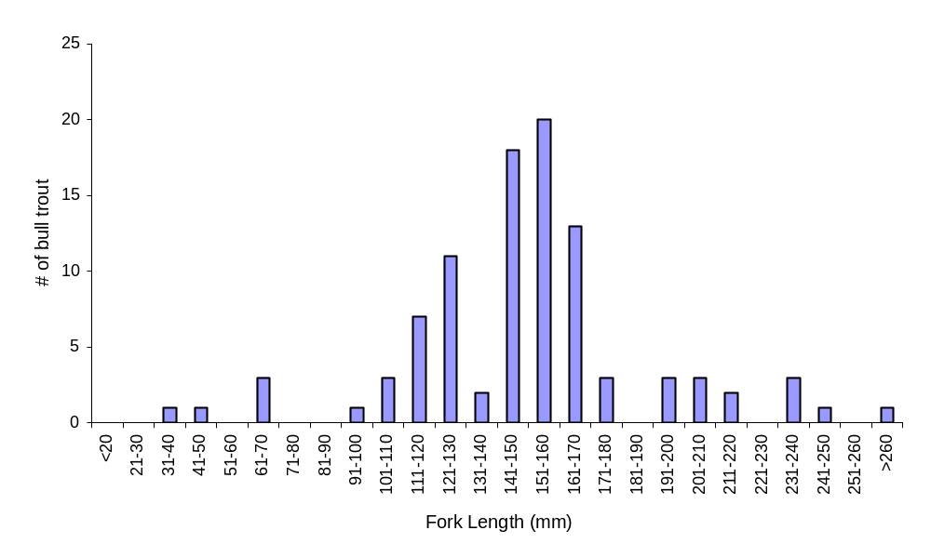
Figure 10. Length frequency of sub-adult bull trout captured at Peshastin smolt trap, 2004

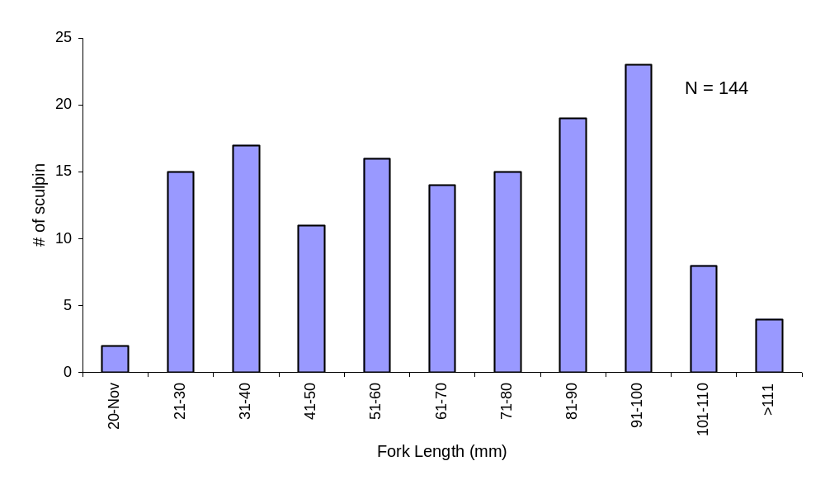
Figure 11. Length frequency of sculpin captured at Peshastin smolt trap, 2004.

Production Estimates

Regression models can be used to estimate fish production when trap efficiency trials exhibit a significant relationship to an independent variable (e.g., stream discharge, gage height). In 2004, the construction of daily emigration estimates using regression modeling was not possible due to extended periods of limited fish availability for trap efficiency trials and intermittent Peshastin Creek discharge data throughout the season.

Estimates of population size for both sub-yearling Chinook and steelhead/rainbow trout were conducted by combining daily catch into seasonal strata (Tables 6 and 7, Figure 12). These strata were identified and chosen by combining similar trap efficiencies, with similarity in flow and catch by species size classes. An estimated 66,395 (±30%) spring Chinook juveniles and 16,082 (±25%) steelhead/rainbow trout are estimated to have emigrated from Peshastin Creek in 2004. Estimated daily emigration rates were generated for Chinook (Figure 7) and steelhead/rainbow trout (Figure 9) using catch as an estimated proportion of the population estimate by strata.

Table 6. Peshastin Creek juvenile Chinook population estimate and error by seasonal strata for 3/18/04 to 11/21/04.
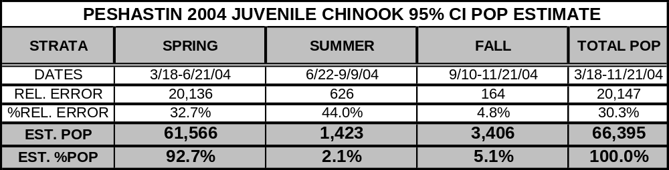

Table 7. Peshastin Creek juvenile steelhead/rainbow trout (SRT) population and error estimate by seasonal strata for 3/18/04 to 11/21/04.
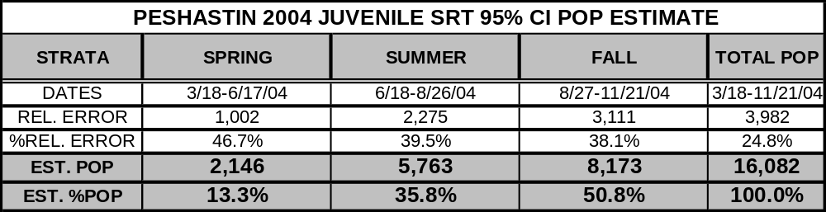

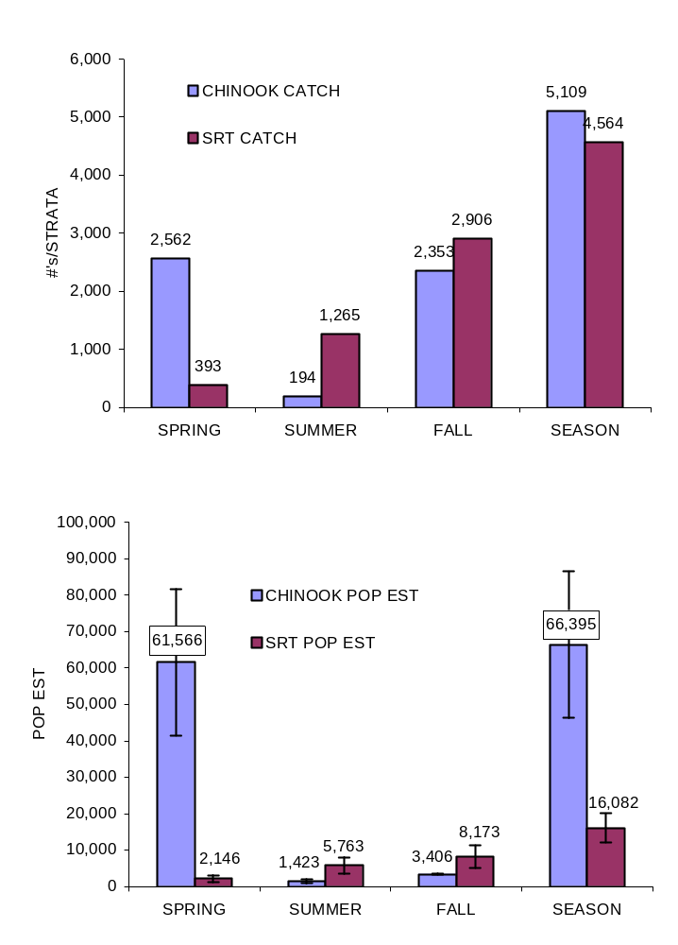

Figure 12. Peshastin Creek sub-yearling spring Chinook and steelhead/rainbow trout catch (top) and population estimate (bottom) with 95% CI by seasonal strata, 2004.

Estimates of population size for each age-class of steelhead/rainbow trout were conducted by expanding the daily catch proportions of each age into the population estimate for each stratum (Figure 13). In 2004, steelhead/rainbow trout age-classes 0, 1, and 2 represented 52%, 42%, and 6%, respectively of the population estimate. Age-2 dominated early production and exited the system primarily in the spring, peaking in migration by late-April. Age-1 steelhead/rainbow trout was present throughout the trapping season and primarily dominated the summer catch but did not peak in migration until mid-September, the latest of all age-classes. Age-0 steelhead/rainbow trout began to appear as fry in trap catches in mid-June and quickly dominated the catch composition by late-summer/early fall and peak migration occurred in late-August. This age-class went on to provide the greatest proportion of the steelhead/rainbow trout population estimate.

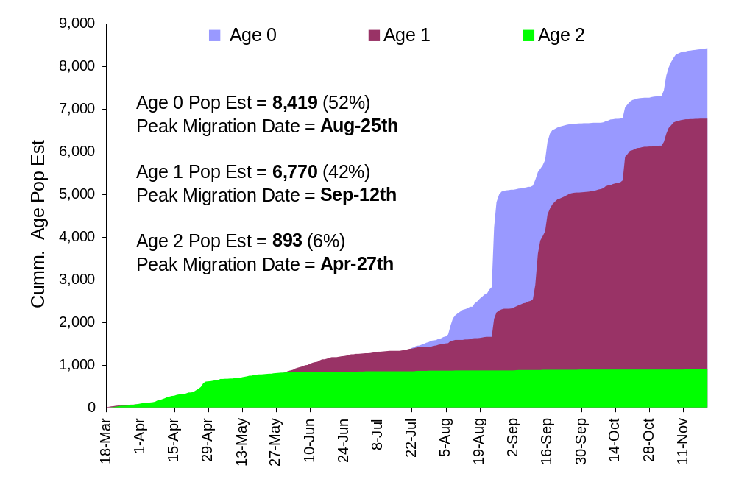
Figure 13. A graphical comparison of the cumulative population estimate and temporal migration patterns by age-class for Peshastin Creek steelhead/rainbow trout, 2004.

Data Entry

All data for the 2004 Peshastin Creek Smolt Monitoring Program has been validated, quality-controlled and is housed both on the common and network computer drives at the USFWS Mid-Columbia River Fishery Resource Office. All PIT files have been validated and submitted to Pacific States Marine Fisheries Commission (PSMFC). Daily catch by species and life stage can be found on the internet at: http://www.fpc.org or http://www.cbr.washington.edu/mcpud/.

Trapping Frequency Evaluation

As previously mentioned, 2004 was the first year of trapping operations on Peshastin Creek. Efforts were made to operate the trap during as much of the estimated migration season as possible to document periods of fish movement. It was an aim of the project to evaluate trapping frequency and in subsequent years limit operation during anticipated times of little or no fish movement to reduce project costs. The 2004 catch and population estimates of Chinook and steelhead/rainbow trout under the actual trapping schedule (5 day/wk spring and 7-day/wk summer-fall) were compared against a variety of alternative schedules (Table 8). The best alternative schedules included a 5-day/week spring and summer with a 7-day/week fall or a 5-day/week spring with a 7-day/week fall (omit summer = greatest cost savings) schedule. Although both schedules estimate approximately 98-100% of the actual 2004 Chinook population estimate they underestimate the steelhead/rainbow trout population by 29-36%. Due to the actual 5-day/week sampling in the spring, no schedule comparisons were made to include a spring 7-day/week schedule.

Table 8. Alternative schedules and the estimated population estimate for Chinook and steelhead/rainbow trout compared against the actual 2004 trapping schedule/population estimate.

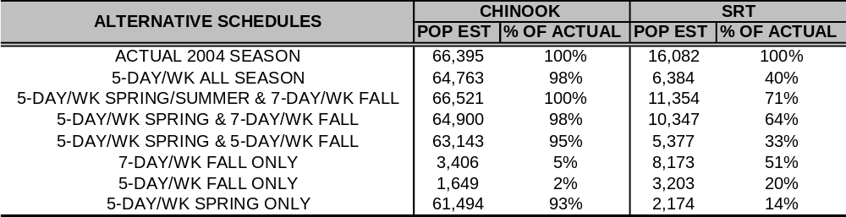

DISCUSSION

Prior to 2004, little was known about the production or temporal migration of juvenile salmonids from the Peshastin Subbasin. The Peshastin Smolt Monitoring Program was successful in determining relative abundance, production and migrational timing of Chinook and steelhead within this system. Additionally, trapping was successful in capturing and PIT tagging a substantial number of juvenile Chinook for future analysis of survival and migrational timing through the Columbia River hydro-corridor. The analysis of these marked Chinook will also provide the USFWS and others a performance comparison of naturally reared hatchery progeny against traditional hatchery programs at Leavenworth NFH and elsewhere in the Upper Columbia. Overall trap operation in 2004 provided data towards many “unknowns” that previously existed and many obstacles were overcome. As in any first year study, methodology was modified to provide greater site specific efficiency in an effort to generate greater consistency during future operations. However, challenges still exist and the remaining discussion will focus on identifying each obstacle and recommendations for improvement.

The primary challenge throughout the spring and summer months of the monitoring program was in capturing sufficient numbers of migratory fish to conduct efficiency trials. Trap efficiency testing throughout the spring stratum (March 18 – June 21) was limited to the quantity of species and life stages available. The vast majority of trap catch was newly emerged Chinook fry most likely displaced by spring discharge events. Consistent catch of fry appeared to occur coinciding with times of increasing discharge (Appendix C) possibly indicating forced rather than volitional migration. Additionally, small sized fry and parr are highly susceptible to within live box predation when bull trout and steelhead are present. These predators can quickly bias a recapture event when few marked fish are recaptured. During the summer, error in population estimates may have been the result of utilizing primarily Chinook fry/parr and rainbow trout parr. These larger life stages were less susceptible to within trap predation but may also have not been truly migratory. Marked groups possibly resided upstream of the trap following release and merely dispersed downstream seeking favorable habitat and did not pass the trap until much later. This is indicated by some pit-tagged release groups captured several weeks to a month following release 1.6 miles upstream of the trap. Similarly, it is suspected that the transitional pre-smolt steelhead may not be migratory (although not validated with pit tags in 2004) and that this biased recapture rates. In September, however, Chinook numbers increased markedly associated with stream cooling and increased discharge following an early fall rain event. During the month of September a total of 2,415 Chinook were captured. The increased Chinook catch exhibiting “true” migratory behavior gave us the opportunity to conduct several quality trap efficiency trials. This resulted in Chinook population error rates dropping substantially compared to spring/summer estimates. In contrast, the increased fall catch of steelhead/rainbow trout did not help in reducing error to a significant degree.

Lack of true migrational tendencies and loss of marked fish to predators is thought to have caused some inconsistency in recapture rates and subsequent error in population estimates. Recommendations to improve future trap efficiency testing include: 1) release of Chinook and steelhead/rainbow fry/parr within 300 meters of trap (ODFW recommendation) to mimic within stream migration behavior of non-marked population, 2) create a refuge for captured fry within live box to avoid predation, 3) conduct upstream releases using differentially segregated transitional/smolt groups and parr type groups of Chinook and steelhead to determine migrational tendencies.

During 2004, salmonid production was most effectively quantified on a seasonal basis. An effort has been made to identify periods of the year where reduced trapping efforts could occur without significantly impacting population estimates. This has proved difficult as our target species (Chinook and steelhead) exhibited differing periods of substantial contribution to productivity estimation. Based on estimation, Chinook fry captured in the spring contributed ~93% of the productivity, while steelhead in this same time accounted for only 13% of the populations estimate. Conversely, during the summer, Chinook production accounted for only 2% of the population estimate while steelhead accounted for 36% of their production estimate. The fall provided the highest capture and lowest population error rates for both species. However, the estimated contribution for production contrasted for each species with over 50% of steelhead versus only 5% of the Chinook population estimate attributable to the fall stratum. In all there was little evidence to eliminate a particular trapping window if precise production of both species is desired. A better approach may be to reduce the number of sample days during times of consistent catch/discharge such as in the summer to reduce program effort and expense.

Another issue of concern in the 2004 season was the relative lack of yearling Chinook or age-1+ steelhead smolt observed exiting the system during the spring. Only one yearling Chinook was captured (no population estimate for this life stage generated) and as previously mentioned only 13% of the steelhead were estimated to have emigrated during the spring of 2004 (mostly age-2). It seems most likely that the absence of yearling Chinook and the extensive migration of age-0 steelhead/rainbow trout in the summer/fall may indicate that Peshastin Creek does not provide adequate over wintering habitat. However, it is also possible that the March 18 start date in 2004 missed early migration or the five day a week trapping schedule (until June) missed substantial emigration pulses by these older age-classes.

Recommendations to improve future trap operation include: 1) Begin trapping in early-March to document low over-winter emigration rates prior to prevalence of spring conditions 2) Operate the trap seven days a week during the spring and fall to capture all potential pulses in emigration. 3) Conduct or acquire consistent and reliable monitoring of stream characteristics to provide greater precision in which to relate trap efficiency tests towards generating sound daily emigration estimates.

REFERENCES

Cappellini M.M.J. 1998. Peshastin Creek Washington – 1997 Stream Survey Report. US Fish and Wildlife Service Mid-Columbia River Fishery Resource Office Report pp. 19.
Hillman, T.W. 2004. Monitoring strategy for the Upper Columbia Basin: Draft report February 1, 2004. Prepared for Upper Columbia Regional Technical Team, Wenatchee, Washington.
Mosey, T.R., and L.J. Murphy. 2000. Spring and summer chinook spawning ground surveys on the Wenatchee River Basin, 2000.Chelan County Public Utility District. Wenatchee, WA. pp. 33.

Mullan, J.W., Williams, K.R., Rhodus, G., Hillman, T.W., and J.D. McIntyre. 1992. Production and habitat of salmonids in Mid-Columbia River tributary streams. U.S. Fish and Wildlife Service, Monograph 1, Leavenworth, Washington.

Murdoch, A., K. Petersen, A. Mikkelsen, and M. Tonseth. 1997. Freshwater production and emigration of juvenile spring Chinook salmon form the Chiwawa River in 1995. Report No. H97-02. Washington Department of Fish and Wildlife, Olympia, WA.

Murdoch, A., K. Petersen, A. Mikkelsen, and M. Tonseth. 1998a. Freshwater production and emigration of juvenile spring Chinook salmon form the Chiwawa River in 1996. Report No. H98-01. Washington Department of Fish and Wildlife, Olympia, WA.

Murdoch, A., K. Petersen, M. Tonseth, and T. Miller. 1998b. Freshwater production and emigration of juvenile spring Chinook salmon form the Chiwawa River in 1997. Report No. H98-05. Washington Department of Fish and Wildlife, Olympia, WA.

Murdoch, A., K. Petersen, T. Miller, M. Tonseth, and T. Randolph. 1999. Freshwater production and emigration of juvenile spring Chinook salmon form the Chiwawa River in 1998. Report No. SS99-05. Washington Department of Fish and Wildlife, Olympia, WA. pp. 57.

Rawson, K. 1984. An estimate of the size of a migrating population of juvenile salmon using an index of trap efficiency obtained by dye marking. Alaska Department of Fish and Game, Division of Fisheries and Rehabilitation, Enhancement, and Development. Report Number 28. Juneau, Alaska.

Rife, D.W. 1999. Lower Peshastin ecosystem restoration project. Leavenworth Ranger District, Wenatchee National Forest, Fisheries Biological Evaluation. August 18, 1999. pp.50.

Ringel, B. K. 1997. Analysis of fish populations in Icicle Creek, Trout Creek, Jack Creek, Peshastin Creek, Ingalls Creek, and Negro Creek, Washington 1994 and 1995. US Fish and Wildlife Service Mid-Columbia River Fishery Resource Office Report pp. 49.

Todd, G. 1994. A lightweight, inclined-plane trap for sampling salmon smolts in rivers. Alaska Fishery Research Bulletin. 1(2): 168-175.

Appendix A. Daily catch of subyearling spring Chinook (top graph) and steelhead/rainbow (bottom graph) compared with Wenatchee River discharge, 2004.

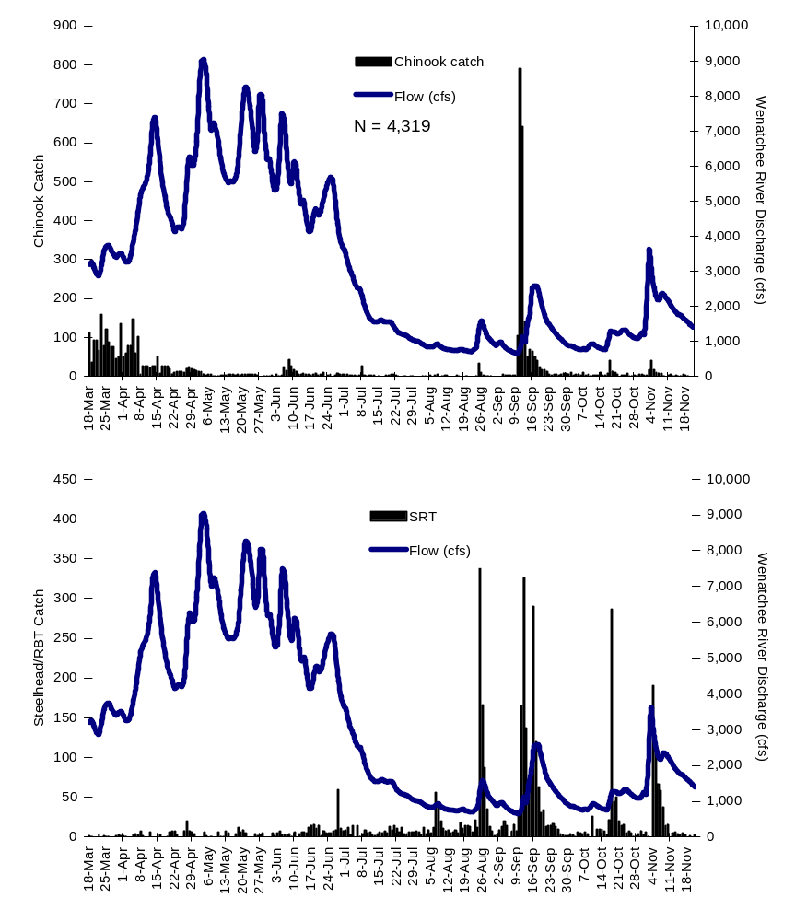

Appendix B. Daily catch of bull trout (top graph) and coho (bottom graph) compared with Wenatchee River discharge, 2004

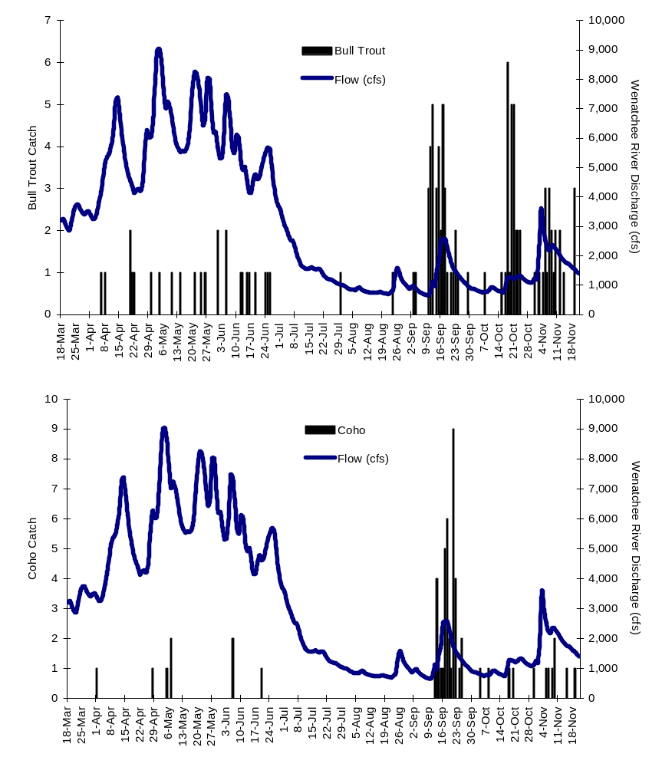

Appendix C. Peshastin Creek mark-recapture trials with trap efficiency percentages relative to flow, 2004.

RELEASE | SPECIES | MARK | NUMBER | RECAP | RECAP | T.E. | WENATCHEE
DATE | SPECIES | TYPE₁ | RELEASED | DAY 1 | DAY 2 | (%) | RIVER (CFS)²
3/24/2004 | Chinook fry | DM | 300 | 21 | 1 | 7.3 | 3570.0
3/31/2004 | Chinook fry | DM | 223 | 8 | 1 | 4.0 | 3510.0
4/7/2004 | Chinook fry | DM | 191 | 1 | 0 | 0.5 | 4690.0
4/14/2004 | Steelhead | UC | 4 | 0 | 0 | 0.0 | 7380.0
4/21/2004 | Steelhead | LC | 6 | 2 | 0 | 33.3 | 4370.0
4/28/2004 | Steelhead | RV | 30 | 5 | 0 | 16.7 | 6260.0
5/12/2004 | Steelhead | LC | 2 | 1 | 0 | 50.0 | 5840.0
5/19/2004 | Steelhead | RV | 6 | 2 | 0 | 33.3 | 6890.0
5/26/2004 | Steelhead | LV | 2 | 0 | 0 | 0.0 | 6720.0
6/3/2004 | Steelhead | UC | 7 | 0 | 0 | 0.0 | 5370.0
6/6/2004 | Steelhead | LC | 7 | 0 | 0 | 0.0 | 7330.0
6/8/2004 | Chinook fry | DM | 78 | 0 | 0 | 0.0 | 5680.0
6/13/2004 | Steelhead | RV | 4 | 0 | 0 | 0.0 | 4920.0
6/16/2004 | Steelhead | LV | 2 | 0 | 0 | 0.0 | 4160.0
6/30/2004 | Chinook smolts | PIT | 3 | 0 | 0 | 0.0 | 3700.0
6/30/2004 | Steelhead | UC | 1 | 0 | 0 | 0.0 | 3700.0
7/3/2004 | Chinook smolts | PIT | 2 | 0 | 0 | 0.0 | 3050.0
7/3/2004 | Steelhead | LC | 2 | 0 | 0 | 0.0 | 3050.0
7/5/2004 | Chinook smolts | PIT | 1 | 0 | 0 | 0.0 | 2670.0
7/6/2004 | Steelhead | RV | 2 | 0 | 0 | 0.0 | 2530.0
7/7/2004 | Chinook smolts | PIT | 1 | 0 | 0 | 0.0 | 2490.0
7/7/2004 | Steelhead | RV | 1 | 0 | 0 | 0.0 | 2490.0
7/9/2004 | Chinook smolts | PIT | 24 | 0 | 0 | 0.0 | 2030.0
7/10/2004 | Chinook smolts | PIT | 4 | 0 | 0 | 0.0 | 1840.0
7/13/2004 | Chinook smolts | PIT | 1 | 0 | 0 | 0.0 | 1560.0
7/13/2004 | Steelhead | RV | 1 | 0 | 0 | 0.0 | 1560.0
7/19/2004 | Chinook smolts | PIT | 3 | 0 | 0 | 0.0 | 1560.0
7/19/2004 | Steelhead | LV | 2 | 0 | 0 | 0.0 | 1560.0
7/21/2004 | Chinook smolts | PIT | 3 | 0 | 0 | 0.0 | 1430.0
7/21/2004 | Steelhead | RV | 3 | 0 | 0 | 0.0 | 1430.0
7/24/2004 | Steelhead | UC | 4 | 1 | 0 | 25.0 | 1210.0
7/25/2004 | Chinook smolts | PIT | 1 | 0 | 0 | 0.0 | 1190.0
7/25/2004 | Steelhead | LC | 2 | 0 | 0 | 0.0 | 1190.0
7/26/2004 | Chinook smolts | PIT | 1 | 0 | 0 | 0.0 | 1170.0
7/29/2004 | Steelhead | RV | 1 | 0 | 0 | 0.0 | 1040.0
7/31/2004 | Steelhead | LV | 4 | 1 | 0 | 25.0 | 1000.0
8/2/2004 | Steelhead | UC | 2 | 0 | 0 | 0.0 | 907.0
8/3/2004 | Steelhead | LC | 2 | 0 | 0 | 0.0 | 873.0
8/4/2004 | Steelhead | LC | 1 | 0 | 0 | 0.0 | 842.0
8/5/2004 | Chinook smolts | PIT | 1 | 0 | 0 | 0.0 | 843.0
8/7/2004 | Steelhead | RV | 7 | 1 | 0 | 14.3 | 894.0
8/7/2004 | Chinook smolts | PIT | 3 | 0 | 1 | 33.3 | 894.0
8/8/2004 | Chinook smolts | PIT | 4 | 0 | 0 | 0.0 | 923.0
8/9/2004 | Steelhead | LV | 2 | 0 | 0 | 0.0 | 848.0
8/12/2004 | Chinook smolts | PIT | 1 | 0 | 0 | 0.0 | 766.0
8/13/2004 | Steelhead | UC | 2 | 0 | 1 | 50.0 | 758.0
8/16/2004 | Chinook smolts | PIT | 1 | 0 | 0 | 0.0 | 739.0
8/16/2004 | Steelhead | LC | 3 | 0 | 0 | 0.0 | 739.0
8/20/2004 | Steelhead | LV | 3 | 0 | 0 | 0.0 | 725.0
8/24/2004 | Chinook smolts | PIT | 1 | 0 | 0 | 0.0 | 835.0
8/25/2004 | Steelhead | UC | 22 | 5 | 1 | 27.3 | 1320.0
8/25/2004 | Chinook smolts | PIT | 31 | 7 | 2 | 29.0 | 1320.0
8/26/2004 | Steelhead | LC | 14 | 4 | 3 | 50.0 | 1580.0
8/26/2004 | Chinook smolts | PIT | 9 | 0 | 0 | 0.0 | 1580.0
8/27/2004 | Steelhead | RV | 7 | 0 | 0 | 0.0 | 1430.0
RELEASE | SPECIES | MARK | NUMBER | RECAP | RECAP | T.E. | WENATCHEE
DATE |  | TYPE¹ | RELEASED | DAY 1 | DAY 2 | (%) | RIVER (cfs)²
8/27/2004 | Chinook smolts | PIT | 3 | 0 | 0 | 0.0 | 1430.0
8/28/2004 | Chinook smolts | PIT | 1 | 0 | 0 | 0.0 | 1220.0
8/29/2004 | Steelhead | LV | 4 | 3 | 0 | 75.0 | 1100.0
8/29/2004 | Chinook smolts | PIT | 1 | 0 | 0 | 0.0 | 1100.0
9/2/2004 | Steelhead | UC | 5 | 2 | 0 | 40.0 | 942.0
9/3/2004 | Steelhead | LC | 8 | 2 | 0 | 25.0 | 976.0
9/4/2004 | Steelhead | LV | 8 | 3 | 0 | 37.5 | 884.0
9/4/2004 | Chinook smolts | PIT | 4 | 2 | 0 | 50.0 | 884.0
9/7/2004 | Steelhead | UC | 3 | 0 | 0 | 0.0 | 725.0
9/7/2004 | Chinook smolts | PIT | 2 | 0 | 1 | 50.0 | 725.0
9/8/2004 | Steelhead | LC | 4 | 2 | 1 | 75.0 | 685.0
9/8/2004 | Chinook smolts | PIT | 1 | 0 | 0 | 0.0 | 685.0
9/9/2004 | Steelhead | RV | 4 | 2 | 0 | 50.0 | 669.0
9/9/2004 | Chinook smolts | PIT | 2 | 1 | 0 | 50.0 | 669.0
9/10/2004 | Chinook smolts | PIT | 101 | 62 | 0 | 61.4 | 657.0
9/11/2004 | Chinook smolts | PIT | 93 | 58 | 0 | 62.4 | 780.0
9/12/2004 | Chinook smolts | PIT | 71 | 60 | 5 | 91.5 | 1120.0
9/15/2004 | Chinook smolts | PIT | 66 | 50 | 0 | 75.8 | 1810.0
9/18/2004 | Chinook smolts | PIT | 113 | 86 | 0 | 76.1 | 2560.0
9/22/2004 | Chinook smolts | PIT | 46 | 19 | 0 | 41.3 | 1570.0
10/16/2004 | Chinook smolts | PIT | 16 | 11 | 0 | 68.8 | 765.0
10/16/2004 | Steelhead | UC | 1 | 0 | 0 | 0.0 | 765.0
10/20/2004 | Chinook smolts | PIT | 56 | 46 | 0 | 82.1 | 1260.0
11/6/2004 | Chinook smolts | PIT | 45 | 22 | 1 | 51.1 | 2260.0
¹MARK TYPE: DM = Bismark brown dye-marked; UC = Upper caudal lobe fin-clip; LC = Lower caudal lobe fin-clip; LV = Left ventral fin-clip;
RV = Right ventral fin-clip; PIT = Tag code and injection scar were used as identifiers.
²Wenatchee River (CFS): Discharge taken from USGS Gauging Site #12459000 Wenatchee River at Peshastin, Washington. Available online
at: http://waterdata.usgs.gov/wa/nwis/uv?12459000.
;
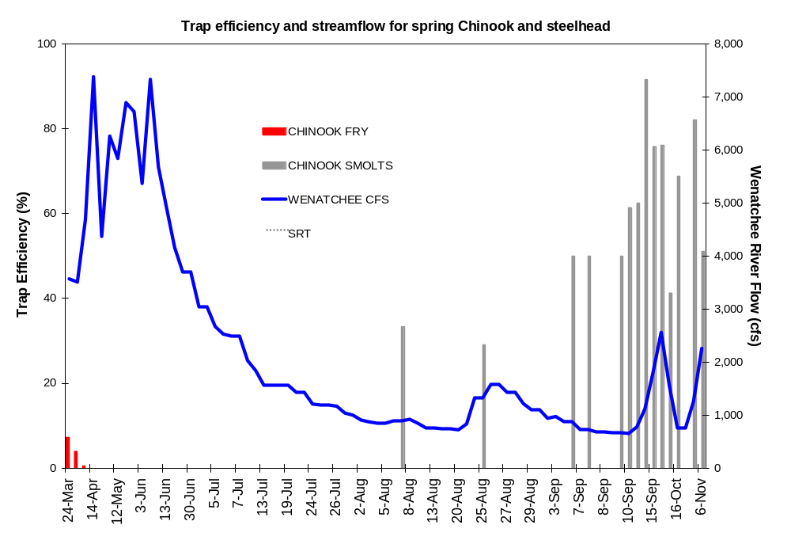

Appendix D. Peshastin Creek subyearling Chinook catch and total number PIT-tagged by seasonal strata. Peshastin Creek steelhead/rainbow trout catch and total numbers that were of taggable size.
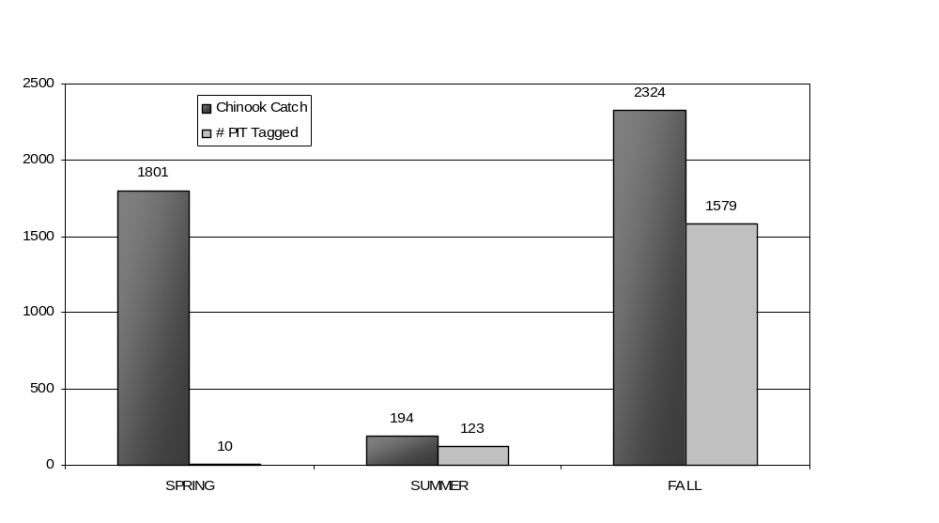

Catch numbers

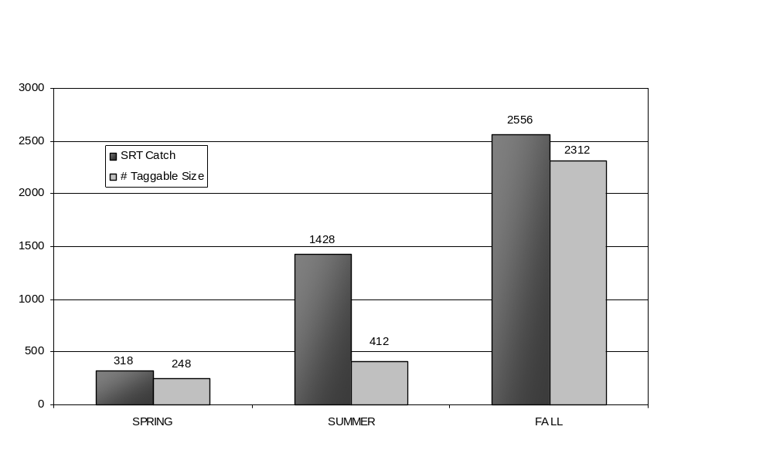

Catch numbers

