
National Aeronautics and Space Administration
Reasonable Accommodation: Procedures, Rights, and Responsibilities
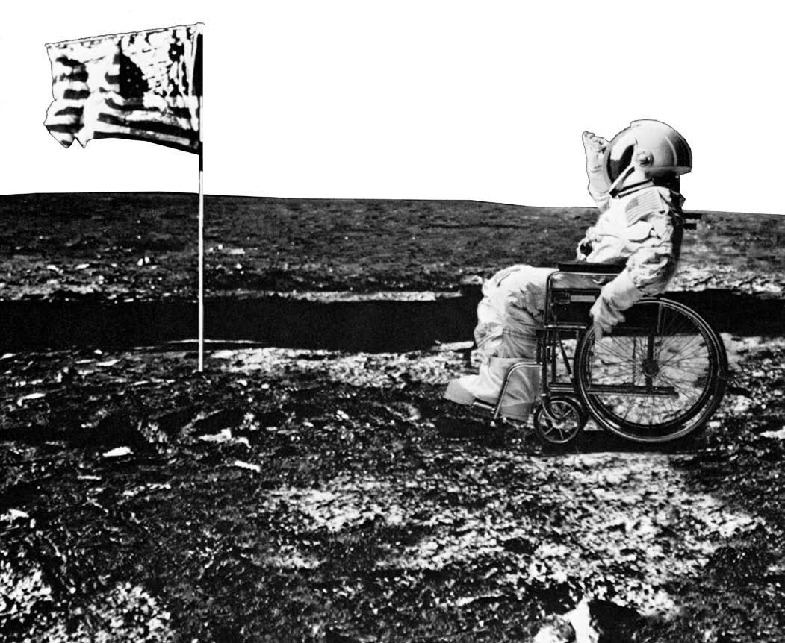
A Handbook for Goddard Space Flight Center Applicants, Employees, and Supervisors
Photo courtesy of National Multiple Sclerosis Society

www.nasa.gov

Reasonable Accommodation: Procedures, Rights, and Responsibilities
Table of Contents
I. Background
A. Policy 1
B. Authority 1
C. General Principles 2
D. Rights and Responsibilities 3
E. Types of Reasonable Accommodation 4

II. Reasonable Accommodation Procedures
A. Initiating the Request 5
B. Processing the Request 6
C. Time Limits 8
D. Medical Information 9
E. Reassignment 12
F. Denials of Requests 13
G. Information Tracking and Record Keeping 13
Appendices
A. Key Terms 16
B. Examples of Reasonable Accommodations 18
C. NASA Form 1699 Facsimile 19
D. NASA Form 1699A Facsimile 21
E. Selected Reasonable Accommodation Resources 23
F. Standard Form 256 Facsimile 26
G. Procedural Checklists for Reasonable Accommodation 28


I. Background
A. Policy
The National Aeronautics and Space Administration (NASA) is committed to fully comply with the reasonable accommodation requirements of the Rehabilitation Act of 1973, as amended. Under that law, NASA will provide reasonable accommodation to qualified applicants and employees with disabilities, unless to do so would cause undue hardship or result in a direct threat to the health or safety of an individual, his or her co-workers, or other individuals in the Agency.
The provision of reasonable accommodations ensures that individuals with disabilities face no barriers that prevent them from applying for positions; performing the essential duties of the job or activity; gaining access to the workplace or the location of the program or activity; enjoying equal benefits and privileges of employment; as well as enjoying full access to all programs, facilities, or activities that are conducted by, or for, the Agency or any of its components.
These requirements cover applicants for, and employees in, part-time and full-time positions. Also covered are co-ops, as well as interns, fellows, visiting scientists, and detailees who are not in a civil service status.
NASA will process all requests for reasonable accommodation and, where appropriate, provide reasonable accommodation in a prompt, fair, and efficient manner.
For definitions of key terms [Benefits and Privileges, Decision Maker, Direct Threat, Essential Functions, Individual with a Disability, Qualified Person with a Disability, Reasonable Accommodation, and Undue Hardship] see Appendix A

B. Authority
NASA provides reasonable accommodation under the authority of United States laws and regulations, as well as NASA Policies and Requirements, and Executive Order. These include, but are not limited to:
1 Rehabilitation Act of 1973, as amended
2. Americans with Disabilities Act of 1990 (ADA)
3. NASA Procedural Requirements (NPR) 3713.1 “Procedures for Providing Reasonable Accommodations for Individuals with Disabilities” [This document can be located in the NASA Online Directives Information System (NODIS) Library at http://nodis3.gsfc.nasa.gov]
4. Executive Order 13164

C. General Principles
1. The Rehabilitation Act of 1973, as amended, (29 U.S.C. 701 et seq.) requires Federal agencies to provide reasonable accommodation to qualified employees or applicants with disabilities, unless doing so would cause undue hardship or pose a direct threat. In general, no qualified individual with a disability will be denied the benefits of, be excluded from participation in, or otherwise be subjected to discrimination under any program or activity conducted by the Federal government.
2.Workplace barriers prevent individuals from performing jobs they could otherwise do with some form of accommodation. These barriers may be physical obstacles, such as inaccessible facilities or equipment. They also may be procedures or rules, such as those concerning when work is performed, when breaks are taken, or how essential or marginal functions are performed. Reasonable accommodations remove workplace barriers for individuals with disabilities.

3. The Disability Program Manager (DPM) in the Equal Opportunity Programs Office (EOPO) has been designated as the central point of contact for all matters relating to the provision of reasonable accommodation. Contact information for the DPM is located on the back cover of this publication. The DPM will, in most cases, provide guidance and input to the Center’s Equal Opportunity Officer about decisions regarding reasonable accommodation.

4. The reasonable accommodation must be effective; it must accomplish the purpose for which it is intended as related to the performance of the essential duties of the job.

5.There are modifications or adjustments that are not considered forms of reasonable accommodation. The Center is not required to:

a. Eliminate an essential function, i.e., a fundamental duty of the position.

b. Lower production standards—whether qualitative or quantitative—that are applied uniformly to all employees; however, the Agency may have to provide reasonable accommodation to enable an employee with a disability to meet the production standard.

c. Provide personal use items needed in accomplishing daily activities, i.e., a prosthetic limb, eyeglasses, hearing aids. Items that might otherwise be considered personal, however, may be required as reasonable accommodations where they are specifically designed or required to meet job-related, rather than personal, needs. For example, if an employee does not use a wheelchair at home, but circumstances require greater mobility, the employee may request a wheelchair that stays at the employee’s work site at all times.

For more information on reasonable accommodation policy, procedures, guidelines, and other materials, see the Reasonable Accommodation Web Page of Equal Opportunity Programs Office of Goddard Space Flight Center. You can find this at http://eeo.gsfc.nasa.gov/reasonableaccommodation.html.
D. Rights and Responsibilities
The process of requesting reasonable accommodation can be seen in terms of general rights and responsibilities of all parties involved, including applicants or employees and supervisors.
1. Employee/Applicant
a. Must notify the supervisor, or other individual identified by the Center, that an accommodation is needed or have this done by an interested third party.
b. Must be qualified to perform the essential duties of the job, with or without reasonable
accommodations.
c. Must provide medical documentation of need for an accommodation, when requested.

d. May refuse an accommodation, understanding that refusal will necessitate further discussion and could result in not receiving an accommodation.
e. Must document the request using NASA Form 1699 within five days after the need is made known, unless the need for accommodation is on a repeated basis.

f. May consult with the DPM, Employee Assistance Program (EAP), or Office of Human Capital Management (OHCM), at any time before, during, or after the request process.
2. Supervisor
a. Usually acts as the decision maker (DM) in this process.

b. Must provide reasonable accommodations for the known disabilities of a qualified person within 20 days after the request is made, or the need is made known, in any way or format, unless there are extenuating circumstances.

c. Must engage in an interactive process or dialogue with the employee or applicant regarding the nature and purpose of the request, if the need for accommodation is not obvious, or if there is more than one reasonable option for an accommodation.

d. May seek advice from the DPM, EAP, or OHCM.

e. Must respond to request in writing using NASA Form 1699A.

f. Must work with the employee to institute temporary measures to provide accommodations if the agreed upon reasonable accommodation is not immediately available.

g. May encourage the use of ADR or the EOPO to resolve issues.

h. May require medical documentation, narrowly tailored to the specific request, that an accommodation is necessary if the disability or the need for an accommodation is not obvious.
i. Must ensure accommodations are effective.

For more information about medical documentation, please refer to Part II, Section D, Medical Information.
To see a facsimile of NASA Form 1699, please see Appendix C.

To see a facsimile of NASA Form 1699A, please see Appendix D.

E. Types of Reasonable Accommodation
There are three broad types of reasonable accommodations. These are modifications or adjustments to:
1. The job application process—When applying for temporary or permanent part-time or full-time positions, as well as internships, fellowships, cooperative education placements, and any other opportunities offered by, or for, the Agency, whether at a NASA site or any other location.
2. The work environment, or to the manner or circumstances under which the job duties are customarily performed—Employees who need an accommodation to perform the essential duties of the job or activity, or gain access to the workplace or the location of the program or activity. This includes the option of telecommuting, if appropriate. Reasonable accommodation will be provided to qualified employees regardless of whether they have temporary or permanent appointments, work part-time or full-time, or are considered probationary.

3. The circumstances by which employees enjoy the benefits and privileges of employment—Employees who require an accommodation to enjoy the same benefits and privileges of employment as other similarly situated employees without disabilities.
II. Reasonable Accommodation Procedures

A. Initiating the Request

1. Starting the Process
A request for reasonable accommodation can be initiated by the employee with a disability, a family member, health professional, or other representative. The request should be made directly to the employee’s immediate supervisor. If this is not practical or possible, the request may also be made to any of the following who could act as the DM: a supervisor or manager in the employee’s organizational hierarchy, the EOPO, or in the case of an applicant for a position, any NASA employee with whom the applicant has contact in the OHCM.
If the request is made by anyone other than the employee or applicant, management will confirm with the person with a disability that he or she, in fact, wants a reasonable accommodation. The individual’s immediate supervisor may also initiate the discussion about reasonable accommodation if he or she thinks that one might be appropriate.
A request for reasonable accommodation may be made at any time during the application process or during the period of employment. An individual should request a reasonable accommodation when he or she recognizes there is a workplace barrier that is preventing him or her—because of a disability—from effectively competing for a position, performing a job, or gaining equal access to a benefit of employment. As a practical matter, it is in the employee’s best interest to request a reasonable accommodation before performance suffers or conduct problems occur.
Although it is not a requirement in the reasonable accommodation process, the EOPO recommends that employees ensure that their SF 256, “Self Identification of Handicap” reflects their current disability status. This form is usually completed when employees begin their Federal careers, but it should be updated as their personal circumstances change. Please note that the completion of this form is voluntary and is not considered a part of the process for requesting reasonable accommodation.
For more information about this form, and the ramifications of filling it out, please contact the DPM. If an employee chooses to update this form, it can be obtained from the EOPO or the OHCM; or, as a PDF on the Office of Personnel Management (OPM) Web Site at: http://www.opm.gov/forms/pdfimage/sf256.pdf. To see a facsimile of SF 256, please see Appendix F.
The EOPO has created procedural checklists for employees and supervisors, or other DMs. These checklists are designed to assist employees and supervisors in the reasonable accommodation process. Please see Appendix G.
2. Format of Request
A request for reasonable accommodation may be made orally or in writing. The person making the request does not have to use particular words. He or she merely needs to state that an adjustment or change at work or in the application process is needed. The words “reasonable accommodation” specifically do not have to be used.

When a request has been made, the employee should complete NASA Form 1699 “Request for Reasonable Accommodation” and forward it to the EOPO within five working days to ensure accurate record keeping and program analysis.

For more information about NASA Form 1699, please refer to Section G, Information Tracking and Record Keeping.

3. Assistance Available
Within the EOPO, the DPM has expertise in the requirements of the Rehabilitation Act of 1973, as amended, possible accommodations, and available resources. Any supervisor, manager, employee, or applicant may consult with the DPM for further information or assistance in connection with requesting or processing a request for reasonable accommodation. In addition, employees and supervisors have the opportunity to contact the EAP for additional support.
B. Processing the Request
1. Decision Maker
The employee’s first line supervisor, or other DM, should receive and approve requests for reasonable accommodation. The decision for providing the reasonable accommodation can be made, in the case of applicants, by the Human Resources Management Specialist (HRMS) who is responsible for the application. If the request is not received and processed by the supervisor or the HRMS, it is forwarded to DPM in the EOPO for process and review.
2. Interactive Process
If the need for an accommodation is not immediately obvious, the employee and his or her supervisor, or other DM, will enter into an interactive process. This discussion is necessary also when there are several options for providing accommodation. When engaging in this process, the employee and the supervisor will consider the employee’s essential duties, the functional limitations imposed by the employee’s disability or medical condition, and the effectiveness of the various options for reasonable accommodation that could mitigate the effects of those functional limitations.
The discussions might also include additional issues that relate to the work environment of the employee, such as the parking lot, the route to the building(s) where the work is done, the employee’s office, the bathrooms, as well as places other than the office where the employee typically travels or works. The discussions may also address equal benefits and privileges of working at NASA, as well as official and unofficial office events such as participating in employee clubs and activities.
As stated, the DPM can provide technical assistance to the employee, the supervisor, and any other stakeholders. This is especially important where the specific limitation, problem, or barrier is unclear; where an effective accommodation is not obvious; or where the parties are choosing between different possible reasonable accommodations.
3. Identifying Options
During the interactive discussions, options will be developed and evaluated to determine the most efficient way of removing any barrier(s). Factors that may be included in the discussion include, but are not limited to, the cost of the accommodation, the effect on the employee’s performance, personal preferences of the employee, and time needed to complete the tasks. If necessary, temporary solutions will be agreed to until permanent changes and modifications can be completed.
The critical aspect of the interactive process is coming to an agreement, which sometimes involves compromises and trade-offs. The goal of this negotiation is to agree on an accommodation that is reasonable, practical, and effective in removing barriers.
During these discussions, the individual with a disability does not necessarily have to specify the precise accommodation he or she prefers. He or she does need, however, to describe the problems posed by the workplace barrier.
For examples of various types of Reasonable Accommodation, see Appendix B.

4. Choosing the Most Effective Option
If there are two or more possible options, and one costs more or is more burdensome than another, management may choose the less expensive or easier accommodation as long as it is effective. The option chosen may or may not be the first choice of the employee or supervisor. If more than one accommodation is effective, the preference of the individual with a disability should be given primary consideration. Center management, however, has the ultimate discretion to choose among effective accommodations.
5. Providing the Accommodation
The supervisor, or other DM, should consult with the EOPO to determine who will provide the accommodations. For most electronic or computer-based assistive technology, NASA has entered into an agreement with the Computer/Electronic
Accommodations Program (CAP) at the Department of Defense. This program provides this technology to employees with disabilities at no cost to NASA.
For all other accommodations, if there is a cost, it is usually the responsibility of the employee’s organization. This can be discussed with the DPM who has access to extensive lists of resources to acquire accommodations.
For more information on CAP and other resources, please see Appendix E.

6. Temporary Measures
If an accommodation is not immediately available, the supervisor, or other DM, will work with the employee to identify and institute temporary measures that will allow the employee to perform the essential duties of the job until the permanent accommodation is provided.
7. Dispensation of Request
When a decision is made regarding the request for reasonable accommodation, the supervisor must complete NASA Form 1699A “Dispensation of Request” and forward it to the EOPO within 10 working days.

More information about this form can be found in Section G, Information Tracking and Recordkeeping.

C. Time Limits
1. General Guideline
It is NASA policy that if a request for an accommodation requires no supporting medical information, and no extenuating circumstances apply, the request shall be processed and the accommodation provided in no more than 20 business days from the date that the request was first made known to the supervisor, DM, or other Center official. The Center will strive, however, to process requests and provide reasonable accommodation in less than 20 days, if possible.
This time requirement begins from the day the request is first made, in any format, NOT from the date NASA Form 1699 was completed.
The time necessary to respond to any particular request for accommodations will depend largely on the nature of that accommodation. The time period is considerably reduced when a supervisor is able to grant it.
2. Expedited Request
Special situations may require a request for reasonable accommodation to be expedited where, for instance, the reasonable accommodation is needed to enable an individual to apply for a job, or is needed for a specific activity that is scheduled to occur shortly.
3. Extenuating Circumstances
“Extenuating circumstances” are factors that could not reasonably have been anticipated or avoided in advance of the request for the accommodation. These might include situations where equipment must be back-ordered or other legitimate delays. When processing the request or providing the accommodation, will take longer than anticipated, the DM will inform the individual of the reason for the delay, and keep that individual informed of the date on which the process should be completed, and when he or she will receive the accommodation.
If a delay is necessary, the DM will work with the employee to institute temporary measures to assist the individual with a disability so that he or she is not penalized or suffers harm and is able to perform the essential functions of the job.
D. Medical Information
1. General Guidelines
The DM may only request documentation that is needed to establish that the individual has a disability and that the disability requires a reasonable accommodation. The employee or applicant must be able to provide medical information related to the disability, functional limitation(s), and an explanation of the requested accommodation in situations where the disability or need for accommodation is not obvious.

Failure to provide documentation could result in a denial of reasonable accommodation.

The DM may not request medical information where both the disability and the need for reasonable accommodation are obvious, or if the individual has already provided the supervisor or other decision maker with sufficient information to document the existence of the disability and his or her functional limitations. Furthermore, if an individual has more than one disability, the DM can request information pertaining only to the disability that requires a reasonable accommodation.

If medical documentation is needed, the 20-day decision requirement will be suspended until sufficient documentation is received. When that occurs, the “time clock” resumes.
2. Nature of the Documentation
The DM may request information or documentation regarding the employee’s disability or medical condition. The employee should ask his or her medical professional(s) to provide a letter that includes clear and concise answers regarding:

a. The nature, severity, duration, and prognosis of the individual’s medical condition or disability.

b. The extent and nature of the functional limitations imposed by the disability or condition.

c. The activity or activities that are impacted by the functional limitations of the individual and the extent to which the medical condition or disability limits the individual’s ability to perform those activities of the job.

d. If possible, the types of tasks that could be successfully accomplished, given the functional limitations of the disability, and the nature of the employee’s work.
e. Any medication the individual is taking, the side effects of the medication and, for new or modified prescriptions, the time it will take until the medication begins to be effective.

f. Any special procedures or protocols the individual must perform that will effect his or her work.

g. Why the individual requires a reasonable accommodation or the particular reasonable accommodation that has been requested, as well as how the reasonable accommodation will assist the individual to apply for a job, perform the essential functions of the job, or enjoy a benefit of the workplace.

The documentation about the disability or functional limitations must come from a health care or rehabilitation professional. Professionals could include, but are not limited to, doctors; chiropractors; psychiatrists; psychologists; nurses; physical, occupational, or speech therapists; practitioners of alternative medicines and practices; licensed mental health professionals; social workers; or rehabilitation counselors.
The supervisor or other decision maker will request only the information that is necessary to establish the existence of a disability and functional limitation(s) related to the disability. In most situations, this does not require access to a person’s complete medical record.
To assist the health care or rehabilitation professional, the employee should provide a description of the job, the essential functions he or she is expected to perform, and any other information that is relevant to evaluating the request.
3. Confidentiality
The Rehabilitation Act requires that all medical information be kept confidential. All medical information that is obtained in connection with a request for reasonable accommodation will be kept in the separate file record that is maintained by the DPM for the requested accommodation. This file is separate from the individual’s personnel file, which is maintained in the OHCM.
Because documentation may contain sensitive information about a person’s medical condition, an employee may feel uncomfortable about sharing it with a supervisor or other DM. In such circumstances, the employee or applicant may provide the information to the DPM or the Medical Director of the Center to review the documentation. This intermediary then may merely tell the supervisor or other DM that the employee or applicant has a disability rather than sharing all of the details about the medical condition.
Medical information obtained will only be shared with the individuals involved in the various aspects of providing reasonable accommodation. The information will not be disclosed except as follows:
a. Supervisors, managers, or other DMs who need to know may be told about necessary restrictions on the work or duties of the employee and about the necessary accommodation(s).

b. First aid and safety personnel may be told if the disability might require emergency treatment.
c. Government officials may be given only the information necessary to investigate the Center’s compliance with the Rehabilitation Act.
d. Information may, in limited and specific circumstances, be disclosed to workers’ compensation offices or insurance carriers.
e. NASA Equal Employment Opportunity (EEO) officials may be given statistical or anecdotal information to maintain records and evaluate and report on the Center’s performance in processing reasonable accommodation requests. In these circumstances, the confidentiality of the individual will be maintained.

4. Additional Documentation
The DM may request supplemental medical documentation when the information already submitted does not identify the disability, or the functional limitations it causes; or does not clarify how the requested accommodation will assist the employee to perform the essential functions of the job, or enjoy the benefits and privileges of the workplace.
If additional documentation is needed, the supervisor or other DM will explain why the submitted documentation is insufficient; identify the information that is needed; and allow the individual an opportunity to provide the information.

Alternately, the individual can sign a limited release that will allow the Center’s Medical Director to contact the individual’s doctor or other health professional directly for further information.
In the circumstance where the individual requesting an accommodation is still unable to provide sufficient information in support of the request, the supervisor or other DM may request that the individual be examined by the Medical Director, or a health care professional of the Center’s choice and at the Center’s expense. Any such medical examination must be limited to determining the existence of a disability and/or the functional limitations that require a reasonable accommodation.
Where a medical examination is warranted, the DM will explain to the individual with a disability that failure to agree to it could result in a denial of reasonable accommodation.
E. Reassignment
1. Last Resort
If the DM determines that no other reasonable accommodation will permit the employee with a disability to perform the essential functions of his or her current position it will consider a reassignment as a “last resort” option.
Reassignment may be made only to a vacant position, whether currently advertised or not. The Agency is not required to create a new position or move employees from their jobs in order to create a vacancy. The new position must be equivalent to the current position in terms of pay, status, and other relevant factors, such as benefits or geographical location. The employee may not receive a promotion but may accept a voluntary downgrade. The employee usually bears any relocation costs associated with a Permanent Change of Station (PCS).
This option is not available for applicants.
2. Qualification of Employee
The employee with a disability must be qualified for the new position. This means that the employee (1) satisfies the requisite skill, experience, education, and other job-related requirements of the position; and (2) can perform the essential functions of the position with or without reasonable accommodation. If the employee is qualified for the position, he or she will be reassigned to the job as a reasonable accommodation and will not have to compete for it.
3. Search for Vacancies
The OHCM will conduct a search for available vacancies and will consult with the employee as necessary to determine whether there are limits on the search the employee would like the OHCM to conduct; whether the employee is qualified for a particular job; or whether the employee would need a reasonable accommodation to perform the essential functions of a new position. If the employee wishes, OHCM can search for vacancies at any NASA facility in the country.
F. Denial of Requests
An organization must provide a reasonable accommodation to a qualified individual with a disability unless doing so would pose an undue burden on the organization or a direct threat of the health and safety of the employee or others. More information about undue hardship or direct threat, can be found in Appendix A.
Should management wish to deny or modify the request for reasonable accommodation, the decision must be in writing, or other appropriate media, and specify the reasons for the decision. The notice will be written in plain language with as much specificity as possible, and will identify the supervisor, or other DM, who made the decision. If the request has been modified, the notice will include the reasons why it was modified, and why the accommodation chosen will be more effective than the requested accommodation.
Before denying a request, because of undue hardship, direct threat, or any other reason, the supervisor, or other DM, must consult with the EOPO to discuss the circumstances that led to that determination.
The supervisor, or other DM, must notify the employee of his or her rights and avenues of redress.
When a decision is made, the supervisor, or other DM, will complete NASA Form 1699A “Dispensation of Request for Reasonable Accommodation” and forward it to the EOPO within 10 working days.
If a request is denied or the employee is not satisfied with the proposed modification, the employee should first pursue the issue with higher level management in his or her organization.
If the employee is still not satisfied, he or she can consult with the ADR Office or the EOPO.
G. Information Tracking and Record Keeping
To enable NASA management to keep accurate records regarding requests for accommodation, the employee must follow up an oral request by completing NASA Form 1699, “Request for Reasonable Accommodation” and forwarding it to the EOPO within five working days. This form can be found in Appendix C of this document and Appendix A of NPR 3713.1, “Procedures for Providing Reasonable Accommodation for Individuals with Disabilities.”
The form is also available on the Goddard Space Flight Center EOPO Web Site at http://eeo.gsfc.nasa.gov/reasonableaccommodation.html.
For applicants seeking a reasonable accommodation, the HRMS handling the request must give the individual a copy of the form to fill out. If the individual with a disability requires assistance with this requirement, the staff member receiving the request will provide that assistance.
This form need not be completed when an individual needs a reasonable accommodation on a repeated basis, such as a sign language interpreter or a reader. The written confirmation is only required for the first request.
While NASA Form 1699 should be completed following the request, it is not a requirement for the request itself. The Agency will begin processing the request immediately.
Similarly, when a supervisor, or other DM, makes a decision regarding the request, he or she must fill out NASA Form 1699A, “Disposition of Reasonable Accommodation Request” and forward it to the EOPO within 10 working days. This form can be found in Appendix D of this document and Appendix A of NPR 3713.1, “Procedures for Providing Reasonable Accommodation for Individuals with Disabilities.”
The form is also available on the Goddard Space Flight Center EOPO Web Site at http://eeo.gsfc.nasa.gov/reasonableaccommodation.html.
The Center will maintain records of all requests for reasonable accommodation for either the length of the employee’s tenure with NASA, or five years, whichever is longer. The records will include all relevant information and documentation about the request and dispensation; track the processing of the requests; and maintain the confidentiality of medical information received in accordance with applicable law and regulations. This information will be used to evaluate where the Center needs to improve its handling of reasonable accommodation requests. The documentation will also be used if the employee or the supervisor needs to review the process by which the accommodations were provided.
Tracking performance is critical to assess whether the Center has adequately responded to requests for reasonable accommodations. Evaluating program effectiveness includes looking at the number of requests and the time it takes to respond to them, assessing the costs and any differences in the provision of various types of accommodations, and noting any systemic patterns in delays or denials of requests. The EOPO will investigate the reasons for any problems that exist and take the steps that are necessary to correct them.
Individual medical records that contain information about a particular individual with a disability are fully subject to the confidentiality restrictions of the Rehabilitation Act. NASA’s record keeping systems will contain safeguards to ensure that those restrictions are fully observed. Medical records will be segregated from official personnel files, and kept in the EOPO, in the file maintained by the DPM. Medical information will be disclosed only according to laws and regulations, as previously enumerated. It should be noted that the Equal Employment Opportunity Commission (EEOC) has the right to review all relevant records upon request to evaluate the efficacy of the Center’s reasonable accommodation procedures.

Appendices
Appendix A
Key Terms
1. Benefits and Privileges
Benefits and privileges are not related directly to a work product, but are enjoyed by employees of an organization. These include, but are not limited to, the employee clubs, activities, and store; Employee Assistance Program (EAP); credit union; cafeterias; health unit; fitness center; transportation services, and social functions. Also included is information that is communicated such as NASA Television, presentations, e-mail, Web pages, exhibits, and bulletin boards.
2. Decision Maker
The Decision Maker (DM) is the person who determines whether or not a request for reasonable accommodation is granted. In the case of applicants, this shall be the HRMS who is handling the vacancy. In the case of employees, the DM will, in most cases, be his or her immediate supervisor. In all other circumstances, the Center’s Equal Opportunity Officer, with consultation by the Disability Program Manager (DPM), will be the DM.
3. Direct Threat
A direct threat exists when the employee poses a significant risk or high probability of substantial harm to self or others. The burden of proof is on the employer to demonstrate that the employee poses a direct threat to the health or safety of himself/herself or others. The employer must consider whether reasonable accommodation can eliminate or reduce such a risk to an acceptable level. The perception of threat must be based on objective facts, not fears or stereotypes.
4. Essential Functions
The essential functions of a job are those job duties that are so fundamental that the individual cannot successfully do the job without being able to perform them. A function is considered to be “essential” if the position exists specifically to perform that function, there are a limited number of other employees who could perform the function if it were assigned to them, or the function is specialized and the individual is hired based on his or her ability to perform it.
The essential duties of the position should be included in the written description before advertising or interviewing applicants. The essential duties are determined by the actual work of the employee, or in the employee’s performance evaluation. Not all aspects of an employee’s job duties will be found in a generic position description.
5. Individual with a Disability
An individual with a disability is a person who has a physical or psychiatric impairment that substantially limits one or more major life activities; has a record of such an impairment; or is regarded as having such an impairment. Major life activities include, but are not limited to, performing manual tasks, walking, seeing, hearing, speaking, breathing, learning, and caring for one’s self.
6. Qualified Individual with a Disability
A qualified individual with a disability is one who, with or without reasonable accommodation, can perform the essential functions of the employment position. The individual satisfies the requisite skill, education, experience, and other job-related requirements of the position. The individual must be able to perform these duties without endangering his or her health and safety or the safety of others within the work environment.
7. Reasonable Accommodation
A reasonable accommodation is a change or modification in the job requirements, work environment, equipment or instruments used, or the way things are customarily done, that would enable an otherwise qualified individual with a disability to enjoy the same employment opportunities and benefits of employment as employees and applicants without disabilities. Reasonable accommodations will be provided to qualified applicants and employees with disabilities.
A reasonable accommodation does not include the elimination of an essential job function, acceptance of lower production standards, or items of a personal nature unless they are required to meet job-related duties or responsibilities, such as a wheelchair used only at the job site.
8. Undue Hardship
An undue hardship means that a specific accommodation would require significant difficulty or expense. This determination, which must be made on a case-by-case basis, considers factors such as the nature and cost of the accommodation requested, and the impact of the accommodation on safety and other operations of the organization.
Appendix B

Examples of Reasonable Accommodations
Reasonable accommodations that NASA may provide include, but are not limited to:
1. Making existing facilities accessible—providing accessible parking spaces and routes to the buildings, accessible entrances to buildings; and modifying workplaces, buildings, bathrooms, and common areas
2. Restructuring jobs—reallocating or redistributing marginal job functions; altering when and/or how a function is performed
3. Allowing part-time or modified work schedules—adjusting arrival or departure times, providing periodic breaks, altering when certain functions are performed, allowing an employee to use leave, or providing additional unpaid leave
4. Telecommuting—allowing the employee to telecommute, if this can be done without imposing an undue burden on the organization or its functions
5. Acquiring or modifying equipment—adapting equipment or tools, providing auxiliary aids, providing enabling or assistive technology
6. Changing tests, training materials, or policies—providing alternatives to standard testing, training, or policies; providing usable training materials; providing effective communication access
7. Providing qualified and effective readers, interpreters, or other forms of communication facilitation
8. Instituting flexible leave policies—permitting the use of accrued paid leave, or unpaid leave for disability related activities such as, obtaining medical treatment, obtaining repairs on a wheelchair, accessible van, prosthetic device, or training a service animal
9. Reassignment to a vacant position—a “last resort” when an employee who, because of a disability, can no longer perform the essential functions of his or her current position, with or without reasonable accommodation, and is qualified for an existing position. In such cases, the employee does not have to compete for the position

Appendix C
NASA Form 1699 Request for Reasonable Accommodation
(on next page)
Available online in both PDF and Word at the Goddard Space Flight Center EOPO Web site at: http://eeo.gsfc.nasa.gov/reasonableaccommodation.html
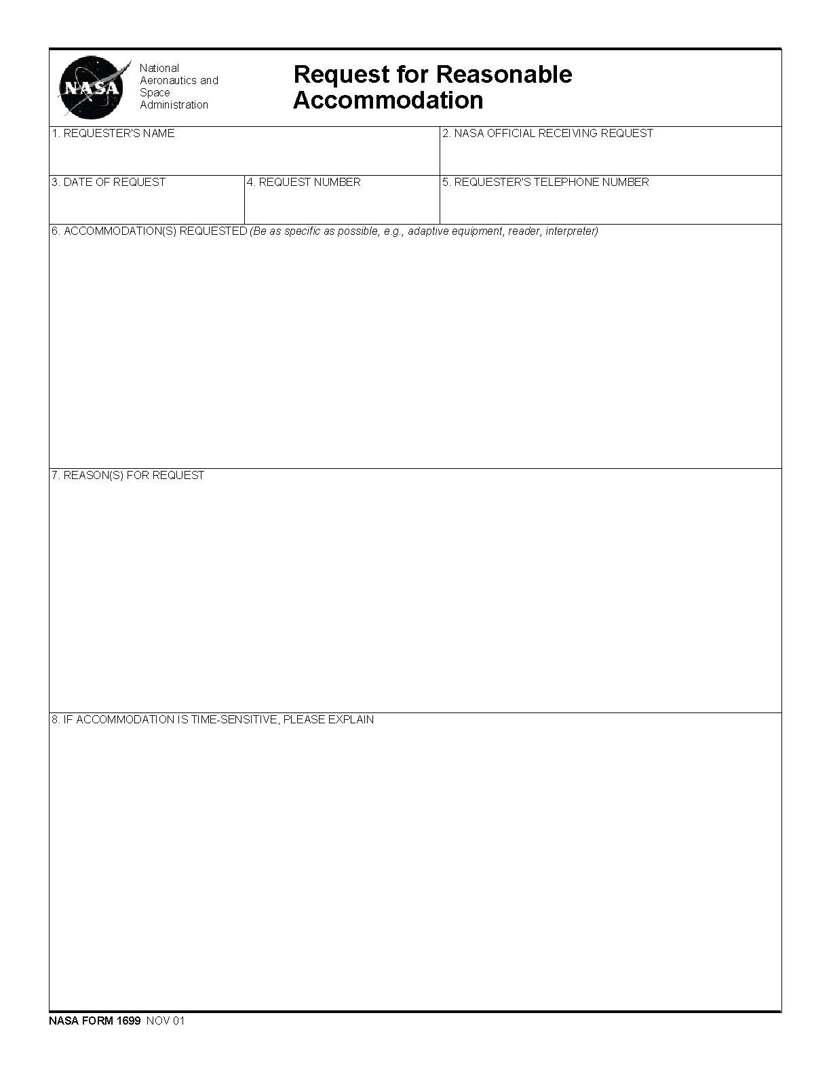
Appendix D
NASA Form 1699A Disposition of Reasonable Accommodation Request
(on next page)
Available online in both PDF and Word at the Goddard Space Flight Center EOPO Web site at: http://eeo.gsfc.nasa.gov/reasonableaccommodation.html
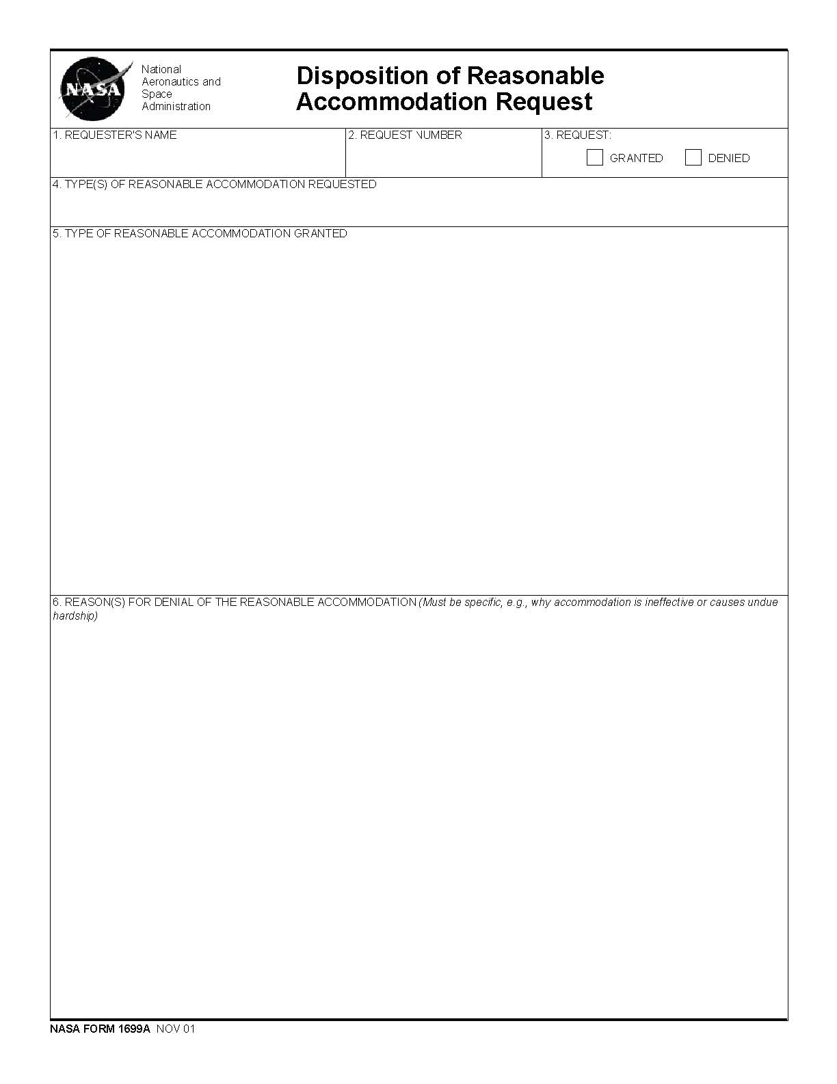
Appendix E
Selected Reasonable Accommodation Resources
1. Computer/Electronic Accommodations Program (CAP)
(703) 681-8813 (Voice)
(703) 681-0881 (TTY)
(703) 681-9075 (Fax)
cap@tma.osd.mil
http://cap.tricare.osd.mil
CAP provides assistive technology and services to people with disabilities, Federal managers, supervisors, and IT professionals. CAP increases access to information and works to remove barriers to employment opportunities by eliminating the costs of assistive technology and accommodation solutions.
NASA has entered into an agreement with CAP to obtain assistive technology at no cost to the Agency. Assistive technology includes, but is not limited to:
a. Computer input devices—Alternative keyboards, pointing devices, voice recognition
systems
b. Computer output devices—Screen readers, large monitors, Braille terminal, scanner/reader software
c. Telecommunication devices—TTYs and PC based TTY programs; web cameras
d. Assistive listening devices—Personal amplification devices, amplified handset
e. Alternative forms of documentation—Braille, large print, electronic
The employee can make a direct request for assistive technology to CAP. To make a request online, please go to the CAP Web site. The EOPO must be notified when requesting assistive technology from CAP for record keeping purposes.
2. Job Accommodation Network (JAN)
1-800-232-9675 (Voice/TT)
http://janweb.icdi.wvu.edu/
A service of the U.S. Department of Labor, Office of Disability Employment Policy (ODEP) formerly the President’s Committee on Employment of People with Disabilities. JAN can provide information, free-of-charge, about many types of reasonable accommodations.
3. ADA Disability and Business Technical Assistance Centers (DBTACs)
Mid-Atlantic Region ADA & IT Center
(301) 217-0124 (V/TTY)
(301) 217-0754 (Fax) 1-800-949-4232 (Voice/TTY) adainfo@transcen.org http://www.adainfo.org
The National Institute on Disability and Rehabilitation Research (NIDRR) has established DBTACs to provide information, training, and technical assistance to employers, people with disabilities, and other entities.
4. U.S. Equal Employment Opportunity Commission
1-800-669-3362 (Voice) 1-800-800-3302 (TTY) http://www.eeoc.gov
The EEOC provides basic information and enforcement guidance on reasonable accommodation and undue hardship. Publications include a technical assistance manual on employment provisions under the Rehabilitation Act of 1973, as amended, and the Americans with Disabilities Act, which includes a 200-page Resource Directory, including Federal and state agencies, and disability organizations that can provide assistance in identifying and locating reasonable accommodations.
5. DisabilityInfo.gov—Web Site
http://www.disabilityinfo.gov
This Web site contains links to information of interest to people with disabilities, their families, employers, service providers, and other community members.
6. Office of Personnel Management—Federal Employment of People with Disabilities— Web Site
http://www.opm.gov/disability
The Web site provides access to information that is relevant to the recruitment, employment, and retention of individuals with disabilities in the Federal government. Target audiences are applicants and employees with disabilities, Federal managers and supervisors, and human resources professionals.
Appendix F
Standard Form 256 Self-Identification of Handicap
(on next page)

Available from the EOPO or the OHCM, or, as a PDF from the Office of Personnel Management (OPM) Web Site at:

http://www.opm.gov/forms/pdfimage/sf256.pdf
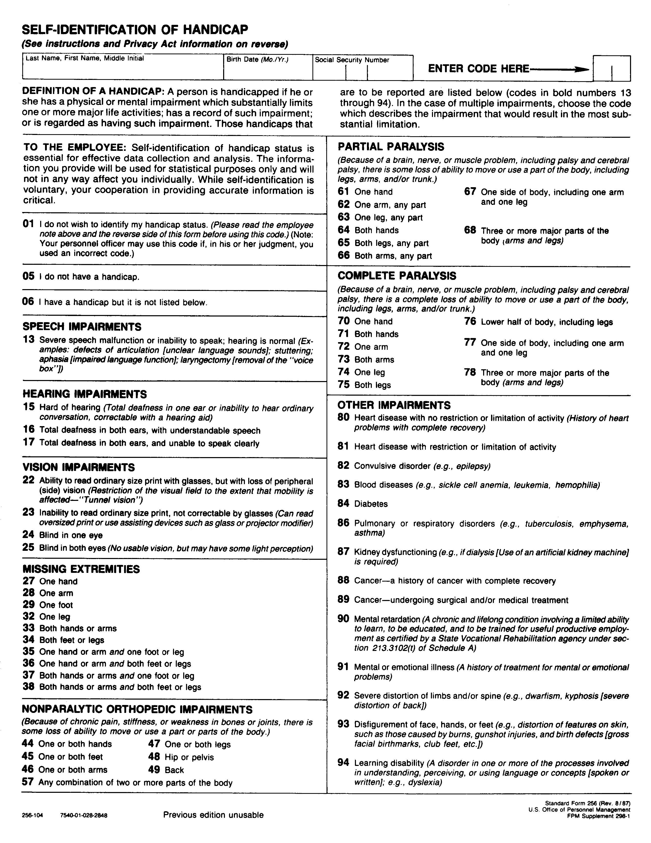
Appendix G

Procedural Checklists for Requesting and Processing Reasonable Accommodation

These checklists are intended to assist employees and supervisors, or other DMs, in navigating the reasonable accommodation process. For more information on each step, please see the appropriate section of this booklet.
NOTE: The medical documentation guidelines are found in Part II, Section D.

I. Employee Checklist:
___ 1. Make need for reasonable accommodation known
___ 2. Fill out NASA Form 1699, submit to supervisor, or other DM
___ 3. Provide relevant medical documentation, if requested
___ 4. Engage in interactive process with supervisor, or other DM
___ 5. Identify all possible options for accommodation with supervisor, or other DM
___ a. Choose the most effective option
___ b. Accept and implement the chosen option
___ c. If option is refused by employee, investigate possible alternatives
___ 6. Report to supervisor on effectiveness of the accommodation

If request is denied, by supervisor or other DM, investigate possible alternatives

II. Supervisor, or Other DM, Checklist:
___ 1. Accept notification of need for reasonable accommodation
___ 2. Receive and acknowledge NASA Form 1699
___ 3. Provide accommodation, if immediately possible; skip to #10
___ 4. Request relevant medical documentation, only if necessary
___ 5. Engage in interactive process with employee
___ 6. Identify all options for accommodation with employee
___ 7. Choose most effective option with employee
___ 8. Provide reasonable accommodation, if accepted by both parties, within 20 business days, except when extenuating circumstances exist
___ a. Develop temporary measures if the accommodation is not immediately available
___ 9. If request is to be denied, first review circumstances with EOPO
___ 10. Fill out NASA Form 1699A, and give to employee
___ 11. Provide a copy of NASA Form 1699A to EOPO for record keeping
___ 12. Follow up with employee on effectiveness of the accommodation

For the latest version of this publication, please go to the following Web site:
http://eeo.gsfc.nasa.gov/disability/publications.html
For further information on reasonable accommodation policy, procedures, guidelines, and other materials, please go to:
http://eeo.gsfc.nasa.gov/reasonableaccommodation.html
For further information, or to obtain additional copies, or copies in an alternate format, please contact:
Michael J. Hartman
Program Manager for Individuals with Disabilities
(301) 286-5715, voice and TTY Michael.J.Hartman@nasa.gov
http://eeo.gsfc.nasa.gov/disability/index.html

Equal Opportunity Programs Office
Code 120 Goddard Space Flight Center Greenbelt, MD 20771 301-286-7348, voice and TTY
http://eeo.gsfc.nasa.gov

