PUBLIC NOTICE
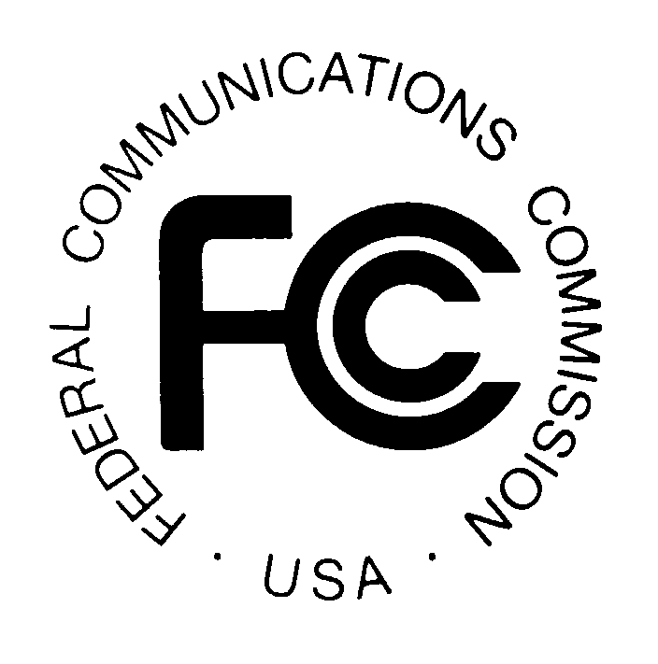
News media information 202 / 418-0500
Fax-On-Demand 202 / 418-2830
Internet: http://www.fcc.gov
TTY 202 / 418-2555

Federal Communications Commission
445 12th St., S.W.

Washington, D.C. 20554

DA 01-1679
July 13, 2001

COMMENTS INVITED ON LOG ON AMERICA, INC. APPLICATION TO DISCONTINUE DOMESTIC TELECOMMUNICATIONS SERVICES

NSD File No. W-P-D-507

Comments Due: July 27, 2001

Section 214 Application

Applicant: Log On America, Inc.

On July 2, 2001, Log On America, Inc. (LOA or Applicant), located at One Cookson Place, Providence, Rhode Island 02903, filed an application requesting authority under section 214(a) of the Communications Act of 1934, 47 U.S.C. § 214(a), and section 63.71 of the Federal Communications Commission's (FCC or Commission) rules, 47 C.F.R. § 63.71, to discontinue its domestic telecommunications service. Specifically, Applicant seeks to discontinue its telephone services to residential customers including local, in-state toll, and interstate long distance services.

The application states that LOA is in the process of selling its residential telephone customers to United Systems Access Telecom, Inc. (USA). The transaction is subject to approval by the Commission, as well as by both the Rhode Island and Maine public utility commissions. Applicant indicates that customer migration will occur no later than September 30, 2001.

In accordance with 47 C.F.R. § 63.71(c), the application will be deemed to be automatically granted on the thirty-first (31st) day after the release date of this notice, unless the Commission has notified Applicant that the grant will not be automatically effective. The FCC will normally authorize proposed discontinuances of service unless it is shown that customers or other end users would be unable to receive service or a reasonable substitute from another carrier, or that the public convenience and necessity is otherwise adversely affected.

Comments objecting to this application must be filed with the Commission by July 27, 2001. Such comments should refer to application file number W-P-D-507. Comments should include specific information about the impact of this proposed discontinuance on the
commenter, including any inability to acquire reasonable substitute service. Comments should be sent to the Office of the Secretary, Federal Communications Commission, 445 12th Street, SW, Room TW-A325, Washington, DC 20554. Two (2) copies of the comments should also be sent to the Network Services Division, Common Carrier Bureau, Federal Communications Commission, 445 12th Street, SW, Room 6-A207, Washington, DC 20554; Attention: Al McCloud.

The application will be available for review and copying during regular business hours at the FCC Reference Center, Portals II, 445 12th Street, SW, Room CY-A257, Washington, DC 20554, (202) 418-0270. A copy of the application may also be purchased from the Commission’s copy contractor, International Transcription Service, Inc. (ITS), 1231 20th Street, NW, Washington, DC 20036, telephone (202) 857-3800, facsimile (202) 857-3805, TTY (202) 293-8810.

For further information, contact Al McCloud, (202) 418-2499 (voice), amccloud@fcc.gov, or Jon Minkoff (202) 418-2353 (voice), jminkoff@fcc.gov, of the Network Services Division, Common Carrier Bureau. The TTY number is (202) 418-0484. For further information on procedures regarding Section 214 please visit the Network Services Division web site at: http://www.fcc.gov/ccb/nsd/documents/214.html.

-FEDERAL COMMUNICATIONS COMMISSION-

