Critical Infrastructure Analysis of Telecom for Natural Disasters
Gerard O’Reilly, Ahmad Jrad, Ramesh Nagarajan  {goreilly, jrad, rameshn}@lucent.com  Bell Laboratories Research, Lucent Technologies, 101 Crawfords Corner Rd.  Holmdel, NJ 07733 | and | Theresa Brown, Stephen Conrad  {tbrown, sconrad,}@sandia.gov  Sandia National Laboratories  Albuquerque, NM

ABSTRACT
Critical national infrastructures for power, emergency services, finance, and other basic industries rely heavily on information and telecommunications networks (voice, data, Internet) to provide services and conduct business. While these networks tend to be highly reliable, severe, large scale outages do occur, especially at times of unfolding disasters, which can lead to cascading effects on other dependent infrastructures. This paper describes recent natural disasters in the USA, namely hurricanes Katrina, Rita, and Wilma, and the impacts they have had on power outages and flooding leading to failures on the dependent critical infrastructure. In particular we consider the impact of these disasters on the affected telecommunication networks. We quantify the level of availability of wireline and wireless services during these network failures. We also discuss studies that were performed in preparation for a hurricane impact. The studies have been performed using the Network Simulation Modeling and Analysis Research Tool (N-SMART), which has been developed to support detailed wireline and wireless network simulations under varying network conditions and degrees of failures. We analyze the levels of outages and recovery times for these disaster events as well as possible mitigations to prepare in advance for these and other potential future disasters.

INTRODUCTION
Network outages are usually small in comparison to those large-scale outages which occur only once in many decades. The impact of three major hurricanes hitting the same region (Southeast USA) in a single year in 2005 is an example of just such a large impact event (See Figure 1):

- Hurricane Katrina, first hit Florida as a category 1 hurricane on 25 August 2005. Then Katrina crossed the Gulf of Mexico and rose gradually to a category 5 hurricane on 28 August. Katrina weakened slightly before it made landfall on 29 August 2005 and struck Louisiana, Mississippi, and the southwest part of Alabama, as a strong Category 4 with maximum sustained winds of 140 mph.
- Hurricane Rita, hit southeast Texas, and Louisiana on 24 September 2005 as a category 3 hurricane.
- Hurricane Wilma, a category 3 hurricane, hit Florida on 24 October 2005.

Figure 1. Overview of the three hurricanes

These hurricanes caused several billions of dollars of damages to telecom networks and other critical infrastructure in the impacted areas.

Communications systems were disabled because of the following:
- Direct storm damage
- Resultant flooding
- Major and widespread power outages
- Repair crews' inability to access communication equipment.

Figure 2 shows the percent of wirelines and wireless out of service in the affected areas, derived from public references [6] through [11]. The major wireline carrier in the area, BellSouth, together with the major wireless carriers, suffered approximately 3 millions lines out of service at the peak. This is estimated to be about 50% of the total lines and wireless subscribers in the affected area. Many lines were down due to loss of power, access lines on poles were blown down, and wireless towers were blow over due to high winds. Recovery was fairly rapid, over a period of weeks to most customers whose homes and businesses were still standing. There remain some uninhabitable areas, so a couple of hundred thousand “potential” lines remain out of service. Also, flooding, especially in New Orleans and surrounding areas, destroyed central office buildings.

Figure 2 - % of wirelines and wireless out of service

After Hurricane Katrina hit and caused devestating damage, there was great fear that the next hurricane, called Rita, would cause the same level of damage to the Houston area where it was directly headed. This paper describes some of the planning of possible damage scenarios for Rita and the use of simulations for predicting possible outcomes. We first introduce our simulation that represents a metropolitan area telecommunications network. Then, we describe the disruption scenarios and simulation results. Finally, we conclude with possible mitigations in advance of a hurricane.
The Houston /Galveston area, where Rita was headed, is shown on Figure 3 with all the wirecenter boundaries. This area serves approximately 4.1 million wireline and mobile subscribers.

Figure 3 - Houston, Texas Area
We will be using the following terms and abbreviations throughout the rest of the paper:
- Traffic: used to refer to actual telecom calls
- LE – Local Exchange: this is a switch serving wireline customers
- MSC – Mobile Switching Center: this is a switch serving wireless customers
- LD – Long Distance: a switch that serves no actual lines but provides long distance service
- LT – Local Tandem switch
- AT- Access Tandem switch
- ISP – Internet Service Provider: receives and processes modem calls to the Internet. ISPs do not originate calls, they only receive them
- Intra-LE traffic: traffic that originates and terminates on LEs
- LE traffic: traffic that uses an LE at either end. This also includes the Intra-LE traffic as well but it also has the LE-LD, LE-MSC, LE-ISP traffic.
The same terms above apply to MSC & LD traffic.

Traditional TELEPHONY Simulation
The Network-Simulation Modeling and Analysis Research Tool (N-SMART) has been developed to support detailed wireline and wireless network simulations [1]. It studies telecom network readiness and traffic behavior on various disaster scenarios. It can create scenarios that demonstrate the pattern of telecom traffic loads and user behavior during the time of disaster, such as physical line disconnection and switching system failure.

Figure 4. N-SMART-Voice Model
N-SMART is a discrete event (call level) telecom model that simulates capacities, blocking levels, retrials, and time to complete calls for both wireline and wireless networks. Figure 4 depicts the building blocks of the N-SMART-Voice simulation model, information input, and model output [1][2][3][4][5].
Various simulation scenarios analyze how different traffic patterns, traffic loads, user behaviors, and disaster severities impact network performance and recovery. By analyzing the results of simulations, the tool shows how different telecom elements, such as bandwidth deficiency, switch processor overload, and user behavior, impact the performance of the network and its robustness.
The simulation engine employs of algorithms to generate events related to calls, re-attempts, network failures, switch processor overloads, and collects session data in the form of simulation output. See [2-4] for details on N-SMART.
The traffic pattern in a telecommunications network changes as a function of the time-of-day. During certain hours of the day, the traffic is at a maximum while at some other hours there is a very small amount of traffic in the network. This is represented by a traffic profile, as shown in Figure 5 (e.g., 4 PM to 8 PM is the busy hours of traffic). This traffic profile is used in N-SMART to drive the traffic generation throughput during the simulation day.

Figure 5. 24-Hour Traffic Profile

Disruption Scenarios
We describe three simulation scenarios as follows:
- Baseline scenario without any disruption.
- Wide scale power outage. This is a power infrastructure outage cascading into the telecom infrastructure.
- Wide scale power outage AND disrupt many buildings in the South East region due to flooding, that is both a power infrastructure and a telecom outage.
Using the traffic profile from Figure 5 for the baseline scenario, Figure 6 shows the simulation results.
Figure6. Baseline Calls

There are nine statistics on Figure 6 as follows:
- FATT - first attempts of calls
- GEN - total calls generated
- ADM - admitted calls which complete
- SWBL - switch blocked calls
- TRBL - trunk blocked calls
- BSY - calls which end to busy line
- ABDN - calls which are abandoned
- ANSM - calls routed to an answering machine
- ACTIVE - total active calls across the network

All of these statistics, with the exception of ACTIVE, are cumulative call counts over 5-minute intervals. The ACTIVE measure is a snapshot of the total number of active calls at the sampling instant (end of every 5 minute interval). Figure shows call statistics for the baseline scenario, also representing the 24-hour traffic profile for our metropolitan area. The busy hour is from 16:00 (4 PM) to 20:00 (8 PM). Under normal conditions (no disruptions), most first attempts (FATT) are admitted (ADM) and complete except for a small fraction encountering busy. But most of them are retried and complete on subsequent attempts if the user doesn’t abandon.

Scenario 2 Discussion
In advance of the impending hurricane Rita, the storm track was identified as heading straight for Houston, Texas as shown in Figure 7.

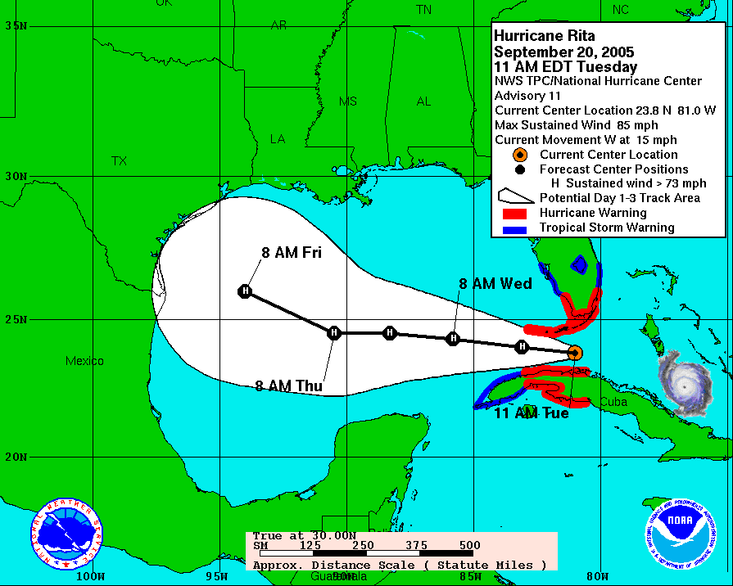

Figure 7 - Rita Unfolding (as of 21 Sept 2005)
Predictions were made by Los Alamos National Laboratory on the potential power outage in the area (Figure 8).
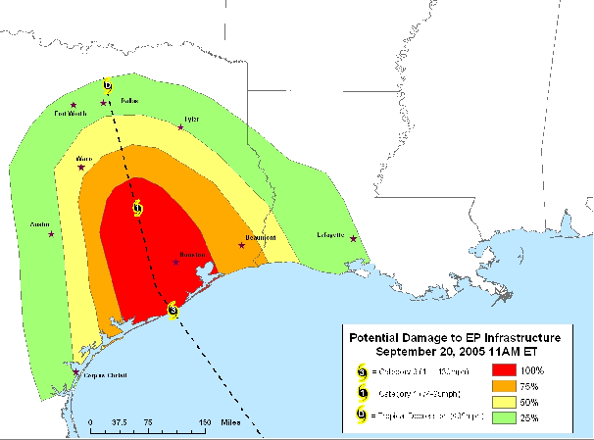

Figure 8 - Possible Power Outage map

Figure 9 - Scenario 2: Traffic Impacted by wide scale power outage
In a wide scale power outage, most mobile traffic will be out of service after a few hours when the cell towers batteries run out. i.e., about 36% of overall traffic in the area as shown on Figure 9. Note: wireline and mobile switching offices with diesel back-up generators should survive power outages.

Scenario 3 RESULTS
This scenario considers failure of the entire mobile network due to power outage of base stations + telecom office failures in the Southeast region due to flooding.

- 12 total Mobile Switch Centers are failed because their cell towers failed.
- 18 total Local Exchanges (LEs) are failed
- No Access Tandem, Local Tandem, or Long Distance offices are failed
The failure lasts for just 24 hours (in reality flooding would cause the failure to potentially last much longer). The failure occurs from 12:00 noon of the first day of impact to 12 noon of the second day.

Figure 10 shows the level of call build-up, because of re-attempts across the wireline and mobile networks. Generated calls at the peak can be more than 20 times normal.

Figure 10 - Scenario 3 – power outage and SE Region flooded

Figure 11 shows the blocking levels for all calls during the disruption which was greater than 95% for many hours of the simulation.

Figure 11 - Scenario 3 – blocking levels
Figure 12 shows a network snapshot at the height of blocking where red shows the highest level of blocking (greater than 75%).

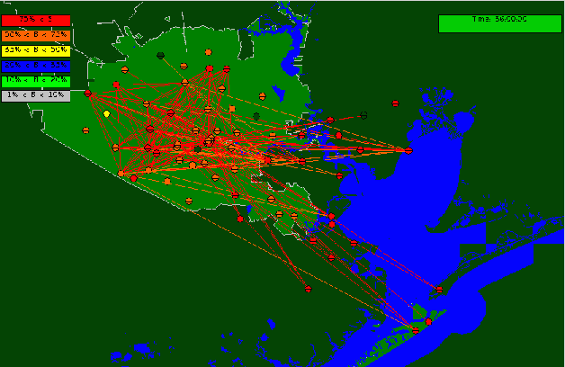

Figure 12 - Scenario 3 during the height of failure
Figure 13 shows the network starting to recover 30 minutes after the failure ends. It takes several hours for the substantial blocking levels to subside.

Figure 13 - Scenario 3 - 30 minutes after the failure ended

There are many potential uses for simulations of this type as follows:

- Pre-Evaluate Susceptible Regions
- Set Requirements and Practices for Mitigation
- Network Design Changes for Redundancy
- Pre-Deploy Spares and Material
- Real-Time Deployment of Emergency Staff

In addition, special scenarios can be simulated to assess the impact of various evacuation scenarios on the telecommunication network. This can help in finding and employing the scenario, which would maintain the maximum connectivity between the affected residents and the local authorities and emergency services.

Mitigating Strategies
Communications companies, both wireline and wireless, have mitigating strategies to prepare for disasters and to restore service after disasters.

In general, restorations are prioritized along these general guidelines:
- TSP (Telephone Service Priority - Ordered list of critical facilities to restore)
- Critical Services
- High priority business sites

Mitigating Power Disruptions
Many telephone service interruptions result from widespread power outages. In anticipation of electrical outages during severe weather conditions, telcos maintain generators in all central offices and back-up power sources to remote terminals. The back-up power to remote terminals lasts approximately 8 to 10 hours. If it is depleted, Telco crews enter the area as soon as it safe and accessible to deploy generators or replace back-up power sources.
Some wireless operators adopt a strategy to get their cell sites back in operation without the support of commercial power.
- First, some wireless networks are "hardened" with the installation of permanent generators for cell sites serving critical public sector clients such as hospitals, airports and military installations.
- Second, hundreds of portable generators are ready to be deployed to cell sites that have lost power. They have also pre-planned deliveries of fuel to these emergency generators and high priority status for additional deliveries during an emergency.

Mitigating Strategies for HURRICANES
Telcos prepare in many ways for disaster situations. For example, they
- Move vehicles and equipment away from the coast, and deploy crews to staging sites where they can enter the affected areas after the storm ends.
- Put controls in place to manage network traffic flow.
- Survey remote terminals near the coast so they can be repaired quickly as needed.
- Make plans to assess damage after the storm abates.
- Put employees in other regions on stand-by to assist as needed, and arrange for local emergency housing.

After a natural disaster like a hurricane occurs, a Telco’s efforts proceed in an orderly manner designed to ensure the safety of employees. Restoration begins in the central offices and moves outward toward the customers’ premises. As soon as the affected area is declared safe for entry, Telco employees survey and assess the damage to company facilities. Once the downed power lines are cleared, Telco employees can begin restoration work. The facility restoration/sweep process focuses on repairing damage to large feeder cables first, followed by smaller distribution cables next. These facilities must be restored before restoring service to local areas and replacing facilities into each customer's home or business. Unlike power companies that can usually repair a common line serving many people in an area, the telecommunications network features a dedicated pair of wires in each cable for each customer. As a result, telecom restoration can potentially be far more complex to achieve and service must be restored one customer connection at a time.

Wireless MITIGATIONS
Wireless telcos have much the same procedures as wireline operators, except that their “access plant” is different, i.e., wireless cell phone to cell tower. They prepare in many ways, For example, they
- Tow or drive self-contained mobile cell sites called Cellular on Wheels, or "COWs," into an area to provide extra call capacity or to restore communications following a disaster.
- Drive "COLTs," (Cellular on Light Trucks), which are smaller than COWs, wherever a mobile cell site is needed and include two masts for microwave antennas.
- Prepare a "RAT," or Remote Antenna Trailers, to provide back-up antenna service if a tower is out of service.
- Send portable electrical generators in from across the country to provide emergency power to cell sites without permanent generators.
- Ready thousands of loaner wireless phones and extra batteries for distribution and use by local emergency personnel.
- Finally, since high winds and falling limbs cause much of the damage during storms, some telcos place a high percentage of their lines in underground facilities (Buried Cable and Conduit) instead of aerial cable on poles. For example, Table 1 shows the % aerial cable by State, the lower number the better for telecommunications survival. This is more costly but increases telecommunications survival of both the access plant for wireline and cell tower connectivity for wireless.

Table 1- % Aerial cable by State
State | % aerial cable
Texas | 19%
Florida | 22%
Louisiana | 26%
Mississippi | 33%
Alabama | 39%

References
- David J. Houck, Eunyoung Kim, Gerard P. O’Reilly, David D. Picklesimer, Huseyin Uzunalioglu, “A Network Survivability Model For Critical National Infrastructure,” Bell Labs Technical Journal, Volume 8, Number 4, 2003.
- Ahmad Jrad, Huseyin Uzunalioglu, David J. Houck, Gerard O’Reilly, Stephen Conrad, Walt Beyeler “Wireless and Wireline Network Interactions in Disaster Scenarios, presented at MILCOM 2005, September 2005.
[3] Gerard P. O’Reilly, David J. Houck, Eunyoung Kim, Thomas B. Morawski, David Picklesimer, Huseyin Uzunalioglu, “Infrastructure Simulations of Disaster Scenarios,” Networks 2004, Vienna, Austria, June, 2004.
[4] Walt Beyeler, Stephen Conrad, Thomas Corbet, Gerard P. O’Reilly, David D. Picklesimer, “Inter- Infrastructure Modeling - Ports and Telecommunications,” Bell Labs Technical Journal, Volume 9, Number 2, 2004, 91-105.
[5] Gerard O’Reilly, Huseyin Uzunalioglu, Stephen Conrad, Walt Beyeler, “Inter-Infrastructure Simulations across Telecom, Power, and Emergency Services,” 2005 Design of Reliable Communication Networks - 5th International Workshop, Ischia, Italy, October 2005,
[6] BellSouth Press Releases, http://bellsouthcorp.com/emergency.
[7] Cingular Wireless Releases. http://cingular.mediaroom.com
[8] SBC Press Releases. http://www.sbc.com/gen
[9] Sprint Nextel Releases http://www2.sprint.com/mr/newsrelease
[9] Verizon Press Release news.vzw.com
[10] Mobile Pipeline http://www.mobilepipeline.com
[11] Cellular South www.cellularsouth.com

