FEDERAL COMMUNICATIONS COMMISSION
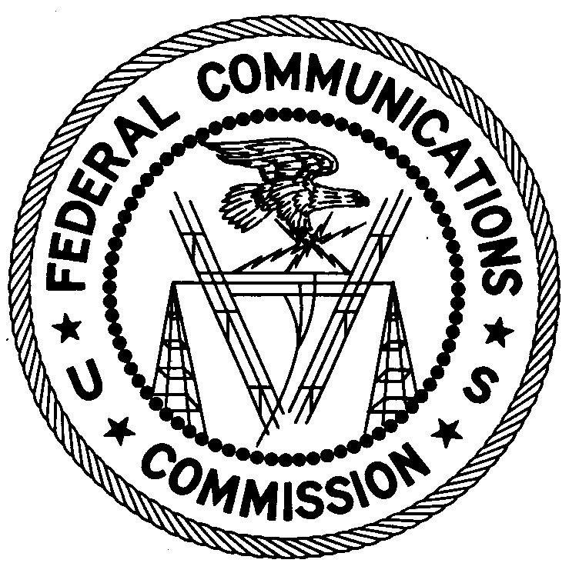
ENFORCEMENT BUREAU
Western Region

San Diego Office
4542 Ruffner Street, Suite 370

San Diego, CA 92111

July 13, 2005

Overdrive Broadcasting
Flagstaff, Arizona 86001

NOTICE OF UNLICENSED OPERATION

Case Number: EB-04-SD-198

Document Number: W200532940002

The San Diego Office received information that an unlicensed broadcast radio station on 1650 kHz was allegedly operating in Flagstaff, Arizona. On May 17, 2005, agents from this office confirmed by direction finding techniques that a radio transmitter operating on the frequency 1650 kHz was located on West University Street, Flagstaff, Arizona. The Commission’s records show that no license was issued for operation of a broadcast station at this location on 1650 kHz in Flagstaff, Arizona.

Radio stations must be licensed by the FCC pursuant to 47 U.S.C. § 301. The only exception to this licensing requirement is for certain transmitters using or operating at a power level that complies with the standards established in Part 15 of the Commission’s rules, 47 C.F.R. §§ 15.1 et seq. Your operation on frequency 1650 kHz was measured at 7,400 microvolts per meter (µV/m) at 122 meters. This exceeds the allowable unlicensed limit of 14.5 µV/m at 30 meters established in 47 C.F.R. § 15.209(a). Thus, this station is operating in violation of 47 U.S.C. § 301.

You are hereby warned that operation of radio transmitting equipment without a valid radio station authorization constitutes a violation of the Federal laws cited above and could subject the operator to severe penalties, including, but not limited to, substantial monetary fines, in rem arrest action against the offending radio equipment, and criminal sanctions including imprisonment. (See 47 U.S.C. §§ 401, 501, 503 and 510).

UNLICENSED OPERATION OF THIS RADIO STATION MUST BE DISCONTINUED IMMEDIATELY.

You have ten (10) days from the date of this notice to respond with any evidence that you have authority to operate granted by the FCC. Your response should be sent to the address in the letterhead and reference the listed case and document number. Under the Privacy Act of 1974, 5 U.S.C. § 552a(e)(3), we are informing you that the Commission’s staff will use all relevant material information before it to determine what, if any, enforcement action is required to ensure your compliance with FCC Rules. This will include any information that you disclose in your reply.

You may contact this office if you have any questions.

William R. Zears Jr.
District Director
San Diego Office

Attachments:
Excerpts from the Communications Act of 1934, As Amended
Enforcement Bureau, "Inspection Fact Sheet", July 2003

