POLAR Spacecraft Status As of: Weds May 11 12:00 EST
(changes from last week in bold border)
Subsystem/  Component | NOAA-12D  AM: 1648=AN  STIP data only | NOAA-14J  AM: 2019=AN  STIP data only | NOAA-15K  AM: 1817=AN  GAC data only | NOAA-16L  PM: 1430=AN  GAC&LAC data | NOAA-17M  AM: 2224=AN  GAC&LAC data | NOAA-N18  Planned PM  Plan AN=14:00
LAUNCHED | 05/14/91 | 12/30/94 | 05/13/98 | 09/21/00 | 6/24/02 | 12May05 10:30Z  Slip due to winds
CNTL OBP | OBP2 | OBP2  OBP1 inoperative | OBP2 | OBP2 | OBP2 | Dress Rehearse #1  Completed 13Jan
BUS | B-BUS  XSU-1 | B-BUS  XSU2 (XSU1 inop) | B-BUS  XSU-1 | B-BUS  XSU-1  XSU1 TOAR 444 | B-BUS  XSU-1 | Dress Rehearse #2  Completed 14Apr05
BUS VETO | NO | NO | NO | NO | NO | Dress rehearse #3  Completed 9 May 05
ADACS  X=Yaw  Y=Roll  Z=Pitch | Nominal Mode  RGmode=Monitor  Gyro chans=XYZ | Nominal Mode  Rgmode=Disabled  Gyro chans=XYZ  SS check Disabled when mode=YGC | Nominal Mode  Rgmode=Monitor  Gyro-3 Off 6/26/00 Gyro chans=AAB  N2 Low PSI invalid | Nominal Mode  Rgmode=Monitor  Gyro-3 Off 6/10/04  Gyro chans=AAA | Nominal Mode  Rgmode=Monitor  Gyro-3 Off 6/10/04  Gyro chans=AAB | New  ring laser gyro
RXO | PRI  BU random enables  daily bias+6.5 mS | PRI  BU random enables daily bias–7.0 mS | PRI  daily bias -8 mS  +100 mS 31Au04 | PRI  Daily Bias –5.5 mS  -100 mS 31Au04 | PRI  Daily Bias –3 mS
CLOCK DIV | 2 | 2 | 2 | 2 | 2
MIRP | External Synch  Rephase Enabled | External Synch  Rephase 0730 Daily | External Synch Rephase 0730 daily | External Sync  Rephase each orbit | External Sync  Rephase Enabled
TIP SIDE | 1 | 1 | 2  (since 4/23/03)  3 Channels inop | 2  since 4/18/05 | 1  Analog telem drifting
DTRs | 3A, 4, 5B  Safestate 5B | 1, 2B, 5 Safestate- 1B | 1, 2, 3, 4 Safestate 1B EOT | 1,2,3,4A  Safestate 3A  4B STIP only | 1,2,3,4  Safestate=1B  DTR2-SSR | All solid state digital recorders
VTX  (APT data) | #1 ON  137.50 MHZ  Conflict with N15 | OFF  Since 8/14/02 | OFF  (15Apr-16May)  Conflict with N12 | INOP  OFF since 11/15/00 | #2 ON  137.62 MHZ | #1=137.1 MHZ #2=137.9125 MHZ
BTX | #1  136.77 MHZ | #2  137.77 MHZ | #1  137.35 MHZ | #1  137.35 MHZ | #2  137.77 MHZ
STX  #1=1698.0 mhz  #2=1702.5 mhz  #3=1707.0 mhz  #4=2247.5 mhz | 1 – HRPT;  2,3 - Playback | 3 – HRPT  2, 1 – Playback | 2-Omni HRPT  4-Playback  1,2,3-Degraded | 1 – HRPT;  2– Playback;  4 – Playback  3 low power unused | 3 – HRPT  TOAR424 low power  2 & 4 Playback  1-Standby  STX-1 output power drop TOAR 443. | STX-3  Replaced at VAFB
POWER  (Array offset and CANT angle, charge & V/T rates, eclipse states and sun angle) | ArrayOff +50  since 8/31/04  Eclipse season 21Apr-17Aug  Batt UVtrip 7/25/04  Sun Angle 27  up to 37 mid-June  Batts 1&2=LRC  V/T=4  Shunt degraded  SA CANT=37 degs | Array Off -55  Since 8/21/03  Eclipse all year  Sun angle 44  up trend to 52 in June  Batts 1-3= LRC  Batts 1&3V/T=7/11  Batt2 VT=8/11  SS trigger =18.98  Shunt Degraded  SA CANT=22 degs | Array Off -45  Since 1/25/01  Full Sun  Eclipse Season starts 21 May  Sun Angle 22, up- trend to 32 in June  Batts 1-3= LRC  V/T=7/9  SA CANT=37 degs | Array Off -40  Since 7/16/02  Eclipse all year  Sun Angle 54  Steady trend  Batts 1-3= LRC  V/T=4/8  SA CANT=22 degs  SADPOS timer increased 5 Apr | Array Off. –40  Since 1/29/04  Eclipse all year  Sun Angle at 69  Uptrend to 72 at  the end of May  Batts 1-3= LRC  V/T= 4/8  SA CANT=37 degs  SADPOS timer increased 5 Apr
AVHRR | Nominal | INOP  Scan motor stalled  14 Apr 04 | Nominal  Rare major scan motor surges. Last  Incident 11/18/04 | Operational  TCE24 OFF 4/14/04  Occasional Image Wave patterns  Chan 3B only. | Nominal  3A-B switch enabled | New brushless scan motors
AMSU-A1 |  |  | Operational  Ch14 inoperative  Ch11 inoperative  Record low component temps reversed trend | Operational  Primary PLLO chans 9-14 bias shift.  Backup PLLO inop  Channel 9-14 noise improved since 1/19 | OFF/INOP  Since 10/30/03  Survival heat on.
AMSU-A2 |  |  | Nominal | Nominal  Space Position-2 | Nominal
AMSU-B |  |  | Operational  Bias in All Chans.  Motor surges most recent 11/14/04  IPD Reports of degraded data on Chan-3 since 4/30 | Operational  Space Position-3  IPD reports channel 8 degradation | Nominal | Replaced by MHS
HIRS | ON / INOP  Turned on 8/30/04  For power balance  Filter Wheel turned OFF 10/17/02. | NOMINAL  Operational  Occasional loss of Fwheel synch | INOP  Downgraded to RED status  19 Apr 05  TOAR 445 submitted  FW mode=Hi Powr  FW Heater OFF  Frequent Filter  Excessively high FM temps and currents continue | DEGRADED  Longwave channel imagery improved radiometric noise level is still high  TOAR 441 submitted 11 Jan05  Considering high power mode  Occasional major FM surges, most recent  12/9/04 | NOMINAL  1 Pixel cross track misalignment . | HIRS-4 replacing HIRS-3
MHS/MIU |  |  |  |  |  | Replaces AMSUB
MSU | ON / INOP  On For power balance Scan Motor OFF since 3/12/03 | Operational  Scan motor and antenna problems
SSU |  | Nominal
DCS | Nominal | Nominal | Nominal | Nominal | Nominal
SARR |  | Nominal | Operational  A-Side, AGC Mode  Intermittent failures for 243MHz A&B | Operational  Switched back to mode AA  26Apr05 14:10Z  A-side, AGC Mode  (B-side in FG mode)  243 MHz = INOP. | Nominal  A-side  All AGC Mode
SARP |  | OFF  Power Failure | Nominal  RCVR B/W = 2 | Nominal  RCVR B/W = 2 | Nominal
SEM | ON/Nominal  Turned on 8/30/04  Elec-CH-HVPS=4  Prot-CH-HVPS=0 | Operational  Elec-CH-HVPS=0  Prot-CH-HVPS=0  1 of 4 Telescopes inoperative | Nominal  E-CDEM-HVPS=2  P-CDEM-HVPS=0 | Nominal  E-CDEM-HVPS=5  P-CDEM-HVPS=4 | Nominal  E-CDEM-HVPS=2  P-CDEM-HVPS=3
SBUV |  | Degraded  Grate motor sticks  Flex memory 3 (giant step) ops suspended 12/2/03  Reduced operations |  | Operational  Degraded Ozone data  Backup Diffuser inop  Primary Diffuser deployment problem TOAR 426  AMSU EMI causing erratic Behavior in PMT cathod, range 3 | Nominal  Anode Mode  Plan sweep mode Standard Ops Procedure change  starting 17 May
SADPOS |  |  | N/A | ON  Enabled MFactor50%  Timer changed to 12 (from 8 mins 5 Apr | ON  ENABLED  Timer changed to 12 (from 8 mins 5 Apr
THERMAL  Heaters, louvers  TCE’s | Nominal  TCE’s back to nominal configuration following 7/25/04 UVtrip. | Nominal | TCE26 & 15H  Telem invalid  TOAR 432  HIRS FW Heat tuned ON 17 Apr and OFF on 18 Apr  TCE24L&25L (HIRS & AVHRR) failed 5/13/98  RCE thermostat failed 5/13/98 | Nominal  TCE24 OFF 4/14 (AVHRR H&L)  HIRS Filter heater turned OFF 1/18/05 | TCE3H Batt 2A heater failed ON, turned off 8/26/03 TOAR 428  CLOSED 9/14/04 no corrective action possible.  AMSU-A1 survival heaters on 10/29/03
 | N12 | N14 | N15 | N16 | N17 | NOAA-N18

COMMENTS/CHANGES:

NOAA-12 There were no changes on N12 during the past reporting period.

NOAA-14: Spacecraft is operating nominally and power subsystem remains stable and above safe state threshold values as the
long slow increase in percentage darkness time per orbit continues through mid-June 05. Otherwise there were no changes to N14 during the past reporting period.

NOAA-15: The N15 HIRS filter wheel remained at severely elevated (albeit not record high) temperatures and currents last week although it did remain generally stable. Imagery remains completely degraded, period monitor values excessive and filter wheel synch always out of synch. No further discussion has ensued regarding the possibility of toggling the filter motor in the hope of breaking the filter wheel through whatever is obstructing it. N15 HIRS remains red in status (inoperative) in high power mode with heaters OFF. (See illustration 1).

NOAA remains concerned about the possible influence that the HIRS situation will have on the spacecraft subsystem, notably AMSU’s, and the AVHRR (power was originally a concern as well but has proven to be a non-issue). The N15 AVHRR scan motor current has shown some indications of less stable scan motor current and has thermally been approaching record highs (and may even have actually exceeded record highs if one takes into consideration the drop in values that followed the N15 TIP swap). In addition, synch delta has continued to slowly increase and is running at its highest level this year (although it remains well below MIRP rephase thresholds) while imagery still appears to be nominal (illustrations 2-4). The N15 AMSU-B also appears to be performing in a slightly less stable manner but its scan motor currents and temps remains within nominal values (illustration 5). The two other AMSU’s (A1 and 2) have been stable and nominal throughout the past reporting period (illustration 6).

The N15 eclipse season is expected to start within the next 2 weeks, EMOSS engineer Carl Gliniak has generated a
floor procedure in preparation for this event. No reconfigurations are expected although additional assessments will be
performed as the spacecraft progresses through this eclipse season.

N15 VTX-1 (APT data) remains turned off due through 16 May to an RF conflict with N12.

NOAA-16: The N16 AVHRR scan motor current and especially synch delta continued to degrade over the past week. Several
confirmed and several other probable (but unconfirmed) MIRP rephases have occurred in recent days as the synch delta has degraded. Conversely, even with relatively high scan motor currents, the N16 AVHRR imagery appears to be relatively nominal with the only degradation being the single frames of lost data that occurs when the MIRP rephases. Even wave patterns, which almost always occurred at the scan motor currents at recent levels, are not apparent in the imagery reviewed by EMOSS engineers. Also on the favorable side are the AVHRR scan motor temps which have been nominal and stable throughout 2005 even though the AVHRR TCE has been powered off during that entire period. (See illustrations 7-10.)

The N16 HIRS was nominal and stable last week (illustration 11) as were the N16 AMSU’s and ADACS subsystem.

NOAA-17: The N17 AVHRR scan motor current and temps were both very stable during the past week while synch delta and
AVHRR component temps were very stable and imagery remained nominal (illustrations 12 and 13). The two remaining AMSU’s (A2 and B) were also nominal during the same time period (illustration 14). The N17 HIRS was also generally stable during the past week although its period monitor appeared to be slightly less stable than the week before. However, in analyzing this period monitor value over the course of the mission, this slight reduction of stability appears to be well within nominal operating ranges (illustrations 15 and 16). NOTE: THE ILLUSTRATIONS FOR N17 DATA INCLUDE MERGED FILES OF ABE AND GRETA DATA. AS THE ILLUSTRATIONS SHOW, THEY APPEAR TO MATCH UP PERFECTLY.

At the request of the Polar Program Office EMOSS engineer Jim Walters is overseeing a change in the N17 SBUV standard operating procedure. The NOAA-17 SBUV currently spends 14 orbits in sweep mode every Tuesday. This will be reduced to 4 orbits in sweep mode. These orbits should not cross over the CONUS, or at least not do so in daylight. The SOMS procedure SBSWMODE will be run every Tuesday and the wait time in this procedure must be changed to 24240 seconds. These schedule changes are intended to be permanent and will be implemented beginning 17 May 05.

NOAA-N: EMOSS Supported the final (#3) dress rehearsal is scheduled on 9 May and is a go for launch. The launch slipped 24
hours from to 12 May (same time, approx 10:30Z) because of high winds with at the launch site (Vandenberg). The EMOSS on-console support schedule for launch and OV are included at the back of this report.

MISC: Integrating ABE into the Greta process continues to make progress and meet with difficulty at the same time. The
primary problem is one of “results success/failure variability” when running “fixed” scripts and inputs. Jeff Devine is EMOSS POC for this effort.

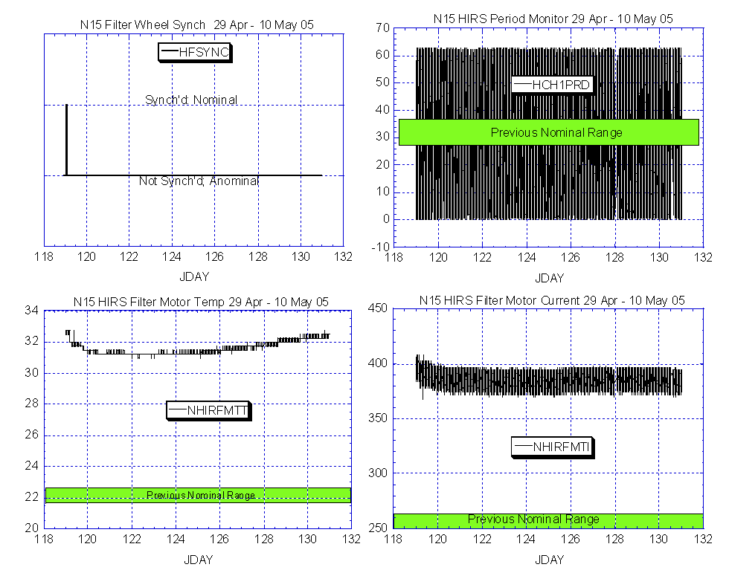

Illustration 1: N15 HIRS Health Analysis:

(Inoperative and no improvement)

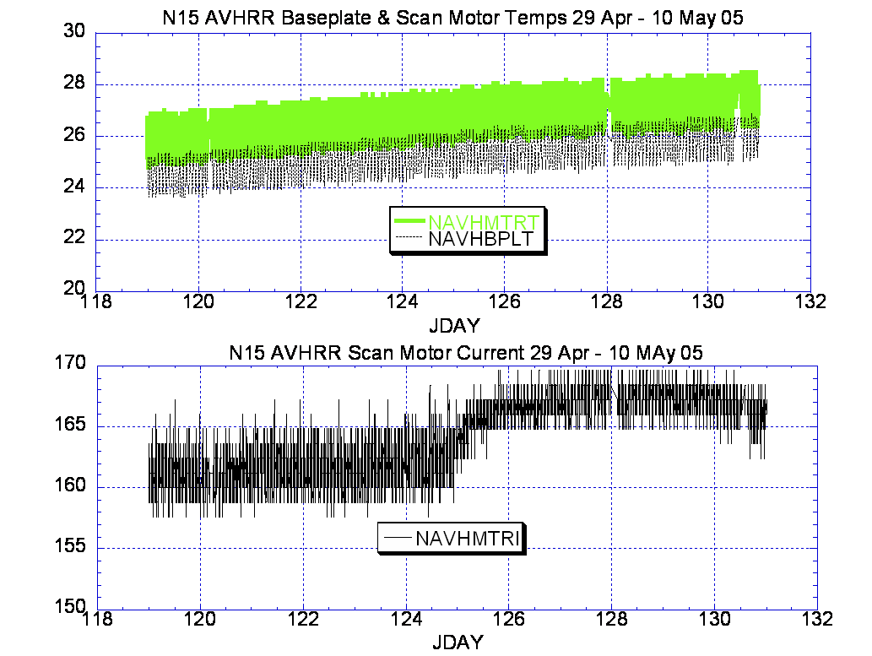

Illustration 2: N15 AVHRR Analysis

(Looking for cause effects from HIRS anomaly, none readily apparent, but the small increase on JDAY 125 is something to keep an eye on.)

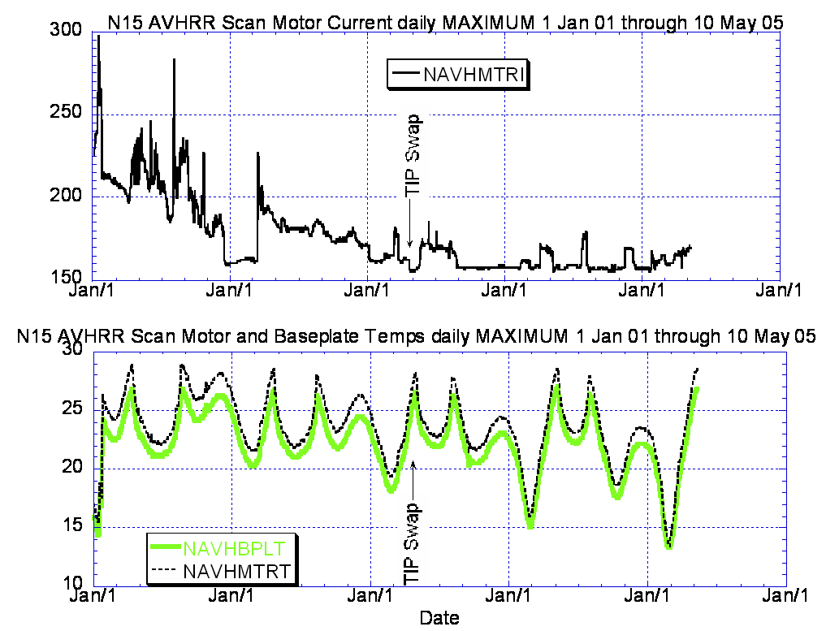

Illustration 3: N15 AVHRR Analysis in perspective

(Scan motor current rise not especially significant from a historical perspective but the temps are approaching all time highs and, if the drop caused by the TIP swap in Apr 2003 is taken in to account, may even be at all time highs.)

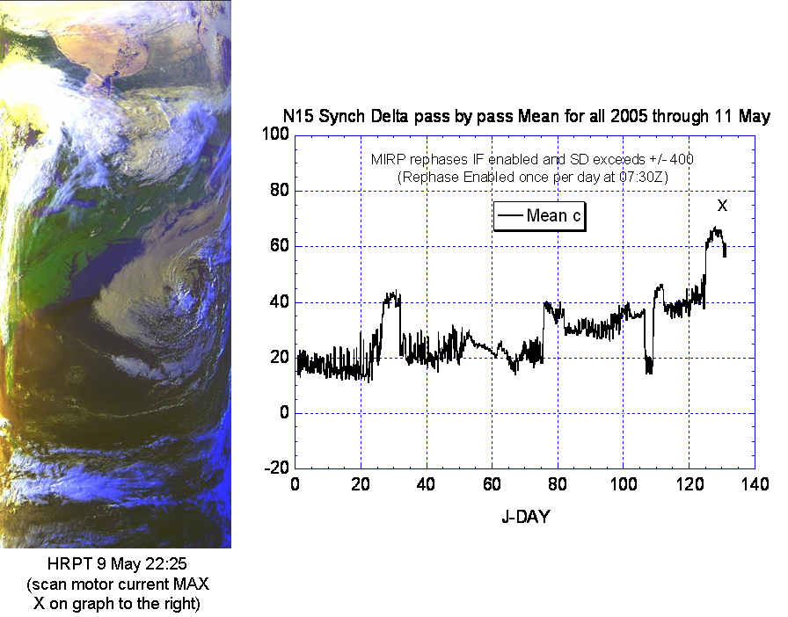

Illustration 4: N15 AVHRR Imagery and Synch Delta Analysis
(Looking for cause effects from HIRS anomaly, none readily apparent but there is a non-auspicious trend that seems to be developing on the synch delta value that may require further attention in the weeks ahead.)

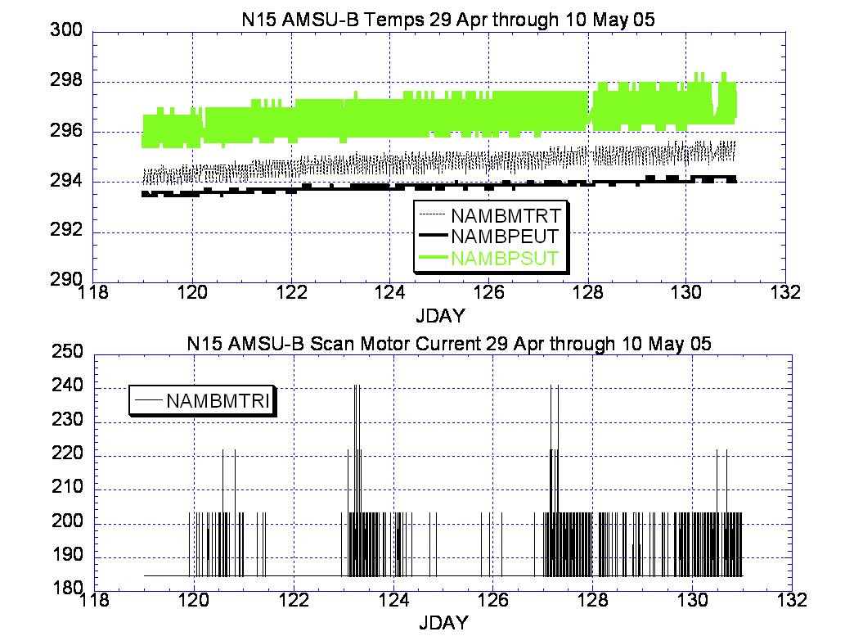

Illustration 5: N15 AMSU-B Analysis
(Looking for cause effects from HIRS anomaly, none readily apparent although the AMSU-B scan motor current continues showing some minor instabilities that are well within normal operating profiles.)

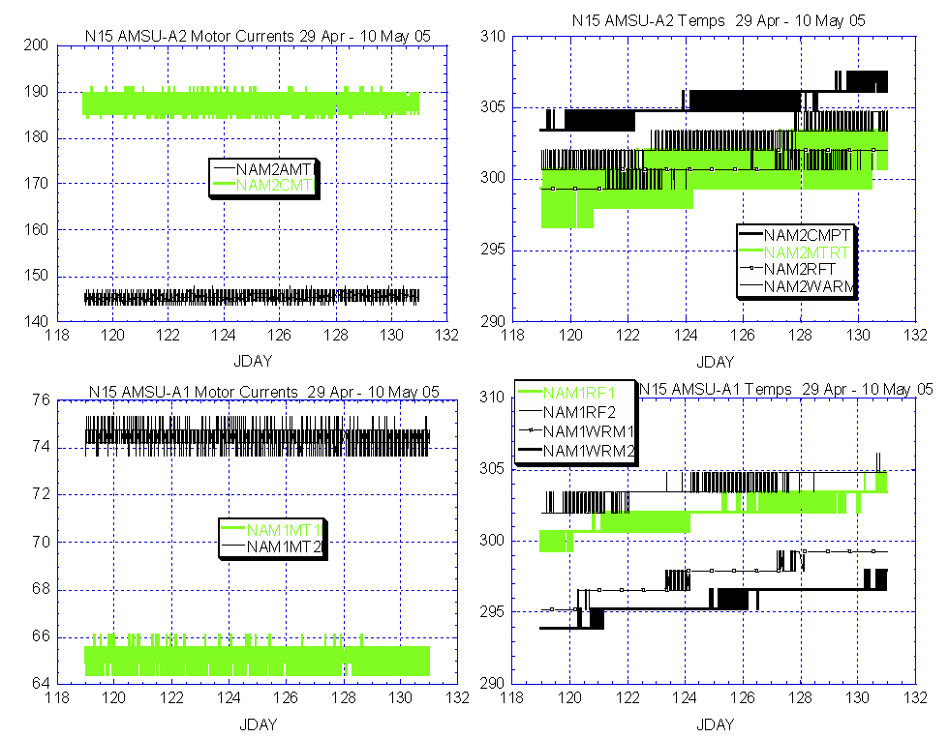

Illustration 6: N15 AMSU-A1and 2 Analysis
(Looking for cause effects from HIRS anomaly, none readily apparent, in fact, power usage, as measured by bus current appears slightly lower since the HIRS started drawing additional current.)

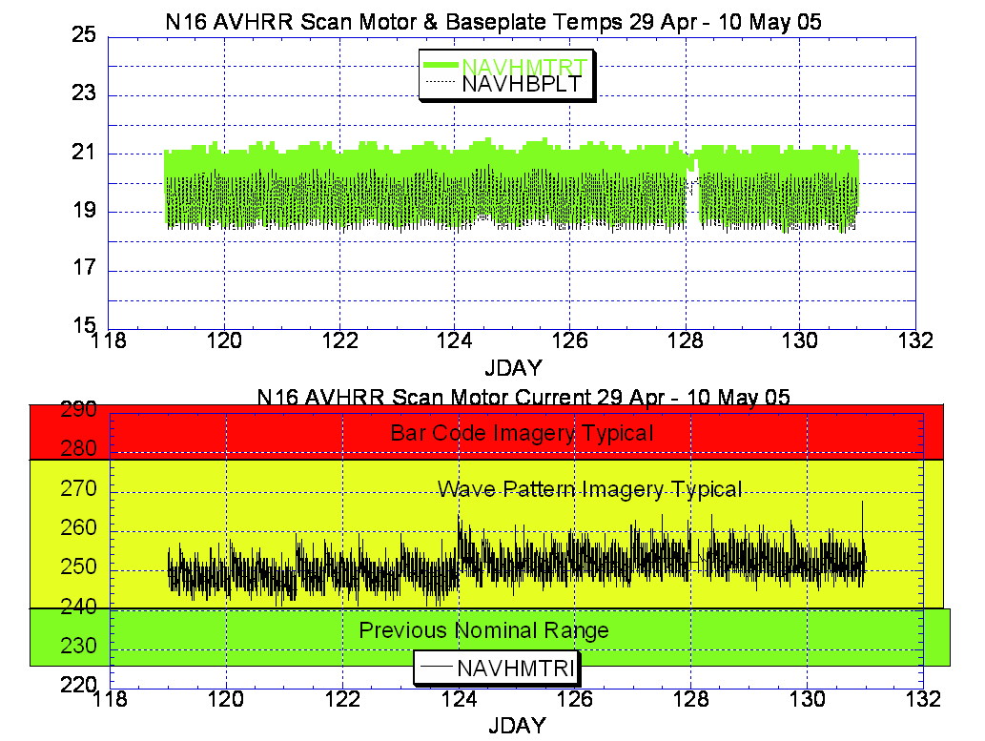

Illustration 7: N16 AVHRR Health
(The scan motor current has been better and its not trending in a favorable direction.)

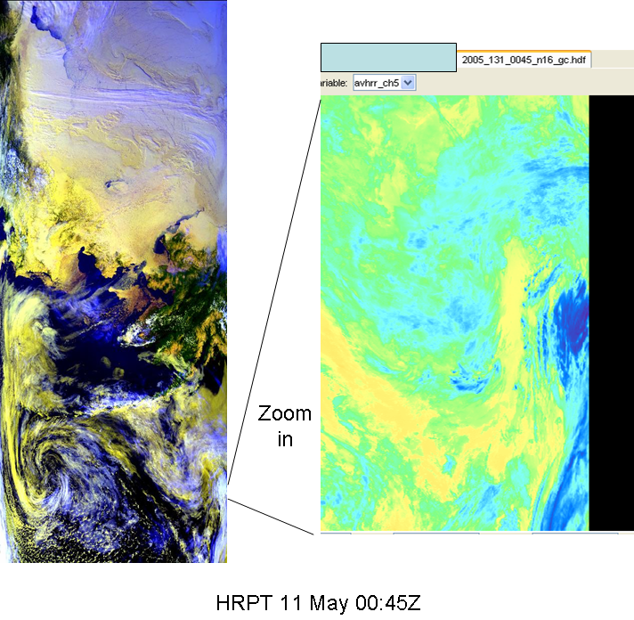

Illustration 8: N16 AVHRR Imagery Analysis
(Imagery looks OK today, notwithstanding the elevated scan motor current, wave patterns have not been readily apparent from an EMOSS perspective of imagery analysis.

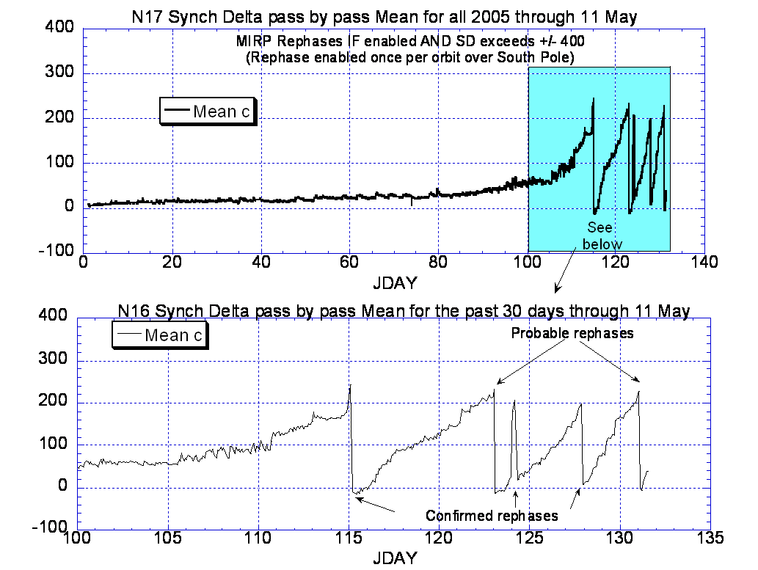

Illustration 9: N16 Synch Delta Analysis
(Definitely not a favorable trend)

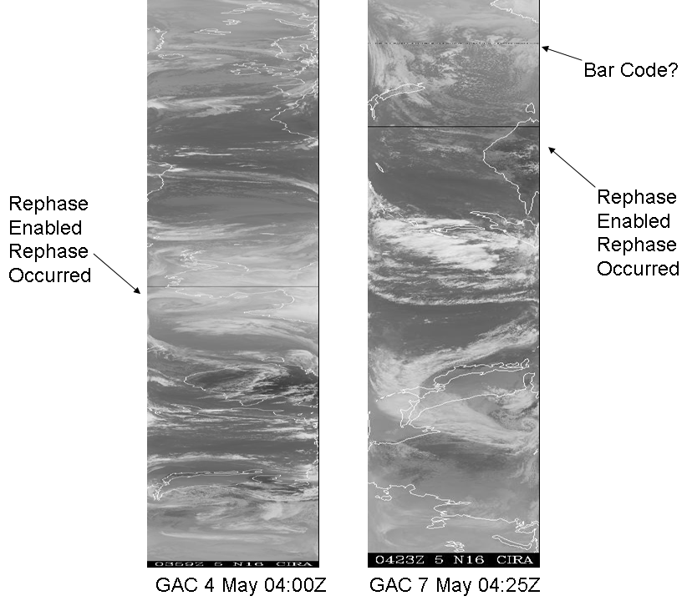

Illustration 10: N16 Imagery Analysis relative to synch delta
(Also, definitely not a favorable trend. Not all rephases are “detectable” relative to the EMOSS process. Use of GAC imagery that includes South Polar Region provides the best evidence of rephases occurring.)

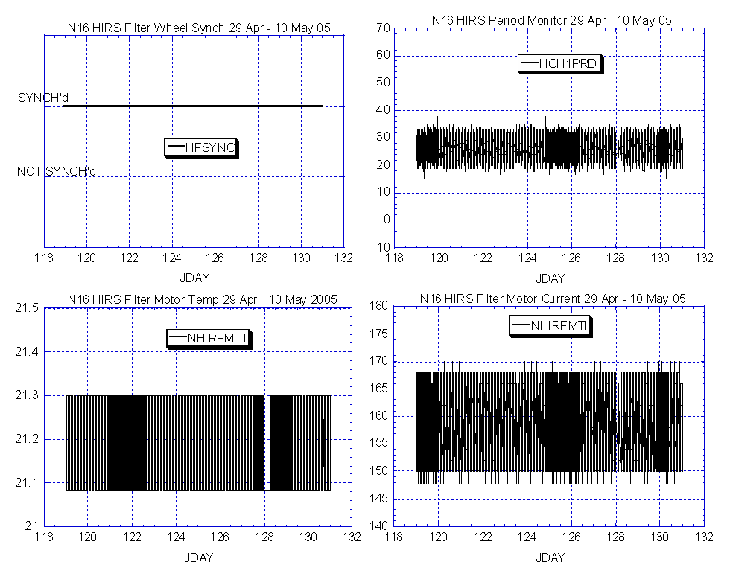

Illustration 11: N16 HIRS Analysis
(Stable.)

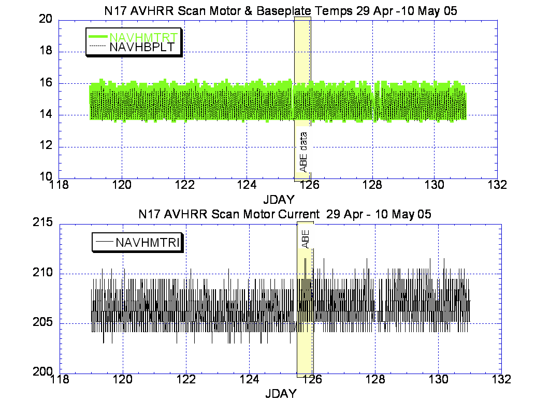

Illustration 12: N17 AVHRR Analysis
(Stable and nominal note the inclusion of ABE data into this primarily Greta data graph.)

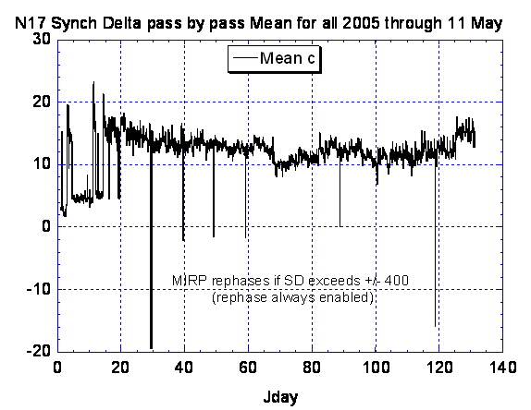

Illustration 14: N17 Synch Delta Analysis
(Generally stable and nominal)

Illustration 13: N17 Synch Delta Analysis
(Generally stable and nominal)

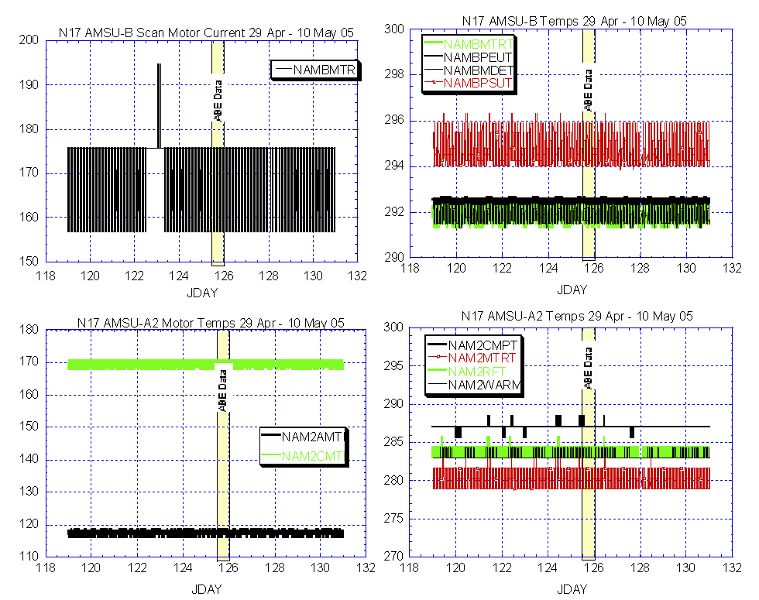

Illustration 14: N17 AMSU-A2 and B Health Analysis
(Stable and nominal. Note the use of ABE data within this primarily Greta data graph.)

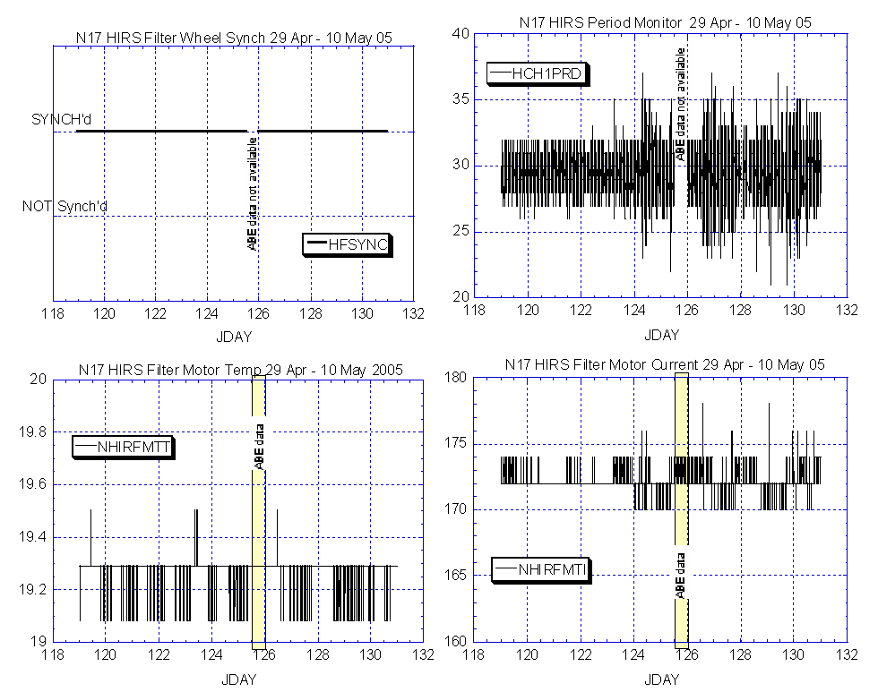

Illustration 15: N17 HIRS Health Analysis

(Nominal and generally stable except for the Period Monitor value which appears a little less stable than last week.)

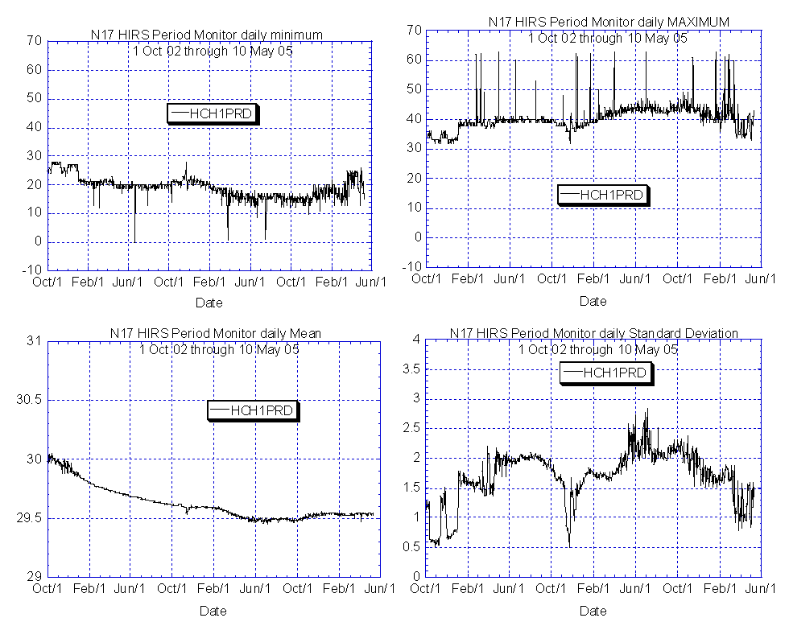

Illustration 16: N17 HIRS Period Monitor in perspective
(Well within historical norms.)

N17 MEMORY SCRUB REPORT

Last week

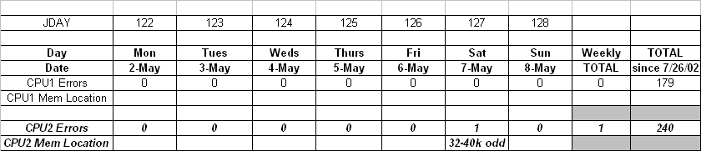

POLAR SPACECRAFT TIP CLOCK ERROR

WEEK ENDING May 6, 2005
DAY/DATE | NOAA-12 | NOAA-14 | NOAA-15 | NOAA-16 | NOAA-17
FRI. 04/29 | N/A | +177 msec | -153 msec | +083 msec | +034 msec
SAT. 04/03 | +715 msec | +180 msec | -154 msec | +084 msec | +034 msec
SUN. 05/01 | +716 msec | +179 msec | -156 msec | +084 msec | +033 msec
MON. 05/02 | +719 msec | +174 msec | -157 msec | +084 msec | +035 msec
TUE. 05/03 | N/A | +175 msec | -157 msec | +084 msec | +036 msec
WED. 05/04 | +717 msec | +177 msec | -160 msec | +084 msec | +036 msec
THU. 05/05 | N/A | +177 msec | -159 msec | +088 msec | +037 msec

EMOSS POC for this chart is JIM SHEPHERD

NOAA-12 *Alternating +/- 500 millisecond clock jumps will occur at 76-day intervals as long as fractional second daily ETCUP is utilized to manage clock drift..
Daily ETCUP bias of +6.5 mSec started on 12/10/03.
NOAA-14: As of 1223/03 the TIP clock is corrected daily by –7.0 msec to compensate for drift.
Subtracted 150 mSecs on 30 June
NOAA-15: As of 04/23/03 the TIP clock is corrected daily by –8 msec to compensate for drift.
Added 100 msec to spacecraft command clock on 31 Aug 04
NOAA-16: As of 12/23/03 the TIP clock is corrected daily by –5.5 msec to compensate for drift.
Subtracted 100 msec from spacecraft command clock on 31 Aug 04.
NOAA-17: As of 12/23/03 the TIP clock is corrected daily by –3 msec to compensate for drift.
Added 125 Msecs3 Feb 04.

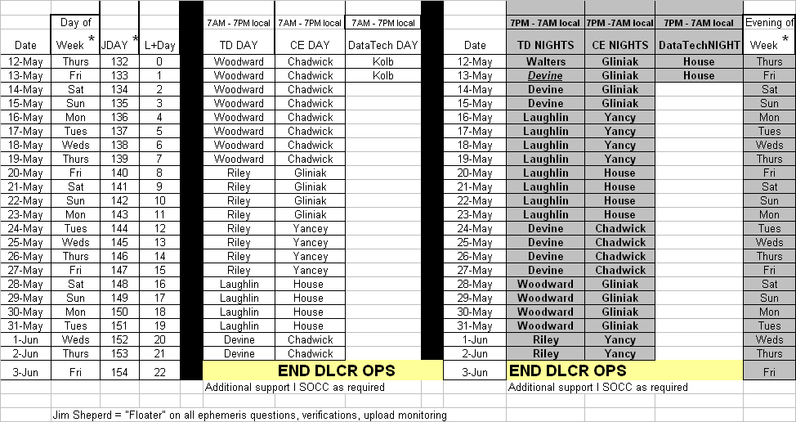

EMOSS ON Console Schedule for N18 Launch and OV

POES Engineering Contact List

Government

Renee Smith-Dearing NOAA POES Constellation Lead 301-817-4117
Dong Han: NOAA, POES Payloads 301-817-4127

Micky Fitzmaurice: NOAA, POES Bus, IJPS 301-817-4016
Nicolaie Todirita (Todi): NOAA Ground Systems 301-817-4229

EMOSS-2 Contractor

Jeff Devine: EMOSS POES Lead 301-817-4020
Jim Walters: EMOSS, POES Payload Engineer 301-817-4033

Angelique Riley, EMOSS, POES Comm and DHS 301-817-4028
Carl Gliniak, EMOSS POES Power and Thermal 301-817-4207

Jim Sheperd, EMOSS POES Attitude Control 301-817-4030
Jon Woodward EMOSS, POES Flight Software C&CS 301-817-4019

Sally House EMOSS POES Payloads 301-817-4026
William Chadwick EMOSS, POES Comm and DHS 301-817-4015

