NASA Earth Science Enterprise
Applications Program
___________________________________________________________________________

Earth Science for Carbon Management

Carbon Management Program Element Plan: 2004-2008

March 11, 2004 (v2.9)




Earth Science Exploration Serving Society
Accelerating the realization of economic
and societal benefits from Earth science,
information, and technology …

NASA Earth Science Enterprise - Earth Science Applications Program
Earth Science for Carbon Management

Carbon Management Program Element Plan: 2004-2008

Contents:

Purpose and Scope

- Goals and Objectives
A. Goals: FY04-08
B. Objectives: FY04
- Objectives: FY05
- Objectives: FY06-08

- Leadership Network
A. Management Assignments
B. Network

- Applications Activities
    - Decision support tools for 1605(b) process
    - Long term carbon sequestration history in North America
    - Solicitations
    - Carbon modeling, verification and validation
    - Legacy projects
    - Other activities

- Budget Table

- Schedule and Milestones

- Program Management and Performance Measures

- Roadmap

Note: This plan is based on the President’s proposed FY2004 budget.
NASA Earth Science Enterprise - Earth Science Applications Program
Earth Science for Carbon Management

Carbon Management Element Plan: 2004-2008

I. Purpose and Scope
The carbon management program element is one of twelve elements in the Earth Science Enterprise (ESE) Earth Science Applications Program. NASA and the Earth Science Applications Program collaborate with partner organizations to enable and enhance the application of NASA’s Earth science research results to serve national priority policy and management decision-support tools. The desired outcome is for partner organizations to use project results, such as prototypes and benchmark reports, to enable expanded use of Earth science products and enhance their decision-support capabilities.

Carbon management is a key resource management and policy issue of the 21st century. The atmospheric concentration of CO₂ increased by about 25% during the 20th century and is continuing to increase in part due to the burning of fossil fuels and changes in land cover and land use. Increases in the atmospheric concentration of CO₂ and other greenhouse gases are likely to produce significant changes in global climate and accompanying changes in the energy and water cycles. These changes will have profound impacts on society and the Earth’s ecosystems.

The US administration launched an initiative in 2001 to address specific elements of the climate change issue. The carbon management program element responds to the Climate Change Research Initiative (CCRI) and focuses on carbon emissions and sequestration in terrestrial, oceanic and geologic systems. The program element responds to requirements and programs of the operational agencies responsible for implementation of the Climate Change Technology Initiative (CCTI) in regard to the use of NASA systems (e.g., Landsat, Terra/Aqua, Aura, SeaWiFS, Orbiting Carbon Observatory (OCO)) to measure and monitor carbon sequestration in terrestrial, lacustrine and oceanic environments and the flux of carbon among these environments and the atmosphere. Projects sponsored through this program element build toward an operational carbon management regime that informs resource managers and policy makers of the current state of the distribution of carbon sources and sinks and provides information on near-term and long-term impacts of mitigation actions. Measurements and observations from NASA’s Earth orbiting systems will be especially useful in scaling up in situ and local measurements to regional and global scales. The carbon management program will also consider carbon emissions commencing in FY05.

The Earth Science Applications Program (http://www.earth.nasa.gov/eseapps), through the carbon management program element, uses data and models acquired and developed through the NASA/ESE carbon research program to benchmark assimilation of observations and predictions into decision support tools that support management of carbon sources and sinks by NASA’s applications partners. The carbon management program, as with the other elements in Earth science applications of ESE, draws upon the research and technology developed through ESE to support the next generation of integrated research solutions. The carbon management program also benefits from models developed by NASA centers and laboratories and international collaborations, especially with the carbon sequestration research and operational implementation of Australia.

In developing a science-based carbon management regime knowledge of the carbon cycle is exploited to assist operational agencies (e.g., the US Department of Agriculture (USDA), Department of Energy (DOE), Environmental Protection Agency (EPA), and the US Geological Survey (USGS)) fulfill their mandates to manage carbon and to support local, regional, national, and global policy and planning for control of carbon in the environment. The program element collaborates with academic and government laboratories and operational agencies in the North American Carbon Program (NACP) to develop, test, and implement new technologies for measuring, monitoring, and validation of carbon management practices.

NASA implements the carbon management program element through partnerships with USDA, DOE and EPA and competitive solicitations. The operational agencies are the senior members in these partnerships; they are responsible for establishing requirements for decision support systems, monitoring progress, incorporating results into operational procedures, and on-going, operational use of the tools and systems based on NASA research results.

An example of the strategy and implementation of the carbon management program element is the work sponsored by the Earth Science Applications Program to support DOE, USDA, and EPA implementation of a program for voluntary sequestration of greenhouse gases (see Figure 1). In February 2002, the President directed the Secretary of Agriculture, in consultation with the Secretary of Energy and the Administrator of the Environmental Protection Agency, to revise the rules and guidelines for the voluntary reporting of greenhouse gas sequestration projects under section 1605(b) of the Energy Policy Act of 1992 (EPACT). Section 1605(b) affords an opportunity for any company, organization or individual to establish a public record of emissions, reductions, or sequestration achievements in a national database. Participants can gain recognition for environmental stewardship, demonstrate support for voluntary approaches to achieving environmental policy goals, support information exchange, and inform the public debate over greenhouse gas emissions. In 2002, DOA invited NASA/ESE to participate on a Greenhouse Gas Accounting Rules and Guidelines Working Group, with DOE and EPA, to develop the guidelines.

One of NASA’s roles in the working group is to assist in the development of software tools to model carbon sequestration in the United States and monitor sequestration through the program. In December 2002, the Earth Science Applications Program initiated a project at Ames Research Center to extend carbon sequestration research currently underway (Chris Potter – principal investigator) to benchmark decision support tools for 1605(b) program. That work is underway, and the decision support tool (CQUEST) will be available on-line for test by the working group members and the public in FY04.

The program element also endorses outreach toward federal, state, and local agencies responsible for carbon management; inter-disciplinary training for key individuals in those partner agencies; and development of protocols for handling acquisition, processing, warehousing, display, and distribution issues in the use of Earth system science and remote sensing observations for measurement and monitoring of carbon emissions and sequestration.

II. Goals and Objectives
Projects sponsored by the Earth Science Applications Program carbon management element in FY04 address objectives 1.1, 1.2 and 3.1 of the NASA 2003 Strategic Plan, and the NASA Integrated Budget and Performance Document (IBPD) performance measures 4ESA1, 4ESA5, and 5ESA9 (see Table 1).

A. Goals: FY04-08:
The carbon management program element seeks to maximize the benefit of NASA/ESE observations, predictions from model output and systems engineering in decision support systems and tools used by agencies and organizations responsible for policy and resource decisions related to carbon emissions and sequestration – from local to global scales.

B. Objectives: FY 2004:
- Identify and evaluate potential Earth science inputs to one decision support system related to carbon management in a federal agency. ($200k)
- Complete implementation of the CQUEST decision support tool for USDA/DOE/EPA implementation of the 1605(b) carbon management system and characterize the impact of the tool on the 1605(b) process. ($300k)
- Select at least 3 new projects from the competitive solicitation NRA-04-OES-01 (Carbon Cycle Science) that will integrate unique NASA capabilities into decision support systems for carbon management. Initiate projects in FY04. (estimated total cost per year: $1M.)
- Initiate project, in collaboration with NASA/ESE Research Division, to calibrate land cover data from MODIS and Landsat TM/ETM+ and MSS data, thus extending the MODIS record back to the early 1970’s, and use the land cover information to improve accuracy of terrestrial carbon sequestration monitoring. ($250k)
- Document in appropriate journals (at least one special edition) and web pages (NASA/ESE web site) the progress and capabilities of the carbon management program element. ($25k)
- Represent the carbon management program element on the NASA/USDA Interagency Working Group. ($50k)
- Participate in the NACP and seek projects that match NASA Earth science capabilities with the measurement and monitoring requirements of the CCTP for carbon emissions and sequestration. ($25k)

Table 1:
Linkage among objectives from the NASA 2003 Strategic Plan,
The IBPD and the Carbon Management Program Plan

NASA Strategic Plan 2003 | Objective | FY04 Carbon Mgmt Objective | FY05 Carbon Mgmt Objective
1.1 | Understand how the Earth is changing, better predict change, and understand the consequences for life on earth. | 1,4 | 1,2
1.2 | Expand and accelerate the realization of economic and societal benefits from Earth science, information and technology | 1,3 | 1,2
3.3 | Improve the Nation's economic strength and quality of life by facilitating the innovative use of NASA technology | 1,2,4,5,7 | 3
IBPD FY04-05
4ESA1, 4ESA5 | Benchmark the process of assimilating observations from missions and predictions from models into decision support systems for carbon management | 2
5ESA9 | Benchmark the use of predictions from 2 NASA Earth system science models for use in national priorities such as support for the CCSP and CCTP. |  | 1,3

C. Objectives FY05-08
- Validate and benchmark the CQUEST tool as part of the 1605(b) guidelines (complete in FY05)
- Evaluate the use of at least two data products that extend the sequestration modeling capability of MODIS data to the Landsat historical archive; improve the accuracy of the MODIS-based products. (Complete in FY06)
- Benchmark performance of NASA Earth science inputs to two decision support systems for carbon management (emissions or sequestration). (Complete by FY08)

III. Leadership Network
A. Management Assignments
1) Program Manager carbon management element
Mr. Ed Sheffner
Earth Science Applications Division (Code YO)
Office of Earth Science
NASA Headquarters
Washington DC
Responsibilities:
• Development of and implementation of interagency agreements and partnerships with other organizations.
• Program development including program plans and budgets.
• Development and implementation of solicitations for carbon management tasks.
• Primary responsibility for metrics, performance goals and other performance evaluation criteria.
• Point of contact for CCTP working group on sequestration, NASA/ESE carbon program (for applications), and NASA/USDA focus area working group on carbon management.

2) Deputy Program Manager for carbon management element
Dr. Carlos Del Castillo
Project Research Scientist
Earth Science Applications Directorate
Stennis Space Center, MS (SSC)
Responsibilities:
• Coordinator and liaison with program element management for carbon management tasks at NASA centers other than Stennis.
• COTR or studies manager (as appropriate) for grants and cooperative agreements related to carbon management and funded by the Earth Science Applications Division through procurement at SSC.
• Management of tasks at SSC related to the carbon management element of the Earth Science Applications Division.

B. Network
The NASA carbon management program element contributes nodes to a network involving government, industry and the academic sector (see Figure 2). This network is improving knowledge of how carbon moves through the environment and is developing and implementing technology to measure carbon emissions, monitor carbon sequestration programs, and provide managers and policy makers with continuous information on which decisions can be made on resource use and policies that impact the global environment. Key nodes in the network (currently involved with the program element) include:
- NASA HQ partners
• Diane Wickland (YS: terrestrial and ecosystem processes)
• Paula Bontempi (YS: ocean processes)
• Woody Turner (YS/YO: ecological forecasting)
• William Emanuel (YS/IPA: terrestrial processes)

- Partner agency contacts:
• USDA: Bill Hohenstein, Global Change Program Office, Washington DC; Richard Birdsey, US Forest Service, chair, carbon management focus area working group for USDA/NASA Interagency Working Group; Steven Shafer and Paul Doriaswamy, Agricultural Research Service
• EPA: Ken Andrasko, Sequestration Team, Office of Atmospheric Programs, Washington DC
• DOE: Jeff Amthor, Climate Change Research Division, Germantown, MD
• USGS: Tom Loveland, EROS Data Center, Sioux Falls, SD

3) Government agencies and programs:
• Department of Agriculture (USDA): Global Change Program Office; Sequestration Working Group for CCTI; carbon management focus area for NASSA/USDA interagency working group (Dr. Richard Birdsey)
• Department of Energy (DOE): Lead in CCTI; Measurement, Monitoring and Verification Working Group for CCTI; lead agency for implementation of 1605(b) guidelines. (Dr. Roger Dahlman)
• Department of the Interior (DOI) especially the US Geological Survey (USGS): Land cover and land cover change information for carbon sequestration. (Dr. Tom Loveland)
• The Environmental Protection Agency (EPA): Partner in development of 1605 (b) guidelines. (Dr. Ken Andrasko)
• Climate Change Science Program (CCSP): carbon cycle research especially location of sources and sinks (terrestrial and aquatic) and their dynamics. (Dr. Steven Shafer)
• Climate Change Technology Program (CCTP): Development and verification of sequestration technology. (Dr. William Hohenstein)
4) NASA Centers:
- Ames Research Center: Modeling of carbon sequestration; development of tools and processes for 1605(b) compliance and verification (Dr. Chris Potter)
- Goddard Space Flight Center: Calibration of MODIS and Landsat datasets to exploit extended record of Landsat for land cover change and its impact on carbon cycling and carbon management. (Dr. Chuck McClain)
- Johnson Space Center: Coral reef studies – link to oceanic sources and sinks. (Dr. Kamlesh Lulla)
- Marshall Space Flight Center: Climate studies and forecasting; impact of climate change on source and sink dynamics. (Dr. Steve Goodman)
- Stennis Space Center: Carbon dynamics in near shore and deep oceans; management of carbon projects. (Dr. Carlos Del Castillo)
5) Universities (current, active contacts):
• Colorado State University: Impact of wild fires on carbon cycling and carbon sequestration. (Dr. Ingrid Burke)
• Mississippi State University: Forest structure visualization; monitoring carbon accumulation in forest biomass and soils. (Dr. Roger King)
• University of Georgia: Agricultural decision support and carbon sequestration in developing countries. (Dr. Ed Kanemasu)
• University of Maryland: Impact of fires on carbon sequestration. (Dr. David Roy)
• University of Montana: Climate change impact on the carbon cycle in forests. (Dr. Ramakrishna Nemani)
5) Other Organizations:
• Conservation International: Fires in tropical forests. (Dr. Marc Steininger)

The carbon management program element is based on the observations, models, and systems engineering from NASA’s Earth Science Enterprise. The ESE research program for carbon responds to key questions listed in the NASA/ESE “Strategic Plan 2003” and in the strategic plan for the Climate Change Science Program. The questions address uncertainties about the carbon cycle in terrestrial and aquatic ecosystems, land use and land use changes that impact the carbon cycle and global climate, and the linkages between ecosystems and global climate.

The Earth Science Enterprise is a participant in the NACP, an element of the CCSP. The goal of the NACP is to reduce the uncertainties about carbon sources and sinks in North America. Activities of this program will extend beyond the next decade. They should produce information and models that will be integrated through the CCTP for the development of new technologies. These will be the basis for the assistance that NASA Earth Science Applications provides to carbon management applications.

In the near-term, the state of knowledge can be exploited in decision support tools that address mandates of operational agencies. Base lining the performance of the tools defines the current state of the technology and serve to gauge improvements in the tools as new observations, model results and systems engineering methodologies become available.

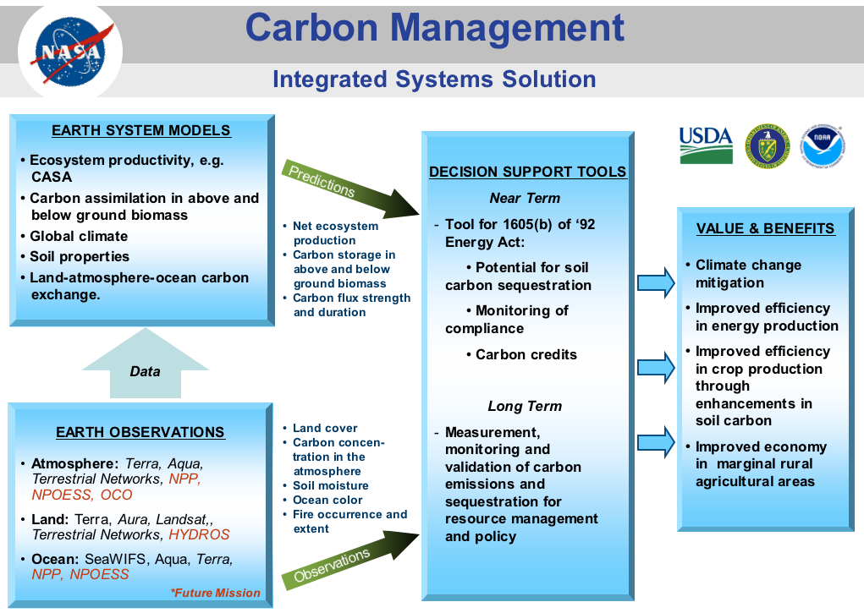

Figure 1: Carbon Management Integrated Systems Solution

Science and
Technology
Drivers
CCSP, CCTP,
NACP, YS/YF obs. and priorities, etc.
Systems Development
and Evaluation
Universities
NASA Centers
NGOs, etc.

Commercial Sector

Inputs
Data
Data products
Systems engineering
and Ops support
ESE
Carbon Mgmt
Program Element
NASA Derived
Observations and
Predictions
NASA Systems, Centers and Laboratories, DAACs

Users/

Decision Makers
USDA
DOI
EPA
DOE, etc.

Figure 2
The Earth Science Application Program Node in
the Carbon Management Network
The carbon management program element coordinates input from government, academic and commercial sources with NASA measurements, models, and systems engineering, and integrates NASA’s unique assets and capabilities with decision support tools and systems for managing carbon – especially sequestration of carbon in terrestrial systems. The outer ring represents the communication among network members that does not flow through ESE carbon element.

IV. Application Activities
A. Decision support tools for 1605(b) process:
This project will build and implement a decision support tool (CQUEST) that utilizes the NASA-CASA model for prediction of carbon sequestration potential and monitoring compliance. The DSS relies on baseline outputs and carbon flux algorithms used in the NASA-CASA model (Carnegie Ames Stanford Approach) Biosphere model. The primary DSS product is an internet-based query and modeling application that lets users access NASA-CASA model estimates of carbon sequestration in agricultural and forest ecosystems anywhere in the United States from a web browser. A graphical user interface will be created which lets land managers query information from the baseline NASA-CASA results for their area(s) of interest. The current version of the DSS uses AVHRR 8 km data. Transition to 1km MODIS data is in progress. The user interface is available in FY04 in preparation for publication of the 1605(b) guidelines in June 2004.
PI: Dr. Chris Potter, Ames Research Center
Objective for FY04: Complete and evaluate performance of CQUEST.
FY04 budget: $300K.
FY05 budget: $200K (final year)

B. Long term carbon sequestration history in North America
Extend current measurements of land cover and land cover change from MODIS in North America back to the early 1970’s by calibrating MODIS and Landsat ETM+, TM and MSS data. This work is coordinated with the ESE Research Division as part of the NACP – a task within the CCSP working group on carbon. Results of the program will assist in carbon sequestration activities. The impact of this work on carbon management includes both improved understanding of the potential for carbon sequestration in different regions of North America and improved understanding of how MODIS data and data products can be used in carbon management systems. This project coordinates with the CQUEST project at Ames to extend, if possible, the record of “carbon change” back to the beginning of the Landsat era.
PI: Dr. Jeff Masek, Goddard Space Flight Center
Objective for FY04: “Beta” version of land surface reflectance product (for above ground biomass) and forest change products available for evaluation.
FY04 budget: $250K (approximately equal to funding from Research Division)
FY05 budget: $250K
FY06 budget: $250K (final year)

C. Solicitations
Carbon management is one of four proposal areas in a solicitation for carbon cycle science and ecosystems in FY04. Projects awarded for carbon management under the solicitation will have a duration of no more than three years, and address decision support in terrestrial, oceanic or geologic sequestration in response to priorities that emerge from the CCSP and CCTP. The carbon management element will also monitor progress for proposals awarded in FY04 under the following NASA solicitations: NRA-03-OES-02: “Earth System Science Research using Data and Products from TERRA, AQUA and ACRIM Satellites” (see Table 2); and NRA-03-OES-03: “Interdisciplinary Science in the NASA Earth Science Enterprise” (see Table 3).

Table 2:
Carbon Related Projects Funded Under NRA-03-OES-02

Balch, William | The MODIS Ocean Product for Particulate Inorganic Carbon (MOD 25): Refinement of Calcium Carbonate Estimates in the Global Ocean | Bigelow Laboratory
Carlson, Barbara | Understanding Spatial and Temporal Variability in the Earth's Radiative Fluxes Through Analysis of CERES, MODIS, AIRS, and ISCCP Data | Goddard Institute for Space Studies
Chin, Mian | A Global Model Analysis of Anthropogenic Aerosol Radiative Forcing Using Data from Terra and Aqua Satellites, Ground-Based Networks, and In-Situ Measurements | Goddard Space Flight Center
Chopping, Mark | Quantifying Changes in Carbon Pools with Shrub Invasion of Desert Grasslands Using Multi-Angle Data from EOS Terra and Aqua | Montclair State University
Emmons, Louisa | Closing the Carbon Monoxide Budget: Variability in CO Emissions | National Center for Atmospheric Research
Entekhabi, Dara | Global Estimates of Evaporation from Variational Assimilation of Multi-Platform Land Surface Temperature into a Dynamic Model of the Surface Energy Balance | Massachusetts Institute of Technology
Fu, Rong | Investigating the Influences of Vegetation, Biomass Burning, Clouds on Wet Season Onset over the Amazon Using Terra, Aqua in Conjunction with In Situ and Other Satellite Data Sets | Georgia Institute of Technology
Gower, Stith | Applications of MODIS to Resolve the Effects of Global Change on Boreal Forest C Dynamics: Disturbance Versus Climate Warming | University of Wisconsin Madison
Jacob, Daniel | Quantifying the Sources and Global Transport of Combustion Gases and Aerosols Using MOPITT, MODIS, MISR, and Related Satellite Observations | Harvard University
Justice, Christopher | Refinement and Maintenance of the MODIS Fire Product Suite and MODIS Land Discipline Leader | University of Maryland College Park
Marra, John | Primary Productivity from Ocean Color Based on Photosynthetic Quantum Efficiency and Phytoplankton Absorption | Columbia University Lamont Doherty Earth Observatory
McClain, Charles | MODIS Ocean Color Calibration and Validation Support | Goddard Space Flight Center
Nemani, Ramakrishna | Prognostic/Diagnostic Analysis of Land Surface Processes Using Ecosystem Modeling and TERRA/AQUA Products | Ames Research Center
Neuer, Susanne | Analysis of Nutrient Budgets and Carbon Export in the Eastern and Western Subtropical North Atlantic Ocean | Arizona State University
Njoku, Eni | Aqua/AMSR-E Soil Moisture Algorithm and Product Improvements | Jet Propulsion Laboratory
Randerson, James | Using Satellite and Inverse Techniques to Constrain Regional and Global Fire Emissions from 1997 to 2005: An Approach Based on the Carbon Isotope Ratio of Fire Emissions | California Institute of Technology
Ranson, Kenneth | Boreal Zone Forest Type and Structure from EOS Data Sets | Goddard Space Flight Center
Redemann, Jens | Spatial Variability of MODIS and MISR Derived Atmospheric Data Products | Bay Area Environmental Research Institute
Reichle, Rolf | Assimilation of AMSR-E Data and Application to the Initialization of Soil Moisture Reservoirs in a Seasonal Forecasting System | University of Maryland Baltimore County
Remer, Lorraine | Maintenance and Refinement of the Global MODIS Aerosol Products from Terra and Aqua (MOD04/MYD04) | Goddard Space Flight Center
Running, Steven | EOS Algorithm Refinement Proposal-Global Validation and Refinement of the MOD 17 Terrestrial Net Primary Production and MOD 16 Evaporative Index | University of Montana
Saatchi, Sassan | Forest Woody Biomass Carbon Estimates of North America from Synergistic Analysis of MODIS, MISR, and JERS Data in Support of the North American Carbon Program | Jet Propulsion Laboratory
Stramski, Dariusz | Towards Global Monitoring of Particulate Organic Carbon in the Ocean from Satellite Observations | Scripps Institution of Oceanography
Townshend, John | Enhanced Land Cover and Land Cover Change Products from MODIS; An EOS Algorithm Refinement Proposal | University of Maryland College Park
Ustin, Susan | Global Estimation of Canopy Water Content | University of California Davis
Waring, Richard | Predicting Tree Species Diversity Across the Contiguous U.S.A. from Seasonal Patterns in Photosynthesis Derived with Satellite-Driven Models | Oregon State University
Weaver, Clark | Spectral Signatures of Aerosols from Satellite Radiances | Goddard Space Flight Center

Table 3:
Carbon Related Projects Funded Under NRA-03-OES-03
Name Proposal Title Institution
Tian, Hanqin | Linking Multi-Scale Remotely Sensed Data, Field Observations and Biogeochemistry Models to Evaluate Changes in the Terrestrial Ecosystems of China | Auburn University.
Moore, Berrien | Understanding the Changing Carbon, Nitrogen and Water Cycles in the Earth System | Univ. of New Hampshire
Muller-Karger, Frank E. | An Assessment of Global Organic Carbon Flux Along Continental Margins | Univ of. South Florida
Elvidge, Christopher | Development Sprawl Impacts on Terrestrial Carbon Dynamics | NOAA NESDIS-NGDC
Fung, Inez | Studies of Biosphere-Atmosphere Interactions with a GCM with MODIS Spectral Resolution | UC Berkeley
Thompson, David | Understanding the Impacts of Large-Scale Climate Variability on the Global Carbon Cycle. | Colorado St. Univ.
Prinn, Ronald | Testing Trace-Gas Flux Models Using In Situ and Remotely –Sensed Data | MIT
Hofmann, Eileen E. | Eastern U.S. Continental Shelf Carbon Budget: Modeling, Data Assimilation, and Analysis | Old Dominion Univ.
McWilliams, James C. | Simulating and Assessing the Carbon Cycle off the West Coast of North America | UCLA
Ojima, Dennis | Carbon Data Assimilation Modeling: Remote Sensing and Field Observational Constraints of Earth System Carbon Analysis | Colorado St. Univ.
Gao, Yuan | Natural Iron Fertilization in the Ocean and Its Impacts on Ocean Nitrogen Fixation and Carbon Cycles | Rutgers Univ.
Dubayah, Ralph | Characterizing Forest Structure for Assessments of Carbon Cycling and Biodiversity: An Integrated Approach Using Lidar Remote Sensing, Field Studies, and Ecosystem Modeling | Univ. Maryland
Kustas, William | Accounting for Effects of Subpixel Surface Variability on Regional Flux Estimation Using Large Eddy Simulation with Terra and Aqua Sensors | USDA/ ARS

D. Carbon modeling verification and validation
The carbon management program element includes systems engineering for validation and verification of datasets and model predictions employed in decision support tools for carbon management. The systems engineering includes: evaluation of data products from existing and planned exploratory missions; identification, baselining and benchmarking impact of NASA/ESE Earth science inputs on carbon management decisions support tools; and technical and managerial oversight of carbon projects awarded through competitive solicitations conducted by ESE.
FY04 budget: $766K (Non direct costs)

E. Legacy projects to be completed in FY04 (These projects were fully funded in FY03 for completion by spring, 2004. FY04 expenditures to complete are not expected to exceed $100K)
• Colorado State University: Application of remotely sensed imagery to assessing the probabilities and carbon consequences of fire – Ingrid Burke*
• Conservation International: Application of a satellite model of tropical forest flammability – Marc Steininger*
• NASA/JSC: Distributing Information on Land Cover and Shallow Reefs to Resource Managers – Kamlesh Lulla*
• Mississippi State University: Analysis of Competing Vegetation in Forest Management Areas with the Utilization of Remote Sensing Technology – Andy Ezell; Developing Enabling Technologies for Remote Sensing Applications in Agriculture, Forestry, and Transportation Applications – David R. Shaw; Automatic Determination of Tree Crown Shape, Volume, and Density, Developed, Verified, and Visualized using Virtual Environments – Robert Moorhead, Scott Roberts, and David Evans; Development of Procedures for Intensive Stand-level Inventories Combining LIDAR and Spectral Remote Sensing Tools with Traditional Inventory Approaches – David Evans, Scott Roberts, Robert Parker, and Ian Munn**
• University of Arizona: Establishing a Basis for Carbon Management Policy at the State Level: Carbon Dynamics at Site, landscape, and Regional Scales for Arizona State Lands – Stuart Marsh*
• University of Georgia: Carbon from communities: a satellite view – Constance Neely*
• University of Maryland: Burned area mapping in South Africa: case Study – David Roy*
• University of Montana: Developing a biospheric nowcast and forecast capability for the conterminous US – Ramakrishna Nemani* (Now at Ames Research Center)
• US Forest Service: Large scale validation of carbon stock and flux estimates from remote sensing – Richard Birdsey*
• Woods Hole Research Center: Remote sensing applications for forest resource assessment – Scott Goetz*
* Selected through competitive solicitation - NRA-00-OES-08, awarded June, 2001.
** Funded under Challenge Grant to Mississippi State University

F. Other activities
Other activities related to carbon management in FY04-FY08:
Program management activities and participation in CCSP/CCTP costs: $180k in FY04.
1. Headquarters:
• Participation in carbon cycle working group of the CCSP.
• Participation in the sequestration working group of the CCTP.
• Identification of collaborative projects with USDA working through the NASA/USDA Interagency Working Group and the USDA Remote Sensing Coordinating Committee.
• Member – Carbon Cycle Interagency Working Group
• Contribute to planning, implementation and management of the North American Carbon Program.

2. Ames
• Participate in interagency (USDA, DOE, EPA) Greenhouse Gas Accounting Rules and Guidelines Working Group
• NACP Tier 3 Site Measurement Guidelines working group.

3. Fellowships: NASA Fellowships for the period FY2002 through 2006 with potential impact on the carbon management program:

Name Institution Title
Jeanne Anderson | University of New Hampshire | The Integration of AVIRIS and LIDAR Data for Remote Detection of Forest Structure, Species Composition, and Land-Use Legacies in the White Mountains of New Hampshire.
Isabel Ashton | Stony Brook University | Biological invasions and alterations of the global carbon balance.
Asmeret Asefaw Berthe | University of California Berkeley | Stability and Loss of Buried Soil Organic Carbon
Bryan Brandel | University of Colorado | Regional Scaling of Biogeochemistry in a Larrea tridentata Ecotone: Implications for Carbon Sequestration in the Southwestern United States
Amy Frappier | University of New Hampshire | The Terrestrial Carbon Cycle and ENSO: Evaluating ecosystem processes that amplify the effects of El Nino events on carbon isotope dynamics in a tropical forest
Daniel Hayes | Oregon State University | Mapping Regional Carbon Stocks and Monitoring Carbon Emissions from Land Cover and Land Use Change Along the Mesoamerican Biological Corridor
Emily Hollister | Texas A&M University | Land Use and Land Cover Changes in Temperate Savannas: Impact of Woody Plant Encroachment and Prescribed Fire on Ecosystem Carbon Storage
Laura Koteen | University of California at Berkeley | A Comparison of Carbon Cycling and Material Exchange in Landscapes Dominated by Native and Exotic Grasses in Northern Coastal California
Desheng Liu | University of California at Berkeley | Systematic Evaluation of Machine Learning Approaches for Remote Sensing Land Cover Classification
Tasha Reddy | Stanford University | Model Resolution Effects on Oceanic Primary Production Estimates and Validation using Remotely Sensed Data: A Case Study for the Ross Sea, Antarctica
Jingfeng Xiao | University of North Carolina | Carbon Sink Due to Woody Encroachment in Non-Forest Areas in the Western U.S. and Impacts of Fire and Climate
V. Budget Table (all cost in $k)
 | Carbon Management - Direct Costs
 |  | FY04 | FY05 | FY06 | FY07 | FY08
Projects
 | CASA/CQUEST | 300 | 200
 | N. Amer. Sequestration History (with YS) | 250 | 250 | 250
 | New decision support tools (emis. & oceans) |  | 100 | 300 | 400 | 400
 | Integration of OCO data in DS tools |  |  | 250 | 500 | 500
 | Subtotal | 550 | 550 | 800 | 900 | 900
Solicitations
 | FY05 CAN/NRA (including emissions) |  | 750 | 750 | 750
 | FY07 CAN/NRA |  |  |  | 750 | 750
 | Subtotal | 0 | 750 | 750 | 1500 | 750
Interagency Activities
 | CCSP/CCTP committees, DSS identification, etc. | 180 | 180 | 200 | 200 | 200
 | Subtotal | 180 | 180 | 200 | 200 | 200
 | Total (Program Element Direct Costs) | 730 | 1480 | 1750 | 2600 | 1850
 | Non Direct Costs
 | Requests from Crosscutting
IBS/SysE
 | V&V of MODIS products | 417 | 300 | 250 | 250 | 250
 | New Carbon DSS baselining | 349 | 300 | 200 | 200 | 200
 | Baseline potential of OCO data |  |  | 400 | 200 | 100
 | Benchmark Earth science inputs to carbon |  | 300 | 300 | 400 | 500
MSU
 | Visualization of carbon processes | 450 | 100
 | Biomass estimation | 350 | 100
 | Subtotal | 1566 | 1100 | 1150 | 1050 | 1050
 | Requests from Outreach
 | Conferences | 10 | 15 | 20 | 20 | 20
 | Materials | 8 | 10 | 12 | 12 | 12
 | Subtotal | 18 | 25 | 32 | 32 | 32
 | Other
Solicitations | FY04 Carbon NRA (funded by YS) | 1000 | 1000 | 1000
 | FY07 Carbon NRA (funded by YS) |  |  |  | 1500 | 1500
 | Subtotal | 1000 | 1000 | 1000 | 1500 | 1500
 | Total (Non Direct Costs) | 2584 | 2125 | 2182 | 2582 | 2582
 | TOTAL COSTS: Direct and Non Direct | 3314 | 3605 | 3932 | 5182 | 4432
VI. Schedule and Milestones
FY04:
October 2003
• Workshops on CCTP sequestration and MMV activities.
• Initiate land cover/carbon sequestration index task (Masek) at GSFC.
• USDA carbon management focus area meeting.
December
• 1605(b) decision support tool (CQUEST) on-line.
January 2004
• Identification of carbon management DSS for benchmarking at SSC.
• Announcement of Earth Science Applications NRA (including carbon management)
February
• CQUEST DSS implements climate variability scenario module
March
• Carbon sequestration workshop (NASA projects)
• Beta release of land surface reflectance product from NACP sequestration history task
April
• Publication of CCTP Strategy
June
• Selection of carbon management projects from Earth Science Applications NRA September
• Publication by DOE/USDA/EPA of guidelines for voluntary sequestration of greenhouse gas program
• CQUEST DSS incorporates MODIS land cover and radiance products for development of land cover change scenario development.

FY05:
• Support integration of ESE capabilities in decision support tools for carbon in the emissions and oceans.
• Operational implementation of carbon sequestration estimation tool by NASA partner organization.
• Benchmark improvement in monitoring carbon management potential in 1605(b) program.
• Implement carbon management projects from FY04 carbon solicitations
• Initial evaluation of North American carbon sequestration history at MODIS and Landsat scales.
• Report on development of carbon management tools at appropriate national and international conferences, e.g., American Geophysical Union, International Geophysical and Remote Sensing Symposium, and input to appropriate assessments and reports, e.g., 4th IPCC assessment and CCSP reports.

FY06:
• Evaluate Orbiting Carbon Observatory (OCO) products through simulations of data. Baseline impact of OCO data on existing decision support tools for carbon sequestration and emissions.
• Evaluate products for soil moisture from HYDROS through simulations of data. Baseline impact of HYDROS data on existing decision support tools for carbon sequestration and emissions.
• Final evaluation of North American carbon sequestration history. Integration of history into carbon sequestration models and tools. Benchmark impact of tools on carbon sequestration tools.

FY07:
• Carbon solicitation with carbon management focus on emissions and oceanic sequestration.
• Integration of OCO and HYDROS data into carbon management decision support tools and systems. Benchmark impact of data on existing tools and systems.

FY08:
• Benchmark integration of new model results and observations in existing carbon management tools.

VII. Program Management and Performance Measures
The carbon management program element team uses performance measures to track progress, identify issues, evaluate projects, make adjustments, and establish results of the program element. The program’s Goals and Objectives (Section II) state what the program intends to achieve. These measures help monitor progress within and across specific activities to ensure the program meets its goals and objectives. The management team analyzes these measures retrospectively in order to made adjustments proscriptively to the program approach and objectives.

The measures are in two categories. Program management measures are internally focused to assess the activities within the program. Performance measures are externally focused to assess if the program activities are serving their intended purpose. In general, the program manager uses these measures to evaluate the performance of activities conducted and sponsored by the program, especially the projects. In addition, the Earth Science Applications Division uses this information in preparing IBPD directions and PART responses.

Program Management Measures (Internally-focused):
Inputs | Potential issues and DSTs identified for carbon management – number, type, range  Eligible partners to collaborate with – number, type, range  Potential results/products identified to serve carbon management – number, type, range
Outputs | Assessments or evaluations of DSTs – number, range  Assessments of Earth science results/products to serve DSTs – number, range  Agreements with partners – presence  Reports (evaluation, validation, benchmark) – number, type
Quality & Efficiency | Earth science results/products – number used per DST, ratio of utilized to potential  Agreements – ratio of agreements to committed partners  Reports – partner satisfaction, timeliness, time to develop  Reports – ratio of validations to potential products, ratio of benchmarks to validations

Performance & Results Measures (Externally-focused):
Outcomes | Earth science products adopted in DSTs – number, type, range; use in DST over time  Earth science products in use – ratio of products used by partners to reports produced  Partner & DST performance – change in partner DST performance, number & type of  public recognition of use & value of Earth science data in DST
Impacts | Partner value – change in partner metrics (improvements in value of partner decisions)

In addition to the stated measures, the carbon management program element manager periodically requests an assessment of its plans, goals, priorities, and activities through external review. The carbon management program element team uses these measures along with comparisons to programmatic benchmarks to support assessments of the Earth Science Applications Program (e.g. internal NASA reviews and OMB PART).

VIII. Roadmap
The carbon management program draws upon and contributes to the carbon science program of ESE. NASA/ESE sponsored science supporting climate, weather and natural hazards objectives will generate observations, models and technology that are the primary contributions of the carbon management program to carbon management decision support tools and systems. The roadmaps for carbon science and carbon management are similar - as illustrated below. The major milestones of the science program, such as the introduction of OCO data and the impact that will have on understanding the flux of carbon among land, ocean and atmosphere, are also milestones for the carbon management program. These roadmaps provide illustrate the anticipated major objectives and timing for the program in the next 10-15 years.
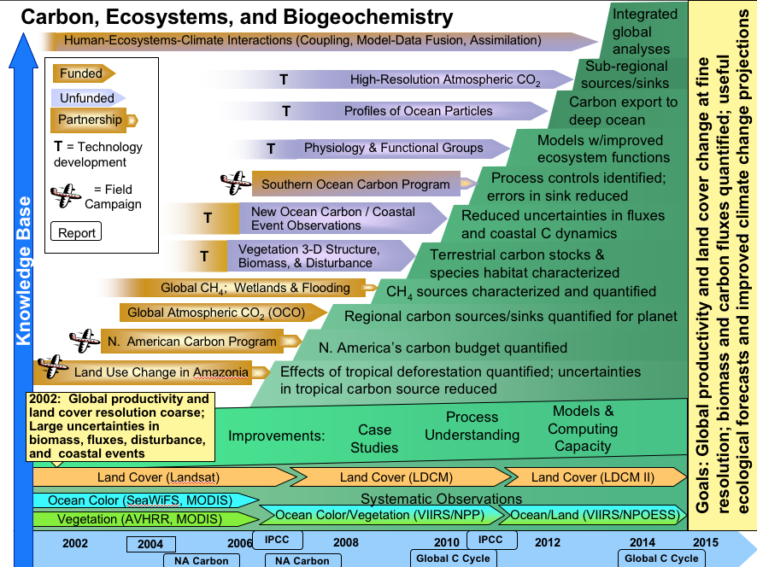
A. Carbon Science Roadmap

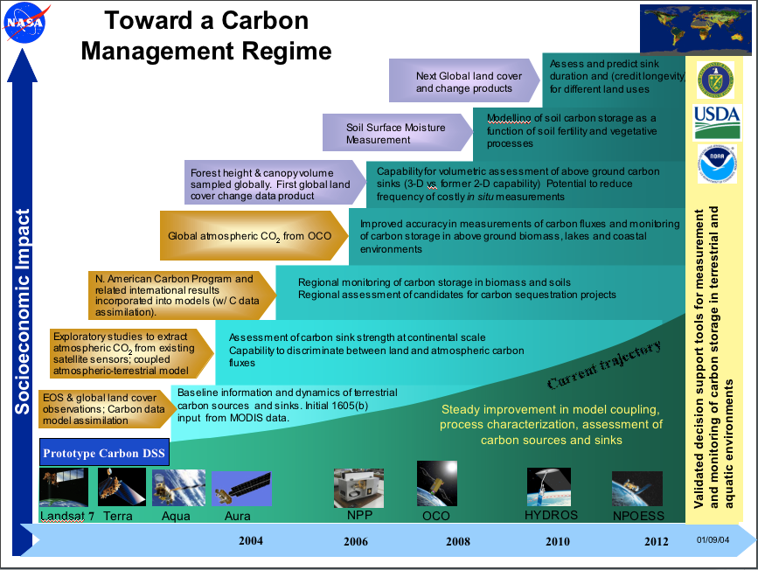
B. Carbon Management Roadmap

NASA Earth Science Enterprise – Earth Science Applications Program

Earth Science for Carbon Management

This document contains the Carbon Management Plan for FY2004-2008. This plan derives direction established in the NASA Strategic Plan, ESE Strategy, Earth Science Applications Plan, Earth Science Applications Program Plan, and OMB/OSTP guidance on research and development. The plan aligns with and serves the commitments established in the NASA Integrated Budget and Performance Document.

The Program Manager and the Earth Science Applications Program Leadership have reviewed the plan and agree that the plan appropriately reflects the goals, objectives, and activities for the Program Element to serve the Earth Science Applications Program, ESE, NASA, the Administration, and Society.

Ed Sheffner Date
Program Manager, Carbon Management
Earth Science Applications Program
NASA Earth Science Enterprise

Lawrence Friedl Date
Lead, Earth Science Applications
Earth Science Applications Program
NASA Earth Science Enterprise

Ronald J. Birk Date
Director, Earth Science Applications Program
NASA Earth Science Enterprise

The initiative augmented the on-going US Global Change Research Program (USGCRP) with the multi-agency Climate Change Research Initiative (CCRI.) In February, 2002, the USGCRP and the CCRI were integrated into the Climate Change Science Program (CCSP) and included in a new cabinet level management structure that oversees public investments in climate change science and technology. Also included within the new structure was the Climate Change Technology Program (CCTP) responsible for climate change related technology research and development. The CCSP is directed by the Department of Commerce (DOC) and includes participation from fourteen agencies and departments and the Office of Science and Technology Policy (OSTP). The CCTP is directed by the Department of Energy (DOE) and includes participation from thirteen departments and agencies and OSTP. The CCSP and CCTP report to the interagency Working Group on Climate Change Science and Technology co-chaired by DOC and DOE. The goals and initiatives established by the CCSP and CCTP are the primary manifestation of the US response to the climate change challenge.
See http://www.eia.doe.gov/oiaf/1605/background.html for more information on 1605(b).
“CQUEST” is the name of the tool, not an acronym.
Now at NASA Ames Research Center
See http://geo.arc.nasa.gov/sge/casa/cquest.html

