

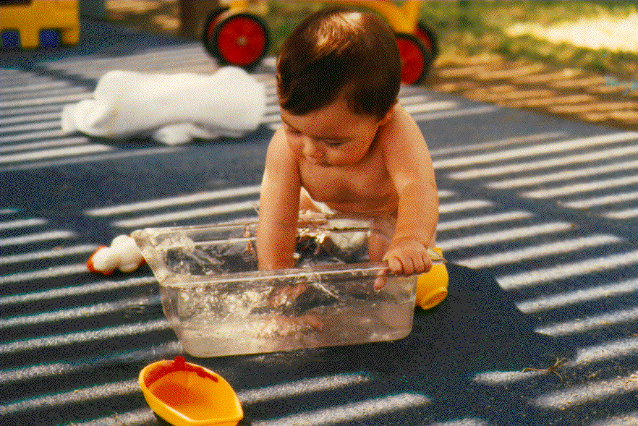



Starting A Child Development Center

table of contents

1. overview
start-up process
schedule & costs

2. authorities
490 b (Trible amendment)
crime control act
P.L. 106-58
Presidential Memorandum

3. surveys
feasibility discussion
employee needs assessment and discussion
market survey

- roles and responsibilities
interagency agreement

5. standards
GSA (license form 1582)
state and/or local
NAEYC accreditation

6. cost, quality and affordability

7. additional resources
consultants

1
Overview

START-UP PROCESS FOR CHILD CARE CENTERS IN GSA SPACE

AGENCY & GSA GSA
CONTACT GSA FOR
GUIDANCE
EVALUATE
SPACE
NEEDS
FORM
ORGANIZING COMMITTEE

CONDUCT NEEDS ASSESSMENT
OBTAIN MANAGEMENT COMITTMENT
PLAN
SPACE
LAYOUT

CONDUCT MARKET SURVEY
ESTABLISH AGREEMENT BETWEEN AGENCIES/ PRIVATE PARTNERS
PROVIDE
INITIAL ALTERATIONS

EQUIP CENTER

ESTABLISH
LOCAL
BOARD OF DIRECTORS
NEGOTIATE SPECIAL CONDITIONS TO GSA LICENSE (1582)
DESIGNATE
SERVICE
PROVIDER

PROVIDE
BUILDING
SERVICES

SERVICE PROVIDER
SECURE LOCAL LICENSE

HIRE STAFF
MARKET
PROGRAM
PROVIDE
PROGRAM
OVERSIGHT

OBTAIN
LIABILITY
INSURANCE

ENROLL
CHILDREN

OPEN CENTER

COLLECT TUITION

Start Up Process for Centers in GSA Space

CONTACT GSA

The primary mission of the GSA’s Child Care Operations Center of Expertise is to ensure that Federal and community families receive quality care for their young children in child care centers located in GSA managed space. We assist with all areas of establishing a child development center. Regional Child Care Coordinators can offer assistance regarding the formation of the organizing committee and eventual board, needs assessments and local child care market surveys, recommendations for center size and programs, selection of center management and technical assistance and coordination for the actual build out and equipping of the center.

Our nationwide network of Regional Child Care Coordinators works in partnership with other Federal agencies, advisory boards, providers, and center staff to establish and maintain high quality programs. What follows is a brief overview of the start up process. The appropriate Regional Child Care Coordinator should be consulted for further guidance.

OBTAIN MANAGEMENT COMMITMENT

A commitment from the local Federal agency’s or agencies’ top management is crucial to the development and operation of a child care center. It is the key to the release of funds to develop the center and to the agency’s continuing support.

FORM ORGANIZING COMMITTEE

The committee should reflect the agency(ies) which will utilize the center and should be comprised of individuals whose professional expertise or background will benefit the committee (e.g. accountant, attorney, educator, fundraiser, etc.) In many cases, some members of the organizing committee stay on as future board members. The permanent board is well served by maintaining this mix of individuals, as well as seeking upper management and community participation on the board.

When more than one sponsoring agency is involved, each should be proportionally represented on the committee according to their occupancy within the building.

ESTABLISH INTERAGENCY AGREEMENTS

When more than one agency sponsors a center, an interagency agreement (IA) should be signed between the agencies involved. The IA establishes the framework within which the agencies will participate in the development and ongoing support of the center. The IA can establish board participation and enrollment priorities.

ESTABLISH FEASIBILITY *

The organizing committee needs to have data that indicates a center is needed and will be used by employees at this site. A feasibility study includes:

EMPLOYEE NEEDS ASSESSMENT - SURVEY or FOCUS GROUPS
(This survey will help determine):

- the expected population, thus size of the center
- the ages of children in need of care
- desired hours of operation
- the types of services to be provided

MARKET SURVEY (This survey will help determine):

- the availability of other existing child care services
- tuition costs

The feasibility study needs to include the guidance from GSA on utilization rates and acceptable center size requirements. A center must be large enough to exist as a viable business.

Community partnerships with non federal entities are permitted and encouraged. A partnership with a local business or government could make a center viable where your population alone will not support one. Any agreements made for sharing a center must be based on the authorities and requirements of the Trible amendment.

EVALUATE SPACE NEEDS/SEEK SPACE*

The organizing committee should obtain copies of the applicable state and local regulations governing child care centers (http://nrc.uchsc.edu/states.htm). In most instances child care centers are required to be on ground floor levels with access to outdoor play space. The GSA child care coordinator is available to help identify if appropriate space is available. The agency requests space from GSA. GSA is responsible for finding, designing and building out the space for the child care center under established policy. The agency(ies) pay rent to GSA for the space under established procedures for “common use space”.

EQUIP CENTER

GSA is responsible for the initial purchase of equipment and subsequent repair and replacement of equipment. GSA does not purchase toys, curriculum materials or consumable goods, this is the responsibility of the provider.

PROVIDE BUILDING SERVICES

GSA is responsible for providing building services to the center, which include cleaning, utilities, and security systems. The centers are cleaned at standards for clinical space. Security is provided in accordance with a GSA security survey and analysis. Services considered above standard level are paid for by the requesting agency.

PROVIDE PROGRAM OVERSIGHT

GSA, using independent professionals performs program and health reviews. GSA professionals perform periodic safety and security reviews.

DESIGNATE SERVICE PROVIDER

Options for service provider and issuance of GSA License for Use of Space:

- GSA can issue a license directly to a service provider or board. An organizing committee or board of directors will issue a solicitation, with the guidance of GSA, to select a provider to deliver the service. The board will enter into a contract with the selected provider and sign a memorandum of understanding with GSA. GSA and the board are responsible for oversight of the center and ensuring license compliance.

- GSA can execute an agreement directly with an agency, which is then responsible for selecting a provider, issuing a license and ensuring license compliance.

SECURE CHILD CARE LICENSE

The child care provider is responsible for obtaining and maintaining the appropriate state/ local licenses.

HIRE STAFF

Staffing is the key to quality. The provider is responsible for hiring and training staff. Employee background checks are required. GSA will perform criminal history background checks.

MARKET PROGRAM

The child care provider is primarily responsible for marketing the program initially and on an on going basis. The board of directors must help in these efforts by at a minimum easing access to employee newsletters, bulletin boards, and activities.

OBTAIN LIABILITY INSURANCE

The provider must have liability insurance on the center. The necessity of insurance for the board of directors is determined locally and is sometimes carried as a rider on the center’s insurance.

OPEN THE CENTER

Parents typically make child care plans according to the academic year. All planning should be done to allow for a summer opening. The opening of a child care center is a time to build networks and to garner community support. A grand opening ceremony will provide agency employees and management an opportunity to see the center, meet the staff and to learn about the program.

* If your feasibility study proves positive and you are ready to move ahead with a center you should get a copy of the GSA Board of Directors Child Care Resource Book and the GSA Child Care Center Design Guide. Both guides are available from your RCCC or on the web at: http://www.gsa.gov/pbs/centers/child/child.htm

Costs

AGENCY

- RENT (approximately office rate) Estimate 100 square feet per child
- Tuition Subsidy (agency may use appropriated funds to help off set the tuition costs for lower income employees, P.L. 106-58)

PARENTS

- Tuition (market rate)
Fundraising dollars raised by the local board of directors is used to help reduce the tuition costs for eligible families

BUILD OUT AND EQUIPMENT COSTS

- Construction within existing space: estimated at between $65 - $100 dollars a square foot. New construction: $175 dollars a square foot
- Equipment estimated at $1,000 per child, can be higher if playground equipment is not part of initial construction cost

GSA is usually responsible for initial construction and equipment costs in GSA controlled facilities.

Schedule

 |  |  |  |  |  | 200- |  |  |  |  |  |  |  | 200-
TASKS | WHO | Jan | Feb | Mar | Apr | May | Jun | July | Aug | Sept | Oct | Nov | Dec | Jan | Feb | Mar | Apr | May | Jun | July | Aug | Sept
Design complete | GSA |  |  |  |  |  | x
Start Constructon | GSA |  |  |  |  |  |  |  |  |  | x
Finish Construction | GSA |  |  |  |  |  |  |  |  |  |  |  |  |  |  |  |  |  |  |  | x
Create Start-up Board | Agencies |  |  | x
File Incorporation | Board
write by laws | Board
write articles | Board
File Tax Exempt | Board
Develop RFP | Board/GSA |  |  |  |  |  |  |  |  |  |  |  |  | x
Develop Bidders List | Board/GSA |  |  |  |  |  |  |  |  |  |  |  |  | x
Advertise | Board |  |  |  |  |  |  |  |  |  |  |  |  |  | 2wks
Pre-Bid Meeting | Board/GSA |  |  |  |  |  |  |  |  |  |  |  |  |  | 15th
Bid Closes |  |  |  |  |  |  |  |  |  |  |  |  |  |  | end
Evaluate offers | Board/GSA |  |  |  |  |  |  |  |  |  |  |  |  |  |  | x
interviews
visits
Make Selection | Board |  |  |  |  |  |  |  |  |  |  |  |  |  |  |  | 1st
Sign Contract | Board
Sign GSA License | ?/GSA
Hire Staff | Operator
Purchase Materials | Operator
Purchase Equipment | GSA
State License Center | Operator
Enroll Children | Operator
Open Center |  |  |  |  |  |  |  |  |  |  |  |  |  |  |  |  |  |  |  |  | ***** | ****
Dedication Ceremony | Board/GSA/Operator/Agencies
Fundraising Plan | Board
CFC application
Tuition Assist Plan | Board
Market Center | Operator/Board
Seek Corporate | Board
Partners
All this work can legally be done by the board on official time and with gov't supplies and equipment.

2
authorities
TITLE 40--PUBLIC BUILDINGS, PROPERTY, AND WORKS

Sec. 490b. Child care services for Federal employees in
Federal Buildings

(a) Allotment of space; conditions

If any individual or entity which provides or proposes to provide child care services for Federal employees during fiscal year 1988 or any fiscal year thereafter, applies to the officer or agency of the United States charged with the allotment of space in the Federal buildings in the community or district in which such individual or entity provides or proposes to provide such service, such officer or agency may allot space in such a building to such individual or entity if--
(1) such space is available;
(2) such officer or agency determines that such space will be used to provide child care services to children of whom at least 50 percent have one parent or guardian who is employed by the Federal Government; and
(3) such officer or agency determines that such individual or entity will give priority for available child care services in such space to Federal employees.

(b) Charges for rent or services; payment of costs, accreditation fees, and travel and per diem expenses; ``services'' defined
(1) If an officer or agency allots space during fiscal year 1988 or any fiscal year thereafter, to an individual or entity under subsection (a) of this section, such space may be provided to such individual or entity without charge for rent or services.
(2) If there is an agreement for the payment of costs associated with the provision of space allotted under subsection (a) of this section or services provided in connection with such space, nothing in title 31, or any other provision of law, shall be construed to prohibit or restrict payment by reimbursement to the miscellaneous receipts or other appropriate account of the Treasury.
(3) If an agency has a child care facility in its space, or is a sponsoring agency for a child care facility in other Federal or leased space, the agency or the General Services Administration may pay accreditation fees, including renewal fees, for that center to be accredited by a nationally recognized early-childhood professional organization, and travel and per diem expenses for attendance by representatives of the center at the annual General Services Administration child care conference.

(4) For the purpose of this subsection, the term ``services''
includes the providing of lighting, heating, cooling, electricity,
office furniture, office machines and equipment, classroom furnishings and equipment, kitchen appliances, playground equipment, telephone service (including installation of lines and equipment and other expenses associated with telephone services), and security systems (including installation and other expenses associated with security systems), including replacement equipment, as needed.

(c) Guidance, assistance, and oversight

Through the General Services Administration's licensing agreements, the Administrator of General Services shall provide guidance, assistance, and oversight to Federal agencies for the development of child care centers to promote the provision of economical and effective child care for Federal workers.

(d) Consortium with private entities

If a Federal agency has a child care facility in its space, or is a sponsoring agency for a child care facility in other Federal or leased space, the agency or the General Services Administration may enter into a consortium with one or more private entities under which such private entities would assist in defraying the costs associated with the salaries and benefits provided for any personnel providing services at such facility.

(Pub. L. 100-202, Sec. 101(m) [title VI, Sec. 616], Dec. 22, 1987, 101 Stat. 1329-390, 1329-423; Pub. L. 102-393, title V, Sec. 528, Oct. 6,1992, 106 Stat. 1760.)

TITLE 42--THE PUBLIC HEALTH AND WELFARE

CHAPTER 132--VICTIMS OF CHILD ABUSE

SUBCHAPTER V--CHILD CARE WORKER EMPLOYEE BACKGROUND CHECKS

Sec. 13041. Requirement for background checks

(a) In general

(1) Each agency of the Federal Government, and every facility
operated by the Federal Government (or operated under contract with the
Federal Government), that hires (or contracts for hire) individuals
involved with the provision to children under the age of 18 of child
care services shall assure that all existing and newly-hired employees
undergo a criminal history background check. All existing staff shall
receive such checks not later than May 29, 1991. Except as provided in
subsection (b)(3) of this section, no additional staff shall be hired
without a check having been completed.
(2) For the purposes of this section, the term ``child care
services'' means child protective services (including the investigation
of child abuse and neglect reports), social services, health and mental
health care, child (day) care, education (whether or not directly
involved in teaching), foster care, residential care, recreational or
rehabilitative programs, and detention, correctional, or treatment
services.

(b) Criminal history check

(1) A background check required by subsection (a) of this section
shall be--
(A) based on a set of the employee's fingerprints obtained by a
law enforcement officer and on other identifying information;
(B) conducted through the Identification Division of the Federal
Bureau of Investigation and through the State criminal history
repositories of all States that an employee or prospective employee
lists as current and former residences in an employment application;
and
(C) initiated through the personnel programs of the applicable
Federal agencies.

(2) The results of the background check shall be communicated to the
employing agency.
(3) An agency or facility described in subsection (a)(1) of this
section may hire a staff person provisionally prior to the completion of
a background check if, at all times prior to receipt of the background
check during which children are in the care of the person, the person is
within the sight and under the supervision of a staff person with
respect to whom a background check has been completed.

(c) Applicable criminal histories

Any conviction for a sex crime, an offense involving a child victim,
or a drug felony, may be ground for denying employment or for dismissal
of an employee in any of the positions listed in subsection (a)(2) of
this section. In the case of an incident in which an individual has been
charged with one of those offenses, when the charge has not yet been
disposed of, an employer may suspend an employee from having any contact
with children while on the job until the case is resolved. Conviction of
a crime other than a sex crime may be considered if it bears on an
individual's fitness to have responsibility for the safety and well-
being of children.

(d) Employment applications

(1) Employment applications for individuals who are seeking work for
an agency of the Federal Government, or for a facility or program
operated by (or through contract with) the Federal Government, in any of
the positions listed in subsection (a)(1) of this section, shall contain
a question asking whether the individual has ever been arrested for or
charged with a crime involving a child, and if so requiring a
description of the disposition of the arrest or charge. An application
shall state that it is being signed under penalty of perjury, with the
applicable Federal punishment for perjury stated on the application.
(2) A Federal agency seeking a criminal history record check shall
first obtain the signature of the employee or prospective employee
indicating that the employee or prospective employee has been notified
of the employer's obligation to require a record check as a condition of
employment and the employee's right to obtain a copy of the criminal
history report made available to the employing Federal agency and the
right to challenge the accuracy and completeness of any information
contained in the report.

(e) Encouragement of voluntary criminal history checks for others who
may have contact with children

Federal agencies and facilities are encouraged to submit identifying
information for criminal history checks on volunteers working in any of
the positions listed in subsection (a) of this section and on adult
household members in places where child care or foster care services are
being provided in a home.

(Pub. L. 101-647, title II, Sec. 231, Nov. 29, 1990, 104 Stat. 4808;
Pub. L. 102-190, div. A, title X, Sec. 1094(a), Dec. 5, 1991, 105 Stat.
1488.)

Amendments

1991--Subsec. (a)(1). Pub. L. 102-190, Sec. 1094(a)(1), substituted
``May 29, 1991. Except as provided in subsection (b)(3) of this section,
no additional staff'' for ``6 months after November 29, 1990, and no
additional staff''.
Subsec. (b)(3). Pub. L. 102-190, Sec. 1094(a)(2), added par. (3).

TREASURY AND GENERAL GOVERNMENT APPROPRIATIONS ACT, 2000

Public Law 106-58
106th Congress

An Act

Making appropriations for the Treasury Department, the United States Postal Service, the Executive Office of the President, and certain Independent Agencies, for the fiscal year ending September 30, 2000, and for other purposes. Sept. 29, 1999 - [H.R. 2490]

Sec. 643. (a) In General.--Upon promulgation of the regulations
required under subsection (c), an Executive agency which provides or proposes to provide child care services for Federal employees may use appropriated funds (otherwise available to such agency for salaries) to provide child care, in a Federal or leased facility, or through contract, for civilian employees of such agency.
(b) Affordability.--Amounts so provided with respect to any such facility or contractor shall be applied to improve the affordability of child care for lower income Federal employees using or seeking to use the child care services offered by such facility or contractor.
(c) Regulations.--The Office of Personnel Management shall, within 180 days after the date of the enactment of this Act, issue regulations necessary to carry out this section.
(d) Definition.--For purposes of this section, the term ``Executive agency'' has the meaning given such term by section 105 of title 5, United States Code, but does not include the General Accounting Office.
(e) Notification.--None of the funds made available in this or any other Act may be used to implement the provisions of this section absent advance notification to the Committees on Appropriations.

From the 1998 Presidential Documents Online via GPO Access [frwais.access.gpo.gov]
Monday, March 16, 1998
Volume 34--Number 11
Week Ending Friday, March 13, 1998

Memorandum on Steps To Improve Federally Sponsored Child Care

March 10, 1998

Memorandum for the Heads of Executive Departments and Agencies

Subject: Steps to Improve Federally Sponsored Child Care

Now more than ever, America's working parents are struggling to balance their obligations to be good workers--and their more important obligations to be good parents. By choice or by financial necessity, millions of Americans rely on child care to care for their children for part of each day. Parents deserve to know that their children are safe
and nurtured in child care.
One of my highest priorities is to make child care better, safer, and more affordable. That is why my balanced budget includes the most significant investment in child care in our Nation's history and proposes specific measures to improve child care quality.
As a supplier of child care and as an employer that must recruit and retain a strong workforce, the Federal Government should lead the way in improving child care. I am proud that our military has developed one of the finest child care delivery systems in the world, and that the Department of Defense, at my request, is sharing its expertise with the
public and private sectors. Still, we need to do more. The executive branch of the Federal Government has responsibility for over 1,000 child care centers--788 through the military, 109 through the General Services Administration, and 127 through other Federal departments. In addition, the military oversees nearly 10,000 professional family child care
providers. In total, approximately 215,000 children are in our care.
Today I am directing my Administration to take significant new steps to improve the quality of Federally sponsored child care in the executive branch by (1) ensuring proper background checks of child care workers; (2) achieving 100 percent independent accreditation of all eligible centers; (3) exploring partnerships among Federal agencies and with the private sector to improve child care quality and affordability; and (4) ensuring
that all Federal workers become better informed of child care benefits and the options available to them.
First, all child care workers in Federally sponsored centers should undergo thorough background checks to make sure that our children are safe. The vast majority of child care workers are caring people who have dedicated their lives to teaching and nurturing children. But one tragedy in child care is too many, and criminal and civil background checks are necessary to determine whether the people caring for our children are fit for this responsibility. The military already has a model system to conduct background checks of child care workers. I now want to guarantee that workers at all nonmilitary, Federal child care facilities undergo such background checks in a thorough and timely fashion.
I therefore direct the Administrator of General Services (``Administrator'') to report to me, within 90 days, with a plan to ensure complete and timely background checks, to the fullest extent possible, for all child care workers in nonmilitary, Federally sponsored child care settings. Agencies with oversight of nonmilitary child care settings will report to the Administrator within 60 days on this matter.
Second, all Federally sponsored child care centers should receive nationally recognized, independent accreditation as soon as they are eligible to do so. Currently, only 76 percent of military centers, and 35 percent of other Federally sponsored centers, are accredited. By the
year 2000, 100 percent should be accredited. I therefore direct the Secretary of Defense and the Administrator to provide me, within 90 days, with a plan to ensure, to the fullest extent possible, independent, nationally recognized accreditation of all eligible, Federally sponsored child care by the year 2000. Agencies with oversight of non-military child care settings shall report to the Administrator within 60 days on this matter.
Third, partnerships among Federal agencies and with the private sector are an increasingly important way to maximize existing resources and improve child care. I therefore direct the Administrator to work with the heads of all Federal departments and agencies to explore opportunities for collaboration both within Government and with the
private sector to improve child care quality and affordability in Federally sponsored settings.
Finally, employers have a responsibility to make sure that their workers are better informed on child care and the options available to them at the national, State, and local levels. I therefore direct the Director of the Office of Personnel Management (``Director'') to ensure that, to the fullest extent possible, all Federal workers receive full information about child care benefits available to them on the Federal, State, and local levels, including information on resource and referral networks, available tax credits such as the Child and Dependent Care Tax Credit and Child Tax Credit, as well as public subsidies. The Director
shall also host a nationwide summit designed to showcase model public and private sector solutions to child care needs.

William J. Clinton

3
surveys

Child Care Center Feasibility

Background: In 1991 GSA’s Office of Child Care and Development Programs conducted a national survey to assess the utilization rate of child care centers located in GSA controlled space. The study sought to find a relationship between the number of Federal employees located in a building or within a close proximity to the building where Federal families are housed and the actual number of Federal families who enrolled children in the center. The study also considered the relationship of needs assessment results and actual utilization rates.

Results: Results showed that most centers enroll between 2% and 5% of the overall Federal population. The variance is related to quality of the center, marketing efforts, tuition costs, and other characteristics unique to a particular center. The study also showed that approximately 20% of the affirmative responses on the needs assessments become actual users of the center.

Recommendations and Discussion: GSA recommends that agencies conduct a market availability survey to identify other child care in the area available to the Federal population and a needs assessment and factor in the utilization formula described above to make a determination to construct a child care center. The needs assessment is weighted less heavily than the remaining factors since it is typically conducted with a population of employees whose children may be too old once the center is built. In addition, the results of the needs assessment typically inflates the true interest in center use since parents may discover tuition rates are unaffordable, the quality is insufficient or local care is more attractive for them. Thus, the needs assessment results must be used with extreme caution.

If overall age of female Federal employees is older than the average age of child bearing women, the true utilization rate will be lower. We are seeing an ever increasing number of Federal employees who are bringing their grandchildren to the centers but we have not yet done a study on this group.

To assure the financial viability of a center, GSA strongly recommends no center be built for fewer than 74 children. The child care centers are operated as independent businesses with no service fees provided by the government. In some communities providers can be hard to find if the proposed center is too small. Infant care can be twice as expensive as preschool care and the proper balance between age groups must be sought to make the budget work. Smaller centers without infant care can sometimes be viable.

Under the authority of 40 U.S.C. 490b commonly known as the Trible Amendment agencies may provide space and service to the centers. In FY 2000 agencies were authorized to use appropriated funds to subsidize the cost of care for lower income Federal employees. (P.L. 106-58)
Employee Needs Assessment Survey

Adapting the Questionnaire to Address Local Circumstances

Modification of the questionnaire form to meet local requirements and circumstances is encouraged. The questionnaire should not be so brief that information necessary for the program planning is not collected from the potential users, nor should it be so detailed as to confuse and intimidate employees. Where circumstances dictate changes, working with local agency managers, employees and union representatives to make those modifications will help avoid potential misunderstanding.

We have found return rates on surveys to be around 35%. Where a large population is to be surveyed, 3,000 or more, you may want to consider having a service take care of the printing and tabulating. Child care consultants or universities have been used for this purpose. In smaller populations the committee can probably tabulate the surveys by hand. Your computer systems department may be able to format and automate the survey on your e-mail system.

Elements of the Needs Assessment Survey

The needs assessment questionnaire responses are a vitally important part of the child care planning process. The following is an examination of the questions to better understand what the survey results might indicate. The questions seek to provide a localized profile of the Federal employee population. These questions address the following topics:

- The number of children, their ages and projected additions to the family, enable a determination as to the estimated population of the center, both in the short and longer term (questions 1 and 2)

- The present child care arrangements made by parents and its cost. The respondents are asked about their willingness to change those child care arrangements, and their specific interest in on-site care (questions 3, 4, and 5)

- The amount of money that parents would be willing to pay for care, to get an idea as to the tuition cost target and fund raising goals which the organizing committee might need to aim for (questions 6 and 7)

- The logistics of work location, transportation, work schedules, as those responses may determine the likelihood of an employee to enroll his or her child, and may affect policies of the center such as hours of operation, and whether to make intermittent or part-time care available (questions II-1, 4, 5 and 6)

- The need for child care from, the perspective of the employer, (questions II-2 and 3)

In addition, the opportunity for a written response is provided to allow employees space to share their own views and opinions regarding on-site child care.

Interpreting the Survey Responses

The primary purpose for conducting the needs assessment survey is to determine the need for a child care center, its potential enrollment and the size of the center. This level of demand will change over time, but from survey questions addressing both current and projected family size, along with history of employee turnover observed by local agency management, the immediate and longer term viability of the center can be estimated.

No specific numbers or pattern of survey responses can be offered as a firm cut off point for determining whether or not a center should be established. The percent of employees who actually use the center is typically around 20 to 30 percent of the positive survey numbers.

Each potential site must be carefully reviewed and assessed on a case-by-case basis. Factors such as the historical employee turnover rate, the typical age of new hires and the long term staffing plans for the agency will influence the decision to establish a center.

As noted above the various questions on the survey are included to provide more information than simply projecting the size and capacity of the center. Knowing parents’ current child care arrangements, their degree of satisfaction with their current arrangements, what they presently pay for care, what they would be willing to pay and whether they would enroll their child in the on-site center if one was established, is necessary to the overall planning process.

The answers provided in response to the survey when viewed in the aggregate, can help direct the program planning activities of the child care organizing committee and the provider, as well as the administrative decisions of the local Board of Directors. Such issues might include; is a kindergarten class needed? Should a hot breakfast and lunch be served? What should the hours of operation be? What is an acceptable level of tuition?

Addressing these questions early in the life of the center will enhance the probability of rapid and sustained enrollment, thus ensuring the ongoing viability of the center.
Model Child Care Needs Assessment

Please take a few moments to respond to these questions. The answers you provide are essential for planning a possible on-site child care center. This survey will also help determine the capacity of the center as well as the type of care needed now and in the future.
This information will be used for planning purposes only. Your participation in the survey does not obligate you in any way.

Please return this survey by ________ to___________________________
(date) (surveyor)

Your Agency:__________________________________________________

- Do you have children who require child care while you work?

________ Yes _______No

How many children do you have, and what are their ages? (For each age range, indicate the number of children in your family.)

___________ Infant ___________ 4 year old

___________ 1 year old ___________ 5 year old

___________ 2 year old ___________school age (6-12)

___________ 3 year old

- Do you plan to have children or adopt children within the next 2-3 years?

________ Yes _______No

What type(s) of on-site child care services do you think
you might need in the next 3 years? (check all that apply)

_____Infant care ______ Full time ______After School care

_____Toddler care ______ Part time _____ Summer or Holiday
Program (for ages 6 - 12)
_____Preschool care ______ Drop-in/back up

_____On-site Kindergarten ______ Other (include special needs)

- What type of child care arrangement do you currently have?

_____In-home sitter ______ Child care in someone’s home

_____ Child Care Center ______Stay with relative

_____Other (explain)_________________________________________

- Do you anticipate changing your child care arrangements in the next 6 months?

_____yes ______no

If you answered yes to question 4, please indicate your reason(s) for the decision.

_____Inconvenient location _____Not dependable

_____Too costly _____ No interaction with other children

_____Limited Educational value _____Safety/Sanitation

_____Inconvenient hours _____Limited individual attention

_____other (specify)_________________________________________

- If a child care center for children of Federal employees were established, would you consider enrolling your child if it were:

On site? ______ Yes _____ No

Nearby? ______Yes _____No

- What are you presently paying per child for child care?

_____ Less than $70 per week _____$70 - $80 per week

_____$80 - $90 per week _____$90 - $100 per week

_____$100 – $120 per week _____$120 - $140 per week

_____$140 - $160 per week _____$160 - $180 per week

_____$ more than $180 per week

- What tuition are you willing to pay for on-site child care for your child?

_____$80 - $90 per week _____$90 - $100 per week

_____$100 – $120 per week _____$120 - $140 per week

_____$140 - $160 per week _____$160 - $180 per week

_____$more than $180 per week

II. Some Questions About You……….

1. How do you get to and from work?

_____Public Transportation _____Member of car pool

_____Drive own car _____Other (walk, ride bike)

2. In the past 6 months, how many whole working days have you missed due to some child care related problem?

_____Not any _____One time _____Two times _____Three or more

- In the past 6 months, how may times have you missed from 15 minutes to one half day of work due to a child care-related problem?

_____Not any _____One time _____Two times _____Three or more

4. What are your normal working hours?

Time of your arrival:

_____6:00-6:30 a.m. _____6:30-7:00 a.m. _____7:00-7:30 a.m.

_____7:30-8:00 a.m _____8:00-8:30 a.m. _____8:30-9:00 a.m.

Time of your departure:

_____2:30-3:00 p.m. _____3:00-3:30 p.m. _____3:30-4:00 p.m.

_____4:00-4:30 p.m _____4:30-5:00 p.m. _____5:00-5:30 p.m.

_____5:30-6:00 p.m. _____6:00-6:30 p.m.

5. How often do you work overtime? (circle your answer)

Constantly Frequently Seasonally Seldom Never

6. How often do you travel on business? (circle your answer)

Constantly Frequently Seasonally Seldom Never

Typical travel schedule is _______ days per month.

I would be willing to work on setting up and supporting a child care center if one is established:

_____Yes _____No

If you answered yes, please supply the following information:

Name________________________________Agency_____________________

Phone number at work: ______________________email___________________

YOUR COMMENTS PLEASE………

THANK YOU

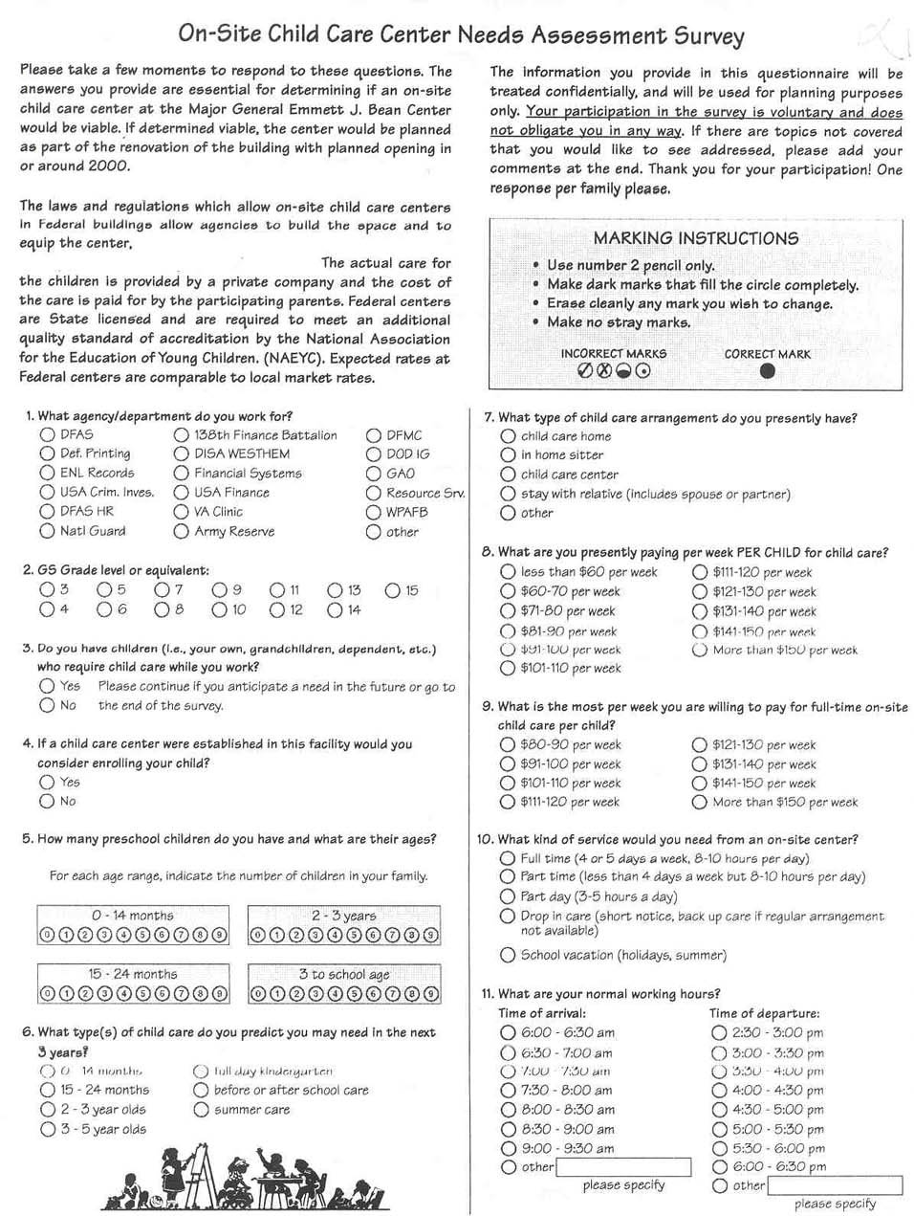

MARKET SURVEY

The following market survey will be used to assess each child care facility located within the worksite or a 5 block radius of the worksite. Worksites located in rural areas should extend their areas of consideration to commuting routes.

Note: This survey should be conducted by the appointed child care representative and not be performed by all employees.

- Name of Child Care Center: _________________________________

Address and proximity to worksite: ______________________________

Child Care Center is managed by :
_____ National for-profit Provider
_____ Local Independent for-profit Provider
_____ Local not- for- profit Provider
_____ National affiliated not-for-profit Provider
_____ Church Sponsored
_____ Federal/State/Local government

- What age range does the center accommodate and how many children are currently enrolled in each category:

Age No. enrolled Waiting List Length of wait
Infant _____ _________ _________ ___________
Toddler _____ _________ _________ ___________
Two’s _____ _________ _________ ___________
Pre-K _____ _________ _________ ___________
School age _____ _________ _________ ___________

- What are the center hours:__________________________________

- Does the center charge an additional fee for “extra” hours or late pick up?

- In which geographic location do the majority of your patrons work?
- How many Federal employees’ children are currently enrolled?______________

- What are the WEEKLY child care rates:

Age Full time part time multi child discount
Infant _______ _________ _________
Toddler _______ _________ _________
Two’s _______ _________ _________
Pre-K _______ _________ _________
School age _______ _________ _________

- Are meals included?___________________________________________________________

9. Is the center currently accredited by the National Academy of Early
Childhood Programs? NAEYC_______________________________________________

10. Are there plans to become accredited? _____________________________________________

- What is the teacher/ child ratio?___________________________________________________

- What is the level of parental involvement at the center?_________________________________

_________________________________________________________________________________

13. What supplies are parents expected to bring?__________________________________________

- Are there any plans in the immediate future to expand the facility?
Yes______ NO______
If yes, please explain:

- Are you aware of any child care centers planning to expand or any new
centers opening? Yes______ NO __________
If yes, please explain:

4
roles & responsibilities

ROLES AND RESPONSIBILITIES

GSA:

Sets policy for the child care program nationwide - Provides finished space, services, utilities and equipment to the center - Conducts background checks on center staff - Sets and oversees quality standards through a license agreement - Trains and provides materials for boards, agencies and providers

TENANT AGENCIES:

Sponsor the center for their employees and pay RENT, generally assigned as joint use space - May appoint board members, may provide direction to the board - May allocate resources for lower income federal employees to use for tuition - May allocate recycling funds to be used for tuition assistance programs - May provide space for fund-raising activities.

BOARD OF DIRECTORS:

Make quality child care available to federal employees and others in the local commuting area - Select the provider - Support the program - Fund-raise and administer a tuition assistance program - Help market the center - Serve as a liaison between the government, the provider, and the parents - Monitor center goals and board effectiveness.

PROVIDER:

Operate a high quality, state licensed and NAEYC accredited child care center, this includes: hiring staff, establishing curriculum, collecting fees, marketing the center, maintaining liability insurance, and serving the families.

STATE AND/OR LOCAL LICENSING AUTHORITIES:

Set minimum quality standards for child care centers. Ensure compliance and investigate complaints - Inspect the centers, including health, program and fire safety inspections.
INTERAGENCY AGREEMENT
BETWEEN

List Participating Agencies

I. Purpose

This Interagency Agreement (IA) sets forth the terms and conditions under which a child care facility shall be provided start up assistance and other support and oversight for the benefit of the employees of ___________________.

II. Authority

This IA is entered into pursuant to the authority contained in the Economy Act, section 1535 of Title 31, United States Code. The parties have determined that the services provided pursuant to this IA cannot be obtained as economically or as conveniently from a commercial enterprise, or by the parties acting independently from one another, and that the IA is in the best interest of the Government. Authority allowing Federal agencies to establish child care centers is provided under 40 U.S.C. 490b.

III. Background

Each of the parties to this IA has determined that a child care facility is necessary for the welfare of its employees. Employer support for child care services is a well established mechanism for increasing productivity through improved staff recruitment and retention, reduced absenteeism, and higher employee morale. Such services are especially important for lower graded employees, who may find child care services difficult to obtain and the lack of such services an impediment to employment or advancement. In furtherance of this commitment to providing their employees with child care services, the participating agencies have formed an interagency working group to oversee the actions necessary to establish a facility. The facility is defined as the physical space that houses the children and child care staff and in which a profit or nonprofit organization operates a child care center. In addition, the participating agencies will also provide assistance in forming a board of directors incorporated as a not for profit organization to oversee, support and generate scholarship dollars and administer a tuition assistance program for the child care center.

IV. General Provisions: would include discussion of sponsorship of committee members, reporting requirements of the committee to the agencies, discussion of appointed or volunteer participation (can be either or combination of both)

V. Responsibilities: include specific number of committee members per agency, expected work products, accessibility to employee newsletters for board and center marketing efforts, etc.

VI. Financial Arrangements: to include one time or ongoing dollar commitments,including formula for sharing RENT if applicable (based on total employee base, or specific purchased long term slots) Include provision for paying for board or center staff to go to the GSA conference per authorities of 490b.

VII. Effective Date and Duration

This IA is effective on the date of the last signature below by the approving officials and will continue in effect for each participating agency unless and until an agency withdraws by giving written notice at least 90 days before the end of its participation. Furnishings and other Government owned personal property provided for the facility will remain in the possession of the facility and under control of the designated property officer.

VIII. Modifications

This IA may be modified at any time by written agreement of the parties.

IX. Approvals

On behalf of our respective agencies, this IA is approved.

_____________________________________________________ ____________
Approving Official Date
Title

_____________________________________________________ ____________
Approving Official Date
Title

_____________________________________________________ ____________
Approving Official Date
Title

5
standards

Standards

CARING
FOR
OUR CHILDREN

NATIONAL HEALTH AND
PERFORMANCE STANDARS:
GUIDELINES FOR OUT-OF-HOME
CHILD CARE PROGRAMS

NAEYC
ACCREDITATION CRITERIA
NATIONAL ACADEMY OF EARLY CHILDHOOD PROGRAMS

GSA STANDARDS/LICENSE REQUIREMENTS
CPSC SAFETY CHECKLIST + HANDBOOK FOR PUBLIC PLAYGROUNDS

STATE LICENSING STANDARDS/ LOCAL LICENSING STANDARDS
MUST MAINTAIN AND DISPLAY A STATE LICENSE

All centers must be State licensed. In some areas a local city license may also be required. State requirements can be found on the following WEB site: http://nrc.uchsc.edu
We consider the requirements of the State license to be the minimum requirements. To operate in GSA federal space you must also meet our GSA license requirements. These requirements are outlined in the special conditions of the license for use of space and include the guidelines from our Design Guide and Security Survey. In addition we follow the Consumer Product Safety Commission (CPSC) guidelines as our standard for playgrounds and for safety requirements within the space.

Additionally, centers must operate a program that follows the National Association for the Education of Young Children (NAEYC) criteria for accreditation. That means, in staffing, group sizes and ratios, the center is required to follow NAEYC standards if they differ from State requirements. (We use the most stringent requirements)

Finally, if there is a question of standard not specifically addressed by NAEYC our GSA license or the State, we defer to the standards in “Caring for our Children.” 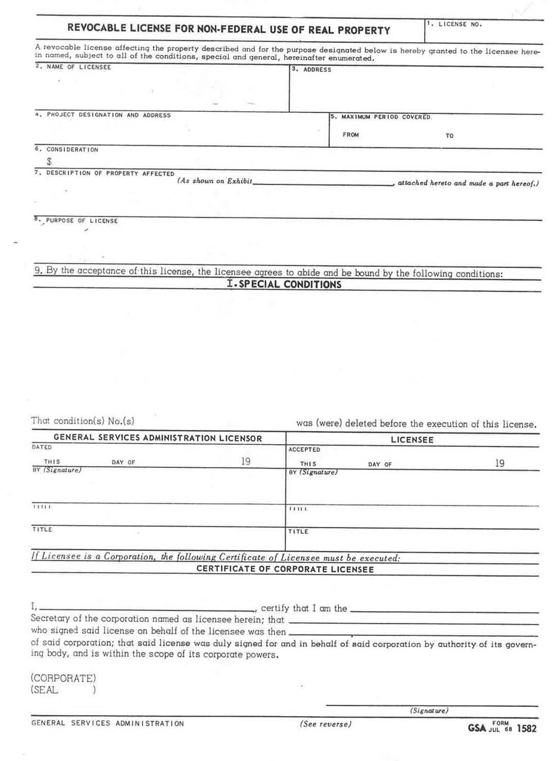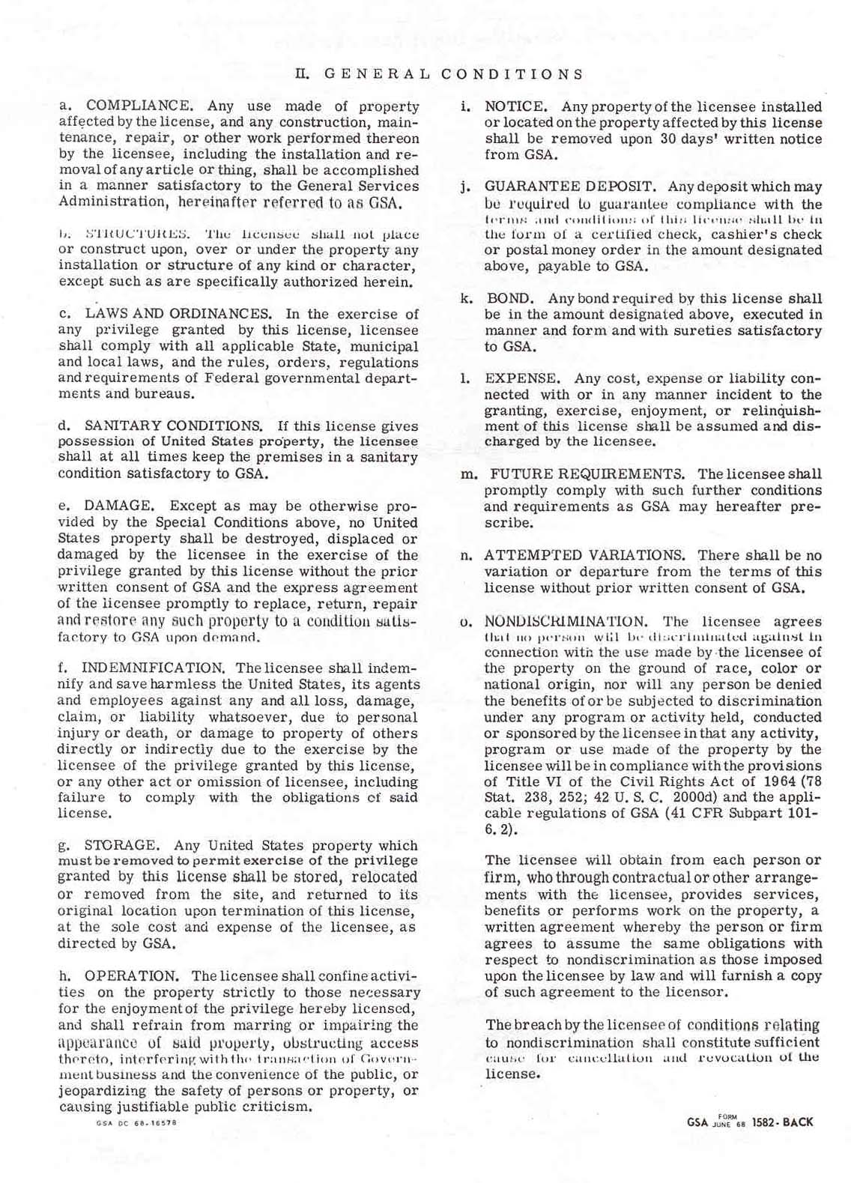
SPECIAL CONDITIONS TO THE LICENSING AGREEMENT BETWEEN
GSA AND

1.LICENSE AUTHORITY

This license is granted pursuant to the authority of and subject to the conditions in 40 U.S.C. 490b. The Child Care Provider who provides child care at the site agrees to abide by these Special Conditions.

2.CRIMINAL HISTORY BACKGROUND CHECKS

The Child Care Provider and its employees are subject to the Crime Control Act of 1990 Public Law 101-647 as amended by Public Law 102-190, dated December 5, 1991, and will submit to criminal history background checks. Providers or employees who have a conviction for sex crimes, offenses involving children as victims, or drug felonies will be denied employment or dismissed, except that for a conviction of a crime other than a sex crime or offense involving children the government will review the facts of the individual case before exercising its right to deny or have terminated the employment of that employee.

In addition, the Child Care Provider and its employees are subject to any other checks as may be required by GSA, and any pertinent local regulatory authorities. The child care provider will certify that they have completed appropriate background checks of each new hire to include: reference, employment and educational certification.

NATIONAL ACCREDITATION

The child care provider shall begin the National Association for the Education of Young Children (NAEYC) accreditation process within one year of operation and will achieve accreditation within 2 years of operation. The child care provider will maintain accreditation through the renewal process of the National Academy of Early Childhood Programs.

4.TERMS AND CONDITIONS OF OCCUPANCY

The child care center will be operated in accordance with the following terms and conditions:

- Maintain and operate a developmental child care program from a.m. to p.m., Monday through Friday except on Federal holidays. The child care center may be closed one week per year for maintenance.

- The center's employees shall comply with all building regulations and special building security arrangements. Building security arrangements may include the display of Government-furnished identification (ID) cards, where required. All Government furnished IDs remain the property of the Government and must be surrendered to the Provider's management by all center employees leaving the Provider's employ. Such IDs must then be immediately returned to the Government's designated building security officer.

- The Child Care Provider shall not discriminate on the basis of race, religion, color, national origin or disability with respect to enrollment of children or employment of staff.

- By signing this agreement the Child Care Provider has acknowledged receipt of and use of equipment and other property as furnished by the government, and shall provide routine care of any government furnished equipment during the term of this license.

- The Child Care Provider shall be responsible for any damage to the equipment arising from wrongful acts or acts of negligence of the Child Care Provider.

- The Child Care Provider must maintain the facility in a clean and safe manner. General housekeeping is expected so that the center appears clean and well kept at all times. Cleaning responsibilities of the provider include, but are not limited to: cleaning and sanitizing of all toys, toy shelves, children’s furniture, kitchen appliances inside and out, kitchen pantries, storage closets including shelves, as well as pet cages and aquariums. Immediate spot cleaning is required during snacks, mealtimes, during and after craft projects, etc. Storage of all bleach/sanitizing solutions will be out of reach of children.

- The Child Care Provider must ensure that staff members have had training in the prevention and detection of child abuse, valid first aid certifications in employees’ files and demonstrate verifiable staff training in emergency and evacuation procedures, and other training that may be required by State or local licensing authorities. This requirement is in addition to the training requirements per accreditation and state criteria.

- The Child Care Provider will ensure that all incidents occurring in the center: criminal incidents or accidents/incidents requiring immediate professional medical attention are immediately reported to the Federal Protective Service. The Child Care Provider will ensure that notification of the incident is provided to the regional child care coordinator as soon as possible but no later than 24 hours after the occurrence.

- The Child Care Provider will notify the appropriate local authority in cases of suspected child abuse or neglect per Public Law 104-28. The Federal Protective Service will not be notified in these matters unless the suspected abuse occurred on site, in which case the FPS is notified in addition to the appropriate local authority.

- The Child Care Provider will post in a public area of the center its current state or local license to operate a child care center.

- The Child Care Provider will comply with all Federal, State or local safety policies, including the smoking policy.

- The Child Care Provider will post an emergency evacuation plan for the center. The Child Care Provider will ensure that a fire drill is conducted by the staff at the Child Care Center at least monthly and will keep a record of these drills available to GSA upon request. The Child Care Provider will work with appropriate Government officials to ensure that the center’s evacuation plan is appropriately incorporated into the occupant emergency plan (OEP) for the building.

- The GSA Regional Child Care Coordinator, will on a regular basis, collect demographic data and other pertinent information relating to center operations. The Child Care Provider will respond in a timely and expeditious manner.

- The Child Care Provider must demonstrate that it is financially capable of continuing its operations under the terms of its license to use space. The child care provider agrees to provide upon request financial statements, which may include quarterly financial statements and/or an annual audit by an independent reviewer.

- The Child Care Provider shall provide all supplies (consumables and manipulatives) such as toys, food and curriculum materials which remain the property of the provider.

- The Child Care Provider shall market the program, its quality and availability to Federal employees and others. This can be accomplished through newsletters, posters, building displays, lunch & learns, flyers, e-mail and other marketing techniques.

5. GSA INITIATED REVIEWS

The Child Care Provider shall agree to have GSA initiated program, health and safety assessments accomplished on center operations and shall meet all requirements as a result of these reviews.

6. STATUS OF THE CHILD CARE PROVIDER

The Child Care Provider is not an employee or agent of the Government. Parents with children enrolled at the center shall contract directly with the Child Care Provider. Except for matters explicitly addressed in this license, decisions and responsibilities with respect to program, levels of enrollment, fees, tuition, hiring, policy making, and any and all other aspects of the operation and conduct of the Center's business shall be the exclusive right, prerogative, and responsibility of the Child Care Provider.

7. PRIORITY ENROLLMENT

The Child Care Provider shall give priority for available child care services to employees of the sponsoring agencies. Per the conditions of 40 U.S.C. 490b Federal employees will be given priority placement for all available spaces and at least 50% of the children enrolled in the center are to be children or dependents of Federal employees. If this requirement is not met a plan must be put into effect to increase Federal enrollment. Remaining enrollment may be open to the general public.

8. INSURANCE

The Child Care Provider shall, at its own expense, provide and maintain during the term of this license, and any extension thereof, comprehensive liability insurance in an amount not less than $1 million. A copy of the insurance certificate including renewals shall be provided to GSA prior to occupancy of the center or as soon thereafter as possible. An accident insurance policy will be maintained on all students by the Child Care Provider.

9.TUITION ASSISTANCE

A tuition assistance program for families in economic need shall be established. The tuition assistance program can/will be established through a nonprofit Federal employee organization. Participation in the Combined Federal Campaign or local United Way campaign should be planned.

10. TERMINATION

GSA or the Child Care Provider may terminate this license after _____ days written notice, or immediately if there is a substantial breach of the conditions of this license.

11. EFFECTIVE DATE AND DURATION

This agreement is effective on the date of the last signature and will continue in effect for each party unless and until terminated by either party under the conditions in section 10 of this agreement. (Can set a term)

12. MODIFICATIONS

This agreement may be modified at any time by written agreement of the parties.

13. CHANGES IN STATUS

The Child Care Provider agrees to notify GSA immediately of any changes in the manner in which the Center is being operated or in its change of status including the creation of any public private partnerships. This license is nontransferable and may be cancelled if the provider sells its business.

NATIONAL RESOURCE CENTER FOR HEALTH AND SAFETY IN CHILD CARE

http://nrc.uchsc.edu/states.html phone 1-800-589-KIDS
<!-- commented out section
TEST..............
#70DB93 Aquamarine
#5F9F9F Cadet
#B87333 Copper
#7093DB Dark Turquoise
#D19275 Feldspar
#F5CCBO Flesh
#COCOCO Grey
#FFFFFF White
#93DB70 Light Green
#9F9F5F Khaki
#8F8FBD Steel Blue
#E9C2A6 Light Wood
#32CD99 Medium Aquamarine
#EBC79E Medium Turquoise
#8FBC8F Pale Green
#BC8F8F Pink-grey
#D9D9F3 Lavendar
#38B0DE Bright Aqua
#ADEAEA Turquoise
-->

Individual States' Child Care Licensure Regulations:* <!DOCTYPE HTML SYSTEM "html.dtd">
Alabama (334)242-1425 | Illinois  (217)524-1983 | Montana  (406)444-7770 | Rhode Island (401)222-4741
Alaska (907)465-3170 | Indiana (317)232-4740 | Nebraska  (402)471-9302 | South Carolina  (803) 898-7345
Arizona  (602)674-4220 | Iowa  (515)281-4357 | Nevada  (775) 687-4232 | South Dakota (605)773-4766
Arkansas  (501)682-8590 | Kansas  (785)296-1270 | New Hampshire (603) 271-4624 | Tennessee  (615)313-4778
California  (916)657-2586 | Kentucky  (502)564-2800 | New Jersey  (609) 292-1018 | Texas (512)438-3262
Colorado  800-799-5876 | Louisiana  (225) 922-0015 | New Mexico  (505) 827-7499 | Utah (801)538-9299
Connecticut  (860)509-8004 | Maine  (207)287-5060 | New York  (518)474-9454 | Vermont  (802) 241-3110
District of Columbia  (202) 442-5888 | Maryland | North Carolina (919)662-4527 | Virginia  (804) 692-1776
Delaware  (302)892-5800 | (410) 767-7805  Massachusetts  (617)727-7600 | North Dakota (701)328-4809 | Washington  (360)902-8044
Georgia  (404)657-5562 | Minnesota  (651) 296-3971 | Oklahoma  (405)271-4471 | Wisconsin  (608) 266-9314
Florida  (850)488-4900 | Michigan  (517)335-6068 | Ohio (614)466-1043 | West Virginia  (304) 232-4411
Hawaii  (808)586-5770 | Mississippi  (601) 576-7613 | Oregon  (503)947-1400 | Wyoming  (307)777-6595
Idaho  (208) 334-0641 | Missouri  (573)751-2450 | Pennsylvania  (717)787-8691

*Note: Local authorities may have additional regulations such as zoning, building or firecodes-please check with your local authorities.
<!-- <LI><A HREF=http://www.dhs.state.tx.us/tdprs/ccl/intreg.html>Texas</A> -->

“The National Association for the Education of Young Children (NAEYC) exists for the purpose of leading and consolidating the efforts of individuals and groups working to achieve healthy development and constructive education for all young children.”

The National Association for the Education of Young Children (NAEYC) is the nation’s largest organization of early childhood professionals and others dedicated to improving the quality of early childhood education programs for children birth through age eight.

www.naeyc.org

About NAEYC Accreditation
The National Academy of Early Childhood Programs, a division of NAEYC, administers a national, voluntary, professionally sponsored accreditation system for all types of preschools, kindergartens, child care centers, and school-age child care programs.

NAEYC accredited programs have demonstrated a commitment to providing a high quality program for young children and their families.

The accreditation process looks at the following components of a center’s program.

Interactions among Staff and Children

Curriculum
- Staff-Parent Relations

Staff Qualifications and Development
- Administration

Staffing

Physical Environment
- Health and Safety
- Nutrition and Food Service
- Evaluation

6
cost quality and affordability

COST, QUALITY AND AFFORDIBILITY

“Anyone with more than a passing acquaintance with child care in the United States has confronted what many in the profession call the “trilemma”. Briefly characterized the trilemma means that parents cannot afford to pay what good early care and education costs, child care providers cannot earn enough money to live on and children cannot get the quality of care they deserve”.

Child care is very labor intensive. Staff costs make up between 70% to 85% of a budget, with most caregivers still earning less than a GS 4 level salary.

In private centers, center space is typically between 5% and 25% of a child care center’s budget. The lower end reflects centers that receive free or subsidized space. The high end reflects suburban centers where they have built facilities. What we believed when we first opened child care facilities in our space was that if we provided the facility (the equivalent of as much as 25% of a center’s budget) then we would see a reduction in fees of equal measure. This belief was based on the erroneous assumption that child care available in the marketplace was of high quality. What we learned was that this was not true. The existing child care market was not providing the high quality care and learning environments we wanted in our centers.

Since the subsidy provided by free space and equipment is not enough to provide for high quality programs and subsidized low tuition costs for parents we have focused our space subsidy on improved quality.

In 1995 a long awaited research study was published: “The Cost Quality and Child Outcomes in Child Care Centers” by Suzanne Helburn and Mary Culkin from the University of Colorado at Denver, Carolle Howes from UCLA, Sharon Kagan from Yale University and Richard Clifford from the University of North Carolina.

Some Key findings:

- Child care in most centers in the United States is poor to mediocre. The level of quality in most centers does not meet children’s needs for health, safety, warm relationships and learning. Only one in seven centers was rated as developmentally appropriate.

- Key determinants in the provision of high quality care are staff to child ratios, staff education and administrators’ prior experience. The most significant determinant of quality was found to be staff-to-child ratios. Center quality was also found to increase as the percentage of staff with a high level of education increases and as the prior experience of the administrator increases. Centers providing the lowest quality of care were found to have teachers who were paid the lowest wage, had the least education and received the least specialized training.

- States with more demanding licensing standards have fewer poor quality centers.

- Highest quality was found in centers that have access to extra resources to improve quality. Centers that do not have to depend solely on parent fees are able to provide the highest quality.

- Good quality services cost more, but not a lot more. The difference between mediocre quality care and good quality care was about 10%. The provision of excellent quality care requires a much greater increase in costs.

- Quality of service is not significantly different between for profit and non profit sectors.

- Parents tend to over estimate the quality of care their children are receiving. While parents say they value the quality of care their children receive, they tend to be ineffective in evaluating quality. Ninety percent of parents rated the quality of the services their children receive as very good, while the ratings of trained observers indicate that most of those same programs are providing care that ranges from inadequate to mediocre. The inability of parents to recognize good quality care implies that they do not demand it. Thus centers dependent on parent fees have little or no incentive to provide a higher level of quality at a higher cost.

- Inadequate public subsidies lower the demand for good quality child care. Government purchasing practices often fail to contribute to raising the level of quality. When government agencies impose low payments through low funding caps and reimbursement rates when purchasing care for low income children, they too contribute to lowering the demand for good quality child care.

Knowing the cost of high quality care is too high for many families to pay, most of our Federal centers function with a Nonprofit Board which serves as the major player for fundraising and tuition assistance programs.

7
additional resources
USING AVAILABLE RESOURCES

Knowing what is available and where to find help will save the start-up committee time and effort in their work. Many excellent resources have become available through the Internet. If you can not access the Internet at work or at home then try your public library.

Your most important local resource for information will be the local Child Care Resource and Referral Agency or CCR&R. This is an organization whose mission is to know the local child care market, “do whatever it takes to make child care work for families and communities” thus they can facilitate in identifying providers, training opportunities, funding streams and current issues/events in your area. You can find your CCR&R by looking in the Yellow Pages of the phone book under: Child Care Referral Services.

The following WEB sites have good information:

- GSA, Child Care Operations Center of Expertise
http://www.gsa.gov/pbs/centers/child/child.htm

- National Clearinghouse for the Military Child Development Program
http://dticaw.dtic.mil/milchild/

- The National Association for the Education of Young Children (NAEYC)
http://www.naeyc.org/default.htm

- The National Resource Center for Health and Safety in Child Care
http://nrc.uchsc.edu.

- National Child Care Information Center
http://nccic.org/

- National Association of Child Care Resource and Referral Agencies (NACCRRA)
http://www.naccrra.net/

- Department of Labor, Women’s Bureau National Resource and Information Center
http://www.dol.gov/dol/wb/

- Office of Personnel Management
http://www.opm.gov

The following organizations have a number of materials for: board development, and/or child care quality and early education, which can be purchased.

◊ National Center for NonProfit Boards
Suite 510-G, 2000 L. Street N.W. Washington, DC 20036-4907 (800)883-6262

- Child Welfare League of America (CWLA)
440 First Street N.W. Third Floor, Washington, DC 20001 (202) 638-2952

◊ Center for the Child Care Workforce
733 15th Street, NW Suite 1037
Washington, DC 20005-2112 (202) 737-7700 or 800 U.R. WORTHY
http://www.ccw.org

◊ The National Association for the Education of Young Children (NAEYC)
1834 Connecticut Avenue, N.W. Washington, DC 20009 (800) 424-2460
http://www.naeyc.org/default.htm

Publications:

- Accreditation Criteria and Procedures of the National Academy of Early Childhood Programs (NAEYC)
1834 Connecticut Avenue, N.W. Washington, DC 20009 (800) 424-2460
http://www.naeyc.org/default.htm

◊ Tax -Exempt Status for Your Organization
IRS Publication 557 (800) 829-3676

◊ Handbook for Public Playground Safety
U.S. Consumer Product Safety Commission, Washington, DC 20207
http://www.cpsc.gov

◊ Office of Personnel Management 5 CFR Part 950
(Combined Federal Campaign, CFC)
Solicitation of Federal Civilian and Uniformed Service Personnel for Contributions to Private Voluntary Organizations
http://www.opm.gov

◊ Child Care Design Guide, PBS-PQ 140
◊ Child Care Board of Directors Resource Guide
General Services Administration, Public Buildings Service
http://www.gsa.gov/pbs/centers/child/child.htm

◊ Caring for Our Children, National Health and Safety Performance Standards:
Guidelines for Out-of-Home Child Care Programs.
A joint collaborative project of the American Public Health Association and the American Academy of Pediatrics
American Public Health Association Publication Sales Department 5037,
Washington, DC 20061-5037 (202) 789-5636
http://nrc.uchsc.edu/national/index.html#TOP

CONSULTANTS

GSA typically does not use consultants in starting our centers. For those groups outside of GSA space, the need to enlist the aid of a consultant is dependent on:

- The expertise of the members of the organizing committee
- Time availability
- Resource priorities of the sponsoring agency

If the organizing committee makes a decision to hire a consultant, specific tasks for the consultant must be determined. Once tasks are determined, the committee should take the following steps:

- Contact several consultants requesting resumes, references and sample final reports
- Contact references and discuss quality of work
- Meet with each consultant and discuss your specific needs; marketing, program issues
- Provide scope of work
- Have consultant submit a proposal in response to the discussion and scope of work
- Select the best consultant and develop the contract

When assessing the credentials of the consultant:

- Consider experience and expertise in the specific area or areas in which you need assistance; curriculum, marketing, etc.
- Assess overall knowledge of the field: knowledge of demographic and early childhood trends, issues, accepted practice in the field, promising developments, legislation, etc.
- Assess knowledge of local regulations, licensing standards and other local and state requirements for center operation
- Discuss the consultant’s position on specific issues such as accreditation, board composition, curriculum development, and evaluation
- Assess knowledge of child care operations in federal space

The consultant/committee relationship will depend to a great extent on the specificity of the scope of work. The most common problem with consultant-organizing committee relationships evolves from the lack of a clearly defined scope of work. Often, committees have made assumptions that consultants will perform tasks that are not defined. Consultants, on the other hand, may make assumptions that certain tasks are being performed by those on the committee or by other consultants. Assumptions made by either party can lead to miscommunication and dissatisfaction. Excellent committee/consultant relationships develop when expectations are clear and communication is open. In some cases it may be necessary to hire more than one consultant for different tasks, whereas, some centers can become operational without a consultant.

The major task of the organizing committee is to collect as much information as possible from existing resources and determine which specific task areas, if any are in need of the skills of a consultant.

Finding Funding: Sources of Resources For Child Care, by John Surr. Chapter 8 of the Handbook on Quality Child Care For Young Children, Settings, Standards, and Resources. Edited by Carol Ann Baglin and Michael Bender.
Cost, Quality, and Outcomes Study, Campus Box 159, PO Box 173364, University of Colorado at Denver, CO 80217-3364. Executive Summary $8, Public Report $15, Technical Report $40

