II. STUDENT CHARACTERISTICS

Infants and Toddlers Served Under IDEA

Preschoolers Served Under IDEA

Students Ages 6 Through 21 Served Under IDEA

Meeting the Needs of Students with Co-occurring Disabilities

Students with Orthopedic Impairments

Infants and Toddlers Served Under IDEA
In 1986, the Infants and Toddlers Program was added as Part H of the Individuals with Disabilities Education Act (IDEA), with the goal of encouraging development or expansion of statewide early intervention services for children ages birth through 2 with disabilities and their families. By September 30, 1994, all States had ensured full implementation of Part H. Under the reauthorization of IDEA, the IDEA Amendments of 1997, Part H was renamed Part C.

The Number of Children Served Under IDEA, Part C

It is most useful to evaluate the number of children served under Part C of IDEA beginning with the data reported in December 1994 because it was in this fiscal year that all States reported that they had fully implemented Part C (see figure II-1). In 1994, 165,351 children were reported served under Part C. By 1997, 197,625 infants and toddlers were reported as receiving services. Anecdotal reports from the States attributed this steady increase to better child-find efforts and more efficient tracking and reporting methods. Surprisingly, however, the number of children served under Part C has declined since 1997: In 1998, the number of children reported as receiving services under Part C decreased by 4.4 percent, to 188,926. Two States, Ohio and Illinois, accounted for 82.4 percent of the decline. These two States reported changes in administrative data collection procedures that may provide some explanation for the change.

In 1997, Ohio reported 22,917 infants and toddlers served under Part C, compared with 5,161 in 1998 (see table AH1). The State reported that this decrease resulted from the use of a new data collection system, Early Track, that was first implemented in 1998. Ohio’s data managers believe that this system is more reliable and will eliminate potential duplication of child count that may have contributed to the higher counts reported in the past. The State expects data collection to improve as personnel become more familiar with the new tracking system.

Illinois reported a less striking but still significantly lower number of children served in 1998: The 1997 figure of 7,758 dropped to 4,849 in 1998. Illinois noted that this decrease was likely the result of a change in the Part C lead agency; responsibility for Part C passed from the Department of Education to the Department of Human
Figure II-1
Number of Infants and Toddlers Served Under IDEA, Part C,
1994 Through 1998

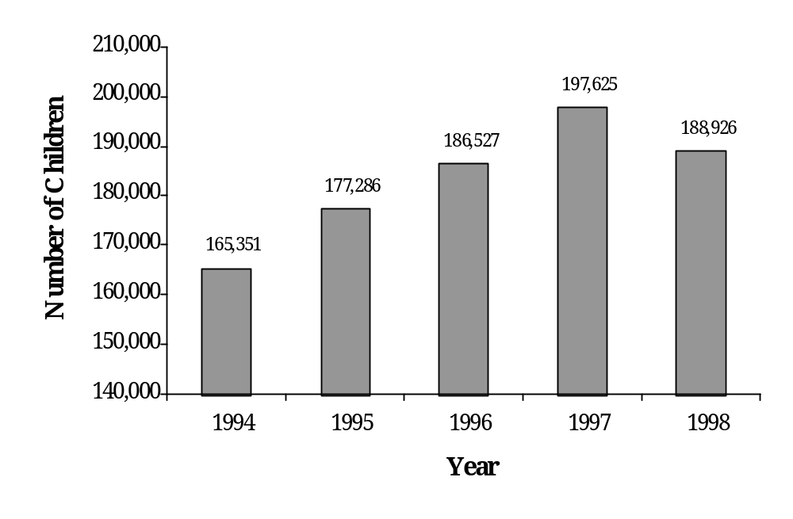Source: U.S. Department of Education, Office of Special Education Programs, Data Analysis System (DANS).

Services in January 1998. A change in lead agency can affect child count data, as different agencies often have different counting systems and different priorities. Together, Ohio and Illinois reported serving 20,665 fewer children under Part C in 1998 than in 1997. Finally, Puerto Rico reported serving 4,773 children in 1997 and 2,592 in 1998 a decline of 2,181. Puerto Rico did not provide an explanation for the decline.

In contrast, 20 States and Outlying Areas reported minimal or no declines in their 1998 Part C child counts, and 36 States and Outlying Areas reported increases. The most significant increases were reported by California (16,696 in 1997 to 19,421 in 1998) and New York (17,950 in 1997 to 20,592 in 1998). Texas also reported a significant increase, serving 12,877 children in 1998 and 11,861 in 1997. Reasons for increases in the number of infants and toddlers served under Part C varied. For instance, Kentucky attributed its increase in the number of children served in 1998 to a more accurate count as a result of its new electronic counting system and general growth in the system. South Dakota noted that its increase was the result of increased child find efforts, an explanation given by a number of States.
The IDEA Amendments of 1997 encouraged all States to develop methods of identifying, evaluating, and serving at-risk children. This was also the first year that States which report that they serve at-risk children were required to separately report the number of at-risk children served. Currently, eight States and one Outlying Area serve at-risk populations under Part C (California, Guam, Hawaii, Indiana, Massachusetts, New Hampshire, New Mexico, North Carolina, and West Virginia). Although the criteria for defining an at-risk child vary by State, in general, an at-risk child is one who would be at risk of experiencing a substantial developmental delay if early intervention services are not provided. According to the Part C Data Dictionary, States may consider prominent biological and environmental factors that can have a derogatory effect on development, including low birth weight, respiratory difficulties in newborns, infection, malnutrition, and a history of abuse and neglect (Westat, 2000).

Of the States that serve at-risk children, two reported more than half of their Part C population in that category. California reported 13,737 children at risk, or 70.7 percent of its Part C population, and Hawaii reported 1,976 children at risk, or 63.4 percent of its Part C population. The other States that serve these children reported much smaller proportions of their Part C children as being at risk (see table AH2).

Race/Ethnicity of Infants and Toddlers Served

A new component of the 1998 child count for all programs under IDEA was the collection of race/ethnicity data. This collection is intended to provide more information on the issue of potential minority overrepresentation among children receiving special education services. Since race/ethnicity was a new component of the 1998 data collection, the race/ethnicity data should be interpreted cautiously. Comparisons of the children served under Part C with the general population of infants and toddlers by race/ethnicity are shown in figure II-2. The racial/ethnic distribution was generally comparable for the two groups. It was reported that 62.2 percent of the children served under Part C were white (non-Hispanic), compared with 62.8 percent of the birth-through-2 population nationally. Eighteen percent of the children served under Part C were black (non-Hispanic), compared with the national figure of 13.7 percent. The Hispanic population accounted for 14.9 percent of the children served under Part C vs. 18.2 percent of birth through 2-year-olds
Figure II-2
Race/Ethnicity: National Versus Part C Percentages

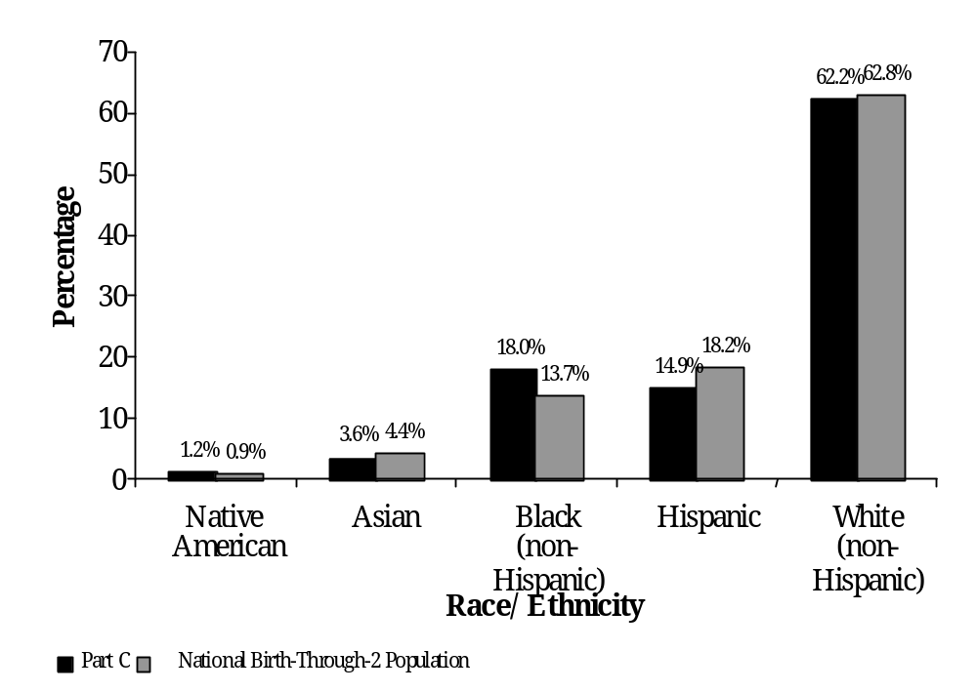Source: U.S. Department of Education, Office of Special Education Programs, Data Analysis System (DANS).

nationally. Asian children comprised 3.6 percent of the children served under
Part C vs. 4.4 percent nationwide. Finally, 1.2 percent of the children served under Part C were American Indian, which was comparable to the national average of 0.9 percent for birth through 2-year-olds (see tables AH3 and AF6).

Also reported on the basis of race/ethnicity were data describing the at-risk populations of the States and Outlying Areas that serve them. Of the eight States that serve at-risk children under Part C, six reported race/ethnicity data for those children. The racial/ethnic population of California’s at-risk population was comparable to all infants and toddlers served under Part C in that State. In both cases, the percentage of Hispanics served under Part C, whether as at risk (13.2 percent) or under the general Part C criteria (12.0), was double the percentage of Hispanics in California’s resident population (5.6 percent). In Indiana, the percentage of at-risk children served in each race/ethnicity category was comparable to both the general Part C and resident populations. The racial/ethnic composition of the at-risk children in North Carolina was almost identical to the general Part C service population. In both these populations, the percentage of black infants and toddlers served (40.0 percent) was greater than in the general population (23.9 percent), while the percentage of white children (52.0 percent in the Part C population) was less than the general population (68.2 percent). Hawaii reported a slightly higher percentage of its Asian population served to be at risk (89.7 percent) than that which was represented in its total Part C population (83.9 percent) or the general population (64.6 percent). Hawaii reported only half the percentage of white, non-Hispanic children as at risk (5.8 percent vs. 10.7 percent of the total Part C population). New Hampshire reported higher numbers of American Indian and Hispanic children as being at risk than occurred in the population: American Indians comprised 0.8 percent of New Hampshire’s Part C population, but 5.3 percent of the State’s at-risk population, and Hispanics comprised 1.9 percent of New Hampshire’s Part C population, but 10.5 percent of the at-risk population. Finally, West Virginia reported a higher percentage of black (non-Hispanic) children at risk (6.5 percent) than that of the total Part C population (1.8 percent) (see table AH3).

Early Intervention Service Settings for Infants and Toddlers with Disabilities

Since 1990, birth through 2-year-olds with disabilities have been served in one of the following eight reported setting categories: early intervention classroom, family child care, home, hospital (inpatient), outpatient service facility, regular nursery school/child care, residential facility, and other. The IDEA Amendments of 1997 placed greater emphasis on encouraging States to provide services in natural environments; for infants and toddlers, this is the home. In 1997, all but 10 States and Outlying Areas reported serving children in all eight categories. Alaska, Iowa, Maine, and American Samoa used seven settings categories; Minnesota and Vermont used five; the District of Columbia and Massachusetts used four; Connecticut used three; Puerto Rico used only the outpatient service facility category, and
Figure II-3
Part C Settings

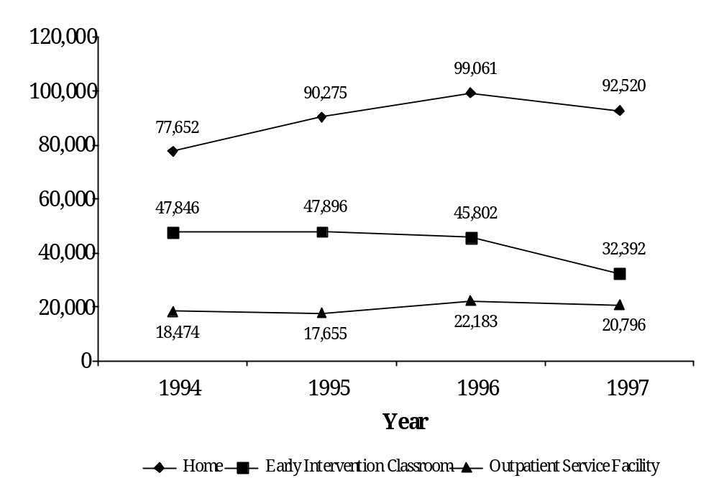
Source: U.S. Department of Education, Office of Special Education Programs, Data Analysis System (DANS).

Massachusetts used only the home category. California and Kentucky did not report any settings data.

The variation in the use of service setting categories makes it difficult to analyze the data and discern trends. However, since 1994, the most commonly reported settings have consistently been home, early intervention classroom, and outpatient service facility (see figure II-3). In 1997, this trend continued: 58.3 percent of infants and toddlers were reported served in the home, 20.4 percent were served in early intervention classrooms, and 13.1 percent were served in an outpatient service facility (see table AH7).

The structure of the Part C program varies by State. The service delivery models operating in the State affect the emphasis in services, personnel, and settings. For example, Connecticut noted that its decrease in the number of infants and toddlers served in outpatient service facilities was a result of its attempt to provide services in more natural environments. Delaware, while reporting increases in other settings, reported a decrease in outpatient service facilities, which was also related to an attempt to serve children in more natural environments. Colorado noted that its increases in the home and early intervention classroom settings and decrease in other settings were largely due to more accurate reporting and categorization methods. Colorado also pointed out that it has made a concerted effort to provide more services in the home. In 1997, Colorado almost doubled the percentage of children who received the majority of early intervention services in the home (50.3 percent, vs. 28.7 percent in 1996). Other reasons given by States for year-to-year changes in the use of different service environments include a focus on serving children in natural environments; increased use of managed care, which requires that services be provided in a clinical setting; and improved reporting and categorization methods.

Summary

In 1998, for the first time since the full implementation of Part C of IDEA in 1994, the States and Outlying Areas reported a slight decline in the number of infants and toddlers served. This decline was largely the result of changes in data collection procedures in a few States. In addition, 1998 saw the first race/ethnicity data reported on birth through 2-year-olds. Most State-reported data showed no significant minority overrepresentation among the infants and toddlers served under Part C, with the exception of some States that serve the at-risk population. States continued to emphasize the home setting as a natural environment in providing services to infants and toddlers with disabilities and their families.

References
Westat. (2000, July). OSEP IDEA, Part C data dictionary. Rockville, MD: Author.

Preschoolers Served Under IDEA,
The 1986 Amendments to the Education for All Handicapped Children Act (EHA) changed the Preschool Grants Program for Children with Disabilities from an incentive program to a mandated program. In order to be eligible for funding under this program, funds attributable to this age under the Grants to States Program, or IDEA discretionary grants targeted to 3- through 5-year-olds, States were required to serve all eligible 3- through 5-year-olds by fiscal year 1991. States are required to have in effect policies and procedures that assure the provision of a free appropriate public education (FAPE) for all 3- through 5-year-olds with disabilities, and, at the State’s discretion, to 2-year-old children with disabilities who will turn 3 during the school year.

The Individuals with Disabilities Education Act (IDEA) Amendments of 1997 revised the formula for allocating funds under the Preschool Grants for Children with Disabilities Program. Under the revised formula, each State is first allocated an amount equal to the amount it received in fiscal year 1997. For any year in which the appropriation is greater than the prior year level, 85 percent of the funds above the 1997 level are distributed based on the State’s relative percentage of the total number of children ages 3 through 5 in the general population. The other 15 percent is distributed based on the relative percentage of children ages 3 through 5 in each State who are living in poverty. In addition, the IDEA Amendments of 1997 provided for situations in which the program appropriation decreases, as well as several minimums and maximums regarding the amount a State can receive during any year. These formula changes went into effect in Federal fiscal year 1998.

IDEA mandates that States report data that could be a measure of the States’ progress in providing special education and related services to preschoolers with disabilities. The data analyzed in this module summarize information about the number of children ages 3 through 5 who received special education services, the racial/ethnic makeup of preschoolers in special education, and the environments in which these children received services.

The Number of Preschool Children Served Under Part B of IDEA

During the 1998-99 school year, 573,637 preschool-aged children with disabilities were served under Part B (see table AA1). This represented approximately 4.8 percent of all preschool-aged children who lived in the United States and its Outlying Areas. However, the percentage of preschoolers served varied considerably by State. Kentucky reported the highest percentage, with 9.4 percent of its preschoolers receiving special education services. Arkansas, Maine, Wyoming, and West Virginia each reported that more than 8.0 percent of their resident preschoolers received special education and related services. California, Hawaii, Texas, and the District of Columbia reported that fewer than 4 percent of their preschool-aged children received special education services. The United States territories reported the lowest special education enrollment rates, with Palau reporting less than 1.0 percent, American Samoa 1.0 percent, and Guam 1.3 percent (see table AA12).

Special education service provision to preschoolers increased with age. Of the preschoolers who received services in 1998-99, 20.5 percent (117,698) were 3 years old, 34.9 percent (199,924) were 4 years old, and 44.6 percent (256,015) were 5 years old (see table AA9). A goal of the U.S. Department of Education FY 2000 Annual Plan was to identify and provide services to children with disabilities at an earlier age (U.S. Department of Education, 1999). Between 1992-93 and 1998-99, the percentage of 3-year-olds receiving services grew 33.2 percent, and the percentage of 4-year-olds receiving services increased 31.8 percent (see figure II-4). The percentage of 5-year-olds receiving services increased at a slower rate of 18.8 percent. The 1998-99 State-reported data suggest that greater numbers of younger children were being identified and provided services.

Between 1989-90 and 1998-99, the total number of preschoolers served under IDEA increased 48.8 percent (see table AA18). The past 10 years began with a slow growth of 2.4 percent between 1989-90 and 1990-91. However, the next 4 years saw the most significant growth in providing services to preschoolers with disabilities during the 1990s. Between 1991-92 and 1994-95, the number of preschool children receiving services increased by an average of 7.3 percent in each year. Growth slowed to 5.0 percent between 1994-95 and 1995-96. Over the last 3 years of the decade, the number of preschool children served under IDEA continued to grow slowly, averaging 1.5 percent per year. In fact, between 1997-98 and 1998-99, the number of preschool children receiving services increased by just 0.6 percent. This trend parallels the slower growth in the general 3- through 5-year-old population during the same period.

Figure II-4
Number of Preschool Children with Disabilities Served by Age and Year, 1992-93 Through 1998-99

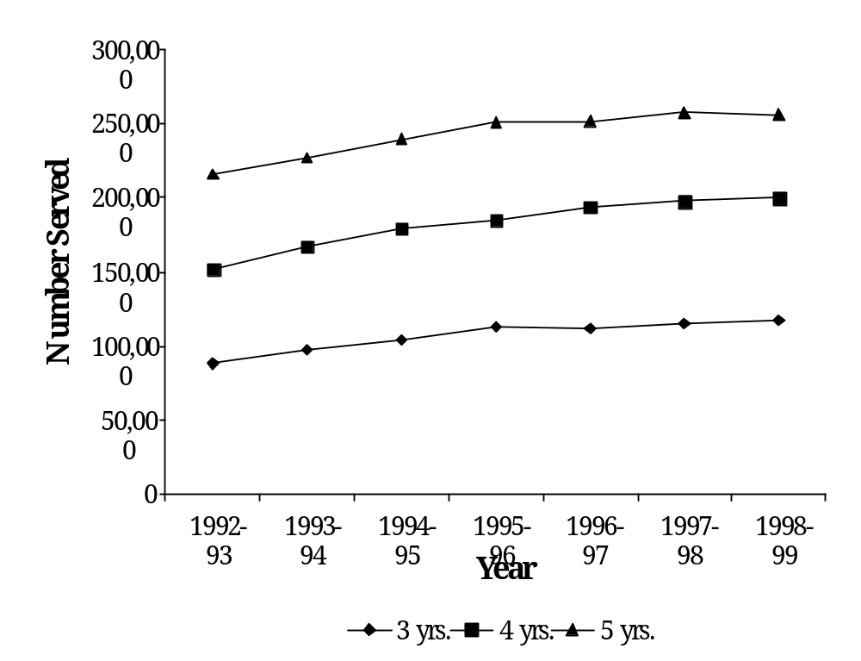Source: U.S. Department of Education, Office of Special Education Programs, Data Analysis System (DANS).

Race/Ethnicity of Preschoolers Served Under IDEA

In the IDEA Amendments of 1997, Congress mandated that States submit data regarding the race/ethnicity of children receiving special education and related services. This section of the module compares the racial distribution of preschoolers in special education with that of the general preschool population (see figure II-5). Since this was the first year that race/ethnicity were collected, the data should be interpreted cautiously.

U.S. Census population estimates for 1998 indicate that white children represented 63.3 percent of the general 3- through 5-year-old population, while 1998-99 State-reported data indicate that 68.9 percent of the preschoolers receiving special
Figure II-5
Race/Ethnicity of Preschoolers Receiving Special Education and of the General Preschool Population, 1998-99

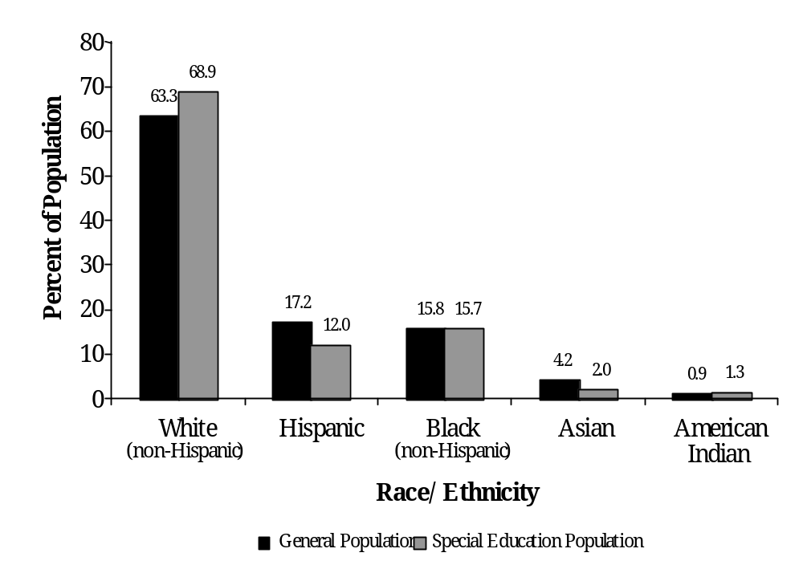Source: U.S. Department of Education, Office of Special Education Programs, Data Analysis System (DANS).

education and related services were white (non-Hispanic). Hispanic children comprised 17.2 percent of the general preschool population but just 12.0 percent of the preschoolers receiving special education. Representation of black (non-Hispanic) children receiving Part B services appeared to be nearly comparable to the general population: 15.7 percent vs. 15.8 percent, respectively. Asian children represented 4.2 percent of the 3- through 5-year-old population, and 2.0 percent of the preschool Part B population. And 1.3 percent of preschoolers in special education were American Indian, compared with 0.9 percent of the general preschool population (see tables AA7 and AF7).

The data reported by the States for 1998-99 indicated that the racial/ethnic distribution of the general preschool population versus the special education preschool population was, on average, generally comparable. Hispanic and Asian preschool children were slightly underrepresented in the special education preschool population. Conversely, the data indicated that white, non-Hispanic children were somewhat overrepresented among preschoolers receiving special education and related services.

Educational Environments for Preschoolers with Disabilities

During 1997-98, preschool settings were defined using the same terminology as settings for school-aged children (see table II-1). However, the terms were changed in 1998-99 to reflect settings more appropriate to preschoolers.

In 1997-98, Hawaii, the District of Columbia, the Northern Marianas, and the Virgin Islands did not report on educational environments for preschool-aged children with disabilities. Among the States that did report settings data, 92.2 percent of preschool-aged children with disabilities received special education and related services in a regular public school setting. Of these children, the majority (52.5 percent, or 276,839) were served in classrooms with nondisabled children for at least 80 percent of the day. Another 31.2 percent (164,512) received services in separate classes from their nondisabled peers for more than 60 percent of the school day. The remaining 8.5 percent of preschool children who received services in a regular public school were served in a resource room environment (see table AB3).

Among the preschoolers who did not receive services in a regular public school setting, a public separate facility was the most common setting for the provision of special education and related services. These students represented 3.8 percent (20,257) of the preschool children receiving IDEA services during 1997-98. Small percentages of preschoolers received special education and related services in a private separate facility (1.4 percent), public or private residential facility (0.2 percent), or a home/hospital environment (2.3 percent). For each of these settings, several States reported no children served in non-public school environments. No children were reported as receiving services in a public separate facility in 4 States, a private separate facility in 10 States, a public residential facility in 14 States, a private residential facility in 29 States, and a home/hospital environment in 8 States (see table AB3).
Table II-1
Educational Settings for Children Ages 3 Through 5 with Disabilities

Regular Class: includes children who receive services in programs designed primarily for nondisabled children, provided the children with disabilities are in a separate room for less than 21 percent of the time receiving services. This may include, but is not limited to, Head Start centers, public or private preschool and child care facilities, preschool classes offered to an age-eligible population by the public school system, kindergarten classes, and classes using co-teaching models (special education and general education staff coordinating activities in a general education setting).

Resource Room: includes children who receive services in programs designed primarily for nondisabled children, provided the children with disabilities are in a separate program for 21 to 60 percent of the time receiving services. This includes, but is not limited to, Head Start centers, public and private preschools or child care facilities, preschool classes offered to an age-eligible population by the public school system, and kindergarten classes.

Separate Class: includes children who receive services in programs designed primarily for nondisabled children, provided the children with disabilities are in a separate program more than 60 percent of the time receiving services. This includes, but is not limited to, Head Start programs, public or private preschools or child care facilities, preschool classes offered to an age-eligible population in the public school system, and kindergarten classes.

Separate School (public and private): includes children who receive services in a separate program for 61 to 100 percent of the time receiving services. It does not include children who received education programs in public or private separate day or residential facilities.

Residential Facility (public and private): includes children who are served in publicly or privately operated programs in which children receive care 24 hours a day. This could include placement in public nursing care facilities or public or private residential schools.

Homebound/hospital: includes children who are served in either a home or hospital setting, including those receiving special education and related services in the home and provided by a professional or paraprofessional who visits the home on a regular basis (e.g., a child development worker or speech services provider in the child’s home). It also includes children 3 through 5 years old receiving special education and related services in a hospital setting on an inpatient or outpatient basis. However, children receiving services in a group program that is housed at a hospital should be reported in the separate school category. For children served in both a home/hospital setting and in a school/community setting, report the child in the placement that comprises the larger percentage of the time receiving services.

Source: U.S. Department of Education, Office of Special Education Programs, 1997.

Over the past 10 years, the regular classroom has been the most common service setting for preschool children with disabilities (see figure II-6). The U.S. Department of Education (1999) indicated in its FY 2000 Annual Plan that increasing inclusion of children with disabilities in regular classroom settings was an important objective in the improvement of special education. The use of the regular classroom has gradually increased from 42.2 percent in 1988-89 to 52.5 percent in 1997-98 (see table AB7). Thus, the State-reported data indicated progress toward the Department’s goal of greater inclusion for preschool-aged children with disabilities.
Figure II-6
Percentage of Preschool Children Served in Different Educational Environments in 1988-89 and 1997-98

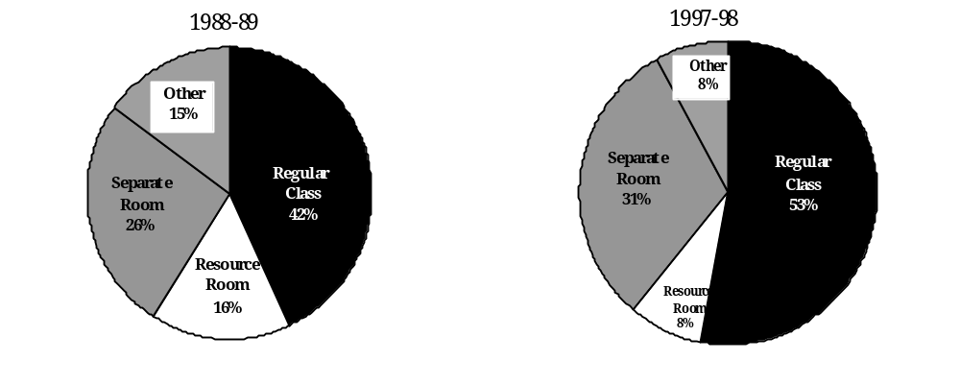Note: Percentage may not sum to 100 due to rounding.
Source: U.S. Department of Education, Office of Special Education Programs, Data Analysis System (DANS).

Although residential programs remained the least common service environment for preschoolers, both public and private residential programs experienced growth from the 1996-97 school year to the 1997-98 school year. The number of preschoolers served in public residential facilities rose from 700 in 1996-97 to 833 in 1997-98, an increase of 19.0 percent. After 3 years of decline, the number of preschoolers in private residential facilities rose 92.5 percent, from 173 in 1996-97 to 333 in 1997-98. In addition, the use of home/hospital programs decreased 3.3 percent between 1995-96 and 1997-98 (see table AB7). The reasons for these changes in service settings were unclear.

Summary

In the 1990s, the number of preschool children receiving special education and related services grew each year. State-reported data indicated that over the past 7 years, the number of 3- and 4-year-old children being identified and provided services grew at a much faster rate than did the number of 5-year-old children, indicating that children with disabilities were being identified and provided services at an earlier age.

Race/ethnicity data, reported for the first time in 1998-99, suggest that minority enrollment in special education was similar to the resident population of 3- through 5-year-olds. Asian and Hispanic children were slightly underrepresented among preschoolers in special education, while white (non-Hispanic) children were somewhat overrepresented.

The data reported regarding educational environments for preschool children with disabilities indicated that the majority of 3- through 5-year-olds served under IDEA received services in regular education classrooms with their nondisabled peers for 80 percent of the school day. The number of preschoolers served in regular classrooms continued to grow during the decade.

References
U.S. Department of Education, Office of Special Education Programs (OSEP). (1997). Instructions for OSEP Part B Data, Part II Table 2. Rockville, MD: Westat.

U.S. Department of Education. (1999). U.S. Department of Education FY 2000 annual plan, volume 2: Program performance plans. Washington, DC: Author.

Students Ages 6 Through 21 Served Under IDEA
The number of children with disabilities receiving special education and related services has steadily grown since passage of the Education for All Handicapped Children Act (EHA) in 1975. The number of students ages 6 through 21 served under Part B of the Individuals with Disabilities Education Act (IDEA) reached 5,541,166 in 1998-99, a 2.7 percent increase over the previous year (see table AA14). In the past decade, the number of students served grew 30.3 percent, from 4,253,018 in 1989-90 to 5,541,166 in 1998-99. Table II-2 shows the number of children served in 1989-90 and 1998-99 and the percentage change by disability category.

The growth in the number of children with disabilities exceeded the growth in both the resident population and school enrollment. For this same period, growth in the United States resident population of children ages 6 through 21 was 9.7 percent (from 56,688,000 to 62,204,713). School enrollment grew 14.1 percent, from 40,608,342 to 46,349,803.

Students Served Under IDEA by Disability Category

States and Outlying Areas report data on children served in 13 disability categories: specific learning disabilities, speech or language impairments, mental retardation, emotional disturbance, multiple disabilities, hearing impairments, orthopedic impairments, other health impairments, visual impairments, autism, deaf-blindness, traumatic brain injury, and developmental delay. The latter was the most recently added disability category and is applicable only to children ages 3 through 9. Prior to implementation of the IDEA Amendments of 1997, developmental delay applied only to children ages 3 through 5. The use of the developmental delay category is at the discretion of the State and local education agencies. Autism and traumatic brain injury were optional reporting categories in the 1991-92 school year and were required categories beginning in 1992-93.

Table II-2
Number of Students Ages 6 Through 21 Served Under IDEA^{a/} in the 1989-90 and 1998-99 School Years

 | 1989-90 | 1998-99 | Percent Change
Specific Learning Disabilities | 2,062,076 | 2,817,148 | 36.6%
Speech and Language Impairments | 974,256 | 1,074,548 | 10.3
Mental Retardation | 563,902 | 611,076 | 8.4
Emotional Disturbance | 381,639 | 463,262 | 21.4
Multiple Disabilities | 87,957 | 107,763 | 22.5
Hearing Impairments | 57,906 | 70,883 | 22.4
Orthopedic Impairments | 48,050 | 69,495 | 44.6
Other Health Impairments | 52,733 | 220,831 | 318.7
Visual Impairments | 22,866 | 26,132 | 14.3
Autism | NA | 53,576 | b/
Deaf-Blindness | 1,633 | 1,609 | -1.5
Traumatic Brain Injury | NA | 12,933
Developmental Delay | NA | 11,910 | c/
All Disabilities | 4,253,018 | 5,541,166 | 30.3

a/ Data from 1989-90 through 1993-94 include children with disabilities served under
Chapter 1 of ESEA (SOP). Beginning in 1994-95, all services to students with disabilities were provided under IDEA only.
b/ Autism and traumatic brain injury were first required to be reported in 1992-93. The percentage increase for these disability categories between 1992-93 and 1998-99 was 243.9 percent and 226.6 percent, respectively (see table AA18).
c/ Developmental delay was first reported in 1997-98. The percentage increase between the two years was 214.1 percent (see table AA18).
Source: U.S. Department of Education, Office of Special Education Programs, Data Analysis System (DANS).

In 1998-99, specific learning disabilities continued to be the most prevalent disability among students 6 through 21. The IDEA regulations define this category as comprising children with “. . . a disorder in one or more of the basic psychological processes involved in understanding or in using language, spoken or written, that may manifest itself in an imperfect ability to listen, think, speak, read, write, spell, or to do mathematical calculations, including conditions such as perceptual disabilities, brain injury, minimal brain dysfunction, dyslexia, and developmental aphasia” (34 CFR §300.7(c)(10)(i)). Over half of the students with disabilities served under IDEA were categorized as having specific learning disabilities (2,817,148, or 50.8 percent). Speech and language impairments (1,074,548, or 19.4 percent), mental retardation (611,076, or 11.0 percent), and emotional disturbance (463,262, or 8.4 percent) were
Table II-3
Percentage of Students Ages 6 Through 21 Served Under IDEA by Disability Category, 1989-90 and 1998-99

 | 1989-90 | 1998-99
Specific Learning Disabilities | 48.5% | 50.8%
Speech and Language Impairments | 22.9 | 19.4
Mental Retardation | 13.3 | 11.0
Emotional Disturbance | 9.0 | 8.4
Multiple Disabilities | 2.1 | 1.9
Hearing Impairments | 1.4 | 1.3
Orthopedic Impairments | 1.1 | 1.3
Other Health Impairments | 1.2 | 4.0
Visual Impairments | 0.5 | 0.5
Autism | NA | 1.0
Deaf-Blindness | >0.1 | >0.1
Traumatic Brain Injury | NA | 0.2
Developmental Delay | NA | 0.2

Source: U.S. Department of Education, Office of Special Education Programs, Data Analysis System (DANS).

the next most common disabilities. As illustrated in table II-3, there have been only slight variations in disability prevalence since 1989-90. The largest increase, a jump of 318.8 percent, occurred in the other health impairments category, which accounted for only 1.2 percent (n=52,733) of the children served in 1989-90 and now accounts for 4.0 percent (n=220,808). States have reported that the increase in the number of children with other health impairments is largely a function of increased identification and service provision to children with attention deficit disorder and attention deficit hyperactivity disorder. It should also be noted that the use of the developmental delay category for 3- through 9-year-olds affects the number of students reported in other disability categories.

The significant growth in the higher incidence disabilities may mask some of the changes that have occurred among the low-incidence disabilities. As an example, consider these five disability categories: hearing impairments, orthopedic
Figure II-7
Growth Reported in Low-Incidence Disabilities From 1989-90 to 1998-99

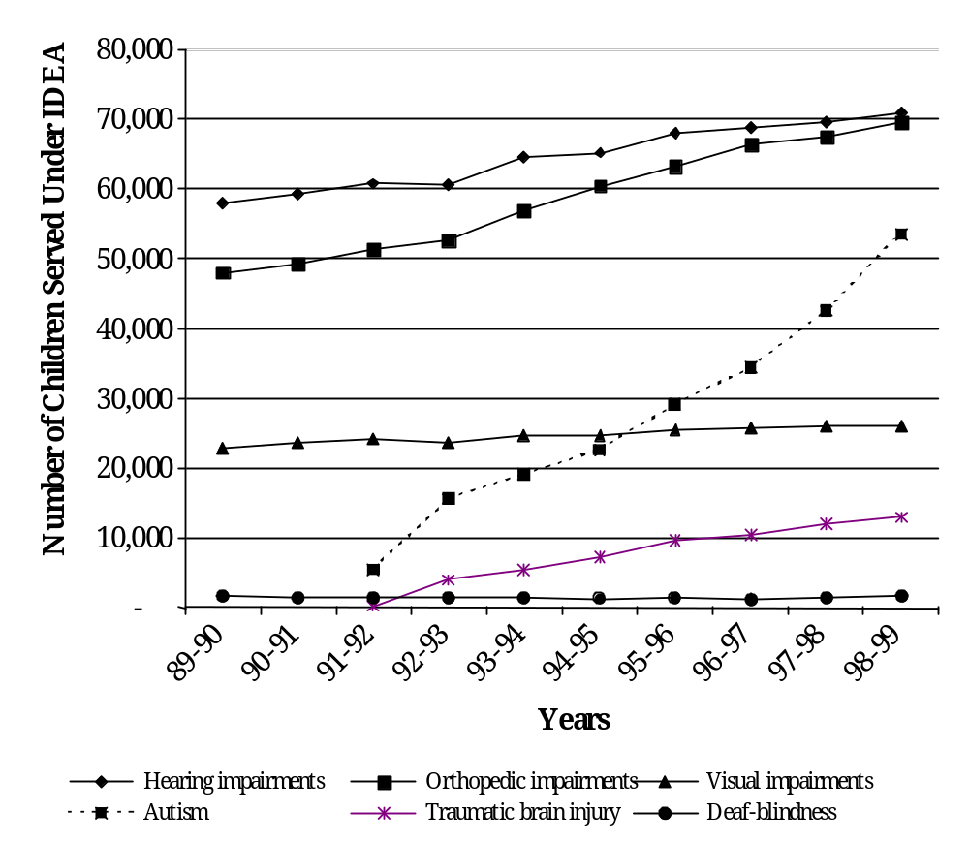
Source: U.S. Department of Education, Office of Special Education Programs, Data Analysis System (DANS).

impairments, visual impairments, autism, and traumatic brain injury. Figure II-7 shows the changes that have occurred in these disability categories over the past decade. The percentage of students with hearing impairments grew by 22.4 percent during the 10-year period, and the percentage of students with visual impairments increased by 14.3 percent. Both of these rates of increase were lower than the growth rate for all disabilities during the same period.

Table II-4
Child Counts in States Reporting Students with Other Health Impairments in the Orthopedic Impairments Category

States | 1989-90 | 1998-99 | Percent Change
Colorado | 777 | 4,536 | 483.8%
Delaware | 258 | 746 | 189.1
Michigan | 3,767 | 10,860 | 188.3
Mississippi | 807 | 1,433 | 77.6

Source: U.S. Department of Education, Office of Special Education Programs, Data Analysis System (DANS).

Reporting in the category of orthopedic impairments showed significant growth from 1989-90 to 1998-99, increasing by 44.6 percent. In part, this increase is a function of the reporting by four States: Colorado, Delaware, Michigan, and Mississippi include students with other health impairments in this category. The growth in the number of students reported in the orthopedic impairments category for these four States is shown in table II-4 above.

If these four States are removed from the analysis, the growth rate in orthopedic impairments is 22.3 percent, which is slightly below the overall growth rate for all disabilities.

Traumatic brain injury (TBI) and autism were first reported as separate disability categories in 1991-92. Most States require 2 to 3 years to fully capture new data categories, as the addition of new data requirements necessitates making adjustments to existing data systems and training staff at the school, LEA, and State levels. In addition, because States have a 3-year evaluation cycle, the full complement of students with a newly specified disability may not emerge until the cycle is complete. As shown in figure II-7, the number of students with TBI has increased steadily since it was first reported, but growth in this category has diminished over the past 3 years. Between 1992-93 and 1995-96, the number of students served with TBI rose by 141.9 percent; the increase since 1995-96 was just 35.0 percent (see table AA18 for service numbers by individual years).

The most striking increase among low-incidence disabilities has been reporting in the autism category. Between 1992 and 1998, the number of children with autism served under IDEA grew by 243.9 percent. Figure II-8 examines the growth in reporting of autism by age cohort as a percentage of the resident population. As the figure illustrates,
Figure II-8
Children Reported with Autism Served Under IDEA by Age Cohort Expressed as a Percentage of the Resident Population^{a/}

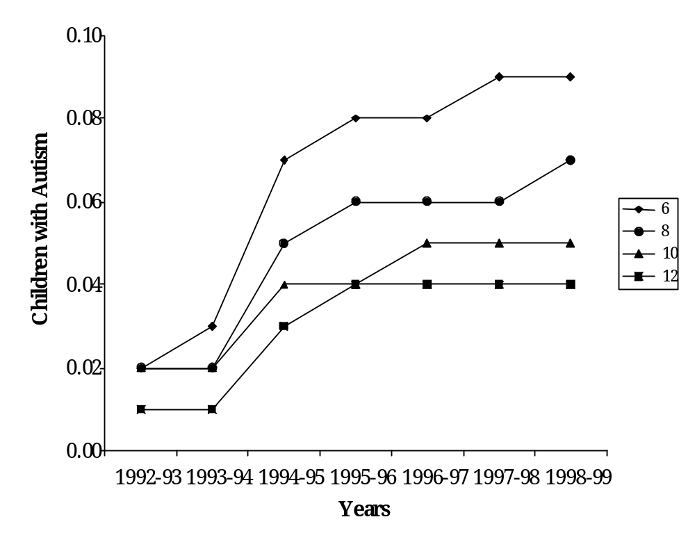
a/ Census figures, which are included in DANS, are from July 1998 estimates by the U.S. Bureau of the Census.

Source: U.S. Department of Education, Office of Special Education Programs, Data Analysis System (DANS).

the rate of growth in reporting in this category was dramatic from 1992-93 to 1995-96, the period associated with establishing a new data collection category and subsequent re-evaluation. The rate of increase slowed significantly after 1995-96. Since that year, States reported increases resulting from better diagnosis and identification, continued reclassification, and improved training in the assessment of autism. Florida described in more detail the State’s efforts to identify and work with children with autism and their families, including:

- Establishment of regional centers that provide better diagnosis of children with autism;
- Broadening of the definition of the disability;
- Better understanding of the disability; and
- Increase in the number of families that have children with autism who have moved into the State because of the availability of services.

Race/Ethnicity of Students with Disabilities

The IDEA Amendments of 1997 required that States report by race/ethnicity the number of children with disabilities served. Five race/ethnicity categories were used in the collection of these data: American Indian, Asian/Pacific Islander, black (non-Hispanic), Hispanic, and white (non-Hispanic). Nine States and Outlying Areas reported discrepancies in counts of children by disability and counts of children by race/ethnicity (see table AA3). The Virgin Islands could not provide the data by race/ethnicity categories. Five of the nine States reported discrepancies of less than 30 children. The remaining States--New York, North Carolina, and Rhode Island--had discrepancies of 4.3 percent, 0.9 percent, and 6.2 percent, respectively. Percentages for race/ethnicity tables are based on the total number of students reported under race/ethnicity. Although the requirement of race/ethnicity data was new for this collection, 32 States were collecting such data as of fall 1993. However, many of these States used race/ethnicity categories that differ from those used for the Federal collection. Consequently, several States had difficulty providing race/ethnicity data. Table II-5 shows the racial/ethnic distribution found in each disability category.

The race/ethnicity distribution of the population of students served under IDEA and the general population of students ages 6 through 21 showed some disparities:

- Asian/Pacific Islander students represent 3.8 percent of the general population. Among students receiving special education services in all disability categories, Asian/Pacific Islander students represent only 1.7 percent of the population. This percentage varies by individual disabilities; in the areas of hearing impairments (4.6 percent), autism (4.7 percent), and deaf-blindness (11.3 percent), the representation of Asian/Pacific Islander students is greater than their representation in the resident population.
Table II-5
Percentage of Students Ages 6 Through 21 Served by Disability and Race/Ethnicity in the 1998-99 School Year

Disability | American Indian | Asian/ Pacific Islander | Black (non-Hispanic) | Hispanic | White (non-Hispanic)
Specific Learning Disabilities | 1.4 | 1.4 | 18.3 | 15.8 | 63.0
Speech and Language  Impairments | 1.2 | 2.4 | 16.5 | 11.6 | 68.3
Mental Retardation | 1.1 | 1.7 | 34.3 | 8.9 | 54.1
Emotional Disturbance | 1.1 | 1.0 | 26.4 | 9.8 | 61.6
Multiple Disabilities | 1.4 | 2.3 | 19.3 | 10.9 | 66.1
Hearing Impairments | 1.4 | 4.6 | 16.8 | 16.3 | 66.0
Orthopedic Impairments | .8 | 3.0 | 14.6 | 14.4 | 67.2
Other Health Impairments | 1.0 | 1.3 | 14.1 | 7.8 | 75.8
Visual Impairments | 1.3 | 3.0 | 14.8 | 11.4 | 69.5
Autism | .7 | 4.7 | 20.9 | 9.4 | 64.4
Deaf-Blindness | 1.8 | 11.3 | 11.5 | 12.1 | 63.3
Traumatic Brain Injury | 1.6 | 2.3 | 15.9 | 10.0 | 70.2
Developmental Delay | .5 | 1.1 | 33.7 | 4.0 | 60.8
All Disabilities | 1.3 | 1.7 | 20.2 | 13.2 | 63.6
Resident Population | 1.0 | 3.8 | 14.8 | 14.2 | 66.2

Source: U.S. Department of Education, Office of Special Education Programs, Data Analysis System (DANS).

- Black (non-Hispanic) students account for 14.8 percent of the general population for the 6 through 21 age group, compared with 20.2 percent of the special education population in all disabilities. In fact, in 10 of the 13 disability categories, the percentage of the special education population composed of black students equaled or exceeded the resident population percentage. Black students’ representation in the mental retardation and developmental delay categories was more than twice their national population estimates.
- Representation of Hispanic students in special education (13.2 percent) was generally similar to the percentages in the general population
(14.2 percent). However, Hispanic students exceeded the resident population percentages in three categories: specific learning disabilities (15.8 percent), hearing impairments (16.3 percent), and orthopedic impairments (14.4 percent).
- American Indian students represent 1.0 percent of the general population and 1.3 percent of special education students. American Indian students slightly exceeded the national average in nine disability categories, reaching the largest percentages in the categories of deaf-blindness (1.8 percent) and TBI (1.6 percent).
- Overall, white (non-Hispanic) students made up a smaller percentage (63.6 percent) of the special education students than the general population (66.2 percent). However, their representation was higher than the national population estimates in five disability categories: speech and language impairments (68.3 percent), orthopedic impairments (67.2 percent), other health impairments (75.8 percent), visual impairments (69.5 percent), and TBI (70.2 percent).

Summary

The number of students with disabilities served under IDEA continues to grow at a greater rate than both the resident population and school enrollment. However, the increase in students served varies by disability category, with the largest increase occurring among students with other health impairments. Orthopedic impairments, traumatic brain injury, and autism have shown the greatest increase among the low-incidence disabilities. Reasons for the continued increase in students served include better diagnosis and identification. Reclassification of students in the newer disability categories accounts for large increases in those categories.

The 1998-99 school year was the first time that States were required to report the race and ethnicity of children served under IDEA. Comparisons of the racial/ethnic distribution of students in special education with the general student population reveal that Asian students and white students were underrepresented in the special education population, while black students were overrepresented. American Indian students were also overrepresented. Hispanic students ages 6 through 21 were generally represented among the special education population at a rate comparable to the resident population. These relationships varied by category.

Meeting the Needs of Students with Co-occurring Disabilities
This module addresses issues related to students with two or more co-occurring disabilities, defined as “the co-occurrence of at least two different disorders in the same individual” (Light & DeFries, 1995). For over 20 years, educators have debated the benefits of disability categories delineated in the Individuals with Disabilities Education Act (IDEA). Reynolds and Birch (1977, p. 75) noted that “the traditional categories for exceptional children do not ‘carve nature at its joints.’ They are not usually real, necessary, meaningful, or useful.” Goldstein and colleagues (1975) delineated advantages and disadvantages of categorical classification. Among the advantages, the authors reported that the categories improve communications among professionals, apply labels that are educationally relevant, and provide a rallying point for public support. Among the disadvantages, they noted that the categories encourage overgeneralizations about children, assume that the cause of learning problems resides exclusively with the child, may bias teachers’ expectations, and do not provide information necessary to design effective instruction.

IDEA defines a child with a disability as a child:

(i) with mental retardation, hearing impairments (including deafness), speech or language impairments, visual impairments (including blindness), serious emotional disturbance (hereinafter referred to as emotional disturbance), orthopedic impairments, autism, traumatic brain injury, other health impairments, or specific learning disabilities; and

(ii) who, by reason thereof, needs special education and related services.

. . . The term ‘child with a disability’ for a child aged 3 through 9 may, at the discretion of the State and the local education agency, include a child--

(i) experiencing developmental delays, as defined by the State and as measured by appropriate diagnostic instruments and procedures, in one or more of the following areas: physical development, cognitive development, communication development, social or emotional development, or adaptive development; and
(ii) who, by reason thereof, needs special education and related services (§602(3)).

In part because of the definitions used in IDEA, many parents, educators, administrators, policymakers, and other stakeholders think of disability as a categorical construct, with categories reflecting the 13 disabilities identified in the law. Traditionally, personnel preparation programs and certification and licensure have been categorical; in consequence, many special education programs have also been categorically based. The data-reporting requirements specified under IDEA require States to report counts of children by disability, further reinforcing the categorical model.

At one level, IDEA recognizes that some students have more than one disability: students with deaf-blindness and multiple disabilities are specifically mentioned. Children with developmental delay, by definition, may have delays in one or more areas. Multiple disabilities are defined in Federal regulations as “concomitant impairments. . .the combination of which causes such severe educational needs that they cannot be accommodated in special education programs solely for one of the impairments” (CFR 34 §300.7(c)(7)). While this definition does not require any particular level of severity of disability, it is accepted practice for State education agencies to report their child count by primary disability unless the co-occurring disabilities are severe. However, the use of primary disability classifications can obscure the fact that many special education students have more than one disability.

This module focuses on a broader scope of students than those who have multiple disabilities, as defined by IDEA. The report reviews available literature and uses data from the National Health Interview Survey-Disability Supplement (NHIS-D) to explore issues related to students with two or more co-occurring disabilities. It addresses the prevalence of co-occurring disabilities, the demographic characteristics of students with co-occurring disabilities, special education and related services for this population, and parental satisfaction with those services.

Review of the Literature

As a group, students with co-occurring disabilities may have more complex needs than those with a single disability (Abikoff & Klein, 1992; Downing & Eichinger, 1996; Orelove, 1996). For example, students with co-occurring learning and emotional disabilities may have more difficulty learning than students with only one of these disabilities. This literature review summarizes information on the prevalence of co-occurring disabilities, identification and assessment, special education and related services, and educational outcomes for this population.

Prevalence of Co-occurring Disabilities

Previous research suggests that co-occurring disabilities are quite common among children with disabilities. However, estimates vary from study to study, in part because of differences in the populations covered and definitions of disability used. Some researchers estimate that 19 percent of special education students have co-occurring disabilities; others report figures as high as 48 percent (Hogan, Msall, Rogers, & Avery, 1997; Wagner et al., 1991).

According to the National Longitudinal Transition Study of Special Education Students (NLTS), 19 percent of secondary-aged students in special education had additional disabilities beyond their primary disability; the most common were speech impairments (10 percent) (Wagner et al., 1991). Hogan and colleagues (1997) found that approximately 48 percent of the 4 million children ages 5 through 17 who had at least one serious functional limitation in mobility, self-care, communication, or learning also had one or more additional mild limitations in other areas of functioning. However, it is not clear if these mild limitations would meet the IDEA standard for eligibility.

Based on analyses of the National Household Education Survey (NHES), Westat (1998) found that 11 percent of children ages 3 through 5 with disabilities had two disabilities, and 51 percent had three or more disabilities. Among children ages 6 through 11, 26 percent had two disabilities, and 22 percent had three or more disabilities. It should be noted that the NHES relies on parent reports of disability, which are generally different from administrative reports.

Many smaller studies have documented the prevalence of co-occurring disabilities among specific populations. Learning disabilities and emotional disturbance frequently co-occur. Fessler, Rosenberg, and Rosenberg (1991) found that 38 percent of children treated at an in-patient psychiatric hospital had learning disabilities. Javorsky (1995) reported a similar percentage: 33 percent. Forness, Kavale, and Lopez (1993) found that 27 percent of children with conduct disorder also had learning disabilities. However, because of differences in medical and educational definitions of emotional disorders, these children did not necessarily meet the IDEA definition of emotional disturbance. Hinshaw (1992) argued that the percentage of externalizing children with learning disabilities (i.e., those exhibiting impulsivity, defiance, or inattention) is lower than commonly believed (6 to 20 percent) and that, among children with learning disabilities, the most common emotional disturbances are internalizing (such as sadness, withdrawal, and anxiety).
Learning disabilities and speech and language impairments also frequently co-occur. Schoenbrodt, Kumin, and Sloan (1997) asserted that the boundaries between communication disorders and learning disabilities often overlap, making it difficult to separate the effects of each from their combined effects. Many of the defining characteristics of learning disabilities are language related: difficulty with listening, speaking, reading, and writing. Gibbs and Cooper (1989) found that 96.2 percent of 242 students with learning disabilities had one or more communication disorders, including speech, language, and hearing disorders. The most common were language disorders (90.5 percent).

Because some visual impairments have a neurological basis and because low birth weight may increase the risk of both visual impairments and learning disabilities, these two disabilities may co-occur at a higher rate than would be expected (Erin & Koenig, 1997). Corn and Ryser (as cited in Erin & Koenig, 1997) estimated that 14 percent of students with visual impairments had co-occurring learning disabilities.

The Florida Department of Education collects duplicated and unduplicated counts of children’s disabilities. The unduplicated count captures each child’s primary disability, while the duplicated count captures all disabilities for each child. During the 1997-98 school year, speech impairments, language impairments, and visual impairments were the disabilities with the highest percentage differences between duplicated and unduplicated counts, suggesting that these disabilities occurred more commonly among those with more than one disability. The duplicated count of children with speech impairments was 37 percent greater than the unduplicated count; the duplicated count of children with language impairments was 57 percent greater, and the duplicated count of children with visual impairments was 51 percent greater (B. Harrison, personal communication, January 14, 1999).

Identification and Assessment

Identification and assessment of students with co-occurring disabilities can be challenging (Fessler et al., 1991; Forness et al., 1993; Light & DeFries, 1995). Severe behavioral problems, for example, may prevent the child’s specific learning needs from being accurately identified (Fessler et al., 1991). Learning disabilities and language disorders may be particularly difficult to distinguish. Children who have difficulty reading, writing, and spelling may have language disorders rather than learning disabilities because these two disabilities often present in similar ways, through “difficulty with language form; disruption of content; impairment to use; distortions in interactions among form, content, and use; and separation of form, content, and use” (Schoenbrodt et al., 1997, p. 266). Schoenbrodt and colleagues (1997) believe that children with learning disabilities may exhibit difficulties only in academic settings, while those with both language and learning disabilities may have difficulties in social situations as well.

Regulatory definitions of learning disabilities (34 CFR §300.7(c)(10)) and emotional disturbance (34 CFR §300.7(c)(4)) may force school personnel to rule out other disabilities before including a child in either category. For example, the IDEA regulations’ definition of learning disabilities excludes children whose learning problems are primarily the result of mental retardation or emotional disturbance. Therefore, the guidelines presume a distinct and measurable difference between children with learning disabilities, emotional impairments, and mental retardation (Bricklin & Gallico, 1984). The National Joint Committee on Learning Disabilities’ (NJCLD) definition of a learning disability explicitly states that learning disabilities may occur concomitantly with other disabilities, including mental retardation (as cited in Polloway, Patton, Smith, & Buck, 1997). Some researchers suggest that it can be difficult to distinguish among these disabilities, which often manifest themselves through poor academic achievement, social maladjustment, and below average IQ (Hallahan & Kauffman, as cited in Hallahan & Kauffman, 1977). Others disagree, noting empirical differences (Affleck, Edgar, Levine, & Kortering, 1990; Polloway, Epstein, Polloway, Patton, & Ball, 1986). Polloway and colleagues (1997) asserted that learning disabilities must be viewed as a disability secondary to mental retardation and not the reverse. For students initially identified with mental retardation, the addition of a learning disability label encourages a view that individuals with mental retardation have both strengths and weaknesses and that they exhibit intrapersonal discrepancies in performance. The addition of a mental retardation label for an individual with learning disabilities, they suggested, may be less valuable for program planning.

In reference to students with co-occurring learning and emotional disabilities, Fessler and colleagues (1991, p. 104) asked, “When these [students] were identified as having special needs, did the mandate to ascertain a primary [disability] limit the focus of the school’s evaluation? Were the subjects’ behavioral problems so severe that their individual learning needs could not be identified?” Javorsky (1995) supported these concerns when he reported that 23 percent of the children in psychiatric placements who were identified with learning disabilities received special education services to address their learning disabilities, 14 percent received services for emotional disturbance, and only 6 percent received services for both learning and emotional disabilities. Children with disruptive disorders were more likely than children with affective disorders to be identified with learning disabilities.

Because many sensory impairments are identified before children reach school age, academic difficulties associated with a learning disability may be attributed to the sensory impairment. For example, many signs of learning disabilities, such as frustration with reading, difficulty identifying letters and words, and poor handwriting, may all be attributed to poor vision. Harley, Truan, and Sanford (as cited in Erin & Koenig, 1997) listed the characteristics of students with visual impairments who might have co-occurring learning disabilities. These characteristics included academic achievement below expectations based on intellectual capacity; distraction and inattention; use of avoidance behaviors; and difficulties with perception, organization, memory, concrete thinking, perseveration and fixation, language, or generalization.

Special Education and Related Services

In addition to complicating identification and assessment, co-occurring disabilities may also impede provision of appropriate services (de Mesquita & Gilliam, 1994; Fessler et al., 1991). For example, students with both learning and behavior problems may be especially difficult to serve, and special education delivery systems may be inadequate for meeting the concomitant needs of many students in special education.

Several studies suggest that services for students with co-occurring disabilities are inadequate (Fessler et al., 1991; Giangreco, Dennis, Edelman, & Cloninger, 1994; Gibbs & Cooper, 1989). For example, Gibbs and Cooper (1989) reported that only 6 percent of students with learning disabilities received speech/language services despite the fact that over 90 percent of them had communication disorders; many of these disorders were in the mild-to-moderate range. Giangreco and colleagues (1994) analyzed the IEPs of students with severe multiple disabilities. They found that many of the IEPs included goals that were overly broad and were unconnected to the general education curriculum; listed goals for staff rather than students; and were discipline-referenced, meaning that they lacked coordination among goals written by various service providers. Because students with co-occurring disabilities are more likely than students with a single disability to receive special education and related services from a variety of providers, there may be a need for greater collaboration in planning and providing these services.

Teachers who work with students with co-occurring disabilities may require specialized preservice and inservice training and materials (Shaughnessy, 1996). Results from three studies suggest that personnel who serve students with co-occurring disabilities feel inadequately prepared to address all their students’ educational needs (Ford & Fredericks, 1995; Izen & Brown, 1991; Sobsey & Wolf-Schein, 1996). In one of these studies, roughly half the teachers serving children with visual impairments and severe, multiple disabilities felt they were inadequately prepared (Erin, Daugherty, Dignan, & Pearson, 1990). Another study found that teachers of students with profound multiple disabilities were less satisfied with their preservice training as the number of students with multiple disabilities in their classrooms increased, suggesting a mismatch between preservice preparation and job responsibilities (Izen & Brown, 1991). Ford and Fredericks (1995) observed that the majority of children with deaf-blindness were served by teachers trained to teach children with other severe disabilities. These teachers’ knowledge was generally inadequate to meet the needs of children with deaf-blindness. Similarly, directors of special education cooperatives in rural areas reported that the limited quality of educational services provided to students with severe to profound mental impairments and multiple disabilities was, in part, due to the lack of qualified teachers (Cates & Kinnison, 1991).

Study Methods

The National Health Interview Survey (NHIS) is an annual survey on the health of the nation’s civilian, noninstitutionalized population. The NHIS includes a standard set of questions, known as the core questionnaire, as well as supplemental questions on additional topics of interest. The NHIS is administered through in-person, computer-assisted interviews. An adult member of the household is asked questions about him or herself as well as about other household members, including children.

In 1994 and 1995, NHIS included a disability survey (NHIS-D) along with the core questionnaire; it was used to identify children and adults with disabilities eligible to participate in a follow-back interview on disability. The disability follow-back for children included items on use of and need for services, functional assessment, the impact of the child’s disability on the family, and educational services. The respondent was the parent or adult in the household who knew the most about the child’s health. Because the data were collected from parent interviews, underreporting or overreporting of some disabilities is possible.

Previous research suggests that estimates of the number and percentage of children receiving special education and related services differ depending on whether the source of the estimate is administrative records or parent reports. In general, prevalence estimates based on parent reports are lower than those based on administrative records. OSEP’s Annual Report to Congress and the NHIS-D, for example, report different totals for children ages 6 through 17 who received special education and related services during the 1994-95 school year. The Annual Report, which is based on State administration records, reports the total number of children at 4,668,933 (U.S. Department of Education, 1996). The NHIS-D, which is a survey of a sample of parents, indicates that the total number of children was 2,655,912. It may be that some parents are not aware that their children receive special education and related services, or that some parents are unfamiliar with the terminology used in health or educational surveys. This may be especially true for families from ethnic minority groups because the concept of disability varies across cultures.

Prevalence estimates based on parent reports and administrative records may also differ within disability category. Parents tend to overreport the prevalence of visual impairments because they are unfamiliar with the criteria States use for determining special education eligibility. In administrative records, State and local education agencies typically report on the primary disabilities of students receiving special education and related services. In cases of co-occurring disabilities, decisions about which disability is primary may also affect prevalence estimates.

The NHIS-D follow-back survey included a sample of 2,687 children. Of those, 801 were children age 3 or older who received special education services during the 12 months prior to the survey. Of those 801 children, 600 had adequate disability information and were included in the analyses. This report compares three groups of children included in the NHIS-D: children who were reported as having one disability, children who were reported as having two disabilities, and children who were reported as having three or more disabilities. In some cases, sample sizes were too small to support analyses of children with three or more disabilities. When that occurred, children with two and three or more disabilities were combined into a single group. Because the NHIS-D was not designed for describing students with co-occurring disabilities, sample sizes were too small to result in statistically significant differences between or among groups at alpha = .05. This was exacerbated by the complex sample design used in the NHIS-D, which had large design effects, reducing the effective sample sizes even further. Data were analyzed using WesVar, a statistical package designed for use with complex samples.

NHIS-D Findings

This section of the report describes the results of the NHIS-D analyses on children with co-occurring disabilities. It includes information on the prevalence of co-occurring disabilities, demographic characteristics of children with co-occurring disabilities, the special education and related services these students received, the educational environments in which students were served, and parents’ satisfaction with those services.

Prevalence of Co-occurring Disabilities

Based on data from the NHIS-D, 68 percent of special education students had a single disability, 23 percent had two disabilities, and 9 percent had three or more disabilities. This suggests that the prevalence of co-occurring disabilities is 32 percent. However, this percentage is somewhat lower than percentages reported in previous research.

Among children with one disability, the largest percentage had learning disabilities (58 percent), followed by speech/language impairments (25 percent). Of children with two disabilities, the most commonly reported co-occurring disabilities were learning disabilities and speech/language impairments (49 percent) and learning disabilities and emotional disturbance (24 percent).

Demographic Characteristics of Children with Co-occurring Disabilities

Previous research indicates that students in special education have different demographic characteristics from school-aged children overall. Students with disabilities are more likely than other students to be black, from low-income families, and from families whose parents have less formal education (Wagner et al., 1991). This section describes the demographic characteristics of students with co-occurring disabilities and compares them with the characteristics of students with a single disability. The demographic characteristics included in NHIS were gender, race, ethnicity, family structure, parents’ education, and poverty.

The gender distributions of children with one disability and two or more co-occurring disabilities were quite similar. Of children with one disability, 67 percent were male, and 33 percent were female. This is compatible with previous research that showed that males comprise slightly over two-thirds of special education students (Wagner et al., 1991). Of children with co-occurring disabilities, 68 percent were male, and 32 percent were female.

Children from racial minority groups were more likely than white children to have two or more co-occurring disabilities (37 percent compared to 31 percent; although this difference was not statistically significant). It is not clear from this analysis whether the disproportion is a function of bias in the special education eligibility process, poverty among racial minority groups, or other factors.

Data from the NHIS-D suggest that Hispanic students were slightly less likely than non-Hispanic students to have co-occurring disabilities, 29 percent compared to 32 percent; this difference was not statistically significant. The underrepresentation of Hispanics in special education and, in particular, in certain disability categories, has been documented in earlier studies (Harry, 1994; Westat, 1998). For example, Hispanic students appear to be underrepresented in programs for students with speech/language impairments. Because speech/language impairments is one of the most common co-occurring disabilities, it follows that Hispanic students may be underrepresented in this population as well.

NHIS-D also included information on family structure. Students with two or three or more co-occurring disabilities were more likely to live with a single parent (36 percent) or no parent (50 percent) than students with a single disability (32 percent) (see table II-6).

The relationship between co-occurring disabilities and poverty level was not significant. This may be because of the poverty measure used; it distinguished only among those above and below the poverty line. A poverty measure with more income categories might have shown a stronger relationship with the prevalence of co-occurring disabilities. Point estimates suggested that students with two or more co-occurring disabilities were more likely than students with one disability to live below the poverty level (see table II-7). It seems logical to associate poverty with co-occurring disabilities because of the economic costs of caring for children with co-occurring disabilities or because co-occurring disabilities may be more common among individuals living in poverty. The more complex needs of students with co-occurring disabilities may impede parents’ ability to work full-time outside the home or may be associated with higher medical expenses. Families living in poverty may have limited access to high-quality preschool experiences or medical care, which may
Table II-6
Number and Percentage of Students Receiving Special Education and Related Services, by Family Structure and Number of Disabilities

Number of Disabilities | Both  Parents^{a/} | Single Parent^{a/} or No Parent^{b/} | Total
One | 1,057,435 | 491,025 | 1,548,460
Percent | 68.3 | 31.7 | 100.0
Two | 319,492 | 180,149 | 499,641
Percent | 63.9 | 36.1 | 100.0
Three or more | 107,429 | 106,680 | 214,109
Percent | 50.2 | 49.8 | 100.0
Total | 1,484,356 | 777,854 | 2,262,210
Percent | 65.6 | 34.4 | 100.0

a/ With or without another adult relative.
b/ One adult relative.
Notes: The following responses were set to missing: other and no parent, but two or more adult relatives.
Source: 1995 National Health Interview Survey.

Table II-7
Number and Percentage of Students Receiving Special Education and Related Services, by Poverty Threshold^{a/} and Number of Disabilities

Number of Disabilities | At or Above the Poverty Threshold | Below the Poverty Threshold | Total
One | 1,067,390 | 411,208 | 1,478,598
Percent | 72.2 | 27.8 | 100.0
Two | 341,825 | 155,760 | 497,585
Percent | 68.7 | 31.3 | 100.0
Three or more | 119,246 | 71,448 | 190,694
Percent | 62.5 | 37.5 | 100.0
Total | 1,528,461 | 638,416 | 2,166,877
Percent | 70.5 | 29.5 | 100.0
a/ Poverty threshold is based on family size, number of children under 18 years of age, and family income using the 1994 poverty levels derived form the August 1995 Current Population Survey.
Source: 1995 National Health Interview Survey.
Table II-8
Number and Percentage of Students Receiving Special Education and Related Services, by Highest Educational Level of Responsible Adult Family Member and Number of Disabilities

Number of Disabilities | Less Than High School Diploma | High School Diploma or More | Total
One | 270,045 | 1,308,912 | 1,578,957
Percent | 17.1 | 82.9 | 100.0
Two or more | 141,947 | 596,115 | 738,062
Percent | 19.2 | 80.8 | 100.0
Total | 411,992 | 1,905,027 | 2,317,019
Percent | 17.8 | 82.2 | 100.0
Notes: p < .05.
Source: 1995 National Health Interview Survey.

lead to secondary disabilities that are prevented in higher income households. In addition, students with co-occurring disabilities were less likely to live in two-parent households, affecting household income.

The findings regarding poverty and family structure are interesting in light of a recent article by Fujiura and Yamaki (2000). These authors used NHIS data from 1983 through 1996 to examine trends in childhood disability prevalence and their interaction with socioeconomic status. Disability risk was higher among children living in poverty and in single-parent households, although the direction of these relationships was unclear. For example, the authors noted that they could not determine “the extent to which single parenthood is a cause or consequence of poverty, or what underlying dynamics attenuate or exaggerate risk” (Fujiura & Yamaki, 2000, p. 196). Although these findings could not be considered conclusive, the authors concluded that they were “highly suggestive and should be a source of concern” (Fujiura & Yamaki, 2000, p. 194).

The relationship between the highest education level of responsible adults and the prevalence of co-occurring disabilities completes the demographic profile of students with co-occurring disabilities. Parents or guardians of children with co-occurring disabilities were less likely than those of children with only one disability to have a high school diploma although these differences were not significant (see table II-8). Having a parent with a high school diploma is associated with a range of positive outcomes for children. Education level is also highly correlated with poverty status (Wagner et al., 1991; Westat, 1997).

Table II-9
Number and Percentage of Students Receiving Selected Special Education and Related Services, by Type of Services Received^{a/} and Number of Disabilities

Number of Disabilities | Transportation | Speech/  Language Therapy | Audiology | Mental Health or Counseling | Developmental Testing
One | 81,215 | 496,301 | 79,145 | 175,083 | 292,607
Percent | 5.3 | 32.6 | 5.2 | 11.5 | 19.2
Two or more | 138,437 | 414,615 | 99,482 | 171,336 | 245,243
Percent | 19.3 | 57.8 | 13.9 | 23.9 | 34.2
Total | 219,652 | 910,916 | 178,627 | 346,419 | 537,850

a/ Respondents could indicate more than one type of service received. Percentages are based on total number of respondents by type of service received and number of disabilities.
Source: 1995 National Health Interview Survey.

Special Education and Related Services

Data from the NHIS-D suggest that students with co-occurring disabilities received a greater variety of special education and related services than students with one disability. On average, children with one disability received only one type of service (an average of 1.4 services per child); those with two disabilities received two types of services (1.9 services per child); and children with three or more disabilities received three types of services (3.1 services per child).

A larger percentage of children with co-occurring disabilities than of children with only one disability received each selected special education and related service, such as transportation, speech/language therapy, audiology, counseling, and developmental testing (see table II-9). The most common service for children with one disability and two or more co-occurring disabilities was speech/language therapy, which was received by 32.6 percent and 57.8 percent of students, respectively (see table II-9). The differences in the percentage of students receiving specific services may reflect the complex needs of students with co-occurring disabilities, although these differences were not statistically significant.

Table II-10
Number and Percentage of Students Receiving Special Education and Related Services in Various Educational Environments, by Number of Disabilities

Number of Disabilities | Regular Classroom Setting | Resource Room | Separate  Class | More Than One of These Locations | Total
One | 393,705 | 510,734 | 289,744 | 212,235 | 1,406,418
Percent | 28.0 | 36.3 | 20.6 | 15.1 | 100.0
Two or more | 147,774 | 118,030 | 188,118 | 207,602 | 661,524
Percent | 22.3 | 17.8 | 28.4 | 31.4 | 99.9
Total | 541,479 | 628,764 | 477,862 | 419,837 | 2,067,942
Percent | 26.2 | 30.4 | 23.1 | 20.3 | 100.0

Notes: Special day schools, special residential schools, homes, hospitals or institutions, provider’s offices, and other environments were excluded due to small sample sizes.
Source: 1995 National Health Interview Survey.

Educational Environments

The majority of children with disabilities received educational services in regular classes, resource rooms, or separate classes in regular schools for either all or part of the day. A greater percentage of children with two or more co-occurring disabilities than of children with one disability received special education and related services in separate classes (28 percent vs. 21 percent), although this was not statistically significant. Overall, the percentage of children receiving services at a special day or residential school, at home, in a hospital or institution, or at a provider’s office was small.

A larger percentage of children with co-occurring disabilities than of children with one disability received their educational services in a separate classroom located in a regular school (for either all or part of the day). Students with only one disability received their educational services primarily in a resource room located in a regular school (see table II-10). Furthermore, compared to children with only one disability, a greater proportion of children with two or more co-occurring disabilities received services in more than one of the specified locations (31 percent compared to 15 percent).

Table II-11
Number and Percentage of Students Whose Parents Expressed Overall Satisfaction with Educational Services, by Number of Disabilities

Number of Disabilities | Satisfied | Dissatisfied | Total
One | 1,322,062 | 207,296 | 1,529,358
Percent | 86.5 | 13.6 | 100.1
Two or more | 579,935 | 140,886 | 720,821
Percent | 80.5 | 19.6 | 100.1
Total | 1,901,997 | 348,182 | 2,250,179
Percent | 84.5 | 15.5 | 100.0

Notes: Percentages may not sum to 100 due to rounding.
Parents who were very satisfied or somewhat satisfied were coded as satisfied, and parents who were very dissatisfied or somewhat dissatisfied were coded as dissatisfied.
Source: 1995 National Health Interview Survey.

Parental Satisfaction with Services

Parents of students with co-occurring disabilities (81 percent) were slightly less likely than parents of students with one disability (87 percent) to report that they were satisfied with the educational services provided to their children (see table II-11). In addition, 19 percent of parents whose children had co-occurring disabilities reported that they tried to get additional special education and related services for their child. This compared with 10 percent of parents whose children had one disability.

Summary and Implications Drawn From the Literature

In comparing the demographic characteristics of students with a single disability to students with two or more co-occurring disabilities, data from the NHIS-D suggested that racial minorities were more likely to have co-occurring disabilities. Hispanic students were slightly less likely to have co-occurring disabilities. The gender distributions of children with one disability and children with co-occurring disabilities were compatible with previous research that suggests that males comprise slightly over two-thirds of special education students. In addition, the NHIS-D revealed that students with co-occurring disabilities were more likely to live with a single parent or no parent and to have parents who did not have high school diplomas.

One-third of students who received special education and related services had co-occurring disabilities. The most common combinations of disabilities were learning disabilities with speech/language impairments and learning disabilities with emotional disturbance. Overall, children with co-occurring disabilities received a greater number of special education and related services than children with only one disability. A greater percentage of children with co-occurring disabilities received special education and related services in separate classes than children with one disability. Also, a greater percentage of them received a broader scope of services in more varied educational settings than children with one disability. Caregivers of children with co-occurring disabilities requested additional services more often than caregivers whose children had only one disability and were less likely to report that they were satisfied with the services provided to their children.

Co-occurring disabilities may be difficult to identify and may make the provision of appropriate services particularly challenging. For example, behavioral disorders may overshadow learning disabilities, leading educators to ignore important disability-related needs. In addition, service providers must recognize that language-based services may be less effective for children with co-occurring speech/language impairments. For example, individual and family counseling may be less effective with children who have both psychiatric and language disorders (Forness & Kavale, 1991; Forness et al., 1993; Light & Defries, 1995). Poor communication skills may inhibit children’s ability to describe themselves and their feelings or recall or interpret what was said by others. Direct instruction in language and social skills may be needed (Javorsky, 1993).

Awareness of co-occurring disabilities may improve the identification and assessment process by encouraging teachers, administrators, school psychologists, and other service providers to look beyond students’ primary disabilities to identify and address all of their disabilities. This may lead to improved educational services for students with co-occurring disabilities and a more complete view of students’ characteristics and needs. Researchers must also be aware of co-occurring disabilities in evaluating special education services and programs. Failure to consider co-occurring disabilities may confound studies. For example, a study of students with one disability (e.g., learning disabilities) may produce findings that are largely a consequence of a second, ignored disability (e.g., ADD) (Light & DeFries, 1995).

The prevalence of co-occurring disabilities and research on teacher preparedness suggest a need for changes in preservice and inservice training. Most individuals in training to serve students with learning disabilities will face students with co-occurring learning disabilities and speech and language impairments, emotional disturbances, and attention deficits. Teachers of students with visual impairments are likely to serve students with severe multiple disabilities. Many teachers reported feeling inadequately prepared to address co-occurring disabilities. To address these concerns, administrators of preservice and inservice programs might consider ways to enhance their focus on the characteristics and needs of students with common co-occurring disabilities and on appropriate interventions to address those needs.

References
Abikoff, H., & Klein, R.G. (1992). Attention-deficit hyperactivity and conduct disorder: Comorbidity and implications for treatment. Journal of Consulting and Clinical Psychology, 60, 881-892.

Affleck, J.Q., Edgar, E., Levine, P., & Kortering, L. (1990). Post-school status of students classified as mildly mentally retarded, learning disabled or non-handicapped: Does it get better with time? Education and Training in Mental Retardation, 25, 315-324.

Bricklin, P., & Gallico, R. (1984). Learning disabilities and emotional disturbance: Critical issues in definition, assessment, and service delivery. Learning Disabilities, III, 141-156.

Cates, D.L., & Kinnison, L. (1991). Students with severe to profound mental handicaps and multiple disabilities in rural schools: Can their needs be met? (ERIC Document Reproduction Service No. ED 342 537)

de Mesquita, P.B., & Gilliam, W.S. (1994). Differential diagnosis of childhood depression: Using comorbidity and symptom overlap to generate multiple hypotheses. Child Psychiatry and Human Development, 24, 157-172.

Downing, J.E., & Eichinger, J. (1996). Educating students with diverse strengths and needs together: Rationale and assumptions. In J.E. Downing, Including students with severe and multiple disabilities in typical classrooms: Practical strategies for teachers (pp. 1-14). Baltimore: Paul H. Brookes.

Erin, J., Daugherty, W., Dignan, K., & Pearson, N. (1990). Teachers of visually handicapped students with multiple disabilities: Perceptions of adequacy. Journal of Visual Impairment & Blindness, 84, 16-21.

Erin, J.N., & Koenig, A.J. (1997). The student with a visual disability and a learning disability. Journal of Learning Disabilities, 30, 309-320.

Fessler, M.A., Rosenberg, M.S., & Rosenberg, L.A. (1991). Concomitant learning disabilities and learning problems among students with behavioral/emotional disorders. Behavioral Disorders, 16, 97-106.

Ford, J., & Fredericks, B. (1995). Perceptions of inclusion by parents of children who are deaf-blind. In N.G. Haring & L.T. Romer (Eds.), Welcoming students who are deaf-blind into typical classrooms (pp. 37-54). Baltimore: Paul H. Brookes.

Forness, S.R., & Kavale, K.A. (1991). Social skills deficits as primary learning disabilities: A note on problems with the ICLD diagnostic criteria. Learning Disabilities Research and Practice, 6, 44-49.
Forness, S.R., Kavale, K.A., & Lopez, M. (1993). Conduct disorders in school: Special education eligibility and comorbidity. Journal of Emotional and Behavioral Disorders, 1, 101-108.

Fujiura, G.T., & Yamaki, K. (2000). Trends in demography of childhood poverty and disability. Exceptional Children, 66, 187-199.

Giangreco, M.F., Dennis, R.E., Edelman, S.W., & Cloninger, C.J. (1994). Dressing your IEPs for the general education climate. Remedial and Special Education, 15, 288-296.

Gibbs, D.P., & Cooper, E.B. (1989). Prevalence of communication disorders in students with learning disabilities. Journal of Learning Disabilities, 22, 60-63.

Goldstein, H., Arkell, C., Ashcroft, S., Hurley, O., & Lilly, S. (1975). Schools. In N. Hobbs (Ed.), Issues in the classification of children (Vol. 2) (pp. 4-61). San Francisco: Jossey-Bass.

Hallahan, D.P., & Kauffman, J.M. (1977). Labels, categories, behaviors: ED, LD, and EMR reconsidered. The Journal of Special Education, 11, 139-149.

Harry, B. (1994). The disproportionate representation of minority students in special education: Theories and recommendations. Alexandria, VA: National Association of State Directors of Special Education.

Hinshaw, S.P. (1992). Academic underachievement, attention deficits, and aggression: Comorbidity and implications for intervention. Journal of Consulting and Clinical Psychology, 60, 893-903.

Hogan, D.P., Msall M.E., Rogers, M.L., & Avery, R.C. (1997). Improved disability population estimates of functional limitation among American children aged 5-17. Maternal and Child Health Journal, 1, 203-213.

Izen, C.L., & Brown, F. (1991). Education and treatment needs of students with profound, multiply handicapping, and medically fragile conditions: A survey of teachers’ perceptions. Journal of The Association for Persons with Severe Handicaps, 16, 94-103.

Javorsky, J. (1993). Language coding deficits in ADHD children and adolescents. The ADHD Report, 1, 8-9.

Javorsky, J. (1995). An examination of language learning disabilities in youth with psychiatric disorders. Annals of Dyslexia, XLV, 215-231.

Light, J.G., & DeFries, J.C. (1995). Comorbidity of reading and mathematics disabilities: Genetic and environmental etiologies. Journal of Learning Disabilities, 28, 96-106.

Orelove, F.P. (1996). Designing transdisciplinary services. In F.P. Orelove & D. Sobsey, Educating children with multiple disabilities. A transdisciplinary approach (pp. 1-34). Baltimore: Paul H. Brookes.

Polloway, E.A., Epstein, M.H., Polloway, C.H., Patton, J.R., & Ball, D.W. (1986). Corrective reading program: An analysis of effectiveness with learning disabled and mentally retarded children. Remedial and Special Education, 7, 41-47.

Polloway, E.A., Patton, J.R., Smith, T.E., & Buck, G.H. (1997). Mental retardation and learning disabilities: Conceptual and applied issues. Journal of Learning Disabilities, 30, 297-308.

Reynolds, M.C., & Birch J.W. (1977). Origins of change. In M.C. Reynolds & J.W. Birch, Teaching exceptional children in all America’s schools. Reston: The Council for Exceptional Children.

Schoenbrodt, L., Kumin, L., & Sloan, J.M. (1997). Learning disabilities existing concomitantly with communication disorder. Journal of Learning Disabilities, 30, 264-281.

Shaughnessy, M.F. (1996). Working with multiply handicapped children. The Educational Forum, 61, 63-66.

Sobsey, D., & Wolf-Schein, E. (1996). Children with sensory impairments. In F.P. Orelove & D. Sobsey, Educating children with multiple disabilities. A transdisciplinary approach (pp. 411-450). Baltimore: Paul H. Brookes.

U.S. Department of Education. (1996). Eighteenth annual report to Congress on the implementation of the Individuals with Disabilities Education Act. Washington, DC: U.S. Government Printing Office.

Wagner, M., Newman, L., D’Amico, R., Jay, E.D., Butler-Nalin, P., Marder, C., & Cox, R. (1991). Youth with disabilities: How are they doing? Prepared under contract for the Office of Special Education Programs, U.S. Department of Education. Menlo Park, CA: SRI International.

Westat. (1997). Report on extant data sets and disability classifications. Rockville, MD: Author.

Westat. (1998). Final report on extant data sets and disability classification. Rockville, MD: Author.
Students with Orthopedic Impairments
The educational abilities and disabilities of students with orthopedic impairments vary widely. Caldwell and her colleagues (1997) list the following factors that may interfere with the learning process for students with orthopedic impairments or other physical disabilities: lack of experience; frequent school absences; poor concentration, anxiety, pain, and fatigue due to illness, medical treatment or medication; interference with classes and studying due to time allocated for health care or therapies; limited acceptance and understanding by peers; poor self-image; unrealistic expectations by service providers; and co-occurring disabilities such as learning disabilities.

This module summarizes recent research on students with orthopedic impairments. It describes their characteristics and prevalence, the special education and related services they receive, their educational results, personnel issues in meeting students’ needs, and Office of Special Education Programs (OSEP) efforts to enhance services for these students.

Characteristics and Prevalence

In 1998-99, the States reported that 69,492 students ages 6 through 21 with orthopedic impairments received special education and related services (see table AA2). Students with orthopedic impairments represent a small but growing population. The number of students served increased by 3 percent from 1997-98 to 1998-99, and by 48 percent from 1987-88 to 1998-99. The regulations implementing IDEA define an orthopedic impairment as:

a severe orthopedic impairment which adversely affects a child’s educational performance. The term includes impairments caused by congenital anomaly (e.g., club-foot, absence of some member, etc.), impairments caused by disease (e.g., poliomyelitis, bone tuberculosis, etc.), and impairments from other causes (e.g., cerebral palsy, amputations, and fractures or burns which cause contractures) (34 CFR §300.7(c)(8)).

As this definition suggests, students with orthopedic impairments may vary considerably in the nature and severity of their disabilities. Many orthopedic impairments do not limit students’ academic performance (Sherrill, 1993). However, the age at which the disabilities occurred, the underlying cause of the disability, and the presence of secondary disabilities may affect the students’ need for special education and related services. For example, the age at onset of the disability and the suddenness with which it occurred may affect the student’s adjustment. Students whose disabilities occur when they are young children may miss valuable opportunities for social development through play with same-age peers. Students with orthopedic impairments resulting from disease may have ongoing health concerns that affect their educational performance (Dunn, 1997). Table II-12 describes a number of conditions that may lead to orthopedic impairments.

In general, disabilities are more common among students who are black, male, and living in low-income households. This is less true for secondary-aged students with orthopedic impairments than it is for secondary-aged students with other disabilities. Table II-13 allows a comparison of the demographic characteristics of secondary-aged students with all disabilities and with orthopedic impairments. The percentage of black students with orthopedic impairments is slightly smaller than the percentage of black students with all disabilities, while the percentage of Hispanic students with orthopedic impairments is slightly larger than the percentage of Hispanic students with all disabilities. Students with orthopedic impairments are almost evenly divided between males and females, unlike secondary-aged students with disabilities overall, who are 68 percent male. Household incomes for secondary-aged students with orthopedic impairments are similar to those of all students with disabilities, with slightly more families at the extremes, that is, earning less than $12,000 or more than $50,000 per year (Valdes, Williamson, & Wagner, 1990).

Special Education and Related Services for Students with Orthopedic Impairments

An individualized education program (IEP) describes the special education and related services to which students are entitled. Anderson (as cited in Porter, Haynie, Bierle, Caldwell, & Palfrey, 1997) developed a checklist of items to consider in developing an IEP for students with physical disabilities, including students with orthopedic impairments. They include transportation; building accessibility; physical, occupational, and speech therapy; self-help skills; curricular modifications; classroom
Table II-12
Selected Conditions Causing Orthopedic Impairments in Children

Condition | Description
Cerebral Palsy | Condition that results in brain lesions and different types of neuromuscular disabilities that limit voluntary muscle control.
Traumatic Spinal Cord Injury | Injury to the spinal cord affects innervation of muscles, causing weakness or paralysis. The higher up the spinal cord the injury occurs, the great the limitations in movement.
Spina Bifida Manifesta or Neural Tube Defect | A congenital anomaly that results when the dorsal arch in one or more vertebrae does not fuse.
Congenital Hip Dislocation | Partially or completely displaced femoral head that is present from birth.
Talipes or Clubfoot | Usually a congenital condition in which the foot is twisted out of shape or position.
Osteochondrosis  (growth plate disorder) | A disorder in the growth center of the bone.
Epiphysiolysis | Condition in which the growth center of the bone separates from the bone itself.
Amputation | Extremities may be removed due to congenital conditions, tumor, trauma, or disease.
Burns | May cause loss of extremity and severe contractures.
Juvenile Rheumatoid Arthritis | Condition causing inflammation of the joints.
Muscular Dystrophy | Group of muscle diseases that progressively weaken muscles.
Note: Table compiled by Westat (2000) based on various data sources.

assistance; physical education; enrichment; equipment needs; medication; mobility assistance; positioning assistance; stamina issues; fire safety; and home/hospital services. Accommodations and services such as rest periods, extra sets of books at home, and extended school year or extended school-day services may help students with orthopedic impairments overcome their educational difficulties (Caldwell et al., 1997). Environmental accommodations for students with orthopedic impairments might include extended time, a writer for class assignments, adequate space in the classroom for equipment, or preferential seating. Adaptive equipment, such as adapted keyboards, track balls, keyguards, or speech recognition systems, may also be required (St. Louis Community College Access Office, 2000). In addition, students with orthopedic impairments may require test accommodations, such as extended time, a writer, oral tests, a tape recorder for recording responses, a word processor, or adaptive equipment.

Table II-13
Demographic Characteristics of Secondary-aged Students with All Disabilities and Students with Orthopedic Impairments

Characteristic | Students with All Disabilities  %  (S.E.) | Students with Orthopedic Impairments  %  (S.E.)
Race
American Indian/Alaska Native | 1.2  (0.3) | 0.5  (0.5)
Asian/Pacific Islander | 0.7  (0.2) | 1.8  (0.9)
Black, non-Hispanic | 24.2  (1.2) | 19.0  (2.6)
Hispanic | 8.1  (0.8) | 15.1  (2.4)
White, non-Hispanic | 65.0  (1.4) | 63.1  (3.2)
Gender
Male | 68.5  (1.2) | 54.2  (3.1)
Household Income (in 1986 dollars)
<$12,000 | 34.8  (1.5) | 36.7  (3.5)
$12,000 to $24,900 | 33.5  (1.5) | 30.5  (3.4)
$25,000 to $37,999 | 16.2  (1.2) | 12.8  (2.5)
$38,000 to $50,000 | 9.3  (0.9) | 8.9  (2.1)
>$50,000 | 6.1  (0.7) | 11.0  (2.3)

Note: The standard error of the mean (S.E.) shows the amount of sampling error in the estimate.
Source: Valdes, K.A., et al., 1990.

Students with orthopedic impairments may need instructional accommodations as well. Examples include the use of multimodal teaching materials; mental rehearsal strategies for students with limited expressive language; use of teacher wait time to accommodate slow student verbal response; and use of adapted curricula, such as self-care, self-determination, and life management skills (Sherwood Best, personal communication, March 16, 2000).

In 1997-98, the vast majority of students with orthopedic impairments--94 percent--attended schools with their nondisabled peers. This 94 percent breaks down as follows: 47 percent received special education and related services outside the regular classroom for less than 21 percent of the school day; 21 percent received services outside the regular classroom 21 to 60 percent of the school day; and 26 percent received services outside the regular classroom for more than 60 percent of the day (see table AB2). The percentage of students with orthopedic impairments receiving services in regular schools and classrooms has grown over the past 5 years: in 1992-93, 89 percent of students attended schools with their nondisabled peers. Comprising this 89 percent were 35 percent who received services outside the regular classroom for less than 21 percent of the school day; 20 percent who received services outside the regular classroom 21 to 60 percent of the day; and 34 percent who received services outside the regular classroom more than 60 percent of the school day (U.S. Department of Education, 1995).

Students with orthopedic impairments may be more likely to be hospitalized than students with other disabilities. In 1997-98, 2.01 percent of students with orthopedic impairments were served in the home/hospital category, compared with .55 percent of all students with disabilities (see table AB2). The psychosocial needs of hospitalized students are particularly acute. Curricular, instructional, and equipment adaptations may be required to meet the needs of hospitalized students.

Special Education Services

Much of the research specific to students with orthopedic impairments focuses on issues such as social adjustment, and the resources targeted toward educators appear to deal with services such as transportation, physical therapy, and occupational therapy. In general, the literature contains little information on special education services for students with orthopedic impairments; the exception to this generality is physical education. This section of the module will therefore emphasize physical education for students with orthopedic impairments.

Physical Education

Many students with orthopedic impairments may require accommodations to participate in physical education classes or may require specialized physical education services. Physical education may be particularly important for students with orthopedic impairments, as it facilitates the development of motor skills, physical health, and self-worth that are important for broader achievement (Kasser, Collier, & Solava, 1997). Stein (1998) describes the goals of physical education as the “development of physical and motor fitness, development of fundamental motor skills and patterns, and development of skills in aquatics, dance, individual and group games and sports” (p. 80). The regulations implementing IDEA specifically include “instruction in physical education” as part of special education (34 CFR §300.26(a)(ii)). Stein (1998) reports that some students with disabilities do not receive physical education because districts replace it with physical therapy or occupational therapy, which generally are related services, not special education services. Stein (1998) notes that since physical education is a primary service, physical and occupational therapy should be secondary to it, not substitutes for it. IDEA’s implementing regulations also require the provision of special physical education if prescribed in a child’s IEP (34 §300.307(c))

One of the reasons students with orthopedic impairments may not receive adequate special physical education is a shortage of adequately prepared personnel. While IDEA leaves to States’ discretion the qualifications for teaching physical education, in 1998, only 15 States offered certification or endorsements in adapted physical education. Other States offered undergraduate courses in adapted physical education for individuals seeking certification in physical education. Currently, most individuals with a master’s degree in adapted physical education work as district consultants. These personnel work with school-based physical education teachers to develop programs for students with disabilities, and school-based personnel carry out the program in the consultant’s absence (Nolan, Ellery, & Maguire, 1998).

Related Services

Many students with orthopedic impairments require related services in order to benefit from their special education programs. Related services may include transportation, speech pathology and audiology, psychological services and counseling, medical services (for evaluation purposes), physical therapy, occupational therapy, recreation, school health services, social work services, and early identification and assessment of disabilities. Valdes, Williamson, and Wagner (1990) found that a large percentage of secondary-school students with orthopedic impairments received related services, including help with transportation (53 percent), physical therapy/mobility training (42 percent), occupational therapy (40 percent), speech-language services (23 percent), and personal counseling (16 percent). This section of the module summarizes recent research related to the provision of related services to students with orthopedic impairments, with a specific focus on physical therapy, occupational therapy, transportation, and counseling.

Physical Therapy

Physical therapy is designed to improve students’ posture and balance, prevent physical complications stemming from orthopedic impairments, and enhance gross motor function (Cusick, 1991). Such therapy may include “alignment of spine, legs, and feet, fitting and monitoring positioning equipment, braces, prostheses, or casts, post-operative rehabilitation” (Cusick, 1991, p. 16). Many students with orthopedic impairments need physical therapy services.

Throughout the 1980s and early 1990s, the nation experienced a shortage of physical therapists, which made it difficult for local education agencies (LEAs) to secure adequate numbers of therapists. A study conducted for the American Physical Therapy Association (APTA) concluded that, by 1998, the United States would reach a balance between the supply of and demand for physical therapists and that a sizable surplus of 20 to 30 percent would exist by 2005-2007 (Vector Research, 1997) and, in fact, this has proven true (APTA, 1999). A number of factors were cited to account for this shift. The first factor cited is the growth of managed care, which has limited the number of reimbursable visits to physical therapists, thus reducing the demand for services. In addition, physical therapy assistants, chiropractors, athletic trainers, and occupational therapists absorb a portion of the market for physical therapy services. The third factor is that the number of newly trained physical therapists will continue to outpace changes in demand brought about by population growth and increases in per capita income. The results of the APTA study bode well for students with orthopedic impairments and for the LEAs trying to meet those students’ needs. After years of difficulty in securing adequate physical therapy services, districts may find it easier to recruit and retain qualified physical therapists.

Occupational Therapy

Many students with orthopedic impairments may also require occupational therapy. Occupational therapy includes services provided by a qualified occupational therapist in order to improve, develop, or restore functions; improve students’ ability to perform tasks for independent functioning; and prevent initial or further impairment (34 CFR §300.24(b)(5)). It may foster coordination of eye-hand skill; optimize the use of the arms and hands for self-feeding, writing, typing, and self-care; prevent deformity in the arms and hands; assess and remediate perceptual skills; evaluate sensory integration; and promote independence in activities of daily living (e.g., toileting, dressing, and food preparation) (Cusick, 1991, p. 17).

The NLTS indicated that almost half of secondary-aged students with orthopedic impairments received occupational therapy or life skills training at some point. The 22 percent of students who had received such services in the past year averaged 34.7 hours of occupational therapy during the year. Students from higher income households were more likely than peers from lower income households to receive occupational therapy (Valdes et al., 1990).

Transportation

Under the regulations implementing the IDEA Amendments of 1997, transportation services are defined as including “. . . travel to and from school, and between schools; travel in and around school buildings, and specialized equipment (such as special or adapted buses, lifts, and ramps). . . .” (34 CFR §300.24(b)(15)). Some students with orthopedic impairments require specialized transportation services in order to benefit from special education. Transportation options vary according to or depending on the student’s height and weight, the extent of needed support and/or positioning, and the need for personal assistance. Options include conventional car seats, specialized car seats, regular bus seats, or wheelchair transportation. Specialized training may be needed for drivers or other adults accompanying students with orthopedic impairments in transit (Daley & Larson, 1997). Valdes et al. (1990) reported that, of the various types of transportation assistance that youths with orthopedic impairments received, rides on a special vehicle were most common. Less common were rides to go places they could not otherwise go, an aide to push their wheelchair, and help in getting into vehicles. Many students with orthopedic impairments benefit from assistive technology to facilitate mobility. Additional NLTS data indicate that 45 percent of secondary-aged students with disabilities use a wheelchair; 25 percent use crutches, a cane, or a walker; 20 percent use prosthetics or orthotics; and 14 percent use computers to aid in their mobility (Valdes et al., 1990).

Counseling

Some students with orthopedic impairments may also require counseling to benefit from special education. The visibility of many orthopedic impairments requires that they be acknowledged in social situations; such disabilities may alter social relations between students with orthopedic impairments and their peers or between students and their service providers (Best, 1999). A study of high school students with physical disabilities found that the students were rated highly by their nondisabled peers on measures of independence and assertion but lower on measures of social acceptance. The author speculated that nondisabled students may be comfortable expressing positive attitudes toward their peers with orthopedic impairments but are reluctant to include them in group activities (Isaacson-Kailes, as cited in Best, 1999). Findings such as these suggest a possible need for further training to help students with orthopedic impairments better manage social situations (Sherwood Best, personal communication, March 16, 2000). Field and Hoffman (as cited in Best, 1999) emphasized that students with orthopedic impairments may be at risk for setting inappropriate goals because service providers, family members, and peers may be overprotective or may reinforce passivity. An emphasis on self-determination, which includes recognition of individual strengths and weaknesses, is likely to be important for many students with disabilities, including those with orthopedic impairments.
Counseling services are rarely provided to secondary-aged students with orthopedic impairments. The NLTS found that 86 percent of these students did not receive counseling services from their school in the past year, and, of those who did receive counseling, the average number of hours provided was just 8 per year. These figures were fairly consistent across rural, suburban, and urban schools and between males and females. Students with orthopedic impairments from higher income households were slightly more likely to receive counseling services than were their peers from lower income households (Valdes et al., 1990).

Personnel Serving Students with Orthopedic Impairments

In 1996, few States offered teacher certification in physical and health disabilities, and several of those that did offer such certification were considering eliminating it as they moved toward more generic special education certification and licensure. States with certification in physical and health impairments were more likely to employ State agency personnel or consultants with expertise in that area, and universities in those States were more likely to employ faculty with such expertise (Heller, Fredrick, Dykes, Best, & Cohen, 1999).

As for all students with disabilities, the availability of a qualified workforce is critical in meeting the needs of students with orthopedic impairments. A survey of teachers serving students with physical and health impairments, including orthopedic impairments, found that over 40 percent of respondents felt they were not well-trained on 11 of 23 competencies selected from the Council for Exceptional Children’s list of essential knowledge and skills for special education teachers serving students with physical and health impairments. Large percentages of teachers responding to the survey did not feel well trained in teaching students to use assistive technology (50.8 percent); using adaptive equipment, such as wedges and prone standers to facilitate positioning, mobility, communication, and learning (42.4 percent); and strategies to work with chronically or terminally ill students and their families (72.4 percent). Smaller percentages of teachers reported feeling inadequately trained in physical and health characteristics (17.2 percent), collaboration skills (20.4 percent), and modifying assessments (23.7 percent). Teachers who held degrees in special education with an emphasis in physical or health impairments, a subset of respondents, reported higher levels of preparedness; however, only 14 percent of responding teachers held such degrees. This research suggests that many teachers serving students with orthopedic impairments do not feel adequately prepared for their teaching assignments (Heller et al., 1999). Table II-14 at the end of this module lists recommended knowledge and skills necessary for beginning special education teachers serving students with physical and health impairments, including orthopedic impairments.

Educational Results for Students with Orthopedic Impairments

Data on educational results for students with orthopedic impairments can help gauge the extent to which these students receive appropriate services. This section explores several measures of educational results: functional and self-care skills, high school performance and completion, self-determination, and postsecondary enrollment.

Valdes and colleagues (1990) reported on the self-care and functional skills of secondary-aged students with orthopedic impairments. The measure of self-care combined the ability to dress oneself completely, feed oneself, and get to places outside the home. Based on these measures, 42 percent of secondary-aged students with orthopedic impairments had high self-care skills, 31 percent had medium skills, and 27 percent had low self-care skills. The functional skill rating combined data on youths’ abilities to count change, tell time on an analog clock, read and understand common signs, and look up telephone numbers and use a phone. As with the self-care skills, youths with orthopedic impairments were diverse in their level of functional skills. On a 16-point scale, 40 percent of respondents with orthopedic impairments scored 16, meaning they could complete all the aforementioned tasks very well. However, 30 percent scored 13 to 15; 22 percent scored 9 to 12; and 8 percent of respondents with orthopedic impairments scored 4 to 8 on the 16-point scale (Valdes et al., 1990).

Valdes and colleagues (1990) also reported on the high school performance of students with orthopedic impairments. Many of these students receive good grades in secondary school. Fifteen percent of youths with orthopedic impairments had a grade point average (GPA) of 3.25 or higher. Twenty-four percent had GPAs from 2.75 to 2.74, 28 percent from 2.25 to 2.74, 19 percent from 1.75 to 2.24, and 15 percent had GPAs below 1.74. Of those students with orthopedic impairments required to take a minimum competency test in high school, 60 percent passed the test in full, and 31 percent passed portions of the test (Valdes et al., 1990).

High school completion is an important educational milestone, in part because it is strongly associated with earning power and other adult outcomes. In 1997-98, 72.4 percent of students with orthopedic impairments ages 17 and older who left the educational system graduated with a diploma, 12.8 percent received a certificate of completion, 4.4 percent reached the maximum age for services, and 10.3 percent dropped out of school. The percentage of students with orthopedic impairments graduating with a diploma was higher than that for students with disabilities overall, 72.4 percent compared to 61.6 percent.

Despite their relatively strong academic performance, Hostler (as cited in Johnson & Dorval, 1999) found that 57 percent of adolescents with physical disabilities ages 11 to 14 were unable to explain their disability, 50 percent could not name medications they take or the reasons they take them, and 90 percent could not describe their long-term therapeutic goals. Capelli, MacDonald, & McGrath (as cited in Johnson & Dorval, 1999) found that self-care skills, such as managing catheters, bowel care, taking medication, making doctor’s appointments, and performing daily health care procedures, were better predictors than “book knowledge” of successful transitions from secondary school to adult life.

Postsecondary education and training are also important educational achievements supported by IDEA, through its transition requirements. Fowler, Brewer, and Abresch (1997) conducted a survey of college students with neuromuscular diseases and disorders, which are considered orthopedic impairments. They found that the students with neuromuscular disabilities were similar to nondisabled students in terms of gender, marital status, degrees expected, living arrangements, and grade point averages. Students with neuromuscular disabilities were older than their nondisabled peers, were more likely to be enrolled part-time, and, generally, took longer to complete school. About half of the respondents with neuromuscular conditions received financial support from Social Security Insurance or vocational rehabilitation programs. More than 60 percent reported that their disability had a negative effect on their career goals. Respondents with neuromuscular impairments cited a supportive family, personal attitude, and influence of faculty as factors in their academic success. Eighty-nine percent of these students indicated that special education programs in high school were beneficial for them.

The Postsecondary Education Descriptive Analysis Reports (PEDAR) published by the National Center for Education Statistics (NCES) provides a more detailed picture of high school graduation rates and the postsecondary results experienced by students with orthopedic impairments (Horn & Berktold, 1999). The National Education Longitudinal Study of 1988, Third Follow-up (NELS:88/94) examined the high school completion status of students who were in the eighth grade in 1988. By 1994, 75 percent of students with an orthopedic impairment had received a high school diploma, compared with 72 percent of all students with disabilities and 84 percent of students without disabilities. However, 17 percent of the students with orthopedic impairments had dropped out of school, compared with 10.3 percent of
Table II-15
Percentage of Students Exiting High School, by Disability Status

 | High School Diploma | GED or Equivalent | Enrolled in High School/  Working Toward GED | Dropped Out
Students with an orthopedic impairment | 75.0 | 1.7 | 5.9 | 17.4
All students with disabilities | 72.4 | 6.7 | 10.6 | 10.3
Students with no disability | 83.8 | 5.9 | 4.3 | 6.0

Source: National Education Longitudinal Study of 1988, Third Follow-up (NELS:88/94).

all students with disabilities and 6.0 percent of students without disabilities (Horn & Berktold, 1999; see table II-15).

The NELS:88/94 data also suggest that students with orthopedic impairments have high rates of postsecondary enrollment. Seventy-four percent of the students with orthopedic impairments were reported enrolled in postsecondary education in 1994, compared with 63 percent of all students with disabilities and 72 percent of students without disabilities (see table II-16). The samples for some of the individual disability types were small, but when students with specific disabilities were compared to all students with disabilities, those with orthopedic impairments were much more likely to be enrolled in a 4-year institution (71 percent vs. 42 percent of all students with disabilities). These data differ somewhat from those of the 1995-96 National Postsecondary Student Aid Study (NPSAS:96), which were also reported in PEDAR. In that study, 34 percent of students with orthopedic impairments were enrolled in a 4-year institution, compared with 40 percent of all students with disabilities and 47 percent of students with no disability. Enrollment rates for other institutions were 66 percent for students with orthopedic impairments, 60 percent for all students with disabilities, and 53 percent for students without disabilities (Horn & Berktold, 1999).
Table II-16
Percentage of Students Enrolled in Postsecondary Education,
by Disability Status

 | Total Enrolled | Four-Year Institutions | Other Institutions^{a/}
Students with an orthopedic impairment | 74 | 71 | 29
All students with disabilities | 63 | 42 | 58
Students with no disability | 72 | 62 | 39

a/ Includes private for-profit institutions; public less-than-2-year institutions; and private, non-profit less-than-4-year institutions.
Source: National Education Longitudinal Study of 1988, Third Follow-up (NELS:88/94).

In addition, PEDAR provides information about the extent to which students with orthopedic impairments persist in postsecondary education. The Beginning Postsecondary Students Longitudinal Study (BPS:90/94) looked at students with and without disabilities who began postsecondary training during the 1989-90 school year. In 1994, 45 percent of the students with orthopedic impairments had attained a degree or certificate, and 10 percent were still enrolled in postsecondary education; 45 percent had dropped out. Among all students with disabilities, 41 percent had earned a degree or certificate and 12 percent were still enrolled. Just over half of the students with no disability had completed a degree or certificate, and 13 percent were still enrolled (Horn & Berktold, 1999; see table II-17).

Finally, PEDAR includes data from the 1993 Baccalaureate and Beyond Longitudinal Study, First Follow-up (B&B:93/94), which provide information about how students with orthopedic impairments fare after completing a bachelor’s degree. Of students with an orthopedic impairment who earned a bachelor’s degree in 1992-93, 64 percent were employed full-time, compared with 67 percent of all students with disabilities and 73 percent of those without disabilities. Unemployment rates were 10 percent for the students with orthopedic impairments, 11 percent for all students with disabilities, and 4 percent for students with no disability. There were small differences in the percentages of students in each group who were out of the labor force altogether (see table II-18). The students with orthopedic impairments had an average starting salary of $23,345 in 1994, compared with $26,988 for students with all disabilities and $25,219 for students without disabilities (Horn & Berktold, 1999).

Table II-17
Percentage of Students Persisting in Postsecondary Education,
by Disability Status

 | Persisted
 | Attained Degree or Certificate | Enrolled in 1994 | Total | Not Enrolled/No Degree or Certificate
Students with an orthopedic impairment | 45 | 10 | 55 | 45
All students with disabilities | 41 | 12 | 53 | 47
Students with no disability | 51 | 13 | 64 | 36

Source: Beginning Postsecondary Students Longitudinal Study (BPS:90/94).

Table II-18
1994 Employment Status of 1992-93 Bachelor’s Degree Recipients,
by Disability

 | Employed Full-Time | Employed Part-Time | Unemployed | Out of Labor Force
Students with an orthopedic impairment | 64 | 16 | 10 | 10
All students with disabilities | 67 | 13 | 11 | 10
Students with no disability | 73 | 14 | 4 | 8

Source: 1993 Baccalaureate and Beyond Longitudinal Study, First Follow-up (B&B:93/94).

OSEP Efforts To Improve Results for Students with Orthopedic Impairments

Under its discretionary grant program, OSEP funds a number of projects to improve results for students with orthopedic impairments. For example, the Oregon Research Institute (ORI) is investigating the efficacy of realistic, three-dimensional computer-generated representations of real-world settings for conducting science experiments that students with orthopedic impairments could not otherwise complete. Staff at the ORI Virtual Reality Lab are working with secondary science teachers to identify units in the curriculum from which students with orthopedic impairments are excluded. Technical staff will develop the virtual reality experiments, implement them in selected classrooms, evaluate the results, and disseminate findings. At the Education Development Center, Inc. in Newton, Massachusetts, an OSEP grant is being used to make Re:Search Organizer more accessible to middle-school students with orthopedic and other disabilities. Re:Search Organizer is a software program that helps students pose research questions, develop research plans, collect and analyze data, and present their findings. The improved software package will be tested in middle schools and disseminated throughout the nation.

OSEP has also contracted for design and completion of two major new studies that will provide detailed information on students with orthopedic impairments as well as other disabilities. The Special Education Elementary Longitudinal Study (SEELS) will describe elementary-aged students with disabilities, including orthopedic impairments; their academic and social skills; and the services they receive. Preliminary SEELS results will be available in 2001. The NLTS-2 will provide similar information on secondary-aged students with orthopedic impairments. Preliminary results from the NLTS-2 will be available in 2002. These OSEP-funded studies will provide valuable information on the experiences of students with orthopedic impairments as they progress through elementary and secondary school and make the transition to adult life.

References
American Physical Therapy Association. (1999). Job losses and reduced hours most prevalent in skilled nursing facilities, home health, and private practices. Alexandria, VA: Author. Retrieved April 3, 2000, from the World Wide Web: http://www.apta.org/research/survey_stat/employment/surveyfinds

Best, S. (1999). Psychosocial correlates of physical and health disabilities. In V.L. Schwean & D.H. Saklofske (Eds.), Handbook of psychosocial characteristics of exceptional children. NY: Kluwer Academic/Plenum Publishers.

Caldwell, T.H., Sirvis, B.P., Still, J., Still, M., Schwab, N., Jones, J., et al. (1997). Students who require medical technology in school. In S. Porter, M. Haynie, T. Bierle, T. Heintz, & J. Palfrey (Eds.), Children and youth assisted by medical technology in educational settings (pp. 3-18). Baltimore: Paul H. Brookes.

Council for Exceptional Children (CEC). (1998). What every special educator should know. Reston, VA: Author.

Cusick, B. (1991). Therapeutic management of sensorimotor and physical disabilities. In J.L. Bigge, Teaching individuals with physical and multiple disabilities, (3rd ed.), (pp. 16-49). Upper Saddle River, NJ: Prentice-Hall.

Daley, J.E., & Larson, S.M. (1997). Transportation of students with special health care needs. In S. Porter, M. Haynie, T. Bierle, T. Heintz, & J. Palfrey (Eds.), Children and youth assisted by medical technology in educational settings
(pp. 63-73). Baltimore: Paul H. Brookes.

Dunn, J.M. (1997). Special physical education: Adapted, individualized, developmental. (7th ed.). Madison, WI: Brown and Benchmark.

Fowler, W.M., Brewer, M.L., & Abresch, R.T. (1997). Postsecondary education profiles in neuromuscular and other diseases. Washington, DC: National Institute on Disability and Rehabilitation Research.

Heller, K.W., Fredrick, L.D., Dykes, M.K., Best, S., & Cohen, E.T. (1999). A national perspective of competencies for teachers of individuals with physical and health disabilities. Exceptional Children, 65, 219-234.

Horn, L., & Berktold, J. (1999). Students with disabilities in postsecondary education: A profile of preparation, participation, and outcomes. NCES 1999-187. Washington, DC: National Center for Education Statistics.

Johnson, C.P., & Dorval, J. (1999). Spotlight: Transition in adolescence. Retrieved
March 14, 2000, from the World Wide Web: http://www.sbaa.org/html/sbaa_docs.html
Kasser, S.L., Collier, D., & Solava, D.G. (1997). Sport skills for students with disabilities: A collaborative effort. Journal of Physical Education, Recreation, and Dance, 68, 50-53.

Nolan, J., Ellery, P., & Maguire, P. (1998). Perspectives on adapted physical education services to rural populations. Coming together: Preparing for rural special education in the 21st century. Conference proceedings of the American Council on Rural Special Education, March 25-28, 1998, Charleston, SC.

Porter, S., Haynie, M., Bierle, T., Caldwell, T.H., & Palfrey, J.S. (1997). Children and youth assisted by medical technology in educational settings: Guidelines for care. (2nd ed.). Baltimore: Paul H. Brookes.

Sherrill, C. (1993). Adapted physical activity, recreation, and sport. Boston: MCB/McGraw-Hill.

St. Louis Community College Access Office. Orthopedic disabilities. Retrieved
March 14, 2000, from the World Wide Web: www.stlcc.cc.mo.us/fv/access/ortho.htm

Stein, J.U. (1998). Physical education and special education--Likely partners? Journal of Education, 180, 77-93.

U.S. Department of Education. (1995). Seventeenth annual report to Congress on the implementation of the Individuals with Disabilities Education Act (IDEA). Washington, DC: U.S. Government Printing Office.

Valdes, K.A., Williamson, C.L., & Wagner, M.M. (1990). The National Longitudinal Transition Study of special education students: Statistical almanac, Volume 1.
Menlo Park, CA: SRI International.

Vector Research, Inc. (1997). APTA executive summary conclusions. Workforce study prepared for the American Physical Therapy Association. Retrieved January 12, 2000, from the World Wide Web: http://www.apta.org/research/WorkforceStudy.html

Table II-14
II-66

22nd Annual Report to Congress

Knowledge and Skills for All Beginning Special Education Teachers of Students with Physical
and Health Disabilities

Philosophical, Historical, and Legal Foundations of Special Education
Knowledge
Current educational definitions of individuals with physical and health disabilities including identification criteria, labeling issues, and current incidence and prevalence figures.
Historical foundations and classic studies, including the major contributors, that undergird the growth and improvement of knowledge and practices in the field of special education and related services for individuals with physical and health disabilities and their families.
Contemporary issues in special education and related services for individuals with physical and health disabilities and their families.
Laws, regulations, and policies related to the provision of specialized health care in the educational setting.
Skills
Articulate the service delivery for individuals with physical and health disabilities and its relation to contemporary educational placement and instructional content.
Characteristics of Learners
Knowledge
Implications of physical and health disabilities on psychosocial, educational, vocational, and leisure outcomes for individuals, families, and society.
Generic medical terminology used to describe the impact of physical and health disabilities.
Etiology and characteristics of physical and health disabilities across the life span.
Secondary health care issues that accompany specific physical and health disabilities.
Assessment, Diagnosis, and Evaluation
Knowledge
Specialized terminology used in the assessment of individuals with physical and health disabilities.
Legal provisions, regulations, and guidelines regarding unbiased assessment and use of instructional assessment measures of individuals with physical and health disabilities.
Specialized policies regarding referral and placement procedures for students with physical and health disabilities.
Table II-14 (cont’d)
II-67

Students with Orthopedic Impairments

Assessment, Diagnosis, and Evaluation (continued)
Skills
Modify and adapt assessment procedures for use with individuals with physical and health disabilities.
Develop and use a technology plan based on assistive technology assessment.
Assess reliable method(s) of response of individuals who lack typical communication and performance abilities.
Use results of specialized evaluations, such as oral, motor, reflex, and movement, to make instructional decisions for individuals with physical and health disabilities.
Instructional Content and Practices
Knowledge
Research-supported instructional practices, strategies, and adaptations necessary to accommodate the physical and communication characteristics of students with physical and health disabilities.
Sources of specialized materials, equipment, and assistive technology for students with physical and health disabilities.
Skills
Interpret sensory, mobility, reflex, and perceptional information to create appropriate learning plans for individuals with physical and health disabilities.
Use appropriate adaptations and assistive technology such as switches, adapted keyboards, and alternative positioning to allow students with physical and health disabilities full participation and access to the core curriculum.
Adapt lessons that minimize the physical exertion of individuals with specialized health care needs.
Design and implement an instructional program that addresses instruction in independent living skills, vocational skills, and career education for students with physical and health disabilities, emphasizing positive self-concepts and realistic goals.
Design and implement curriculum and instructional strategies for medical self-management procedures by students with specialized health care needs.
Participate in the selection and implementation of augmentative or alternative communication devices and systems, including sign language, electronic devices, picture and symbol systems, and language boards, for use with students with physical and health disabilities.

Table II-14 (cont’d)
II-68

22nd Annual Report to Congress

Planning and Managing the Teaching and Learning Environment
Knowledge
School setting adaptations necessary to accommodate the needs and abilities of individuals with physical and health disabilities.
Appropriate use of assistive devices to meet the needs of individuals with physical and health disabilities.
Specialized health care practices, first aid techniques, and other medically relevant interventions necessary to maintain the health and safety of students in a variety of educational settings.
Common environmental and personal barriers that hinder accessibility and acceptance of individuals with physical and health disabilities.
Skills
Use local, community, and state resources available to assist in programming for individuals with physical and health disabilities.
Coordinate activities of related services personnel to maximize direct instruction time for individuals with physical and health disabilities.
Use techniques of physical positioning and management of individuals with physical and health disabilities to ensure participation in academic and social environments.
Use local, community, and state resources available to assist in programming for individuals with physical and health disabilities.
Coordinate activities of related services personnel to maximize direct instruction time for individuals with physical and health disabilities.
Use techniques of physical positioning and management of individuals with physical and health disabilities to ensure participation in academic and social environments.
Demonstrate appropriate body mechanics to ensure student and teacher safety in transfer, lifting, positioning, and seating.
Use appropriate adaptive equipment such as wedges, seat inserts, and standers to facilitate positioning, mobility, communication, and learning for individuals with physical and health disabilities.
Use positioning techniques that decrease inappropriate tone and facilitate appropriate postural reactions to enhance participation.
Practice recommended universal precautions to maintain healthy environments.
Assist individuals to develop a sensitivity toward those who have communicable diseases.
Monitor the effects of medication on individual performance.
Integrate an individual’s health care plan into daily programming.
Table II-14 (cont’d)
II-69

Students With Orthopedic Impairments

Managing Student Behavior and Social Interaction Skills
Knowledge
Communication and social interaction alternatives for individuals who are nonspeaking.
Communication and Collaborative Partnerships
Knowledge
Sources of unique services, networks, and organizations for individuals with physical and health disabilities.
Roles and responsibilities of school-based medical and related services personnel.
Roles and responsibilities of community-based medical and related services personnel.
Skills
Collaborate with service providers regarding acquisition, development, modification, and evaluation of assistive technology, procedures, and curricula to assist in meeting functional, social, educational, and technological needs of students with physical and health disabilities.
Use strategies to work with chronically ill and terminally ill individuals and their families.
Professionalism and Ethical Practices
Knowledge
Rights to privacy, confidentiality, and respect for differences among all persons interacting with individuals with physical and health disabilities.
Consumer and professional organizations, agencies, publications, and journals relevant to the field of physical and health disabilities.
Types and transmission routes of infectious disease.
Skills
Participate in transdisciplinary team activities in providing integrated care for individuals with physical and health disabilities, particularly when students are transitioning from home, hospital, or rehabilitation facility to school.
Maintain confidentiality of medical records and respect for privacy of individuals with physical and health disabilities.
Practice appropriate universal precautions when interacting with individuals with physical and health disabilities.
Seek information regarding protocols, procedural guidelines, and policies designed to assist individuals with physical and health disabilities as they participate in school and community-based activities.
Participate in the activities of professional organizations relevant to the field of physical and health disabilities.

Source: Council for Exceptional Children, 1998.

This annual report includes child count data for 1998-99 and non-child count data for 1997-98.
Two States--Massachusetts and New Mexico--did not separately report the number of at-risk infants and toddlers served on the data form.
Census figures, which are included in DANS, are from July 1998 estimates by the U.S. Bureau of the Census.
For this analysis, we excluded the infants and toddlers served in Puerto Rico and the Outlying Areas. Puerto Rico classified its children as nearly 100 percent Hispanic. Including those children increases the percentage of Hispanic children served under Part C of IDEA to 16.2 percent.
Outpatient service facility refers to an office, clinic, or hospital where an infant or toddler receives services for a short period of time; services may be offered individually or in small groups.
States report on only the primary setting, or the setting in which the child receives the most hours of early intervention services.
California noted that it did not have reliable data to report.
Kentucky said that it could not provide the information in the format requested because its data collection system could only collect data in two categories: home or community-based and office- or center-based settings.
This annual report includes child count data for 1998-99 and non-child count data for 1997-98.
Although preschoolers are generally ages 3 through 5, some States also serve 2-year-olds who will turn 3 during the school year under Part B.
In 1990, the Act was renamed the Individuals with Disabilities Education Act (IDEA).
Comparisons were based on July 1998 U.S. Bureau of the Census estimates and were included in DANS.
Data using the new settings categories will be reported for the first time in the 23rd Annual Report to Congress.
This annual report includes child count data from 1998-99 and non-child count data from 1997-98.
Resident population counts are based on July 1998 estimates from the U.S. Bureau of the Census. Enrollment is based on National Center for Education Statistics (NCES) counts of enrollment for individuals with and without disabilities in pre-kindergarten through 12th grade. Population and enrollment figures reflect data from the 50 States and the District of Columbia.
Low-incidence disabilities are defined as those that occur in fewer than 100,000 persons.
While developmental delay meets this definition, it is an optional category and applies only to children ages 3 through 9. The 1997-98 school year was the first time these data were collected. It has been excluded from this discussion.
The racial and ethnic composition of Puerto Rico and the Outlying Areas may be expected to differ from that of the 50 States and the District of Columbia; for example, Puerto Rico classified as Hispanic 99.89 percent of its 6- through 21-year-olds served under IDEA. Puerto Rico and the Outlying Areas have therefore been excluded from this analysis. See tables AA3 and AF8 for the racial/ethnic distribution of students served under IDEA and the resident populations of Puerto Rico and the Outlying Areas.
Students who have been described in some literature as having multiple disabilities will be referred to in this module as having co-occurring disabilities, where applicable.
Once respondents indicated that their children received special education and related services, they were asked about the types of disabilities their children had. Interviewers read a list of disabilities to the respondent and asked whether the child had each disability. The order in which the disabilities were listed could have affected responses. For example, the multiple disability category is one of the last disabilities listed. All of the respondents who indicated that their children had multiple disabilities also indicated that they had other specified disabilities. This suggests that there may have been some double counting of disabilities. Three disabilities were always selected in combination with other disabilities: traumatic brain injury, autism, and mental retardation. As in the case of multiple disabilities, it is not clear whether respondents were referring to different aspects of a single disability or to separate disabilities.
A series of complex decision rules were used to code students as having one, two, or three or more disabilities. Children with deaf-blindness were coded as having two disabilities. Children with multiple disabilities were coded as having two or more disabilities depending on the specific disabilities reported by parents. For example, if parents indicated that their child had a learning disability, emotional disturbance, and multiple disabilities, the child was coded as having two disabilities. If parents indicated that their child had a learning disability, speech or language impairments, visual problems, and multiple disabilities, the child was coded as having three or more disabilities. It was difficult to determine whether children with developmental delays had co-occurring disabilities because one or more delays may be included under the definition; these children were excluded from the analyses. A total of 152 children were reported as having developmental delays.
Caution should be used in interpreting this percentage due to small sample sizes.
Sample sizes were inadequate to conduct a multivariate analysis predicting the prevalence of co-occurring disabilities based on demographic characteristics.
Physical therapy and occupational therapy were not included in the analysis because of the small numbers of students in the sample who received those services.
Colorado, Delaware, Michigan, and Mississippi include students with other health impairments in their count of students with orthopedic impairments.
Although it is now a decade old, the National Longitudinal Transition Study (NLTS) remains the best source of information on students with orthopedic impairments. An update of the study, the NLTS-2, is scheduled to be completed in the next few years. The Special Education Elementary Longitudinal Study (SEELS), which begins data collection in 2000, will provide comparable data on elementary-aged students with orthopedic impairments, which have been unavailable to this point.
Because students may drop out prior to age 17 but rarely graduate before age 17, OSEP recommends calculating graduation percentages based on school leavers ages 17-21+ and dropout percentages based on school leavers 14-21+. In 1997-98, 14.0 percent of students with orthopedic impairments ages 14-21+ who left the educational system dropped out of school.
The sample of eighth graders in NELS:88/94 excluded about 5 percent of the potential sample. The sample excluded “1) students with severe mental disabilities; 2) those whose knowledge of English was not sufficient to complete the tests; and 3) students with severe physical or emotional problems that would have made it difficult for them to participate in the survey” (Horn & Berktold, 1999, p. 4). The NELS sample was therefore more representative of students with less severe disabilities than of all students served under IDEA.
This category included private for-profit institutions; public less-than-2-year institutions; and private, non-profit, less-than-4 year institutions.

