UNITED STATES DEPARTMENT OF AGRICULTURE
Rural Utilities Service

Bulletin 1724D-104

SUBJECT: An Engineering Economics Computer Workbook Procedure

TO: RUS Electric Borrowers and RUS Electric Staff

EFFECTIVE DATE: Date of Approval

OFFICE OF PRIMARY INTEREST: Distribution Branch, Electric Staff Division

FILING INSTRUCTIONS: This is a new bulletin. File hard copy along with 7 CFR 1724. This bulletin can be accessed via the Internet on the RUS website: http://www.usda.gov/rus

PURPOSE: This bulletin announces the availability of a Rural Utilities Service engineering economics computer application. This application offers users a planning tool for calculating the approximate “total owning” costs of planned construction projects. The application also compares annual costs of alternative construction projects. The bulletin explains the worksheets, formulas and results of this computer application.

_____________________________ _____________
Assistant Administrator Date
Electric Program
TABLE OF CONTENTS
Page
1. GENERAL DESCRIPTION
2. USES FOR THE WORKBOOK ANALYSIS
3. AVAILABILITY
4. EXPLANATION OF WORKSHEET CALCULATIONS
5. EXPLANATION OF RESULTS
6. SENSITIVITY ANALYSIS
EXHIBIT 1: Worksheet “READ ME”
EXHIBIT 2: Worksheet “FCR”
EXHIBIT 3: Worksheet “INPUT”
EXHIBIT 4: Worksheet “PLAN 1” (First 9 of 30 years)
EXHIBIT 5: Worksheet “PLAN 2” (First 9 of 30 years)
EXHIBIT 6: Worksheet “COMPARE”

ABBREVIATIONS

FCR Fixed Charge Rate, (an economics term)
kW kilowatts (1,000 watts), (an amount of electrical power demand)
kWh kilowatt-hours (1,000 watt-hours), (an amount of electrical energy)
LdF Load Factor
LsF Loss Factor
MWh Megawatt-hours (1,000,000 watt-hours), (an amount of electrical energy)
RUS Rural Utilities Service

1. GENERAL DESCRIPTION
This guide bulletin describes a computerized engineering economics procedure developed by the Rural Utilities Service (RUS) which can be used by RUS borrowers and others. This application was developed on Microsoft Excel 5.0 for Windows. This guide bulletin details how the RUS application can be used and explains the calculations made within its worksheets. The bulletin does not derive the engineering economics methodology used.

The application consists of a 645 kilobyte workbook file, named “ECONPLAN.XLS” which contains the following 6 worksheets:

- “READ ME” is a written page of instructions for entering data.
- “FCR” is a form used to calculate the blended interest rate and the fixed charge rate factors from data found in RUS Form 7, “Financial and Statistical Report.”
- “INPUT” is a form used to calculate the annual load and loss factors. This form is also used to enter load losses, power costs, alternative fixed charge rate factors, inflation rates and present worth rates, all used in the engineering economics analysis.
- “PLAN 1” is a form in which proposed construction descriptions, costs and expected changes in kW losses are entered by year. The costs of construction and losses are calculated and displayed.
- “PLAN 2” is a form identical to “PLAN 1.” “PLAN 2” is used to calculate and display the costs of an alternative construction plan with the same economic factors as used in “PLAN 1.”
- “COMPARE” is a worksheet which displays and compares, in tables and bar graphs, the accumulated costs of construction and losses of the alternative plans entered.

Examples of these worksheets with sample data are included in Appendix A at the end of this bulletin.

1.1 The workbook associated with this bulletin determines the theoretical present cash required to finance a portion of a construction program, per year, for a period of up to 30 years. The workbook does the following:

- Provides instructions and forms for entering data and information;
- Inflates estimated construction costs to the year of installation, determines the present worth value of the inflated costs, and multiplies the results by the fixed charge rate;
- Calculates future demand and energy losses and their future and present worth costs;
- Totals and accumulates the above two sets of costs for each year for 30 years;
- Displays all of the input data and calculated results; and,
- Displays selected accumulated totals in tables and on bar graphs.

1.2 This evaluation procedure is widely used in the electric utility industry. RUS finds this methodology of engineering economic analysis acceptable for use by its borrowers in presenting construction project evaluations. Other methods are also acceptable to RUS.

1.3 Users should determine if this computer application is compatible for use on their own computer and printer.

2. USES FOR THE WORKBOOK ANALYSIS
This computer application was developed as a planning tool for engineers, managers, and accountants. It can be used to:

- Determine the approximate “total owning cost” of a planned construction project or a partial construction plan;
- Compare construction requirements and the annual costs of two or more feasible plans that will each resolve an electric service problem. The most economically beneficial plan can be easily identified;
- Document, for reference purposes, engineering and planning work that has been performed; and,
- Display some of the details of a plan for presentation to others.

2.1 Worksheet printouts can also be used as documentation, and sometimes justification, for recommending a construction project. The application is especially useful when two alternative, feasible plans are under consideration. The printouts can be used for description and justification exhibits in Construction Work Plans and their amendments, Long-Range System Plans, and other studies. RUS generally prefers that only one or two such exhibits be included in such studies to serve as a sample of the economic analysis performed by the engineer for the entire study. However, for the more costly, complex, construction recommendations, the inclusion of additional exhibits is appropriate.

3. AVAILABILITY
A copy of the RUS Workbook program can be obtained free of charge by either of the following procedures:

3.1 Internet: Download the file from the Internet. The workbook file is available at the following Internet address:
http://www.usda.gov/rus/electric/econplan.xls

3.2 RUS Washington: Request a copy of the file from RUS by sending in a blank, DOS-formatted, 3 1/2 inch disk (high density) and a self-addressed mailer to:

Chief, Distribution Branch
Rural Utilities Service
STOP 1569
1400 Independence Avenue SW
Washington, DC 20250-1569

4. EXPLANATION OF WORKSHEET CALCULATIONS
The procedure and formulas used to calculate the displayed quantities on the worksheets
in the workbook are explained below.

4.1 Worksheet “READ ME” is a page of written instructions for entering data. No calculations are performed on this spreadsheet.

4.2 Worksheet “FCR” is a form that can be used to calculate the blended interest rate of construction loans and the fixed charge rate (FCR) factors from data found on a borrower’s completed RUS Form 7. The formulas used to calculate the FCR factors and the FCR are shown on the worksheet. (See Appendix A, Exhibit 2). These factors are required for subsequent calculations.

4.2.1 The fixed charge rate is the sum of the following rates:

- Cost of capital (equals the cost of debt plus the cost of equity);
- Taxes;
- Depreciation;
- Operations; and,
- Maintenance.

4.2.2 The fixed charge rate, when multiplied by the cost of a new construction project, yields the annual “fixed charges.” Thus, the fixed charges are the annual interest expenses of the money borrowed to build, plus the annual costs to operate and maintain a new construction project.

4.3 Worksheet “INPUT” is a form with instructions and cells for entering certain economic, load and cost factors. This worksheet may also be used to calculate the annual load factor (LdF) and loss factor (LsF). The formulas used for all of the calculations are shown on the worksheet. (See Appendix A, Exhibit 3).

4.3.1 The LdF is used to determine the average hourly demand over a one year period from a given annual peak kW demand. The LsF, which is based on the LdF and empirical data, correlates demand and energy losses. The LsF is used to calculate energy losses from the annual peak kW demand of losses.

4.3.2 The user may enter alternative FCR factors if those calculated on Worksheet “FCR” are incomplete or unsatisfactory. If the user does not enter values for the LsF or the FCR, then the procedure automatically uses the values of 0.400 and 15.00, respectively. Any other data that is not known may be assumed. Data has to be entered in all of the shaded cells so that the final calculated results are complete and meaningful.

4.4 Worksheet “PLAN 1” is the form in which the user enters the descriptions and present estimated costs of proposed construction projects. The user also enters any anticipated changes in kW losses. All of the formulas used and the calculations performed on this worksheet are explained below, on a column by column basis, beginning at the left side of the worksheet.

4.4.1 “CHANGES PEAK kW LOSSES” Column: A planned future construction project will usually decrease, but sometimes increase, a circuit’s kW demand and kWh energy losses. If a future change in kW losses is anticipated, then the user enters the amount of the estimated or calculated annual peak kW losses change in the space provided to the right of the item description. If a reduction in kW losses is expected, a negative kW amount should be entered.

4.4.2 “INFLATED COST” Column: The present year estimated cost entered for each construction item is inflated to the year of construction by the using the following formula:



The above estimated cost is entered by the user on Worksheet “PLAN 1.” The Inflation Rate is the “Annual Increases of the Cost of New Construction” entered on Worksheet “INPUT.” The Inflated Cost is displayed to the right of the present year estimated cost.

4.4.3 “PRESENT WORTH” Column: The present worth of each of the Inflated Cost calculated above is determined by using the following formula:

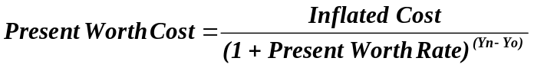

The Present Worth Rate (for the Cost of New Construction) is entered on Worksheet “INPUT.” The above Present Worth Costs are displayed to the right of the Inflated Cost of each construction item.

4.4.4 “FIXED CHARGES” Column: Each of the above calculated Present Worth Costs are multiplied by the fixed charge rate which is calculated on Worksheet “FCR” or alternatively entered on Worksheet “INPUT.” This product, which is the present worth of the Fixed Charges for each construction item, is displayed to the right of each calculated Present Worth Cost.

The Fixed Charges for the construction items are totaled for each year. Next, the previous year’s Accumulated Fixed Charges total is divided by the factor (1+ Present Worth Rate). These two present worth quantities are added together and displayed in bold fonts for each year in the Row “TOTAL COST for Year” in the “FIXED CHARGES” Column.

The above Total Cost of Fixed Charges for each year is added to the Accumulated Fixed Charges of the previous year and also displayed in bold fonts for each year in the Row “ACCUMULATED through Year End.”

4.4.5 “kW LOSSES” Column: The annual peak demand for the first year is the same as the value entered by the user on Worksheet “INPUT.” Each subsequent year is calculated by multiplying the previous year’s annual peak kW losses by the factor: (1+ Growth Rate)². To this product is added the positive or negative value of any changes in peak kW demand losses that has been entered for that year. The results are shown as “Ann. Peak” in this column.

The above annual peak kW demand of losses is assumed to occur during the one month of the year with the greatest total kW usage and demand losses. The demands for the other 11 months of the year are almost always less than the peak month. On Worksheet “INPUT” the user is instructed to enter a monthly demand coincidence factor. By definition, this factor, when multiplied by the annual peak demand, will yield an average monthly billing demand. This coincidence factor varies greatly from system to system and area to area. The determination of this factor is left to the user.

The monthly average of kW losses is calculated by multiplying the annual peak of kW losses, (“Ann. Peak” discussed above), by the coincidence factor defined above. This monthly average is displayed as “Month Avg.” for each year. The calculated monthly averages of kW demand losses are used later to calculate the annual cost of kW losses.

4.4.6 “kWh LOSSES” Column: The annual energy kWh losses are calculated for each year using the loss factor (LsF) calculated on Worksheet “INPUT”, the annual peak kW losses discussed above in Section 4.4.5, and the following formula.

The kWh (Accumulated) Losses for each year is the sum the of the above kWh Losses (Annual) for the year plus the kWh (Accumulated) Losses of the previous year. Both the Annual and the Accumulated kWh losses for each year are displayed in the “kWh LOSSES” Column.

4.4.7 “(INFLATED COST OF:) ANNUAL kW” Column: The cost of kW demand losses are increased each year by the “Annual Cost Increase for kW Demand” entered on Worksheet “INPUT.” For each year, the cost of the kW demand losses are calculated according to the formulas:

The Monthly Average of kW Losses is discussed above in Section 4.4.5. The Demand Cost is entered on Worksheet “INPUT.”

Then, for each year, the present worth of the above Inflated Cost of Annual kW losses is calculated using the following formula:

The above Present Worth Rate is entered on Worksheet “INPUT” as “Present Worth Rate for Cost of Losses (%).” The above Annual (Present Worth) Cost of kW Losses is displayed in bold fonts for each year on the worksheet in the “ANNUAL kW” Column and in the Row “TOTAL COST for Year.”

The Accumulated (present worth of the inflated) Cost of Annual kW Losses is calculated for each year by adding the Annual Cost of kW Losses for the year to the Accumulated Cost of kW Losses for the previous year. This accumulated total is displayed in bold font for each year in the Row “ACCUMULATED through Year End.”

4.4.8 “(INFLATED COST OF:) ANNUAL kWh” Column: The present worth of the inflated annual cost of kWh energy losses is calculated according to the following steps.

The kWh Losses (Annual) is calculated as discussed in Section 4.4.6. The Energy Cost and Ann. Cost Increase (for energy) are entered on Worksheet “INPUT.” The above calculated quantity is displayed in the “ANNUAL kWh” Column for each year.

Then, the present worth of the above Inflated Cost of Annual kWh Losses is calculated for each
year using the following formula:

The Present Worth Rate (for the cost of losses) is entered on Worksheet “INPUT.” The above present worth of the Inflated Cost of Annual kWh Losses are also displayed for each year, in bold fonts, on the worksheet in the “ANNUAL kWh” Column and in the Row “TOTAL COST for Year.”

The Accumulated (present worth of the inflated) Cost of Annual kWh Losses is calculated for each year by adding the above Annual Cost of kWh Losses to the previous year’s Accumulated Cost of kWh Losses. This accumulated total is displayed in bold fonts for each year in the Row “ACCUMULATED through Year End.”

4.4.9 Year Cost Totals (Rows): Two cost totals are displayed for each year of the plans next to the year number. The top number is the total cost for the year and the bottom number is the accumulated yearly costs through the end of the year. Both totals are the sum of the yearly displayed cost of fixed charges plus the annual cost of the kW demand and the kWh energy losses. All of the totals, displayed in bold font, are present worth costs.

4.5 Worksheet “PLAN 2” is identical to “PLAN 1” in form and calculations. Both worksheets use the same economic and losses factors. This alternative plan can be used to compare the cost of construction and losses of two plans that each resolve the same electric system deficiency.

4.6 Worksheet “COMPARE” displays, in tables and bar graphs, the total accumulated costs and MWh energy losses from Worksheets “PLAN 1” and “PLAN 2” for the first 6 years and every 5 years thereafter. The tables and graphs conveniently summarize and exhibit entered economic factors and the final results of the procedure used.

5. EXPLANATION OF RESULTS
The year by year, accumulated totals of the present worth of the inflated costs of the fixed charges plus losses are considered the final results of this procedure. The accumulated total cost for any given year is the theoretical present year cash required to finance the plan through that given year. It is assumed that a portion of the theoretical cash on hand is earning interest at the cost of capital rate; the remaining portion of the cash on hand is earning interest at the entered present worth rates. The present worth rates may be the blended interest rate, the rate of return on investments, the inflation rate or another rate and basis adopted at the discretion of the user.

6. SENSITIVITY ANALYSIS
Nearly all of the numerical data entered on the worksheets is either assumed or estimated. Thus, the calculated cost results are only accurate within some unknown range. The user can easily vary each of the input variables, individually or in combination, through reasonable ranges and monitor the new calculated cost totals. This sensitivity analysis will reveal total cost ranges and trends. This analysis may also give the user a perception of accuracy percentages and confidence levels of the final results. Performing this sensitivity analysis is a simple process and especially useful when comparing alternative plans whose calculated total costs nearly equal.

EXHIBIT 1: Worksheet “READ ME”

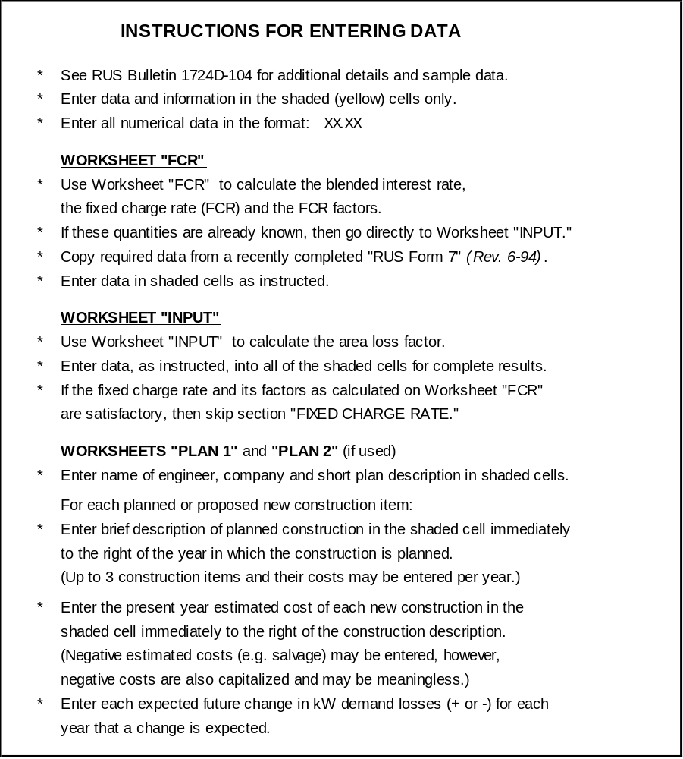

EXHIBIT 2: Worksheet “FCR”

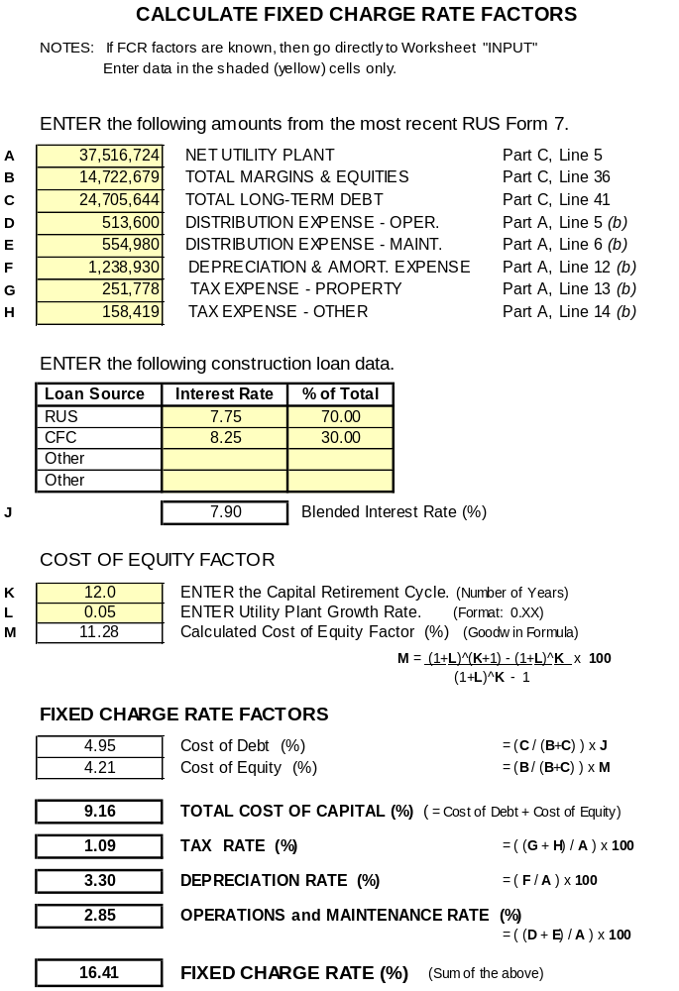

EXHIBIT 3: Worksheet “INPUT”

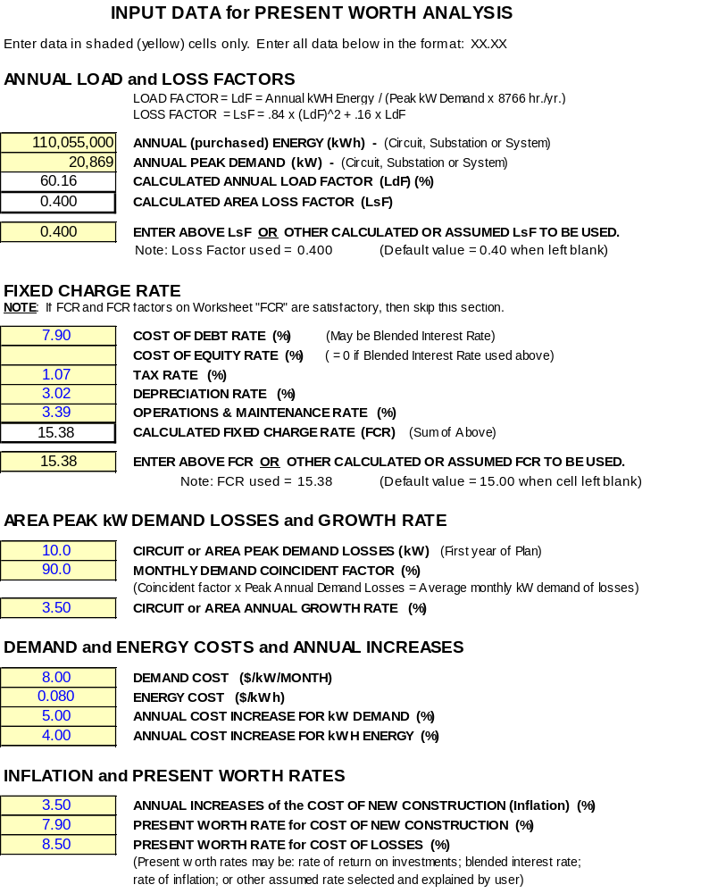

EXHIBIT 4: Worksheet “PLAN 1” (First 9 of 30 years)

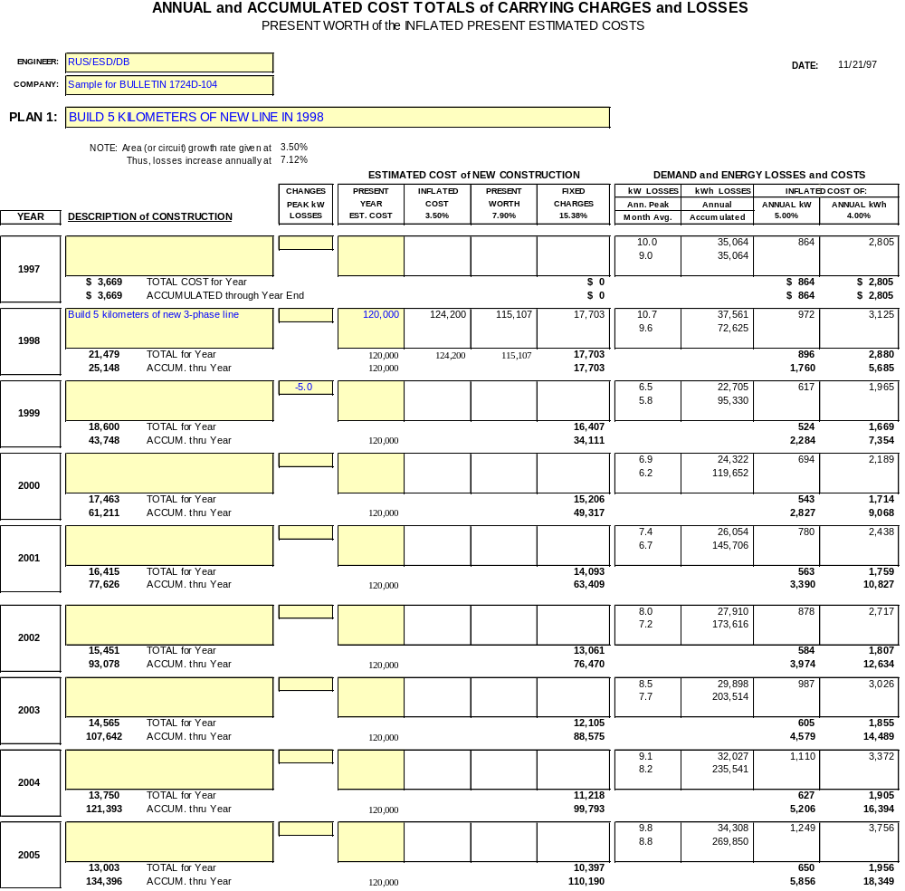

EXHIBIT 5: Worksheet “PLAN 2” (First 9 of 30 years)

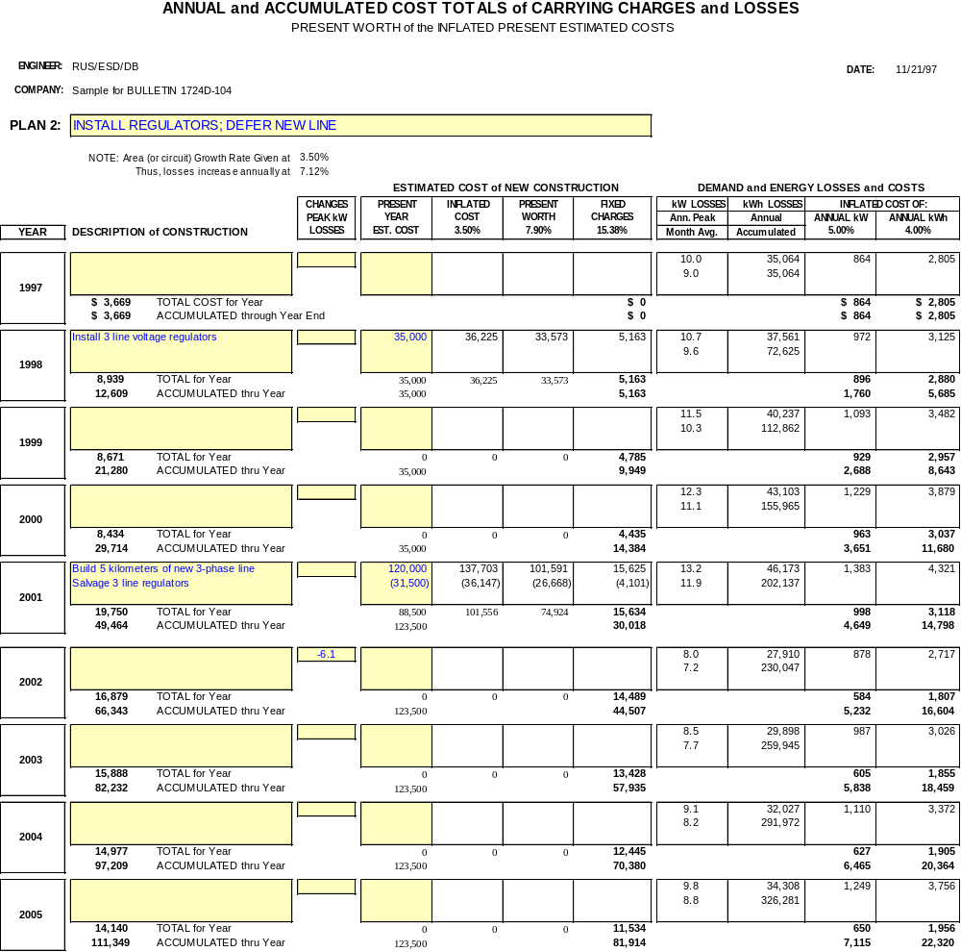

EXHIBIT 6: Worksheet “COMPARE”

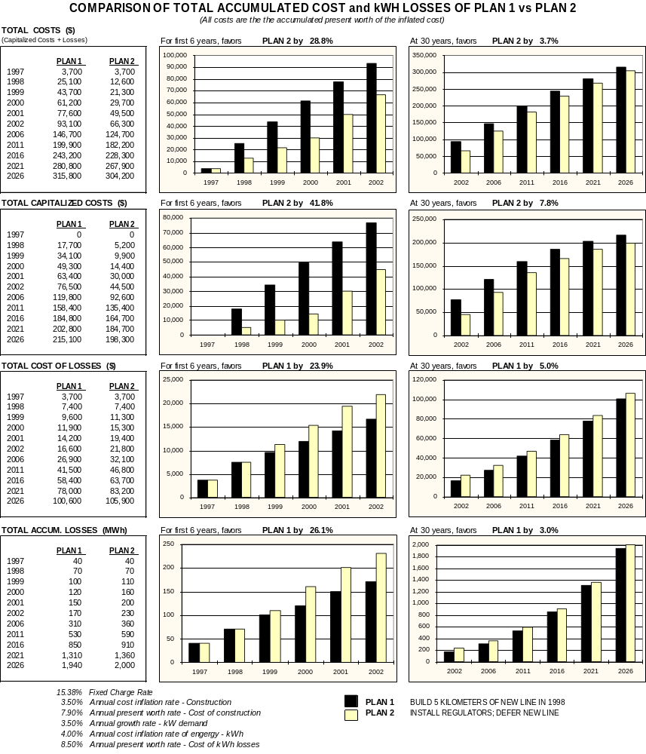

Microsoft, Excel and Windows are registered trademarks of the Microsoft Corporation

