Contract Report

High Throughput, Low Toxic Processing of Very Thin, High Efficiency CIGSS Solar Cells

Year 1, Second Quarter Report

Report no. FSEC-CR 1559-05

December 19, 2005

Prepared for
National Renewable Energy Laboratory

1617 Cole Boulevard

Golden, CO 80401

Submitted by

Neelkanth G. Dhere
Florida Solar Energy Center®

1679 Clearlake Road

Cocoa, FL 32922-5703

Cocoa, FL 32922-5703 Cocoa, FL 32922-57CC



High Throughput, Low Toxic Processing of Very Thin, High Efficiency CIGSS Solar Cells. NREL contract no. XXL-5-44205-08, UCF/FSEC Account no. 2012 8098
Year 1, Second Quarter Report no. FSEC- CR-1559-05

Introduction

In the Year 1, First Quarter report, initial experiments towards optimizing the selenization parameters were discussed in detail. During this quarter the experiments were continued using both conventional and rapid thermal processing approaches. In the following discussion, the preparation and the characterization of CuIn_{1-x}Ga_{x}Se₂ and CuIn_{1-x}Ga_{x}S₂ thin films and solar cells are discussed in detail.

Optimization of Selenization Parameters

Experiments were carried out to determine the adequate selenization temperature and soaking time at that temperature. The metallic precursors CuGa and indium were deposited using DC magnetron sputtering technique. Prior to the deposition of metallic precursors, a small amount (~8.7 nm) of NaF was added to facilitate the crystalline growth of the chalcopyrite crystal [1]. A thin layer of NaF was deposited by thermal evaporation on Mo coated glass prior to the deposition of metallic precursors. The thickness of the NaF layer was monitored by quartz crystal rate and thickness monitor and control unit. Selenization and sulfurization parameters were varied with each experiment. The following micrograph shows the morphology of the film selenized at 475ºC for 30 minutes and sulfurized at 475ºC for 20 minutes. The sample was etched in 10% KCN to remove the excess Cu layer.

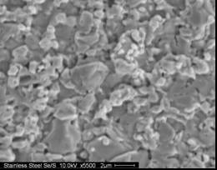

Figure 1. SEM of film selenized at 475 ºC for 30 minutes followed by sulfurization at 475 ºC for 20 minutes

Table 1. XEDS result of KCN etched sample

Elem. | Cu | In | Se | S
At% | 28.68 | 22.90 | 41.23 | 7.20

Since the sulfurization time and temperature were reduced, the amount of sulfur incorporation in the film was limited to 7.2 at.%. Larger grains were also observed at subsurface level. Having achieved some promising parameters a series of experiments were carried out on 2 mil (50 μm) polished stainless steel foil. The back of the foil was deposited with a 700 nm layer of Mo to prevent it from reacting with selenium or sulfur vapor. On the front side, a Mo layer of approximately 1 μm was deposited as a back contact followed by metallic precursors CuGa and Indium. The films were selenized in a gas mixture of DESe, H₂ and N₂.
Figure 2 shows SEM micrographs of samples after each heat treatment. The inset image in each figure is the same micrograph at a lower magnification. It is observed that heat treatment carried out at 475 ºC gave rise to a secondary phase that was rich in indium, while the selenization carried out at 500ºC led to a homogeneous phase. The second phase appeared as small globules clearly observed at lower magnification. The grain size for all four samples was approximately 1 μm. The grain size on stainless steel substrate was comparatively smaller than that on glass substrate. The precursor deposition parameters were those corresponding to slightly copper-poor chemistry. Therefore, it can also be seen that the sulfurized film shows the smallest grain size. These observations were helpful in understanding that higher temperatures or even longer soaking times are required to obtain larger grains.
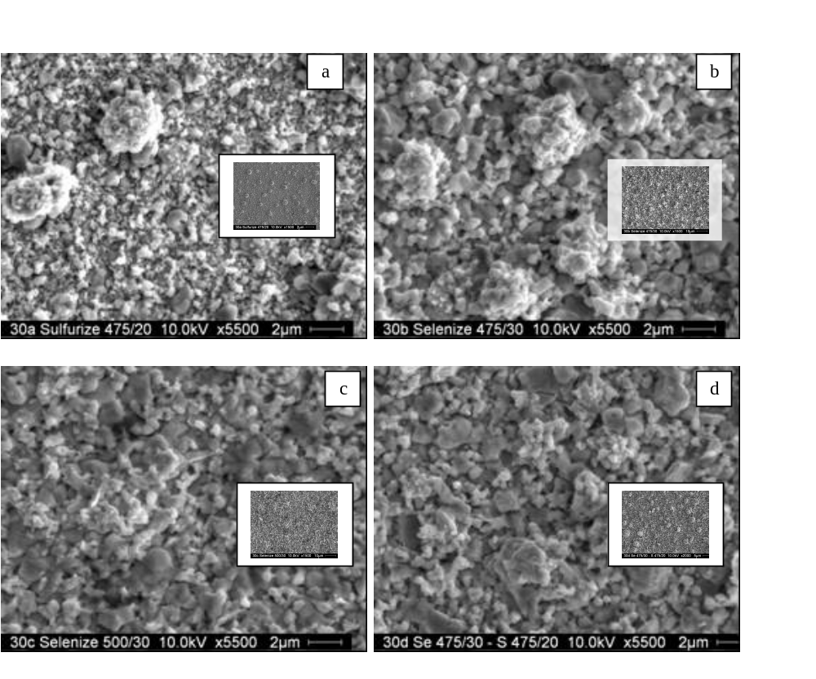
Figure 2. (a) Sulfurized at 475ºC/20 min, (b) Selenized at 475ºC/30 min, (c) Selenized at 500ºC/30 min, (d) Selenized at 475ºC/30 min and sulfurized at 475ºC/20 min

Table II. XEDS: Chemical composition of samples a-d in Figure 2

Sample ID | Cu (At%) | In (At%) | Ga (At%) | Se (At%) | S (At%)
a (unetched) - S | 29.52 | 20.62 | 1.26 | 48.60 | ---
a (etched) - S | 26.67 | 22.6 | ------- | 50.73 | ----
b (unetched) - Se | 27.09 | 18.63 | 5.48 | 48.81 | ---
b (etched) - Se | 23.43 | 20.08 | 6.68 | 49.81 | ---
c (unetched) - Se | 24.54 | 19.77 | 5.26 | 50.43 | ---
c (etched) - Se | 23.73 | 19.92 | 7.3 | 49.05 | ---
d (unetched) – Se/S | 27.21 | 18.96 | 5.5 | 36.94 | 11.40
d (etched) – Se/S | 23.14 | 19.16 | 7.27 | 38.12 | 12.31

Further the DESe setup was modified and experiments were carried out on glass substrates. Figure 3 represents the micrograph of the film that was selenized at 500 ºC for 30 minutes in dilute DESe atmosphere. The precursor layer was modified to a sandwiched pattern with indium layer sandwiched between two CuGa layers. In this experiment DESe and hydrogen gas were filled separately to establish different quantities of each gas. The grains were compact and approximately 1 μm in size. Further experiments will be carried out to optimize the quantity of DESe to achieve a high-quality absorber layer.
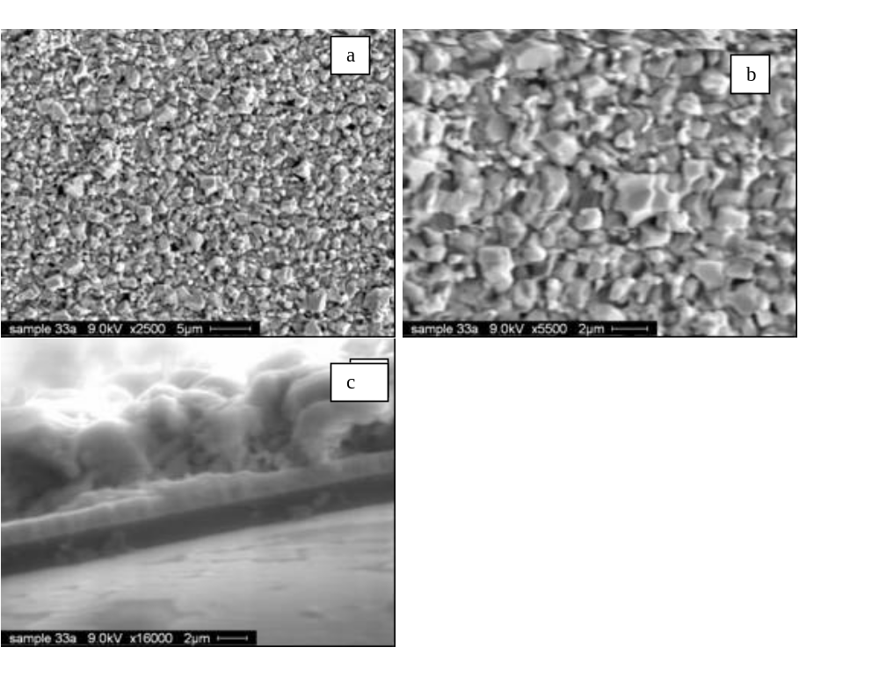
Figure 3. (a) SEM micrograph at 2500X, (b) at 5500X, (c) cross-sectional view at 16000X.

Table III. Chemical composition of the selenized and sulfurized film using XEDS

Elem. | Cu | In | Ga | Se | S
At% | 23.14 | 19.16 | 7.27 | 38.12 | 12.31

Rapid Thermal Processing

In continuation of the work carried out in Quarter 1 [2,3], Auger electron spectroscopy (AES), Secondary Ion Mass Spectroscopy (SIMS), X-ray diffraction (XRD) and electron probe microanalysis (EPMA) analyses were carried out. The results are reported in ure 4,5,6.

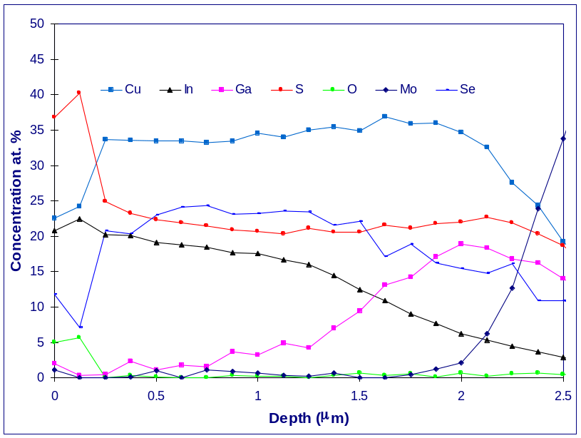
Figure 4: AES depth profile

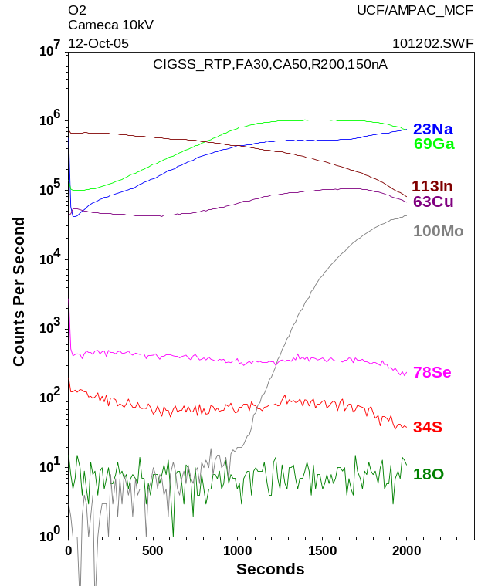
Figure 5: Secondary Ion Mass Spectroscopy analysis
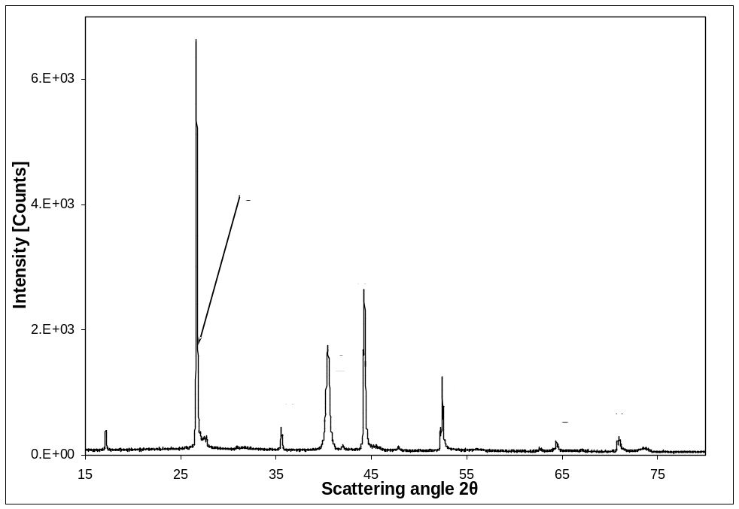
Figure 6: X-ray diffraction pattern

In earlier experiments, the sheet resistance of the sample was observed to be very low. It was suspected that there was an extreme loss of Se in the form of In₂Se₃. In order to ensure proper intermixing of the metallic precursors i.e. CuGa and In, they were deposited in the form of a few alternating layers, which were designed to obtain a Cu/In+ Ga ratio of around 0.95. EPMA analysis data of selenized sample is given in Table IV.

Table IV- EPMA analysis data for selenized sample.
Cu/In+Ga = 0.93

Cu | In | Ga | Se
24.52 | 20.55 | 6.01 | 24.44

Table V- EPMA analysis data for selenized and sulfurized sample.
Cu/In+Ga = 0.92

Cu | In | Ga | Se | S
24.24 | 19.28 | 6.92 | 27.05 | 22.48

EPMA data (from NREL) for this selenized and sulfurized sample (Table V) showed more sulfur (~20 %) than the required amount. In the subsequent experiment the metallic precursors were deposited with different thicknesses so as to obtain a Cu/In+ Ga ratio of around 0.95. Further experiments were designed to reduce the amount of sulfur to ~10% (at. wt) [4]. The amount of Se evaporated was 1.6 times the value required for stoichiometric CIGS. The amount of NaF was reduced to 30-40 Å. The precursor layers were pre-annealed at 80-120 °C for 15-30 minutes in the RTP setup. Selenization/sulfurization was carried out at 500-550 °C for 6 minutes. The sheet resistances achieved after rapid thermal processing were around 10KΩ/€. CIGSS thin-film solar cells were completed by chemical bath deposition of CdS hetrojunction partner layer followed by RF magnetron sputter deposition of ZnO(i)/ZnO:Al transparent and conducting oxide window layer and then Cr/Ag contact fingers by thermal evaporation. Current-voltage (I-V) characteristics (figure 7) were plotted for these cells using the I-V setup that was built in-house.

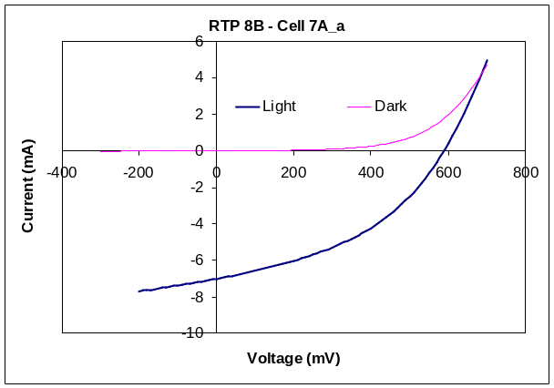

Figure 7: I-V characteristics for CIGSS solar cell processed by RTP

Table VI. Device parameters for the cell processed by RTP
Parameter | Value
Rsh | 279.22 Ω
Rs | 31.65 Ω
Area | 0.441 cm²
I_{sc} | -7.01 mA
V_{oc} | 589.99 mV
I_{pk} | -4.60 mA
V_{pk} | 370.00 mV
Fill Factor | 41.24 %
Efficiency | 3.87 %

In the following experiment the amount of thermally evaporated Se on the CuGa and In layers was doubled. No NaF was deposited in this experiment. RTP was carried out by pre-annealing the substrate at 80-120 °C for 15-30 minutes. Selenization/sulfurization was carried out at 450-550 °C for 6 minutes. The sheet resistance achieved was in the range of 10kΩ/€ to 15kΩ/€.
In another experiment, 30-40 Å of NaF was deposited by thermal evaporation on Mo back contact followed by multi-layer sputter deposition of CuGa and In similar to above experiments designed to obtain a Cu/In+Ga ratio of around 0.95. The amount of Se deposited by thermal evaporation was maintained at a level twice that required for a stoichiometric film. The absorber layers are now being analyzed.

Sulfurization approach for low toxic absorber

CuIn_{1-x}Ga_{x}S₂ (CIGS2) thin films were prepared in two steps. Step one consisted of the deposition of CuGa-In metallic precursors using DC magnetron sputtering. The metallic precursors were deposited in the copper excess composition of Cu/(In+Ga) = 1.4. Step two consisted of sulfurization of metallic precursors in dilute H₂S ambient (8% H₂S). Since the CIGS2 growth was carried out in the copper excess composition, excess copper segregated on top of CIGS2 in the form of Cu_{2-x}S was etched away using 10% KCN solution.
XRD pattern of etched CIGS2 thin film shows (101), (112), (103), (200), (220), (312), (400), (316) and (424) reflections of highly crystalline chalcopyrite CIGS2 and also reflections from molybdenum (Figure 8). The strongest reflection was from the (112) plane at 2θ = 27.92°. The lattice parameters calculated were a = 5.52 Å and c = 11.04 Å. Molybdenum reflection was observed at 2θ = 40.4°. The intensity ratio of I(112)/I(220/204), measured for these films was 2.74, showing a preferred {112} orientation.

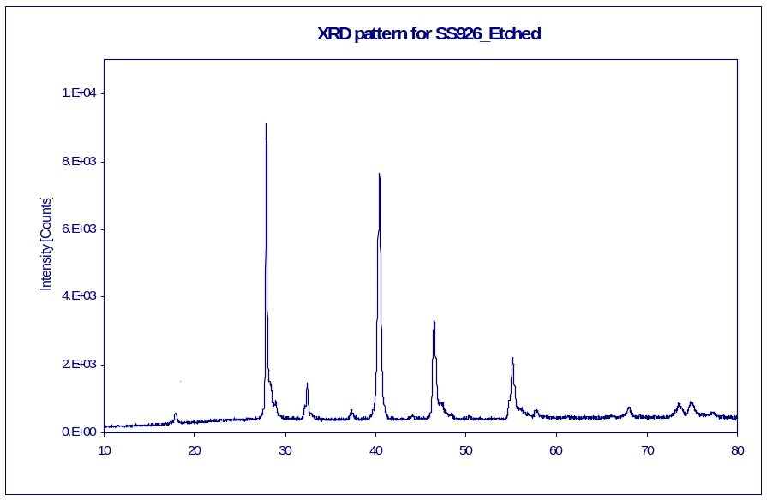

Figure 8. XRD pattern of series cell prepared in Cu/(In+Ga)=1.4 ratio

Figure 9 shows the I-V characteristic of the best cell measured at NREL. Device parameters were V_{oc}, 830.2 mV, J_{sc}, 20.88 mA/cm², FF 69.13% and efficiency of 11.99%. This is the world record efficiency to date for selenide-free CIGS2/CdS thin film solar cells prepared by sulfurization of metallic precursors. The highest efficiency so far on CIGS2/CdS thin film solar cells is 12.3% developed using two stage co-evaporation techniques [5]. The open circuit voltage reported in this research (830.2 mV) is the highest ever obtained on CIGS2/CdS thin-film solar cells. The cells have been awarded the “Voc champions” title. The same cell was sent to NASA Glenn Research Center (NASA GRC) for I-V measurements in AM0 conditions. AM0 simulates the conditions in space. The best values were V_{oc}, 827.52 mV, J_{sc}, 25.0 mA/cm², FF, 67.7% and efficiency of 10.25%. Table VII and VIII shows the device parameters obtained from I-V measurements in AM 1.5 and AM 0 conditions.

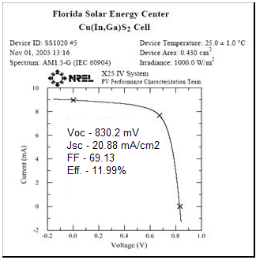

Figure 9. I-V characteristic of the highest reported Voc cell, measured at NREL

Table VII. Device parameters of I-V measurements carried out at AM 1.5 conditions

Sample ID | Voc (mV) | Jsc (mA/cm²) | FF (%) | Efficiency (AM 1.5)
SS1020-1 | 810 | 18.69 | 63.77 | 9.65
SS1020-2 | 810 | 18.23 | 63.81 | 9.42
SS1020-3 | 810 | 18.79 | 64.49 | 9.81
SS1020-4 | 810 | 18.55 | 64.86 | 9.75
SS1020-5 | 810 | 19.64 | 63.07 | 10.03
SS1020-6 | 820 | 19.09 | 60.89 | 9.53
SS1020-7 | 810 | 19.36 | 63.55 | 9.96
SS1020-8 | 800 | 18.46 | 63.53 | 9.38
SS1020-9 | 800 | 19.29 | 62.42 | 9.63

Table VIII. Device parameters of I-V measurements carried out at AM 0 conditions

Cell | Voc (mV) | Jsc (mA/cm²) | Fill Factor (%) | Efficiency (AM0)
SS1020-1 | 827.08 | 24.13 | 68 | 9.93
SS1020-2 | 824.14 | 23.76 | 68 | 9.75
SS1020-3 | 825.13 | 24.40 | 68.6 | 10.1
SS1020-4 | 825.69 | 24.00 | 69.1 | 10.01
SS1020-5 | 827.52 | 25.00 | 67.7 | 10.25
SS1020-6 | 825.37 | 24.56 | 63.5 | 9.41
SS1020-7 | 822.37 | 24.57 | 67.1 | 9.92
SS1020-8 | 819.96 | 24.31 | 67.5 | 9.84
SS1020-9 | 814.83 | 25.23 | 64.7 | 9.73

TEM analysis

The CIGS2 absorber layer is fairly smooth throughout with occasional waviness. Large-sized CIGS2 grains of about 1 µm size are seen on the top side towards the CdS layer whereas small grains of about 150 nm size are observed close to the Mo back contact (Figure 10). Adhesion between the layers looks good especially that between CIGS2 and Mo. Some porosity is seen in the small-sized CIGS2 grains near the Mo layer.

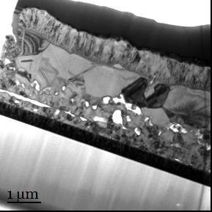
Pt layer (from FIB)

Cr/Ag contacts
ZnO

CdS

CIGS₂

Mo

Glass
Figure 10. Bright field transmission electron micrograph giving an overview of the cross-section of the CIGS2 –based thin film solar cell

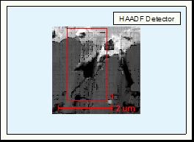
Cr/Ag

ZnO

CIGS₂

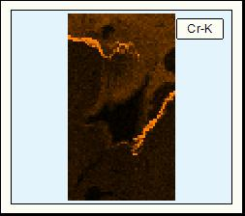
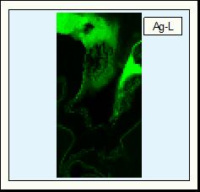
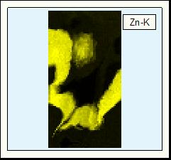
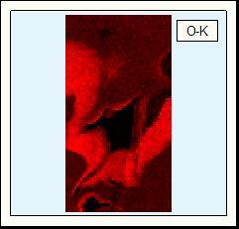

Figure 11. Scanning transmission electron microscopy (STEM) high-angle annular dark-field (HAADF) image (top) and energy dispersive x-ray (EDX) elemental maps (bottom) of an area at the ZnO-Ag/Cr interface.

The sample has Cr-Ag front contacts with Cr very close to the ZnO layer. In the regions where CIGS2 is wavy, a rough ZnO layer is observed and there is a break in the continuity of the Cr-Ag contacts as revealed by the elemental area maps (Figure 11). As we scan the CIGS2 layer from top to bottom (Figure 12), there is an exchange of Ga to In ratios. The distribution of Cu and S is constant throughout the CIGS2 layer. A line scan over the pores (Figure 12) close to the Mo layer reveals an increase in the Si and O signal very close to the pores. There is also segregation of indium closer to the pores but just beyond the Si and the O signal.

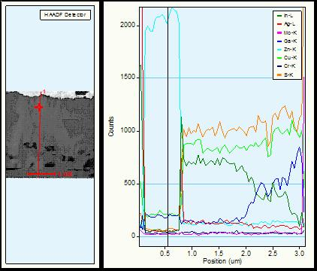

Figure 11. HAADF image (left) and energy dispersive x-ray (EDX) line scan (right) of the cross-section of the thin-film solar cell from top to bottom.

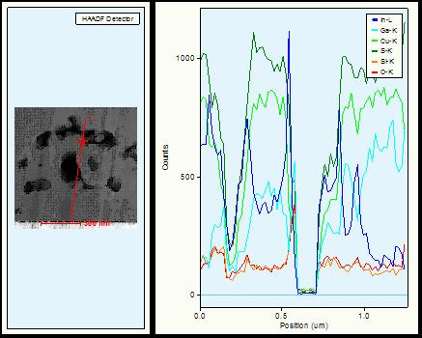

Figure 12. HAADF image (left) and EDX line scan (right) across some pores close to the Mo layer showing segregation of In and an increase in the Si and O signals at the pore surfaces.

Even though pores are found in the first micron above the back contact, efficiencies of the best cells were measured to be 11.99%. This gives hope that a complete elimination of pores leads to improved performance. The CIGS2 grain size above the back contact may be increased by further heat treatments. This would also possibly reduce the fraction of pores. However, the beneficial Ga/In gradient across the absorber layer should be maintained.

Acknowledgements
Authors are thankful to Helio Moutinho and Bobby To (from NREL) for XRD and EPMA analysis respectively and to Mr. Mikhail Kilmov of AMPAC’s MCF at UCF for SIMS analysis.

References
- J. E. Granata, J. R. Sites, J. Schmidt (Ed.), Proceedings of the Second World Conference on Photovoltaic Energy Conversion, Vienna, Austria, (1998), 604.
- NREL Proposal on High Throughput, Low Toxic Processing of Very Thin, High Efficiency CIGSS Solar Cells
- Earlier quarter I report.
- Rapid CIS-process for high efficiency PV-modules: development towards large area processing.V. Probst, W. Stetter, W. Riedl, H. Vogt, M. Wendl, H. Calwer, S. Zweigart, K. -D. Ufert, B. Freienstein, H. Cerva, and F. H. Karg Thin Solid Films Volume 387, Issues 1-2, (2001),262-267
- R. Klenk, S. Bakehe , R. Kaigawa , A. Neisser , J. Reiß , M. Ch. Lux-Steiner, Thin Solid Films 451 –452 (2004) 424–429.

