FIRST DRAFT OF THE PM STAFF PAPER
FIGURES FOR CHAPTER 5, SECTION ON VISIBILITY

Denver, Colorado Images

Note: These images were generated using the WinHaze 2.8.0 visual air quality modeling program.

Figure 5-5. Denver, CO - 35 Mm⁻¹ (112 km visual range)

Figure 5-6. Denver, CO - 43 Mm⁻¹ (91 km visual range)

Figure 5-7. Denver, CO - 51 Mm⁻¹ (77 km visual range)

Figure 5-8. Denver, CO - 61 Mm⁻¹ (64 km visual range)

Figure 5-9. Denver, CO - 76 Mm⁻¹ (52 km visual range)

Figure 5-10. Denver, CO - 93 Mm⁻¹ (42 km visual range)

Figure 5-11. Denver, CO - 167 Mm⁻¹ (23 km visual range)

Figure 5-12. Denver, CO - 258 Mm⁻¹ (15 km visual range)
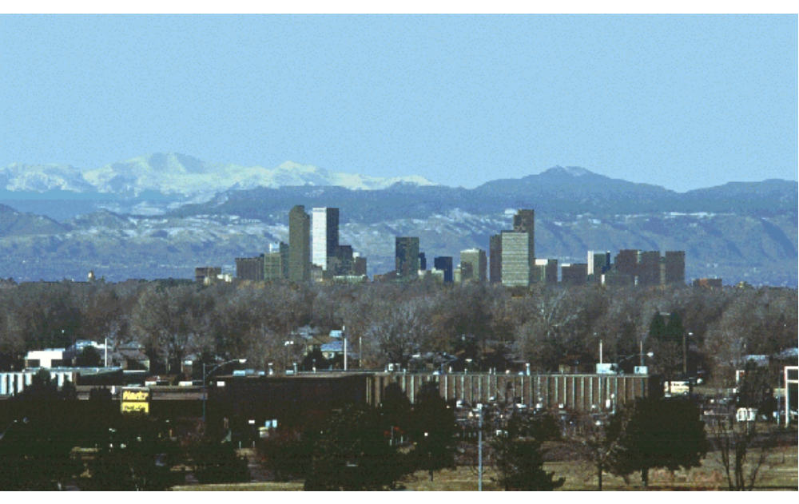
Figure 5-5. Denver, CO - 35 Mm⁻¹ (112 km visual range)

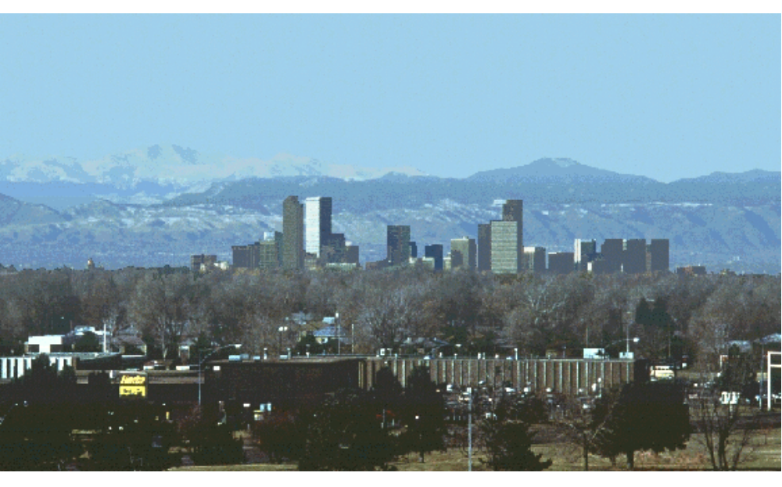
Figure 5-6. Denver, CO - 43 Mm⁻¹ (91 km visual range)

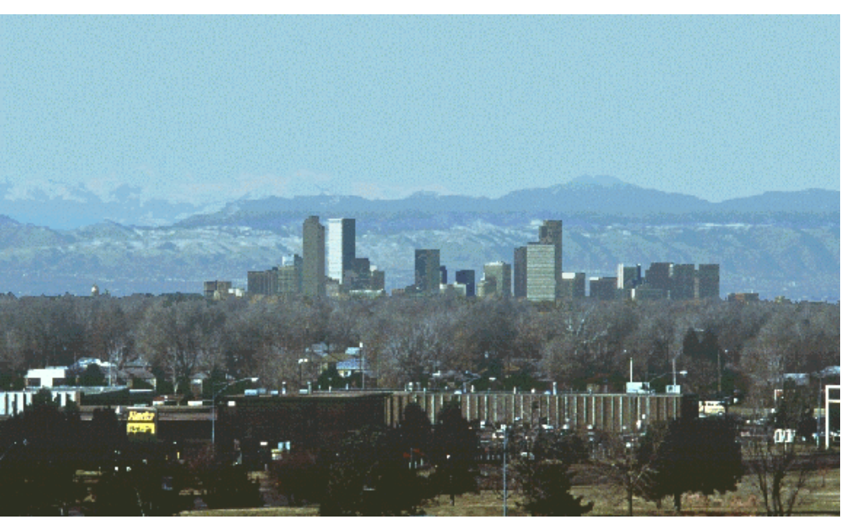
Figure 5-7. Denver, CO - 51 Mm⁻¹ (77 km visual range)

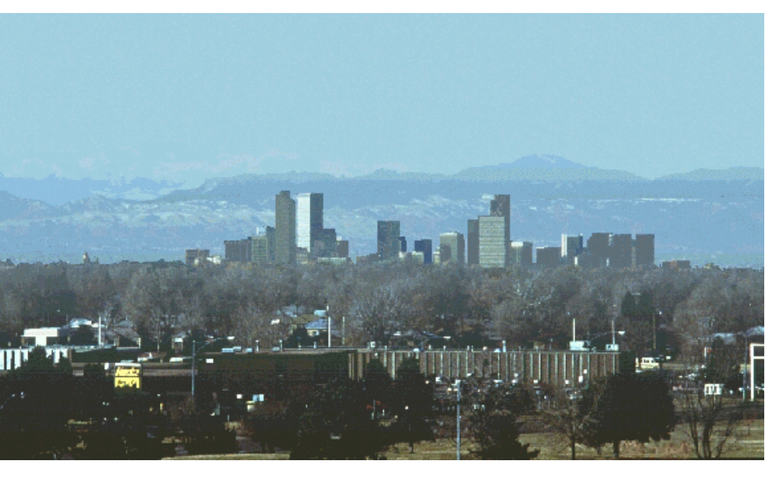
Figure 5-8. Denver, CO - 61 Mm⁻¹ (64 km visual range)

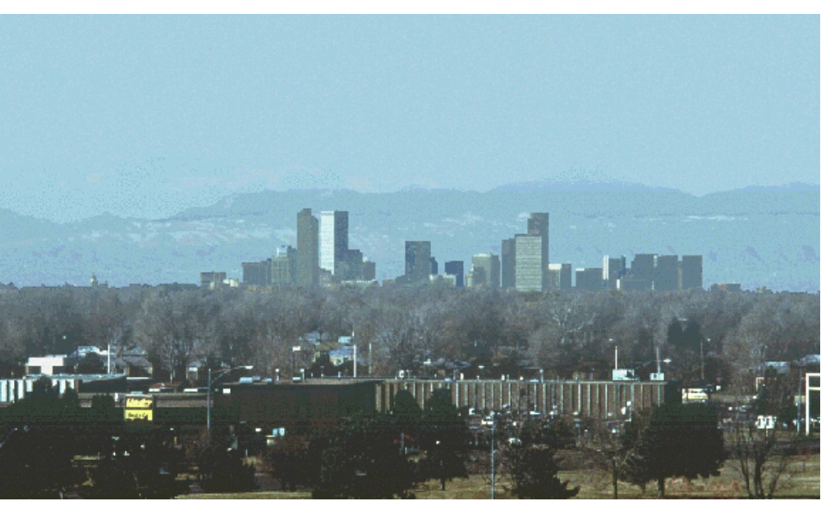
Figure 5-9. Denver, CO - 76 Mm⁻¹ (52 km visual range)

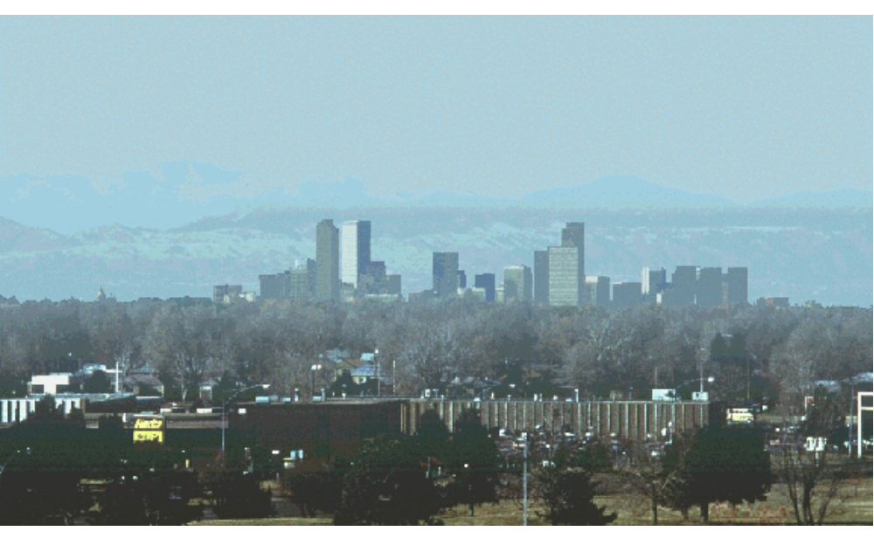
Figure 5-10. Denver, CO - 93 Mm⁻¹ (42 km visual range)
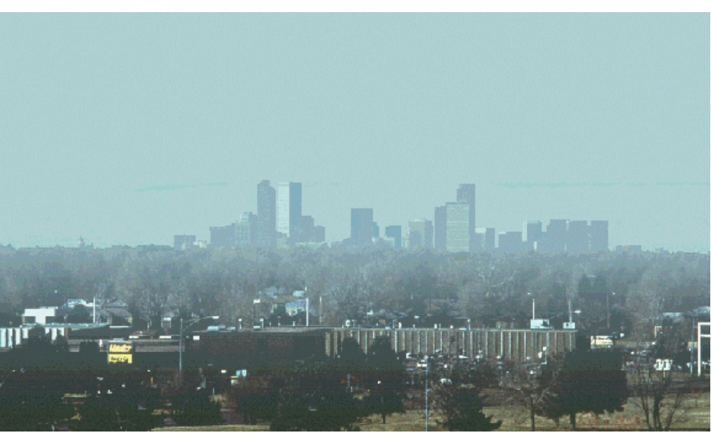
Figure 5-11. Denver, CO - 167 Mm⁻¹ (23 km visual range)

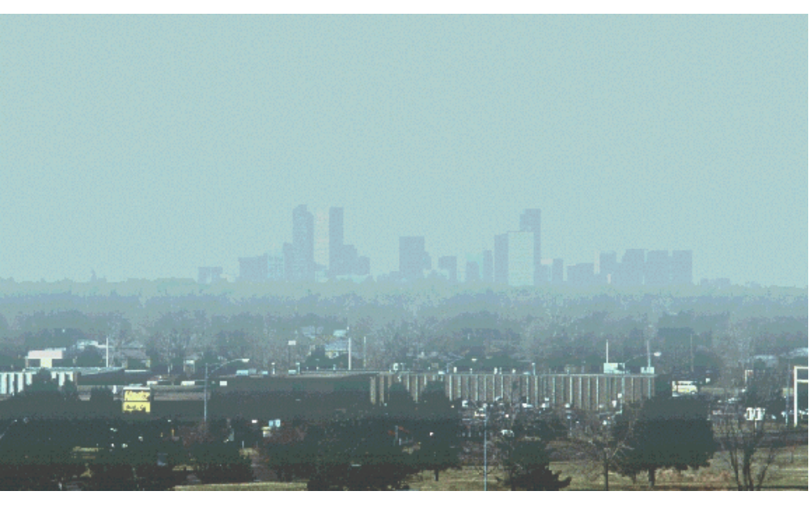
Figure 5-12. Denver, CO - 258 Mm⁻¹ (15 km visual range)

FIRST DRAFT OF THE PM STAFF PAPER
FIGURES FOR CHAPTER 5, SECTION ON VISIBILITY

Phoenix, Arizona Images

Note: These images were generated using the WinHaze 2.8.0 visual air quality modeling program.

Figure 5-13. Phoenix, AZ - 2.5 Fg/m³ PM_{2.5} (87 km visual range)

Figure 5-14. Phoenix, AZ - 5 Fg/m³ PM_{2.5} (71 km visual range)

Figure 5-15. Phoenix, AZ - 10 Fg/m³ PM_{2.5} (52 km visual range)

Figure 5-16. Phoenix, AZ - 15 Fg/m³ PM_{2.5} (41 km visual range)

Figure 5-17. Phoenix, AZ - 20 Fg/m³ PM_{2.5} (34 km visual range)

Figure 5-18. Phoenix, AZ - 30 Fg/m³ PM_{2.5} (25 km visual range)

Figure 5-19. Phoenix, AZ - 40 Fg/m³ PM_{2.5} (20 km visual range)

Figure 5-20. Phoenix, AZ - 65 Fg/m³ PM_{2.5} (13 km visual range)
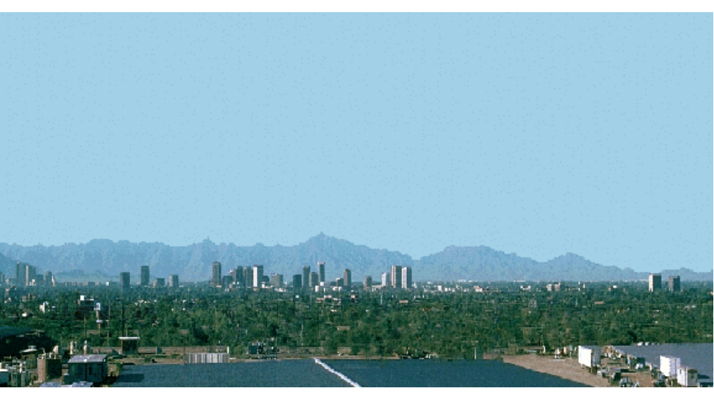
Figure 5-13. Phoenix, AZ - 2.5 Fg/m³ PM_{2.5} (87 km visual range)

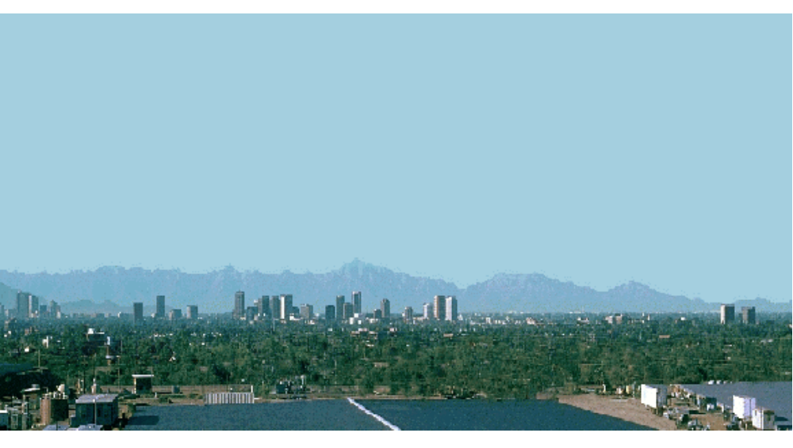
Figure 5-14. Phoenix, AZ - 5 Fg/m³ PM_{2.5} (71 km visual range)

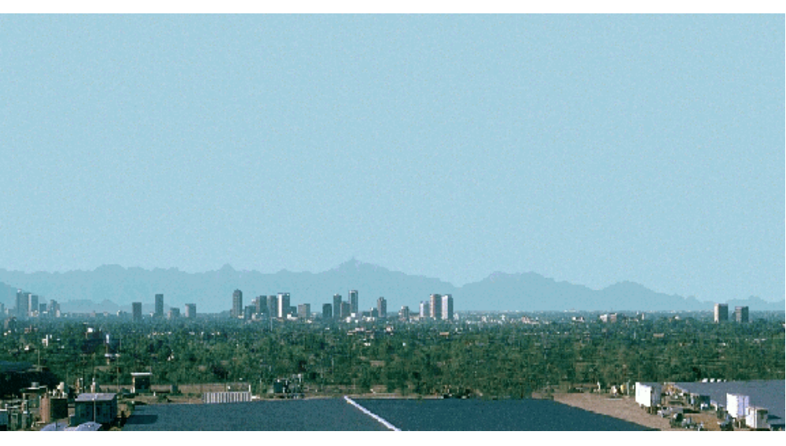
Figure 5-15. Phoenix, AZ - 10 Fg/m³ PM_{2.5} (52 km visual range)

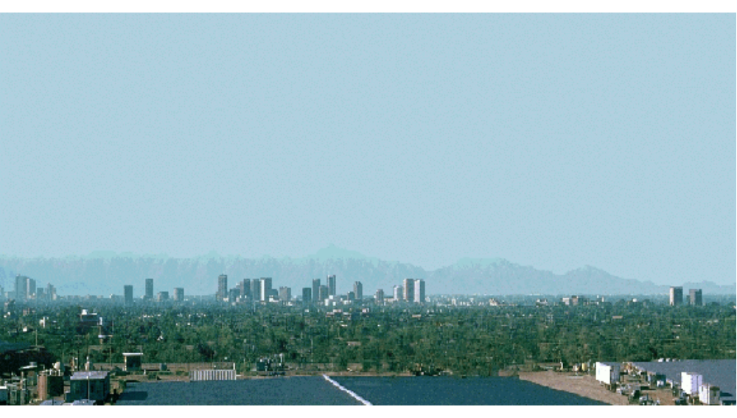
Figure 5-16. Phoenix, AZ - 15 Fg/m³ PM_{2.5} (41 km visual range)
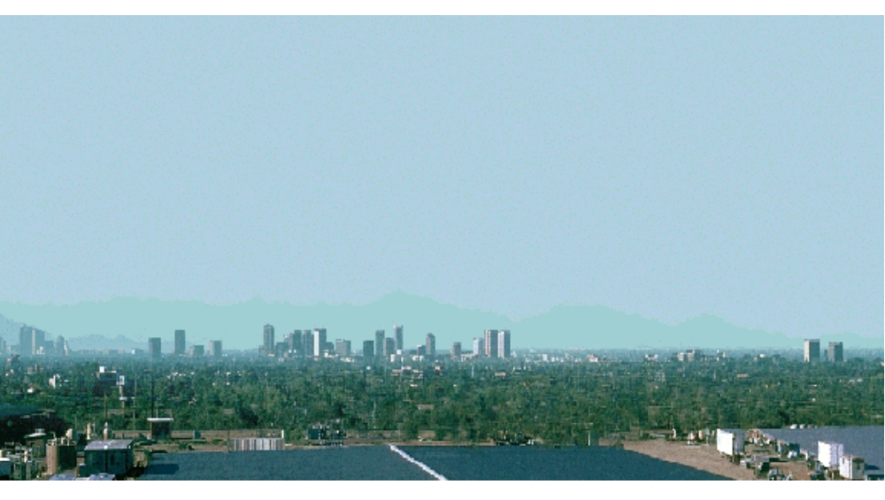
Figure 5-17. Phoenix, AZ - 20 Fg/m³ PM_{2.5} (34 km visual range)

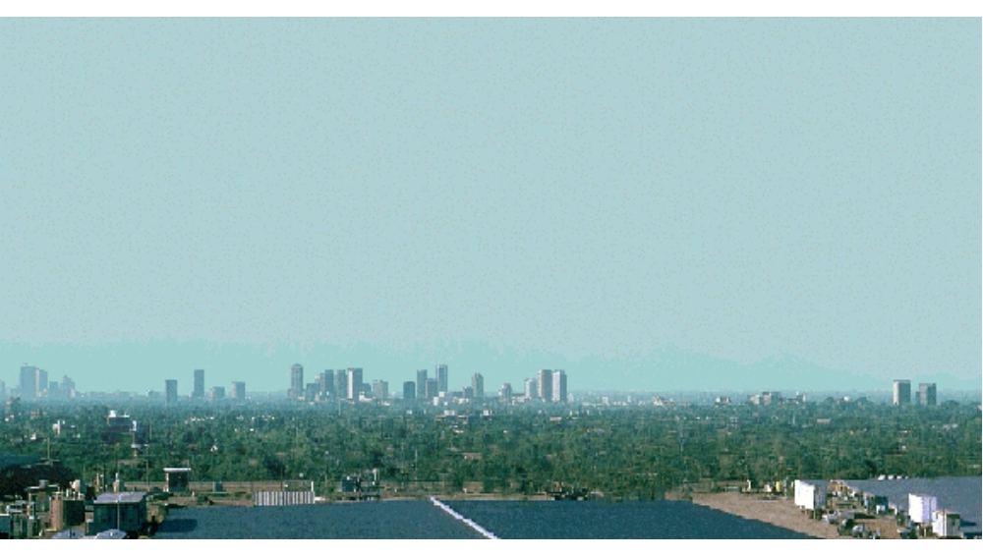
Figure 5-18. Phoenix, AZ - 30 Fg/m³ PM_{2.5} (25 km visual range)

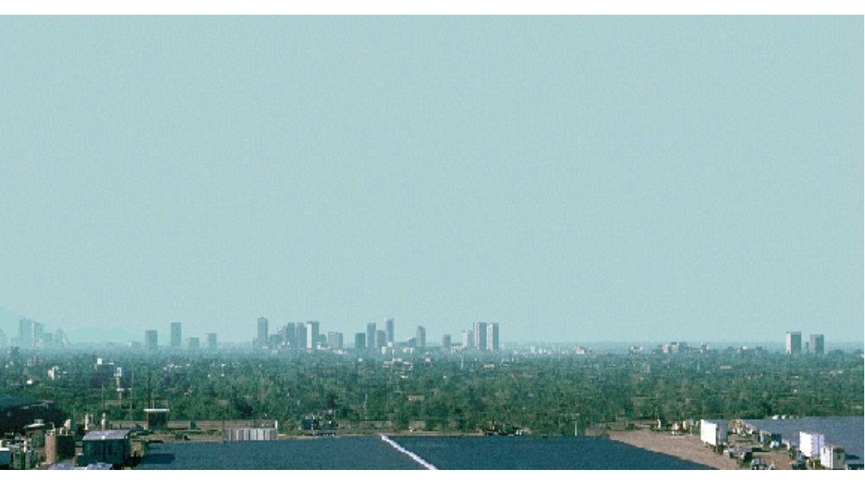
Figure 5-19. Phoenix, AZ - 40 Fg/m³ PM_{2.5} (20 km visual range)

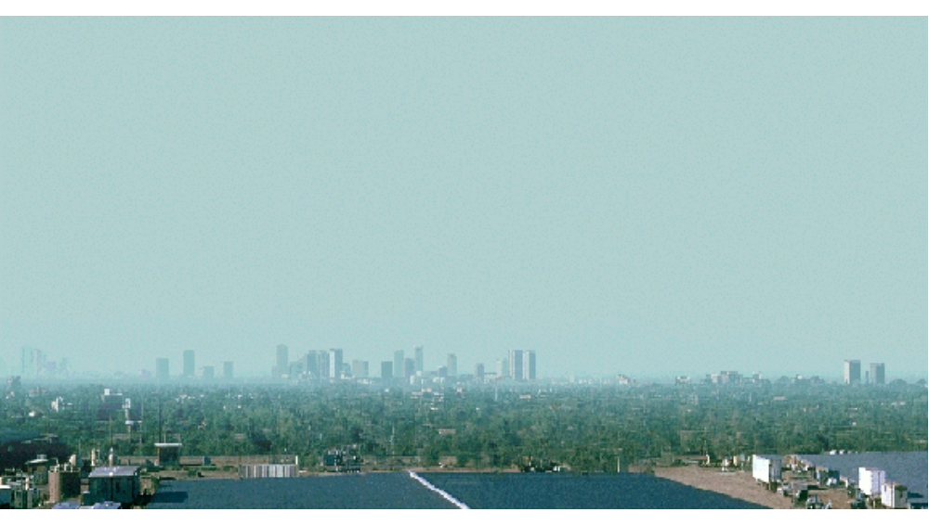
Figure 5-20. Phoenix, AZ - 65 Fg/m³ PM_{2.5} (13 km visual range)

