PUBLIC NOTICE
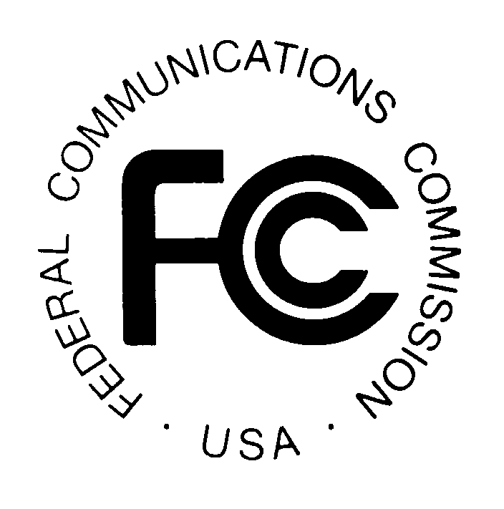

FEDERAL COMMUNICATIONS COMMISSION News Media Information: (202) 418-0500
445 12th STREET, S.W. Fax-On-Demand: (202) 418-2830

WASHINGTON, D.C. 20554 Internet: http://www.fcc.gov

ftp.fcc.gov

DA 05-609
March 8, 2005

MM Docket No. 99-325

COMMISSION CLARIFIES POLICY REGARDING MULTIPLE AUDIO STREAMS IN IBOC transmissions
Experimental authority must be requested
On October 10, 2002, the Commission authorized the commencement of interim operation with the iBiquity hybrid IBOC systems. Under these interim authorization procedures, stations may use only facilities similar to those evaluated by the National Radio Systems Committee (NRSC). Since the NRSC’s initial recommendations, certain modifications to the IBOC system have been introduced and tested. In particular, National Public Radio (NPR) has sponsored a program that takes advantage of advances in audio coding technology to offer multiple digital program channels within the bandwidth originally used for a single digital channel. The program, known as “Tomorrow RadioSM,” has been tested extensively on several NPR affiliates.
NPR has filed test results indicating that the FM IBOC system can accommodate both a main and a secondary digital program channel with good quality and sufficient robustness for mobile service. NPR requests that the Commission expand the digital notification procedures to permit immediate implementation of IBOC systems with multiple digital channels. Multicast operations do not fall within the scope of the notification procedures authorized by the IBOC Order. Thus, until the Commission modifies these procedures, licensees will be required under the rules to obtain experimental authorizations. We also recognize that the extremely encouraging Tomorrow RadioSM test results establish the feasibility of multiple digital audio transmissions in the hybrid mode. Accordingly, we issue this Public Notice to clarify the procedures which licensees should follow to commence multicast transmissions.

The staff will continue to authorize multiple digital audio transmissions as experimental operations under the provisions of 47 C.F.R. § 73.1510. Requests for experimental authority pursuant to Section 73.1510 require only an informal application, typically a letter, and include no fee or form. The staff normally approves requests to participate in this type of experimental program within a week of receipt. The matter of expanded notification procedures will be addressed in the next Report and Order in this proceeding. For additional information, contact Susan Crawford or Ann Gallagher at the Audio Division, Media Bureau at (202) 418-2700.

By: Acting Chief, Media Bureau

-FCC-

The term “hybrid” refers to a system which transmits both the digital and analog signals within the spectral emission mask of a single AM or FM channel.
See Digital Audio Broadcasting Systems and Their Impact on the Terrestrial Broadcast Service, 17 FCC Rcd 19990, 20004 (2002) (“IBOC Order”).
Other participants in the Tomorrow RadioSM program are Kenwood USA, the Corporation for Public Broadcasting, and Harris Corporation’s Broadcast Communications Division.

