SOUTHWEST AREA
FIRE WEATHER
ANNUAL OPERATING PLAN

2006



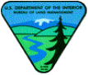



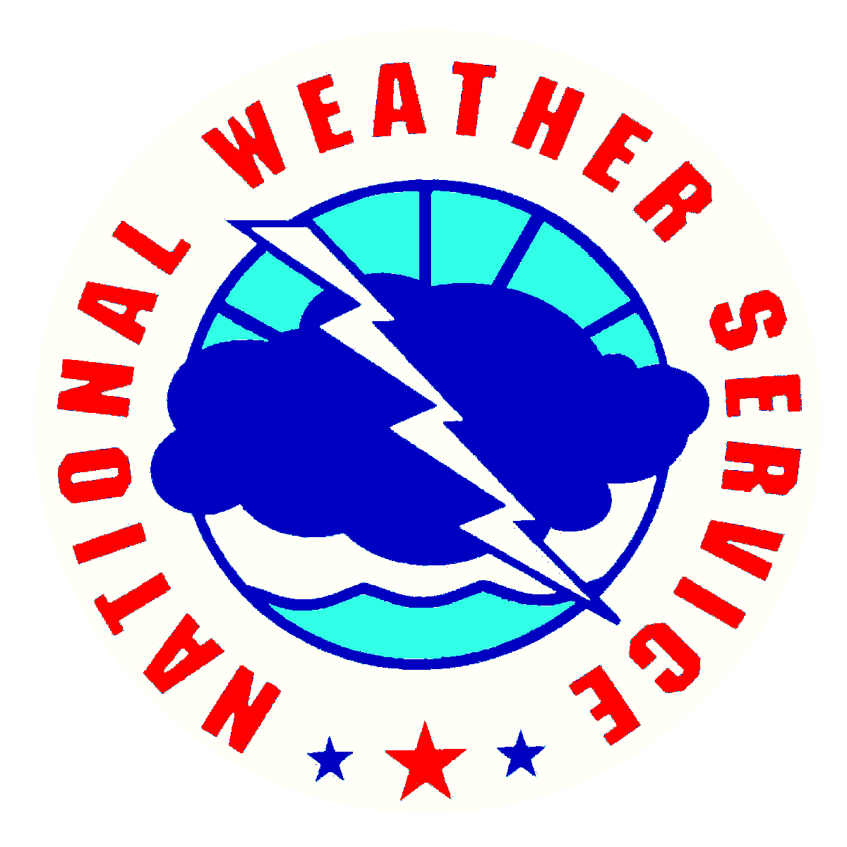




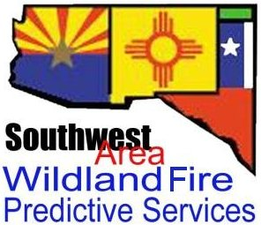

Arizona
New Mexico
West Texas
Oklahoma Panhandle
2005 SOUTHWEST AREA FIRE WEATHER ANNUAL OPERATING PLAN

SECTION PAGE

I. INTRODUCTION 5

II. SIGNIFICANT CHANGES SINCE PREVIOUS PLAN 5

III. SERVICE AREAS AND ORGANIZATIONAL DIRECTORY 5

IV. NATIONAL WEATHER SERVICE SERVICES AND RESPONSIBILTIES 10
A. Basic Services 10
1. Routine Narrative Forecast. 10
2. Spot Forecast. 11
3. Red Flag Warning/Fire Weather Watch. 14
4. NFDRS Forecast. 15
B. Special Services. 16
C. Forecaster Training. 16
D. Individual Forecast Office Information 16
1. Northwest Arizona – Las Vegas, NV 16
2. Northern Arizona – Flagstaff, AZ 17
3. Southeast Arizona – Tucson, AZ 19
4. Southwest and South-Central Arizona – Phoenix, AZ 21
5. Northern and Central New Mexico – Albuquerque, NM 22
6. South-Central and Southwest New Mexico – El Paso, TX 24
7. Southeast New Mexico and Southwest Texas – Midland, TX 25
8. West-Central Texas – Lubbock, TX 26
9. Texas and Oklahoma Panhandles – Amarillo, TX 28

V. WILDLAND FIRE AGENCY SERVICES AND RESPONSIBILITIES…. 29
A. Predictive Services 29
B. Program management 30
C. Monitoring, feedback and improvement 31
D. Technology transfer 31
E. Agency computer systems 31
F. WIMS ID’s for NFDRS Stations 31
G. Fire weather observations 32
H. Reimbursement of NWS for on-site support and training assistance 33
I. SWACG Predictive Services Committee Liaisons 34

VI. JOINT RESPONSIBILITIES… 34
A. Training 34
B. Incident Response 35
C. Briefings 35
D. Fire Weather Coordination Calls 36
E. Communication and Conflict Resolution 37

VII. EFFECTIVE DATES OF AOP 38

VIII. AGENCY SIGNATURES 38

IX. APPENDICES 39

A. Forecast Element Definitions 39
1. General Elements and Haines Index 39
2. Ventilation Index 40
3. Lightning Activity Level. 41
B. NWS Forecast Examples 42
1. General Narrative Forecast 42
2. General Tabular Forecast 46
3. Spot Forecast 47
4. Red Flag Warning / Fire Weather Watch 48
5. NFDRS Forecast 50
C. Predictive Services Product Examples 51
1. Daily Summary 51
2. 10-Day Fire Weather/Fire Danger Outlook 52
3. Monthly Large Fire Potential Outlook 53
4. Fire Season Outlook 57
D. Narrative Fire Weather Zone Maps. 59
E. NFDRS Zones. 61
F. New Mexico NOAA Weather Radio Transmitters. 63
G. Backup Spot Forecast Request Form. 66
1. Example of Correctly Completed Spot Request Form 68
H. Catalog of RAWS and NFDRS Observation Sites 69

Southwest Area Interagency Fire Weather Operating Plan - 2006

- INTRODUCTION

This document serves as the Interagency Fire Weather Annual Operating Plan (AOP) for the Southwest Geographic Area. The general relationship between NWS and the interagency fire management community is set forth in the National Interagency Agreement for Meteorological Services. The AOP provides specific procedural and policy information regarding the delivery of meteorological services to the fire management community in the Southwest Area, as allowed under the umbrella of the National Agreement.

References include:

- National Weather Service NWSI 10-4: Fire Weather Services
- Interagency Agreement for Meteorological Services (National MOA or “National Agreement”)
- Southwest Area and National Mobilization Guides

- SIGNIFICANT CHANGES SINCE LAST YEAR

  - New Mexico NFDRS fire weather zones reconfigured (page 60)
  - Experimental Digital services from the National Weather Service (Appendix F.)
  - 7 Day Significant Fire Potential Outlook from Predictive Services (Pages 29 & 52)
  - Red Flag event criteria changed from 3 or more continuous hours to 3 or more hours (Page 13)
  - Site-specific ventilation data available in spot forecasts under adverse dispersion conditions (page 11)

- SERVICE AREA AND ORGANIZATIONAL DIRECTORY

  - Fire weather services are provided by SWA Predictive Services and the NWS forecast offices listed below. (Service areas are depicted in the Appendix D, starting on page 59). Contact information follows.

Amarillo, TX Lubbock, TX El Paso, TX
Midland, TX Albuquerque, NM
Tucson, AZ Phoenix, AZ
Flagstaff, AZ Las Vegas, NV
SOUTHWEST AREA PREDICTIVE SERVICES
333 Broadway SE, Albuquerque, NM 87102
FAX Number: (505) 842-3414 or (505) 842-3801
Web Site Address: http://www.fs.fed.us/r3/fire/

Name Position Work Cell E-Mail
Chuck Maxwell Meteorologist / Group Leader (505) 842-3419 362-7008 cmaxwell@fs.fed.us
Rich Naden Meteorologist / RAWS Coord. (505) 842-3415 362-7038 rnaden@fs.fed.us
Jay Ellington Fire Intelligence Coordinator (505) 842-3473 301-0850 jayellington@fs.fed.us

WEATHER SERVICE FORECAST OFFICE, PAB 500, P.O. Box 52025, Phoenix, AZ 85072-2025
FAX Number: (602) 267-8051
Web Site Address: http://www.wrh.noaa.gov/psr/fire/index.php?wfo=psr
Backup Office: NWS WFO Tucson, AZ

Name Position Unlisted Direct Phone E-Mail
Valerie Meyers IMET Trainee/Fire Weather Prog. Mgr. (602) 275-7003 Valerie.Meyers@noaa.gov
David Runyan Warning Coord Meteorologist (602) 275-7003 David.Runyan@noaa.gov
Tony Haffer Meteorologist-ln-Charge (602) 275-7003 Anton.Haffer@noaa.gov

WEATHER SERVICE FORECAST OFFICE, P.O. Box 16057, Flagstaff, AZ 86015-6057
FAX Number: (928) 774-3914
Web Site Address: http://www.wrh.noaa.gov/fgz/fwx/fwx.php?wfo=fgz
Backup Office: WFO Phoenix

Name Position Unlisted Direct E-Mail
Mark Stubblefield IMET (928) 774-4414 mark.stubblefield@noaa.gov

Robert Bohlin Fire Weather Prog. Manager (928) 774-4414 robert.bohlin@noaa.gov
George Howard Warning Coord. Meteorologist (928) 774-4414 george.howard@noaa.gov
Brian Klimowski Meteorologist in Charge (928) 774-4414 brian.klimowski@noaa.gov

WEATHER SERVICE FORECAST OFFICE, 520 N. Park Ave., Suite 304, Tucson, AZ 85719
FAX Number: (520) 670-5167
Web Site Address: http://www.wrh.noaa.gov/twc/firewx.php
Backup Office: WFO Phoenix

Name Position Unlisted Direct E-mail

Steve Reedy IMET/Fire Weather Prog. Manager (520) 670-5161/5160 steve.reedy@noaa.gov
Tom Evans Warning Coord. Meteorologist (520) 670-5161/5160 tom.evans@noaa.gov
Glen Sampson Meteorologist In Charge (520) 670-5161/5160 glen.sampson@noaa.gov

WEATHER SERVICE FORECAST OFFICE, 7851 Dean Martin Drive, Las Vegas, NV 89139
FAX Number: (702) 263-9759
Web Site Address: http://weather.gov/lasvegas/fire.php
Backup Offices: WFO Reno - Phone 775-673-8105/ Fax 775-673-8110 and WFO Elko - Phone 775-778-6720/Fax 775-778-9786

Name Position Unlisted Direct E-mail
Jim Harrison Fire Weather Program Mgr./IMET (702) 263-9750/9749 jim.harrison@noaa.gov
Andy Bailey Warning Coord. Meteorologist (702) 263-9750/9749 andy.bailey@noaa.gov
Kim Runk Meteorologist In Charge (702) 263-9750/9749 kim.runk@noaa.gov

WEATHER SERVICE FORECAST OFFICE, 2341 Clark Carr Loop SE, Albuquerque, NM 87106
FAX Number: (505) 842-9162
Web Site Address: http://www.srh.noaa.gov/abq/firewx/fw-3.htm
Backup Office: WFO El Paso/Santa Teresa

Name Position Unlisted Direct E-mail
Brent Wachter Fire Weather Program Mgr./IMET (505) 244-9148* john.wachter@noaa.gov
Keith Hayes Warning Coord. Meteorologist (505) 244-9148* keith.hayes@noaa.gov
Charlie Liles Meteorologist In Charge (505) 244-9148* charlie.liles@noaa.gov

WEATHER SERVICE FORECAST OFFICE, 2579 South Loop 289 Suite 100, Lubbock, TX 79423-1400
FAX Number: (806) 745-1058
Web Site Address: http://www.srh.noaa.gov/lub/fire/firewx.htm
Service Backup Office: WFO Amarillo

Name Position Unlisted Direct E-mail
Jose Valdez Fire Weather Program Leader (806) 745-4260/3980 jose.valdez@noaa.gov
Justin Weaver Meteorologist In Charge (806) 745-4260/3980 justin.weaver@noaa.gov

WEATHER SERVICE FORECAST OFFICE, 1900 English Rd., Amarillo, TX 79108
FAX Number: (806) 335-3118
Web Site Address: http://www.srh.noaa.gov/ama/fire_weather/
Service Backup Office: WFO Lubbock

Name Position Unlisted Direct E-mail
Ken Schneider Fire Weather Program Leader (806) 335-9022 ken.schneider@noaa.gov
Steve Drillette Warning Coord. Meteorologist (806) 335-9022 steve.drillette@noaa.gov
Jose Garcia Meteorologist In Charge (806) 335-9022 jose.garcia@noaa.gov

WEATHER SERVICE FORECAST OFFICE, 7955 Airport Road, Santa Teresa, NM 88008
FAX Number: (505) 589-1158
Web Site Address: http://www.srh.weather.gov/elp/misc/firewx.shtml
Service Backup Office: WFO Albuquerque

Name Position Unlisted Direct E-mail
Tom Bird Fire Weather Prog. Leader/IMET (505) 589-3982* tom.bird@noaa.gov
Corey Pieper IMET Trainee (505) 589-3982* corey.pieper@noaa.gov
John Fausett Warning Coord. Meteorologist (505) 589-4162 john.fausett@noaa.gov
Bill Alexander Meteorologist In Charge (505) 589-4161 bill.alexander@noaa.gov

WEATHER SERVICE FORECAST OFFICE, 2500 Challenger Dr., Midland, TX 79706-2606
FAX Number: (432) 563-8117
Web Site Address: http://www.srh.noaa.gov/maf/HTML/fire_weather.html
Service Backup Office: WFO San Angelo, TX, (432) 944-0715

Name Position Unlisted Direct E-mail
Greg Murdoch Fire Weather Prog. Leader/IMET (432) 563-5006/6217 gregory.murdoch@noaa.gov

Pat Vesper Warning Coord. Meteorologist (432) 563-5006/6217 pat.vesper@noaa.gov
Ray Fagen Meteorologist In Charge (432) 563-5006/6217 raymond.fagen@noaa.gov

Southwest Area PREDICTIVE SERVICES Committee Liaisons
Albuquerque WFO |  |  | John Kwait  Bureau of Land Management – Albuquerque  John_Kwait@blm.gov  Office: (505) 761-8732  Cell: (505) 250-2239
Lubbock & Amarillo WFOs |  |  | Steve Fisher  Lake Meredith National Recreation Area  Steve_Fisher@nps.gov  Office: (806) 865-3874  Cell:
Midland & Santa Teresa WFOs |  |  | James Villard  Lincoln National Forest – Sacramento RD  jvillard@fs.fed.us  Office: (505) 682-2551  Cell: (505) 301-2032
Phoenix WFO |  |  | Helen Graham  Bureau of Land Management - Phoenix  Helen_Graham@blm.gov  Office: 623 580-5635  Cell: 602 903-8626
Tucson WFO |  |  | Russ Babiak  Buenos Aires National Wildlife Refuge  Russ_Babiak@fws.gov  Office: 520 823-4251 ext. 113  Cell: N/A
Las Vegas WFO |  |  | Vacant  Bureau of Land Management - Kingman  Office 928-692-4429  Cell: 928 530-2100
Flagstaff WFO |  |  | Ed Hiatt  Grand Canyon National Park  Office: (928) 638 0001  Edward_Hiatt@nps.gov  Cell: (928) 606 1401
SOUTHWEST AREA PREDICTIVE SERVICES COMMITTEE
Name | Agency/Unit | Phone |  | E-mail
Ed Hiatt | NPS/Grand Canyon | 928-638-0001 |  | Edward_Hiatt@nps.gov
*Chuck Maxwell | FWS/SWCC | 505-842-3419 |  | cmaxwell@fs.fed.us
Rich Naden | NPS/SWCC | 505-842-3415 |  | rnaden@fs.fed.us
John Kwait | BLM NM/Albuquerque | 505-761-8732 |  | John_Kwait@blm.gov
Rita Booth | USFS/A-S NF | 928-333-4417 |  | rbooth@fs.fed.us
Ron Melcher | AZ State Lands | 602-255-4059 |  | ronmelcher@azstatefire.org
James Villard | USFS/Lincoln NF | 505-682-2551 |  | jvillard@fs.fed.us
Steve Fisher | NPS Lake Meredith | 806-865-3874 |  | Steve_Fisher@nps.gov
Helen Graham | BLM AZ/Phoenix | 623-580-5635 |  | Helen_Graham@blm.gov
Russ Babiak | FWS/Buenos Aires | 520-823-4251 ext. 113 |  | Russ_Babiak@fws.gov
Brad Smith | Texas Forest Service | 903-297-4840 |  | bsmith@tfs.tamu.edu
* Denotes committee chair

  - Participating Agencies
    - DOC/NOAA/National Weather Service – Western and Southern Regions
    - USDA Forest Service – Southwest Region
    - DOI Bureau of Land Management – Arizona & New Mexico State Offices
    - DOI National Park Service – Intermountain Region
    - DOI US Fish and Wildlife Service – Southwest Region
    - DOI Bureau of Indian Affairs – Units of the Southwest, Navajo, and Western Regions that fall within the Southwest Geographic Area
    - New Mexico State Forestry Division
    - Arizona State Land Department
    - Texas Forest Service – Areas west of 100°W longitude

- NATIONAL WEATHER SERVICE SERVICES AND RESPONSIBILITIES

  - Basic Services – The following constitute the current operational fire weather forecast products provided by NWS. Significant changes to these forecast services or deployment of new operational forecast products and services will be coordinated through the Southwest Area Weather Committee and Southwest Area Predictive Services (Reference NWSI 10-403). Any non-operational forecast products will be clearly labeled as “Experimental” or “Prototype”.

    - Fire Weather Planning Forecasts

Fire weather planning forecasts are issued by all NWS offices serving the Southwest Area. The intent is to provide general, zone based information for daily preparedness and planning purposes.

      - Issuance times - At least once daily by 830 a.m. local time on a year round basis. Afternoon forecasts will be issued by some offices on a year round basis, and by others on a seasonal basis, no later than 330 p.m. local time. Beginning and ending dates of seasonal afternoon forecasts will be coordinated through Predictive Services.

Forecasts will be updated when a Fire Weather Watch or a Red Flag Warning is issued, the current forecast does not adequately represent current or expected weather conditions or a typographical/format error is detected.

      - Access – Forecasts are made available within minutes via WIMS, the Southwest Area Wildland Fire Operations Web Site and the web sites of the various NWS offices that serve the Southwest Area. Links to all forecasts and NWS office web pages can be found at. http://gacc.nifc.gov/swcc/predictive/weather/weather.htm

      - Content and Format – Forecasts will conform to either the national standard narrative or national standard tabular format, per NWSI 10-401. The Amarillo and Lubbock offices will use the tabular format, while all others will use the narrative format. Morning forecasts will focus on the following 36 hours and afternoon forecasts on the following 48 hours, with general extended outlooks in both cases out to at least 5 days.

Each forecast will begin with pertinent headlines and a non-technical weather discussion. Headlines are required for Red Flag Warnings and Fire Weather Watches, but may be included for other situations including air stagnation, record heat, severe weather potential, etc.

Forecasts for the first 36 or 48 hours will contain at least the following elements for each zone or zone grouping, listed in the order they will appear.

        - Headline(s) as appropriate
        - Sky/weather
        - Temperature and 24 hour trends
        - Humidity and 24 hour trends
        - Wind - 20 foot RAWS standard (slope/valley)
        - Ridgetop or 10,000 Ft. MSL Wind
        - Probability of Precipitation
        - Lightning Activity Level (LAL)
        - Haines Index
        - *Mixing Level
        - *Transport Winds
        - *Ventilation (kt-ft) and Ventilation/Dispersion Category (State defined)
        - Extended outlook to at least day 5 (or at end of product)

* Ventilation/smoke dispersion required for daytime periods only. In addition to Ventilation value (kt-ft), Ventilation/Dispersion category will be provided on the same line or on the following line. Ventilation information not provided for every zone in AZ or TX.

Format examples and descriptions of forecast parameters can be found in the appendices.

      - Consistency and Applicability Guidelines

The following guidelines for wind speed and relative humidity in the daily narrative forecasts do not apply if there are legitimate meteorological reasons for deviating from the guidelines AND the reasons are clearly explained in the narrative discussion. Where a range of values is given in the forecast, the midpoint will determine the value for the purposes of consistency and applicability. (i.e. A 20 ft. wind speed of 10-20 mph would be counted as 15 mph, and a forecast of < 5 mph or > 25 mph for an adjacent zone would be considered inconsistent.)

Parameter | Inter-zone Consistency | Applicability (Forecast Range)
20 ft. wind speeds | ± 10 mph | 5 mph for speeds ≤ 10 mph  10 mph for speeds > 10 mph
10,000 ft MSL winds | ± 10 mph | 50% of highest speed indicated
Min RH | ± 5% when RH ≤ 20%  ± 10% when RH > 20% | 5% when RH ≤ 20%  10% when RH > 20%
Max RH | ± 10% when RH ≤ 40%  ± 20% when RH > 40% | 10% when RH ≤ 40%  20% when RH > 40%
    - Spot forecasts

      - Criteria - Spot forecasts are site-specific forecast products issued for wildfires, prescribed burns, search and rescue operations, aerial spraying, etc., and are available upon request at any time of day, week or season. Spot forecasts are available to any federal, state or municipal agency.

Site-specific forecasts are considered one-time requests, and are not routinely updated. Spot forecasts will be updated when representative observations are available to the forecaster and/or the forecaster deems the current forecast does not adequately represent current or expected weather conditions. Priority for the update of spot forecasts is as follows:

- Wildfires
- Prescribed burns or Wildland Fire Use (WFU)
- Everything else

Land management personnel should contact the appropriate WFO for a spot update if forecast conditions appear unrepresentative of the actual weather conditions.

The spot forecast will be corrected when a typographical/format error is detected. Corrections should be delivered to users in the same manner as the original spot forecast when possible.

NWS Western Region offices willl offer automatic 7-day FARSITE weather support with all wildfire spot forecast issuances. For prescribed burn spot forecasts, FARSITE data will be produced at the request of the agency. Please refer to Appendix F – Experiemental Digital Services from the NWS.

      - Content and Format – Spot forecasts will contain the required minimum elements, unless otherwise specified upon request:

        - Headline (required when Red Flag Warning / Fire Weather Watch)
        - Discussion
        - Sky/weather (including chance of rain)
        - Temperature
        - Relative humidity
        - 20 foot winds

Optional elements may be included upon request, including site-specific ventilation for smoke management purposes. The following conditions apply to the provision of ventilation data in spot forecasts in New Mexico and Arizona:

- Ventilation for the nearest forecast reference point in the fire weather planning forecast rates as POOR in New Mexico or MARGINAL or POOR in Arizona.
- Elevation-adjusted ventilation for a specific site, based on the information in the fire weather planning forecast, rates as POOR in New Mexico or MARGINAL or POOR in Arizona.
- Extenuating circumstances exist where site-specific ventilation information is necessary to accomplish management objectives (i.e. particularly sensitive downwind receptor, high visibility burn or smoke situation, etc.)

The valid time will be determined at the time of the request. Most spots contain three periods, usually “TODAY”, “TONIGHT”, and “NEXT DAY”, e.g., “TODAY”, “TONIGHT”, and “THURSDAY”.

      - Procedures – Internet based spot programs are the standards for requesting and retrieving spot forecasts and should be used when available. They are accessible via the SWCC Fire Operations Web Site and the web sites of the various NWS offices that serve the Southwest Area. Links to all forecast information and NWS office web pages can be found at http://gacc.nifc.gov/swcc/predictive/weather/weather.htm. In times when Internet access is hindered or not possible, spot forecasts may be requested and disseminated via phone or fax using the backup spot forecast request form found in the appendices. In all cases, spot forecasts should be available 60 minutes or less from the time the appropriate NWS office receives the request. NWS should be contacted immediately by telephone if a spot forecast is not available within this time frame.

At or before the time of a spot request, the requesting agency should provide information about the location, topography, fuel type(s), elevation(s), size, ignition time, and a contact name(s) and telephone number(s) of the responsible land management personnel. Also, quality representative observation(s) at, or near, the site of the planned prescribed burn, or wildfire, should be available to the responsible WFO along with the request for a spot forecast(s). NWS Spot and the backup form will provide blocks to fill this data in and will indicate which are absolutely essential to receive a spot forecast.

Spot Forecast Feedback Requirement

Responsibility for providing fireline observations for the validation of forecast accuracy rests with the fire management agencies, as outlined under, “Fireline Observations & Spot Forecast Feedback” on page 32.

    - Fire Weather Watches and Red Flag Warnings - The Red Flag program is a means by which the weather forecaster informs the land management agencies of the combination of dry fuels and weather conditions that support extreme fire behavior. Identification of Red Flag events is a primary responsibility of the forecaster producing the fire weather forecasts, though fire management personnel may request that an event be so identified under extenuating circumstances. Such requests will be passed to the appropriate zone coordination center(s) and then on to the appropriate NWS office(s).

A Red Flag Warning is used to inform agencies of the imminent or actual occurrence of Red Flag conditions. A Red Flag Warning will be issued immediately when there is high confidence that Red Flag criteria will be met within the next 24 hours, if those criteria are already being met or if fire management personnel specifically request that one be issued.

A Fire Weather Watch is used to alert agencies to the high potential for development of a Red Flag event in the 12-72 hour time frame. The watch may be issued for all, or selected, portions within a fire weather zone or region. As with Red Flag Warnings, a Watch may also be issued upon specific request from fire management personnel.

      - Criteria – Standardized criteria for issuance of Fire Weather Watches and Red Flag Warnings in the Southwest Area are a combination of weather and fire danger ratings. In the absence of overriding input from fire management personnel, a Red Flag event is defined by the following conditions occurring simultaneously for three or more hours across any portion of a fire weather zone:

        - 20 ft. winds sustained at 20 mph or greater or gusting to 35 mph or greater
        - Relative humidity of 15% or lower
        - NFDRS adjective fire danger rating of “High” or higher

The following are assumed:

- Sustained winds are considered relative to the midpoint of a forecast range (i.e. 15-25 mph meets criteria, 15-20 mph does not)
- RH is considered relative to the minimum value in a given forecast range. (i.e. 13-23% forecast for a zone meets criteria for those locations in the zone expected to be 15% or less)
- Wind forecasts are for the 20 ft. level/10 min. time average and apply to RAWS properly sited and maintained, per NWCG National Fire Danger Rating System (NFDRS) Weather Station Standards.

      - Product Format and Contents - A short message (RFW) will be used for issuing, updating, and canceling all Fire Weather Watches and Red Flag Warnings. That message will include:

        - Headline including description of watch/warning, description of valid location and time period for which watch/warning is valid.
        - List of fire weather zones impacted
        - Short discussion detailing causes and nature of event

      - Procedures and Access - When Fire Weather Watches and Red Flag Warnings are issued; they will be headlined in spot forecasts, the fire weather narrative and the appropriate zone sections where the conditions are expected. The headline will be in the same descriptive format as on the RFW product itself. If issuance of a Red Flag Warning or Fire Weather Watch requires an update of the general forecast, the NWS office will verbally notify the affected zone dispatch centers, and e-mail the update to SWCC Predictive Services, as soon as possible. Red Flag Warnings and Fire Weather Watches will remain in effect through the expiration time noted in the forecast, or until canceled or upgraded

Red Flag Warnings and Fire Weather Watches are available within minutes of issuance via WIMS, the SWCC Fire Operations Web Site and the web sites of the various NWS offices that serve the Southwest Area. Links to all forecasts and NWS office web pages can be found at http://gacc.nifc.gov/swcc/predictive/weather/weather.htm

    - NFDRS Forecasts – The National Weather Service role in NFDRS is providing 24 hour forecasted weather which allows the NFDRS software to predict the next day's fire danger indices.

      - Criteria for Issuance – NWS will issue forecasts for use by the NFDRS daily on a year-round basis when NFDRS observations are received. NFDRS observations must be complete and available in WIMS by 1350 LST (1450 LDT) to be received by NWS in time to produce a forecast. NFDRS stations that do not have valid observations in WIMS on time will not have next day fire danger indices available.

      - Content and Format – Complies with NWSI 10-4 and is outlined in Appendix A for reference. Required meteorological elements for NFDRS forecasts are: State of Weather, temperature, humidity, wind speed, and precipitation duration. Lighting Activity Level (LAL) will be forecast only for the portions of Arizona served by NWS Las Vegas, Phoenix, and Tucson; while LAL will be discontinued as a forecast element elsewhere. The actual NWS NFDRS forecast product is used only by WIMS and is not viewed directly by fire management.

      - Procedures – For every NFDRS observation received from WIMS at the 1400 LST (1500 LDT) collective, forecast weather parameters for 1300 LST (1400 LDT) the next day will be produced. This will occur through any combination of zone trend, station trend or station specific forecasts. Zone and station trend forecasts will be favored over station specific forecasts. Where station specific point forecasts are issued, NWS will be responsible for taking reasonable actions to ensure forecasted values do not conflict with the historical possibility for those stations.

    - Participation in Interagency Groups - NWS offices providing service within the Southwest Area are expected to provide representation at the annual regional AOP meeting, with proxy representation acceptable, and will be invited to serve as technical advisors on the Southwest Area Predictive Services Committee as appropriate. NWS offices are also expected to host at least one meeting per year with local fire management units to strengthen the customer relationship and address local concerns.

  - Special Services. – NWS will provide and maintain a cadre of trained IMETs. Enough IMETs should be available from Southwest Area offices to support multiple incidents in May and June. At least one IMET from the offices that serve the Southwest Area should be available for dispatch between March 1st and August 1st.

  - Forecaster Training. - The NWS recognizes the need for specialized training in fire weather meteorology for forecasters. Any NWS meteorologist producing fire weather products will have met the requirements set forth in NWSI 10-405

  - Individual Forecast Office Information

    - Northwest Arizona - Las Vegas, NV

Unless otherwise mentioned, it is to be assumed that services provided by NWS Las Vegas for units in Arizona will follow the regional policies and procedures set forth in the Southwest Area Fire Weather AOP.

General Information

The National Weather Service in Las Vegas, NV is responsible for providing Fire Weather support for northwest Arizona. The area of responsibility covers fire weather narrative zones 101 and 102, which includes all of Mohave County. The office Fire Weather Program Manager is also a certified Incident Meteorologist (IMET) and available for dispatch to fires.

Fire Weather Planning Forecasts

Narrative forecasts will be issued by 700 am and 330 pm during the fire season and by 700 am during the off-season for Arizona narrative zones 101 and 102.

Spot Forecasts

The Las Vegas office will prepare spot weather forecasts for prescribed burns and wildfires as requested for locations within the office’s fire weather service area. Spot forecasts can be requested and retrieved via the Internet at:

http://weather.gov/lasvegas/fire.php

Click on the link to the spot forecast request.

Red Flag Warnings / Fire Weather Watches

Red Flag Warnings and Fire Weather Watches will be issued as required for Arizona narrative zones 101 and 102 after coordination with customers and adjacent NWS offices.

NFDRS Forecasts

The Las Vegas office will issue NFDRS forecasts for Arizona NFDRS zones 301 and 311.

Training

The fire weather program leader and the warning coordination meteorologist are available to handle fire weather training requests from Northwest Arizona customers.

Additional Information

The Las Vegas office maintains a Fire Weather Page on its web site home page. This page contains links to forecasts, RAWS observations, annual operating plans, and other fire weather related sites. A clickable map is provided to obtain a narrative forecast. Simply click on the map within the region of interest. To go directly to the Las Vegas fire weather web site, use the following url:

http://weather.gov/lasvegas/fire.php

    - Northern Arizona - Flagstaff, AZ

Unless otherwise mentioned, it is to be assumed that services provided by NWS Flagstaff will follow the regional policies and procedures set forth in the Southwest Area Fire Weather AOP.

General Information

The National Weather Service office in Flagstaff provides fire weather support for most of northern Arizona. This area covers fire weather zones 104 through 118 and zones 137 through 140 (NFDRS zones 302, 303, 304, and 308). The office provides a full range of support services including regular fire weather pre-suppression forecasts, spot forecasts for prescribed burns and wildfires, ventilation forecasts, fire weather watches and Red Flag warnings. The office also provides training support for the S-290 course, RX-300 course, and other training requirements as requested by the fire management agencies.

Fire Weather Planning Forecasts

The Flagstaff office issues routine Fire Weather Forecasts for its narrative zones (104 through 118 and 137 through 140) at 7:30 a.m. and 3:30 p.m. daily during the fire weather season. During the non-fire weather season, the Fire Weather Forecast is issued once daily by 7:30 a.m. Ventilation forecasts for Flagstaff, Whiteriver and several other locations in northern Arizona are provided.

Spot Forecasts

The Flagstaff office prepares spot weather forecasts for prescribed burns and wildfires on request. The primary means of requesting spot forecasts is the web-based spot weather forecast system on the NWS Flagstaff homepage. The requesting agency should place a follow-up phone call to the NWS Flagstaff office to ensure receipt of the request. The forecaster will call the requesting agency when the spot forecast is completed and available on the web page. The web address for requesting and retrieving spot forecasts is:

http://www.wrh.noaa.gov/spot/spotmon.php?wfo=fgz

Red Flag Warnings / Fire Weather Watches

Red Flag Warnings and Fire Weather Watches are issued as required for Arizona narrative zones 104 through 118 and 137 through 140. These products are coordinated with the appropriate adjacent weather offices.

NFDRS Forecasts

NFDRS forecasts are issued for Arizona NFDRS zones 302, 303, 304, and 308.

IMET Services

The Flagstaff office has an IMET available for dispatch to major forest fires and projects.

Training Services

Meteorologists are available to assist with training requirements of the fire management agencies in northern Arizona.

Additional Information

The NWS Flagstaff office maintains a Local Fire Weather Page on its website. This page contains routine Fire Weather and Spot Forecasts, as well as Fire Weather Watches and Red Flags Warnings. Other information of interest to land managers also resides there. The web site address is: http://www.wrh.noaa.gov/fgz/fwx/fwx.php?wfo=fgz.

    - Southeast Arizona - Tucson, AZ

Unless otherwise mentioned, it is to be assumed that services provided by NWS Tucson will follow the regional policies and procedures set forth in the Southwest Area Fire Weather AOP.

General Information

The National Weather Service in Tucson is responsible for providing Fire Weather support for southeast Arizona. Its area of responsibility covers Arizona fire weather zones 146 through 148. The office provides a full range of support services including the regular fire weather pre-suppression forecast, spot forecasts for prescribed burns and wildfires, as well as any Fire Weather Watches and Red Flag Warnings. The National Weather Service Office in Tucson will also provide training support for weather portions of Forest Service courses in southeast Arizona.

Fire Weather Planning Forecasts

NWS Tucson will issue narrative forecasts for Arizona narrative zones 146, 147 and 148 by 730 am and 300 pm daily. Forecast content and format for days 1 and 2 will conform to the general regional guidelines described earlier in this document.

A 3 to 7 day extended forecast will be provided in the morning and afternoon forecasts. A forecasted wind speed and direction will be included in the 3 to 5 day forecast if the sustained synoptic scale winds are expected to be greater than 15 mph, otherwise the forecast wording will be stated as “No Significant Wind Over 15 mph”. Minimum relative humidity values will also be provided in the 3 to 5 day forecast.

Spot Forecasts

The Tucson office will prepare spot weather forecasts as requested for wildfires and prescribed burns at any time. Spot weather forecasts will be issued as promptly as possible, usually in 30 minutes or less. The primary means of requesting and disseminating spot forecasts will be through the Internet based spot forecast/reply program. The Internet Spot program for Tucson can be accessed at from Tucson’s fire weather page at:
http://www.wrh.noaa.gov/twc/firewx.php

Red Flag Warnings / Fire Weather Watches

Red Flag products (Fire Weather Watches and Red Flag Warnings) will be issued when required for Arizona fire weather zones 146 through 148. These products will be closely coordinated with the adjacent forecast offices

NFDRS Forecasts

The Tucson office will issue the NFDRS forecasts for NFDRS zones 305 and 306 between 2:45 pm and 3:15 pm daily. NFDRS Zone 305 corresponds to fire weather narrative zone 147 and NFDRS Zone 306 corresponds to fire weather narrative zones 146 and 148.

Incident Meteorologist

The Tucson office will have an Incident Meteorologist available for dispatch. All requests for IMET services shall be forwarded to the Southwest Coordination Center or, if unavailable, the National Fire Weather Operations Coordinator at NIFC in Boise, ID.

Training Requests

The Tucson Office will be available to assist with training requirements. Requests for these services should be made as far in advance as possible through the Tucson Fire Weather Program Manager or Meteorologist in Charge (MIC). NWS Tucson will handle all fire weather training requests from Southeast Arizona customers.

Office Visits

The Tucson Fire Weather Program Manager will visit local customer offices on a regular basis for coordination and quality assurance. The program manager will visit customers outside the Tucson metropolitan area as time permits.

Customers are encouraged to visit the weather service office to meet the forecasters who provide support and to see the latest in weather observation and forecast technology. Local customers are encouraged to attend the office weather briefing at 1130 am Monday through Friday (except holidays). Special briefings can be arranged on the weekends and holidays during extreme fire weather situations.

Internet

The Tucson office maintains a Fire Weather Page on its web site home page. The Tucson Fire Weather Home Page is located at:
http://www.wrh.noaa.gov/twc/firewx.php

    - South-Central and Southwest Arizona - Phoenix, AZ

Unless otherwise mentioned, it is to be assumed that services provided by NWS Phoenix will follow the regional policies and procedures set forth in the Southwest Area Fire Weather AOP.

General Information

The National Weather Service, Phoenix Weather Forecast Office (WFO) is responsible for providing 24-hour fire weather support for southwest and south-central Arizona, as well as a portion of southeast California. The office provides a full range of services including routine fire weather pre-suppression forecasts, spot forecasts for prescribed burns and wildfire, fire weather watches and red flag warnings. The WFO’s Arizona fire weather zones are 131, 132, and 133 and the southeast California fire weather zones are 230, 231, and 232.

Changes from Last Year

- The Phoenix office will have an Incident Meteorologist Trainee available.

Fire Weather Planning Forecasts

During the fire weather season, the routine fire weather forecast is issued twice-a-day no later than 730 a.m. and 330 p.m. MST. During the non-fire weather season, the fire weather forecast is issued once-a-day, no-later-than 730 a.m. MST.

Spot Forecasts

SPOT fire weather forecast requests are to be made either by the internet service at http://spot.nws.noaa.gov/cgi-bin/spot/spotmon?site=psr or by faxing the SPOT request WS Form D-1 to the Phoenix WFO. After submitting the request, please call the WFO to confirm that the SPOT forecast request has been received. SPOT forecast requests may be submitted at any time.

Red Flag Warnings / Fire Weather Watches

Red Flag Warnings and Fire Weather Watches will be issued as appropriate for Arizona fire weather narrative zones 131, 132 and 133, after collaboration with neighboring WFOs.

NFDRS Forecasts

Year-round NFDRS station trend forecasts are issued daily, no later than 330 p.m. MST based on NFDRS 1 p.m. MST observations from Arizona NFDRS zones 307, 309, and 310.

IMET Services

An IMET Trainee is available for training assignments to support regional fires contingent upon the availability of the IMET and the WFO’s staffing resources.

Training

Meteorologists are available to assist with training requirements of the fire management agencies in Phoenix’s fire weather service area.

Additional Information

The WFO’s internet fire weather page is at http://www.wrh.noaa.gov/psr/fire/index.php?wfo=psr with direct links to the SPOT forecast request service. The WFO’s primary internet web site for all services is at http://www.wrh.noaa.gov/psr.

    - North and Central New Mexico - Albuquerque, NM

Unless otherwise mentioned, it is to be assumed that services provided by NWS Albuquerque will follow the regional policies and procedures set forth in the Southwest Area Fire Weather AOP.

General Information

This section provides information specific to services provided by NWS Albuquerque.

Changes from Last Year

- NFDRS zone boundaries changed to match the Fire Weather zone boundaries.

Fire Weather Planning Forecasts

NWS Albuquerque issues routine fire weather narrative forecasts (FWF) for northern and central New Mexico. This includes FWF zones 101 - 109, which correspond generally to the areas encompassed by Taos, Santa Fe and Albuquerque dispatch zones. During the off-season, the afternoon forecast (Smoke Management Forecast) will contain only ventilation information.

Spot Forecasts

Albuquerque is responsible for spot forecasts for agencies within Taos, Santa Fe and Albuquerque dispatch zones. NWS Albuquerque uses the Internet based program called NWS spot for providing spot forecasts. Requests are taken and forecasts disseminated using the same interface at the following web address:

http://spot.nws.noaa.gov/cgi-bin/spot/spotmon?site=abq

Please call if a spot forecast is not received within an hour of the time it was requested. Also, please call if a spot forecast request is sent via fax.

Red Flag Warnings / Fire Weather Watches

Red Flag Warnings and Fire Weather Watches will be issued as appropriate for New Mexico narrative zones 101 through 109. The product will continue to use the segmented format.

NFDRS Forecasts

NWS Albuquerque issues NFDRS forecasts for the following NFDRS zones in central and northern New Mexico: 351 to 359.

Incident Meteorologist

The IMET at NWS Albuquerque has primary responsibility for incident response in central and northern portions of the state, essentially Taos, Santa Fe and Albuquerque zones. See the IMET ordering procedures earlier in the plan for additional information.

Additional Information - NWR (NOAA Weather Radio)

General weather information is broadcast continuously over NOAA Weather Radio. See NWR website: http://www.srh.noaa.gov/abq/nwr/nwr.htm .

    - South-Central and Southwest New Mexico - El Paso, TX

Unless otherwise mentioned, it is to be assumed that services provided by NWS El Paso (located in Santa Teresa, NM) will follow the regional policies and procedures set forth in the Southwest Area Fire Weather AOP.

General Information

NWS El Paso serves Fire Weather interest across Southwest and South-Central New Mexico. These areas generally correspond to land entities served by the Gila and Lincoln dispatch zones, including: the Gila NF, Smokey Bear and Sacramento RDs of the Lincoln NF, New Mexico portion of the Coronado NF, BLM Las Cruces District, BIA Mescalero, NM State Forestry Socorro and portions of Capitan districts.

Changes from Last Year

- NFDRS zone boundaries changed to match the Fire Weather zone boundaries.
- New IMET Trainee on staff.

Fire Weather Planning Forecasts

NWS El Paso issues daily fire weather narrative forecasts (FWF's) for South-Central and Southwest New Mexico for New Mexico fire weather zones 110 through 113. Twice a day in-season issuance times are by 830 am and 230 pm Mountain Time. The off-season forecast is issues once daily by 830 am and is primarily in support of Rx burns.

Spot Forecasts

El Paso prepares spot forecasts upon request from fire management agencies within its fire weather service area. El Paso utilizes the national web based spot program as the primary way of requesting a spot forecast. The web address is: http://www.noaa.gov/cgi-bin/spot/spotmon?site=epz . Contact El Paso NWS for training or assistance needed with this program. If the web based spot page is unavailable, requests can be faxed to NWS El Paso via (505) 589-1158. Feedback is appreciated on all forecasts. Please call (505) 589-3972 if a spot forecast is not received within an hour of the time it was requested.

Red Flag Warnings / Fire Weather Watches
NWS El Paso issues Red Flag Warnings and Fire Weather Watches as appropriate for narrative zones 110 through 113 in South-Central and Southwest New Mexico.

NFDRS Forecasts

NWS El Paso issues NFDRS forecasts for stations in the following NFDRS zones in southwest and south-central New Mexico: 360, 361, 362 and 363.

Incident Meteorologist

The IMET at NWS El Paso has primary responsibility for incident response in south-central and southwest portions of the state, essentially the Gila and Lincoln zones.

Training Assistance

El Paso is the primary provider of fire weather related training assistance in southwest and south-central New Mexico.

Office Web Site

NWS El Paso maintains a fire weather web page at the following address:
http://www.srh.noaa.gov/elp/misc/firewx.shtml

    - Southeast New Mexico and Southwest Texas - Midland, TX

Unless otherwise mentioned, it is to be assumed that services provided by NWS Midland will follow the regional policies and procedures set forth in the Southwest Area Fire Weather AOP.

General Information

NWS Midland serves southeast New Mexico and southwest Texas. Midland’s fire weather service area includes the Pecos Valley Dispatch and a significant portion of Lincoln Zone. This includes lands managed by BLM Roswell, Bitter Lake NWR, NPS Carlsbad Caverns, the Guadalupe Mountains RD on the Lincoln NF, Big Bend NP, and Guadalupe Mountains NP, as well as Texas Forest Service and other state or municipal entities.

Generally, the fire weather season for this area is mid February through October with the largest fires typically occurring in May and June. The beginning and ending of peak season is coordinated with user agencies and is dependent on variable fuel and weather conditions.

Changes from Last Year

- New Mexico

- NFDRS zone boundaries changed to match the Fire Weather zone boundaries.

Fire Weather Planning Forecasts

WFO Midland issues daily narrative forecasts for its fire weather service area. During the fire season, these forecasts are issued twice daily by 830 am Mountain Time (930 am Central Time) and 230 pm Mountain Time (330 pm Central Time). The off-season FWF is mainly in support of Rx burns and is issued once a day by 830 am Mountain Time (930 am Central Time).

Spot Forecasts

Midland will issue a spot fire weather forecast upon request from fire management agencies within its fire weather service area. The web based spot program is the primary means of initiating a spot request and is found at:

http://spot.nws.noaa.gov/cgi-bin/spot/spotmon?site=maf

If this means is unavailable, request forms should be faxed to WFO Midland at 432-561-5057 or phoned into 432-563-6217 or 1-800-597-3220.

Red Flag Warnings / Fire Weather Watches

NWS Midland issues Red Flag Warnings and Fire Weather Watches as appropriate for the fire weather narrative zones in its fire weather service area.

NFDRS Forecasts

WFO Midland is responsible for issuing NFDRS forecasts for New Mexico NFDRS zones 364/365 and the Texas portion of NFDRS zone 364. Midland also issues NFDRS point forecasts for Panther Junction and Chisos Basin in Big Bend National Park.

Incident Meteorologist

NWS Midland has one IMET available for incident response.

    - West-Central Texas - Lubbock, TX

Unless otherwise mentioned, it is to be assumed that services provided by NWS Lubbock will follow the regional policies and procedures set forth in the Southwest Area Fire Weather AOP.

General Information

The Lubbock Weather Forecast Office fire weather service area covers the following counties in the South Plains of Northwest Texas:

Bailey, Briscoe, Castro, Childress, Cochran, Cottle, Crosby, Dickens, Floyd, Garza, Hale, Hall, Hockley, Kent, King, Lamb, Lubbock, Lynn, Motley, Parmer, Stonewall, Swisher, Terry, Yoakum.

The fire weather season is generally from January 15 to April 30 west of the Caprock Escarpment. East of the Caprock Escarpment it is generally from December 15 to March 15 and from July 1 to September 15.

Federal Land Management Area Served

U.S. Fish and Wildlife Service (Muleshoe National Wildlife Refuge)

Fire Weather Planning Forecasts

These forecasts will be issued routinely once a day by 7 am and will conform to the national standardized tabular format for narrative forecasts.

Spot Forecasts

Lubbock will issue spot forecasts upon request for locations within its fire weather service area. Spot forecasts can be requested and retrieved at the following web address:

http://spot.nws.noaa.gov/cgi-bin/spot/spotmon?site=lub

Red Flag Warnings / Fire Weather Watches

NWS Lubbock issues Red Flag Warnings and Fire Weather Watches as appropriate for counties within its fire weather service area.

NFDRS Forecasts

NWS Lubbock issues NFDRS forecasts for stations within its service area from which daily observations are received. Currently, this includes two NFDRS stations owned by Texas Forest Service: Caprock (418901) and Matador (418902).

    - Texas and Oklahoma Panhandles - Amarillo, TX

Unless otherwise mentioned, it is to be assumed that services provided by NWS Amarillo will follow the regional policies and procedures set forth in the Southwest Area Fire Weather AOP.

General Information

This section provides information specific to services provided by NWS Amarillo. NWS Amarillo has the responsibility of providing fire weather information for its fire weather service area, which covers the following counties in the Amarillo service area:

Texas panhandle: Armstrong, Carson, Collingsworth, Dallam, Deaf Smith, Donley, Gray, Hansford, Hartley, Hemphill, Hutchinson, Lipscomb, Moore, Ochiltree, Oldham, Potter, Randall, Roberts, Sherman, and Wheeler

Oklahoma panhandle: Cimarron, Texas, and Beaver

Federal Land Management Agencies Served

- U.S. Fish and Wildlife Service: (Buffalo Lake National Wildlife Refuge)
- U.S. Forest Service: (Black Kettle National Grassland, McClellan Creek National Grassland, Rita Blanca National Grassland, and miscellaneous grasslands administered by the Cibola National Forest)
- National Park Service: (Lake Meredith National Recreational Area and Alibates Flint Quarries National Monument)

Fire Weather Season

Generally, there are two fire weather seasons for the Oklahoma and Texas panhandles. The first season is the winter season, which normally runs from November through March and the second season normally runs from June through September.

Fire Weather Planning Forecasts

These forecasts will be issued routinely twice a day by 7 am and 330 pm, with updates as necessary. The content and format will conform to the national standardized tabular format for fire weather forecasts, as exhibited on page 46.

Spot Forecasts

Amarillo will issue a spot weather forecast upon request from all local, state, and federal land management agencies in support of wildland fires and prescribed burns. Spot forecasts are requested and retrieved using the following web address:

http://spot.nws.noaa.gov/cgi-bin/spot/spotmon?site=ama.

If this means is unavailable, request forms should be faxed to WFO Amarillo at 806-335-3118 or phoned into 806-335-1421 or 1-800-275-8165.

Red Flag Warnings / Fire Weather Watches

Red Flag Warnings and Fire Weather Watches will be issued as required and in conjunction with Region 3 guidelines for minimum relative humidity, wind speed/gusts and fire danger rating level will be followed. Additionally, WFO Amarillo will also consider issuance based on dry lightning potential due to life and property concerns.

Fire Danger Statement

This is an event driven product that elaborates on the weather conditions which support high fire behavior.

NFDRS Forecasts

NWS Amarillo issues an NFDRS point forecasts for CEDAR station at Lake
Meredith National Park and also for the Texas Forest Service’s BOOTLEG station in Deaf Smith county. For a forecast to be issued, an observation must be received by 1530 LST.

Additional Access to Fire Weather Products

If you would like to have any or all of the fire weather products e-mailed to you, please send your e-mail address to ken.schneider@noaa.gov.

- WILDLAND FIRE AGENCY SERVICES AND RESPONSIBILITIES

Wildland Fire Agencies’ programs provide Geographic Area and national products for the strategic role of resource prioritization and utilization. Some specific responsibilities of Wildland Fire Agencies are listed below.

  - Operational Support and Predictive Services – Interagency fire meteorologists
at SWCC combine forecast information from NWS and other sources into areawide summaries and briefings. These meteorologists work in conjunction with Fire Intelligence to form the Predictive Services Group, which produces integrated fire weather/fire danger assessments for the entire Southwest Area. The intent of Predictive Services is to provide strategic, regional and sub-regional information to assist in the preparedness, movement and allocation of firefighting resources. SWCC Predictive Services is the exclusive provider of fire danger and potential forecasts within the Southwest Area beyond the next day NFDRS forecasts provided by NWS. All products and services are available online and can be obtained from the SWCC website at http://gacc.nifc.gov/swcc/predictive/outlooks/outlooks.htmhttp://

Predictive Services Products – (Examples in Appendix C)

    - Day 1 and Day 2 Area-Wide Fire Weather & Behavior Outlooks. Fire weather outlooks combine information from FCAMMS/Rocky Mountain Center, NWS and Predictive Services meteorologists into a day 1 and day 2 graphic of significant fire weather parameters. When the Fire Behavior Service Center is functioning at SWCC (Preparedness Level 3-4+), daily reports and maps of general fire behavior potential will be produced as well.

Issuance Schedule:
1700 mountain time for the next day (primary), with updates as necessary by 1000 the following morning from April 1 – July 15, or as fire danger or activity warrants. Occasionally or upon request before and after peak season to support prescribed fire as well.

    - 7-Day Significant Fire Potential Outlook. Integrates fuel dryness, weather triggers and resource capability into statistically based large fire potential by Predictive Services Area (PSA). Includes general weather synopsis, fire potential discussion and resource discussion.

Issuance Schedule: Daily by 0930 mountain time from April 1 – July 15, or as fire danger or activity warrants. Monday through Friday by 1030 during the remainder of the year.

    - Monthly and seasonal fire potential outlooks. Utilizes all available weather, climate and fire danger information to make longer-term predictions of fire business potential. Outlooks will highlight time frames and potential for large fire activity and resource utilization relative to normal.

Issuance Schedule (Monthly): Year round, a few days before the end of each month.
Issuance Schedule (Seasonal): Two to three times per year, with a preliminary issuance in January and a primary outlook issued by the first week in April.

  - Program Management - Management of federal land management and fire agencies’ fire weather programs and responsibilities.

    - RAWS/NFDRS - Regional RAWS Coordinator at SWCC will manage the interagency RAWS program for the Southwest Area. This includes regular monitoring of data quality, assisting with station maintenance and acquisition and development of appropriate training.

    - Liaison - Predictive Services Group Leader/Fire Weather Program Manager will be the primary liaison between field fire managers and various service providers including NWS, the private sector and the research community.

  - Monitoring, Feedback and Improvement of Fire Weather Information – SWCC meteorologists will monitor all sources of fire weather information to ensure consistency, quality and applicability. Where issues arise, data will be archived and brought to the attention of the provider to enhance awareness and work towards improvement. Some priorities include:

    - NFDRS forecast consistency with station climate histories.
    - General forecast parameter consistency across the Southwest Area, especially across forecast area and land management unit boundaries.
    - Accuracy and applicability of Red Flag Warnings.
    - Quality of fireline observations and spot forecast feedback.
    - Overall adherence to policies and procedures set forth in AOP.

  - Technology Transfer – SWCC meteorologists will work to integrate advanced technology analytical and prediction systems into fire management planning and operations. Some efforts will include:

    - Regional numerical modeling of weather and smoke dispersion
    - Proper use of RAWS and NFDRS
    - Research and development to advance fire meteorology

  - Agency Computer Systems - Where fire management computer systems like WIMS are locally available, access to the systems will be granted to NWS to provide or develop services, as needed. Costs will be borne by the Interagency Wildland Fire Agencies for requirements that are beyond the distribution of weather information through a central communications gateway.

  - WIMS ID’s for NFDRS Stations – All NFDRS observation stations are assigned a 6-digit NWS station identification number for use in WIMS. The SWCC RAWS Coordinator must be contacted for assignment of a 6-digit number for any new station, or for any changes in location made to existing stations that already have an NWS ID number. The RAWS Coordinator will obtain appropriate 6-digit ID’s and will notify NWS, the Arizona Department of Environmental Quality and other appropriate entities of any new or relocated NFDRS stations. A listing of current NFDRS stations and IDs is included in the appendices.

  - Fire Weather Observations

    - RAWS & NFDRS Observations

Fire weather observations for stations that desire next day forecasts will be entered into WIMS no later than 1350 LST (1450 LDT). Observations from Remote Automated Weather Stations (RAWS) sites will be the latest data available from the satellite interrogation. RAWS and NFDRS stations are expected to be sited and maintained according to NWCG PMS 426-3 “National Fire Danger Rating System Weather Station Standards”. Proper siting of all stations is a goal in the Southwest Area rather than an operational reality. In practice, some long standing NFDRS stations will remain improperly sited due to extensive fire danger histories. Any new or relocated stations will be correctly sited in a long-term effort to address this issue. Regardless of station age or location, annual RAWS maintenance requirements will be strictly adhered to.

    - Fireline Observations & Spot Forecast Feedback

Fireline Observations – Fireline observations are required when requesting a spot forecast. Fire management agency personnel will take standard fireline observations of temperature, humidity, wind speed and direction and weather/sky condition consistent with guidance provided in NFES 2140 "Weather Station Handbook - an Interagency Guide for Wildland Managers".

Spot Forecast Feedback and Validation - Feedback on spot forecasts is required to validate forecasts and improve accuracy. The following observational information is required to be made available to the appropriate NWS office the same day any spot forecast is issued for prescribed burn or wildland fire use (WFU) purposes. Feedback on forecasts issued for wildfires is encouraged.

Requirement: The character of temperature, humidity and wind affecting the burn period. Information made available to NWS within 24 hours of forecast issuance or before issuance of next spot forecast, whichever is first.

At a minimum, the following must be included (assuming daytime burn):
      - Maximum temperature
      - Minimum Relative Humidity
      - Significant afternoon winds (speed and direction)

In the event of nighttime burning, conditions affecting the burn period could include minimum temperature and maximum relative humidity.

Example of Minimum Required Feedback for Daytime Period:
Maximum temp = 61
Minimum RH = 18 %
Afternoon winds = South 2-4G8, shifting to west at 1500.

Acceptable Methods of Providing Feedback:

        - Faxed copies of fireline (belt weather) observations.
        - Phone call to appropriate NWS office
        - Submission of required information (see example) via “Feedback” section of Internet spot forecast.
        - Faxed or electronically transmitted copies of hourly weather data from an on-site portable weather station.
        - Notification of deployment of a portable GOES telemetered RAWS onsite, so NWS can download data from the Internet.

  - Reimbursement for NWS Provided On-site Support and Training Assistance – Federal agencies will reimburse NWS for all costs incurred by the agency for IMET support and training assistance, per the procedures set forth in the National Agreement. Non-federal agencies do not have blanket reimbursable agreements under the national agreement, but are still required to reimburse NWS for costs incurred.

- Emergency (Incident) Support – Per the National Agreement, NWS will submit an itemized bill to the appropriate fire management agencies at the end of the fiscal year. This bill will include; a) incident name, b) reimbursable costs incurred, and c) appropriate incident management code.

- Training Assistance – Reimbursement of appropriate NWS costs related to provision of training assistance will be covered by a new interagency agreement entered into between NWS and USFS. This agreement covers appropriate NWS training expenses provided to all cooperating wildland fire management entities in the Southwest Area. Below is the basic procedure for NWS to meet the terms of the reimbursable agreement pertinent to FY06, with updated information to be distributed at the beginning of FY07.

  - Upon confirmation of a training request where reimbursable costs will be incurred, the affected WFO will contact the SWCC Predictive Services Group Leader (contact information on page 5) to convey the scope of the training.
  - Upon completion of training, the NWS training provider must complete a standard travel voucher and NWS Reimbursable Expenses for Fire Weather Services form, which itemizes the reimbursable expenses. The USFS agreement number that must be referenced on the document (in place of the management code) is 06-IA-11031600-009.
  - Copies of the NWS travel voucher and Reimbursable Expenses for Fire Weather Services forms must be sent to the Predictive Services Group Leader (contact information on page 5) upon their completion.
  - At the end of the fiscal year, NWS national or regional headquarters will present consolidated itemized bills for all services to the USFS, at the address below:

USDA Forest Service
Payments – Grants & Agreements
101B Sun Ave. NE
Albuquerque, NM 87109
1-877-FS ASC48 (1-877-372-7248)

  - Liaisons to Southwest Area Predictive Services Committee – The Predictive Services Committee of the Southwest Area Coordinating Group will identify fire management agency contact points for each NWS Weather Forecast Office (WFO). These persons will act as primary liaisons between each NWS office, the fire management units they serve, and the Predictive Services Committee. Liaisons will provide single points of contact to aid in communication, organization of local customer meetings and the elevation of local issues to the Predictive Services Committee, as appropriate. Predictive Services Committee liaisons are listed in the organizational directory.

- JOINT RESPONSIBILITIES

  - Training – Meteorological training assistance for NWCG and other courses will be provided jointly. NWS has priority for training conducted by local units while SWCC meteorologists have priority for training conducted on a sub-regional or regional basis. Requests for training from NWS offices should be directed to that office’s Meteorologist-in-Charge. Requests for training from SWCC meteorologists should be directed to the Predictive Services Group Leader/Fire Weather Program Manager. In all cases, sufficient advance notice should be given to allow for scheduling and proper preparation. Costs incurred by NWS in providing training assistance will be reimbursed via USFS Agreement Number 05-IA-11031600-025, as described in section V.H.2 on page 33.

The following conditions must be met in order for NWS to provide training for non-federal agencies:

- Sufficient lead-time to schedule an instructor must be given to an NWS office’s Meteorologist-in-Charge.

- The NWS instructor must be the only one available to provide the training. (i.e. There are no land management agency or private meteorologist who are ready, willing and able to provide the training.) The Southwest Area Predictive Services Group Leader will be the contact concerning the availability of non-NWS fire weather instructors.

- NWS must be able to be reimbursed for associated overtime and travel costs. (This is covered via a USFS reimbursable agreement, per section V.H.2 on page 33).

  - Incident Response - In general, Southwest Area NWS IMETs will be requested to respond to all incidents within the Southwest Area. Costs incurred by NWS in providing IMET support will be borne by the requesting agency. Through coordination with the NWS National Fire Weather Operations Coordinator at NIFC, certified fire management agency IMETs may be utilized under special circumstances. All requests for IMETs will be processed through SWCC. The following information will be provided to the requested IMET:

- Name of fire
- Location of fire
- Directions to location where the IMET is to report and Fire Camp Location
- Name of Incident Commander, Plans Chief and Fire Behavior Analyst if available.
- Request and Resource Order number for IMET
- Verification that “Special Needs” section on Resource Order includes authorization for use of cell phone, computer equipment and the All Hazards Meteorological Response System (AMRS).

Additionally, the user agency is responsible for providing adequate shelter to allow the equipment and fire weather meteorologist to function efficiently. This would include a location free of excessive dust, heat and moisture, protection from wind and other elements, table and chair. Transportation and shelter arrangements should be made at the time of request. 120 volt AC power is desirable.

IMETs will carry their own communications equipment and will no longer need a separate order for an ATMU. An ATMU may be ordered by the IMET from the incident. Below is a list of IMETs and ATMUs in the Southwest Area.

    - Southwest Area Incident Meteorologists
Location Name Agency ROSS Unit ID
Albuquerque, NM Brent Wachter NWS NM-ABQW
El Paso, TX Tom Bird NWS NM-EPZW
El Paso, TX Corey Pieper (T) NWS NM-EPZW
Midland, TX Greg Murdoch NWS TX- MAFW

Phoenix, AZ Valerie Meyers (T) NWS AZ-PSRW
Flagstaff, AZ Mark Stubblefield NWS AZ-FGZW
Tucson, AZ Steve Reedy NWS AZ-TWCW
Las Vegas, NV Jim Harrison NWS NV-VEFW

    - Southwest Area ATMUs

CACHE RESOURCE
Prescott AZ-01
Prescott AZ-02
Silver City NM-01
Silver City NM-02

  - Briefings – Either NWS or SWCC meteorologists will conduct briefings upon request, time and resources permitting. SWCC meteorologists will provide briefings for strategic planning purposes and will refer the requesting entities to the local NWS office or offices for specific, operationally oriented information.

  - Fire Weather Event Coordination Calls

    - Fire Weather Event Coordination Calls (FWCCs) will be hosted and initiated by Southwest Area Predictive Services as appropriate. The following guidance as well as common sense and the need for situational awareness will serve as criteria for these calls.

      - Fire weather watches/red flag warnings in effect or being considered, or potential for a critical fire weather pattern over the next 3-5 days which could lead to the issuance of watches or warnings
      - Large wildfires (>100 acres) or wildland fire use (WFU) fires, significant wildfires (fires threatening homes and/or structures), wildfires with IMETs (two or more) deployed, or large/significant prescribed fire activity planned or ongoing.
      - Large-scale air stagnation or other phenomena relevant to smoke management is imminent or expected.
      - Predictive Services or any WFO wants clarification, resolution, or discussion on forecasts or products, including discussions on whether or not forecast element variations across CWA boundaries are realistic with regard to regional forecast consistency criteria.
      - Predictive Services wants to disseminate information on fuels, fire danger changes, developing critical fire weather patterns, or any other parameters deemed appropriate. (e.g. rapidly changing conditions in the spring as snow packs melt)

    - Initiation of a FWCC will be accomplished through the following methods:

      - By 9:00 am MDT (1500 UTC), Predictive Services will notify the WFO’s that they would like to participate via a link from the fire weather section of the Southwest Area Wildland Fire Operations web site. (http://www.fs.fed.us/r3/fire/swapredictive/swaweather/swaweather.htm). Calls will be optional for those offices not specifically listed.
      - Any WFO or deployed IMET wishing to coordinate with two or more other WFO’s and/or Predictive Services may initiate a call by notifying Predictive Services by 8:45 am MDT (1445 UTC). Predictive Services will then notify the WFO’s via the method in 2(a).

    - Calls will be held at 10:00 am MDT (1600 UTC). Zone dispatch centers and other fire management interests will be invited to listen in/participate at their discretion.

    - Calls will be run by Predictive Services and will follow the outline below. All attempts will be made to keep the calls as succinct as possible.

      - Overview of fire activity and fire danger situation by Predictive Services
      - Regional synopsis of current and expected fire weather situation by Predictive Services, focusing on Critical Fire Weather patterns and/or other pertinent forecast concerns.
      - Participating WFO and IMET input regarding differences from regional synopsis and/or forecasts from neighboring offices.

    - Brief notes from FWCC’s will be taken by Predictive Services and posted to the Southwest Area Wildland Fire Operations web site within an hour of the end of the calls. The post will be made to a hidden or password protected location.

    - Details on access to the conference calls, including the appropriate phone number and access codes, will be disseminated to the appropriate parties when that information becomes available.

  - Communication and Conflict Resolution

    - Local Wildland Fire Agency Units and NWS Weather Forecast Offices - Fire Management Units should work with their local Weather Forecast Offices (WFOs) to resolve issues at the local level. Units should raise substantive issues to the Geographic Area Lead Predictive Services meteorologist (Agency Fire Weather Program Manager). WFOs, at the discretion of the Meteorologist-in-Charge, should be encouraged to coordinate significant issues with the NWS Regional Fire Weather Program Manager. This is intended to keep NWS regional and Geographic Area Coordination Center (GACC) personnel informed and should not impede local communication. Minor issues such as late products, typographical errors, and missing weather observations should be handled locally.

    - Geographic Area and NWS Regional Fire Weather Program Managers - The Geographic Area Predictive Services meteorologist (Fire Weather Program Manager) should collaborate with the NWS Regional Fire Weather Program Manager to resolve issues raised from the local level. Issues that cannot be resolved at the Geographic Area level should be elevated to the National Fire Weather Program Manager at the National Interagency Fire Center (representing the federal fire agencies). The NWS Regional Fire Weather Program Manager should be encouraged to elevate unresolved issues to the next management level.

    - National Fire Weather Program Managers - The National Fire Weather Program Manager at the National Interagency Fire Center (representing the federal wildland fire agencies) should collaborate with the NWS National Fire Weather Program Manager to resolve issues raised from the regional level. These issues should be resolved within a timeframe agreed to by the geographic area and the national office. Issues that cannot be resolved at the national level should be elevated to the Federal Agency Fire Directors. The NWS National Fire Weather Program Manager should be encouraged to elevate unresolved issues to the next management level as well.

- EFFECTIVE DATES ON THE AOP

Roughly March 15, 2006 to April 15, 2007.

Strictly, this AOP shall be effective on the date the last signature is placed on the signature section and it will remain in effect until the date the last signature is placed on the signature page the following year. Updates or amendments may be added in the interim upon agreement of all signatories.

- AGENCY SIGNATURES (On file)

_________________________
Chair, Predictive Services Committee Date
Southwest Area Coordinating Group

_________________________
Chief, Meteorological Services Division Date
NWS Western Region Headquarters

_________________________
Manager, Regional Fire and Aviation Programs Date
NWS Southern Region Headquarters

- APPENDICES
  - APPENDIX – FORECAST PARAMETER DEFINITIONS
    - General Parameters
Sky/weather – Cloud cover and weather. Weather could include rain, snow, showers, thunderstorms, etc. Cloud cover is as follows
Clear 6% or less cloud cover
Mostly Clear/Mostly Sunny 7% - 31% cloud cover
Partly cloudy/Partly Sunny 32% - 69% cloud cover
Mostly Cloudy 70% - 94% cloud cover
Cloudy/Overcast 94% or greater cloud cover

Temperature and 24 hour trend – Dry bulb temperature extreme, either daytime or nighttime, and trend of extreme from previous 24 hours.

Humidity and 24 hour trend – Relative humidity extreme, either daytime or nighttime, and trend of extreme from previous 24 hours.

Wind - 20 foot RAWS standard – Surface wind speed and direction as altered by local terrain and surface roughness and measured per instrumentation and siting standards set by NWCG for the RAWS program and NFDRS. In practice, surface wind forecasts produced based on the ASOS standard will be reduced by 20% to obtain 20 ft. winds, except in cases where wide open rangeland or desert is predominant. This same comparison will be used in considering stations other than RAWS to validate forecasts.

10,000 foot MSL Wind – Synoptic scale wind speed and direction representative of winds at roughly 10,000 feet above mean sea level, which are generally unaltered by surface frictional effects. Equivalent to “ridgetop wind”, “wind aloft”, “free-air wind” and “general wind”.

Chance of Rain – Probability of occurrence of 0.01” or greater liquid equivalent precipitation. In the case of convective cells, this will pertain to the areal coverage of cells producing rainfall.

Haines Index – A numerical means to indicate the potential for existing large wildfires to experience extreme fire behavior (i.e. crowning, spotting, and rapid rates of spread). The Index combines both the instability and dryness of the air by examining the lapse rate between two pressure levels in the atmosphere and the dryness at the lower level. For most of the Southwest Area, the levels used are 700 mb (about 10,000 ft) and 500 mb (about 18,000 ft). The drier and more unstable the atmosphere, the higher the Haines Index and the potential for extreme fuel driven fire behavior. Haines Index values vary from 2 to 6 and classifications are shown below:

HAINES INDEX POTENTIAL FOR LARGE FIRE GROWTH
2 or 3 Very Low
4 Low
5 Moderate
6 High
(Haines Index does not include the effects of wind on fire spread.)
APPENDIX A - FORECAST PARAMETER DEFINITIONS (VENTILATION)
    - Ventilation
Basic ventilation information is used by the states of Arizona and New Mexico in considering the potential for smoke impacts from wildland fires. The following are terms and definitions necessary to understanding ventilation data and values:

Mixing height or mixing depth: The height to which relatively vigorous mixing occurs due to heating. Units are in feet above ground level (AGL), with ground level being the elevation above mean sea level (MSL) of the upper-air site. It is important that wildland fire managers note the difference in elevation between the burn site and the referenced upper-air sight, and modify the provided mixing depths accordingly.

Transport winds: A measure of the average rate of the horizontal transport of air within the mixing layer. Units are in knots (1 knot = 1.15 mph). An average wind direction (the direction from which the wind is blowing) is provided. If winds are light and variable as they likely will be in a critical situation, then it may be best to consider the normal drainage winds.

Ventilation: The product of the mixing height and the transport wind speeds. It is a measure of the volume rate of horizontal transport of air within the mixing layer per unit distance normal to the winds. Units are in knot-feet, though some regulatory entities use meters²/second. Ventilation values are established at a State level and used as breakpoints for general Ventilation or Dispersion Categories that are used for smoke management or regulatory purposes.

Ventilation (Dispersion) Categories and Values
Adjective Category | Knot - Feet | Meters²/Second
ARIZONA
Excellent | > 100,000 | > 15,700
Very Good | 70,000 – 99,999 | 11,000 – 15, 699
Good | 40,000 – 69,000 | 6,300 – 10,999
Fair | 20,000 – 39,999 | 3,100 – 6,299
Marginal | 8,500 – 19,999 | 1,300 – 3,099
Poor | < 8,500 | < 1,300
NEW MEXICO
Excellent | > 150,000 | > 23,500
Very Good | 100,000 – 149,999 | 15,700 – 23,499
Good | 60,000 – 99,999 | 9,400 – 15,699
Fair | 40,000 – 59,999 | 6,300 – 9,399
Poor | < 40,000 | < 6,300
APPENDIX A – FORECAST PARAMETER DEFINITIONS (LAL)
    - Lightning Activity Level (LAL)

LIGHTNING ACTIVITY LEVEL GUIDE
 |  |  | Individual storm cell cloud to ground lightning discharges
LAL | Cloud and Storm Development | Areal Coverage | Counts 1cg/5 min | Counts 1cg/15 min | Average 1cg/min
1 | No thunderstorms | None | ---- | ---- | ----
2 | Cumulus clouds are common but only a few reach the towering stage. A single thunderstorm must be confirmed in the rating area. The clouds mostly produce virga but light rain will occasionally reach ground. Lightning is very infrequent. | <15 % | 1-5 | 1-8 | <1
3 | Cumulus clouds are common. Swelling and towering cumulus cover less than 2/10 of the sky. Thunderstorms are few, but 2 to 3 occur within the observation area. Light to moderate rain will reach the ground, and lightning is infrequent. | 15-24 % | 6-10 | 9-15 | 1-2
4 | Swelling cumulus and towering cumulus cover 2-3/10 of the sky. Thunderstorms are scattered but more than three must occur within the observation area. Moderate rain is commonly produced, and lightning is frequent. | 25-50 % | 11-15 | 16-25 | 2-3
5 | Towering cumulus and thunderstorms are numerous. They cover more than 3/10 and occasionally obscure the sky. Rain is moderate to heavy, and lightning is frequent and intense. | >50 % | >15 | >25 | >3
6 | Dry lightning outbreak. (LAL of 3 or greater with majority of storms producing little or no rainfall.) | >15 % | ---- | ---- | ----
1 Cloud-to-ground lightning discharges

  - APPENDIX – NWS FORECAST EXAMPLES
    - Narrative Standard Format – Morning Issuance
FNUS55 KABQ 311526
FWFABQ

FIRE WEATHER PLANNING FORECAST FOR NORTH AND CENTRAL NEW MEXICO
NATIONAL WEATHER SERVICE ALBUQUERQUE NM
800 AM MST FRI JAN 31 2003

.DISCUSSION...UPPER LEVEL RIDGE PROVIDES DRY CONDITIONS THROUGH
THE WEEKEND. LOOK FOR THE RIDGE TO BREAK DOWN EARLY NEXT WEEK
WITH AN UPTICK IN WINDS AS THE UPPER LEVEL FLOW STRENGTHENS.
HUMIDITIES ARE EXPECTED TO DROP TO BELOW 15 PERCENT ACROSS
WESTERN NEW MEXICO EARLY NEXT WEEK.

NMZ101-312130-
NEW MEXICO FIRE WEATHER ZONE 101
NORTHWEST PLATEAU/FARMINGTON BLM/ABZ-
830 AM MST FRI JAN 31 2003

.TODAY...
SKY/WEATHER.............MOSTLY SUNNY.
MAX TEMPERATURE.........48-53
24 HR TREND.....DOWN 3 DEGREES.
MIN HUMIDITY............22-28 PCT.
24 HR TREND.....DOWN 2 PCT.
WIND...20 FOOT..........TERRAIN DOMINATED 5 TO 10 MPH.
10000 FT MSL WIND.......NORTHWEST 10 MPH.
CHANCE OF PRECIP........0 PCT.
LAL.....................1.
HAINES INDEX............3 VERY LOW.
MIXING HEIGHT...........2600 FT AGL.
TRANSPORT WINDS.........NORTHWEST 5 KNOTS.
VENTILATION CAT.........POOR/13000 KT-FT.

.TONIGHT...
SKY/WEATHER.............MOSTLY CLEAR.
MIN TEMPERATURE.........32-40.
24 HR TREND.....UP 2 DEGREES.
MAX HUMIDITY............55-65 PCT.
24 HR TREND.....NO CHANGE.
WIND...20 FOOT..........TERRAIN DOMINATED 5 TO 10 MPH.
10000 FT MSL WIND.......SOUTHWEST 10 MPH.
CHANCE OF PRECIP........0 PCT.
LAL.....................1.
HAINES INDEX............4 LOW.

.SATURDAY...
SKY/WEATHER.............MOSTLY SUNNY.
MAX TEMPERATURE.........48-56.
24 HR TREND.....UP 1 DEGREE.
MIN HUMIDITY............19-24 PCT.
24 HR TREND.....DOWN 3 PCT.
WIND...20 FOOT..........WEST 5 TO 10 MPH.
10000 FT MSL WIND.......WEST 13 MPH.
CHANCE OF PRECIP........0 PCT.
LAL.....................1.
HAINES INDEX............4 LOW.
MIXING HEIGHT...........2900 FT AGL.
TRANSPORT WINDS.........SOUTHWEST 5 KNOTS.
VENTILATION CAT.........POOR/14500 KT-FT.

.FORECAST DAYS 3 THROUGH 5...
.SUNDAY...PARTLY CLOUDY. HIGHS 50 TO 55. TERRAIN DOMINATED 5 TO 10 MPH. MINIMUM HUMIDITIES 15 TO 20 PERCENT.
.MONDAY...MOSTLY CLEAR. HIGHS 52 TO 57. SOUTHWEST WINDS 10 TO 15 MPH. MINIMUM HUMIDITIES 12 TO 18 PERCENT.
.TUESDAY...MOSTLY CLEAR. HIGHS 55 TO 60. SOUTHWEST WINDS 10 TO 20 MPH. MINIMUM HUMIDITIES 10 TO 16 PERCENT.

$$
Narrative Standard Format – Afternoon Issuance

FIRE WEATHER PLANNING FORECAST FOR NORTH AND CENTRAL NEW MEXICO
NATIONAL WEATHER SERVICE ALBUQUERQUE NM
330 PM MST FRI FEB 28 2003

.DISCUSSION...UPPER LEVEL RIDGE DOMINATES THE WEATHER
ACROSS NEW MEXICO THROUGH THE WEEKEND. THUS DRY CONDITIONS
WITH LITTLE CHANGE IN THE TRENDS. WINDS PICK UP EARLY NEXT
WEEK AS THE RIDGE BREAKS DOWN AND THE FLOW ALOFT STRENGTHENS.

NMZ103-291530-
NEW MEXICO FIRE WEATHER ZONE 103
SANGRE DE CRISTO MOUNTAINS/EASTERN CARSON AND SANTA FE NF/SNZ-TAZ-
330 PM MST FRI FEB 28 2003

.TONIGHT...
SKY/WEATHER..............MOSTLY CLEAR.
MIN TEMPERATURE..........
ABOVE 8000 FT....26-32
BELOW 8000 FT....23-30
24 HR TREND......UP 3 DEGREES.
MAX HUMIDITY.............
ABOVE 8000 FT....40-50 PCT
BELOW 8000 FT....51-68 PCT
24 HR TREND......DOWN 5 PCT.
WIND...20 FOOT...........SOUTHWEST 5 TO 10 MPH.
10000 FT MSL WIND........SOUTHWEST 15 MPH.
CHANCE OF PRECIP.........0
LAL......................1
HAINES INDEX.............4 LOW.

.SATURDAY...
SKY/WEATHER..............MOSTLY SUNNY.
MAX TEMPERATURE..........
ABOVE 8000 FT....40-48
BELOW 8000 FT....49-56
24 HR TREND......UP 3 DEGREES.
MIN HUMIDITY.............
ABOVE 8000 FT....18-22 PCT
BELOW 8000 FT....14-19 PCT
24 HR TREND......DOWN 2 PCT.
WIND...20 FOOT...........TERRAIN DOMINATED 5 TO 10 MPH.
10000 FT MSL WIND........WEST 12 MPH.
CHANCE OF PRECIP.........0
LAL......................1
HAINES INDEX.............4 LOW.
MIXING HEIGHT............4800 FT AGL
TRANSPORT WINDS..........SOUTHWEST 10 KNOTS.
VENTILATION CAT..........FAIR/48000 KT-FT.

.SATURDAY NIGHT...
SKY/WEATHER..............PARTLY CLOUDY.
MIN TEMPERATURE..........
ABOVE 8000 FT....26-34
BELOW 8000 FT....30-39
24 HR TREND......UP 5 DEGREES.
MAX HUMIDITY.............
ABOVE 8000 FT....52-58 PCT
BELOW 8000 FT....42-50 PCT
24 HR TREND......DOWN 4 PCT.
WIND...20 FOOT...........TERRAIN DOMINATED 5 TO 10 MPH.
10000 FT MSL WIND........WEST 10 TO 15 MPH.
CHANCE OF PRECIP.........0
LAL......................1
HAINES INDEX.............4 LOW.

.SUNDAY...
SKY/WEATHER..............PARTLY CLOUDY.
MAX TEMPERATURE..........
ABOVE 8000 FT....42-49
BELOW 8000 FT....50-57
24 HR TREND......UP 2 DEGREES.
MIN HUMIDITY.............
ABOVE 8000 FT....15-20 PCT
BELOW 8000 FT....11-16 PCT
24 HR TREND......DOWN 2 PCT.
WIND...20 FOOT...........WEST 5 TO 10 MPH.
10000 FT MSL WIND........WEST 15 MPH.
CHANCE OF PRECIP.........0
LAL......................1
HAINES INDEX.............5 MODERATE.
MIXING HEIGHT............5400 FT AGL
TRANSPORT WINDS..........SOUTHWEST 10 KNOTS.
VENTILATION CAT..........FAIR/54000 KT-FT.

.FORECAST DAYS 3 THROUGH 5...
.MONDAY...MOSTLY CLEAR. HIGHS 45 TO 65. SOUTHWEST WINDS 10 TO 15 MPH. MINIMUM HUMIDITIES 8 TO 18 PERCENT.
.TUESDAY...PARTLY CLOUDY. HIGHS 47 TO 67. SOUTHWEST WINDS 10 TO 20 MPH. MINIMUM HUMIDITIES 9 TO 19 PERCENT.
.WEDNESDAY...MOSTLY CLEAR. HIGHS 45 TO 65. WEST WINDS 10 TO 20 MPH. MINIMUM HUMIDITIES 11 TO 21 PERCENT.

$$

(Additional forecast groups as necessary. Extended forecast may be omitted from each zone grouping and included at the end of the product and generalize to apply to the entire forecast area.)
B. APPENDIX – NWS FORECAST EXAMPLES
    - Tabular Standard Format – Morning Issuance

FNUS54 KAMA 241241
FWFAMA

TEXAS/OKLAHOMA PANHANDLES FIRE WEATHER PLANNING FORECAST
NATIONAL WEATHER SERVICE AMARILLO TX
700 AM CST MON FEB 24 2003

.DISCUSSION...A COLD SURFACE RIDGE OF HIGH PRESSURE WILL REMAIN
IN PLACE ACROSS THE SOUTHERN PLAINS TODAY AND TONIGHT...AND
WILL DRIFT EASTWARD ON TUESDAY.

OKZ001-250000-
CIMARRON-
INCLUDING THE CITY OF...BOISE CITY
700 AM CST MON FEB 24 2003

TODAY TONIGHT TUE

CLOUD COVER CLOUDY CLOUDY MCLDY
PRECIP TYPE SNOW SNOW SNOW
CHANCE PRECIP (%) 40 30 20
TEMP (24H TREND) 15 (-11) 11 (+8) 31
RH % (24H TREND) 66 (+14) 94 (-3) 46
20FTWND-AM(MPH) NE 12 S 12
20FTWND-PM(MPH) NE 11 E 6 S 13
PRECIP AMOUNT 0.09 0.04 0.00
MIXING HGT (FT-AGL) 5890 4890
TRANSPORT WND (KTS) NE 4 E 10
LAL 1 1 1
HAINES INDEX 3 3 3

.EXTENDED FORECAST...
.TUESDAY NIGHT...MOSTLY CLOUDY. CHANCE OF SNOW. LOWS IN THE LOWER
20S. SOUTHEAST WINDS 5 TO 10 MPH.
.WEDNESDAY...MOSTLY CLOUDY. CHANCE OF SNOW. HIGHS IN THE LOWER 30S.
NORTHEAST WINDS 10 TO 15 MPH.
.WEDNESDAY NIGHT...MOSTLY CLOUDY. SLIGHT CHANCE OF SNOW. LOWS IN THE
LOWER 20S. LIGHT WINDS.
.THURSDAY...MOSTLY CLOUDY. CHANCE OF SNOW. HIGHS IN THE MID 30S.
LIGHT WINDS.
.THURSDAY NIGHT...MOSTLY CLOUDY. CHANCE OF SNOW. LOWS IN THE LOWER
20S. SOUTHEAST WINDS 5 TO 10 MPH.
.FRIDAY...MOSTLY CLOUDY. CHANCE OF SNOW. HIGHS IN THE MID 30S.
SOUTHEAST WINDS 5 TO 10 MPH.

$$
B. APPENDIX – NWS FORECAST EXAMPLES
    - Spot Forecast
FNUS75 KABQ 241548
FWSABQ

SPOT FORECAST FOR HIGHWAY 4 PROJECT BURN......NPS
NATIONAL WEATHER SERVICE ALBUQUERQUE
848 AM MST MON FEB 24 2003

IF CONDITIONS BECOME UNREPRESENTATIVE, CONTACT THE NATIONAL WEATHER SERVICE.

DISCUSSION...COLDER AIR IN EASTERN NEW MEXICO WILL SEEP WESTWARD
TONIGHT AS MOISTURE AHEAD OF A PACIFIC STORM SYSTEM INCREASES ACROSS
THE SOUTHWEST U.S.

FOR PLANNED IGNITION TIME OF 930 MST 2/24/03
CLOUDS/WEATHER.....CLOUDY WITH PERIODS OF LIGHT SNOW. UP TO AN
INCH OF NEW SNOW. 8/10 TO 10/10 CLOUD COVER.
CHC OF PRECIP .....70 PERCENT
TEMPERATURE........MAX 34
RELATIVE HUMIDITY..MIN 80 PERCENT
20 FOOT WIND.......SOUTHWEST 10 TO 15 MPH
OPTIONAL ELEMENTS..(PER REQUEST)

FOR TONIGHT
CLOUDS/WEATHER.....CLOUDY WITH PERIODS OF LIGHT SNOW OR FLURRIES.
CHC OF PRECIP......70 PERCENT
TEMPERATURE........MIN 26
RELATIVE HUMIDITY..MAX 100 PERCENT
20 FOOT WIND.......BECOMING SOUTHEAST 8 TO 12 MPH
OPTIONAL ELEMENTS..(PER REQUEST)

FOR TUESDAY
CLOUDS/WEATHER.....CLOUDY WITH PERIODS OF LIGHT SNOW OR FLURRIES.
CHC OF PRECIP......70 PERCENT
TEMPERATURE........MAX 34
RELATIVE HUMIDITY..MIN 80 PERCENT
20 FOOT WIND.......SOUTH 10 TO 15 MPH
OPTIONAL ELEMENTS..(PER REQUEST)

FORECASTS FOR WINDS ARE 20 FOOT WIND SPEEDS AND MUST BE ADJUSTED
ACCORDING TO FUEL TYPE AND SHELTERING TO GET EYE LEVEL WIND SPEED.

FORECASTER...EAP

$$
B. APPENDIX – NWS FORECAST EXAMPLES
    - Red Flag Warning / Fire Weather Watch
000
WWUS85 KABQ 101433
RFWABQ

RED FLAG WARNING
NATIONAL WEATHER SERVICE ALBUQUERQUE NM
733 AM MST FRI MAR 10 2006

…FIRE WEATHER WATCH FOR SATURDAY CANCELLED ACROSS THE NORTHEAST
PLAINS…

...RED FLAG WARNING IN EFFECT 11 AM THROUGH 7 PM TODAY FOR
CENTRAL PORTIONS OF THE RIO GRANDE VALLEY EASTWARD TO THE ESTANCIA
BASIN AND EASTERN PLAINS FOR STRONG WINDS AND LOW HUMIDITIES...

...FIRE WEATHER WATCH IN EFFECT FOR SATURDAY AFTERNOON ACROSS THE
EAST CENTRAL PLAINS FOR STRONG WINDS AND LOW HUMIDITIES...

.DISCUSSION...VERY STRONG WINDS AND LOW RH LEVELS EXPECTED TODAY
ACROSS MANY LOCALS. OUTSIDE OF THE WARNING AREA...HIGH WINDS ARE ALSO
LIKELY BUT RH LEVELS TO REMAIN ABOVE 15 PERCENT. HIGHER RH LEVELS
ARE ANTICIPATED ON SATURDAY WITH EXCEPTION THE EAST CENTRAL PLAINS
ALONG AND SOUTH OF INTERSTATE 40. WINDS WILL INCREASE SATURDAY
AFTERNOON IN THE EAST PROMPTING THE CONTINUATION OF THE FIRE
WEATHER WATCH. AS MENTION...HIGHER RH LEVELS ACROSS THE NORTHEAST
PLAINS ARE ANTICIPATED THUS CANCELLED THE WATCH FOR THAT ZONE.
GUSTS COULD EXCEED 60 MPH IN MANY LOCATIONS WITH SUSTAINED RANGING
FROM 30 TO 40 MPH FOR SEVERAL HOURS.

NMZ104-110200-
/O.CAN.KABQ.FW.A.0018.060311T1900Z-060312T0000Z/
/O.CON.KABQ.FW.W.0022.060310T1800Z-060311T0200Z/
NEW MEXICO FIRE WEATHER ZONE 104
NORTHEAST PLAINS/EASTERN KIOWA AND RITA BLANCA GRASSLANDS/ABZ-TNZ-
733 AM MST FRI MAR 10 2006

...FIRE WEATHER WATCH IS CANCELLED...
...RED FLAG WARNING REMAINS IN EFFECT FROM 11 AM THIS MORNING TO
7 PM MST THIS EVENING...

THE NATIONAL WEATHER SERVICE IN ALBUQUERQUE HAS CANCELLED THE
FIRE WEATHER WATCH FOR SATURDAY. A RED FLAG WARNING REMAINS IN
EFFECT FROM 11 AM THIS MORNING TO 7 PM MST THIS EVENING.

RELATIVE HUMIDITY OF 15 PERCENT OR LOWER WITH SUSTAINED 20 FOOT
WINDS OF 20 MPH OR HIGHER...AND HIGH FIRE DANGER ARE EXPECTED.

PLEASE ADVISE THE APPROPRIATE OFFICIALS OR FIRE CREWS IN THE
FIELD OF THIS RED FLAG WARNING.

$$

NMZ108-110200-
/O.CON.KABQ.FW.W.0022.060310T1800Z-060311T0200Z/
/O.CON.KABQ.FW.A.0018.060311T1900Z-060312T0000Z/
NEW MEXICO FIRE WEATHER ZONE 108
EAST CENTRAL PLAINS/WESTERN KIOWA GRASSLANDS BLM/ABZ-SNZ-
733 AM MST FRI MAR 10 2006

...RED FLAG WARNING REMAINS IN EFFECT FROM 11 AM THIS MORNING TO
7 PM MST THIS EVENING...
...FIRE WEATHER WATCH REMAINS IN EFFECT SATURDAY AFTERNOON...

A RED FLAG WARNING REMAINS IN EFFECT FROM 11 AM THIS MORNING TO
7 PM MST THIS EVENING. A FIRE WEATHER WATCH REMAINS IN EFFECT
SATURDAY AFTERNOON.

RELATIVE HUMIDITY OF 15 PERCENT OR LOWER WITH SUSTAINED 20 FOOT
WINDS OF 20 MPH OR HIGHER...AND HIGH FIRE DANGER ARE EXPECTED.

PLEASE ADVISE THE APPROPRIATE OFFICIALS OR FIRE CREWS IN THE
FIELD OF THIS RED FLAG WARNING.

$$

NMZ103-106-107-110200-
/O.CON.KABQ.FW.W.0022.060310T1800Z-060311T0200Z/
NEW MEXICO FIRE WEATHER ZONE 103
NORTHEAST HIGHLANDS/EASTERN CARSON AND SANTA FE NF/SNZ-TAZ-
NEW MEXICO FIRE WEATHER ZONE 106
MIDDLE RIO GRANDE VALLEY/ALBUQUERQUE-SOCORRO BLM/ABZ-GLZ-
NEW MEXICO FIRE WEATHER ZONE 107
SANDIA-MANZANO AND GALLINAS MOUNTAINS/EASTERN CIBOLA NF/ABZ-
733 AM MST FRI MAR 10 2006

...RED FLAG WARNING REMAINS IN EFFECT FROM 11 AM THIS MORNING TO
7 PM MST THIS EVENING...

A RED FLAG WARNING REMAINS IN EFFECT FROM 11 AM THIS MORNING TO
7 PM MST THIS EVENING.

RELATIVE HUMIDITY OF 15 PERCENT OR LOWER WITH SUSTAINED 20 FOOT
WINDS OF 20 MPH OR HIGHER...AND HIGH FIRE DANGER ARE EXPECTED.

PLEASE ADVISE THE APPROPRIATE OFFICIALS OR FIRE CREWS IN THE
FIELD OF THIS RED FLAG WARNING.

$$

B. APPENDIX – NWS FORECAST EXAMPLES
    - NFDRS

a. ZONE/FCST* Shows whether this forecast is 24 hour trend (ZONE) or specific forecast values (FCST). Trend forecasts can apply to either NFDRS zones or individual stations. Specific point forecast values apply only to individual NFDRS stations and are done where only a few observations are available.
b. YYMMDD* Year, month, and day valid forecast time.
c. NO* NFDRS Zone Number (or individual NFDRS station number)
d. 13* Always 1300 LST
e. WX* State of Weather valid at 1300 LST tomorrow. Valid entries are:

0 clear
1 scattered clouds (1/8 to 4/8)
2 broken clouds (5/8 to 7/8)
3 overcast clouds (more than 7/8)
4 foggy
5 drizzle
6 raining
7 snowing or sleeting
8 showers (in sight or at the station)
9 thunderstorm
(Categories 5, 6, or 7 sets NFDRS index to 0)

f. TEMP* Temperature in deg F valid at 13 LST (or temperature trend + or -)
g. RH* Relative humidity in percent valid at 13 LST (or RH trend + or -)
h. LAL1# Lightning Activity Level 1400 LST to 2300 LST
i. LAL2# Lightning Activity Level 2300 LST to 2300 LST
j. WIND* Wind speed in mph valid at 13 LST (or wind speed trend + or -, 20 ft level/10 minute
average)
k. 10HR 10 hour timelag fuel moisture in percent valid at 13 LST (or trend + or -)
l. Tx Max temperature from 1300 LST to 1300 LST tomorrow
m. Tn Min temperature from 1300 LST to 1300 LST tomorrow
n. RHx Max relative humidity from 1300 LST to 1300 LST tomorrow
o. RHn Min relative humidity from 1300 LST to 1300 LST tomorrow
p. PD1* Precipitation duration in hours 1300 LST to 0500 LST
q. PD2* Precipitation duration in hours 0500 LST to 1300 LST
r. WETFLAG Y or N. Indicates whether liquid water will be on the fuels at 13 LST. (Use with
caution - a “Y” will set all the NFDRS indices to zero!)

* = Required forecast element for NFDRS # = Required forecast element for select NWS offices only

The NFDRS Forecast will follow the comma delimited format as shown:

ZONE/FCST,NO,YYMMDD,13,WX,TEMP,RH,LAL1,LAL2,WIND,10HR,TX,TN,RHx,RHn, PD1, PD2,WETFLAG

An example of the product, formatted for transmission into AWIPS, is displayed below:

FNUS85 KBOI DDHHMM
FWMBOI

ZONE,403,011027,13,1,-3,0,1,1,0,0,,,,,0,0,N Zone trend
ZONE,404,011027,13,0,3,0,1,1,0,0,,,,,0,0,N Zone trend
ZONE,102708, 011027,13,0,4,-5,1,1,,,,,0,0,N Station trend
FCST,102709,011027,13,0,84,15,1,1,12,5,87,60,50,12,0,0,N Station specific

  - APPENDIX – PREDICTIVE SERVICES PRODUCT EXAMPLES
    - Day 1 and Day 2 Fire Weather Outlooks

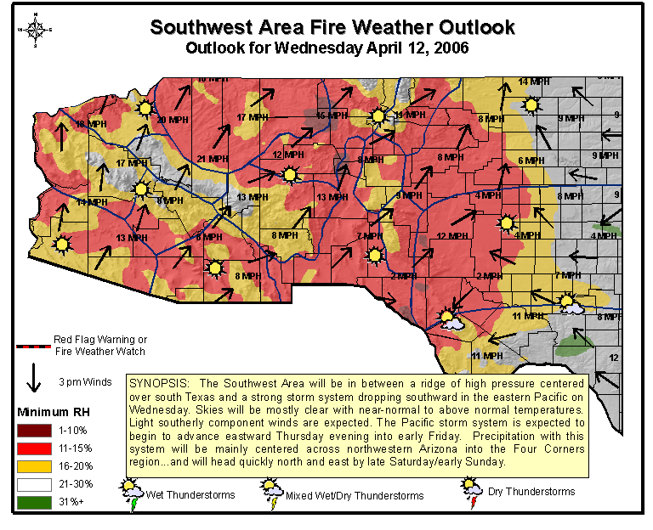

C. APPENDIX - PREDICTIVE SERVICES PRODUCTS EXAMPLES
    - 7-Day Significant Fire Potential Outlook

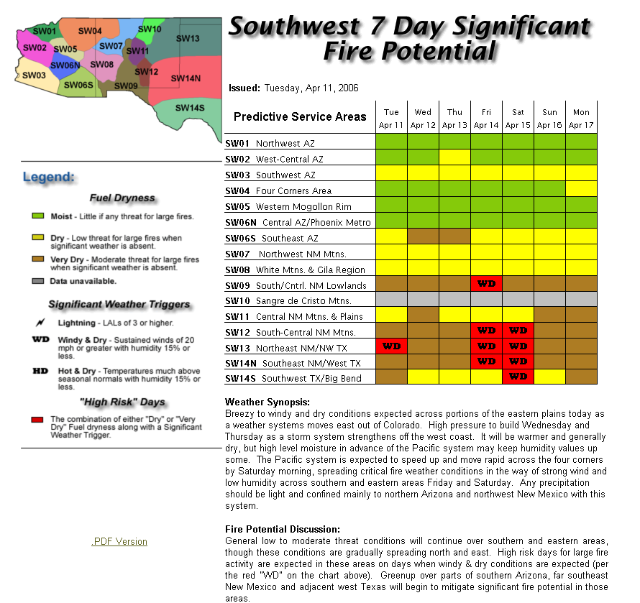
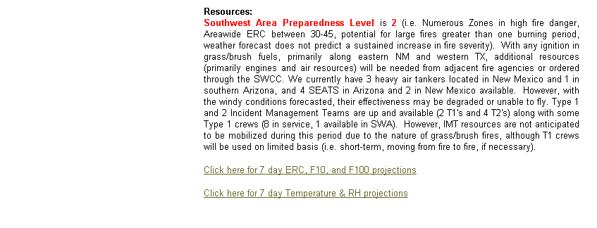
C. APPENDIX - PREDICTIVE SERVICES PRODUCTS EXAMPLES
    - Monthly Large Fire Potential Outlook
SOUTHWEST AREA
MONTHLY FIRE WEATHER / FIRE DANGER OUTLOOK
Issued for: March 2003

1. POTENTIAL FOR SERIOUS/CRITICAL FIRE PROBLEMS:

COMING MONTH  March | BELOW NORMAL | X | NORMAL | X | ABOVE NORMAL
SEASON | BELOW NORMAL |  | NORMAL | X | ABOVE NORMAL | X

2. WEATHER FACTORS:

Current Weather/Drought Situation…
A return to more “normal” El Nino conditions over the last several weeks has lead to at least 3 significant storms that have produced much needed rainfall throughout the Southwest Area (2-3” in AZ). Unfortunately most of the precipitation has been in the form of rain with accumulating snowfall confined to elevations above 8000 feet. Thus, many areas along the Mogollon Rim in Arizona are without significant snowpack. Across the higher elevations of north central New Mexico much of the precipitation has been in the form of snow with over 40” of accumulation at some of the ski resorts since February 1. As a result of the significantly wetter weather pattern, both long and short-term drought indices have shown improvement in the past 30 days.

Weather Outlook…
Moderate El Nino conditions are expected through the end of March. The result will be continued chances for both temperatures and precipitation to be normal to above normal throughout the Southwest Area. The warmer temperatures will constrain the continuous snowpack mostly above 8,500 feet. With an active storm track across the southwest, southeast New Mexico and adjacent southwest Texas will have the greatest likelihood for short term dry and windy conditions between intermittent moisture.

3. FUEL FACTORS:

CURRENT FINE FUELS:
GRASS STAGE | GREEN |  | CURED | X
NEW GROWTH | SPARSE |  | NORMAL | X | ABOVE NORMAL

CURRENT 1000-HOUR DEAD FUEL MOISTURE: 18-25%
AVERAGE 1000-HOUR DEAD FUEL MOISTURE FOR THIS TIME OF YEAR: 18-25%
CURRENT LIVE FUEL MOISTURE (sage, deciduous, conifer): 70-120%

- AVERAGE FIRE OCCURRENCE/ACRES BURNED:
(Average 2000-2002, Cumulative April – September Only)

FIRE OCCURRENCE: N/A

ACRES BURNED: N/A

- YEAR-TO-DATE FIRE OCCURRENCE/ACRES BURNED:
(Average 2000-2002, Cumulative April – September Only)

FIRE OCCURRENCE: N/A

ACRES BURNED: N/A

- WRITTEN SUMMARY:

Potential: Below Normal to Normal

General fire danger levels have rescinded to within the below normal to normal range for this time of year due to recent precipitation, though levels across the southeast quadrant of New Mexico remain elevated. Any new ignitions should be held to the initial attack stage. The exception might be on rangelands in the southern portion of the Area, where fuel conditions dry out much sooner than in other parts of the Area.

Large Fires

For the month of March during the period 1991-2002, the SWA experienced a total of 59 large fires (ie. Fires >100 acres). Of this number, 54 were human caused and 5 were ignited by lightning. By year, 1993 stands out as the year with the highest number of large fires at 15. The years 2000 and 1999 had 12 and 10, respectively. Overall, the average number of large fires for the month of March is less than 5.

With precipitation continuing to flow into the Area every 5-7 days, fuel conditions are wet enough to keep fire spread rates to a minimum. Thus, expectations are the number of large fires should remain below five for the month.
Mobilization of Resources

Incidents with Teams Assigned: For the same period (1991-2002), only six incidents required the mobilization of a Type 1 or 2 team. Thus, the average number of team assignments during this 12-year period is less than one per year. Of the six assignments, four of them occurred during 2000.

With fire danger expected to be in the below normal to normal range, significant resource mobilization (i.e. team assignment) is not anticipated. As always, though, local engine resources may be needed and should be ready and available.

7. MAP:

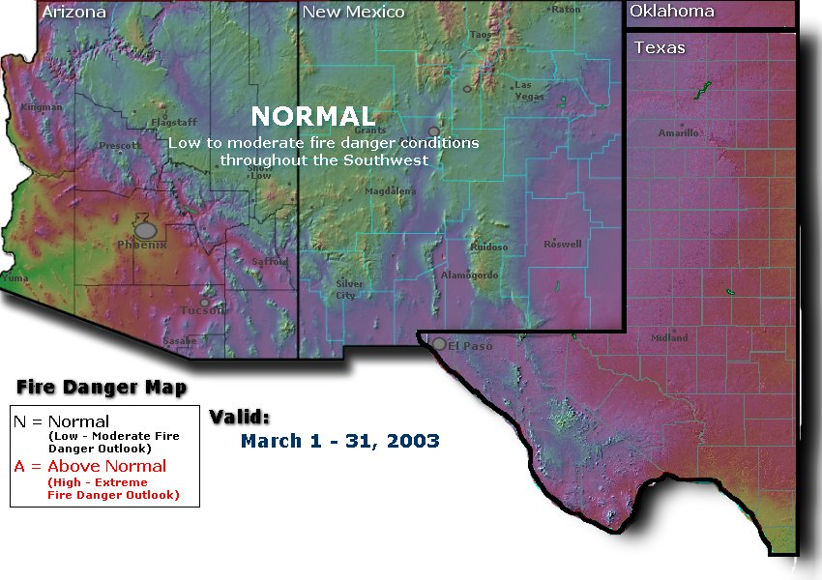

Issued: February 20, 2003

Southwest Coordination Center
Predictive Services Group

C. APPENDIX - PREDICTIVE SERVICES PRODUCTS EXAMPLES
    - Seasonal Outlook

SOUTHWEST AREA - 2002 Fire Season Outlook

EXECUTIVE SUMMARY

The fire danger across the Southwest Area is expected to be much above normal. This is due to low amounts of winter precipitation and a general forecast of continued warm and dry conditions in early summer, plus a continuance of multi-year drought in some areas. The following highlights are based on a consensus “most likely” scenario. The complete seasonal outlook follows this summary below.

Key factors for this season are:

- Expect initial attack activity through April, May, and June to be above normal at all elevation levels.
- Large fire potential will be above normal all season.
- Some precipitation events are anticipated in March and April; the impact will only delay the season, but not reduce seasonal severity.
- Chances for large-scale strong wind events (Red Flag) should be below normal in May and June.
- It is likely that there will be a transition into an El Niño pattern this year, but it will not have any impact on the fire season.
- There is no indication that the monsoon will begin early or late, or be especially weak or strong.
- Annual and perennial fuels will be more susceptible to carrying surface fire than would be normally expected.
- Given the expected state of both herbaceous and dead fuels, a higher probability of ignition will exist from any ignition source.
- By May, it is expected that 1000 hour fuel moisture will reach near record low values.
- Area average ERC values will near or exceed record levels several times throughout the season.
  - Near or above critical 90th percentile values from mid April through early July. (8-10 weeks)
  - Near or above critical 97th percentile values in June. (2-3 weeks)
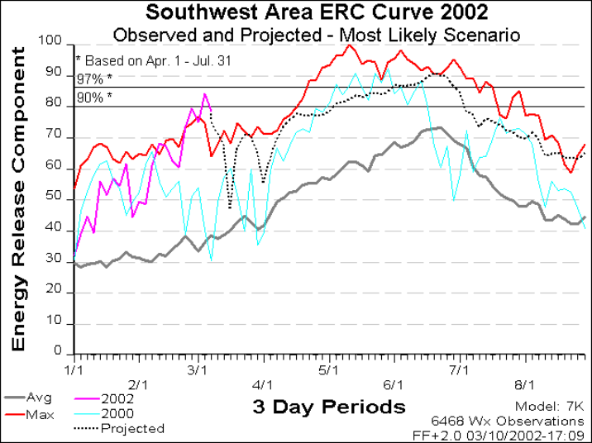

  - APPENDIX – NARRATIVE FIRE WEATHER ZONE MAPS (Arizona)

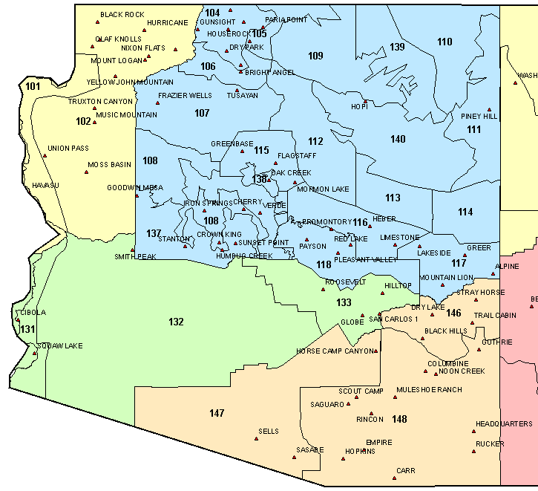
D. APPENDIX - NARRATIVE FIRE WEATHER ZONE MAPS (New Mexico, Texas & OK)

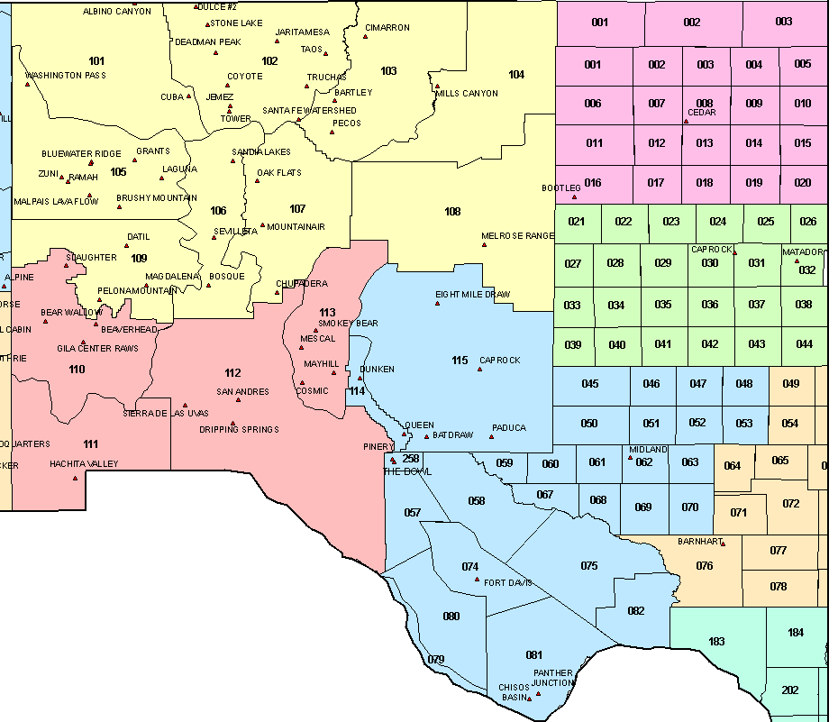

  - APPENDIX – NFDRS ZONE MAPS (Arizona)

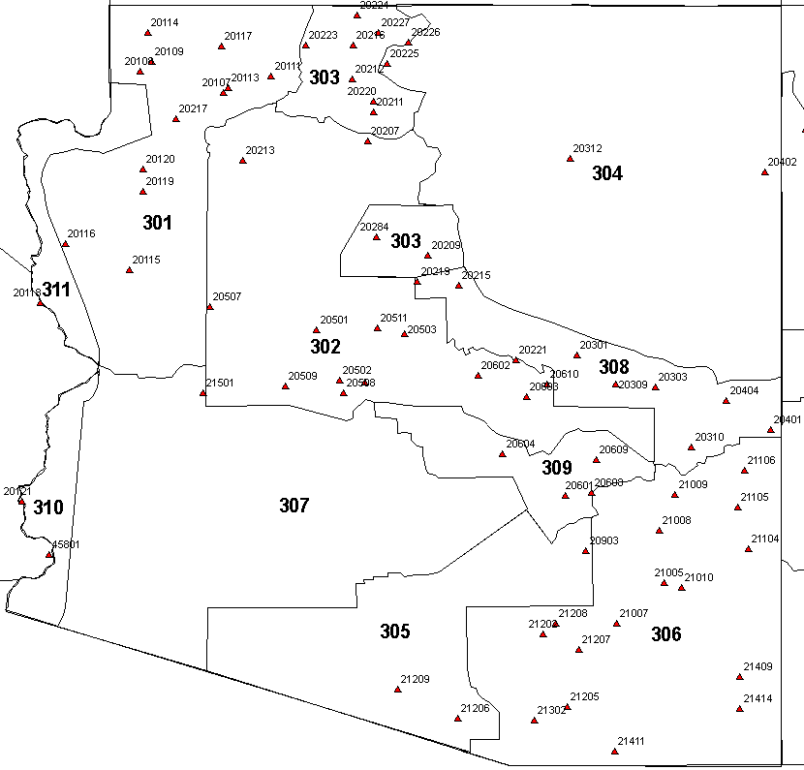
E. APPENDIX – NFDRS ZONE MAPS (New Mexico)

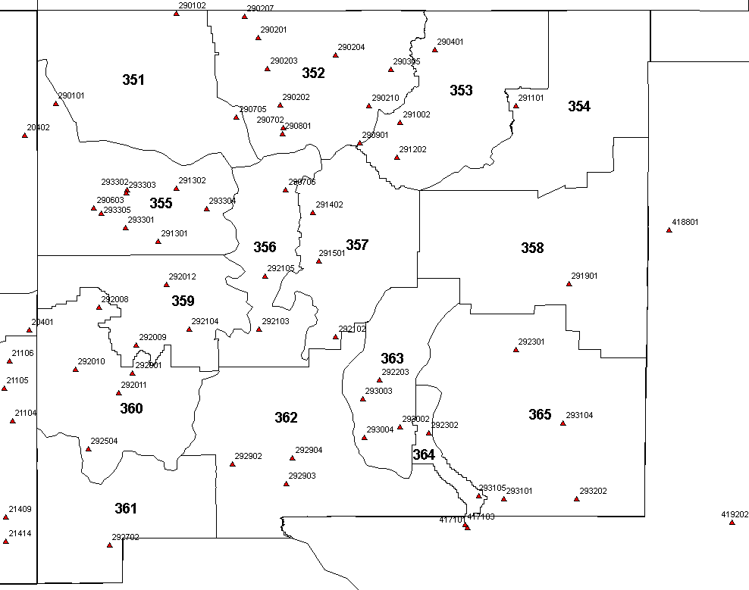

  - APPENDIX – Experimental Digital Services from the National Weather Service

WR Implementation Plan for NDFD-based FARSITE Weather Support

1. Prepare and post OCCWS-approved Product Development Description (PDD). Appendix 1

2. Distribute SOD-approved AWIPS formatter and forecaster GUI script to all WR WFOs, along with instructions for installation. Prepare and post Mod Note. SOD review in Progress

3. Provide instructions to WFO webmasters for posting FARSITE data on the internet. FARSITE product page will be same format as that currently available from WFO SLC:
http://www.wrh.noaa.gov/slc/projects/ifp/data/FARSITE/FARSITE.php. Approximate workload - less than 2 hours. Appendix 2

4. MSD provided AOP insert announcement of this service. Appendix 3

5. Forecaster familiarization of FARSITE data. Approximate workload - less than 30 minutes. Provide NWSEO/MICs guidance emphasizing negligible workload associated with this service. Appendix 4

6. Planned implementation date: May 1

Appendix 1: WR FARSITE PDD

Gridded Weather Input for Fire Area Simulation Model (FARSITE)

Product Description Document (PDD)

Part I – Mission Connection

a. Product Description – FARSITE is a deterministic model developed and used by land management agencies. FARSITE simulates the spatial and temporal spread and behavior of fires under conditions of heterogeneous terrain, fuels, and weather. Required FARSITE weather input consists of maximum and minimum relative humidity, maximum and minimum temperature, daily precipitation, wind speed and direction and cloud cover. FARSITE is an important tool that fire agencies use to help keep firefighters safe. Pursuant to the NWS mission of saving lives and property, NOAA/NWS forecasters have been manually supplying FARSITE weather input to fire managers for a number of years.

FARSITE is an important tool for land management agencies in Western Region. This model is used to help plan safe and efficient suppression tactics for wildland fires, to better manage prescribed burns so that these fires to not become out-of-control wildland fires and to allow increased used of Wildland Fire Use (WFU) projects. Land management agencies are increasing use of WFU projects to achieve greater public lands fuels reduction goals at less taxpayer expense. Consequently, Western Region WFOs are receiving increasing requests from fire managers for FARSITE weather input. Increased automation is desired to reduce the workload involved in fulfilling these requests.

An IFPS formatter is available to provide FARSITE weather input automatically from the NDFD (Gibson, Gorski, 2004) based on the latitude and longitude of the fire as provided by the requesting fire official. This formatter will be available for download from the Western Region applications server and is easily implemented on any local AWIPS platform. FARSITE output from this formatter has been supplied to the requesting fire agency by a variety of means. In 2006, all Western Region WFOs will make FARSITE weather input available to the requesting official on the WFO fire weather web page.

b. Product Type - Experimental

c. Purpose – Establish a regional standard for providing requested FARSITE weather data via production from NDFD and access via WFO fire weather web pages. This will allow fire weather customers easier access to needed FARSITE weather data and will reduce workload on Western Region WFOs. Fire agency customers request FARSITE data via the web or telephone call to their servicing WFO.

d. Audience – Fire managers using FARSITE are the customers of this data and web page option. Most customers will be managers in the U.S. Forest Service, Bureau of Land Management, National Park Service and other federal and state land management agencies.

e. Presentation Format – FARSITE weather data support is presented in the standard format needed by this fire spread model. It is simple text arranged vertically by date and horizontally by weather element:

WTR (weather) output:
12 08 00 0700 1600 10 27 99 38 9870
12 09 00 0700 1600 10 33 73 43 9870
12 10 00 0700 1600 13 36 72 33 9870
12 11 00 0700 1600 14 37 66 33 9870
12 12 00 0700 1600 14 35 67 29 9870
12 13 00 0700 1600 13 33 64 30 9870
12 14 00 0700 1600 12 31 70 39 9870
12 15 00 0700 1600 12 31 71 39 9870

WND(wind output):
12 22 0000 11 200 44
12 22 0300 13 210 53
12 22 0600 17 220 70
12 22 0900 14 220 65
12 22 1200 11 220 56
12 22 1500 09 260 55
12 22 1800 08 310 52
12 22 2100 08 300 52
12 23 0000 08 240 52
12 23 0300 08 270 58
12 23 0600 07 310 70
12 23 0900 09 330 67
12 23 1200 10 001 60
12 23 1500 11 010 47

f. Feedback Method – The MIC solicits feedback from the fire agencies via telephone, e-mail and customer outreach visits.

g. Example - National Weather Service - NWS Salt Lake City (http://www.wrh.noaa.gov/slc/projects/ifp/data/FARSITE/FARSITE.php)

h. PDD Approved by Vickie Nadolski, Director, Western Region

Part II – Technical Description

a. Format and Science Basis – The methodology of delivering FARSITE weather support information was developed to ease the workload on the WFO and increase convenience for fire weather customers to request and access the information. The IFPS formatter utilizes the published WFO Digital Forecast Database (DFD) to generate this weather data in the format required by FARSITE. Prior to being published, the forecaster reviews and if necessary, adjusts the DFD to ensure consistency and accuracy with other products and the current assessment of expected meteorological conditions during the product valid time. It should be noted that this PDD represents a more efficient production and dissemination method for data that has been supplied by NOAA/NWS to fire weather customers for a number of years. The data type is not new.

b. Availability – FARSITE weather data will be generated upon request by a fire agency official, usually concurrent with a spot forecast request. When a forecaster creates a draft spot forecast from the DFD, FARSITE data will be automatically generated and sent to the WFO fire weather web page. If a FARSITE user does not need a full spot forecast, they can call the WFO. The forecaster can then produce FARSITE data by entering fire location and name in a small AWIPS GIU. Again, the data is produced and sent to the web automatically.

c. Additional Information – Information regarding the availability of FARSITE weather data on Western Region WFO fire weather web pages, as well as the procedure for requesting this support, will be provided in all 2006 Western Region Fire Weather Annual Operating Plans (AOP).

Point Forecast Matrix Product (PFM) for RAWS sites

1. Limited number of PFM’s will be produced across Region III during the 2006 caldendar year.

2. Graphical map containing links to PFM sites will be found on each office's fire weather web site. SWCC will also provide a Region III wide graphical map for which the product will be linked.

3. Some format differences within the product may be found across Region III.

Example format link: http://www.wrh.noaa.gov/vef/firematrix.php?loc=orientalwash
Example format link: http://www.srh.noaa.gov/maf/Fire/getpfw.php?loc=midland

4. Forecasts will be based on a 2.5 or 5 square km grid box for which the RAWS site is located.

  - APPENDIX – BACKUP SPOT FORECAST REQUEST FORM
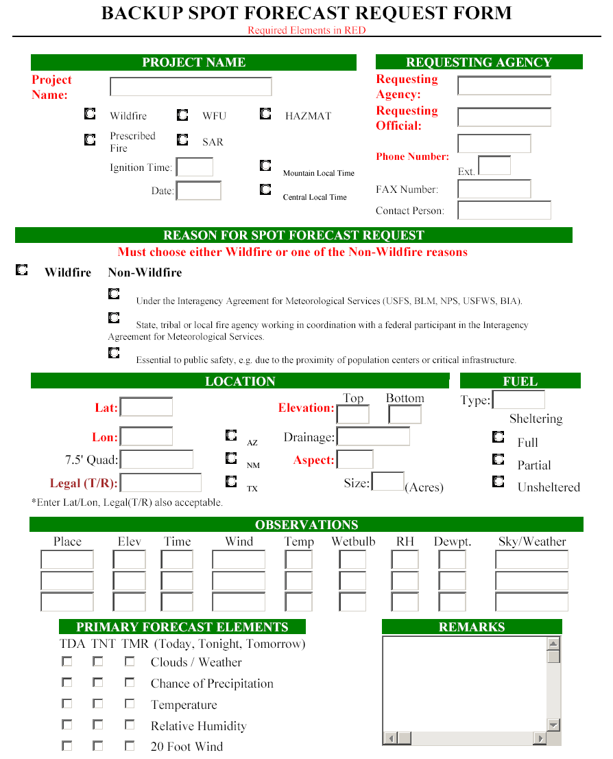

    - Example of Completed Spot Request Form - Entries for location show three different, correct methods; legal description, lat/lon in decimal degrees, and lat/lon in degrees, minutes and seconds.

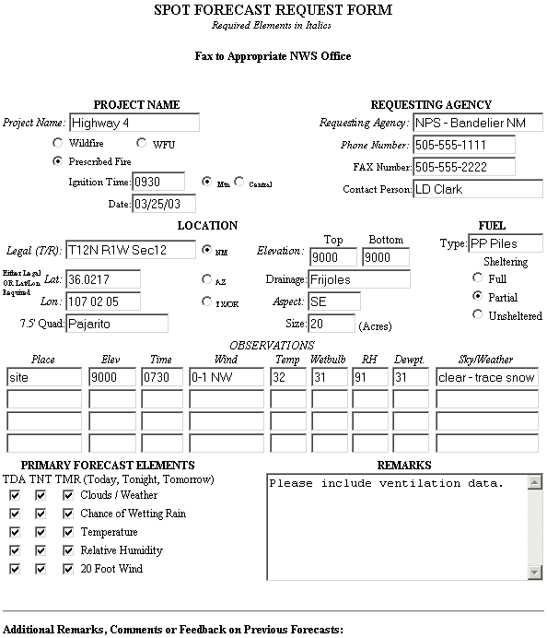

  - APPENDIX – CATALOG OF RAWS AND NFDRS OBSERVATION LOCATIONS

Permanent Stations and Locations Sorted by NFDRS Zone

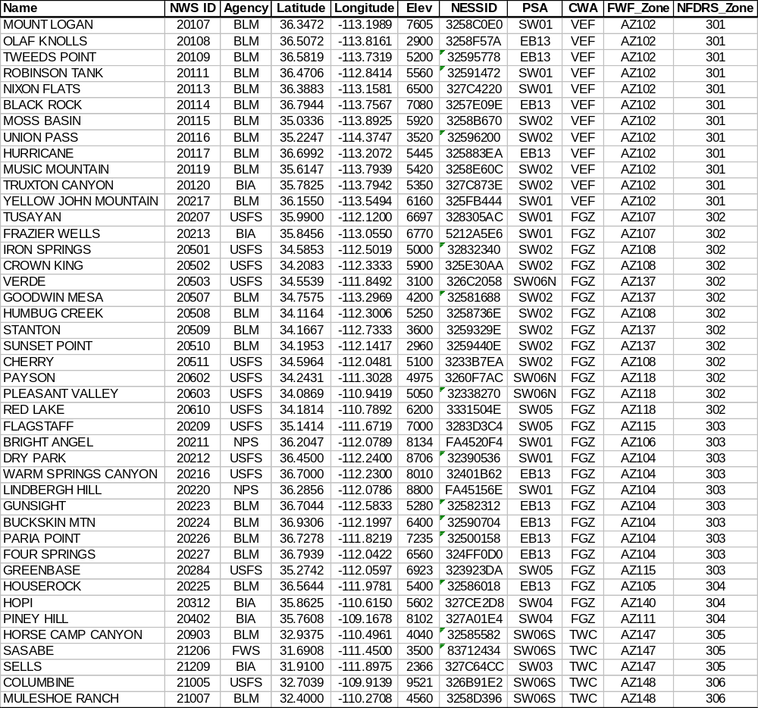
APPENDIX H - CATALOG OF RAWS AND NFDRS OBSERVATION LOCATIONS

Permanent Stations and Locations Sorted by NFDRS Zone (cont.)
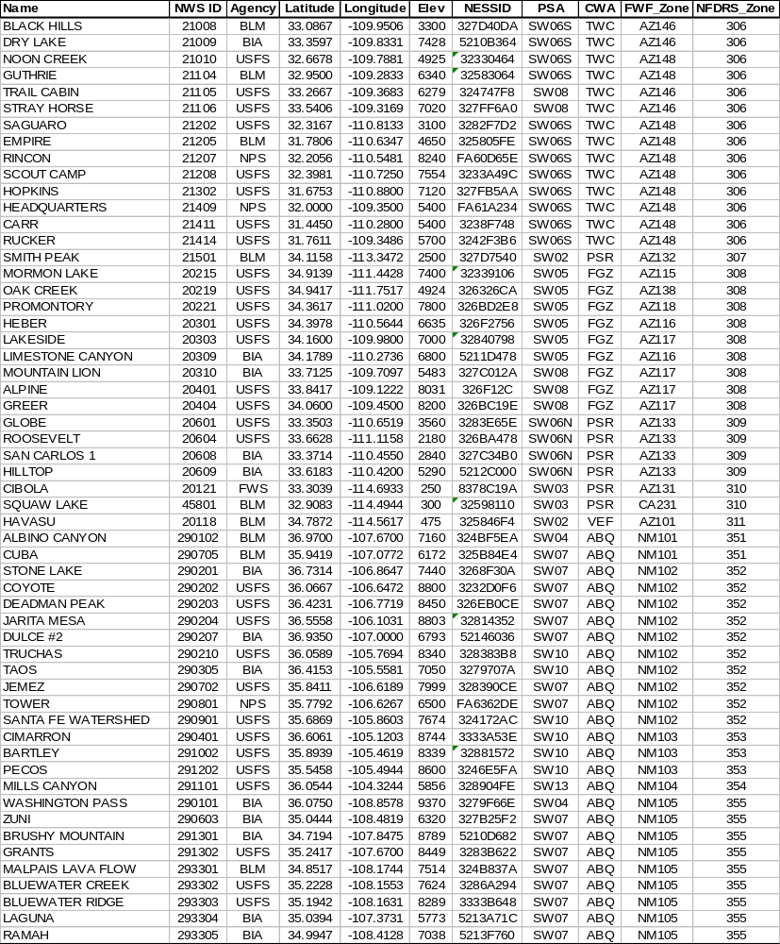
APPENDIX H - CATALOG OF RAWS AND NFDRS OBSERVATION LOCATIONS

Permanent Stations and Locations Sorted by NFDRS Zone (cont.)

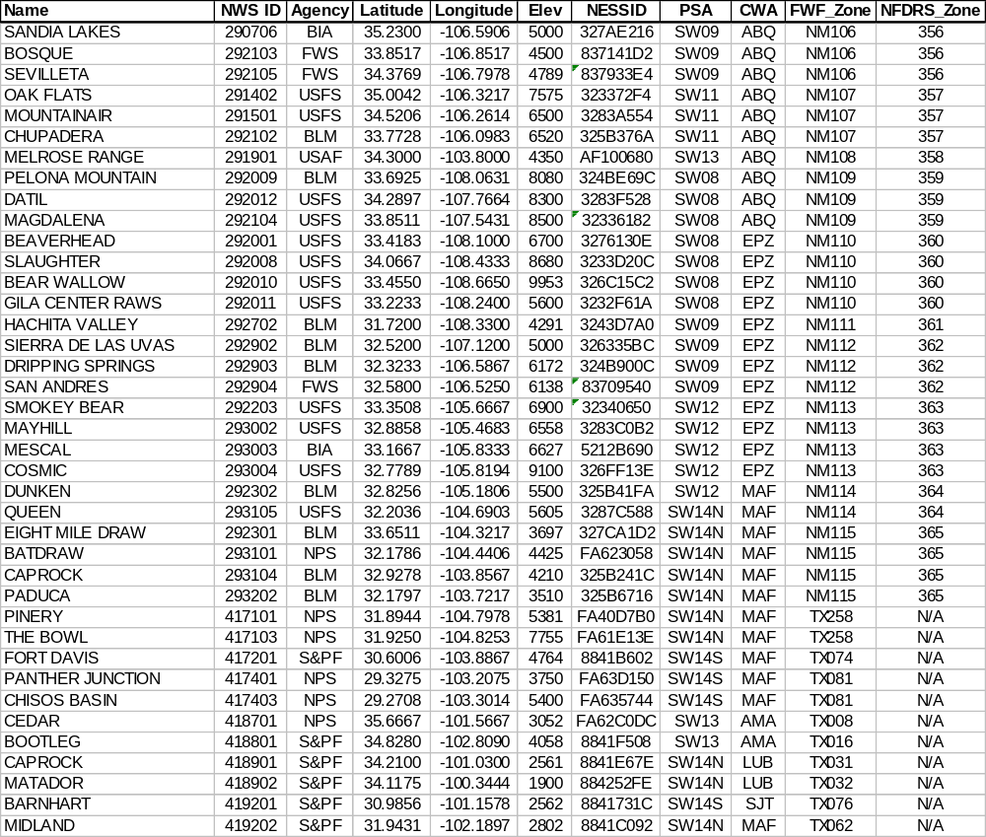

I. APPENDIX – VERIFICATION

1. National Digital Forecast Database: http://www.weather.gov/forecasts/graphical/sectors/

2. Rocky Mountain Center: http://fireweather.sc.egov.usda.gov/verification_main.htm

3. NFDRS: To be implemented during 2006 season. Web address will be forwarded upon service launch.

4. SWCC Products: To be implemented. Web address will be forwarded upon service launch.

